

HR Connect Ticket Request Process
Job Aid

Human Resources Center (HRC) Supervisor

02 January 2024

Contents
Introduction 3
Ticket Submission Workflow 3
Ticket Processing Timeline 3
Ticket Priority Level 4
Access HR Connect 5
Filter Tickets 8
Ticket Status Options 8
View Submitted Tickets 9
Assign Tickets 13
Assign a Submitted Ticket 13
Assign Returned Without Action Status to Ticket 20
Submit HR Connect Feedback 27
Executive Dashboard 31
Overview 31
HR Connect National Metrics Dashboard Data 32
HR Connect District Metrics Dashboard Data 33
Access Executive Dashboard 34
Export Executive Dashboard Data (Summarized) 39
Export Executive Dashboard Data (Data with Current Layout) 43

Introduction
HR Connect serves as a mandatory user-friendly workload ticketing system between the Human Resources Liaisons (HRLs)/Human Resources Development (HRD) Specialists and their servicing HRC for all non-Manager Self-Service (MSS) related actions. The procedures described in this job aid are designed for HRC Supervisors who access HR Connect to approve and prioritize non-MSS tickets. HR Connect allows HRC Supervisors to view all unassigned tickets, determine priority of ticket requests, assign and reassign ticket requests to Human Resources Specialists (HRSs), and access an Executive Dashboard to view national and district ticket metrics.

Ticket Submission Workflow
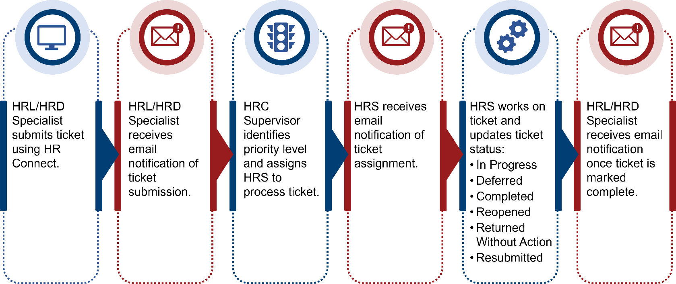

Ticket Processing Timeline
The following processing timelines apply for tickets submitted in HR Connect:
- HRC Supervisor to assign ticket: 1 business day.
- HRS to begin working on ticket (move ticket to In Progress): 1 business day.
- HRS to complete ticket: Varies, depending on circumstance/complexity of ticket, whether additional information is needed, etc., along with considerations within performance plan (if applicable).
- HRS to close ticket after completion: Same day that ticket is completed.
NOTE: Ticket priority impacts the ticket processing timeline.
NOTE: A user who submits feedback via the Submit Feedback option on the HR Connect home screen should expect to receive a response within 2 business days.

Ticket Priority Level
When a ticket is submitted, an HRC Supervisor receives the ticket, assigns a priority level, and assigns an HRS to process the ticket. HRC Supervisors are the only role with permission in HR Connect to change ticket priority—based on review of the issue and their own expertise/judgement—and to assign/reassign tickets.
The three priority levels are described below.
NOTE: While definitions and examples are listed below, HRC Supervisors have the latitude to assign priority based on review and judgement of issue.
Priority Level | Description of Issue
High | - Involves pay/benefits  - Impacts a system(s) (e.g., ePerformance, HR Smart)
Medium | Does not impact pay, benefits, or systems, yet involves an impact that requires higher than Low priority (e.g., Official Job Offer [OJO], Tentative Job Offer [TJO], ePerformance question)
Low | Does not impact pay or systems and can be addressed after HRS addresses High and Medium priority tickets (e.g., Service Computation Date [SCD] review)

Access HR Connect
HRC Supervisors who attempt to access the tool without the appropriate permission receive a Request Access message as shown below.
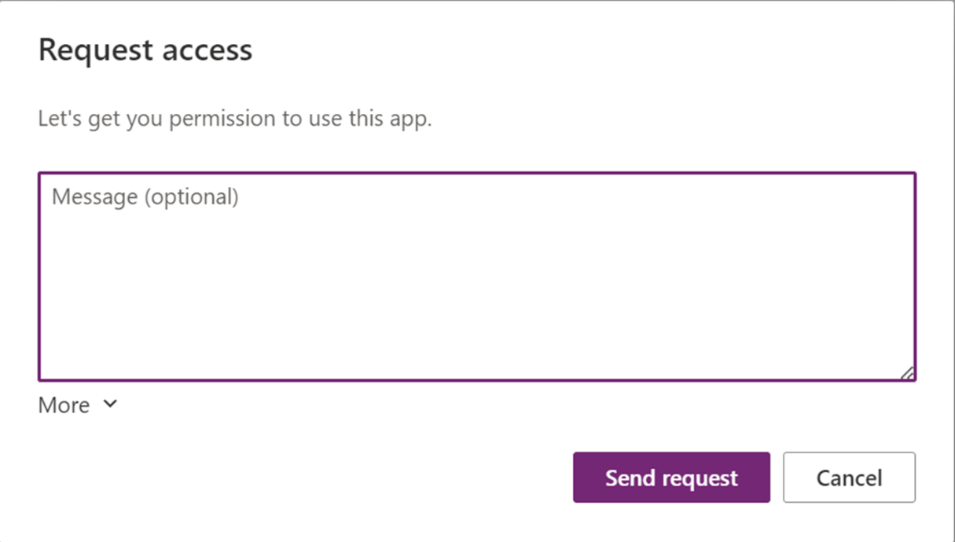
Supervisors must request access from the HR Connect team to begin using the application. Once access is granted, HRC Supervisors receive an email notification confirming their access to HR Connect.
- Select the HR Connect link within the HR Connect Access Request email.
NOTE: HR Connect launches in Microsoft Edge.
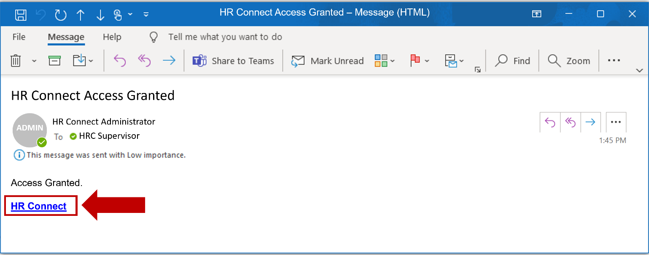

- Select Allow on the Permissions popup window.
NOTE: Allow must be selected in order to access the HR Connect application.
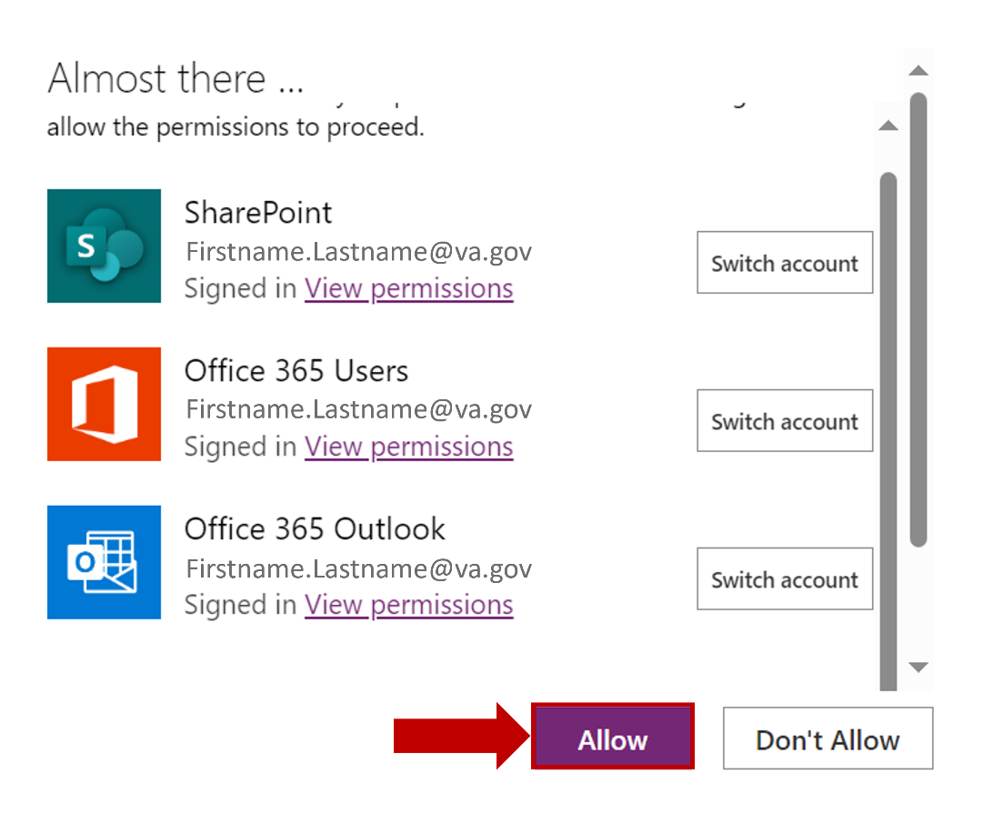
- Select the Agree checkbox to acknowledge the sensitive information disclaimer.
NOTE: Bookmarking this page allows for easy access to HR Connect.
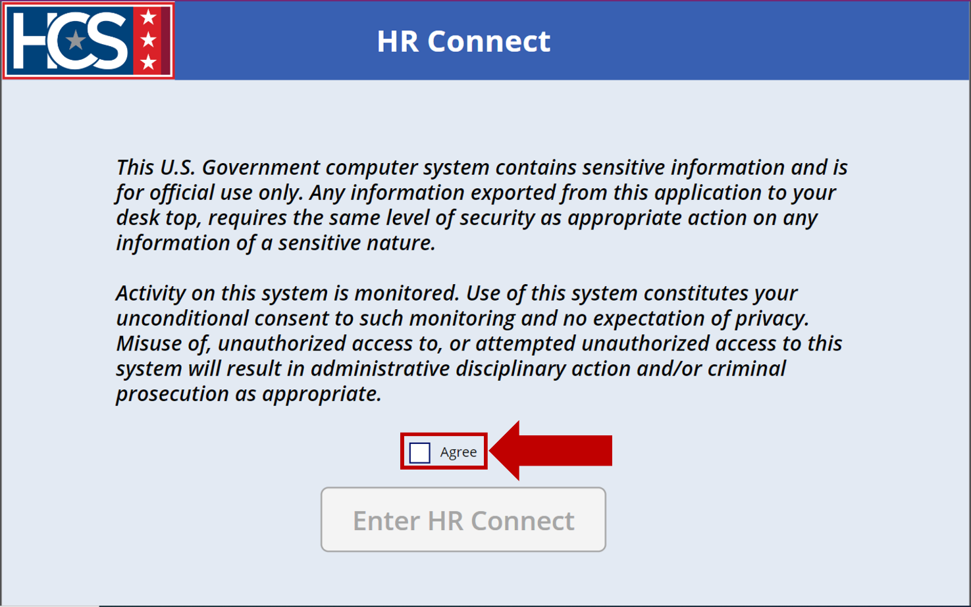
- Select Enter HR Connect.
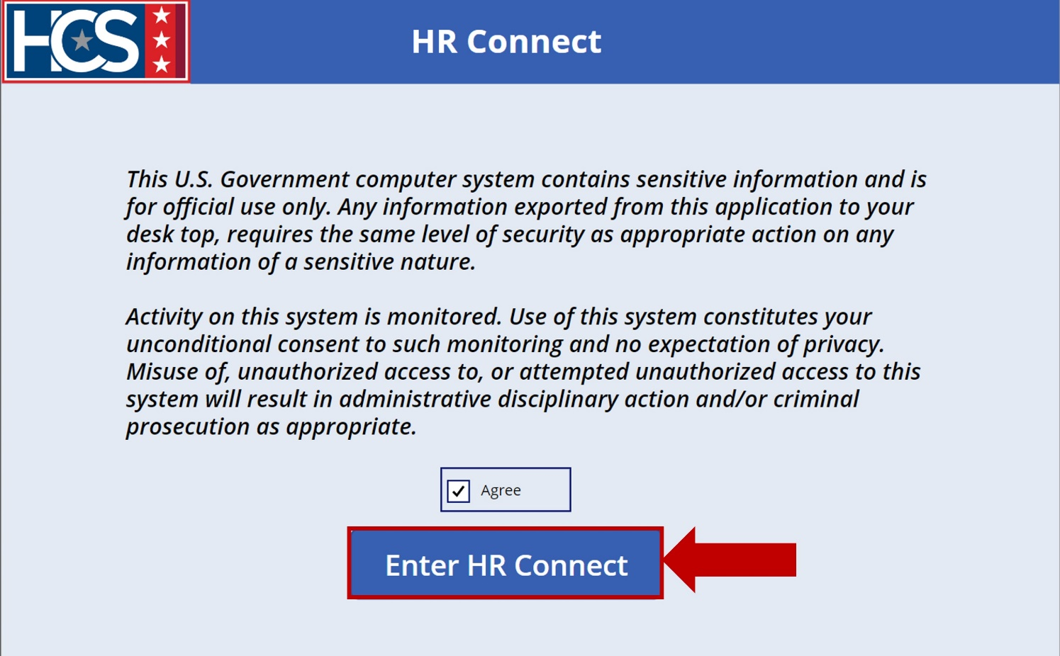
- Observe the HR Connect home screen.
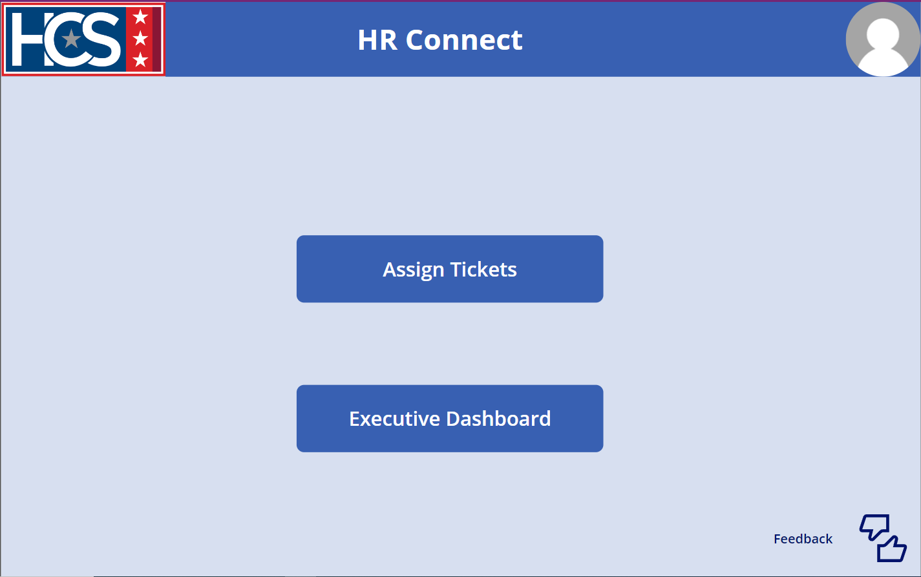

Filter Tickets

Ticket Status Options
HR Connect allows for straightforward tracking and viewing of tickets as they progress through the system. Once a ticket is submitted, an HRC Supervisor can view ticket status using the Assign Tickets option. Status filters include:
- Submitted: HRC Supervisor has not yet assigned the ticket to an HRS.
NOTE: This status type is not visible to an HRS viewing their assigned tickets.
- Assigned: HRC Supervisor has determined the ticket priority (High, Medium, Low) and has assigned the ticket to an HRS.
- In Progress: HRS has started working on the ticket.
- Deferred: Ticket has been placed on hold, pending action or information from an internal or external third-party source.
- Reopened: Ticket was closed but reopened (e.g., resolution in error, additional resolution needed).
- Returned Without Action: Ticket is returned to the HRL/HRD Specialist for several reasons, which include: Duplicate; MSS Request; Missing Documents; Additional Information Needed. The reason for the ticket being Returned Without Action is provided in the HRC Details section of the submitted ticket.
NOTE: If the ticket lists either Missing Documents or Additional Information Needed, the ticket can be resubmitted with the missing document(s) or additional information.
- Completed: HRS has resolved the ticket.
- Resubmitted: A ticket that was Returned Without Action is submitted again with missing documents or additional information included.
NOTE: HRLs/HRD Specialists can only update tickets with a status type of “Submitted” or “Returned Without Action.”
When a status filter is selected, the color of the option changes and only the tickets that apply to the selected filter display. If no tickets have the selected status, no tickets display on the screen.
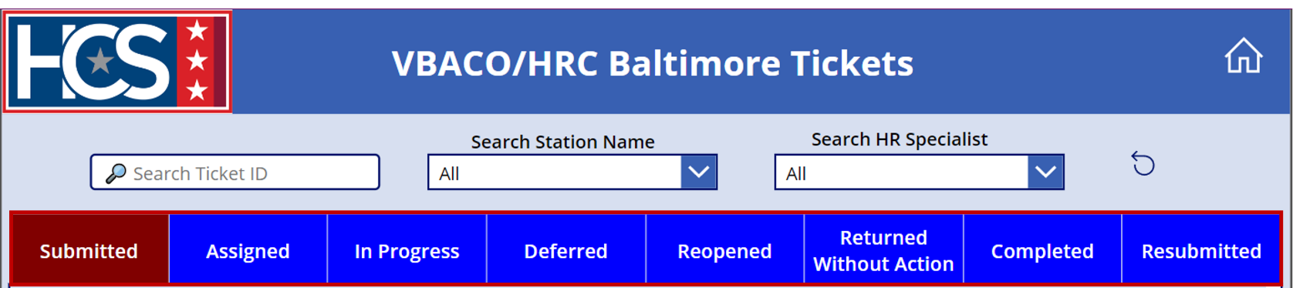

View Submitted Tickets
- Select Assign Tickets on the HR Connect home screen.
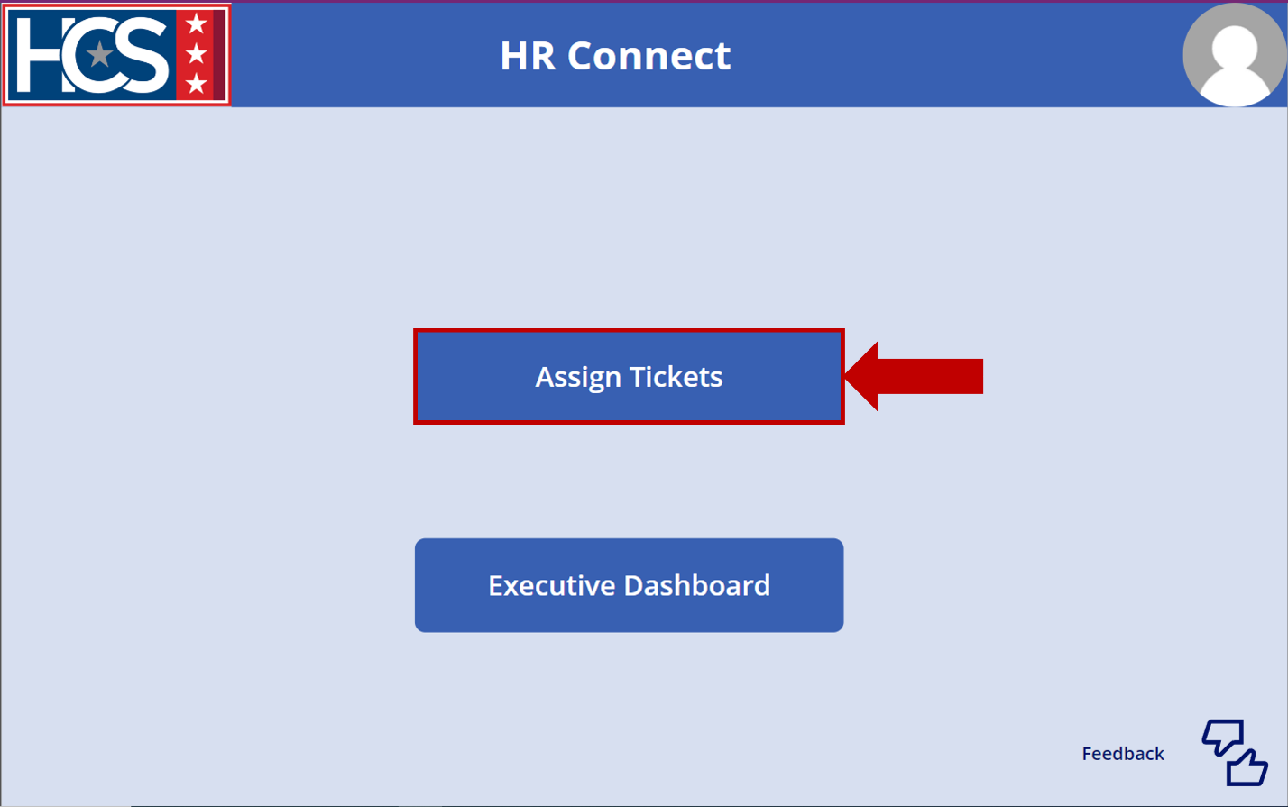
- Observe the VBACO/HRC Baltimore Tickets screen.
NOTE: The title of the screen reflects the assigned District of the user in HR Connect.
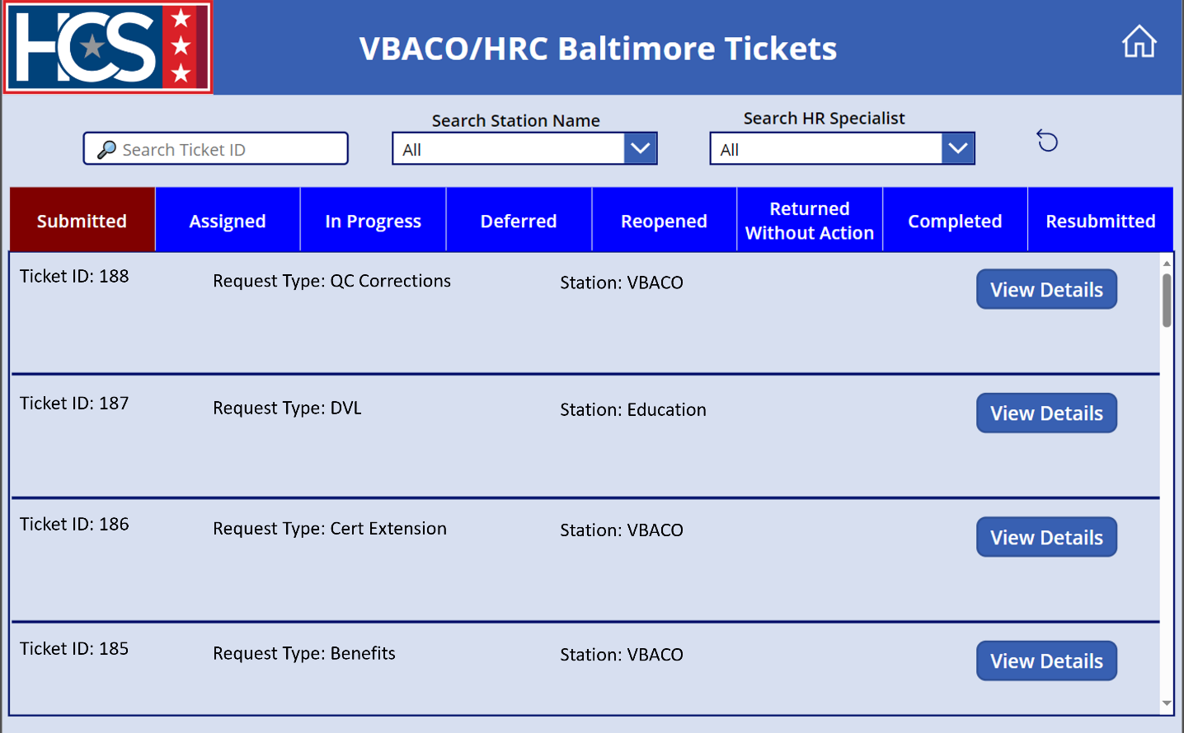
- Type a ticket number in the Search Ticket ID text field.
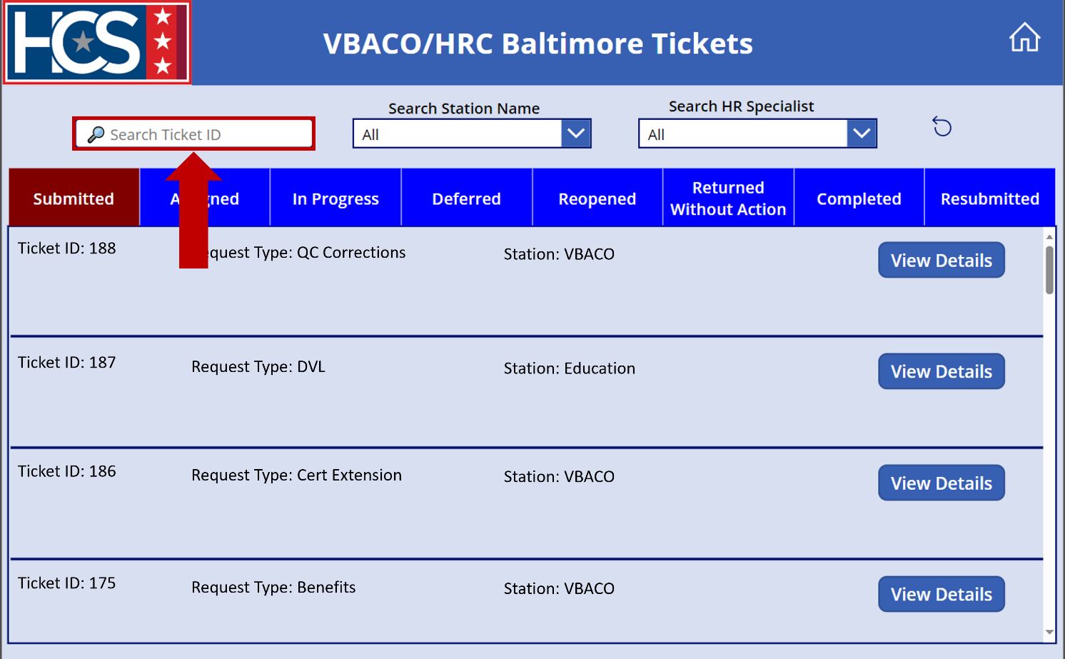
- Review tickets that display as a result of the entered ticket ID number on the VBACO/HRC Baltimore Tickets screen.
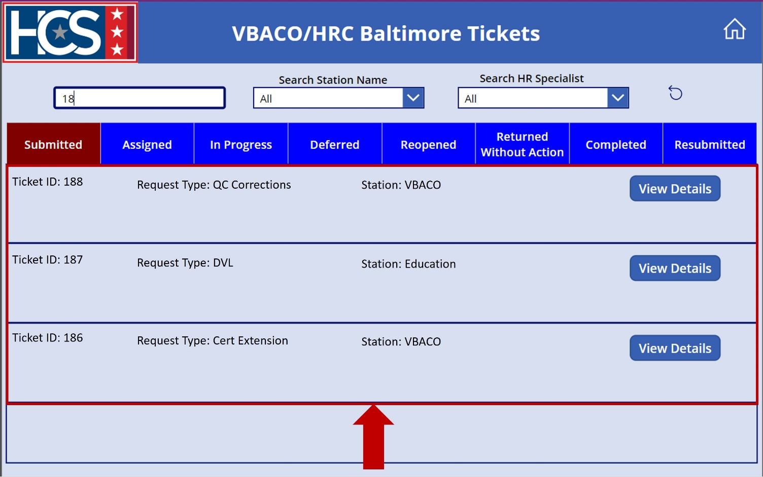
- Use the Search Station Name dropdown menu to filter tickets by station name.
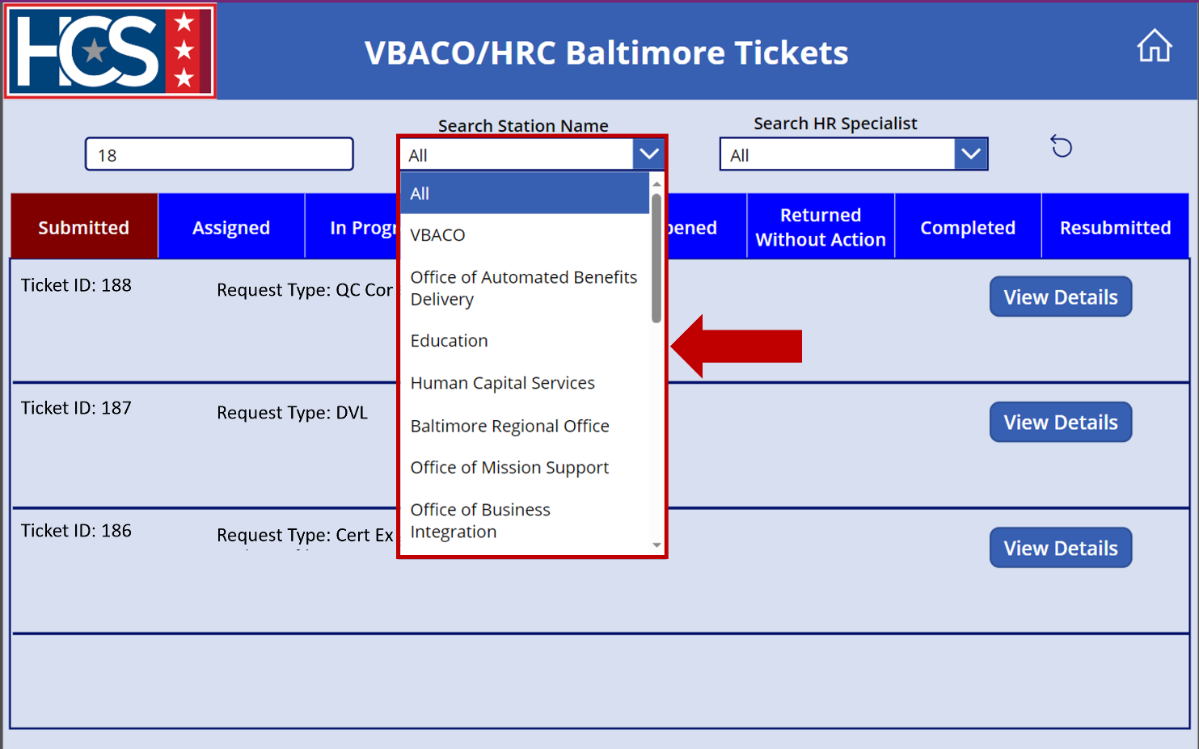
- Review tickets that display on the VBACO/HRC Baltimore Tickets screen as a result of the ticket ID and station name selections.
NOTE: If no tickets match the search criteria, no tickets display.
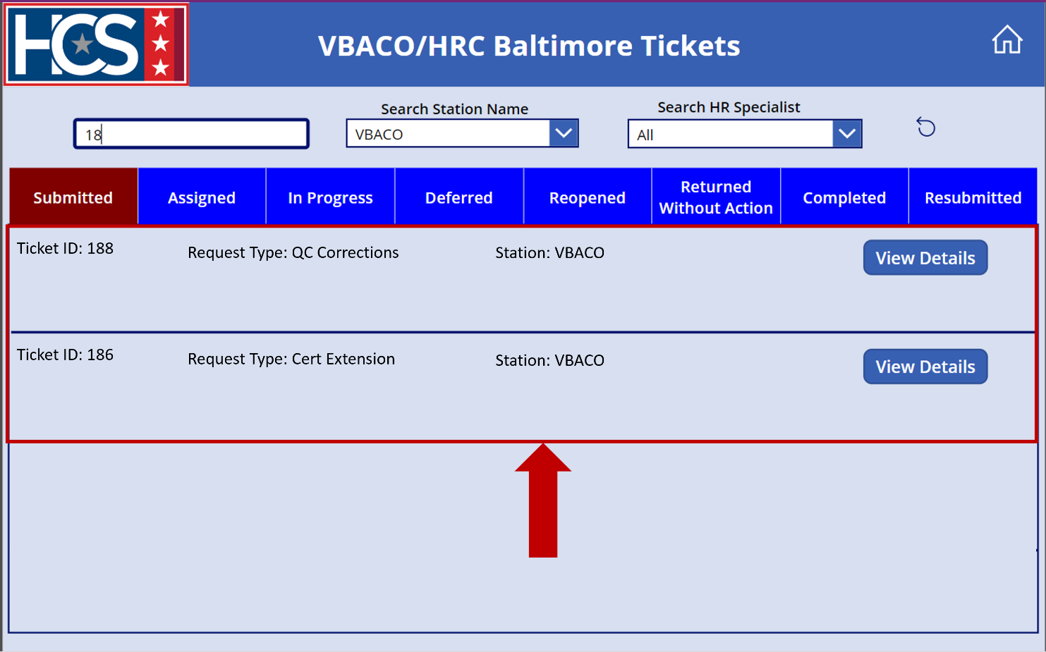
- Use the Search HR Specialist dropdown menu to filter tickets by HRS name.
NOTE: When filtering Submitted tickets, “All” must be selected to display any ticket results. The Search HR Specialist filter only displays ticket results with Assigned, In Progress, Reopened, Returned Without Action, Completed, or Resubmitted statuses.
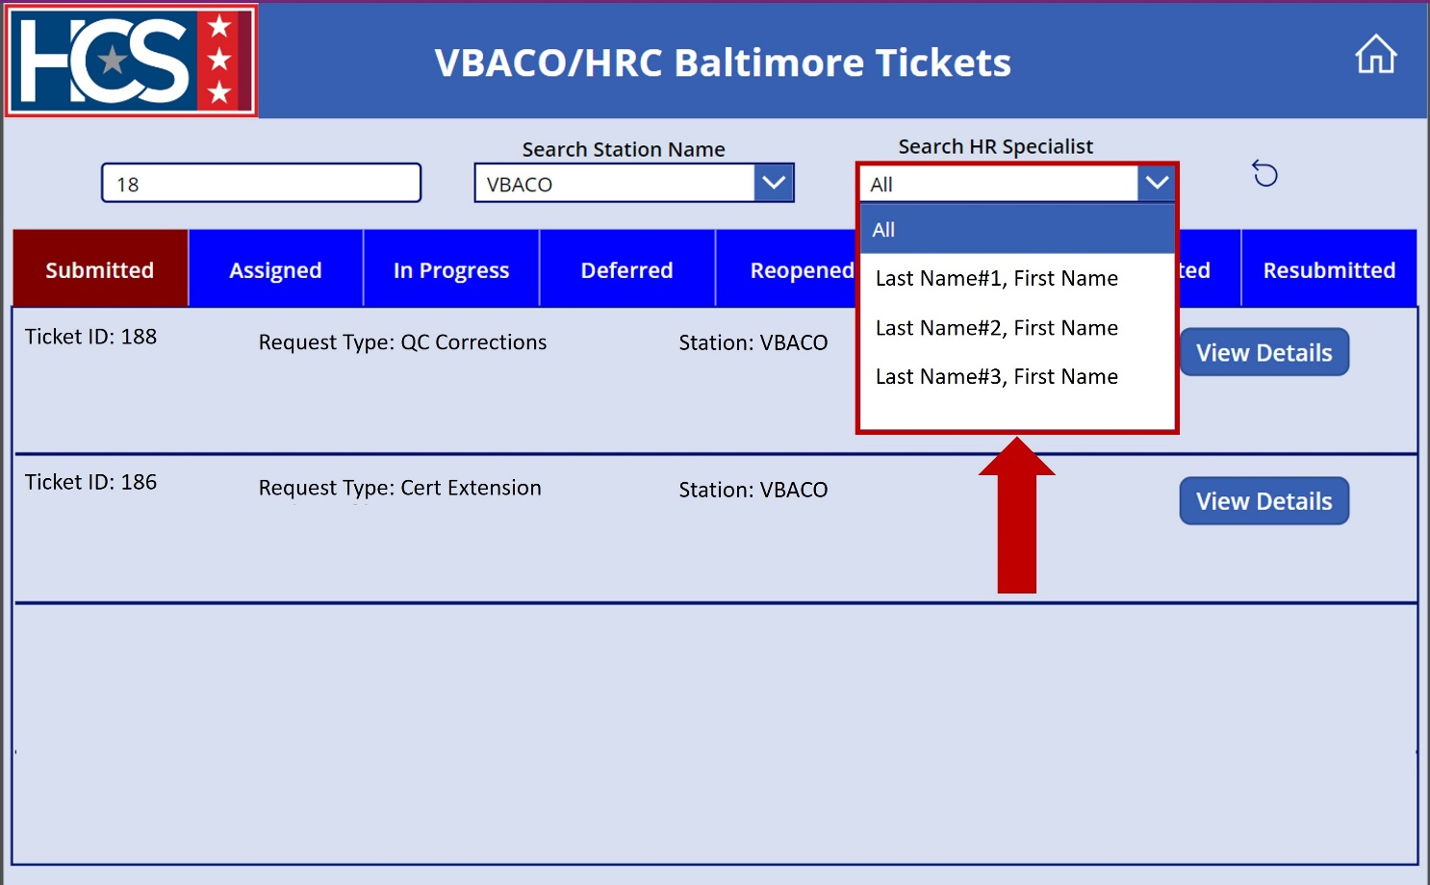
- Select the Reset icon to clear and reset filters, if needed.
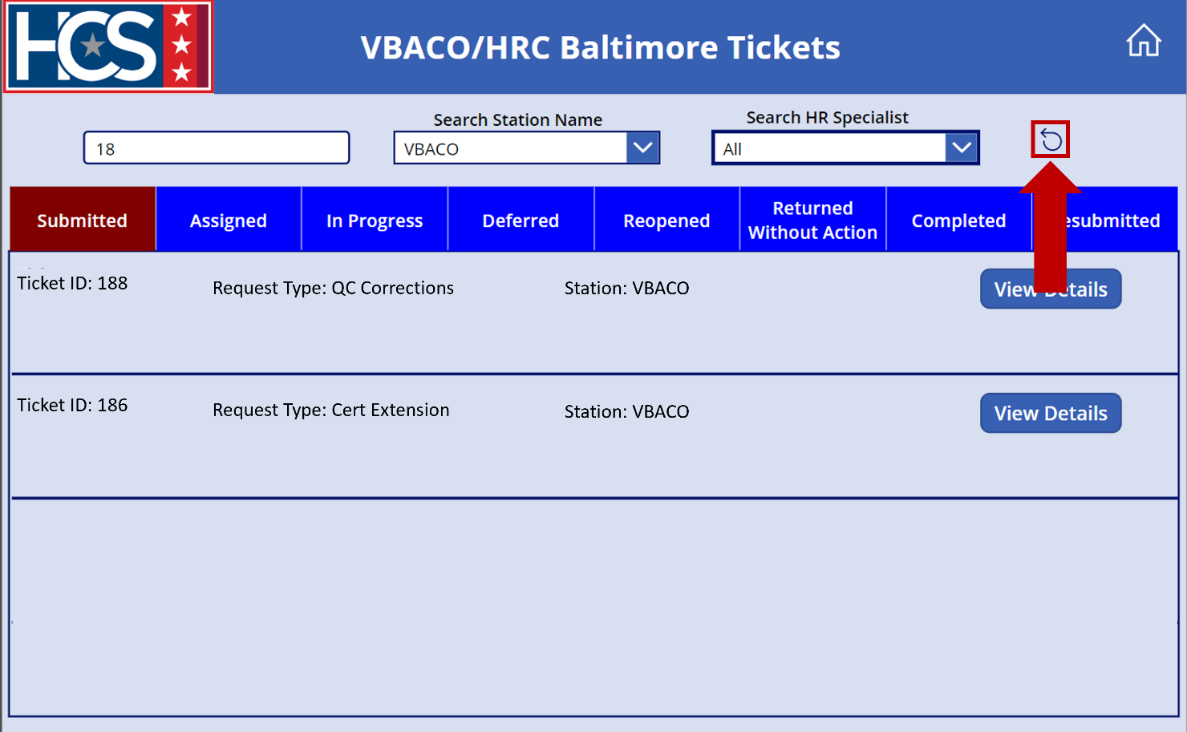

Assign Tickets

Assign a Submitted Ticket
- Select View Details for the ticket to be updated on the VBACO/HRC Baltimore Tickets screen.
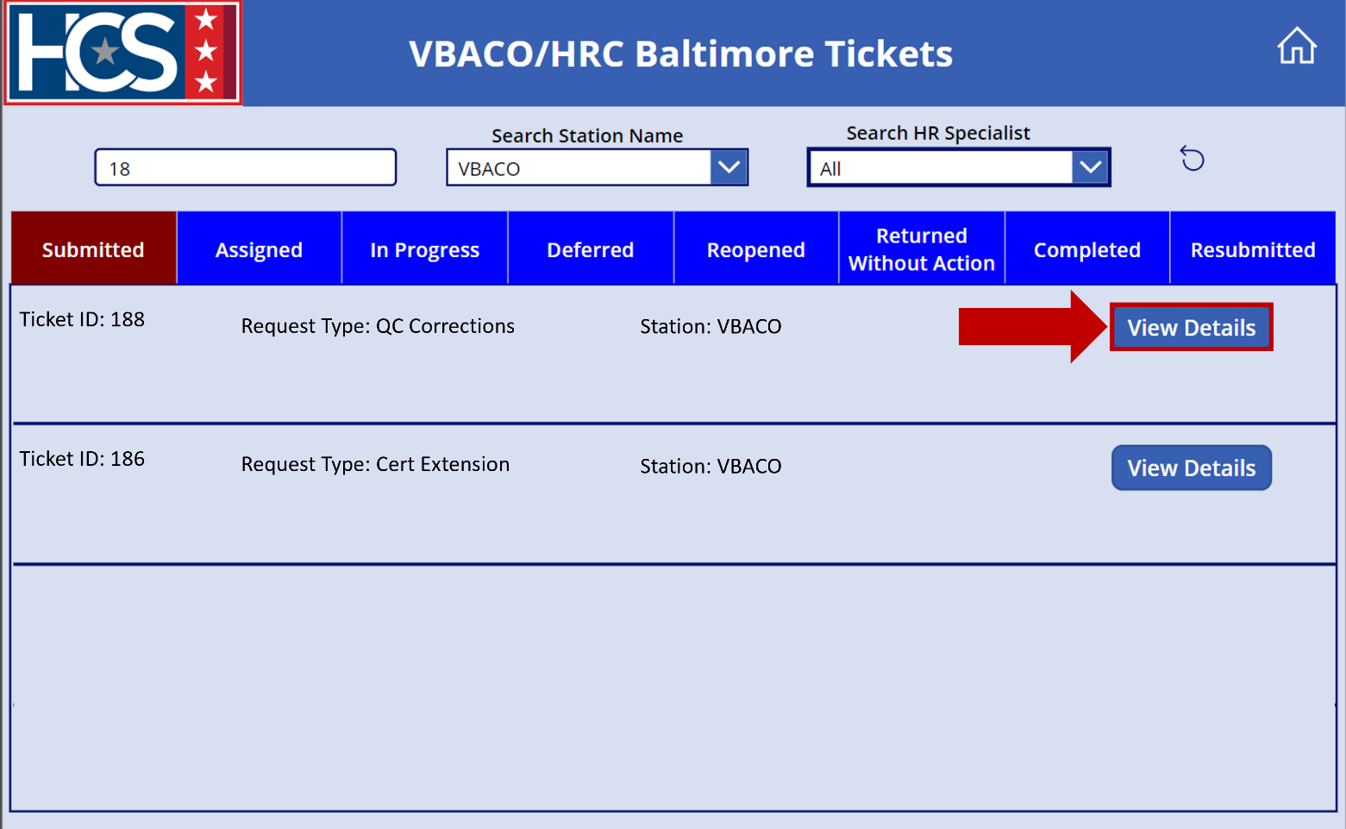
- Observe the Ticket: # Details screen.
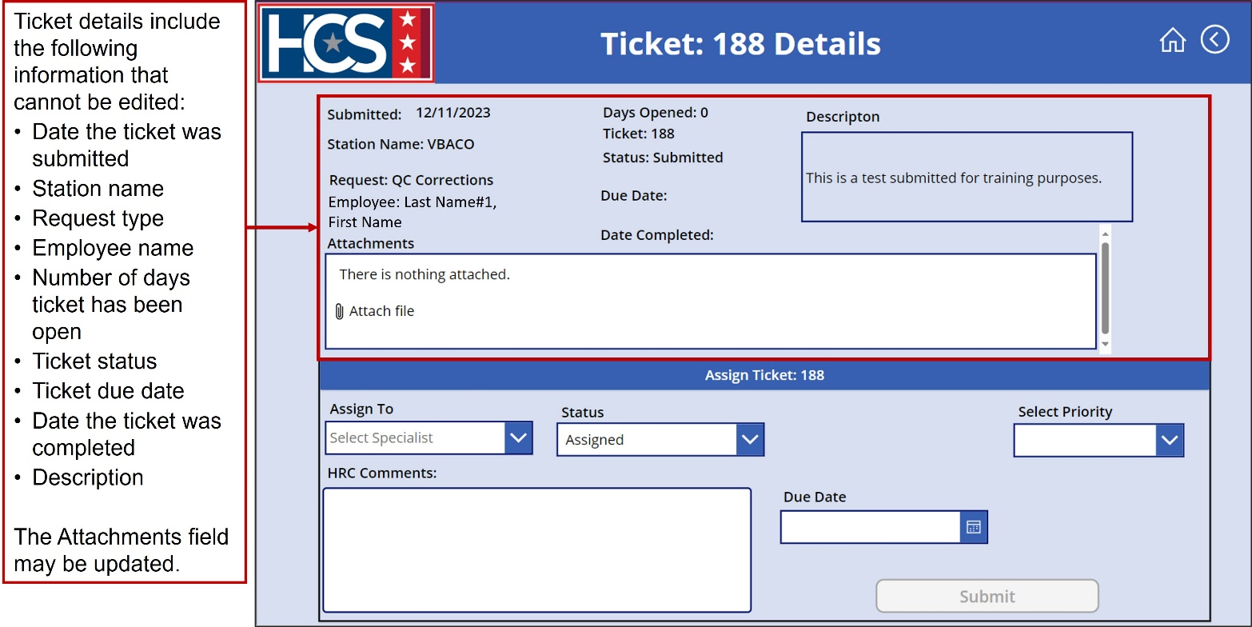
- Select HRS name from the Assign To dropdown menu.
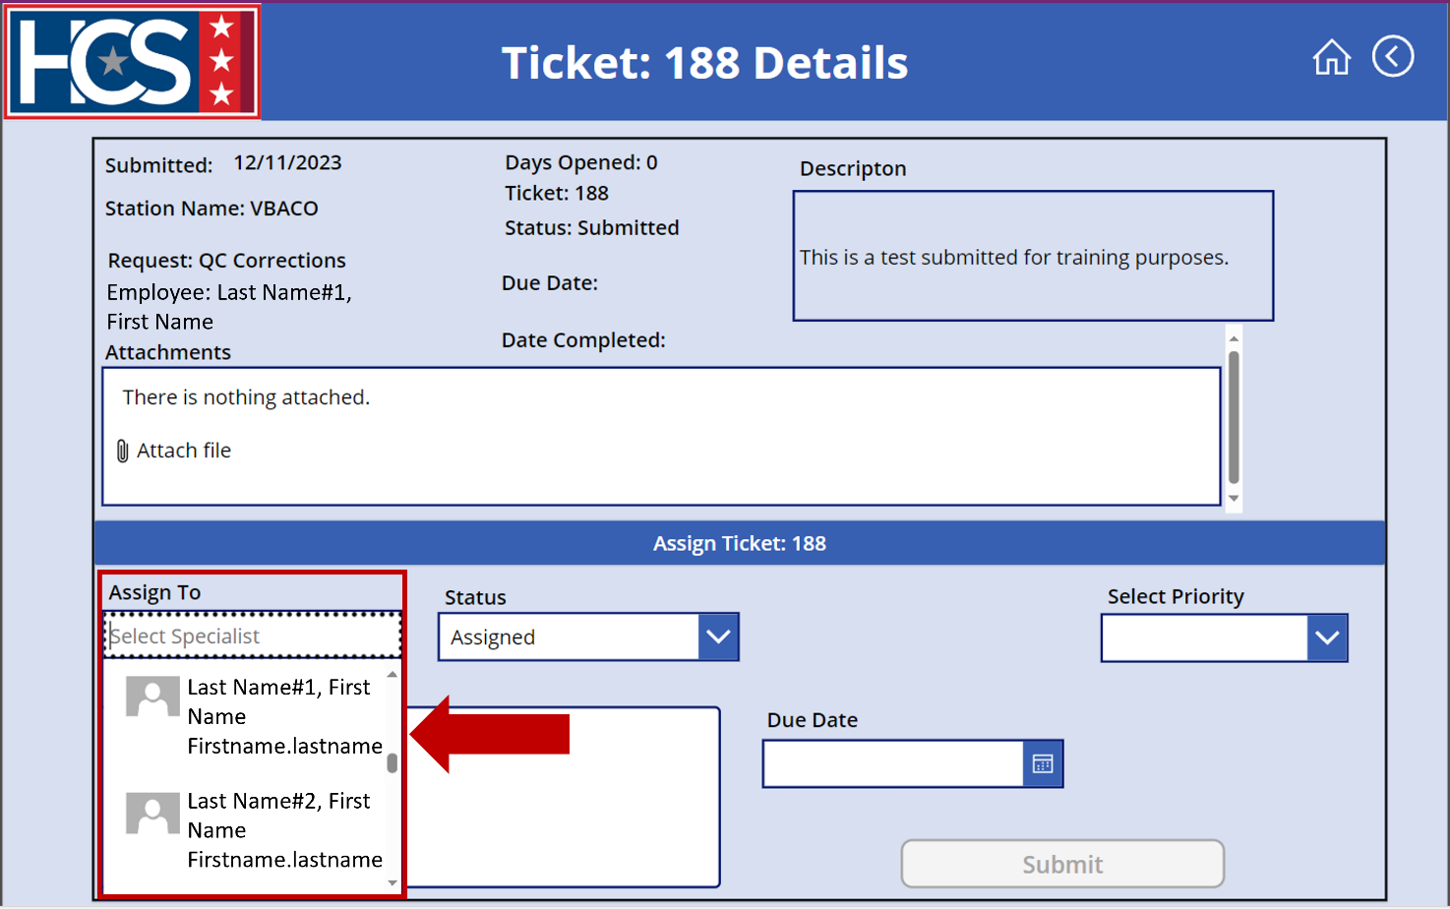
- Select Assigned from the Status dropdown menu.
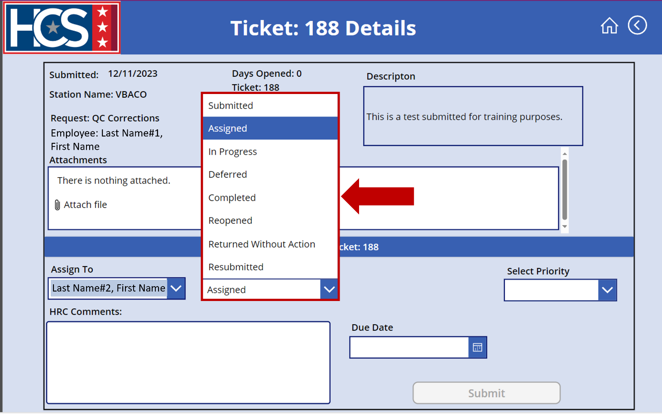
- Select appropriate priority from the Select Priority dropdown menu.
NOTE: Priority must be selected in order to enable the Submit option.
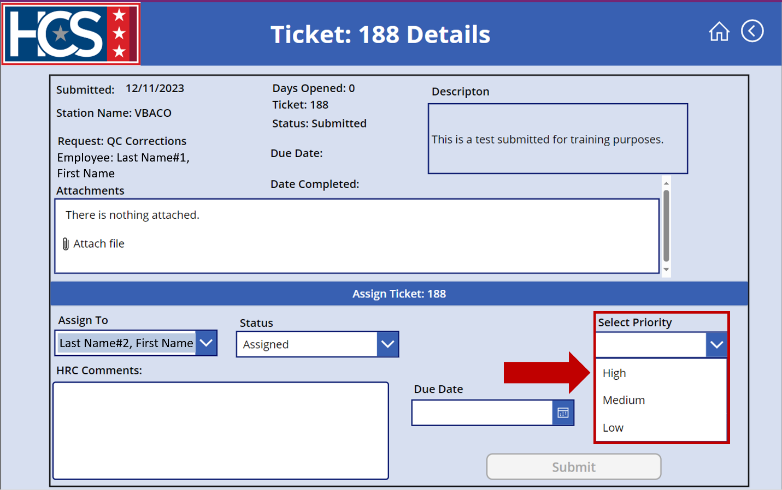
- Type a description in the HRC Comments text field.
NOTE: Descriptions should include as much detail as possible to ensure efficient ticket processing.
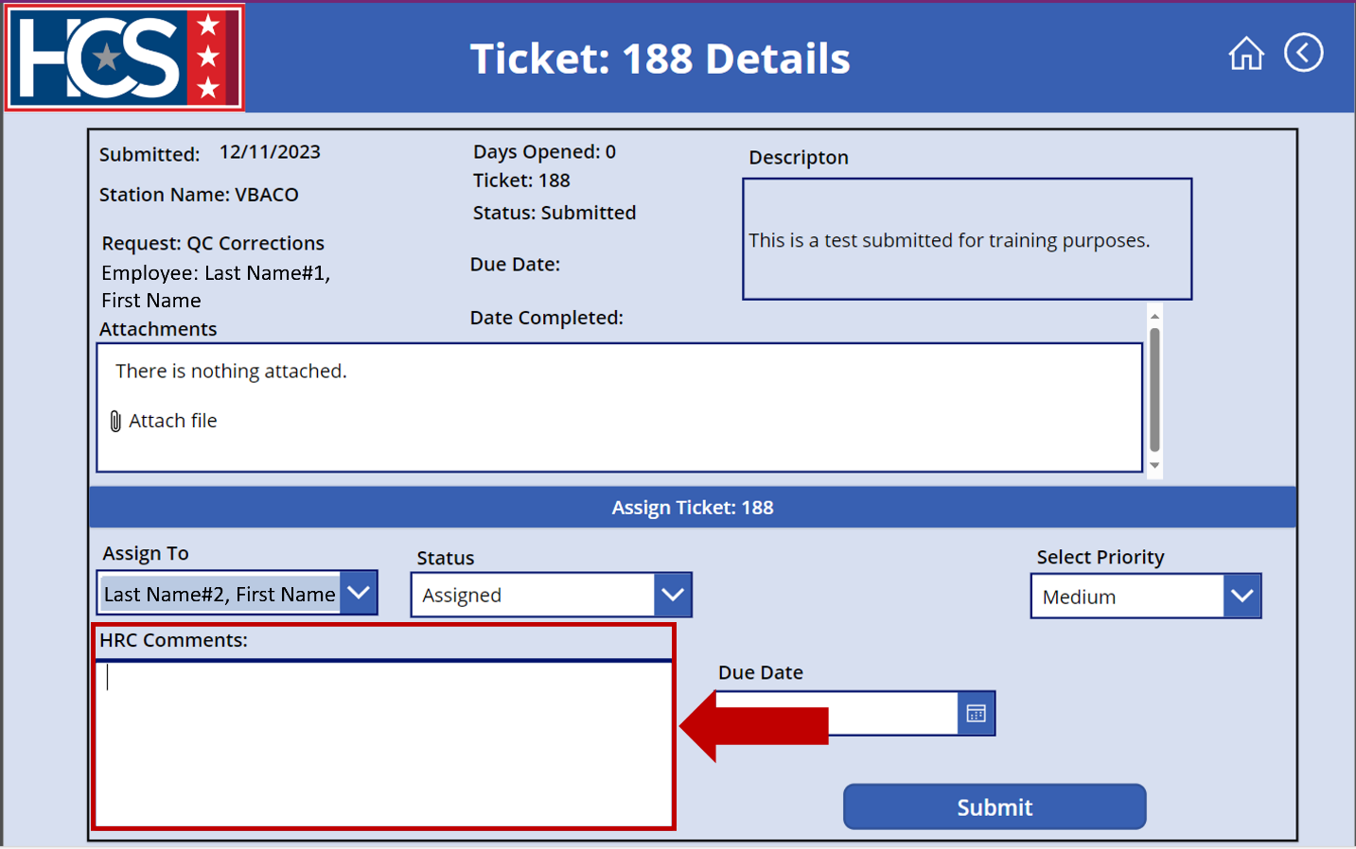
- Select the calendar icon to enter a Due Date.
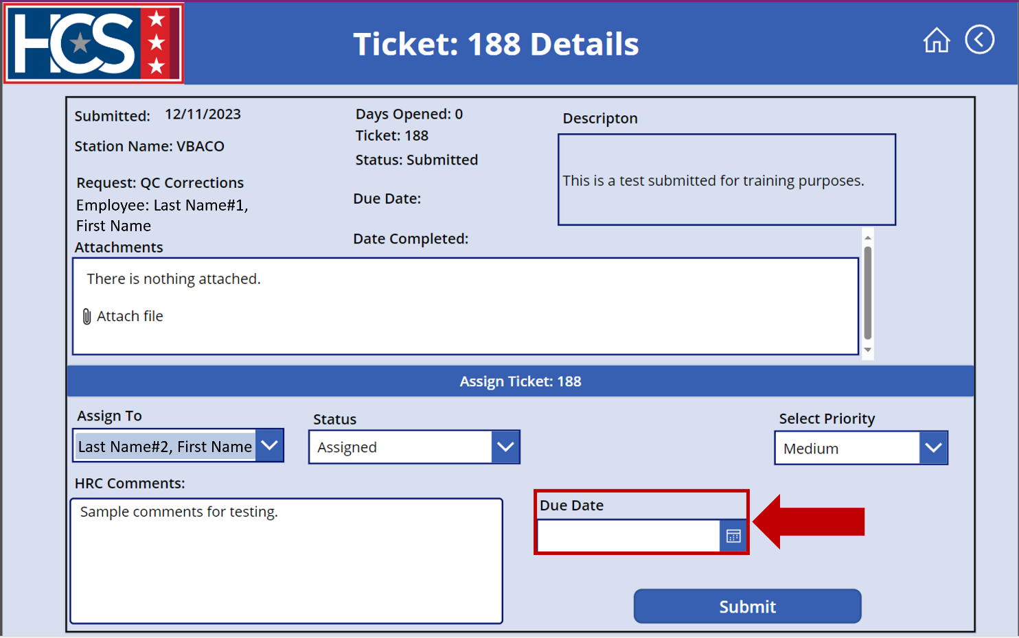
- Select the due date for the ticket from the calendar that displays.
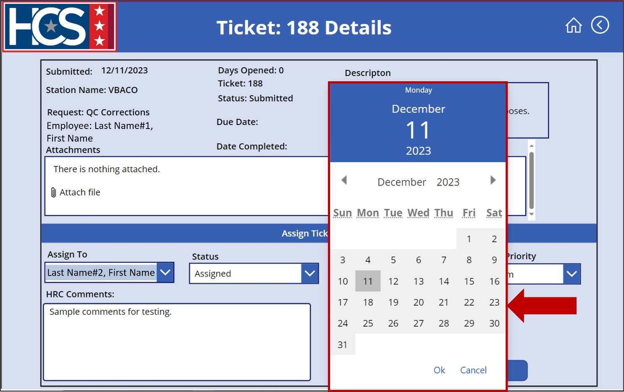
- Select Ok to add the date.
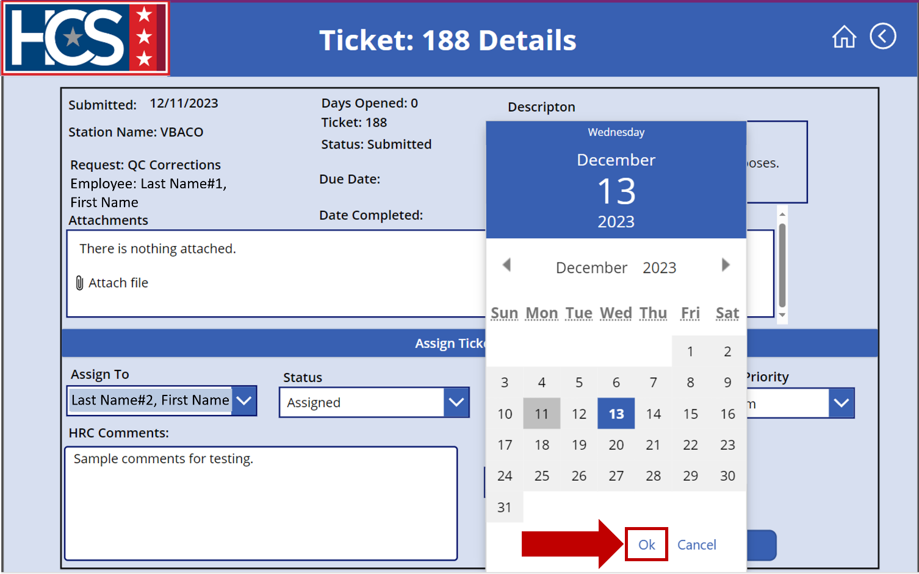
- Select Submit.
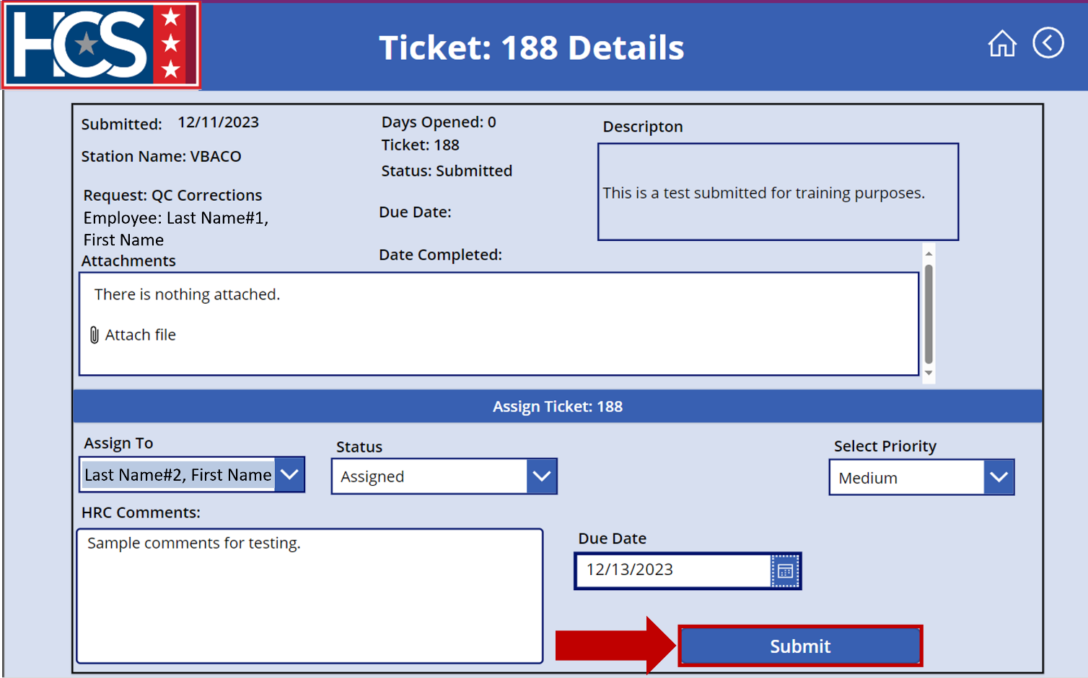
- Observe ticket no longer displays under Submitted on the VBACO/HRC Baltimore Tickets screen.
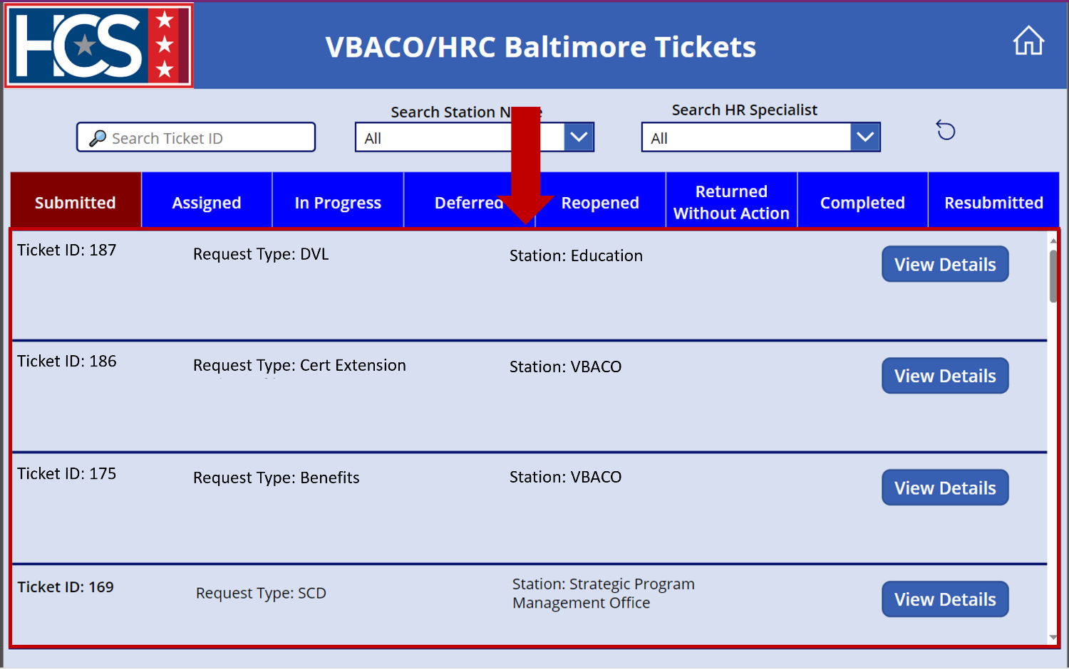
- Select Assigned on the VBACO/HRC Baltimore Tickets screen to display tickets with a status of Assigned.
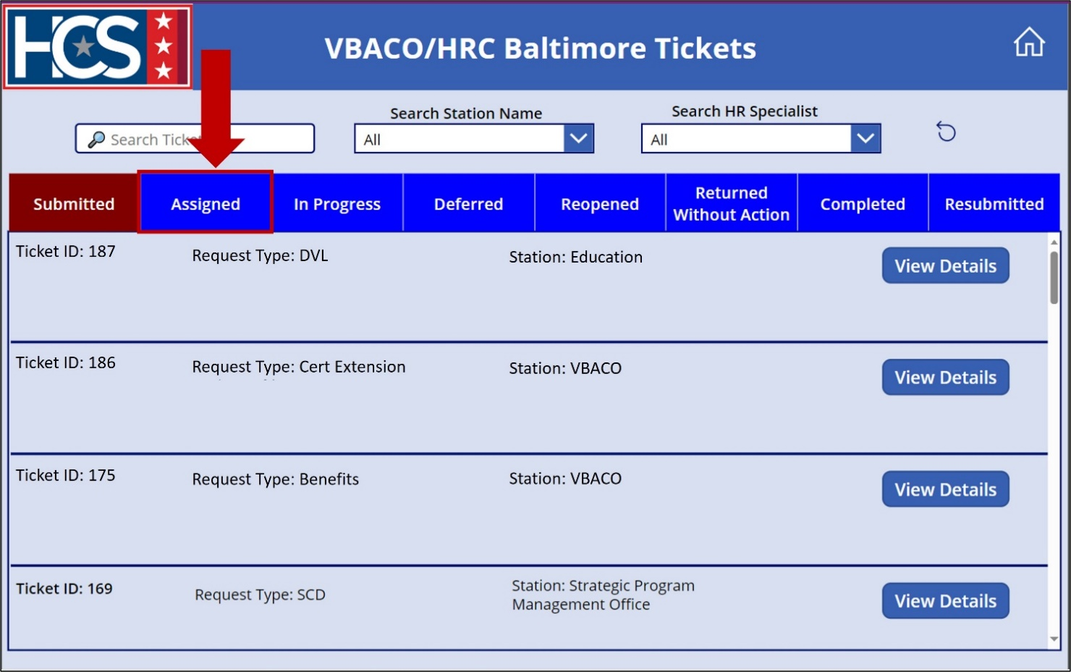
- Verify the ticket now displays under the Assigned ticket status on the VBACO/HRC Baltimore Tickets screen.
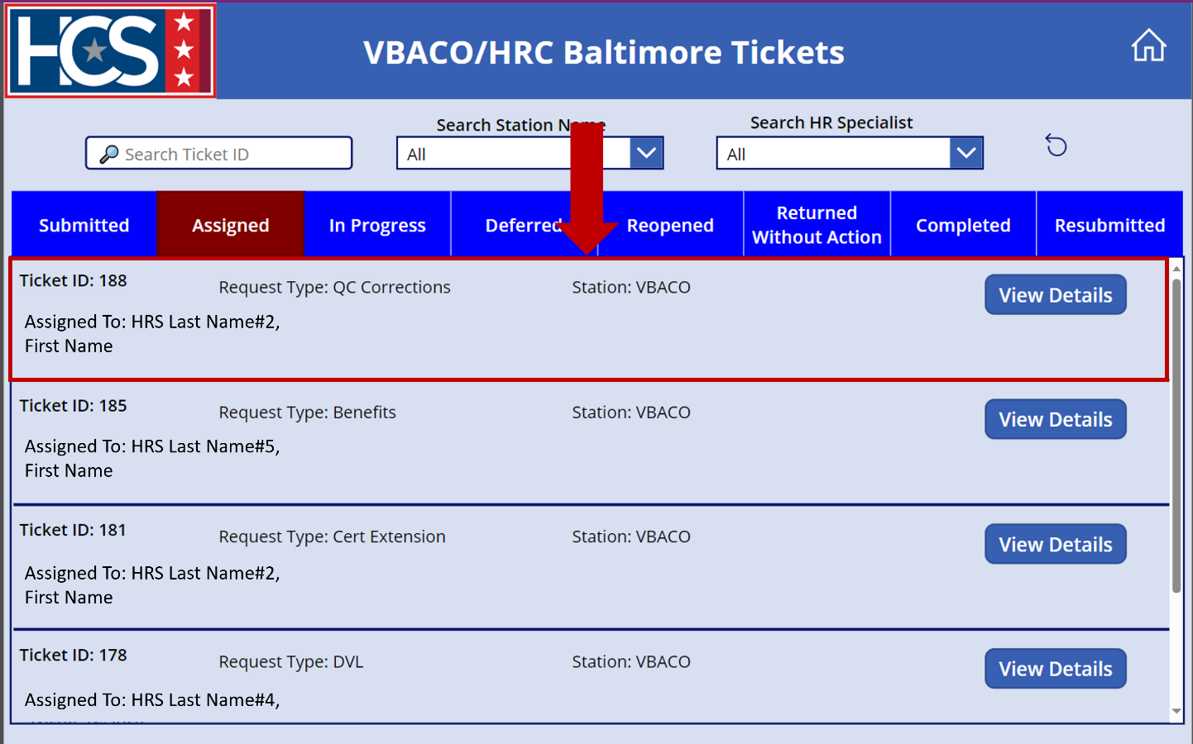

Assign Returned Without Action Status to Ticket
If the HRC Supervisor determines that a ticket is a duplicate submission or should be submitted through MSS, the HRC Supervisor should select the Returned Without Action status. An HRC Supervisor can also use the Returned Without Action status if the submitted ticket is missing required documentation or critical information.
When selecting Returned Without Action, the HRC Supervisor must provide a reason for returning the ticket without action using the Reason dropdown menu. If the reason is either Missing Documents or Additional Information Needed, the HRL/HRD Specialist can update the ticket with the appropriate documentation/ information and resubmit the ticket for processing.
- Use search filters to filter tickets on the VBACO/HRC Baltimore Tickets screen, if needed.
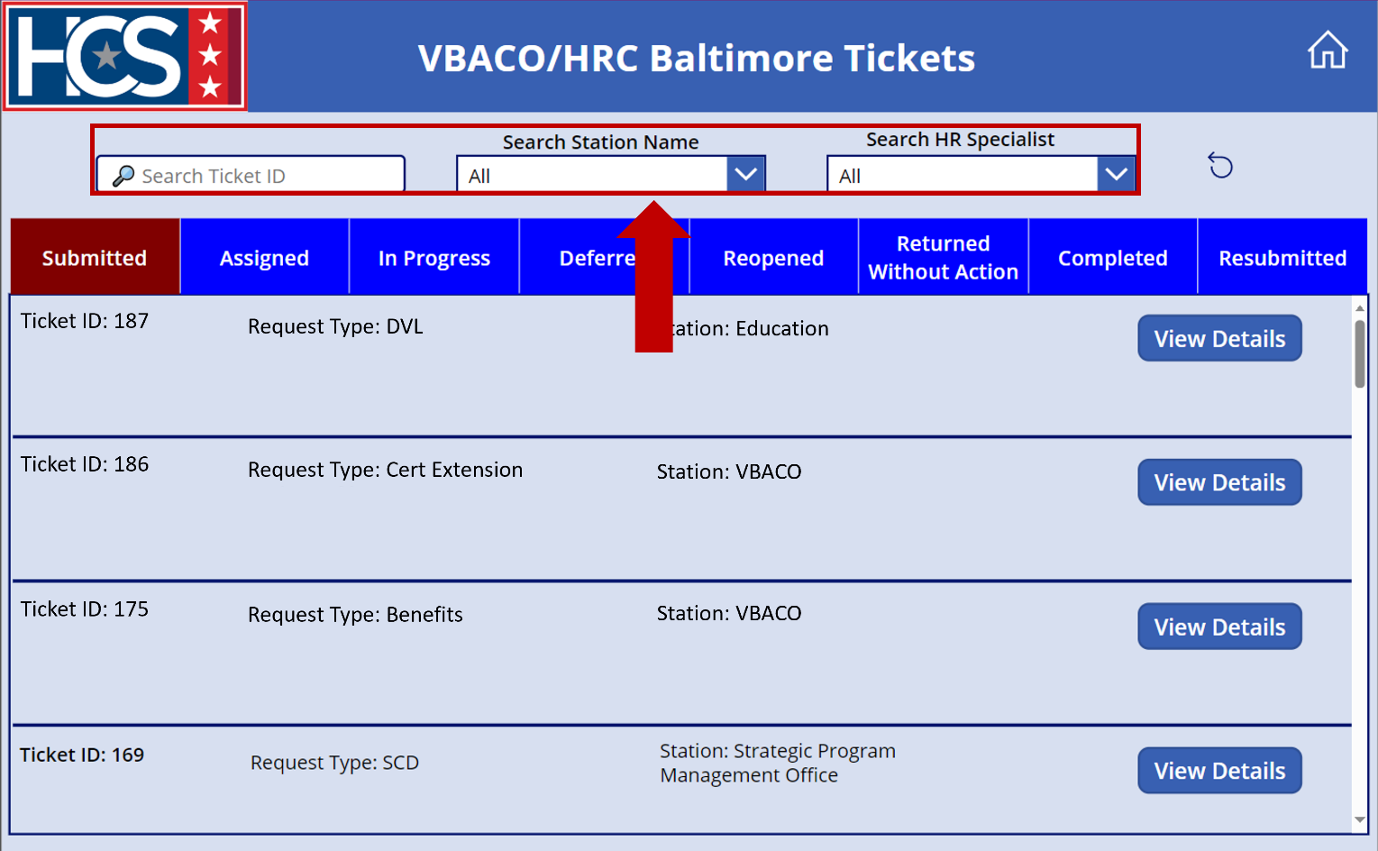

- Select View Details on the ticket to be updated.
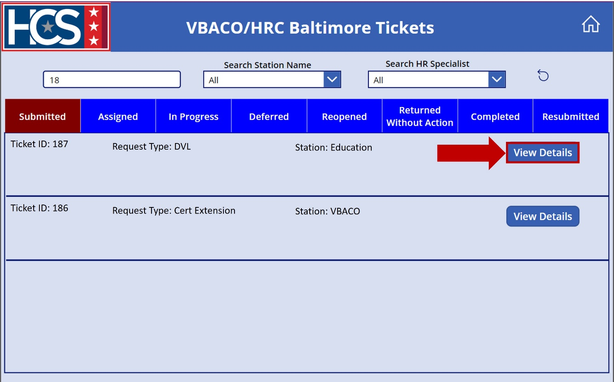
- Select name from the Assign To dropdown menu.
NOTE: When assigning a status of Returned Without Action, the HRC Supervisor must select their own name on the Assigned To dropdown menu.
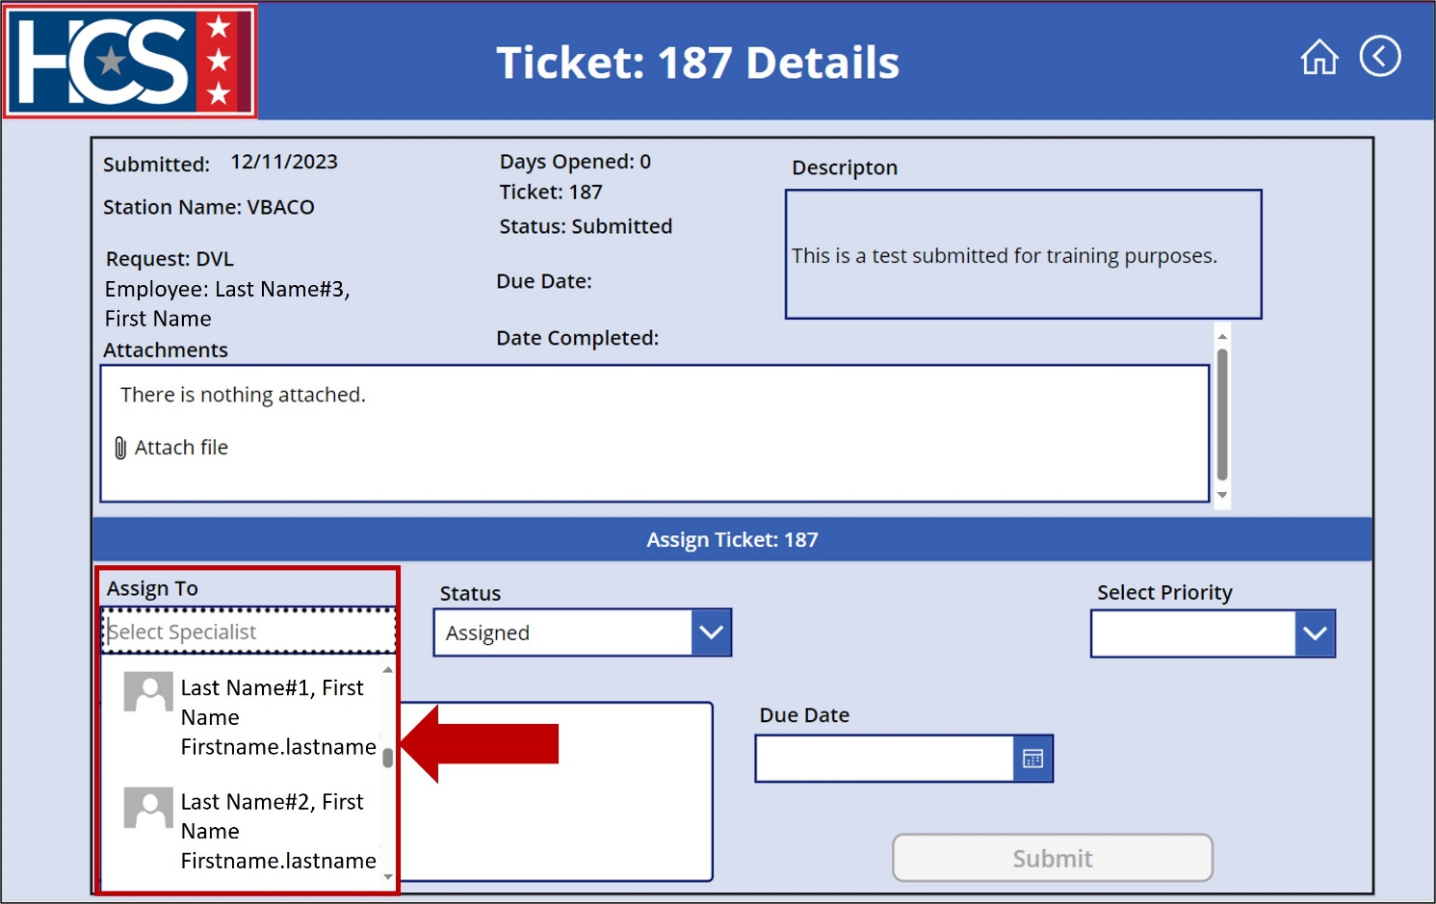
- Select Returned Without Action from the Status dropdown menu.
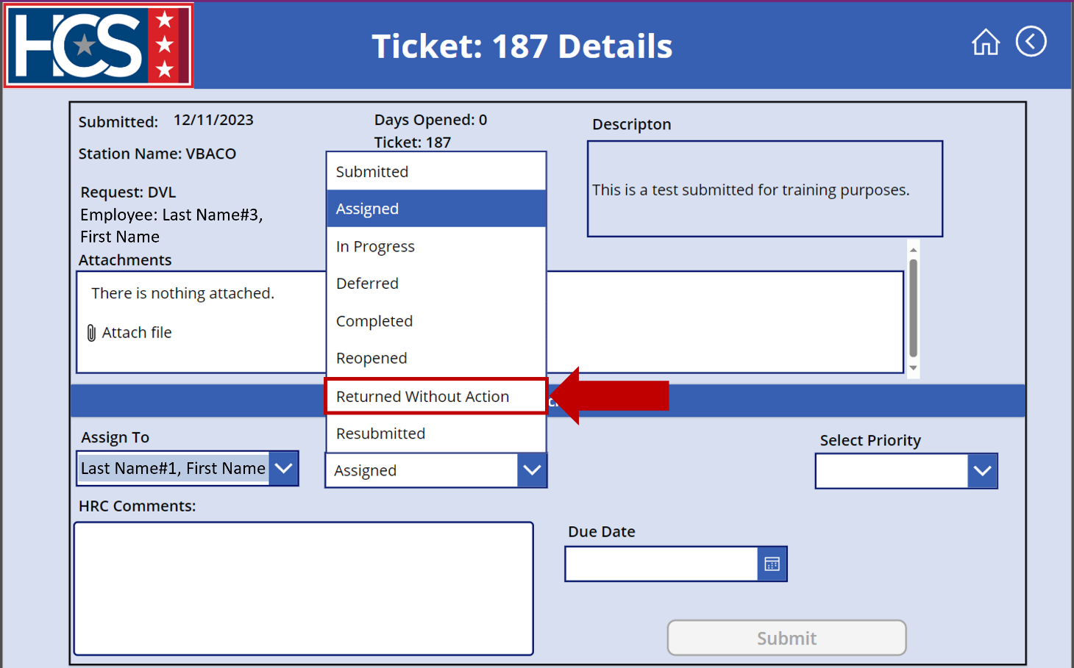
- Observe that the Reason field displays.
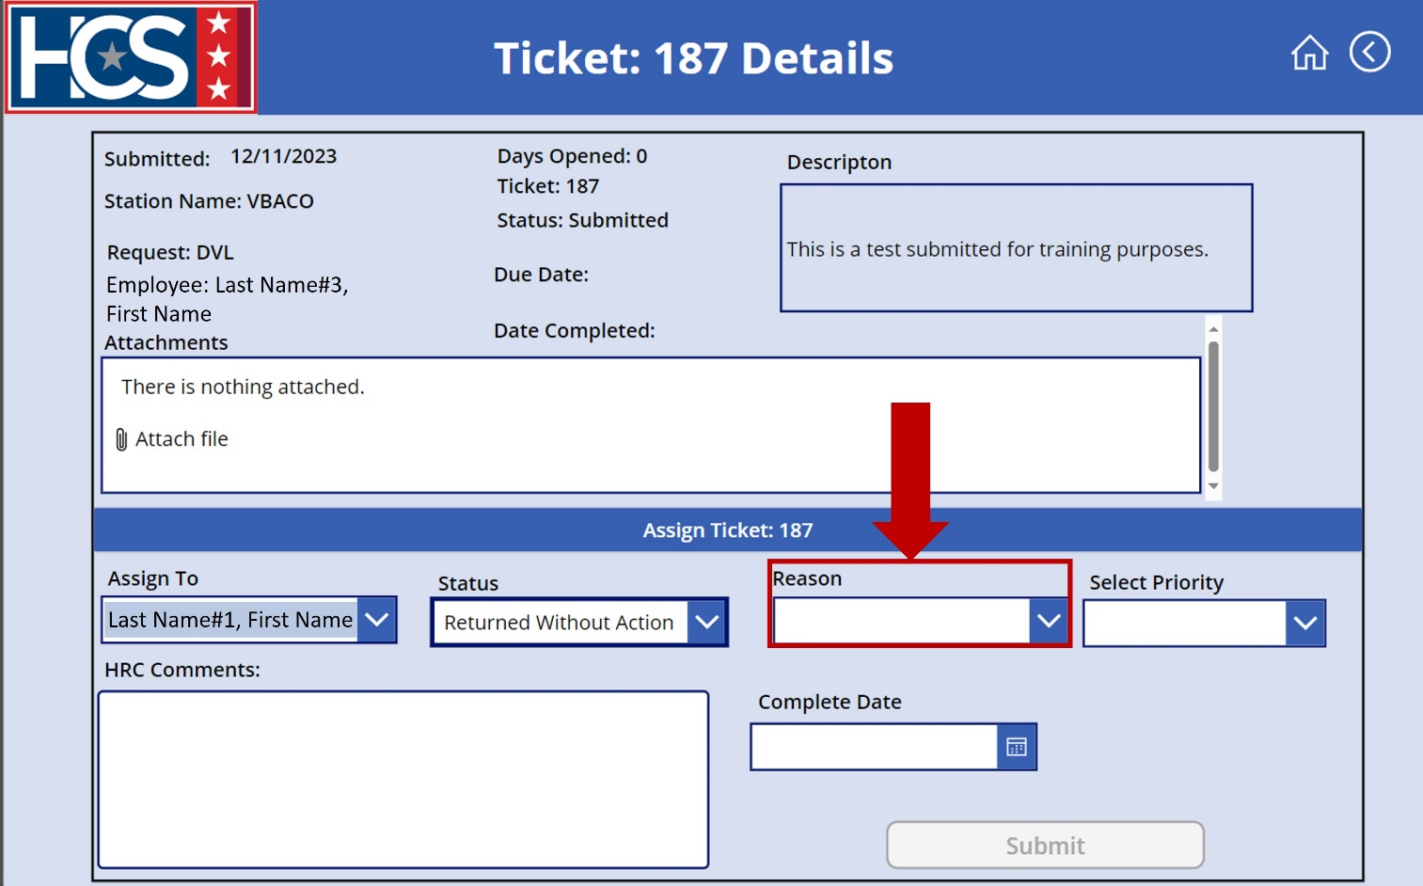
- Select the reason for the Returned Without Action status using the Reason dropdown menu.
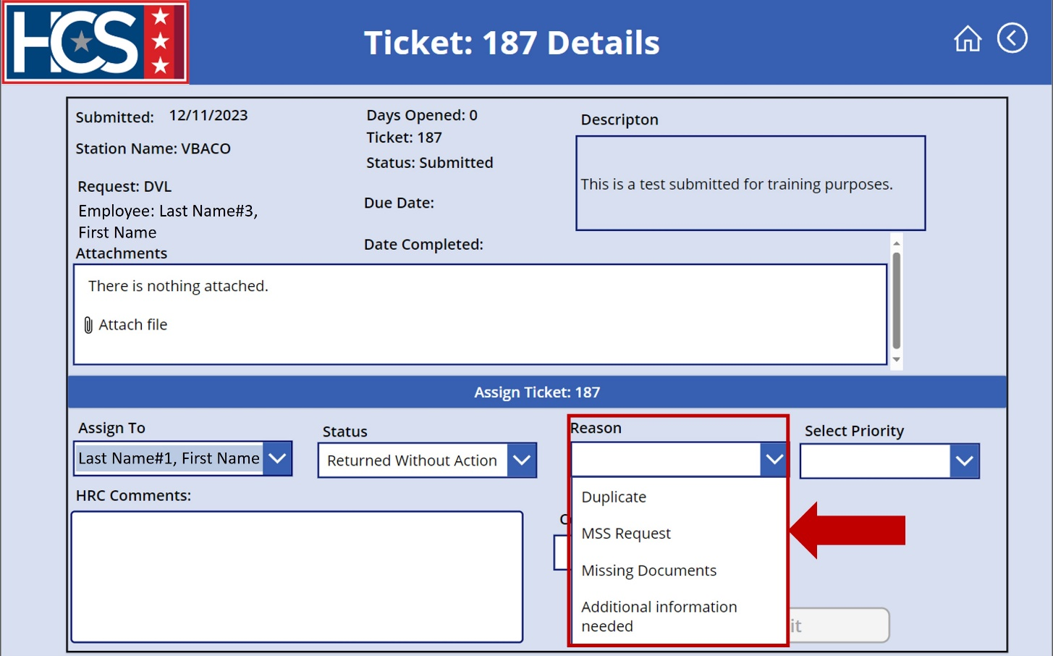
- Select Low from the Select Priority dropdown menu.
NOTE: Priority must be selected in order to enable the Submit option.
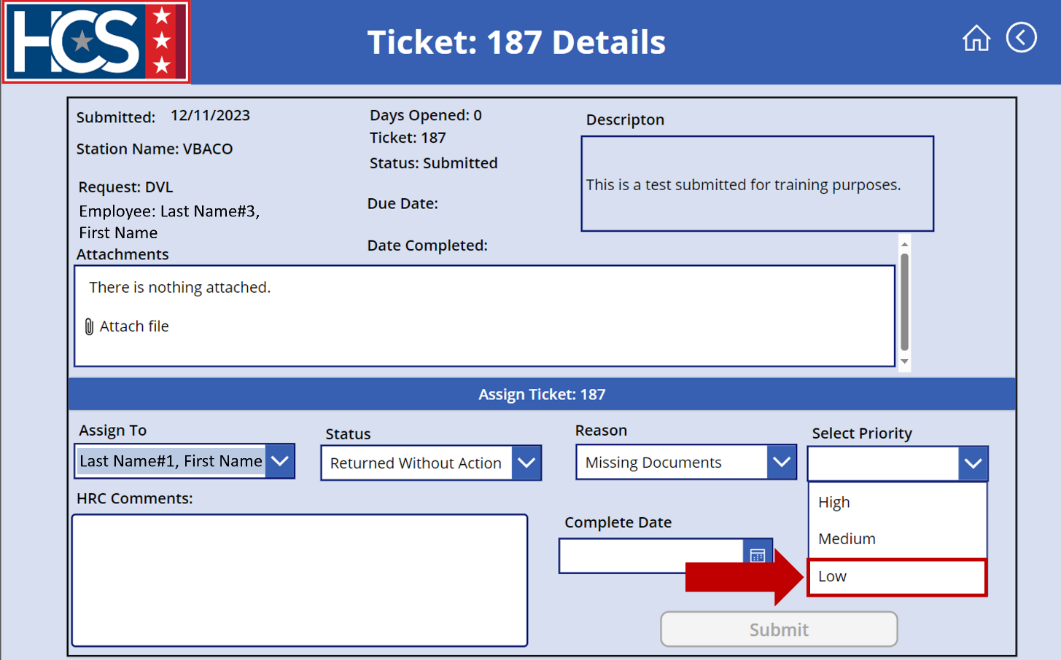
- Type a description in the HRC Comments text field.
NOTE: Descriptions should include as much detail as possible to ensure efficient ticket processing.
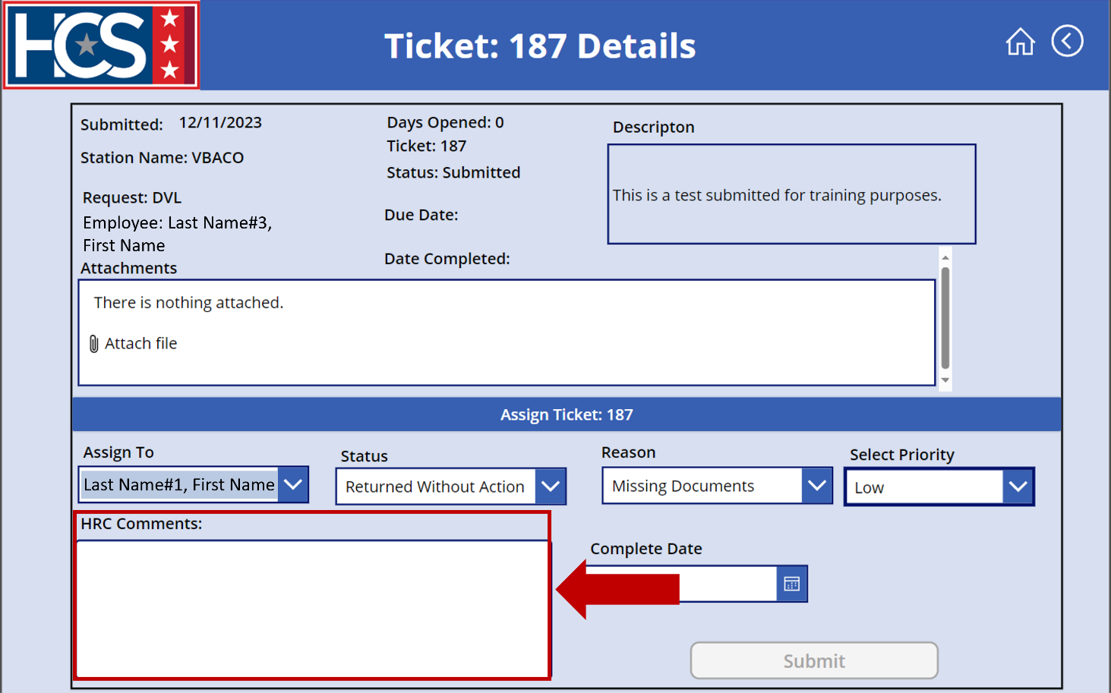
- Select Submit.
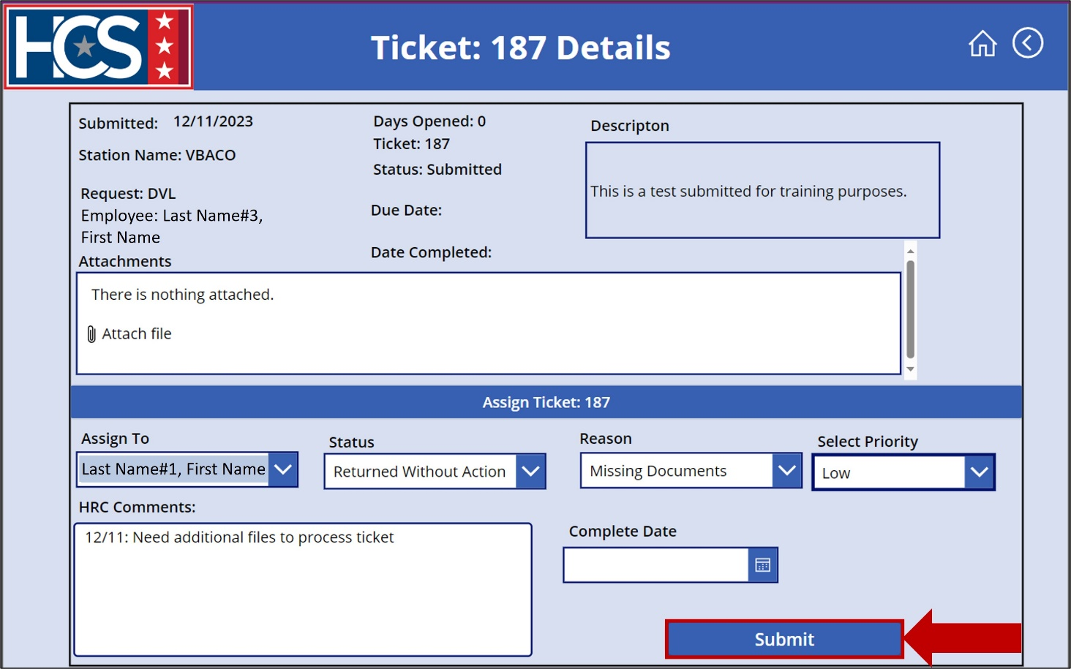
- Observe ticket no longer displays under Submitted on the VBACO/HRC Baltimore Tickets screen.
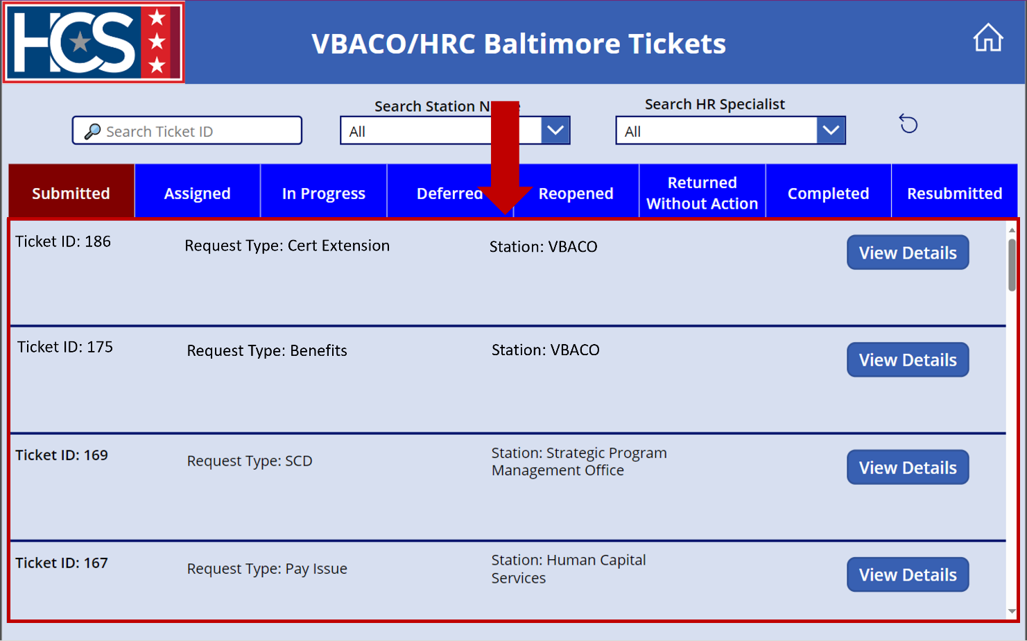
- Select Returned Without Action on the VBACO/HRC Baltimore Tickets screen to display tickets with a status of Returned Without Action.
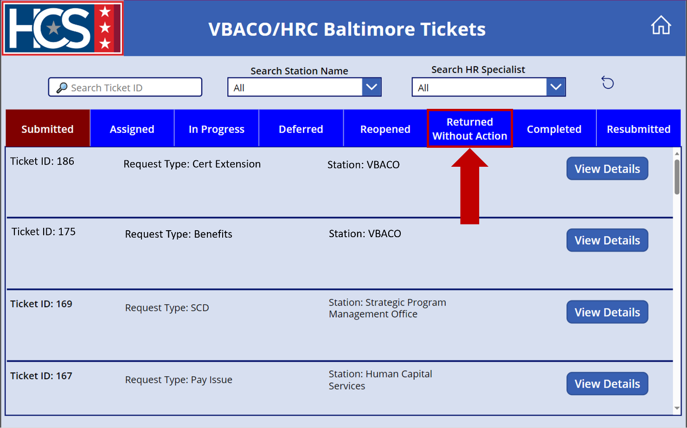
- Verify the ticket now displays under the Returned Without Action ticket status on the VBACO/HRC Baltimore Tickets screen.
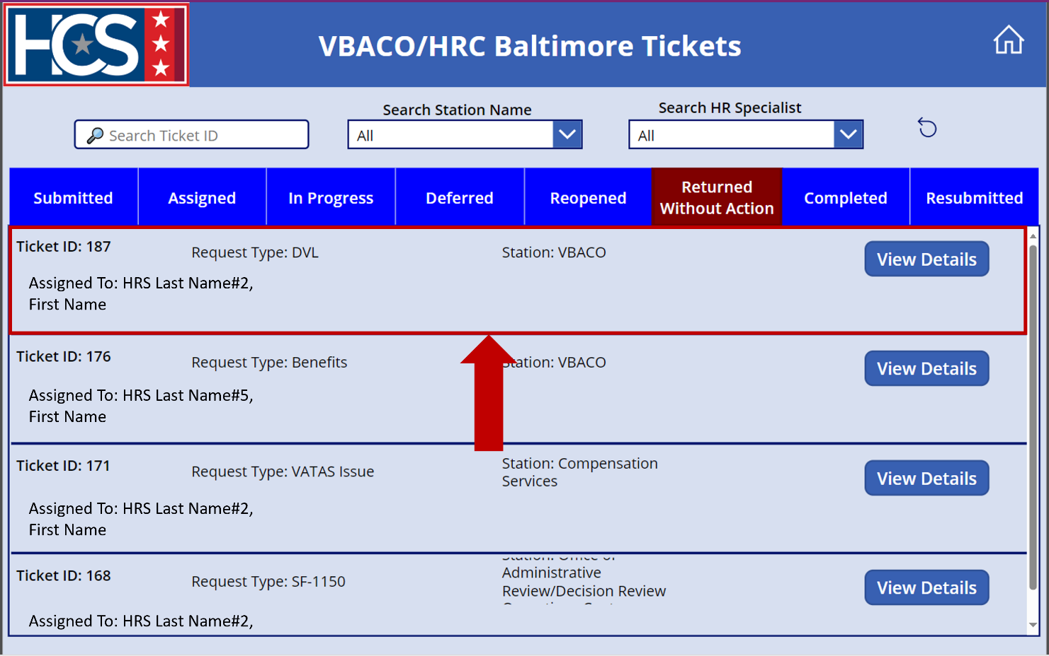

Submit HR Connect Feedback
- Select Feedback on the HR Connect home screen to submit any HR Connect-related feedback, if needed.
NOTE: The Feedback option on this screen allows for the submission of recommendations for system enhancements, issues with the system, access requests, etc.
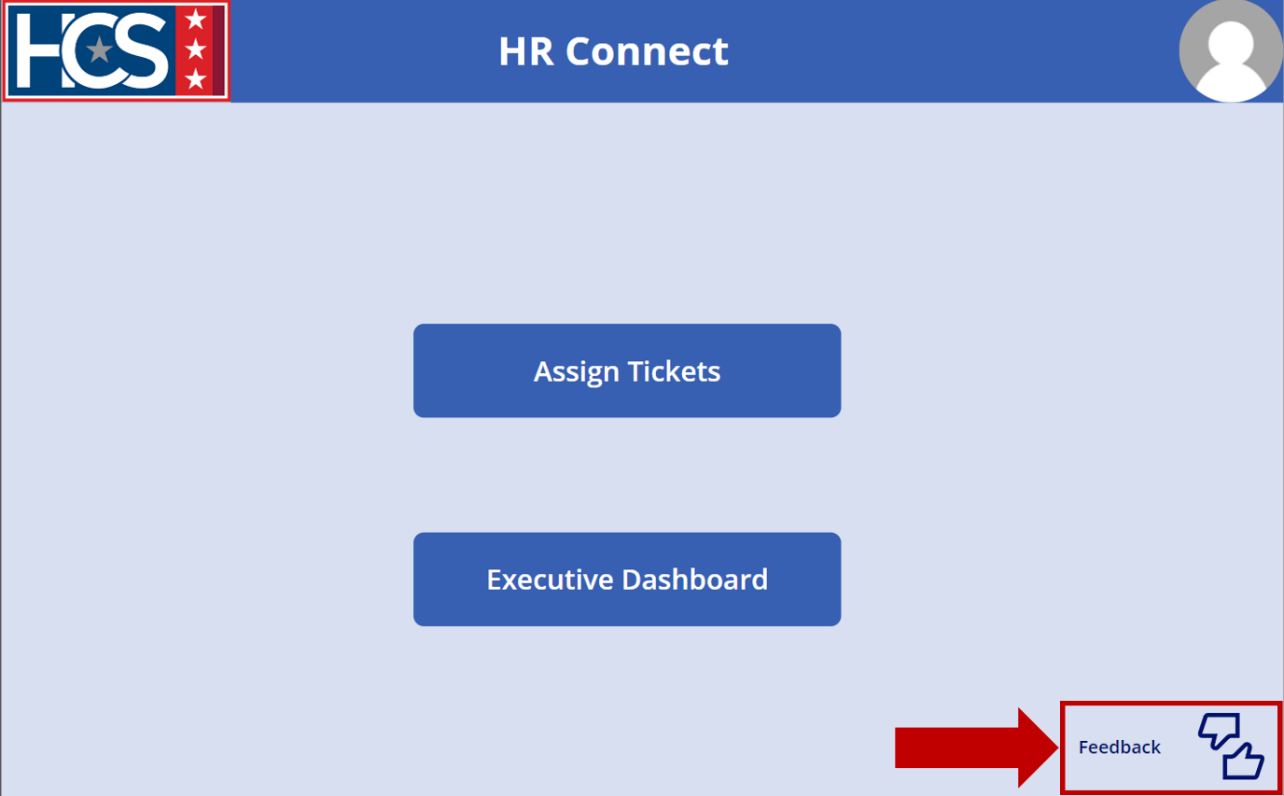
- Observe the Feedback screen.
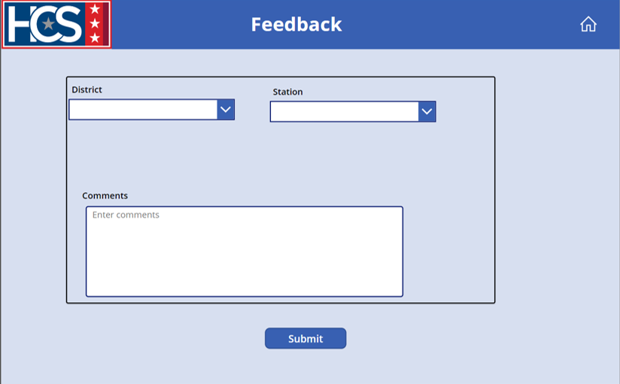
- Select the appropriate district from the District dropdown menu.
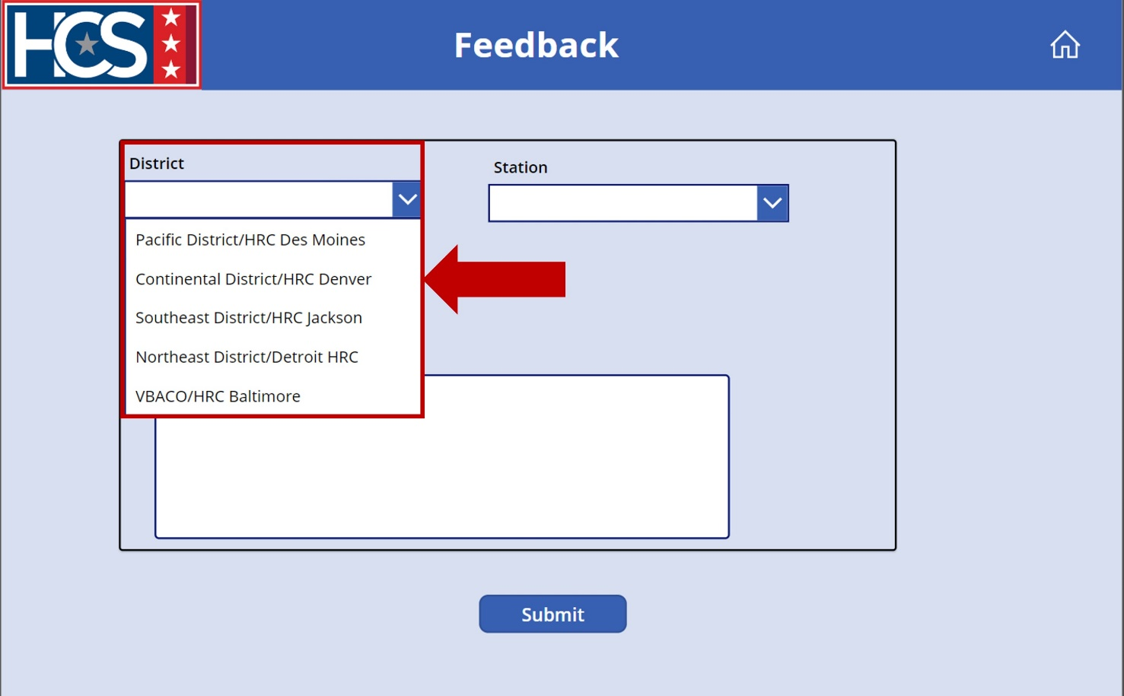
- Select the appropriate station from the Station dropdown menu.
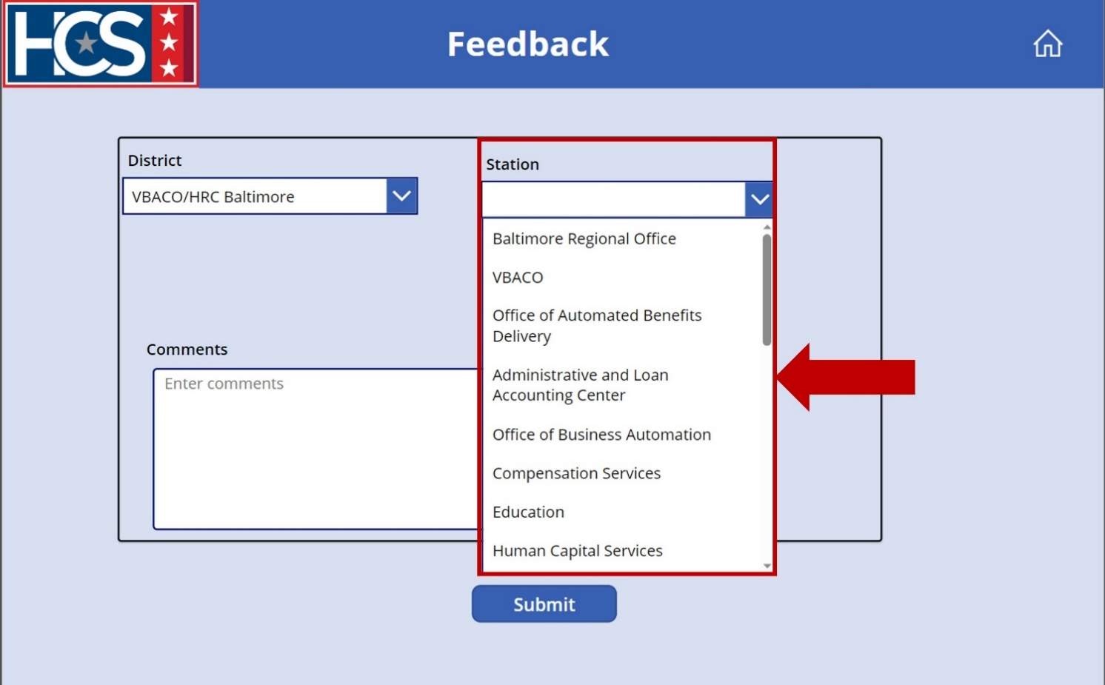
- Type feedback in the Comments field.
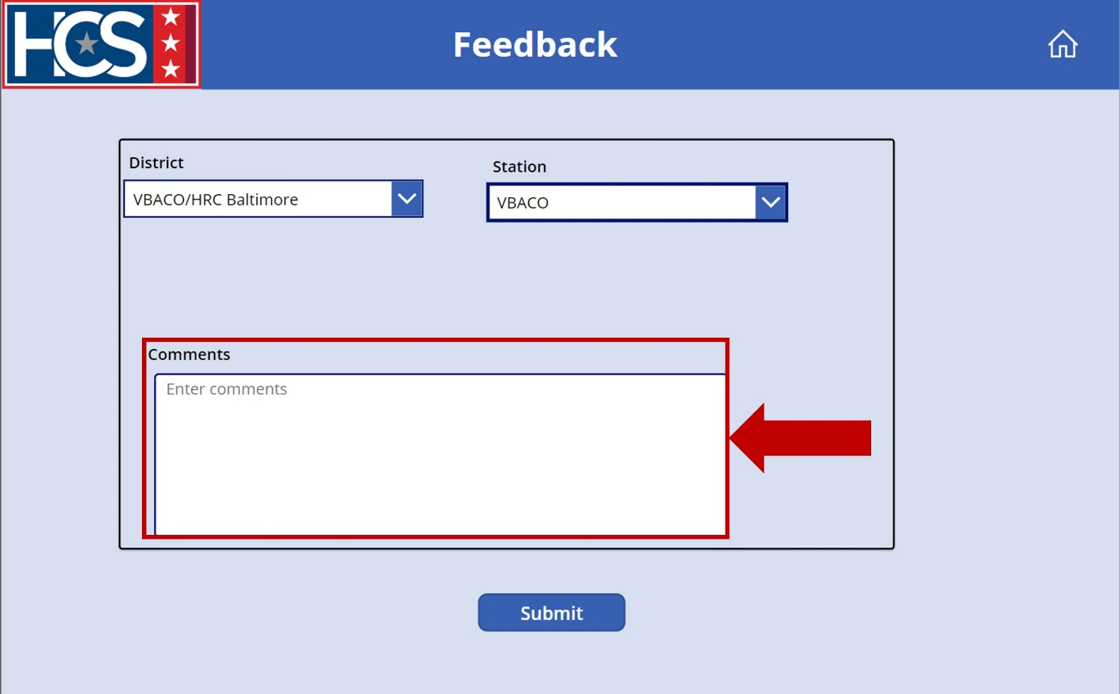
- Select Submit.
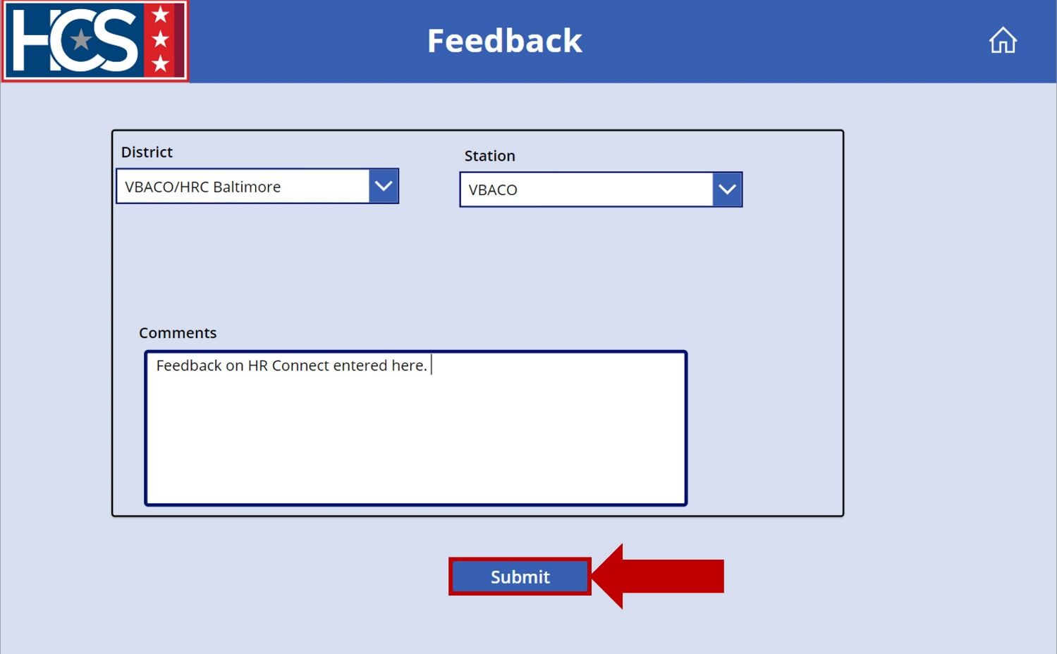
- Select the Home icon to return to the home screen.
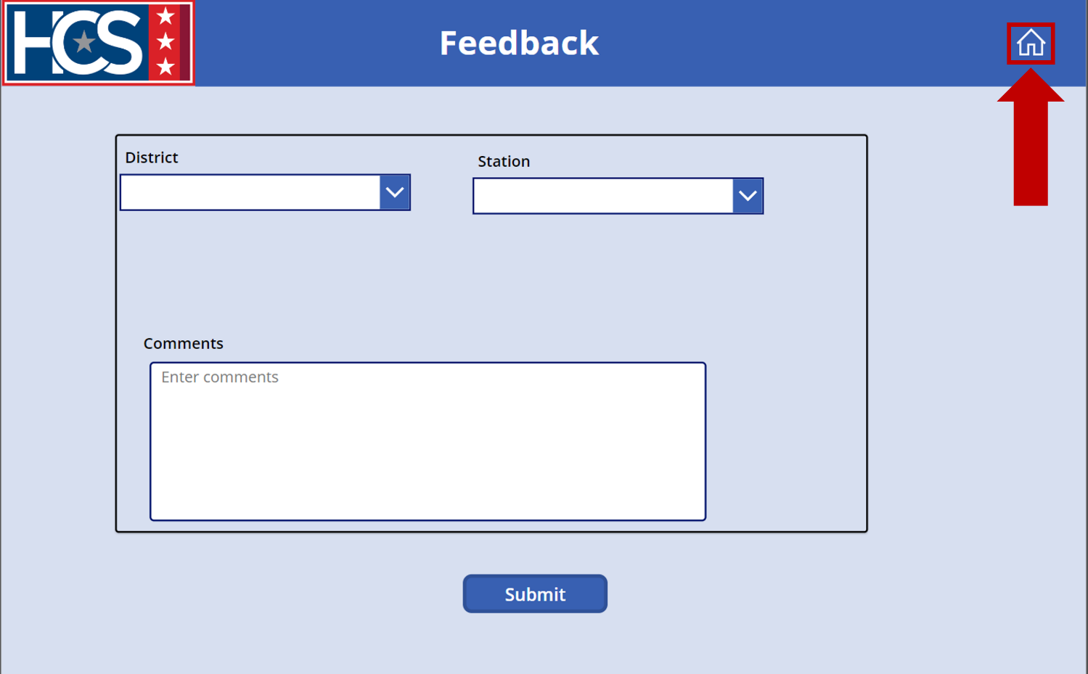

Executive Dashboard

Overview
The Executive Dashboard provides executive leadership with a comprehensive snapshot of ticket requests for all districts, by a specific district, and/or by specific station. The data within the dashboard allows an HRC Supervisor to view trends in request categories, identify areas in need of training, review processing timelines for requests by category, and search for tickets. HRC Supervisors also have the option to export tables into MS Excel for additional review outside of the dashboard.
The data displayed on the dashboard can be refined using the provided filters:
- District
- Station Name
- Category
- Task Status
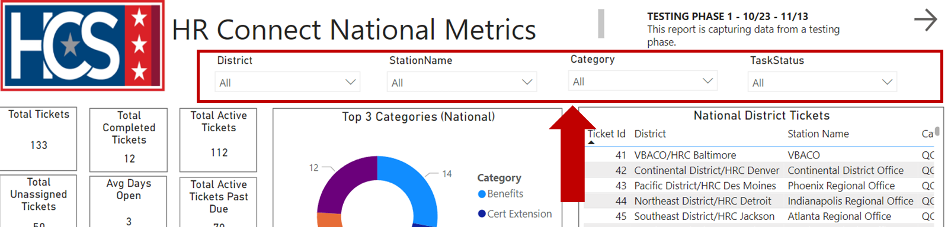

Each filter includes a dropdown menu that allows for filtering of information:
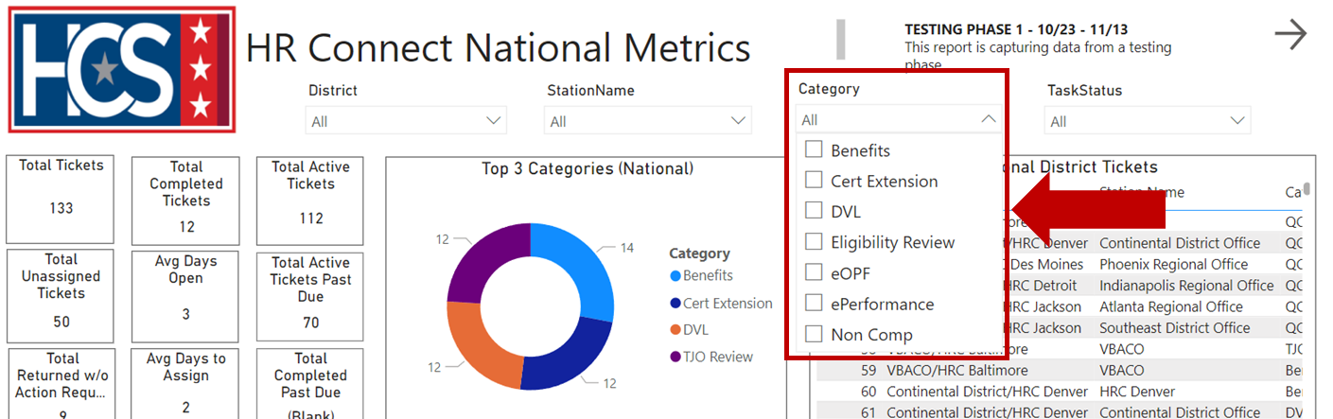

HR Connect National Metrics Dashboard Data
Information on the HR Connect National Metrics dashboard includes several data categories.
- Snapshot of national ticket requests, providing data that includes:
  - Total Tickets.
  - Total Completed Tickets.
  - Total Active Tickets.
  - Total Unassigned Tickets.
  - Average Days Open.
  - Total Active Tickets Past Due.
  - Total Returned Without Action Requests.
  - Average Days to Assign.
  - Total Completed Past Due.
- National top 3 categories of request types displayed as a pie chart.
- Complete list of national district tickets.
- Top 3 categories of request types for each District displayed with a pie chart.
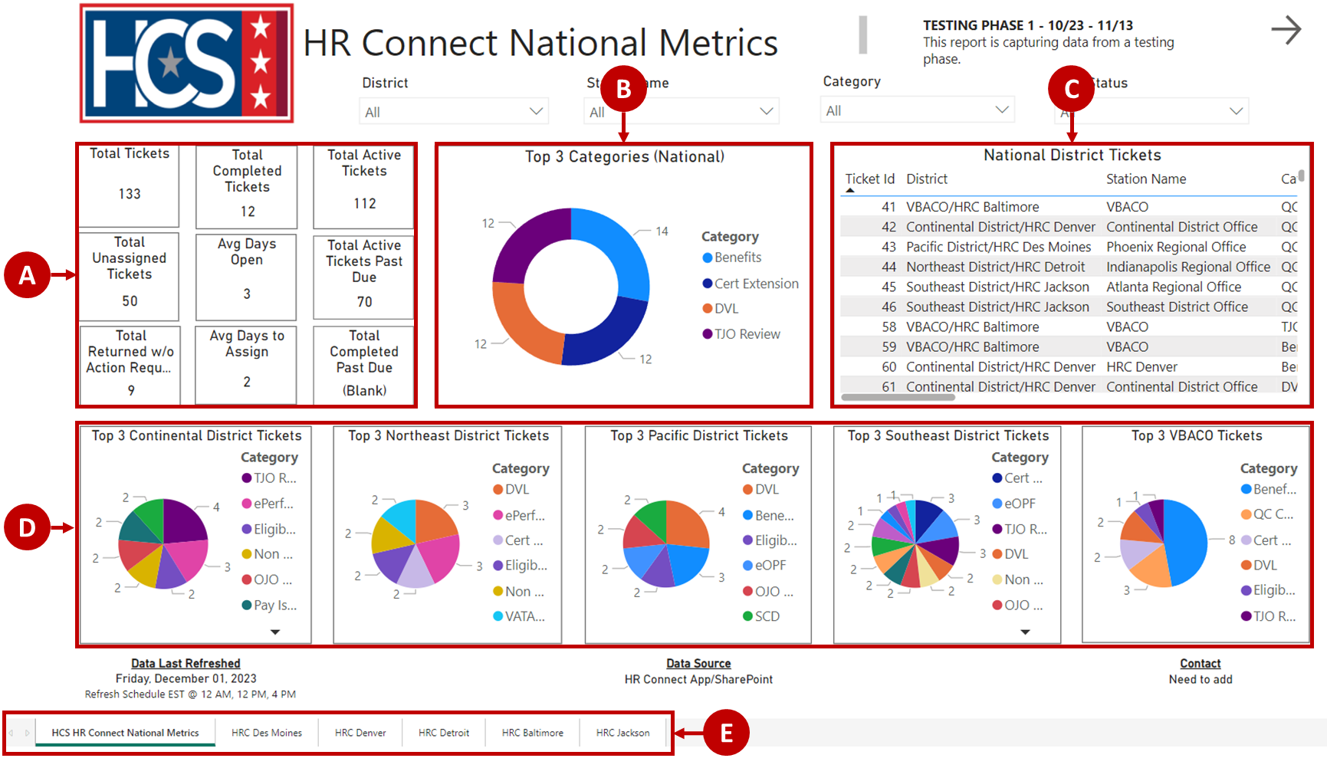

HR Connect District Metrics Dashboard Data
Information on the HR Connect District Metrics dashboard includes several data categories.
- Snapshot of district ticket requests, providing data that includes:
  - Total Tickets.
  - Completed Tickets.
  - Unassigned Tickets.
  - Active Tickets.
  - Average Days to Assign.
  - Average Days Open.
- Lists that display ticket information for all Active Tickets Past Due and Tickets Returned Without Action.
- Complete list of District tickets.
- Bar chart for each station displaying ticket request types.
- Back and Next arrows that return to the previous tab or advance to the next tab.
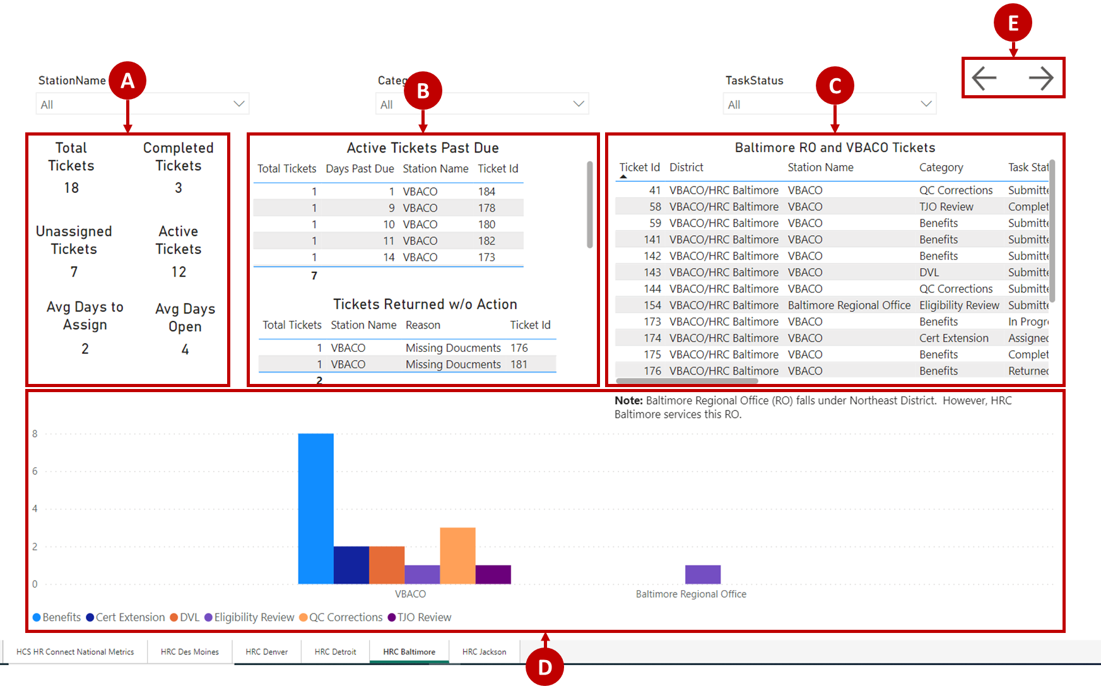

Access Executive Dashboard
- Select Executive Dashboard on the HR Connect home screen.
NOTE: The Executive Dashboard launches in a new Microsoft Edge browser tab.
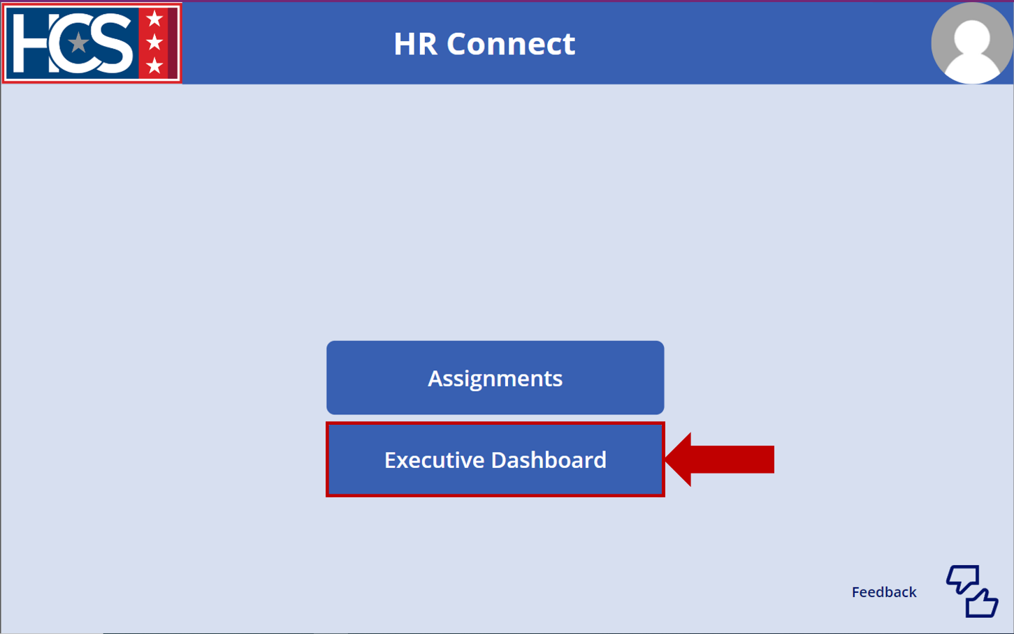
- Observe the metrics displayed on the HR Connect National Metrics screen.
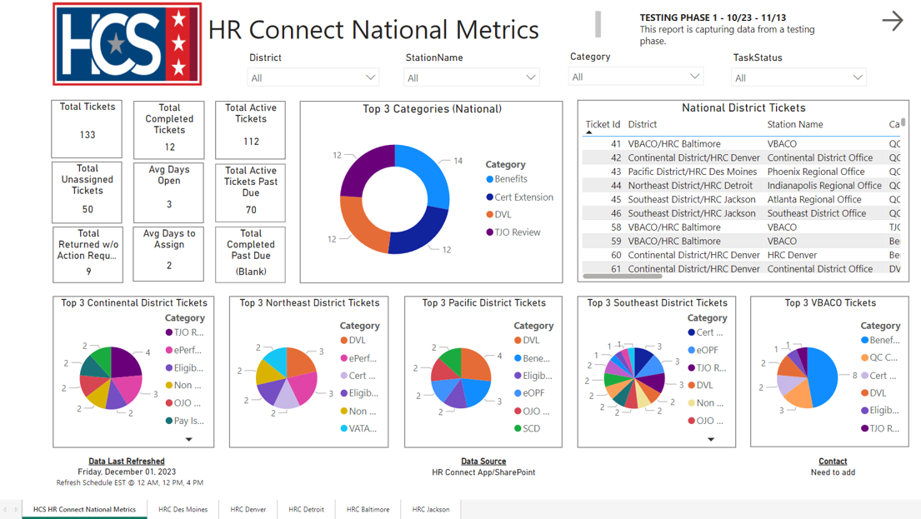
- Use the filters to refine data, as needed.
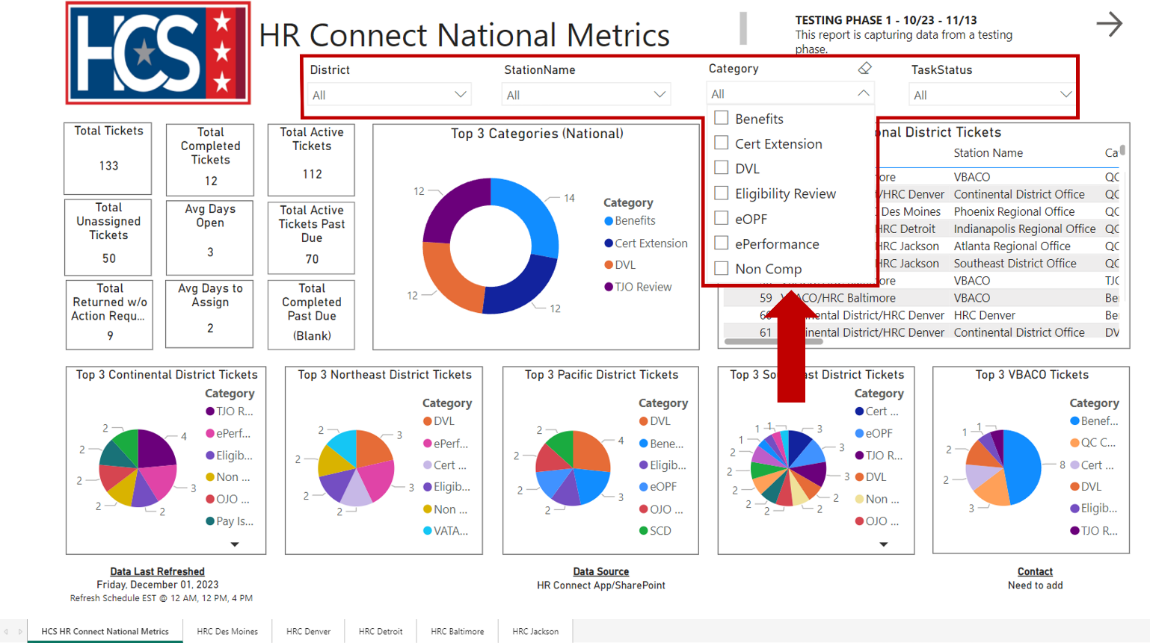
- Observe the metrics displayed as a result of applying the Category filter.
NOTE: To clear an applied filter, select the filter checkbox again.
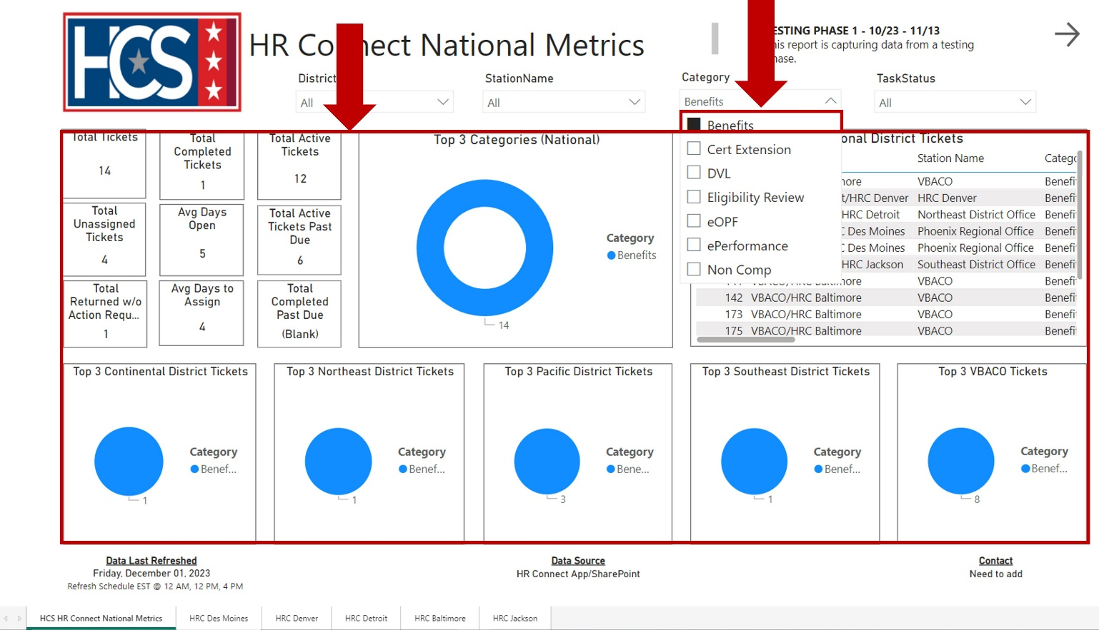

- Select a District tab to view the metrics for a specific district.
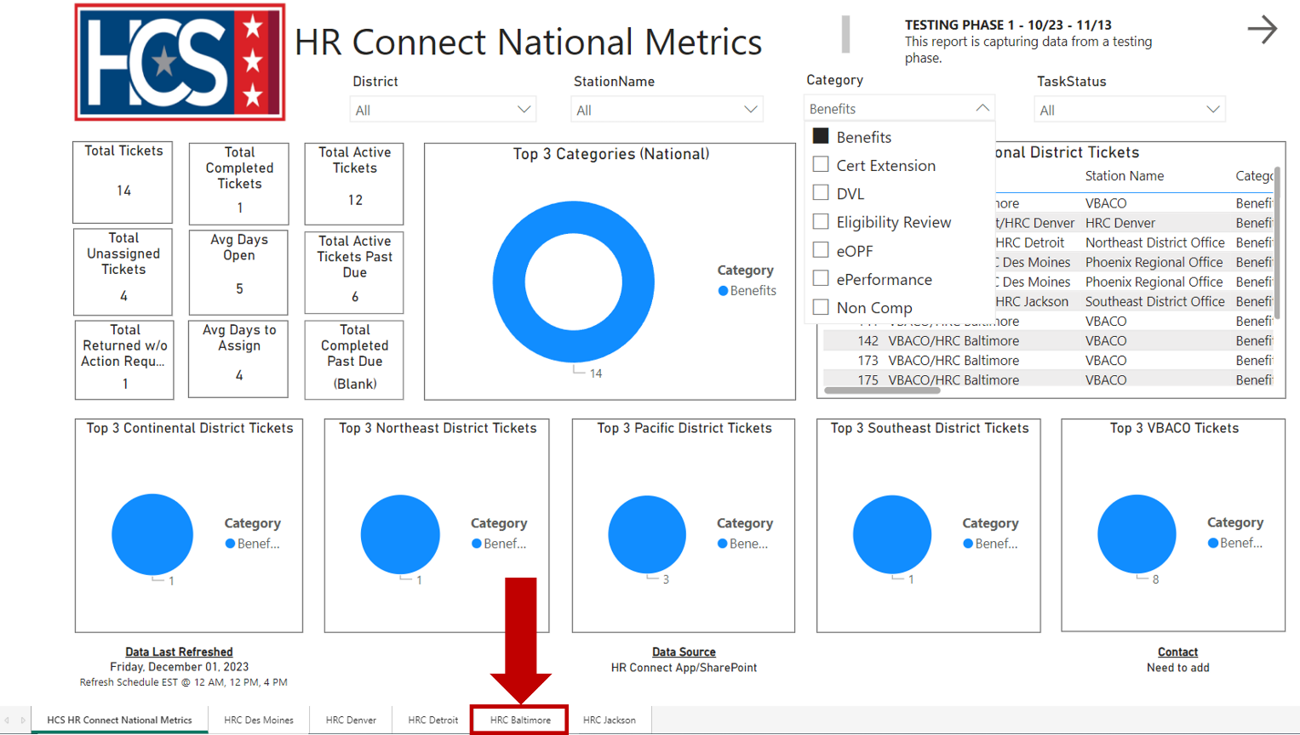
- Observe the metrics displayed on the District View screen.
NOTE: Ticket Request Type statistics are reflected in a bar chart by Station.
NOTE: Additional filters may be applied to the District to further refine the data.
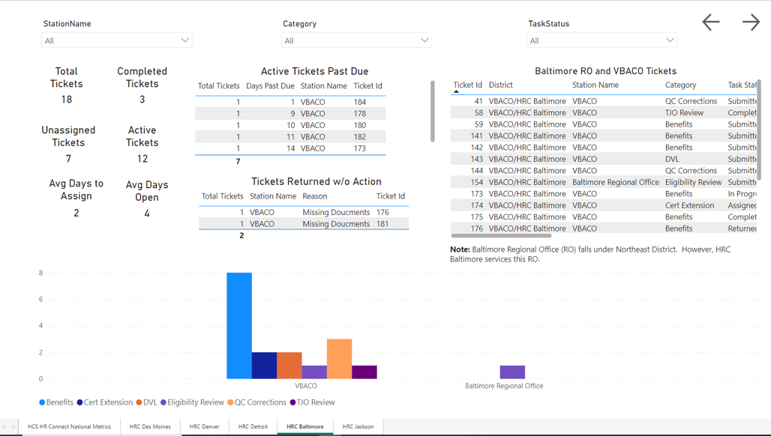
- Select Focus mode from the pop-up menu that displays when mousing over the top-right section of the selected data pod.
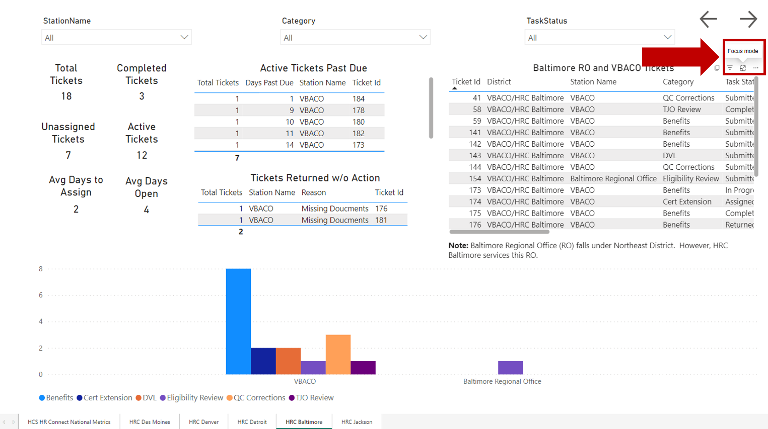
- Observe the information in the expanded data pod.
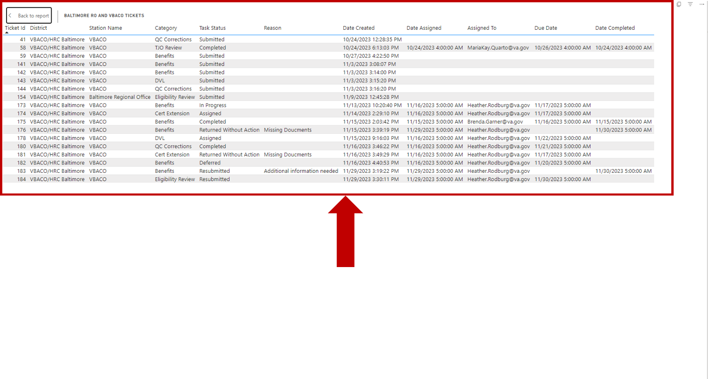

- Select Back to report to return to the District View screen.
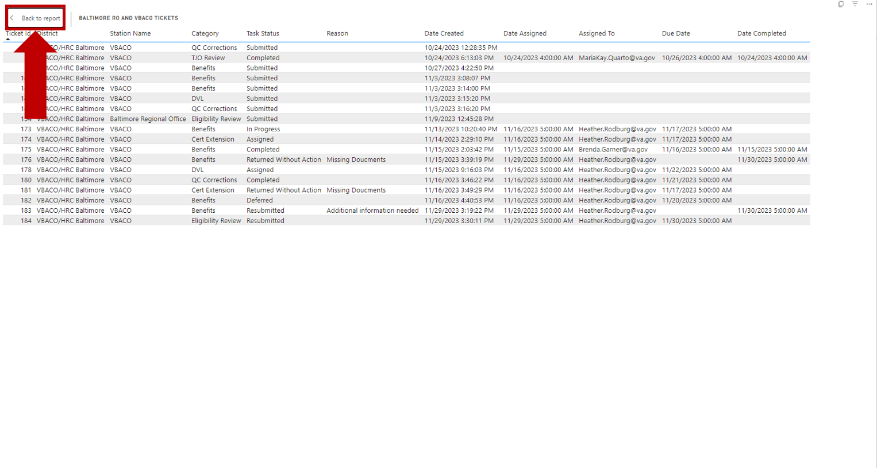
- Observe the District View screen.

Export Executive Dashboard Data (Summarized)
- Mouse over the top-right corner of the data pod to be exported.
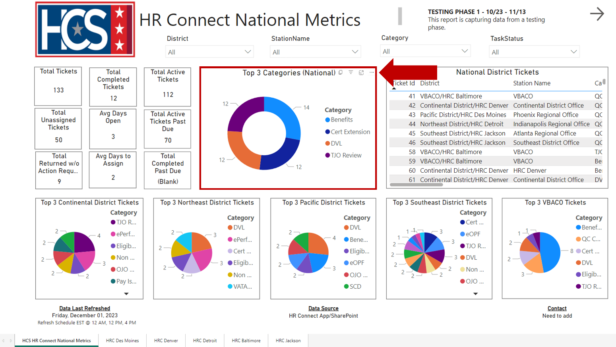
- Select Export data from the pop-up menu.
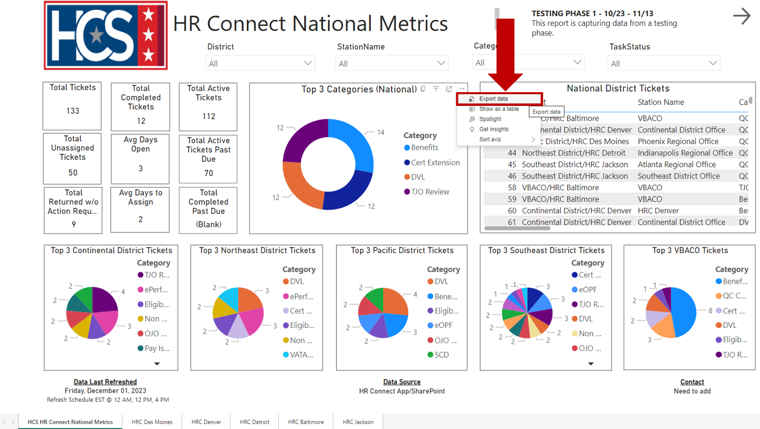

- Observe the Export window.
NOTE: If exporting data from a graph data pod, the only export option available on the Export window is Summarized data.
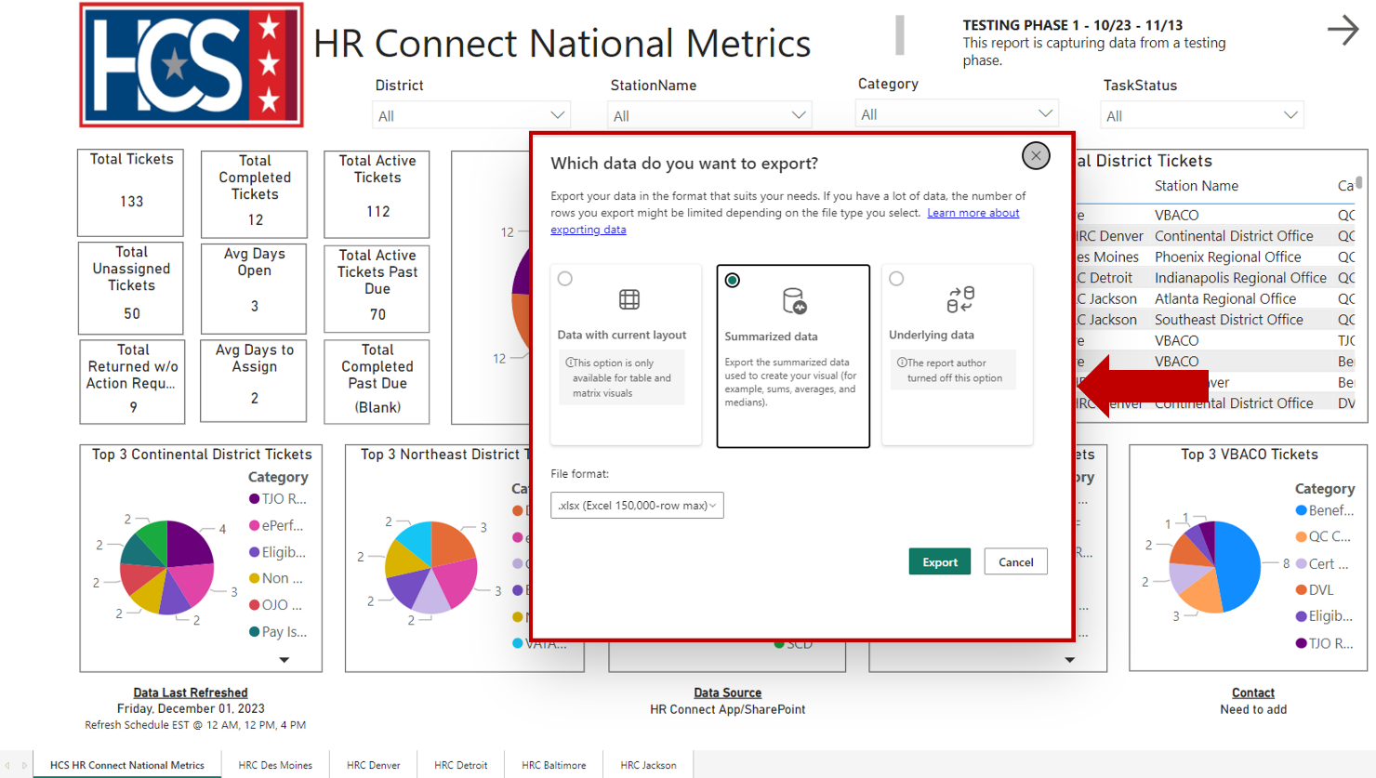
- Select File format using the dropdown menu.
NOTE: The types of file formats available for export are .xlsx and .csv. The default format is.xlsx.
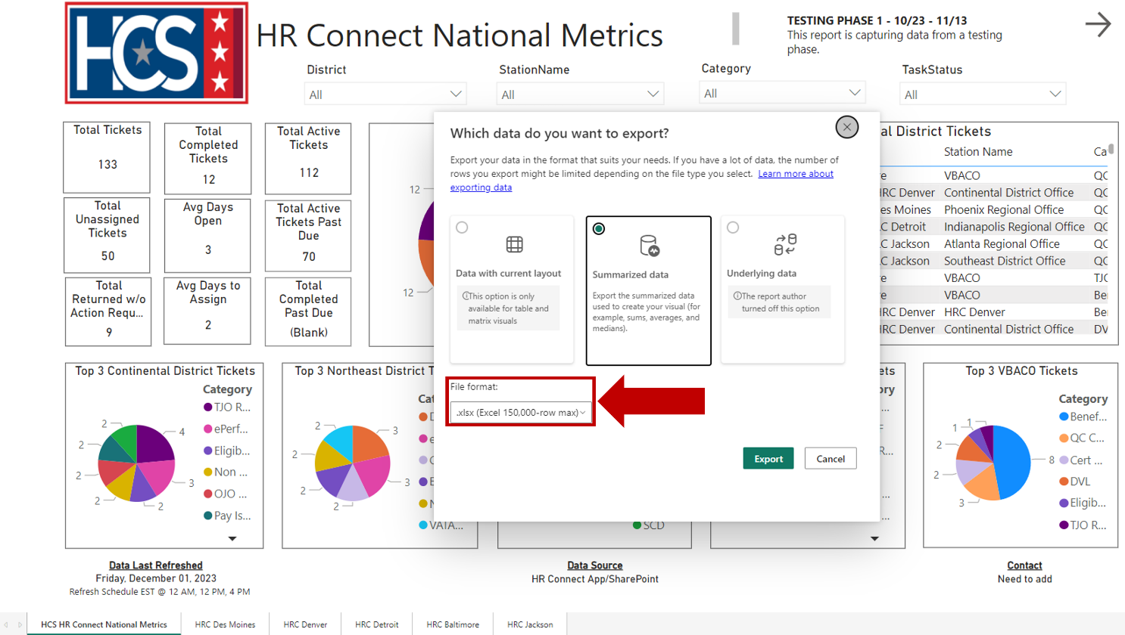
- Select Export.
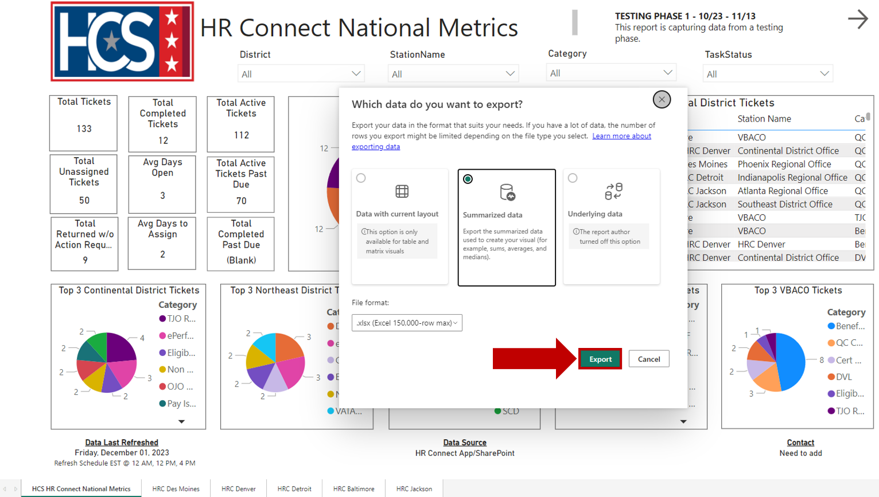
- Select either Open or Save as to view and/or save the file once the data export is complete.
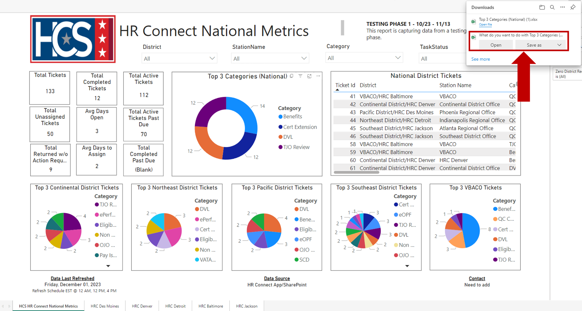

- Observe the information in the exported file.
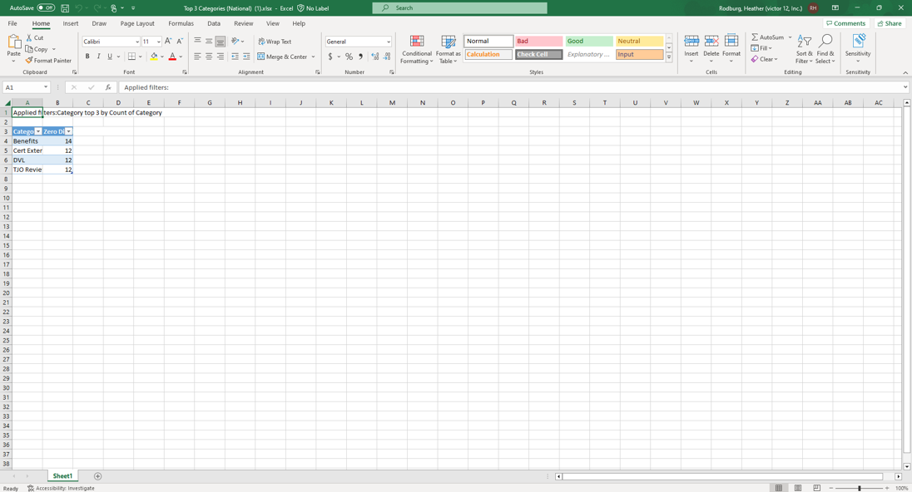

Export Executive Dashboard Data (Data with Current Layout)
- Mouse over the top-right corner of the data pod to be exported.
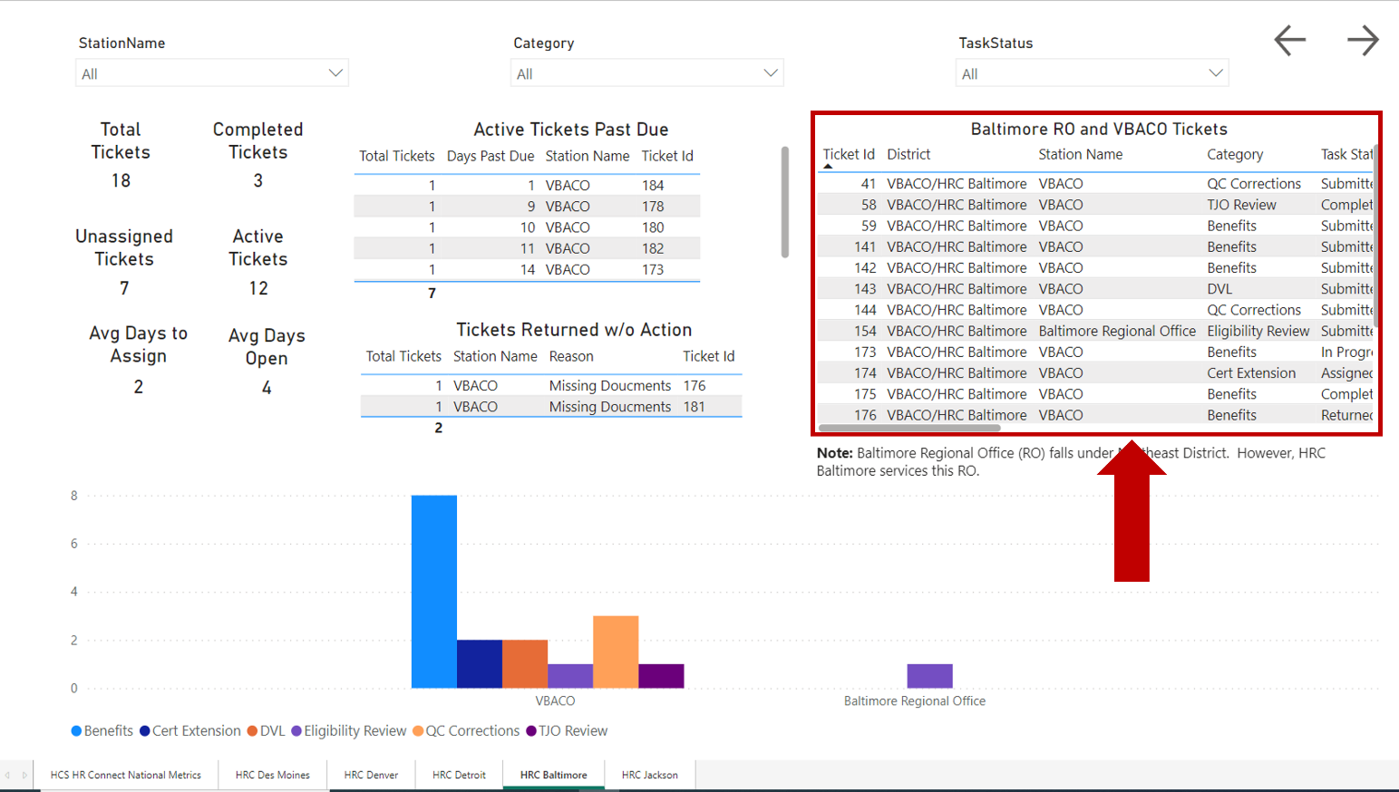
- Select Export data from the pop-up menu.
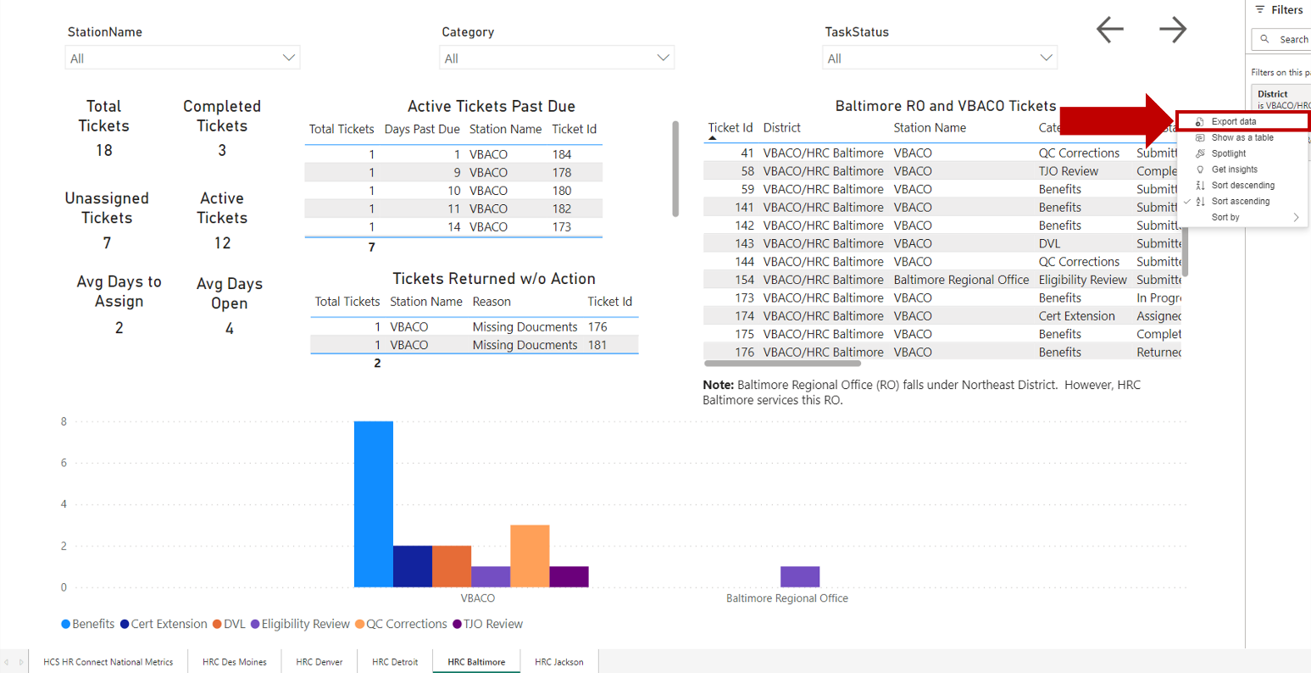

- Observe the Export window.
NOTE: If exporting data from a data list pod, the only export option available in the Export window is Data with current layout.
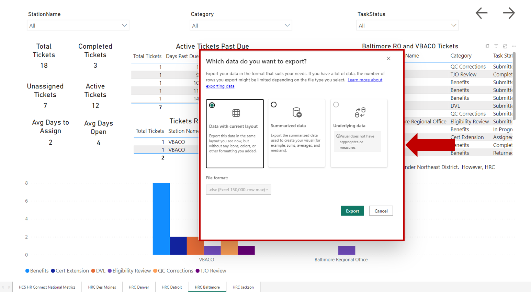
- Select File format using the dropdown menu.
NOTE: The types of file formats available for export are .xlsx and .csv. The default format is.xlsx.
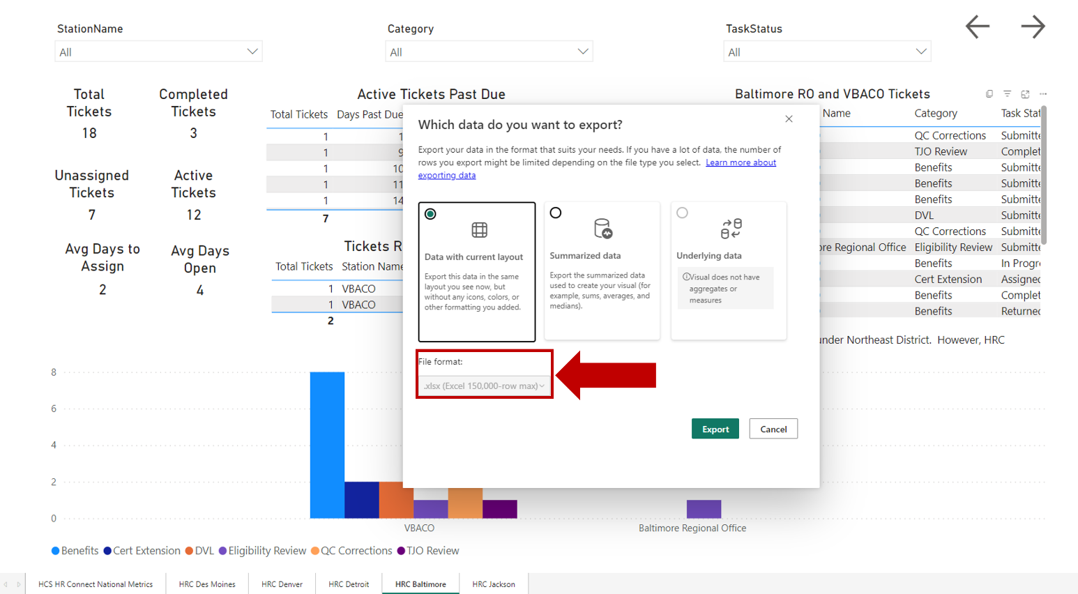
- Select Export.
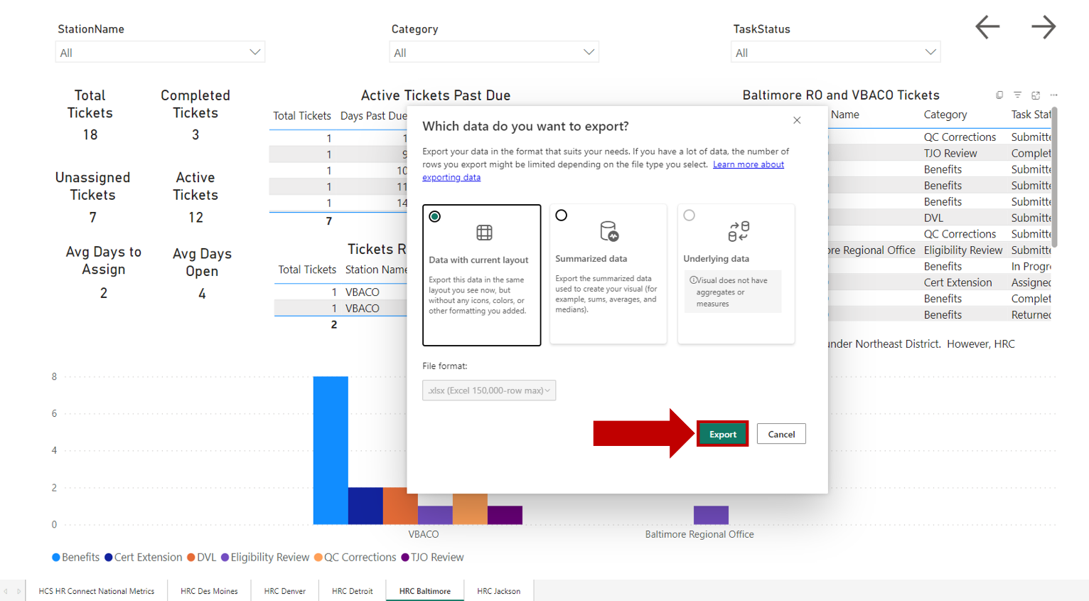
- Select either Open or Save as to view and/or save the file once the data export is complete.

- Observe the information in the exported file.
