

HR Connect Ticket Request Process
Job Aid

Human Resources Specialist (HRS)

21 December 2023

Contents
Introduction 3
Ticket Submission Workflow 3
Ticket Processing Timeline 3
Ticket Priority Level 4
Access HR Connect 5
View Assignments 8
Ticket Status Options 8
View Assigned Tickets 9
Manage Ticket Status 13
Update Ticket Status to In Progress 13
Update Ticket Status to Completed 19
Update Ticket Status to Returned Without Action 25
Update Ticket Status to Deferred 29
Submit HR Connect Feedback 33
Executive Dashboard 37
Overview 37
HR Connect National Metrics Dashboard Data 38
HR Connect District Metrics Dashboard Data 39
Access Executive Dashboard 40
Export Executive Dashboard Data (Summarized) 45
Export Executive Dashboard Data (Data with Current Layout) 49

Introduction
HR Connect serves as a mandatory user-friendly workload ticketing system between the Human Resources Liaisons (HRLs)/Human Resources Development (HRD) Specialists and their servicing Human Resources Center (HRC) for all non-Manager Self-Service (MSS) related actions. The procedures described in this job aid are designed for HRSs who access HR Connect to update, process, and close non-MSS tickets, along with guidance for viewing national and district ticket metrics via Executive Dashboard.

Ticket Submission Workflow
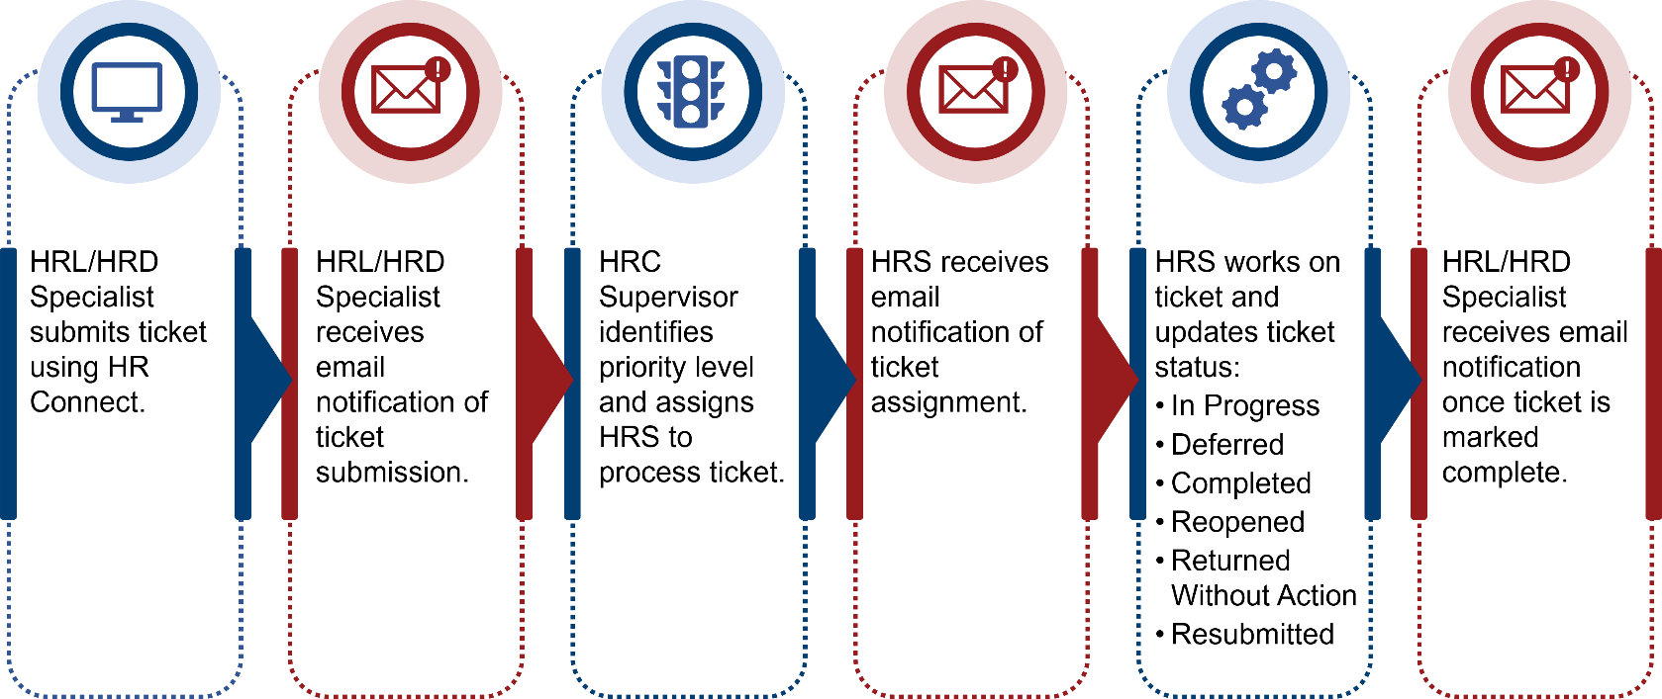

Ticket Processing Timeline
The following processing timelines apply for tickets submitted in HR Connect:
- HRC Supervisor to assign ticket: 1 business day.
- HRS to begin working on ticket (move ticket to In Progress): 1 business day.
- HRS to complete ticket: Varies, depending on circumstance/complexity of ticket, whether additional information is needed, etc., along with considerations within performance plan (if applicable).
- HRS to close ticket after completion: Same day that ticket is completed.
NOTE: Ticket priority impacts the ticket processing timeline.
NOTE: A user who submits feedback via the Submit Feedback option on the HR Connect home screen should expect to receive a response within 2 business days.

Ticket Priority Level
When a ticket is submitted, an HRC Supervisor receives the ticket, assigns a priority level, and assigns an HRS to process the ticket. HRC Supervisors are the only role with permission in HR Connect to change ticket priority—based on review of the issue and their own expertise/judgement—and to assign/reassign tickets.
The three priority levels are described below.
NOTE: While definitions and examples are listed below, HRC Supervisors have the latitude to assign priority based on review and judgement of issue.
Priority Level | Description of Issue
High | - Involves pay/benefits  - Impacts a system(s) (e.g., ePerformance, HR Smart)
Medium | Does not impact pay, benefits, or systems, yet involves an impact that requires higher than Low priority (e.g., Official Job Offer [OJO], Tentative Job Offer [TJO], ePerformance question)
Low | Does not impact pay or systems and can be addressed after HRS addresses High and Medium priority tickets (e.g., Service Computation Date [SCD] review)

Access HR Connect
HRSs who attempt to access the tool without the appropriate permission receive a Request Access message as shown below.
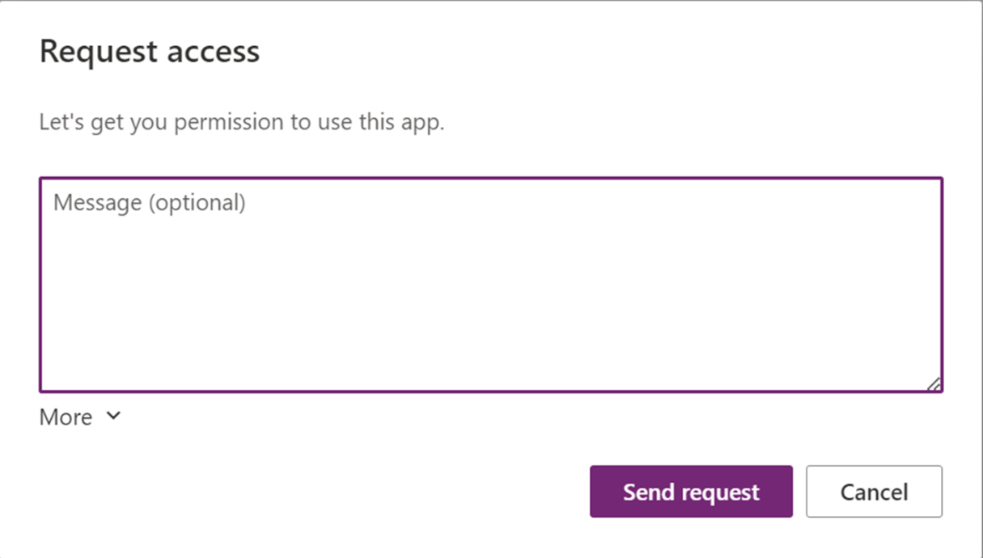
Supervisors must request access from the HR Connect team in order for HRLs/HRD Specialists to begin working tickets. Once access is granted, HRSs receive an email notification confirming their access to HR Connect.
- Select the HR Connect link within the HR Connect Access Request email.
NOTE: HR Connect launches in Microsoft Edge.
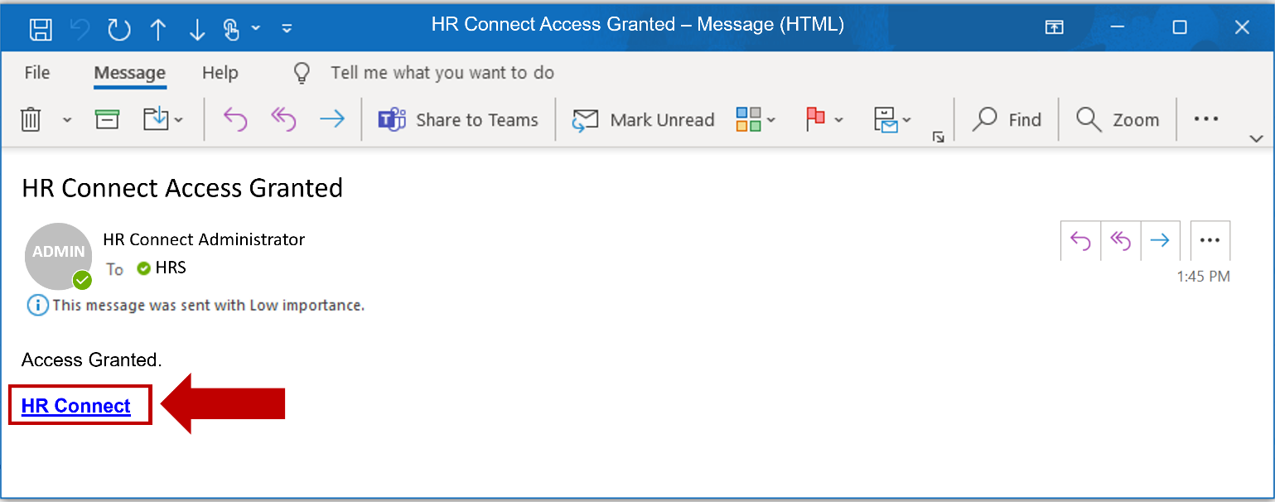

- Select Allow on the Permissions popup window.
NOTE: Allow must be selected in order to access the HR Connect application.
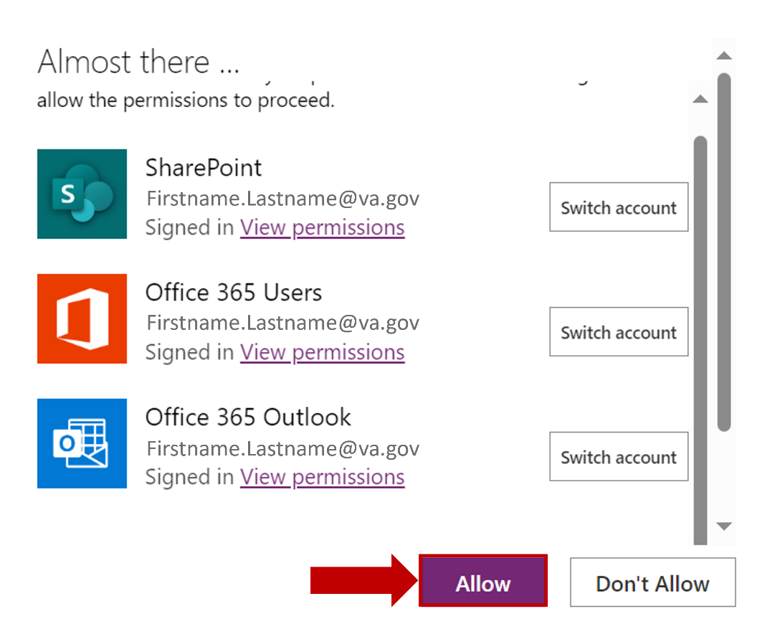
- Select the Agree checkbox to acknowledge the sensitive information disclaimer.
NOTE: Bookmarking this page allows for easy access to HR Connect.
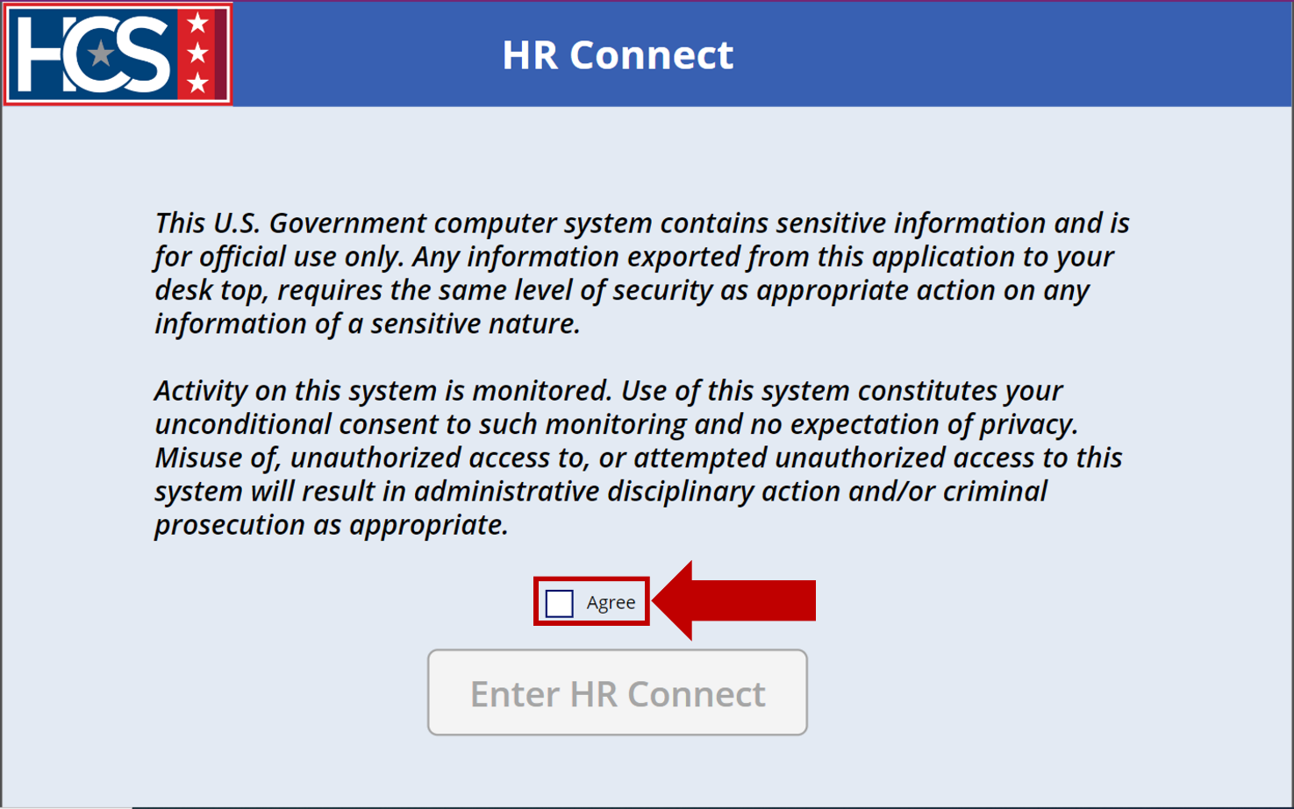
- Select Enter HR Connect.
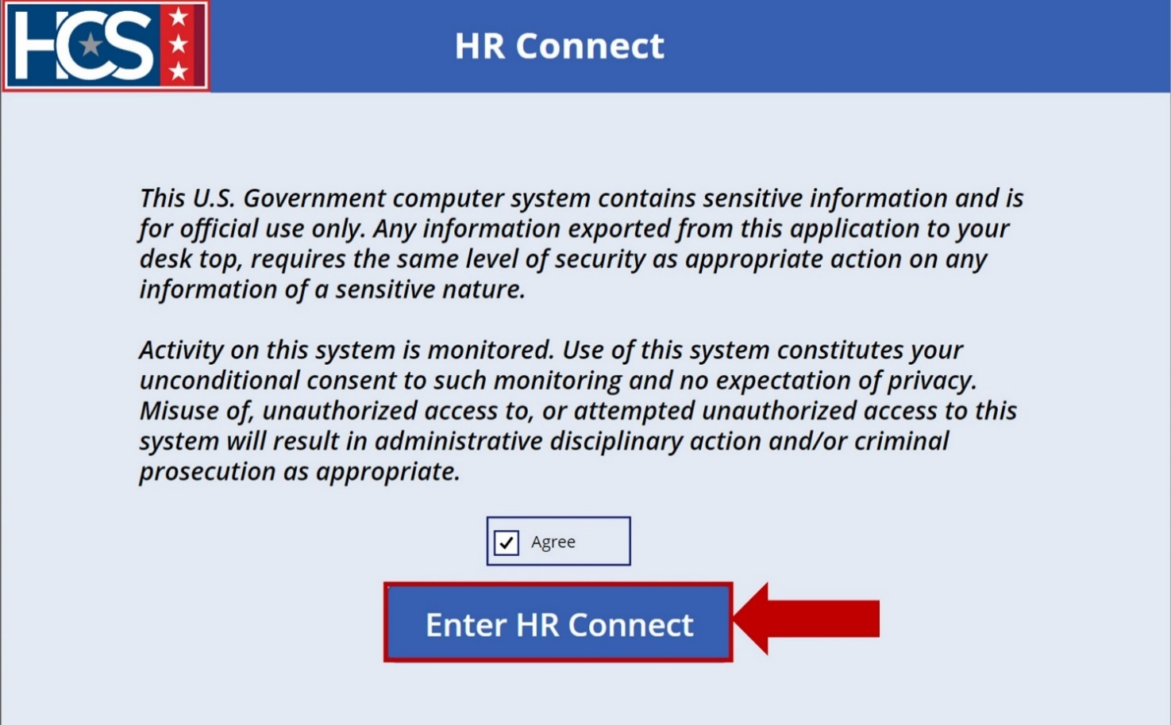
- Observe the HR Connect home screen.
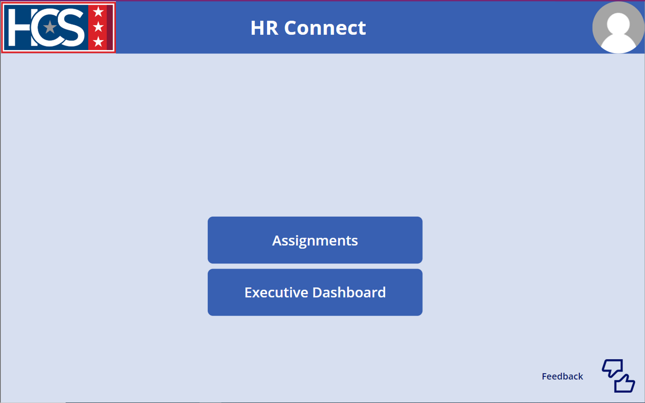

View Assignments

Ticket Status Options
HR Connect allows for straightforward tracking and viewing of tickets as they progress through the system. Once a ticket is submitted, an HRS can view ticket status using the Assigned Tickets option. Status filters include:
- Submitted: HRC Supervisor has not yet assigned the ticket to an HRS.
NOTE: This status type is not visible to an HRS viewing their assigned tickets.
- Assigned: HRC Supervisor has determined the ticket priority (High, Medium, Low) and has assigned the ticket to an HRS.
- In Progress: HRS has started working on the ticket.
- Deferred: Ticket has been placed on hold, pending action or information from an internal or external third-party source.
- Reopened: Ticket was closed but reopened (e.g., resolution in error, additional resolution needed).
- Returned Without Action: Ticket is returned to the HRL/HRD Specialist for several reasons, which include: Duplicate; MSS Request; Missing Documents; Additional Information Needed. The reason for the ticket being Returned Without Action is provided in the HRC Details section of the submitted ticket.
NOTE: If the ticket lists either Missing Documents or Additional Information Needed, the ticket can be resubmitted with the missing document(s) or additional information.
- Completed: HRS has resolved the ticket.
- Resubmitted: A ticket that was Returned Without Action is submitted again with missing documents or additional information included.
NOTE: HRLs/HRD Specialists can only update tickets with a status type of “Submitted” or “Returned Without Action.”
When a status filter is selected, the color of the option changes and only the tickets that apply to the selected filter display. If no tickets have the selected status, no tickets display on the screen.
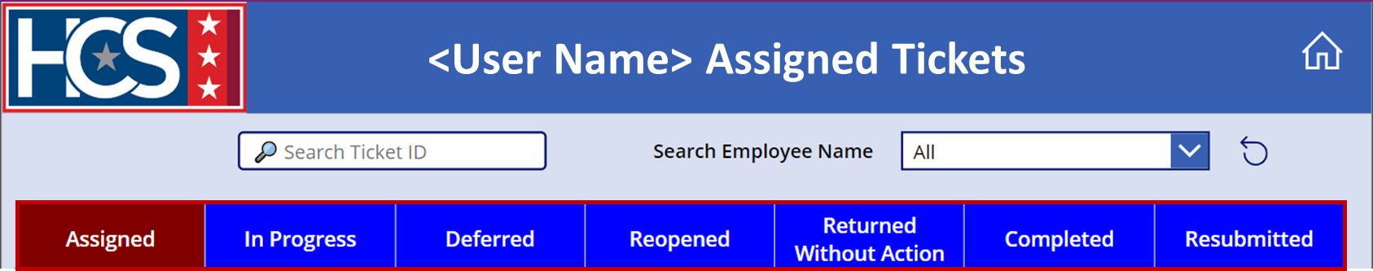

View Assigned Tickets
- Select Assignments on the HR Connect home screen.
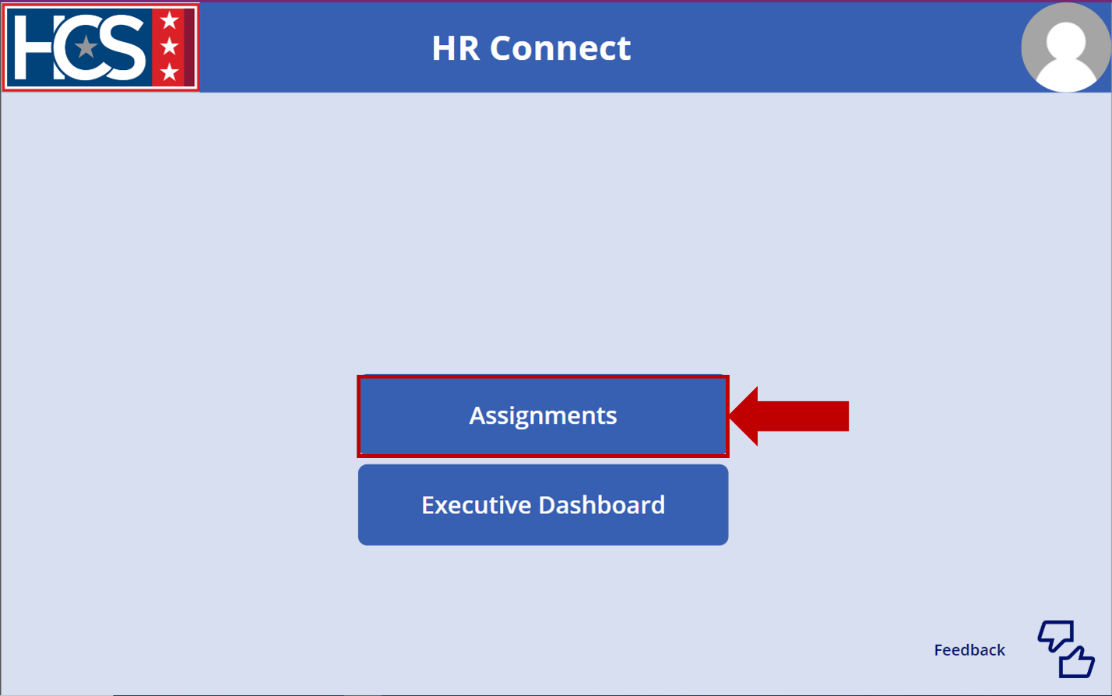
- Observe the <User Name> Assigned Tickets screen.
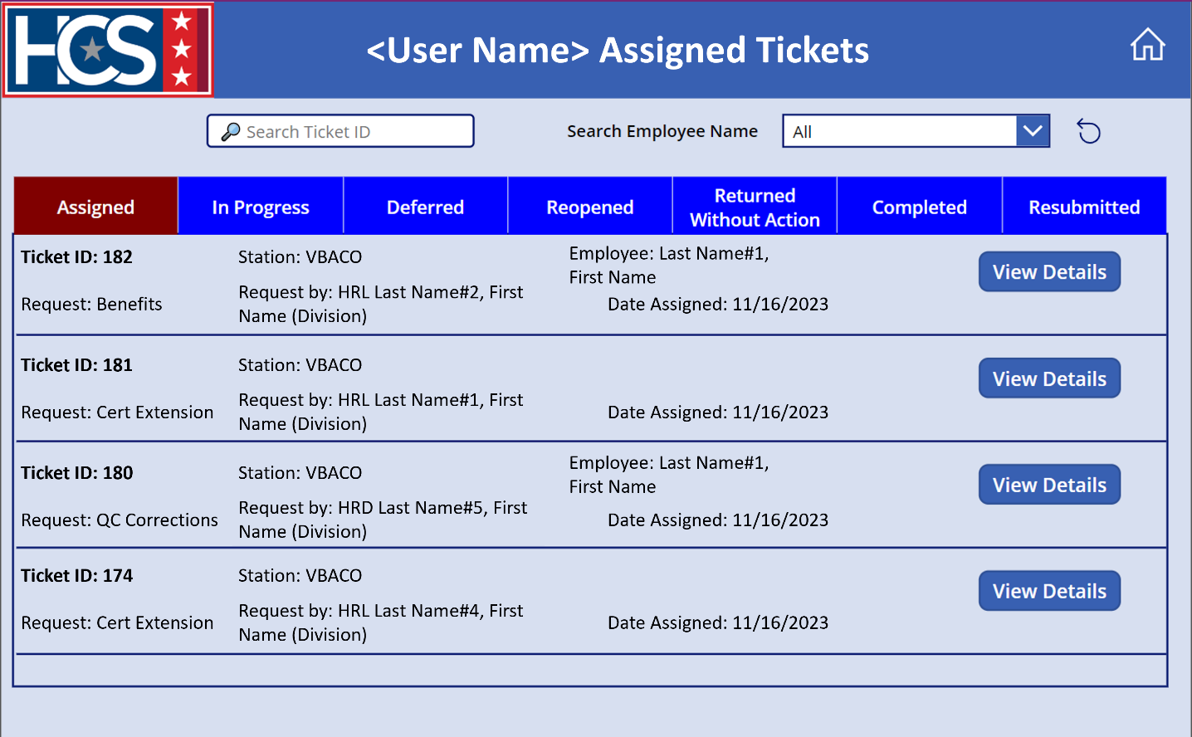

- Type a ticket number in the Search Ticket ID text field.
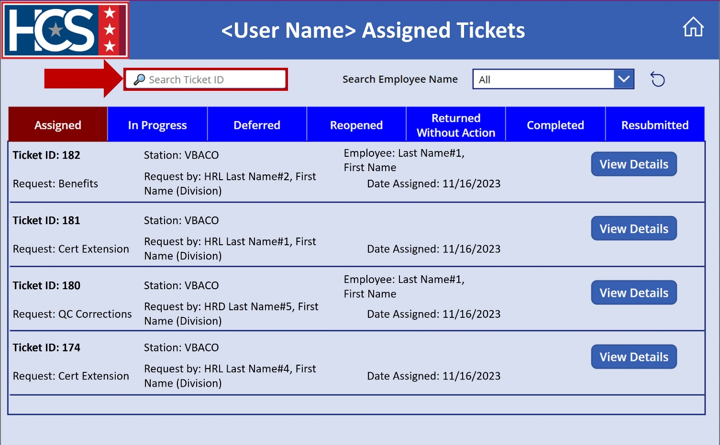
- Review tickets that display as a result of the entered ticket ID number on the <User Name> Assigned Tickets screen.
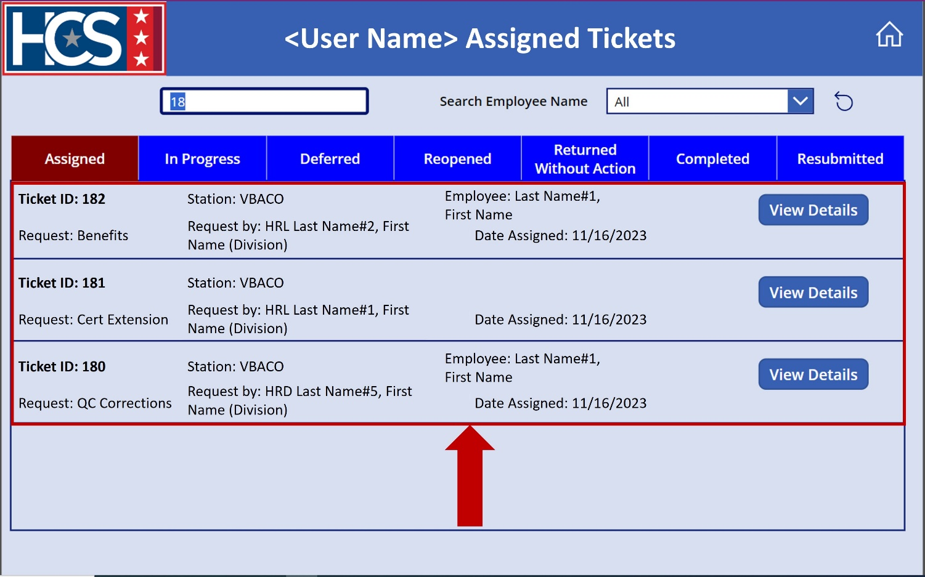
- Select employee name from the Search Employee Name dropdown menu to filter tickets by employee name. 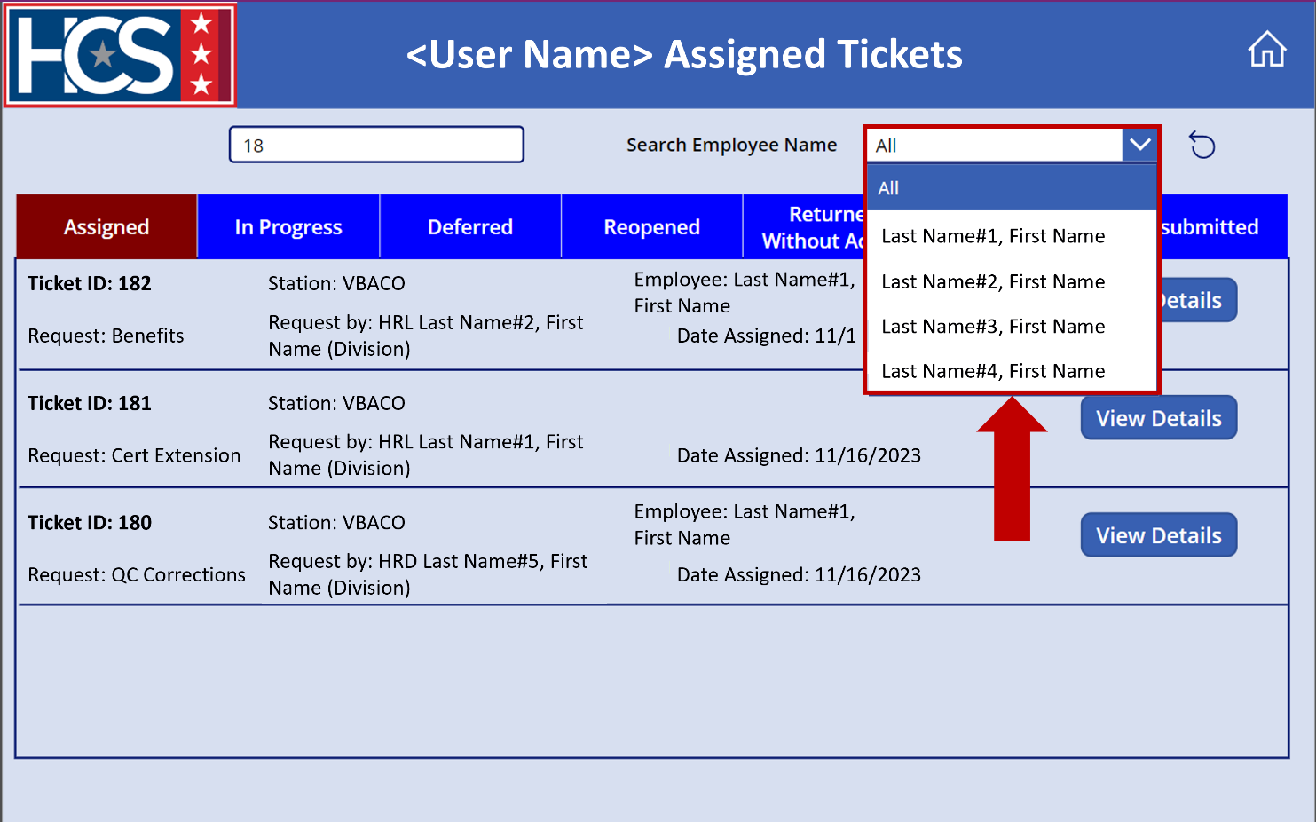
- Review tickets that display on the <User Name> Assigned Tickets screen as a result of the ticket ID and employee selections.
NOTE: If no tickets match the selected employee name, no tickets display.
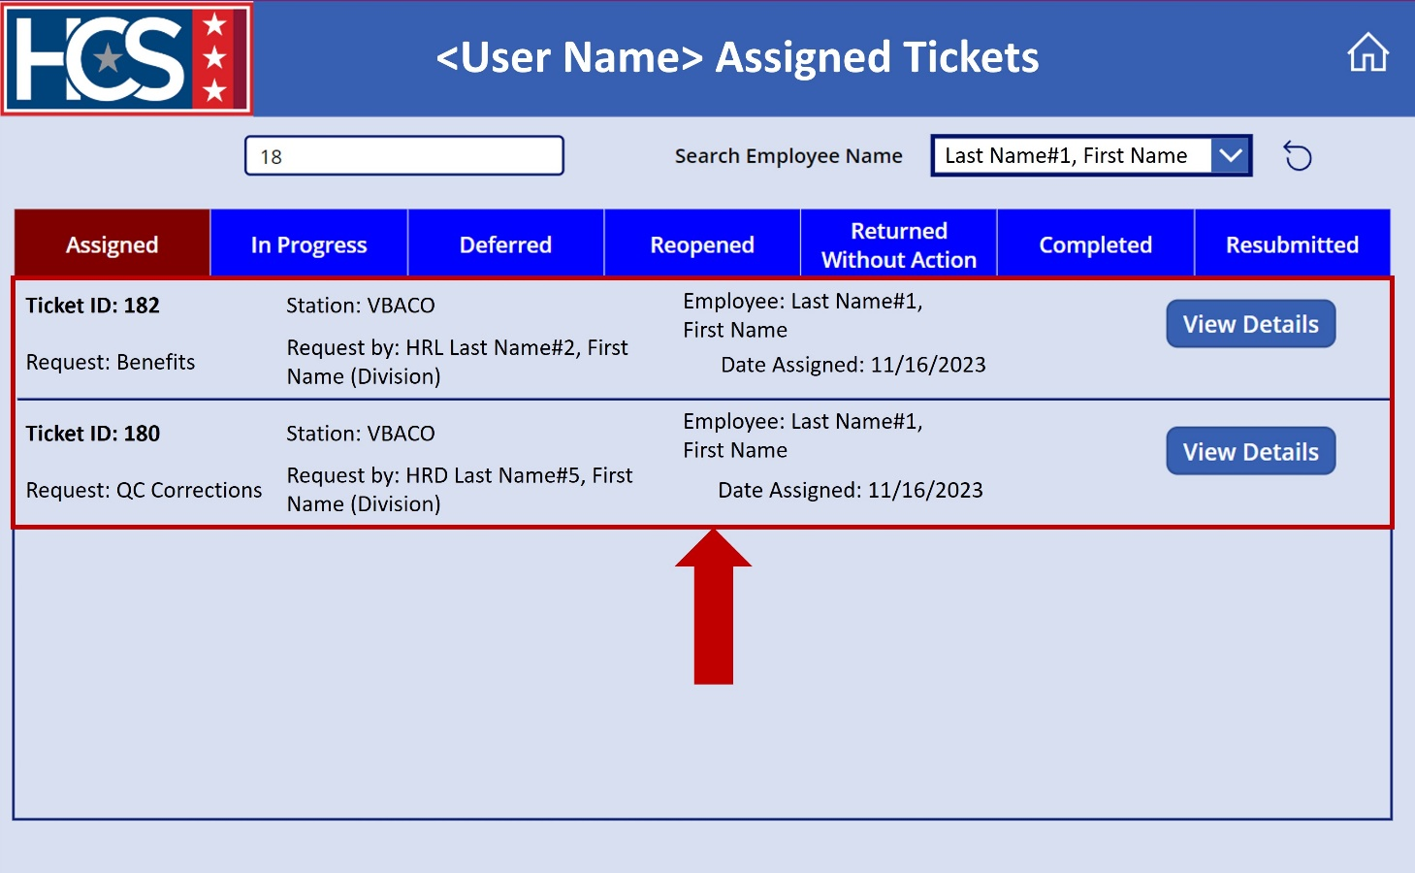
- Select the Reset icon to clear and reset filters, if needed.
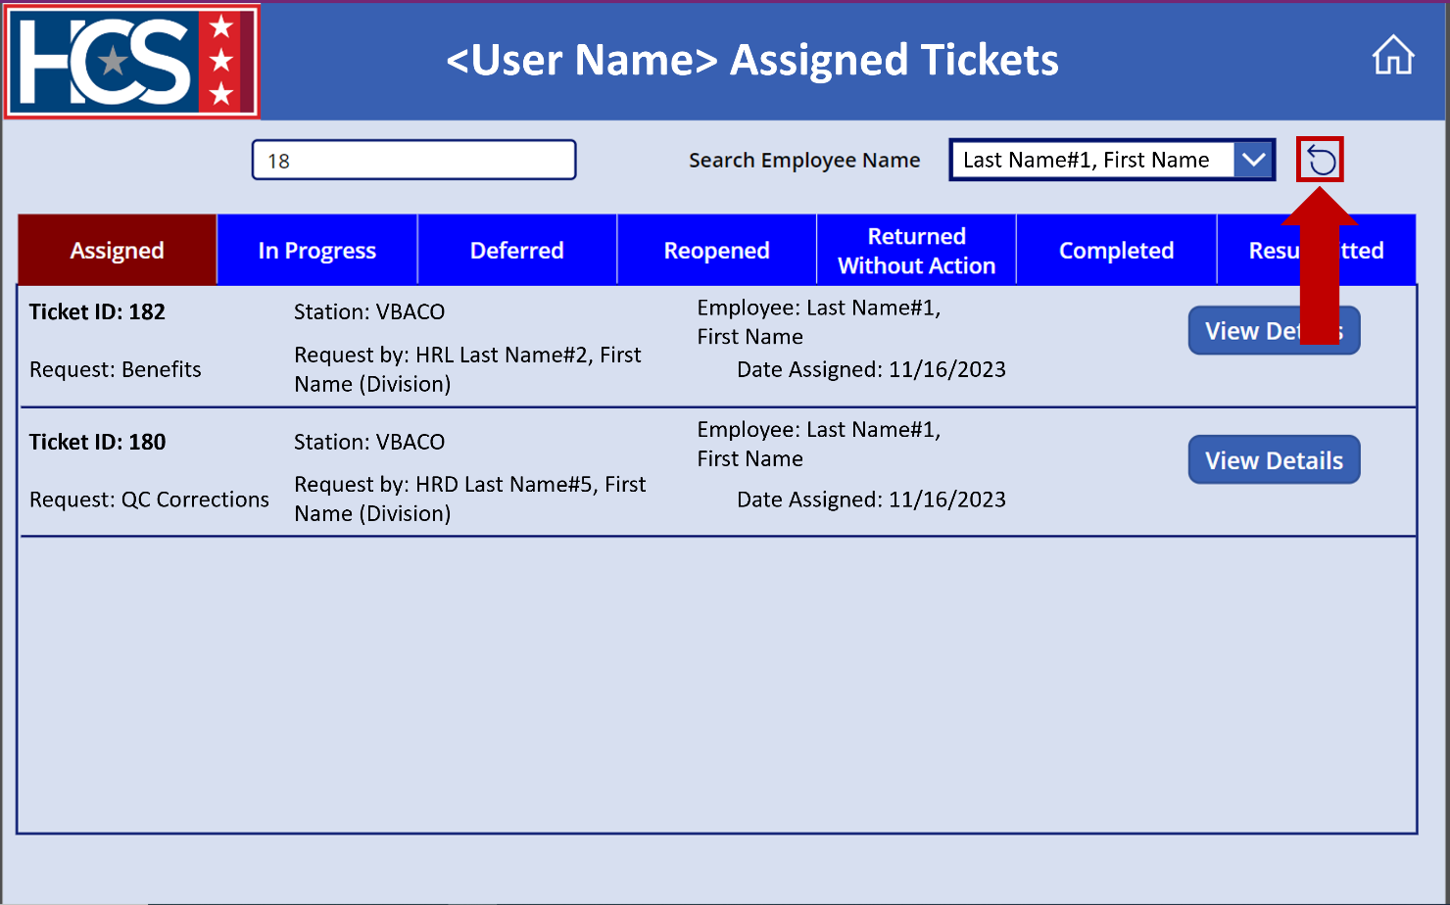

Manage Ticket Status

Update Ticket Status to In Progress
- Select View Details for the ticket to be updated on the <User Name> Assigned Tickets screen.
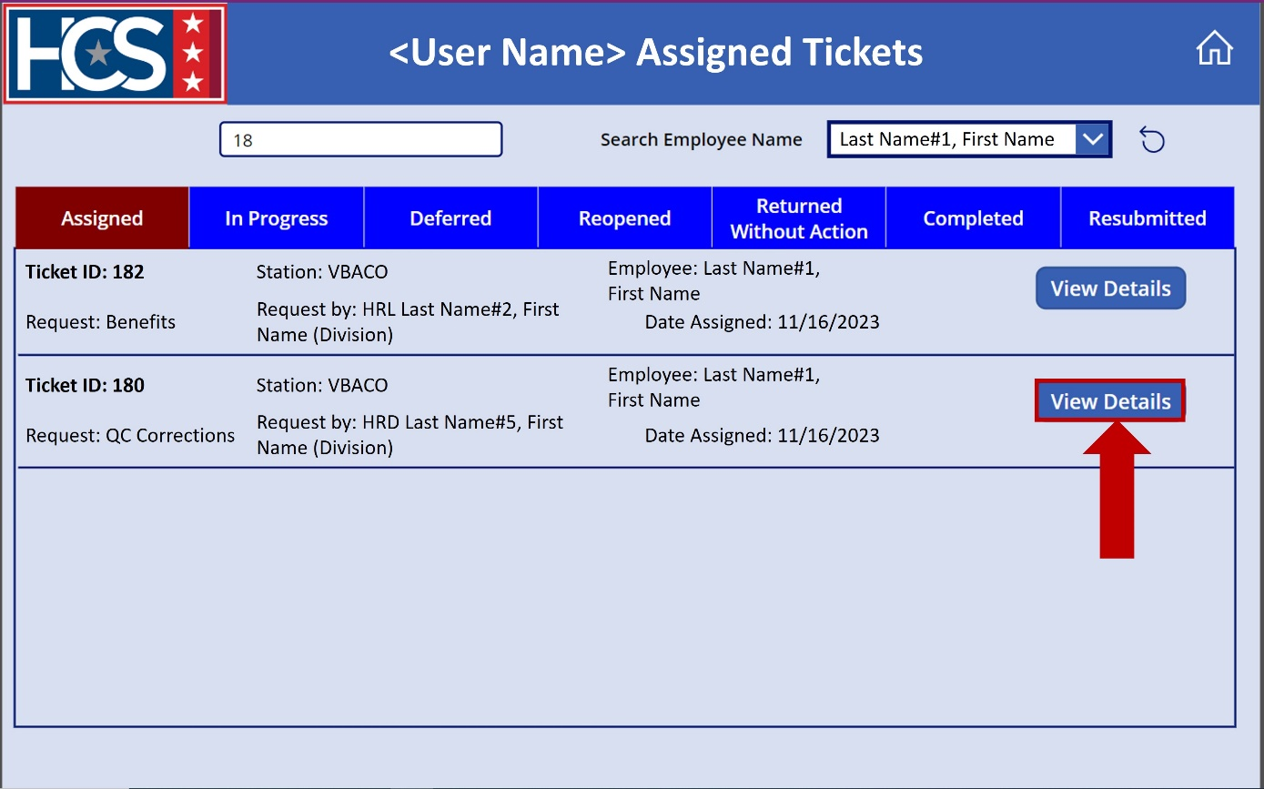
- Observe the Ticket # Details screen.
NOTE: The ticket number in the screen title reflects the number of the selected ticket.
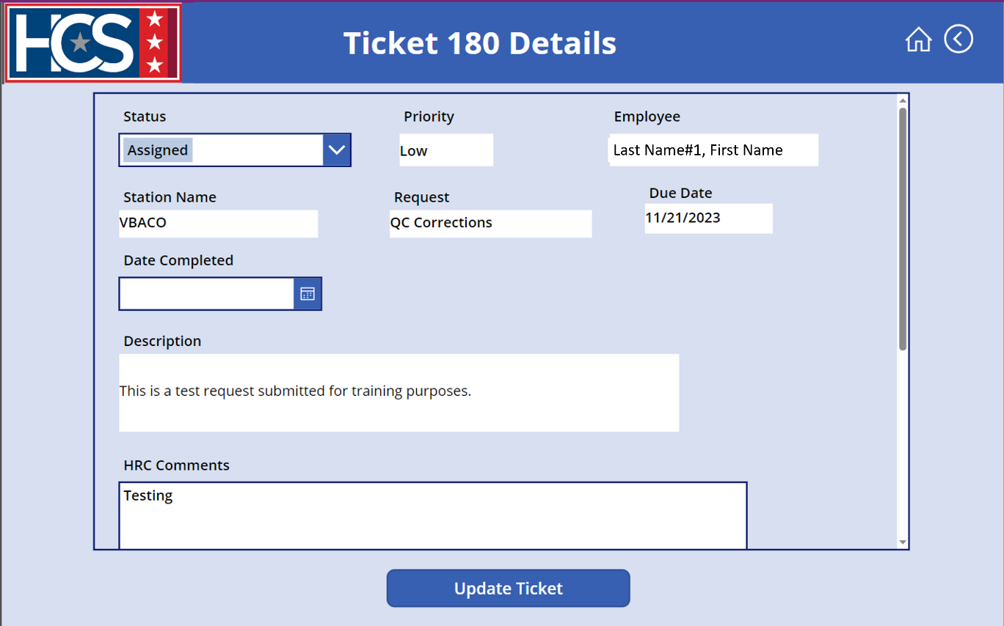
- Select In Progress from the Status dropdown menu.
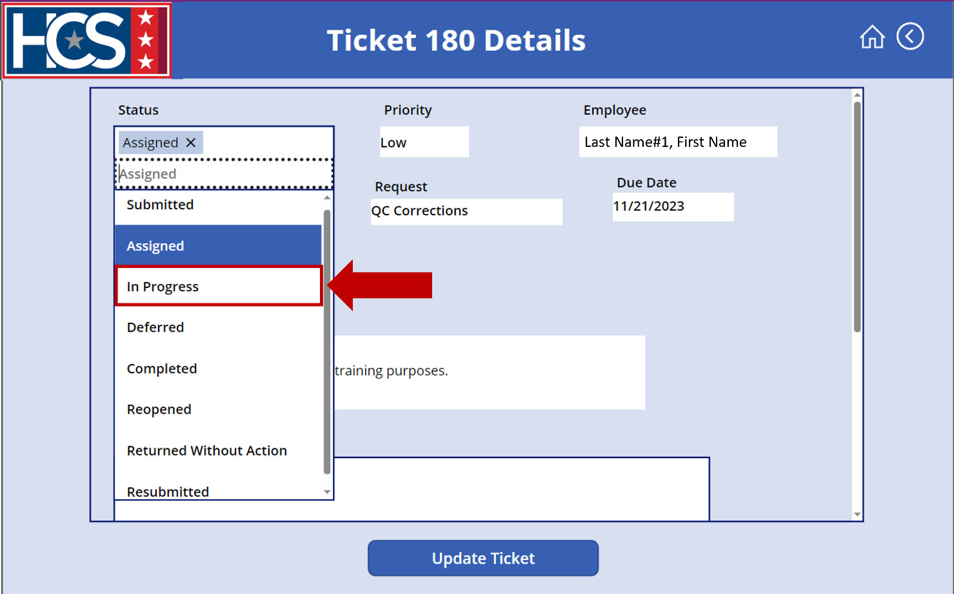
- Use the scroll bar to scroll down on the ticket details.
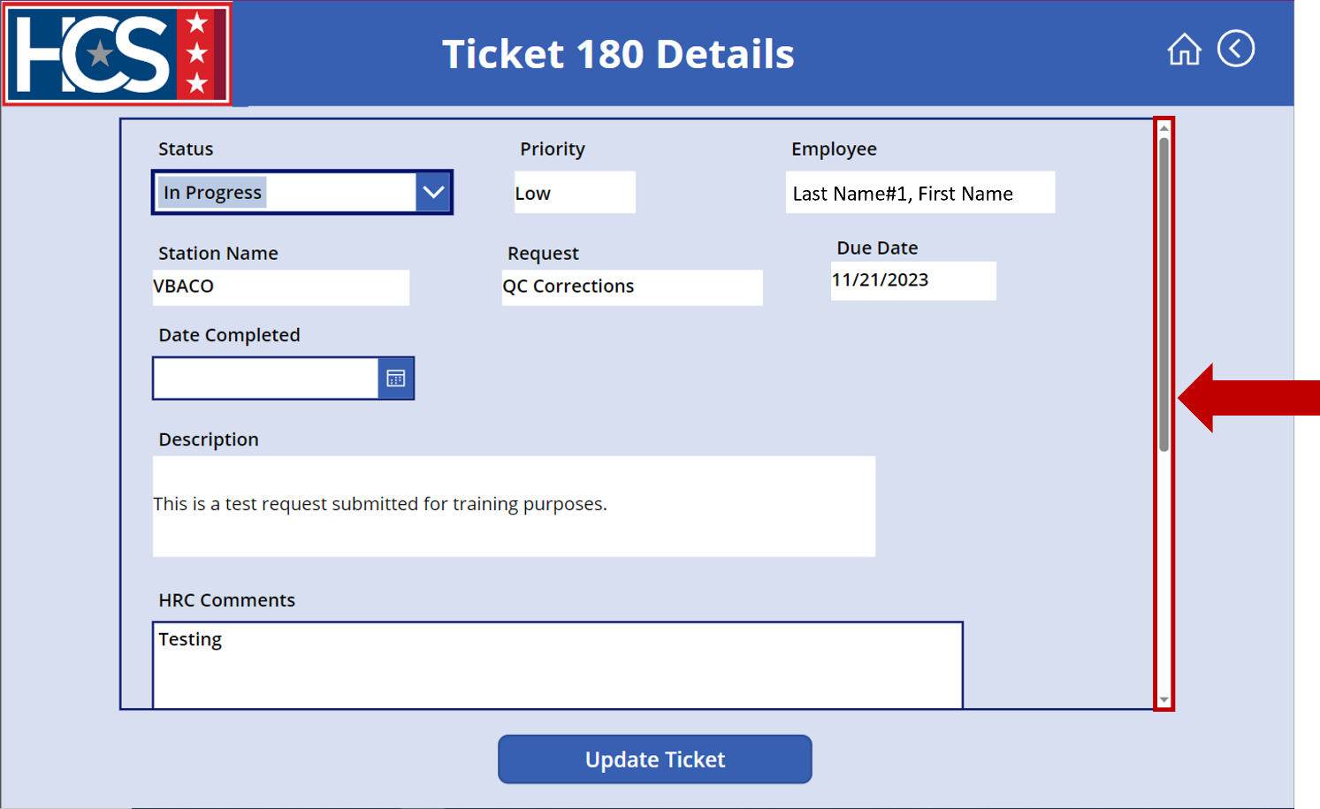
- Type/update comments in the HRC Comments text field.
NOTE: Comments should include as much detail as possible to ensure efficient ticket processing.
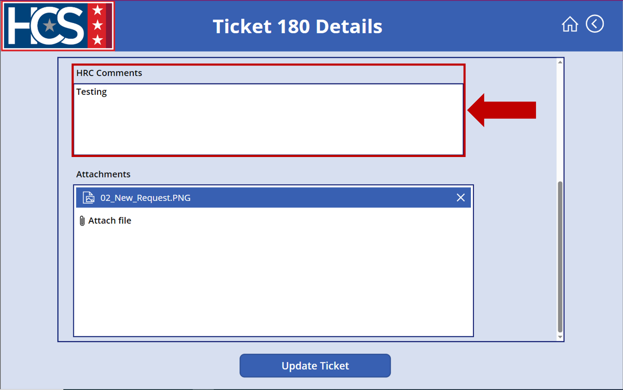
- Select Attach file to add supplemental documents, as needed.
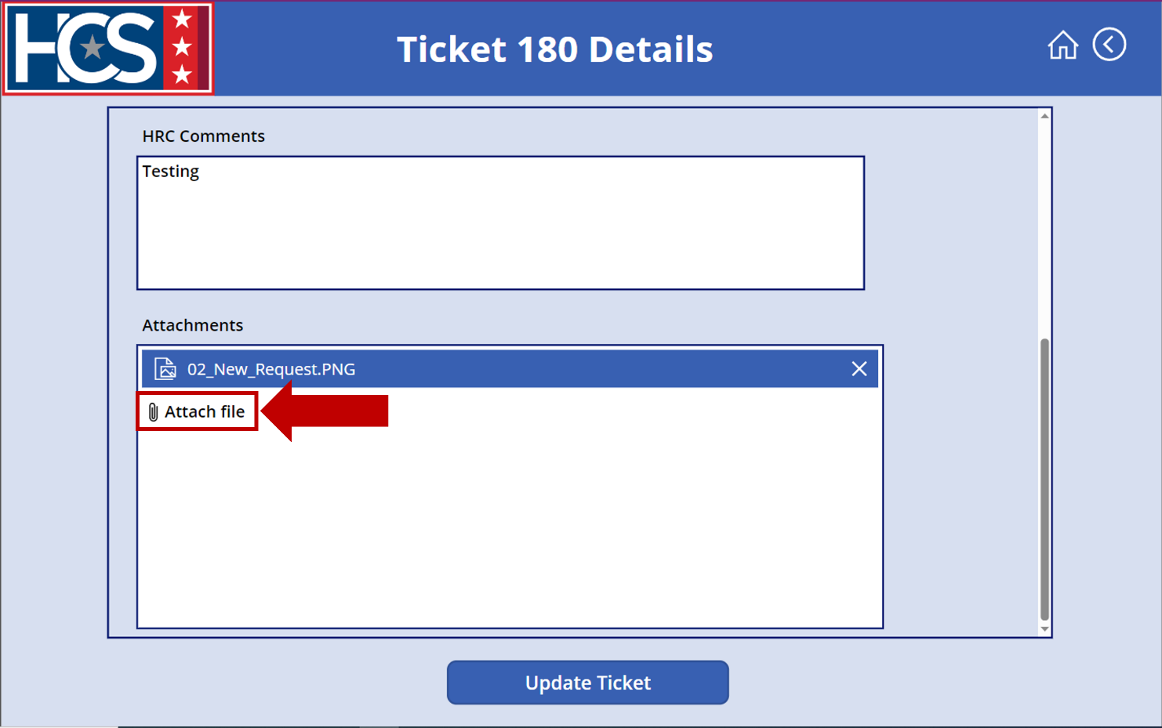
- Select the file(s) from the Open dialog box that displays.
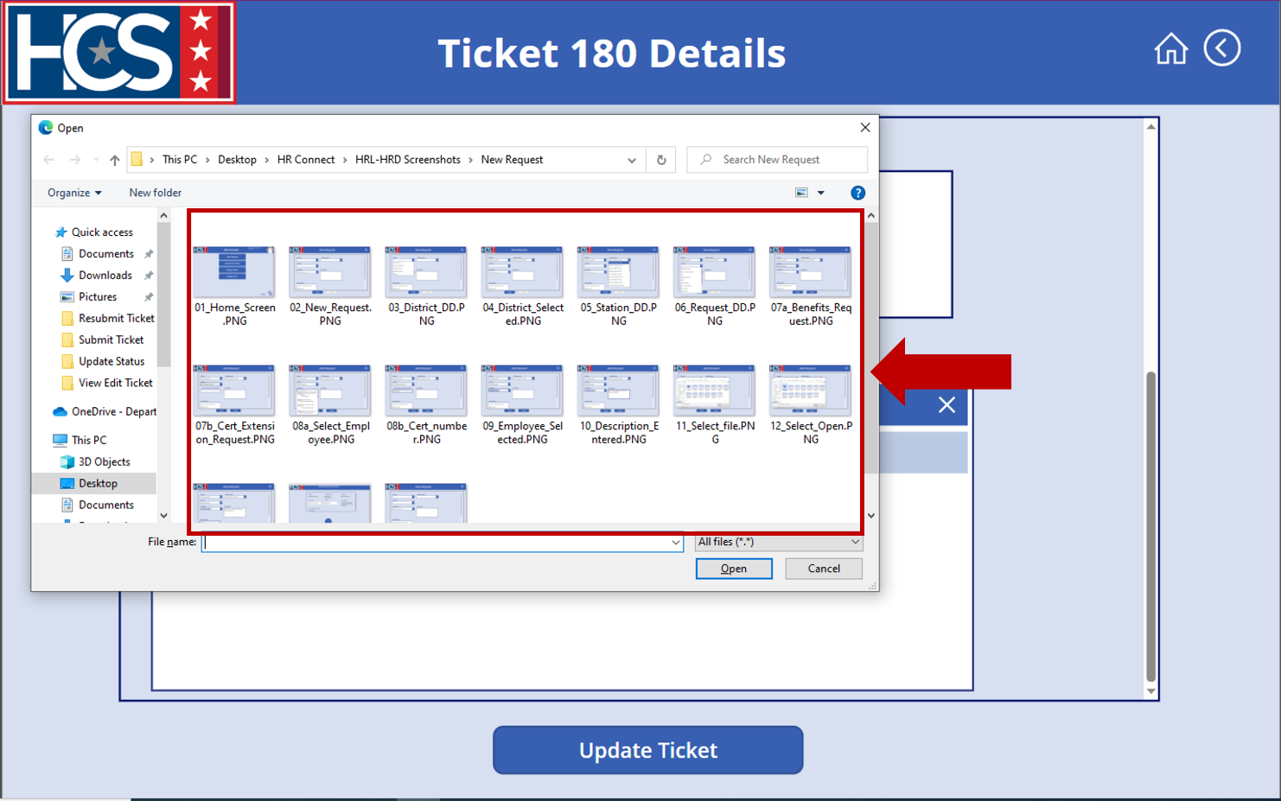
- Select Open to attach the file(s).
NOTE: The following file formats are accepted as attachments: PNG, PDF, DOCX.
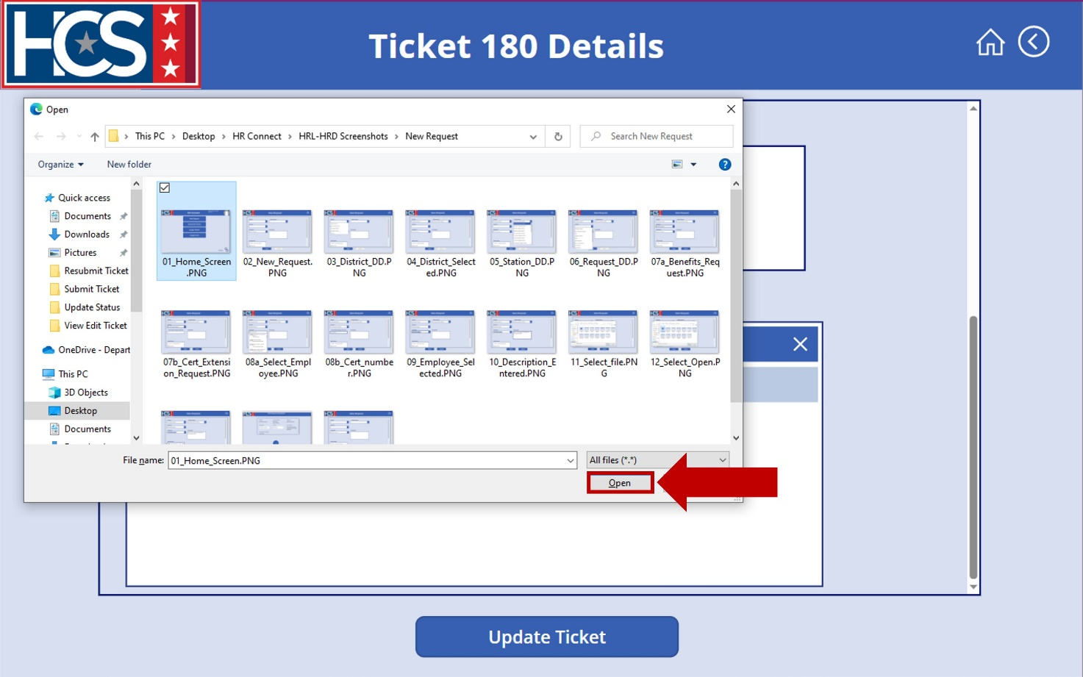
- Select Update Ticket.
NOTE: If Update Ticket is not selected, any changes to the ticket are not saved.
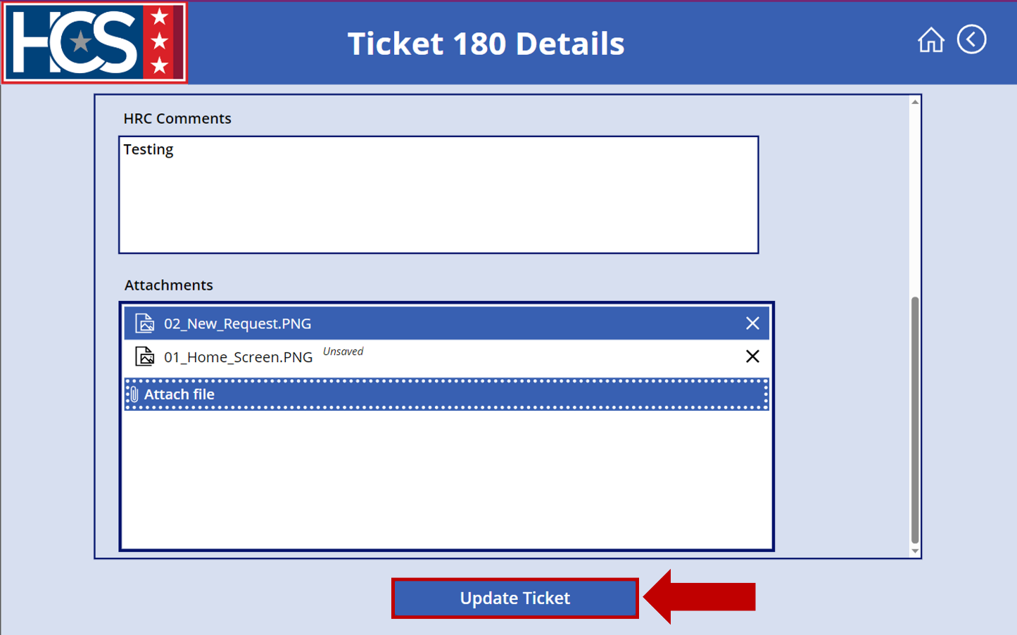
- Observe the ticket no longer displays under the Assigned ticket status on the <User Name> Assigned Tickets screen.
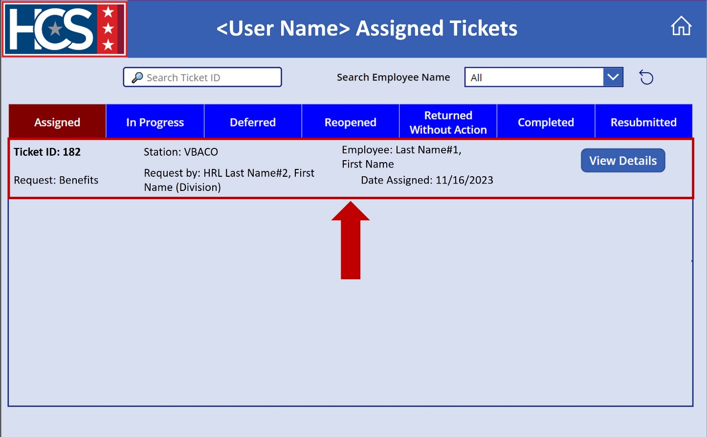
- Select In Progress on the <User Name> Assigned Tickets screen to display tickets with a status of In Progress.
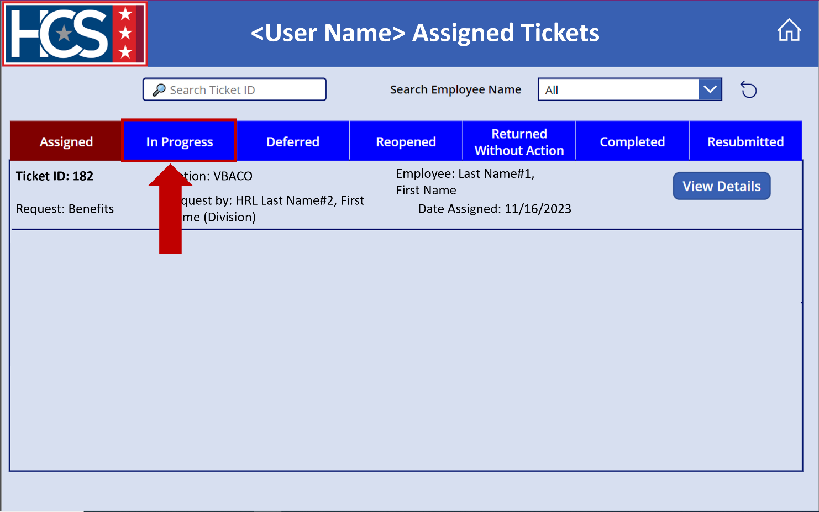
- Verify the updated ticket now displays under the In Progress ticket status on the <User Name> Assigned Tickets screen.
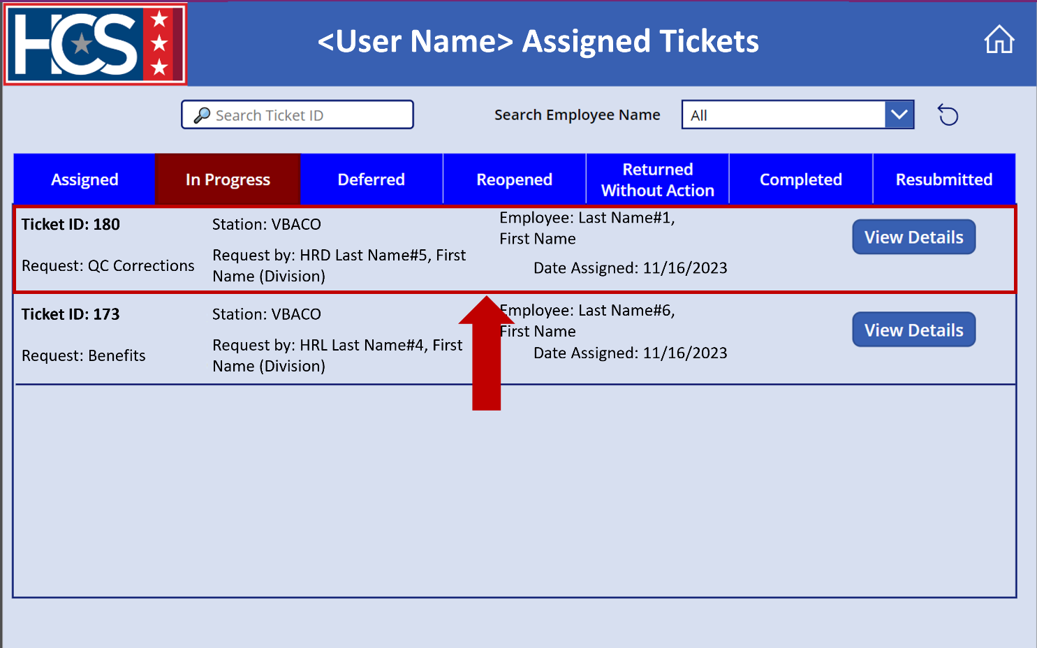

Update Ticket Status to Completed
- Select In Progress on the <User Name> Assigned Tickets screen.
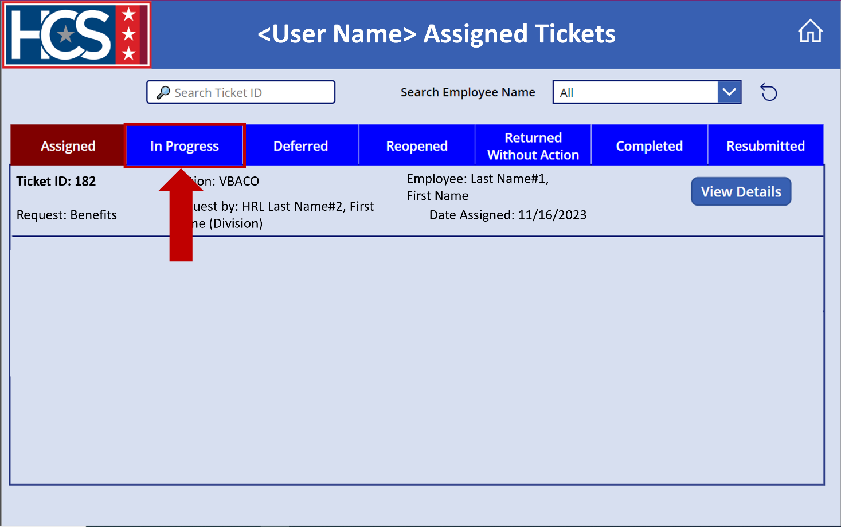
- Select View Details on the ticket to be updated.
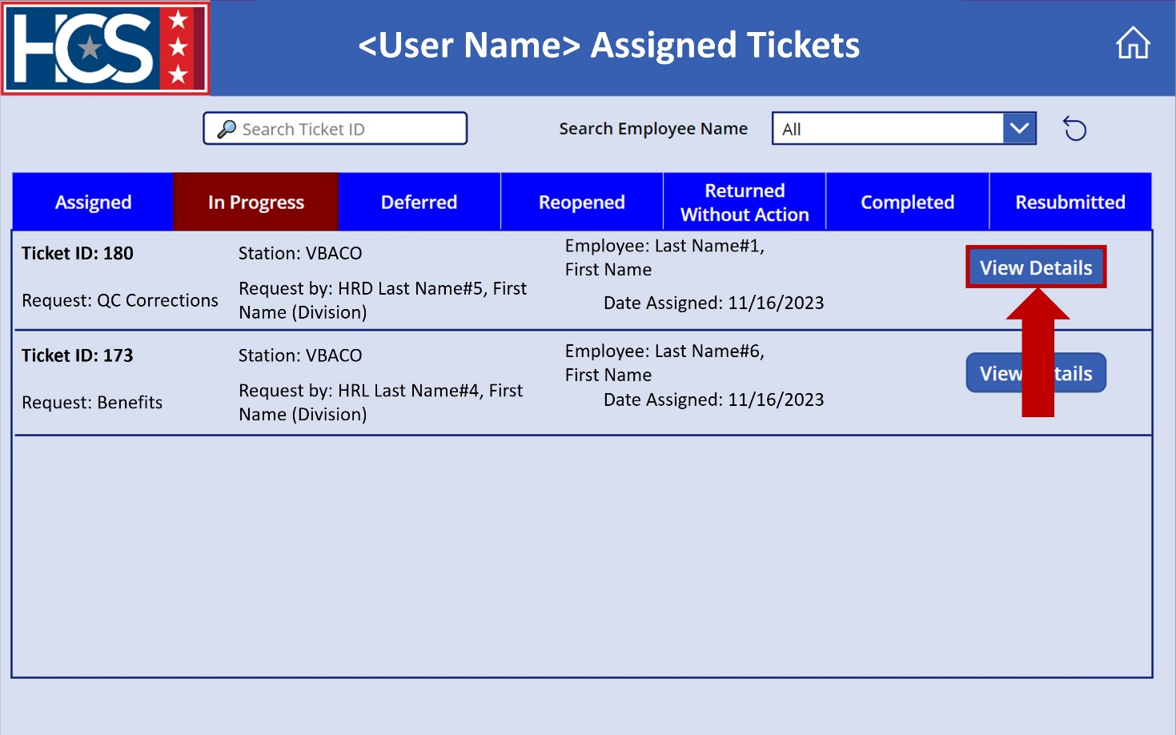

- Select Completed from the Status dropdown menu.
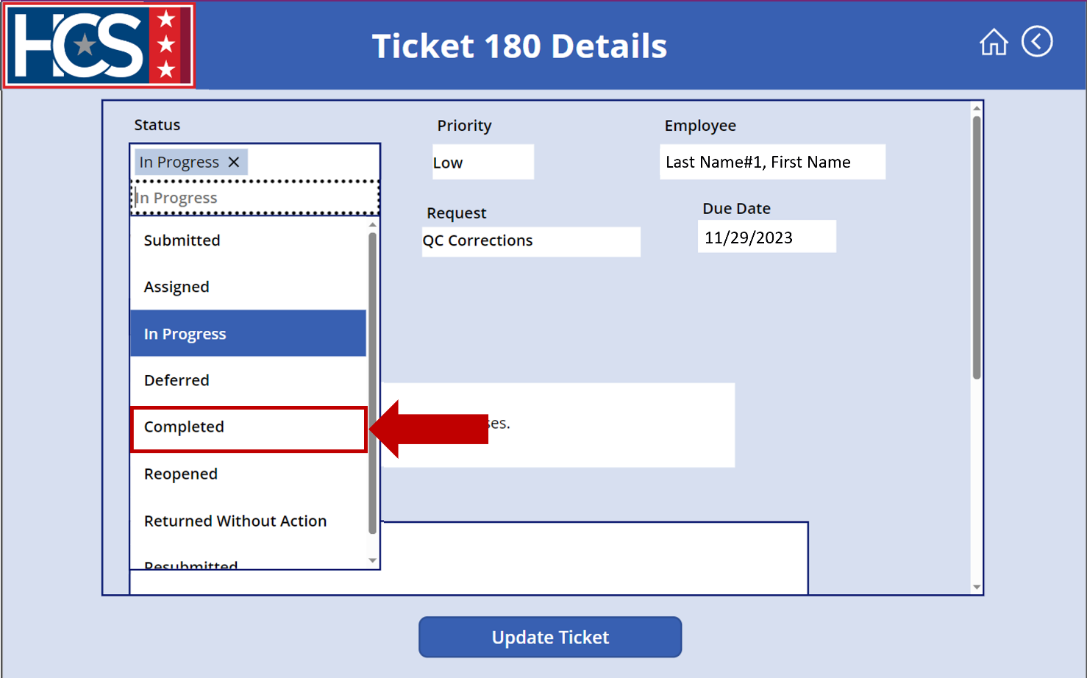
- Select the calendar icon to enter Date Completed.
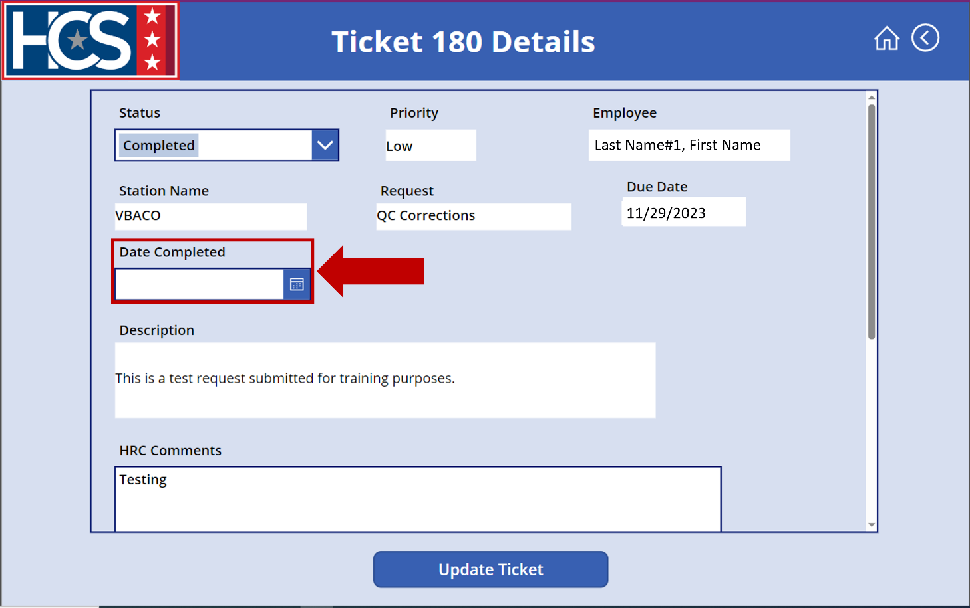
- Select the date that the ticket was completed from the calendar that displays.
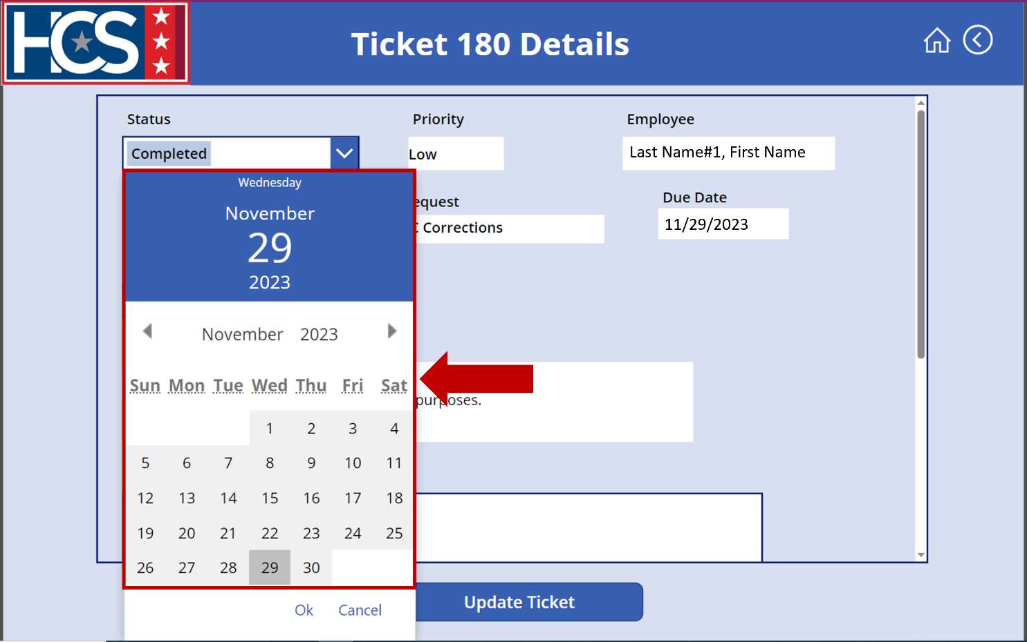
- Select OK to add the date.
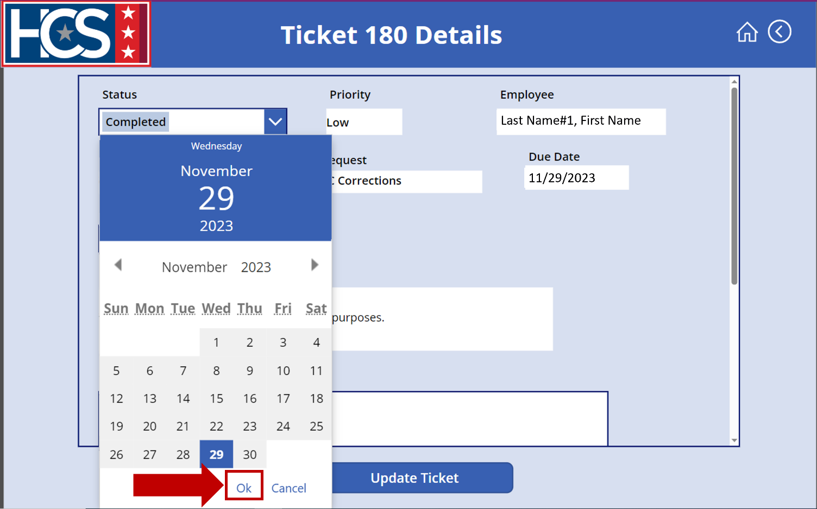
- Use the scroll bar to scroll down on the ticket details.
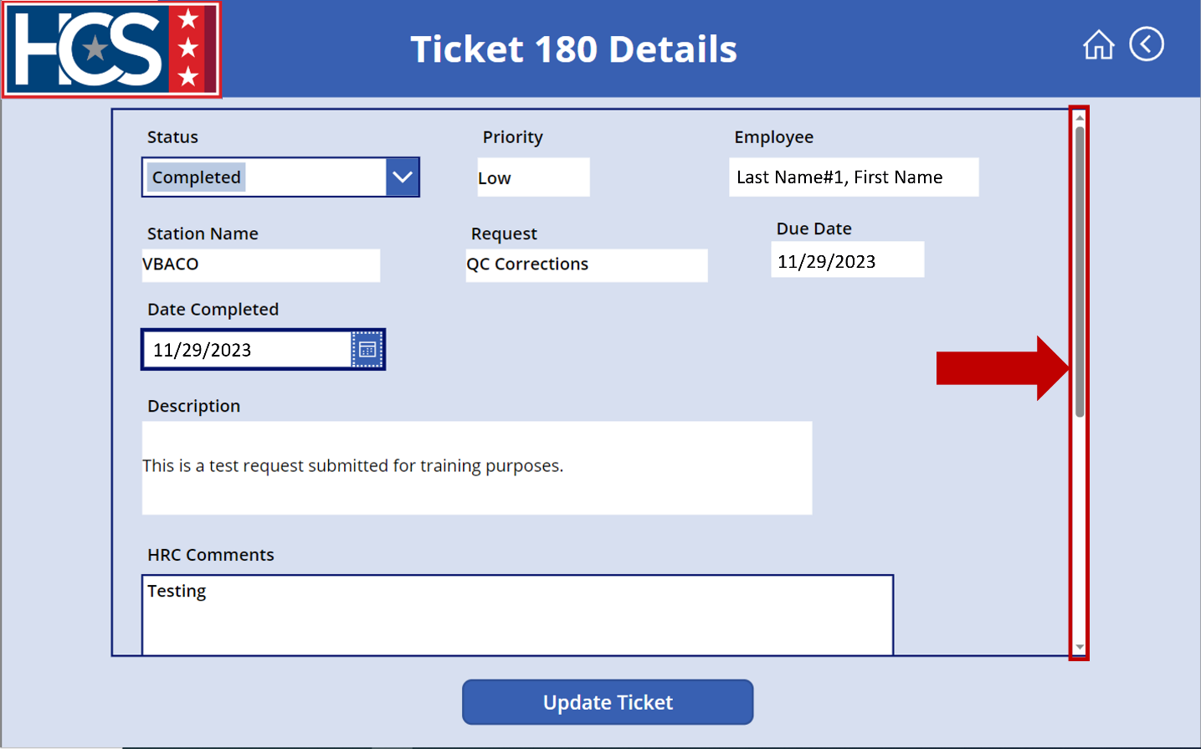
- Update the HRC Comments.
NOTE: The description added to the HRC Comments field should be relevant to the completion of the ticket (e.g., “11/29/2023: Document uploaded to eOPF.”).
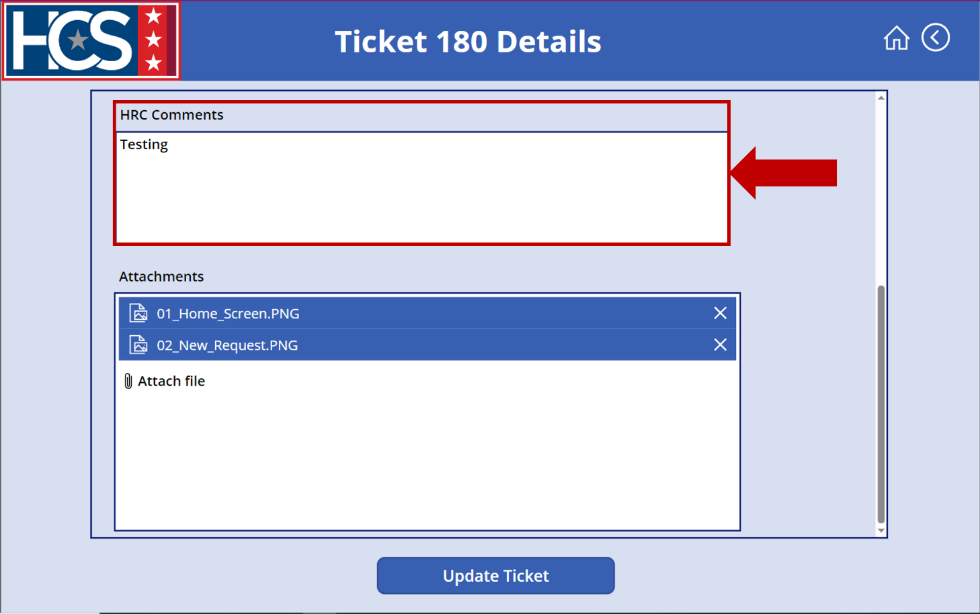
- Select Attach File to add attachments, if needed.
NOTE: Include any relevant paperwork to support ticket completion.
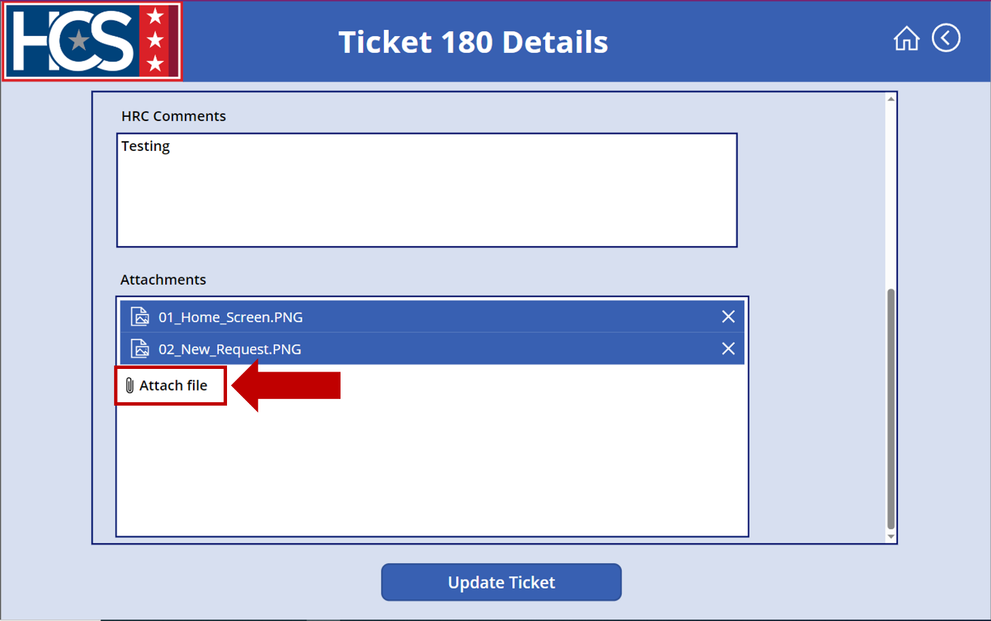
- Select Update Ticket.
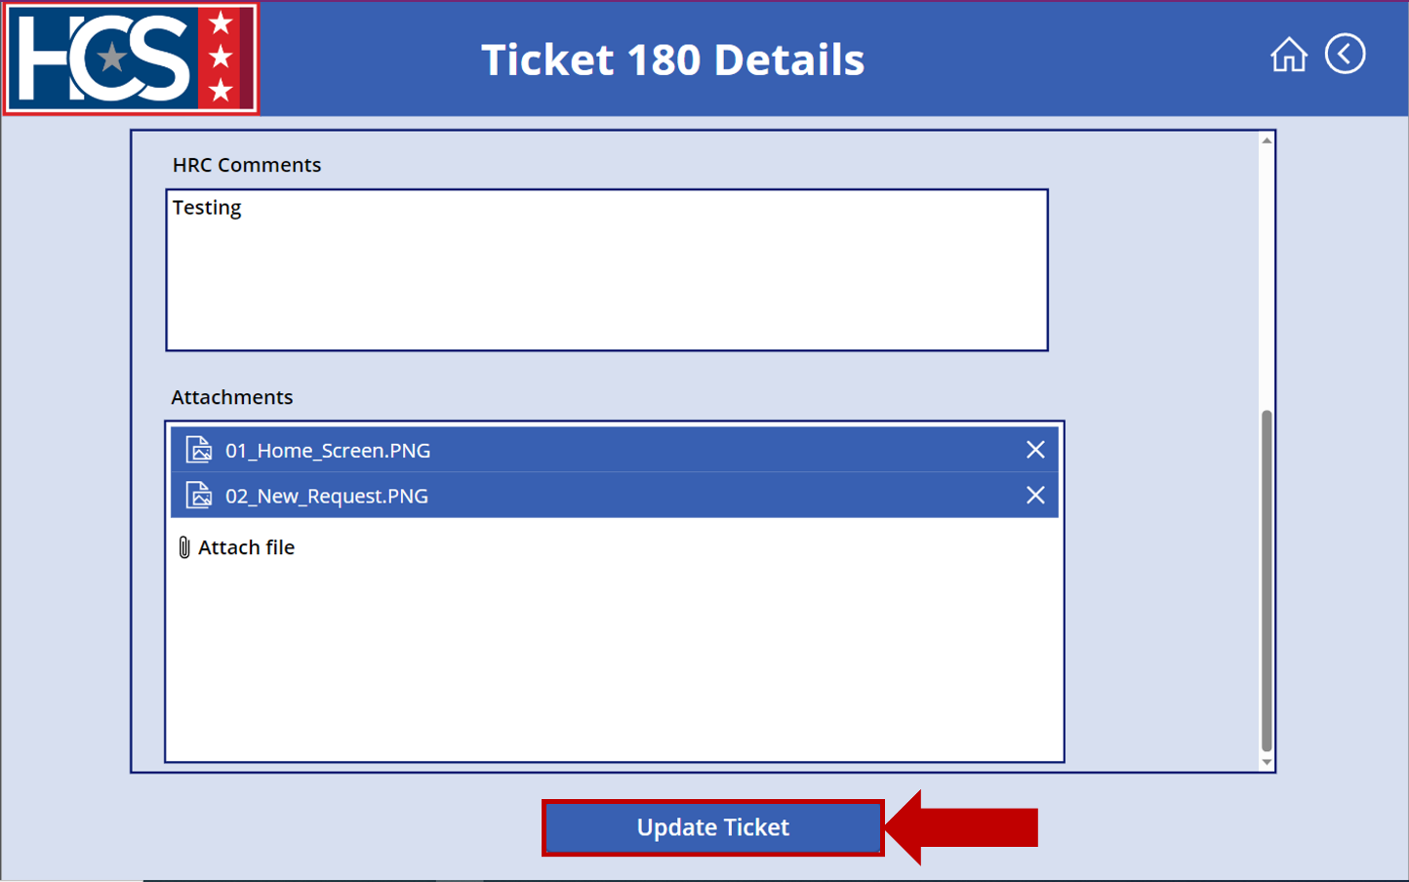
- Select Completed on the <User Name> Assigned Tickets screen to display tickets with a status of Completed.
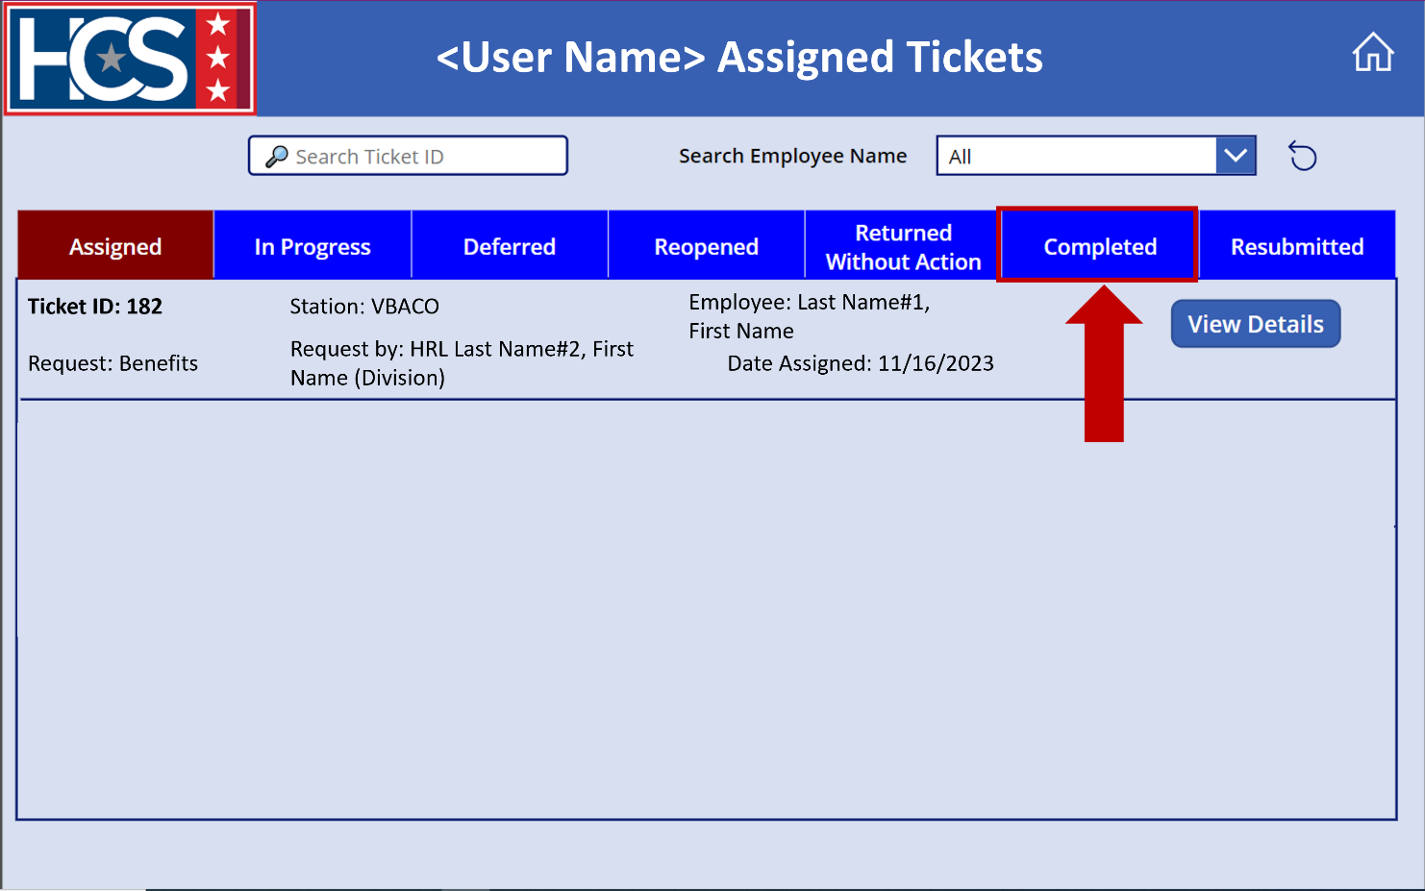
- Verify the ticket now displays under the Completed ticket status on the <User Name> Assigned Tickets screen.
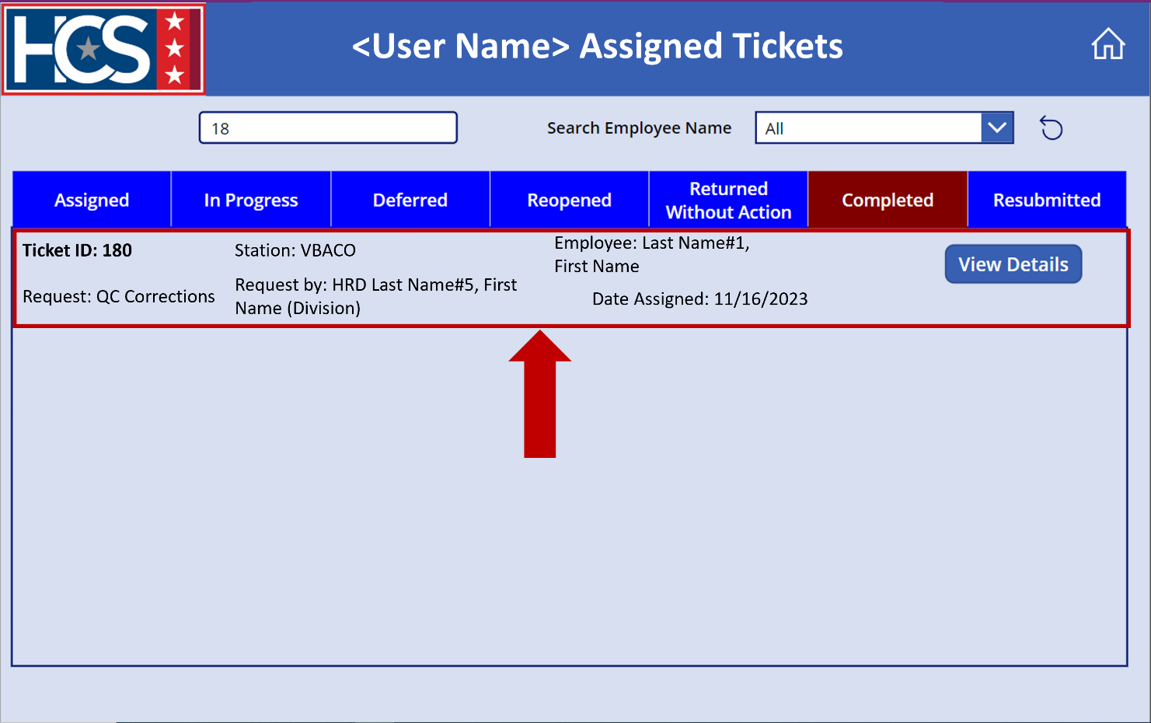

Update Ticket Status to Returned Without Action
If the HRS determines that a ticket is a duplicate submission or should be submitted through MSS, then the HRS should select the Returned Without Action status. An HRS can also use the Returned Without Action status if the submitted ticket is missing required documentation or critical information.
When selecting Returned Without Action, the HRS must provide a reason for returning the ticket without action using the Reason dropdown menu. If the reason is either Missing Documents or Additional Information Needed, the HRL/HRD Specialist can update the ticket with the appropriate documentation/information and resubmit the ticket for processing.
- Use search filters to filter tickets on the <User Name> Assigned Tickets screen, if needed.
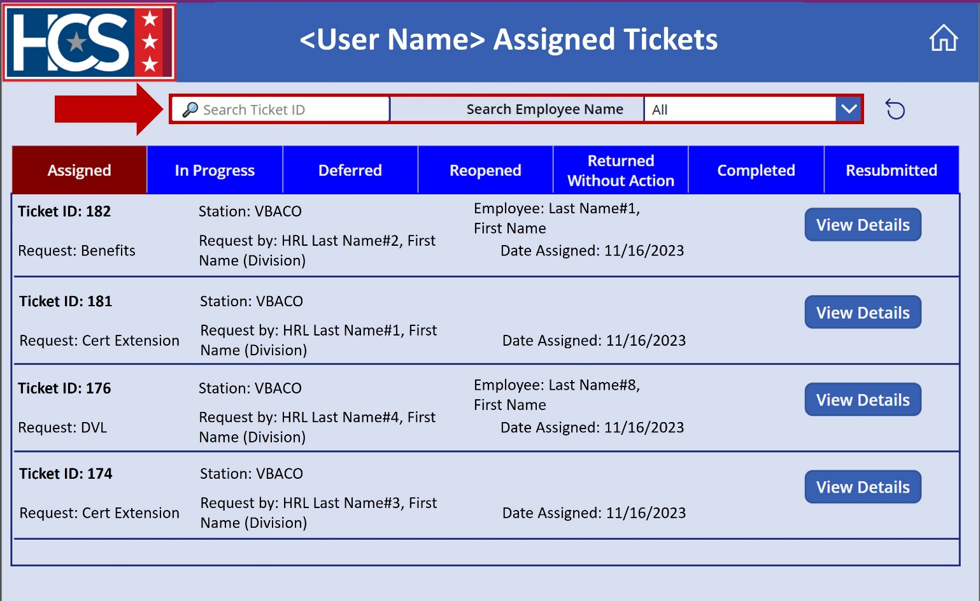

- Select View Details on the ticket to be updated.
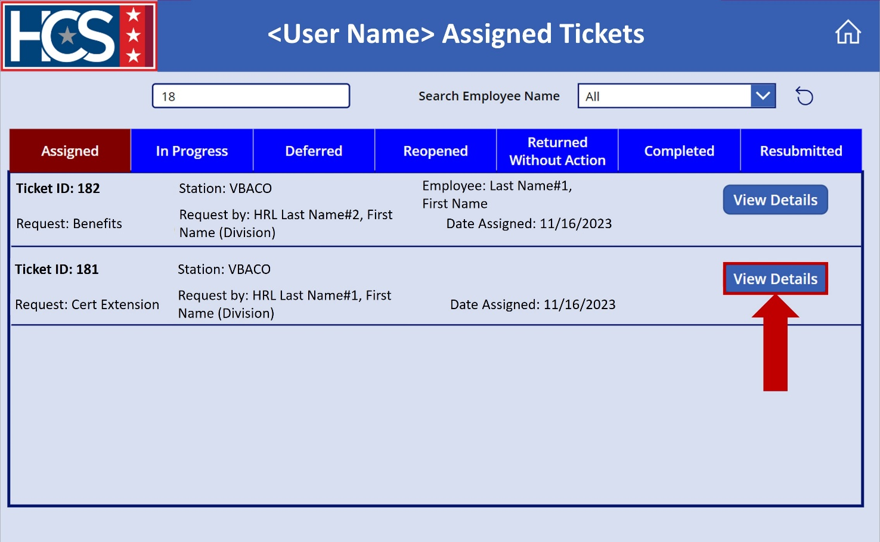
- Select Returned Without Action from the Status dropdown menu.
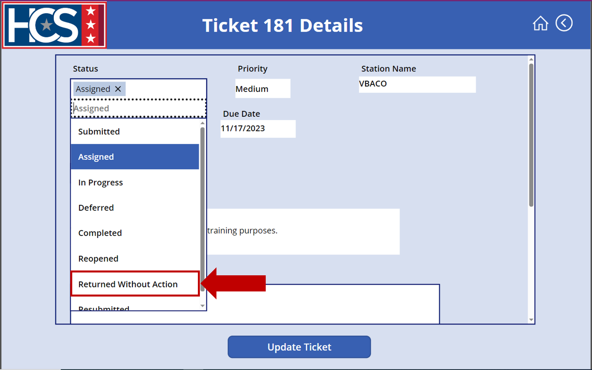
- Select the reason for the return without action using the Reason dropdown menu.
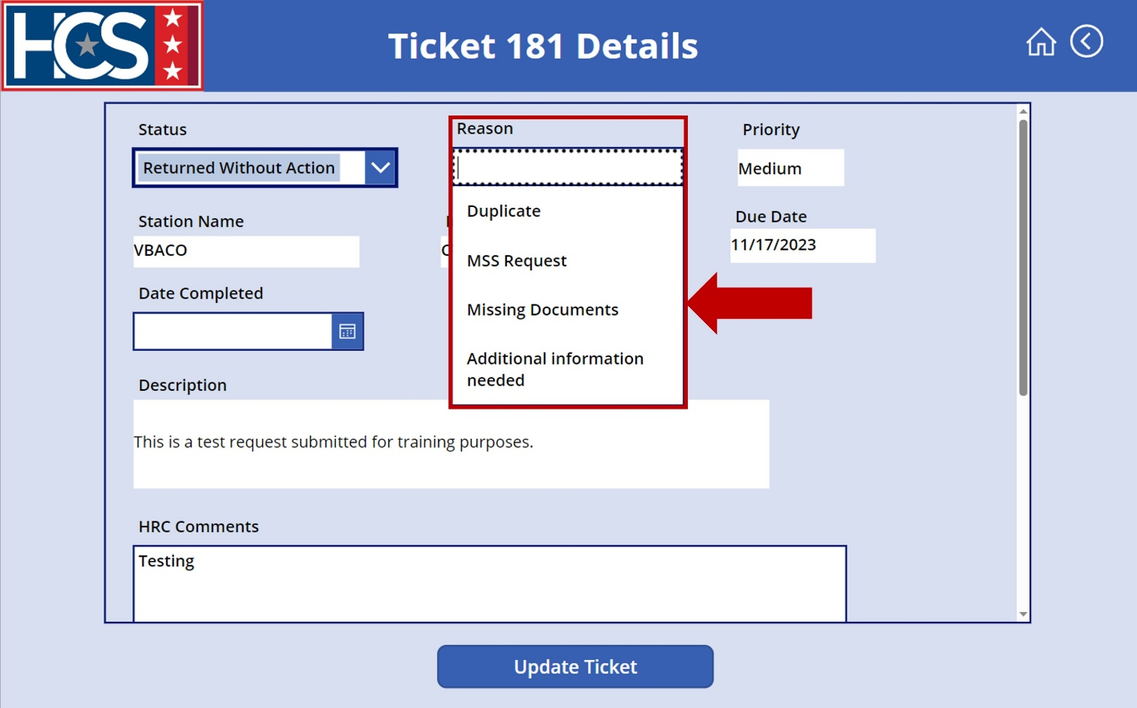
- Select Update Ticket.
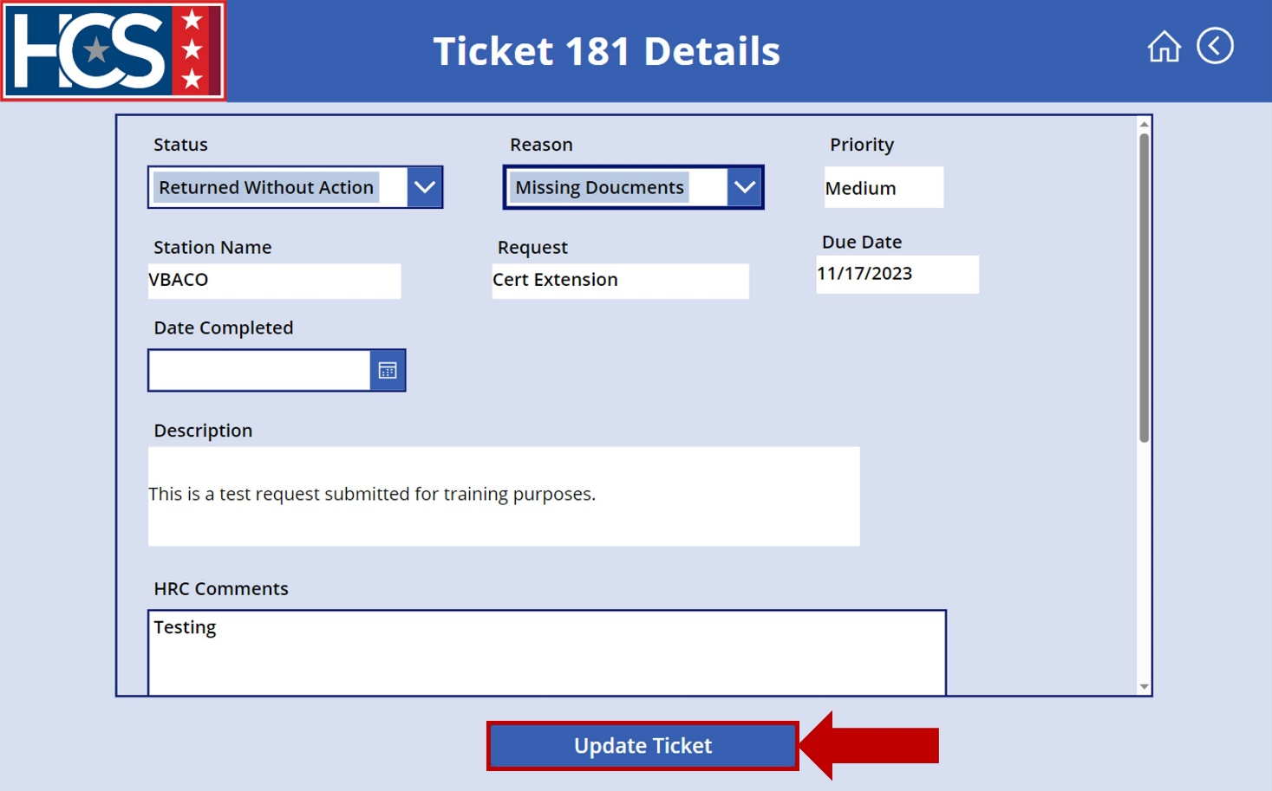
- Select Returned Without Action on the <User Name> Assigned Tickets screen to display tickets with a status of Returned Without Action.
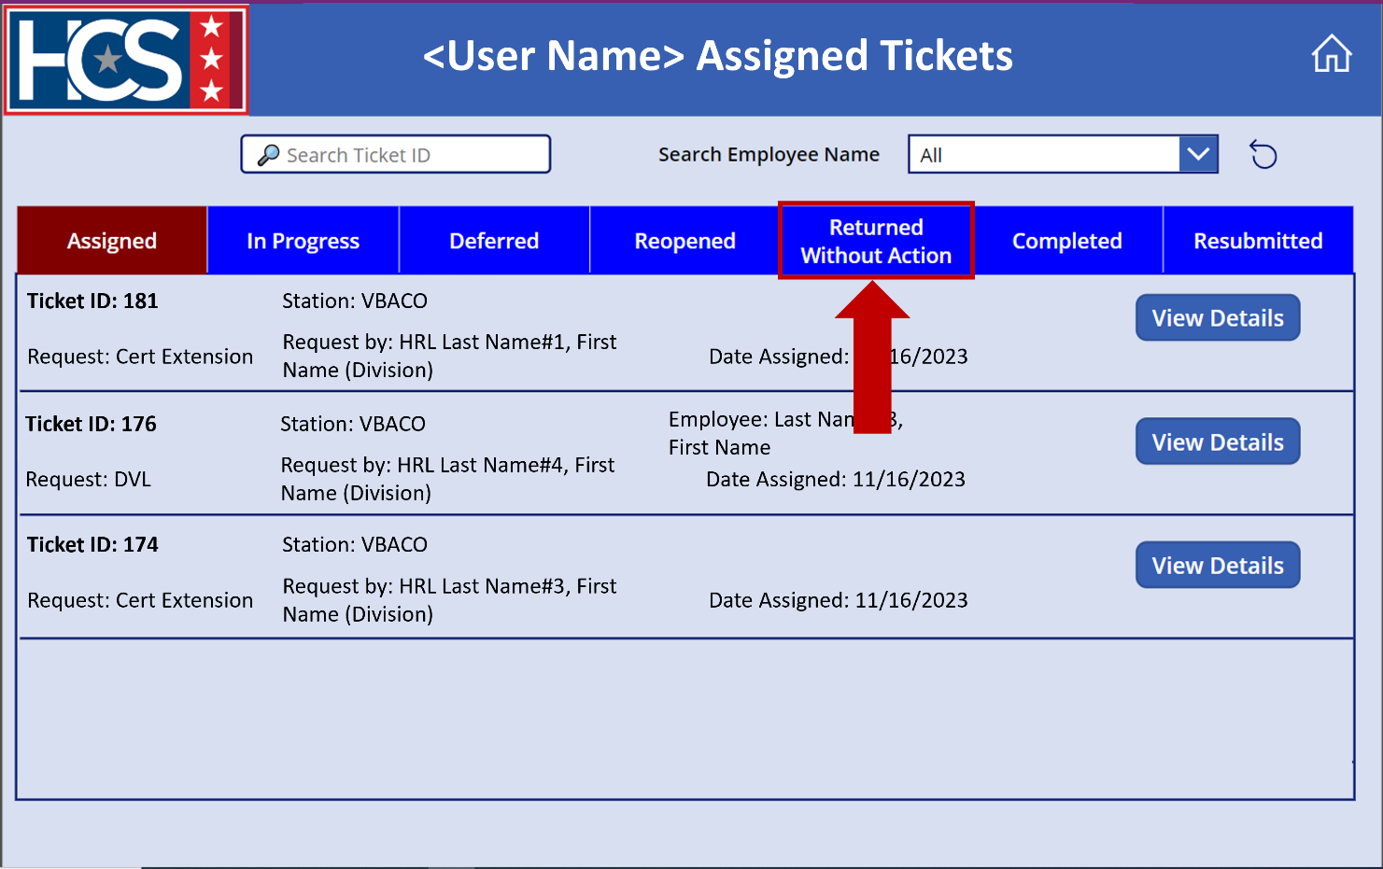
- Verify the ticket now displays under the Returned Without Action ticket status on the <User Name> Assigned Tickets screen.
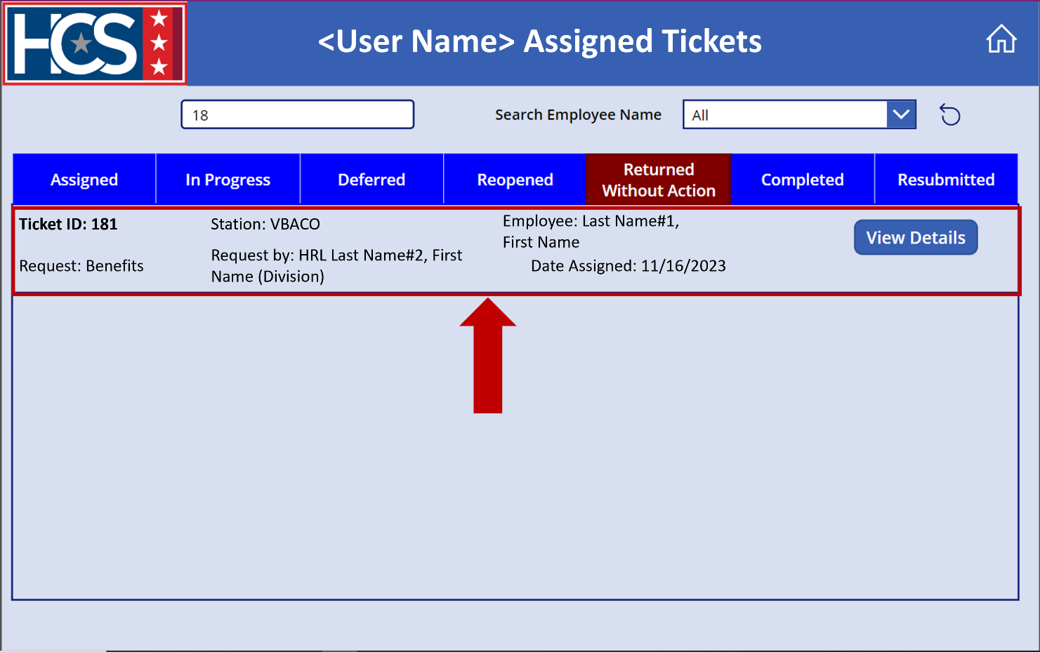

Update Ticket Status to Deferred
If an HRS must contact a third party (Office of Personnel Management [OPM], records center, etc.) in order to complete the ticket, they should use the Deferred status (rather than In Progress) to indicate to the HRL/HRD Specialist and HRC Supervisor that the ticket cannot be processed until a response from the third party is received.
Examples of situations that warrant a Deferred status include:
- Pay issue that results in HRS submitting tickets (remedy, debt offset, etc.) to Defense Finance and Accounting Service (DFAS).
- An employee requiring an SCD review, where the HRL submits SF 144a Form: Statement of Prior Service Worksheet using HR Connect and the HRS requests records from the National Archives and Records Administration to verify the Federal service claimed on the form.
When updating a ticket to Deferred status, the HRS must include a detailed description that explains the exact reason the ticket is being deferred and the third-party organization involved with the process. This description provides information for HRC Supervisors when managing metrics for their HRC and valuable details for HRLs waiting for the HRS to process the ticket.
- Use search filters to filter tickets on the <User Name> Assigned Tickets screen, if needed.
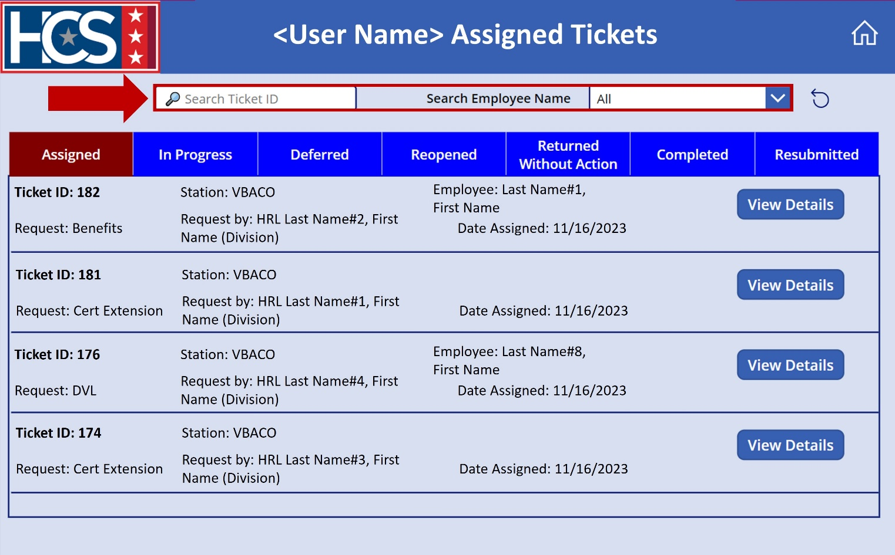

- Select View Details on the ticket to be updated.
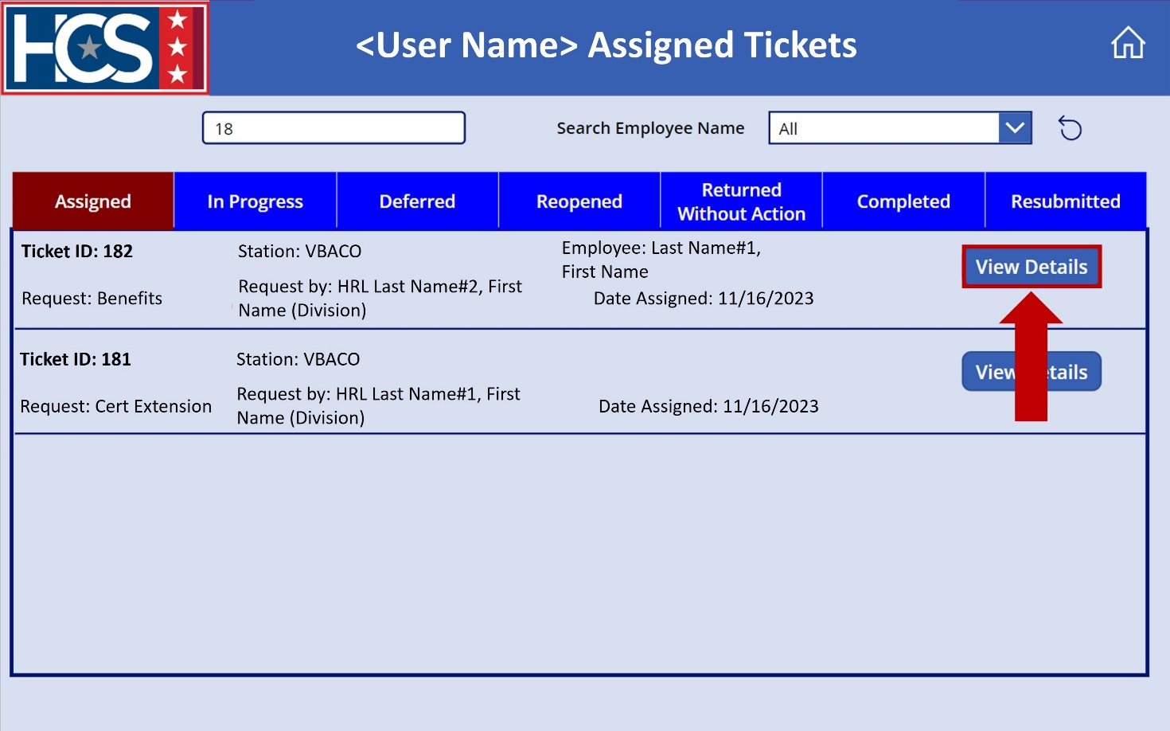
- Select Deferred from the Status dropdown menu.
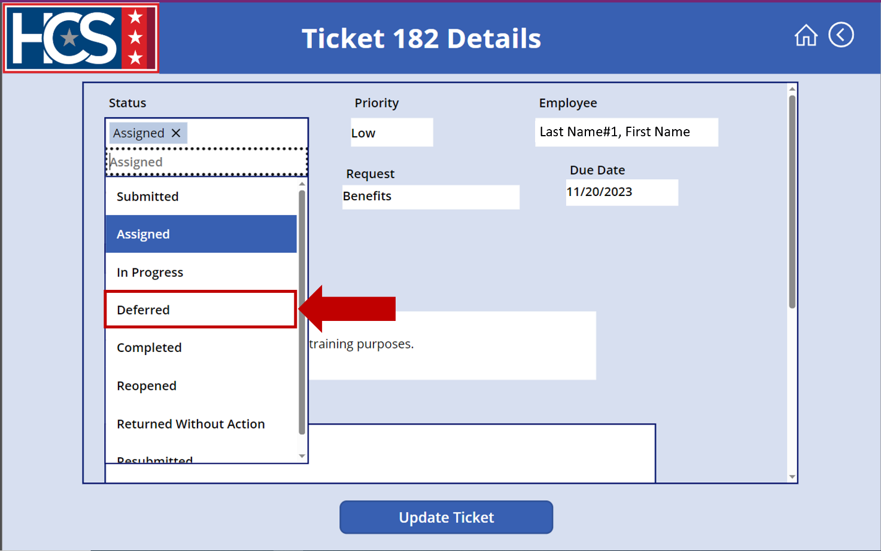
- Select Update Ticket.
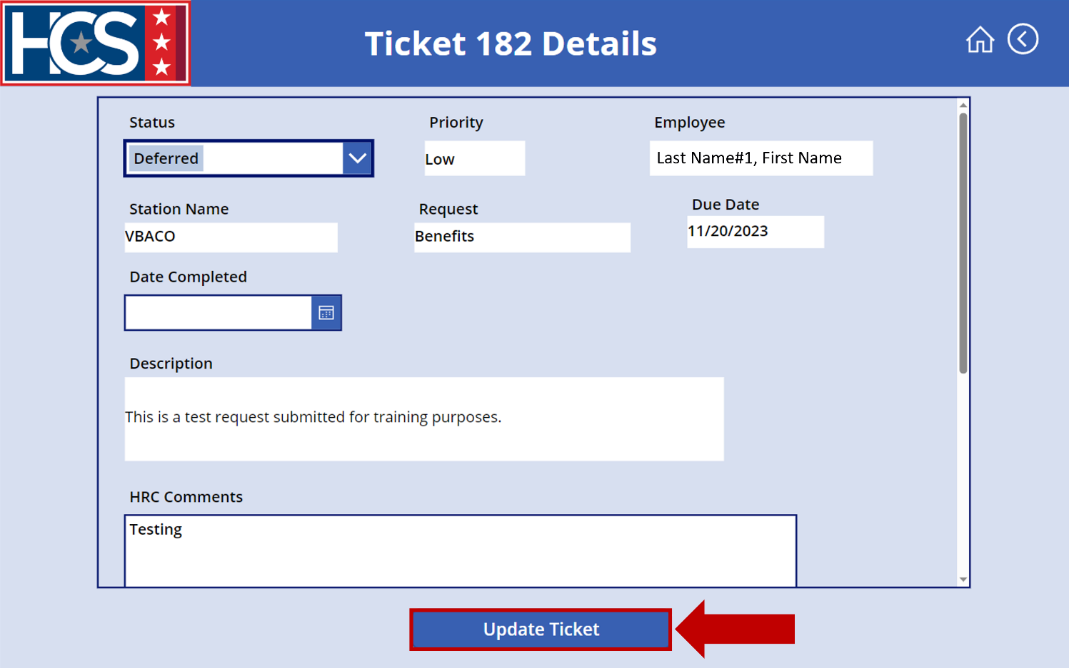
- Select Deferred on the <User Name> Assigned Tickets screen to display tickets with a status of Deferred.
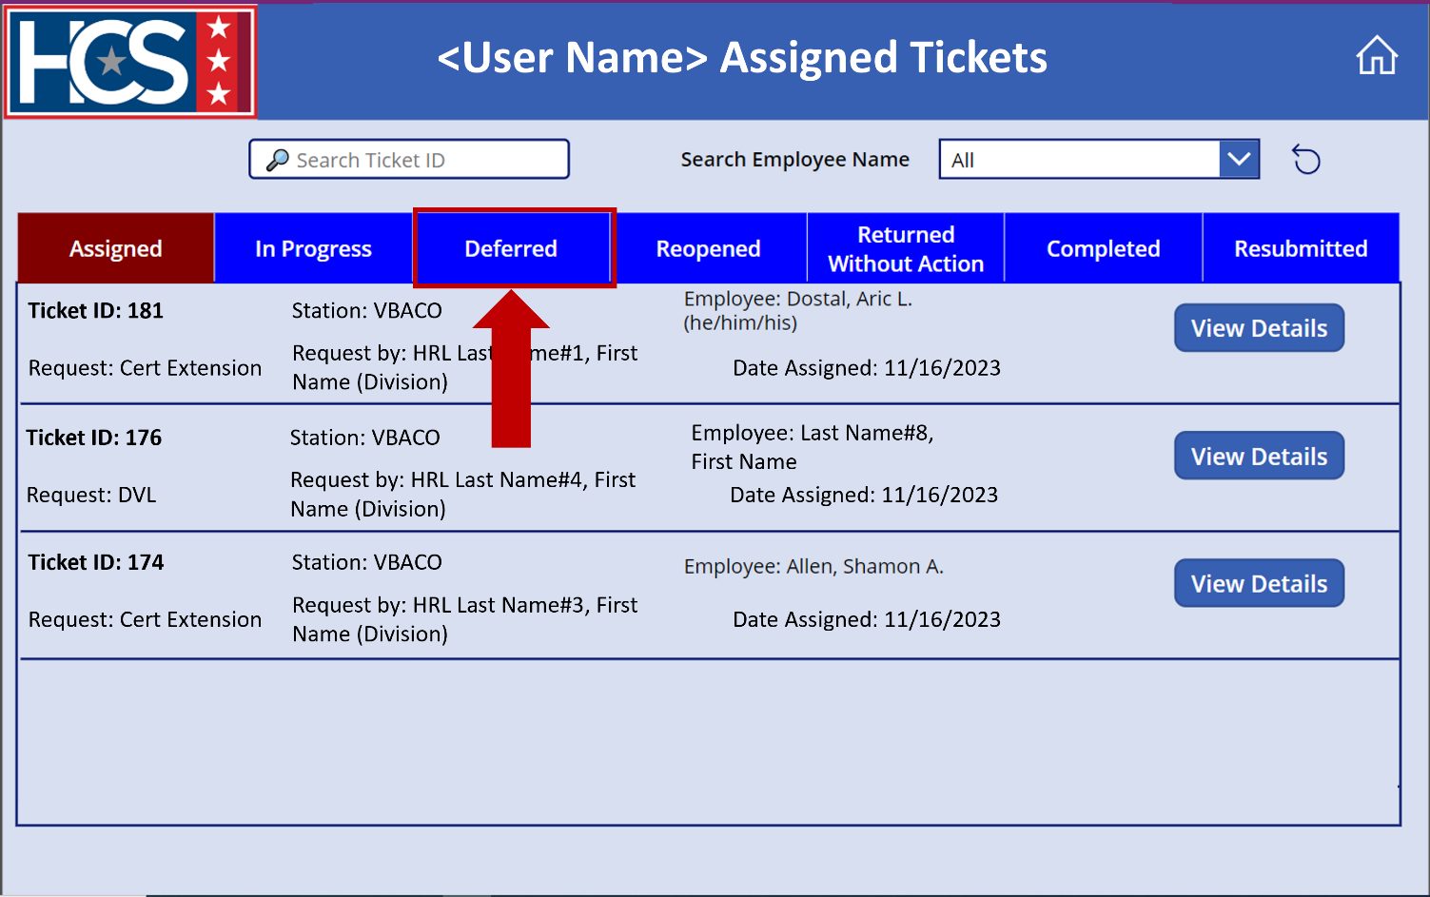
- Verify the ticket now displays under the Deferred ticket status on the <User Name> Assigned Tickets screen.
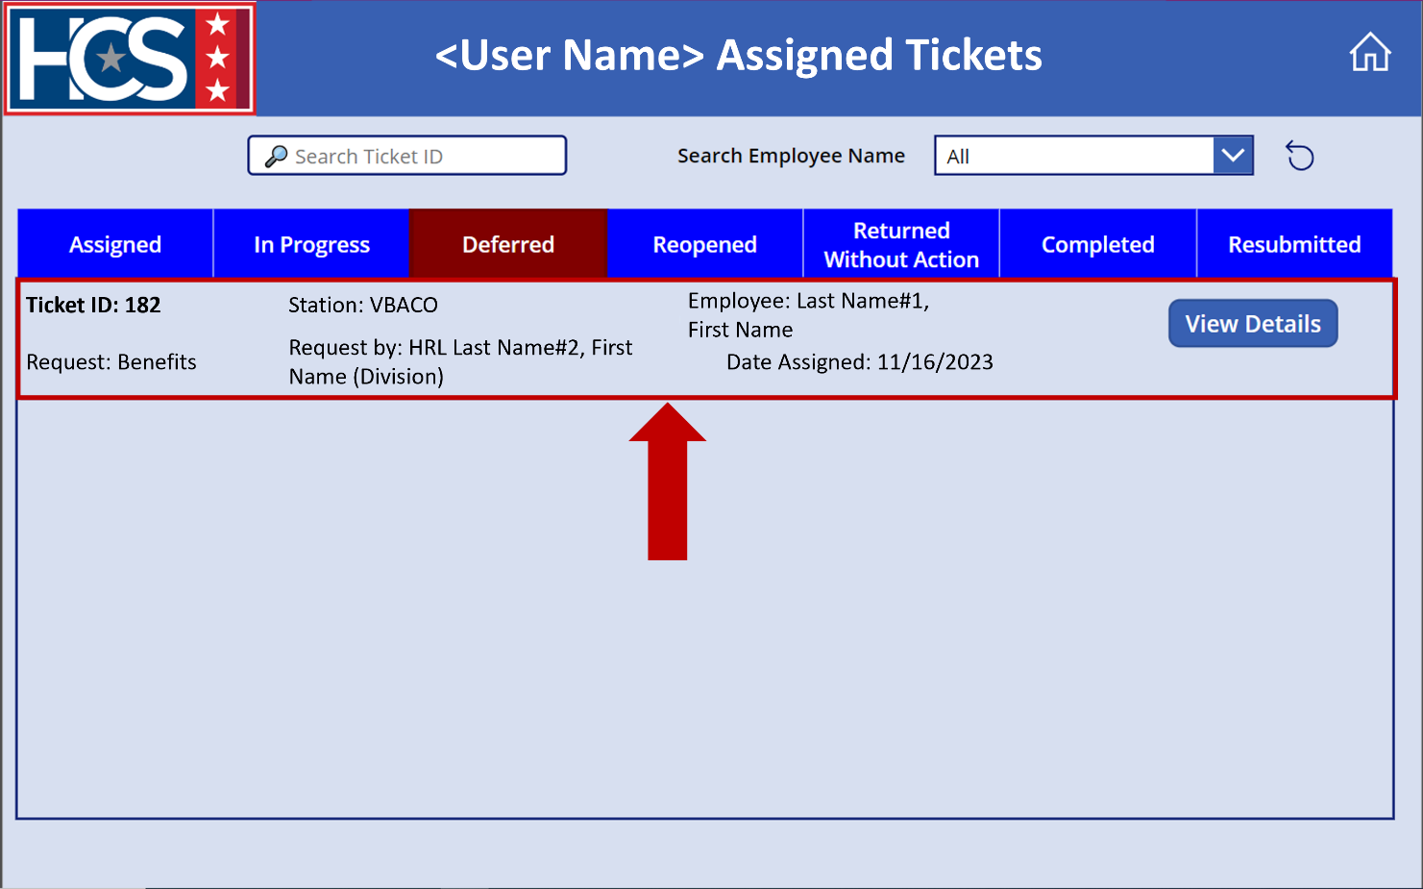

Submit HR Connect Feedback
- Select Feedback on the HR Connect home screen to submit any HR Connect-related feedback, if needed.
NOTE: The Feedback option on this screen allows for the submission of recommendations for system enhancements, issues with the system, access requests, etc.
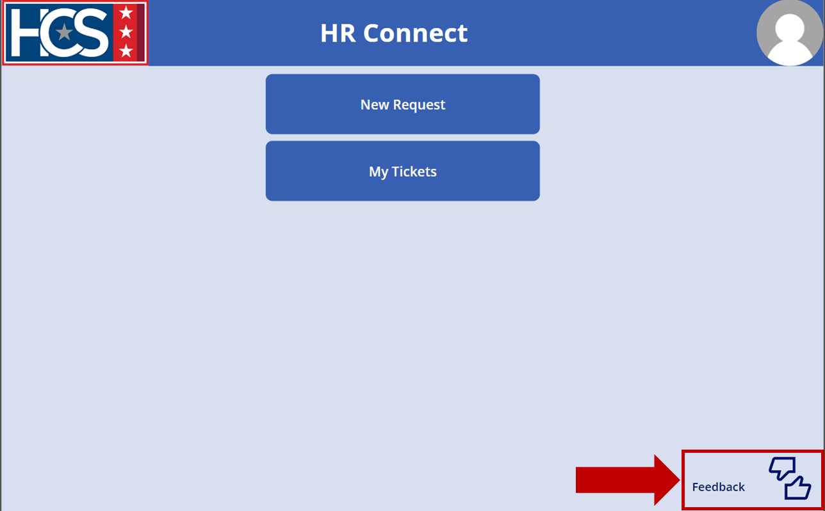
- Observe the Feedback screen.
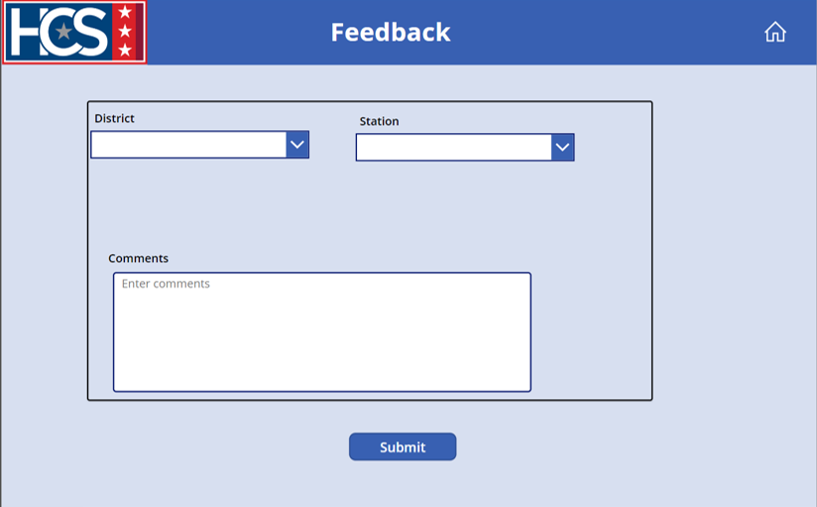
- Select the appropriate district from the District dropdown menu.
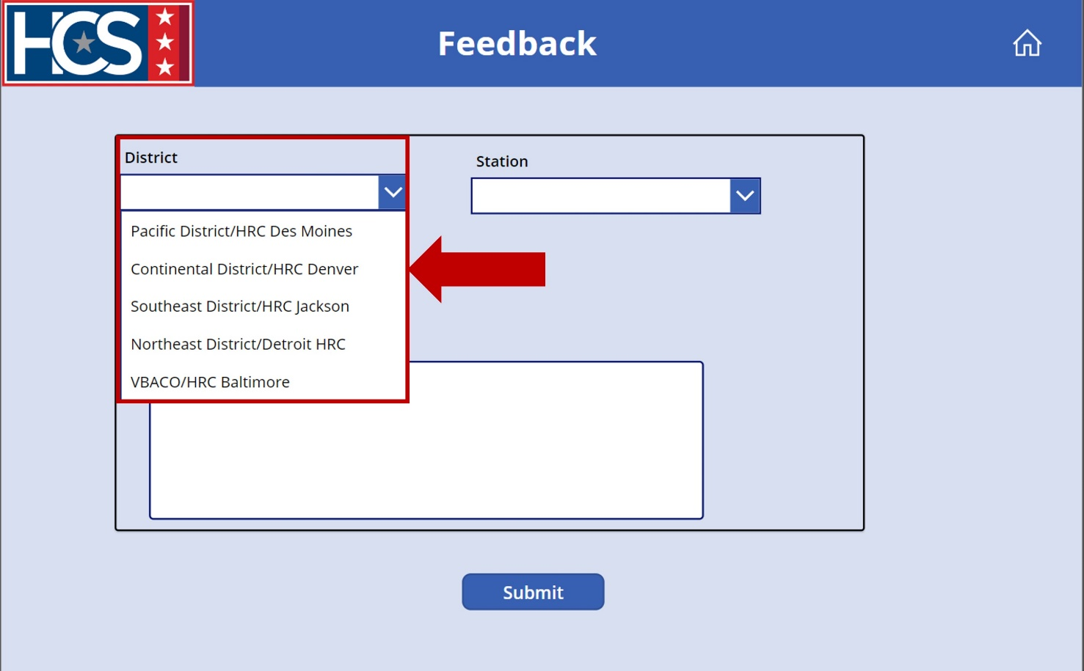
- Select the appropriate station from the Station dropdown menu.
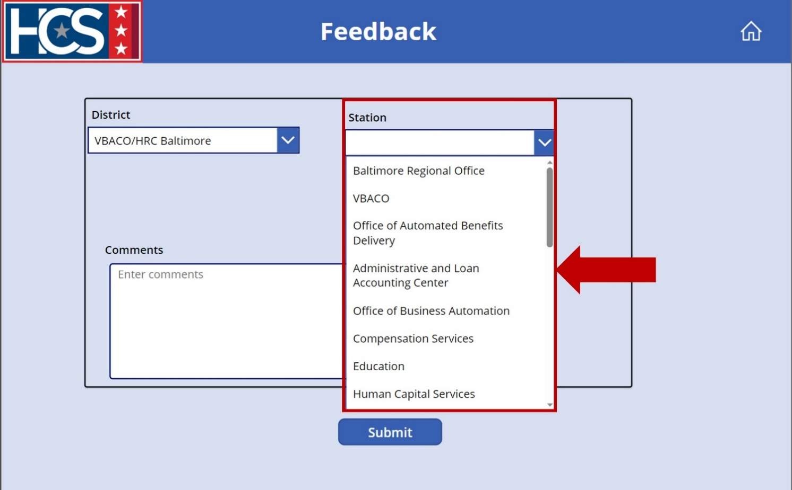
- Type feedback in the Comments field.
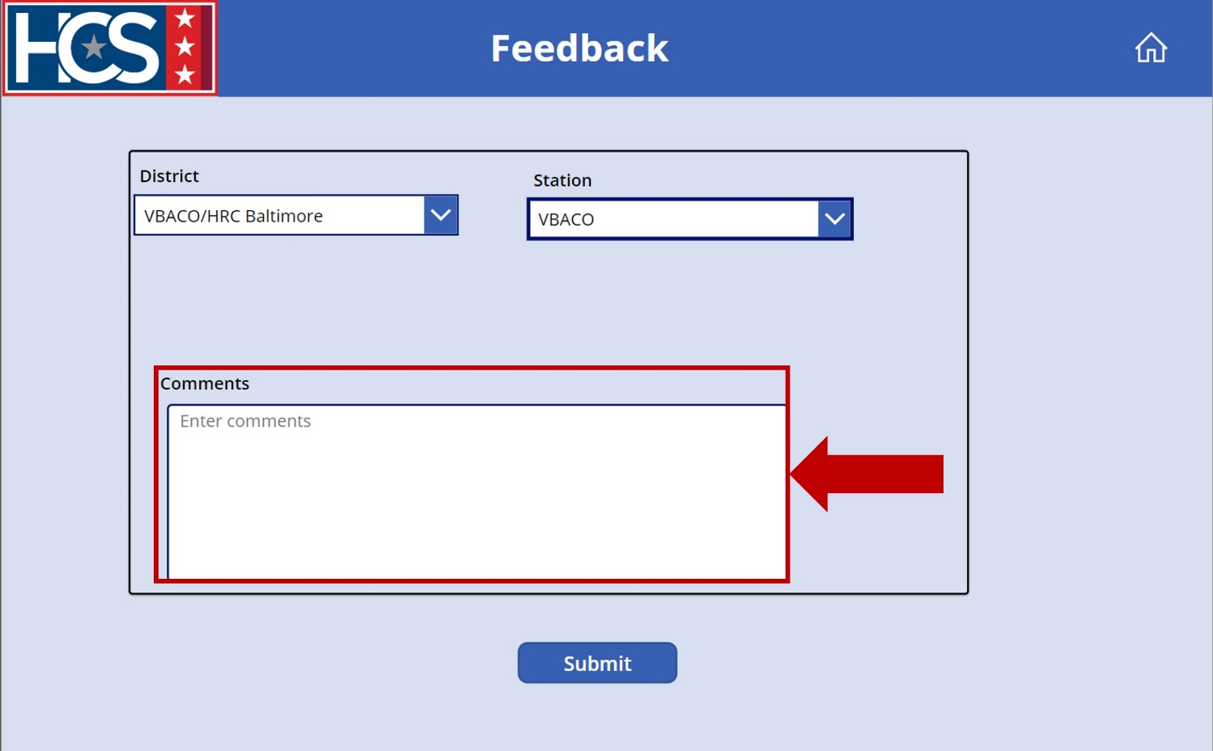
- Select Submit.
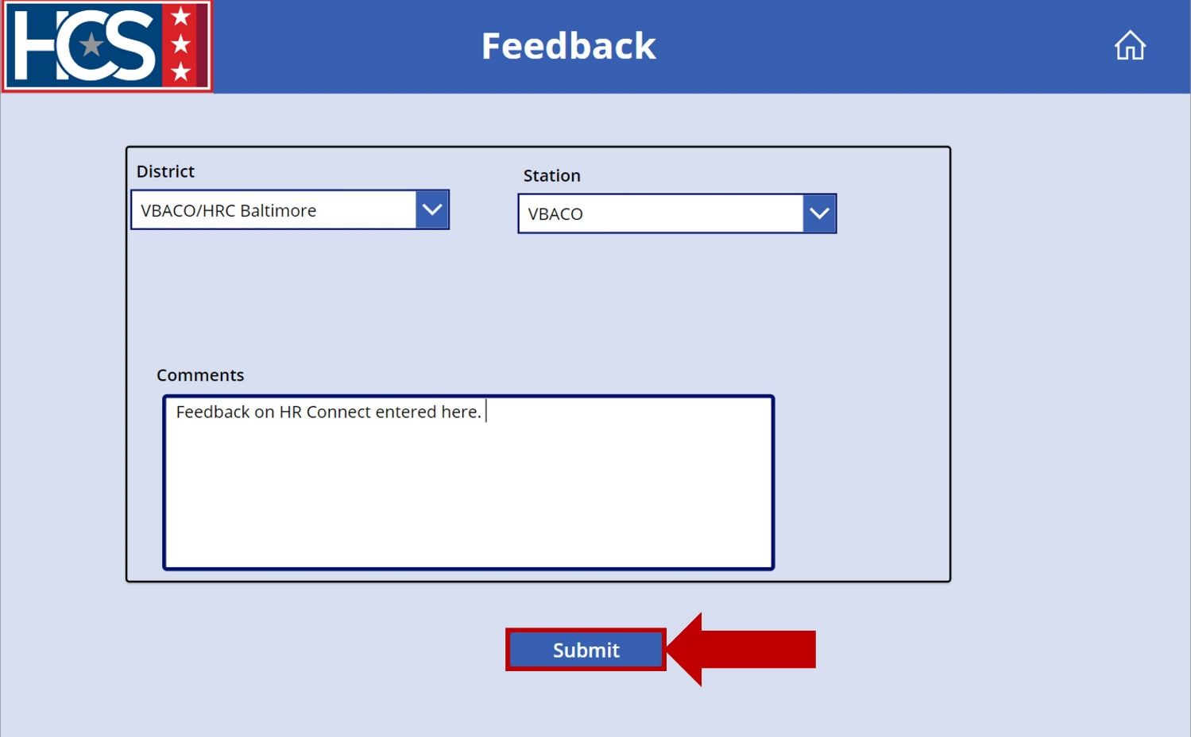
- Select the Home icon to return to the home screen.
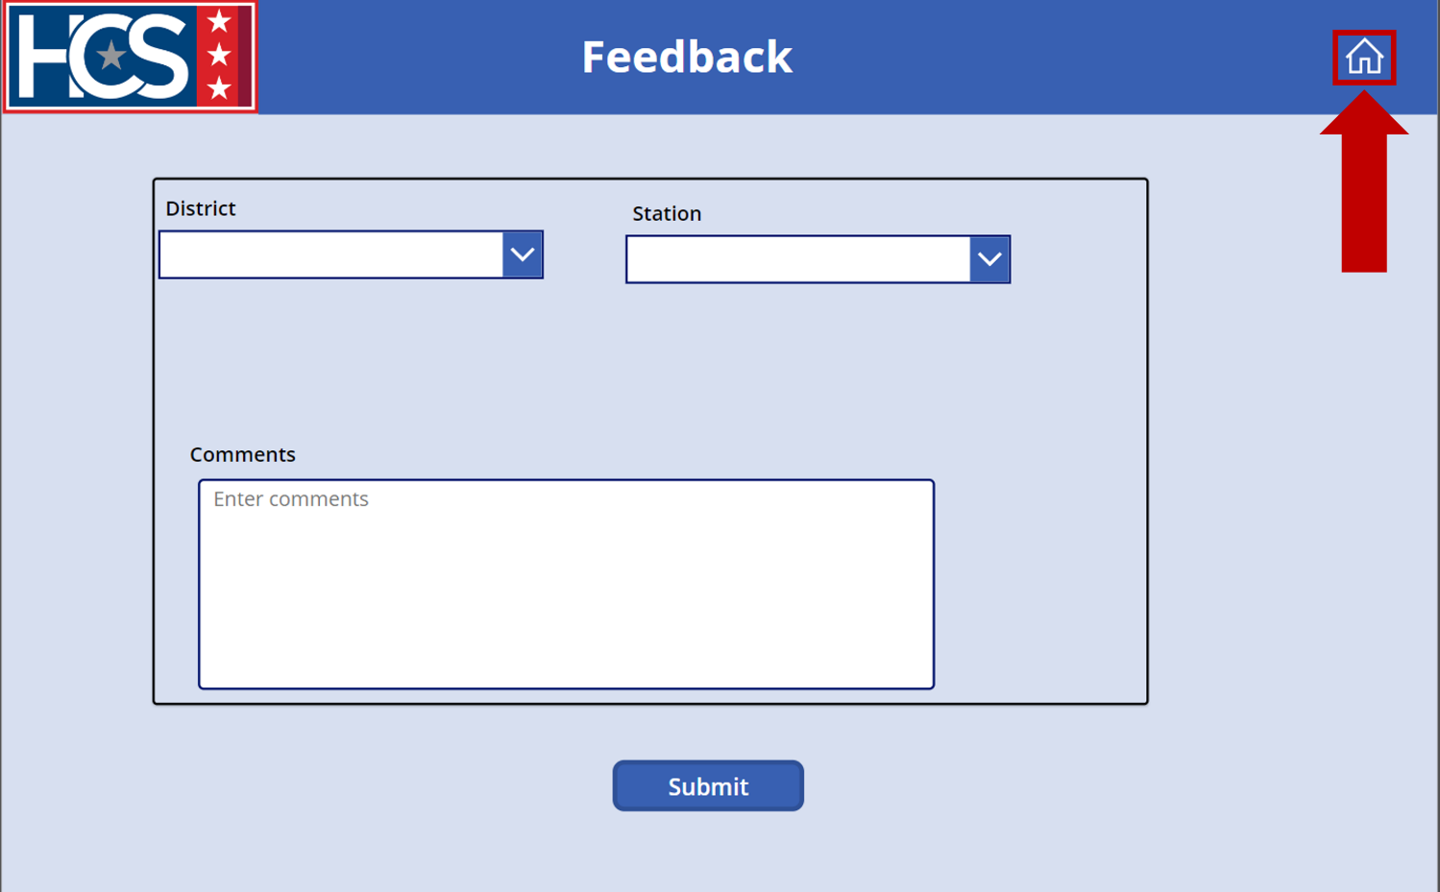

Executive Dashboard

Overview
The Executive Dashboard provides executive leadership with a comprehensive snapshot of ticket requests for all districts, by a specific district, and/or by specific station. The data within the dashboard allows an HRL/HRD Specialist/HRS to view trends in request categories, identify areas in need of training, review processing timelines for requests by category, and search for tickets. HRLs/HRD Specialists/HRSs also have the option to export tables into MS Excel for additional review outside of the dashboard.
The data displayed on the dashboard can be refined using the provided filters:
- District
- Station Name
- Category
- Task Status
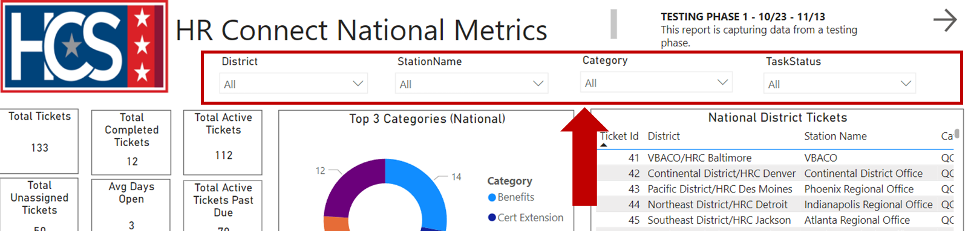

Each filter includes a dropdown menu that allows for filtering of information:
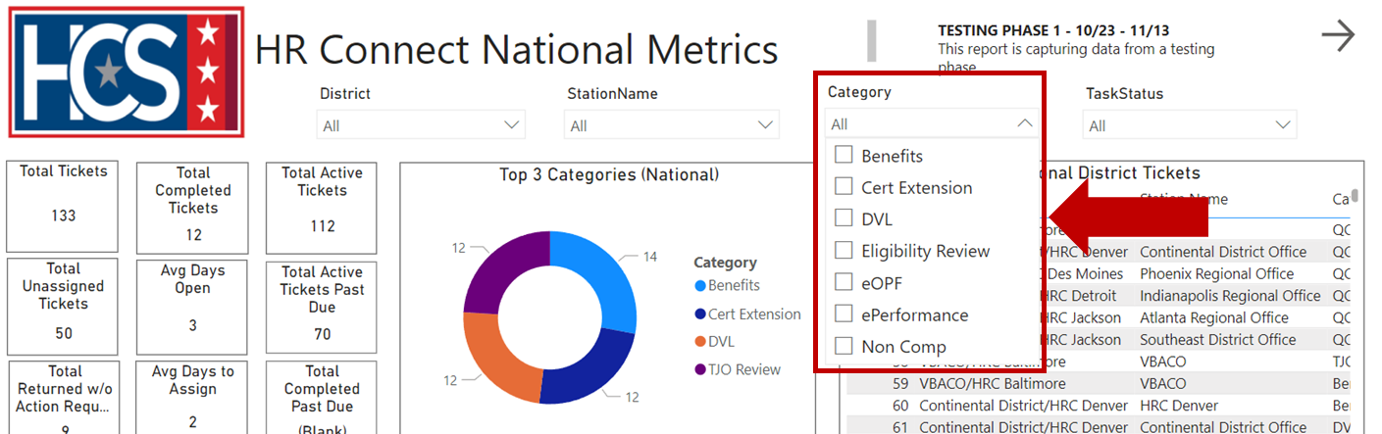

HR Connect National Metrics Dashboard Data
Information on the HR Connect National Metrics dashboard includes several data categories.
- Snapshot of national ticket requests, providing data that includes:
  - Total Tickets.
  - Total Completed Tickets.
  - Total Active Tickets.
  - Total Unassigned Tickets.
  - Average Days Open.
  - Total Active Tickets Past Due.
  - Total Returned Without Action Requests.
  - Average Days to Assign.
  - Total Completed Past Due.
- National top 3 categories of request types displayed as a pie chart.
- Complete list of national district tickets.
- Top 3 categories of request types for each District displayed with a pie chart.
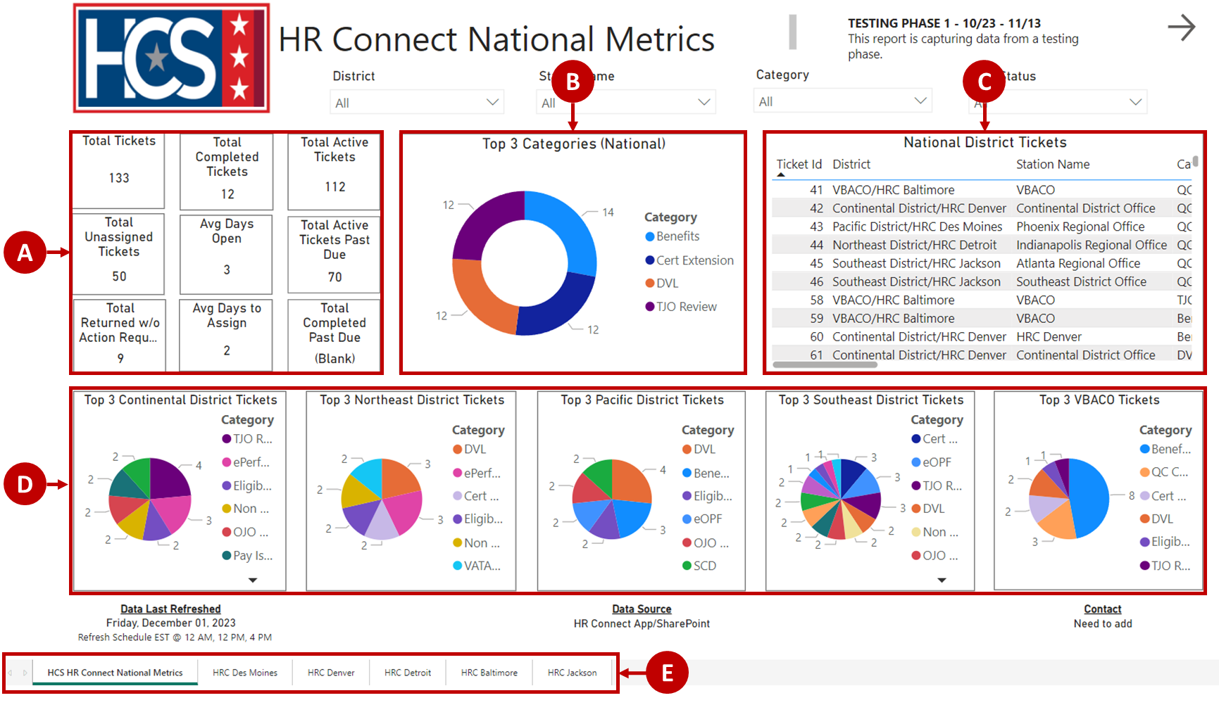

HR Connect District Metrics Dashboard Data
Information on the HR Connect District Metrics dashboard includes several data categories.
- Snapshot of district ticket requests, providing data that includes:
  - Total Tickets.
  - Completed Tickets.
  - Unassigned Tickets.
  - Active Tickets.
  - Average Days to Assign.
  - Average Days Open.
- Lists that display ticket information for all Active Tickets Past Due and Tickets Returned Without Action.
- Complete list of District tickets.
- Bar chart for each station displaying ticket request types.
- Back and Next arrows that return to the previous tab or advance to the next tab.
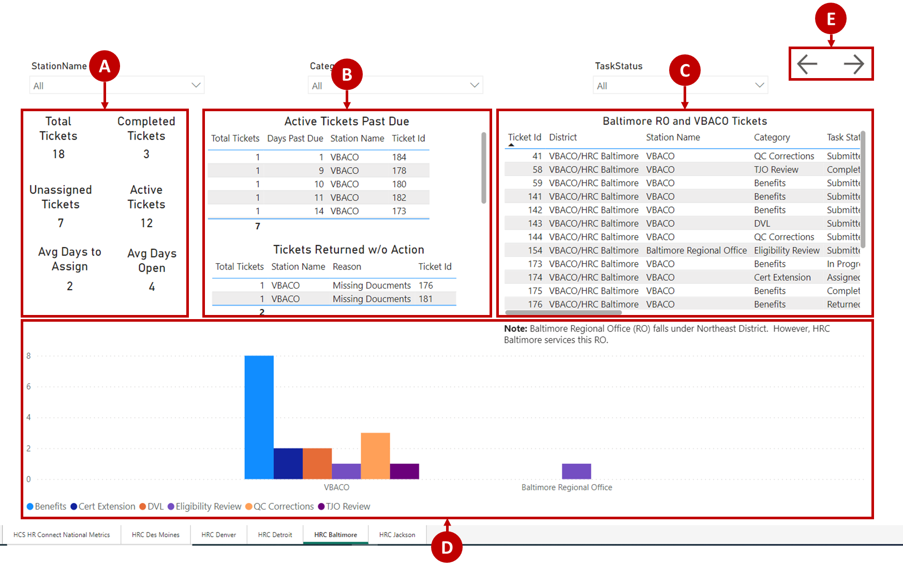

Access Executive Dashboard
- Select Executive Dashboard on the HR Connect home screen.
NOTE: The Executive Dashboard launches in a new Microsoft Edge browser tab.
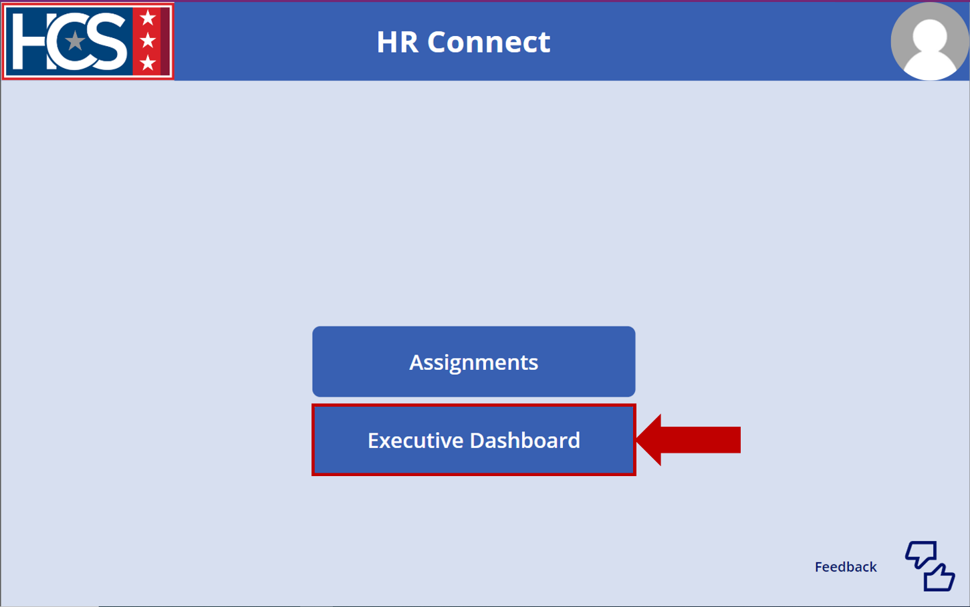
- Observe the metrics displayed on the HR Connect National Metrics screen.
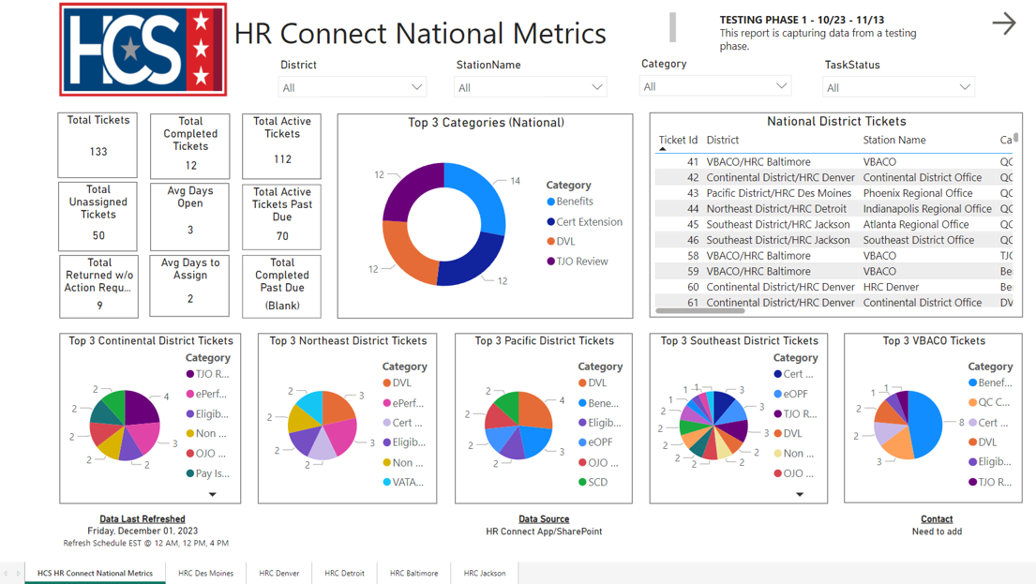
- Use the filters to refine data, as needed.
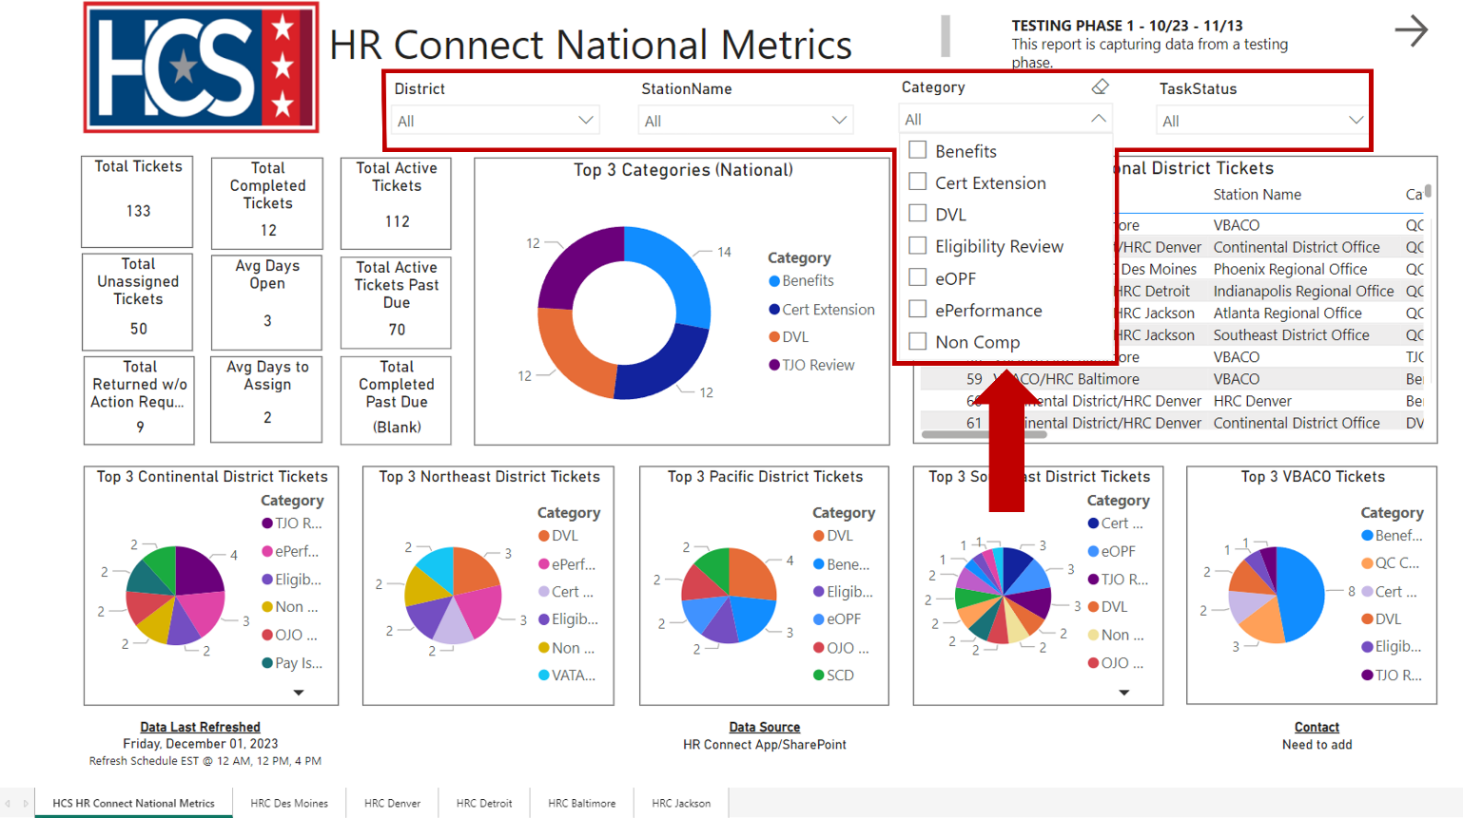
- Observe the metrics displayed as a result of applying the Category filter.
NOTE: To clear an applied filter, select the filter checkbox again.
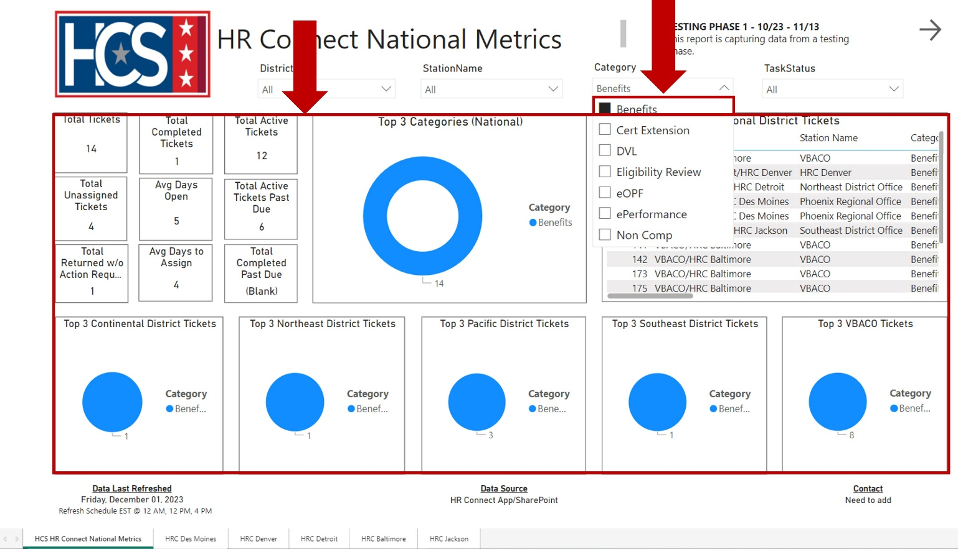

- Select a District tab to view the metrics for a specific district.
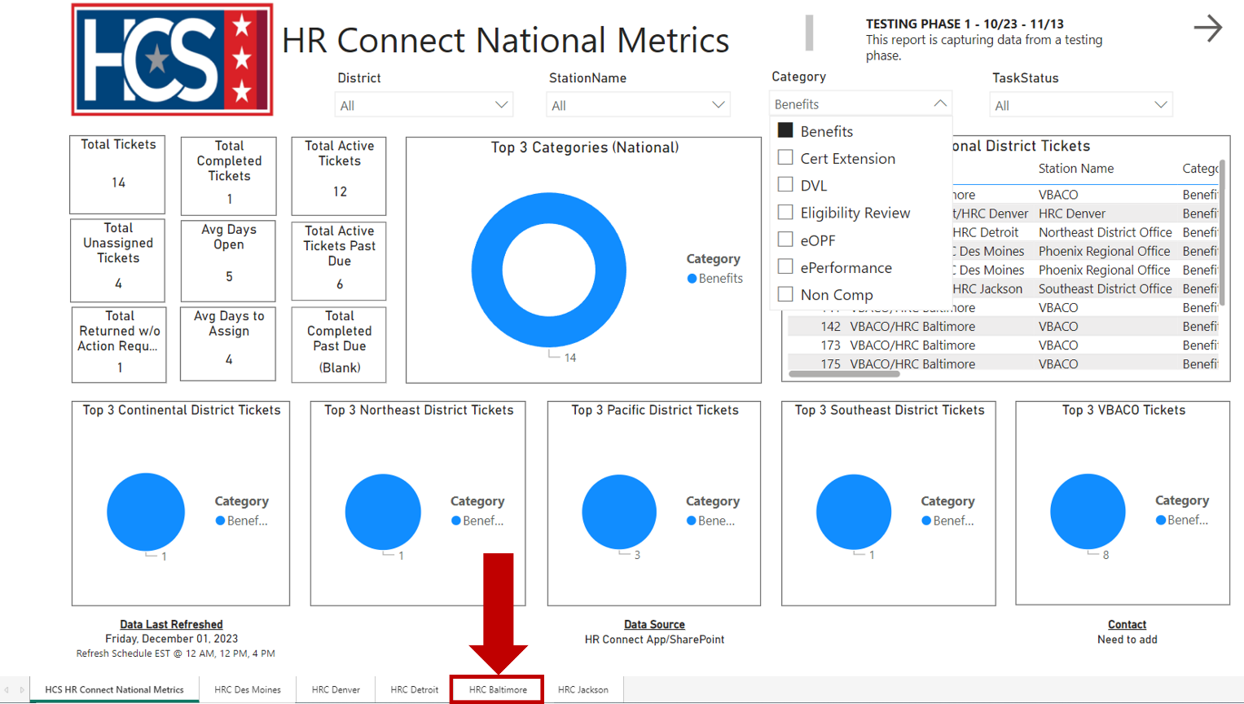
- Observe the metrics displayed on the District View screen.
NOTE: Ticket Request Type statistics are reflected in a bar chart by Station.
NOTE: Additional filters may be applied to the District to further refine the data.
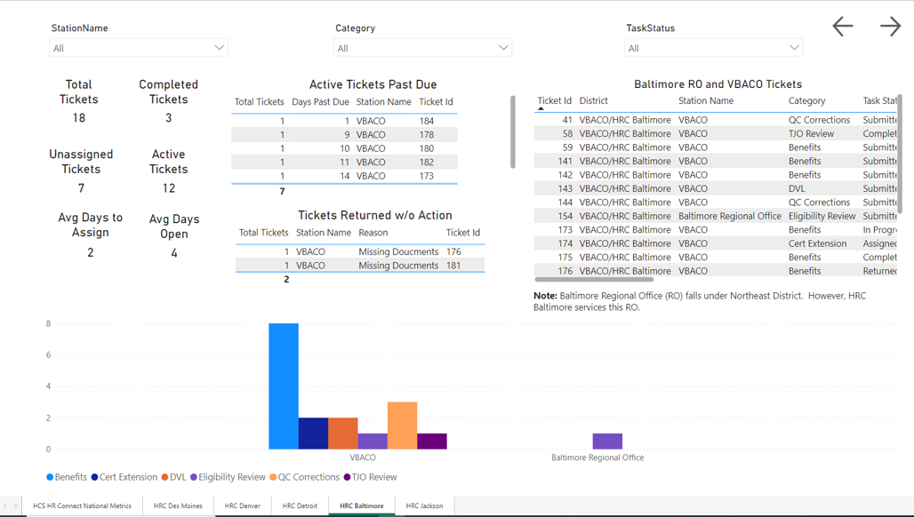
- Select Focus mode from the pop-up menu that displays when mousing over the top-right section of the selected data pod.
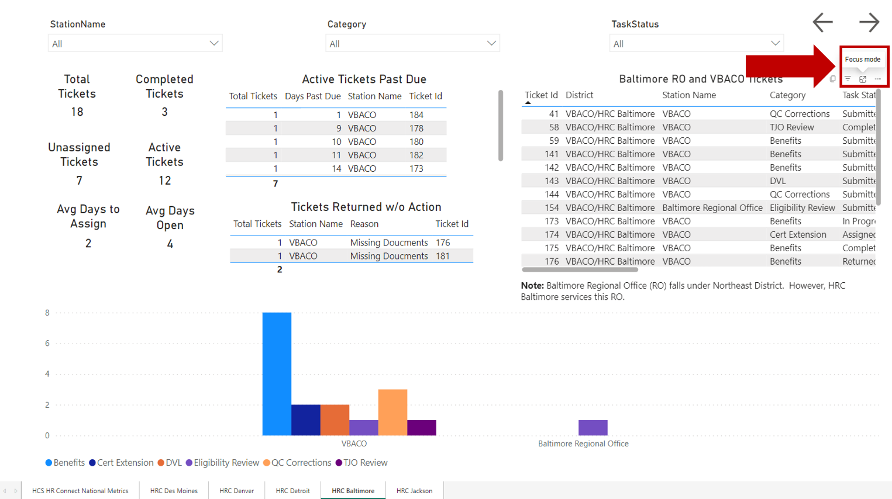
- Observe the information in the expanded data pod.
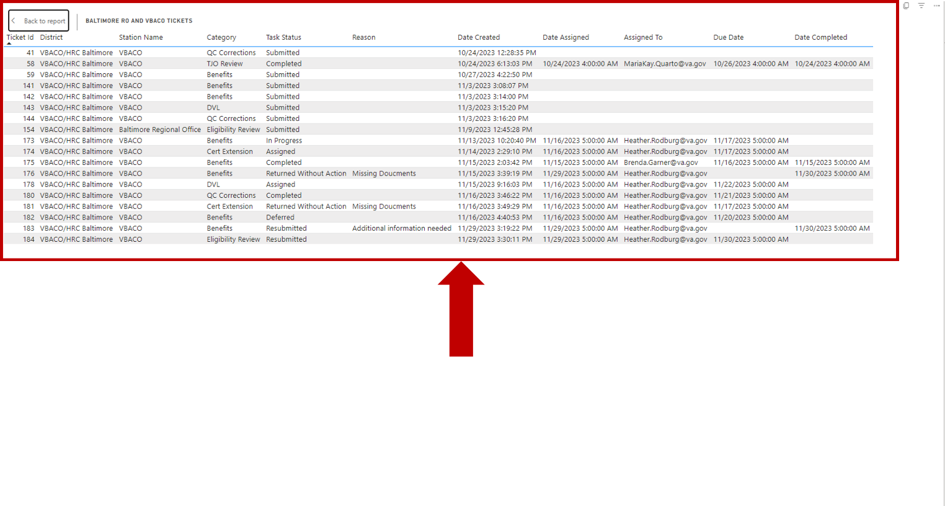

- Select Back to report to return to the District View screen.
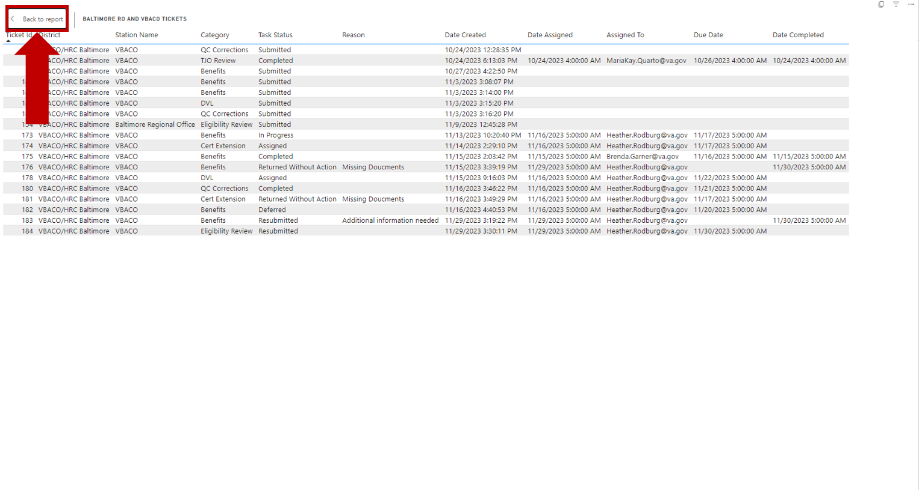
- Observe the District View screen.

Export Executive Dashboard Data (Summarized)
- Mouse over the top-right corner of the data pod to be exported.
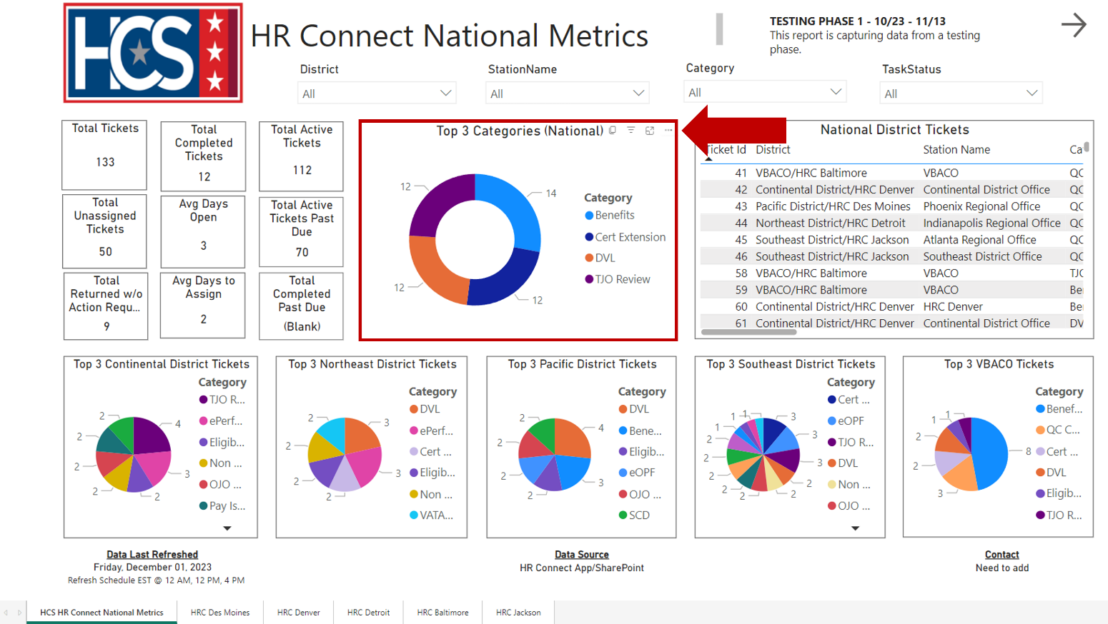
- Select Export data from the pop-up menu.
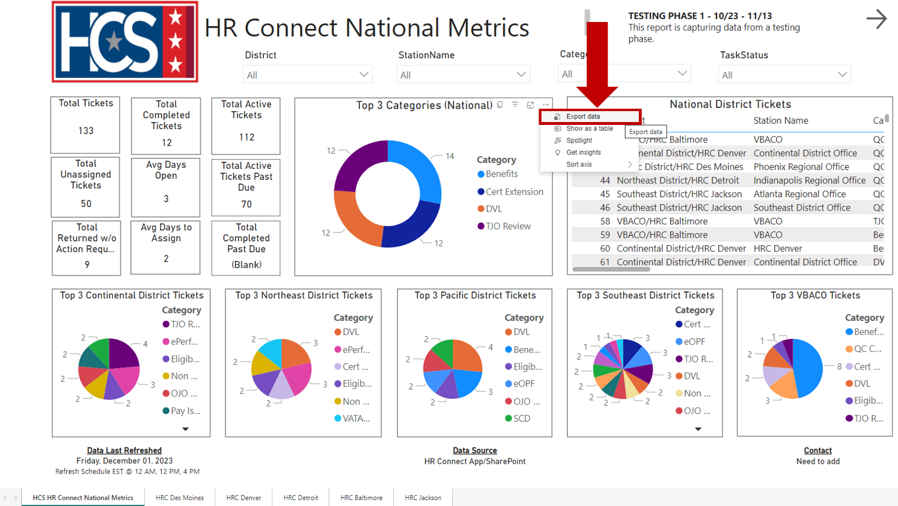

- Observe the Export window.
NOTE: If exporting data from a graph data pod, the only export option available on the Export window is Summarized data.
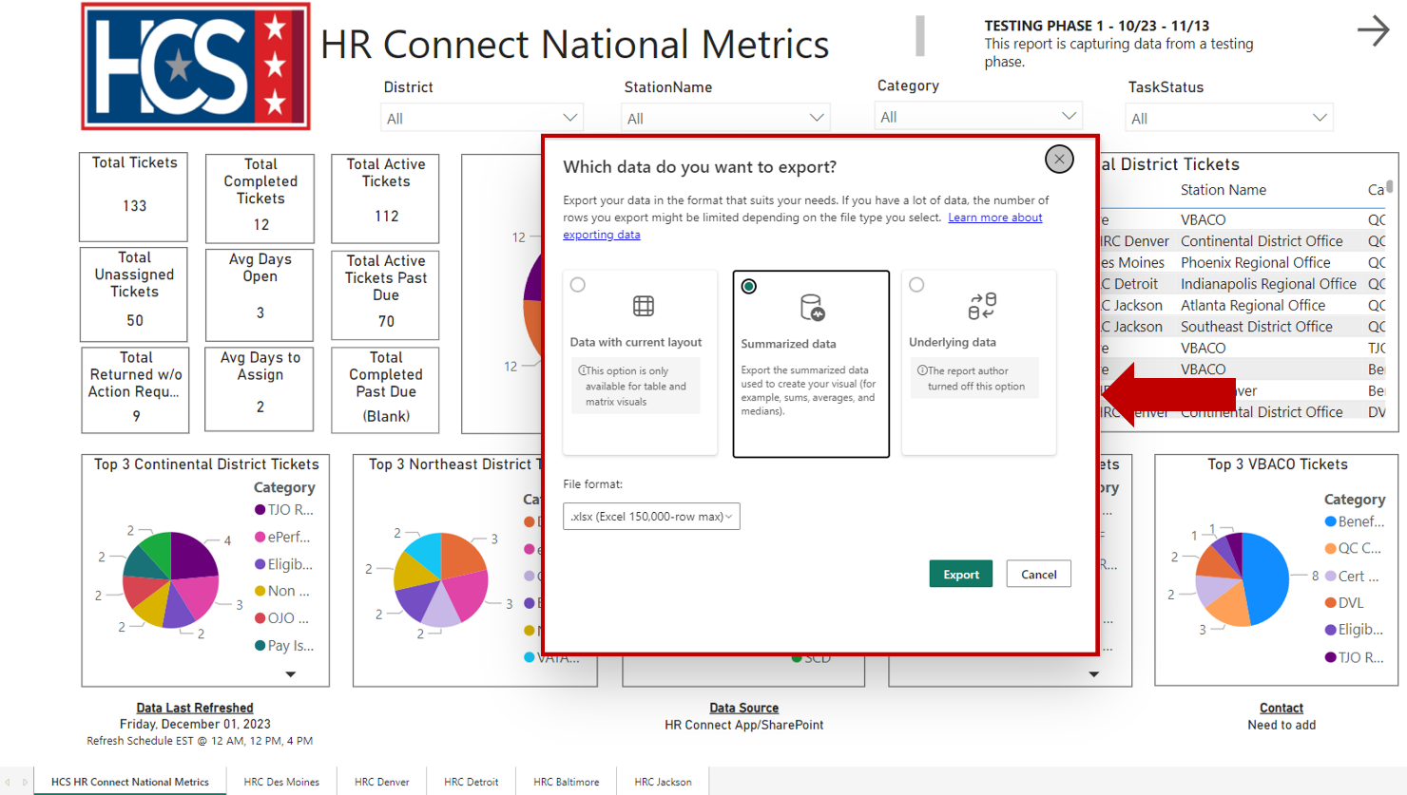
- Select File format using the dropdown menu.
NOTE: The types of file formats available for export are .xlsx and .csv. The default format is.xlsx.
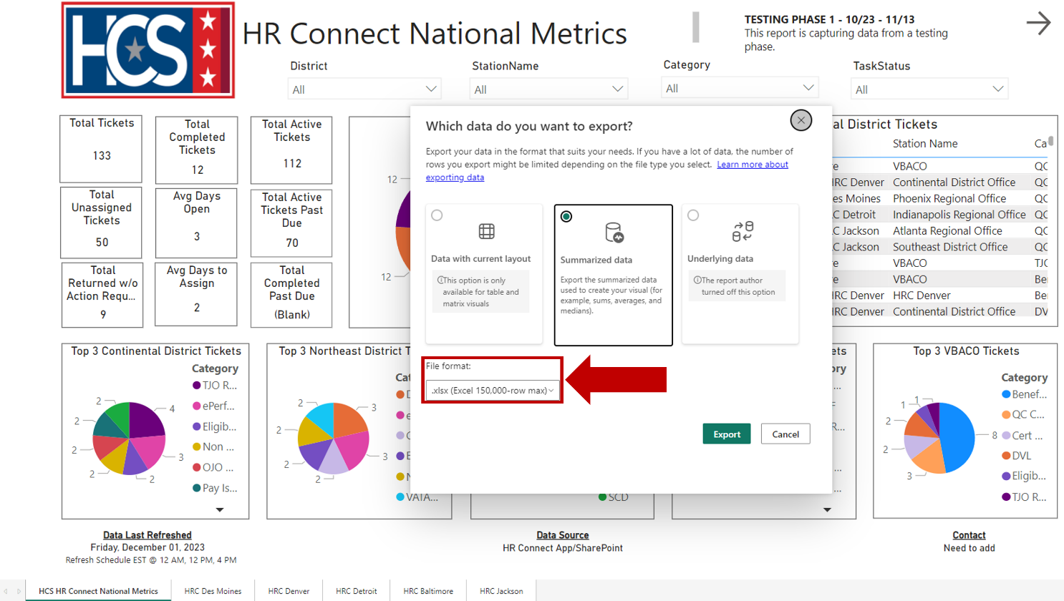
- Select Export.
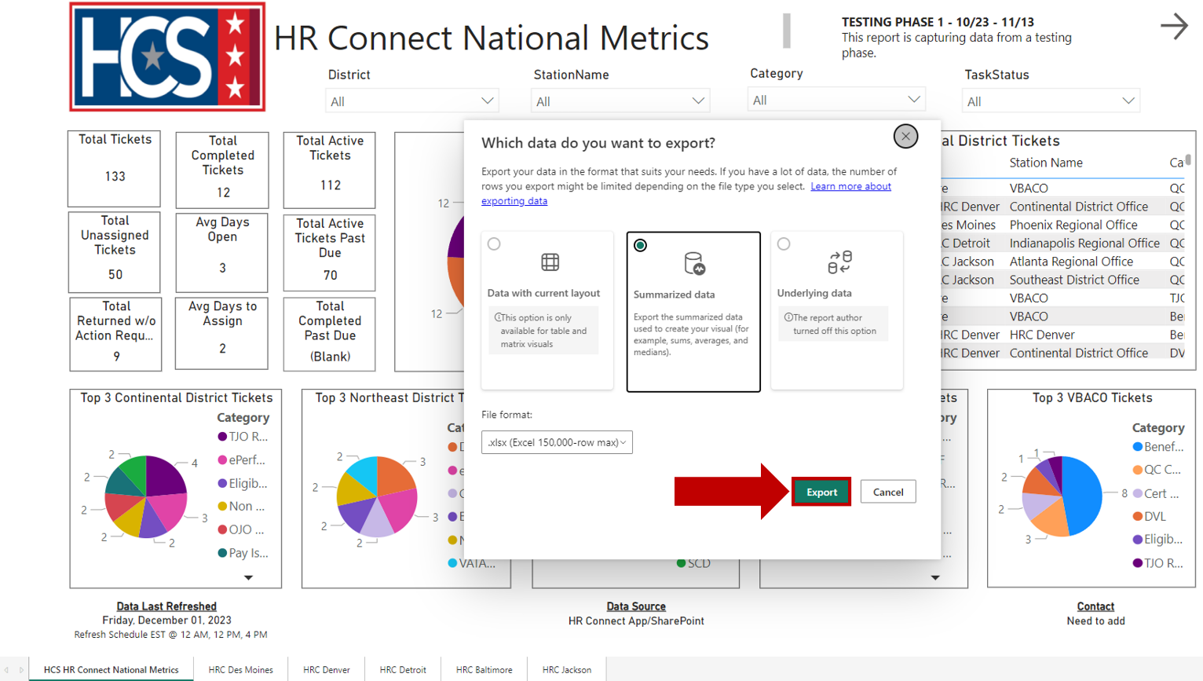
- Select either Open or Save as to view and/or save the file once the data export is complete.
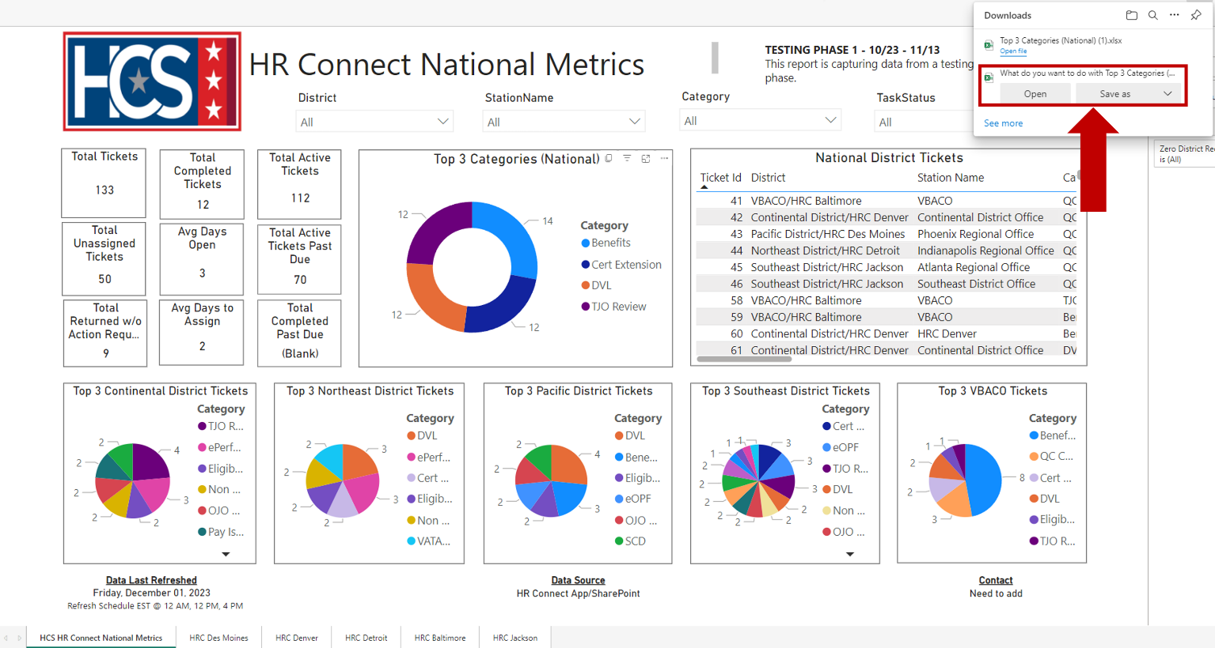

- Observe the information in the exported file.
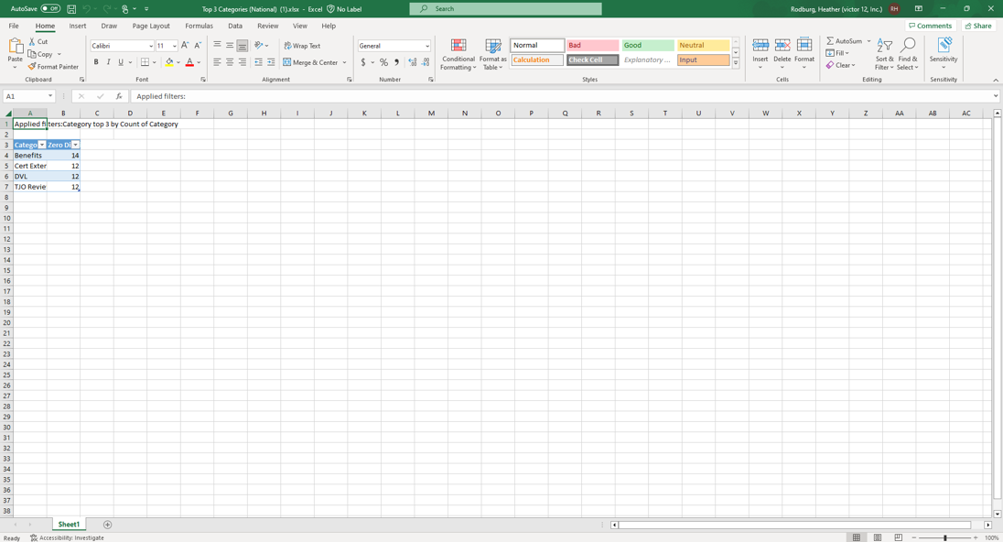

Export Executive Dashboard Data (Data with Current Layout)
- Mouse over the top-right corner of the data pod to be exported.
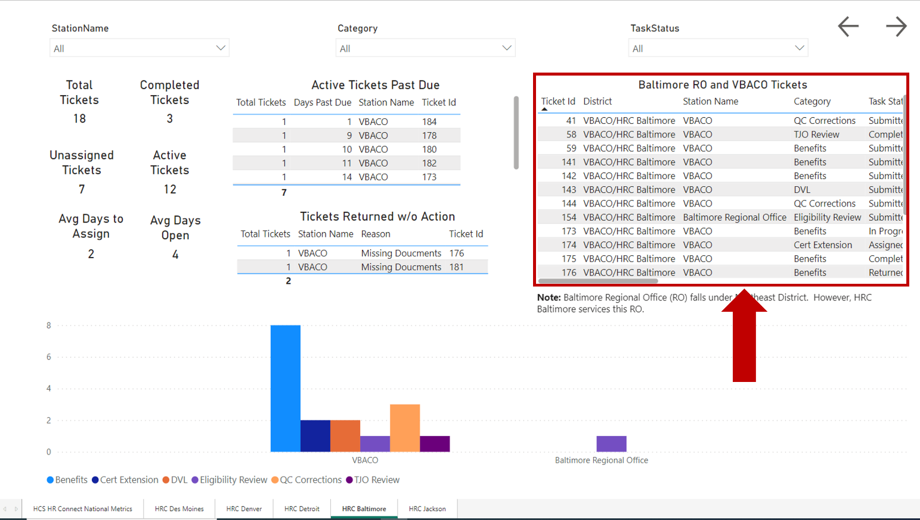
- Select Export data from the pop-up menu.
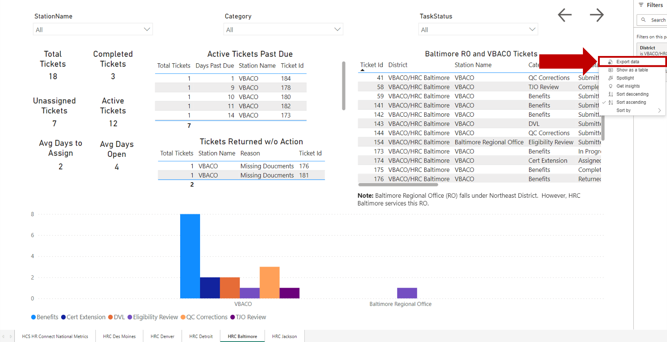

- Observe the Export window.
NOTE: If exporting data from a data list pod, the only export option available in the Export window is Data with current layout.
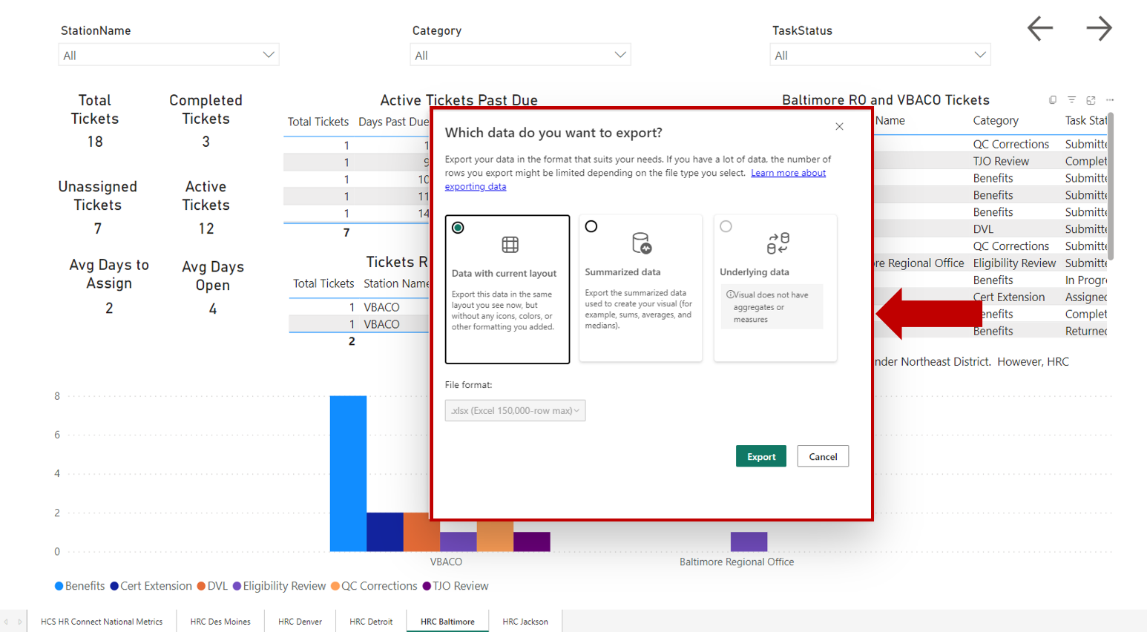
- Select File format using the dropdown menu.
NOTE: The types of file formats available for export are .xlsx and .csv. The default format is.xlsx.
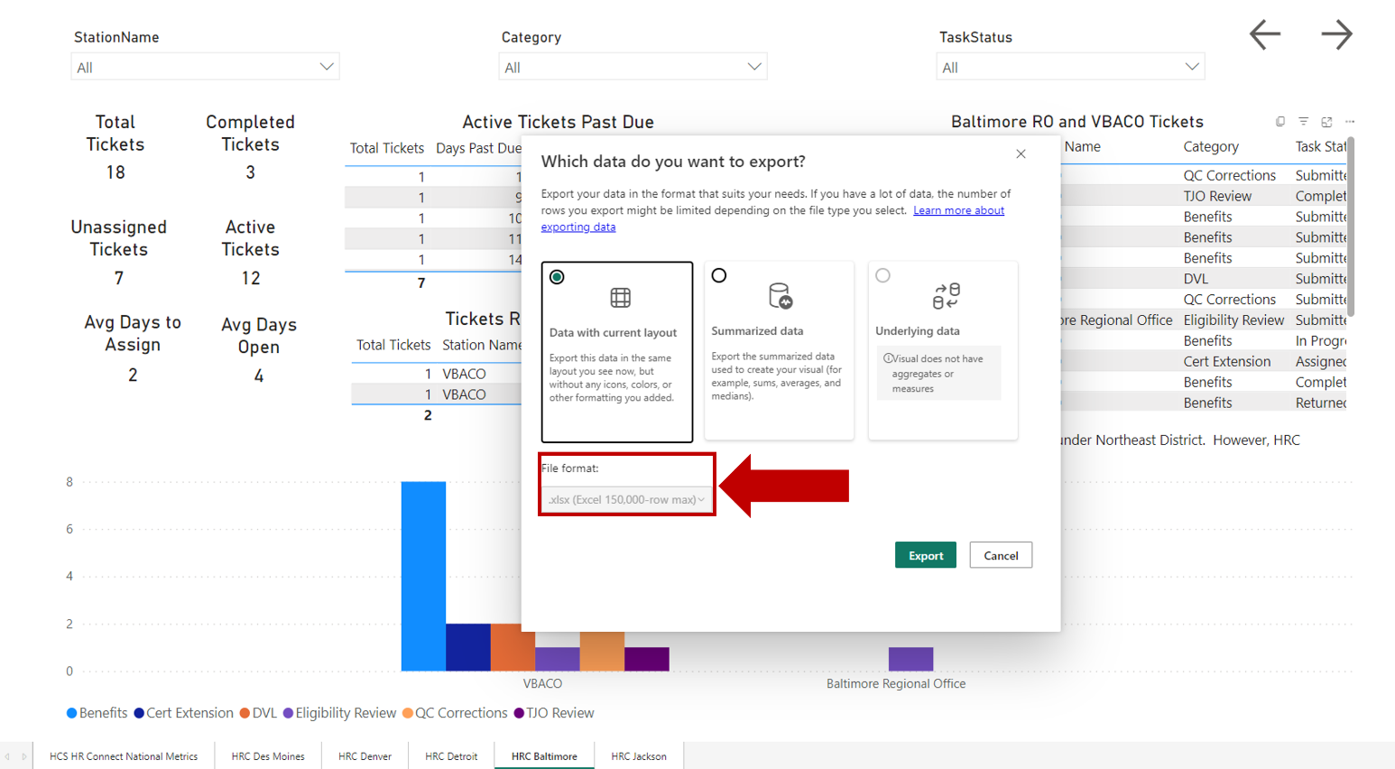
- Select Export.
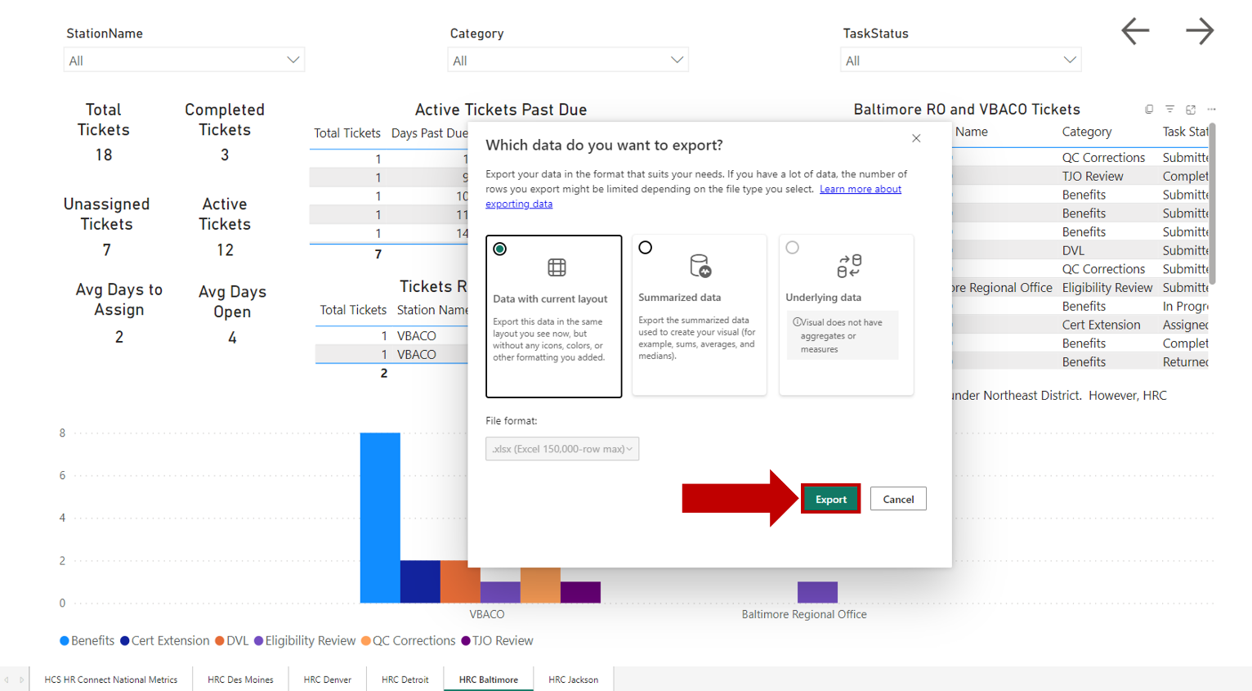
- Select either Open or Save as to view and/or save the file once the data export is complete.

- Observe the information in the exported file.
