

HR Connect Ticket Request Process
Job Aid

Human Resources Liaison (HRL)/
Human Resources Development (HRD) Specialist

21 December 2023

Contents
Introduction 3
Ticket Submission Workflow 3
Ticket Processing Timeline 3
Ticket Priority Level 4
Access HR Connect 5
Submit a New Ticket Request 8
Update an Existing Ticket Request 16
View Ticket Requests 20
Ticket Status Options 20
Filter Tickets 21
Resubmit a Ticket 26
Submit HR Connect Feedback 36
Executive Dashboard 40
Overview 40
HR Connect National Metrics Dashboard Data 41
HR Connect District Metrics Dashboard Data 42
Access Executive Dashboard 43
Export Executive Dashboard Data (Summarized) 48
Export Executive Dashboard Data (Data with Current Layout) 52

Introduction
HR Connect serves as a mandatory user-friendly workload ticketing system between the Human Resources Liaisons (HRLs)/Human Resources Development (HRD) Specialists and their servicing Human Resources Center (HRC) for all non-Manager Self-Service (MSS) related actions. The procedures described in this job aid are designed for HRLs/HRD Specialists who access HR Connect to submit a new ticket request, update an existing ticket request, view the status of a ticket as it progresses through the system, and resubmit a ticket, along with guidance for submitted HR Connect feedback. HRLs/HRD Specialists can also access an Executive Dashboard to view national and district ticket metrics.

Ticket Submission Workflow
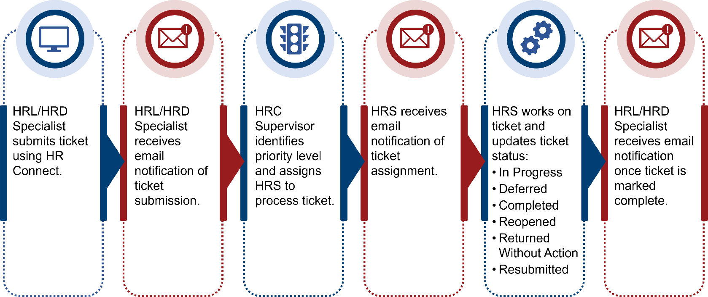

Ticket Processing Timeline
The following processing timelines apply for tickets submitted in HR Connect:
- HRC Supervisor to assign ticket: 1 business day.
- HRS to begin working on ticket (move ticket to In Progress): 1 business day.
- HRS to complete ticket: Varies, depending on circumstance/complexity of ticket, whether additional information is needed, etc., along with considerations within performance plan (if applicable).
- HRS to close ticket after completion: Same day that ticket is completed.
NOTE: Ticket priority impacts the ticket processing timeline.
NOTE: A user who submits feedback via the Submit Feedback option on the HR Connect home screen should expect to receive a response within 2 business days.

Ticket Priority Level
When a ticket is submitted, an HRC Supervisor receives the ticket, assigns a priority level, and assigns an HRS to process the ticket. HRC Supervisors are the only role with permission in HR Connect to change ticket priority—based on review of the issue and their own expertise/judgement—and to assign/reassign tickets.
The three priority levels are described below.
NOTE: While definitions and examples are listed below, HRC Supervisors have the latitude to assign priority based on review and judgement of issue.
Priority Level | Description of Issue
High | - Involves pay/benefits  - Impacts a system(s) (e.g., ePerformance, HR Smart)
Medium | Does not impact pay, benefits, or systems, yet involves an impact that requires higher than Low priority (e.g., Official Job Offer [OJO], Tentative Job Offer [TJO], ePerformance question)
Low | Does not impact pay or systems and can be addressed after HRS addresses High and Medium priority tickets (e.g., Service Computation Date [SCD] review)

Access HR Connect
HRLs/HRD Specialists who attempt to access the tool without the appropriate permission receive a Request Access message as shown below.
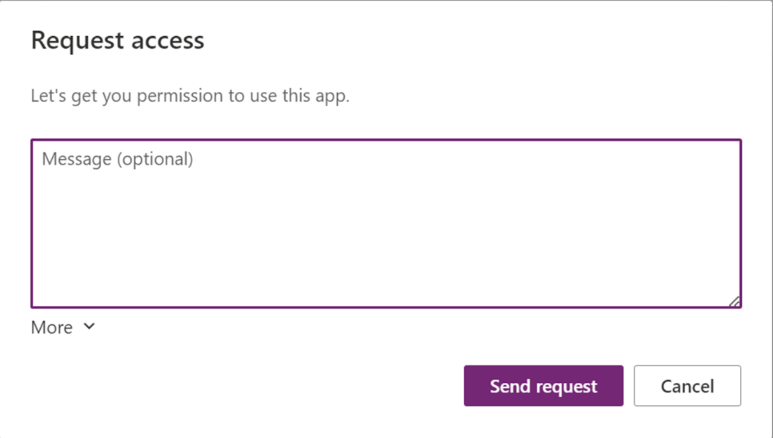
Supervisors must request access from the HR Connect team in order for HRLs/HRD Specialists to begin submitting tickets. Once access is granted, HRLs/HRD Specialists receive an email notification confirming their access to HR Connect.
- Select the HR Connect link within the HR Connect Access Request email.
NOTE: HR Connect launches in Microsoft Edge.
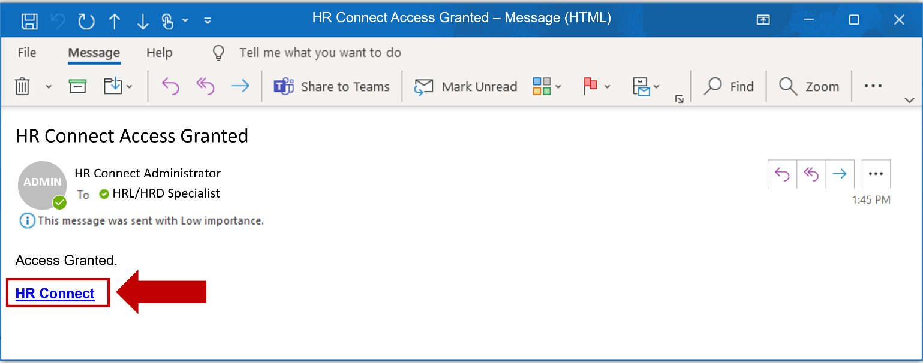

- Select Allow on the Permissions popup window.
NOTE: Allow must be selected in order to access the HR Connect application.
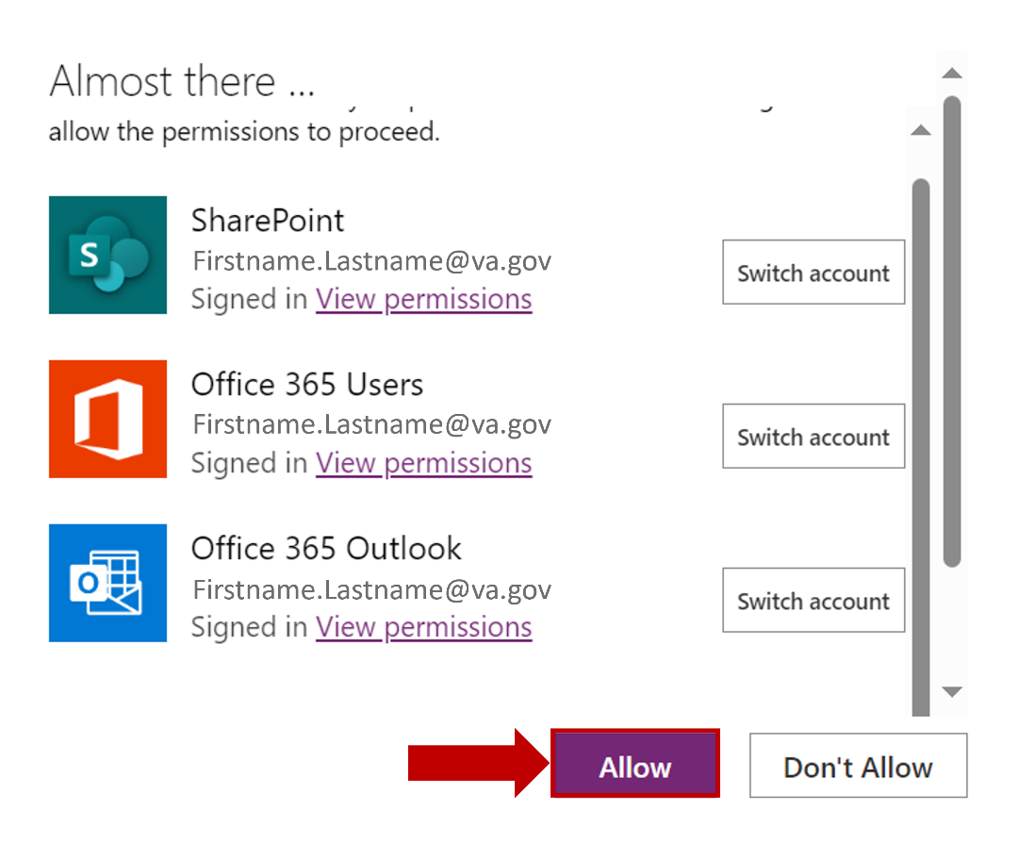
- Select the Agree checkbox to acknowledge the sensitive information disclaimer.
NOTE: Bookmarking this page allows for easy access to HR Connect.
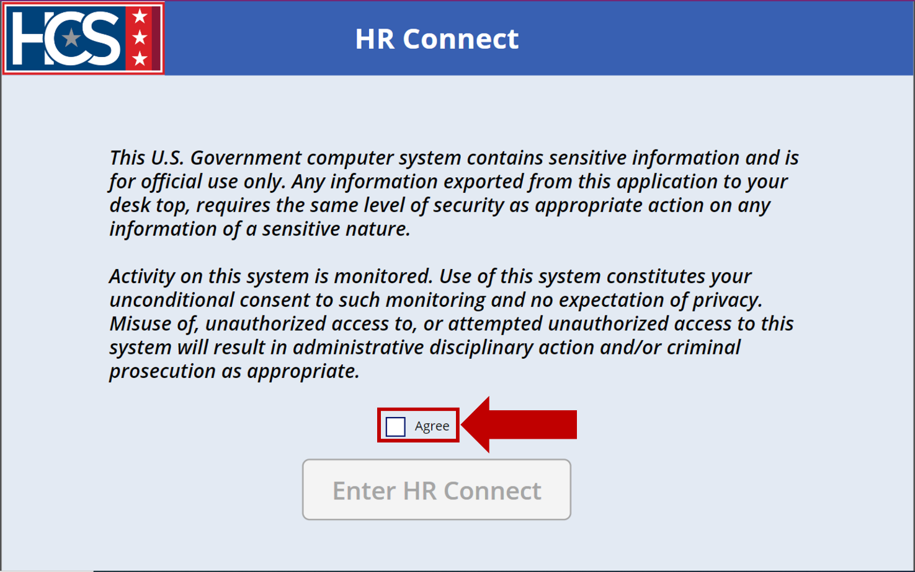
- Select Enter HR Connect.
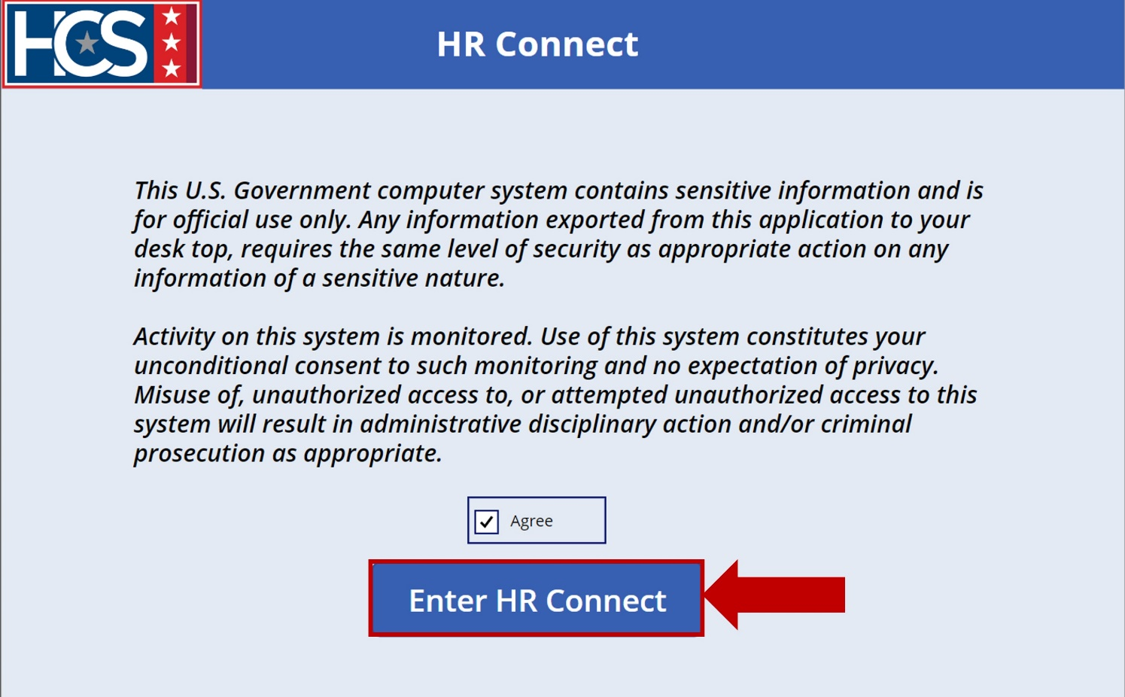
- Observe the HR Connect home screen.
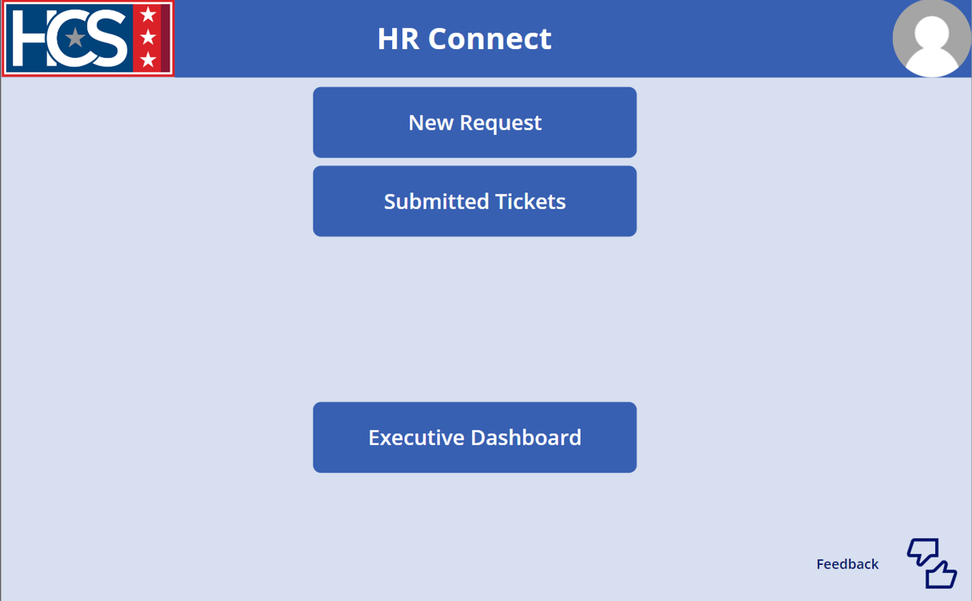

Submit a New Ticket Request
- Select New Request on the HR Connect home screen.
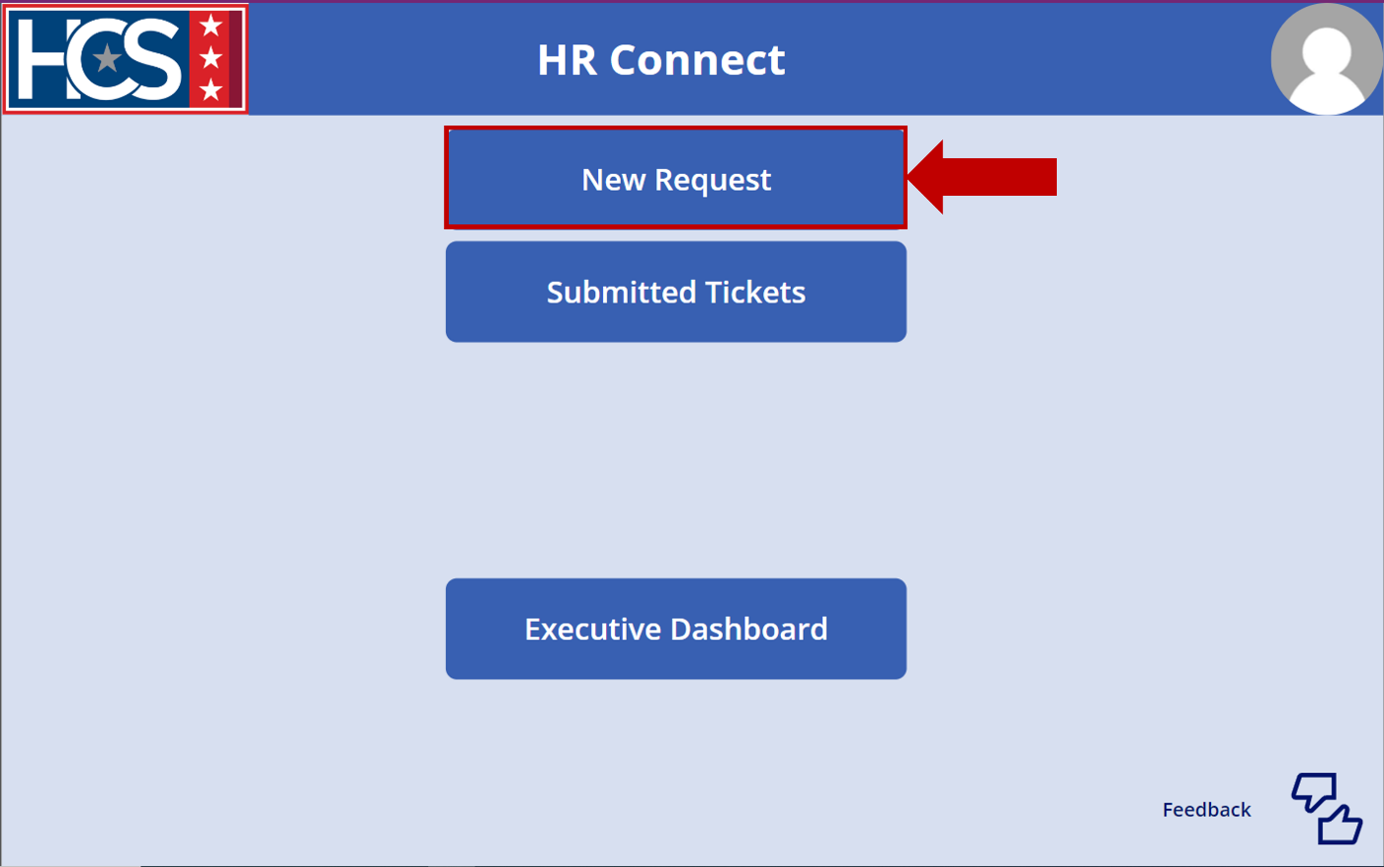
- Observe the New Request screen.
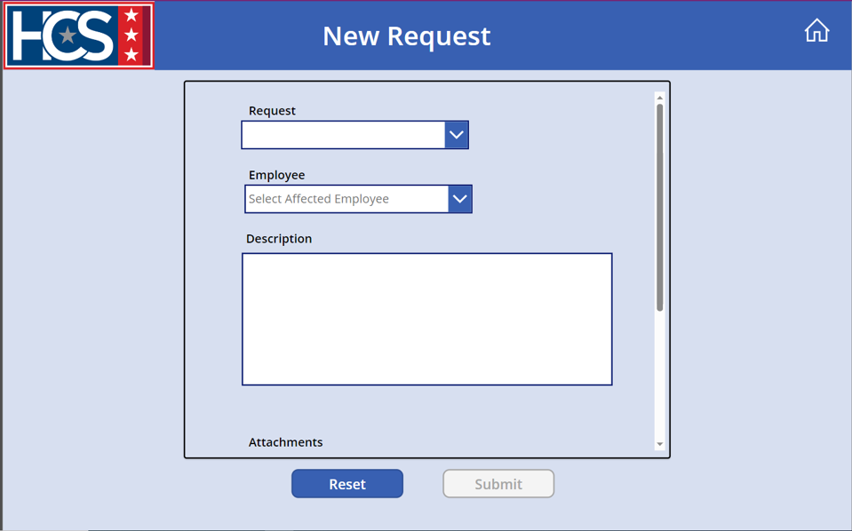
- Select the applicable type of Request from the dropdown menu.
NOTE: Selecting Cert Extension from the Request dropdown menu displays the Cert Extension Request Number field in place of the Employee field.
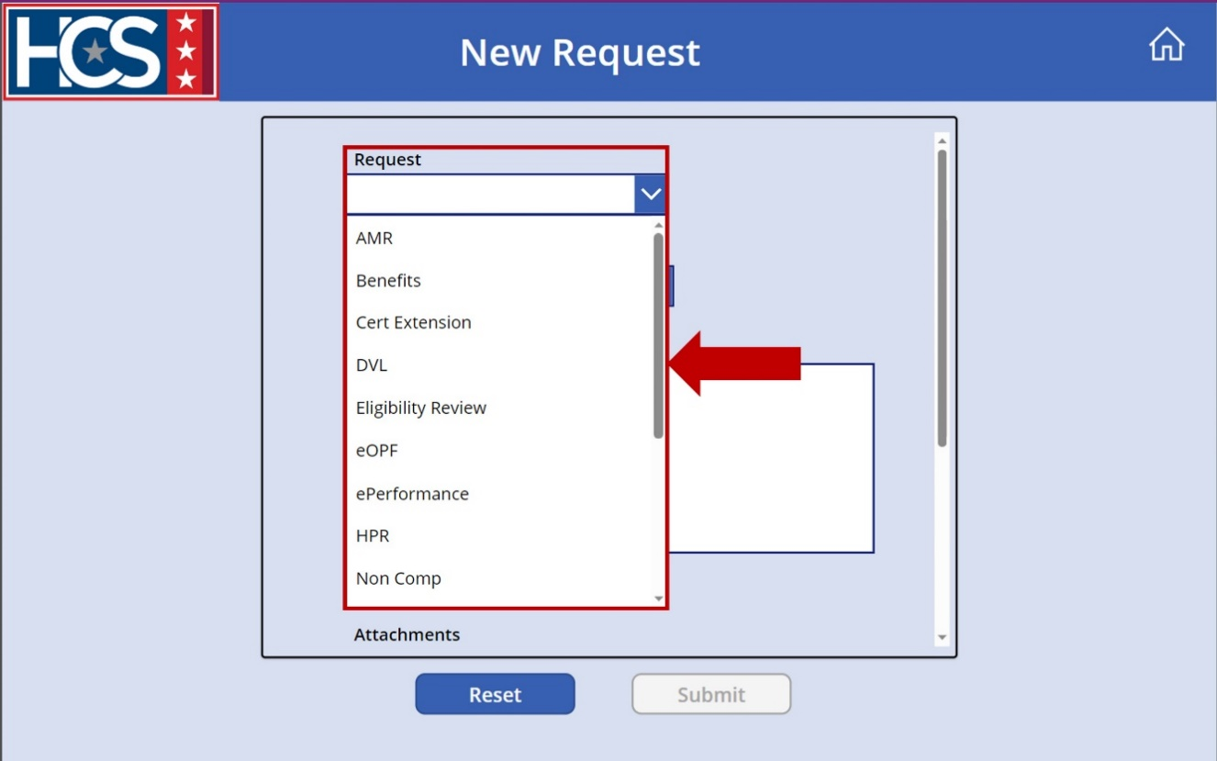

- Select either a Non-Cert Extension (e.g., benefits, pay issue) request or Cert Extension request.
  - For Non-Cert Extension requests, type the name of the employee associated with the ticket in the Employee field and select the name from the prepopulated list.
NOTE: Employee name options populate as the name is typed. Only employees in VA Outlook display in this list and are available for selection. If the employee is not in VA Outlook (e.g., request involves non-competitive qualification review for external applicant), the HRL/HRD Specialist uses their own name for the Employee field.
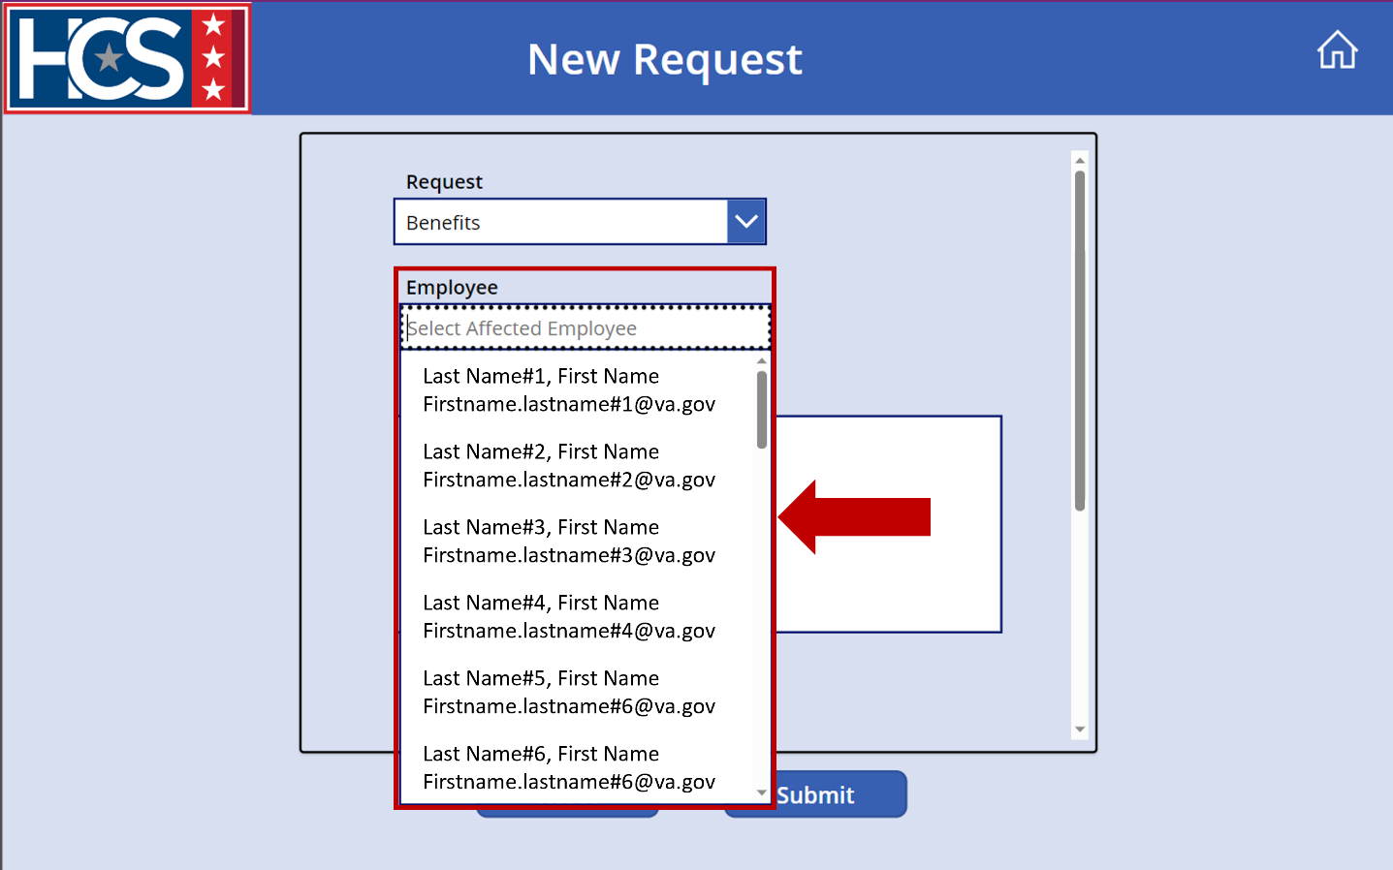
  - For a Cert Extension request, type the Certificate Extension Request Number in the Cert Extension Request Number field.
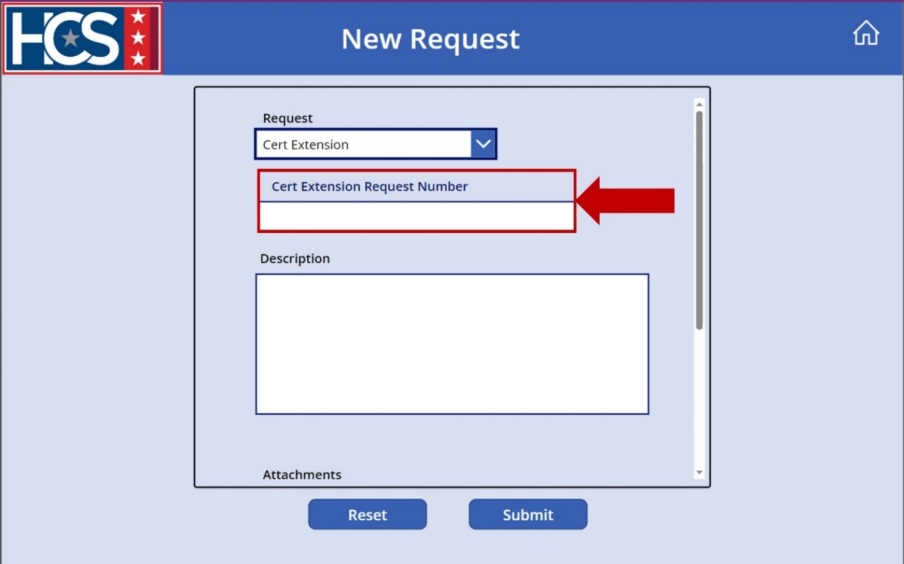
- Type a description in the Description field.
NOTE: Descriptions should include as much detail as possible to ensure clarity and efficient ticket processing. This field can also include the employee name if not available for selection in the previous step.
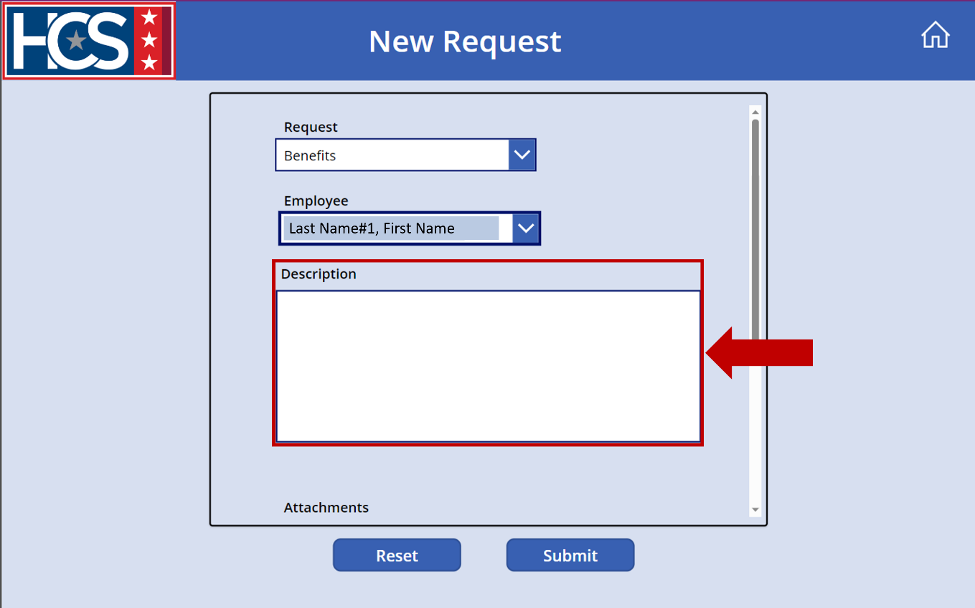
- Use the scroll bar to scroll down on the New Request form.
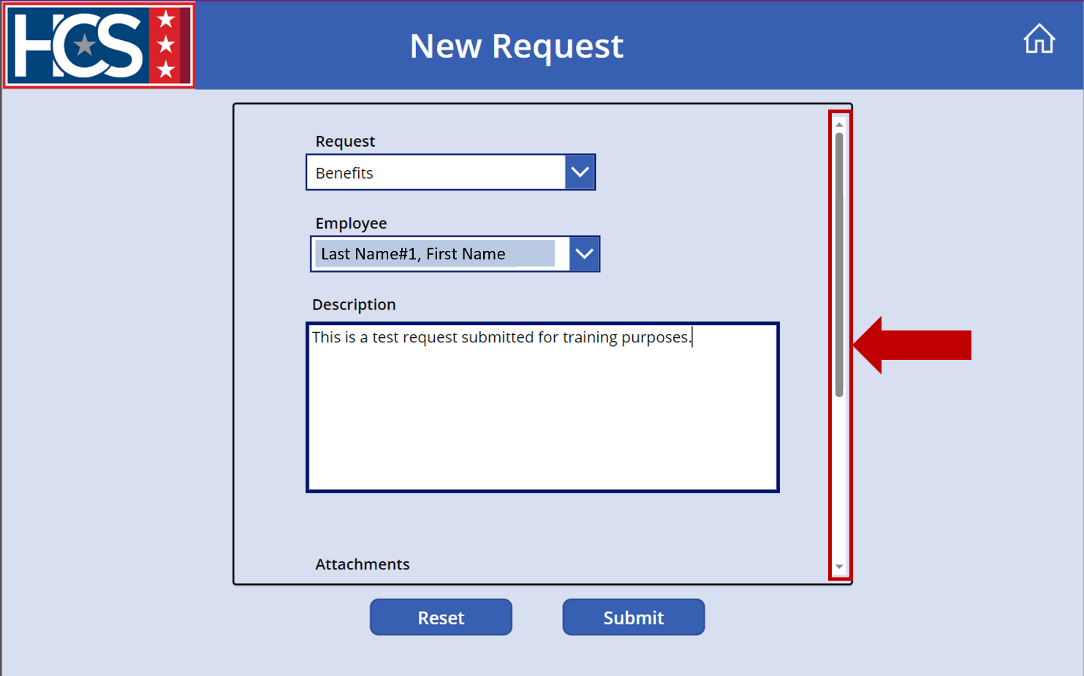
- Select Attach file to add supplemental documents to the new request, as needed.
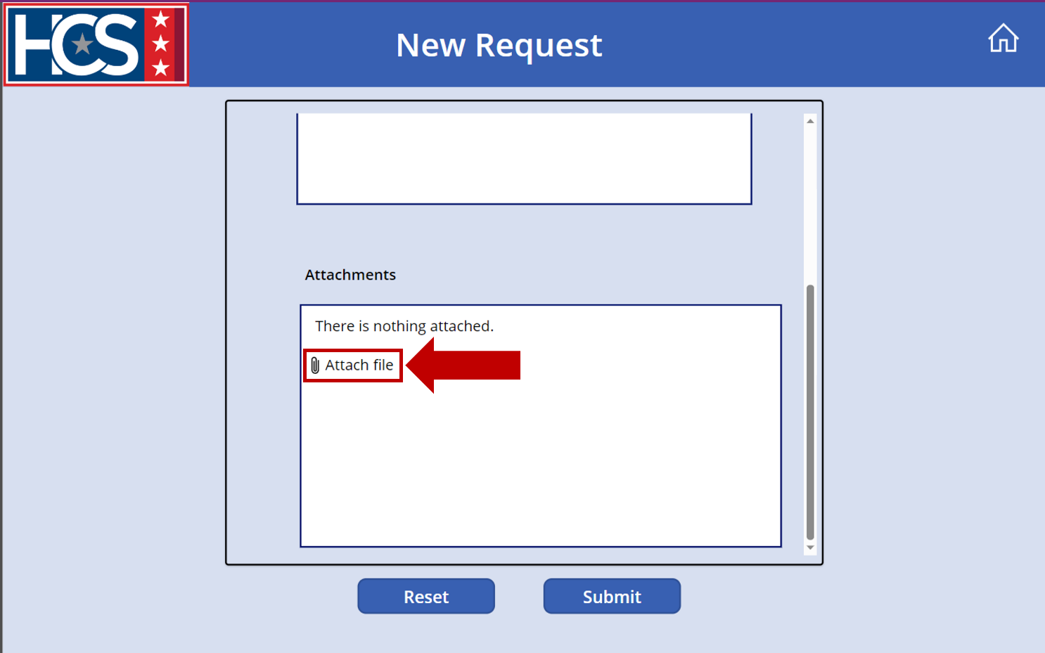
- Select the file(s) from the Open dialog box that displays.
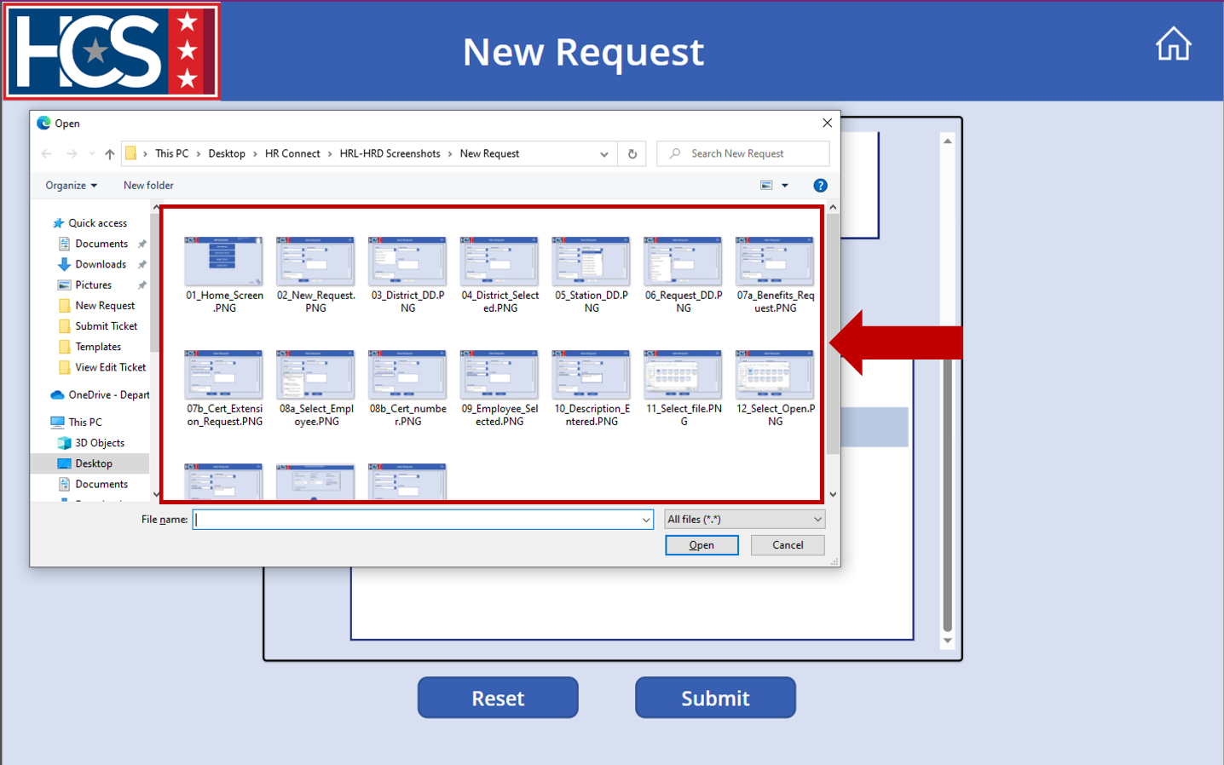
- Select Open to attach the file(s).
NOTE: The following file formats are accepted as attachments: PNG, PDF, DOCX.
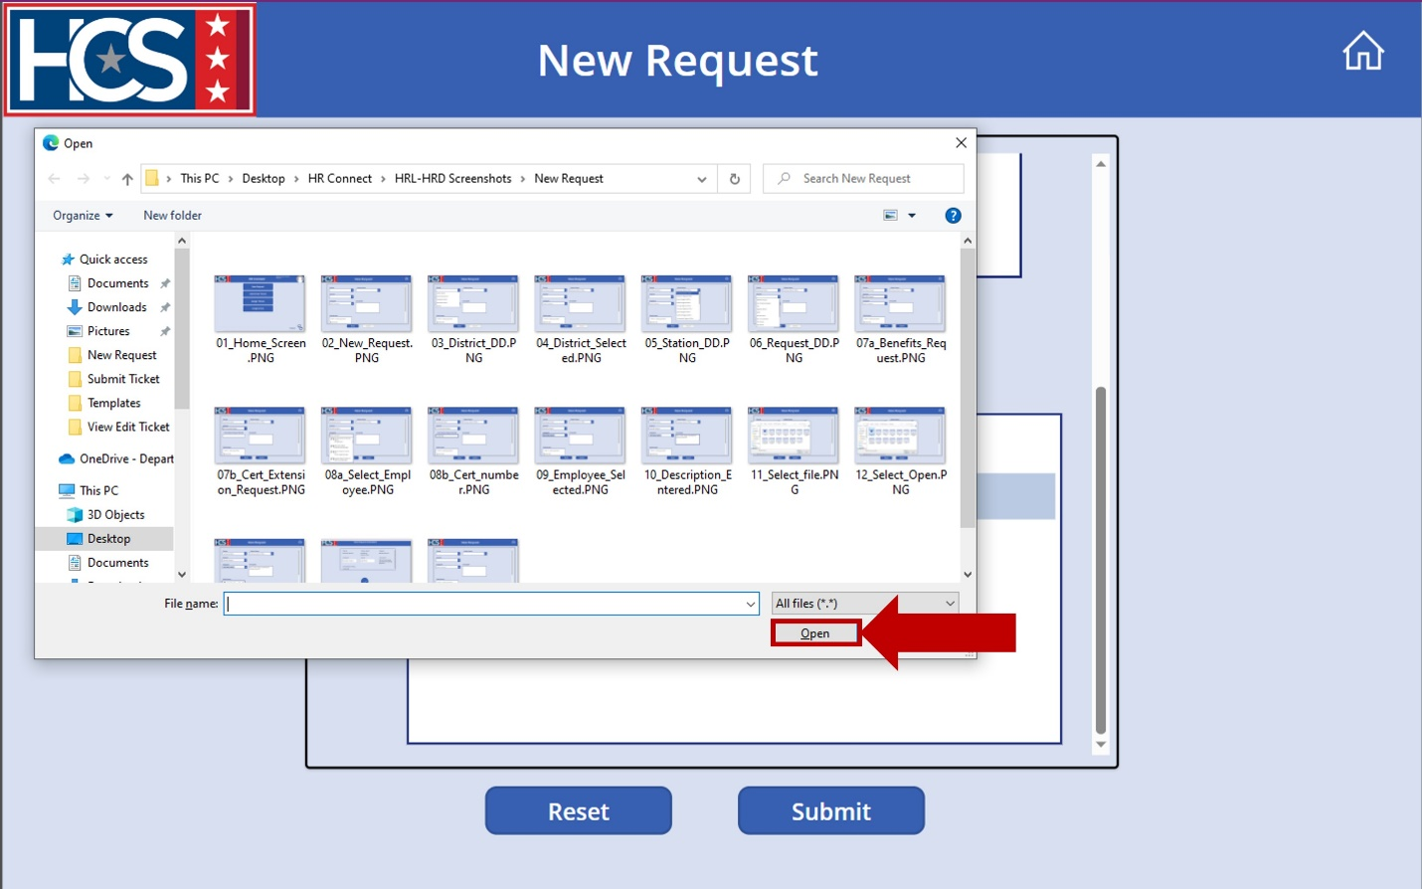
- Confirm that the file is attached to the new request in the Attachments field.
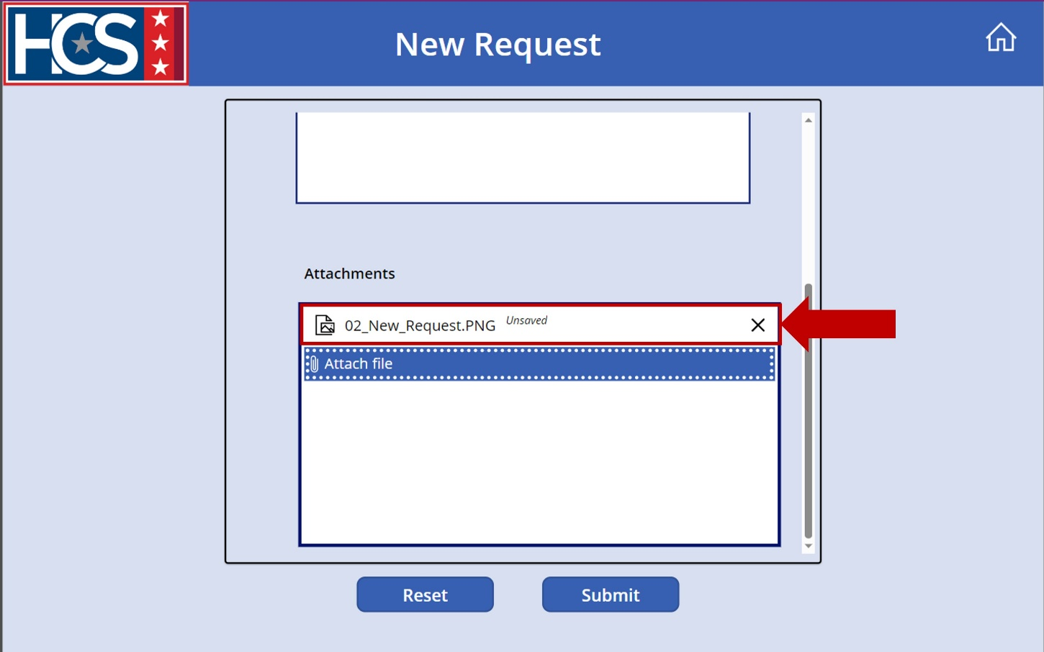
- Select Submit.
NOTE: Once Submit is selected, the ticket request is assigned to an HRS by the HRC Supervisor.
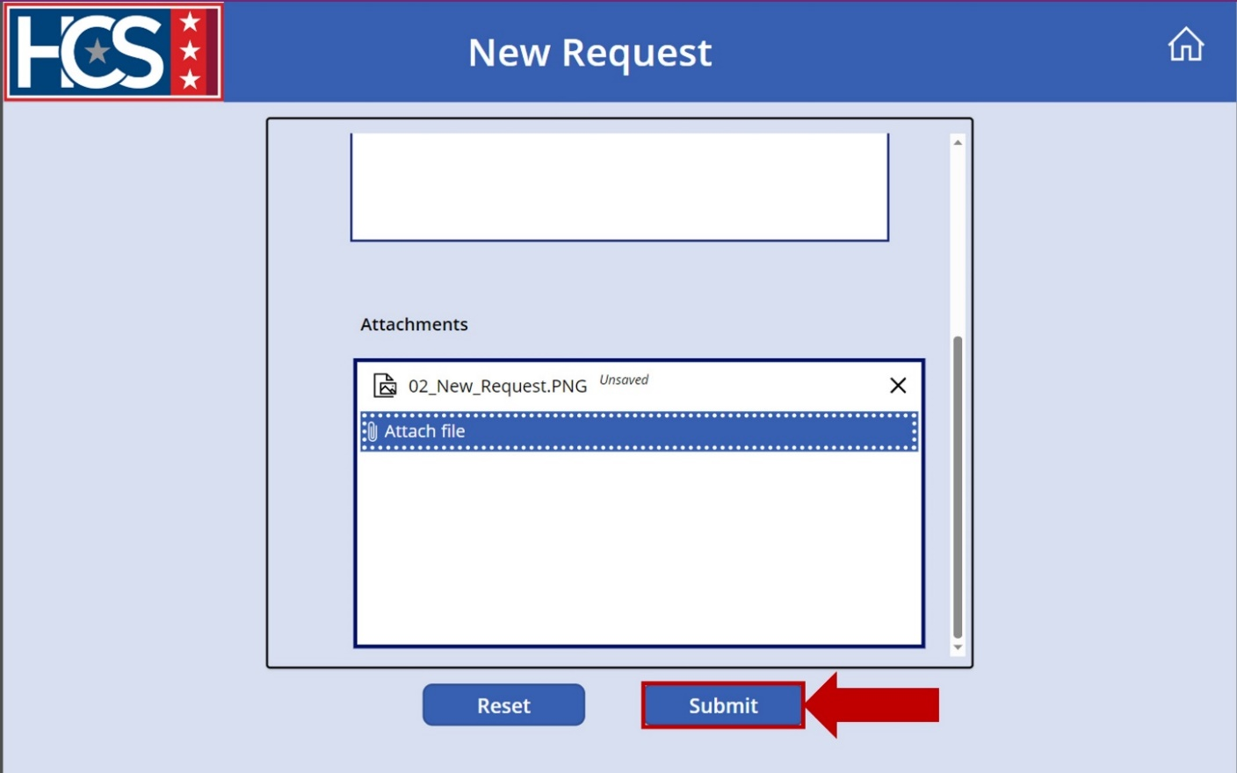
- Observe confirmation screen.
NOTE: The confirmation screen displays and then automatically returns to the New Request screen.
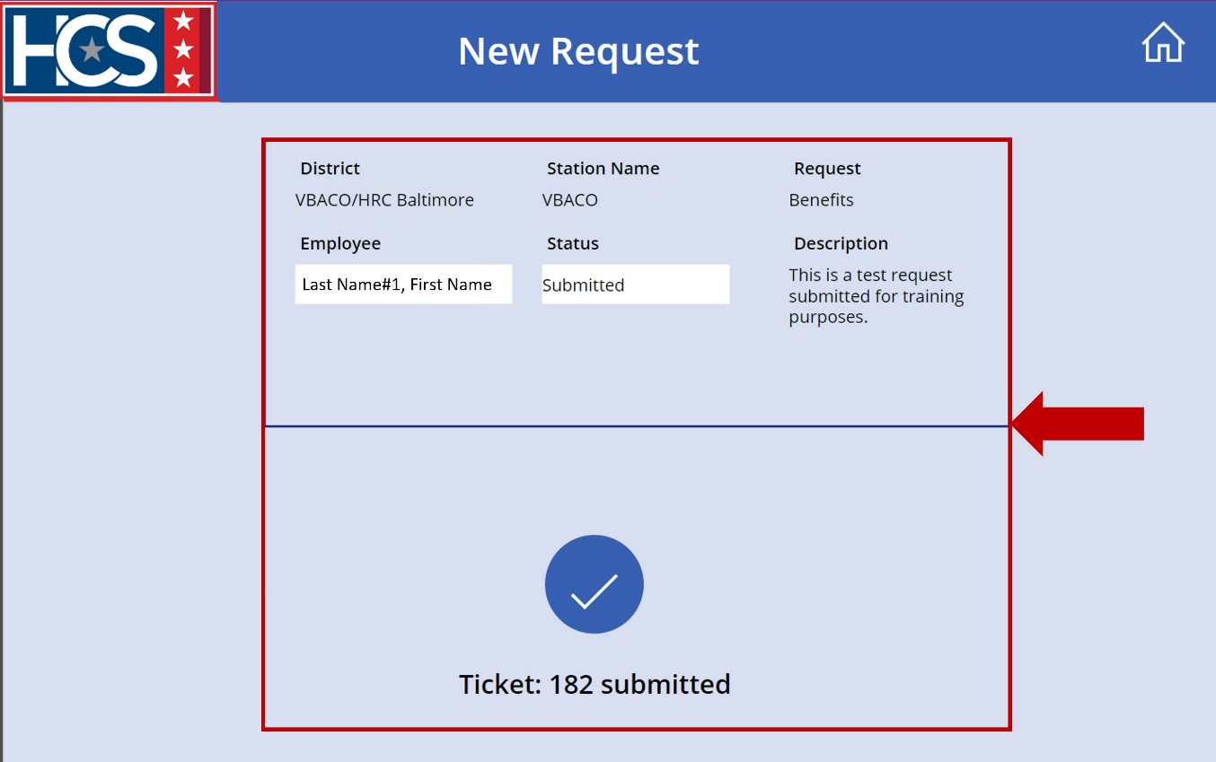
- Enter a new ticket request or select the Home icon to return to the home screen.
NOTE: The Home icon can be selected at any time on the New Request screen. Selecting Home before selecting Submit cancels the request.
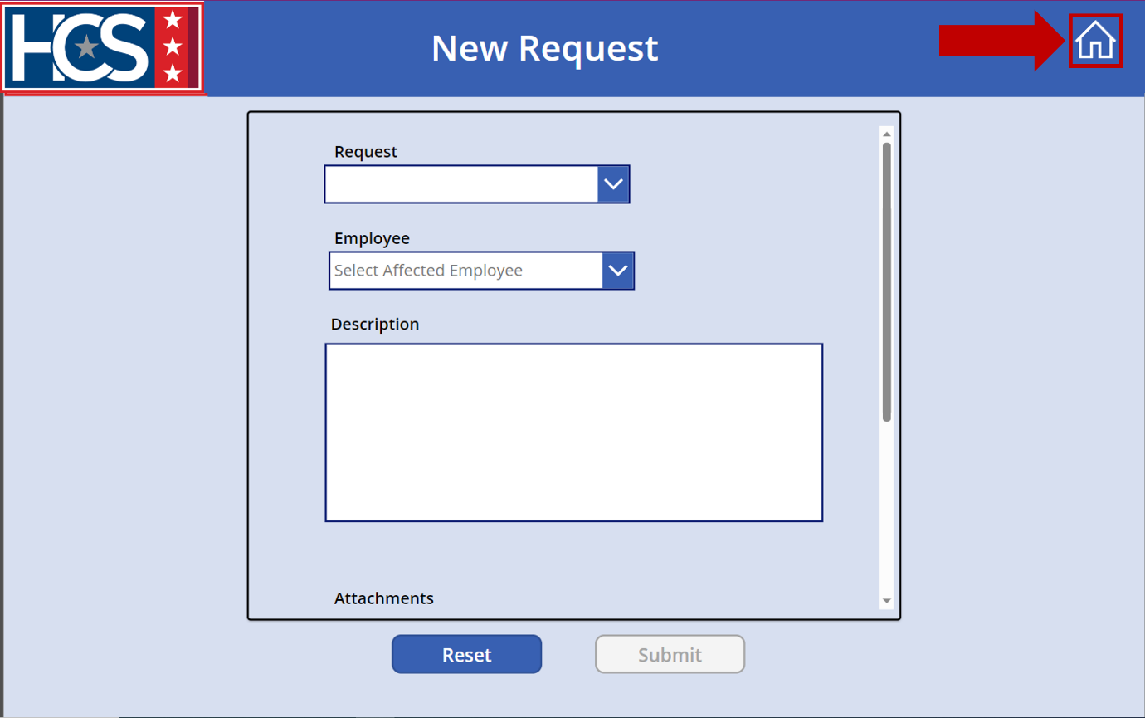
- Confirm receipt of an email notification indicating successful submission of the ticket request.
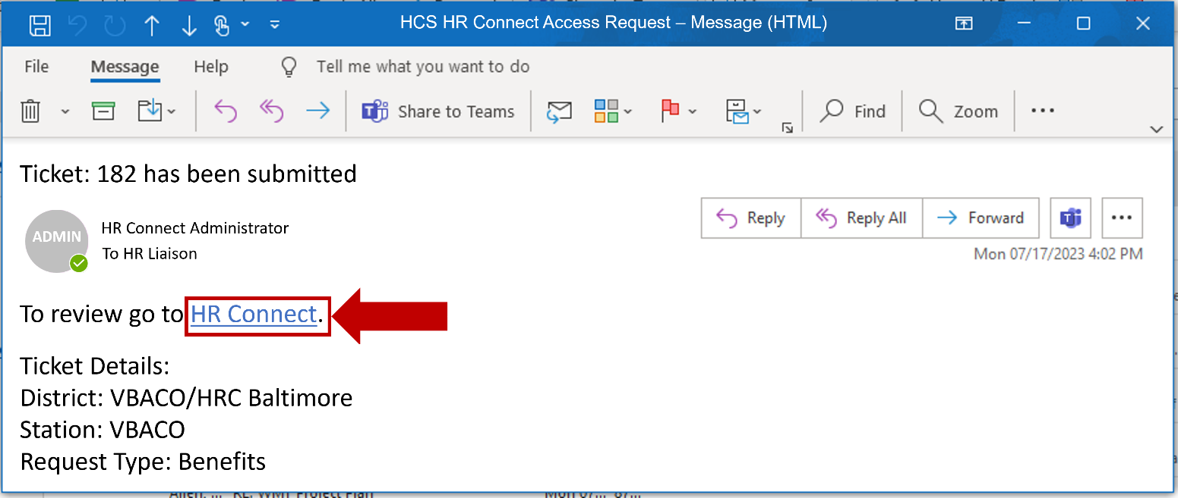

Update an Existing Ticket Request
HR Connect allows for changes to be made to a ticket after submission and before assignment to an HRS.
- Select Submitted Tickets on the HR Connect home screen.
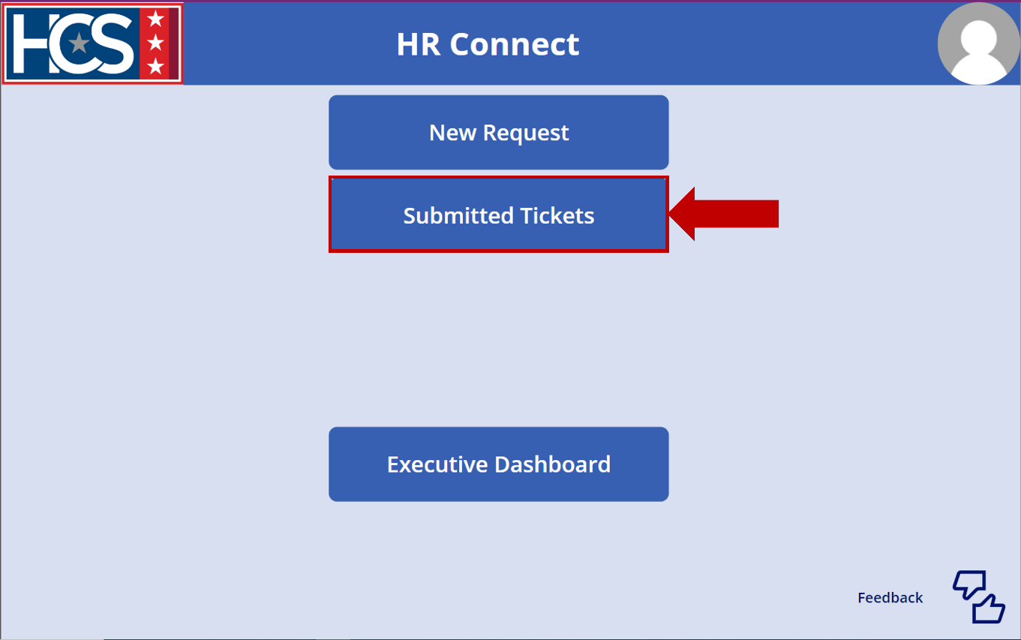
- Observe the Submitted Tickets screen, which defaults to displaying tickets with a Submitted status.
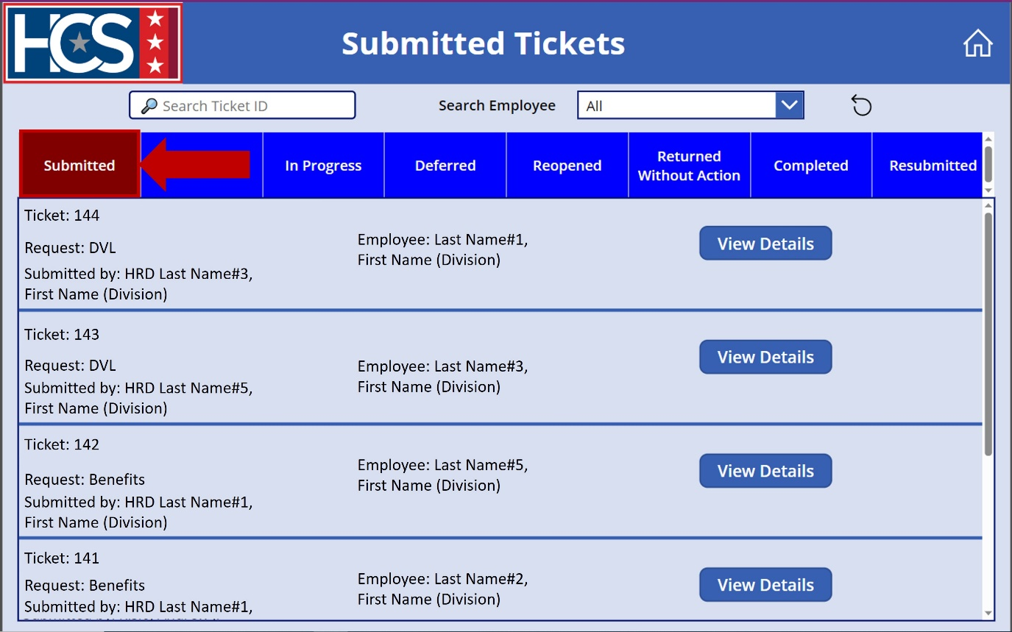
- Select View Details on the ticket to be updated.
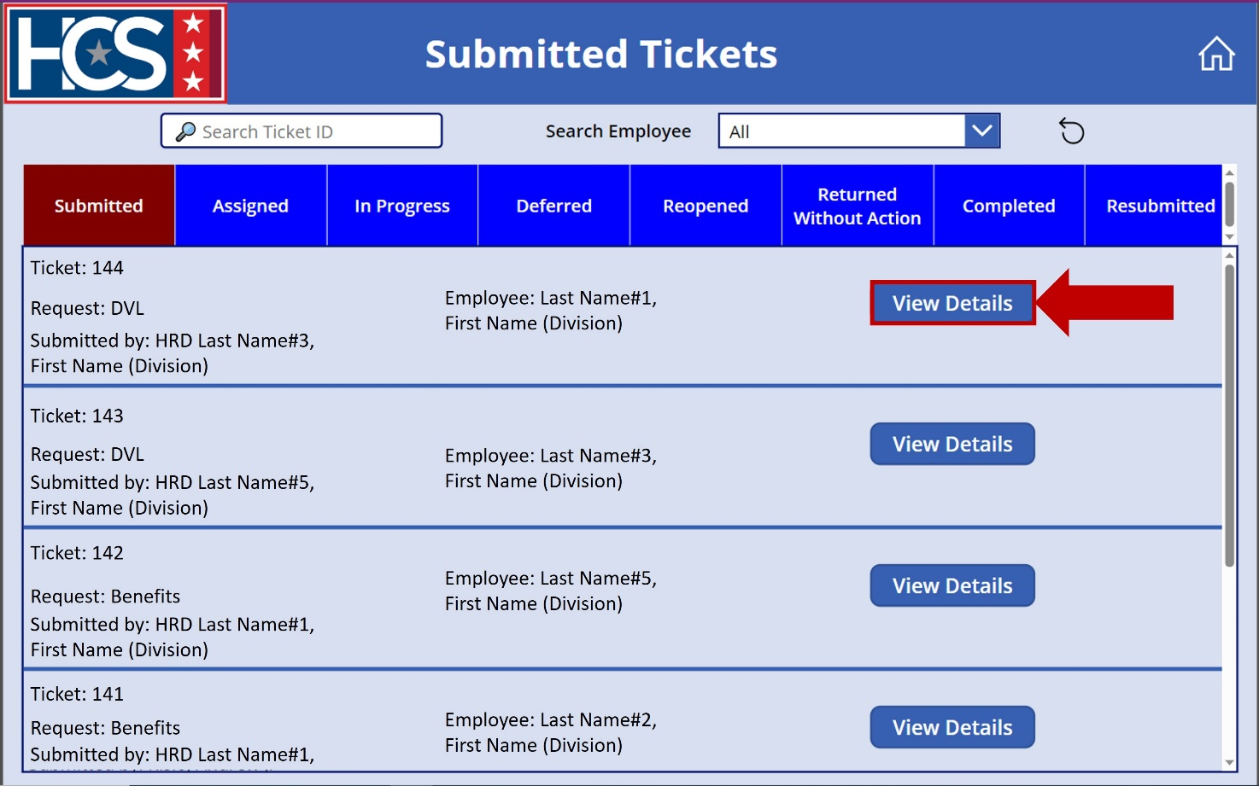

- Review the ticket details and make applicable changes on the Details screen.
NOTE: When updating a ticket, add the date of the update and the reason for the update in the Description field (e.g., 11/10/2023: Employee name updated; 12/15/2023: Standard Form (SF 50) added). Do not delete any previous comments when adding the updated information.
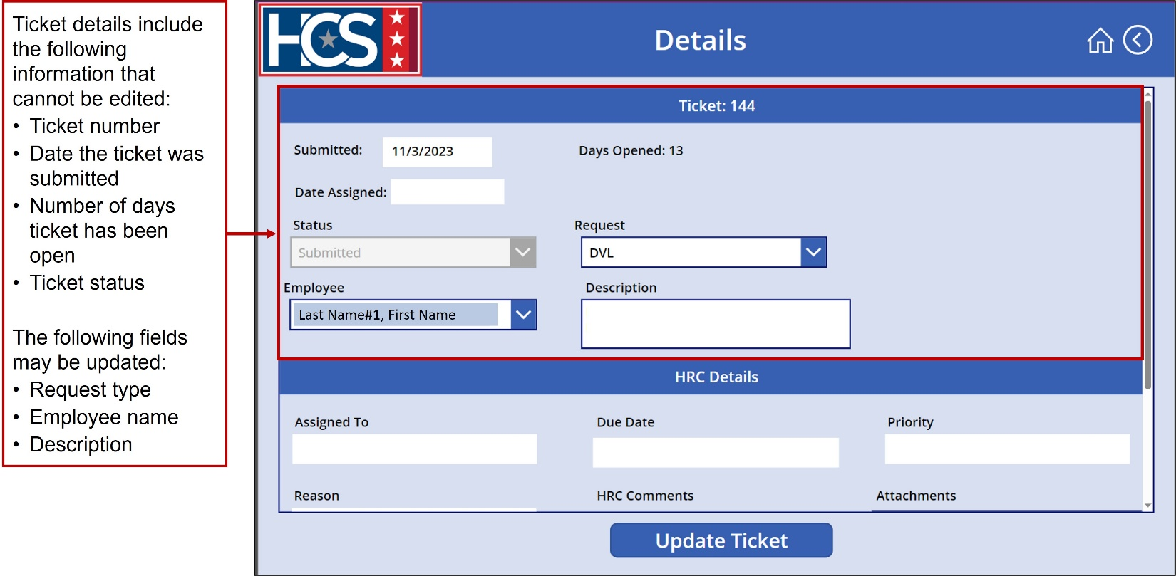
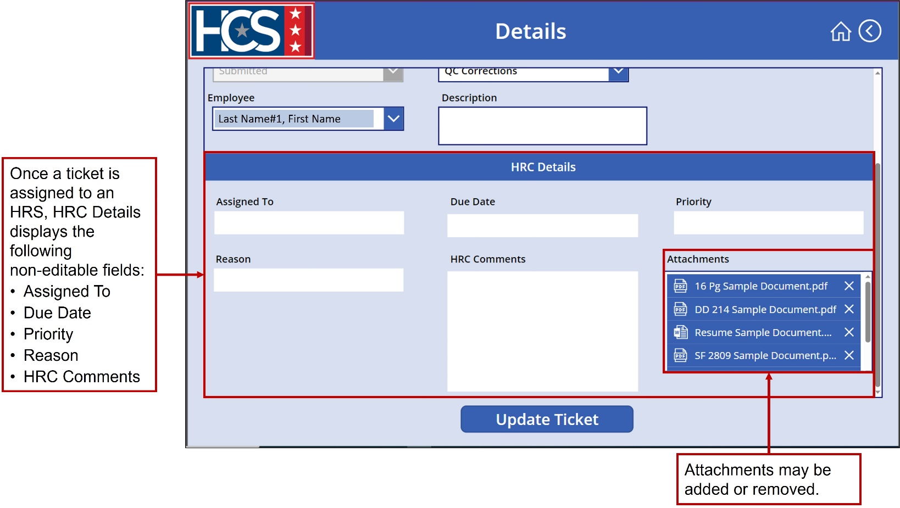

- Select Update Ticket to save updates.
NOTE: If Update Ticket is not selected, all updates are lost.
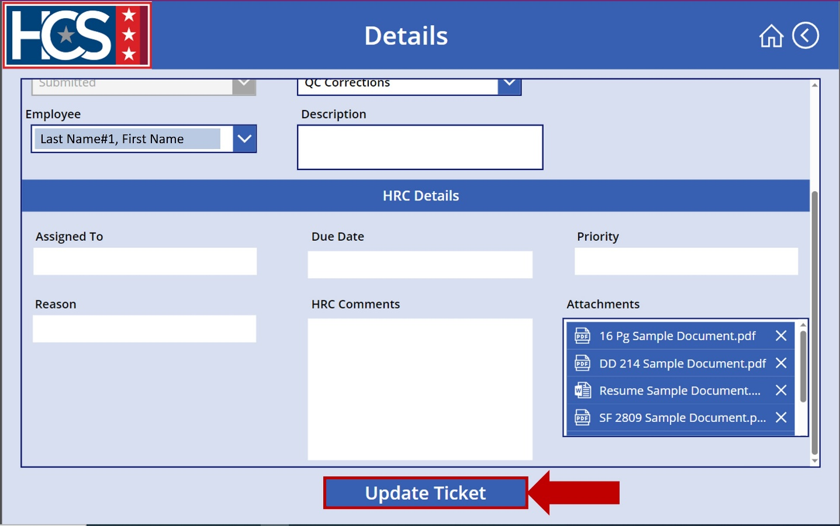
- Observe the Submitted Tickets screen with updated ticket information.
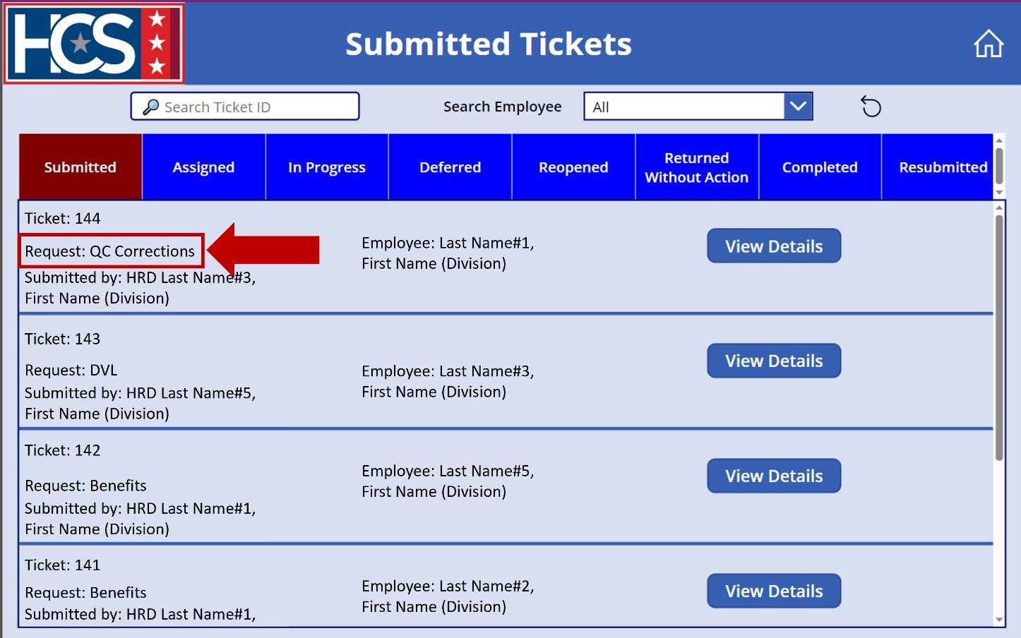

View Ticket Requests

Ticket Status Options
HR Connect allows for straightforward tracking and viewing of tickets as they progress through the system. Once a ticket is submitted, a user can view ticket status using the Submitted Tickets option on the HR Connect home screen. Status filters include:
- Submitted: HRC Supervisor has not yet assigned the ticket to an HRS.
NOTE: This status type is not visible to an HRS viewing their assigned tickets.
- Assigned: HRC Supervisor has determined the ticket priority (High, Medium, Low) and has assigned the ticket to an HRS.
- In Progress: HRS has started working on the ticket.
- Deferred: Ticket has been placed on hold, pending action or information from an internal or external third-party source.
- Reopened: Ticket was closed but reopened (e.g., resolution in error, additional resolution needed).
- Returned Without Action: Ticket is returned to the HRL/HRD Specialist for several reasons, which include: Duplicate; MSS Request; Missing Documents; Additional Information Needed. The reason for the ticket being Returned Without Action is provided in the HRC Details section of the submitted ticket.
NOTE: If the ticket lists either Missing Documents or Additional Information Needed, the ticket can be resubmitted with the missing document(s) or additional information.
- Completed: HRS has resolved the ticket.
- Resubmitted: A ticket that was Returned Without Action is submitted again with missing documents or additional information included.
NOTE: HRLs/HRD Specialists can only update tickets with a status type of “Submitted” or “Returned Without Action.”
When a status filter is selected, the color of the option changes and only the tickets that apply to the selected filter display. If no tickets have the selected status, no tickets display on the screen.
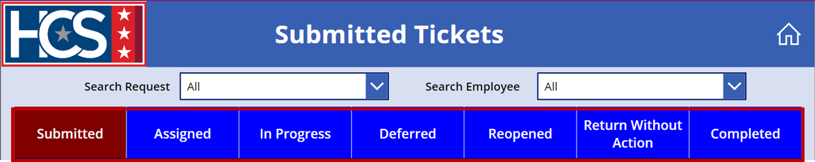

Filter Tickets
- Select Submitted Tickets on the HR Connect home screen.
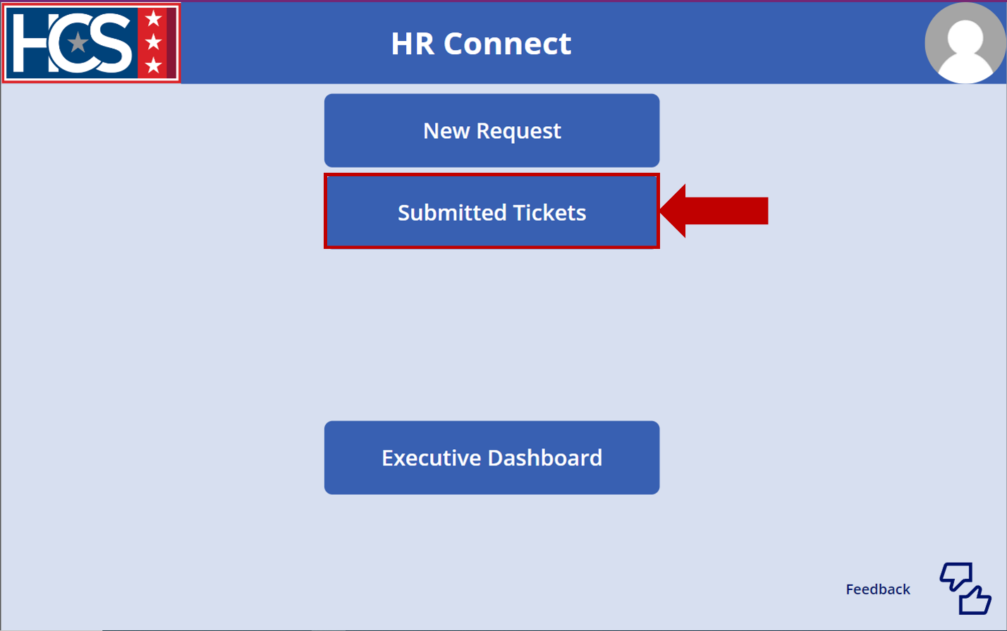
- Select Assigned on the Submitted Tickets screen to display tickets with a status of Assigned.
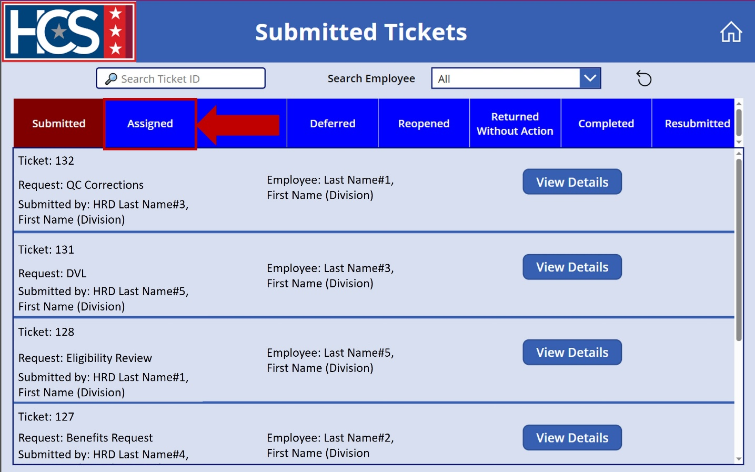
- Review Assigned tickets displayed on the Submitted Tickets screen.
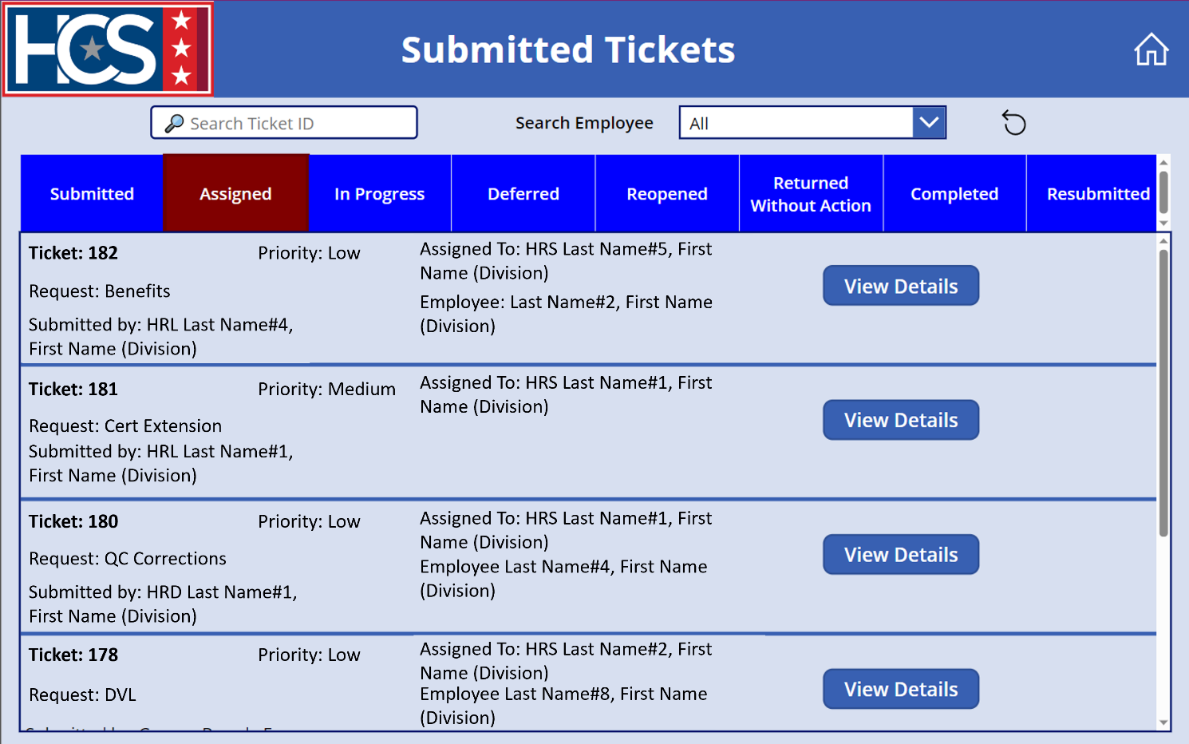
- Type a ticket number in the Search Ticket ID field.
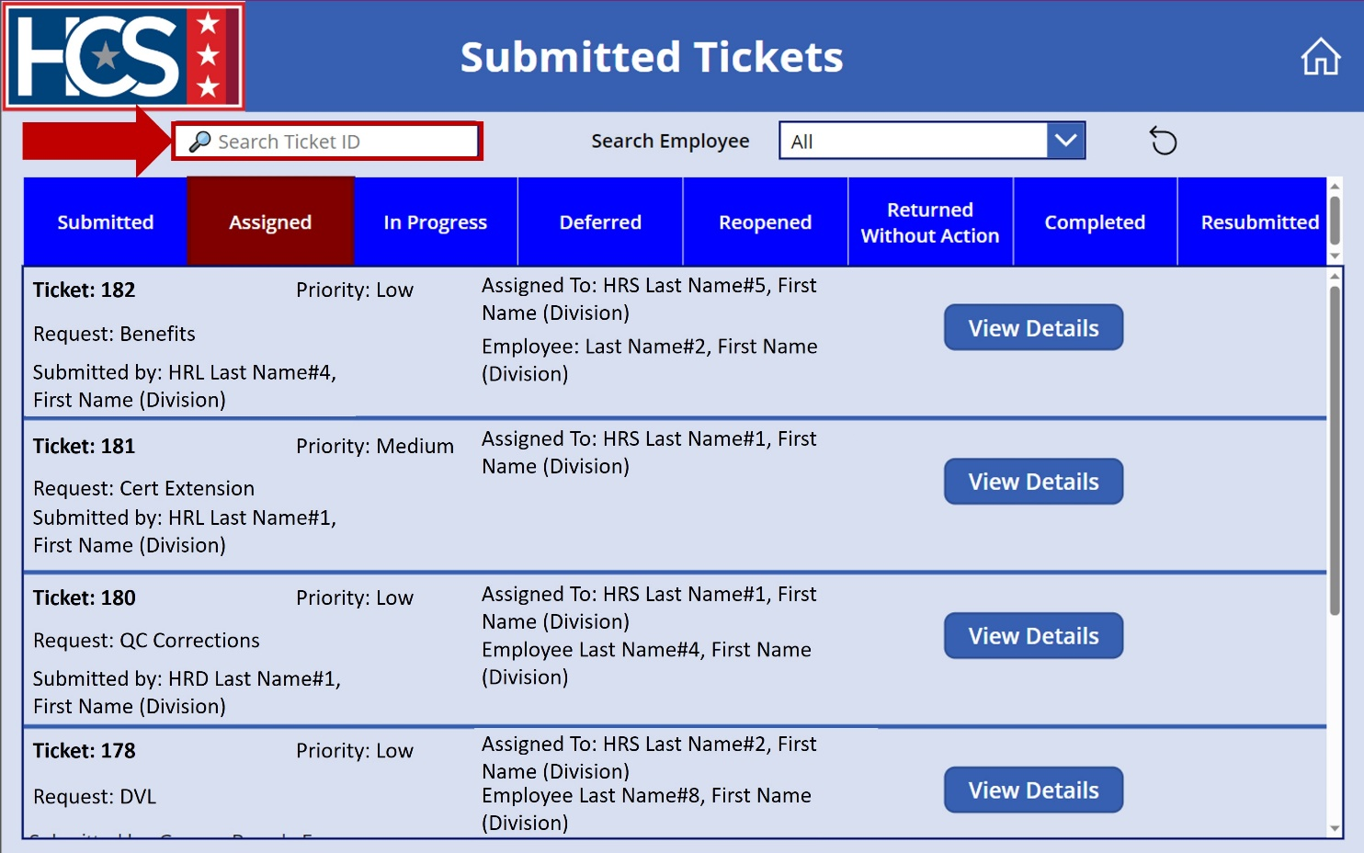
- Review tickets that display as a result of the entered ticket ID number on the Submitted Tickets screen.
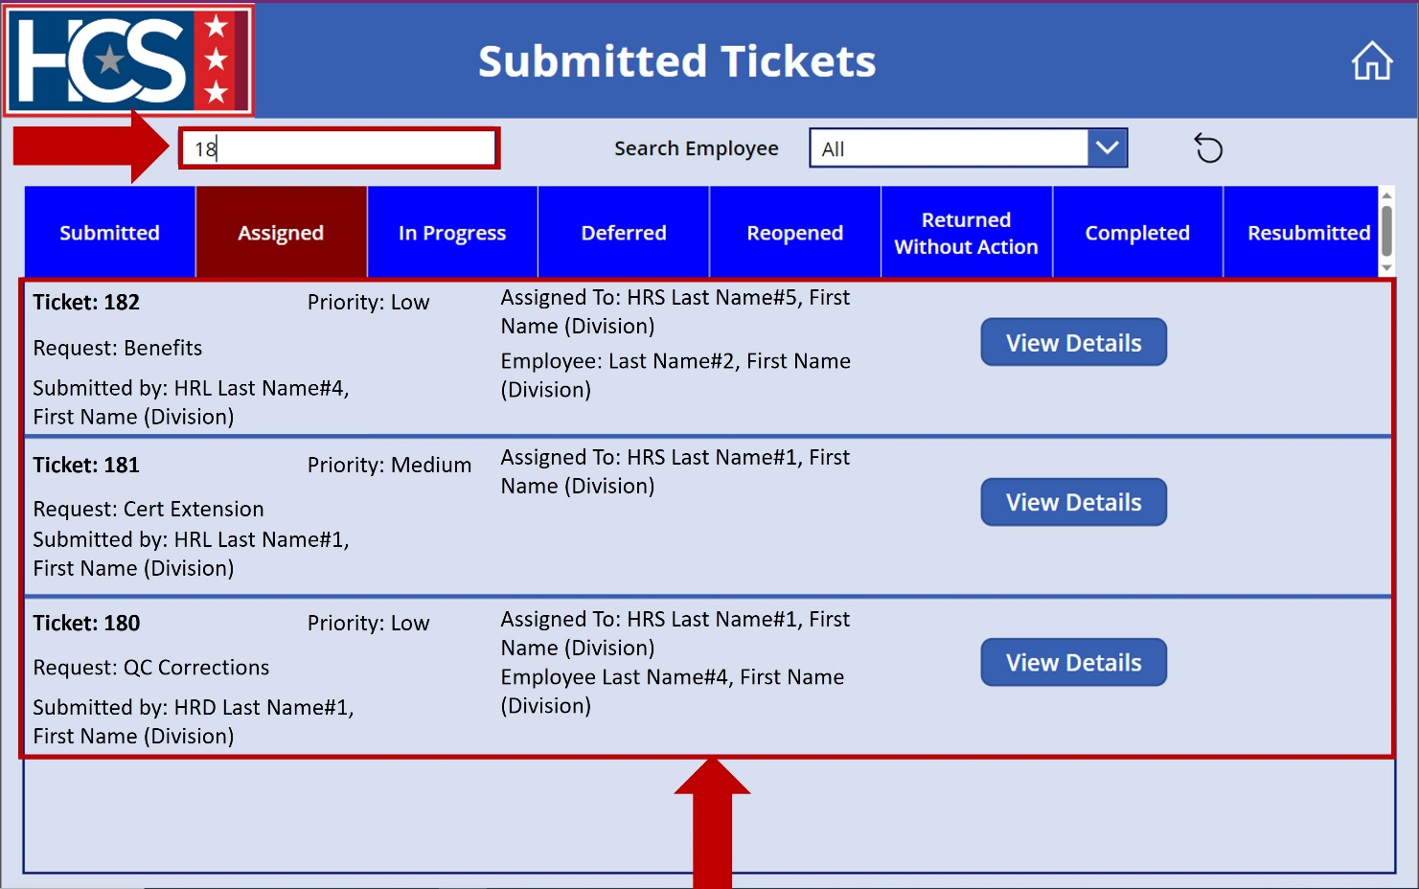
- Select the Search Employee dropdown menu to filter tickets by employee name.
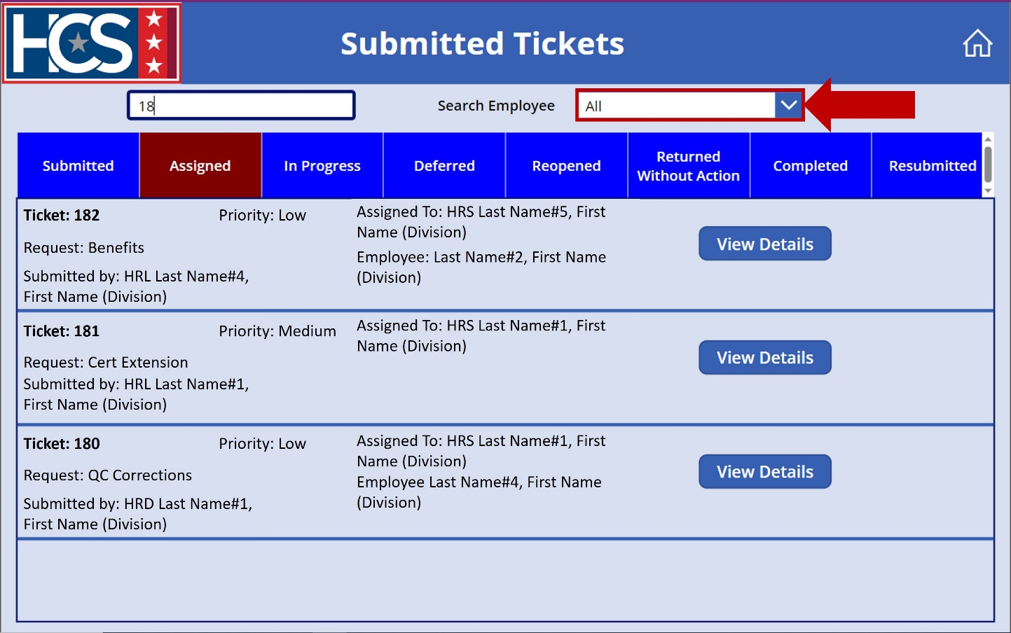
- Select employee name from the dropdown menu.
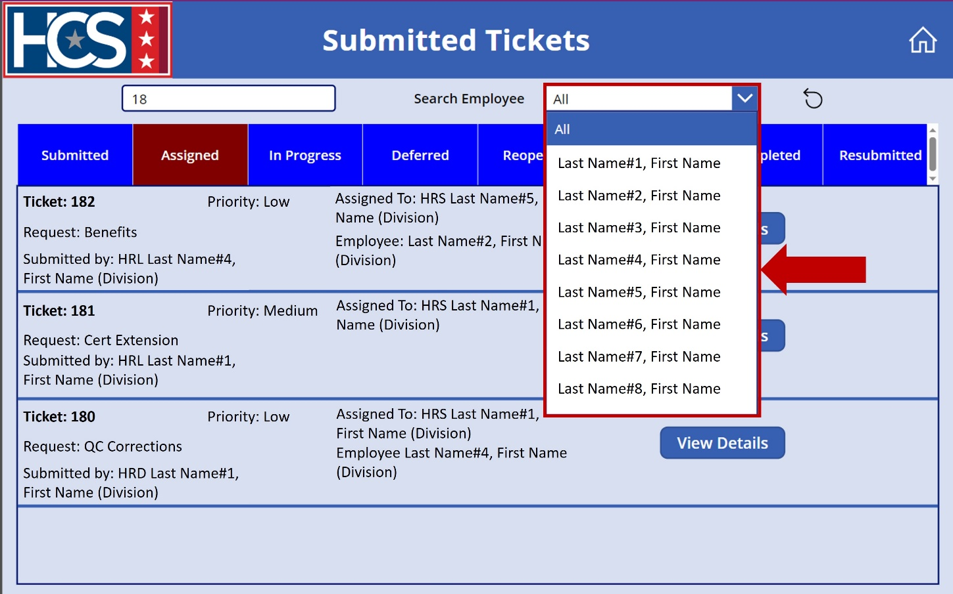
- Review tickets that display on the Submitted Tickets screen as a result of the ticket ID and employee selections.
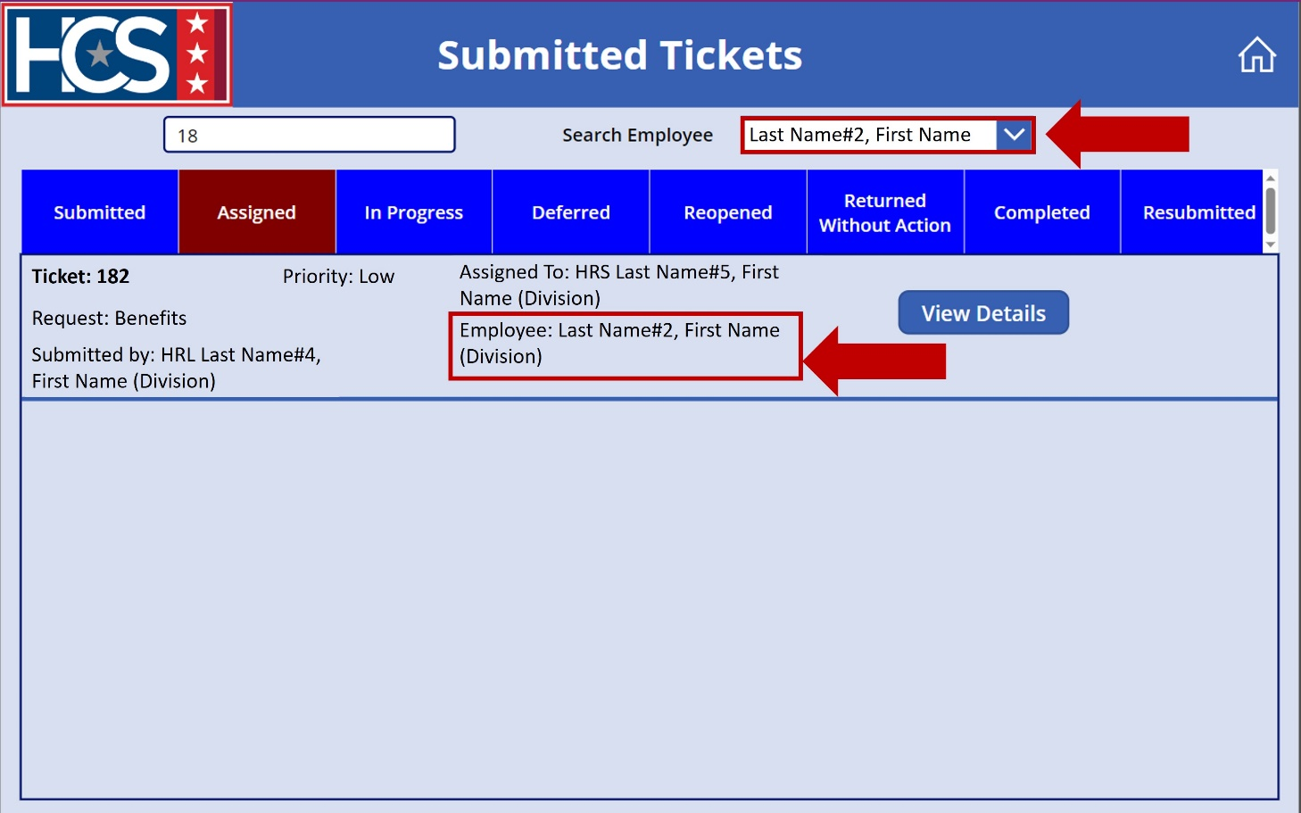
- Select the Reset icon to clear and reset filters.
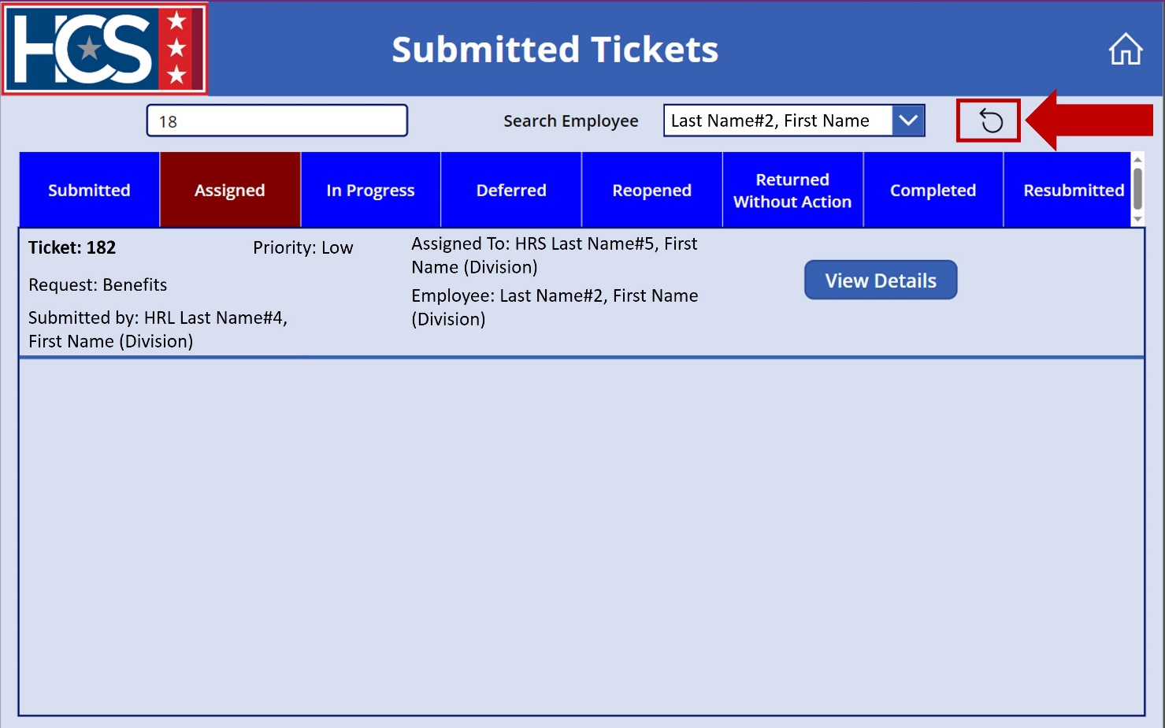
- Observe reset filters for the selected status (Assigned).
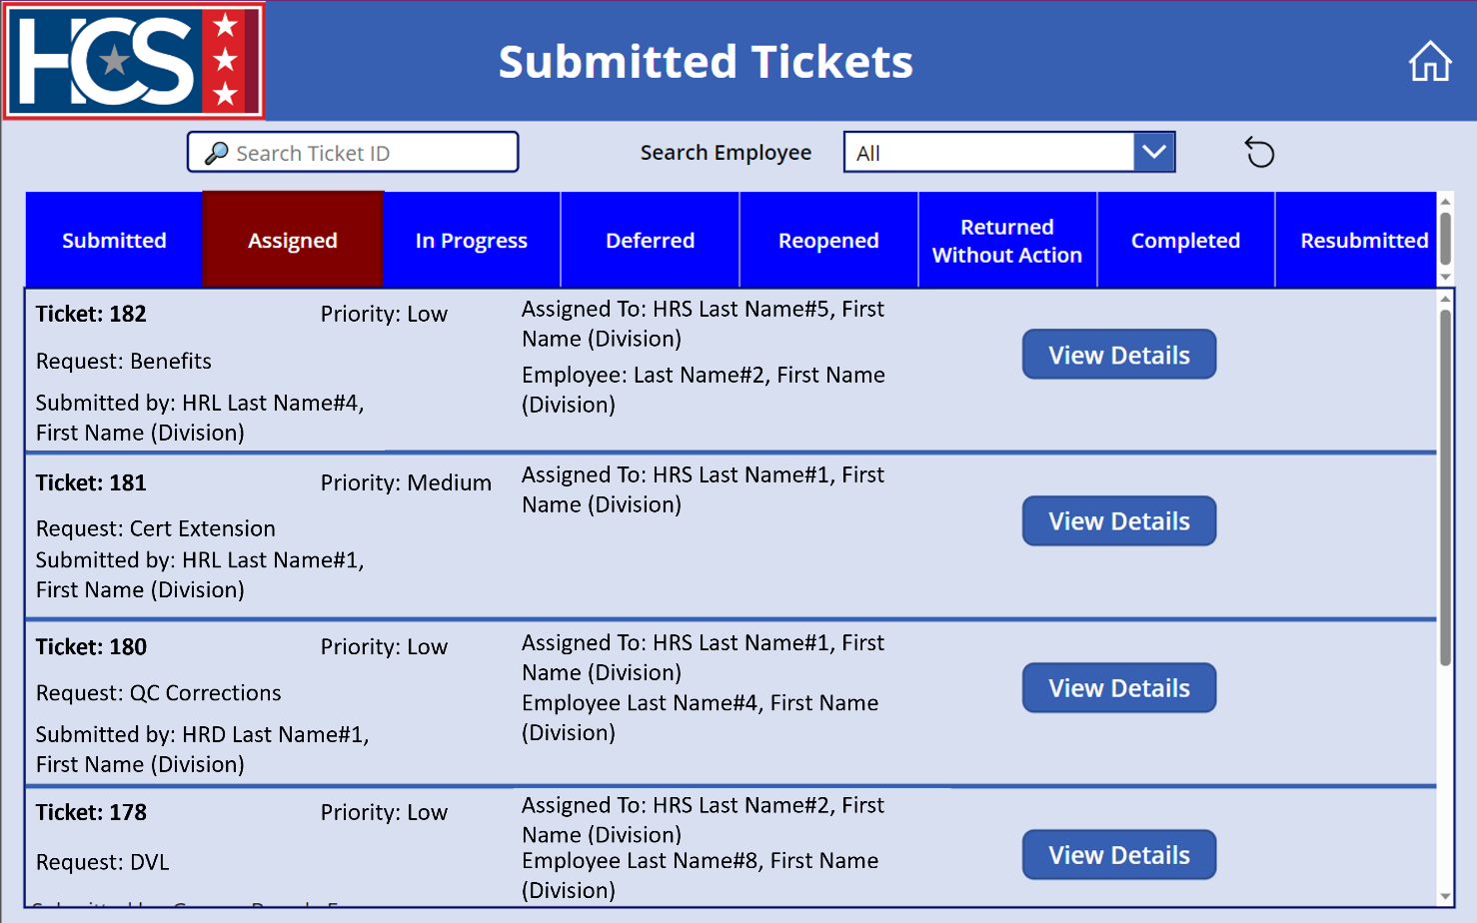

Resubmit a Ticket
If the HRC Supervisor assigns the status of Return Without Action to a ticket, a reason for the return is provided on the returned ticket. If the reason identified is either Missing Documents or Additional Information Needed, the ticket can be updated with the appropriate documentation/information and resubmitted in HR Connect.
- Select Submitted Tickets on the HR Connect home screen.
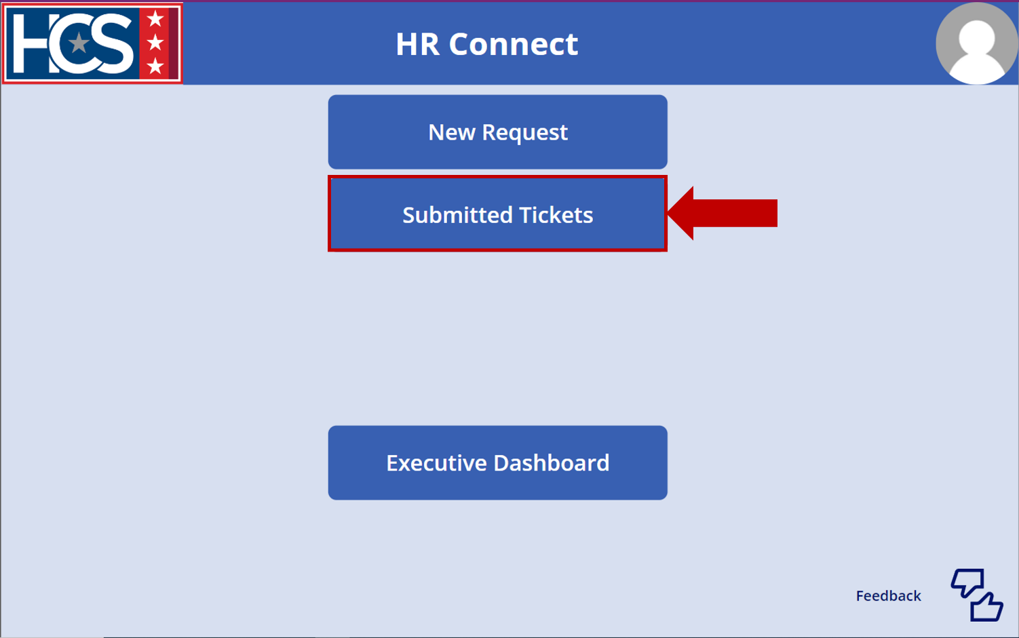

- Select Returned Without Action to display tickets with a status of Returned Without Action.
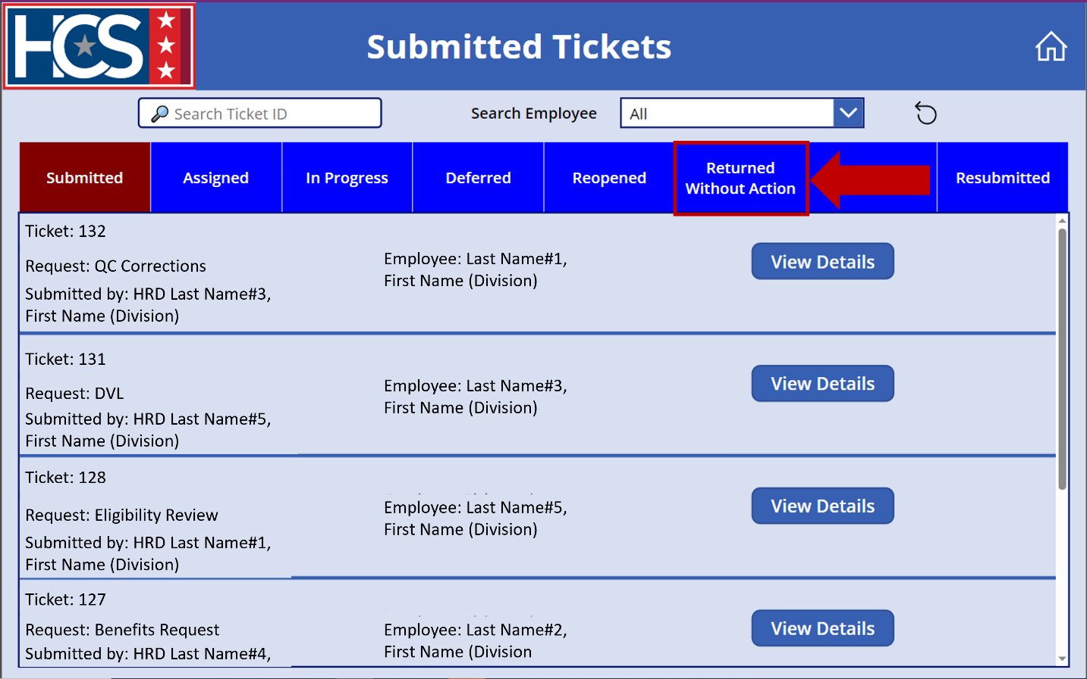
- Observe Returned Without Action tickets displayed on the Submitted Tickets screen.
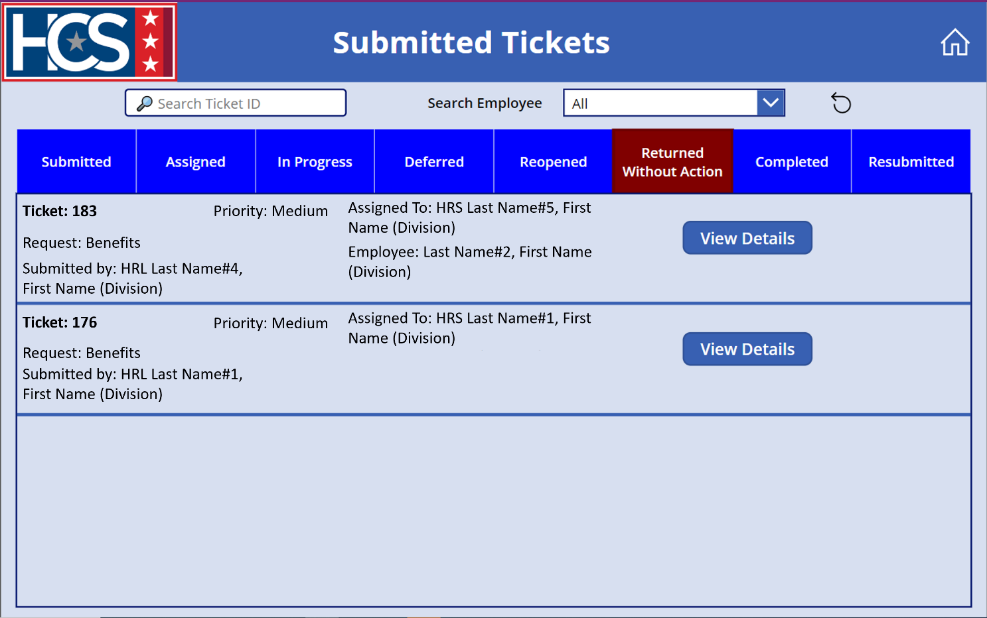
- Select View Details on the ticket to be resubmitted.
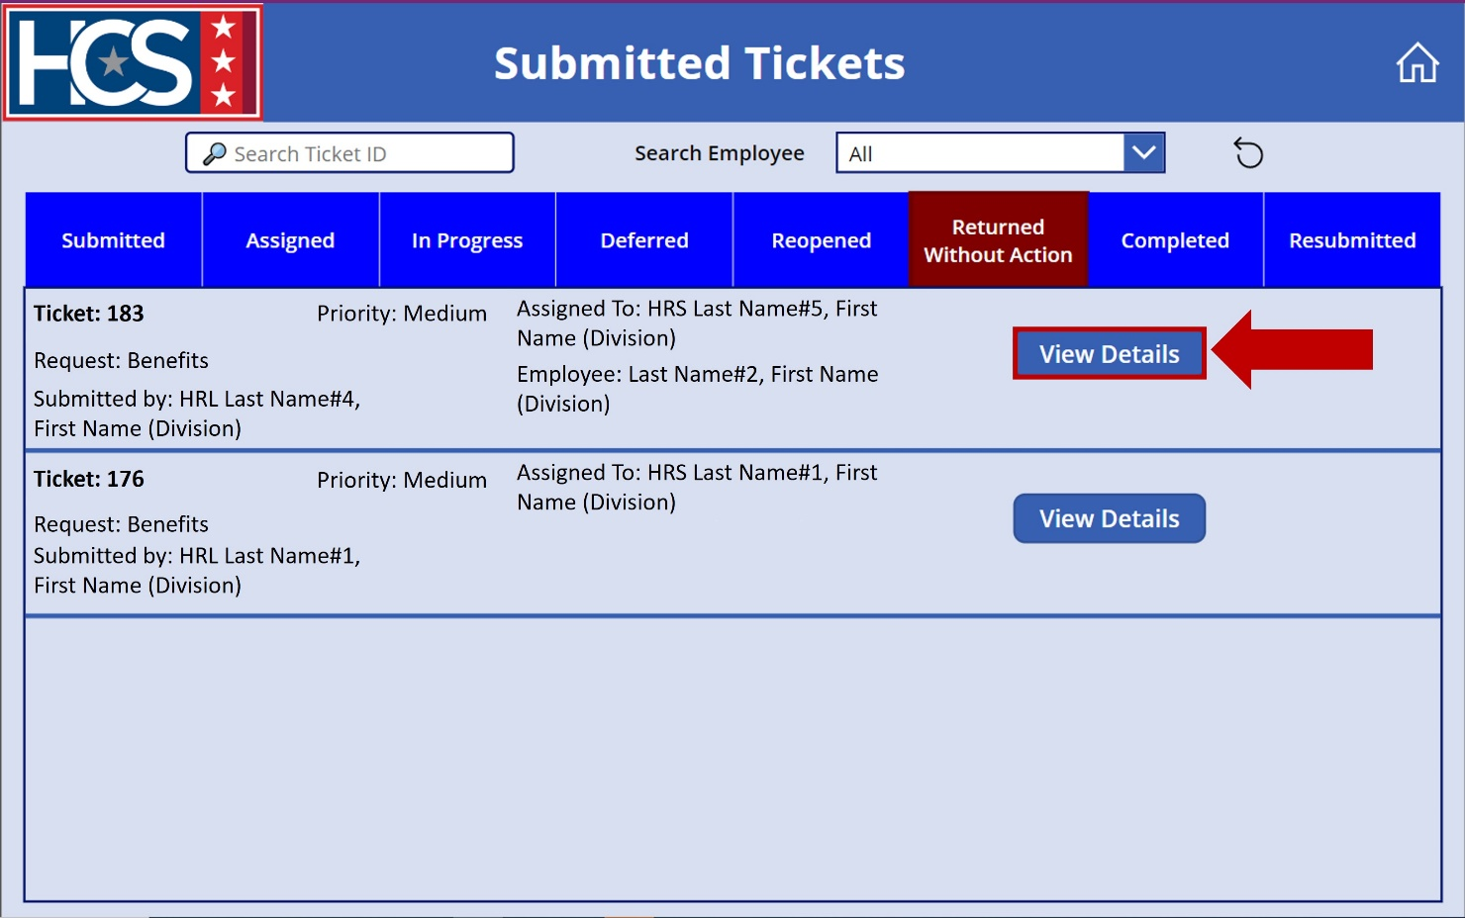
- Observe the Details screen.
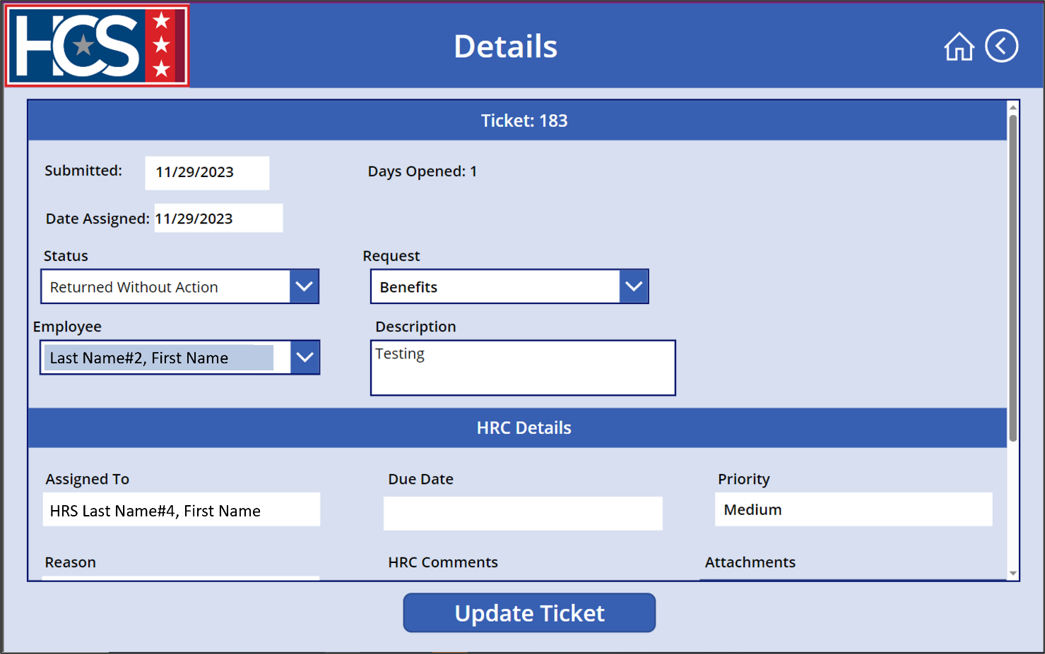
- Use the scroll bar to scroll down on the ticket details.
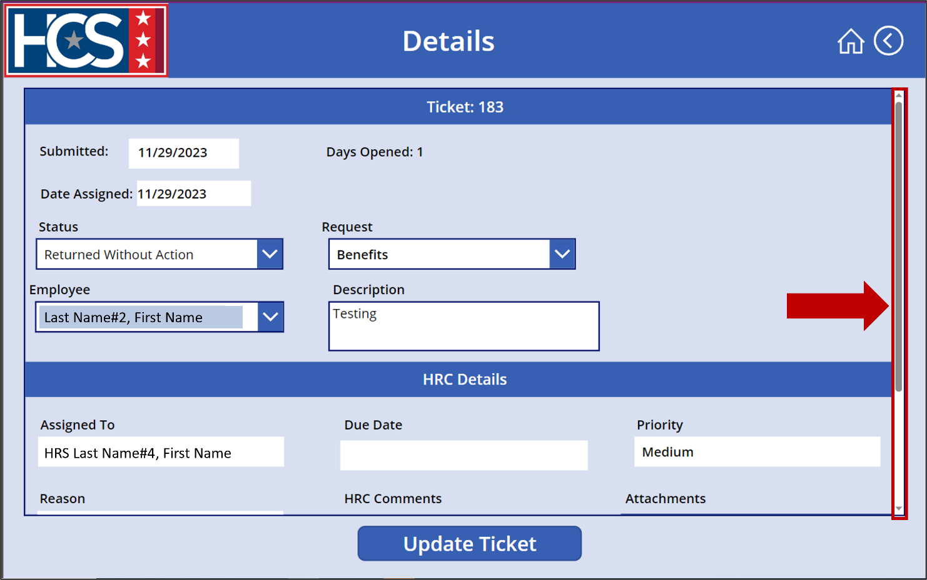
- Review the Reason the ticket was returned without action.
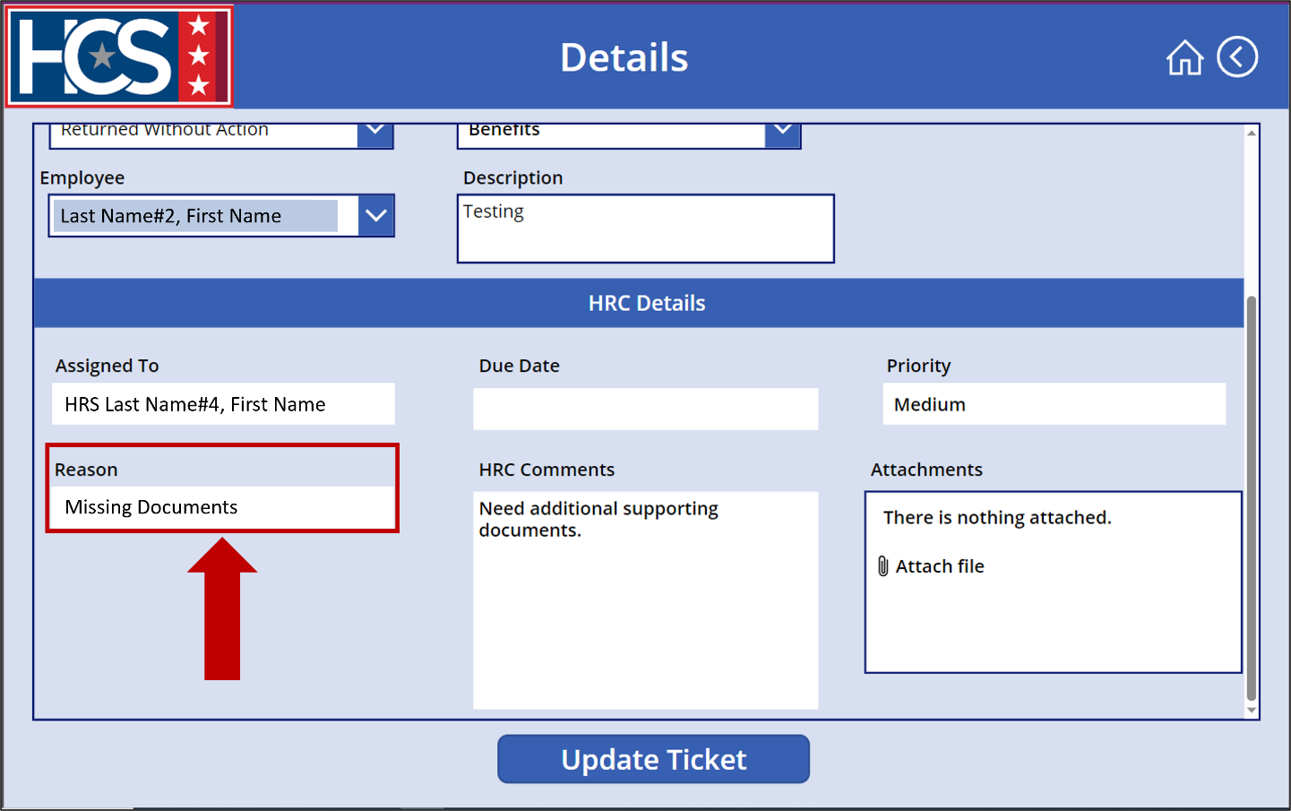
- Select Attach File.
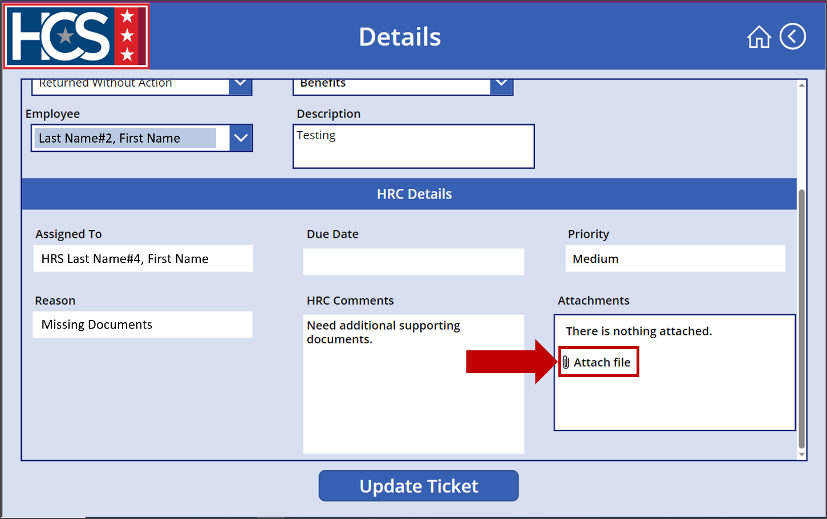
- Select the file(s) from the Open dialog box that displays.
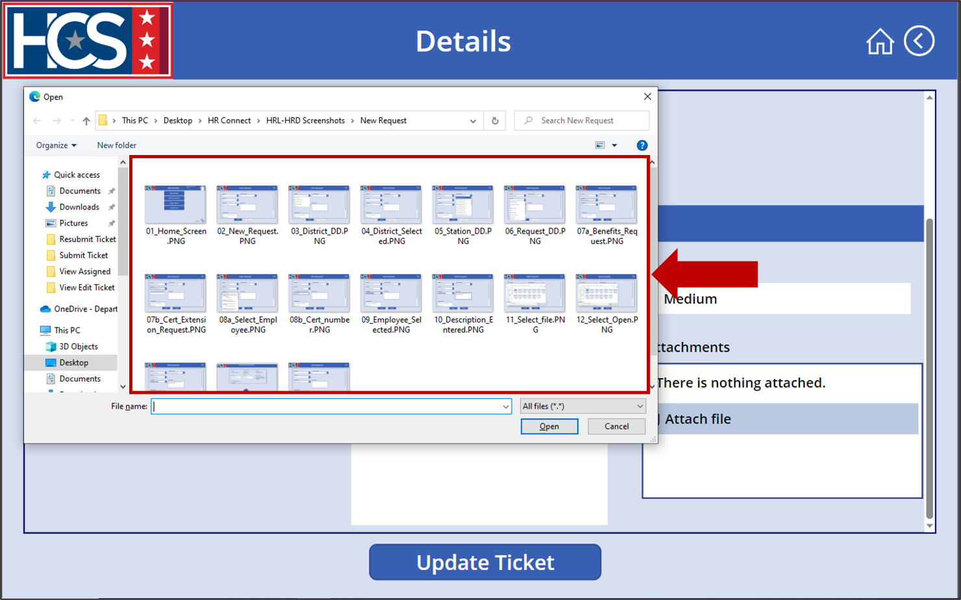
- Select Open to attach the file(s).
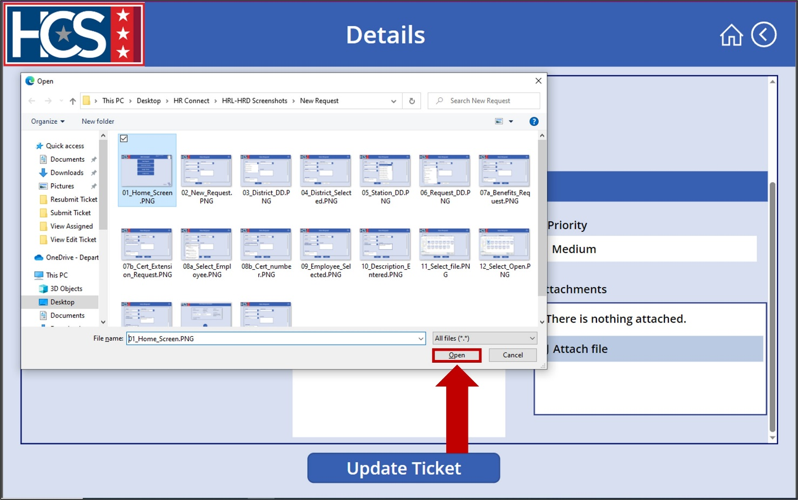
- Confirm that the file is attached to the new request in the Attachments field.
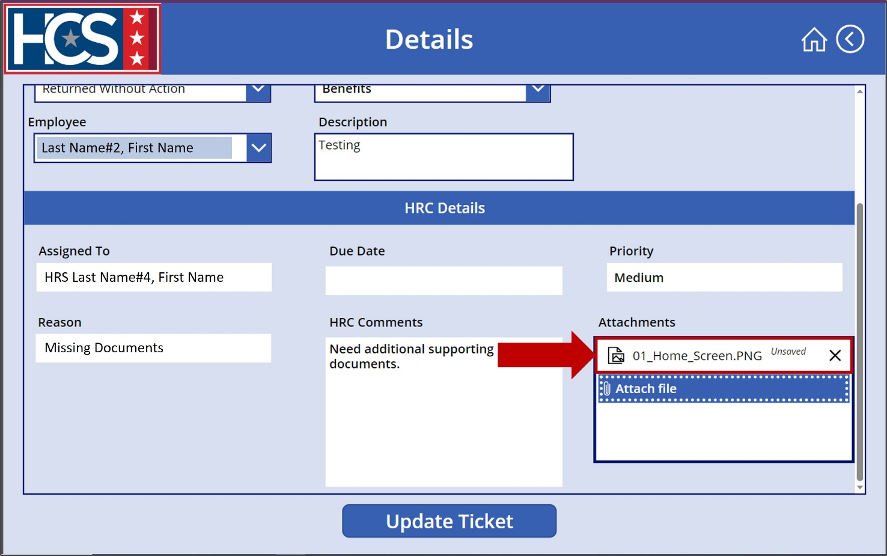
- Use the scroll bar to scroll up on the ticket details.
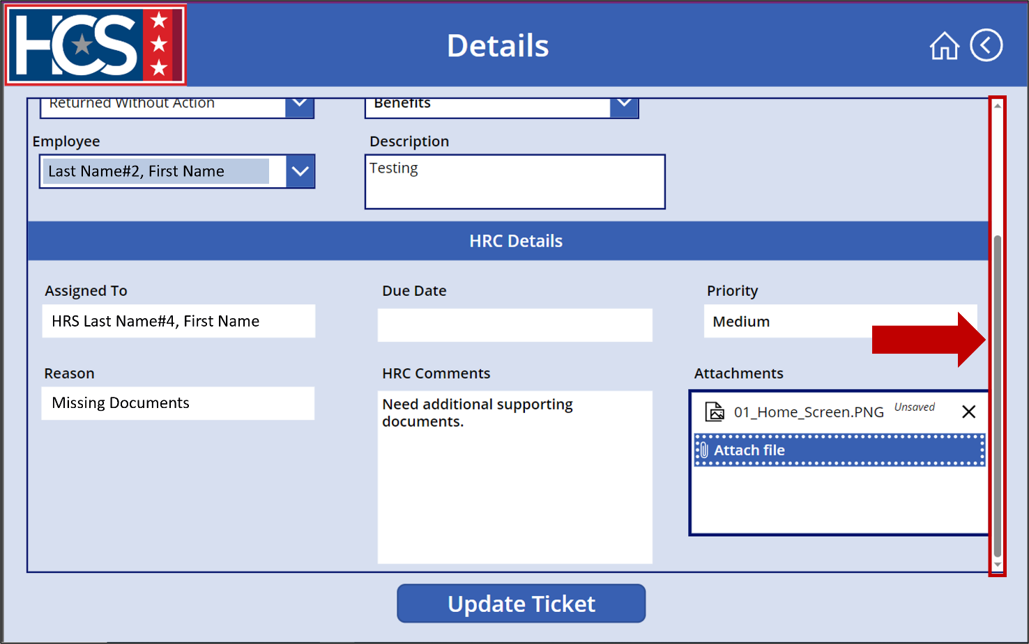
- Select Resubmitted from Status dropdown menu.
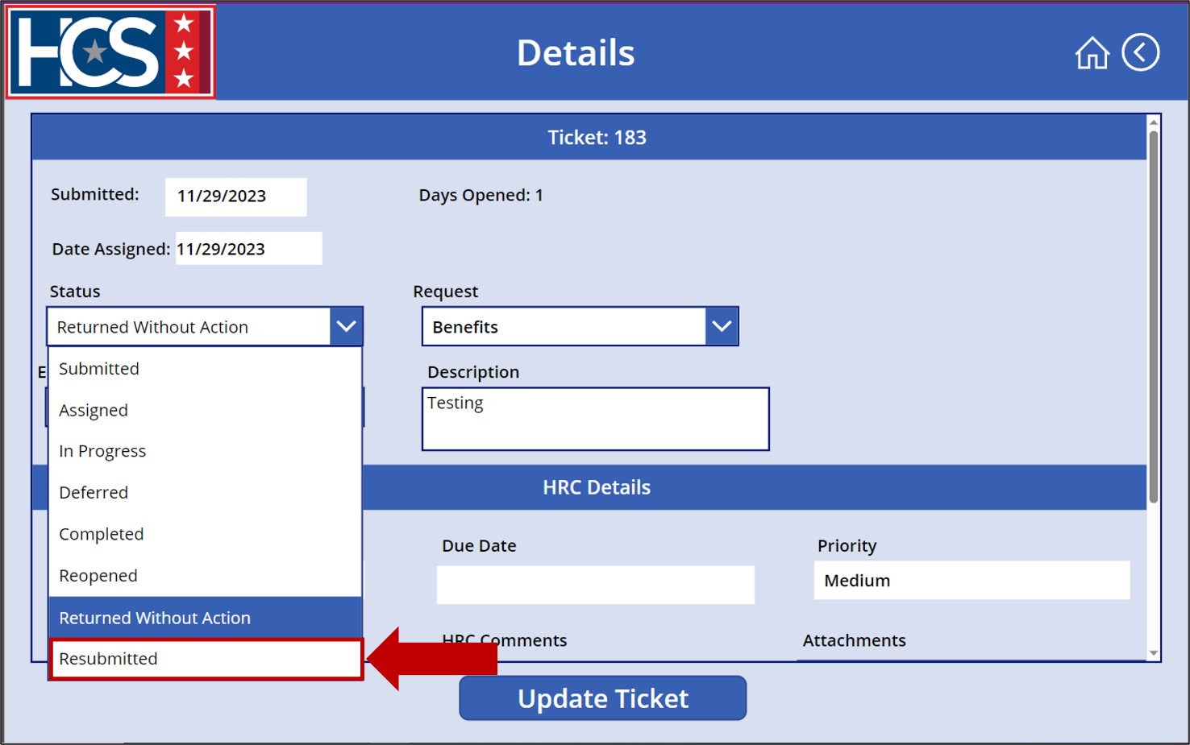
- Observe that the Status field is grayed out once selected.
NOTE: The Status cannot be updated from the dropdown menu once Resubmitted is selected.
NOTE: Request and Employee fields should not be updated.
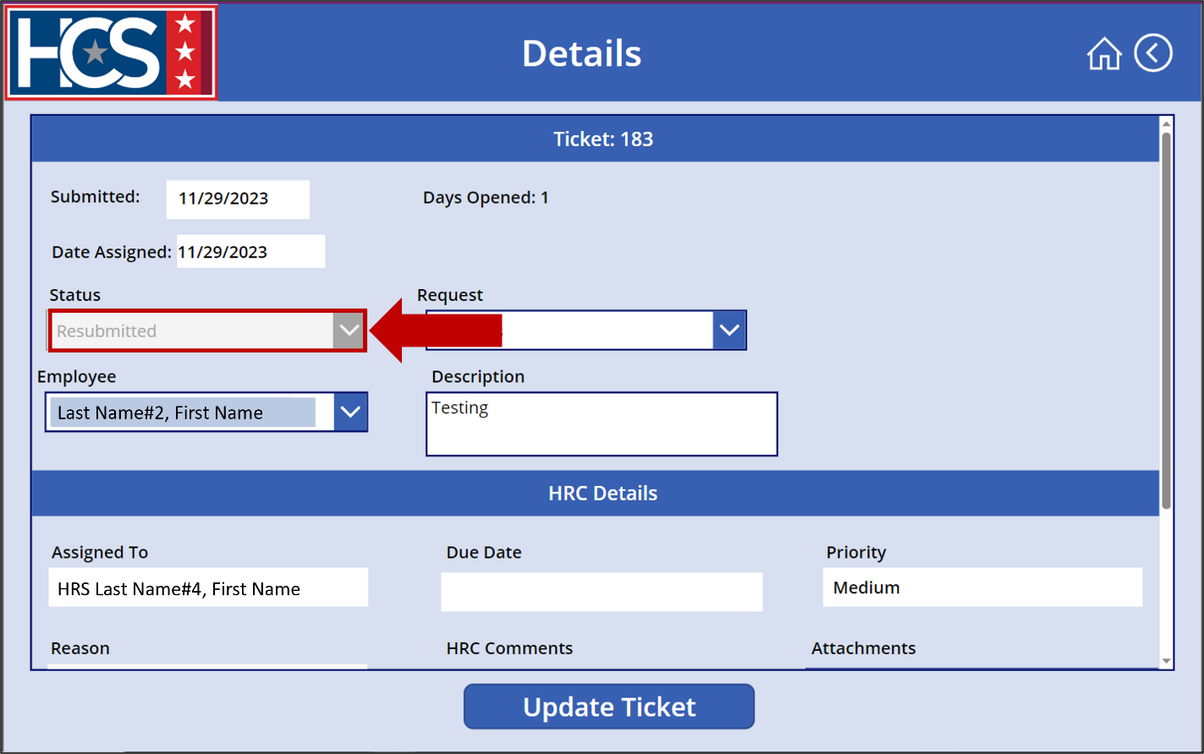
- Select Update Ticket to resubmit the ticket.
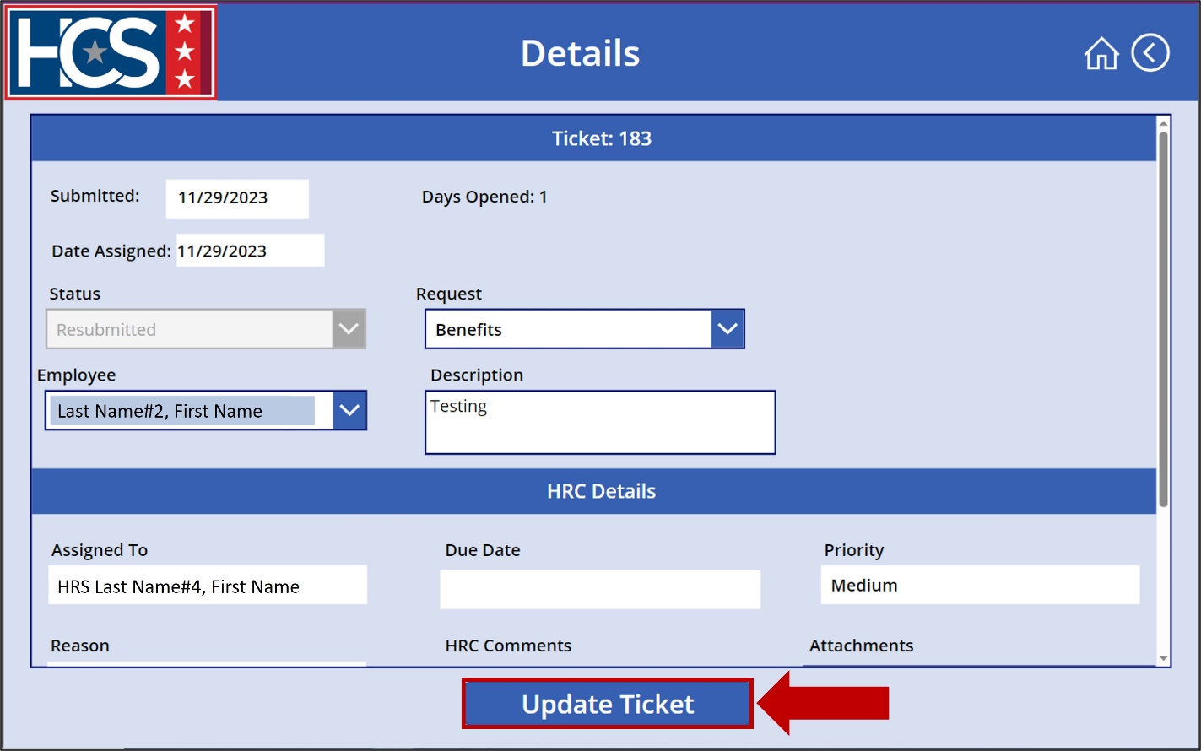
- Observe that the ticket is no longer displayed with the Returned Without Action tickets.
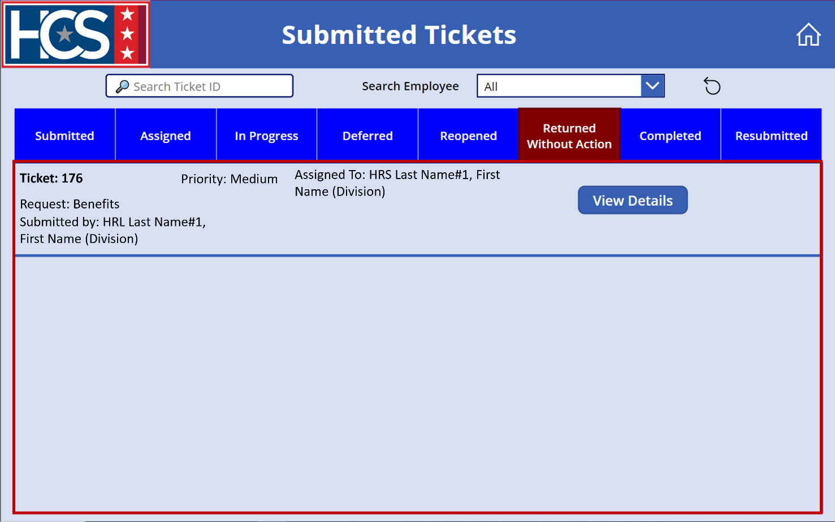
- Select Resubmitted to display tickets with a status of Resubmitted.
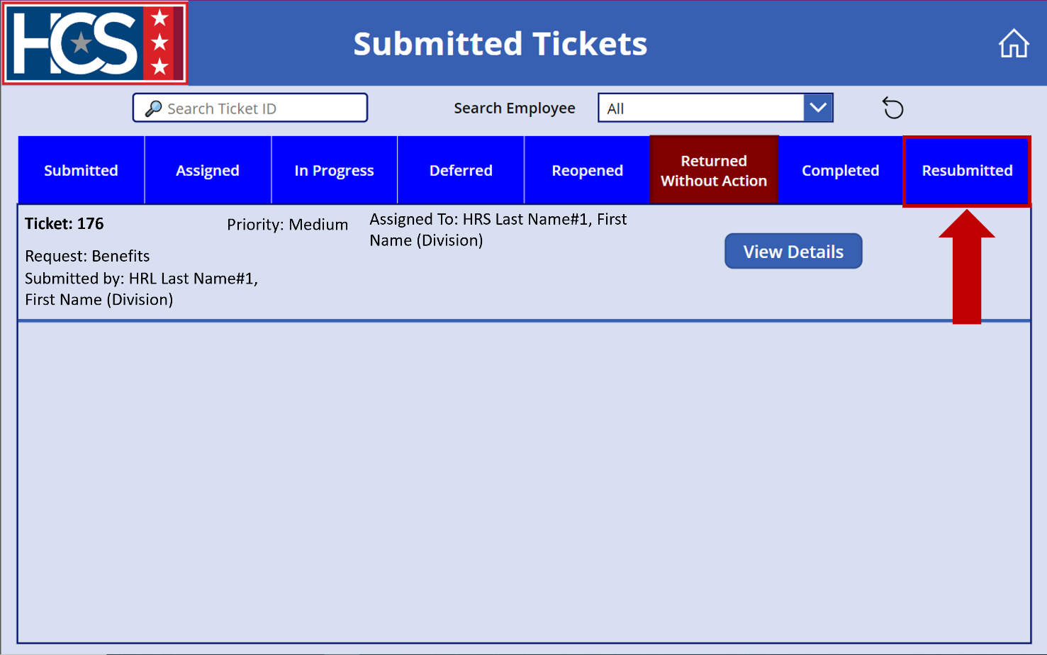
- Observe that the ticket is displayed with the Resubmitted tickets.
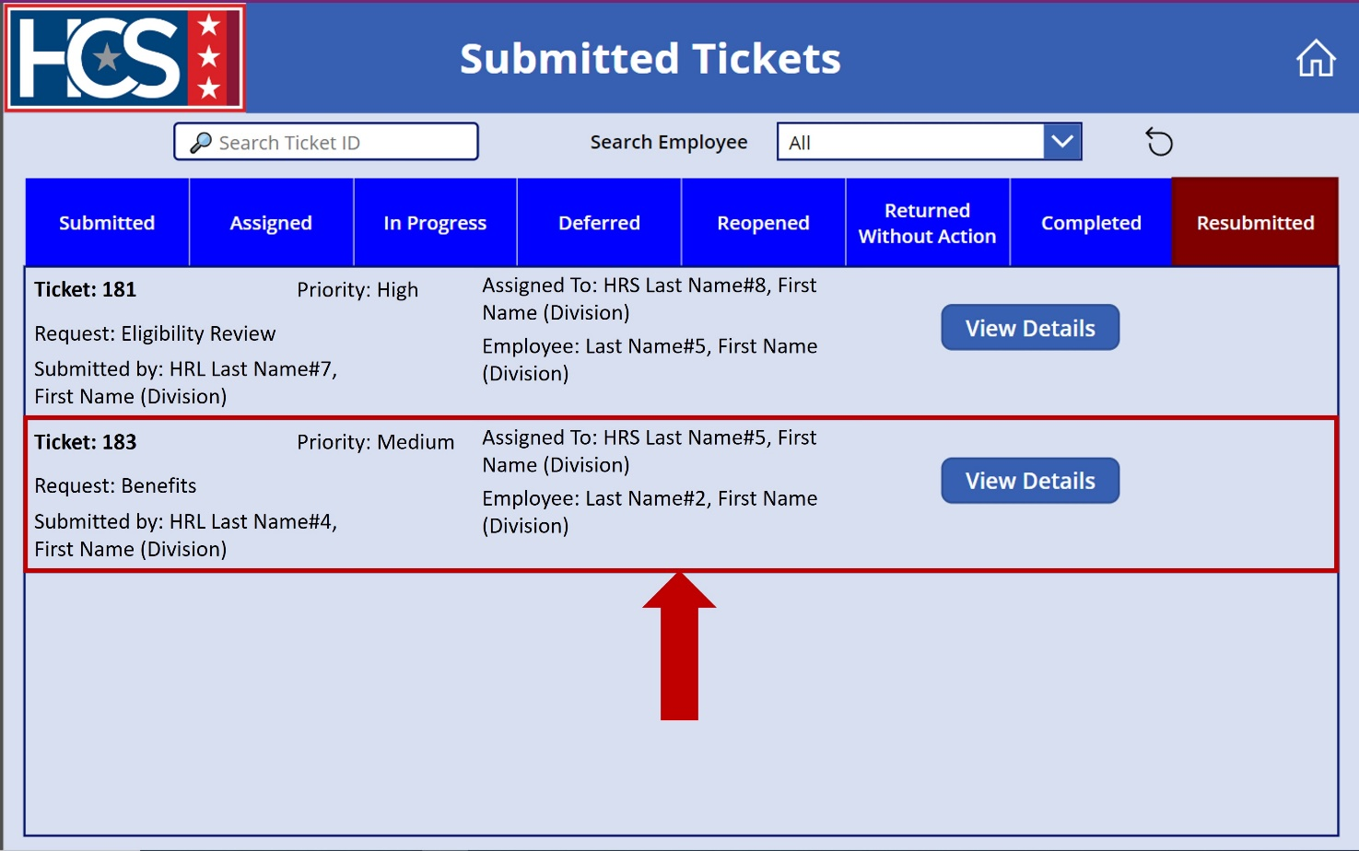

Submit HR Connect Feedback
- Select Feedback on the HR Connect home screen to submit any HR Connect-related feedback, if needed.
NOTE: The Feedback option on this screen allows for the submission of recommendations for system enhancements, issues with the system, access requests, etc.
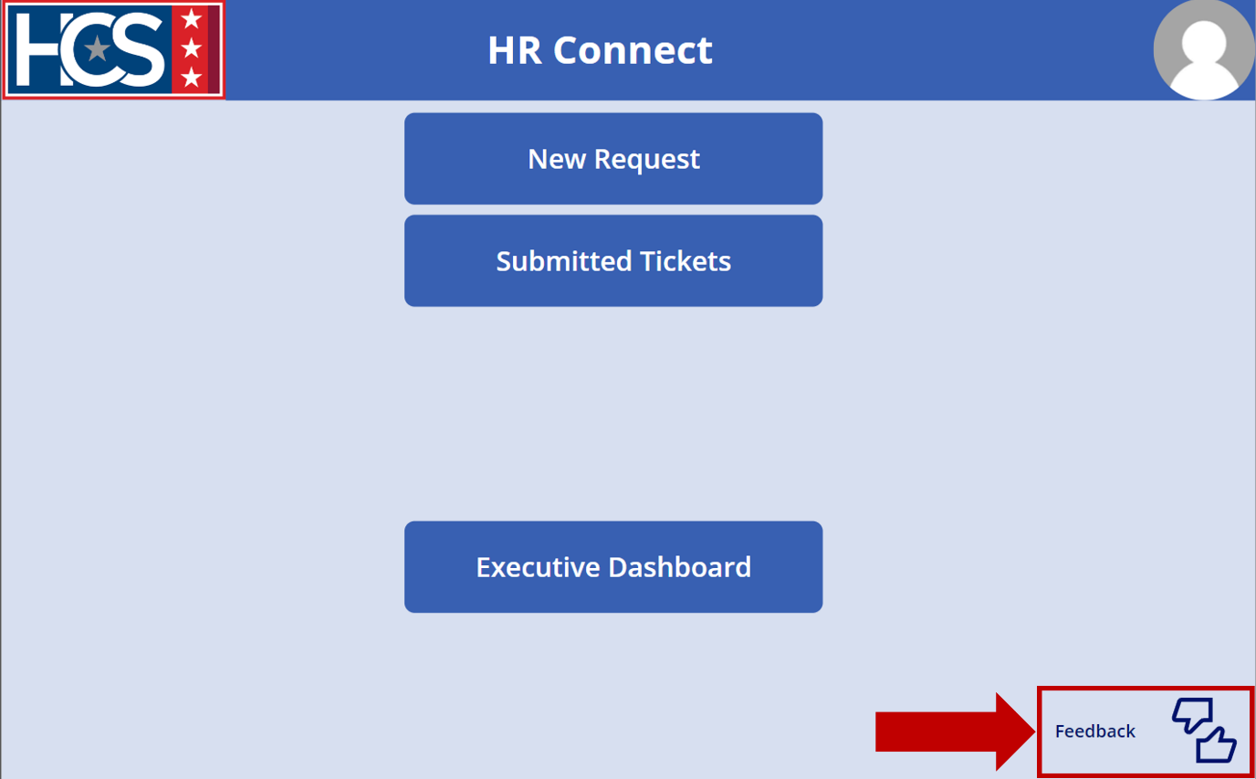
- Observe the Feedback screen.
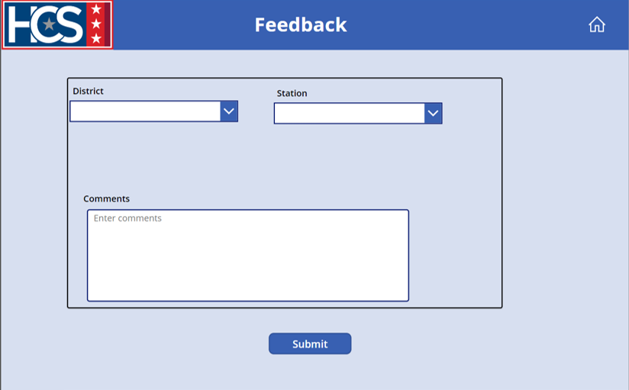
- Select the appropriate district from the District dropdown menu.
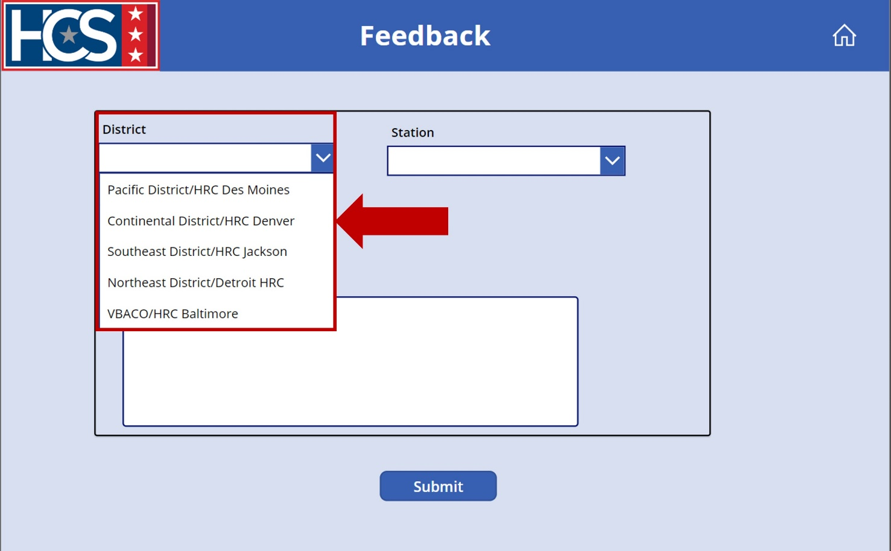
- Select the appropriate station from the Station dropdown menu.
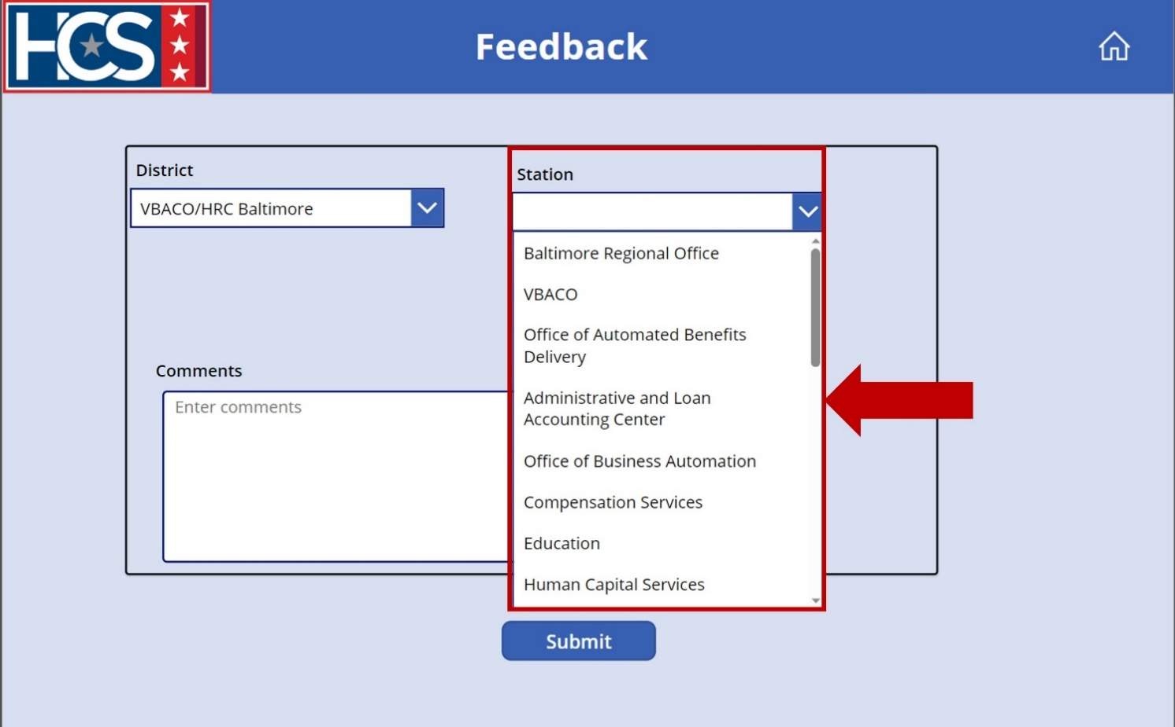
- Type feedback in the Comments field.
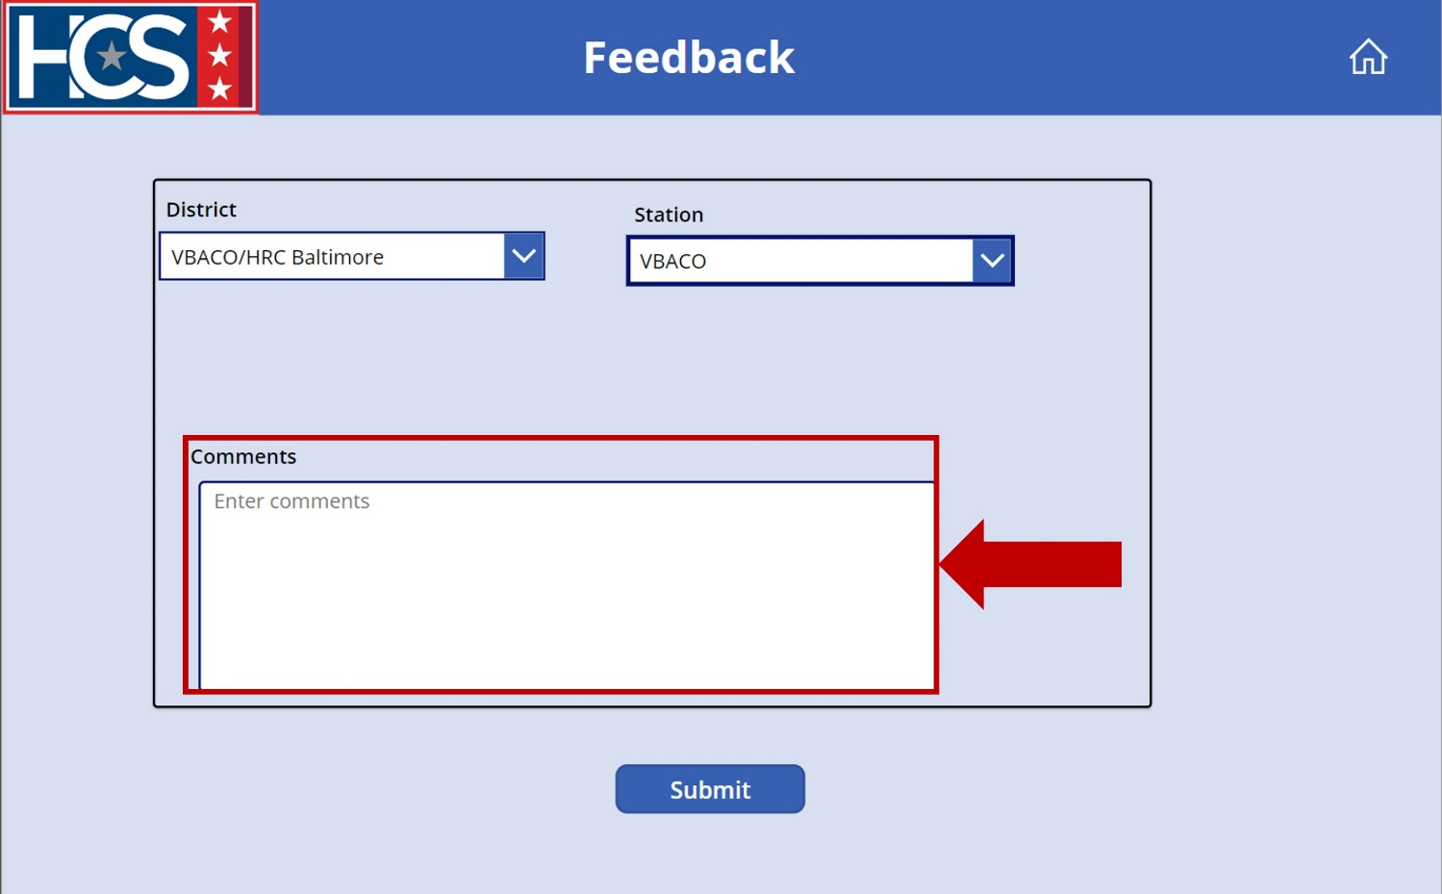
- Select Submit.
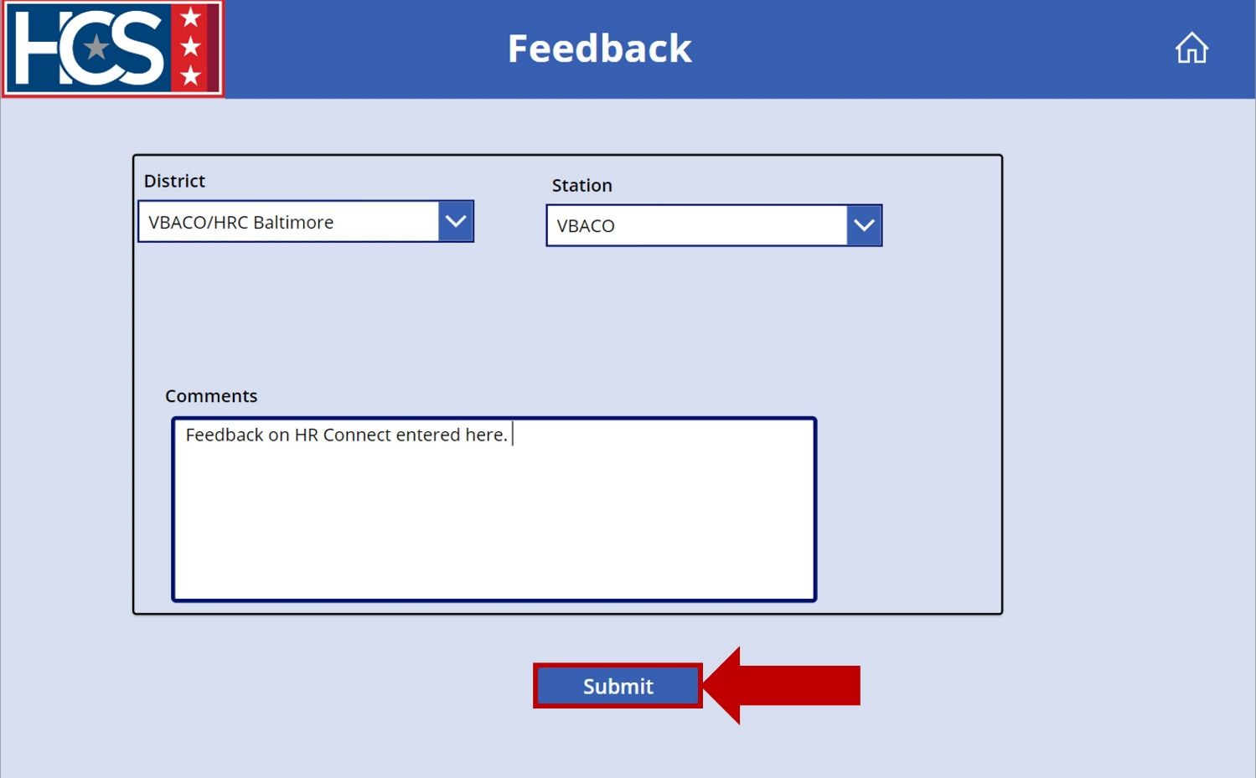
- Select the Home icon to return to the home screen.
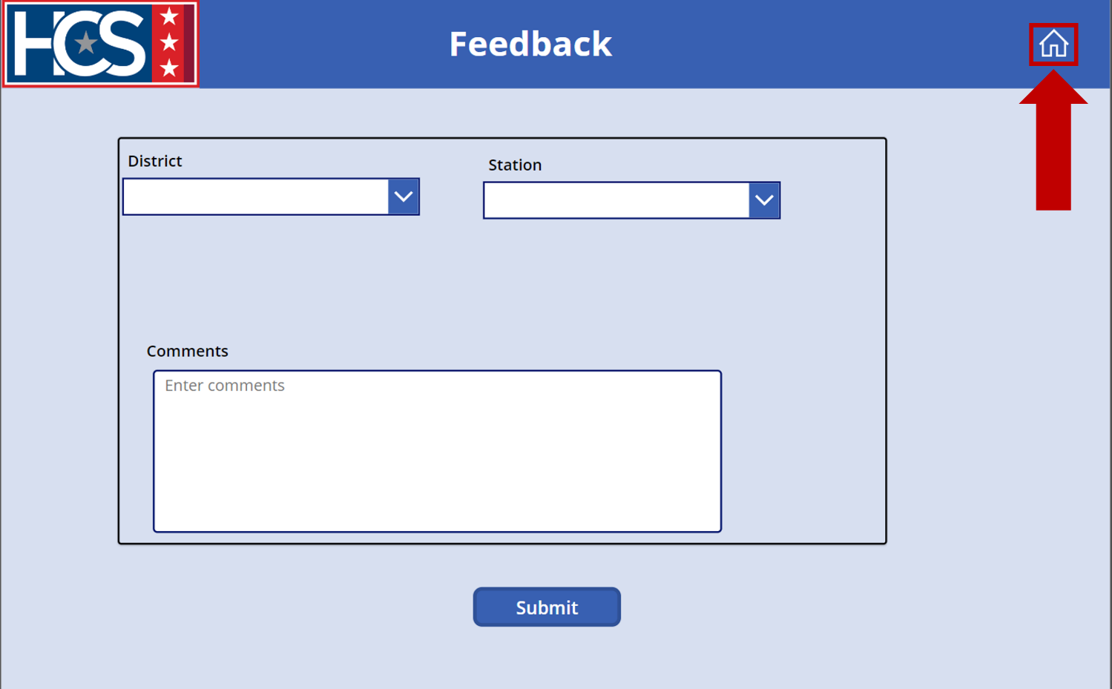

Executive Dashboard

Overview
The Executive Dashboard provides executive leadership with a comprehensive snapshot of ticket requests for all districts, by a specific district, and/or by specific station. The data within the dashboard allows an HRL/HRD Specialist/HRS to view trends in request categories, identify areas in need of training, review processing timelines for requests by category, and search for tickets. HRLs/HRD Specialists/HRSs also have the option to export tables into MS Excel for additional review outside of the dashboard.
The data displayed on the dashboard can be refined using the provided filters:
- District
- Station Name
- Category
- Task Status
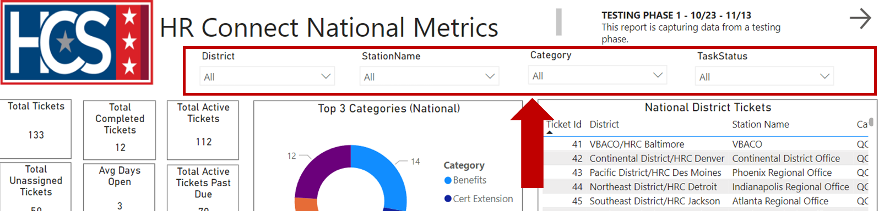

Each filter includes a dropdown menu that allows for filtering of information:
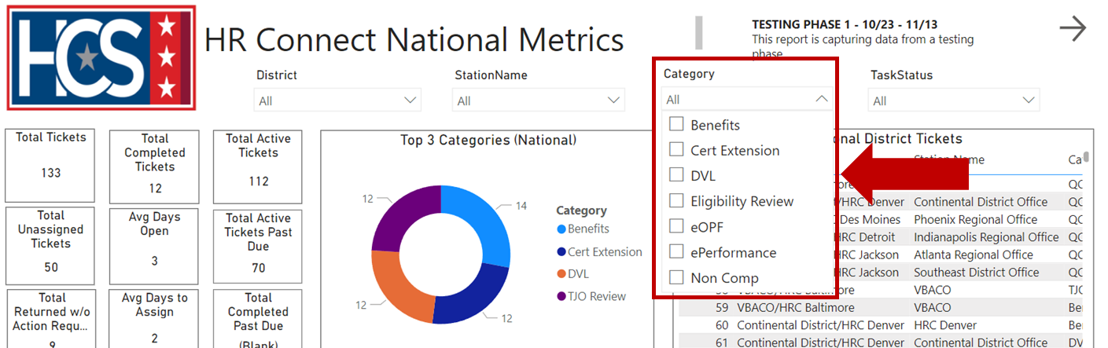

HR Connect National Metrics Dashboard Data
Information on the HR Connect National Metrics dashboard includes several data categories.
- Snapshot of national ticket requests, providing data that includes:
  - Total Tickets.
  - Total Completed Tickets.
  - Total Active Tickets.
  - Total Unassigned Tickets.
  - Average Days Open.
  - Total Active Tickets Past Due.
  - Total Returned Without Action Requests.
  - Average Days to Assign.
  - Total Completed Past Due.
- National top 3 categories of request types displayed as a pie chart.
- Complete list of national district tickets.
- Top 3 categories of request types for each District displayed with a pie chart.
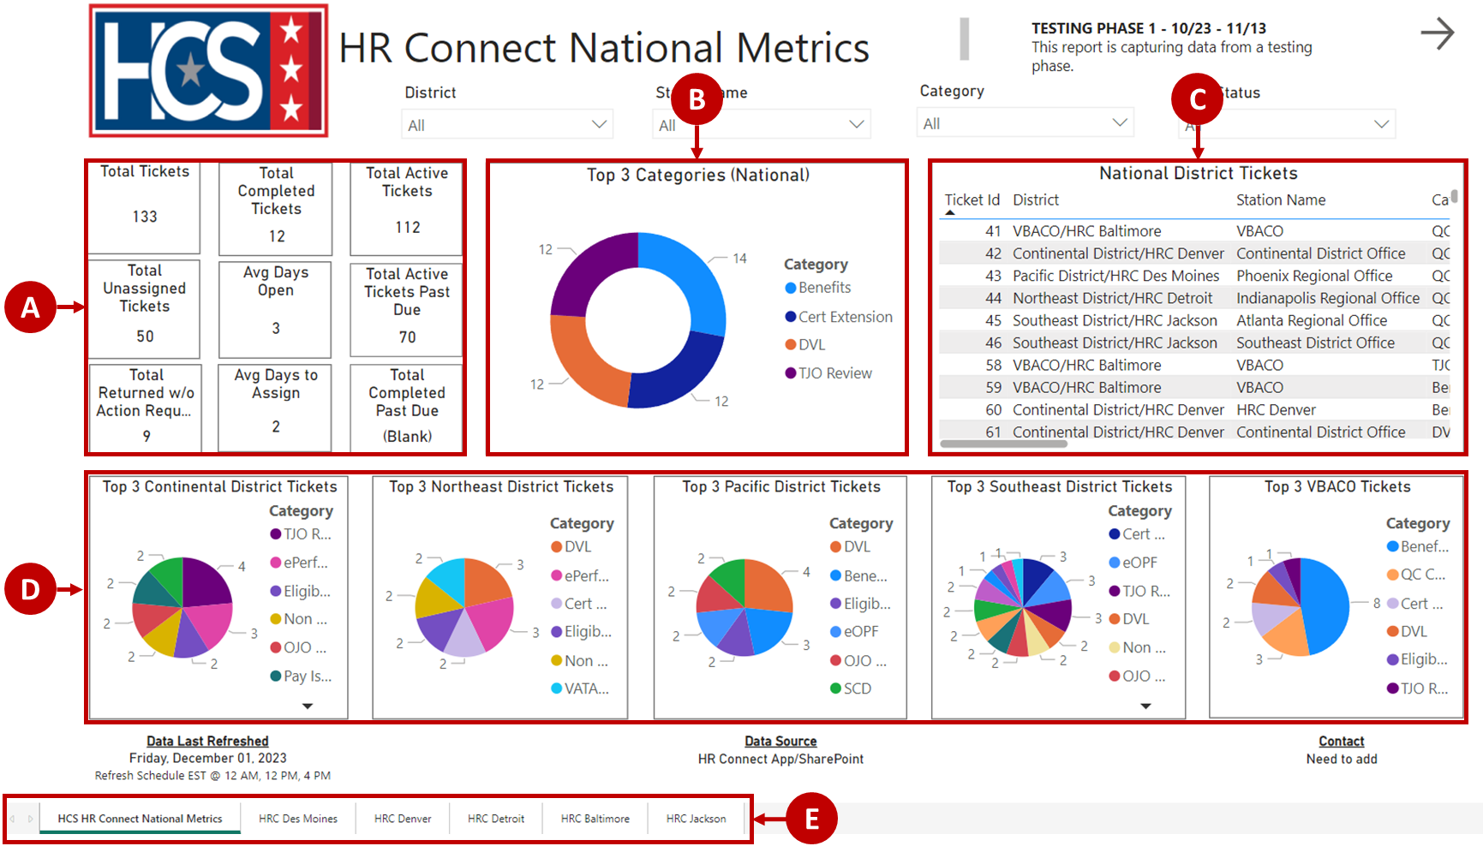

HR Connect District Metrics Dashboard Data
Information on the HR Connect District Metrics dashboard includes several data categories.
- Snapshot of district ticket requests, providing data that includes:
  - Total Tickets.
  - Completed Tickets.
  - Unassigned Tickets.
  - Active Tickets.
  - Average Days to Assign.
  - Average Days Open.
- Lists that display ticket information for all Active Tickets Past Due and Tickets Returned Without Action.
- Complete list of District tickets.
- Bar chart for each station displaying ticket request types.
- Back and Next arrows that return to the previous tab or advance to the next tab.
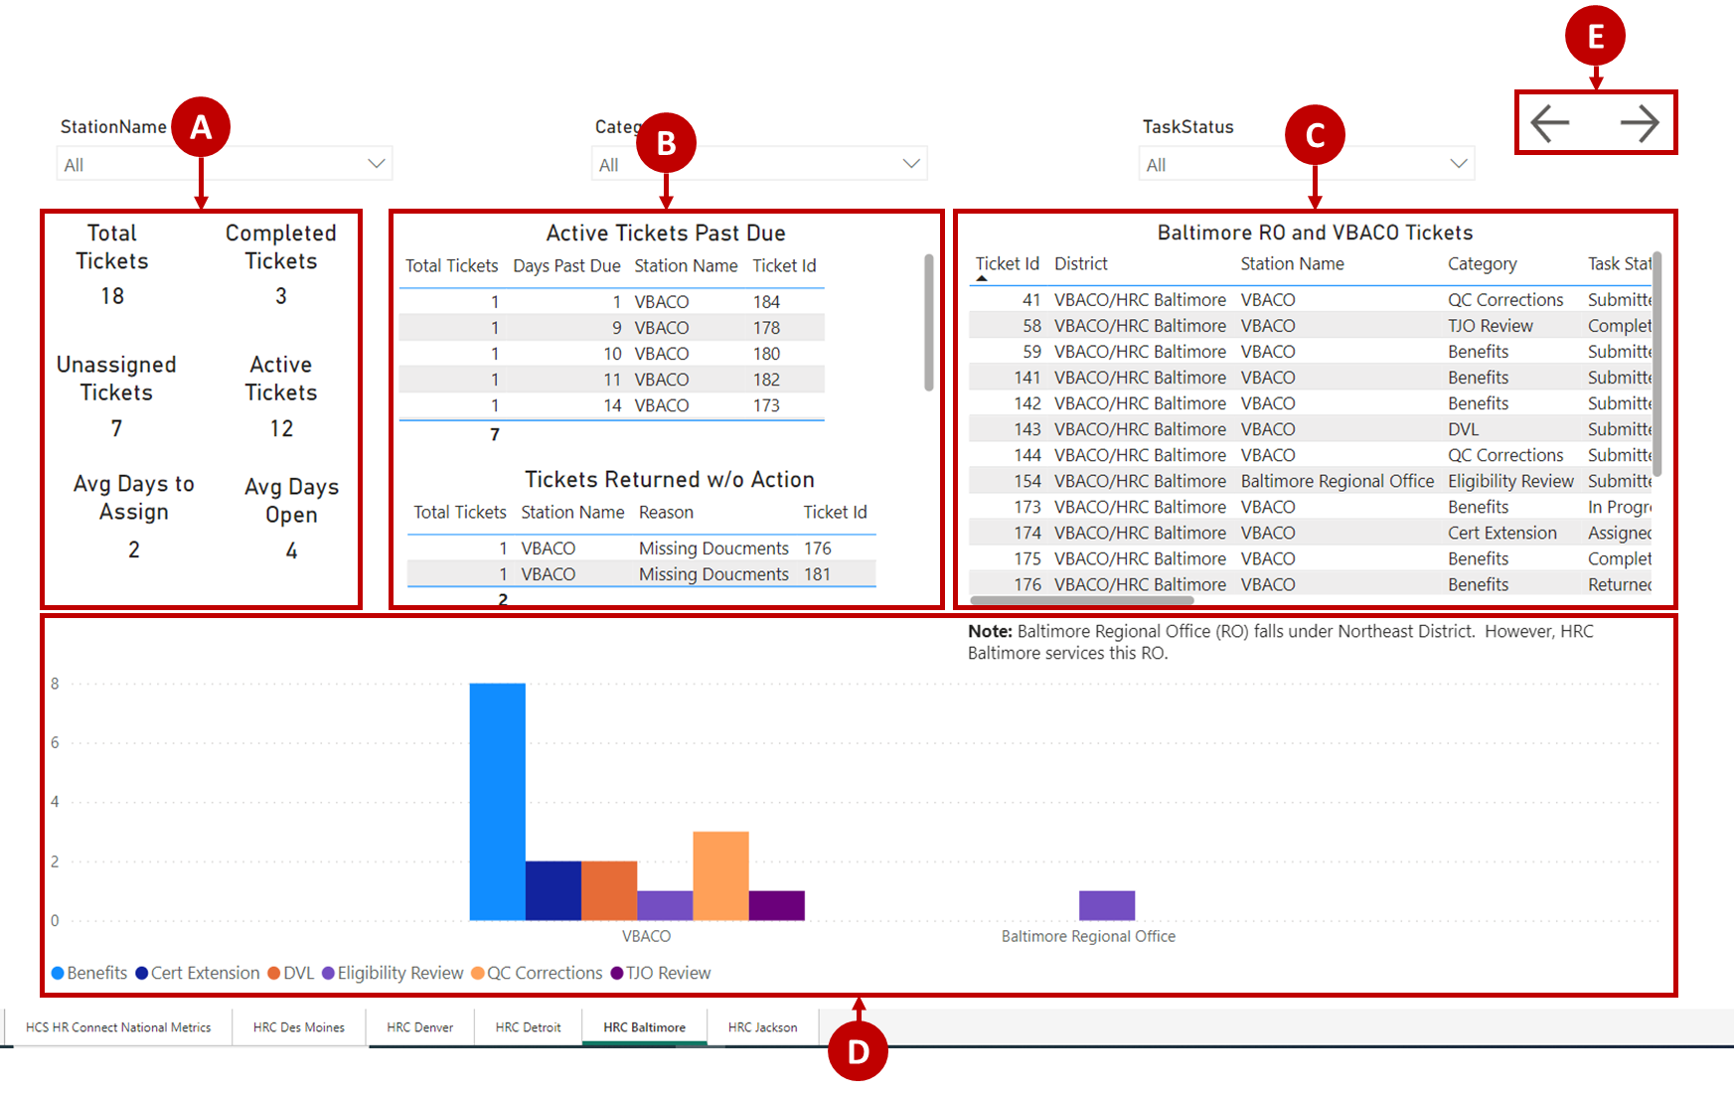

Access Executive Dashboard
- Select Executive Dashboard on the HR Connect home screen.
NOTE: The Executive Dashboard launches in a new Microsoft Edge browser tab.
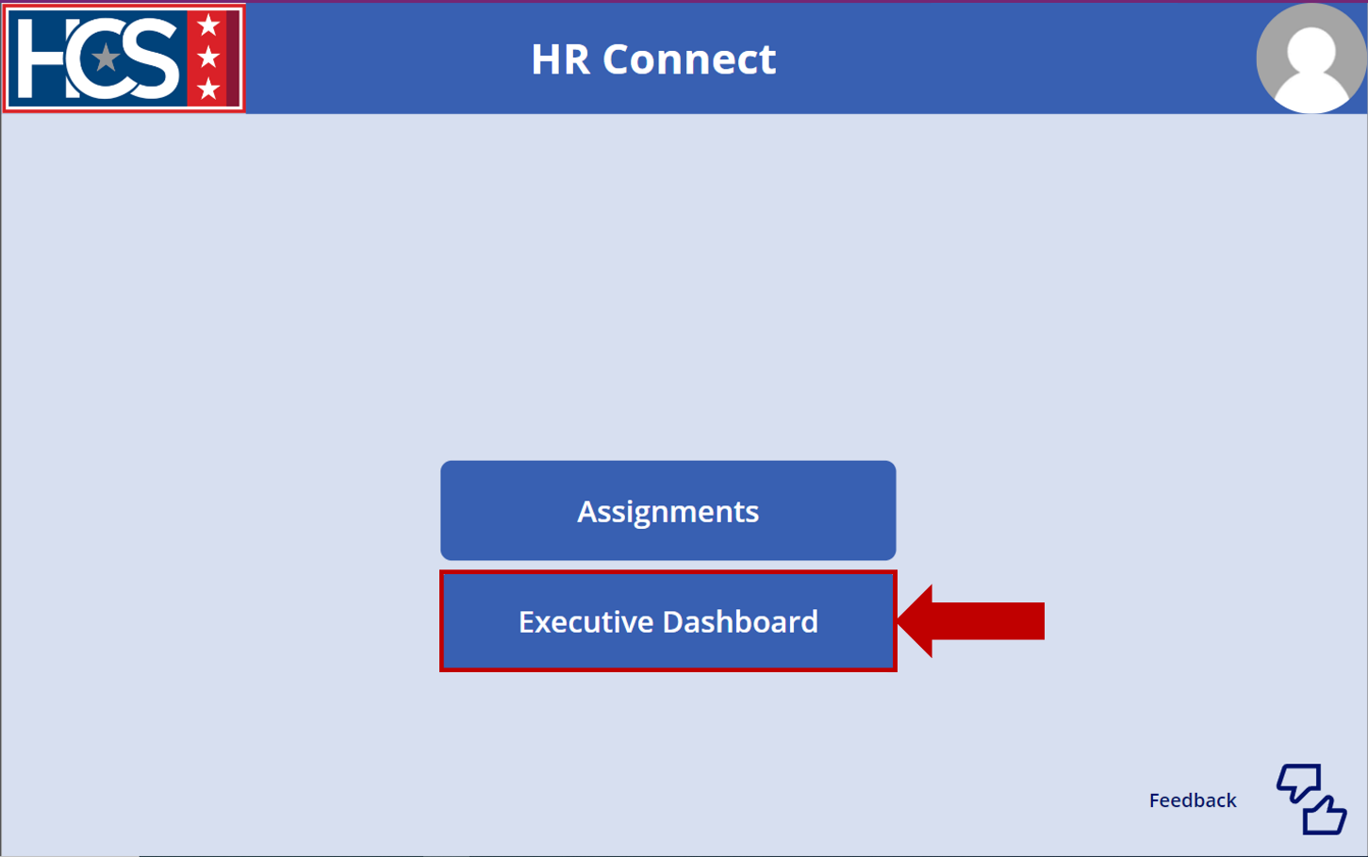
- Observe the metrics displayed on the HR Connect National Metrics screen.
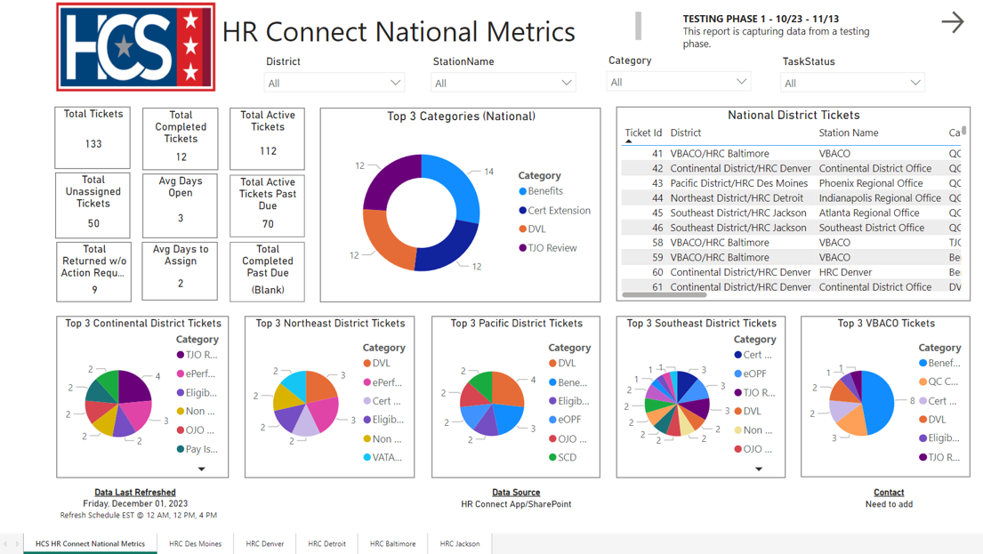
- Use the filters to refine data, as needed.
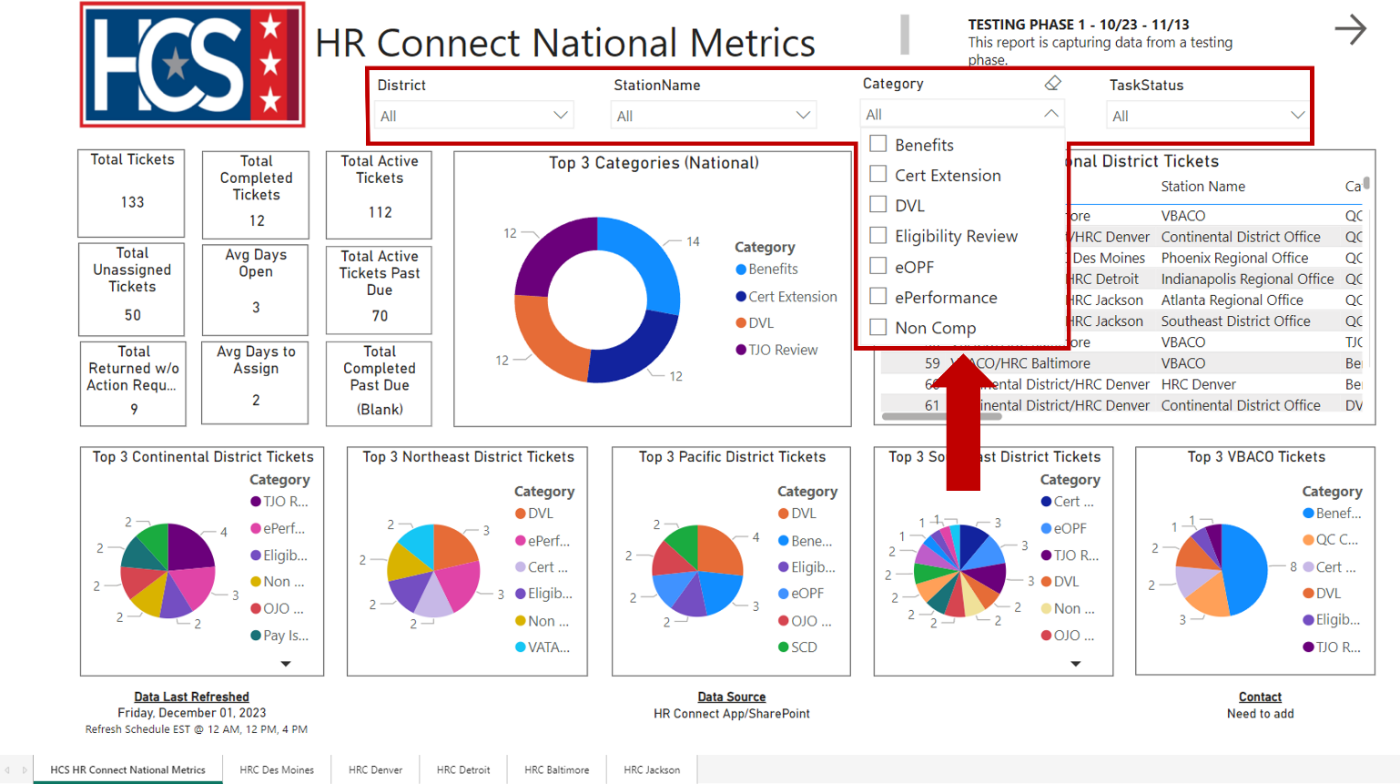
- Observe the metrics displayed as a result of applying the Category filter.
NOTE: To clear an applied filter, select the filter checkbox again.
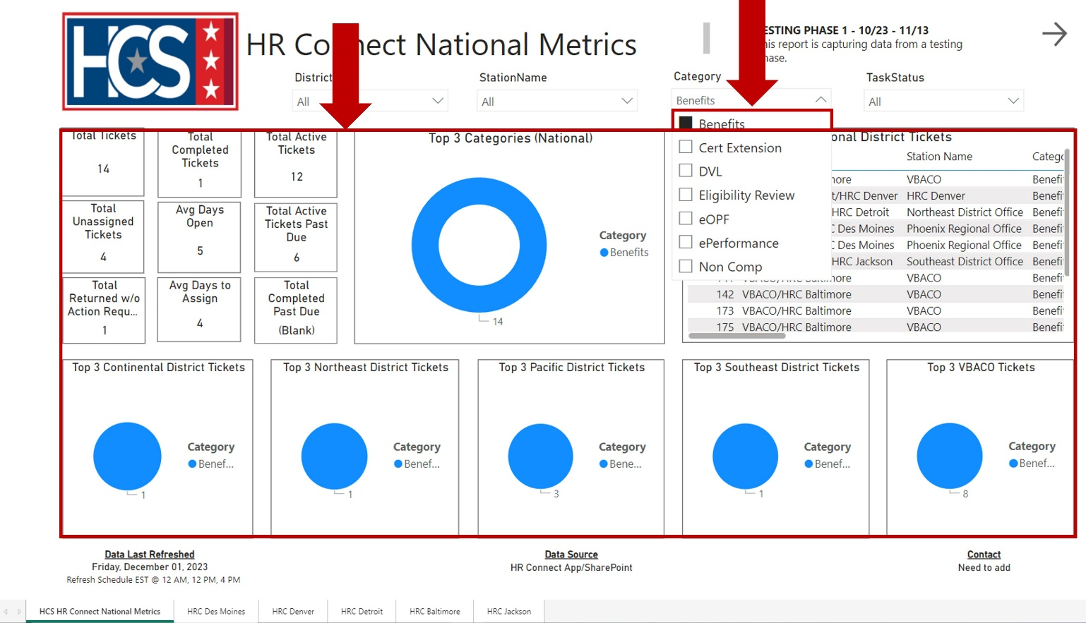

- Select a District tab to view the metrics for a specific district.
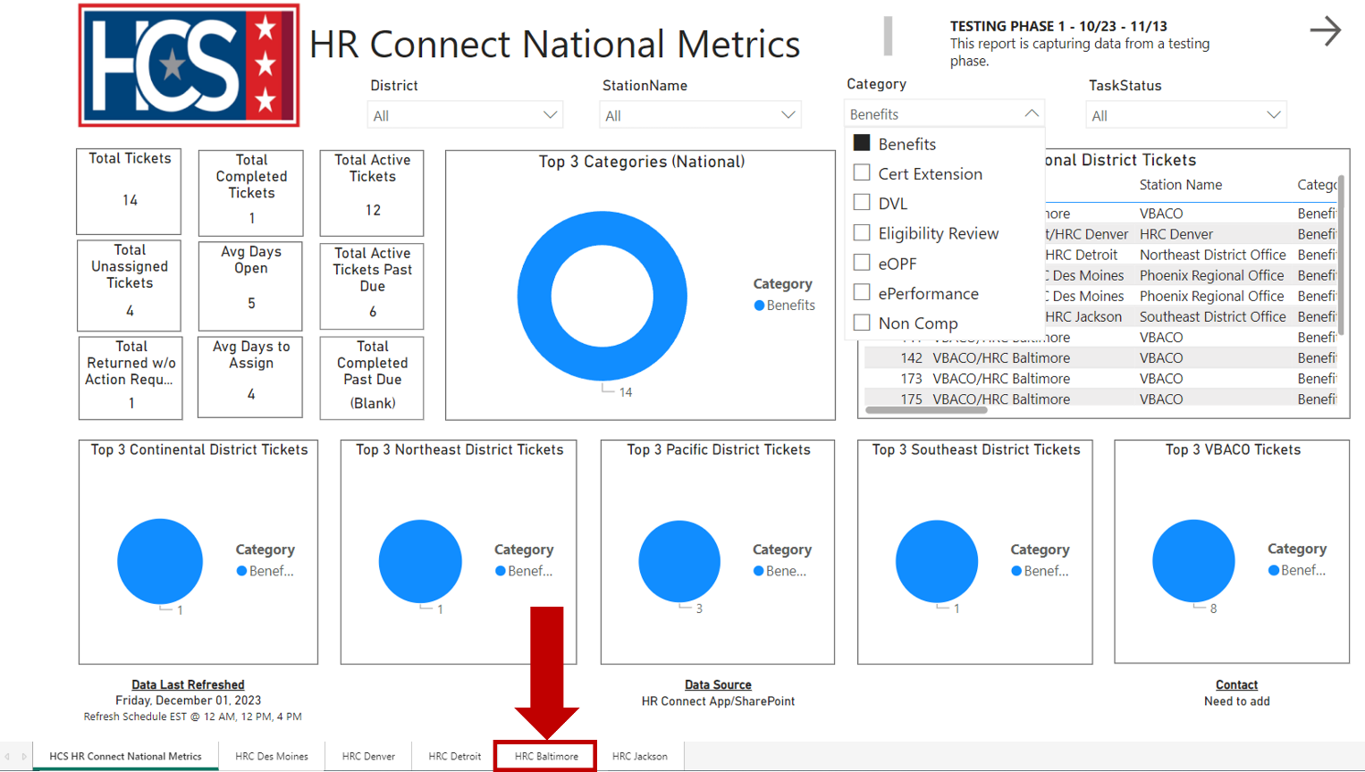
- Observe the metrics displayed on the District View screen.
NOTE: Ticket Request Type statistics are reflected in a bar chart by Station.
NOTE: Additional filters may be applied to the District to further refine the data.
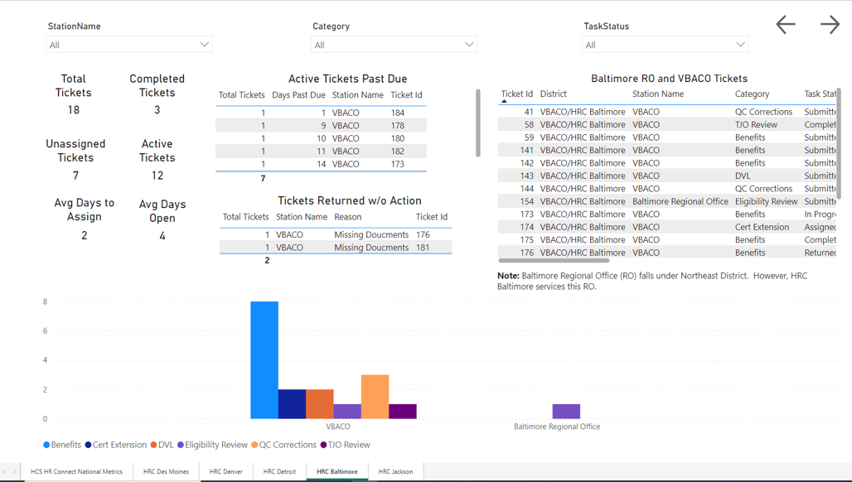
- Select Focus mode from the pop-up menu that displays when mousing over the top-right section of the selected data pod.
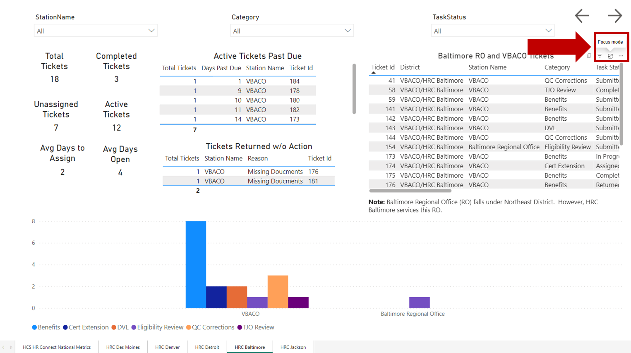
- Observe the information in the expanded data pod.
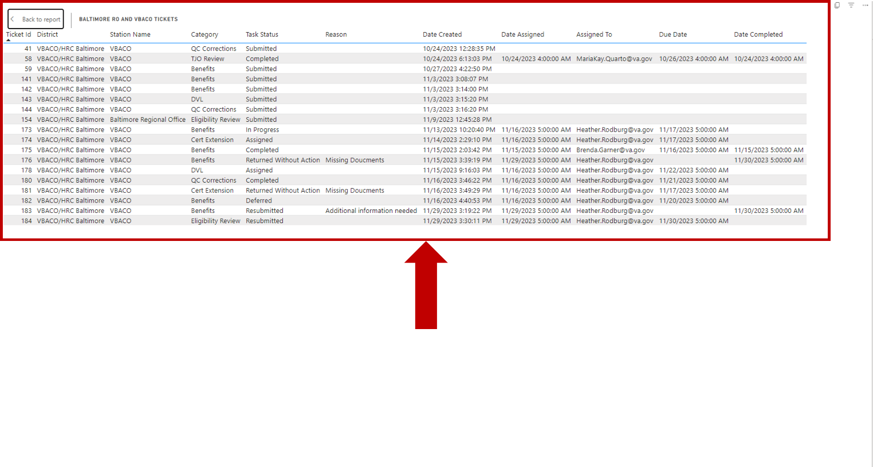

- Select Back to report to return to the District View screen.
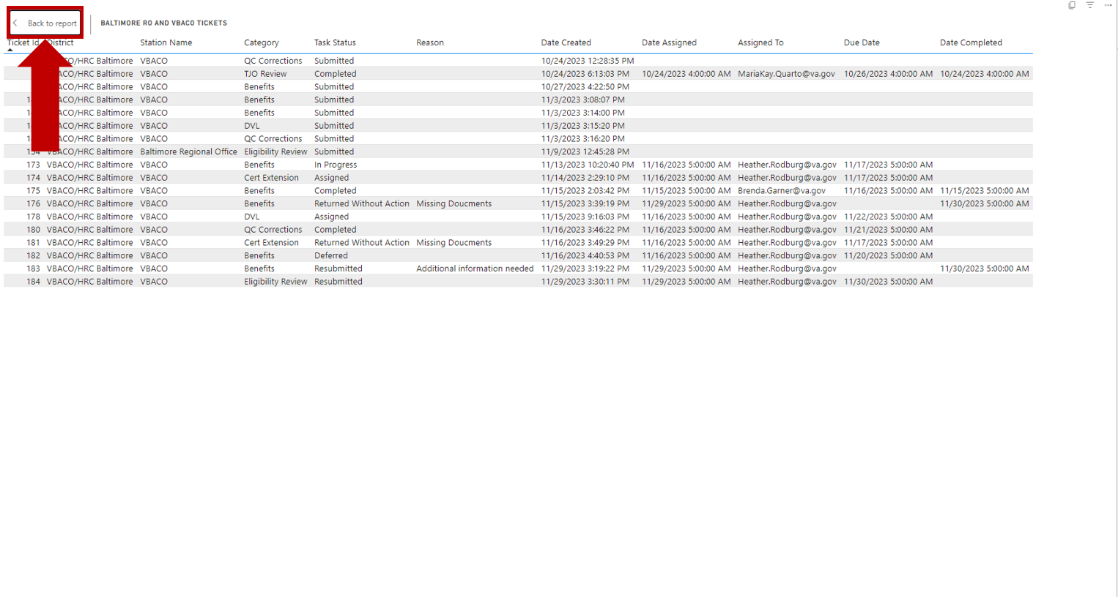
- Observe the District View screen.

Export Executive Dashboard Data (Summarized)
- Mouse over the top-right corner of the data pod to be exported.
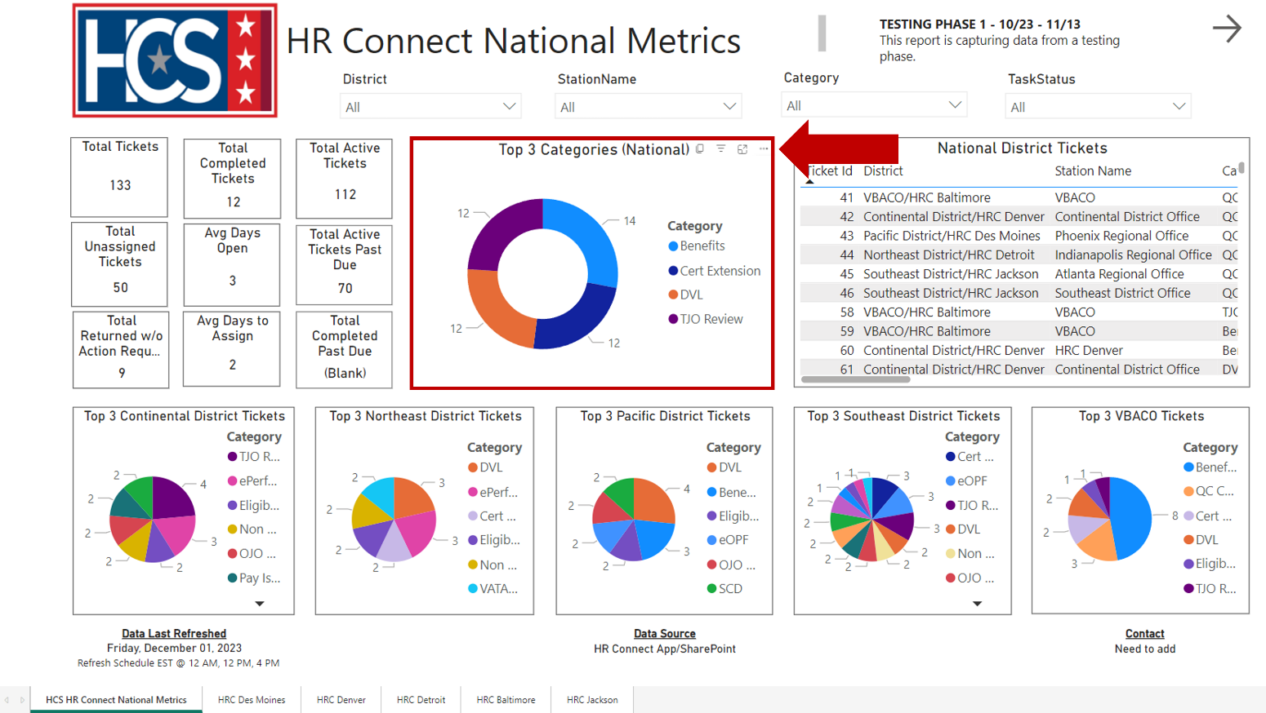
- Select Export data from the pop-up menu.
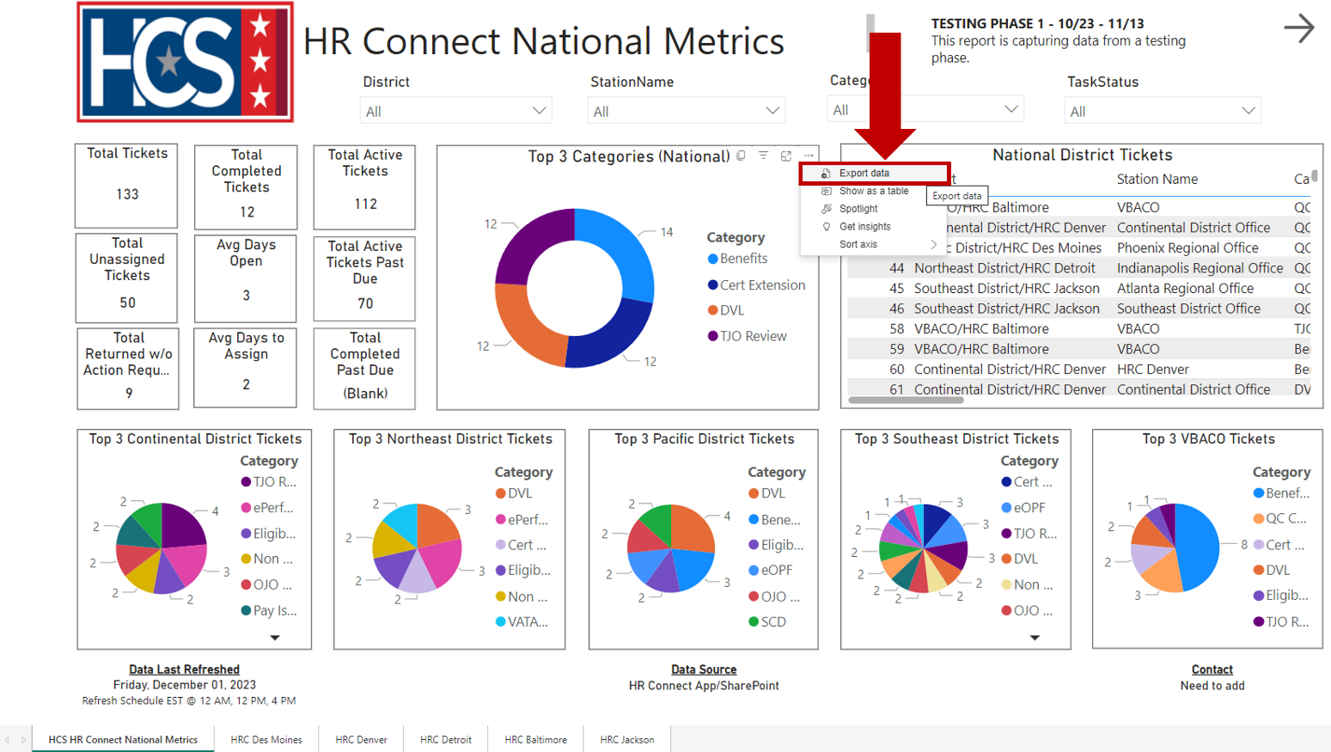

- Observe the Export window.
NOTE: If exporting data from a graph data pod, the only export option available on the Export window is Summarized data.
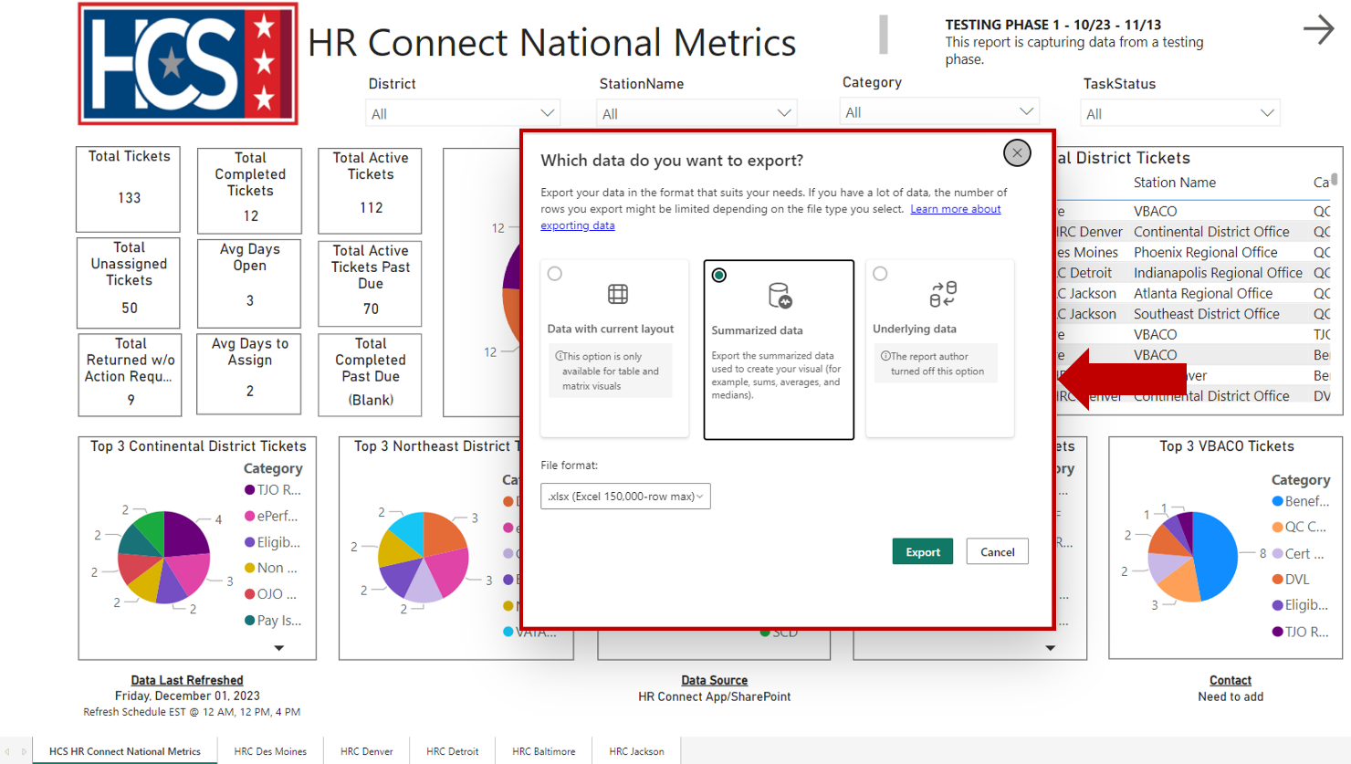
- Select File format using the dropdown menu.
NOTE: The types of file formats available for export are .xlsx and .csv. The default format is.xlsx.
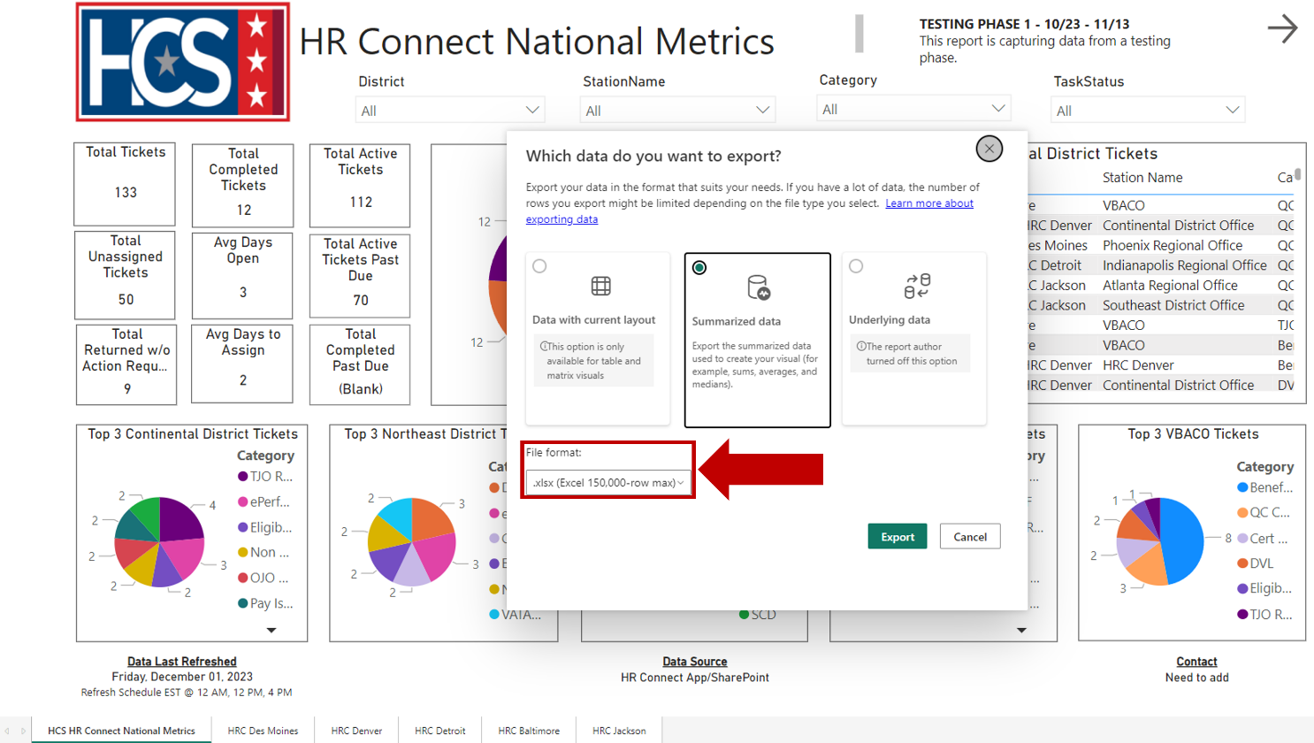
- Select Export.
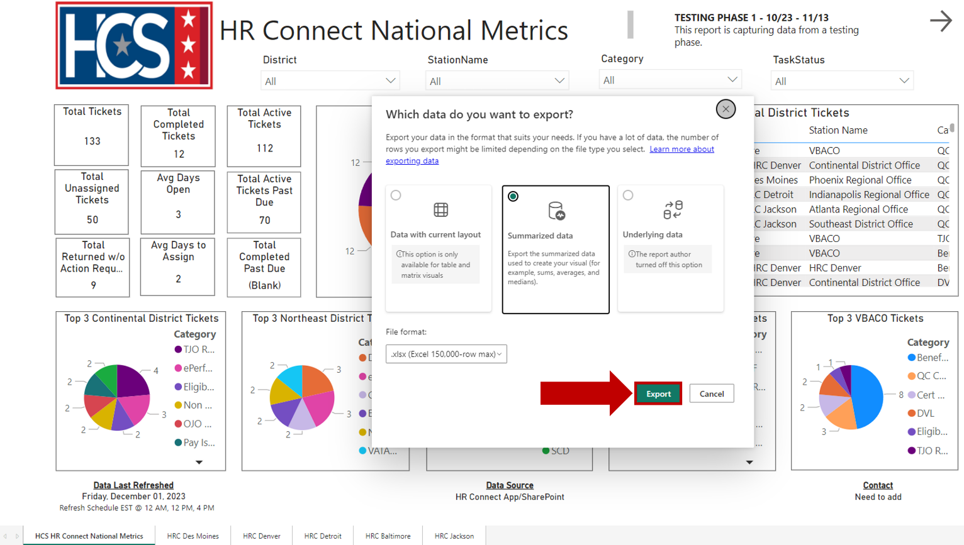
- Select either Open or Save as to view and/or save the file once the data export is complete.
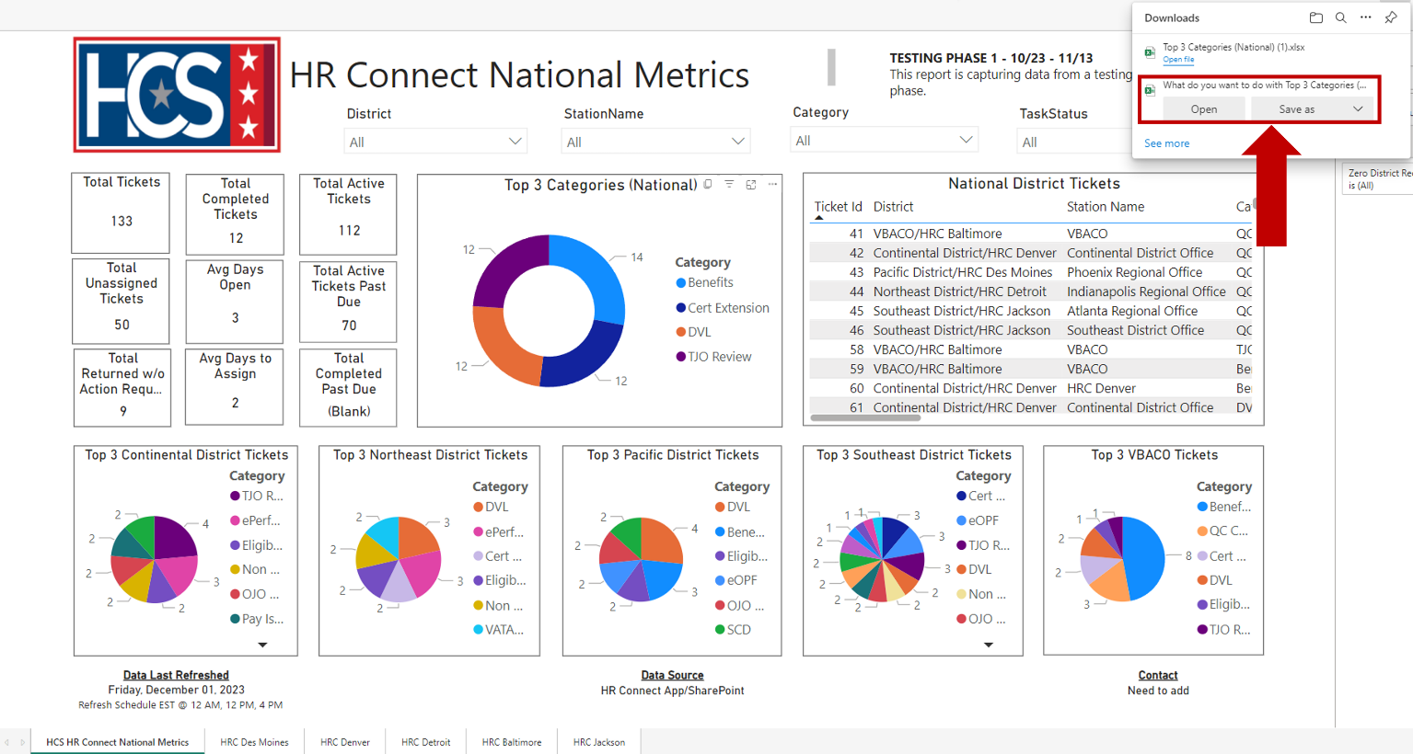

- Observe the information in the exported file.
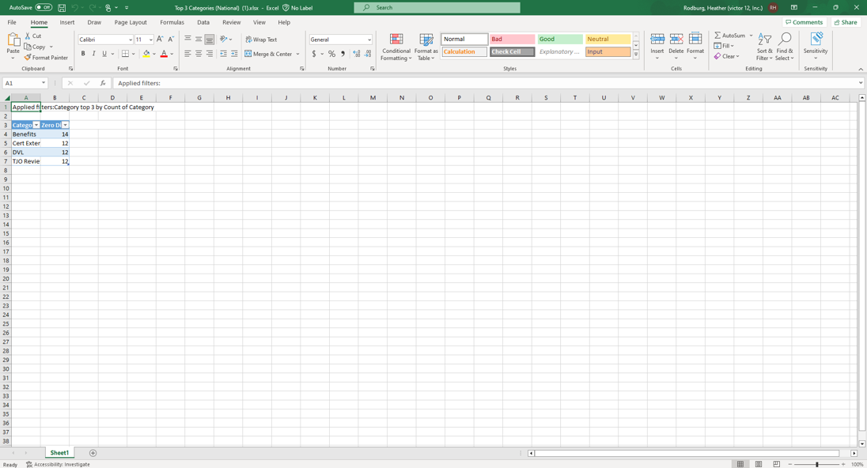

Export Executive Dashboard Data (Data with Current Layout)
- Mouse over the top-right corner of the data pod to be exported.
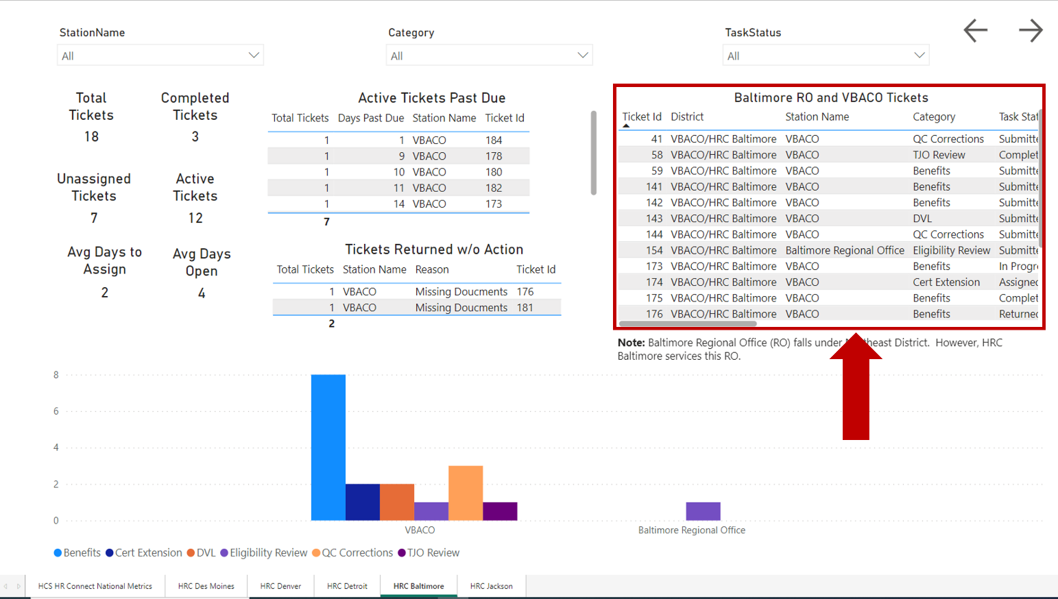
- Select Export data from the pop-up menu.
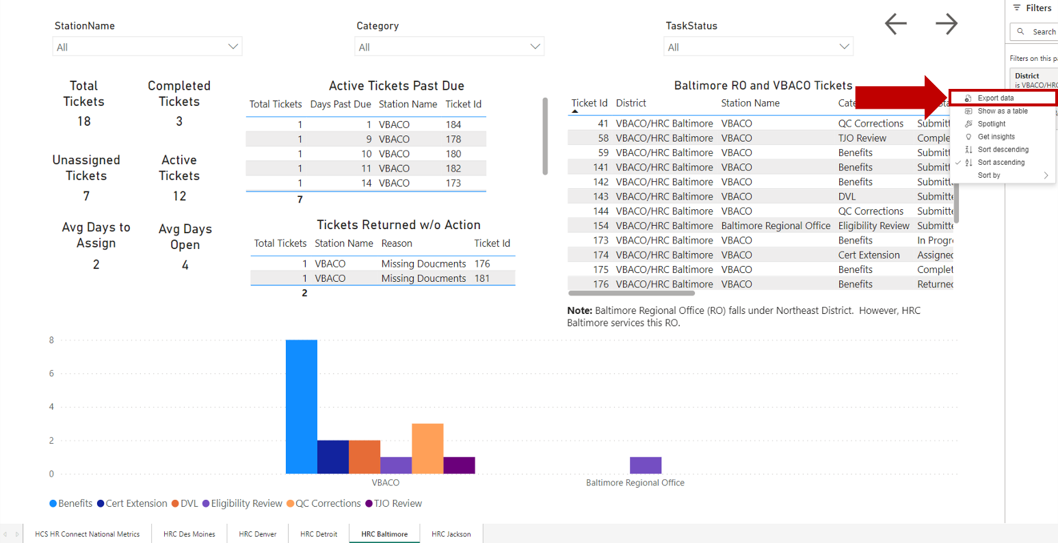

- Observe the Export window.
NOTE: If exporting data from a data list pod, the only export option available in the Export window is Data with current layout.
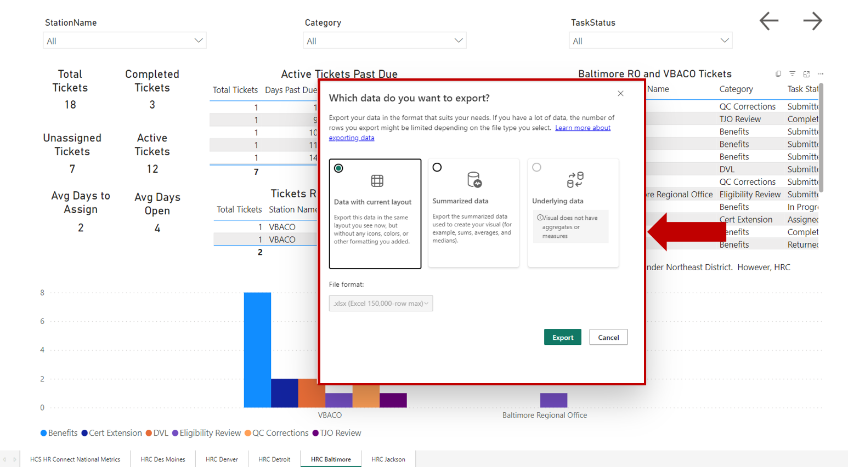
- Select File format using the dropdown menu.
NOTE: The types of file formats available for export are .xlsx and .csv. The default format is.xlsx.
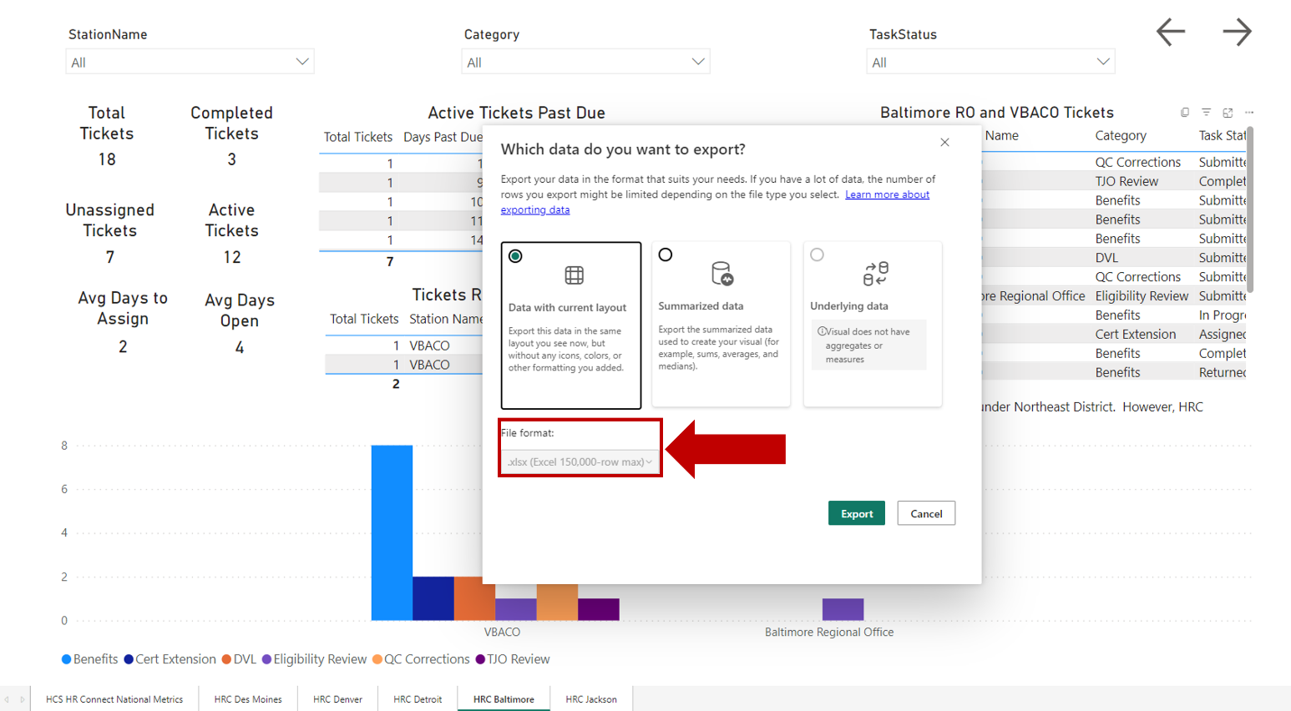
- Select Export.
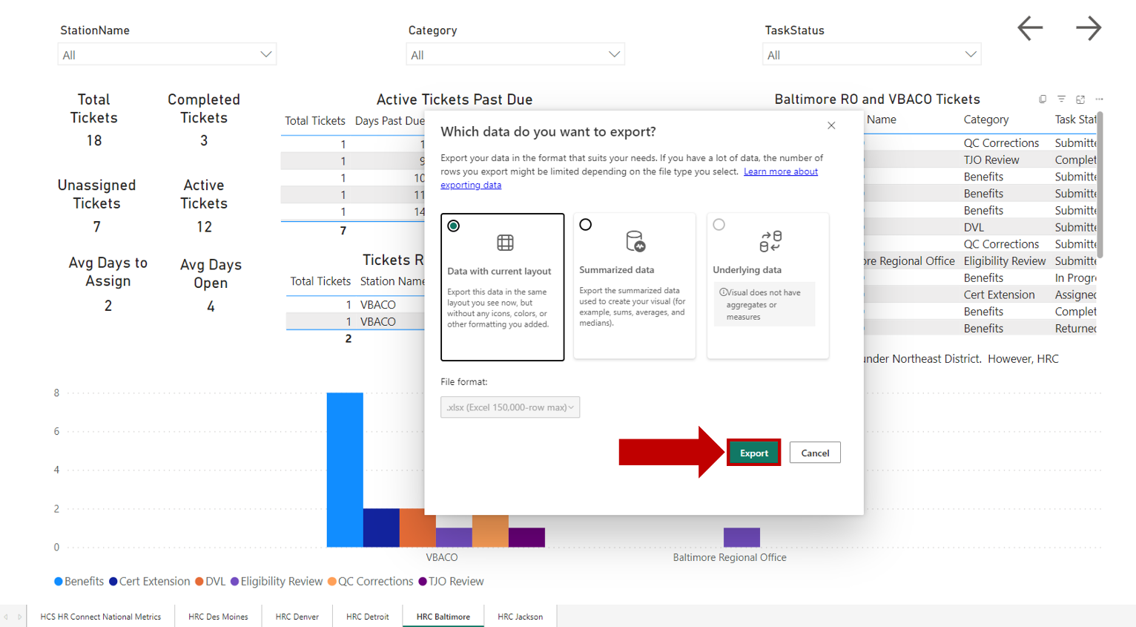
- Select either Open or Save as to view and/or save the file once the data export is complete.

- Observe the information in the exported file.
