**Evidence-Based Budgeting (EBB) – FY26 Narrative Feedback**

**[Business Line Name] – [Focus]**

# OVERVIEW

Per USB/PDUSB request, OSSI, in coordination with VBA-OFM and VACO, is evaluating FY26 Budget Narrative chapters for the strength of evidence (SOE) related to programs and FTE increases. SOE is a requirement directly aligned with the June 2019 edition of OMB A-11, Section 51.2, Section 290, and related OMB guidance and mandates. As part of this evaluation, [Line of Business] FY26 narrative was reviewed and scored with a focus on [insert program name or specify FTE increase].

# sCORING

**Overall: [*Needs Improvement or Demonstrates Evidence] (XX of 23 individual questions are scored below 3)***

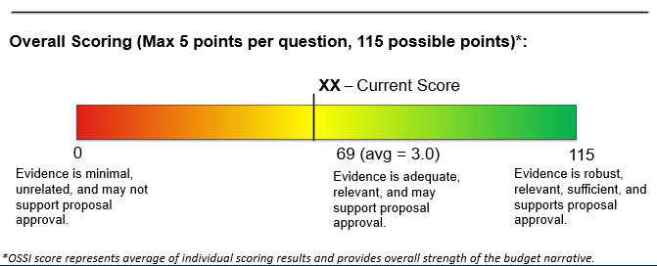

# feedback

|  |  |
| --- | --- |
| **Evidence Strengths**   * [Insert text] * [Insert text] * [Insert text] * [Insert text] * [Insert text] | **Opportunities for Improvement**   * [Insert text] * [Insert text] * [Insert text] * [Insert text] |

Additional details and other related information can be found in the presentation slides shared during the feedback session held on [insert date]. Please contact OSSI Senior Strategist [insert name and link email] with any questions or comments. Thank you for your partnership!