***Introduction to***

***Reference Materials***

***Participant Guide***

**National Contact Center New Hire Challenge Training**

OTED Training

Lesson Content

**Duration:** 2 hours

**TMS: 4644602**

**Audience:** This lesson is intended for new hire Public Contact Representatives (PCRs) within VBA’s National Call Centers (NCCs) however, it is also suitable for any new or experienced VA employee desiring information on this subject.

**Purpose:** This lesson provides VA employees assisting the public with an opportunity to enhance their knowledge on this topic. It fulfills the training requirements outlined in the Standard Operating Procedures (SOP) for new hires in the National Training Curriculum (NTC).

**Objectives:** Upon completing this lesson, trainees will be able to:

* Distinguish between commonly used VA terminology and codes to address customer inquiries
* Successfully access and utilize the following reference material to address customer inquiries:
* M27-1, Benefits Assistance Service Procedures
* Contact Center Knowledge Management (KM) Portal
* Fiduciary Knowledge Management (KM) Portal
* Compensation and Pension Knowledge Management (CPKM)
* VA Intranet
* Benefits Assistance Service (BAS) website
* VA Internet
* VA Forms websites

**References:**

**KM ARTICLE**

* [Jargon Job Aid](https://vaww.vrm.km.va.gov/system/templates/selfservice/va_kanew/help/agent/locale/en-US/portal/554400000001001/content/554400000003901/Jargon-Job-Ahttps:/vaww.vrm.km.va.gov/system/templates/selfservice/va_kanew/help/agent/locale/en-US/portal/554400000001001/content/554400000003901/Jargon-Job-Aid)
* [EP (End Product) Codes](https://vaww.vrm.km.va.gov/system/templates/selfservice/va_kanew/help/agent/locale/en-US/portal/554400000001001/content/554400000003408/EP-End-Product-Codes)
* [BDN Code Tables](https://vaww.vrm.km.va.gov/system/templates/selfservice/va_kanew/help/agent/locale/en-US/portal/554400000001001/content/554400000002598/BDN-Code-Tables?)

**Intranet**

* M27-1, Benefits Assistance Service Procedures
* <https://www.benefits.va.gov/warms/M27_1.asp>
* Contact Center Knowledge Management (KM) Portal
* <https://vaww.vrm.km.va.gov/>
  + - Fiduciary KM
* <https://vaww.fiduciary.km.va.gov>
* Compensation and Pension KM (CPKM)
* <https://vaww.compensation.pension.km.va.gov/>
  + - VA Intranet
* <http://vaww.va.gov>
  + - Benefits Assistance Service (BAS) website
* <https://vbaw.vba.va.gov/BAS/quality-training/training/index.asp>
  + - VA Forms
* Internal: <http://vaww.va.gov/vaforms/>

**Internet**

* + - VA website
* [www.va.gov](http://www.va.gov)
  + - VA Forms
* External: <http://www.va.gov/vaforms/>

# Introduction

This lesson is an introduction to common reference materials that you will use in your role as PCRs in the NCC. All reference materials are meant to complement each other and should be used collectively during your call interactions. As you continue in your VA journey, you will gain additional knowledge and experience using other reference materials.

Part I is a class discussion about common VA terminology and codes, reference tools, and demonstration of those reference tools. Part II is a practice exercise segment that will allow you to apply what you have learned by locating information using reference materials.

# VA Terminology and Codes

VA uses unique terminology and codes to communicate within different business lines and to manage business processes.

## Abbreviations and Acronyms

Abbreviations are a shortened form of a word or phrase. Acronyms are formed from the initial letters of other words and pronounced as a word. Acronyms are used to describe VA job titles, locations, benefits, processes, etc. With time and experience, you will grow to understand and communicate with VA acronyms.

Some common acronyms include:

|  |  |
| --- | --- |
| **Position Titles** | |
| PCR | Public Contact Representative |
| LAS | Legal Administrative Specialist |
| VSR | Veteran Service Representative |
| RVSR | Rating Veteran Service Representative |
| VSO | Veteran Service Officer |
| POA | Power of Attorney |
| FSR | Fiduciary Service Representative |
| FE | Field Examiner |
| **VA Locations** | |
| NCC | National Call Center |
| NPCC | National Pension Call Center |
| RO | Regional Office |
| SOJ | Station of Jurisdiction |
| VSC | Veteran Service Center |
| PMC | Pension Management Center |
| **Process/Benefits** | |
| FDC | Fully Develop Claim |
| ITF | Intent to File |
| NOD | Notice of Disagreement or Notice of Death |
| SMC | Special Monthly Compensation |
| DIC | Dependency & Indemnity Compensation |
| NSC | Non-Service Connected |

## Resources

To search VA acronyms, access the [VA Acronym Lookup](https://vaww.va.gov/acronyms/).

## Jargon

Jargon refers to special words or expressions used by a particular profession or group and may be difficult for others to understand. As PCRs, avoid speaking in VA jargon during call interactions. Instead of using VA jargon, state the full form of a word or phrase and limit the use of abbreviations or acronyms.

## Resources

To help avoid VA jargon, refer to the KM article [Jargon Job Aid](https://vaww.vrm.km.va.gov/system/templates/selfservice/va_kanew/help/agent/locale/en-US/portal/554400000001001/content/554400000003901/Jargon-Job-Aid).

# VA Codes

VA codes are used to represent, track, identify, and justify types of claims.

## End Product Code (EPC)

When a claim is received at a VA Regional Office (RO), an End Product Code (EPC) (also referred to as EP) is generated as part of claims establishment. This process is also referred to as (CEST)ing. EPs categorize claims, track actions to assist in workload management and prioritize claims processing. The EP is a three-digit number that represents a type of pending claim.

Some common EPCs include:

|  |  |
| --- | --- |
| **Original Claims** | |
| 110 | claim seven issue or less |
| 010 | claim eight issues or more |
| **Subsequent Claims** | |
| 020 | to request an increase in a rated disability, or  to add a new disability for compensation |
| 030 | Higher-Level Review Claims |
| 040 | Supplemental Claims |
| **Dependency** | |
| 130 | dependency issue |
| **Appeals** | |
| 170 | appeal control |
| **Pension** | |
| 120 | reopen pension |
| 180 | Initial pension (compensation not an issue) |
| **Death** | |
| 140 | initial death where service connection is an issue |
| **Burial** | |
| 160 | burial, plot, headstone |

## 3rd Digit Modifier

Since an EP is a three-digit number, VA uses the last digit as a special modifier number. The 3rd-digit modifier is used on certain claims for tracking purposes.

Some common examples include:

|  |  |
| --- | --- |
| **Modifier** | **Description** |
| 1 | Benefits Delivery at Discharge (BDD) (011/111/021) |
| 6 | Foreign Cases (Houston, Pittsburgh, White River Junction only) |
| 7 | Pension Management Cent (PMC) or Quick Start |
| 9 | Reopened Dependency and Indemnity Compensation (DIC) claims (029), reopened service-connected (SC) death claims (029), and EP 169, 149, or 299 for automated burial, DIC, or month of death processing |

## Resources

To view EPs and 3rd digit modifier, refer to [EP (End Product) Codes](https://vaww.vrm.km.va.gov/system/templates/selfservice/va_kanew/help/agent/locale/en-US/portal/554400000001001/content/554400000003408/EP-End-Product-Codes).

## Payee Codes/Dependency Codes

A payee code or dependency code designates the type and number of a Veteran’s dependents. Some examples include:

|  |  |
| --- | --- |
| **Payee/Dependent Code** | **Payee/Dependent** |
| 00 | Veteran |
| 10 | Spouse |
| 11 | C&P First Child |
| 12 | C&P Second Child |
| 50 | Dependent Father |
| 60 | Dependent Mother |
| 70 | DIC Award 38 USC412(a) First Payee |

## Child Data Status Codes

Benefits may vary based upon the recipient having children. When a Veteran is service-connected and has children, certain benefits may be awarded. Also,

children are classified based on different criteria.

Some examples include:

|  |  |
| --- | --- |
| **Child Status Code** | **Description** |
| 1 | Under age 18 |
| 2 | School Child |
| 3 | Helpless Child |
| 4 | Under are 18 having potential DEA entitlement (death pension only) |

## Miscellaneous Codes

Along with the codes previously discussed, you may see reason codes and

deduction codes indicated in a claimant’s records when reviewing their file. VA uses these codes to provide identifying information about actions on a claimant’s claim.

### Reason Codes

Reason codes are assigned during the process of generating the award. VA uses various reason codes to identify the justification for adjustments to a claimant’s award amount.

Some examples include:

|  |  |
| --- | --- |
| **Reason Code** | **Reason Description** |
| 05 | Disability 0 percent (or less than 10 percent disabling) |
| 16 | Failure to furnish requested evidence |
| 19 | Veteran on active duty or in receipt of retired pay; or restored to VA rolls; adjustment for drill pay |
| 22 | Death of dependent or person entitled |
| 24 | Child reached age 18 |
| 28 | Claimant or dependent incarcerated or released from prison |

### Deduction and Offset Codes

Deduction and Offset codes are numbers used to indicate why funds from a claimant’s award are being deducted or offset. Sometimes VA may have to withhold or offset payments to a recipient.

Some examples include:

|  |  |
| --- | --- |
| **Deduction/Offset Code** | **Description** |
| 6 | Simultaneous withholdings of 7 and 8 or 7 and 9 |
| 7 | Offset under 38 U.S.C. 1151 |
| 8 | Recoupment of readjustment allowance of separation pay |
| 9 | Recoupment of severance pay |

## Resources

To view miscellaneous codes, refer to [BDN Code Tables](https://vaww.vrm.km.va.gov/system/templates/selfservice/va_kanew/help/agent/locale/en-US/portal/554400000001001/content/554400000002598/BDN-Code-Tables?).

Interactive Activity

*Access and review the VA Acronym Lookup and KM articles Jargon Job Aid, EP (End Product), and BDN Code Tables.*

# Reference Material

After discussing VA terminology and codes you may encounter during call interactions and viewing information in the VA system of records, we turn to reference materials.

# M27-1, Benefits Assistance Service Procedures

The M27-1, Benefits Assistance Service Procedures (also referred to as M27) is housed on the VA Web Automated Reference Materials System (WARMS) website.

The M27 governs Veterans Benefits Administration (VBA) customer-facing activities such as public contact and phone interactions. M27 procedures help to ensure

timely and accurate benefit information and services are consistently provided to Servicemembers, Veterans, dependents, and survivors across all access channels. The M27 is a living document and subject changes.

## M27 Structure

The M27 is organized into five (5) “Parts”:

* Part I- VBA Public Contact and Direct Services
* Part II- VBA Outreach
* Part III- VBA Web Communications
* Part IV- Quality and Training
* Part V- Access and Business Applications

The Parts are further broken down into:

* + - Chapters,
    - Sections, **and**
    - Topics.

Each chapter is a separate word document. Once you select a chapter, you can search by either section number or topic. Chapters include a table of contents hyperlinked to sections and topics. Also, you have the option to search for chapters using the Microsoft Word “control” [Ctrl] + F function.

When you see a manual citation, such as M27-1.I.3.1.k, the citation refers to:

* “I” is the Part
* “3” is the Chapter
* “1” is the Section
* “k” is the Topic

Interactive Activity

*Access and review the M27.*

# Contact Center

# Knowledge Management (KM) Portal

The Contact Center Knowledge Management (KM) Portal (also referred to as KM) was created to provide a consolidated location to organize and manage resources utilized by VBA’s public-facing employees.

The portal is designed to search by topics and keywords to assist with customer interactions.

## Accessing KM

KM is only accessible within the VA network. KM should not be provided as a reference to customers. KM can be accessed in three ways:

* The URL:
* <https://vaww.vrm.km.va.gov>
* The BAS Training webpage:
* <https://vbaw.vba.va.gov/BAS/quality-training/training/index.asp>
* The VBA Intranet Webpage via “Resources and Tools”:
* <https://vbaw.vba.va.gov/benefits/>
* within the “Resources and Tools” section

The KM URLs can be added to browser favorites or saved to a desktop.

## Homepage Quick References

Once logged into KM, the homepage provides several options to perform a search and access information.

### Breaking News

The articles contained in the “Breaking News” section include information on emergent issues and lists of recently updated articles.

Breaking News articles are organized in date order with the most recently updated articles at the top of the list. Breaking News page does not contain all new or updated articles in KM.



Breaking News also includes:

* Information on emergent issues,
* Lists of recently updated articles, **and**
* Links to other KM Portals.

### Most Popular

The “Most Popular” widget is on the right side of the homepage. This widget shows the most often accessed articles by KM users based on KM’s ranking settings.

Select “More” to view a larger list of most popular articles.

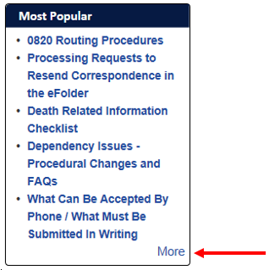

### Crisis Intervention

The “Crisis Intervention” widget is below the Most Popular widget on the homepage. The widget shows quick links to crisis-related articles to assist you in managing crises and escalated call interactions.

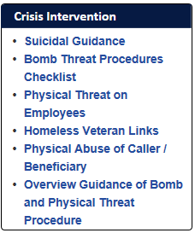

### Employee Resources

At the top of KM’s homepage is “Employee Resources”. The Employee Resources

site provides resources to assist VA employees with their day-to-day tasks.



# Searching KM

All articles contained within KM can be searched and accessed by the homepage. Searches may be performed using either:

* Basic Search, **or**
* “Browse Topic” Fly-Out search

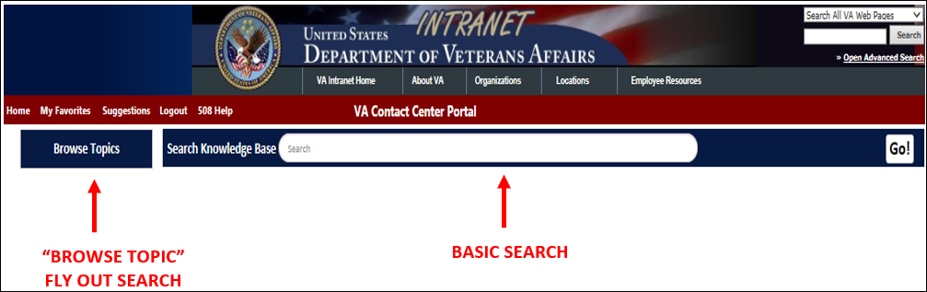

## Basic Search

Basic Search is the most common method used to search KM. To perform a basic search:

1. Type what you are looking for in the “Search Knowledge Base” box, **and**
2. Select “Go!” or press the “Enter” key on your keyboard.

You should be aware of two features when performing a “Basic Search”, the

* Type Ahead/Auto Complete**, and**
* “Did You Mean”.

### Type Ahead/Auto Complete Feature

KM provides common search topics based on what you are typing in the search box. These suggestions appear as you type.



### Did You Mean Feature

The “Did You Mean” feature corrects misspelled words. Misspelled terms and inexact information matches are displayed in a separate box underneath the

“Search Knowledge Base” box with the corrected word spelling. If you select the corrected spelling, you are directed to search content related to the correction.

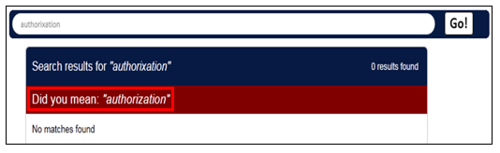

## Browse Topics Fly-Out Search

When articles are created, they are grouped into topics and subtopics. The “Browse Topics” Fly-Out search allows you to search by topics and subtopics.

To perform the search, from the homepage:

1. Hover over “Browse Topics”
2. Hover over the desired topic to display (an arrow to the right of the topic is an indicator of additional subtopics within that topic)
3. Select the search topic or subtopic

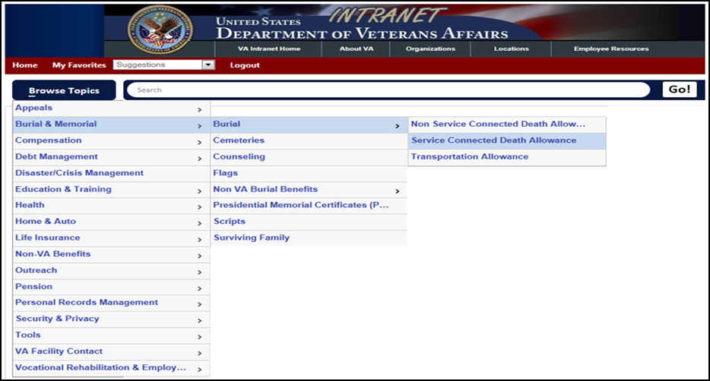

After the topic or subtopic is selected, a bread crumb trail appears under the search box. You can utilize this bread crumb trail to navigate to a previous section, if necessary.

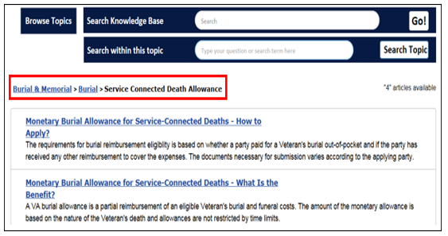

Interactive Activity

*Access and review KM’s* *Basic Search and “Browse Topic” Fly-Out search.*

# KM Search Refinement

Once you complete your initial search, several articles may populate. The desired article may not be among the first articles within the search.  There are several ways to narrow or refine your search.

## Topic Folders

After you perform a basic search, information about your basic search is available in

various topic folders. The direct links to articles are listed in order of relevance to

your basic search. These articles are automatically arranged in order of the most requested information within the search.

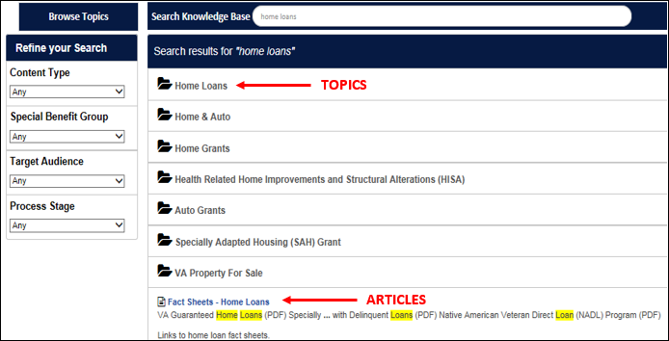

## Search Refinement Tools

There are three (3) search refinement tools that can be used with a search:

* Boolean Search
* Search by Topic Configuration, **or**
* Search Refinement by Category.

### Boolean Search

To refine a search, using a “Boolean Search”, put quotes around “your search phrase” to only receive output with your exact search phrase. KM presents the article with the first instance of the searched phrase highlighted and at the top of the screen.

Placing quotes around your search term tells the search engine only to provide an output that includes your search term/phrase. If you perform a search without the quotation marks, KM splits up the words and highlight them as relevant matches-even when not mentioned as an exact phrase.

Interactive Activity

*Perform a basic search for without quotation marks and with quotation marks”.*

### 

### Search by Topic Configuration

Another search refinement tool is “Search by Topic Configuration”. You may choose to use this refinement tool to access information with many topics and articles. After you perform a “Basic “Search, you can search by:

* “Topic Sub-Folder”
* “Search within this topic”

**Topic Sub-Folder Search**

To search by Topic Sub-Folder:

1. Perform a basic search without quotation marks
2. Select the topic folder
3. Select a sub-folder (if any)

**“Search within this topic” Search**

To perform a Search within this topic search:

1. Perform a basic search without quotation marks
2. Select the topic folder
3. Refine your basic search by entering a topic within the Search within this topic box
4. Select the Search Topic box for results

Interactive Activity

*Perform a* “*Topic Sub-Folder” and “Search within this topic” search.*

**Search Refinement by Category**

The third refinement tool is by category. When searching a topic with several related articles, you may refine your search by content type, special benefit group, target audience, or process stage

To perform a “Search Refinement by Category”:

1. Perform a basic search without quotation marks
2. Select the refinement category

# VA Contact Information (Desk Reference)

In KM, specific VA contact information can be located.

Specific RO information can be searched by:

* State
* City
* 3-digit number code

Also, accessing VA Contact Information (also called Desk Reference) in KM, provides specific RO information.

To access RO Desk References:

1. Perform a “Browse Topics” Fly Out search for “VA Facility Contact”
2. Select “Call Center Contact Info” and the specific RO for information

The option exists to use the “Jump to a Coordinator” button to access specific Coordinator information within the Facility Desk Reference. In situations utilizing RO desk references, be aware of RO contact information that should not be disclosed to the public and requires a warm transfer. Each RO desk reference provides the following:

***“If the name/number field below contains an asterisk (*), a warm transfer may be provided (to coordinators only), but the number is not be released to the general public.”***

# 

# Additional KM Article Information

You should be aware of important KM article information as PCRs in the NCC. Within articles you can (not all-inclusive):

* View procedural guidance
* Review frequently asked questions (FAQs) changes
* Cite NCC quality review effective dates
* Save articles to favorites
* Provide suggestions on articles
* Email articles
* Rate the usefulness of the article

The option to print KM articles exists, however printing articles are rarely advised as printed information can become outdated. Also, all information contained in KM articles is not appropriate to provide the general public, therefore we provide VA fact sheets.

In addition, while viewing some KM articles, you have options to:

* Jump to the end of long articles:
* Click within the article
* Select the [End] button on your keyboard
* Expand article information:
* Select the “Expand All” link within the article
* Find function
* Use CTRL+F within the KM article to find specific phrases and words

Some other information exists in KM articles.

## Favorites

You can create a KM favorites list by using the “Add to Favorites” option at the bottom of the KM articles to save as favorites in KM, **not** Internet Explorer



“My Favorites” located in the top left corner of KM’s homepage.

## Article Rating

You have the option to rate the usefulness of the KM article. The option is located at the bottom of KM articles.



## Article Feedback

To provide feedback on the article, utilize the link at the bottom of KM articles. Add feedback if search terms were difficult to find or articles were not located where you

expected.

You may also provide feedback on formatting. KM administrators review your submitted feedback.



## Attachments

At the bottom of KM articles are attachments applicable to the current article.

You can select the attachment to access the attachment information.



## Related Articles

“Related Articles” are displayed at the bottom of KM articles. This section provides links to other articles that relate to the searched topic. You can select the related article to access the attachment information.



Interactive Activity

*Review KM article* [*Dependency Claims Procedural Changes and FAQs*](https://vaww.vrm.km.va.gov/system/templates/selfservice/va_ka/#!agent/portal/554400000001001/article/554400000011313/Dependency-Claims-Procedural-Changes-and-FAQs)*.*

*Review the location of the following in the within the KM article:*

* *Favorites*
* *Article Rating*
* *Article Feedback*
* *Attachments*
* *Related Articles*

# Additional KM Portals

KM is designed for PCRs, but there are multiple KM portals that include information that may be helpful during call interactions.

KM article [KM Portals](https://vaww.vrm.km.va.gov/system/templates/selfservice/va_kanew/help/agent/locale/en-US/portal/554400000001001/content/554400000075204/KM-Portals) provides access to portals for:

* VA,
* VBA,
* Veterans and Health Administration (VHA), **and**
* Veterans Experience Office.

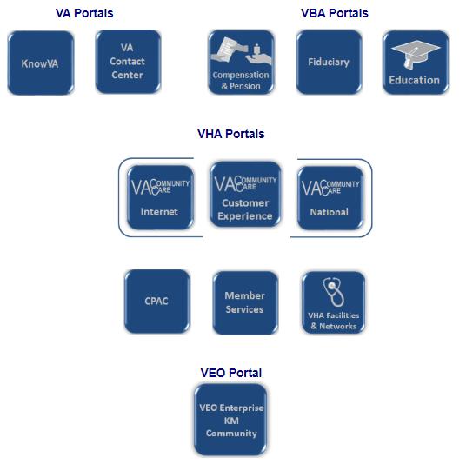

Fiduciary’s Knowledge Management and Compensation and Pension Knowledge Management (also referred to as CPKM) portals are commonly used by PCRs in the NCC.

## Fiduciary Knowledge Management

Fiduciary’s Knowledge Management is designed for Fiduciary Hubs. However, there may be situations when you need to access information available in this portal.

### Accessing Fiduciary Knowledge Management

* The URL:
* <https://vaww.fiduciary.km.va.gov>
* KM Breaking News article:
* [KM Portals](https://vaww.vrm.km.va.gov/system/templates/selfservice/va_kanew/help/agent/locale/en-US/portal/554400000001001/content/554400000075204/KM-Portals)

### Homepage Quick References

Fiduciary’s Knowledge Management homepage display is similar to KM, however, the widgets differ.

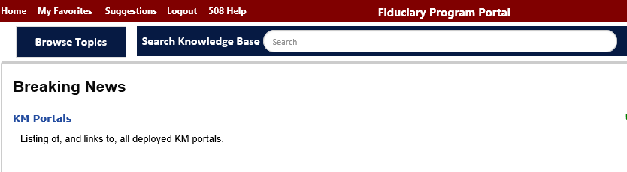

### Searching Fiduciary Knowledge Management

The search functionalities are similar to those previously discussed and reviewed in KM.

## Compensation and Pension Knowledge Management (CPKM)

CPKM houses policies, procedures, and resources utilized by claim and appeal processors to successfully process pending claims and appeals.

### Accessing CPKM

You can access CPKM two (2) ways:

* The URL: <https://vaww.compensation.pension.km.va.gov/>, **and**
* BAS KM Breaking News article [KM Portals](https://vaww.vrm.km.va.gov/system/templates/selfservice/va_kanew/help/agent/locale/en-US/portal/554400000001001/content/554400000075204/KM-Portals).

### Homepage Quick References

CPKM’s homepage display is similar to KM, however, the widgets differ.

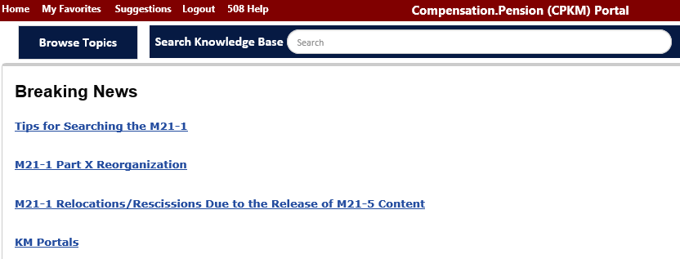

### Searching CPKM

The search functionalities are similar to those previously discussed and reviewed in KM. As PCRs, you may frequently need access to CPKM topics such as the:

* 38 Code of Federal Regulations (CFRs), **and**
* M21-1 Adjudication Procedures Manual.

**38 CFRs**

The Code of Federal Regulations (CFRs) outlines the official regulations of Government Agencies. Title 38 CFRs focus on Pensions, Bonuses, and Veteran’s Relief. Parts 0-199 of Title 38 CFRs pertain to VA. The eCFR is an electronic database available in U.S. Government Publishing Office’s (GPO’s) website.

Links to two (2) Parts of Title 38 CFR are available in CPKM:

* Part 3: Adjudication, **and**
* Part 4: Schedule for Rating Disabilities.

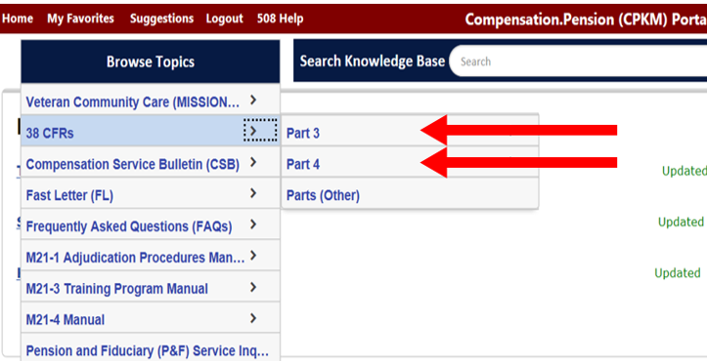

Each Part is broken down into subparts, which are broken down further into topics.

[38 CFR Part 3](http://www.ecfr.gov/cgi-bin/text-idx?SID=d6a0591c8e27caa8723690aa58f90b52&mc=true&tpl=/ecfrbrowse/Title38/38cfr3_main_02.tpl), *Adjudication* provides regulations VBA uses in adjudicating claims.

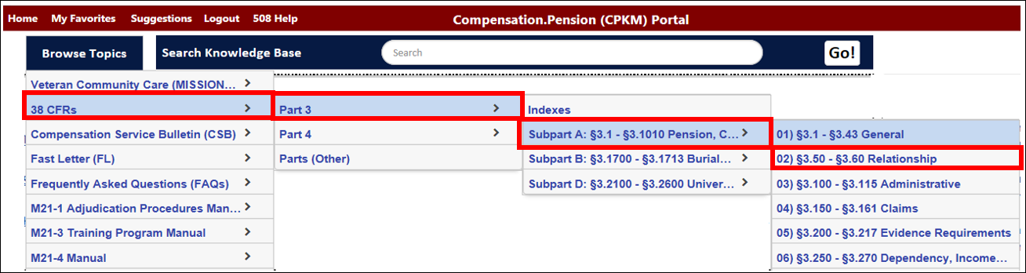

[38 CFR Part 4](http://www.ecfr.gov/cgi-bin/text-idx?SID=781ce9e74c74766522d8976ef80d19df&mc=true&tpl=/ecfrbrowse/Title38/38cfr4_main_02.tpl), *Schedule for Rating Disabilities* provides the general policy and disability rating information. This resource is useful when assisting with inquiries regarding the rating formulas for specific disabilities.

PCRs have access to this information to educate, not adjudicate. PCRs are not to give definite information about a pending or future decision on a claim or appeal.

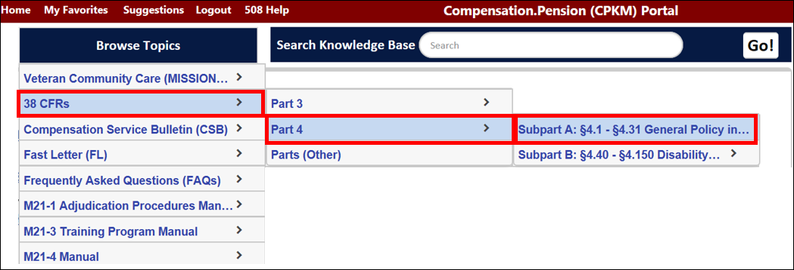

Interactive Activity

*Access and review Fiduciary’s Knowledge Management and CPKM.*

### M21-1

The M21-1 Adjudication Procedures Manual (also referred to as M21-1) provides

procedural guidance for processing claims and appeals. This is the most valuable

source for PCRs within CPKM.

The M21-1 is organized into 10 Parts:

* Part 01 (Part I). Claimants Rights and Responsibilities
* Part 03 (Part III). General Claims Process
* Part 04 (Part IV). Compensation DIC, and Death Compensation Benefits
* Part 05 (Part V). Pension and Parents Dependency and Indemnity Compensation (DIC)
* Part 06 (Part VI). Chapter 18 Benefits
* Part 07 (Part VII). Burial Benefits
* Part 08 (Part VIII). Accrued Benefits
* Part 09 (Part IX). Ancillary and Special Benefits
* Part 10 (Part X). Matching Programs

Each part is further broken down into:

* Subparts
* Chapters
* Sections, **and**
* Topic.

When you see a manual reference such as M21-1MR Part III.iii.5.C.4.a, that's:

* **Part** III
* **Subpart** iii
* **Chapter** 5
* **Section** C
* **Topic** 4.a

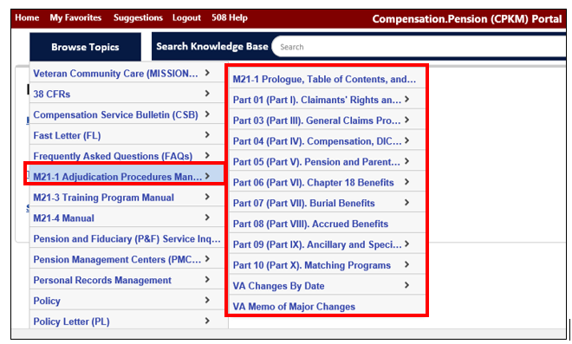

# 

# VA Intranet

A wealth of knowledge exists within the VA Intranet website. This information is specifically designated for VA employees to have a better understanding of the various aspects and benefits of the organization.

The VA Intranet is only accessible within the VA network. The VA Intranet can be accessed:

* The URL:
* <https://vaww.va.gov/default.asp>

## 

## Homepage Quick References

You should be aware of some important tabs located on the homepage.

### About VA

The About VA tab connects to VA’s internet site [www.va.gov](https://www.va.gov/about_va/).

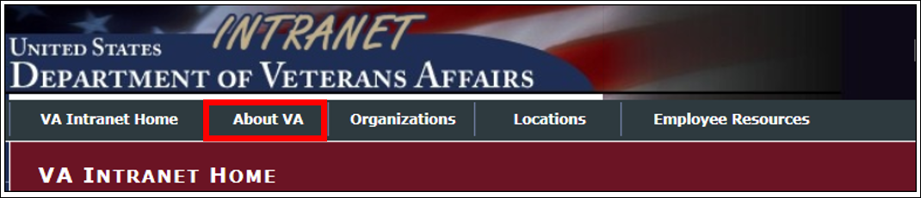

Here both VA employees and Veterans can explore VA’s mission, vision, and core values, in addition to a wealth of information about the VA.

### Organization

The Organization tab navigates to an outline of various business units within the VA.

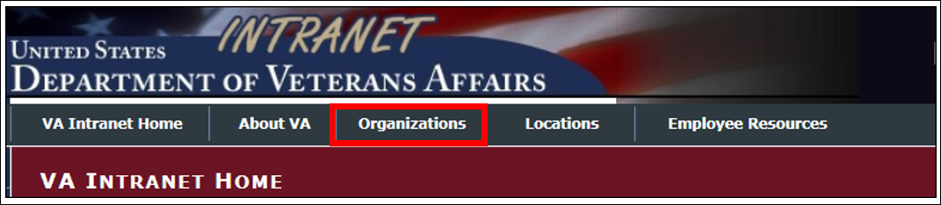

The first three organizations lead to the internal websites for the three administrations within VA; VHA, VBA, and the National Cemetery Administration (NCA).

### Locations

The Location tab provides contact and location information for all VA facilities. The site also provides information on key staff at each VA facility.

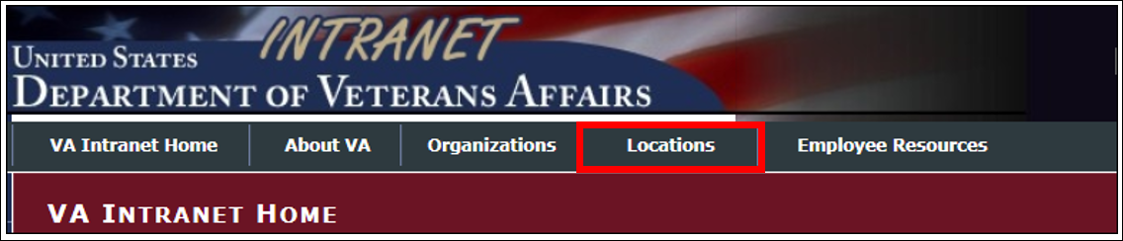

You can use the site to access information based upon categories or by viewing through an interactive map of the United States. Links to various VA services are also available.

Other tabs available to view include and access include:

* Health Care
* Benefits
* Burial & Memorials
* VA Jobs
* My VA
* Board of Veterans’ Appeals
* Public Affairs
* Congressional Affairs
* Veteran Data
* National Desktop Library
* VA Internet

# Veterans Benefits Administration (VBA)

# Intranet

The VA intranet provides access to a variety of resources; however, we will discuss the Under Secretary for Benefits and the Benefits Assistance Service (BAS) Website website.

## Accessing the VBA Intranet

The VBA Intranet is only accessible within the VA network. The VA Intranet can be accessed:

* The URL:
* <https://vbaw.vba.va.gov/benefits/>
* [VA’s Intranet](https://vaww.va.gov/default.asp) homepage
* Select “Benefits”

**Under Secretary for Benefits**

Knowing the leaders and organization of VBA helps to better understand our segment of the organization.

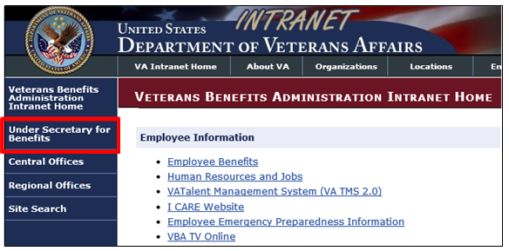

# 

# Benefits Assistance Service (BAS) Website

BAS provides oversight of VBA’s customer-facing activities through Outreach, Public Contact Teams (PCTs), National IRIS Response Center (NIRC), and VBA’s National Call Center (NCC). BAS also provides policies, procedures, quality and compliance oversight, and training to support customer-facing activities across all access channels.

## Accessing BAS Website

PCRs can access BAS Website using:

* The URL:
* <https://vbaw.vba.va.gov/benefits/>
* [VA’s Intranet](https://vbaw.vba.va.gov/benefits/) homepage:
* Select “Central Offices”
* Select “Benefits Assistance Service (27)”

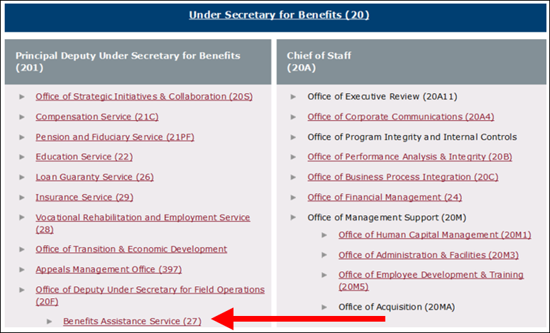

## BAS Homepage

The BAS homepage provides information about divisions within BAS:

* Outreach and Access
* Policy and Training
* Quality and Site Visits

References are available in the Publications. Resources provide additional tools to assist with customer interactions.



## About BAS

About BAS provides links to help you understand BAS. From the webpage, you access BAS’s organization chart, mission, vision, team members, and sitemap.

## Training

BAS’s Training website contains references and materials specific to PCR duties such as:

* Knowledge Management (KM)
* This segment provides a link to KM Solution and links to useful information to help users log in and navigate within KM Solution.
* BAS Video
* This segment provides links to various useful training videos.
* Training Curriculum
* The links in this segment navigate to training materials for:
* Newly Hired representatives within VA’s NCCs, NPCC, and NIRC
* Refresher training for representatives within VA’s NCCs, NPCC, and NIRC
* Refresher training for Public Contact Teams



# VA.gov

In November 2018, VA began migrating VA websites into a single, unified, Veteran-centric platform under the existing name Veterans recognize as VA.gov. Features and functionality from existing websites are incrementally being migrated to the Va.gov platform to present a consistent and accessible external-facing website.

## Accessing VA.gov

You can access VA.gov:

* The URL
* <https://www.va.gov/>

## VA.gov Homepage

The new VA.gov design focuses on the top information Veterans seek out across all VA websites.

# VA Forms

PCRs must often supply Veterans and beneficiaries with forms. Each time a form is requested, the PCR must offer to send by email, fax, mail, or assist the caller on how to locate the form online. However, forms are supplied, PCRs are responsible for providing appropriate return mailing and faxing instructions.

Forms are also a great resource. Benefits information and application instructions are located in most VA forms.

## Accessing VA Forms

You can access VA Forms:

* The URL:
* Internal: <http://vaww.va.gov/vaforms/>
* Available to VA employees. This site includes internal-use only forms that are not available on the external-facing webpage.
* The URL:
* External: <http://www.va.gov/vaforms/>
* The websites will contain the most updated version of each form.

These websites will contain the most updated version of each form. Some forms may not be externally available for print. In such cases, the internal forms site will yield these forms.

PCRs have the option to search for forms:

* By form number, **or**
* Title/keyword.