## RO RESEARCH COORDINATOR TRAINING

**HANDOUT**

**Table of Contents**

Objectives 2

References 3

Topic 1: Scope of Military Records Research Center (MRRC) research 4

Topic 2: Duties of Regional Office (RO) Research Coordinator 5

Topic 3: When an MRRC request is required 5

Topic 4: Helpful hints for research requests 6

Topic 5: Submission of MRRC requests 7

Topic 6: When to contact MRRC. ...10

Topic 7 Reminders 10

## OBJECTIVES

* Establish scope of MRRC research
* Identify duties of RO Research Coordinator
* Determine when an MRRC request is required
* Indicate required fields for MRRC request
* Review steps for submission of MRRC request
* Clarify when to contact the MRRC mailbox

**REFERENCES**

All M21-1 references are found in the Live Manual Website.

* M21-1.I.1.C.1.a VA’s Duty to Obtain Federal Records
* M21-1.VIII.iv.1.A General Information and Development for Post-Traumatic Stress Disorder (PTSD) Claims
* 38CFR 3.159 Department of Veterans Affairs assistance in developing claims

**Assignment of and Qualifications for a RO Research Coordinator**

Each RO must designate an employee to serve a RO Research Coordinator.

The designated employee must

* + possess expertise in military records, and
  + be thoroughly familiar with the information within the M21-1 manual.

Important:

* + Each RO must designate at least one alternate RO Research Coordinator.
  + If an RO does not have sufficient staffing to designate an RO Research Coordinator, the Veterans Service Center Manager (VSCM) should request an exception to this requirement from the Office of Field Operations (OFO)

**TOPIC 1: SCOPE OF RESEARCH**

MRRC conducts research on the following

* + Stressor incidents
  + Herbicide/Agent Orange exposure events
  + All branches of service (including Marine Corps) MRRC Does Not Research
  + Military sexual trauma (MST)
  + C123
  + Asbestos
  + Radiation
  + Camp Lejeune
  + Mustard Gas/Lewisite contaminated water
  + Mistreatment of enemy prisoners
  + Events that almost happened
  + Other environmental toxins/substances
  + Stressors for Benefits Delivery at Discharge (BDD) claims

# TOPIC 2: DUTIES OF RO RESEARCH COORDINATOR

The RO Research Coordinator (RC) serves as the RO primary point of contact with the MRRC and as the primary point of contact within the RO for procedures related to stressor corroboration (unrelated to MST or personal trauma) and herbicide exposure.

The RC reviews claims for post-traumatic stress disorder (PTSD) and herbicide exposure to confirm all required development has been completed. RC duties include:

* + Determining whether there is enough information available to conduct research.
  + Ensuring all military records, to include service treatment records and entire OMPF are of record and have been reviewed
  + Confirming Veterans Benefits Administration (VBA) sanctioned intranet and internet sources have been reviewed, to include the Official Military Activities Report (OMAR) app.
  + Submitting all RO research requests for stressor verification to the MRRC via the Record Research Requests chevron in VBMS Core.
  + Emailing the MRRC mailbox at VAVBAWAS/CO/209/MRRC when a pending research request is no longer needed or needs to be cancelled.

# TOPIC 3: WHEN A MILITARY RECORDS RESEARCH REQUEST (MRRC) IS REQUIRED

Research requests are required in situations where Veteran claims exposure to herbicides or stressful event(s) that cannot be corroborated by RO personnel

The following general criteria must be met before the RO RC may submit a research request for verification of a claimed stressor or herbicide exposure event:

* + The required development is completed, but the claimed stressor cannot be conceded

based on the stressor verification review procedures in

**VIII.iv.1.A.3.d****.  Stressor Verification Review Procedure**

or

* + The claimed herbicide exposure cannot be conceded based on development procedures in M21-1, Part VIII, Subpart I, Chapter 1, Section A AND
  + The claims folder contains minimum information needed to allow additional research as described in M21-1, Part VIII, Subpart iv,1.A.4.b

# TOPIC 4: HELPFUL HINTS FOR RESEARCH REQUESTS

When submitting a request for stressor or herbicide exposure corroboration to MRRC, include the following:

* + the most specific date(s), at minimum the month and year, during which the stressful event occurred (MRRC will research up to a 120-day time frame)
  + the Veteran’s complete tour dates related to the unit of assignment when the incident occurred
  + the geographic location where the claimed event (stressor or exposure) took place. In the location field, provide more concise locations such as Fallujah, Iraq, instead of Iraq, or Seoul, Korea, instead of just Korea and Udorn, Thailand instead of Thailand
  + the designation of the Veteran’s unit of assignment at the time of the event, down to the lowest possible level.

Unit designation by branch:

For **Army** requests, provide the full unit designation to the company level, such as HHC, 1st Brigade, 2d Armored Division (instead of 2d Armored Division only), and Company C, 1st Battalion, 14th Infantry, 1st Brigade Combat Team, 4th Infantry Division.

For **Navy** requests, provide the full unit designation and hull numbers for ships, such as USS Franklin D. Roosevelt (CVA-42) instead of USS Roosevelt only.

For **Air Force** requests, at a minimum, provide squadron and group designations, such as 366th Field Maintenance Squadron, 366th Combat Support Group instead of 366th Tactical Fighter Wing only. Providing just the wing is insufficient because there are numerous units under a wing and various unit locations. **MOS at time of claimed event is required.**

For **Marine Corps** requests, provide the full unit designation, such as Third Shore Party Bn instead of 3rd Marine Division only. If assigned to a ship, provide name of ship and hull number.

For more information on:

* + personnel documents containing the Veteran’s unit(s) of assignment and service

locations, refer to M21-1.VIII.iv.1.A

Additional information identified by MRRC as helpful in conducting stressor research includes:

* + the medals or citations received by the Veteran, and
  + the names of other soldiers or sailors involved in the stressful incident

# TOPIC 5: SUBMISSION OF MRRC RESEARCH REQUESTS IN VBMS

Within Veterans Benefits Management System (VBMS), select the chevron labeled “Record Research Requests” and then select the Create Research Request button.

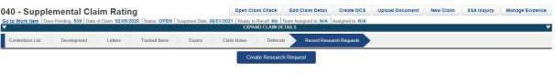

Figure 1. Screenshot of VBMS chevron taskbar highlighting Records Research Requests chevron and the Create Records Request button

Next, select incident type – Stressor or Exposure

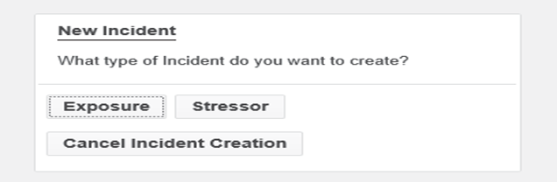

Figure 2. Screenshot of incident type prompt providing options of exposure, stressor, or cancel incident creation

If you select the Stressor option, then you must fill out all fields with stressor event information provided by Veteran.

* Air Force requests require input of Veteran’s Military Occupation Specialty (MOS) at the **time of the claimed event** (review personnel file – Performance Reports to obtain).

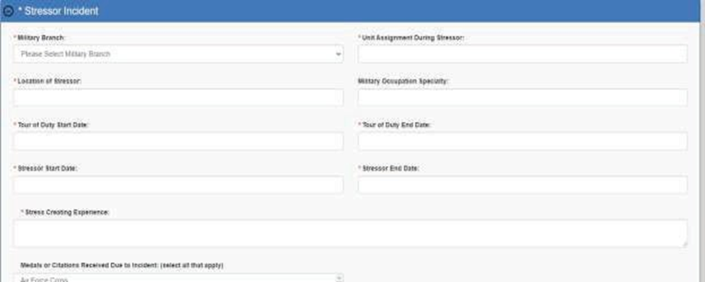

Figure 3. Screenshot of Stressor Incident prompt.

If the Veteran provides name(s) of individuals injured or deceased, then complete the following fields:

Figure 4. Screenshot of prompt asking for last and first name, rank, date of death or injury, whether injured or killed, and unit assignment.


Figure 4. Screenshot of prompt asking for last and first name, rank, date of death or injury, whether injured or killed, and unit assignment.

If you select the Exposure option, then you must fill out all fields with exposure information provided by Veteran.

Figure 5. Screenshot of Exposure Incident prompt. Stressor Incident prompt. 


Figure 5. Screenshot of Exposure Incident prompt.

When all required fields are completed, press the save button.



Figure 6. Screenshot of save button

You will then have the option to submit research request or delete.



Figure 7. Screenshot of options to submit the research request or trashcan (delete) the request

If the “Submit Research Request” button is selected, the user will see the following prompt:



Figure 8. Screenshot of VBMS prompt requesting confirmation of the research request submission.

If request is ready for submission, click “yes”. If edits are needed, click “no”.

Once request has been submitted in VBMS, the user has 2 business days to cancel request and 5 business days to edit the request.

Status of MRRC request

Authorized users can view the status of the request by selecting the Record Research Requests chevron. All requests that have been submitted for the claim will be listed separately.

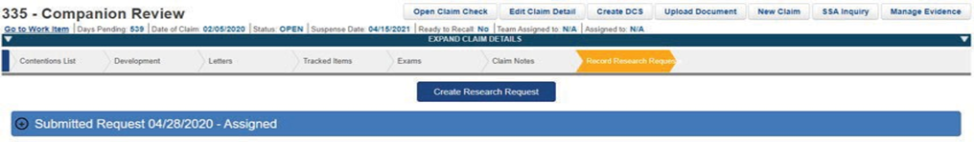

Figure 9. Screenshot of VBMS chevron taskbar with pending research request.

VBMS automatically updates the status of requests upon submission:

* *Research Requested* – automatically generated when the requestor submits a records research request that cannot be immediately assigned to a researcher.
* *Research Assigned* – automatically updated when the records research task is assigned to a researcher.
* *Research in Progress* – manually updated when a researcher launches a records research task.
* *Research Extended* – manually updated when a records research task is extended.
* *Research Response Provided* – automatically updated when a records research task is completed.

**TOPIC 6: WHEN TO CONTACT THE MRRC**

With real time status of research requests available in VBMS, there is no need to send a follow up inquiry to MRRC mailbox.

* + If cancellation of a research request is needed, please send email to VAVBAWAS/CO/209/MRRC [RRC.VBACO@VA.GOV.](mailto:RRC.VBACO@VA.GOV)
  + Be sure to include Veteran’s name, Social Security number (SSN) or file number, date of research request submission and reason for cancellation.
  + For policy and manual related questions and/or feedback related to stressor research, provide detailed but concise information.
  + To request a research request be expedited, provide the basis for the request (see the section *Circumstances Under Which MRRC Requests May Be Expedited*).
  + Excludes routine follow ups. The status of pending research requests may be ascertained by checking VBMS.

**TOPIC 7: REMINDERS**

Research requests involving casualties or injuries are NOT insufficient just because the name of the deceased or injured was not provided.

If a name of deceased is provided, ensure Veteran Service Representative (VSR) searched VBMS for a DD Form 1300. These can be redacted and used for verification of an event.

Fear based stressors only apply to a PTSD diagnosis. All other mental health diagnoses require a verified stressor. A BDD claim does not need stressor verification as this indicates the condition was diagnosed in service.

MRRC will return to the appropriate RO any research request identified as invalid or incomplete, with an explanation of the deficiency(ies) identified. MRRC then closes out the request, and it must be resubmitted as a new request to receive further consideration.