**TABLE OF CONTENTS**

VBMS-A Statement of the Case (SOC) Fee Decision Notice Letter 1

Question and Answer – VBMS-A SOC Fee Decision Notice Letter 7

Reminders 7

Question and Answer – Reminders 7

Agent and Attorney Fee Special Focused Reviews (SFR) Error Trends 8

Question and Answer – Agent and Attorney Fee SFR Error Trends 11

# VBMS-A Statement of the Case (SOC) Fee Decision Notice Letter

**Target Audience:** AAFCs, AAFC Management, Authorization Quality Review Specialists (AQRS), and Quality Review Team (QRT) Management

**Presenter:** Lisa Troen, Management and Program Analyst, OAR

**References:**

* VBMS-A Summary of Case Fee Decision Notice Job Aid
* Upcoming TMS national Attorney Fee Notification training course (course number TBD)
* [June 2023 National AAFC Call Presentation](https://vbaw.vba.va.gov/OAR/docs/june-23-national-aafc-call-slides.pdf)
* [June 2023 National AAFC Call Bulletin](https://vbaw.vba.va.gov/OAR/docs/june-2023-national-call-bulletin-updated1.pdf)

This new functionality will allow agent and attorney fee coordinators (AAFCs) to create and send the summary of case fee decision letter in the Veterans Benefits Management System-Awards (VBMS-A). This will allow the authorizing AAFC to create the fee decision directly in VBMS-A as they are completing corresponding authorization activity. I’m excited to be able to give everyone a brief preview of that new functionality; Also wanted to let everyone know that we will have a thorough job-aid and will be very shortly releasing a national notification training for the field that will incorporate this new functionality as well.

**VBMS-A User Interface**

After the Senior Veterans Service Representative (SVSR) AAFC verifies accuracy of the fee deduction fields on the *Agent/ Attorney Fee* Tab that were input by the VSR AAFC, they will navigate down to the Summary of Case Fee Decision Notice Letter section and click add to begin creating their fee decision notice.

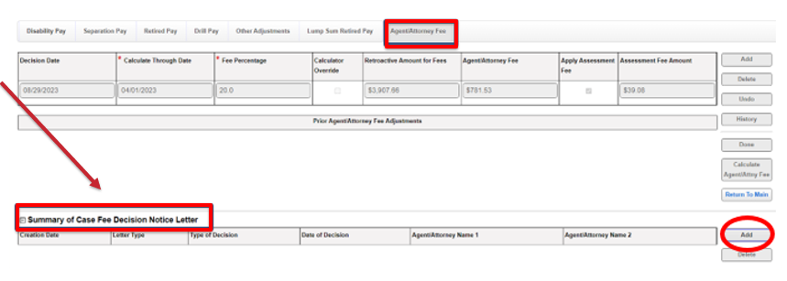

Once you click add, the user will continue selecting the applicable letter type for their specific case as well as which type of decision it is based on, whether that be rating, non-rating, CAVC, or Board decision as well as the corresponding date of decision.

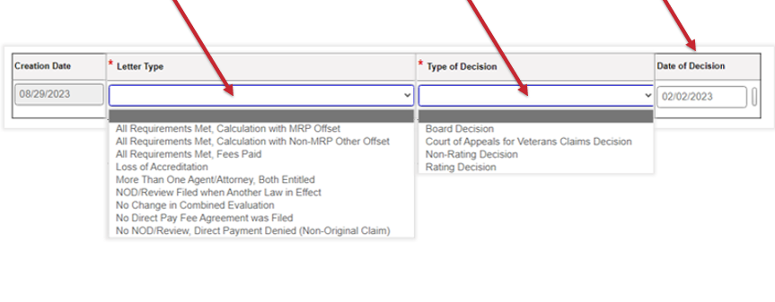

You’ll also notice that there are 3 free text fields. The first two – “Introduction” and “What We Decided and Why” were created based on subject matter expert suggestions and are available for when the auto populated verbiage would not be sufficient to properly notify the claimant of the decision. The third box titled “Requirements Not Met” is specifically for the “No NOD/Review Filed when Another Law in Effect” letter type as it requires that the user identify the specific historical requirement that was not met.

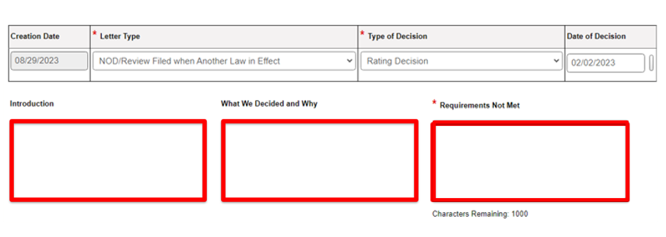

**VBMS-A SOC Recipients**

Next the user will enter the required recipients in the Recipients section:

1. The Veteran/claimant information will auto populate from the system.
2. Current POA information will also auto populate.
   * 1. If the current POA is also the agent/attorney to whom a decision on fees is due, the user will need to manually check the Due Fee Decision box.
     2. Please note the checkbox will default as *unchecked* for the current POA*. But the system, will not allow you to save/click done until there are two recipients with the “due fee decision” checked, since we know that on a contested claim there will always be two recipients.*

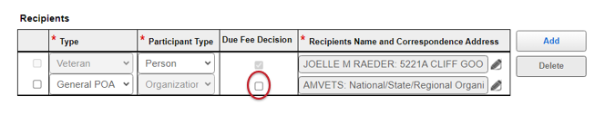

If the agent/attorney whom a fee decision is due is a prior or historical POA, you will Click Add and select the Prior POA Due Fees recipient type.

1. Click Add if the agent/attorney who is due a fee decision is a prior/historical POA of record:
   * The Due Fee Decision checkbox will automatically be checked.
   * Click the pencil Edit icon to add the agent/attorney name and address
2. Click Done. This must be done prior to navigating out of the Summary of Case section to save the fee decision letter.
3. Click Preview to review the fee decision letter for accuracy.

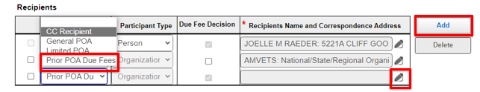

**Current VBMS-A SOC Exclusions/Workarounds**

Exclusions:

* All Requirements Met, Fees Not Withheld (letter type)
* No Direct Pay Fee Agreement was Filed (letter type)
* Denials
  + No NOD/Review, Direct Payment Denied (Non-Original Claim)
  + NOD/Review Filed when Another Law in Effect

Workaround:

* No Change in Combined Evaluation

**Letter Creator – Data Entry**

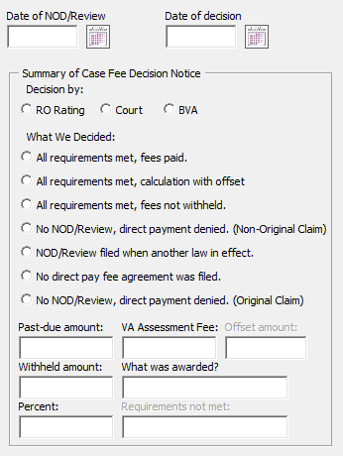 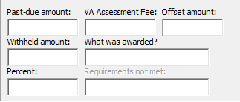

The first field is the Past-Due Amount. This is the *Gross Amount of Past Due Benefits* found on your manual calculator.

Second, is the withheld amount. This is your **total** amount of attorney fees (so including assessment).

Next is the Offset amount. This will be the gross amount of past due benefits minus the net amount from your award print.

Lastly, “what was awarded” is simply the specific issues granted from the decision.

**Letter Creator – Data Entry Example**

The following is an example of how the data you enter populates in your Summary of the Case Fee Decision. We have a past-due amount (or gross) of \***$10,000**. A withheld amount (*or total attorney fee*) of **\*$2000.**

Let’s say our Net amount from our award is 1,000, so our offset amount (again, that’s gross – net) for this field will be \***$9,000**. Assessment of \***$100**, Percent of \***20%**, and our decision was a grant of benefits for \***PTSD** – note here that once your letter opens in word, you will want to write out the complete decision.

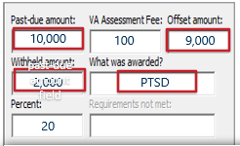

So once your letter is generated you can see that the following paragraph is created as part of our introduction. Our Assessment Fee and Percent populate in two separate paragraphs which we will show in the next slide. But, let’s look at the introduction.

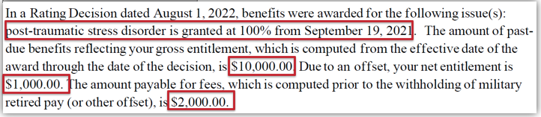

You can see that we’ve got our \***past due amount** and our \***withheld amount** from the entries above**.** Letter creator *does not populate the offset amount*, instead it uses that data entry to tell the reader what the \***net entitlement amount is**. It’s a bit counterintuitive so an important field to remember and come back to this presentation if you are unsure. And the again, for the \***what was awarded** entry you always want to write out the complete decision once you get into your letter.

**Preview Summary of the Case Fee Decision**

Lastly, it is important to examine two sections of the letter that your manual data entries from letter creator will affect. Those two sections are the \***Summary of the case** Introduction and the \***What we decided and why**. While you should be reviewing all of your letter for accuracy, these two sections are especially important.

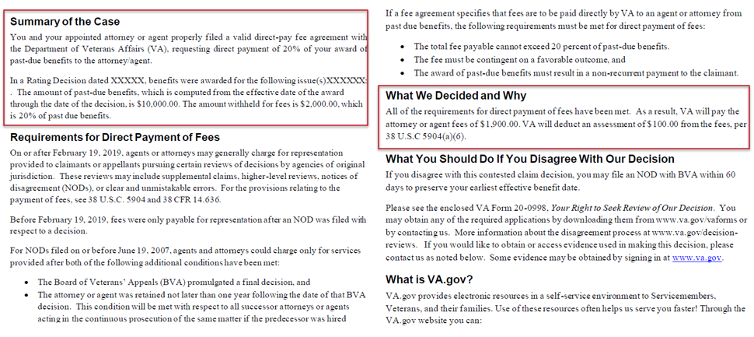

# Question and Answer – VBMS-A SOC Fee Decision Notice Letter

**1. Is there a requirement to send the attorney/agent a copy of the Veteran’s fee determination letter when the attorney/agent gets his/her own copy?**

If the agent/attorney receiving their own personal fee decision is also the current POA of record, a cc copy of the Veteran/Claimant letter is also required procedurally (M21-1 I.i.2.B.1.e, *Requirement to List the Private Attorney or Claims Agent Address in the CC Line*).

**2. How is this going to work for stations whose VSRs do not perform any agent/attorney fee calculation in VBMS-A for the SOC letter?**

Current functionality limits the use of the VBMS-A SOC tool to claims that are utilizing the Agent/Attorney fee deduction in VBMS-A. If a claim is excluded for that reason, the AAFC should be generating their fee decision letter in Letter Creator.

**3. Will the Veteran get a copy of the attorney’s fee decision since the attorney gets a copy of the Veteran’s fee decision?**

No, the agent/attorney gets a cc copy of the Veteran/claimant’s fee decision only if they are the current and active POA (M21-1 VI.ii.3. and M21-1 I.i.2.)

# Reminders

**Target Audience:** AAFCs, AAFC Management, AQRS, and QRT Management

**Presenter:** Lisa Troen, Management and Program Analyst, OAR

* Kristen Vanderkooi - Universal waiver present/future fees: The attorney submitted a universal waiver of present and future fees. Kristen Vanderkooi should no longer be found eligible for direct payment of fees, and correspondingly, AAFC’s should not send any future agent/attorney fee eligibility decisions to this attorney.
* Release memo accuracy: please ensure the careful review release memos to avoid misdirected funds. We’ve had a few instances where funds were paid to the incorrect agent/attorney simply because those fields in the memo were not updated from the users previous memo.
* Ensure a AAFC authorizer adds their digital signature to the manual calculator ([M21-5, 8.B.1.a.](https://vaww.vrm.km.va.gov/system/templates/selfservice/va_kanew/help/agent/locale/en-US/portal/554400000001034/content/554400000205497/M21-5-Chapter-8-Section-B-Processing-a-Case-Seeking-Direct-Payment-of-Fees))
* Please ensure that you are issuing a fee decision on non-original grants, even when denying entitlement – in all cases where a valid fee agreement is present.([M21-5, 8.B.3.a.](https://vaww.vrm.km.va.gov/system/templates/selfservice/va_kanew/help/agent/locale/en-US/portal/554400000001034/content/554400000205497/M21-5-Chapter-8-Section-B-Processing-a-Case-Seeking-Direct-Payment-of-Fees))

# Question and Answer – Reminders

**1. Are there any plans to add fee denial decision letters into the VBMS-A letter list?**

OAR does have a list of enhancement requires submitted to Production Optimization for the VBMS-A SOC tool, one of which, is allowing users to generate their fee decision regardless of whether a fee deduction is being input into VBMS-A.

**2. Could you clarify if you were saying that we need to do attorney fee decisions even with denials?**

Fee decisions should be issued per M21-5 8.B.3.a, When to Make a Fee Decision and Send a Decision Notice.

**3. If there are no fees warranted, does a denial letter have to go to both the attorney and the Veteran/claimant or does the cc’d Veteran/claimant’s copy suffice for the attorney’s notification?**

Attorney fee decisions are contested claims, meaning there are two parties involved. You will always be sending a fee decision to both the Veteran/claimant as well as the agent/attorney.

**4. Should the SOC letter be sent to the agent/attorney when no fee agreement has been received?**

No, a SOC letter is only required if there is valid representation and a valid fee agreement of record.

**5. Should the SOC letter be sent when there is a C&C with no change?**

Fee decisions should be issued per M21-5 8.B.3.a, When to Make a Fee Decision and Send a Decision Notice.

**6. Should the SOC denial letter be sent if a dependent is being added based on a life event (birth/marriage)? In other words, it has nothing to do with the Rating Decisions, hence no fees payable.**

Yes, a fee decision should be issued on a dependency claim denying fees based on no qualifying review – whether that’s outside of the year of final adjudication or grant being based on a life event.

**7. Can the POA still request the SOC when all issues are denied?**

If there is no benefit granted on a Rating Decision, a fee decision is not warranted.

**8. Why are fee decisions necessary for an 020 when 38 CFR 14.636(c) identifies circumstances under which fees may be charged?**

Though it may seem clear, many instances arise in which an EP020 may be considered part and parcel of a qualifying review (examples include issues continuously pursued within a year of a qualifying review). By providing a decision, both parties are afforded appeal rights.

**9. For BEST stations, are SOC’s needed if a Veteran is requesting to have benefits resumed for being released from active duty?**

No, an SOC is not warranted in this case, as there is no associated rating decision that fee eligibility is related to.

**10. Are you saying on an 020EP if none of those contentions were ever appealed, and they grant something, we still must do the letter?**

Yes, a fee decision should be issued per M21-5 8.B.3.a, When to Make a Fee Decision and Send a Decision Notice.

# Agent and Attorney Fee Special Focused Reviews (SFR) Error Trends

**Target Audience:** AAFCs, AAFC Management, AQRS, and QRT Management

**Presenter:** Suzi Ribish, Management and Program Analyst, OAR

**Background**

OAR continues to conduct a special focus review (SFR) of the AAF workload to determine whether actions taken by claim processors are compliant with statutory, regulatory, and procedural requirements.

Each quarter, OAR reviews a total of 70 cases for the AAF SFR.

For the purposes of this presentation, we are taking a look at SFR data Fiscal year to date (FYTD). FYTD, OAR has reviewed 262 AAF cases for the SFR and has identified 123 errors within those cases (77 unique cases had errors from the 262 reviewed – with some cases having multiple errors cited).

The list below demonstrates the number of errors cited under each question on the AAF SFR checklist. The top three error categories were for the following questions: #4 Were the fees calculated correctly?, #5 Were correct procedures followed to make funds available from past due benefits?, and #6 Was the fee eligibility notification correct?.

* Question 1 (Was the Power or Attorney information processed correctly?) had 1 error cited
* Question 2 (Are the attorney fee corporate flashes accurate?) had 12 errors cited
* Question 3 (Was the validity of the fee agreement correctly determined?) had 2 errors cited
* Question 4 (Were the fees calculated correctly?) had 29 errors cited
* Question 5 (Were correct procedures followed to make funds available from past due benefits?) had 24 errors cited
* Question 6 (Was the fee eligibility notification correct?) had 30 errors cited
* Question 7 (Was the decision to grant or deny fees correct?) had 3 errors cited
* Question 8 (Were funds released correctly?) had 8 errors cited
* Question 9 (Were correct failure to withhold procedures followed?) had 3 errors cited
* Question 10 (Were reasonableness review procedures correctly followed?) had 0 errors cited
* Question 11 (Were agent/attorney fee end products and claim attributes correct?) had 11 errors cited

**Question Four**

Question #4 of the checklist asks: Were the fees calculated correctly?

* 13 errors were cited because the AAFC calculator was not digitally signed by the authorizing AAFC as required **(M21-5 8.B.1.a. Step 3)**
* 3 errors were cited because the Agent/Attorney calculator was not uploaded to the VBMS eFolder **(M21-5 8.B.2.d.)**
* 8 errors were cited because fees were not calculated using the correct end date **(M21-5 8,B.2.c.) (**for example, the rating decision was dated March 2, 2022, and the AAFC used a through date of March 1, 2022 on the calculator, causing a failure to withhold fees correctly – 1 day less than needed)
* 3 errors were cited for not using correct payment rates when calculating fees
* 2 errors were cited for using an incorrect assessment fee amount
  + It should be noted that both errors were cited on dependency cases where fees had already been paid. M21-5 8.B.4.d. Releasing Funds When an Assessment Is Required - Only one assessment of up to $100 is to be charged and deducted even if fees must be paid multiple times for different transactions (e.g. dependency, AEW) if the past-due benefits are based on the same rating.

**Question Five**

Question #5 asks, Were correct procedures followed to make funds available from past due benefits?

* 2 errors were cited for not using VBMS-A when required
* 1 error was cited from not inputting the correct amount in VBMS-A
* 7 errors were cited for not uploading the other adjustments tab screenshot *(no longer a requirement)*
* 13 errors were cited for not uploading the award information screenshot as required **(M21-5 8.B.1.a. Step 3)**
* 1 error was cited for not using legacy procedures for month of death and/or accrued cases or other applicable cases

**Question Six**

Was the fee eligibility notification correct?

* 6 errors were cited for the fee eligibility decision not being issued M21-5 8.B.3.a.)
* 3 errors were cited for incorrect payment/past due benefit amounts in the notification
* 1 error was cited for not issuing military retired pay Rosinski information
* 6 errors were cited for missing/incorrect information
* 14 errors were cited for not issuing a fee decision to both the agent/attorney and the Veteran/claimant (M21-5 8.B.3.a.) Many of these errors were cited for only sending one letter to the Veteran/claimant and not sending the agent/attorney a copy in their own right, and also were cited for not ccing the agent/attorney on the Veteran/claimant’s copy of the letter, as required by M21-1 I.i.2.B.1.e. Requirement to List the Private Attorney or Claims Agent Address in the CC Line.

**Key Takeaways**

After examining the error trends from the SFRs conducted FYTD, OAR would like to remind AAFC’s of the following:

* Ensure that the Agent/Attorney Fee Calculator is digitally signed by the authorizing AAFC **(M21-5 8.B.1.a. Step 3)**
* Verify the correct end date is being utilized when calculating fees **(M21-5 8,B.2.c.)**
* Ensure that the award information screenshot is uploaded to the eFolder as required so that the historical award information is of record to verify fees were calculated correctly **(M21-5 8.B.1.a. Step 3)**
* A fee decision must be issued to both the agent/attorney and the Veteran/claimant **(M21-5 8.B.3.a. and M21-1 I.i.2.B.1.e.)**
* Be mindful of systems compliance related issues as well. Questions #2 and #11 were the next largest categories after the top three we just went over in detail. #2. Are the attorney fee corporate flashes accurate? (12 errors) and #11. Were agent/attorney fee end products and claim attributes correct? (11 errors)

# Question and Answer – Agent and Attorney Fee SFR Error Trends

**1. I wasn’t aware that we are not longer required to upload the “Other Adjustments Tab”. When did that change?**

The requirement to upload the “Other Adjustments Tab” screenshot was removed from the manual on April 26, 2023. AAFCs should also no longer be using the “Other Adjustments” tab and should be utilizing the “Agent/Attorney Fee” tab. There is no requirement to upload a screenshot of the “Agent/Attorney Fee” tab.

**NOTE:** There is still a requirement to upload a screenshot of the “Award Information Screen”.

**2. Are there plans to remove the requirement to upload a screenshot of the “Award Information Screen” now that historical award information is on the award print?**

Currently, the requirement to upload the historical award information to the eFolder still exists. There have been defects and issues reported with the historical award information displaying on the award print, and we have not received confirmation that we can rely on that data as accurate yet. Once confirmation is received that the issues have resolved, OAR will revisit the idea of removing this requirement.

**3. There is a debate on the assessment fee for dependency cases. If an assessment fee of less that $100 was charged on a Rating Decision, do we recover up to $100 on the dependency claim? For example, the assessment fee for the rating decision was $55, and we received an eligible dependency claim following that. Do we need to continue to charge an assessment fee potentially up to the $100 amount, less the $55?**

M21-5 8.B.4.d, *Releasing Funds When an Assessment is Required*, states: Only one assessment of up to $100 is to be charged and deducted even if fees must be paid multiple times for different transactions (e.g., dependency, AEW) if the past-due benefits are based on the same rating.

The key to this issue is to focus on the working in the reference: Only *one* (1) assessment of *up to* $100 is to be charged.

In the scenario presented in the question, if we charged an assessment of $55 initially with the rating, there would be no additional assessment if a qualifying dependency claim was received following that.

**4. Are stations being notified as errors are found on these SFRs?**

Yes, stations are notified of the SFR errors within QMS. The error correction record gets assigned to the stations’ QMS Coach Team queues for review. The error correction record is named “NAMOAAFSFR Error Correction”. Currently, there are 32 unresolved NAMOAAFSFR Error Correction records open and pending. RO QRT Coaches should work towards getting these case issues corrected and the error records in QMS resolved.