**TABLE OF CONTENTS**

Community Care & VA Medical Records Development 1

Appeals Modernization Act (AMA) Claim Establishment in VBMS Deployment 2

Quality Error Standards 4

Veterans Law Judge Survey Results & Important Claims Processing Reminders 6

Quality Trend Analysis: FY24 Q4 and FY24 in Review 9

## Community Care & VA Medical Records Development

**Target Audience:** Decision Review Operations Center (DROC) Management and Quality Review Teams (QRT), Decision Review Officers (DRO), Rating Veterans Service Representatives (RVSR), Veterans Service Representatives (VSR), and Claims Assistants (CA)

**Presenter:** Bonnie Rosado, Quality Consultant, CS

**References:**

* [M21-1, III.ii.1.A.](https://vaww.vrm.km.va.gov/system/templates/selfservice/va_kanew/help/agent/locale/en-US/portal/554400000001034/content/554400000014108/M21-1-Part-III-Subpart-ii-Chapter-1-Section-A-Requesting-Evidence-From-Federal-Record-Custodians), *Requesting Evidence from Federal Record Custodians*
* [JLV Tip Sheet](https://dvagov.sharepoint.com/sites/VACOVE2/JLV/Training/VBA%20JLV%20TIP%20SHEET%20Viewing%20Community%20Care%20(Non-VA)%20Records.pdf)
* [VHA’s Community Care website](https://www.va.gov/communitycare/index.asp)
* [JLV Help](https://jlv.med.va.gov/JLV/WebHelp/JLV_help.htm)

What is Community Care (CC)?

* A program that provides eligible Veterans with hospital care, medical services, and extended care services through private health providers when VA cannot offer the care or services the Veteran needs.
* The program ensures Veterans do not experience a lapse in care or difficulty trying to access care.

Acquiring CC Records:

* CC records are not considered Federal or VA records until they are in VA’s possession.
* The Veterans Health Administration (VHA) identifies in its system when CC is requested.
* After the Veteran is treated, VHA must obtain and upload the complete copies of the records.
* The records are saved in the Joint Longitudinal Viewer (JLV).
* The Veterans Benefits Administration (VBA) then obtains the CC records from VHA by reviewing JLV. M21-1 III.ii.1.A.2.d.

Identifying CC Records:

* In JLV the records are labeled as:
  + Community Care – Consult Result Note
  + Community Care Result Note

*If the result note does not contain the records pertaining to the issues claimed, additional development is needed, such as initiating the Private Medical Record (PMR) Retrieval Program process. M21-1 III.ii.1.A.3.d.

VA Medical Records Development:

* M21-1, III.ii.1.A. was updated with detailed guidance on CC; a JLV Tip Sheet was incorporated with the update.
* All available relevant medical records in JLV and the Compensation and Pension Record Interchange (CAPRI) must be acquired to ensure an accurate determination on entitlement to benefits is conducted.
* Treatment records included in JLV:
  + All CAPRI treatment records
  + Electronic Health Record (EHR) treatment records
  + Veterans Information Systems Technology Architecture (VistA) records

## Appeals Modernization Act (AMA) Claim Establishment in VBMS Deployment

**Target Audience:** Decision Review Operations Center (DROC) Management and Quality Review Teams (QRT), Decision Review Officers (DRO), Rating Veterans Service Representatives (RVSR), Veterans Service Representatives (VSR), and Claims Assistants (CA)

**Presenter:** Autumn Paschke, Senior Management and Program Analyst, OAR

**References:**

* Establishment for AMA Claims Job Aid
* Editing Issues After AMA Decision Review Establishment Job Aid
* System Transition Crosswalk-Claim Establishment from Caseflow to VBMS
* VBMS User Guide

OAR in collaboration with the Board of Veterans’ Appeals has transitioned the establishment of Appeals Modernization Act (AMA) decision reviews from Caseflow to VBMS. This system change affects the establishment of higher-level reviews and supplemental claims under VBA’s jurisdiction. The purpose of this initiative was to streamline the process by consolidating updates in VBMS for an efficient user experience.

AMA claim establishment for higher-level reviews and supplemental claims took place on November 4, 2024. Training resources and communication was provided to field users prior to implementation of AMA claim establishment in VBMS.

Past Challenges with Separate Applications:

* Caseflow dependency
  + Required users to switch between applications to make updates to claim attributes, contentions, etc.
  + The need to continually switch between applications created inefficiencies and increases the risk of errors.
* Impacted efficiency
  + Multiple logins and redundant updates slowed down the process.
* Synchronization issues
  + Problems with syncing claim statuses and updates timely.

Benefits of Transitioning to VBMS:

* Improved User Experience
  + Familiar system reduces confusion and makes the transition smoother for claims processors.
* Faster Delivery of Benefits to Veterans
  + Streamlined processes lead to quicker claim decisions, speeding up benefit delivery.
* Streamlined Workflow
  + All tasks managed in one system, eliminating the need to switch between applications.
* Reduced Errors
  + Centralized updates prevent synchronization issues, improving accuracy and consistency

The intake process is similar to other claim types (non-AMA) in VBMS with the exception of contention selection as it will incorporate elements similar to Caseflow, to maintain data tracking at the contention level.

Unlike Caseflow, updates and edits remain in VBMS without switching to a separate application.

Impact on Claims Processors:

* Improved user experience
  + Claims processors are familiar with VBMS and no need for separate logins.
* Reduced errors
  + Fewer sync issues with all updates in one system.
* Greater efficiency
  + Processing claims in a single system increases speed and accuracy.
* Minimal user impact
  + Transition has minimal impact on day-to-day operations for users as these claims will continue to be established by automation.

Subsequent phase for auto-establishment of HLR returns in VBMS:

* Currently developing process to automate the establishment of HLR returns for Duty to Assist (DTA) and Difference of Opinion (DoO) decision reviews in VBMS, replacing Caseflow.
* Deployment date is tentatively scheduled for FY25-Q2.
* Minimal user impact because this is an automated process.

If there are additional questions about AMA Claim Establishment in VBMS, please send them to OAR Program Administration at [OARADMIN.VBAWAS@va.gov](mailto:OARADMIN.VBAWAS@va.gov).

## Quality Error Standards

**Target Audience:** Decision Review Operations Center (DROC) Management and Quality Review Teams (QRT)

**Presenter:** Wafa Abu-Salim, Management and Program Analyst, OAR

**References:**

* [M21-4, Chapter 6, Topic 6, Block a](https://vaww.vrm.km.va.gov/system/templates/selfservice/va_kanew/help/agent/locale/en-US/portal/554400000001034/content/554400000037939/Chapter-6-Quality-Review-Team-QRT), *Purpose of QRT IQRs*
* [M21-4, 6.6.c](https://vaww.vrm.km.va.gov/system/templates/selfservice/va_kanew/help/agent/locale/en-US/portal/554400000001034/content/554400000037939/Chapter-6-Quality-Review-Team-QRT), *Standard of Review for QRT IQRs*

* [M21-5, 3.A.12.b](https://vaww.vrm.km.va.gov/system/templates/selfservice/va_kanew/help/agent/locale/en-US/portal/554400000001034/content/554400000272913/M21-5-Chapter-3-Section-A-Decision-Review-Operations-Center-DROC-Quality-Review-Team-QRT), *Instructions and Guidelines for DRO Review*

Fiscal Year (FY) 24 Findings:

* 127 total DRO errors were cited but ultimately overturned
* Top 5 categories:
  + Deferral/HLR return did not encompass all development that was required or was otherwise incomplete (17 errors)
  + The decisionmaker did not properly identify or document favorable findings (10 errors)
  + Deferral/HLR return was completed for records that were not required or were already contained in the C-file (9 errors)
  + The development for other special issues is not complete (7 errors)
  + Service connection was not warranted but was established (6 errors)

Example #1:

Veteran served on active duty from April 26, 2017, to April 25, 2022, and filed a claim for bilateral knee condition on June 3, 2022. Veteran had complaints of knee pain on active duty, in both 2021 and 2022. An examination conducted on June 29, 2023, confirmed the diagnosis of bilateral knee strain and patellofemoral pain syndrome with the Veteran reporting on the examination that his knee pain started in 2021, consistent with the service treatment records. The claim was initially denied because the RVSR stated there was no diagnosis of bilateral knee problems on active duty. Veteran filed a HLR for the issue and the DRO weighed the evidence and granted service connection.

An error was cited stating the DRO should have returned the issue for a medical opinion. The DRO requested reconsideration stating that they exercised judgment in determining there was continuity demonstrated by the record.

The error was overturned because the claim was received within a year of discharge, the knee examination was conducted with the general medical examination, the Veteran was treated in service, and he was diagnosed with a chronic condition on the exam, thus the grant was not clearly and erroneously premature.

Example #2:

Veteran filed a HLR for service connection for hypertension, erectile dysfunction, hemorrhoids, and peripheral neuropathy. The DRO returned these issues for completion of a toxic exposure risk activity (TERA) memorandum and for additional federal record development, including personnel records and Social Security Administration records.

An error was cited as VA treatment records did not document a diagnosis of these conditions.

The DRO rebutted the error, arguing that the Veteran’s own statements are sufficient to document signs or symptoms of the conditions, especially considering the nature of the conditions claimed, namely erectile dysfunction, hemorrhoids, and peripheral neuropathy. The error was overturned as the DRO used their judgment to determine that the lay statements were sufficient to pursue TERA development.

Example #3:

Veteran filed a HLR for sleep apnea due to inability to be physically active because of service-connected shoulder condition and service-connected vertigo. The DRO returned the issue for a medical opinion and on the VAF 20-0999, wrote “The Veteran’s lay statement notes her assertion that she has gained weight due to not being as physical as before because of her service-connected rotator cuff tendinitis, left shoulder with muscle tension headaches (claimed as left shoulder injury) and right vestibular neuronitis (claimed as vertigo)… her competent statements meet the low threshold for requesting an exam and opinion…. Please request a sleep apnea exam and secondary causation and secondary aggravation opinions.”

Error was cited that while the deferral mentioned weight gain, it only discussed secondary and aggravation and did not specifically address obesity as an intermediate step in the exam request. The DRO rebutted stating that the inference of obesity as an intermediary step is clear and the return included the types of opinions needed, noting there is no requirement for specific quoted verbiage.

The error was overturned as the 0999 did include the statement that the Veteran stated their service-connected conditions cause the obesity which caused the sleep apnea, and while the DRO could have made it clearer, it does not rise to the level of an error.

Standard for Errors:

* Actions that violate current regulations, policies, and/or procedures
* Development directed must clearly be unnecessary and/or erroneous
* Not a difference of opinion regarding sufficient evidence

## Veterans Law Judge Survey Results & Important Claims Processing Reminders

**Target Audience:** Decision Review Operations Center (DROC) Management and Quality Review Teams (QRT), Decision Review Officers (DRO), Rating Veterans Service Representatives (RVSR), Veterans Service Representatives (VSR), and Claims Assistants (CA)

**Presenter:** Chelsey Kondrak, Senior Management and Program Analyst, OAR

**References:**

* [38 C.F.R. § 20.802](https://www.ecfr.gov/current/title-38/chapter-I/part-20/subpart-I/section-20.802), *Remand for correction of error*
* [38 C.F.R. § 3.2500](https://www.ecfr.gov/current/title-38/chapter-I/part-3/subpart-D/subject-group-ECFR005f4054f4b08c3/section-3.2500), *Review of Decisions*
* [38 C.F.R. § 3.159](https://www.ecfr.gov/current/title-38/chapter-I/part-3/subpart-A/subject-group-ECFR7629a1b1e9bf6f8/section-3.159), *Department of Veterans Affairs assistance in developing claims*
* [38 C.F.R. § 3.344](https://www.ecfr.gov/current/title-38/chapter-I/part-3/subpart-A/subject-group-ECFR39056aee4e9ff13/section-3.344), *Stabilization of disability evaluations*
* [M21-1, I.i.1.A](https://vaww.vrm.km.va.gov/system/templates/selfservice/va_kanew/help/agent/locale/en-US/portal/554400000001034/content/554400000181474/M21-1-Part-I-Subpart-i-Chapter-1-Section-A-Description-and-General-Information-on-Duty-to-Notify-and-Duty-to-Assist)., *Description and General Information on Duty to Notify and Duty to Assist*
* [M21-1, III.ii.1.A](https://vaww.vrm.km.va.gov/system/templates/selfservice/va_kanew/help/agent/locale/en-US/portal/554400000001034/content/554400000014108/M21-1-Part-III-Subpart-ii-Chapter-1-Section-A-Requesting-Evidence-From-Federal-Record-Custodians)., *Requesting Evidence from Federal Record Custodians*
* [M21-1, IV.i.1.A.,](https://vaww.vrm.km.va.gov/system/templates/selfservice/va_kanew/help/agent/locale/en-US/portal/554400000001034/content/554400000180494/M21-1-Part-IV-Subpart-i-Chapter-1-Section-A-Duty-to-Assist-With-Providing-a-Medical-Examination-or-Opinion)*Duty to Assist with Providing a Medical Examination or Opinion*
* [M21-1, V.ii.3.B](https://vaww.vrm.km.va.gov/system/templates/selfservice/va_kanew/help/agent/locale/en-US/portal/554400000001034/content/554400000180487/M21-1-Part-V-Subpart-ii-Chapter-3-Section-B-Making-Partial-Rating-Decisions)., *Making Partial Rating Decisions*
* [M21-1, V.iv.1.A.5.f.](https://vaww.vrm.km.va.gov/system/templates/selfservice/va_kanew/help/agent/locale/en-US/portal/554400000001034/content/554400000180523/M21-1-Part-V-Subpart-iv-Chapter-1-Section-A-Completing-the-Rating-Decision-Narrative), *Definition: Favorable Finding*
* [M21-5, 4.5.e.](https://vaww.vrm.km.va.gov/system/templates/selfservice/va_kanew/help/agent/locale/en-US/portal/554400000001034/content/554400000141022/M21-5-Chapter-4-Appeals-Modernization-Act-AMA-Control-and-Other-Activities), *Generating Decisions*

Veterans Law Judges (VLJ) identified the following common trends they see when reviewing and assessing the **quality of decisions** issued by the Veterans Benefits Administration (VBA):

* Agency of jurisdiction (AOJ) accepts a supplemental claim or higher-level review (HLR) on issues on appeal to the Board and issues a new rating decision.
  + Reminder: Before accepting and adjudicating a supplemental claim or HLR, AOJ claims processors should check to see if an appeal of the same issue or issues is already pending at the Board and, if so, reject the supplemental claim or HLR.
* When a claimant raises TDIU as part of a claim for an increased rating, the AOJ does not address that claim or complete proper development before issuing a decision.
* AOJs should wait until a VA examination assessing the level of the Veteran’s disability has been obtained before issuing the rating decision establishing service connection.
  + Reminder: When implementing Board Grants, refer to updated guidance under M21-5, 7.G.1.d., Determining When an Examination Is Needed for Board Grants which states, “If the evidence of record warrants service connection, but is insufficient to establish an appropriate evaluation for an issue, defer the issue in its entirety and continue the End Product (EP) pending completion of an examination identifying the appropriate evaluation.”
* When assigning an effective date, AOJs should determine if the claim has been continuously pursued.
  + Reminder: When a claim is continuously pursued, assignment of the effective date will be fixed in accordance with the date of receipt of the initial claim or date entitlement arose, whichever is later, under 38 C.F.R. 3.2500(h)(1). Assignment of an effective date based on the date of receipt of the most recent supplemental claim is not appropriate. Determining whether a claim has been continuously pursued requires reviewing more than just the prior decision under review because a claim can go through review lanes, without being finally adjudicated. There may have been supplemental claims, higher-level reviews, Board decisions, or even Court of Appeals for Veterans Claims (CAVC) decisions since the date of the original denial.
* Favorable findings in a rating decision should be findings related to a question of fact at issue in the claim or the application of the law to the facts of the claim.
* When a rating decision determines that no new and relevant evidence (NRE) was received as part of a supplemental claim to warrant readjudication of the claim, the decision should stop there and not then adjudicate the merits of the claim.
* When a rating decision determined New and Relevant Evidence (NRE) was received it should identify the NRE.
* In rating reduction decisions, AOJs often base the decision to reduce a Veteran’s non-protected rating on a VA examination showing the disability is not as severe as it was in a prior VA examination.
  + Reminder: When considering reduction of a Veteran’s non-protected disability evaluation, the evidence must show: 1) an actual improvement in the disability; and 2) it is reasonably certain that the improvement will be maintained under the ordinary conditions of life, including employment. (38 CFR 3.344(a); M21-1 X.ii.4.A.1.b.; Brown v. Brown, 5 Vet. App. 413, 421 (1993))

Veterans Law Judges identified the following common trends they see when reviewing and assessing the **development** completed by VBA:

* CAPRI records frequently note that other electronic records (e.g., audiometric findings, VistA records, Community Care records, Choice Act records) have been “scanned,” but those records have not actually been uploaded to the Veteran’s claims file.
* Claims processors should ensure that a VA examiner’s opinion addresses the Veteran’s lay contentions and if it does not it should be returned for an opinion that does.
* Claims processors should ensure VA examinations for hearing loss do not solely rely on a finding that there was no documented in-service hearing loss to support a conclusion that any current hearing loss is not related to service.
* When a VA examination opinion states that additional records or testing are necessary to provide an adequate medical opinion, the claims processor should attempt to obtain the records and/or additional testing and then request a new VA medical opinion before adjudicating the claim.
* Claims processors should ensure that a negative TERA opinion addresses the Veteran’s specific contentions, addresses the specific toxic exposures the Veteran has alleged, and explains how any cited medical literature relates to the Veteran’s claim.

## Quality Trend Analysis: FY24 Q4 and FY24 in Review

**Target Audience:** Decision Review Operations Center (DROC) Management and Quality Review Teams (QRT), Decision Review Officers (DRO), Rating Veterans Service Representatives (RVSR), Veterans Service Representatives (VSR), and Claims Assistants (CA)

**Presenter:** Holly Backes-Kozlak, Management and Program Analyst, OAR

Fiscal Year (FY) 2024 - Quarter 4:

Compensation Rating National Quality Reviews FY24 Q4

* OAR completed 75 reviews
* Benefit Entitlement (BE) accuracy (unweighted) was 86.7%, while the issue-based accuracy was 91.1%

**Compensation Rating National Quality Reviews FY24 Q4**

|  |  |  |
| --- | --- | --- |
| **Error Category** | **Total Errors** | **Total BE Errors** |
| Question 7: Are all effective dates affecting payment correct? | 5 | 5 |
| Question 1: Were all claimed issues addressed and decided? | 4 | 4 |
| Question 2: Were all inferred and/or ancillary issues addressed? | 3 | 3 |
| Question 4: Does the record show VCAA compliant development to obtain all indicated evidence (including a VA exam, if required) prior to deciding the claim? | 2 | 2 |
| Question 6: Was the percentage evaluation assigned correct (including combined evaluation)? | 1 | 0 |
| Question 16: Were Rating Comments correct (end product (EP) under review)? | 2 | 0 |
| Question 15: Were comments correct (EP not under review)? | 1 | 0 |
| **TOTAL** | **18** | **14** |

Compensation Authorization National Quality Reviews FY24 Q4

* OAR completed 30 reviews
* Benefit Entitlement (BE) accuracy was 100%, with one non-critical errors identified

**Compensation Authorization National Quality Reviews FY24 Q4**

|  |  |  |
| --- | --- | --- |
| **Error Category** | **Total Errors** | **Total BE Errors** |
| Question 11: Were all systems accurately updated? | 1 | 0 |
| **TOTAL** | **1** | 0 |

Pension Rating National Quality Reviews FY24 Q4

* OAR completed 18 reviews for the Seattle DROC
* Benefit Entitlement (BE) accuracy (unweighted) for the review period was 94.4%, while the issue-based accuracy was 97.4%

**Pension Rating National Quality Reviews FY24 Q4**

|  |  |  |
| --- | --- | --- |
| **Error Category** | **Total Errors** | **Total BE Errors** |
| Question 4: Does the record show VCAA compliant development to obtain all indicated evidence (including a VA exam, if required)? | 1 | 1 |
| Question 16: Were Rating Comments correct (EP under review)? | 1 | 0 |
| **TOTAL** | **2** | **1** |

Pension Authorization National Quality Reviews FY24 Q4

* OAR completed nine reviews for Seattle DROC
* Benefit Entitlement (BE) accuracy was 100% with zero non-critical errors

Fiscal Year 2024 in Review:

Compensation Authorization National Quality Reviews FY24

* OAR completed 120 reviews. A total of five errors were identified, none of which contained a BE error for a 100% accuracy.

**Compensation Authorization National Quality Reviews FY24**

|  |  |  |
| --- | --- | --- |
| **Error Category** | **Total Errors** | **Total BE Errors** |
| Question 11: Were all systems accurately updated? | 4 | 0 |
| Question 8: Were all dependency adjustments and/or decision correct? | 1 | 0 |
| **TOTAL** | **5** | **0** |

Pension Rating National Quality Reviews FY24

* OAR completed 74 reviews. Nine unique claims contained 10 errors, eight of which contained a BE error for an accuracy rate of 89.2% (unweighted). The issue-based accuracy is 95.1%.

**Pension Rating National Quality Reviews FY24**

|  |  |  |
| --- | --- | --- |
| **Error Category** | **Total Errors** | **Total BE Errors** |
| Question 4: Does the record show VCAA compliant development to obtain all indicated evidence (including a VA exam, if required) prior to deciding the claim? | 4 | 4 |
| Question 5: Was the grant or denial of all issues correct? | 2 | 2 |
| Question 1: Were all claimed issues addressed and decided? | 1 | 1 |
| Question 2: Were all inferred and/or ancillary issues addressed? | 1 | 1 |
| Question 15: Were comments correct (EP not under review)? | 1 | 0 |
| Question 16: Were Rating Comments correct (EP under review)? | 1 | 0 |
| **TOTAL** | **10** | **8** |

Pension Authorization National Quality Reviews FY24

* OAR completed 48 reviews. Four non-critical errors were identified. Zero BE error for a 100% accuracy.

**Pension Authorization National Quality Review FY24**

|  |  |  |
| --- | --- | --- |
| **Error Category** | **Total Errors** | **Total BE Errors** |
| Question 14: Were all other actions correct? (unrelated EP or EP notification) | 2 | 0 |
| Question 3: Proper Development or Procedural Issues? | 1 | 0 |
| Question 6: Burial issues correct? | 1 | 0 |
| **TOTAL** | 4 | **0** |

Compensation Rating National Quality Reviews FY24

* OAR completed 324 reviews. A total of 40 BE errors were identified for an 87.7% accuracy rate (unweighted) and a 93.2% issue-based accuracy rate.

**Compensation Rating National Quality Review FY24 – Highest three BE error categories**

|  |  |  |
| --- | --- | --- |
| **Error Category** | **Total Errors** | **Total BE Errors** |
| Question 4: Does the record show VCAA compliant development to obtain all indicated evidence (including a VA exam, if required) prior to deciding the claim? | 16 | 16 |
| Question 7: Are all effective dates affecting payment correct? | 12 | 11 |
| Question 6: Was the percentage evaluation assigned correct (including combined evaluation)? | 10 | 6 |
| Question 1: Were all claimed issues addressed and decided? | 6 | 6 |

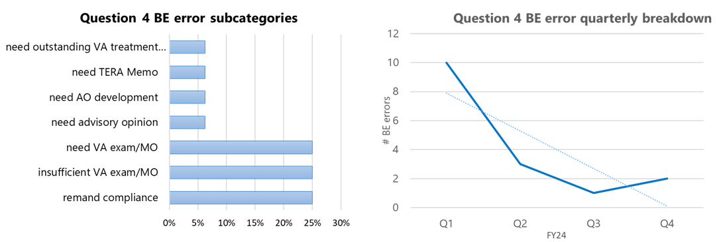

Remediation Recommendations

* Given overall improvement, no active remediation at this time.
* Continue to monitor.

Bar chart representing Question 7 BE errors by associated error reference.  Three BE errors involved improper application of 38 CFR §3.2500. Two BE errors were identified relating to liberalizing legislation 38 CFR §3.114.
Two BE errors involved an incorrect effective date based on increase factually shown and failure to properly apply 38 CFR §3.400(o)(2).  One BE error involved a missed Intent to File to correctly assign the effective date.  One BE error failed to amend the codesheet to reflect the effective date discussed in the narrative, which was proper.  One BE error did not identify the CUE in the assigned effective date for an initial grant of service connection.  One BE error corrected an effective date without providing due process resulting in the creation of an overpayment. Additionally, a line graph demonstrates the Question 7 BE error quarterly breakdown.  Quarter 1 with three BE errors, quarter 2 with one BE error, quarter 3 with two BE errors, and quarter 4 with five BE errors.  Overall there is a general trend upward throughout fiscal year 24.

Remediation Recommendation:

* DROCs to provide effective date training. Emphasis to demonstrate application of 38 CFR §3.400(o)(2), §3.2500(h)(1), §3.2500(h)(2), and §3.114.

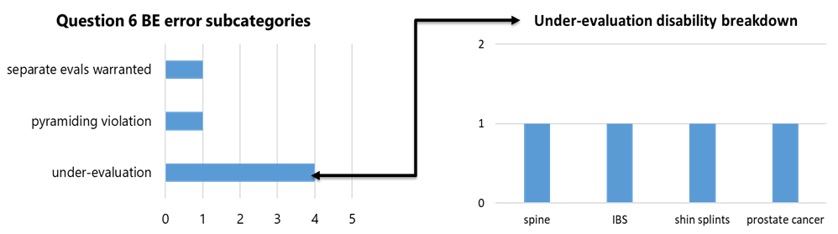

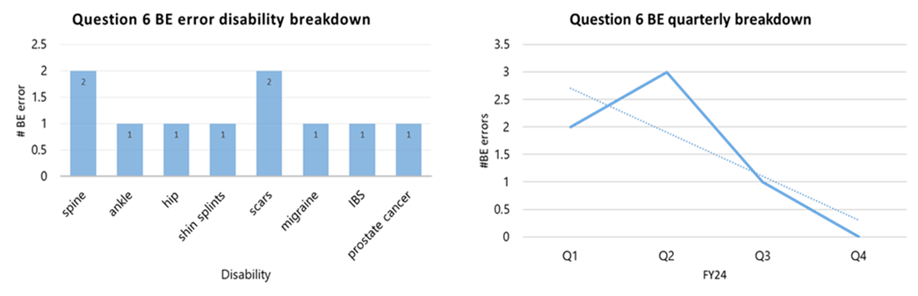

Remediation Recommendation:

* Given variety of error subcategories, variety of medical conditions, and overall decrease, no active remediation at this time.
* Continue to monitor.

Question 1, “Were all claimed issues addressed and decided?”:

* Five BE errors for EP 070 prematurely cleared prior to recertification to Board
* One BE error for request to change lanes without a proper withdrawal

Remediation Recommendation:

* Reminder to employees that in the instance of a legacy appeal remand, the EP 070 must remain pending for control when reviewing additional evidence and development actions for the remand (to include the 30 days following issuance of an SSOC). EP 070 is only cleared AFTER the appeal is dispatched in VACOLS and the Remanded Appeal Returned to BVA letter has been sent. Refer to the specific processing sequence in M21-5, 7.G.4.f-g.