**TABLE OF CONTENTS**

Updates to VA Form 20-0998 1

Automated VA Form 20-0999, Higher Level Review Return 4

Quality Trend Analysis: FY24 Q3 5

Definition of an Issue Under AMA 7

Important Reminder 8

Questions and Answers 8

## Updates to VA Form 20-0998

**Target Audience:** Decision Review Operations Center (DROC) Management and Quality Review Teams (QRT), Decision Review Officers (DRO), Rating Veterans Service Representatives (RVSR), Veterans Service Representatives (VSR), and Claims Assistants (CA)

**Presenter:** Shireen Lackey, Senior Management and Program Analyst, OAR

**References:**

* M21-1, VI.i.1.B.1.b., *Decision Notice Requirements*
* M21-1, VI.i.1.B.1.j., *Providing Review Rights in a Decision Notice*
* M21-1, X.v.1.D.1., *General Information on Hearings*
* M21-1, X.v.1.D.2., *General Conduct for Hearings*
* M21-1, X.v.1.D.3., *Scheduling and Preparing for the Hearing*
* M21-1, X.v.1.D.4., *Conducting the Hearing*
* M21-1, X.v.1.D.5., *Additional Issues Raised During the Hearing*
* M21-1, X.v.1.D.6., *Transcribing the Hearing*
* M21-1, X.v.1.D.7., *Reviewing Evidence Presented at the Hearing*

An updated version of VA Form 20-0998, Your Right to Seek Review of Our Decision is now available.

The form is dated April 2024 and supersedes the version dated September 2022.

* Released on August 25, 2024, in VBMS.
* Released on VA forms websites on August 26, 2024.

VA Form 20-0998 Changes:

* Updated VA Seal
* Under the Supplemental Claim column:
  + Added: “You are entitled to a hearing at any time in the supplemental claims process.”
* Hyperlinked each form number to its respective form
* On page 2, added a sub-bullet under the first paragraph with the following:
  + If you wish to have a hearing during the supplemental claim process, you can contact us online through Ask VA: <https://ask.va.gov/> or call us toll-free at 1-800-827-100 (TTY:711).”
* Edited the contested claim paragraph with the addition of the words:

“or claims for life insurance”

The screenshot below of the first page of the form shows the inclusion of the official VA seal. In the supplemental claim column, information regarding entitlement to a hearing has been added.

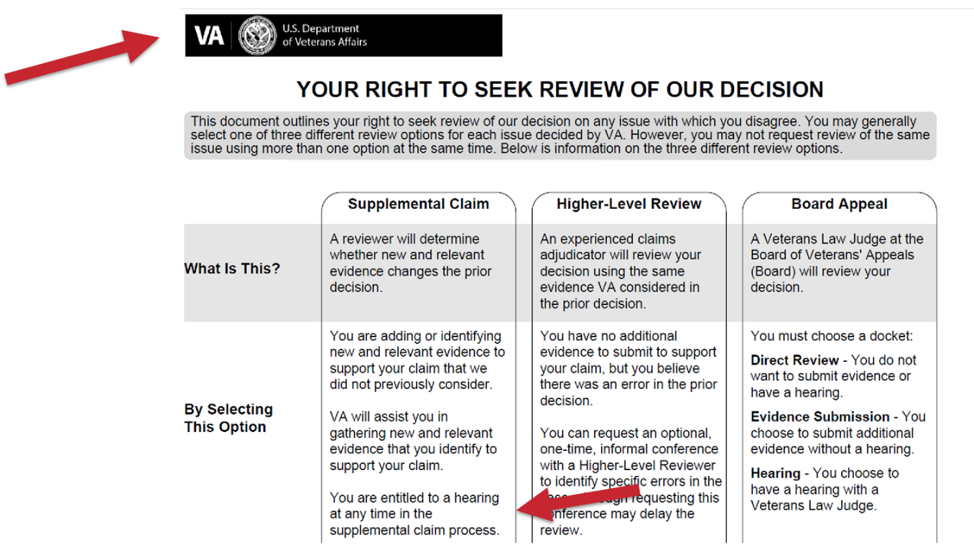

This screenshot shows that hyperlinks have been added to the form numbers. The bottom left corner of the form identifies the current April 2024 version of the form. The new form supersedes the previous version of the form dated September 2022.

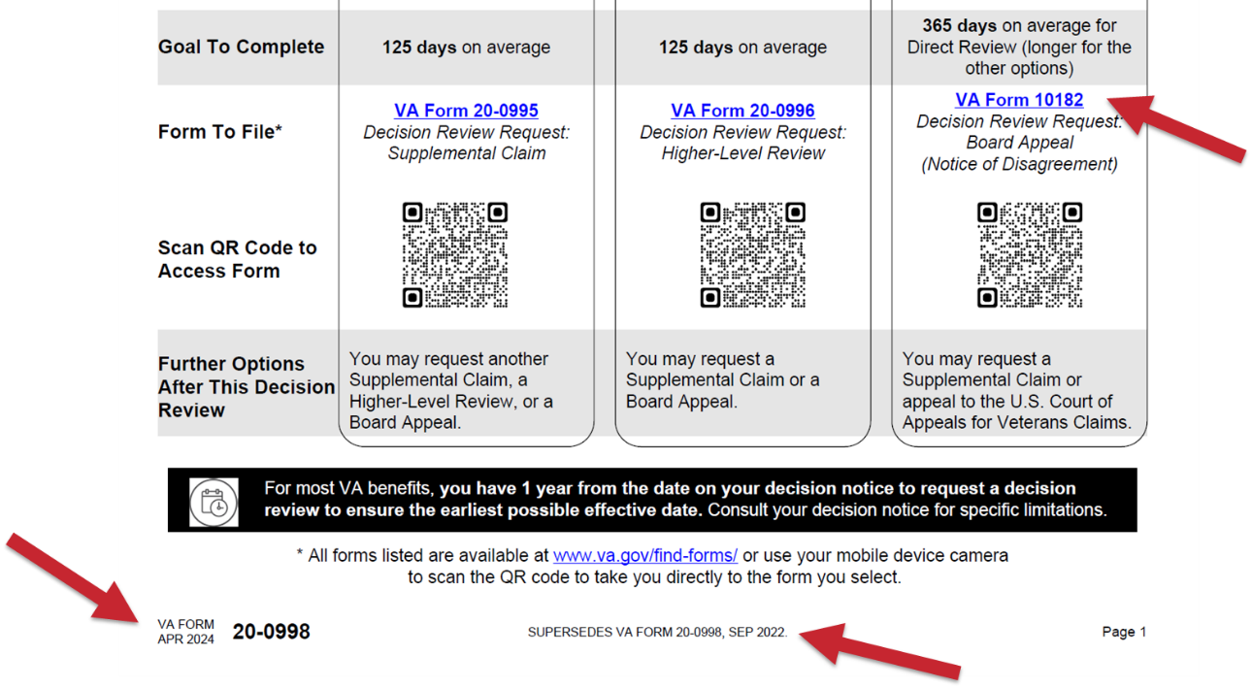

This last screenshot shows the second page of the form. The form now provides information regarding how to request a hearing. The contested claims section was updated to include life insurance claims.

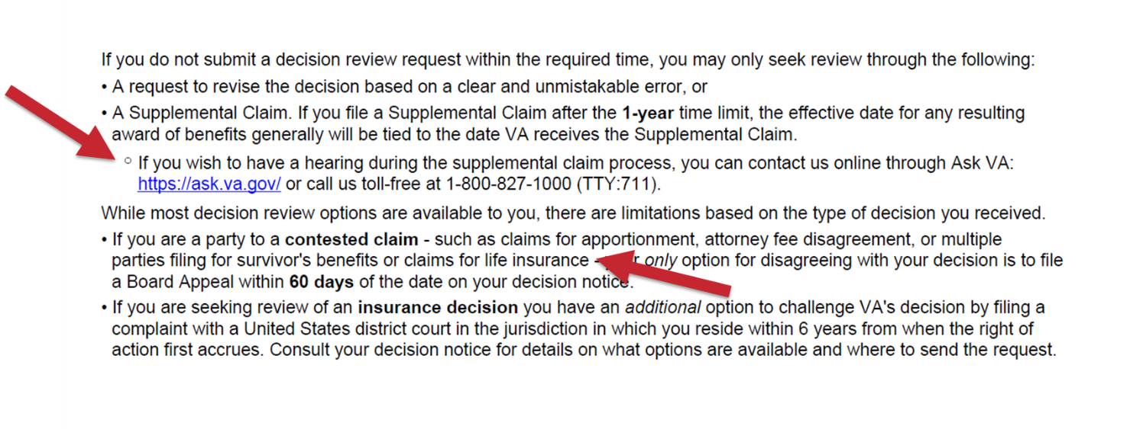If there are additional questions about the VA Form 20-0998, please send them to OAR Program Administration at [OARADMIN.VBAWAS@va.gov](mailto:OARADMIN.VBAWAS@va.gov).

## Automated VA Form 20-0999, Higher Level Review Return

**Target Audience:** Decision Review Operations Center (DROC) Management and Quality Review Teams (QRT), Decision Review Officers (DRO), Rating Veterans Service Representatives (RVSR), Veterans Service Representatives (VSR), and Claims Assistants (CA)

**Presenter:** Autumn Paschke, Senior Management and Program Analyst, OAR

**References:**

* Automated VA Form 20-0999 Job Aid
* Automated VA Form 20-0999 Standard Operating Procedure (SOP)
* [Automated VA Form 20-0999 Platform](https://viccs-prod.ibm-intelligent-automation.com/suite/sites/oar/page/createHLR)

As part of the higher-level review (HLR) process, Decision Review Officers (DRO) determine if issues need to be returned for further development as a:

* Duty to Assist Error (DTA)
* Difference of Opinion (DoO)

DROs use the VA Form 20-0999, Higher-Level Review Return, documenting the development needed on each issue.

OAR is committed to improving user experience during the decision review process and enhancing automation opportunities.

Automation of the VA Form 20-0999 is an initial step for examination automation in the future for HLR returns and overall efficiency.

The automated VA Form 20-0999 is available on a platform outside of VBMS for DROs to complete.

Automated updates to the form include:

* Pre-populated dropdowns
* Pre-populated Veteran or claimant information
* DTA and DoO selection for each contention
* Pre-populated contentions for selection
* Attachment for medical opinion descriptions or additional comments

After a DRO completes the VA Form 20-0999 on the platform it will automatically upload the document to the VBMS eFolder.

* Copies will remain on the platform for future edits or changes that may be needed.
* The platform will not delete or replace prior versions.

The Decision Review Operation Centers (DROCs) will begin utilizing the automated VA Form 20-0999 in FY25-Q1.

* User acceptance testing (UAT) began in April 2024 and DROs and SVSRs from the three DROC locations participated.

Local training will be conducted in FY25-Q1 with training materials/references provided.

If there are additional questions about the VA Form 20-0999 automation, please send them to OAR Program Administration at [OARADMIN.VBAWAS@va.gov](mailto:OARADMIN.VBAWAS@va.gov).

## Quality Trend Analysis: FY24 Q3

**Target Audience:** Decision Review Operations Center (DROC) Management and Quality Review Teams (QRT), Decision Review Officers (DRO), Rating Veterans Service Representatives (RVSR), Veterans Service Representatives (VSR), and Claims Assistants (CA)

**Presenter:** Holly Backes Kozlak, Management and Program Analyst, OAR

Rating Quality

Compensation Rating National Quality Reviews FY24 Q3

* OAR completed 75 reviews
* Benefit Entitlement (BE) accuracy (unweighted) was 94.7%, while the issue-based accuracy was 98.1%

**Compensation Rating National Quality Reviews FY24 Q3**

|  |  |  |
| --- | --- | --- |
| **Error Category** | **Total Errors** | **Total BE Errors** |
| Question 7: Are all effective dates affecting payment correct? | 2 | 2 |
| Question 4: Does the record show VCAA compliant development to obtain all indicated evidence (including a VA exam, if required) prior to deciding the claim? | 1 | 1 |
| Question 6: Was the percentage evaluation assigned correct (including combined evaluation)? | 1 | 1 |
| Question 16: Were Rating Comments correct (end product (EP) under review)? | 3 | 0 |
| Question 9: Was decision document correct | 1 | 0 |
| Question 15: Were comments correct (EP not under review)? | 1 | 0 |
| **TOTAL** | **9** | **4** |

Benefit Entitlement Errors (FYTD)

* 14 BE errors under Question 4
* Six BE errors under Question 6
* Six BE errors under Question 7

Authorization

Compensation Authorization National Quality Reviews FY24 Q3

* OAR completed 30 reviews
* Benefit Entitlement (BE) accuracy was 100%
* Zero non-critical errors identified

Benefit Entitlement Errors (FYTD)

* 90 authorization quality reviews completed
* Zero BE errors
* Four non-critical errors

Pension Rating

Pension Rating National Quality Reviews FY24 Q3

* OAR completed 18 reviews for the Seattle DROC
* Benefit Entitlement (BE) accuracy (unweighted) for the review period was 94.4%, while the issue-based accuracy was 97.7%

**Pension Rating National Quality Reviews FY24 Q3**

|  |  |  |
| --- | --- | --- |
| **Error Category** | **Total Errors** | **Total BE Errors** |
| Question 1: Were all claimed issues addressed and decided? | 1 | 1 |
| **TOTAL** | **1** | **1** |

Benefit Entitlement Errors (FYTD)

* 56 pension rating quality reviews completed
* Seven BE errors

Pension Authorization

Pension Authorization National Quality Reviews FY24 Q3

* OAR completed nine reviews for Seattle DROC Benefit Entitlement (BE) accuracy was 100% with two non-critical errors

**Pension Authorization National Quality Review FY24 Q3**

|  |  |  |
| --- | --- | --- |
| **Error Category** | **Total Errors** | **Total BE Errors** |
| Question 6: Burial issues correct? | 1 | 0 |
| Questions 14: Were all other actions correct? | 1 | 0 |
| **TOTAL** | **2** | **0** |

Benefit Entitlement Errors (FYTD)

* 39 pension authorization reviews completed
* BE accuracy remains at 100%

## Definition of an Issue Under AMA

**Target Audience:** Decision Review Operations Center (DROC) Management and Quality Review Teams (QRT), Decision Review Officers (DRO), Rating Veterans Service Representatives (RVSR), Veterans Service Representatives (VSR), and Claims Assistants (CA)

**Presenter:** Lynn Rowzee, Management and Program Analyst, OAR

**References:**

* 38 U.S.C. § 5104, Decisions and notices of decisions
* 38 U.S.C. § 5104B, Higher-level review by the agency of original jurisdiction
* 38 U.S.C. § 5104C, Options following decision by agency of original jurisdiction
* 38 C.F.R. § 3.151, Claims for disability benefits
* 38 C.F.R. § 3.2500, Review of decisions
* M21-5, 4.4, Withdrawing or Changing Reviews)

In response to inquiries received from the field, OAR is providing clarification that an issue under AMA encompasses all elements of the contention, including effective date and evaluation.

Per 38 C.F.R. § 3.2500(b), concurrent election is prohibited regarding the adjudication of a claim or an issue as defined in § 3.151(c).

38 C.F.R. § 3.151(c)(1) states, “To the extent that a complete claim application encompasses a request for more than one determination of entitlement, each specific entitlement will be adjudicated and is considered a separate issue for purposes of the review options prescribed in § 3.2500. A single decision by an agency of original jurisdiction may adjudicate multiple issues in this respect, whether expressly claimed or determined by VA to be reasonably within the scope of the application as prescribed in § 3.155(d)(2). VA will issue a decision that addresses each such identified issue within a claim. Upon receipt of notice of a decision, a claimant may elect any of the applicable review options prescribed in § 3.2500 for each issue adjudicated.”

Guidance for reviewing mail and placing AMA claims under control is provided in **M21-5, Chapter 4.**

* If concurrent elections for the same issue are received on the same day, contact the claimant and/or authorized representative to clarify their intent
* If concurrent elections for the same issue are received on different days, the one received *first* takes precedence unless a clear request to withdraw is received in writing or electronically in a manner prescribed by the Secretary.
* M21-5,4.4. provides detailed information on requirements and procedures for withdrawing decision reviews and changing review lanes.

## Important Reminder

When conducting higher-level reviews, decisionmakers will not revise the outcome of a decision in a manner that is less advantageous to the claimant based solely on a difference of opinion (DoO), as referenced in 38 C.F.R. 3.2601(j).

Please note: This also applies to returning cases for additional development that may result in an outcome less advantageous to the claimant, based only on a difference of opinion.

However, the higher-level adjudicator may reverse or revise (even if disadvantageous to the claimant) prior decisions on the ground of clear and unmistakable error (CUE) under 38 C.F.R. 3.105(a).

## Questions and Answers

Several questions arose following the [August 2024 OAR Quality Call](https://vbaw.vba.va.gov/OAR/docs/august-2024-quality-call-bulletin-updated.pdf), specifically regarding the topic of ‘Requesting Examinations for Remands When a Specialist is Not Available’. We have detailed those questions below**.**

**Q1:** Is the negative reply from a vendor or VHA sufficient to complete the memo? Or are claims processors required to schedule the exam at another vendor/VHA to exhaust all efforts to have specialist conduct the C&P exam??

**A1:** Exam requests are distributed to vendors based on contractual agreements with VBA. To ensure proper examination workload distribution, use of the ERRA Tool is mandatory per M21-1, IV.i.2.A.1.c. Claims processors must route examinations according to the ERRA results.

If the ERRA-indicated contracting site does not have the specialist indicated within a remand, they should provide adequate notification. If one contract vendor is unable to supply a specialist examiner successfully in this instance, all contract vendors will likely have the same result per M21-1, IV.i.2.A.2.d. The negative indication as well as the reason from the ERRA noted facility is sufficient to complete the [**Examination Specialist Unavailable Memorandum template**](https://vbaw.vba.va.gov/OAR/docs/examination-specialist-unavailable-memorandum.docx).

The Board is aware of such facts and will accept a medical examination from an appropriate examiner when VBA has made reasonable efforts to obtain an exam/opinion from a specialist. In these cases, the examiner who does perform the exam should indicate that they have the appropriate knowledge base and/or skill set to complete the exam or render the requested opinion.

If VHA has capability to perform the examination, this should be noted within ERRA. As always, VA resources will be utilized to the fullest extent possible. The use of contract/vendor resources is authorized whenever a VA examination facility has reached or exceeded maximum capacity. For VHA purposes, the exam type comments within ERRA will describe what DBQs are disabled at any specific location. If these are disabled, the location does not have the personnel to conduct the exam as described. Typically, the ‘Routing Location Comments’ in the ERRA will provide contact information including telephone numbers. If further information is needed from a specific C&P department, utilize the [National C&P point of contact list](https://dvagov.sharepoint.com/sites/VHADMA/National%20C&P%20POC%20List/SitePages/National-C&P-POC-List.aspx).

Additionally, it should be noted that splitting of examination requests between VHA and a vendor for a single claimant is required when such is indicated by the ERRA results per M21-1, IV.i.2.A.2.d.

**Q2:** If the vendor or VHA does not provide a reason why a specialist is not available within their network to complete the C&P exam, are claims processors required to contact the vendor for the reason?

**A2:** A complete memorandum includes:

* date(s) of request(s) for the examination specialist,
* response from VHA or a contract examiner confirming an examination specialist is not available to conduct the C&P examination for VA purposes, and
* justification from VHA or a contract examiner for why an examination specialist is not available to conduct the C&P examination for VA purposes (for example, rural areas or claimants with a foreign address).

The rationale as to the staffing of any facility should be provided in the response of provider unavailability. Use the information submitted by the facility in conjunction with their obligations in this matter. Contact the facility when inadequate or no information is provided that would allow for sufficient completion of the memo.