**TABLE OF CONTENTS**

*BVA Decision* Corporate Flash 1

Updates to VA Form 20-0996 2

Quality Trend Analysis: FY24 Q2 5

## *BVA Decision* Corporate Flash

**Target Audience:** Decision Review Operations Center (DROC) Management and Quality Review Teams (QRT), Veterans Service Representatives (VSR), Claims Assistants (CAs)

**Presenter:** Drew Martin, Management and Program Analyst, OAR

**References:**

* M21-4, Appendix E.1.b., *Index of Corporate Flashes*
* M21-4, 6.A.d., *Systems Compliance Errors – Corporate Flashes*
* Questions & Answers - 2021 Office of Administrative Review (OAR) Decision Review Operations Center (DROC) Virtual Quality Review Team (QRT) Symposium

Under Task 11 of the VSR Checklist, failure to correctly enter the appropriate corporate flashes is a critical error.

During the 2021 DROC Virtual QRT Symposium, OAR provided guidance that the BVA Decision corporate flash was no longer required and QRS should not cite errors for applying or not applying the flash.

However, the BVA Decision flash continues to be listed under the Index of Corporate Flashes (M21-4 Appendix E), as well as the VSR checklist (M21-4 6.A.d).

OAR issued the following interim guidance on May 30, 2024:

* Claims processors should not add the BVA Decision flash to the Veteran’s VBMS profile.
* Claims processors should remove the BVA Decision flash if identified during review of Veteran’s VBMS profile.
* QRSs should not cite critical errors under Task 11 of the VSR Checklist or correctable comments under Task 12 for failure to apply or remove the BVA Decision flash.
* Updates to the M21-4 are forthcoming.
* The flash is scheduled to be deactivated in the July 2024 coordinated install.

## Updates to VA Form 20-0996

**Target Audience:** Decision Review Operations Center (DROC) Management and Quality Review Teams (QRT), Decision Review Officers (DRO), Rating Veterans Service Representatives (RVSR), Claims Assistants (CAs)

**Presenter:** Shireen Lackey, Senior Management and Program Analyst, OAR

VA Form 20-0996: Decision Review Request, Higher-Level Review became available on April 29, 2024. Updates to the form include:

* Minor changes to instructions and form
* Flow, wording, and formatting
* Replaced the old VA logo with the official VA seal
* Changes to content and style to align with plain language guidance
* Revised informal conference instructions to make it easier for claimants to understand
* Added information to instructions about VA’s military sexual trauma coordinator services

The screenshot below (first page of the instructions) demonstrates the use of the VA seal rather than the previous VA logo. There are also examples of the plain language wording and formatting, such as the change to shorter sentences and phrases with bulleted lists.

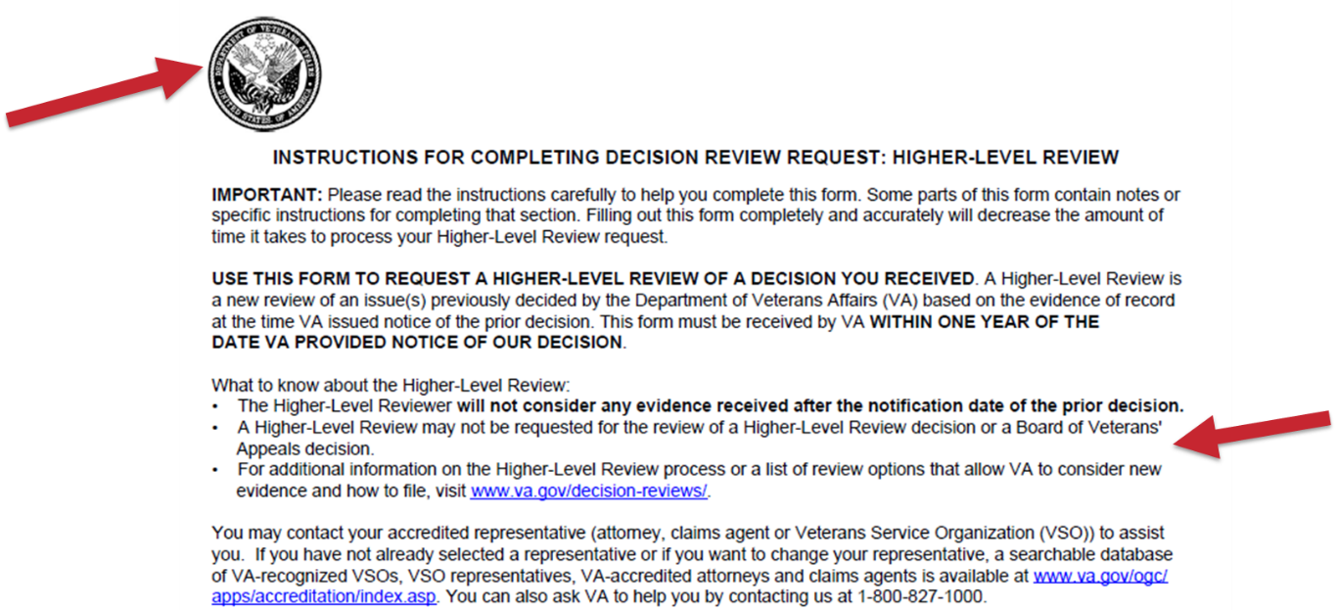

As shown below, the form was updated with new language regarding VA’s military sexual trauma coordinator services, which was added at the end of the general instructions, on page 1.

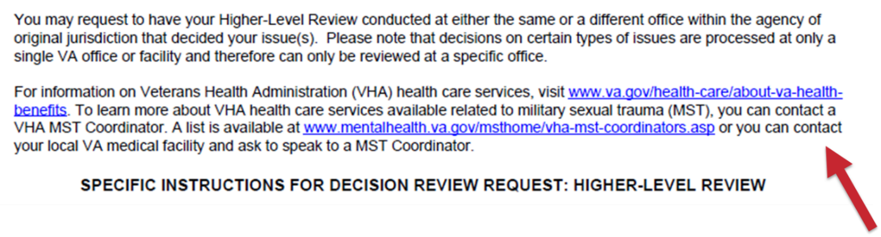

Specific changes to fillable sections of the VA Form 20-0996 include:

* Removal of the requirement to sign in ink
* Updated terminology regarding homelessness
* Edits to section IV – optional informal conference, to clarify the instructions and manner in which the informal conference may be conducted
* Revised wording for informal conference contact preferences
* Simplification of the issues portion of the form and removal of examples from specific issues column

As captured in the screenshot on the page below, the requirement to sign the form in ink was removed. The previous version of the form stated to “print the information requested in **ink**, neatly and legibly” whereas the new form only states to “print the information neatly and legibly”.

The terminology for homeless claimants has also changed. The verbiage was changed from “I am homeless or at risk of homelessness” to “I am experiencing homelessness or at risk of homelessness.” This aligns wording with the Board of Veterans’ Appeals, VA Form 10182.

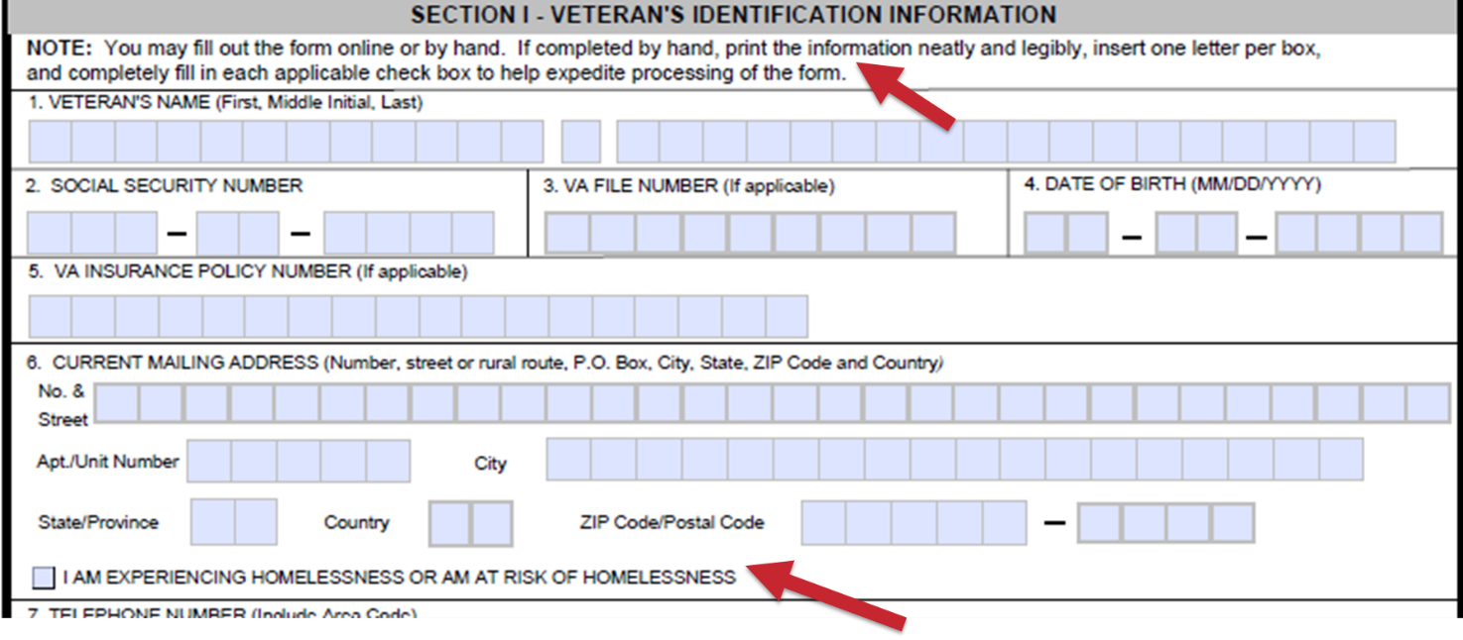

As demonstrated below, there have been changes to the informal conference section, including the instructions for how the conferences can be conducted.

In the preferences section, the timeframes were removed and replaced with an option for morning hours and afternoon hours, based on the time zone in which the requester is located.

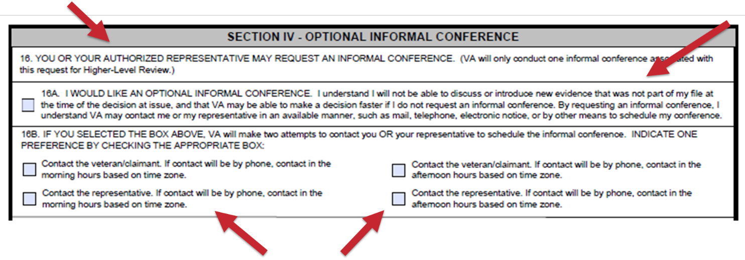

The effective date of the new form is March 31, 2024, and it should be accepted immediately. The new form is identified by the date “MAR 2024” in the bottom left corner, as well as the OMB expiration 03/31/2027, on page 3.

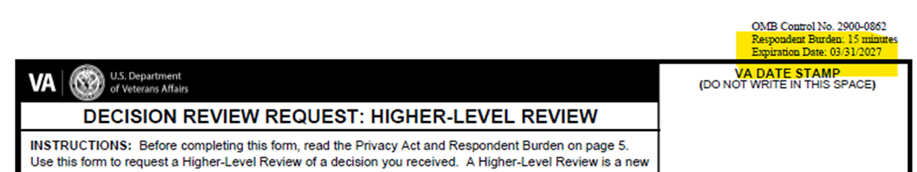

The updated version of the form can be found on [www.va.gov/find-forms](http://www.va.gov/find-forms). Prior versions of VA Form 20-0996, with OMB expiration 04/30/2024 (including the April 2021 and September 2022 versions), should continue to be accepted until March 31, 2025. For more information regarding accepting outdated versions of VA forms, please refer to M21-1 II.i.2.B.4.a.

## Quality Trend Analysis: FY24 Q2

**Target Audience:** Decision Review Operations Center (DROC) Management and Quality Review Teams (QRT), Decision Review Officers (DRO), Rating Veterans Service Representatives (RVSR), Veterans Service Representatives (VSR), and Claims Assistants (CA)

**Presenter:** Holly Backes-Kozlak, Management and Program Analyst, OAR

Compensation Rating National Quality Reviews

* OAR completed 75 reviews during fiscal year FY24 Q2.
* The Rating Benefit Entitlement (BE) accuracy (unweighted) for the review period was 90.7%, while the issue-based accuracy was 95.2%.

**Compensation Rating National Quality Reviews FY24 Q2**

|  |  |  |
| --- | --- | --- |
| **Error Category** | **Total Errors** | **Total BE Errors** |
| Question 6: Was the percentage evaluation assigned correct (including combined evaluation)? | 5 | 3 |
| Question 4: Does the record show VCAA compliant development to obtain all indicated evidence (including a VA exam, if required) prior to deciding the claim? | 3 | 3 |
| Question 2: Were all inferred and/or ancillary issues addressed? | 2 | 2 |
| Question 7: Are all effective dates affecting payment correct? | 1 | 1 |
| Question 12: Was the end product selected for review timely developed? (over-developed) | 1 | 0 |
| Question 15: Were comments correct (EP not under review)? | 1 | 0 |
| Question 16: Were Rating Comments correct (end product (EP) under review)? | 1 | 0 |
| **TOTAL** | **14** | **9** |

* Remand remediation recommendations have been developed and are pending workgroup review for implementation through Internal Controls.
* OAR will continue to monitor the emerging error trend involving Question 6.

Compensation Authorization National Quality Reviews

* OAR completed 30 reviews during fiscal year FY24 Q2.
* The Authorization BE accuracy was 100%.

**Compensation Authorization National Quality Reviews FY24 Q2**

|  |  |  |
| --- | --- | --- |
| **Error Category** | **Total Errors** | **Total BE Errors** |
| Task 11: Were all systems accurately updated? | 3 | 0 |
| **TOTAL** | **3** | **0** |

* Three claims contained a non-critical error for failure to continue the EP at authorization when issues were remanded.
* Each Task 11 non-critical error originated at the Seattle DROC.
* Reminder to authorizers about appeal EP disposition discussed within M21-4, Appendix B, Topic 2, 070

Pension Rating National Quality Review

* OAR completed 18 reviews for the Seattle DROC during fiscal year FY24 Q2.
* The BE accuracy (unweighted) for the review period was 94.4%, while the issue-based accuracy was 97.4%.

**Pension Rating National Reviews FY24 Q2**

|  |  |  |
| --- | --- | --- |
| **Error Category** | **Total Errors** | **Total BE Errors** |
| Question 5: Was the grant or denial of all issues correct? | 1 | 1 |
| **TOTAL** | **1** | **1** |

* OAR will continue to monitor a potential emerging trend originating in Q1 associated with specialized development of the PACT Act.

Pension Authorization National Quality Reviews

* OAR completed 21 reviews for Seattle DROC during fiscal year FY24 Q2.
* The Authorization BE accuracy was 100% with zero non-critical errors.
* OAR will continue to monitor the pension authorization national quality workload to validate high accuracy rates and/or recommend remediation for identified error trends.