**TABLE OF CONTENTS**

Important Concepts 1

Question and Answer – Important Concepts 7

Updates Timeline 7

Troubleshooting Memos to Release 9

Question and Answer – Troubleshooting Memos to Release 15

# Important Concepts

**Target Audience:** AAFCs, AAFC Management, Authorization Quality Review Specialists (AQRS), Quality Review Team Management, Support Service Division (SSD) Personnel, and SSD Management.

**Presenter:** Ambria Davis, Senior Management and Program Analyst, OAR

**References:**

* [M21-5 8.B.2.j, *Handling Cases Involving an Existing Debt Against the United States Government*](https://vaww.vrm.km.va.gov/system/templates/selfservice/va_kanew/help/agent/locale/en-US/portal/554400000001034/content/554400000205497/M21-5-Chapter-8-Section-B-Processing-a-Case-Seeking-Direct-Payment-of-Fees)
* [VAOPGCPREC 12-93,](https://vaww.vrm.km.va.gov/system/templates/selfservice/va_kanew/help/agent/locale/en-US/portal/554400000001034/content/554400000043484/VAOPGCPREC-12-93-Dec-21-1993-Payment-of-Attorney-Fees-from-Past-due-Benefits-when-Veterans-Indebtedness-to-the-US-Exceeds-Total-Amount-of-Past-due-Benefits) Payment of Attorney Fees from Past-due Benefits when Veteran's Indebtedness to the U.S. Exceeds Total Amount of Past-due Benefits
* [M21-5 8.B.6.a, *When to Consider Action for Failure to Make Funds Available for Fees*](https://vaww.vrm.km.va.gov/system/templates/selfservice/va_kanew/help/agent/locale/en-US/portal/554400000001034/content/554400000205497/M21-5-Chapter-8-Section-B-Processing-a-Case-Seeking-Direct-Payment-of-Fees)
* [M21-5 8.B.6.e, *Recovery of Fees Paid by VA in the Absence of a Non-Recurrent Payment to the Claimant Because of Offset/Reduction*](https://vaww.vrm.km.va.gov/system/templates/selfservice/va_kanew/help/agent/locale/en-US/portal/554400000001034/content/554400000205497/M21-5-Chapter-8-Section-B-Processing-a-Case-Seeking-Direct-Payment-of-Fees)
* [eMPWR Job Aids](https://empwr.va.gov/help/)
* [M24-1 Chapter 03 All Programs Part 06 Attorney Fee (NEW PROCEDURES) Section 6.01 (j)](https://vaww.vrm.km.va.gov/system/templates/selfservice/va_kanew/help/agent/locale/en-US/portal/554400000001057/content/554400000204941/M24-1-Chapter-03-All-Programs-Part-06-Attorney-Fee-NEW-PROCEDURES)

***Rosinski* impact – Award Funds and VA Funds**

Outline of the flow of funds for a basic award with no offsets or reductions:

* Award Net Effect - $5,000
* Fee Deduction - 18/31J $1,000
* Fee Sent to Suspense Account/eMPWR accountable balance - $1,000
* Bank Account - $4,000

The court, in [*Rosinski v. Wilkie*](https://vaww.vrm.km.va.gov/system/templates/selfservice/va_kanew/help/agent/locale/en-US/portal/554400000001034/content/554400000164990/Rosinski-v.-Wilkie,-Jan-30,-2020,-32-Vet.App.-264-(2020)), 32 Vet. App. 264 (Fed. Cir. 2020), addressed VA’s obligations to agents/attorneys under [38 U.S.C. 5904(d)](https://www.law.cornell.edu/uscode/text/38/5904) in cases when deciding entitlement to direct payment of fees, but an applicable statutory provision requires reduces or eliminates payment.  The court held that in a case involving military retired pay (MRP), fees must be calculated and directly paid to the agent/attorney based on the pre-reduction amount of the award.  A non-recurring payment to the claimant is not a pre-requisite to payment of fees under a direct pay fee agreement.

Calculate past-due benefits based on the award amount prior to reduction:

* Military retired pay
* Drill pay
* Severance or separation pay
* Benefits payable under 38 U.S.C. 1151 after settlement of a tort claim
* Incarceration adjustments
* Survivor Benefit Plan payments

Calculate past-due benefit by utilizing gross rates.

* Gross rate previously paid (award information screen)
* Gross rate on pending award

The award net effect is impacted by the reductions and offsets entered.

Funds for Release – Award Funds

* Net effect covers fee.
* Funds from the award are used to pay the fee.
* Upon authorization, a portion of the past-due benefits is deducted and sent to the eMPWR accountable balance.

Funds for Release – VA Funds

* Net Effect $0.00 (or any amount less than the fee)
* VA funds are used to pay the agent/attorney fee.
  + Prior to December 22, 2023, finance utilized the 06A transaction to pay fees that were not covered by the net effect.
  + On/after December 22, 2023, the finance transaction 06J6 runs in the background to bring funds to the eMPWR accountable balance to cover the fee that is not covered by the net effect.
* If the withheld award funds are subsequently released, then VA funds used to pay fee must be recouped.

**Audit Error Worksheet (AEW)**

An AEW is a document containing data regarding a Veteran’s military retired pay (MRP) and entitlement to Concurrent Retirement Disability Pay (CRDP) or Combat-Related Special Compensation (CRSC). The document instructs VA to release withheld benefits.

If VA funds were used or will be used to pay a fee, then a collectible receivable (04E transaction) must be processed while processing all fee related AEW awards. The 04E must be processed regardless of the AEW being generated before or after the payment of fees.

BEST AAFCs will determine the amount of the collectible receivable (04E) by analyzing the net effect of the award that granted and withheld benefits (ex. award processing a higher-level review grant with military retired pay withholdings) and the fee deduction. The collectible receivable established (04E) will send the funds directly to appropriations (VA funds). See the chart below for examples.

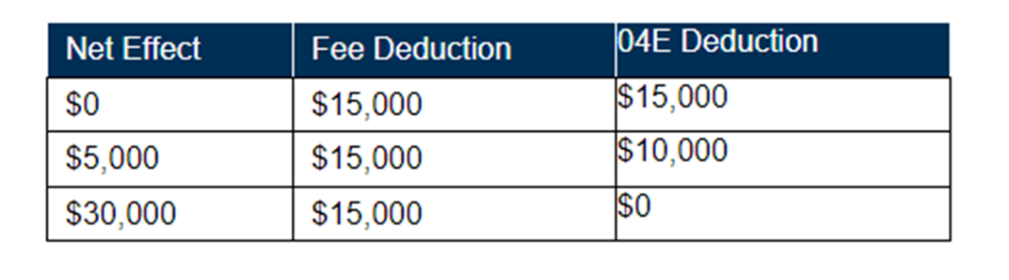

**Transactions**

**06J1**

* Funds were made available from the VBMS-A award net effect or the automatic 06J6 transaction.
* Fee deduction established by AAFC input into VBMS-A or 18/31J finance action.
* Used to pay the agent/attorney or can be used to return funds to the claimant.

**06J5 (VA assessment now included in 06J1)**

* Formerly 06J3 standalone transaction but now within 06J1.
* Funds were made available from the VBMS-A award net effect or the automatic 06J6 transaction.
* Fee deduction established by AAFC input into VBMS-A or 18/31J finance action.
* Used to send the assessment fee that VA collects for processing fees to the appropriate fund.

**06J3**

* Used to send funds to appropriations.

**06J6**

* Automatic transaction
* Funds pulled from appropriations after award authorization (overnight processing) and deposited into the accountable balance.
* Funds did not come from the VBMS-A award net effect.

**06A**

* Manual transaction
* Funds pulled from appropriations at the time of payment processing.
* Funds did not come from the VBMS-A award net effect.
* Used to pay the agent/attorney including the assessment fee.

**06J7**

* Formerly 06B
* Creates a debt on the claimant and simultaneously pays the fee.

**04E**

* Creates a debt.
* Establishes a collectible receivable.

**04E (AEW processing)**

* Creates a debt.
* Establishes a collectible receivable.
* Award must be authorized within 48 hours.
* Sends fund to appropriations NOT the eMPWR accountable balance.

**Handling Cases Involving an Existing Debt to the United States Government**

In VAOPGCPREC 12-93 Payment of Attorney Fees from Past-due Benefits when Veteran's Indebtedness to the U.S. Exceeds Total Amount of Past-due Benefits, the Office of General Counsel concluded that the **direct payment** of fees under section 38 U.S.C. § 5904(d) would be based on the amount available after the indebtedness was satisfied.

AAFCs will need to review the award information screen to determine if there is an existing debt against the United States Government. The award information screen can be located within VBMS and Share. Any existing debt will be found in the receivables field.

Please note that the *Rosinski* holding does not impact these cases.

Fee Cases Involving Existing Debt Procedures

* Fee entitlement is calculated based on gross rates available on the draft award and the award information screen.
* The existence of the debt impacts the **direct payment** of fees by VBA to the agent/attorney.
* AAFCs should still enter the entire fee entitlement into VBMS-A.
* Do not use VA Funds (06A)
  + 06J6 will not trigger

Please review the March 2024 National AAFC Call slides for examples of the notification letter.

The Receivables Balance (Existing Debt) field on the Agent/Attorney Fee Calculator serves as a reminder. That field is not factored into the calculations. The AAFC must correctly evaluate the case to determine the amount that will be available for fees and send the appropriate decision notice.

**VBMS-A Fee Calculator Initiative**

If the VBMS-A attorney fee amount calculated by the system does not match your manual calculator (by more than one cent), DROC AAFCs must follow station guidance to notify the individuals listed below.

* DC DROC
  + Jonathan Thoits
  + Joleen McKinney
  + Ginger Amundson
* St. Petersburg DROC
  + Christina Opperman
  + Lauren Haught
  + Tracy Plante
* Seattle DROC
  + Sandra Lindley
  + Steven Roach
  + Katrina Vanderpoel

For all other divisions, if the VBMS-A attorney fee amount calculated by the system does not match your manual calculator (by more than one cent), please complete the following steps:

1. Re-review all award lines and corresponding amount to verify accuracy of the manual calculator.
2. Enter an IT ticket documenting the issue.
3. Email the [AFC box](mailto:VAVBAWAS/CO/AFC%20%3cAFC.VBACO@va.gov%3e):
   1. Use subject line of “VBMS-A Calculator Ticket”
   2. Include the file number and IT ticket number
   3. Screenshot of VBMS-A Agent/Attorney Fee tab
   4. Copy of the manual Agent/Attorney Fee Calculator
4. Continue the case in pending authorization status until OAR review and coordination with system developers.
5. After OAR review is complete, then utilize the override functionality on the “Agent/Attorney Fee” tab in VBMS-A to manually edit the Retroactive Amount for Fees, the Agent/Attorney Fee (includes the assessment fee), and the Assessment Fee Amount matching the manual calculator.

**VBMS-A Calculator Initiative Reminders:**

* Control Date Override
* Excel calculator must include EVERY applicable line from the award information screen and the draft award.
  + Calculating and Deducting Agent and Attorney Fees (TMS 4635201)
* Do not override VBMS-A for a one-cent difference
  + February 2024 National AAFC Call
* Through date
  + VBMS-A = the date of the decision
  + Excel calculator = the next day

Only converted records from the Benefits Delivery Network (BDN) will have the control date override field.

If the award must be generated from a date earlier than the control date, then the user must change the date on both the record decision screen in the “Only Generate New Award Lines From” field and within the “Control Date Override” box on the Agent/Attorney Fee Tab.

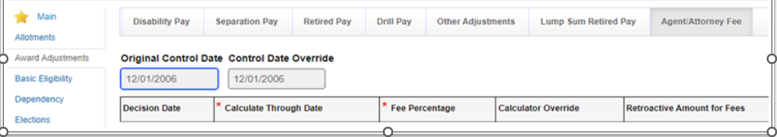

For example, Rating Decision January 5, 2022, granted entitlement to an earlier effective date for cervical spine degenerative disc disease and cervical spine degenerative joint disease effective July 11, 2006. The Veteran has been service connected since 1992. The control date is December 1, 2006. The user must change the control date to August 1, 2006. All relevant decision tabs (ex. dependents) must be backfilled to August 1, 2006. If the user does not update the control date, VBMS-A will not implement any payment changes from August 1, 2006, to December 1, 2006.

The “Calculate Through Date” in VBMS-A is the date of the decision that benefits are being calculated through, it is not the following day. For example, the user will enter March 14, 2024, if fees are due based on rating decision dated March 14, 2024.

The last line in the effective date column entered in the manual Excel Agent/Attorney fee calculator is the day following the decision. The “Through” date column is automatically generated and will reflect the decision date. Please refer to the instructions tab on the calculator.

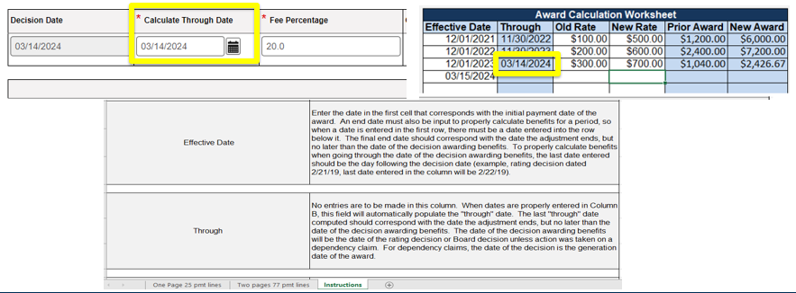

# Question and Answer – Important Concepts

**1. Question - The Agent/Attorney Fee Calculator will not deduct any existing debt. AAFC must manually calculate if funds are available to satisfy the direct payment of fee entitlement. Also, if the debt is for another business line, it will not deduct from the C&P Award.**

Answer – Correct, the "Receivables (Existing Debt)" field on the Agent/Attorney Fee Calculator will not factor into the calculations. The field is present as a reminder for each AAFC to determine if there is a current debt. The AAFC will then need to determine the amount, if any, will be available for the direct payment of fees to send the correct fee decision notice outlined in M21-5 8.B.9.a Decision Notice – Fee Cases Involving Debts to the United States Government.

The debt will be offset when the retroactive payment is for the same period as the existing debt and there is a factual relationship between the circumstances resulting in the current retroactive award and the circumstances surrounding creation of the debt. When the same period and factual relationship conditions are met, the finance system will recoup the full amount of the debt from the retroactive payment, regardless of any repayment plan in place. If the 30B debt overlaps dates and has a factual relationship with the retroactive payment that is being authorized, the 30B debt will offset the retroactive payment.

**2. Question - For us AAFC end users, what is the difference in processing an 06A (or whatever we are calling it today) that was processed before and after 12/22/23?**

Answer - The AAFC must be aware of the functionality in place at the time of award authorization in order to correctly provide payment instructions to finance. If the award was authorized prior to December 22, 2023, and the net effect is less than the fee, then the AAFC will instruct finance to utilize the 06A to issue payment by selecting the "No fee withheld" or "Partial fee withheld" sections of the fee release memorandum. The 06A transaction issued VA funds to the agent/attorneys directly without first depositing the funds into the eMPWR accountable balance. The previous version of the Agent/Attorney Fee Calculator provided release transaction instructions for the AAFC.

If the award was authorized on or after to December 22, 2023, and the net effect is less than the fee, then the AAFC will instruct finance to utilize the 06J1 transaction to issue payment by selecting the "Complete fee withheld" section of the fee release memorandum. The automated 06J6 *Rosinski* transaction went into production on December 22, 2023, and will make VA Funds available for fee payments by automatically depositing those funds into the eMPWR accountable balance.

# Updates Timeline

**Target Audience:** AAFCs, AAFC Management, Authorization Quality Review Specialists (AQRS), Quality Review Team Management, Support Service Division (SSD) Personnel, and SSD Management.

**Presenter:** Aaron Kittel, Lead Financial Systems Analyst, OFM

**Important Dates:**

* January 30, 2020
  + *Rosinski v. Wilkie*
* July 10, 2022 (July 25, 2022)
  + VBMS-A fee deduction
  + eMPWR (06J series transactions)
* April 23, 2023
  + eMPWR Cumulative Balance Enhancement
  + End of Month Processing Update
  + VBMS-A Fee Calculator
* April 26, 2023
  + Proposal of Incompetency Procedures
* May 25, 2023
  + VBMS-A Control Date Override
* October 19, 2023
  + 06J7 replaces 06B
* September 24, 2023
  + VBMS-A Summary of the Case Fee Decision Notice
* December 17, 2023
  + Accrued fee deduction within VBMS-A
* December 22, 2023
  + 06J6 Automated *Rosinski v. Wilkie*
  + Processing fee cases with an existing debt to the United States Government
* January 18, 2023
  + 06J5 (within 06J1) replace 06J3
* March 17, 2024
  + VBMS-A Calculator Update

**Fee Processing Updates Timeline**

The section below outlines the system changes based on the date the VBMS-A award was authorized.

**Prior to *Rosinski* (January 30, 2020)**

* Cash payment to claimant required.
* Fees sent from award net effect to the station’s suspense account (Fund 6279).
* The net effect of the award covered the fee.
* Fees paid from the suspense account.

***Rosinski* to July 10, 2022 (*VBMS-A July 25, 2022)**

* Cash payment to claimant not required.
* Fees sent from award net effect to the station’s suspense account.
* If the net effect did not cover the fee, then the AAFC instructed SSD to process upfront 06A and funds were sent to the suspense account.
* Fees paid from the suspense account.

**July 11, 2022, to December 22, 2023**

* Cash payment to claimant not required.
* Fees send from award net effect to eMPWR. VBMS-A processes most fee deductions instead of SSD.
* If the net effect did not cover the fee, then SSD processed 06A from eMPWR at the time of release.
* Fees paid from eMPWR.

**December 22, 20223, to present**

* Cash payment to claimant not required.
* Fees send from award net effect to eMPWR. VBMS-A processes most fee deductions instead of SSD.
* If the net effect did not cover the fee, then the 06J6 transaction runs automatically after award authorization and deposits funds into the eMPWR accountable balance.
* Fees paid from eMPWR.

**Accrued Processing Update March 2024**

Functionality to process fee deductions for accrued awards within VBMS-A was released on December 17, 2023. The Office of Administrative Review (OAR) is now aware of VBMS-A fee deduction failures for subsequent accrued awards.

There are no reports of initial accrued award failures. Users may continue to utilize VBMS-A to input a fee deduction for the first accrued award.

Please, **do not** utilize VBMS-A to enter a fee deduction for **subsequent accrued awards**. Additionally, users should not send finance a request to process the fee deduction manually (18/31J).

To process fee payments for subsequent accrued awards, please follow the steps listed below:

* Only enter 80% due to the claimant into VBMS-A.
* Generate and authorize the award.
* After the 65-day appeal period, pay the agent/attorney fee 20% with an 06A transaction.

Alternatively, stations previously utilizing the Agent Cashier method may resume this process.

# Troubleshooting Memos to Release

**Target Audience:** AAFCs, AAFC Management, Authorization Quality Review Specialists (AQRS), Quality Review Team Management, Support Service Division (SSD) Personnel, and SSD Management.

**Presenter:** Ambria Davis, Senior Management and Program Analyst, OAR

**Payments to Incorrect Firms/Agents and Attorneys**

There have been a number of reports of the AAFC listing the incorrect agent/attorney or address on the release memorandum as well SSD personnel sending payment to the incorrect account.

Please review the following reminders to help ensure accuracy in fee payment processing:

* Utilize OGC website to determine the address.
* Ensure release memo is updated for each fee case displaying the accurate agent or attorney and current address.
* Do not include the name of the law firm listed on the VA Form 21-22a unless it is also on the OGC website.
* Finance must utilize the Attorney Fee Vendor SharePoint site to verify correct payment information.

**Verify Correct Agent/Attorney**

Some agents/attorneys may have similar names. Please ensure the appropriate code and representative are selected in VBMS. Carefully review the OGC accreditation website when processing appointments.

* Two attorneys named Robert A. Friedman are accredited to represent claimants
  + POA Code 189: Seattle, WA
  + POA Code J99: New York, NY
* Two attorneys named Alison Brown
  + POA Code F94: Alison Marie Brown
  + POA Code HQN: Alison K. Brown
* Two attorneys named Sara(h) Gross
  + **POA Code IGE: Sarah J Gross**
  + **POA Code 9UA: Sara E Gross**
* One agent and one attorney named Mark Dunham:
  + POA Code HWN: Mark Anthony Dunham Jr. (attorney)
  + POA Code A3S: Mark A Dunham Sr. (agent)
* Name changes occur.
  + Cheryl R. Carter (agent), formerly Cheryl R. King
  + POA code remains 6QV

Issuing notice to correct POA is vital.

**Poll 1 Question**

Scenario: The award was authorized on December 28, 2023. Net effect as of award generation (the amount after retired pay withholdings are entered) was $2,562.19. The fee is determined to be $4,762.02. After expiration of the appeal period, the AAFC reviewed the file for release.

The AAFC submits the memo to release shown below.

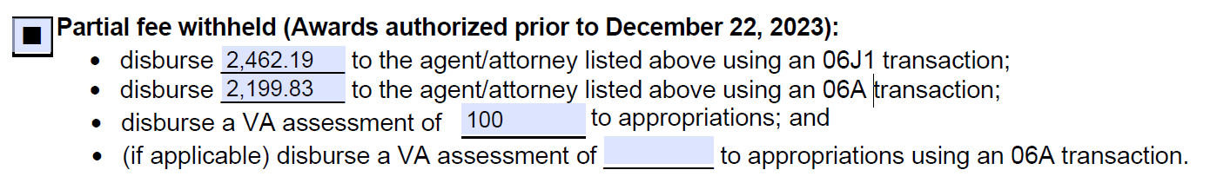

SSD reviews the memo and contacts the AAFC stating all the funds are available and they should review the memo. They suggest using the “Complete fee withheld section” of the memo shown below.

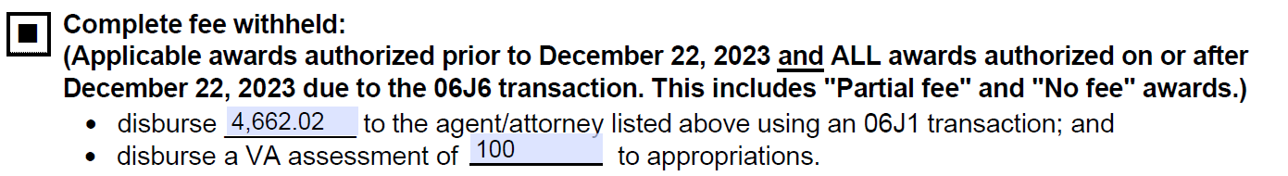

Which memo is correct?

1. AAFC
2. SSD

**Poll 1 Answer**

Answer: B

SSD is correct. The award was authorized on December 28, 2023, after implementation of the 06J6 Automated Rosinski transfer. Therefore, VA funds were deposited into the eMPWR accountable balance after the award was authorized.

OAR updated the Agent/Attorney Fee Calculator on December 22, 2023, to remove the bottom portion with the release transactions. This is no longer needed due to the 06J6 transaction.

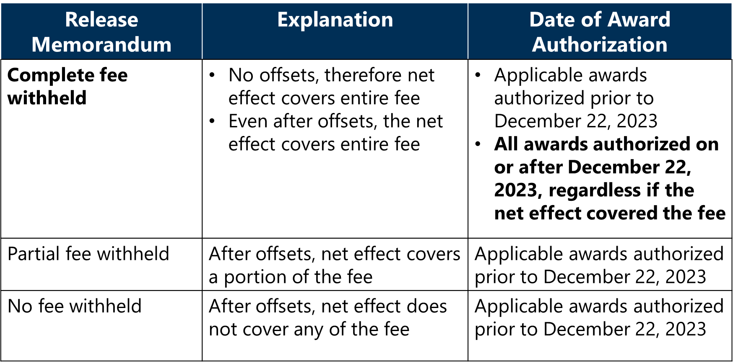

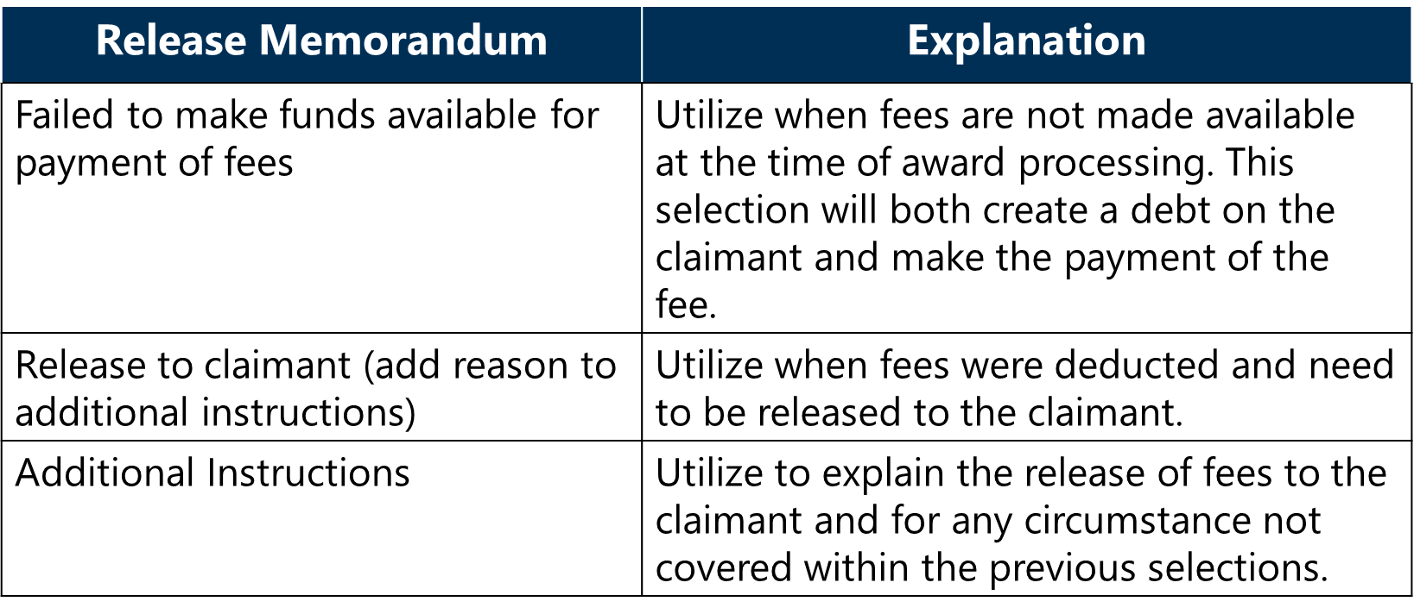

**Poll 2 Question**

I don't see an accountable balance in the amount that's on the memo. The amount is more. Should I go ahead and release the funds anyway?

1. AAFC – Release what the AAFC puts on the release memo.
2. SSD – Return the memo for clarification.

**Poll 2 Answer**

Answer: B

SSD – Return the memo for clarification.

Do not release the funds per the memo if they do not align with what is in the eMPWR-VA accountable balance. Contact the AAFC for explanation. The AAFC should detail discrepancies in the “additional information” section of the release memo.

**eMPWR Cumulative Balance Enhancement**

* Separate award offset balances established for every award with attorney fee deduction.
* Award offset balance properly records to processing station.

**Poll 3 Question**

Scenario: I have received several atty fee releases where the AAFCs are not withholding the assessment fee from the Veteran's award. Should we process the atty fees without the assessment fees? Are the assessment fees no longer needed? For example, I received a release memo for $3,900 to the attorney and $100 for the assessment fee. However, I only have $3,900.

AAFC Response: The AAFC informed SSD that the assessment fee was entered into the “Assessment Fee Amount” field, and they must have missed it when reviewing their system. The AAFC informs them that the total fee amount was $4,000. They entered $3,900 in the “Agent/Attorney Fee” field and $100.00 in the “Assessment Fee Amount” field.

Did the AAFC complete the override correctly?

1. Yes
2. No

**Poll 3 Answer**

Answer: B

No, the AAFC did not complete the override correctly.

The Agent/Attorney Fee field must include the VA assessment amount. It is the only field communicated to eMPWR. This field represents the FULL deduction from the award.

The Attorney Fee Release Memo should include a VA assessment for each rating decision resulting in a payment release. If you see a memo without an assessment, finance can return the memo to the AAFC for clarification to determine if no assessment is required. If the VA assessment has already been applied to a prior payment disbursement on the same rating, the AAFC can let finance know when the memo is returned or include notation of this at the bottom of the Attorney Fee Release Memo.

If the assessment was warranted and the AAFC completed the override incorrectly, the AAFC must issue due process to collect the $100.00 assessment fee.

**Poll 4 Question**

Scenario: Mr. John was granted VA benefits during a higher-level review of his claim. The AAFC determined fees were due in the amount of $50,000 but separation pay withholdings reduced the net effect to $0.00. The award was authorized on December 1, 2023. The AAFC sent a release memorandum for finance to pay the fees using an 06A. Separation pay withholdings are still reflected in the system.

Question: SSD received a release memo, but the accountable balance shows $0.00. This has happened a few times with this AAFC. Should I release fees via an 06J7?

A: The AAFC is correct. SSD should release payment via 06A.

B: SSD is correct. If there are no funds available, SSD must create a debt while paying the fee using the 06J7.

**Poll 4 Answer**

Answer: A

The AAFC is correct. SSD should release payment via 06A.

However, finance should notify AAFC that award did not produce an award offset balance. The AAFC should verify that the correct transaction was selected.

**System Failure**

If attorney fees are payable for this period and funds were inadvertently released, AAFC must notify claimant of failure to make funds available for the payment of fees and begin due process.

Only after due process period has expired (65 days) may finance process a 06J7 transaction which will immediately establish a debt against the claimant. This action cannot be done by finance without due process debt proceedings.

**Recovery of Fees Paid by VA**

My award net effect was $0.00. Should I create a debt to pay fees?

* If the funds for that award are still withheld in the VBMS-A system, a debt cannot be created to recoup the agent/attorney fee
  + For example, separation pay is withheld and is never released. The agent/attorney will be paid from VA funds and a debt should not be created.
* If a future award releases the withheld benefits, then the AAFC must instruct finance to recoup the fee amount previously paid out of VA funds when processing that award (ex. Audit Error Worksheet).

**Current Month Processing**

* Retroactive Amount for Fees
  + Past-due payments accrued during the period from the effective date of the award through the date of the decision awarding benefits (38 CFR 14.636)
* If part of the “retroactive” award is for a “current” period, the portion that is “current” **will not be offset systematically.**
  + Example: Rating Decision dated November 16, 2023, grants increase in benefits effective October 25, 2023. The payment effective date is November 1, 2023. The award is processed on November 18, 2023. No retroactive payment would generate.

**Current Month Processing Procedures**

* 06J6 transaction will automatically bring funds to the accountable balance.
* However, due process is still required to create a debt on the Veteran’s award. After expiration of the appeal period, a debt should be created.
* Please follow the instructions at M21-5.8.B.6.d for {the entire fee deduction amount OR only that portion not already withheld}.
* Utilize the 06J1 to release funds made available by the automatic 06J6 transaction.
* Utilize the 04E to create the debt. Do not utilize the 06J7 because it will bring a second set of funds to the eMPWR accountable balance.

[M24-1 Chapter 03 All Programs Part 06 Attorney Fee (NEW PROCEDURES) (va.gov)](https://gcc02.safelinks.protection.outlook.com/?url=https%3A%2F%2Fvaww.vrm.km.va.gov%2Fsystem%2Ftemplates%2Fselfservice%2Fva_kanew%2Fhelp%2Fagent%2Flocale%2Fen-US%2Fportal%2F554400000001057%2Fcontent%2F554400000204941%2FM24-1-Chapter-03-All-Programs-Part-06-Attorney-Fee-NEW-PROCEDURES&data=05%7C01%7C%7C7340adb83b9c4c669beb08dba57c3a3f%7Ce95f1b23abaf45ee821db7ab251ab3bf%7C0%7C0%7C638285725188640085%7CUnknown%7CTWFpbGZsb3d8eyJWIjoiMC4wLjAwMDAiLCJQIjoiV2luMzIiLCJBTiI6Ik1haWwiLCJXVCI6Mn0%3D%7C3000%7C%7C%7C&sdata=5bwRa%2Fd%2B06l1uRv2%2B7BfULlPpL9fvMM%2FVoT1NiByLVU%3D&reserved=0) Section 6.01, e.

Please note that VA has no authority to establish a debt against the Veteran to recoup any attorney fee nor offset any future benefit to recoup when the past due benefit is insufficient to offset military retirement pay, incarceration, survivor benefit plan payment, etc. and /or overpayment. However, this does not apply to administrative errors when VA failed to properly withhold the attorney fee and/or erroneously released the attorney fee portion to the Veteran/beneficiary claimant. For example, when the 18/31J or the Veterans Benefits Management System – Awards (VBMS-A) fails to withhold the attorney fee properly, or Finance Activity fails to process an 18/31J (on an accrued award) before the past due benefit is released, or when part of the “retroactive” award is for a “current” period then a debt (06J7) will be established against the Veteran to recoup the attorney fee.

**Poll 5 Question**

Scenario: The VBMS-A fee deduction and corresponding eMPWR accountable balance is showing a one-cent difference from the manual Agent/Attorney Fee Calculator uploaded to VBMS.

Question: Should SSD reject the release memorandum?

1. AAFC release memorandum is correct. The VBMS-A calculations is the authoritative source.
2. SSD should reject the memo because it does not reflect the amount on the manual/Excel version of the Agent/Attorney Fee Calculator.

**Poll 5 Answer**

Answer: A

AAFC release memorandum is correct. The VBMS-A calculations is the authoritative source.

**One-Cent Difference**

Do not use the override functionality to update the VBMS-A calculator for a one-cent difference with the manual Agent/Attorney Fee Calculator. Please keep the VBMS-A calculations.

# Question and Answer – Troubleshooting Memos to Release

**1. Question - How or who will finance personnel contact to obtain funds that should be available within eMPWR, to release to the attorney for the 17-month window between 7/10/22-12/22/23? The funds are not available, but the AAFC uploaded the VBMS-A screenshot showing they tried to process the fee deduction in VBMS-A?**

Answer - If the funds withheld for an attorney fee award offset did not catch on the award in VBMS-A and do not appear in the eMPWR-VA system or FMS, the AAFC should be advised by finance that funds were not withheld and failure to make funds available for the payment of fees procedures should be followed.

**2. Question – Regarding the eMPWR cumulative balance enhancement, I'm thinking they should be careful because there can also be overlapping claims even at the same station. If they withheld fees from two different claims can SSD see that, or will it just look like one big amount? What if there were two or more claims in play at the same station?**

Answer - Every individual award from which an attorney fee is deducted will have the deduction established as its own individual Award Offset balance. These balances will display on reports under the authorizing station’s jurisdiction.

**3. Question – So when we have to issue due process, when that time is up does the station who completed the due process then process debt to the veteran?**

Answer - Following the 65-day appeal period, end products with the above claim labels are routed by the National Work Queue (NWQ) to all stations based on available capacity and the identified work group (Rating, Non-Rating, DROC, Pension, etc.) identified by the selected claim label ([M21-5 8.B.6.d Corrective Action for Failure to Make Funds Available for Payment of Fees when a Retroactive Payment of Past-Due Benefits has been Released](https://vaww.vrm.km.va.gov/system/templates/selfservice/va_kanew/help/agent/locale/en-US/portal/554400000001034/content/554400000205497/M21-5-Chapter-8-Section-B-Processing-a-Case-Seeking-Direct-Payment-of-Fees)).

**4. Question** - **Speaking of "paying trough the Decision rate, even if the award is promulgated in the same month", I'm not sure if the CFR supports that.**

Answer - [38 CFR 14.636(h)(3)](https://www.ecfr.gov/current/title-38/chapter-I/part-14/subject-group-ECFRe2d861683c66a39/section-14.636) provides that past-due benefits for the purpose of fee calculations accrue between the effective date of the award and the date of the grant of the benefit ([M21-5 8.B.2.d. Period to Use for Calculating Past-Due Benefits](https://vaww.vrm.km.va.gov/system/templates/selfservice/va_kanew/help/agent/locale/en-US/portal/554400000001034/content/554400000205497/M21-5-Chapter-8-Section-B-Processing-a-Case-Seeking-Direct-Payment-of-Fees)).

**5. Question – The NEW memo is in the job aids, correct?**

Answer – The December 2023 version of the Fee Release Memorandum can be found on the [OAR Resource Page](https://vbaw.vba.va.gov/OAR/attorney-fees.asp).

**6. Question - There are also two individuals with the last name of Dunham. They are father and son one is an agent (dad) and the other an attorney (son).**

Answer – We appreciate the notification. They will be included with the March 2024 National Call materials.

Attorney:

Dunham Jr., Mark Anthony

POA Code: HWN

Agent:

Dunham Sr., Mark A

POA Code: A3S

**7. Question** - **Addresses on the memo do not always match the address that is on OFM's vendor spreadsheet. When checking OGC's website, most of the time it supports the address provided on the memo. Are we to process the memo, or open a ticket to find out if OFM's vendor spreadsheet needs revising?**

Answer - The memo should have the address from OGC's website. If the Attorney Fee Vendor Information SharePoint page displays something other than what is on the OGC website, Finance/SSD should open a FIRE General Operations case for OFM to verify the address on file with FSC is correct.

**8. Question - Are we still using that calculator? I received the new one and use that.**

Answer - Please utilize the current version of the Agent/Attorney Fee Calculator updated on December 22, 2023, to remove the release instructions. The calculator can be found on the [OAR resource page](https://vbaw.vba.va.gov/OAR/attorney-fees.asp).