**TABLE OF CONTENTS**

VBMS-A Accrued Processing 1

Question and Answer – VBMS-A Accrued Processing 2

Transaction 06J7: Failure to Withhold Attorney Fee 3

Question and Answer – Transaction 06J7: Failure to Withhold Attorney Fee 3

Transaction 06J6: Rosinski v. Wilkie Transfer 3

Question and Answer – Transaction 06J6: Rosinski v. Wilkie Transfer 5

Agent/Attorney Fee Calculator Update 5

Question and Answer – Agent/Attorney Fee Calculator Update 7

Fee Release Memorandum Update 7

Question and Answer – Fee Release Memorandum Update 9

Handling Cases Involving a Debt Against the United States Government 9

Question and Answer – Handling Cases Involving a Debt Against the United States Government 11

Current Month Processing Procedures 12

# VBMS-A Accrued Processing

**Target Audience:** AAFCs, AAFC Management, Authorization Quality Review Specialists (AQRS), Quality Review Team (QRT) Management, and Support Service Division (SSD) Personnel and Management

**Presenter:** Ambria Davis, Management and Program Analyst, OAR

**References:**

* [M21-5 8.B.2.a, *When to Request Finance Transactions or Utilize Award Action for Possible Direct Payment of Fees*](https://vaww.vrm.km.va.gov/system/templates/selfservice/va_kanew/help/agent/locale/en-US/portal/554400000001034/content/554400000205497/M21-5-Chapter-8-Section-B-Processing-a-Case-Seeking-Direct-Payment-of-Fees#2)

AAFCs will be able to process agent/attorney fees for accrued awards directly in VBMS-A effective December 17, 2023. This new feature intends to eliminate all previous system processing glitches and will streamline process to establish fee deductions for accrued awards. Please continue to follow normal accrued processing rules and procedures.

If the AAFC determines fees need to be deducted from an accrued award, they will enter the fee amount in the “Attorney Fee Deduction” field within the accrued award tab. The AAFC must enter the specific fee for each claimant for the award being processed.

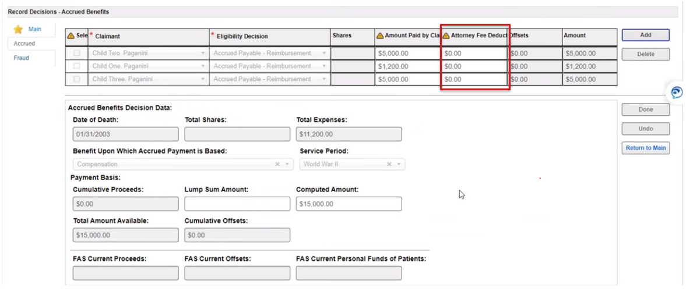

The Attorney Fee Deduction is not cumulative. This means it will not perform in the same manner as the “Computed Amount” field. For example, the fee due from the first accrued award is $200 dollars. The AAFC is now processing a second accrued award for the same claimant. The fee for the second award is $50.00. The AAFC processing the second award will only enter $50.00 in the “Attorney Fee Deduction” field.

The “Attorney Fee Deduction” field will be set to zero after award authorization and the fee will be reflected on the award print. Please note the net effect on the award print will include the agent/attorney fee.

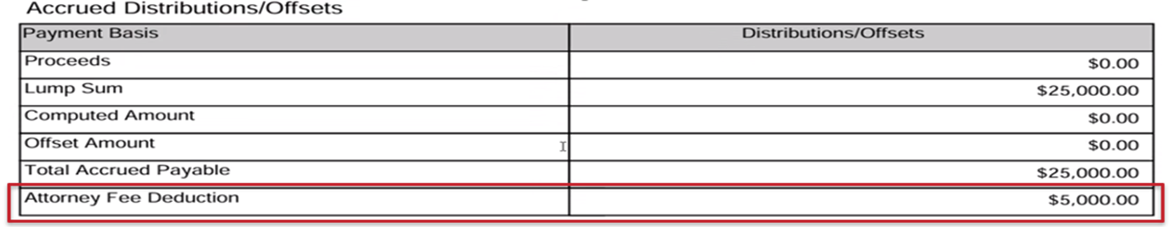

# Question and Answer – VBMS-A Accrued Processing

**1. I just had an accrued case where there was no attorney fee associated. I had to put in $0.00 to get the award to process. Is that ok?**

If no fee deduction is required for the accrued award, please enter $0.00 in the “Attorney Fee Deduction” field.

**2. Regarding the accrued award processing, do the fees display under the payee or the Veteran in eMPWR?**

The fees are displayed for the payee in eMPWR. If there are multiple payees getting fees for each one, then each of those payees will have their own fee associated with them when you look at the accountable balance section.

# Transaction 06J7: Failure to Withhold Attorney Fee

**Target Audience:** AAFCs, AAFC Management, AQRSs, QRT Management. SSD Personnel and Management

**Presenter:** Adelle Degan, Systems and Procedures Analyst, OFM

The **06J7 - Failure to Withhold Attorney Fee** transaction is now available in eMPWR-VA. This transaction is used when VA fails to make funds available for the payment of attorney fees (failed to withhold the fee). The 06J7 transaction will replace 06B One-Time Payment Establish Accounts Receivable.

The 06J7 transaction immediately establishes a debt against the claimant and places funds in the accountable balance for the payment of fees. After the 06J7 has been processed, 06J1 transaction will be used to issue payment to the agent/attorney and 06J3 transaction to transfer VA assessment to the appropriation.

The standardized fee release memorandum has been updated to reflect the 06J7 transaction.

# Question and Answer – Transaction 06J7: Failure to Withhold Attorney Fee

**1. Will the AAFC let finance know to process the 06J7?**

Yes, when there is a failure to withhold the AAFC will let finance know that the due process has expired and to process the 06J7. The fee release memorandum has been updated to replace the 06B transaction with the 06J7 transaction. Current M24 procedures should be followed.

# Transaction 06J6: Rosinski v. Wilkie Transfer

**Target Audience:** AAFCs, AAFC Management, AQRSs, QRT Management. SSD Personnel and Management

**Presenter:** Aaron Kittel, Lead Financial Systems Analyst, OFM

The 06J6 will be released to production on December 22, 2023.

**What is the “06J6 - Rosinski v. Wilkie Transfer” Transaction?**

“*Rosinski v. Wilkie*” is a court case which ruled the VA is responsible for payment of a claimant’s attorney fee if their retroactive payment is insufficient to cover the fee. These payments were previously done with 06A – One Time Payment transactions.

The 06J6 transaction is an automated transaction; finance personnel will never manually process the transaction. The 06J6 will establish an award offset for the remaining amount of an attorney fee if the beneficiary’s retroactive payment is insufficient to cover the fee.

For example, the net effect of the award was reduced to $0.00 due to retired pay withholdings. The AAFC entered a fee amount for $1,000 in VBMS-A. A batch overnight process will run the 06J6 transaction to establish an Award Offset for the $1,000 fee. VA funds will then be deposited to the eMPWR accountable balance and the 06J1 can now be utilized to pay the fee just as it would if the retroactive payment was large enough to cover the fee.

Exception – The 06J6 transaction will not trigger when the retroactive payment is insufficient because it has been applied to the a debt owed to the United States Government.

Please review M21-5 8.B.2.f for a list of applicable reductions and offsets.

The 06J6 transaction will show in a beneficiary’s transaction history as its own line. If the net effect/retroactive benefit does not cover any of the fee, then there will only be one award offset indicated.

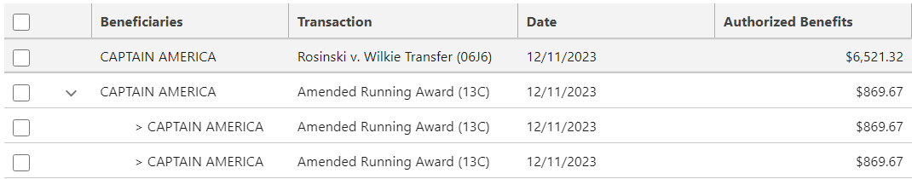

If the net effect/retroactive benefit partially covers the fee, then there will be two different award offset balances. Award offset balances may be differentiated in Accountable Balances due to having their own Cost Code. The top line of the screenshot below is an example of an award offset created by the 06J6 transaction. These transactions will have the cost code “Compensation Veteran Vietnam” indicated with the red box below. If the award offset was recouped from the net effect/retroactive payment, then there will be no cost code associated. Please see the second line below.



# Question and Answer – Transaction 06J6: Rosinski v. Wilkie Transfer

**1. Does the 06J6 account for garnishments?**

The 06J6 will trigger for garnishments.

**4. Will we still need to request a 04E transaction from finance to apply a retro form an AEW toward a 06J6 fee withholding?**

Yes, BEST AAFC personnel must continue to request an 04E transaction when processing an Audit Error Worksheet releasing funds covering the same period that VA funds were used or will be used to pay the agent/attorney fee. BEST AAFCs were previously instructed to utilize the 06A transaction documentation as an indicator that VA funds were used or will be used.

Awards authorized on/after December 22, 2023, will no longer utilize the 06A transaction. Instead, the 06J6 transaction will run automatically to deposit VA funds into the eMPWR accountable balance when the net effect is less than the fee. BEST AAFC personnel must rely on analysis of the net effect of the award and the fee amount. If the fee is greater that the net effect, then VA funds were used and must be recouped using the 04E transaction.

For example, a supplemental case granted retroactive benefits and also required retired pay withholdings. The award for the supplemental case was processed on December 26, 2023, and after retired pay withholdings were entered the net effect was $0.00. Fees were entered in the amount of $6,200. The 06J6 transaction ran automatically in the background and VA funds in the amount of $6,200 are available in the accountable balance. No fiscal print for the 06J6 will upload to the eFolder. On March 5, 2024, the AAFC instructs finance to utilize the available funds and pay the attorney using the 06J1 transaction. The BEST AAFC is processing the AEW releasing all funds on March 20, 2024, must process an 04E in the amount of $6,200. (Please note: If the AEW generated prior to the payment of fees, the BEST AAFC must process the 04E as well.)

# Agent/Attorney Fee Calculator Update

**Target Audience:** AAFCs, AAFC Management, AQRSs, QRT Management. SSD Personnel and Management

**Presenter:** Lisa Troen, Management and Program Analyst, OAR

OAR has updated the attorney fee calculator to coordinate procedurally with the new finance transactions. The calculator is linked in the following locations:

* [*M21-5, Chapter 8, Agent and Attorney Fee Processing*](https://vaww.vrm.km.va.gov/system/templates/selfservice/va_kanew/help/agent/locale/en-US/portal/554400000001034/topic/554400000023087/Chapter-8-Agent-and-Attorney-Fee-Processing)
* [M21-5, Appeals and Reviews, Resources (va.gov)](https://vaww.vrm.km.va.gov/system/templates/selfservice/va_kanew/help/agent/locale/en-US/portal/554400000001034/content/554400000126665/M21-5-Appeals-and-Reviews-Resources)
* [Office of Administrative Review Agent and Attorney Fees](https://vbaw.vba.va.gov/OAR/attorney-fees.asp)

The updated calculator will be uploaded to all three locations on December 22, 2023, which corresponds with the deployment of the 06J6 transaction.

We removed the lower “Withholding Action” section as the implementation of the 06J6 now eliminates the need for 06A identification. We also added and updated several of the fields.

**Updated Calculator Preview**

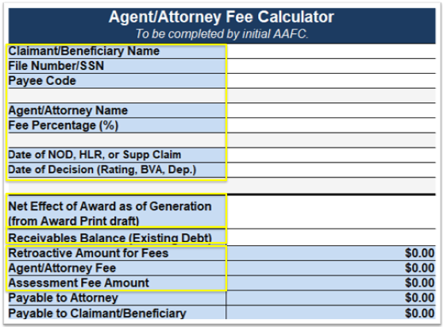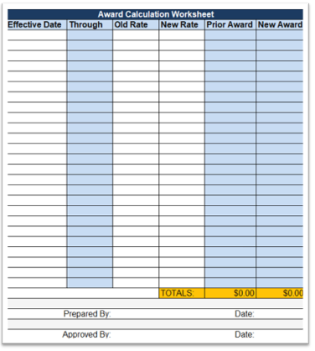

The top portion of the calculator highlighted in yellow was not changed.

The “Net Effect of Award as of Generation” field is still included with the updated calculator because it is still important to be able to easily identify what funds were paid out of the retroactive payment, and what was paid out of appropriations. Specifically BEST AAFC’s processing AEW’s will still need to be aware what portion of the fees were paid out of appropriations/VA funds, if any.

We added the “Receivables Balance” field, or existing debt, which will be useful for the new procedures for when an existing debt to the United States government exists. Finally, we updated the naming convention all of the corresponding fields to match VBMS-A.

The image above on the right is simply showing the removal of the “Withholding Action” section of the calculator.

**Assessment Fee Field**

OAR has received several inquiries regarding the calculator and the assessment field, specifically how does one *remove* an assessment on a case that is not prior to the 2007 regulation change.

In those scenarios, leave the “Date of NOD, HLR, or Supp Claim” field blank on the Agent/Attorney Fee Calculator. This procedure has been added in the “Instructions” tab of the new calculator under both the “Date of NOD, HLR, or Supp Claim” as well as the “Assessment Fee Amount.”

# Question and Answer – Agent/Attorney Fee Calculator Update

**1. For clarification, the calculator no longer needs to be signed? Just typing the name of the person the award was prepared by and approved by is sufficient?**

The digital signature requirement has been removed. Names of AAFC's are still required.

**2. Does the new calculator let us enter $0.00 for assessment fees when applicable?**

The instructions tab of the new calculator explains the workaround is to leave the date of “NOD, HLR, Supp Claim” field blank. That will populate the zero dollars in the assessment fee field.

# Fee Release Memorandum Update

**Target Audience:** AAFCs, AAFC Management, AQRSs, QRT Management. SSD Personnel and Management

**Presenter:** Adelle Degan, Systems and Procedures Analyst, OFM

An updated version of the fee release memorandum will be released in the near future.

The Attorney Fee Release Memo has been updated to include the 06J7 transaction (replacing the 06B) for failure to withhold scenarios.

The memo will also be updated to include the new 06J6 transaction once available for partial and complete Rosinski cases where the retroactive award does not cover the attorney fee award offset amount.

The third change to the memo is the removal of the digital signature block. Even though the digital signature block has been removed, the AAFC’s name must still appear on the memo prior to it being sent to SSD for processing.

The 06J3 Release Award Offset Balance-Return to Appropriation transaction has been removed from the memo. In an upcoming release, the 06J5 transaction will allow the user to enter the VA assessment while processing an 06J1 and the 06J5 will be triggered in the background to transfer the assessment to the appropriation, invalidating the need for processing a separate 06J3 transaction.

**06J6 Impact on Fee Release**

If the award was authorized **prior to** December 22, 2023, then the 06J6 transaction will not bring VA funds from appropriations to the eMPWR accountable balance. Only funds from the award net effect would be available in the eMPWR accountable balance. Therefore, any of the following selections on the fee release memorandum would be appropriate:

* Complete fee withheld
* Partial fee withheld
* No fee withheld
* Failed to make funds available for payment of fees
* Release to claimant

If the award was authorized **on or after** December 22, 2023, then the 06J6 transaction will bring funds from appropriations to the eMPWR accountable balance. Therefore, funds for fees will be available in the eMPWR accountable balance regardless of whether the net effect is large enough to cover the fee. Therefore, any of the following selections on the fee release memorandum would be appropriate:

* Complete fee withheld
* Failed to make funds available for payment of fees
* Release to claimant

**Example Scenario #1**

**Scenario**: Award authorized on **November 1, 2023**. Net effect as of award generation (the amount after retired pay withholdings are entered) was $0.00. The fee is determined to be $5,000.

**Question**: After the appeal period has expired, which fee release memorandum option should the AAFC select and why?

* + A: Complete fee withheld (06J1)
  + B: Partial fee withheld (06J1 and 06A)
  + C: No fee withheld (06A)

**Answer**: C: No fee withheld (06A)

**Explanation:** The net effect did not cover any portion of the fee. The award was processed on **November 1, 2023 prior** to the implementation of the **06J6** transaction. Therefore, no funds will be available in the eMPWR accountable balance and finance must utilize the 06A transaction for the payment of the fee.

**Example Scenario #2**

**Scenario**: Award authorized on **December 29, 2023**. Net effect as of award generation (the amount after retired pay withholdings are entered) was $0.00. The fee is determined to be $5,000.

**Question**: After the appeal period has expired, which fee release memorandum option should the AAFC select and why?

* + A: Complete fee withheld (06J1)
  + B: Partial fee withheld (06J1 and 06A)
  + C: No fee withheld (06A)

**Answer**: A: Complete fee withheld (06J1)

**Explanation:** The net effect did not cover any portion of the fee. The award was processed on **December 29, 2023 after** the implementation of the **06J6** transaction. Therefore, the 06J6 will make funds available in the eMPWR accountable balance. Finance will now be able to utilize the 06J1 transaction for the payment of the fee.

# Question and Answer – Fee Release Memorandum Update

**1. When will the 06J5 be introduced and how will we know when we no longer have to do the 06J3?**

The earliest possible release date for the 06J5 transaction is January 17, 2024. However, it is still undergoing some testing to ensure it is functioning as designed. You will be receiving updates as we get closer to that date, and it is ultimate deployment date.

**2. Why is the 06J3 portion being removed from the fee release memorandum?**

The 06J3 was removed from the fee release memorandum in anticipation of the tentative January 2024 release of the 06J5 transaction. The 06J5 transaction is an automated transaction that will embed the assessment fee release within the 06J1 transaction. The 06J5 is being introduced to reduce the number of transactions users need to process, and to have better tracking in place for assessment fees being deducted. However, the 06J3 will remain in eMPWR for other situations you might need to return a fee to appropriation.

# Handling Cases Involving a Debt Against the United States Government

**Target Audience:** AAFCs, AAFC Management, AQRSs, QRT Management. SSD Personnel and Management

**Presenter:** Ambria Davis, Management and Program Analyst, OAR

**References:**

* [M21-5 8.B.2.j, *Handling Cases Involving an Existing Debt to the United States Government*](https://vaww.vrm.km.va.gov/system/templates/selfservice/va_kanew/help/agent/locale/en-US/portal/554400000001034/content/554400000205497/M21-5-Chapter-8-Section-B-Processing-a-Case-Seeking-Direct-Payment-of-Fees#2)
* [M21-5 8.B.9.a, *Decision Notice – Fee Cases Involving Debts to the United States Government*](https://vaww.vrm.km.va.gov/system/templates/selfservice/va_kanew/help/agent/locale/en-US/portal/554400000001034/content/554400000205497/M21-5-Chapter-8-Section-B-Processing-a-Case-Seeking-Direct-Payment-of-Fees#2)
* [VAOPGCPREC 12-93,](https://vaww.vrm.km.va.gov/system/templates/selfservice/va_kanew/help/agent/locale/en-US/portal/554400000001034/content/554400000043484/VAOPGCPREC-12-93-Dec-21-1993-Payment-of-Attorney-Fees-from-Past-due-Benefits-when-Veterans-Indebtedness-to-the-US-Exceeds-Total-Amount-of-Past-due-Benefits) Payment of Attorney Fees from Past-due Benefits when Veteran's Indebtedness to the U.S. Exceeds Total Amount of Past-due Benefits

In VAOPGCPREC 12-93 Payment of Attorney Fees from Past-due Benefits when Veteran's Indebtedness to the U.S. Exceeds Total Amount of Past-due Benefits, the Office of General Counsel concluded that the **direct payment** of fees under section 38 U.S.C. § 5904(d) would be based on the amount available after the indebtedness was satisfied.

AAFCs will need to review the award information screen to determine if there is an existing debt against the United States Government. The award information screen can be located within VBMS and Share. Any existing debt will be found in the receivables field.

Please note that the *Rosinski* holding does not impact these cases.

**Processing Steps:**

* Determine if there is an existing debt to the United States Government
* Calculate the fees – The fees are calculated with normal processing. However, the fee decision notice will explain the amount available for the direct payment by the VA.
* Utilize the Letter Creator to correctly notify the claimant and agent/attorney

**Notification Requirements**

Introduction

The claimant has an existing debt to the United States Government that may completely or partially exceed the amount of past-due benefits. The Office of General Counsel Precedent Opinion, VAOPGCPREC 12-93, directs VA to satisfy the debt to the United States Government prior to the direct payment of fees under 38 U.S.C. § 5314. This decision outlines any entitlement to fees. However, the VA may not be able to carry out the direct payment of fees based on the amount of the existing debt. Any remaining funds will be used to satisfy the direct pay fee agreement. Any funds that cannot be paid directly by the VA should be handled outside of VA processing.

What We Decided and Why Section

Utilize the decision paragraph below if the debt exceeds the fee

* The claimant has an existing debt to the United States Government in the amount of $[list debt amount] which exceeds the past-due benefits. Therefore, this case is not eligible for the direct payment of fees.

Utilize the decision paragraph below if the debt does not exceed the fee

* The claimant has an existing debt to the United States Government in the amount of $[list debt amount] which will reduce the past-due benefits available for the direct payment of fees. As a result, VA will pay the agent or attorney fees of $[amount available after the debt minus the assessment fee]. VA will deduct an assessment of $[assessment fee amount]. The remaining $[fee amount that cannot be paid via direct payment] is not eligible for the direct payment of fees.

**Fee Decision Notice Example #1**

Scenario: The fee amount is $1,000. However, a review of the award information screen reflects a receivable in the amount of $50,000.

Notification Text:

The claimant has an existing debt to the United States Government in the amount of $50,000 which exceeds the past-due benefits. Therefore, this case is not eligible for the direct payment of fees.

**Fee Decision Notice Example 2**

Scenario: The fee amount is $3,000. However, a review of the award information screen reflects a receivable in the amount of $1,000.

Notification Text:

The claimant has an existing debt to the United States Government in the amount of $1,000 which will reduce the past-due benefits available for the direct payment of fees. As a result, VA will pay the agent or attorney fees of $1,900. VA will deduct an assessment of $100.00. The remaining $1,000 is not eligible for the direct payment of fees.

# Question and Answer – Handling Cases Involving a Debt Against the United States Government

**1. How will we handle cases where the existing debt to the government exceeds the past-due benefits?**

Per the OGC Precedent Opinion, VA will not be able to pay the fees directly. Please follow instructions in M21-5.

# Current Month Processing Procedures

**Target Audience:** AAFCs, AAFC Management, AQRSs, QRT Management. SSD Personnel and Management

**Presenter:** Lisa Troen, Management and Program Analysts, OAR

**References:**

* [M24-1, 03.06, *Attorney Fee*](https://gcc02.safelinks.protection.outlook.com/?url=https%3A%2F%2Fvaww.vrm.km.va.gov%2Fsystem%2Ftemplates%2Fselfservice%2Fva_kanew%2Fhelp%2Fagent%2Flocale%2Fen-US%2Fportal%2F554400000001057%2Fcontent%2F554400000204941%2FM24-1-Chapter-03-All-Programs-Part-06-Attorney-Fee-NEW-PROCEDURES&data=05%7C01%7C%7C7340adb83b9c4c669beb08dba57c3a3f%7Ce95f1b23abaf45ee821db7ab251ab3bf%7C0%7C0%7C638285725188640085%7CUnknown%7CTWFpbGZsb3d8eyJWIjoiMC4wLjAwMDAiLCJQIjoiV2luMzIiLCJBTiI6Ik1haWwiLCJXVCI6Mn0%3D%7C3000%7C%7C%7C&sdata=5bwRa%2Fd%2B06l1uRv2%2B7BfULlPpL9fvMM%2FVoT1NiByLVU%3D&reserved=0)
* [M21-5, 8.B.6.d, *Corrective Action for Failure to Make Funds Available for Payment of Fees when a Retroactive Payment of Past-Due Benefits has been Released*](https://vaww.vrm.km.va.gov/system/templates/selfservice/va_kanew/help/agent/locale/en-US/portal/554400000001034/content/554400000205497/M21-5-Chapter-8-Section-B-Processing-a-Case-Seeking-Direct-Payment-of-Fees)

The regulation defines past-due benefits for the purpose of calculating agent/attorney fees as the past-due payments accrued during the period from the effective date of the award through the date of the decision awarding benefits.

Current month processing refers to instances where the payment effective date and the date of processing are within the same month. For example – A rating decision dated November 16, 2023 granted benefits effective October 25, 2023. Therefore, the payment effective date is November 1, 2023. The award is processed on November 18, 2023.

There is a system limitation where eMPWR does not *recognize* the current months retroactive funds as **available to be used towards the attorney fee deduction**. Essentially, the system is only recognizing retroactive funds from historical months.

This presents a challenge because we know that fees are calculated from November 1 (our payment date) to November 16th (our decision date).

While the new 06J6 transaction will automatically bring funds to the accountable balance, due process is still required to create a debt on the Veteran’s account.

Please follow the instructions in M21-5.8.B.6.d for {either the entire fee deduction amount OR the portion not already withheld}. When completing the fee release memorandum utilize the Additional Instructions section to direct finance to complete an 04E transaction to create the debt. The 06J1 transaction will be used to pay the fee due to the 06J6 transaction brining VA funds to the eMPWR accountable balance.

Within M24-1, this process is specifically outlined as an exception to *Rosinski*, citing that a debt can and should in fact be created if attorney fees were not withhold based on an administrative or system error.

deduct fees.