**TABLE OF CONTENTS**

Reminders 1

Utilize Award Information Screen for Audits (Historical Charts on Award Prints are Inaccurate) 3

Partial *Rosinski* (06J6) on Attorney Fee Release Memo 5

04E Requirement Clarification 6

040 Higer-level Review Returns Fee Release 7

Question and Answer – 040 Higher-level Review Returns Fee Release 8

Summary of the Case Fee Decision Notice Tickets 9

Question and Answer – Summary of the Case Fee Decision Notice Tickets 10

# Reminders

**Target Audience:** AAFCs, AAFC Management, Authorization Quality Review Specialists (AQRS), Quality Review Team Management, Support Service Division Personnel and Management.

**Presenter:** Donald West, Management and Program Analyst, OAR

**References:**

* [M21-5 8.B.2.a.  *When to Request Finance Transactions or Use Award Actions for Possible Direct Payment of Fees*](https://vaww.vrm.km.va.gov/system/templates/selfservice/va_kanew/help/agent/locale/en-US/portal/554400000001034/content/554400000205497/M21-5-Chapter-8-Section-B-Processing-a-Case-Seeking-Direct-Payment-of-Fees)

**VBMS-A Deduction Limit Removal**

VBMS-A deduction field **will** allow entries greater than $99,999. AAFCs may utilize the Agent/Attorney Fee tab in VBMS-A to establish fee deductions larger than $99,999. Previously, AAFCs could not enter a six-figure fee deduction in the “Other Adjustment” tab. That limitation no longer exists.

The OFM Agent/Attorney Fee FAQ was removed.

**Fee Deduction Processing System**

Utilize VBMS-A to establish the fee deduction for the following types of awards:

* Compensation Pension Live (Excluding Apportionments)
* Initial Accrued Awards and,
* Dependency and Indemnity Compensation (DIC).

Do not utilize VBMS-A to establish the fee deduction for the following types of awards:

* Compensation Pension Live with a current OR terminated apportionment,
* Subsequent Accrued Awards,
* Month of Death and,
* Burial.

**Lingering 18/312J – VBMS-A Fee Deduction Failure**

Please review the award information screen every time an award is processed for a lingering 18/31J.

If there is an18/31J in the system and the AAFC attempts to process a fee deduction using VBMS-A, the VBMS-A deduction will fail. If VBMS-A is being used to establish the fee deduction, then the user must confirm an old/lingering 18/31J is not in the system.

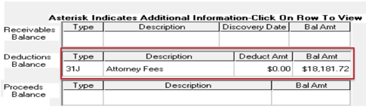

Please note that we are not discussing scenarios that warrant an 18/31J to establish the fee deduction. For example, if there is an active or terminated apportionment on the award, then the AAFC will request finance to establish the 18/31J. The AAFC will NOT enter the fee in VBMS-A for that award.

**One-Cent Difference**

Do not use the override functionality to update the VBMS-A calculator for a one-cent difference with the manual Agent/Attorney Fee Calculator. Please keep the VBMS-A calculations.

**Fee Audits**

AAFCs are reminded to review their audits for the following:

* Do not utilize the historical award chart on the award prints to obtain the “Old Rates.”
* AAFCs must utilize the award information screen to obtain the “Old Rates.”
* AAFCs must enter every line within the entitlement period from the award draft and the award information screen.
* The last line in the “Effective Date” column on the Excel Agent/Attorney Fee Calculator is the day after the decision.
* The “Calculate Through Date” field in the VBMS-A Automated Fee Calculator is the day of the decision.
* The “Total Fee Including Assessment” field in the VBMS-A Automated Fee Calculator must include the assessment fee.

Missing award lines and inputting the incorrect end date are common errors with the manual audits. AAFCs are strongly encouraged to reach out to a senior AAFC or quality prior to overriding the VBMS-A fee calculator. AAFCs are also encouraged to continue to contact OAR and input IT tickets to review discrepancies after the discrepancy is confirmed by another reviewer.

# Utilize Award Information Screen for Audits (Historical Charts on Award Prints are Inaccurate)

**Target Audience:** AAFCs, AAFC Management, Authorization Quality Review Specialists (AQRS), Quality Review Team Management, Support Service Division Personnel and Management.

**Presenter:** Donald West, Management and Program Analyst, OAR

**References:**

* [M21-5 8.B.1.a., *Process for Possible Direct Payment of Fees, Stage 3*](https://vaww.vrm.km.va.gov/system/templates/selfservice/va_kanew/help/agent/locale/en-US/portal/554400000001034/content/554400000205497/M21-5-Chapter-8-Section-B-Processing-a-Case-Seeking-Direct-Payment-of-Fees)
* TMS course VA-4635201 Calculating and Deducting Agent and Attorney Fees
* [February 2024 National Agent and Attorney Fee Coordinator (AAFC) Call  Bulletin](https://vbaw.vba.va.gov/OAR/docs/february2024-oar-aafc-call-bulletin.pdf)

The awards information screen can be accessed either through SHARE using Corporate Inquiries or by using VBMS – Core by selecting Awards Information from the Veteran menu.

Prior to authorization, the AAFCs must utilize the awards information screen to complete the “Old Rate” column on the manual Agent/Attorney Fee Calculator.

The screenshots that are uploaded at stage 3 of M21-5 8.B.1.a. Process for Possible Direct Payment of Feesare required and will be used to verify the amounts used in the calculator.

AAFCs should not utilize the historical charts on the award print. Users have previously identified that the historical charts on the award print are inaccurate.

For example, the historical award chart on the award below does not contain the 01/01/2023 line. The audit will not be accurate utilizing the historical award chart. The AAFC must utilize the award information screen. The award audit must include all dates from the award information screen and the draft award print.

**Award Information Screen**

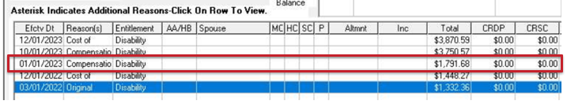

This audit reflects the correct fee amount of $637.34 because the 01/01/2023 line was included in the audit.

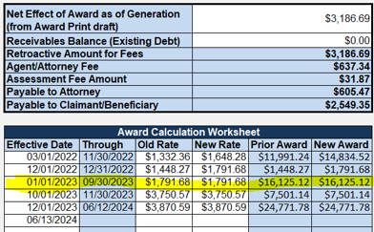

**Historical Award Chart**

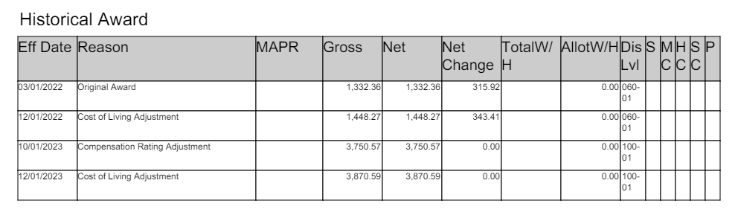

This audit is inaccurate because it utilized the inaccurate historical award chart which did not indicate the Veteran’s rate increased on 01/01/2023.

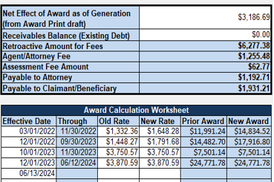

# Partial *Rosinski* (06J6) on Attorney Fee Release Memo

**Target Audience:** AAFCs, AAFC Management, Authorization Quality Review Specialists (AQRS), Quality Review Team Management, Support Service Division Personnel and Management.

**Presenter:** Adelle Degan, System and Procedure Analyst, OFM

When the award for a retroactive payment only covers part of the attorney fees (partial Rosinski), the 06J6 automated transaction will occur in the background to create an accountable balance in eMPWR-VA for the shortfall of attorney fees that could not be offset by the retroactive award.

These funds will appear as two separate line items on the Accountable Balance in eMPWR-VA with the same date:

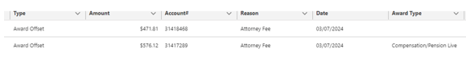

The sum of these offsets will equal the amount that appears on the Attorney Fee Release Memo. Because the 06J1 Release of Award Offset Balance – One Time Payment transaction only allows a user to select one Award Offset Accountable Balance for each transaction, two 06J1 transactions must be processed in this scenario, one of which will include the VA assessment. Finance should not request two separate Attorney Fee Release memos when the 06J6 creates a partial Accountable Balance.

In this example from the Award Offset screen above, the two separate attorney fee offsets equal the total amount shown on the Attorney Fee Release Memo ($471.81+$576.12=$1,047.93):

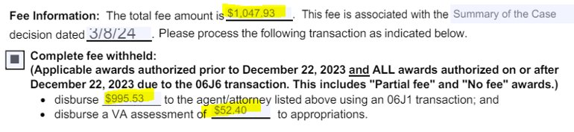

# 04E Requirement Clarification

**Target Audience:** AAFCs, AAFC Management, Authorization Quality Review Specialists (AQRS), Quality Review Team Management, Support Service Division Personnel and Management.

**Presenter:** Adelle Degan, System and Procedure Analyst, OFM

When an Audit Error Worksheet (AEW) is received after an 06A transaction has been paid or an 06J6 (Rosinski) Accountable Balance has been released via 06J1 transaction to an attorney, the SSD Finance that processed the 06A or 06J1 to release 06J6 attorney fee will need to establish a debt (04E) to collect the funds from the Veteran.

The Claims processor will send a memo titled “AEW Letter to Finance” instructing the SSD Finance to establish a collectible 04E transaction for the appropriate amount to be collected. The purpose of the 04E is to recoup from the Veteran the 06A/06J6 VA paid out of the appropriation.

An AEW may come back before an attorney fee is paid (by 06A or 06J1 when a 06J6 has established an Accountable Balance). The procedures above will still be applicable and the claims processor working on the AEW will send the memo to the SSD.

The AAFC will send a memorandum to finance prior to promulgation of the award with the following verbiage:

“Please process an 04E transaction for [amount of fee] to recoup from the claimant the agent/attorney fees paid/to be paid via VA funds related to award action dated [enter date of associated award   with insufficient funds]. When complete, please notify the AAFC [name of employee who submitted the request].”

# 040 Higer-level Review Returns Fee Release

**Target Audience:** AAFCs, AAFC Management, Authorization Quality Review Specialists (AQRS), Quality Review Team Management, Support Service Division Personnel and Management.

**Presenter:** Adelle Degan, System and Procedure Analyst, OFM and Ambria Davis, Senior Management and Program Analyst, OAR

**References:**

* [M21-5 8.B.1.a., *Process for Possible Direct Payment of Fees, Stage 3*](https://vaww.vrm.km.va.gov/system/templates/selfservice/va_kanew/help/agent/locale/en-US/portal/554400000001034/content/554400000205497/M21-5-Chapter-8-Section-B-Processing-a-Case-Seeking-Direct-Payment-of-Fees)

The Office of Administrative Review (OAR) and the Office of Field Operations (OFO) collaborated to create a workload transition plan for the Higher-Level Review (HLR) Return inventory, which includes all HLR Duty to Assist (DTA) Error claims and HLR Difference of Opinion (DoO) claims. OAR and OFO leadership determined that to optimize the processing of HLR Return Inventory, jurisdiction of the HLR Return inventory would transition from OAR to OFO.

Although this inventory will now be under the jurisdiction of OFO, OAR, specifically Washington, DC DROC (DROC DC), will continue to assist with the release of Attorney Fees   that result from the processing of a HLR Return.

**Attorney Fee Impacts**

The attorney fee processing procedures in M21-5, Chapter 8, Section B, will be applicable for each local Agent and Attorney Fee Coordinator (AAFC) when working the EP 040 DTA and DoO claim. DC DROC will perform fee release actions. To ensure automated assignment to DC DROC there will be one adjustment to the steps in stage 3 of the table referenced in M21-5 8.B.1.a. Following the completion of all the processing actions in stage 3, the AAFC (authorizer) will affix the ***Appeal Issue Intertwined*** special issue to the EP 400 controlling the attorney fee memo. Only EP 400s resulting from EP 040 DTA or DoO claims are eligible to affix the ***Appeal Issue Intertwined***special issue. No other attorney fee EP 400s resulting from working any other rating, non-rating, or pension related workload should utilize the ***Appeal Issue Intertwined***special issue. The attorney fee EP 400 with the ***Appeal Issue Intertwined***special issue will be eligible for recall and redistribution to the DC DROC for fee release processing when the EP is actionable and ready to assign. It will be imperative all necessary processing actions (M21-5 8.B.1.a. stages 1 through 3) and uploads are completed in VBMS at the time the EP 400 is established prior to the claim being subject for recall during the next NWQ national production run.

OFO employees will process stages 1-3 and DC DROC employees (AAFCs and SSD) will complete stages 4-7. DC DROC AAFCs will also review for reasonableness review decisions submitted. However, the existence of multiple attorneys and the referral to OGC falls under stage 3 and will be completed by OFO employees.

**DC DROC SSD**

Beginning July 15, 2024, all attorney fee releases for Higher-Level Review (HLR) cases will be sent to Washington, DC DROC 397. At the end of the due process period, DC DROC will send these cases to DC SSD 397 for attorney fee payment release processing.

# Question and Answer – 040 Higher-level Review Returns Fee Release

**1. Question -** **Please explain why the ROs are not allowed to release their own fees on 040 HLR. There doesn't seem to be any logical reason why the ROs would only do the first difficult part of the fee process then send all the relatively easy fee releases to DROC-Dc and lose half the production transactions. What is different about these claim types compared to all the other claims the ROs complete fee processing on that would make it necessary for only DROC-DC to do it? Mandating that DROC-DC does the easiest part of the fee process for the ROs, is giving the impression that they are being given all the ROs transaction credits. Every RO is more than capable of releasing their own fees and are already completing that function daily.**

Answer - We appreciate the question. Please direct workload management questions and concerns to your management.

**2. Question - How will the higher-level return fee release work when there is failure to make funds available scenarios, the incorrect or no Summary of the Case Fee decision notice, or Office of General Counsel (OGC) Review is required?**

Answer - The offices under Office of Field Operation jurisdiction will be responsible for corrective actions. If multiple attorneys are identified, then OFO employees will need to follow the correct procedures to issue the Summary of the Case Fee decision notice to all parties and refer the case to OGC. Issuing the decision notice is listed under stage 3. If there is a reasonableness review or appeal submitted after the fee decision notice is issued, then AAFC at DC DROC will be responsible for processing.

**3. Question - For multiple attorneys, are these pulled immediately to the DROC or sit in the AFC queue establishing the 400? I was told there is backlog of OGC cases is over 400 days unless it is at a DROC, which is less.**

Answer - The average days for OGC to complete a reasonableness review decision regardless of station is approximately 500 days. The DROC cases do not have any priority. If there are multiple attorneys, the VSC/BEST/PMC AAFC should complete the appropriate fee decision notice and refer the case to OGC. The EP 400s with the Appeal Issue Intertwined special issue will be recalled.

**4. Question - How is the EP 400 getting to the DROC to be cleared (NWQ or brokering)?**

Answer - The National Work Queue (NWQ) will route the EP 400 with the Appeal Issue Intertwined special issue to DC DROC. Only EP 400s resulting from EP 040 DTA or DoO claims are eligible to affix the Appeal Issue Intertwined special issue. No other attorney fee EP 400s resulting from working any other rating, non-rating, or pension related workload should utilize the Appeal Issue Intertwined special issue.

**5. Question - The Attorney Fee Processing Guide that was sent out mentions DROC would be creating deferrals on corrections for the station that created the withholding. Would this affect everyone?**

Answer - Yes, DC DROC AAFCs will follow established procedures to notify AAFCs at the VSC/PMC/BEST stations of corrective actions for the EP 400 established from higher-level review returns.

# Summary of the Case Fee Decision Notice Tickets

**Target Audience:** AAFCs, AAFC Management, Authorization Quality Review Specialists (AQRS), and Quality Review Team Management.

**Presenter:** Lisa Troen, Management and Program Analyst, OAR

**Decision Date Incorrect**

The Office of Information Technology (OIT) identified a root cause related to the defect of this defect; however, the fix cannot be immediately scoped and will need to go through IT prioritization (appr. Q1 of FY25).

Example:

* Authorized in VBMS-A on 3/20/24.
* Letter date of 3/17/24 (3 days prior to complete of the award).

**Please be aware of the potential error when calculating tracked item suspense dates** for the 65-day appeal period (examine for actual *date of mailing)* as well as during quality reviews.

IT tickets are not required at this time for this identified date error.

**Defect Upon Concur**

The Office of Information Technology (OIT) identified a root cause related to the defect of the VBMS-A Summary of Case Fee Decision Notice failure at concur. The fix was deployed on June 30, 2024.

Please continue to notify OAR of any future issues experienced with the VBMS-A Summary of Case Fee Decision Notice functionality, to include errors at concur, while also creating a trouble ticket with IT.

Note: Since the fix was deployed, issues with CPD DIC awards over 40k have been reported and OAR has communicated these tickets with OIT.

**Issues/Contentions Defect**

The Office of Information Technology (OIT) has identified a root cause related to the defect of the VBMS-A Summary of Case Fee Decision Notice failure to populate issues.

The identified root cause stems from decisions granting an **earlier effective date** on already service-connected conditions. (Fix is scheduled for July 28th deployment.)

* “An earlier effective date has been assigned for ____ from ____”.
* “An effective date of _____ has been assigned for ____”.

**Please continue to submit IT tickets and notify the Office of Administrative Review, specifying the issues that did not populate in your fee decision.**

# Question and Answer – Summary of the Case Fee Decision Notice Tickets

**1. Question - Please address the confirm and continue as being okay on the SOC in the Bulletin. Doesn't appear to be on the slide and would be helpful to have that in writing.**

Answer - Yes, the fix to correct the issues/contentions defect includes adding the confirmed and continued decisions back into the SOC. This is expected behavior.