**TABLE OF CONTENTS**

VBMS-A Calculator Updates and Reminders 1

Question and Answer - VBMS-A Calculator Updates and Reminders 3

Fee Agreement Validity Training Preview 4

Question and Answer - Fee Agreement Validity Training Preview 5

Policies Reviewed and Under Review 6

# VBMS-A Calculator Updates and Reminders

**Target Audience:** AAFCs, AAFC Management, Authorization Quality Review Specialists (AQRS), and Quality Review Team Management

**Presenter:** Ambria Davis, Program Analyst, OAR

**References:**

* VBMS-A User Guide
* April 2023 National Agent and Attorney Fee Call (TMS 4636332)
* VBMS-A Automated Fee Calculator Job Aid

The “Calculate Through Date” is the date of the decision that benefits are being calculated through, it is not the following day. For example, the user will enter April 26, 2023, if fees are due based on rating decision dated April 26, 2023.

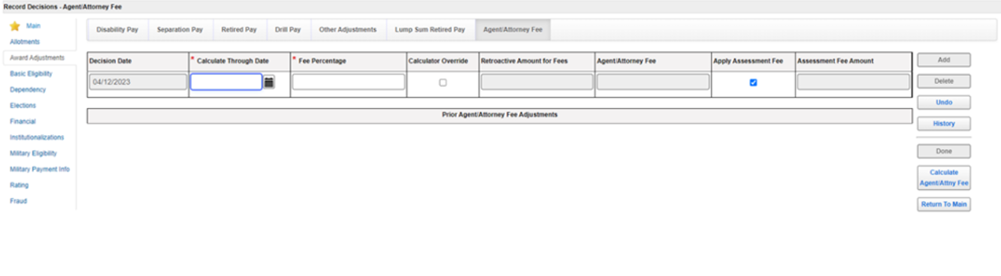

AAFC use of the manual *Agent/Attorney Fee Calculator* is still required when utilizing the new *VBMS-A Automated Fee Calculator*. AAFC must continue to upload the award information screenshots.

If the VBMS-A attorney fee amount calculated by the system does not match your manual calculator, please complete the following steps:

* re-review all award lines and corresponding amounts to verify accuracy of the manual calculator
* enter an IT ticket documenting the issue
* email the AFC box:
  + use subject line of “VBMS-A Calculator Ticket number”
  + include the file number and IT ticket number
  + include a screenshot of VBMS-A Agent/Attorney Fee tab
  + attach a copy of the manual Agent/Attorney Fee Calculator
* select the Calculator Override box on the Agent/Attorney Fee tab in VBMS-A to manually edit the Retroactive Amount for Fees (Gross Amount of Past Due Benefit field on the manual calculator), the Agent/Attorney Fee (includes the assessment fee), and the Assessment Fee Amount matching the manual calculator.

The Office of Financial Management and OAR are aware of the rounding discrepancy between the VBMS-A Automated Fee Calculator and the manual fee calculator which results in a one cent difference in the assessment fee or the agent/attorney fee amount.  Developers are actively working to correct this specific “one cent” issue within the VBMS-A Automated Fee Calculator. Please continue to utilize the override functionality in these situations. Users should discontinue submitting trouble ticket (YourIT) or notifying OAR via email when the discrepancy identified is the “one cent” error.

Discrepancies (greater than one cent) was identified to be related to the automated calculator not accounting for the control date for records converted from the Benefits Delivery Network. The control date can be found in the “Only Generate New Award Lines From” field on the “Record Decisions” screen.

All awards processors must adjust the control date on the record decisions screen in order to successfully generate adjusted payment rates from the earliest implicated effective date. If the decision grants entitlement prior to the control date reflected in the system, the user must change the date and update all tabs within VBMS-A (ex. dependency) to backfill data that precedes the original control date.

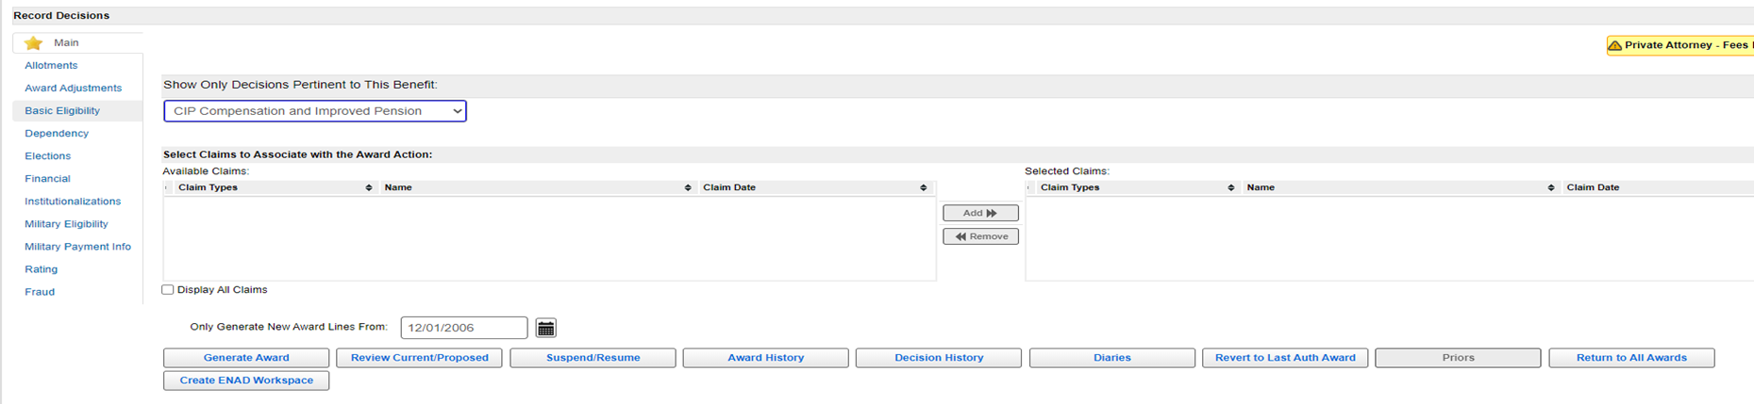

For cases involving agent/attorney fees, the AAFC must enter the new control date in the “Control Date Override” field with the Agent/Attorney Fee tab prior to calculating the agent/attorney fee amount. The AAFC must also update the control date in the “Only Generate New Award Lines From” field on the “Record Decisions” screen prior to award generation.

VBMS-A released version 30.2 with the updated control date functionality on May 21, 2023. Only converted cases will have the control date fields reflected below.

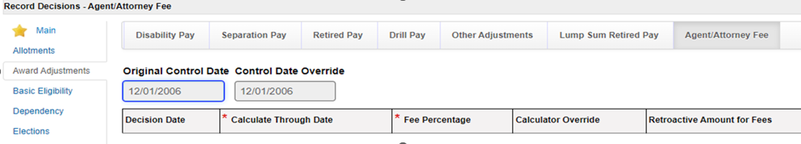

For example, Rating Decision January 5, 2022 granted entitlement to an earlier effective date for cervical spine degenerative disc disease and cervical spine degenerative joint disease effective July 11, 2006. The Veteran has been service connected since 1992. The control date is November 1, 2008. The user must change the control date to August 1, 2006. All relevant decision tabs (ex. dependents) must be backfilled to August 1, 2006. If the user does not update the control date, VBMS-A will not implement any payment changes from August 1, 2006 to November 1, 2008.

# Question and Answer - VBMS-A Calculator Updates and Reminders

**1. Are AAFCs required to override the *VBMS-A Automated Fee Calculator* when there is a $.01 discrepancy with the manual calculator for the assessment amount?**

Yes, please ensure the VBMS-A calculator reflects the manual calculator.

**2. Why are agent/attorney fees paid up to the date of the decision instead of date last paid? The net effect of the award will not pay any days after date last paid; therefore, the award will never match the calculator.**

38 CFR 14.636(h)(3) provides that past-due benefits accrue between the effective date of the award and the date of the grant of the benefit by the agency of original jurisdiction (AOJ), Board, or an appellate court. This regulation is the basis for using the date of decision to calculate attorney fees.

**3. Do we need to annotate or upload a screen shot of the incorrect calculator when we have to use calculator override?**

No, do not upload a screenshot of the incorrect calculator into VBMS Core. However, the AAFC must attach a screenshot of the incorrect calculator results to the email sent to OAR.

**4. Why will the system not always allow you to change the control date?**

The system will not allow a control date later than the original control date.

**5. Will the Control Date Override be available regardless of what tab has been selected or only if the Agent/Attorney Fee tab is activated?**

If the AAFC determines the original control date must be modified in order to implement their decision, then the Control Date Override field must be changed on the agent/attorney fee tab prior to calculating agent/attorney fees. This additional control date override function is necessary only on the agent/attorney fee tab and the retired pay tab because the system is performing calculations for the new award data prior to award generation. When the award is generated, VBMS-A calculates changes based on the control date reflected on the Record Decision screen for all other decisions made within the remaining tabs.

# Fee Agreement Validity Training Preview

**Target Audience:** AAFCs, AAFC Management, Authorization Quality Review Specialists (AQRS), and Quality Review Team Management

**Presenter:** Lisa Troen, Management and Program Analyst, OAR

OAR is excited to announce that the full course on Validity will soon be released to the field. As a precursor, several “hot” topics were discussed to promote consistency.

**Statutory vs Regulatory vs Procedural**

It is important to discuss the difference between the statutes, regulations, and procedures that govern agent/attorney fees when discussing validity of a fee agreement. The statute is the law, it is the broadest, but it must be followed. VA establishes the regulation, and it is an interpretation of the law. Lastly, procedures – think of the M21 – these are step by step instructions on how to comply with the law or regulation. Many of the regulatory or procedural criteria was set in place by VA for efficiency of administrative processing, and they do not affect the actual substance of the agreement itself.

Whether or not the source of the M21-5 *criteria* is regulatory or statutory can affect whether it would invalidate the fee agreement. For example, if you can reasonably identify the claimant, and the agreement is *successfully associated with the claims file before the past-due benefits are released to the claimant*, the fact that the agreement did not include the file number or SSN would not be a basis for denying fees to an attorney who would otherwise be entitled.

**System Updates**

The table below describes the necessary flashes to apply based on the validity of the fee agreement.

|  |  |
| --- | --- |
| **If review of the fee agreement shows...** | **Then...** |
| the document is valid | * the AAFC must remove the Potential Attorney Fee flash from the corporate record and apply the Private Attorney - Fees Payable flash. * the Private Attorney - Fees Payable flash must remain until the fee agreement is withdrawn (entitlement to future fees are waived) by the representative or otherwise no longer requires making funds available for possible payment of fees (no possibility of payment, i.e., full grant of benefits for which the agent/attorney provided representation). |
| the document is invalid | * the AAFC must complete the actions outlined in [**M21-5, Chapter 8, Section A.3.d**](https://vaww.vrm.km.va.gov/system/templates/selfservice/va_kanew/help/agent/locale/en-US/portal/554400000001034/content/554400000205495/M21-5-Chapter-8-Section-A-Introduction-to-Fees#3d). * once all necessary actions are completed, the AAFC will add a permanent note to the eFolder explaining the specific deficiency in the fee agreement and remove the Potential Attorney Fee flash from the corporate record. |

**Actions When a Fee Agreement Is Unacceptable**

If a fee agreement does not meet the criteria, return it to the agent or attorney along with the *Invalid Fee Agreement* letter advising that fee agreement is not acceptable because it does not comply with [38 CFR 14.636](https://www.ecfr.gov/cgi-bin/text-idx?SID=7c8f90d08160838eff7394bf01103d9e&mc=true&node=se38.1.14_1636&rgn=div8). Citing the specific reasons for noncompliance within the *Invalid Fee Agreement* letter is a requirement along with a permanent "Attorney Fee Review" note to the claims file documenting the basis for the invalid determination. A separate denial summary of the case is no longer required based solely on an invalid fee agreement determination.

# Question and Answer - Fee Agreement Validity Training Preview

**1. Do we invalidate the fee agreement when indicates a VA withholding of 20% but does not clearly indicate that the VA will pay that 20% directly to the attorney?**

One of the requirements for a valid fee agreement is that the agreement must state that VA is to pay the agent or attorney directly out of awarded past-due benefits. However, there is so specific phrase to meet this requirement. If the agreement does not contain this requirement nor clearly specify non-direct pay, then it would be appropriate to send an invalid fee agreement letter citing the missing requirement.

**2. When the rating decision is completed, there may be potential fees payable on a dependency claim based on that rating decision. Since there is still a private attorney of record, would the "Potential Attorney Fee" flash be added when the fees payable flash is removed?**

The "Potential Attorney Fee" flash is only used prior to the AAFC validity review. If there is the possibility of future fee entitlement (ie: dependency in this example), then the "Private Attorney - Fees Payable" should remain.

**3. If a fee agreement was received that outlines specific issues in the agreement (i.e. service connection for PTSD, increased evaluation for knee condition) which were previously resolved and new appellate issues are subsequently received, are fees potentially payable? Would we request a new fee agreement from the attorney/agent?**

If the fee agreement of record is limited, it would only pertain to the issues identified.  If new issues are being promulgate that are not within scope of the fee agreement, then fees are not potentially allowable/entitled.  It is not necessary to request a new fee agreement.

**4. Can you clarify when to remove the “Private Attorney - Fees Payable” flash?**

If there is the possibility of future fee entitlement within the year following the PTSD grant for say dependency, then the "Private Attorney - Fees Payable" should remain until the expiration of that year.

**5. In fee agreements which state that in the event that VA does not withhold fees the Veteran shall pay the attorney directly, do we initiate missed fee recoupment procedures or let the Veteran settle?**

If a valid direct pay fee agreement is of record and VA failed to process the deduction of agent/attorney fees, the failure to process steps outlined in M21-5 8.B.6 would need to be followed. During the 65-day appeal period, the agent/attorney and/or Veteran/claimant would have the opportunity to notify us that the matter had been handled directly.

# Policies Reviewed and Under Review

**Target Audience:** AAFCs, AAFC Management, Authorization Quality Review Specialists (AQRS), and Quality Review Team Management

**Presenter:** Ambria Davis, Program Analyst, OAR

OAR has released the following training courses:

* Overview of Agent Attorney Fee Awards and eMPWR Functionality (VA 4629273)
* Automated Agent and Attorney Processing Overview (VA 4632973)
* Agent and Attorney Fee Overview (VA 4633627)
* Releasing Agent and Attorney Fees (VA 4635197)
* Calculating Agent and Attorney Fees (VA 4635201)
* Historical Processing Agent and Attorney Fees with a Proposal of Incompetency (VA 4641403)
* Processing Agent and Attorney Fees with a Proposal of Incompetency (VA 4641408)

National AAFC Call Topics

[**April 2023 – Joint Call (OAR and OFM)**](https://vbaw.vba.va.gov/OAR/docs/april-23-national-aafc-bulletin.pdf)

* eMPWR Enhancements
  + Cumulative Balance Enhancement
  + End of Month Processing Update
  + 06J6 Functionality
* VBMS-A Fee Calculator Release
* AAFC Audit Error Worksheet Processing Update
* Awards Document Update – Fee Deduction
* VBMS Flash – Fee Agreement
* Coming Soon

[**February 2023**](https://vbaw.vba.va.gov/OAR/docs/feb-23-national-call-bulletin-updated.pdf)

* Claim for Increase Update
* EP 400 Reasonableness Review
* Dependency Claims
* Published Questions and Answers Review

[**January 2023**](https://vbaw.vba.va.gov/OAR/docs/jan-23-national-call-bulletin.pdf)

* Agent and Attorney Fee Coordinator Resources
* Failure to Make Funds Available
* Claim for Increase
* Fee Decision Notice Review
* Processing Fees When Incompetency is Proposed

[**December 2022**](https://vbaw.vba.va.gov/OAR/docs/dec-22-aafc-call-bulletin.pdf) **– Joint Call (OAR and OFM)**

* Agent/Attorney Fee System Enhancements
* Audit Error Worksheets
* Debt Creation - $5 Exception
* Assessment Fee
* AAFC eMPWR – Read Only Access
* eMPWR Cumulative Balance

[**November 2022**](https://vbaw.vba.va.gov/OAR/docs/nov22-nationalaafccallbulletin.pdf) **– Joint Call (OAR and OFM)**

* National AAFC Call Format
* Review of Training Courses
* Mandatory Fields on Fee Release Memorandum
* VBMS-A Deduction Limit
* Accrued Processing

There are number of policies that we have received numerous inquiries. These policies are under review and as soon as the policy is determined it will be communicated to the field. We work with numerous business lines and the Office of General Counsel to get policies updated.

* Individual Unemployability
* Retroactive funds used to satisfy existing debts
* Additional clarification for supplemental claims
* EP 600 routing
* Accrued Processing