 | Purpose  The Veterans Benefit Management System – Awards (VBMS-A) version 29.6 release date is April 23, 2023. The updated functionality includes the automation of the fee calculation.  This Job Aid reflects the procedures for agent/attorney fee coordinators (AAFC) to utilize the VBMS-A Automated Fee Calculator.
 | Audience  Veteran Service Representative (VSR) and Senior Veterans Service Representative (SVSR) AAFCs.
 | References  - VBMS-A User Guide  - April 2023 National Agent and Attorney Fee Call
 | VBMS-A Automated Fee Calculator Instructions  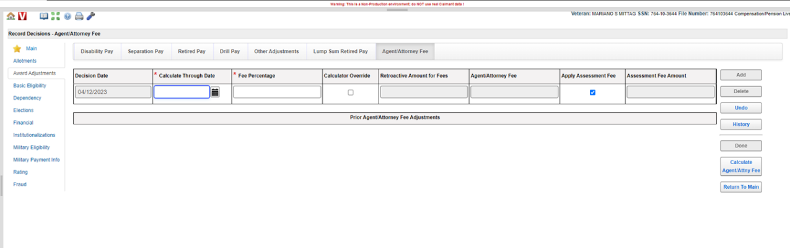  - AAFCs must enter all necessary award decisions (ex. Dependency, Basic Eligibility) prior to navigating to the Agent/Attorney Fee tab.  - Follow the steps below to initiate the fee calculation and deduction:  - from the Record Decisions page, click the Award Adjustments link  - click the Agent/Attorney Fee tab  - click Add  - add Calculate Through Date  - Note: The “Calculate Through Date” is the date of the decision that benefits are being calculated through, it is not the following day. For example, the user will enter April 26, 2023, if fees are due based on rating decision dated April 26, 2023.  - uncheck the Apply Assessment Fee check box if the assessment fee is not warranted  - Note: If the past-due benefits are based on the same rating, only one assessment fee of up to $100 is to be charged and deducted even if fees must be paid multiple times for different transactions (ex. dependency). Assessment fees are not warranted if the appeal is based on a Notice of Disagreement received on or before 6/19/2007.  - enter the Fee Percentage  - click Calculate Agent/Attrny Fee  - the system will generate the Retroactive Amount for Fees, the Agent/Attorney Fee, and the Assessment Fee Amount fields  - click Done.  - Completes the Agent/Attorney Fee Calculator and ensures the VBMS-A Automated Fee Calculator amount matches.  - If there is a discrepancy, the AAFC must complete the following steps:  - re-review all award lines and corresponding amounts to verify accuracy of the manual calculator  - enter an IT ticket documenting the issue  - email the AFC box:  - use subject line of “VBMS-A Calculator Ticket number”  - include the file number and IT ticket number  - include a screenshot of VBMS-A Agent/Attorney Fee tab  - attach a copy of the manual Agent/Attorney Fee Calculator  - select the Calculator Override box on the Agent/Attorney Fee tab in VBMS-A to manually edit the Retroactive Amount for Fees, the Agent/Attorney Fee (includes the assessment fee), and the Assessment Fee Amount matching the manual calculator.  - VSR AAFC generates the award.  - VSR AAFC routes the award and calculator to an SVSR AAFC for review.  - SVSR AAFC verifies accuracy, uploads the Agent/Attorney Fee Calculator, and authorizes the claimant’s award.  - SVSR AAFC will return the award and use deferral functionality in VBMS if corrections are required.  VBMS-A Automated Fee Calculator Additional Instructions  - The VBMS-A Automated Fee Calculator cannot be utilized for awards involving the following:  - entry of priors  - utilization of the generate award override (GAO) function  - use of pension protected rates, and  - unprocessed Cost of Living Adjustment (COLA) adjustments.  - The Calculator Override box must be selected to input the correct fee deduction amount in the cases listed above, and during other scenarios that would prohibit the automated calculation.  - AAFC must enter must utilize the manual Agent/Attorney Fee Calculator and upload it to the eFolder  - The following fields must be manually edited in VBMS-A to match the manual calculator: Retroactive Amount for Fees, the Agent/Attorney Fee (includes the assessment fee), and the Assessment Fee Amount  - The following types of cases require AAFCs to establish the fee deduction through finance activity; the VBMS-A Automated Fee Calculator and fee deduction functionality cannot be used:  - apportionments  - accrued awards  - restored entitlement program for survivors (REPS), and  - Chapter 18.  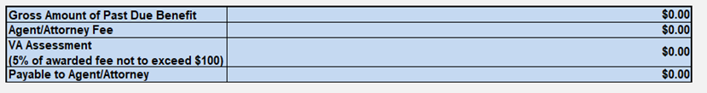  VBMS-A Automated Fee Calculator Field Name Manual Agent/Attorney Fee Calculator Field Name Description  Retroactive Amount for Fees Gross Amount of Past Due Benefit Amount of past-due benefits subject to fees calculated from the effective date of the award through the date of decision awarding benefits.  Agent/Attorney Fee Agent/Attorney Fee Amount of agent/attorney fee to include the assessment fee.  Assessment Fee Amount VA Assessment Amount of the assessment fee.
 | Important Reminders  - Any edits made to an existing Attorney Fee deduction within the Other Adjustments tab will not result in a new deduction of fees. The Other Adjustments tab will not be supported for agent/attorney fee deductions after April 23, 2023.  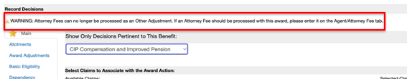  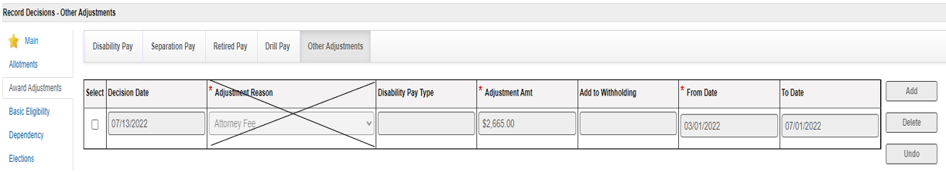
Last Updated:
April 2023

