**TABLE OF CONTENTS**

Rating Quality Review Specialist (RQRS) Quality Assurance Practicum Results 1

Character of Discharge (COD) Manual Updates 2

Citing Relevant Laws and Regulations 4

OAR Special Mission Workload Quality Fiscal Year (FY) 2022 6

# Rating Quality Review Specialist (RQRS) Quality Assurance Practicum (QAP) Results

**Target Audience:** Decision Review Operations Center (DROC) Management and Quality Review Teams (QRT)

**Presenter:** Tom Fryzel, Senior Management and Program Analyst, OAR

Between January 11, 2023, and January 13, 2023, OAR administered an RQRS QAP to assess RQRSs’ ability to properly utilize the RVSR Task Based Quality Review Checklist. The findings from this QAP include:

Compliance:

* OAR assigned this QAP to 40 RQRS.
* 36 completed this QAP.
* Compliance rate was 90%
* Compliance across the DROCs ranged from 76% to 100%
  + DROC DC: 11 out of 11 (100%)
  + St. Petersburg DROC: 13 out of 17 (76%)
  + Seattle DROC: 12 out of 12 (100%)

Overall Percentage of Perfect Scores:

* 25 of the 36 RQRS that completed the QAP made no errors in conducting a quality review of the simulated case file.
* Perfect score rate was 69%
* Percentage of Perfect Scores by DROC
  + Washington, DC, 82%
  + St. Petersburg, 77%
  + Seattle, 50%

OAR identified the following as the main cause of errors among the 11 RQRS who did not achieve a perfect score:

* 9 of 36 (25%), cited an error regarding inferred and/or ancillary issues
  + Back DBQ showed findings of decreased sensation to light touch at the lower leg/ankle bilaterally.
  + Muscle strength and reflex testing were normal.
  + The examiner was unable to perform straight leg raising test.
  + Symptoms were noted to include severe intermittent pain and moderate paresthesia and numbness.
  + Some decision makers or reviewers may interpret the evidence to align more closely with a mild degree of impairment, but the decision in this case to assign a 20% evaluation based on moderate impairment was within the decision maker’s leeway of judgment.
  + An evaluation based on a moderate degree of impairment is allowed for wholly sensory involvement.
  + The Board would assign 20% and cite 4.7.

# Character of Discharge (COD) Manual Updates

**Target Audience:** DROC Management, QRT, Decision Review Officers (DROs), Rating Veterans Service Representatives (RVSRs), and Veterans Service Representatives (VSRs)

**Presenter:** Suzi Ribish, Management and Program Analyst, OAR

**References:**

* M21-1 X.iv.1.A, *Character of Discharge and Bars to Benefits*
* M21-1 X.iv.1.B, *Special Topics Involving Character of Discharge*
* M21-1 X.v.1.C, *Administrative Decisions*

The manual was recently updated on February 2, 2023, in regard to COD concepts and principles. This topic was addressed in the February 2023 Compensation Service Quality Call as well.

The updates include:

* adding guidance on 38 U.S.C. 5303B COD determinations (requiring VA to make COD determinations when requested by a former service member who is not concurrently filing a claim for VA benefits)
* revising the COD determination template to add more instructions and to make the appearance of the template consistent with the administrative decision requirements in M21-1, X.v.1.C
* adding more guidance on favorable findings
* adding and clarifying instructions on treatment-only eligibility for certain former service members under 38 CFR 3.360
* adding guidance on administrative finality and finality applications involving COD determinations
* adding guidance on applying the presumption of regularity where advanced notice of a prior COD determination is not found in the record
* adding guidance on addressing the past failure to make a 38 CFR 3.360 determination
* clarifying the requirements for approval of COD decisions, and
* adding an instruction on uploading COD decisions in VBMS
* There are several updates OAR would like highlight that are particularly important for the DROCs to keep in mind while processing higher-level reviews.

**Favorable Findings in COD Determinations**

Language was added to the manual that further clarifies favorable findings, as they pertain to COD determinations in M21-1 X.iv.1.A.1.l, *Favorable Findings in the COD Determination*.

Only include favorable findings header when:

* The determination is unfavorable, and
* Favorable findings are made

Do not include favorable findings heading when:

* The decision is fully favorable, or
* Unfavorable, but no favorable findings

There are examples in the manual that discuss the scenarios that may apply regarding favorable findings. Specifically:

* When a determination is made that an OTH discharge was dishonorable for VA purposes due to a regulatory bar, but eligibility to health care was established under [38 CFR 3.360](https://www.ecfr.gov/current/title-38/chapter-I/part-3/subpart-A/subject-group-ECFR6477ad08d327384/section-3.360), the fact that no provision of [38 CFR 3.12(c)](https://www.ecfr.gov/current/title-38/chapter-I/part-3/subpart-A/subject-group-ECFRf5fe31f49d4f511/section-3.12) applies is a favorable finding, OR
* When multiple[38 CFR 3.12](https://www.ecfr.gov/current/title-38/chapter-I/part-3/subpart-A/subject-group-ECFRf5fe31f49d4f511/section-3.12) bars were considered, and one was proven, the bases for concluding the other bar(s) could not be established are favorable findings.

**Revisions of Prior COD Determinations – M21-1 X.iv.1.A.1.q.**

When a former service member files a claim for benefits, claims processors must review the file for any prior final COD determination made in accordance with the same criteria and based on the same facts – regardless of whether the filing specifically alludes to a prior COD determination or attaches evidence.

If a prior COD determination was made in connection with a claim and did not address [38 U.S.C. Chapter 17](https://www.law.cornell.edu/uscode/text/38/part-II/chapter-17) eligibility, a new COD determination addressing only that sub-issue is required.

If a prior COD determination was previously made regarding basic eligibility from the period of service underlying the current claim, do not make another COD determination unless:

* new and relevant evidence changes the prior determination
* the prior determination contained a CUE, or
* there was as change in law that provides a new basis for entitlement.

When no change in the prior decision is justified, complete a VA Form 21-0961 documenting the determination in the REMARKS section of the form.

* If late flowing evidence is received, or the claimant submits new and relevant evidence, list the evidence, and state that it was considered but did not change the prior COD determination (make sure to specify the date of the prior determination).
* If a CUE was asserted but not found, briefly explain the determination that no CUE was found.
* Generate a decision notice that meets the requirements expressed in [M21-1, Part VI, Subpart i, 1.B](https://vaww.vrm.km.va.gov/system/templates/selfservice/va_kanew/help/agent/locale/en-US/portal/554400000001034/content/554400000179469/M21-1,-Part-VI,-Subpart-i,-Chapter-1,-Section-B---Decision-Notices).

# Citing Relevant Laws and Regulations

**Target Audience:** DROC Management, QRT, DROs, RVSRs, and VSRs

**Presenter:** Bryan Yost, Program Analyst, OAR

**References:**

* 38 C.F.R. §3.103(f), *Notification of decisions*
* M21-1 V.iv.1.A.5.a, *Purpose of the Reasons for the Decision*
* M21-1 VI.i.1.B.1.b, *Decision Notice Requirements*
* M21-5 7.D.3.b, *Purpose of an SOC*

The pertinent part of 3.103(f) notes that: Written notification must include in the notice letter or enclosures, or a combination thereof, eight specific elements. One of which, is a summary of the laws and regulations applicable to the claim.

OAR Program Administration previously provided a presentation on citing relevant laws and regulations during the November 2020 Quality Call. We recently received a request to revisit the topic as it was perceived that some decision makers were providing numerous irrelevant citations of regulations in their decisions to avoid missing a pertinent regulation and/or avoid receiving a quality error.

There have not been any substantial changes to the policies or procedures relating to this topic since it was previously presented, however, we are readdressing the issue for emphasis and clarity.

Employees should avoid citing laws and regulations that are not relevant to the issue under decision.

The previous guidance ordered that listing too many, or, irrelevant laws and regulations should not be cited as an error, however, the QRS should provide a comment to the employee. As such, DROC Quality Reviewers should not cite an error under Question 9 on the Task Based Quality Review Checklist. DROCs Quality Reviewers will also refrain from providing comments related to listing too many, or irrelevant laws and regulations since the task-based review checklists used by the DROCs does not provide a relevant descriptor in Question 12.

OAR Compliance Staff may continue to provide comments regarding this issue as the National Compensation/Pension Rating Quality Review Checklist for National reviews, Special Focused Reviews, and Special Mission Reviews does provide a catch-all for comments under Question 16 noting: Were Rating Comments correct (for the EP under review)?

A review of the national quality review data for the last fiscal year shows a low instance of error calls that are directly related to the citation of relevant laws and regulations. Most of the cited errors for missing regulations were related to missing 38 CFR § 3.2500 regarding effective dates based on supplemental claims or related to failures to use the appropriate system generated text.

Employees should continue to use the evaluation builder and canned text in VBMS-R, as most of the generated text within the system already includes the applicable laws and/or regulations.

# OAR Special Mission Workload Quality Fiscal Year (FY) 2022

**Target Audience:** DROC Management and QRT

**Presenter:** Chelsey Kondrak, Senior Management and Program Analyst, OAR

OAR conducts quality reviews of higher-level review (HLR), HLR Return, and legacy appeals special mission workload processed at the Seattle DROC and the designated special mission stations to determine whether actions taken by claims processors are compliant with statutory, regulatory, and procedural requirements. These reviews help to identify gaps in performance to realign resources, inform training needs, and address identified areas of improvement. Specifically, OAR reviewed a random sample of 120 rating special mission HLR and HLR Return claims, and legacy appeals, to include Camp Lejeune Contaminated Water (CLCW), foreign, restricted access (RACC), and radiation, completed during FY 2022.

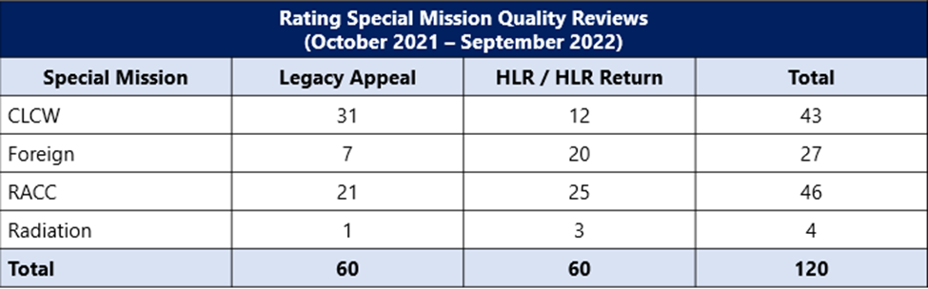

OAR, in coordination with the Office of Field Operations (OFO), identified and realigned special mission workloads to the Seattle DROC during FY 2022.

* Specifically, OAR and OFO realigned foreign and Manila legacy appeals and higher-level review (HLR) development, rating, and post cycle workloads to the Seattle DROC effective July 5, 2022.
* In addition, OAR and OFO realigned CLCW and radiation legacy appeals and HLR rating and post cycle workloads to the Seattle DROC effective August 22, 2022.
* These transitions include the following end products (EP): 070, 170, 030, and 040 (HLR Duty to Assist Errors, Difference of Opinions, and Appeals Modernization Act (AMA) Board Remands).

**Station Completions**

For FY 2022, OAR reviewed 46 RACC, 43 CLCW, 27 foreign, and 4 radiation special issue claims and appeals.

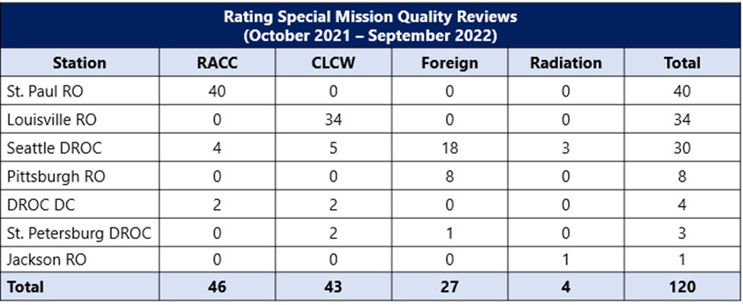

**Rating Special Mission Error Categories**

The OAR rating special mission claim-based accuracy rate for FY 2022 is 84.2%. A total of 19 unique claims and appeals under review contained 24 benefit entitlement (BE) errors.

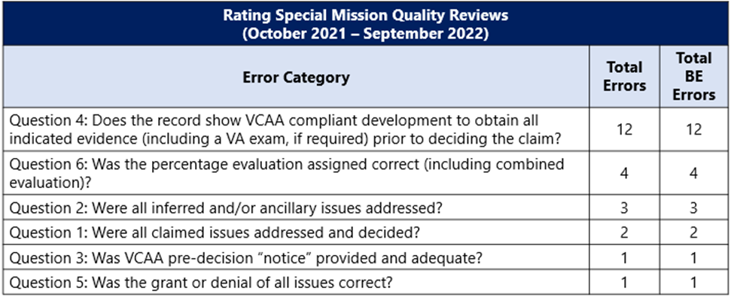

OAR identified the following error trends:

* Twelve BE errors cited under Question 4 for failing to obtain sufficient VA examinations and/or medical opinions, failing to develop for VA treatment records, failing to comply with the Board remand in accordance with *Stegall v. West*, and failing to complete special issue development related to contaminated water at Camp Lejeune.
  + Of the 12 BE errors cited under Question 4, OAR cited 1 error each against DROC DC and the Louisville Regional Office during Quarter 1 (Q1). OAR cited 3 errors under Question 4 against the Louisville Regional Office and 2 errors against the St. Paul Regional Office during Q2. During Q3, OAR cited 2 errors against the Louisville Regional Office, 1 error against the St. Paul Regional Office, and 1 error against the Pittsburgh Regional Office.
  + The Regional Offices and the DROCs showed significant improvement during FY 2022, Q4.
  + OAR cited only 1 BE error under Question 4 against the Louisville Regional Office for failure to request a subject matter expert medical review and opinion. The Veteran claimed diagnosed disabilities were due to contaminated water at Camp Lejeune, and the Veteran’s personnel records confirm service at Camp Lejeune during the contamination period. Therefore, the Decision Review Officer (DRO) should have issued an HLR Return to identify a duty to assist error for failure to request a medical opinion when warranted.
* Four BE errors cited under Question 6 for failing to assign correct percentage evaluations.
  + OAR cited 3 errors under Question 6 for FY 2022, Q1 and 1 error under Question 6 for FY 2022, Q3.
  + OAR did not identify any error trends specific to a station assigning incorrect percentage evaluations as OAR cited all errors under Question 6 against different stations for FY 2022.
* Four non-critical errors cited under Question 9 for failing to include evidence that was the basis for the decisions and failing to address the legal basis for the award (e.g., secondary service connection).
  + OAR cited 2 non-critical errors under Question 9 against the Louisville Regional Office for FY 2022, Q2 and Q4.
  + OAR also cited 1 non-critical error under Question 9 against the Seattle DROC for FY 2022, Q2 and 1 non-critical error against the Jackson Regional Office for FY 2022, Q1.

**Remediation Efforts**

Remediation Effort 1: OAR, in collaboration with OFO, will release a reminder to the special mission stations and the DROCs on which stations maintain jurisdiction of special mission workload and corresponding cycles.

Remediation Effort 2: OAR will present the findings and analyses on the special mission quality reviews on a monthly OAR Quality Call.

During FY 2023, OAR continues efforts to reduce and eliminate DTA errors, specifically those related to exams and medical opinions. OAR is working to implement the following initiatives:

* Establish a “Remand Tiger Team” between OAR and the Board to quickly address clarification requests of Board decisions, error trends, and to identify additional remediation efforts. Creation of this team will allow for the following:
  + Increased visibility for most DTA errors
  + Increased identification of remediation efforts
  + Improved accuracy and timeliness of Board remands
* Increase collaboration between OAR, Medical Disability Examination Office (MDEO), and the Board regarding examination and medical opinion requests. This increased collaboration will allow for the following:
  + Increased accuracy and sufficiency of examinations and medical opinions
  + Decreased DTA errors