**TABLE OF CONTENTS**

Seattle Decision Review Operations Center (DROC) Quality Error Trend Findings 1

ST. Petersburg DROC Quality Error Trend Findings 2

DROC DC Quality Error Trend Findings 4

July 2022 OAR Authorization Quality Review Specialist (AQRS) Quality Assurance Practicum (QAP) Results – Character of Discharge (COD) 5

# Seattle Decision Review Operations Center (DROC) Quality Error Trend Findings

**Target Audience:** Decision Review Operations Center (DROC) Management and Quality Review Teams (QRT), Decision Review Officers (DRO), Rating Veterans Service Representatives (RVSR), Veterans Service Representatives (VSR), and Claims Assistants (CA)

**Presenter:** David Jones, Coach, Seattle DROC

The Seattle DROC reviews error trends each month for the prior month. Normally, the review occurs during the 3rd week of the month. The goal of the reviews is to identify errors and the frequency of those errors. The DROC then develops and provides error training in TMS to the division. The following chart demonstrates the top three errors cited for each position, the task, and the number of errors for each task.

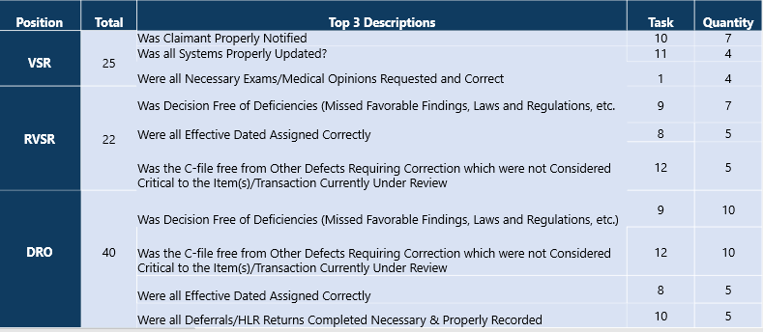

The next chart reflects the top error called for each position for the last three months. The three-month analysis allows the DROC to identify division training needs by position.

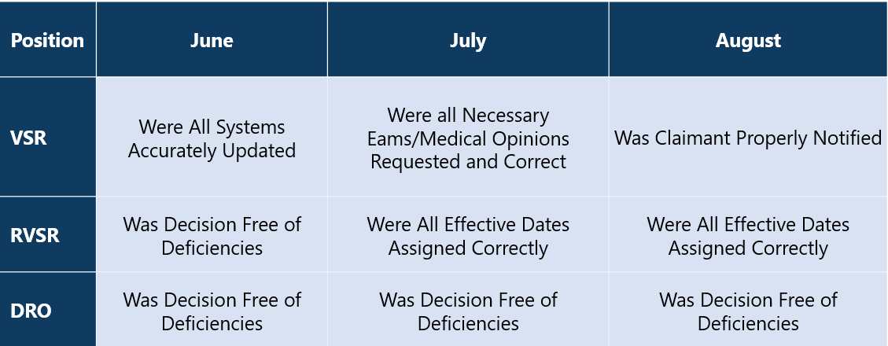

The above chart demonstrates that missed favorable findings, laws and regulations is the trending area of concern for DROs and warrants continued training. Correct effective dates is a trending area of concern for RVSRs. There are no areas currently rending for VSRs.

# ST. Petersburg DROC Quality Error Trend Findings

**Target Audience:** DROC Management and QRT, DROs, RVSRs, VSRs, and CAs

**Presenter:** Nathaniel Unroe, RVSR, St. Petersburg DROC

St. Petersburg DROC conducts Individual Quality Reviews (IQRs) of claims processed by Decision Review Officers (DROs), Rating Veterans Service Representatives (RVSRs), Veteran Service Representatives (VSRs), and Claims Assistants (CAs) within the DROCs.

St. Petersburg DROC IQRs seek to determine whether actions taken by claim processors are compliant with statutory, regulatory, and procedural requirements to identify error trends and address identified areas of improvement.

St. Petersburg DROC reviewed a sample of 713 errors for FY22 May through August to identify trends.

* St. Petersburg DROC reviewed a total of 434 compensation rating quality reviews.
* St. Petersburg DROC reviewed a total of 279 compensation authorization quality reviews.

**St. Petersburg DROC DRO/RVSR FY 22 May through August Top Errors Summary**

St. Petersburg DROC identified “The decisionmaker did not properly identify or document favorable findings” under Task 9 as a top error trend. This error accounted for approximately 14% of all errors cited. Most of the errors are related to a failure to properly consider all specific material elements met that are required to grant the benefit sought. This error has remained the top called error through FY 22.

St. Petersburg DROC identified “Effective date equal to DOC was not applied or was applied inappropriately” under Task 8 as a top error trend. This error accounted for approximately 7% of all errors cited.

Most of the errors are related to a failure to properly consider continuous pursuit of a benefit sought. Remediation reduced this error by 4% in August 2022.

St. Petersburg DROC identified “A condition or conditions were under-evaluated” under Task 7 as a top error trend. This error accounted for approximately 7% of all errors cited.

Most of the errors are related to a failure to review for staged evaluations and a failure to use the Evaluation Builder. Remediation reduced this error by 4% in August 2022.

St. Petersburg DROC provided Targeted Error Trend Training on favorable findings, effective dates, and proper evaluations in July 2022 and August 2022.

**St. Petersburg DROC VSR FY22 May through August Top Errors Summary**

St. Petersburg DROC identified “Were all necessary examinations/medical opinions requested, and correct” under Task 5 as a top error trend. This error accounted for approximately 34% of all errors cited. Most of the errors are related to a failure to properly identify and include pertinent information such as evidence to review and/or sending the claims folder.

St. Petersburg DROC identified “Were all systems accurately updated” under Task 11 as a top error trend. This error accounted for approximately 32% of all errors cited. Most of the errors are related to a failure to properly enter and update tracked items for all requested evidence.

St. Petersburg DROC identified “Was proper pre-decisional notification provided and/or was proper development to the Veterans/claimant completed as required by regulations and/or the manual” under Task 1 as a top error trend. This error accounted for approximately 15% of all errors cited. Most of the errors are related to a failure sent a supplemental development letter to the Veteran/claimant as required.

St. Petersburg DROC routinely provided targeted Q-Tips to address the noted deficiencies.

**St. Petersburg DROC CA FY22 May through August Top Errors Summary**

St. Petersburg DROC identified “Did CA take correct actions to update systems to allow complete tracking and routing of claims and benefits” under Task 3 as a top error trend. This error accounted for approximately 23% of all errors cited. Most of the errors are related to a failure to properly input and update contentions and tracked items when required.

St. Petersburg DROC identified “Did the CA correctly determine that a new end product control was needed, and, if so, did CA establish it correctly” under Task 2 as a top error trend. This error accounted for approximately 8% of all errors cited. Most of the errors are related to “an EP was not required and/or not established based upon the packet or other assignment under review”.

St. Petersburg DROC identified “Were any and all other necessary CA actions taken, and taken correctly” under Task 4 as a top error trend. This error accounted for approximately 5% of all errors cited. Most of the errors are related to a CA establishing the incorrect End Product.

St. Petersburg DROC provided targeted training in August 2022 regarding Legacy EPs and actions.

# DROC DC Quality Error Trend Findings

**Target Audience:** DROC Management and QRT, DROs, RVSRs, VSRs, and CAs

**Presenter:** Jamie Smith, Coach, DROC DC

**August 2022 CA and VSR Error Trends**

There were no error trends noted for CAs during the month of August. The main error trend during the month of August for VSRs was regarding examinations. Nineteen errors were cited for VSRs under Task 5 (Were all necessary examinations and medical opinions requested, and correct?). The DROC provided training during the month of August to remediate this issue via the following training courses:

* Examinations and Medical Opinions (VA 4557891)
* Increase Examination and Secondary Opinion (VA 4560224)
* CPO: VA Examinations (VA 4556866)
* Exam Management System Enhancement Training (VA 4619022)

**August 2022 RVSR and DRO Error Trends**

The main error trend during the month of August for RVSRs was regarding examinations. Three errors were cited for RVSRs under Task 4 (Were all necessary examinations and medical opinions requested and sufficient?). The DROC provided training during the months of August and September to remediate this issue via the following training courses:

* DBQ and Requesting Medical Opinions (VA 4201874)
* Review of VA Medical Examinations (VA 1559310)

The main error trend during the month of August for DROs was regarding examinations. Six errors were cited for DROs under Task 4 (Were all necessary examinations and medical opinions requested and sufficient?). The DROC provided training during the months of August and September to remediate this issue via the following training courses:

* DBQ and Requesting Medical Opinions (VA 4201874)
* Review of VA Medical Examinations (VA 1559310)

**August 2022 End Product (EP) 040 Favorable Findings Error Trends**

DROC DC conducted 57 In-Process Reviews (IPR) on 040 EPs completed by RVSRs during the month of August. The DROC identified 19 errors during review and 47% of the errors related to the failure to include favorable findings. The DROC conducted a training session during the month of September to remediate this issue. During that session, the QRT discussed the IPR findings. The QRT also provided reminders and answered questions submitted by RVSRs.

# July 2022 OAR Authorization Quality Review Specialist (AQRS) Quality Assurance Practicum (QAP) Results – Character of Discharge (COD)

**Target Audience:** DROC Management and QRT

**Presenter:** Suzanne Ribish, Management & Program Analyst, OAR Program Administration

**Snapshot of Results**

Between July 12 and July 15, 2022, OAR administered a practicum on the topic of Character of Discharge (COD) to 33 AQRSs at the three DROCs.

The July 2022 AQRS QAP included one simulated electronic case file with specific factual considerations and details designed to mirror a typical case that AQRSs would receive on the job. To complete the practicum, participants reviewed the case file to determine if the case demonstrated any processing errors.

* There was a 76% compliance rate for participation (25 AQRSs completed the practicum).
* 16% of AQRSs made no errors in reviewing the practicum case file.
* 84% of AQRSs made errors in reviewing the practicum case file. The most common error was for failure to recognize that the conditional periods of service were not calculated correctly in the simulated file.

**QAP Questions and Correct Response Rates**

The following chart demonstrates the correct response rate for each question asked in the QAP.

The most common error identified among the 21 (84%) AQRSs who did not achieve a perfect score was failing to recognize that the conditional periods of service were not calculated correctly. Thirteen (52%) of the participating AQRSs provided an incorrect response.

|  |  |  |
| --- | --- | --- |
| Question Number | Question | Correct Response Rate |
| 1 | Are any error(s) present in Section 1 of the Administrative Decision? | 68% |
| 2 | Are the conditional periods of service calculated correctly? | 48% |
| 3 | Is 38 CFR 3.12(d)(4) the correct bar applied to the dishonorable period of service? | 80% |
| 4 | If the correct bar was not applied to the dishonorable period of service, what is the correct bar? | 95% |
| 5 | Are any error(s) present in Section 4 of the Administrative Decision? | 64% |
| 6 | If an error is present in Section 4, what is the error? | 63% |

**Conditional Discharge Scenario**

We will now examine the information posed during the QAP, as it pertains to the issue of conditional discharges.

The DD Form 214 contained the following information:

* Department: Army
* Entered Active Duty: September 21, 1981
* Released from Active Duty: May 7, 1985

The enlistment contracts reflected the following:

* Initial enlistment contract dated September 21, 1981 for a period of 3 years, 0 months, and 0 days
* Reenlistment contract dated June 28, 1982 for a period of 4 years, 0 months, and 0 days

The conditional periods in the administrative decision were listed as:

* September 21, 1981, to June 28, 1982, and
* June 29, 1982, to May 7, 1985

Question 2 of the QAP stated: “Are the conditional periods of service calculated correctly?”

* 52% of respondents answered “Yes”
* 48% of respondents answered “No” (correct answer)

**Determining Dates for Conditional Discharge**

When determining the dates of service for a conditional discharge, it is necessary to know the length of each enlistment contract the claimant signed.  An example will be presented at the end of this topic, which will highlight the importance of locating the enlistment contracts rather than relying on dates provided on the DD Form 214.

Dates of faithful and meritorious service are calculated by:

* adding the full length of the first enlistment contract to the claimant’s entry into service date, thus calculating the date the individual ***would*** have completed his first period of obligation and would have been discharged, then
* adding the full length of the next enlistment contract to the date determined above, thus calculating the next date that the individual would have completed his period of obligation and would have been discharged, then
* continuing to add the full length of each enlistment contract to the date determined above, until no more enlistment contract periods remain.

Many times, DD Form 214s do not have date ranges that are reflective of the time frames that take into consideration the full enlistment contract period.

We will now move onto the QAP example, in order to demonstrate calculations of conditional periods.

**QAP Date Calculation**

Calculation of conditional discharge periods:

* To calculate the first conditional discharge period, we take the claimant’s entry into service date and add the full length of the first enlistment contract. Adding 3 years to September 21, 1981 results in a period of September 21, 1981, to September 20, 1984.
  + Period one: EOD of September 21, 1981, + 3-year contract
  + Result: September 21, 1981, to September 20, 1984
* To calculate the second conditional discharge period, we take the day following the end of period one, September 21, 1984, and since the claimant did not serve their full 4-year reenlistment contract, the end date would be their final discharge date, resulting in a period of September 21, 1984, to May 7, 1985.
  + Period two result: September 21, 1984, to May 7, 1985