**Table Of Contents**

Board of Veterans’ Appeals (Board) Decisions Targeted Program Review (TPR) 1

Favorable Findings Refresher 5

Draft Rating Approval (DRA) Overview 8

Entering Comments into Quality Management System (QMS) Error Records 18

# Board of Veterans’ Appeals (Board) Decisions Targeted Program Review (TPR)

**Target Audience:** Decision Review Operations Center (DROC) Management, Quality Review Teams (QRT), Decision Review Officers (DRO), Rating Veterans Service Representatives (RVSR), and Veterans Service Representatives (VSR)

**Presenter:** Suzi Ribish, Management and Program Analyst (MPA), Office of Administrative Review (OAR) Program Administration (PA)

**Background and Purpose**

OAR’s PA Staff conducted a TPR on the clarification requests submitted by DROC employees on Appeals Modernization Act (AMA) and Legacy Appeal Board decisions. OAR sought to analyze and identify areas of improvement for the DROCs and the Board to ensure accurate claims and appeals processing. OAR and the DROCs’ utilization of the VBA Feedback Loop SharePoint site allowed for the availability of data pertaining to clarification requests on Board decisions.

**VBA Feedback Loop SharePoint Site**

The VBA Feedback Loop SharePoint Site is a feedback system used to:

* + Ensure VBA is appropriately addressing duty to assist (DTA) errors Veterans Law Judges (VLJ) identify in decisions.
  + Confirm Board Remand return reasons relate only to a DTA error that occurred prior to an initial decision on a claim as prescribed in the AMA and the Veterans Administration (VA) regulations.
  + Communicate and track discrepancies and clarification requests resulting from Legacy Appeal Board decisions.

While OAR and the DROCs utilize the VBA Feedback Loop SharePoint site for tracking and communicating discrepancies and clarification requests pertaining to AMA and Legacy Appeal Board decisions, OAR continues to send requests for clarification to the Board via email at their request.

OAR reviewed data from the VBA Feedback Loop SharePoint site as well as email communications between OAR and the Board.

**Fiscal Year (FY) 2021 Clarification Requests by Station**

During fiscal FY 2021, stations submitted 77 requests for clarification of a Board decision to OAR.

DROC DC submitted 61% (47) of the requests to OAR. St. Petersburg DROC submitted 22% (17), and Seattle DROC submitted 16% (12) of the requests for clarification of a Board decision to OAR.

While OAR limited access to the VBA Feedback Loop SharePoint site to the DROCs, OAR received 1% (1) of the requests for clarification of a Board decision from the Little Rock Regional Office.

**FY 2021 OAR Concurred Decisions**

Of the 77 requests received during FY 2021, OAR concurred on 60% (46) of the inquiries and submitted those to the Board for their review and action.

The top reason for requesting clarification of a Board decision, and that was concurred on by OAR, was for incorrect evaluations of issues. Incorrect evaluations accounted for 30% (14) of OAR concurred reasons for clarification requests for the Board.

Incorrect directives accounted for 22% (10) of OAR concurred reasons for clarification requests for the Board. An example of an incorrect directive involves the Board directing VBA to issue a Statement of the Case (SOC) for entitlement to restoration of a 60 percent rating for status post right knee arthroplasty from August 28, 2012; however, the Veteran was already rated for this condition from this date.

In addition, the stations submitted, and OAR concurred on, 15% (7) of clarification requests for the Board because of discrepancies with effective dates.

**FY 2021 Board Concurred Decisions**

Of the 46 requests for clarification of a decision OAR sent to the Board during FY 2021, the Board concurred on 14 cases.

The length of time for the Board to provide concurrence was approximately 122 days.

The Board non-concurred on 10 cases. It took an average of 96.5 days for the Board to provide non-concurrence.

The Board did not respond to 22 requests for clarification.

**FY 2021 OAR Non-Concurred Decisions**

Of the 77 clarification requests received from the DROCs during FY 2021, OAR non-concurred on 40% (31) of inquiries and returned them to the DROCs to continue processing the claims and appeals.

During FY 2021, the top reason for requesting clarification of a Board decision, and upon which OAR non-concurred, was for reevaluation of the Board decision. Of the OAR non-concurred clarification requests, 55% (17) of the requests for the Board was for reevaluation of the Board decision. DROC DC submitted the greatest number of these requests at 53% (9), and Seattle and St. Petersburg DROCs each submitted 24% (4) of these types of requests.

The category of miscellaneous accounted for 19% (6) of OAR non-concurred reasons for clarification requests. Examples of clarification requests identified as miscellaneous include the following: inquiry pertaining to newly added Agent Orange (AO) presumptive issues and inquiry pertaining to attorney fees and drill pay.

In addition, the DROCs submitted, and OAR non-concurred on, 10% (3) of the clarification requests for the Board because the requests asked the Board to provide effective dates. DROC DC submitted 2 of these requests, and Seattle DROC submitted 1 of these requests.

**Fiscal Year 2022 To Date (FYTD 2022) Clarification Requests by Station**

For FYTD 2022, the DROCs submitted 84 requests for clarification of a Board decision to OAR.

DROC DC submitted 52% (44) of the requests to OAR. St. Petersburg DROC submitted 26% (22), and Seattle DROC submitted 21% (18) of the requests for clarification of a Board decision to OAR.

**FYTD 2022 OAR Concurred Decisions**

Of the 84 requests received during FYTD 2022, OAR concurred on 44% (37) of the inquiries and submitted those to the Board for their review and action.

The top reasons for requesting clarification of a Board decision, and upon which OAR concurred, were for incorrect directives and incorrect evaluations of issues.

Incorrect directives accounted for 32% (12) of OAR concurred reasons for clarification requests for the Board. An example of an incorrect directive involved the Board granting entitlement to service connection for radiculopathy of the left lower extremity. However, a decision maker granted this condition in a prior rating decision, and therefore, the Board erroneously addressed this issue.

Incorrect evaluations accounted for 27% (10) of OAR concurred reasons for clarification requests for the Board.

In addition, the DROCs submitted, and OAR concurred on, 19% (7) of clarification requests for the Board because of discrepancies with effective dates.

**FYTD 2022 Board Concurred Decisions**

Of the 37 requests for clarification of a decision, the Board concurred 2 times. 34 remaining inquiries await a response from the Board.

For FYTD 2022, the Board provided concurrence on clarification requests in an average of 91 days.

**FYTD 2022 Board Non-Concurred Decisions**

Of the 37 requests for clarification of a decision OAR concurred on during FYTD 2022, the Board non-concurred on 1 request.

The length of time for the Board to provide the non-concur response was 40 days.

**FYTD 2022 OAR Non-Concurred Decisions**

Of the 84 clarification requests received from the DROCs, OAR non-concurred on 56% (47) of the inquiries and returned those to the DROCs to continue processing the claims or appeals.

The top reason for requesting clarification of a Board decision, and upon which OAR non-concurred, was related to the evaluation. Requests pertaining to the evaluation of a condition accounted for 23% (11) of OAR non-concurred reasons for clarification requests.

Requests for the Board to reevaluate its decision accounted for 21% (10) of OAR non-concurred reasons for clarification requests.

Miscellaneous accounted for 17% (8) of OAR non-concurred reasons for clarification requests. An example of miscellaneous is failure of the DROC to provide all needed information pertaining to the clarification request.

**Remediation**

The DROCs continue to submit requests for clarification of Board decisions to OAR for review and concurrence via the VBA Feedback Loop SharePoint site.

Furthermore, OAR continues to submit reviewed and concurred requests for clarification of Board decisions to the Board via email communications.

While utilization of the SharePoint site allows for improved submission and tracking of requests as the SharePoint site is a centralized point of intake for requests, a permanent solution involving the Board is still needed that would enable more accurate submissions and tracking.

OAR acknowledges use of the SharePoint site and emails presents challenges by being time consuming when entering required detailed information in the site and in emails.

The SharePoint site currently does not allow for automatic tracking of more specific details for why clarification may be needed for a Board decision.

Communications with the Board via email also create challenges as it is difficult to track the timeliness of responses for clarification requests as the tracking must be done manually.

Based on review and analysis of the findings outlined, OAR provides four remediation efforts to improve the accuracy and timeliness of Board clarification requests, reduce erroneous clarification requests, and improve the accuracy and timeliness of claims and appeals.

* **Remediation 1:** OAR PA Staff will present during an OAR Quality Call, as well as a QRT Management Call, a summary of this TPR report and specifically the reasons OAR and the Board non-concurred on requests for clarification of Board decisions from the DROCs.
* **Remediation 2:** OAR will utilize this TPR report to collaborate with the Board regarding remand clarification requests and ensure consistency in understanding remand compliance across the Board and VBA.
* **Remediation 3:** OAR Leadership will submit a formal request for the Board to coordinate with VBA and OAR on a permanent technical solution for submitting and tracking Board decision clarification requests.
* **Remediation 4:** OAR Leadership will submit a formal request for the Board to coordinate with VBA and OAR on clarification timeliness goals.

# Favorable Findings Refresher

**Target Audience:** DROC Management, QRTs, DROs, RVSRs, and VSRs

**Presenter:** James Fogg, Program Analyst, OAR PA

**References:**

* 38 C.F.R. §3.103(f)(4), *Notification of decisions*
* 38 C.F.R. §3.104(c), *Favorable findings*
* M21-1 V.iv.1.A.5.a, *Purpose of the Reasons for Decision*
* M21-1 V.iv.1.A.5.f, *Definition: Favorable Finding*
* M21-1 V.iv.1.A.5.g, *Requirement to Notify Claimant of Favorable Findings*
* M21-1 V.iv.1.A.5.h, *Addressing Favorable Findings in the Rating Narrative*
* M21-1 X.ii.1.A.2, *Favorable Findings*
* OAR Quality Call Bulletin November 2021

**Documenting Favorable Findings**

The AMA requires VA to address any findings made by an adjudicator that are favorable to the claimant in each notice of a decision affecting benefits.

This requirement applies to decision notices issued on or after February 19, 2019.

38 C.F.R. §3.104(c) defines a favorable finding as a conclusion either on a question of fact or on an application of law to facts made by an adjudicator concerning the issue(s) under review.

Favorable findings relate to a material element that would be required to grant the benefit sought and should be specific.

A favorable finding informs the claimant of any material element that was met, despite the denial.

When documenting favorable findings,

* Clearly identify the material element found to be met such as:
  + Incurrence (relationship to service)
  + Nexus
  + Diagnosis
  + Presumptions (e.g., exposure to herbicides, chemical, radiation, etc.)
* Briefly state the evidence used to support the finding (only include the most relevant and recent evidence of record).

**Addressing Favorable Findings in Rating Narrative**

The following information is a guide for decision makers in determining how to properly address and document favorable findings in the rating decision narrative. (M21-1, V.iv.1.A.5.h.)

If awarding the claim, then decision makers should rely on system-generated grant language automated by Veterans Benefits Management System-Rating (VBMS-R) Disability Decision Information (DDI) screen entries and selections.

If denying the claim, then decision makers must add and save individual entries for each finding that was favorable to the claimant, if any, using the Favorable Findings screen under VBMS-R’s Issue Management tab.

If increasing, reducing, or continuing an existing evaluation, then decision makers should rely on system-generated language automated by evaluation builder entry and selections.

Note: Pursuant to M21-1, V.iv.1.A.5.a., rating decisions for survivor benefits need only document favorable findings in accrued cases involving disability compensation.

**Important Reminder**

During FY 2021, failure to address favorable findings related to presumptive theory of service connection was the most cited favorable findings error trend at the DROCs. For the first part of FY 2022, this category was the third most cited favorable findings error trend at the DROCs.

If denying the claim, then the Reasons for Decision must address:

* + theory of service connection being addressed in the decision, if applicable, and
  + findings favorable to the claimant, if any.

If the rating decision addressed multiple bases of service connection and/or denial reasons, then the decision maker must add relevant text to the rating narrative to discuss the favorable findings relative to each claimed and reasonably raised theory of service connection.

When denying entitlement to the benefit sought, the Rating Decision is only required to address the claimed theory of service connection and those reasonably raised, along with any favorable findings applicable only to the claimed theory and those reasonably raised.

It is not an error if the rating narrative includes accurate favorable findings inapplicable to the theory(ies) of entitlement being addressed in the rating narrative. However, failure of the decision maker to provide accurate favorable findings when denying the claim is an error.

**Overturning Favorable Findings**

During FY 2021, failure to address prior favorable findings, to include bringing favorable findings forward or overturning favorable findings, was the second most cited favorable findings error trend at the DROCs. For the first part of FY 2022, this category was the first most cited favorable findings error trend at the DROCs.

Pursuant to 38 C.F.R. §3.103(f)(4) and 38 C.F.R. §20.801(a)), any favorable finding made by either a VA adjudicator or by the Board is binding on all subsequent adjudicators, unless rebutted by clear and unmistakable evidence to the contrary.

In accordance with M21-1 X.ii.1.A.2.b., to overturn a prior favorable finding, there must be clear and unmistakable evidence to rebut the favorable finding.

The clear and unmistakable rebuttal standard may be satisfied by a finding that the evidentiary record as a whole completely lacks any plausible support for the favorable finding.

For example, we established the Veteran had been diagnosed with hypertension previously, but we denied it.  Upon review of a claim for hypertension, it is found the Veteran did not have hypertension at all, but instead had pre-hypertension.

**Additional Resources**

In addition to reviewing the information within the September 2022 OAR Quality Call Slides and this Bulletin, we encourage employees to review these additional resources that have relevant information on favorable findings.

* VBMS Rating User Guide
* VBMS Job Aid – VBMS-R: Favorable Findings
* *Appeals Modernization Act (AMA) Frequently Asked Questions*
* *Rating Improved Decision Notices – Module 3: Favorable Findings (TMS #: 4623162)*

# Draft Rating Approval (DRA) Overview

**Target Audience:** DROC Management, QRT, DROs, and RVSRs

**Presenter:** Max Estrada, Rating Quality Review Specialist, St. Petersburg DROC

**References:**

* M21-1 V.iv.1.B.7, *Signature*
* Draft Rating Approval Job Aid

**DRA Background**

The DRA is a new format to review and second sign rating decisions requiring second and third signatures. VBA created the DRA to improve the second signature process and eliminate the use and attachment in VBMS of VA Form 21-0961 for electronic signatures. VBA added a new tab in VBMS-R which allows users to include a second and third signature on the rating decision codesheet, eliminating the requirement of attaching an additional second signature form to the decision. This process started in July 2022.

**Accessing DRA Within VBMS-R**

The Decision Maker accesses the new second signature process via VBMS-R. The Decision Maker will use this process for Rating Decisions requiring second and third signatures

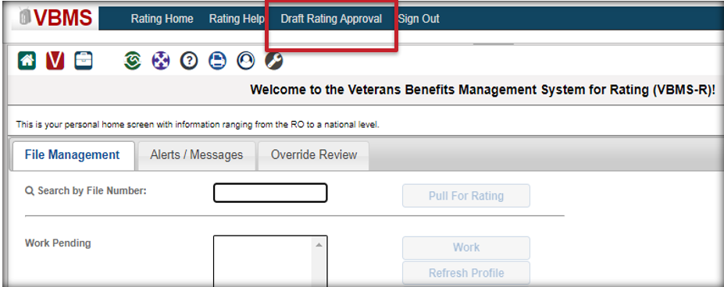

**How to Submit a Draft Rating**

The DRA Review begins at the Document tab in Ratings, prior to selecting the Finalize button. The Decision Maker will have the option to skip the additional review and finalize the Rating or answer “Yes” to the above question and determine which levels of review are needed.

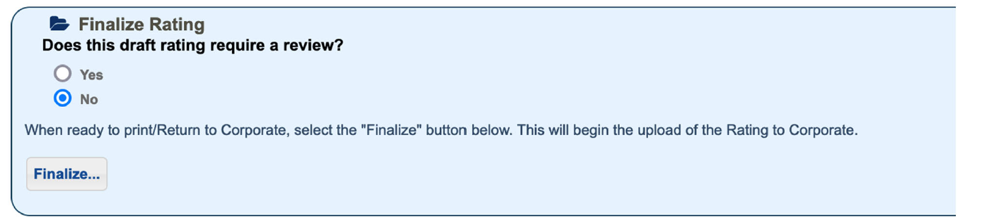

The Decision Maker will then select “Second Level Review,” “RVSR VIP Indicator,” and/or “Special Level Review.” If the Decision Maker checks the “Special Level Review,” in addition to “Second Level Review,” once the appropriate personnel completes and approves the Second Level Review, VBMS-R will automatically forward the case to the Special Level Reviewer. If not checked, this option will be available to the Second Level Reviewer upon approval.

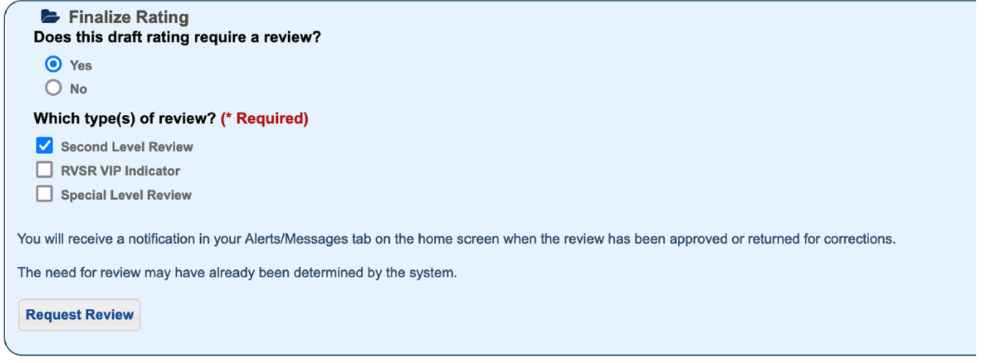

**Draft Rating Approval Process**

Once the Draft Rating is created, a “Review ID” will be created.

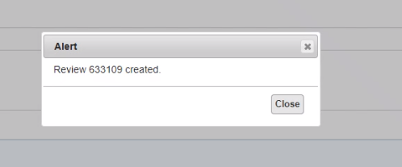

To access the DRA queue as a Second Level Reviewer, click the “Draft Rating Approval” tab which will take you into the actual DRA queue.

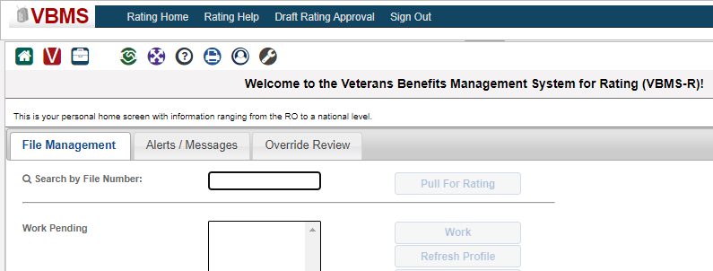

**Assigning Reviews**

To review a Rating Decision, VBMS-R must assign the Rating to you in the DRA queue. The system will not assign any Ratings to a Reviewer that the user themselves completed. The following personnel can self-assign and assign to others:

Self-Assign

Any of the following Second Level Reviewers:

* Rating VSR
* Senior/Journeyman
* DRO
* Rating Higher Level Reviewer
* Rating Coach
* Super Supervisor
* Service Center Manager

Self-Assign or Assign to Others

Any of the following Special Level Reviewers:

* Rating Coach
* Super Supervisor
* Service Center Manager

In order to assign reviews, click the checkbox for each of the claims you would like to assign and then click the actions button. DRA will give you the options of selecting either “Assign to Me” and/or “Assign User,” depending on your review role.

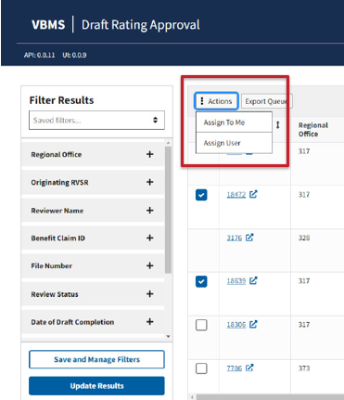

**Sorting the DRA**

All columns within the DRA queue are sortable, except for the Benefit Claim ID field. The columns are sorted ascending or descending by clicking the double arrow icon in each column.



**Filtering the DRA**

On the left-hand side of the screen, you may also filter the DRA queue. To filter, click the + sign to expand the selected attribute(s). Then select the attribute(s) and hit “Add.” Once complete, click the update results button.

Filters include “Keyword,” “Regional Office (RO),” “Originating RVSR,” “Reviewer Name,” “Benefit Claim ID,” “File Number,” “Review Status,” “Date of Draft Completion,” “Date of Second Level Review,” “Date of Special Level Review,” “RVSR VIP Indicator,” “Special Mission,” “Division,” “Flash,” “Special Issue,” “Days in RO Queue.”

A good filtering tip is that you should filter first by RO to eliminate all the cases that are not part of your RO.

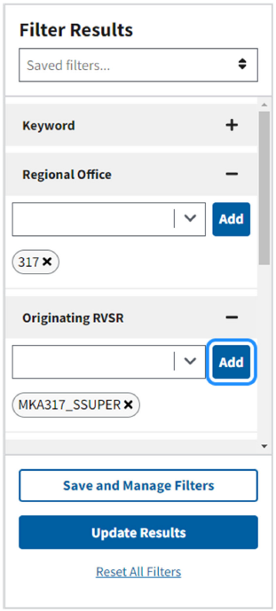

**Reviewing the Draft Rating for Second Review**

In order to access your review, you will need to click the “Review ID”. This will open the Review window, where you will be able to address any correction(s) that is/are required or approve the case if correction(s) is/are not needed.

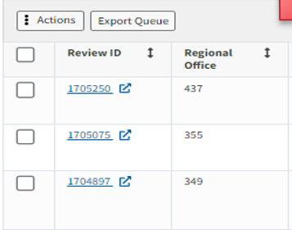

**Methods for Recording Feedback**

There are three methods for recording feedback during the second review:

1. Make notes on the actual decision itself, within the “Documents” narrative as well as on the Codesheet, i.e. add annotations within the Rating Decision Narrative and Rating Codesheet
2. Click “add Comments” and type the comments in the “Reviewer Comments” field, i.e. leaving comments on the review
3. Add comments on an Individual Quality Review (IQR) Checklist. This will provide you with the same checklist located in the Quality Management System (QMS). When you select “No” for any of the tasks, the “Reasons” will then populate.

When using any of these options or all 3, the Decision Maker will be able to see all the notes you made. Once you have finalized your notes, you may not make any additional editing.

**Annotation**

When DRA assigns a review to a Reviewer, they can make annotations for the Rater/DRO on the narrative or the codesheet. To do so click “View Narrative” or “View Codesheet.”

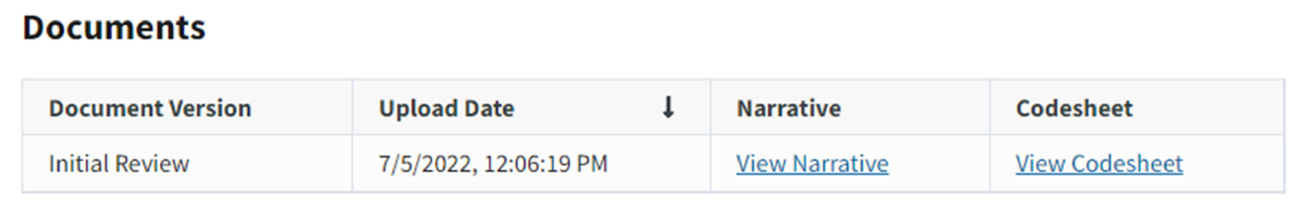

A Reviewer can add annotations using any of the items on the left of the page and the annotations will auto save. To edit or delete annotations, click the list option on the left-hand side of the page and then click the “+” button to expand which annotation(s) you would like to edit or delete.

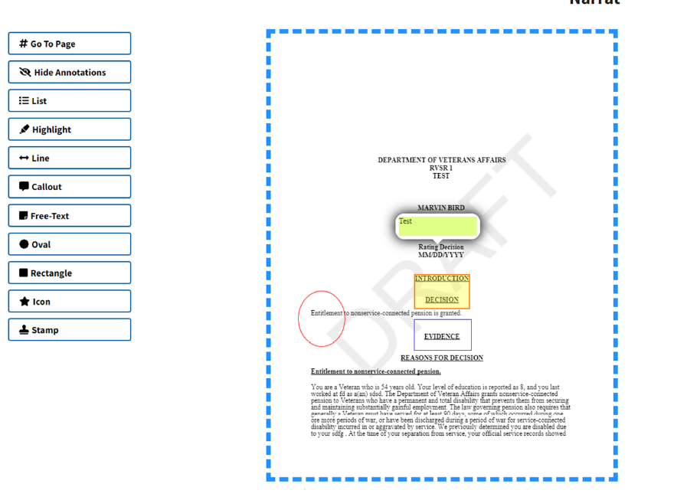

**Comments**

Reviewers are also able to leave comments on the review. Click on the “Add Comment” button and save once complete. The Rater/DRO will be able to view these comments once the Reviewer has sent the Rating back for correction or to go final.

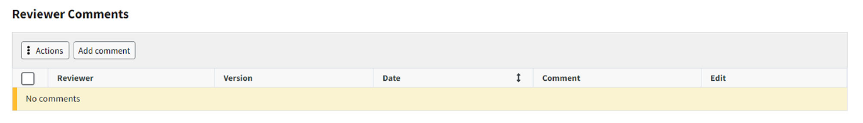

**IQR Checklist**

Unless directed otherwise by leadership or the FAQ, a Reviewer may complete the IQR checklist within the DRA functionality. The Reviewer can select whether each category was met. If the Reviewer selected a “No,” DRA will require them to select a reason. The Reviewer **will need to click the save button** at the bottom of the page to save the IQR checklist. Once the Reviewer selects a “No” on the IQR checklist, no one should change this selection on subsequent review even if the Rater/DRO has made the requested correction. This will allow the exported data to show how many errors were received for each Rater/DRO under the category level findings.

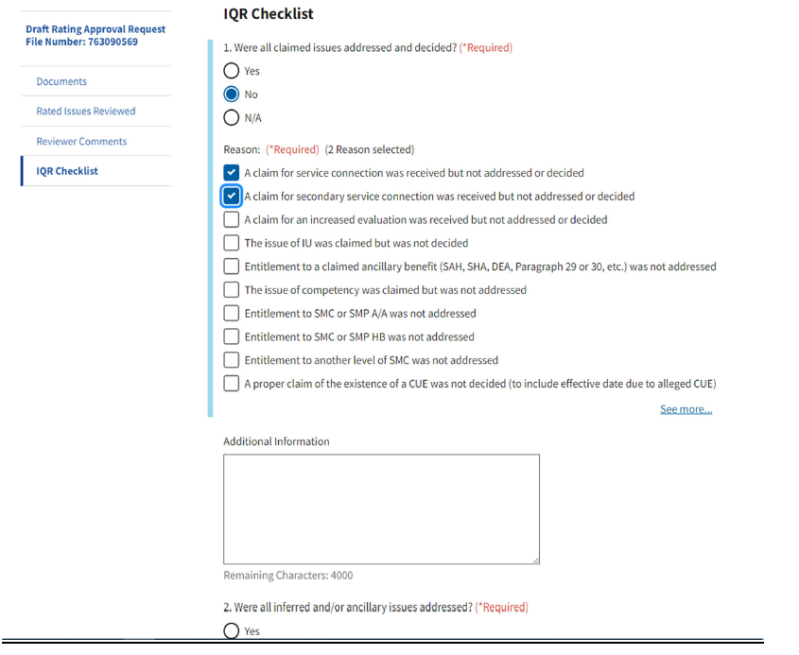

**Draft Rating Approval Finalization**

When the Reviewer returns the case for correction(s), the only option the Decision Maker will have is to “Submit Review Corrections.”

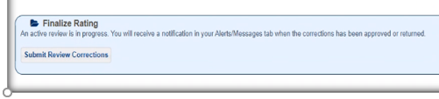

Once you receive the case back and all corrections have been completed or there were no corrections to perform, you will “Approve” the case and the system will provide you with the option of adding the Special Level Reviewer if needed, however, if the Decision Maker checked a “Special Level Reviewer” is required, the DRA will then automatically forward the case to the next Reviewer.

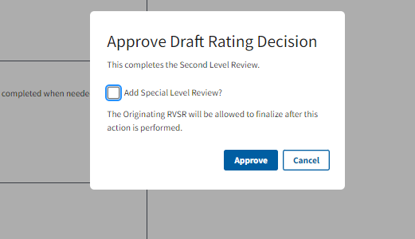

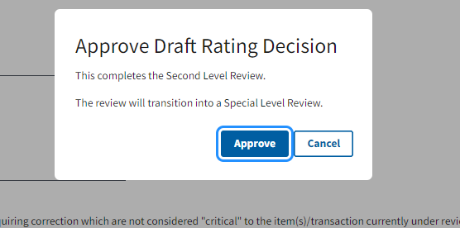

# Entering Comments into Quality Management System (QMS) Error Records

**Target Audience:** DROC Management and QRT

**Presenter:** JaVon Lázaro, Senior Program Analyst, OAR PA

**References:**

* M21-5 3.A.4.e, *Error Narratives: Required Elements*
* M21-5 3.A.5.h, *Reconsideration Requests on Employee Performance Reviews*
* M21-5 3.A.6.c, *Standard of Review for QRT IQRs*
* [QMS User Guide 2.0](https://va.lightning.force.com/lightning/r/ContentDocument/069t0000001YnLUAA0/view)

**Entering Comments into QMS Review Records**

When an error is cited during a quality review in QMS, you should always include the required narrative elements whether you are the initial reviewer, a peer reviewer who disagrees with a review, or a peer who is adding additional error citations to a review.

Statement of the Error:

The QRS should provide a specific statement that clearly identifies the error cited. The statement of error should be clear and concise. It should provide enough details that the reader will understand the basis for the error without needing to review the file. But it should not be overly verbose.

Statement of the Facts:

The QRS should provide a concise statement of the facts that outlines the evidence supporting the finding of an error. The facts should be brief and to the point but provide enough information to be clear on how the evidence supports the finding of CUE or violation of policy or directive.

*(This is not the place to be accusatory or unprofessional)*

Supporting Reference(s):

The QRS should provide all appropriate references to support the error citation. The references should be organized in a logical order and clearly separated.

**NOTE:** the supporting references may not need to be separately listed, if they are included parenthetically

*\*Multiple error citations within the same review should be discussed*

**Entering Comments into QMS Error Records**

1. If an employee does not agree/accept the cited error, they have the option to request a reconsideration of the decision (Commonly referred to a “Reconsideration” or “Rebuttal” in some offices). All reconsideration requests should be entered into QMS with a comment for the reconsideration request, which must include reasoning and a reference to support the request.
2. QMS must be updated with the final reconsideration decisions which includes the appropriate write-up and supporting references. Any relevant reference used when considering the reconsideration request should be included.
3. Employees must accept and correct errors to move them to a completed status. If the employee is still in disagreement after the reconsideration decision(s) have been made, the employee must still accept/correct the error but may enter continued disagreement in the comment box along with the corrective action taken.

All error corrections by employees **should include the action taken including the date corrective action was completed**, if necessary, in the comments box.

**Entering Comments into QMS**

**Don’t: Personalize the Narrative:**

* Don’t use language such as: “You failed to…” or “You didn’t…”

**Do: Stick to the Facts of the Case:**

* Use language such as: “The VAE dated…” or “The evidence submitted shows…”

Remember you review for a wide range of ability levels. By sticking to the facts of the case, you are more likely to effectively communicate the error narrative objectives. Use of subtle, insinuating language or lengthy commentary will distract from the intended message.

Don’t put the employee immediately on the defensive by not only citing an error, but by emphasizing their deficiency.

Do not personalize the error narrative, reconsideration request or reconsideration decision.

We should not create an antagonistic environment, which may hinder a learning opportunity.

In conclusion, we are reminded that QMS is an official government record and comments made within should maintain a level of professionalism, being concise, yet well defined.