**TABLE OF CONTENTS**

Quality Analysis Report Findings for Fiscal Year (FY) 2021, Quarter (Q)4 1

Quality Analysis Report Findings for FY 2022, Q1 4

March Non-Rating Proficiency Assessment (PA) Results 7

Upcoming PAs for FY 2022 8

OAR DROC Quality Review Team (QRT) Symposium 8

DROC QRT Challenge Training 9

# Quality Analysis Report Findings for Fiscal Year (FY) 2021, Quarter (Q)4

**Target Audience:** DROC Management and Quality Review Teams (QRT)

**Presenter:** Chelsey Kondrak, Senior Program Analyst, OAR Program Administration (PA)

**Purpose**

OAR’s Program Administration Staff conducts national quality reviews of claims processed at the Seattle, St. Petersburg, and Washington DC Decision Review Operations Centers (DROCs).

OAR seeks to determine whether actions taken by claim processors are compliant with statutory, regulatory, and procedural requirements.

National Quality reviews help identify gaps in performance to realign resources and address identified areas of improvement.

OAR conducted national quality reviews for FY 2021, Q4 (July 2021 through September 2021) on a random sample of 132 cases composed of compensation rating and authorization workload.

* OAR reviewed a total of 78 compensation rating quality reviews.
* OAR reviewed a total of 54 compensation authorization quality reviews.

**FY 2021, Q4 Rating National Quality Reviews**

The rating benefit entitlement (BE) accuracy (unweighted) for the review period was 85.9%, while the issue-based accuracy was 91.3%. A total of 17 unique claims contained errors, 11 of which contained BE errors, which are detailed in the chart below.

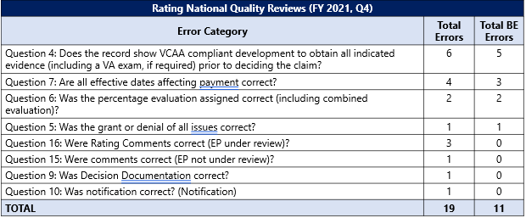

OAR identified error trends to include the following:

* Six errors (5 BE) cited under Question 4 for failing to obtain medical opinions or not returning insufficient medical opinions and/or exams.
* Four errors (3 BE) cited under Question 7 related to effective date errors.
* Two BE errors cited under Question 6 related to incorrect percentage evaluations.

**FY 2021 Rating National Quality Reviews Summary**

The top BE error trend for FY 2021 at the DC and St. Petersburg DROCs was Question 4, VCAA compliant development to obtain all indicated evidence.

* DROC DC accounted for 79% of the errors in FY 2021, and St. Petersburg DROC accounted for 21% of the errors in FY 2021.
* Most of the errors are related to insufficient medical opinions/exams, and specifically remand compliance at DROC DC.
* The number of errors cited under Question 4 at both DROCs remained consistent from FY 2021, Q3 to FY 2021, Q4.
* OAR issued remediation measures in October 2021 to DROC DC and recommended DROC DC conduct in-process reviews (IPR) to identify employees who consistently submit inadequate exam requests and other relevant exam errors.
* OAR also recommended DROC DC conduct targeted exam and remand refresher training by December 2021.

OAR identified Question 6, assignment of correct percentage evaluations, as an error trend for FY 2021.

* DROC DC accounted for 56% of the errors in this category, St. Petersburg DROC accounted for 33% of errors, and Seattle DROC accounted for 11% of errors.
* Most of the errors are related to pyramiding and over/under evaluations.
* Based on a cumulative review of FY 2021 data, OAR did not recommend continued remediation efforts, but we continue to monitor errors in this category to assess for improvement or potential remediation measures if necessary.

OAR noted an emerging trend for effective date errors cited under Question 7.

* The number of errors cited in this category gradually increased over the course of FY 2021.
* DROC DC accounted for 50% of the errors, and St. Petersburg DROC accounted for 40% of the errors in FY 2021.
* Most of the errors are related to general effective date errors.
* OAR issued remediation measures to DROC DC in October 2021 and recommended DROC DC conduct IPRs by December 2021 to identify more granular error trends related to effective date errors.

**FY 2021, Q4 Authorization National Quality Reviews**

The authorization BE accuracy for the review period was 96.3%. A total of six claims contained errors, two of which contained BE errors, which are detailed in the chart below.

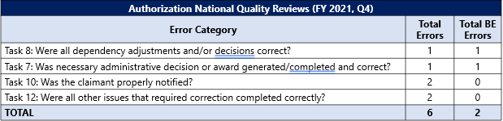

OAR did not identify any specific BE error trends but identified the following non-critical error trends:

* Two non-critical errors under Task 10 for failure to properly notify the claimant.
* Two non-critical errors under Task 12 for actions not associated with the end product under review.

**FY 2021 Authorization National Quality Reviews Summary**

OAR did not identify any significant BE error trends during the review period.

OAR identified Task 10, proper claimant notification, and Task 11, system compliance, as the top two non-critical authorization errors for FY 2021 at the St. Petersburg and Seattle DROCs.

* St. Petersburg DROC accounted for most of the errors cited for Task 10 (88%) and Task 11 (57%) for FY 2021.
* OAR noted an improvement for Task 11 errors as OAR did not cite any errors in this category in Q4 of FY 2021.

OAR identified Task 7 errors as an additional error trend for FY 2021.

* Seattle DROC accounted for 80% of errors cited under Task 7 for FY 2021.
  + However, OAR noted improvement at the Seattle DROC for errors cited under Task 7.
  + Seattle DROC authorization personnel are demonstrating improvement in this category as the number of errors decreased over the course of FY 2021.
* OAR cited three BE errors in this category for FY 2021 but did not identify any granular BE error trends.
* OAR cited most errors in this category as non-critical errors.
* Most of the errors were remediated by the revision of VA Form 20-0996, *Decision Review Request: Higher-Level Review*, published in April 2021. The revision removed the checkbox to request a higher-level review (HLR) at the same office, which significantly reduced the number of errors cited for failure to inform the claimant the request could not be granted.

# Quality Analysis Report Findings for FY 2022, Q1

**Target Audience:** DROC Management and QRT

**Presenter:** Chelsey Kondrak, Senior Program Analyst, OAR PA

OAR conducted national quality reviews for FY 2022, Q1 (October 2021 through December 2021) on random samples of 132 cases composed of compensation and 55 cases composed of pension rating and authorization workload.

* OAR reviewed a total of 100 compensation rating quality reviews.
* OAR reviewed a total of 32 compensation authorization quality reviews.
* OAR reviewed a total of 25 pension rating quality reviews.
* OAR reviewed a total of 30 pension authorization quality reviews.

**FY 2022, Q1 Compensation Rating National Quality Reviews**

The compensation rating BE accuracy (unweighted) for the review period was 88%, while the issue-based accuracy was 94.9%. A total of 23 unique claims contained errors, 12 of which contained BE errors, which are detailed in the chart below.

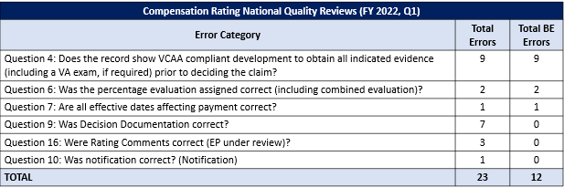

OAR identified error trends to include the following:

* Nine BE errors cited under Question 4 for not returning insufficient medical opinions and/or exams and failing to follow remand instructions.
* Two BE errors cited under Question 6 related to incorrect percentage evaluations.
* Seven non-BE errors under Question 9 related to proper rating decision documentation.
* Three non-BE errors cited under Question 16 related to incorrect disability determinations for EPs under review.

**FY 2022 Compensation Rating National Quality Reviews Summary**

The top BE error trend for FY 2022, Q1 at the DC and St. Petersburg DROCs was Question 4, VCAA compliant development to obtain all indicated evidence.

* DROC DC accounted for 89% of the errors, and St. Petersburg DROC accounted for 11% of the errors in FY 2022, Q1.
* Most of the errors cited related to insufficient medical opinions/exams and remand compliance at DROC DC.
  + Following OAR’s recommendation for DROC DC to conduct IPRs to identify employees who consistently submit inadequate exam requests and other relevant exam errors and to conduct exam and remand refresher training, DROC DC submitted a response on December 16, 2021 indicating they conducted 675 rating IPRs in October and November 2021 and cited only two errors under Question 4.
  + OAR also conducted train-the-trainer training for all DROC Quality Review Team (QRT) members in December 2021 on “Determining Sufficiency of Medical Opinions and Examinations for Board Remands” training.
  + OAR recommends the DROC DC continue to conduct IPRs to identify employees who consistently submit inadequate exam requests and other relevant exam errors and to conduct targeted exam and remand refresher training.

OAR identified Question 9, proper rating decision documentation, as the top non-critical rating error for FY 2022, Q1.

* The errors related to decision makers failing to address the basis of the decision and failing to provide a summary of the considered evidence.
* DROC DC accounted for 57% of the errors in this category, St. Petersburg DROC accounted for 29% of errors, and Seattle DROC accounted for 11% of errors.

**FY 2022, Q1 Compensation Authorization National Quality Reviews**

The compensation authorization BE accuracy for the review period was 96.9%. A total of four claims contained errors, one of which contained a BE error, which is detailed in the chart below.

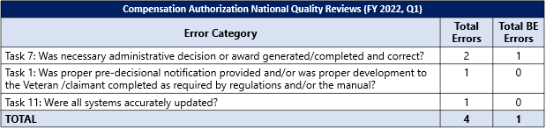

OAR identified one error trend; two errors were cited under Task 7 for an incorrect entitlement outcome and failure to procedurally complete an administrative decision.

OAR did not identify any significant BE error trends during the review period.

The review period data indicates Seattle and St. Petersburg DROC authorization personnel frequently processed claims accurately within statutory, regulatory and procedural requirements.

**FY 2022, Q1 Pension Rating National Quality Reviews**

The pension rating BE accuracy (unweighted) for the review period was 96%, while the issue-based accuracy was 97.4%. A total of two claims contained errors, one of which was a BE error cited under Question 1 for failure to address and decide all claimed issues, which are detailed in the chart below.

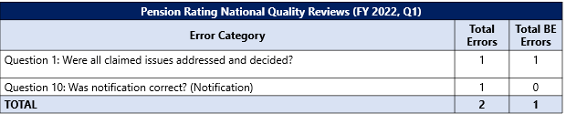

OAR did not identify any significant pension rating BE error trends during the review period. The review period indicates Seattle DROC rating personnel frequently processed pension claims accurately within statutory, regulatory, and procedural requirements.

**FY 2022, Q1 Pension Authorization National Quality Reviews**

The pension authorization BE accuracy for the review period was 100%. A total of six claims contained non-critical errors, which are detailed in the chart below.

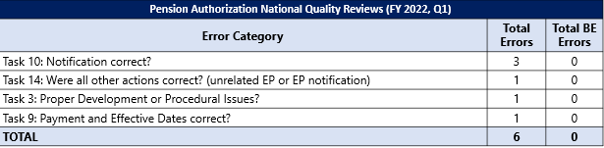

OAR identified three non-critical errors under Task 10 for incorrect notification letters.

Two of the three errors related to erroneous or incomplete information in the notification letter while the remaining error was for failure to upload the notification letter to the file.

# March Non-Rating Proficiency Assessment (PA) Results

**Target Audience:** DROC Management and QRT

**Presenter:** Wafa Abu-Salim, Program Analyst, OAR PA

Each PA focuses on a specific topic determined to be a strategic priority for improving claims processing accuracy. OAR deployed the March 2022 PA to DROC DC. The topic covered in this PA was exam and medical opinion sufficiency for Board remands. It was deployed as both a rating and non-rating. Each version focused on the tasks completed by that group.

The overall compliance rate for the March PA was 91%. Non-rating personnel had a compliance rate of 90% and rating had a compliance rate of 91%. This was comparable to the overall compliance rate in FY21.

Proficiency assessment performance is appraised on both topic mastery and general topic knowledge. Topic mastery means the learner scored 100% on the PA. General topic knowledge looks at the average of the scores.

For non-rating, 29% scored at least 80%, with 16% scoring 100%. The average score was 61%.

For rating, 71% scored at least 80%, with 15% scoring 100%. The average score was 79%.

# Upcoming PAs for FY 2022

**Target Audience:** DROC Management and QRT

**Presenter:** Wafa Abu-Salim, Program Analyst, OAR PA

St. Petersburg and Seattle non-rating personnel completed the April PA the second week of April on HLR effective dates. The rating PA for those DROCs deployed the third week of April.

The May PA will assess St. Petersburg and Seattle non-rating and rating personnel on Appeals Improvement and Modernization Act decision notifications, including favorable findings, informal conferences, and laws and regulations.

The June PA will assess all three DROCs (DC, St. Petersburg, and Seattle) non-rating and rating personnel. The non-rating PA will cover systems compliance and character of discharge determinations. The rating PA will cover systems compliance and Special Monthly Compensation (SMC) Housebound and SMC K.

Please encourage participation by your employees.

# OAR DROC Quality Review Team (QRT) Symposium

**Target Audience:** DROC Management and QRTs

**Presenter:** Alex Katinos, Senior Program Analyst, OAR PA

OAR will host the second annual virtual DROC QRT Symposium on May 24, 2022, 11 am EST – 4 pm EST.

The purpose of this symposium is to ensure reception and sharing of communication on quality topics in a consistent manner between OAR and DROC QRTs

Symposium topics will include:

* Local QRT Best Practices from each DROC
* Character of Discharge presentation
* AMA Requirements when Implementing Board Decisions presentation
* Insufficient Medical Opinions and Rationales presentation

# DROC QRT Challenge Training

**Target Audience:** DROC Management and QRTs

**Presenter:** JaVon Lázaro, Senior Program Analyst, OAR PA

To comply with requirements that QRS attend Challenge, OAR will conduct virtual instructor led DROC AQRS and RQRS Challenge training May 16-19, 2022. The audience for this training includes newly hired AQRSs, RQRSs, QRT Coaches and QRT Assistant Coaches. Employees in these positions who were unable to participate in the prior DROC AQRS and RQRS Challenge training sessions may also attend the upcoming session. DROC management may also select up to 5 current QRT employees from each of the DROCs to attend this session as a refresher training. Current QRT employees should only attend if they have a need for additional training on the quality review process.

Upon completion of Challenge, QRS employees should have a better understanding of navigating the Salesforce system and performing quality reviews. Similarly, DROC QRT Leadership should gain an understanding of QRS responsibilities.

This is a reminder that management must request access to Salesforce and the Quality Management System (QMS) for any newly hired QRS, QRT Coaches and QRT Assistant Coaches. During the DROC QRT Challenge Training session, OAR provides an overview of QMS and conducts a Challenge case review course that requires QMS access. Employees who do not have QMS access at the time of the training do not receive the full benefits of the training.

Participants must attend at least 75% of the DROC QRT Challenge training session to receive credit.