Return of Custody and BOC
Student Handout

Table of Contents

Objectives 2
References 3
Topic 1: Return of Custody 4
Topic 2: Bill of Collection 6
Job Aid: Screenshot 7
Attachment A: Copy of a PMOU Re-conveyance Letter from PMOU 8

Objectives
After completing this training, the Loan technician should be able to
- complete each step within the process successfully at least 80% of the time;
- determine the need to open a Return of Custody process successfully at least 80% of the time; and
- determine the need to open a Bill of Collection and complete the process successfully at least 80% of the time.
References

- VA Technicians Guide-Chapter 10 (10.4) page 129-132

Topic 1: Return of Custody

Definition
VA returns custody of a property if there was an invalid sale or improper transfer of custody, or if there are title problems. The return of custody process can occur after the servicer reports an event to VA that requires a return of custody, or after VA determines the need to return custody.

Timeframes for Reporting Events

- The Invalid Sale Results must be submitted manually through the Servicer Web Portal by the seventh calendar day after the servicer discovered the foreclosure sale was invalid. An invalid sale is when there has been a legal issue that invalidates the sale and the servicer must begin the foreclosure process again and hold a new sale.
- The Improper Transfer of Custody must be submitted manually through the Servicer Web Portal by the seventh calendar day after the servicer discovered the transfer of custody of the property to VA was improper. An Improper Transfer of Custody occurs when the servicer intended to retain the property after the foreclosure, a third party purchased the property at the foreclosure sale, or VA determines title is not clear and returns custody. Servicer will not have the ability to transfer the property back to VA.

Steps of the Returns of Custody Process

- Servicer reports event requiring return of custody or technician determines need to return custody.
- VALERI generates bill of collection (BOC)
- Servicer receives notice of return of custody
- Servicer satisfies BOC

Technician Determines Need to Return Custody

There are circumstances where the VA technician may be required to initiate the Return of Custody process. VA may be informed by Property Management Oversight Unit (PMOU) or VA’s property management contractor indicating the need for the technician to open the Return of Custody process. The VA technician will manually open the Return of Custody process.

Step 1 - Validate Need to Return Custody

- Once you opened the process you will document the reason and review the case file.

Step 2 - Contact Servicer

- You will contact the servicer to request that they report the appropriate event that requires a return of custody (Invalid Sale Results or Improper Transfer of Custody). Once you document the loan notes you will complete step #2.
- You must verify that the event was reported one day after the due date you provided to the servicer. If the servicer reports the event and it is accepted by VALERI, you request that a Servicing Officer (SO) or higher close this process. If the servicer does not report the required event, you complete this step.

Step 3 – Approve or Deny Return of Custody

- If the servicer does not report the required event, a SO must approve or deny the return of custody.

Step 4 – Enter or Confirm Servicer reporting event in SWP

- If the SO approves the need to return custody, they enter the appropriate event (Invalid Sale Results or Improper Transfer of Custody) in the Servicer Web Portal (SWP). Entering the event in the SWP prompts VALERI to initiate a return of custody and a BOC to the servicer.

Topic 2: Bill of Collection

Definition
If the servicer received an acquisition payment for the property, VALERI generates a Bill of Collection (BOC) based on whether the return was due to an invalid sale or improper transfer of custody, and whether or not VA made a claim payment.

Invalid Sale – If the reason for the return of custody was an invalid sale, VALERI calculates the BOC to include all amounts previously paid for acquisition of the property plus property management assignment fees. The servicer may receive a second BOC from Property Management (PM) for additional management expenses. If VA paid a claim, a separate BOC will open to collect the entire claim amount.

Improper Transfer of Custody – If the reason for the return of custody was an improper transfer of custody, VALERI calculates the BOC to include the acquisition amount and property management assignment fees. The servicer may receive a second BOC from VA for additional management expenses.

If the bid type was total debt, and VA paid a claim, VALERI opens a separate BOC to collect the entire claim payment. If the bid type was net value, and VA paid a claim, VALERI recalculates the claim amount using a credit to the indebtedness equal to the greater of the net value or proceeds from the foreclosure sale. After this recalculation, a separate BOC will be generated to include the amount of any advances made after the termination date and any fees or expenses the VA may have paid that are not allowed when a property conveyance is not accepted.

The servicer may appeal a BOC issued for a return of custody within 30 days of receiving notice of the BOC.

Servicer Received Notice of Return of Custody
The return of custody of the property occurs on the date the BOC is certified. When the BOC is certified, the servicer can access this information from the Servicer Web Portal under the Bill of Collections Status and Offsets Report.

Servicer Satisfies BOC
The servicer must submit payment for the BOC by the payment due date included in the BOC status and offsets report. The timeframe for satisfying a BOC is generally 45 days. VA will not accept an additional transfer of custody following a subsequent valid foreclosure sale unless the BOC is satisfied. The BOC status can be viewed from the Payment History screen.
Job Aid: Screenshot

Return of Custody Step #2 – Sample of servicer E-mail contact.

We have been informed by our property management oversight unit that VA is returning custody of the above property due to failure to submit acceptable title. See attached letter regarding this information. Please report the Improper Transfer of Custody event in the VALERI Servicer Web Portal within 48 hours of receipt of this email.

Be advised VA will report this event on your behalf if not completed within 48 hours. This reporting is required in order to generate a Bill of Collection for the acquisition funds that were paid to <Servicer>.

View of BOC status from the Payment History Screen
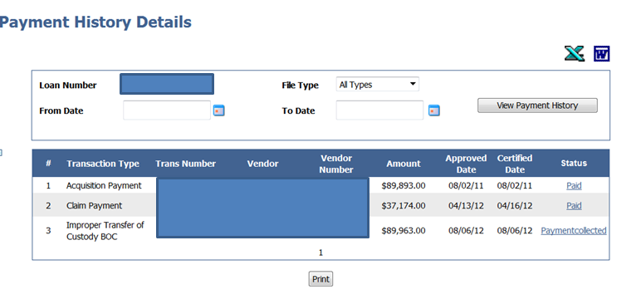

Attachment A: Copy of a PMOU Re-conveyance Letter from PMOU
Final-Reconveyance of Property
Tracking #
June 15, 2012

(Bank and address)
Attn: Foreclosure Department

RE: Prior Mortgagor:
Property Address:
VA#:
Pre-Reconveyance Ltr November 10, 2011

Dear VA Clams Department:

This letter is to notify (Bank) that the Secretary of Veterans Affairs has re-conveyed the above-referenced property for the following reasons:

The property has been in our inventory for 316 days. A sewer lien certificate was not cleared in a timely manner causing a cloud on the title so the property was not marketable.

A property acquisition payment was paid to (Bank), when the property was originally conveyed to the Secretary of Veterans Affairs. Therefore, this payment must be returned to VA along with the estimated expenses indicated below, which total $ ###.

Consideration Amount $ ###
Appraisal Fee $ ###
REO Misc $ ###
Total $ ########

This is a courtesy notice only and funds are not to be forwarded to the Bank of America, NA. The
“Bill of Collection” will be furnished by the VA.

This serves only as an advance notice of the reimbursement for acquisition that your company will be required to make payment upon receipt of VA’s request for funds. VA’s request for funds may also include any claim under guaranty paid.

The re-conveyance also means that your company now has physical custody and ownership of the property.
Therefore, effective immediately (Bank) is now fully responsible for the continued security and maintenance of the property.

If you have any questions, please contact #.

Sincerely,

cc:

Attachment: Copy of Recorded QCD

