

Misuse Manual Updates Overview
Lesson Plan

0ctober 2016 – Version 1.0

Misuse Overview

Lesson Overview
Purpose of the Lesson: | To update the fiduciary hub staff on general updates to the Misuse Process.
Prerequisite Training Requirements: | None
Target Audience: | The lesson is designed for all fiduciary hub staff as a one-time mandated training. All entry level, intermediate and journey level, clerical staff, LIE, Field Examiners, FSR, assistant coach, coach, management analyst, QRT, assistant fiduciary hub manager and hub managers.
Lesson References: | Fiduciary Program Manual, 5 Misuse, Negligence and Reissuance Fiduciary Program Guide.
Lesson Objectives: | Fiduciary Hub Employees and VACO staff will be able to  - Identify the reorganization changes to Fiduciary Program Manual, Misuse Chapter.  - Identify additional stages added to the Misuse Process.  - Identify specific changes in the Misuse Process

Instructor Notes
This lesson covers the general changes, most will not be covered in detail however, the target audience will be instructed to review the entire Fiduciary Program Manual, Misuse, Negligence and Reissuance Chapter to see the full detailed changes.
Additional area specific training will also be provided.

PowerPoint Slides | Instructor Activities
Misuse Manual Updates Overview | DISPLAY slide  - “[Lesson Title]”  INTRODUCE yourself as the instructor and introduce any fellow instructors.  INTRODUCE the lesson.
Overview of Today’s Training  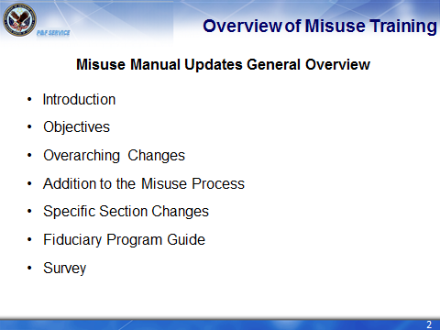 | DISPLAY slide  - “Overview of Today’s Training”  PROVIDE an overview of the day’s schedule.  EXPLAIN that students will be learning about updates to the Fiduciary Program Manual Misuse Chapter today.  DISCUSS P&F Service designed this as a high level overview of the changes to the manual. There are plans for more in depth training, to discuss in more detail some of the specific changes discussed today.  EXPLAIN We will detail the instructions and discuss the individual topics of overarching changes, additions to the misuse process, specific section changes, and the fiduciary program guide.
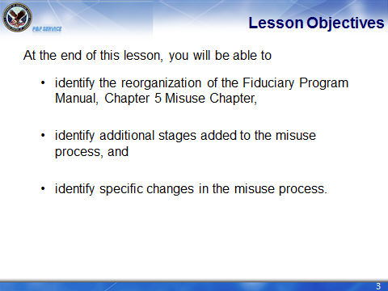 | DISPLAY slide  3 “Lesson Objectives”  REVIEW the lesson objectives and assure students they will have opportunities to practice what they learn.

Over Arching Manual Changes  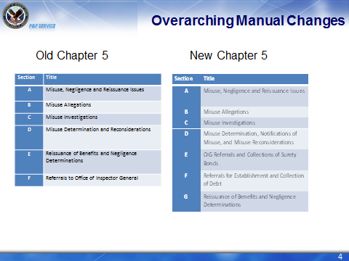 | DISPLAY slide 4 “Over Arching Manual Changes”  NOTE: The entire manual has been reorganized in a process base. What that means to you, is that it is in the order of how all of the misuse process should be completed.  These changes are to make the manual more user friendly and enable ease of access.
Overarching Manual Changes  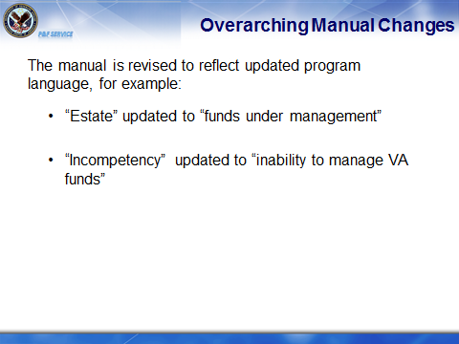 | Display slide 5 “Over Arching Manual Changes  Note: To reflect the changing prospective of the fiduciary program the old language of “estate” is updated to “funds under management and “incompetency” is updated to inability to manage VA funds.”
Questions Screen  What is a big overarching change in the Fiduciary Program Manual, Misuse Chapter. | DISPLAY slide 6 “Questions Screen”  NOTE: Either response below is correct:  A big overarching change to the Fiduciary Program Manual is the reorganization into a process based format.  The previous Fiduciary Program Manual, was well organized in the Misuse Chapter, however, there were small changes to make it fall in the process based model.
Additions to the Misuse Process  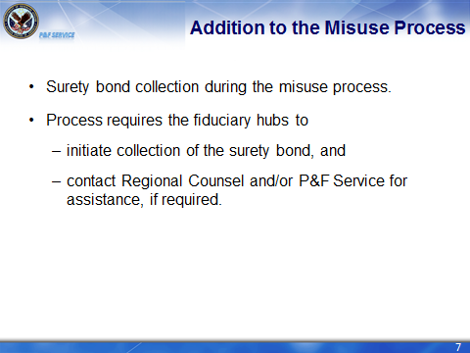 | DISPLAY slie 7 “Additions to the Misuse Process”  NOTE: Chapter 5, now clearly indicates the collection of surety bonds and requires the first attempts to be completed by the fiduciary hub personnel.  Also the information on who to notify of when there are issues collecting the surety bonds was added. The manual provides a clear process based chart on the steps to take to collect the surety bond.  There is clear guidance that if there is difficulty collecting on the surety bond and getting Regional Counsel assistance, a referral can be submitted to VACO for further assistance.
Why the Change?  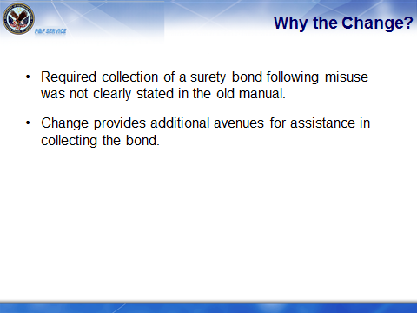 | DISPLAY slide 8 “Why the Change?”  NOTE: In reviewing misuse cases for negligence a fair amount had to be returned to the fiduciary hubs for them to begin the bond collections, by adding this specific step to the manual it should reduce the amount of cases returned for this issue.  A benefit for the additional avenues added is that based on our experience most insurance companies are not always forthcoming with paying the bonds off however, we want to more actively pursue the collection of these bonds as sometimes the collection of bond is the only way a beneficiary may see their misused funds again.
Addition to the Misuse Process  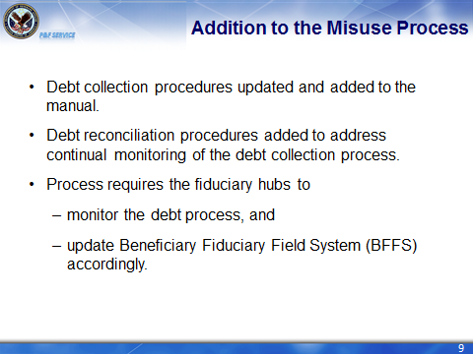 | DISPLAY slide 9 “Additions to the Misuse Process”  NOTE: The debt collection process itself is not new to the Misuse Process; however, the requirement to reconcile the debts is an addition to the process.  The new addition requires the fiduciary hubs to continually monitor the debt collection process and ensure BFFS is accurately up to date.  The addition also, assigns some of the responsibility to P&F Service to assist the hubs in completing the process.
Addition to the Misuse Process  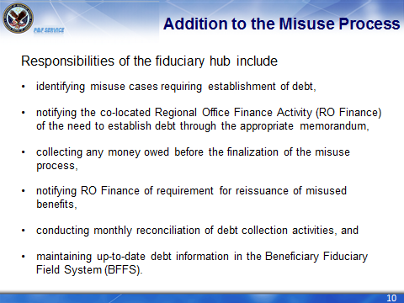 | DISPLAY slide 10 “Addition to the Misuse Process”  NOTE: Most of the responsibilities are not new to the debt collection process however, the manual refined the process more and added a couple of additional components.  Identifying the cases requiring debt establishment, notifying RO Finance, collecting monies owed before completion of misuse process, and notifying RO Finance are all consistent with current policy established.  Conducting reconciliation and maintaining up-to-date debt information in BFFS are new additions to the process.  Reconciliation will be completed in the following process:  - P&F Service will provide the fiduciary hubs with any discrepant data from BFFS and CAATS.  - The fiduciary hub will review the information and correct any discrepant data in BFFS within 15 days.  - The BFFS misuse case remains open until full collection of the misuse debt.  Maintaining up-to-date debt information is a component of the actual reconciliation process.
Why the Change?  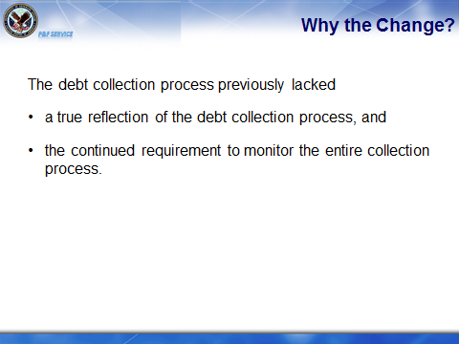 | DISPLAY slide 11 “Why the Change?”  NOTE:
Additions to the Misuse Process  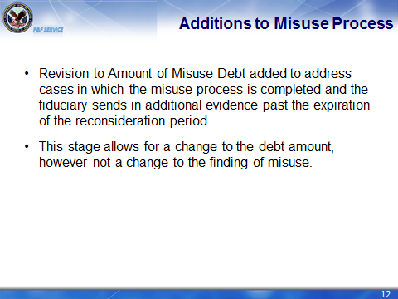 | DISPLAY slide 12 “Additions to the Misuse Process”  NOTE: The Revision to Amount of Misuse Debt added to the Misuse Process based on a review of the work flow, based on information provided by the hubs, it is a necessary addition.  While we don’t foresee using this regularly, it does allow for some flexibility in the Misuse Process. However, an important thing to remember is this process only allows for a change in the amount of debt established. Once a Misuse Determination is completed and the expiration of the reconsideration period without any additional evidence or changes submitted, that finding of misuse may not be changed by the fiduciary.  Maintaining the finding of misuse is important because if someone cannot account or just really doesn’t want to follow fiduciary program policy, we do not need to allow them to continue as fiduciary. Additionally, statutorily we cannot change that misuse finding after the expiration of the reconsideration period, unless the beneficiary appeals the finding.
Why the Change?  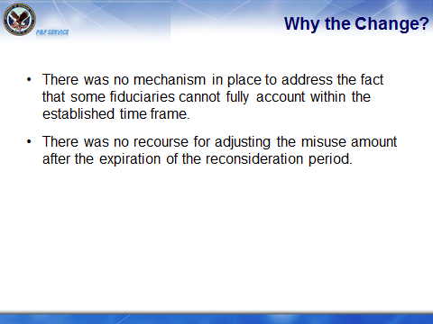 | DISPLAY slide 13 “Why the Change?”  NOTE:
Questions Screen  - Name a process added to Chapter 5. | DISPLAY slide 14 “Questions Screen”  NOTE: The additions to the misuse process are Collection of Surety Bond, Debt Reconciliation, Revision to Amount of Misuse Debt.
Specific Changes to General Overview  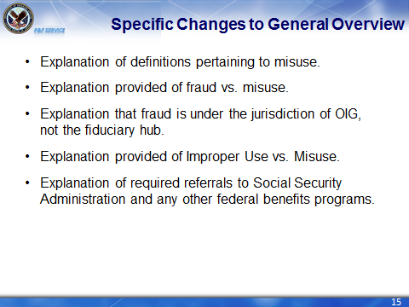 | DISPLAY slide 15 “Specific Changes to General Overview”  NOTE: To better understand the entire misuse protocol, we have added the major definitions that need to be understood to know the misuse protocol.  Adding the differentiation of fraud and misuse is to enable to hubs to identify the individual requirements and take the appropriate action. Fraud is strictly investigated by OIG, and misuse by the fiduciary hub. However, the fiduciary hubs must be aware; there are some instances in which overlapping of the two issues occur.  Clarifying further improper use and misuse assists the fiduciary hub is viewing certain acts, like giving gifts not a misuse, but it does clarify those specific incidents must be critically reviewed.  In the spirit of responsibility to all federal agencies, P&F Service now requires referrals to Social Security and any other agency paying benefits to a fiduciary for a beneficiary. A Fiduciary Program Guide article has been created detailing the specifics of making the appropriate referrals to other federal agencies.
Specific Changes to General Overview  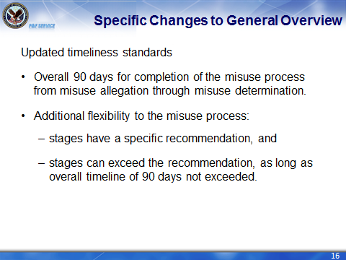 | DISPLAY slide 16 “Specific Changes to Misuse Investigations”  NOTE:  As everyone is aware, P&F Service is updating the way we review information across the board. One of the adjustments is to the misuse timeline. We have made suggestions to how long each stage should take which isn’t a change, however the change comes in the fact those are suggestions and we are really looking at the overall time frame of 90 days from initial allegation through the determination.
Specific Changes to General Overview  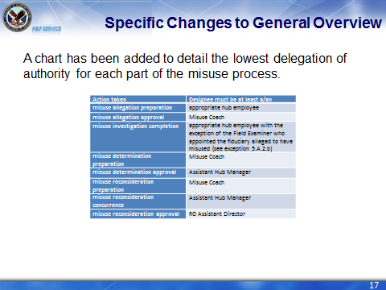  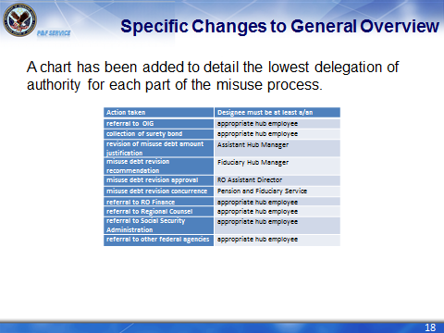 | DISPLAY slide 17 and 18 “Specific Changes to General Overview”  NOTE:  Based on our reviews of the misuse cases for negligence, we noticed a problem sometimes with who is the appropriate staff to complete the appropriate steps in the misuse process. We added the detailed chart as a place to review to ensure every fiduciary hub is following the appropriate protocol for each action.
Specific Changes to Misuse Allegations  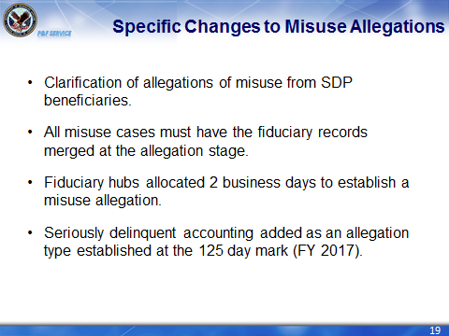 | DISPLAY slide 19 “Specific Changes to Misuse Allegations”  NOTE: Clarification to SDP beneficiary’s and allegation of misuse has been added, as based on future regulations changes, findings of misuse will be a bar to service as fiduciary. Based on that information a SDP beneficiary who has an allegation of misuse, the allegation is specifically as the beneficiary as misuse and if misuse is found that beneficiary can no longer serve as a fiduciary for himself/herself.  All fiduciary records must be merged to ensure we have identified all of the beneficiaries potentially affected by the misuse allegations. A full detailed FPG article will be available following the November 2016 BFFS release that details the process.  There will be 2 business days to establish a misuse allegation once notified or discovered. For Field Examiners, what that means is if the allegation occurs during the field examination, he/she may be required to document and submit the information to the misuse team prior to completion of the Field Examination Report so that the hub can remain timely.  In FY 2017, SDA accountings will automatically become misuse allegations. The process will start from point forward with a plan created to catch the ones this transitions does not. There is not a specific date available for this update however, the field will be provided notice and the manual updated accordingly to reflect this information.
Specific Changes to Misuse Allegations  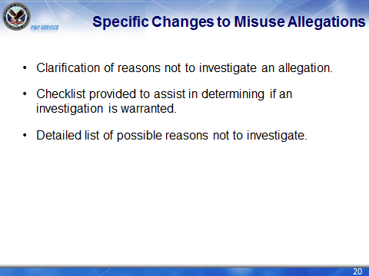 | DISPLAY slide 20 “Specific Changes to Misuse Allegations”  NOTE:  The updates include the listing of specific examples not to investigate.  Also a FPG article is created to assist in making the decision whether to investigate. The reasons, not to investigate are further clarified in this article.
Specific Changes to Misuse Allegations  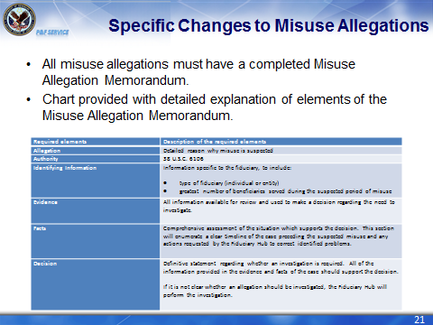 | DISPLAY slide 21 “Specific Changes to Misuse Allegations”  NOTE:  All allegation now require a Misuse Allegation Memorandum. A chart has been added to the section to further detail the expectation in each section of the Misuse Allegation Memorandum.
Specific Changes to the Misuse Investigation  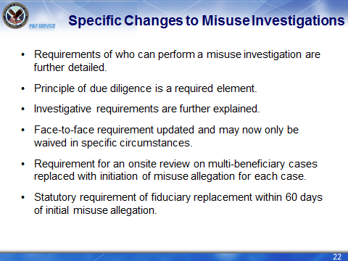 | DISPLAY slide 22 “Specific Changes to Misuse Investigation”  NOTE:  P&F Service updated the Misuse Investigation section with further detail on the appropriate requirements of a misuse investigation, to include who can perform the investigation.  The principle of due diligence is detailed as a requirement, in cases were a face-to-face contact cannot be accomplished. Now required are face-to-face contacts with the fiduciary accused of misuse, we list very limited specific circumstances in which the need for a face-to-face contact may be waived, but we will discuss this aspect further down in the training.  An updated example of an appropriate misuse investigation is provided with detailed explanations of each section within the report.  The requirement for onsite reviews in cases pertaining to fiduciaries serving multiple beneficiaries is removed, instead we are requiring misuse allegation be initiated for all of those beneficiaries served by the fiduciary.  Reiterated the statutory requirement, of a fiduciary found to have misused benefits must be replaced within 60 days of the initial allegations of misuse. This is not an arbitrary requirement, this is a law made by congress, so there is no wiggle room on this aspect.
Specific Changes to Misuse Investigations  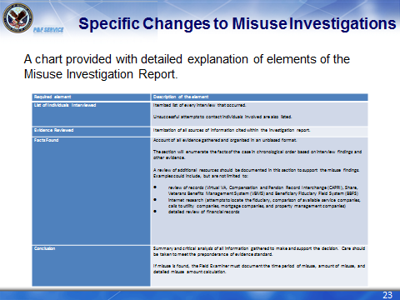 | DISPLAY slide 23 “Specific Changes to Misuse Investigations”  NOTE:  An updated example of an appropriate misuse investigation is provided with detailed explanations of each section within the report.
Specific Changes to Misuse Determination, Notifications and Reconsiderations  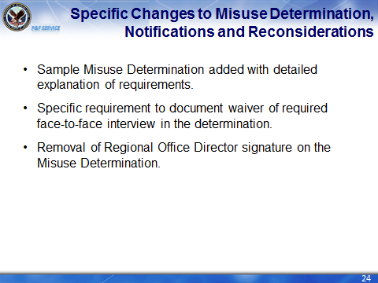 | DISPLAY slide 24 “Specific Changes to Misuse Determination, Notifications and Reconsiderations”  NOTE:  P&F Service updated the Misuse Determination, OIG Referrals and Notifications section with further detail on the appropriate requirements of a misuse determination, to include whose signature authority is required for completion of the determination.  An up to date Misuse Determination is provided with detailed explanation of all the required elements in the determinations.
Specific Changes to OIG Referral  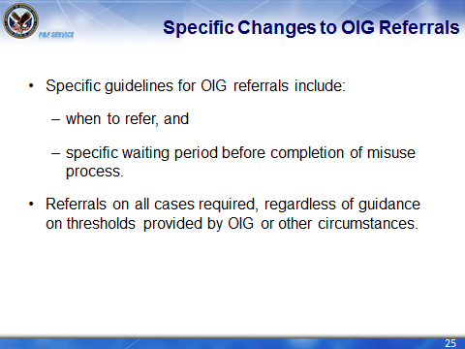 | DISPLAY slide 25 “Specific Changes to OIG Referrals”  NOTE:  Specific guidance is now provided for referrals to OIG, to include an appropriate waiting period for OIG to take action. The change moves the referral to OIG back to after the notification requirements and reconsideration period expiration. This change will not be reflected in BFFS until the November 2016 update.  Reiterates the need to complete referrals in all cases where misuse is found, despite whether OIG has informed staff not to make the referral unless certain circumstances are met.
Questions Screen  Name at least two specific changes to the Fiduciary Program Manual, Misuse Chapter. | DISPLAY slide 26 “Questions Screen”  NOTE: Any of the changes listed on the previous 11 slides are appropriate answers to the question.
Fiduciary Program Guide Articles  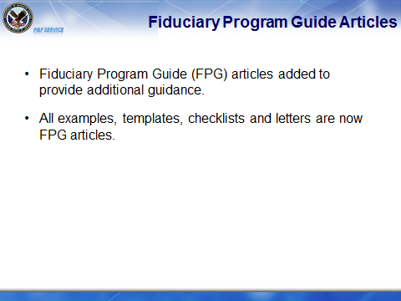 | DISPLAY slide 26 “Fiduciary Program Guide Articles”  NOTE:  Fiduciary Program Guide articles have been added to aid in completing the misuse process. The articles include checklists, templates, and letters.
Summary  Today you:  - Identified the reorganization changes to Fiduciary Program Manual, Misuse Chapter.  - Identified additional stages added to the Misuse Process.  - Identified specific changes in the Misuse Process. | DISPLAY slide 27 “Summary”  REVIEW the information in the day’s lesson.  NOTE: Based on the information provided, you should be able to:  - Identify the reorganization to the Fiduciary Program Manual, misuse chapter.  - Identify additions to the misuse process.  - Identify specific changes in the misuse process.  The information provided does not represent all of the changes to Chapter 5, but the general large changes that occurred. To fully understand all of the changes you may review the new Chapter 5 on Knowledge Management along with the supporting Fiduciary Program Guide articles.
Questions? | DISPLAY slide 28 “Questions?”  ASK students if they have any questions about the day’s lesson.  RESPOND to all questions before tasking students to complete the assessment.
TMS Assessment and Survey  - Th survey have been assigned to you in TMS.  - You should be able to complete the survey within 5 minutes.  - Be sure to complete the survey in TMS to receive credit for this training. | DISPLAY slide 29 “TMS Assessment and Survey”  TELL students how to access the survey in TMS.  REMIND them that they must complete the survey in order to receive credit in TMS for their training.  TELL students that the survey provides them an opportunity to improve the training and that their feedback is welcome.

