

Expedited Spouse Appointments in TPR Cases
Lesson Plan

August 2016 – Version 1.0

Expedited Spouse Appointment Process – 1 Learning Hour

Lesson Overview
Purpose of the Lesson: | The purpose of this lesson is to explain the required expedited spouse appointment process established for TPR cases.
Prerequisite Training Requirements: | N/A
Target Audience: | FY16 P&F Service mandatory training for all fiduciary hub staff
Lesson References: | - PL 21-16-01, Beneficiaries Who Are Unableto Manage their VA Benefits; Claims Processing Errors  - Fiduciary Program Guide, Spouse Fiduciary Expedited Spouse Appointments in Conjuction with PL 21-16-01
Lesson Objectives: | By the end of this lesson, Fiduciary Service Representatives will be able to:  - describe and implement the expedited spouse appointments for Targeted Program Review (TPR) cases identified by Policy Letter (PL) 21-16-01  - understand the purpose of updated procedures

Instructor Notes

PowerPoint Slides | Instructor Activities
[Lesson Title]  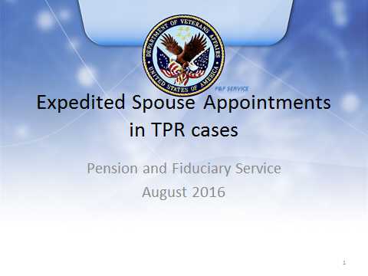 | DISPLAY slide  - “[Lesson Title]”  INTRODUCE yourself as the instructor and introduce any fellow instructors.  INTRODUCE the lesson.
Lesson Objectives  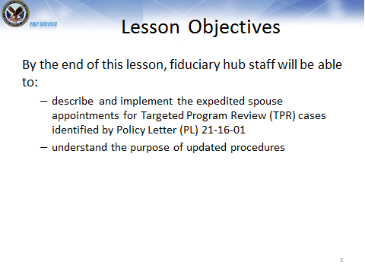 | DISPLAY slide  - “Lesson Objectives”  REVIEW the lesson objectives and assure students they will have opportunities to practice what they learn.  EMPHASIZE that the post-lesson assessment will align with the content and these objectives.
Background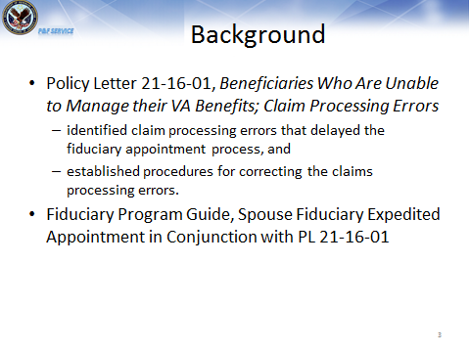 | DISPLAY slide  - “Background”  REVIEW the background of the Policy Letter 21-16-01, Beneficiaries Who Are Unableto Manage their VA Benefits; Claims Processing Errors.  DISCUSS that some of the cases identified under policy letter 21-16-01 established the procedures to working the claims expeditiously.  DISCUSS the Fiduciary Program Guide, Spouse Fiduciary Expedited Spouse Appointments in Conjuction with PL 21-16-01, establishes a manner to expedite the actual appointment process.
Appropriate Use of Expedited Spouse Appointments  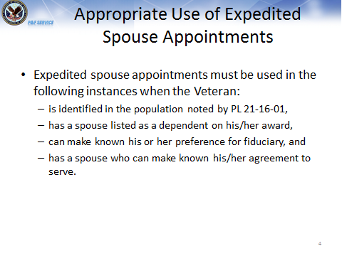 | DISPLAY slide  - “Appropriate Use of Expedited Spouse Appointments”  REVIEW the current general procedures in place for the appointment of a spouse fiduciary.  EXPLAIN that to assist in appointing fiduciaries in a expedited manner without sacrificing the current levels of oversight.  The change in policy is a must for all TPR cases, with a spouse currently on the Veteran’s award.
Inappropriate Use of Expedited Spouse Appointments  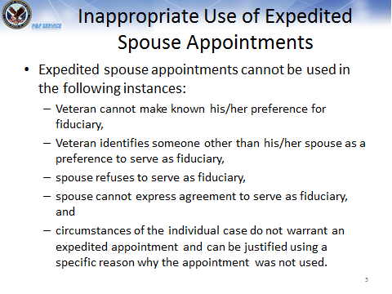 | DISPLAY slide  - “Inappropriate Use of Expedited Spouse Appointments”  EXPLAIN expedited spouse appointments cannot be used in specific instances.
Contact the Veteran  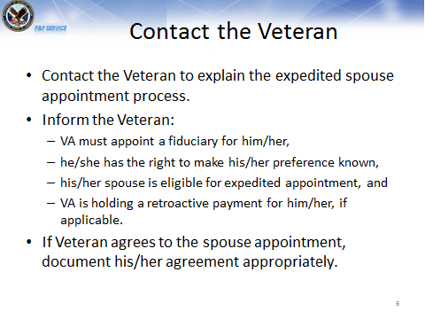 | DISPLAY slide  - “Contact the Veteran”  DISCUSS the required contacts with the Veteran.  EXPLAIN the Veteran must be informed all of the information listed.  EMPHASIZE the Veteran must agree to the appointment.  EMPHASIZE the contact must be documented on a VA Form 27-0820, Report of General Information.
Problems Obtaining Veteran Agreement  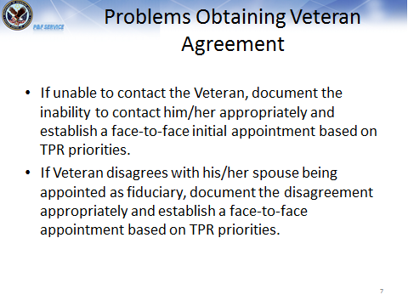 | DISPLAY slide  - “Problems Obtaining Veteran Agreement”  DISCUSS what occurs when the Veteran cannot be contacted and if the Veteran disagrees.  EMPHASIZE that in either instance a face-to-face initial appointment must be established using the previously established TPR procedures.
Contact the Spouse  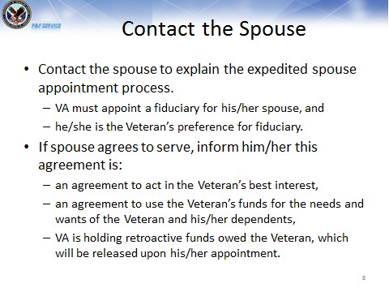 | DISPLAY slide  - “Contact the Spouse”  DISCUSSthe required contact with the spouse.  EXPLAIN the spouse must be informedof all information listed.  EMPHASIZE the spouse must agree to the appointment and the spouse must agree to the established VA guidelines.  EMPHASIZE the contact must be documented on a VA Form 27-0820, Report of General Information.

Problems Obtaining Spouse Agreement  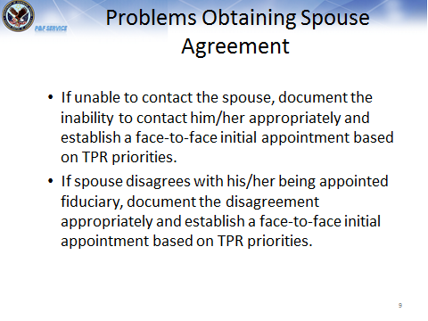 | DISPLAY slide  - “Problems Obtaining Spouse Agreement”  DISCUSSwhat occurs when the spouse cannot be contacted and if the spouse disagrees.  EMPHASIZE that in either instance a face-to-face initial appointment must be established using the previously established TPR procedures.
Complete the Appointment  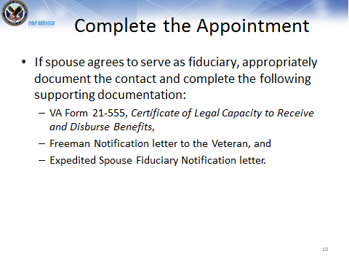 | DISPLAY slide  - “Complete the Appointment”  DISCUSS the procedures if the spouse agrees to serve as fiduciary.  EMPHASIZE the required documentation specific to these cases. The FPG article provides the appropriate sample documents for use and the documents must be used.
Update Systems  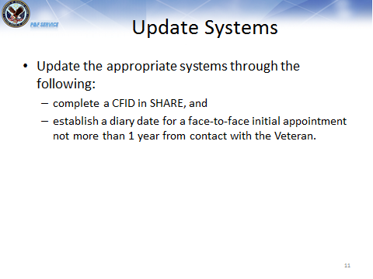 | DISPLAY slide  - “Update Systems”  DISCUSS the required system updates to complete the appointment process.  EMPHASIZE that a diary date for not more than 1 year from the contact with the Veteran must be established.
Important Information  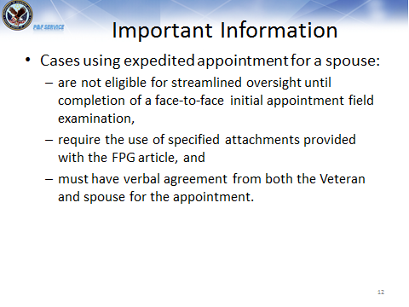 | DISPLAY slide  - “Important Information”  EMPHASIZE these cases cannot be monitored by streamlined oversight until after the one year face-to-face follow-up is completed, require the use of the attachments provided with the FPG article, must have agreement from both the Veteran and spouse.
Summary  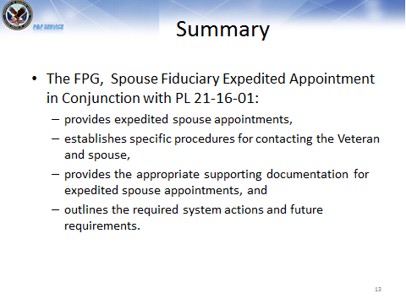 | DISPLAY slide  - “Summary”  REVIEW the information in the day’s lesson.
Questions?  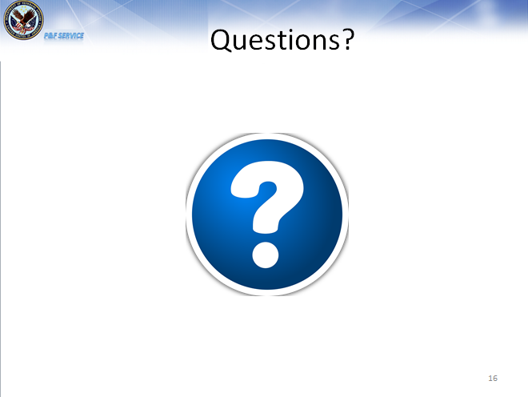 | DISPLAY slide  - “Questions?”  ASK students if they have any questions about the day’s lesson.  RESPOND to all questions before tasking students to complete the assessment.

TMS Assessment and Survey  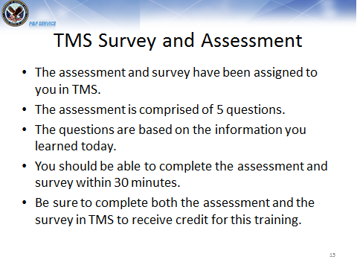 | DISPLAY slide  - “TMS Assessment and Survey”  TELL students how to access the assessment and survey in TMS.  EXPLAIN that the assessment is 5 questions and will cover what they learned in class today.  REMIND them that they must complete both the assessment and the survey in order to receive credit in TMS for their training.  TELL students that the survey provides them an opportunity to improve the training and that their feedback is welcome.

