Fiduciary – Introduction to VBMS



Lesson Plan
August 2016 – Version 1.0
Lesson Title: Introduction to VBMS – Lesson Time: One Hour

Lesson Overview
Purpose of the Lesson: | The purpose of this lesson is to provide fiduciary program personnel with the steps necessary to access Veterans Benefits Management System (VBMS), search for a beneficiary and review documents in the VBMS eFolder. This is introductory lesson to VBMS and the eFolder and additional hands on practice follows this lesson.
Prerequisite Training Requirements: | N/A
Target Audience: | This lesson is designed for all hub employees who have not received training in the navigation of the VBMS eFolder. This is mandatory training for all hub employees. This training may also be provided as refresher training after the initial training has been provided.
Lesson References: | http://vbaw.vba.va.gov/VBMS/resources.asp
Lesson Objectives: | - Advise users how get started and navigate to the help feature in VBMS.  - Identify how to search for a beneficiary record in VBMS.  - Identify how to manage documents in the VBMS eFolder.

Instructor Notes
IDENTIFY AND PREPARE: Before the lesson, identify and prepare an eFolder that you will use to demonstrate VBMS eFolder navigation.

Instructors should review the lesson plan, which includes suggested talking points/speaker notes, and practice giving the training. This will promote familiarity with the materials and allow for the identification of any questions prior to the training session.

TRAINING MATERIALS:
- Fiduciary - Introduction to VBMS Lesson Plan
- Introduction to VBMS Presentation Slides
- Introduction to VBMS Presentation with Demo Slides (use only if system is unavailable)

PREFERRED MODE OF INSTRUCTION: This lesson is best given as a live demonstration of the content. In a situation where live demonstration is not feasible, the presentation with demo slides may be used.

LESSON PLAN CONTENT OVERVIEW: This lesson plan is contains two guides: The Presentation Guide and The Demonstration Guide. The Presentation Guide includes the slides that the instructor will display at the beginning and end of the training session. The Demonstration Guide provides images to assist the instructor with navigating through the live demonstration.

SCREEN GUIDE: The slides provided within the Demonstration Guide should be used to guide the instructor through the live demonstration.

RECOMMENDED CLASSROOM RULES:
- The instructor should identify designated points to open the discussion for questions.
- If computers are available, the instructor should request students log off/do not log into their computer.

Presentation Guide
NAVIGATE: Show presentation slide one.

DISCUSS: An introduction of yourself as the instructor and introduce any fellow instructors.

Lesson protocols (How questions will be answered, where materials will be located, presentation method etc.
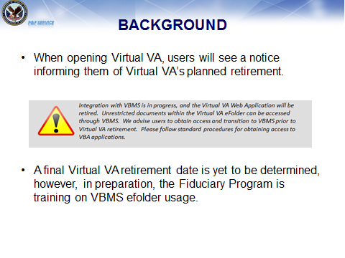 | NAVIGATE: Show presentation slide two.  DISCUSS: The Virtual VA (VVA) System is the current document repository for the fiduciary program. VVA will be retiring, in preparation for its retirement; this introduction to VBMS is being provided to fiduciary staff.  The purpose of this lesson is to provide users with the steps necessary to access the VBMS, search for a beneficiary and review documents in the VBMS eFolder. This is introductory lesson to VBMS and the eFolder and additional hands follows this lesson.
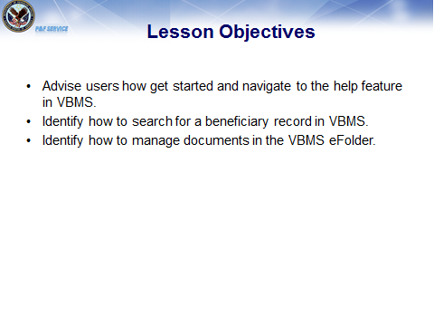 | NAVIGATE: Show presentation slide three.  DISCUSS: Review lesson objectives.
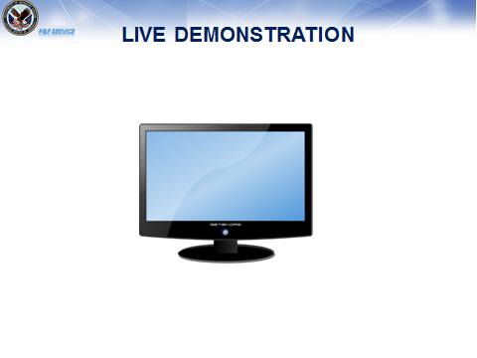 | NAVIGATE: Show presentation slide four then share a view of the computer desktop  DISCUSS: You will now begin the live demonstration.  (Go to the Demonstration Guide for live demonstration talking points)
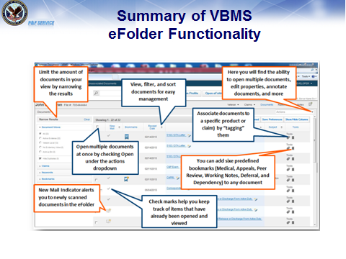 | NAVIGATE: Show presentation slide five.  DISCUSS: Review the slide to summarize
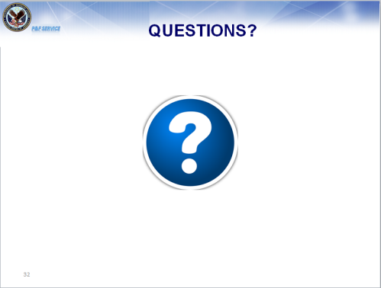 | NAVIGATE: Show presentation slide six.  DISCUSS: Answer questions asked by users
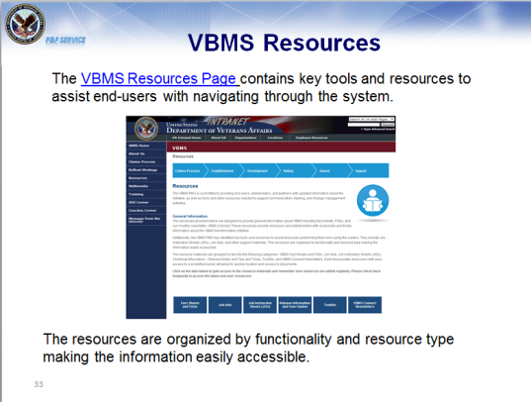 | NAVIGATE: Open the VBMS home page on the VBA Intranet and demonstrate where users may locate job aids. VBMS Job Aids  DISCUSS: VBMS maintains a website that has a job aids associated with the navigation of VBMS that was discussed during training.

Demonstration Guide
Please note: The screen guide contains slides as a reference to ensure the instructor is navigating to the appropriate screens within VBMS during the live demonstration. The following slides should not be used as part of the presentation unless the VBMS system is unavailable.
Screen Guide | Instructor Activities
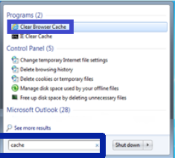 | NAVIGATE: Show users the Clear Browser Cache tool by using the windows search icon.  DISCUSS: Users may need to clear their cache to ensure they are using the most current version of VBMS. The Clear Browser Cache tool has been developed to help you efficiently perform these actions.  As a VBMS user, you may be required to clear the Internet Explorer (IE) cache and Java cache.  When you can no longer open documents within VBMS, it is an indicator of when to clear your IE cache and Java cache.  Additionally, when there has been a new software release, it is important to clear your cache prior to using VBMS. This ensures that you are not accessing the earlier release that was previously stored in cache. By clearing the cache first, you can be certain that you are using the most current release of VBMS.  Inform students that there is a job aid with step by step instructions on how to clear the cache located on the VBMS resources page.
NAVIGATE: VBMS Log In Screen

DISCUSS: Users log in information is the same information that is used to log into VVA. If a student cannot access VBMS, they should contact their supervisor.

Users will need to change their password every 90 days.

If you don’t log into VBMS for more than 90 days, the access is lost, and you have to request access again by contacting your supervisor.

If no actions are performed, the system logs out after 60 minutes.
NAVIGATE: To VBMS Core

DISCUSS: Upon signing into VBMS, an announcement banner populates to alert the user of any system-related notifications.
This includes scheduled maintenance and downtime. The banner above displays a notification for scheduled maintenance.

When you login to VBMS, you are in VBMS Core.
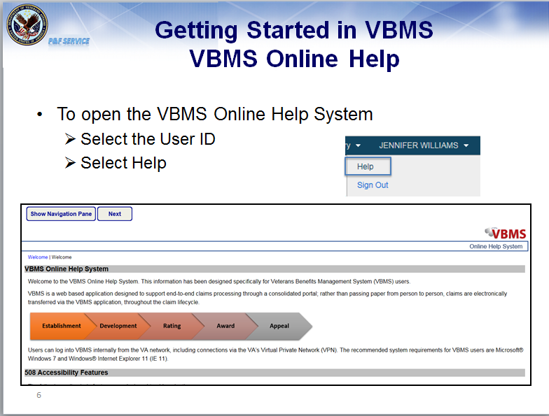 | NAVIGATE: Demonstrate the Help Feature  DISCUSS: Online help is accessed by clicking on the drop down arrow next to your name in the top right corner. From there you can access Online Help.  The VBMS Online Help System screen displays in a new screen. Select the appropriate links on the Help screen (either from the links in the left-hand panel, or from the links on the main screen) to open the desired topic.  You can access the online help system anytime. When a user is unsure how to perform an operation in VBMS, he/she should always consult Online Help first before calling you or the VBMS Service Desk.
NAVIGATE: Show users the location of the search options.

DISCUSS:

Profile search: Navigate directly to Veteran Profile screen

eFolder search: Navigate directly to Veteran eFolder to view documents

More search options: Includes several search criteria fields for each category being searched
The most efficient way to search for a particular Veteran is to input their file or social security number, if available. If a user searches by a common name, the search results may generate multiple Veterans.
- Valid search criteria are required.
Acceptable criteria include:
- file numbers,
- first and last name separated by a space,
- last name then first separated by a comma,
- social security numbers in the form of xxx-xx-xxxx or xxxxxxxxx
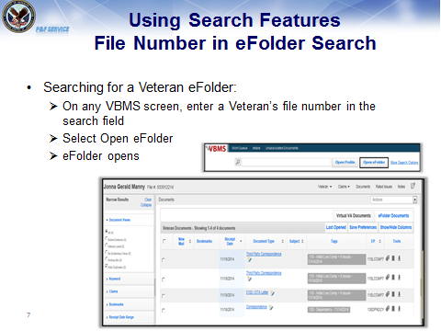 | NAVIGATE: Show users the location of the search box. Enter a pre-identified file number and open the eFolder.  EXPLAIN: eFolder search allows the user to navigate directly to the Veteran eFolder to view documents
NAVIGATE: Show users the location of the search box and enter a name and open the eFolder.

DISCUSS: You will demonstrate how to perform a search using a Veteran’s name.

Remind users that the most efficient way to search for a particular Veteran is to input their file or social security number, if available
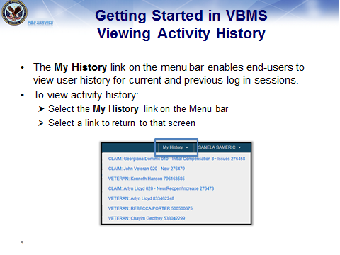 | NAVIGATE: Select the My History link on the Menu bar to show the activity history.  DISCUSS: Selecting a link in the My History Screen enables end-users to view user history for current and previous log in sessions.
NAVIGATE: Show users the magnifying glass and enter a designated file from your history of searches

DISCUSS: The magnifying glass icon to the left of the search field allows end-users to access a history of searches.

Selecting the icon displays the most recent basic and advanced searches from both current and previous log in sessions.
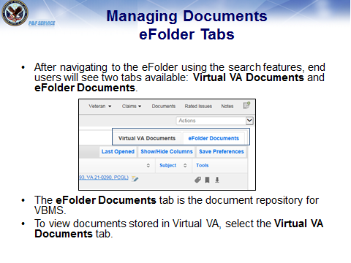 | NAVIGATE: Show users the eFolder.  DISCUSS: The eFolder Documents tab is the document repository for VBMS.  To view documents stored in Virtual VA, select the Virtual VA Documents tab. We will discuss the Virtual VA eFolder further along in the training.
NAVIGATE: Show users the eFolder.

DISCUSS: Documents arrive in the eFolder from multiple sources.

Additional Information for the instructor:
National Archives and Records Administration (NARA)
- Locates and scans Official Military Personnel Files (OMPFs) and service treatment records (STRs) housed in their facilities.
Records Management Center (RMC)
- Scans any STRs for live VBMS claims.
Contract Scanning Vendors
- Regional Offices (ROs) and the RMC ship claim materials to the vendors who scan documents and upload images into the VBMS eFolder.
VONAPP Direct Connect
- Online applications and supplemental documents are uploaded directly from the eBenefits portal.
Stakeholder Enterprise Portal (SEP)
- The SEP is a single, secure entry portal that provides VA partner organizations and external stakeholders the ability to submit documents in support of a Veteran’s claim.
End-User Uploads
- VBMS system functionality allows users with the proper credentials to upload documents directly into the VBMS eFolder.
VBMS Rating & Correspondence Engines
- Rating Decisions and development and notification letters generated in VBMS are automatically uploaded into the Veteran’s eFolder.
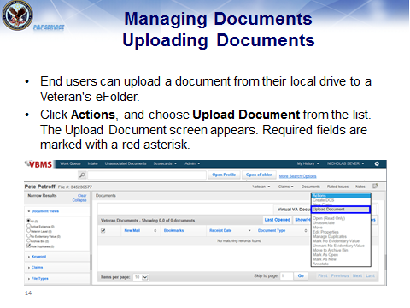 | NAVIGATE: Show users where the “Actions drop down menu is located.  DISCUSS: Click Actions, and choose Upload Document from the list. The Upload Document screen appears. Required fields are marked with a red asterisk.  If you upload a document with the same name as a document that is already in the eFolder, a warning will appear, providing options to keep both documents, or replace the existing document.
NAVIGATE: Show users the location of the New Mail Indicator.

DISCUSS:
New documents uploaded into an eFolder that are pending Claim Processor review will display the New Mail Indicator. If there is a check mark next to it, this means the document was viewed by the user currently logged in.

Additional Information for the instructor:
If you, as a Super user with the Observer Role, view a document, the New Mail Indicator will disappear from your view of eFolder. The New Mail Indicator will still be visible to other users that need to view the document.
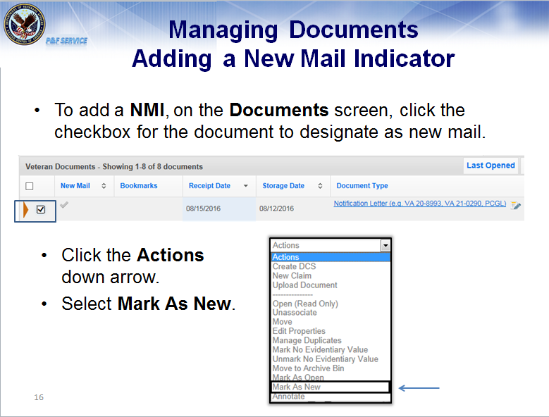 | NAVIGATE: Drop Down Menu to update mail status  DISCUSS: VBMS currently supports two new mail indicators. One indicator is available for the RO and various external employees and one is available for VSO employees.  A user’s role determines which new mail indicator is used to present information on various screens and which new mail indicator gets updated when a document is opened.  Additional Information for the instructor: You can display a new mail indicator for specific documents on the Documents screen by logging in as a Supervisor.
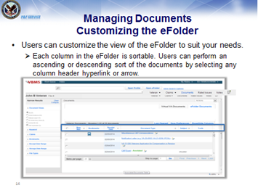 | NAVIGATE: Show users the header row within the eFolder.  DISCUSS: When viewing the eFolder, users have the ability to customize their view in a way that is most efficient for them.  For example:  A user may wish to view all the rating decisions at once. That user can select Document Type and this will group the document types together, such as rating decisions and award documents.  Users can also sort the document by receipt date. Users can select how many documents they want to see per page, as well as save their preferences so that every time that user signs into any eFolder, the preferences previously established will be saved.
NAVIGATE: To Show/Hide Columns

DISCUSS: On the Documents screen, you can click the Show /Hide Columns to determine which columns are displayed on the documents screen.

Users may utilize the Show/Hide Columns feature to organize the columns they want to view and what columns aren’t necessary to view.

Once you select optional columns, these columns appear on the Documents screen.
NAVIGATE: To the bottom tool bar.

DISCUSS: You can select 10, 25, 50 or 100 documents to appear on the Documents screen.

If you make changes to the column layout or documents per page, you can save these preferences as the default view for the Documents screen.
NAVIGATE: To the Save Preferences tab to show how to save column display preferences.

DISCUSS: To save document preferences select Save Preferences button. These preferences will then appear each time you log into VBMS.
NAVIGATE: To the Narrow Results Pane to show how to narrow the documents available for review.

DISCUSS: On the Documents screen, if you need only specific documents to appear. You can use the Narrow Results panel to filter documents. This panel uses dynamic filtering.

As you make selections or enter filter data, the Documents screen displays filtered results automatically.
In the Document Views section, you can click All, Active Evidence, Veteran Level, No Evidentiary Value, or Archive Bin to filter documents based on these views.

Click the Hide Duplicates checkbox to hide any documents you have designated as duplicates.
NAVIGATE: Review each category in the Narrow Results Pane.

DISCUSS:
- In the Keyword field, enter up to five keywords. Keywords filter on bookmark comments as well.
- In the Claims section, click the claim checkboxes to filter only by specific claims.
- In the Bookmarks section, click the checkboxes to filter by specific bookmarks.
- In the Receipt Date section, enter from and to dates in the fields to set a date range.
- In the Storage Date section, enter from and to dates in the fields to set a date range.
- In the File Types section, click the PDF checkbox to filter by only PDF file types.
- You can click Clear to clear all filters.
- Click Collapse to collapse any expanded sections.
NAVIGATE: Show the functionality of the Keyword function in Narrow Results Pane.

DISCUSS: This is an example of how users can filter documents by utilizing the Keyword Search functionality. In this example, we have performed a targeted search for Rating Decisions.

If a user wants to read the reasons and basis behind the Rating Decisions, the user could find those here by inputting the keyword “Rating.” Users can also target the search for Service Treatment and personnel records to locate a line of duty death determination.
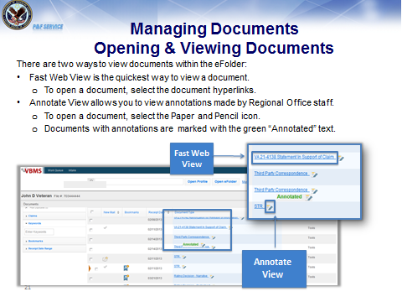 | NAVIGATE: Show a prescreened document that has been selected for the live demonstration.  DISCUSS: Now that we’re familiar with the interface of the eFolder, let’s explore opening and viewing the eFolder’s documents.  Users can view documents with either the Fast Web View or the Annotate View.  Fast Web View is the fastest and most efficient way to open a document in the eFolder. Users can immediately begin to review the first page of the document as the rest of the document continues to load; similar to functionality used in a Google search.  Annotations are comparable to the post-it or sticky notes that Regional Office Claim Processors use to mark certain documents within the paper claims folder.  Explain that you may open multiple documents at a time by selecting the check box in the far left corner and selecting open read only from the drop down options on the right side for the screen.  Additional Information for the instructor: Observers are unable to make annotations, but they are able to view them.
NAVIGATE: Open a previously identified document using fast web view.

DISCUSS: When the document is open, users can view the document as a whole by scrolling down, or select the thumbnail view and see all of the pages on the left side panel.
NAVIGATE: Select the binoculars within the open document to show how the keyword feature can be used to navigate a document.

DISCUSS: If a user is looking for a particular keyword within the document, select the binocular icon and type in the keyword.
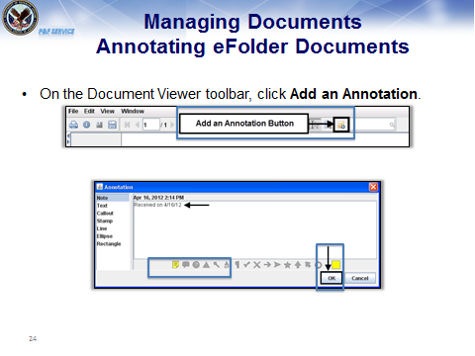 | NAVIGATE: Open a previously identified document. Select the paper and pencil to show users how to add an annotation.  DISCUSS: Users may use the annotation feature to make notes or highlight specific items on a document. Annotations may be viewed by all users who have the ability to view annotations.  Explain to users that the must save their annotation by selecting the disk on the toolbar before closing the annotation.  The annotation allows users to leave notes within a document, which can be reviewed internally.  NAVIGATE: Return to the eFolder and show users the location of the annotation that was created during training.
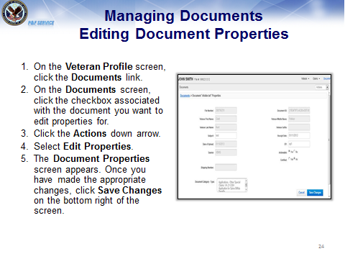 | NAVIGATE: Show user the document properties. Demonstrate that you can edit document properties on the drop down  DISCUSS: There may be situations where the document properties that have been loaded into the eFolder are incorrect. For examples the receipt date may be incorrect.  You may edit the document properties within the document or by navigating through the document properties screen.  Express to users the steps to edit the document properties using the steps below.  - Open the document  - Click the Document Properties button. The Editable Properties section appears on the left side of the screen.  - You can edit document properties for Subject, Receipt Date, Document Category - Type, EP, Actionable, and Certified.  - Click Save to save your changes to the document properties.
NAVIGATE: Select the VVA Tab within the eFolder.

DISCUSS: Upon selecting the Virtual VA Documents Tab, you will be brought to the VVA Documents screen. The columns available on this screen are Receipt Date, Document Type, Subject, Treatment/Condition, Treatment Start Date, and Treatment End Date.

Selecting a link in the Document Type column to open a Virtual VA document. Users can also select the checkboxes and select Open (Read Only) from the Actions Drop-down to open multiple documents.

IMPORTANT NOTE: Users will be able to see both restricted and non-restricted documents listed under the Document Type column. If you click a link to a restricted document, a Notification screen appears informing you that this document type is restricted. Restricted documents can only be accessed via the Virtual VA system.
NAVIGATE: Return to the Presentation Slide Deck. Go to Slide 5: Summary of VBMS Functionality.

DISCUSS: This concludes the live demonstration of VBMS.

