

Changes to FSR Process
Lesson Plan

June 2016 – Version 1.0

Changes to FSR Processes – 2 Learning Hours

Lesson Overview
Purpose of the Lesson: | The purpose of this lesson is to explain the addition of Chapter 7 to the Fiduciary Program Manual (FPM) which directs Fiduciary Service Representatives (FSRs) on how to promulgate fiduciary ratings, awards, and other authorization activities.
Prerequisite Training Requirements: | N/A
Target Audience: | FY16 P&F Service mandatory training for trainee and experienced FSRs
Lesson References: | - FPM Chapter 7
Lesson Objectives: | By the end of this lesson, Fiduciary Service Representatives will be able to:  - describe and implement the revisions to fiduciary promulgation team processing procedures as outlined in Fiduciary Program Manual (FPM), Chapter 7  - describe and implement the new procedures for transferring actions related to a beneficiary’s inability to manage his/her VA benefits  - understand the purpose of the updated procedures

Instructor Notes

PowerPoint Slides | Instructor Activities
[Lesson Title]  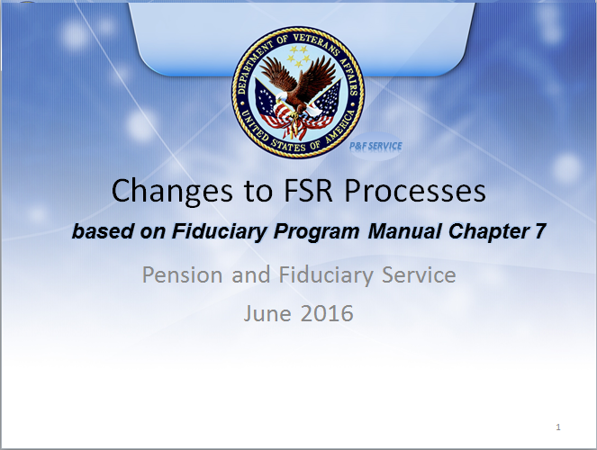 | DISPLAY slide  - “[Lesson Title]”  INTRODUCE yourself as the instructor and introduce any fellow instructors.  INTRODUCE the lesson.
Lesson Objectives  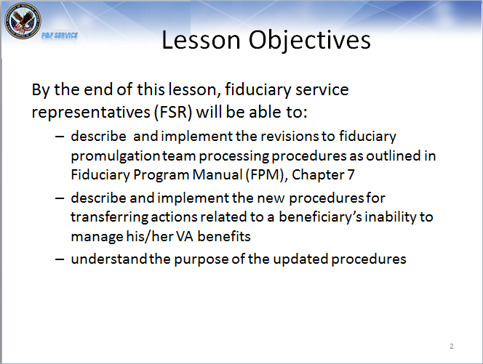 | DISPLAY slide  - “Lesson Objectives”  REVIEW the lesson objectives and assure students they will have opportunities to practice what they learn.  EMPHASIZE that the post-lesson assessment will align with the content and these objectives.
Background  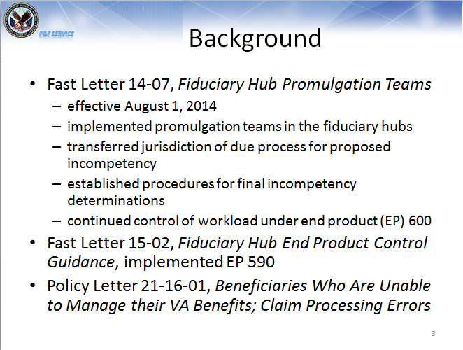 | DISPLAY slide  - “Background”  REVIEW the background of the manual chapter 7 by discussion Fast letter 14-07.  Discuss that Fast Letter 15-02 implemented the fiduciary hub specific EP to allow for better workload management.  Discuss that some of the cases identified under policy letter 21-16-01 were the result of a breakdown in the procedures for transferring the work from the VSC or PMCs to the fiduciary hub.
Previous Procedures  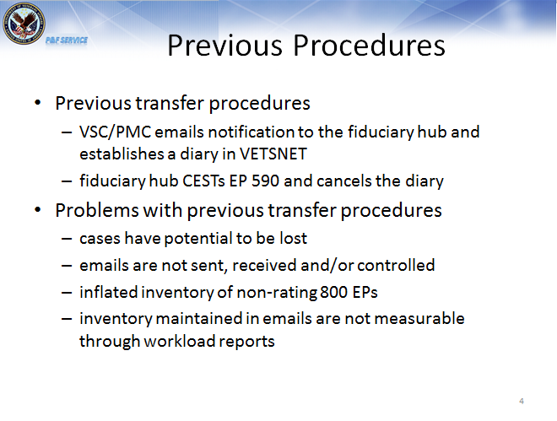 | DISPLAY slide  - “Old Procedures”  REVIEW the old procedures and the issues.  EXPLAIN that VA system updates allow for updated transfer procedures.
New Procedures  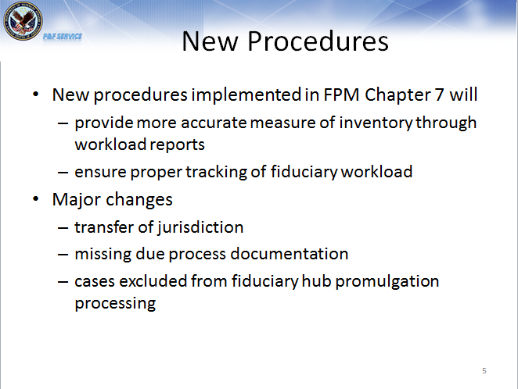 | DISPLAY slide  - “New Procedures”  REVIEW the advantages of the new procedures.  DISCUSS the major changes that will be covered during the training.
Transfer of EP 590 to Hub  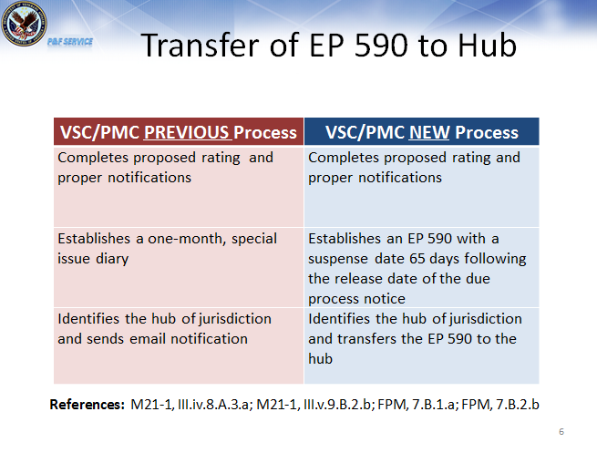 | DISPLAY slide  - “Transfer of EP 590 to Hub”  REVIEW the previous versus new procedures for the VSC/PMC.  EMPHASIZE that the VSC/PMC employee will establish the EP 590 immediately following the proposed rating.
Transfer of EP 590 to Hub (Cont.)  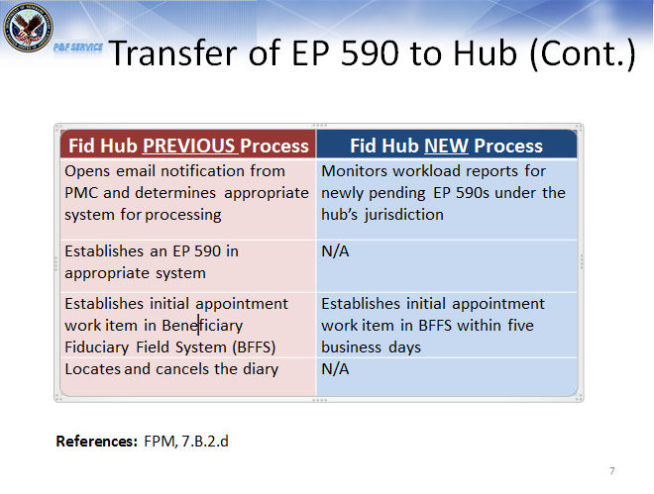 | DISPLAY slide  - “Transfer of EP 590 to Hub (Cont.)”  REVIEW the previous versus new procedures for the fiduciary hub.  EMPHASIZE that the new procedures ensure that the case is under immediate EP control and eliminates the potential for the case to be lost in the email exchange, and also eliminates the issues with diaries.
Missing Documentation  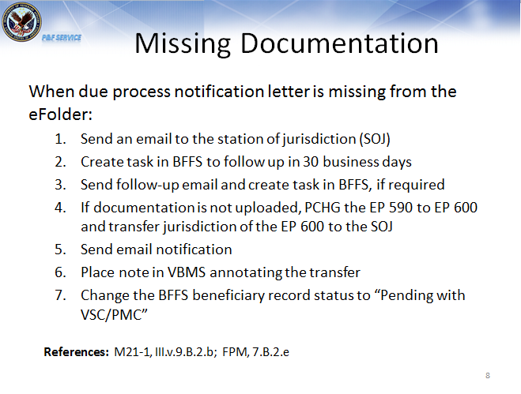 | DISPLAY slide  - “Missing Documentation”  DISCUSS VA’s requirement to provide the beneficiary due process.  REVIEW the procedures to request the due process notification letter if it is not in the eFolder. Point out that the fiduciary hub cannot establish an initial appointment work item without the date of letter.
Missing Documentation (Cont.)  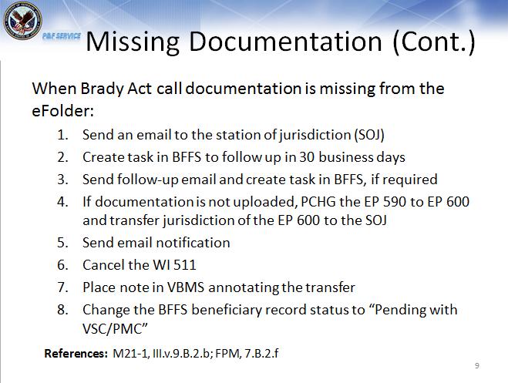 | DISPLAY slide  - “Missing Documentation (cont.)”  DISCUSS VA’s requirement to notify the beneficiary of the Brady Act implications.  REVIEW the procedures to request the Brady Act call documentation if it is not in the eFolder. Point out that the fiduciary hub will establish an initial appointment work item in these cases.
Referring Cases with Additional Evidence  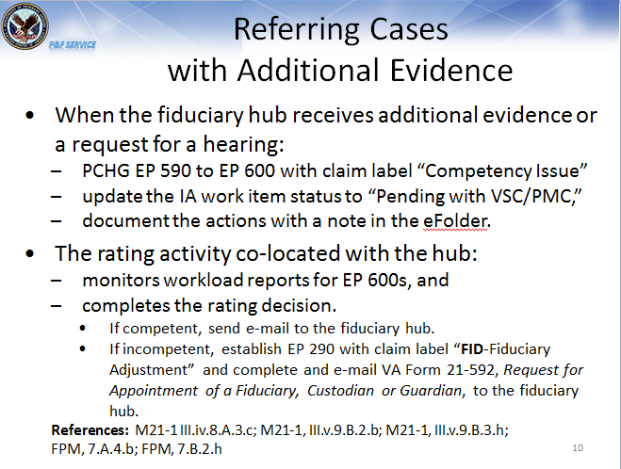 | DISPLAY slide  - “Referring Cases with Additional Evidence”  REVIEW the procedures for the hub to refer the case to the co-located rating activity when additional evidence is received.  REVIEW the procedures for the co-located VSC/PMC to refer the case back to the hub.  DISCUSS that the “FID- fiduciary adjustment” claim label identifies that EP as the fiduciary hubs jurisdiction.
Transferring Requests for Fiduciary Appointment (EP 290) with Judicial Determinations  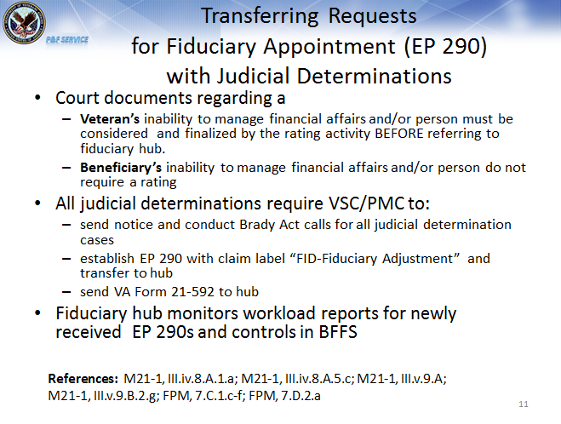 | DISPLAY slide  - “Transferring Requests for Fiduciary Appointment (EP 290) with Judicial Determinations”  DISCUSS that previously the rating for a Veteran with a judicial determination was completed after the fiduciary appointment.  DISCUSS that under new procedures, the VSC/PMC will complete the rating for a Veteran BEFORE referring to the hub.  REVIEW the procedures for the VSC/PMC to refer judicial determinations to the hub.  EMPHASIZE that the EP 290 will be established by the VSC/PMC and transferred to the hub.
Award Actions  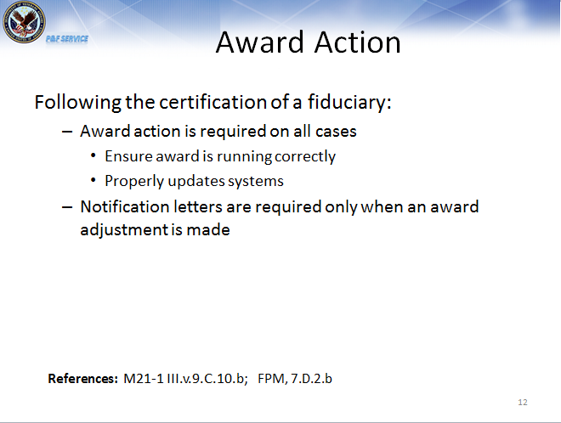 | DISPLAY slide  - “Award Actions”  DISCUSS that an award needs to be completed to ensure that the award is running correctly and to properly update the systems.  DISCUSS that if the award amount has not changed from the time of the proposed rating, there is no need to send another letter. The fiduciary is notified of the retroactive benefit during the field examination and in the budget letter, making an additional letter redundant and confusing for the fiduciary.
COLA Write-outs  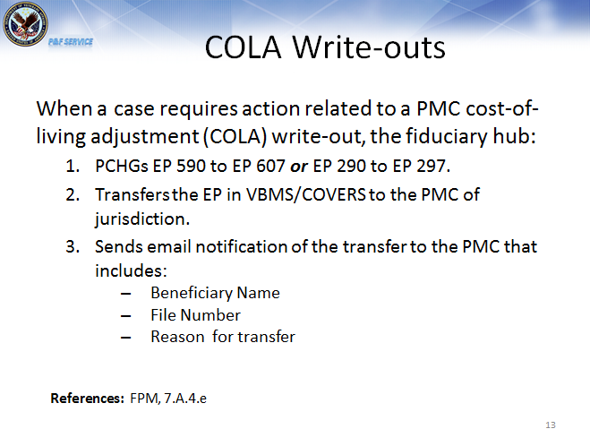 | DISPLAY slide  - “COLA Write-outs”  DISCUSS that previously the rating for a Veteran with a judicial determination was completed after the fiduciary appointment.  DISCUSS that under new procedures, the VSC/PMC will complete the rating for a Veteran BEFORE referring to the hub.  REVIEW the procedures for the VSC/PMC to refer judicial determinations to the hub.  EMPHASIZE that the EP 290 will be established by the VSC/PMC and transferred to the hub.
Excluded Cases  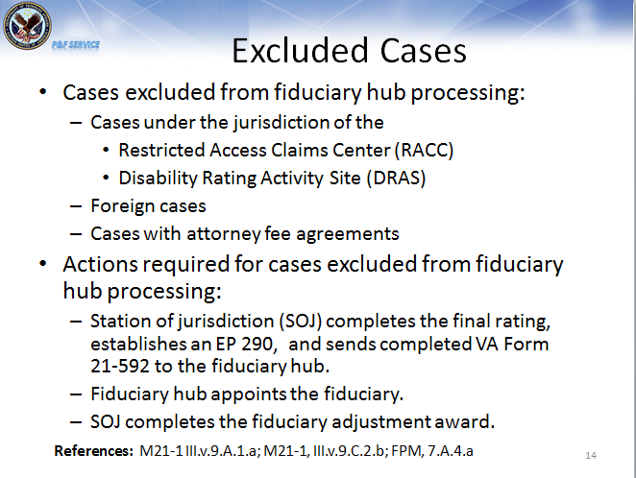 | DISPLAY slide  - “Excluded Cases”  EXPLAIN that there are some cases that have unique processing requirements and must be excluded from fiduciary hub promulgation.  DISCUSS the cases that are excluded from fiduciary hub processing.  REVIEW the actions required for cases excluded from fiduciary hub processing.
Summary  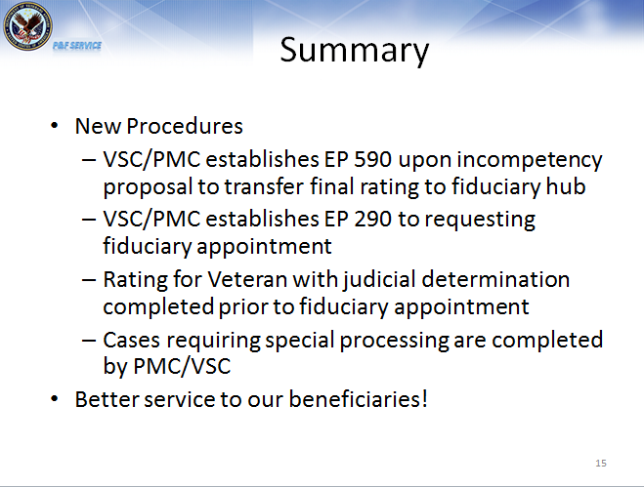 | DISPLAY slide  - “Summary”  REVIEW the information in the day’s lesson.
Questions?   | DISPLAY slide  - “Questions?”  ASK students if they have any questions about the day’s lesson.  RESPOND to all questions before tasking students to complete the assessment.
TMS Assessment and Survey  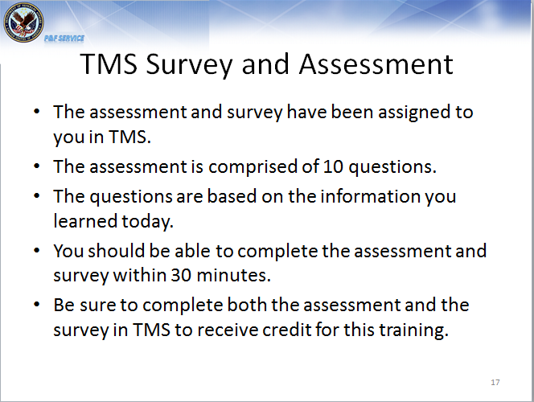 | DISPLAY slide  - “TMS Assessment and Survey”  TELL students how to access the assessment and survey in TMS.  EXPLAIN that the assessment is 10 questions and will cover what they learned in class today.  REMIND them that they must complete both the assessment and the survey in order to receive credit in TMS for their training.  TELL students that the survey provides them an opportunity to improve the training and that their feedback is welcome.

