
DEPARTMENT OF VETERANS AFFAIRS
In Reply Refer To:
334
C
VETERAN
Central Area Fiduciary Hub - Lincoln
P.O. Box 5444
Lincoln, NE 68505

DATE

FIDUCIARY
FIDUCIARY FOR VETERAN
555 MAIN ST
CITY STATE ZIP

Dear Fiduciary:

Thank you for submitting the accounting on behalf of VETERAN for the accounting period 07/16/11 through 07/15/12.

What Did We Decide?

We have reviewed the accounting on VA Form 21-4706b, Federal Fiduciary Account and VA Form 21-4718a, Certificate of Balance on Deposit and Authorization to Disclose Financial Record. The Accounting for the period has been approved.

Open Communication Between Fiduciaries and Beneficiaries

To ensure transparency, you must provide a copy of the approved accountings to the beneficiary within 14 days of the date of this letter. This requirement pertains only to VA Forms 21-4706b, Federal Fiduciary’s Account. You are not required to provide bank statements and other documentation submitted to VA in support of your accounting.

Estate Protection

Under current VA regulations, the current surety bond is not sufficient to protect Kenneth Foster’s VA estate of $61,238.02 plus anticipated VA income for the upcoming year of $33,228. Please present this letter to the bonding company as authorization to increase the current surety bond to $95,000. The bonding company may issue a rider to an existing bond or purchase an additional bond to equal the amount stated above.

This letter is your authorization to make this purchase. Keep a copy of this letter for your records and give the original to your insurance agent when purchasing the bond. You may use the veteran’s funds to purchase this bond. Please provide all original surety bonds to the address noted above by 01/01/13.

Monthly Fund Usage and Needs

Based on our review of these accountings, it appears that Joe Smith’s financial needs have changed. Please use the following budget to disperse the veteran’s VA funds. Excess funds should be conserved in an interest-bearing account for future expenses for the beneficiary. If you find that any of the monthly expenditures increases by more than 15 per cent or a new category needs to be added to the budget, please call our office at (888) 407-0144 to speak with a Legal Instruments Examiner. You may also wish to contact your field examiner and discuss the changes with them.

Category | Old Amount | New Amount | VA Funds
Rent/Room & Board | $650.00 | $700.00 | $700.00
Personal Use | $500.00 | $500.00 | $500.00
Electric | $200.00 | $215.00 | $215.00
Heat – Gas | $90.00 | $115.00 | $115.00
Cable | $0.00 | $164.55 | $164.55
Auto loan | $250.00 | $250.00 | $250.00
Auto insurance | $110.79 | $110.79 | $110.79
Fiduciary Fee | $106.92 | $110.76 | $110.76
Clothing ($500 annually) | $41.67 | $41.67 | $41.67
Surety Bond ($700 annually) | $58.34 | $58.34 | $58.34
Total: | $2007.72 | $2266.11 | $2266.11

Additional Information

Your next accounting period should cover from 07/16/12 through 07/15/13. Your beginning balance should be $61,238.02.

Please send the original surety bond to the address at the top of this letter by 01/01/13. To expedite the review of your information, place the enclosed cover sheet on top of the documents.

If you have any questions or require further assistance, please call Tammy Alley, the Legal Instruments Examiner assigned to this case, at (402) 420-4178.

We appreciate, and thank you for serving our VA beneficiary.

Sincerely,

Fiduciary Hub Manager

Copy: POA
Enclosures:
Approved VA Forms 21-4706b with signature
Cover sheet

Veteran's name |  |  | FOSTER , KENNETH |  |  |  |  | C-File # |  | 123456789 |  | Fid name |  |  | RAUL VILLARREAL
Beneficiary name |  |  | FOSTER , KENNETH |  |  |  |  | ASSETS AT THE END OF PERIOD
LAST YEARS ENDING BALANCE = |  |  |  |  |  |  | 92582.4
Amt rcvd from VA (most recent on top) | 12 |  |  |  |  | 2673 | 32076 | Cash on Hand (Not on deposit) |  |  |  |  |  |  |  |  | 0
Amt rcvd from VA (most recent on top) | 0 |  |  |  |  | 0 | 0 | Checking |  |  |  |  |  |  |  |  | 110137.87
Amt rcvd from VA (most recent on top) | 0 |  |  |  |  | 0 | 0 | Savings 1 |  |  |  |  |  |  |  |  | 0
Amt rcvd from VA (most recent on top) | 0 |  |  |  |  | 0 | 0 | Savings 2 |  |  |  |  |  |  |  |  | 0
Amount from SS | 0 |  |  |  |  | 0 | 0 | Savings 3 |  |  |  |  |  |  |  |  | 0
Amount from SS | 0 |  |  |  |  | 0 | 0
Interest earned |  |  |  |  |  |  | 51.47
Only other VA Monies |  |  |  |  |  |  | 0 | Savings Bonds Cashed? |  |  |  |  |  |  |  |  | 0
VA Lump Sum: |  |  |  |  |  |  | 0 | Multiple CD's |  |  |  |  |  |  |  |  | 0
otherr1 |  |  |  |  |  |  | 0
other2 |  |  |  |  |  |  | 0
otherr3 |  |  |  |  |  |  | 0 | OUTSTANDING DEPOSIT |  |  |  |  |  |  |  |  | 0
otherr4 |  |  |  |  |  |  | 0 | LESS OUTSTANDING CHECKS |  |  |  |  |  |  |  |  | 0
Total yearly earnings |  |  |  |  |  |  | 32127.47 | TOTAL ASSETS at END OF PERIOD |  |  |  |  |  |  |  |  | 110137.87
TOTAL INCOME at END OF PERIOD = |  |  |  |  |  |  | 124709.87 | Perfect |  |  |  |  |  |  |  |  | 0
MONEY SPENT THIS PERIOD =
Room &Board/Rent |  | 2 |  |  | 2000 |  | 4000
Clothing |  |  |  |  |  |  | 800 | other |  |  |  |  |  |  |  | 0
Entertainment |  |  |  |  |  |  | 0 | other |  |  |  |  |  |  |  | 0
Personal Use |  | 12 |  |  | 200 |  | 2400 | other |  |  |  |  |  |  |  | 0
Dependent Support |  | 0 |  |  | 0 |  | 0 | other |  |  |  |  |  |  |  | 0
Federal Fiduciary Fee |  |  |  |  | 1283.04 |  | 875 | other |  |  |  |  |  |  |  | 0
IF COURT Place X |  |  |  |  |  |  | 4 % | other |  |  |  |  |  |  |  | 0
BED |  |  |  |  |  |  | 900 | other |  |  |  |  |  |  |  | 0
Sergio Palacios transportation, etc. |  |  |  |  |  |  | 4800 | other |  |  |  |  |  |  |  | 0
Walthall Sachse bond |  |  |  |  |  |  | 678 | other |  |  |  |  |  |  |  | 0
stamps |  |  |  |  |  |  | 44 | other |  |  |  |  |  |  |  | 0
birthday |  |  |  |  |  |  | 75 | other |  |  |  |  |  |  |  | 0
other |  |  |  |  |  |  | 0 | other |  |  |  |  |  |  |  | 0
other |  |  |  |  |  |  | 0
other |  |  |  |  |  |  | 0
TOTAL MONEY SPENT at END OF PERIOD |  |  |  |  |  |  | 14572
TOTAL ESTATE at END OF PERIOD |  |  |  |  |  |  | 110137.87
 |  |  |  |  |  |  | HISTORICAL
 |  |  |  |  |  |  | VA |  | OTHER |  | LUMP SUM
Enter Last Years Estate Balance = |  |  |  |  |  |  | 92582.4 |  | 0 |  | 0 |  |  | 0
ESTATE BALANCE = |  |  |  |  |  |  | 110137.87 |  | 0
 |  |  |  |  |  |  |  |  | = |  | LIE# 033/TA
Surety Bond Amount? |  |  |  |  |  |  | 142213.87 |  | 143000
 |  |  |  |  |  |  | Bond Needed
Accounting Period: |  |  |  |  |  |  | 11/09/2009 |  | 11/07/2010
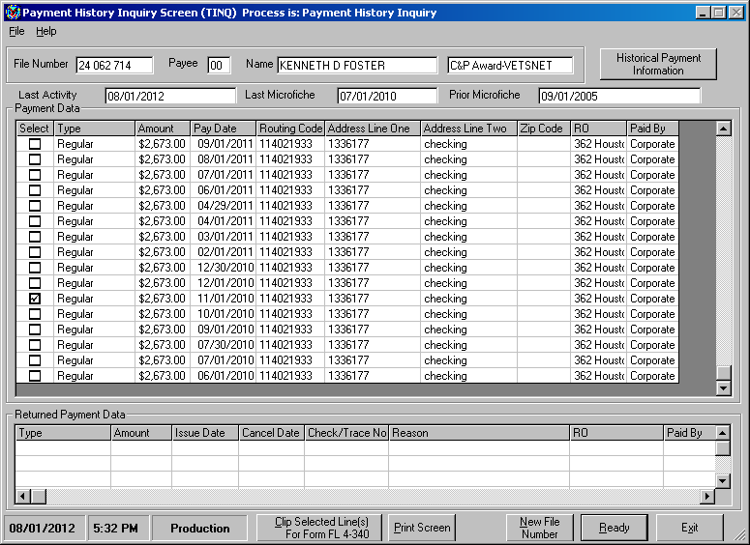

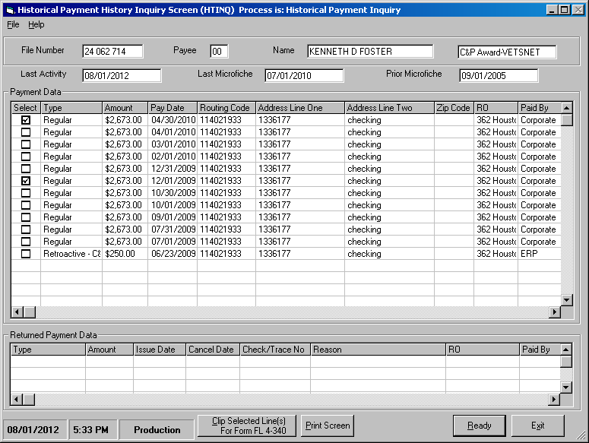
Lname, Fname |  | File No: |  | 123456789 |  |  | Account Date: |  | 11/09/2009 |  | 11/07/2010
 | Use the following chart if the estate HAS historically been broken down to reflect funds considered to have been derived from VA income.
 |  |  | INCOME |  |  |  |  | EXPENSES
 |  |  | VA |  | Other Source (OS) Income | Interest |  | Expenses (less admin) |  | Admin Expenses |  | Total
 | Income from current period |  | 32076 |  | 0 | 51.47 |  |  |  |  |  | 124709.87
 | Expenses from current period |  |  |  |  |  |  | 13697 |  | 875
 | Expenses (excluding administrative expenses) |  | 13697 |  | 0
 | Increase to VA/Other Estate this accounting period |  | 18379 |  | 0
 | Enter and add estate balance from last account |  | 92582.4 |  | 0 |  |  |  |  |  |  | 92582.4
 | Adjustment to estate balance when expenses exceed income |  | 0 |  | 0
 | Net estate - VA/OS breakdown |  | 110961.4 |  | 0 |  |  |  |  |  |  | 110961.4
 | %VA/Other to total estate |  | 100 |  | 0
 | Proportionate distribution of interest income |  | 51.47 |  | 0
 | Sub-total |  | 111012.87 |  | 0
 | Proportonate share of admin expenses |  | 875 |  | 0
 | Ending estate balances |  | 110137.87 |  | 0 |  |  |  |  |  |  | 110137.87
 | Use the following chart if the estate HAS NOT historically been broken down to reflect funds considered to have been derived from VA income
 |  |  | INCOME |  |  |  |  | EXPENSES
 |  |  | VA |  | Other Source (OS) Income | Interest |  | Expenses (less admin) |  | Admin Expenses |  | Total
 | Beginning estate balance |  |  |  |  |  |  |  |  |  |  | 92582.4
 | Income from current period |  | 32076 |  | 0 | 51.47 |  |  |  |  |  | 32127.47
 | Expenses from current period |  |  |  |  |  |  | 13697 |  | 875 |  | 14572
 | Ending estate balance
 | PROCEED
 | Income this account |  | 32076 |  | 0
 | Expenses this period (excluding administrative) |  | 13697 |  | 0
 | Sub-total* |  | 18379 |  | 0
 | %VA/Other to total estate* |  | 100 |  | 0
 | Beginning estate balance
 | Sub-total |  | 110961.4 |  | 0
 | Add back lumpsum payment if applicable
 | Sub-total |  | 110961.4 |  | 0
 | Proportionate distribution of interest income |  | 51.47 |  | 0
 | Sub-total |  | 111012.87 |  | 0
 | Proportionate share admin expenses |  | 875 |  | 0 |  |  |  |  |  |  | 875
 | Ending estate balance |  | 110137.87 |  | 0 |  |  |  |  |  |  | 110137.87
 | *Apply these percentages to the beginning balance (in the next step) to arrive at a baseline breakdown. Adjust as necessary for extenuating factors such as:
 | (1) an initial large VA retro,
 | (2) income limited to VA until recent award of other benefit, or
 | (3) expenditure disallowed by VA should be deducted from other funds.

Review Element | FEDERAL |  | FOSTER
Review Element | FIDUCIARY |  | 24062714
Completeness: Fiduciary signature? | x | Complete
Completeness: Attachments? | x | Complete
Completeness: Missing pages? | x | Complete
Prepare for analysis: Review PGF. | x | Complete
Prepare for analysis: Print payment records. | x | Complete
Certification of document? | x | Complete
Correct accounting period? | x | Complete
Correct beginning balance? | x | Complete
All known income reported? | x | Complete
Income verified? Clarify changes. | x | Complete
Mathematical accuracy? | x | Complete
Account balances verified? | x | Complete
Accounts properly registered? | x | Complete
Checking account balance excessive? | x | Complete
Expenditures appropriate and supported? | x | Complete
Missing expenditures? | x | Complete
Debt payments appropriate? | x | Complete
Inappropriate fiduciary/bene transactions? | x | Complete
Disbursements from estate? | x | Complete
Questionable expenditures verified? | x | Complete
Fiduciary commissions & fees reasonable? | x | Complete
Attorney fees supported? | x | Complete
Protection type/adequate? | x | Complete
FDIC limits? | x | Complete
Investments & registration proper? | x | Complete
Fiduciary arrangement remains appropriate? | x | Complete
Entitlement discrepancies? | x | Complete
Allowances appropriate? | x | Complete
Address changes noted? | x | Complete
Amended accounting? | x | Complete
Fiduciary notification of review results? | x | Complete
VA Form 21-4707, Estate Summary, updated? | x | Complete
21-3045, Estate Action Record, updated? | x | Complete
FBS updated? | x | Complete
Payment records updated? | x | Complete
NOTES:
bond will be addressed for the 10-11 accounting, requesting receipt/statement for rent payment to the boarding house and purchase of bed/sheets

