Quality Management System (QMS)

User Guide 2.0

Table of Contents

Purpose 3

Overview 3

Scope 3

I. QMS Application Basics 3

Salesforce Access and Tip Sheet 3

The Home Page 4

II. Performing a Review 4

Perform Review (Initial) 5

Perform Review (Subsequent) 10

Deselect 13

On-Hold 14

Change Reviewer (QRT Coach Function Only) 14

Deselect Approve/Reject (QRT Coach Function only) 15

Other Actions 15

III. Error Corrections 15

Managing Error Corrections 15

IV. Contact Information 17

V. Supervisory Functions 18

VI. Glossary 18

Appendix A. VBA and QMS Acronyms and Terminology 18

Appendix B. Review Related Descriptions 19

Appendix C: Error Corrections Related Descriptions 28

Appendix D. Contact Page Descriptions 31

Appendix E. Submitting a Trouble Ticket 31

Resources 32

QMS User Guide – Log of Changes 33

# Purpose

The Quality Management System (QMS) system is a next generation claims quality management system that replaces Systematic Technological Analysis Report (STAR), Automated Standardized Performance Elements Nationwide (ASPEN), SharePoint Issue Benefit Report (IBR), numerous SharePoint lists, and manual functions that are part of the current quality process.

QMS integrates multiple quality review processes into one system and provides a single unified source of claims quality information that can be used for metrics, analysis, training recommendations, process improvements, and National Work Queue (NWQ) segmentation. Timeliness of quality actions had been one of the major issues resolved by QMS.

# Overview

Improving benefits and services delivery to Veterans, Service members, and eligible beneficiaries remain a priority goal for the Department of Veterans Affairs (VA). Given this focus, the Veterans Benefits Administration (VBA) has developed and deployed a number of transformation initiatives including the Veterans Benefits Management System (VBMS) and the NWQ. With these technological and operational improvements, VBA revised employee Performance Standards to better support VA’s national workload strategy, which shifts from a focus on a singular, final production target to an emphasis on actions which promote improved efficiency throughout the entire claims process for VBA benefits.

VBA continuing to modernize and improve the quality process to better guide operational improvements and to respond to stakeholder and Congressional mandates.

# Scope

QMS includes the automation of claims quality processing and reporting for VBA business lines and employees. QMS does not include production or excluded time reporting that is part of the existing Workforce And Time Reporting System (WATRS).

For more information on QRT positions and responsibilities specific to each business line, refer to your specific business line manual references.

# I. QMS Application Basics

## Salesforce Access and Tip Sheet

Logging in will be a single sign-on method. A Start Menu shortcut is available to give VBA users easy access to Salesforce. The User will select the “Salesforce” shortcut located at Start -> All Programs -> VBAPPS -> Salesforce. If the shortcut cannot be found, the URL for this site is <https://va.my.salesforce.com>.

This will take the User into the Salesforce Home page. If salesforce does not display the Lightning view the User should follow the appropriate steps in the [Lightning Tip Sheet](https://va.lightning.force.com/lightning/r/ContentDocument/069t000000NGMH3AAP/view). First time Users should review this Tip sheet and also consult the Basic Reviewer Training Course in [TMS](https://ssologon.iam.va.gov/centrallogin/Default.aspx?appname=core&URL=https://ssologon.iam.va.gov/centrallogin/core/redirect.aspx&TYPE=33619969&REALMOID=06-345d7582-c96e-4888-9e5f-6e86468bf060&GUID=&SMAUTHREASON=0&METHOD=GET&SMAGENTNAME=-SM-JDZx1AxYAhQguyl0rfvd%2f5f46jynE%2bEoBtr6BQQU4NWuWIwCZNPIPHj210fDMxqs&TARGET=-SM-HTTPS%3a%2f%2flogon%2eiam%2eva%2egov%2faffwebservices%2fredirectjsp%2fredirect%2ejsp%3fSPID%3dhttps%3a%2f%2fwww%2esuccessfactors%2ecom%2fVAHCM03%26SMPORTALURL%3dhttps-%3A-%2F-%2Flogon%2eiam%2eva%2egov-%2Faffwebservices-%2Fpublic-%2Fsaml2sso%26SAMLTRANSACTIONID%3d27fb4dbe--fc0c514f--06558174--20bcf1c4--e8fa67c4--bb) (VA 4568194).

If you receive a message denying you access to Salesforce or you do not have the Salesforce shortcut in your VBAPPS menu, please contact your supervisor for assistance.

## The Home Page

When logging into the QMS application, the User will see the Home page (shown below). This page provides access to the employee’s assigned Reviews and Error Corrections for easy accessibilty, as well as a link to recent records and Chatter feed activity. The search bar option at the top of the page allows the User to search within the QMS application as a whole or by choosing a specific QMS item (i.e. Reviews, Error Corrections, Reports, Chatter, etc.). Additional “Help and Training” can be accessed by selecting the question mark icon at the top left of the page.

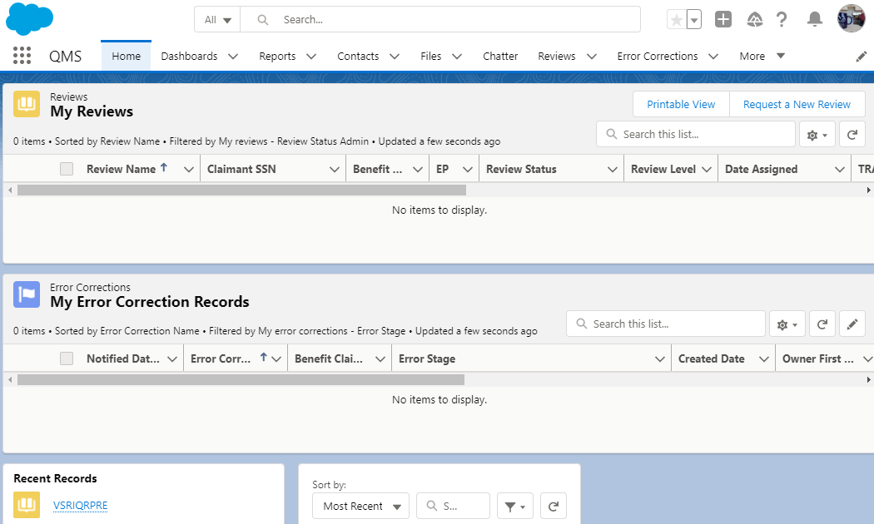

# II. Performing a Review

The main purpose of the QMS system is to create and route quality reviews for completion. Training for performing a review can be found in TMS (VA 4568194).

To begin this process a User must request a review via the Home or Reviews page using the “Request a New Review” button.

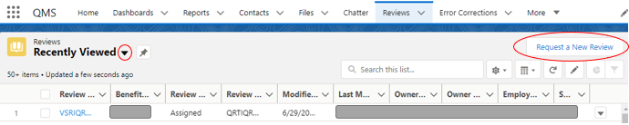

When first selecting the Reviews page a “Recently Viewed” list will display. Using the drop-down option and selecting “My Reviews” will provide a view of the User’s pending reviews, also shown on the Home Page. This list view includes the review type, status, priority and provides a hyperlink to access and take specific actions on a review. The default list view can be edited using the “pin” option. 

Review Levels and Available Review Types designated on the User Contact Detail page will decide which review is selected for assignment. Refer to Section IV for more details on updating Contact records and to the glossary for available Review Levels and Available Review Types.

This section will provide information on the screens a User will experience and their function while performing an Initial and Subsequent review. Additional definition tables for the Review Levels and the Reviews Detail page can be found under Glossary section Appendix B.

## Perform Review (Initial)

Once a new review has been requested and received it will show a review status of “In-process”. A message will be received letting the User know the action was successful. A User may only have one “in-process” review at a time, but can request additional reviews if assigned reviews are “on-hold” or in an “assigned” status (meaning it was assigned by a QRT Coach).

Next select the Review Name which will transfer the User to the Review Detail page. The Review Detail page contains all the Review information pulled for the selected review.

Following examination of Review Details page select “Perform Review” to initiate the quality review process. Note: The other options will be discussed later in this section (the “Change Reviewer” and “Deselect Approve/Reject” are Coach commands only).



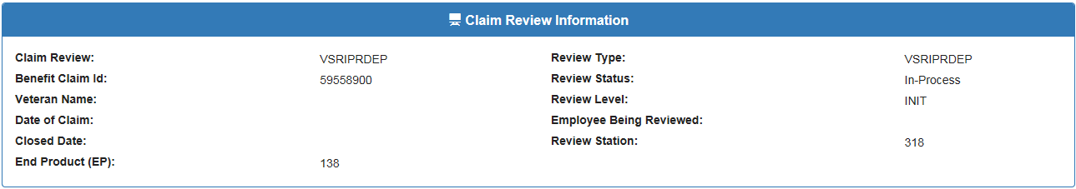

Scroll down to “Claim Review – Initial Review Process” and review the checklist questions and when applicable open the individual list of errors for each question. The User will find all questions related to the checklist and a list of the errors related to each question.

Note: Each review checklist will consist of questions related to that specific review. The majority of checklists consist of a format for answering questions that includes selecting the circle next to “Yes, No or N/A”. Other checklists may have you select the answer from an available list. See below images

A. Click Circle next to correct answer

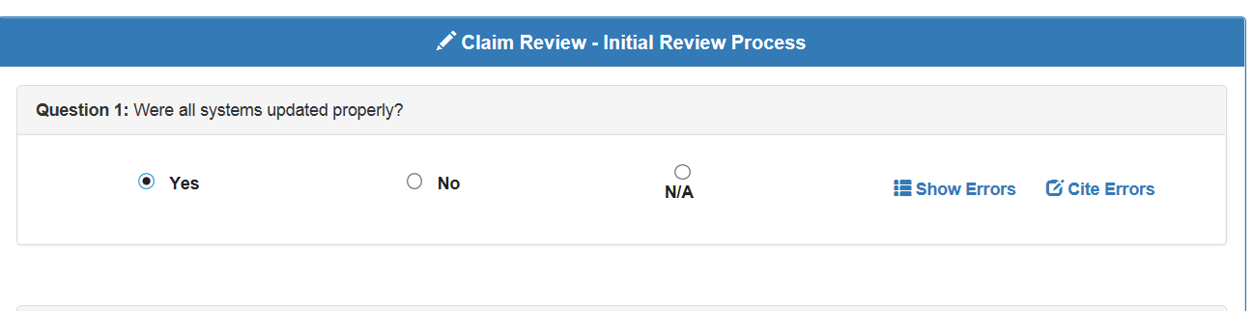

B. Click the answer from available list.

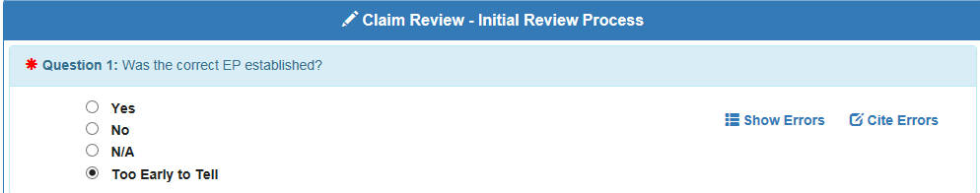

If an error needs to be cited, the User can either select the “No” radial button or “Show Errors” to open a list of errors.

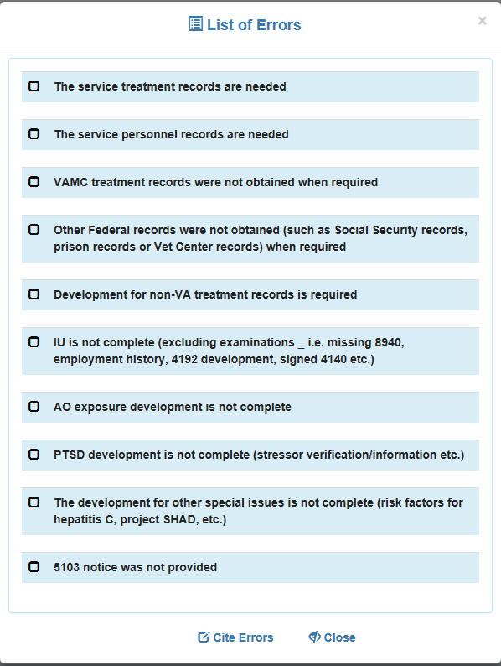

The User can cite the specific error from either the Claim Review or List of Errors screen using the “Cite Errors” option. The list of errors will be displayed giving the User an option to select one of the errors by checking the box next to the error. 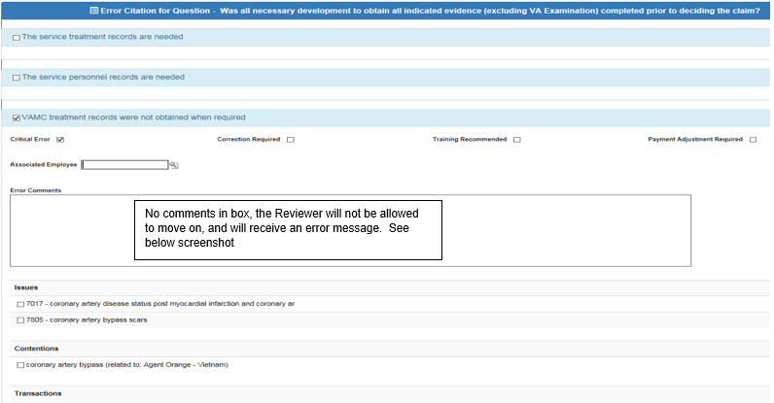

If the critical error box is unchecked, the error will be identified as a non-critical error and not count against an employee’s quality percentage. However, if the “Critical Error” checkmark is removed, the User will add an explanation to why the error cited is a “Non-Critical Error” in the “Error Comment” box.

The User also has the option to check the boxes next to “Correction Required” if any error cited should be corrected, “Training Recommended” if applicable and “Payment Adjustment Required” if the error impacted the benefit payment as necessary (note: an amount is required when selecting this option, enter $0.00 if unknown). Next, when citing an error the User is required to include comments. In the ” Error Comments” box provide the proper “Error Narrative”: Identify the error with a description of the error, a brief but sufficient explanation why the error was cited and a reference to support the cited error.

Once an error is cited, scroll down to display the Issues, Contentions and Transactions which are related to the error called. All boxes in these three categories are defaulted to be unchecked, but can be selected as applicable. When the error citation screen has been completed to include the required “Error Comments”, select “Save Error Citation”.



This will save all error input and return User to the top of the error checklist under “Claim Review – Initial Review Process”, to continue answering the remaining review checklist questions. Note: Selecting the “Cancel” button will return Reviewer to top of Error checklist, but will not save any of the error citation input.

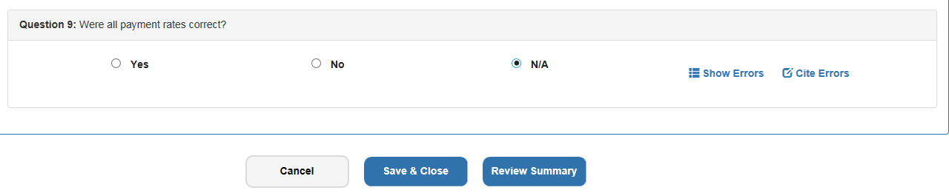

Once to the bottom of checklist the User will be given three options:

* **Cancel** – Stops review and does not save any unsaved error citations called.
* **Save and Close** – Allows User to close the page and leave screen for a brief break, but saves all error citations. This selection returns User to Review Detail screen content. Note: If the User completed their review, they can open the “Review Summary” to continue in completing the review.
* **Review Summary** – Required to navigate to the “Submit Review” button and complete quality review.

The Review Summary button forwards the User to a summary of the review that contains Claim Review Information, Review Metrics, Error Summary and Review Comment box. This step is required to submit and complete the review. It is also an excellent method to validate and confirm the completed checklist, errors cited and their error citations.

The Claim Review Information section provides pertinent information for the claim related to the review.



The Review Metrics section povides the User the option to confirm all data applicable and/or related to errors: Contentions claimed, Transaction taken, number of Critical and/or Non-critical errors and how many require corrective action.

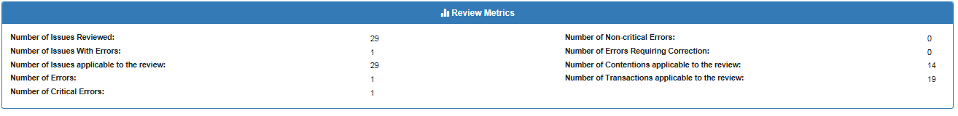

The Error Summary section is used to confirm the response for each checklist question and provides details on each cited error.

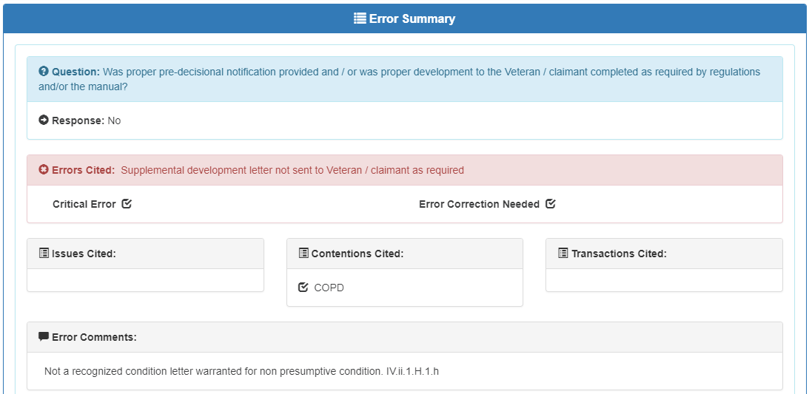

At the bottom of the Review Summary page the User will have four options:

* **Comments (Add)** – The User has the option to include additional comments or other error narratives on their review.
* **Close Summary** – Can be used for temporary interruptions and saves all review input. Closing summary returns to Review Detail page and the User will have to again select “Review Summary” to continue action.
* **Back to Checklist** – Returns User back to the initial “Claim Information” content, but the review input is still saved. The User has the option to edit the review at this time, but will then need to navigate back to the Review Summary to select Submit Review.
* **Submit Review** – This is the last step in completing the review, the User can validate this action by ensuring that the Review Level on the Details page has changed. **IMPORTANT:** **ONCE SELECTED, THERE IS NO RETURN TO CORRECT OR GO BACK TO THE REVIEW.**

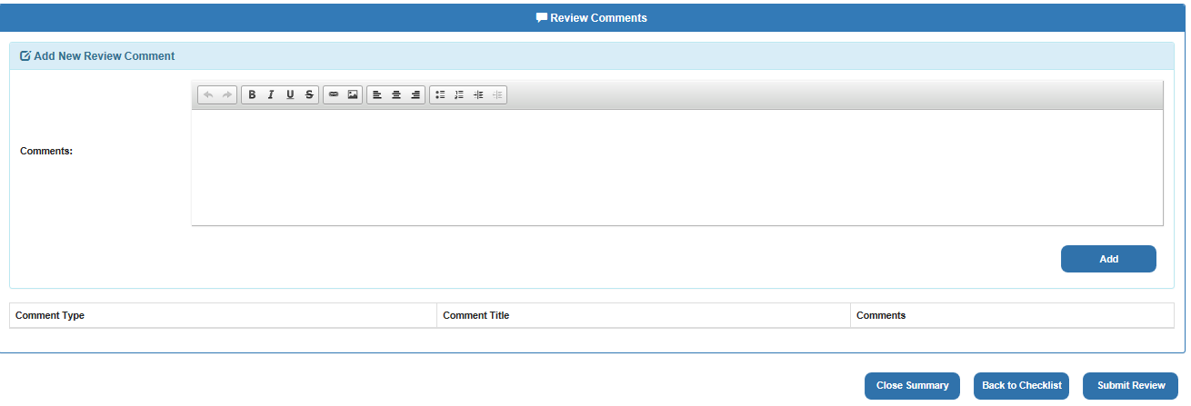

## Perform Review (Subsequent)

The Subsequent Review process begins the same as the Initial Review with the selection of the “Request a New Review” button and navigation to the Review Details screen.

Prior to selecting “Review Summary” the Subsequent Reviewer (QRT member processing a subsequent review) should review the right hand column of the details page which has pertinent information including Question and Error Response and Review Comments and History sections described below. Additional information and descriptions for each section can be found in Appendix B.

* **Question Response** - If a review has been completed, the details of the review checklist to include the question, response, error and sequence will be available for a User to prep for a subsequent review.
* **Error Response** -If a review has been completed, the details of the errors from the review checklist questions to include the Error Name, Error Description, Error Comment (Error Narrative) and if error is active and/or was critical.
* **Review Comments** - Displays all comments related to the Review including error narratives and comments added at each review level.
* **Review History** - A stored historical record of any User actions to change the value in each review field.

Selecting “Review Summary” button forwards the Reviewer to the Claim Information, Review Metrics, Error Summary and Review comment box based on initial Reviewer. This will look the same as shown above in the Initial Review process and provides a visual of the error/s cited by the previous reviewer.

The User can then go back and select “Perform Review” from the Review Detail page to activate the subsequent review process and checklist. **Submitting a Reviewer Decision to “Agree” or “Disagree” with previous reviewer’s findings is required to complete all subsequent level reviews.**

Scroll down to “Claim Review – Initial Review Process” which will display the current recorded review to include any errors cited and error citation box. From this page the Subsequent Reviewer cannot change the checklist answers. See below images

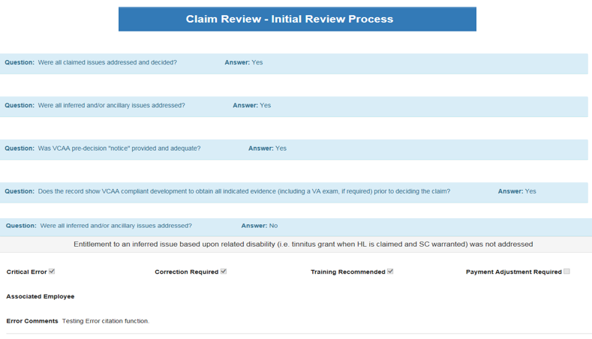

The next section entitled “Initial Reviewer Decision” will display any comments and screenshots added to the checklist.

At the bottom of the page under the “Subsequent Reviewer Decision” section the User will have two options:

* **Agree** – The Subsequent Reviewer concurs with Initial Reviewer, includes comment “I concur with review” and Submit. Subsequent review is completed.
* **Disagree** – A comment should be added by the reviewer detailing why they disagree with the review. The Subsequent Reviewer is returned to the initial review page that contains the “Claim Information” with the answers provided by the Initial Reviewer, but this time the checklist is accessible to editing. Continue to next section below.
* **QRT Performance Error (QRTIQRFinal Level Only)** – Yes or no checkbox selection to determine QRT performance accuracy for the review.

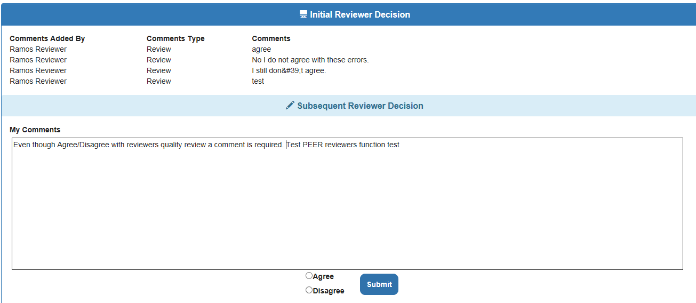

Following a Decision to “Disagree” with the checklist, the Subsequent Reviewer will have the opportunity to cite any additional errors found and/or correct any of the errors called. Below is an example of the Subsequent Reviewer editing the initial review checklist by changing the Question response from “Yes” to “No”, then adding a development error.

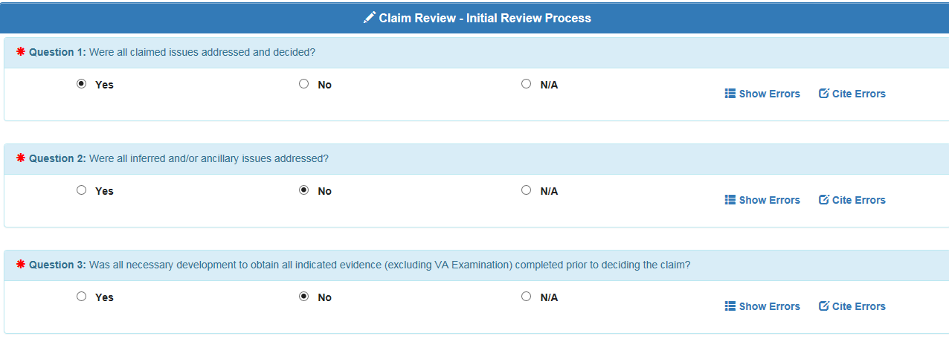

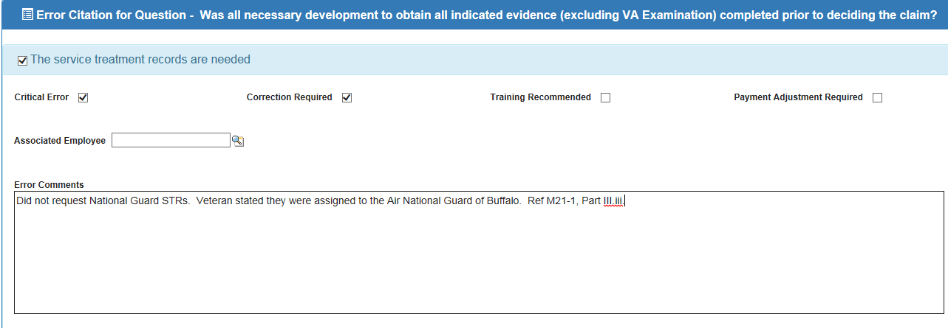

After completing the remaining review checklist and making any other edits the User can select the “Review Summary” option. If the User is satisfied with their review and comments, they can include additional comments and/or select “Submit Review” (selection options on the “Review Summary” page are explained in more detail under Initial Review process).

The User can then confirm that the Review Level has changed and the review is no longer assigned to them. More information can be found regarding claim routing rules on the following document: [Subsequent Review Routing Rules](https://va.lightning.force.com/lightning/r/ContentDocument/069t000000PifPjAAJ/view)

## **Deselect**

Used to send a review that cannot be completed to their supervisor for approval. Note: Once the User deselects a review, the review status will change to “Deselection Pending” and be routed to QRT Coach Team Queue for approval. Proper reasons for deselection can be found in M21-4.6.4.c and in the [QMS Deselections Job Aid](https://dvagov.sharepoint.com/sites/QMSOps/Shared%20Documents/QRT%20Supervisor%20Guide/QMS%20Deselections%20Job%20Aid.docx).

* **Deselection Reason** – drop-down category menu options include EP Prematurely Cleared; EP not warranted, no document basis; EP not warranted, should have been cancelled; EP not warranted, wrong EP cleared, Claim returned for correction, employee in training, Employee Not in Position, Employee not with VBA.
* **Deselection Comments** – Brief explanation why the review needs to be deselected. (Required entry)

Note: To cancel a deselect request, use the “Back to review” arrow at upper left of screen.

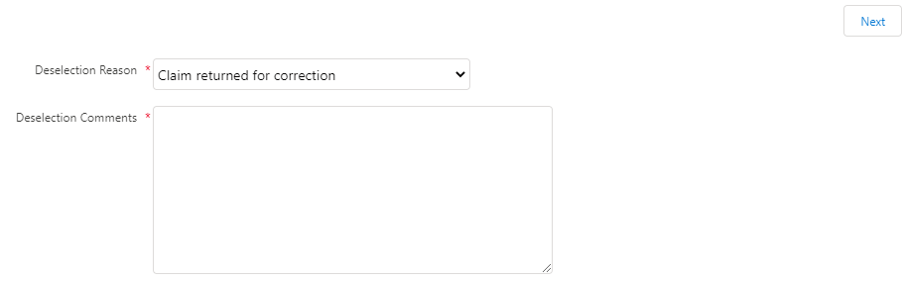

## **On-Hold**

Temporarily deactivates the quality review process. On the Review Detail page click “On-Hold” button. Proper reasons for on-hold reasons, including when to use QMS Admin Tech support, can be found in the [QMS Deselections Job Aid](https://dvagov.sharepoint.com/sites/QMSOps/Shared%20Documents/QRT%20Supervisor%20Guide/QMS%20Deselections%20Job%20Aid.docx).

* **On-Hold Reason** – drop-down category menu includes Not Qualified To Review, Pending Scanning, Request Missing Documents, Pending Feedback or Clarification, Pending Supervisory Guidance, Temporary Interruption and Sensitive Level Case Access Requested/Pending, Sensitive Level Claim – No VBMS Access, QMS Admin Tech Support.
* **On-Hold Comment** – Brief explanation why the review needs to be placed on hold. (Required entry)

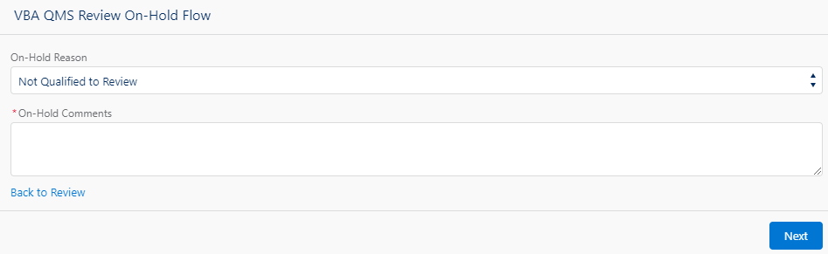

## **Change Reviewer (QRT Coach Function Only)**

This command is available to QRT Coach Team or QMS Admin only to reassign a review to another employee or queue. See Section V.

## **Deselect Approve/Reject (QRT Coach Function only)**

This command is also available only to QRT Coach Team or QMS Admin to approve or reject a request to deselect a quality review. See Section V.

## Other Actions

* **New Transaction, Contention or Issue** – Using the “New” button under each of these sections the User is able to add an additional specified item to the review.
* **Mass Related Issues** – Each of the Issues, Contentions and Transactions tab has a “Mass Relate …*”* button to allow the User a quick method of selecting the data on the screen which is unrelated to the review being processed. The User can check the block next to “Action”, which will place a check in all boxes. Next, click “Mass Relate *…”*
* Once the User selects the Action block and clicks “Mass Relate …” the screen will open and provide the User the option to check which specific *Data names* are related and uncheck what data is unrelated to the current review. Click “Save” and “Related” checks will only appear in the identified section. “Return” transfers User to Review Detail page, and does not save any changes.
* **New Review Comment** – The “New” button under the Review Comment section gives the User the option to include a comment type and description to the review.

# III. Error Corrections

An individual Error Correction record is created for each “Active” Error Response after the completion of a Review. These records are used to track and manage the acceptance and correction of the error, and also provide trends when completed. A List of Error Stages and other Error Correction page definitions can be found in Appendix C. More training on Error Corrections can be found in [TMS](https://ssologon.iam.va.gov/centrallogin/Default.aspx?appname=core&URL=https://ssologon.iam.va.gov/centrallogin/core/redirect.aspx&TYPE=33619969&REALMOID=06-345d7582-c96e-4888-9e5f-6e86468bf060&GUID=&SMAUTHREASON=0&METHOD=GET&SMAGENTNAME=-SM-JDZx1AxYAhQguyl0rfvd%2f5f46jynE%2bEoBtr6BQQU4NWuWIwCZNPIPHj210fDMxqs&TARGET=-SM-HTTPS%3a%2f%2flogon%2eiam%2eva%2egov%2faffwebservices%2fredirectjsp%2fredirect%2ejsp%3fSPID%3dhttps%3a%2f%2fwww%2esuccessfactors%2ecom%2fVAHCM03%26SMPORTALURL%3dhttps-%3A-%2F-%2Flogon%2eiam%2eva%2egov-%2Faffwebservices-%2Fpublic-%2Fsaml2sso%26SAMLTRANSACTIONID%3d27fb4dbe--fc0c514f--06558174--20bcf1c4--e8fa67c4--bb) (VA 4571565)

The Error Correction page works much like the Reviews page in that you can use it to display list views and select records. When an Error Review Name is selected, the Error Correction Details screen will be displayed with action buttons and information to assist the User with managing the error correction process as described in the next section. Use of the “My Error Correcton Records” list view will show the User a list of pending errors assigned to them for action.

## Managing Error Corrections

With the exception of national errors, Error Correction notification is automated and takes place immediately when the Error Correction is created at the completion of the Related Review. The employee cited for the error will be notified via email from the VAVBAWAS/CO/QMSERROR, and their supervisor (“Reports To” contact on their Contact Record) will be cc’d on the email as well. This action will be recorded in QMS by updating the error stage to “Notified” and updating other notified data fields.

Once notification is received by the employee they must take timely action to resolve the error within SalesForce. This action will indicate whether they accept the error and have taken the necessary action to correct it. If they disagree with the error cited, they can initiate a “Recon” (same as a “Rebuttal”). The below selections “Accept Error Correction” and “Initiate Recon” provide the method for employee’s to take these actions.



* **Accept Error Correction** – This command gives the User the option to mark an error as either “accepted”, “corrected” or both. If the employee accepts the error, but has not corrected it, they can check the box “Error Accepted” only and the error stage changes to “Accepted Pending Correction”. If the employee accepted the error and took action to correct the error, they can then check both boxes. This action will change the error stage to “Complete”. Note: All errors must be marked as “corrected” either following correction or if they do not require correction.

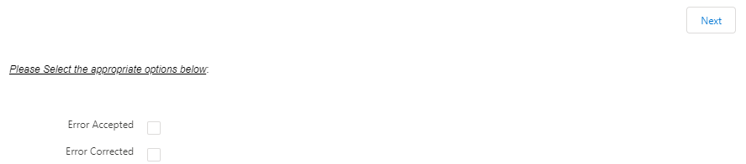

A comment box will appear once “next” is selected, the employee comment should include the action taken including the date corrective action was completed, if necessary. Once the comment is included, the “Next” button is clicked.

If the Employee checked both boxes for Accept Error and Correct Error they will be returned to the Error Correction view list. The Error stage will change to “Complete” and the Error Correction will be removed from Error Correction View list. This is the only way to fully complete the error without it being overturned following reconsideration.

* **Initiate Recon** - If an employee does not agree/accept the cited error, they have the option to request a reconsideration of the decision (Commonly referred to a “Reconsideration” or “Rebuttal” in some offices). All reconsideration requests should be entered into the system using this function, and all requested recons should receive a decision. Following selection of the “Initiate Recon” button the Owner will need to submit a comment for the reconsideration request, which must include reasoning and a reference to support the request. Once the comment is submitted, the error stage will change to “Recon-Received-Pending Review” and other fields under the “Recon Tracker” section will be populated. The Error Correction record will then be routed to the Coach Team queue for a decision.

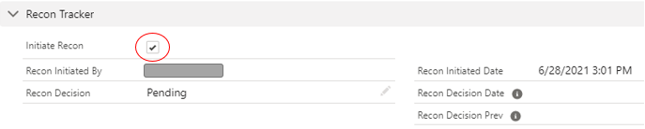

* **Recon Decision (QRT Coach Team Only)** – Used by the QRT Coach or Admin to administer a decision on a reconsideration request. See Section V.
* **Reset (QRT Coach Team Only)** – Used by the QRT Coach or Admin to reset the EC record to it’s original Error Stage.See Section V.
* **Notified (QRT Coach Team Only)** – Provides the QRT Coach or Admin to update the Error Stage from “Pending Notification” to “Notified”. See Section V.

# IV. Contact Information

To locate an Employee’s Contact information using the Search option, first limit your search to “Contacts” only by using the drop down option, then type the employee’s name or full government email address in Search bar. Select the employee’s name to access the record, then select the “Details” tab which will display personal Contact details and QMS Information.

In addition to the Contact record, each employee also has a User record which contains additional information and permissions. User Record updates require a helpdesk ticket which can be submitted using the “Open an Issue with the VA Helpdesk” option with this link: <https://va.lightning.force.com/lightning/n/HelpdeskLinks>.

* **Contact Details** – Employee specific information for Salesforce record. Provides general information including supervisor, active status, location and position, WIT ID and other fields.

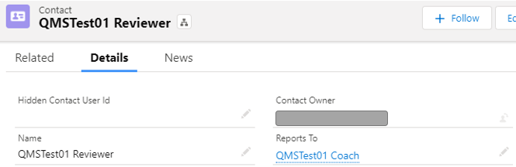

* **QMS Information** – Data on QRT access and workload management: these fields must be updated based on QRS position, station work and special mission changes. Work with your supervisor to ensure you have the correct access and proper review levels and types are selected.

|  |  |
| --- | --- |
| Field | Information |
| Review Level | Suggested review levels for employee type:   * QRS – INIT;Peer;QRTIQR;Final |
| Available Review Types | Based on QRS position/division and any RO special missions. Should include all review types being worked at your office that the QRS is trained to complete. |

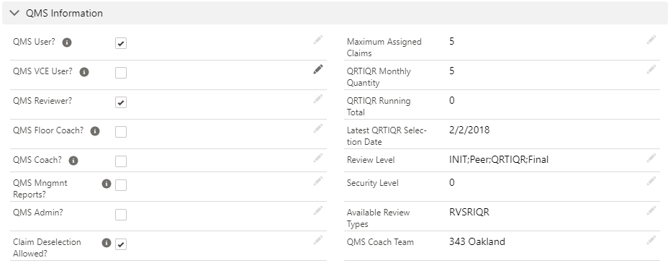

All QMS Users have edit permission to any data showing a “Pencil” icon on the Contact page. When selected it will provide the QMS User access to make the appropriate changes then select the “Save” button. Additional edit capabilities are available for the QRT Coach and Admin level Users.

# V. Supervisory Functions

Additional supervisory functions and guidance can be found in the supplemental QMS [QRT Supervisor Guide](https://va.lightning.force.com/lightning/r/ContentDocument/069t000000PifqVAAR/view).

# VI. Glossary

## Appendix A. VBA and QMS Acronyms and Terminology

|  |  |
| --- | --- |
| **Acronyms** | **Definition** |
| AQRS | Authorization Quality Review Specialist |
| ASPEN | Automated Standardized Performance Elements Nationwide |
| CA | Claims Assistant |
| DRO | Decision Review Officer |
| IDES | Integrated Disability Evaluation System |
| IPR | In-Process Review |
| MOU | Memorandum of Understanding |
| MSC | Military Services Coordinators |
| NQR | National Quality Review (STAR) |
| PA&I | Performance Analysis and Integrity |
| PCA | Pension Claims Assistant |
| PNQR | Pension National Quality Review |
| QRS | Quality Review Specialist |
| QRT | Quality Review Team |
| RO | Regional Office |
| RQRS | Rating Quality Review Specialist |
| RVSR | Rating Veteran Service Representative |
| SFR | Special Focused Review |
| SOP | Standard Operating Procedure |
| STAR | Systematic Technical Accuracy Review |
| TMS | Training Management System |
| VBA | Veterans Benefits Administration |
| VBMS | Veterans Benefits Management System |
| VETSNET | Veterans Network |
| VSR | Veteran Service Representative |
| **Review Type Acronyms** | **Full Description** |
| ANEH | Appeals Nehmer |
| BEST | Benefit Eligibility Support Team |
| BWN | Blue Water Navy |
| CLCW | Camp Lejuene Contaminated Water |
| DEP | Dependency |
| DROC | Decision Review Officer Center |
| FRGN | Foreign |
| IPR | In-Process Review |
| IDES | Integrated Disability Evaluation System |
| NCAQR | National Compensation Authorization Quality Review |
| NCRQR | National Compensation Rating Quality Review |
| NEH | Nehmer |
| NPAQR | National Pension Authorization Quality Review |
| NPRQR | National Pension Rating Quality Review |
| MQR | VIP Review |
| P | Pension |
| PILOT | Pilot testing |
| PNEH | Pension Nehmer |
| POST | Post-Determination |
| PRE | Pre-Development |
| RACC | Restricted Access Claim Center |
| RAD | Radiation |
| RAMP | Rapid Appeals Management Plan |
| RDC | Rating Decision Complete |
| RFD | Ready for Decision |
| SPINA | Spina-bifida |

## Appendix B. Review Related Descriptions

The Review Level designates the current stage of the review

|  |  |  |
| --- | --- | --- |
| Stage | Definition | |
| Initial (INIT) | First time quality review | |
| QRTIQR | Subsequent review which includes performance review on the initial reviewer | |
| Peer | Subsequent review for any review with cited errors that is not designated for QRTIQR | |
| Return | Subsequent review initiated when a Peer reviewer does not agree with the Initial reviewer’s findings, the review is returned to the Initial reviewer to determine if they agree or disagree with the Peer reviewer findings. | |
| QRTIQRRET | The review is returned to the the Initial reviewer to agree/disagree with the QRTIQR findings. | |
| QRTIQRFinal | Subsequent review performed by a QRT Coach when an QRTIQR reviewer disagrees with the Initial reviewer’s findings. Determination will include a decision on QRT Performance. | |
| Final | A third review for a final determination when a Peer reviewer disagrees with the Initial reviewer’s cited error and the Initial Reviewer disagrees with the Peer reviewer. | |
| **Review Status** | |  |
| Status | | Definition |
| Pending | | A review waiting to be selected |
| In-Process | | Review is assigned and activated |
| Assigned | | A review has been assigned. Primarily by QRT Coach |
| On-Hold | | A review is temporarily inactive, based on drop-down reasons |
| Deselection Pending | | A review is pending Coach’s decision to deselect a review |
| Deselected | | A review has been removed based on drop down reasons |
| Submitted | | A completed review |
| Error pending | | A review error awaiting corrective action |

**Reviews Tab List View**

|  |  |
| --- | --- |
| Field | Description |
| Review Name | Self-explanatory and provides hyperlink to open review. |
| File Number | This field will be blank due to Personal Integrated Information (PII) |
| Review Status | Indicates the state of the review In-process, Assigned, Deselection pending and Deselect and On-hold |
| Benefit Claim ID | Claim level identification number |
| EP | End Product |
| Date Assigned | Date the review was placed on “Assigned” status |
| Review Level | Initial-IQRQRT-Peer-QRTFINAL-Final Refer to QMS Index for further details |
| Priority | Indicates high preference to complete. Determined by the QRT Coach Team or PA&I |
| Number of Contentions Applicable | How many Contentions were applicable to the review |
| Number of Issues Applicable | How many Issues were applicable to the review |
| Number of Transactions Applicable | How many Transactions were applicable to the review |
| Edit | For Admin level access only |
| Change Owner | QRT Coach Team action only |

**Review Action Buttons**

|  |  |
| --- | --- |
| Action Buttons | Definition and Details |
| Perform Review | Activates an Initial or Subsequent review process and provides the appropriate review auto-checklist. |
| Deselect | A request to remove a review based specific reason |
| On-Hold | A review is temporarily inactive for specific reason/action needed |
| Change Reviewer – Coach Only. | To reassign a review to another QRT member |
| Review Summary | Provides primary facts to completed review. Primary Facts – Metrics Information – Error Summary – Final Comments |
| Deselect/Reject Approval – Coach Only. | Coach approval/rejection to a deselect request. |
| Printable View | As described |

**Review Details Page** - identifies all review related information and is split into relevant sections.

**General Details**

|  |  |
| --- | --- |
| Field | Description |
| Assigned to | Name of who the review is assigned to |
| Review Status | Refer to Review Status section of User Guide |
| Security Level | A specific level to access sensitive and restricted claim material |
| Date Assigned | Date the claim was selected to perform a quality review |
| Last Review Comment | Last comment record Note: For Subsequent reviews only. Initial review will be blank |
| Last Reviewer Determination | The most recent reviewer’s decision |
| Peer Review | The review has been selected for a Peer review |
| QRT Performance Review | Review has been selected for an IQR on the initial Quality Review Specialist (QRS) |
| QRT Performance Error | Selections are Yes or No The QRT Coach determines if the error was commited by Initial Reviewer. This will determine the Yes or No selection. |
| RuleSTN | Code combination that includes Rule value and Station Value |
| Review Title | Combines Review name and Benefit ID |
| Initial Reviewer Name | Name of who completed Initial Review |
| Review Level | Refer to Training Index |
| Priority | Indicates high preference to complete. Determined by QRT Coach Team or PA&I |
| Critical Error Cited | If checked, a critical error was cited on review |
| Review Correction Needed | If checked, corrections are required based on error cited |
| Rule | Business Line i.e. CS = Compensation Service, PS = Pension Service |
| CoachTeam | Regional Office of Assigned Reviewer |
| Deselection Coach Team | The QRT the review owner is assigned |
| Exported Date | When the data is uploaded via Review Status showing: Completed or Error Pending |

**Veteran/Claimant Information Section**

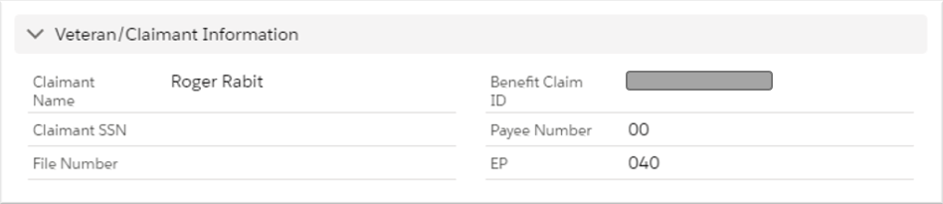

|  |  |
| --- | --- |
| Field | Description |
| Claimant Name | Typically, this will be the Veteran’s Name, unless claim is initiated by a dependent.   If Vet = Veteran’s information, If Dependent, Dependent’s information. |
| Benefit ID Number | Identification number to open the specific claim in VBMS |
| Payee Number | Also referred as a “Payee Code” according to M21-4, Appdx A.2.a |
| Jurisdiction Station Number | Regional Office responsible for processing end product |
| EP | End Product |
| Claim Date | Commonly referred to as the “Date of Claim” or DOC |
| Closed Date | Date the claim was cleared by award PCLR’d (Pending issue cleared) or DISP Date = Disposition Date |
| Cancelled Date | Date the claim was cancelled and the office receives no EP credit |

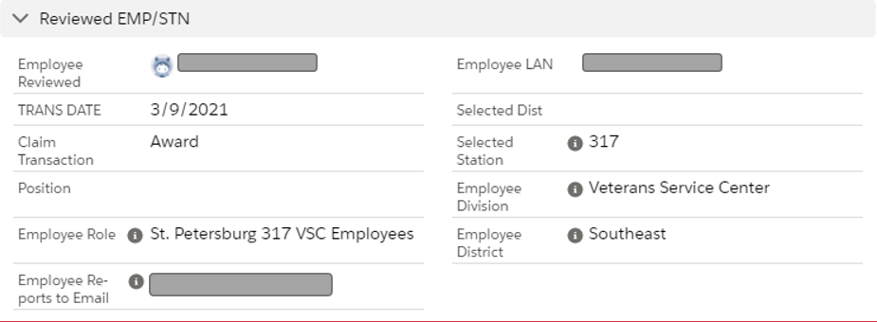

#### Reviewed EMP/STN section

|  |  |
| --- | --- |
| Field | Description |
| Employee Reviewed | Name of employee selected for quality review. Note: Will be blank for National reviews |
| Trans Date | Date action was taken by employee selected for IQR |
| Claims Transaction | Description of action taken |
| Select Station | RO number selected for quality review. Note: Will be blank for National reviews |
| Employee | Employee who last took action on the claim |
| Claims Throughput | Ready For Decision, Award, Rating Decision Complete |

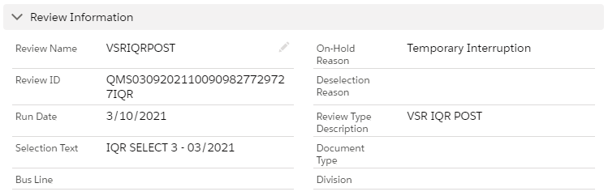

#### Review Information Section

|  |  |
| --- | --- |
| Field | Description |
| Review Name | Same as review name on list of My Reviews on Review Landing Page |
| Deselection Reason | Self-explanatory |
| Review ID | Identity number to locate this review |
| Run Date | Scheduled date to select claims for quality reviews by PA&I |
| Manual User | Individual who set up the review details. Primarily found on Special reviews |
| Review Type Description | Provides Quality Review Type title Ex. National Compensation Authorization Quality Review |
| Selection Text | Why the claim was selected by PA&I for quality review |
| On-Hold Reason | Self-explanatory |

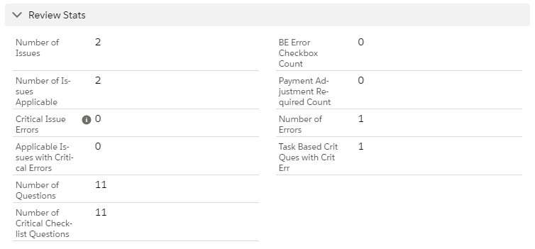

#### Review Stats Section

|  |  |
| --- | --- |
| Field | Description |
| Number of Issues | Rating decision Issues related to a disability |
| Number of Issues Applicable | How many Issues were applicable to the review |
| Number of Contentions | How many contentions were claimed and in VBMS |
| Number of Contentions Applicable | How many Contentions applicable to review |
| Number of Transactions | How many Transactions found in VBMS |
| Number of Transactions Applicable | How many Transactions applicable to the review |
| Number of Issues with Critical Errors | Self–explanatory |

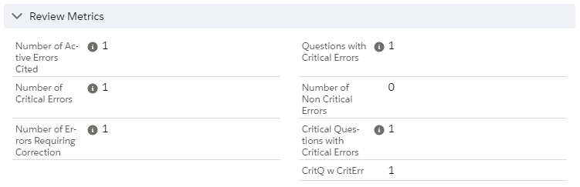

#### Review Metrics Section

|  |  |
| --- | --- |
| Field | Description |
| Number of Active Errors Cited | Total number of errors found |
| Number of Critical Errors | Total number of errors determined to be critical |
| Number of Non-Critical Errors | Total number of errors determined to non-critical |
| Number of Errors Requiring Correction | Total number of errors cited, requiring corrective action |
| Number of Issues with Errors | Total number of issues related to cited errors |
| Number of Questions | Total number of questions on specific review checklist |
| Number of Critical Checklist Questions | Total number of questions on specific review checklist determined to be critical |
| Number of Non-Critical Checklist Questions | Total number of questions on specific review checklist determined to non-critical |
| Questions with Critical Errors | Total number of questions with critical errors |
| Number of Questions N/A Response | Total number of questions not applicable to review |
| Critical Questions with Critical Errors | Total number of critical questions with critical errors |

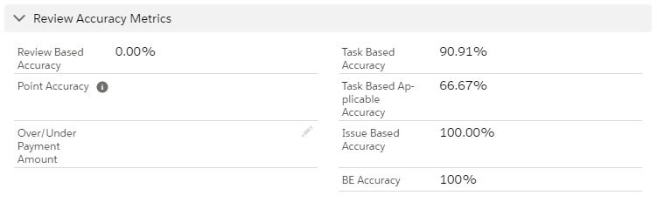

#### Review Accuracy Metrics Section

|  |  |
| --- | --- |
| Field | Description |
| Review Based Accuracy | Overall review accuracy |
| Issue Based Accuracy | Used for calculating national Rating Quality Reviews |
| Over/Under Payment Amount | Total amount to pay or recoup, based on an incorrect effective date. If the reviewer checks the Payment Adjustment Required box on any error cited on the review, QMS will require an amount be entered into the Over/Under payment review level field, “$0.00” is an acceptable entry. |
| Task Based Accuracy | Overall review accuracy, based on all task questions with cited errors |
| Task Based Applicable Accuracy | Overall review accuracy, based on task questions related to review, minus non-related questions |

#### **Transactions / Contentions / Claim / Issues Section** - Claim information from VBMS

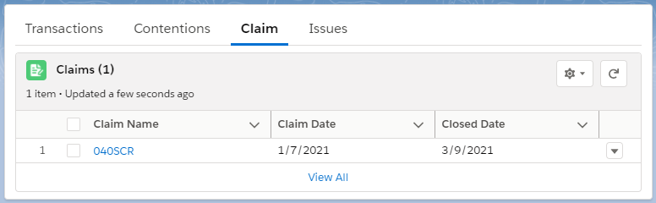

|  |  |
| --- | --- |
| Field | Description |
| Claim Name | Claim label abbreviation from VBMS exported from VBMS at the time of the transaction |
| Claim Date | Claim date exported from VBMS at the time of the transaction |
| Closed Date | Date EP was closed, if applicable |

**Transactions**

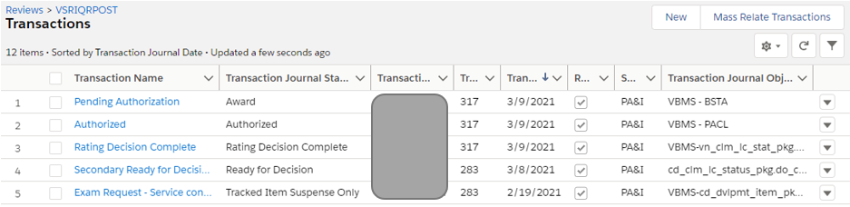

|  |  |
| --- | --- |
| Field | Description |
| Transaction Name | Action taken by an employee |
| Transaction Journal Status Type Code | Provides throughput related to transaction |
| Transaction Journal User ID | Who took the action |
| Transaction Jurisdiction Location ID | RO where action was taken |
| Transaction Journal Date | When action was taken |
| Related | If checked the transaction is related to the review |
| Source | Where data came from |
| TBM Key | Identifying number for transaction |
| Claim Name | Claim Label abbreviation |
| Claim Date | Commonly referred to as the “Date of Claim” or DOC |
| Closed Date | Date the claim was cleared by award PCLR’d (Pending issue cleared) or DISP Date = Disposition Date |
| Cancelled Date | Date the claim was cancelled and the office receives no EP credit |

**Issues**

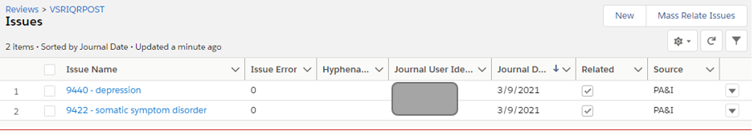

|  |  |
| --- | --- |
| Field | Description |
| Issue Name | Determined by rating specialist |
| Hyphenated Diagnostic Type Code | Determined by rating specialist |
| Journal User Identifier | Employee’s User name who added the issue |
| Journal Date | When the employee added the issue |
| Related | If checked the issue is related to the selected review actions |
| Source | Where data came from |

**Contentions**

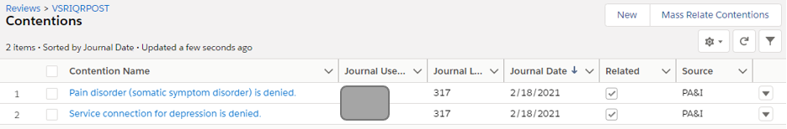

|  |  |
| --- | --- |
| Field | Description |
| Contention Name | From contention list in VBMS |
| Journal User Identifier | Who added the contention in VBMS |
| Journal Date | When was the contention added |
| Related | If checked the contention is related to the selected review actions |
| Source | Where data came from |

**Question Response**

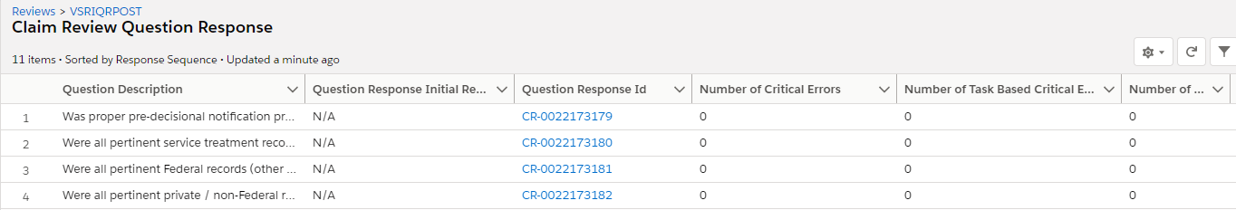

|  |  |
| --- | --- |
| Field | Description |
| Question Description | The actual question on review checklist |
| Question Response Initial Review | Selected answer – Current Ex. Yes, No or N/A |
| Number of Critical Errors | Number of errors cited which are marked critical |
| Number of Task Based Critical Errors | Number of task based errors cited which are marked critical |
| Number of Issue with Critical Errors | Number of issues with errors cited which are marked critical |
| Created By | Who processed and submitted the review to include the date and time submitted |
| Last Modified By | User who last modified the field |
| Response Sequence | The order how question is displayed on review checklist |

**Error Response**

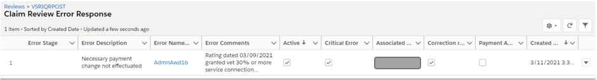

|  |  |
| --- | --- |
| Field | Description |
| Error Stage | Status of error correction process |
| Error Description | Full description of cited error |
| Error Name | Short description code of cited error |
| Error Comments | Error narrative related to cited error |
| Active | Denotes if the error is still active or has been removed |
| Critical Error | Cited error determined to be critical |
| Associated Employee | Employee associated with error |
| Correction Required? | Cited error which requires corrective action |
| Payment Affected? | Denotes if error affected Payment to claimant |
| Created Date | Date and time the error response was created |

**Review Comments**

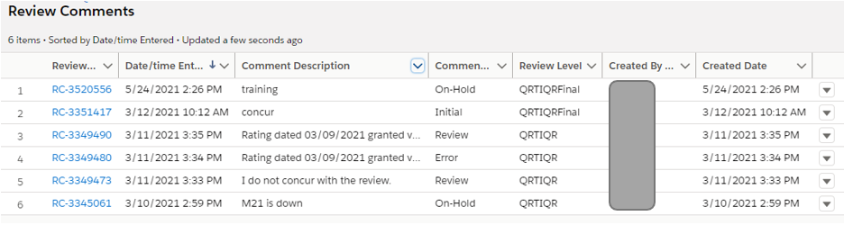

|  |  |
| --- | --- |
| Field | Description |
| Review Comment | Opens the details of the comment |
| Date/time Entered | Date and Time the comment was added to review |
| Comment Description | Is the actual Comment provided by reviewer |
| Comment Type | What the comment is related to |
| Review Level | Review Level at which the comment was added |
| Created By Alias | Who created the comment? |
| Created Date | Date and time the comment was created |

**Review History**

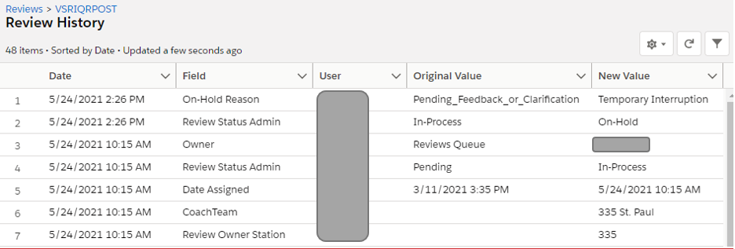

|  |  |
| --- | --- |
| Field | Description |
| Date | Date and Time of users access to review |
| Field | Field value that changed |
| User | Who accessed the reivew |
| Original Value |  |
| New Value |  |
|  |  |

## Appendix C: Error Corrections Related Descriptions

**Error Stage** – Defines the stage of the Error Correction record from creation to completion.

|  |  |
| --- | --- |
| **Stage** | **Definition** |
| Pending Notification | The record has been created, but the employee has not yet been notified. |
| Notified | The record has been created and the employee has been notified. |
| Corrected | The employee took action to correct the error but has not accepted |
| Accept Pending Correction | The employee accepted error, but has not taken any action to correct it. |
| Recon – Received – Pending Review | The recon has been submitted and is pending a decision |
| Local Recon Decision – Upheld – Error stands | A reconsideration decision has been rejected and further action is needed to complete. |
| Local Recon Decision – Overturned – Error removed | A reconsideration decision as been approved and the error has been removed. |
| Mitigated | A reconsideration decision has been completed to mitigate the error (change to non-critical), acceptance and correction is needed to complete. |
| Recon – Assign to PEN STAR | Recon decided and forwarded to Pension STAR staff. |
| Recon – Assign to CS STAR | Recon decided and forwarded to Compensation STAR staff |
| Nat Recon Decision – Upheld – Error stands | Based on rejecting national recon by STAR Team |
| Nat Recon Decision – Overturned – Error removed | Based on approved national recon by STAR Team |
| Complete | All action has been completed to resolve error. |

**General Section**

|  |  |
| --- | --- |
| Field | Description |
| Error Correction Name | Self-explanatory |
| Employee Msg | Explains if review counts toward employee performance |
| Review Type | Abbreviated acronym for the individual review |
| Related Review | Link to related review |
| Error Stage | Last recorded action completed on error correction process. See “Training Index” for Error Stage definitions |
| Owner | Individual assigned and responsible to record error correction process |
| Originally Assigned Coach Team | RO or Station Group |

**Claim Information Section**

|  |  |
| --- | --- |
| Field | Description |
| Related Claim | Claim Review Name related to cited error correction |
| Transaction Date | Date action was taken which the review cited error is based on |
| Cited Emp STN | Station number and name for the employee cited for the error |
| Employee Cited for Error | Name of employee cited for the error |
| Employee Contact | Link to contact page of employee cited for the error |
| Benefit Claim ID | Provides a method of accessing the claim in VBMS, directly related to the review |
| Claim File Number |  |
| Throughput | What stage was the claim in at the time the employee work was selected for a quality review. Ex. Initial development, Ready For Decision, Rating Decision Complete, Promulgate an award |
| Cited Employee Dist | District name for the employee cited for the error |
| Employee Reports To | Reports to contact for employee from contact record |
| Cited By Contact | Reviewer who cited the error |

**Review Information**

|  |  |
| --- | --- |
| Field | Description |
| Requires Correction? | Checkbox will indicate if the error requires correction |
| Payment Adjustment Required? | Checkbox will indicate if the error requires payment adjustment |
| Review ID | QMS identification number for Related review |
| Critical Error? | Checkbox will indicate if the error is critical |
| Review Status | Status of the related review |

**Question Information**

|  |  |
| --- | --- |
| Field | Description |
| Related Claim Review Error Response | Link to Error Response page |
| Related Question | Checklist question that the error was cited under |
| Question Response | Response for related checklist question |

**Cited Error Information**

|  |  |
| --- | --- |
| Field | Description |
| Error Name | Short code name of error |
| Error Description | Error category from checklist question |
| Error Comments | Error narrative to include regulation |

**Recon Tracker**

|  |  |
| --- | --- |
| Field | Description |
| Initiate Recon | Indicates if a Recon has been initated |
| Recon Initiated By | Employee who initiated the Recon |
| Recon Decision | Determination made on Recon request |
| Recon Initiated Date | Self-explanatory |
| Recon Decision Date | Self-explanatory |
| Recon Decision Prev | Determination of previous Recon Decision |

**EC Tracker**

|  |  |
| --- | --- |
| Field | Description |
| Notified | Indicates if employee has been notified |
| Accepted | Indicates if record has been accepted |
| Corrected | Indicates if record has been corrected |
| Allowed Time (Days) | Date allowed for completion of error record, 6.00 days includes day notifed |
| Notified Date | Self-explanatory |
| Notified By | Employee who cited the error |
| Accepted Date | Date accepted |
| Corrected Date | Date corrected |
| EC is Complete | Date and time the record has been resolved |

**EC Validation**

|  |  |
| --- | --- |
| Field | Description |
| EC Validation Selected | Correction selected for validation |
| EC Validation Response | Results of the EC validation |
| EC Validation Response Prev | Previous value of response |
| Correction Validated | Indicates if validated |
| Correction Validated User | Self-explanatory |
| Correction Validated Date | Self-explanatory |

**System Information**

|  |  |
| --- | --- |
| Field | Description |
| Created By | Last reviewer name |
| Last Modified By | Shows last employee and date of modification to the record |

## Appendix D. ***Contact Page Descriptions***

**QMS Information Fields**

|  |  |
| --- | --- |
| **Field** | **Description** |
| QMS VCE User, QMS User, QMS Floor Coach, QMS Coach, QMS Mngmnt Reports, QMS Admin | When checked represents the specific permissions with QMS access. Note: QMS User = AQRS or RQRS |
| Claim Deselection Allowed? | When checked the QMS User has permission to request to deselect a review |
| Maximum Assigned Claims | The maximum number of claims a QRS can have pending in their View list |
| QRTIQR Monthly Quanity | The required number of performance reviews on the QRS |
| QRTIQR Running Total | The total number of performance reviews completed for the current month |
| Latest QRTIQR Selection Date | Self-explanatory |
| Review Level | The assigned review levels when requesting a new review |
| Security Level | Self-explanatory |
| Available Review Types | The assigned review types when requesting a new review |
| QMS Coach Team | RO or Station Group |

Appendix E. Submitting a Trouble Ticket

If an error is received instructing the User to contact the System Administrator, please contact your QRT Coach and if necessary and instructed from a member of the Coach Team, create a Help Desk Ticket, and follow the provided instructions.

When in the Lightning Salesforce Platform, there is a VA Help Desk Application available on the application launcher. Select “Open an Issue with the VA Helpdesk” Instruction on completing each field is provided below:

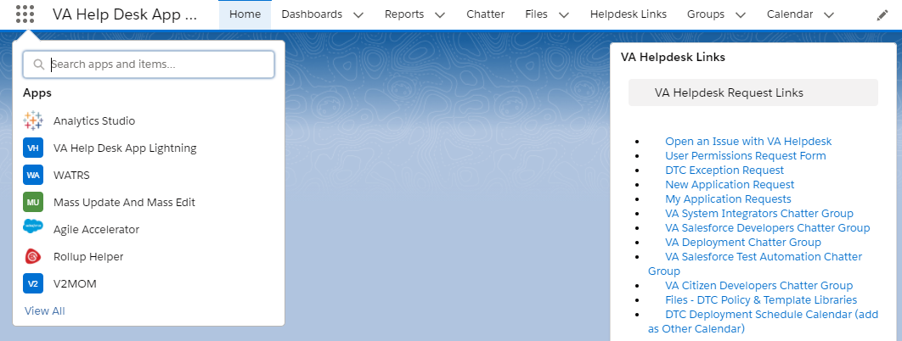

|  |  |  |
| --- | --- | --- |
|  | Field | Description |
| * | Priority | **Low**—cosmetic change  **Medium**—nothing’s broken or incorrect; feedback on functionality and/or requests for enhancement  **High**—incorrect calculation, broken functionality, inability to access a page or section or the application |
| * | DTC Application | WATRS or QMS |
| * | Issue Topic | App Support Request (unless you need help with your user account, which should be rare) |
| * | Description | Describe the problem, include message (error) if had. Please copy and paste the following lines with your responses into the “Description” Box of your Help Desk Ticket:  **Last Name, First Name**  **RO and RO#**  **Do you work at a Veterans Service Center (VSC) or Pension Management Center (PMC)?**  **Employee Position: (Coach, Assistant Coach, RQRS, AQRS, etc.)**  Trouble ticket Issue Information:  **What specific error message do you get? (Please provide screen capture and upload.)** |
| * | Subject | WATRS or QMS [examples: QMS Access issue; QMS calculation incorrect; QMS Error Code; etc.] |
| * | Issue Related to | None—leave blank |
|  | Error Page URL | copy from the browser address bar if you have an error; otherwise leave blank |
| * | Preferred Callback Number | [YOUR PHONE NUMBER] |
| * | Preferred Contact Email | [YOUR E-MAIL address] |

*Required Field

## Resources

* M21-4, Chapter 6
* Quality Management System

## QMS User Guide – Log of Changes

|  |  |  |
| --- | --- | --- |
| **Date of Change** | **Change Description** | **Change Location** |
| 7-13-17 | Add Helpdesk Trouble Ticket Information | Pg. 10 |
| 1-5-18 | Update all Screens, Procedures, Review levels and types | Pgs 12-60 |
| 07-12-21 | Update all information for transition to Saleforce Lightning, move supervisor directions to separate guide | All |