**Slide 1 - FCC Knowledge Management**

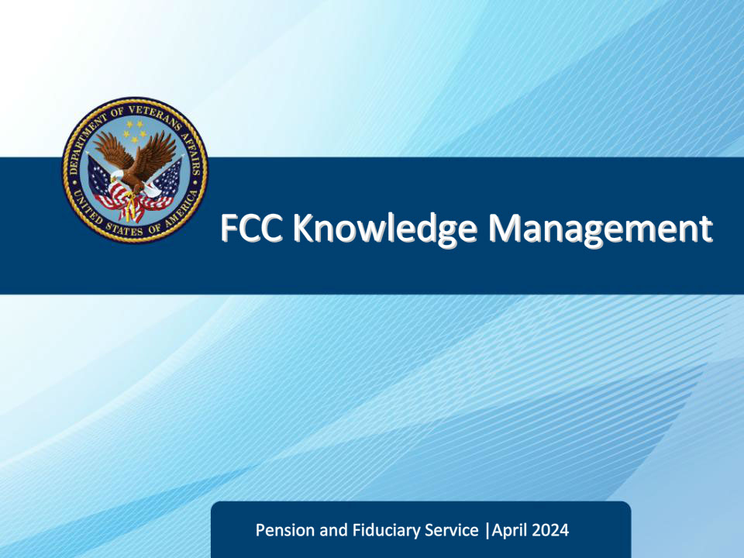

**Slide notes**

Course Description:

The purpose of this course is to teach FCC LASs how to locate Fiduciary Contact Center (FCC) policy and procedure within the VA Intranet Knowledge Management (KM) portal.

**Slide 2 - Objectives**

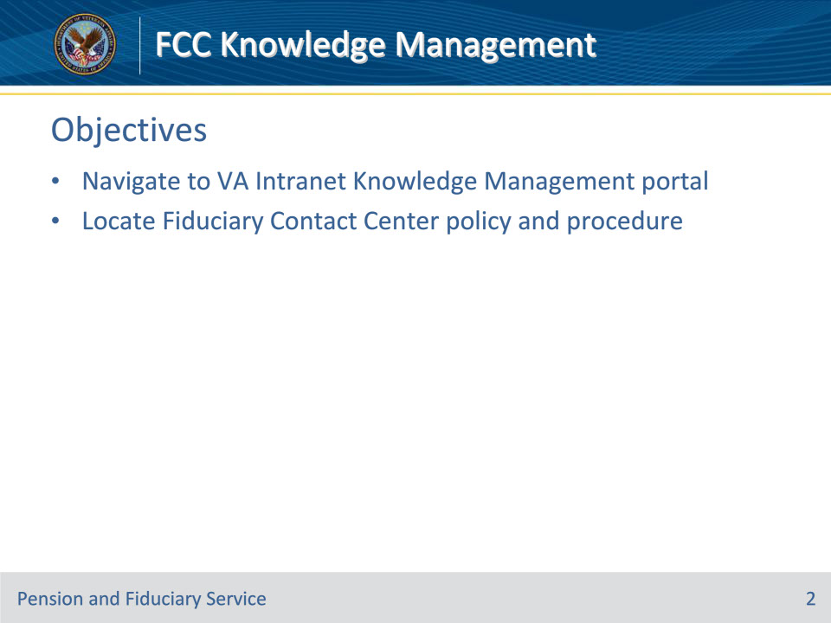

**Slide notes**

Instructor Notes:

At the end of this lesson, given the training and references, the learner will be able to do the following:

• Navigate to VA Intranet Knowledge Management (KM) portal

• Locate Fiduciary Contact Center (FCC) policy and procedure

**Slide 3 - References**

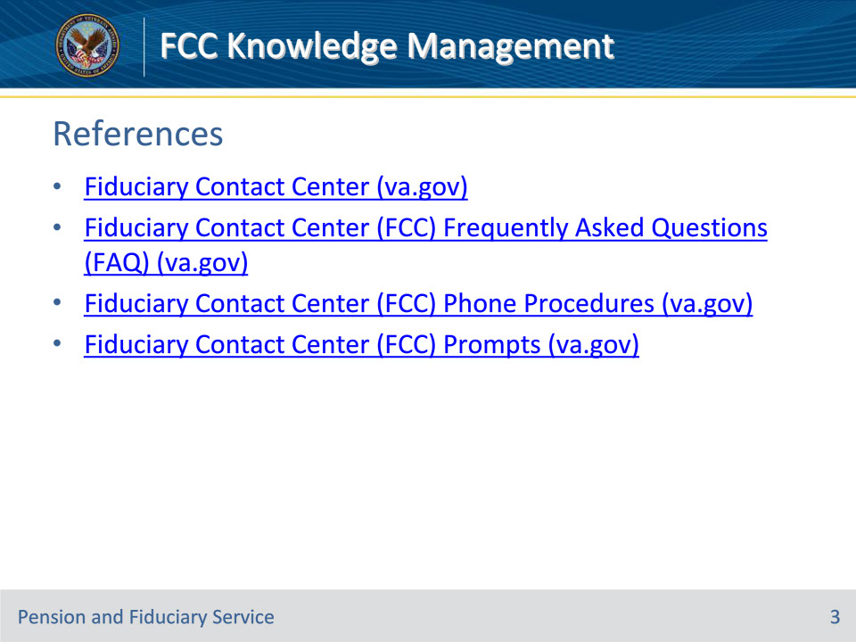

**Slide notes**

Instructor Notes:

These are the relevant references pertaining to this course:

• Fiduciary Contact Center (va.gov)

• Fiduciary Contact Center (FCC) Frequently Asked Questions (FAQ) (va.gov)

• Fiduciary Contact Center (FCC) Phone Procedures (va.gov)

• Fiduciary Contact Center (FCC) Prompts (va.gov)

**Slide 4 - Locating VA Intranet**

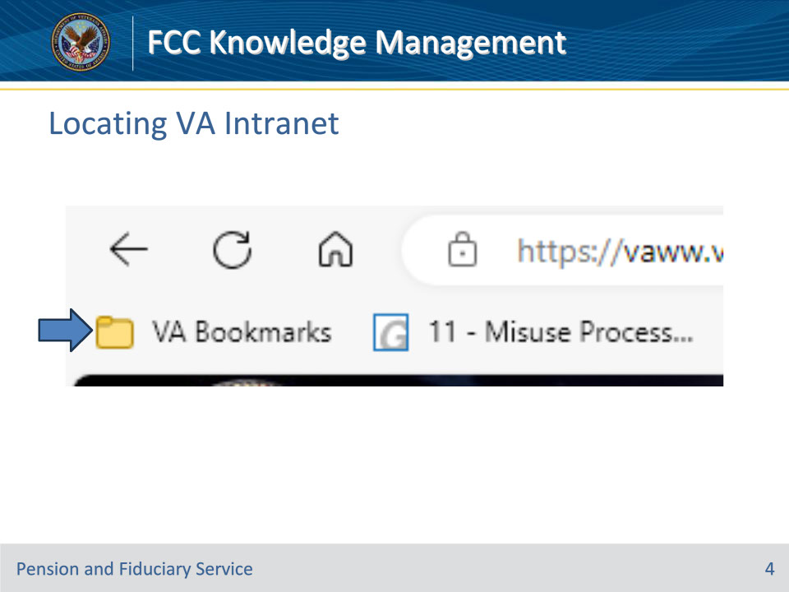

**Slide notes**

Instructor Notes

Locate the VA Bookmarks in your browser.

**Slide 5 - Locating VA Intranet**

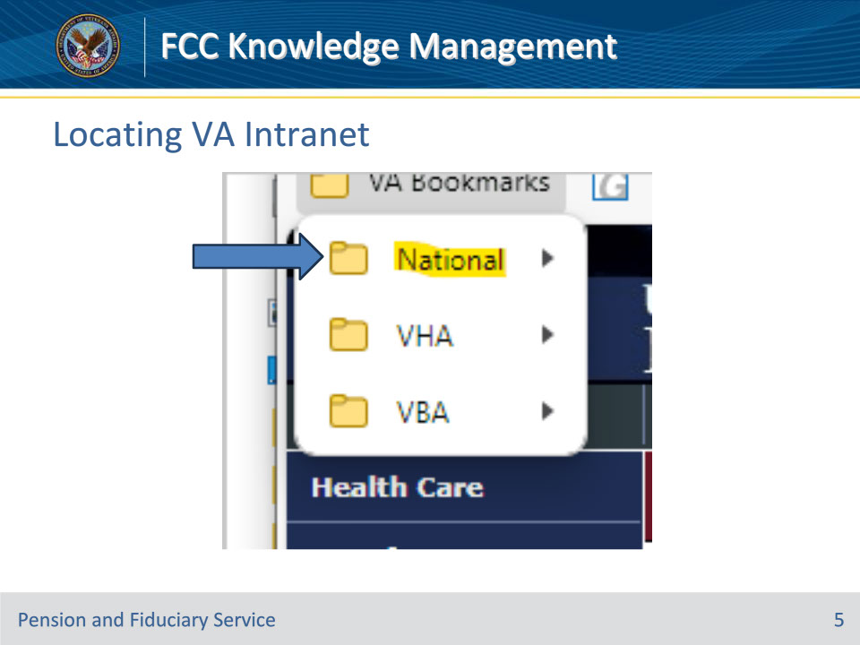

**Slide notes**

Instructor Notes

Select the National option.

**Slide 6 - Locating VA Intranet**

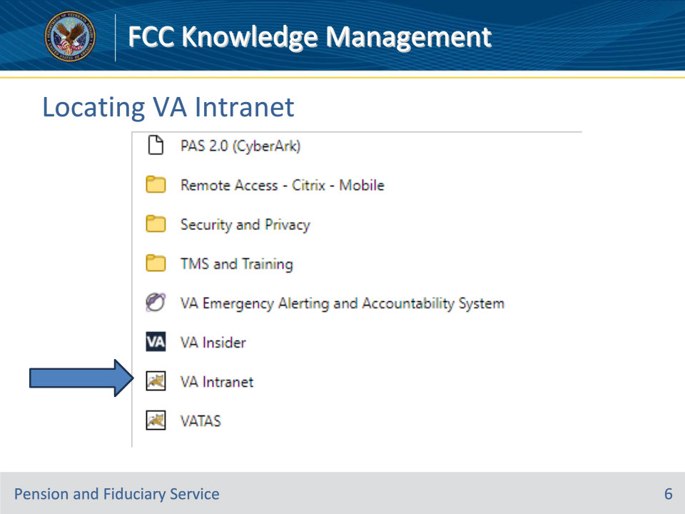

**Slide notes**

Instructor Notes

Select the VA Intranet option.

**Slide 7 - Locating KM Portal**

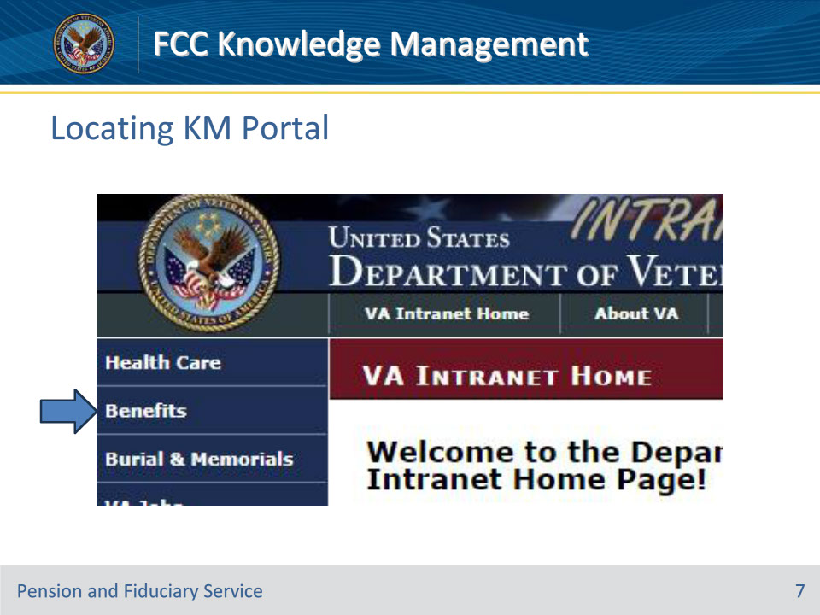

**Slide notes**

Instructor Notes

Select the Benefits tab.

**Slide 8 - Locating KM Portal**

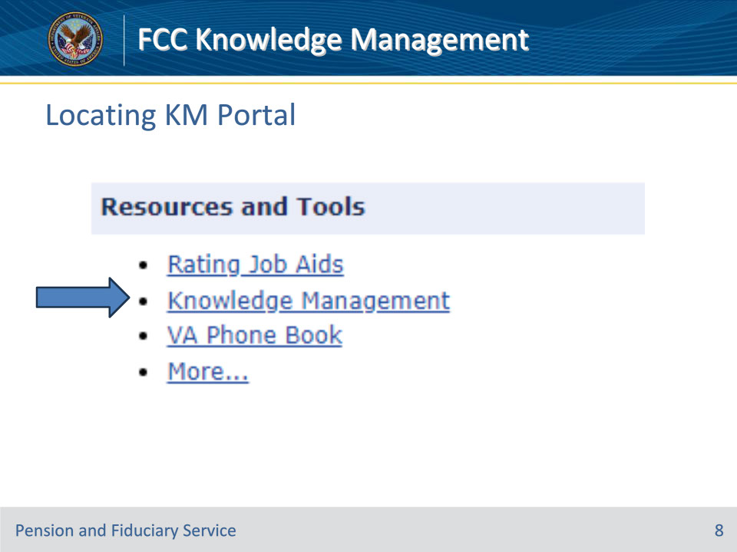

**Slide notes**

Instructor Notes

Select the Knowledge Management option.

**Slide 9 - Locating KM Portal**

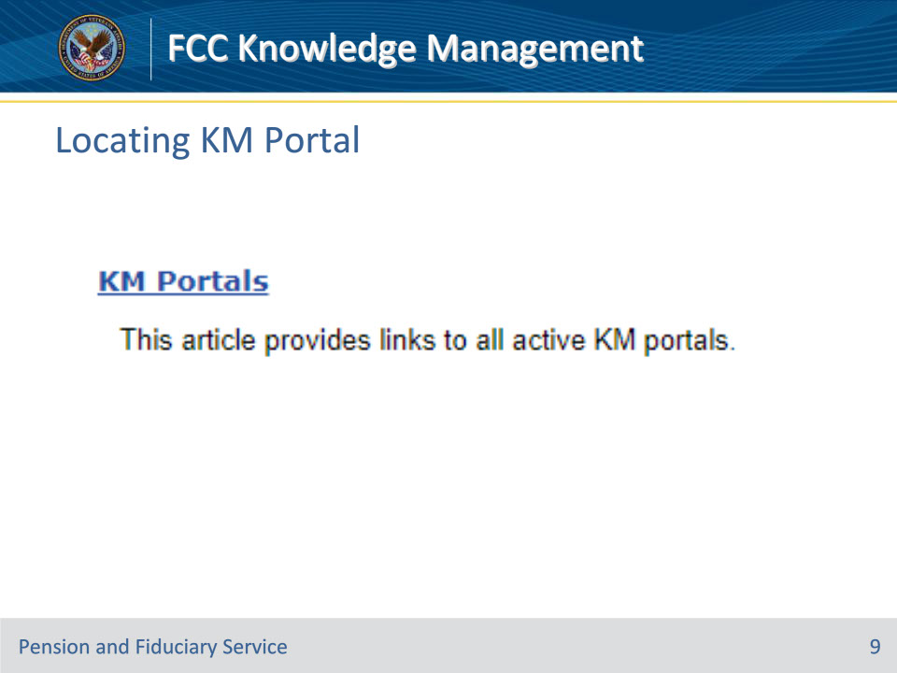

**Slide notes**

Instructor Notes

Select the KM Portals hypertext.

**Slide 10 - Locating KM Portal**

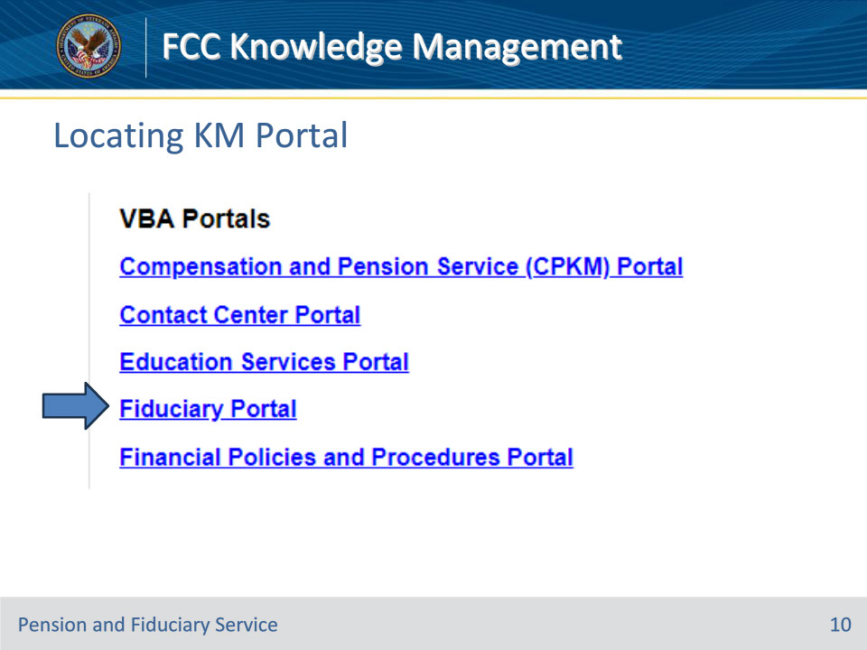

**Slide notes**

Instructor Notes

Select the Fiduciary Portal link.

**Slide 11 - Locating FCC Guidance**

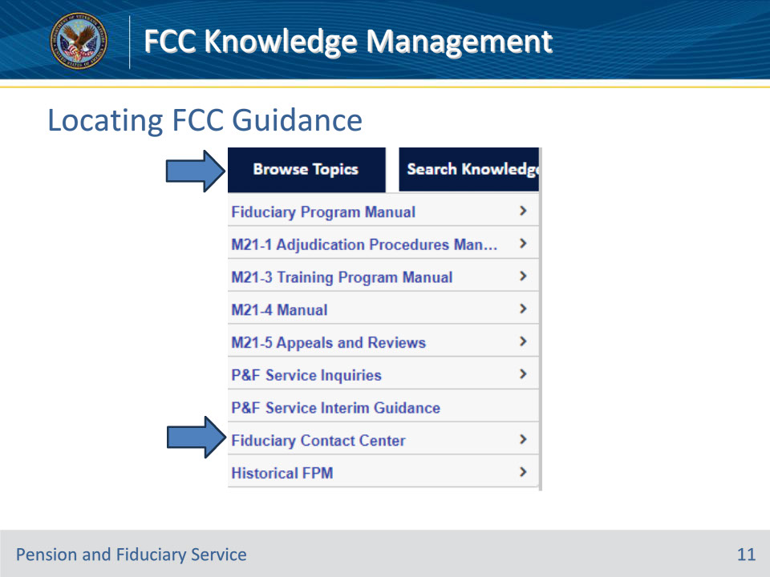

**Slide notes**

Instructor Notes

Hover over the Browse Topics button.

Select the Fiduciary Contact Center option.

This will bring you to Fiduciary Contact Center policy & procedure. Be sure to save this site to your favorites.

**Slide 12 - FCC Sections**

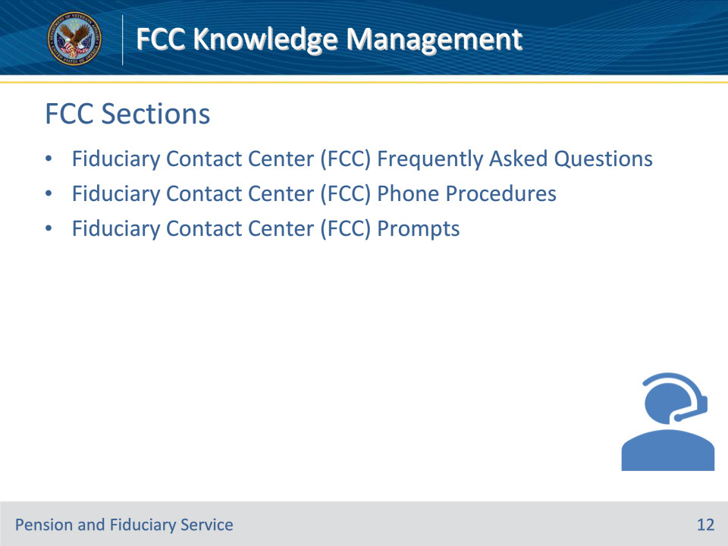

**Slide notes**

Instructor Notes

There are 3 different sections of the FCC Knowledge Management (KM) policy & procedure:

• Fiduciary Contact Center (FCC) Frequently Asked Questions (FAQ)

• Fiduciary Contact Center (FCC) Phone Procedures

• Fiduciary Contact Center (FCC) Prompts

**Slide 13 - FCC Frequently Asked Questions**

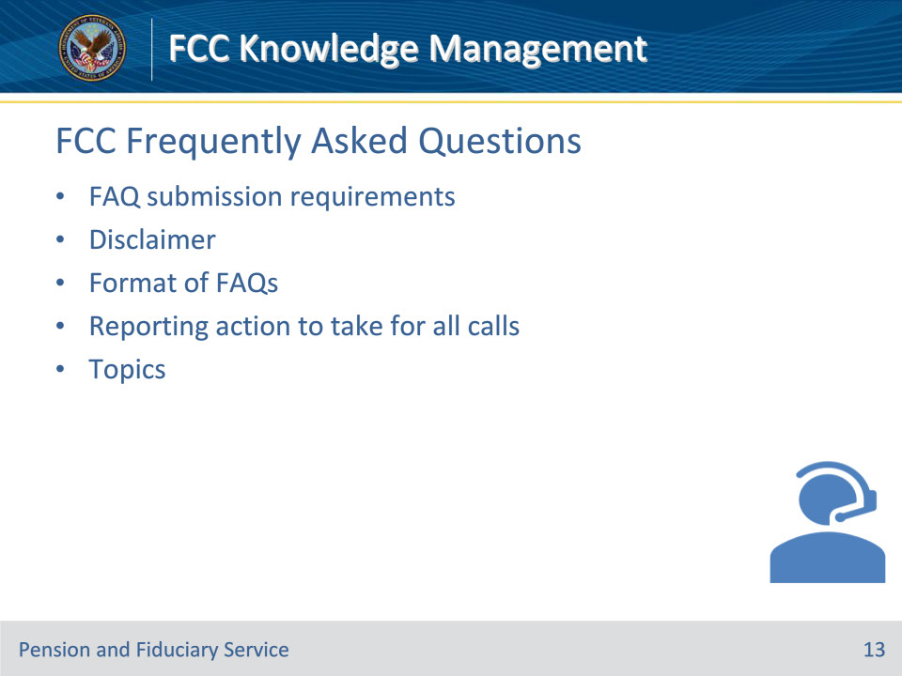

**Slide notes**

Instructor Notes

The FAQ section contains information on how to address FCC FAQs, including

• FAQ submission requirements

• disclaimer

• format of FAQs

• reporting action to take for all calls, and

• topics.

**Slide 14 - FCC Frequently Asked Questions**

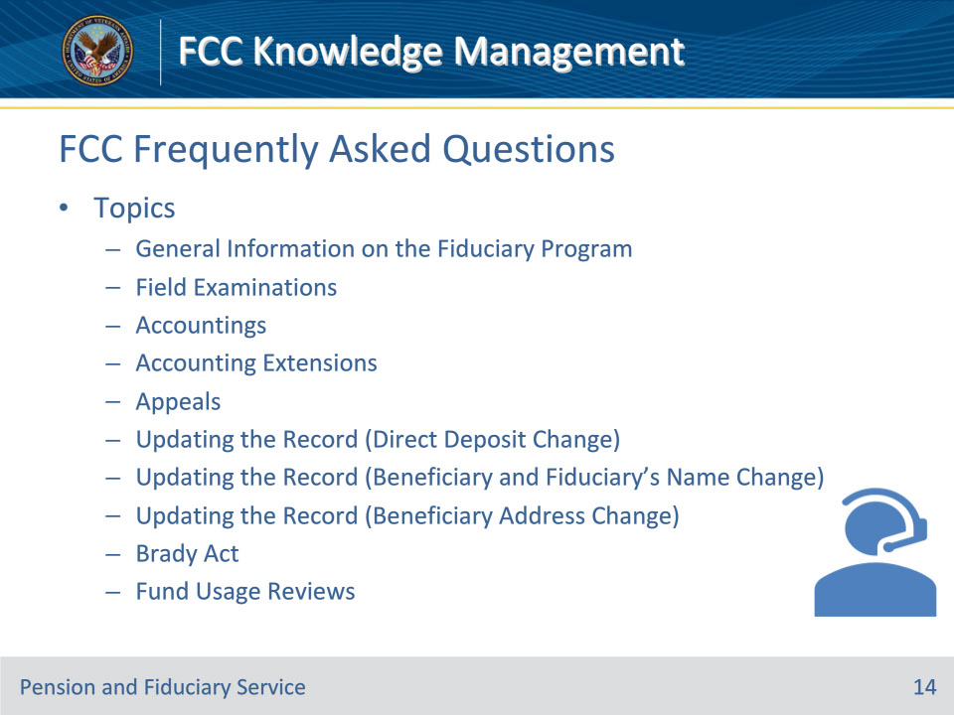

**Slide notes**

Instructor Notes

The FAQ section contains the following topics:

• General Information on the Fiduciary Program

• Field Examinations

• Accountings

• Accounting Extensions

• Appeals

• Updating the Record (Direct Deposit Change)

• Updating the Record (Beneficiary and Fiduciary’s Name Change)

• Updating the Record (Beneficiary Address Change)

• Brady Act

• Fund Usage Reviews

(continued on next slide)

**Slide 15 - FCC Frequently Asked Questions**

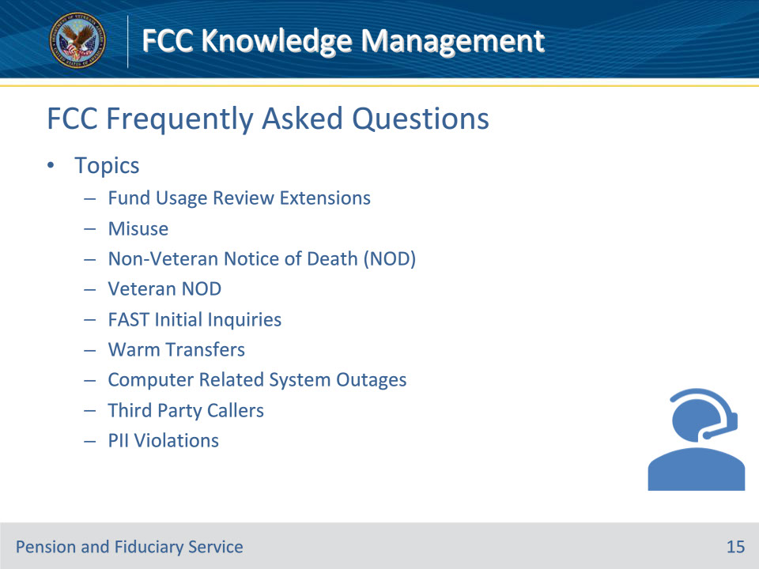

**Slide notes**

Instructor Notes

The FAQ section contains the following topics:

• Fund Usage Review Extensions

• Misuse

• Non-Veteran Notice of Death (NOD)

• Veteran NOD

• FAST Initial Inquiries

• Warm Transfers

• Computer Related System Outages

• Third Party Callers

• PII Violations

(continued on next slide)

**Slide 16 - FCC Frequently Asked Questions**

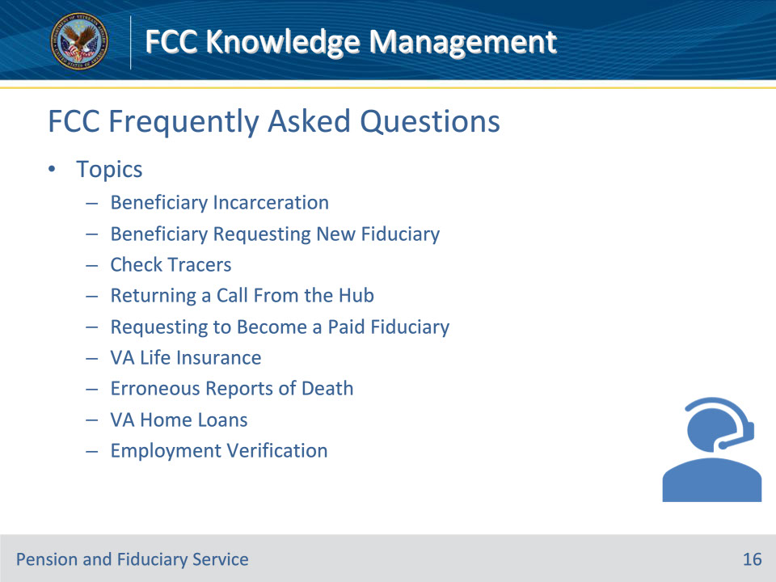

**Slide notes**

Instructor Notes

The FAQ section contains the following topics:

• Beneficiary Incarceration

• Beneficiary Requesting New Fiduciary

• Check Tracers

• Returning a Call From the Hub

• Requesting to Become a Paid Fiduciary

• VA Life Insurance

• Erroneous Reports of Death

• VA Home Loans

• Employment Verification

**Slide 17 - FCC Phone Procedures**

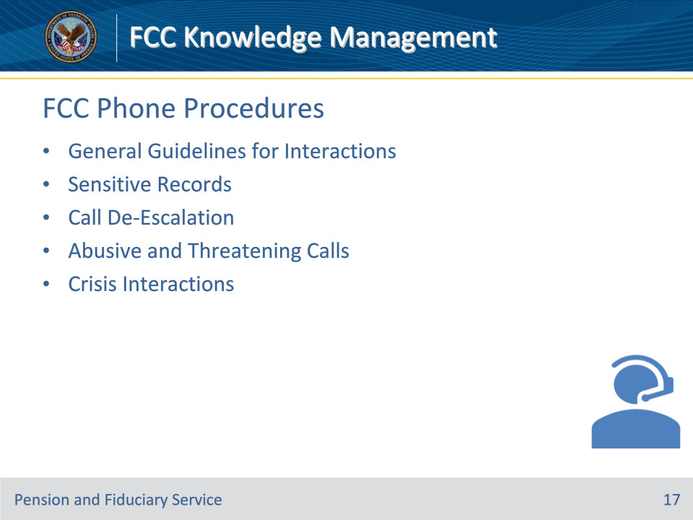

**Slide notes**

Instructor Notes

The FCC Phone Procedures section contains the following topics:

• General Guidelines for Interactions

• Sensitive Records

• Call De-Escalation

• Abusive and Threatening Calls

• Crisis Interactions

**Slide 18 - FCC Prompts**

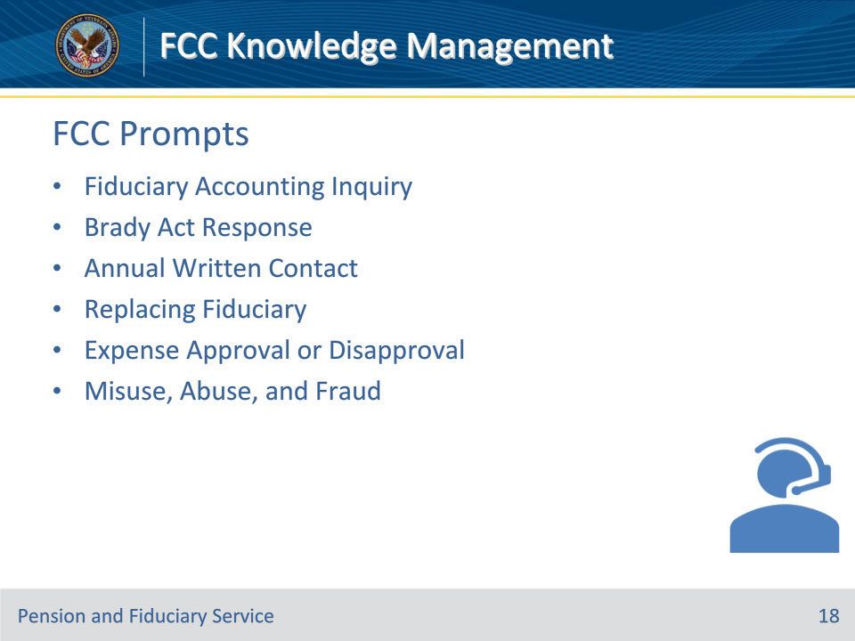

**Slide notes**

Instructor Notes

The FCC Prompts section contains the FCC prompts for frequently asked questions (FAQs). This section contains the following topics:

• Fiduciary Accounting Inquiry

• Brady Act Response

• Annual Written Contact

• Replacing Fiduciary

• Expense Approval or Disapproval

• Misuse, Abuse, and Fraud

**Slide 19 - Questions?**

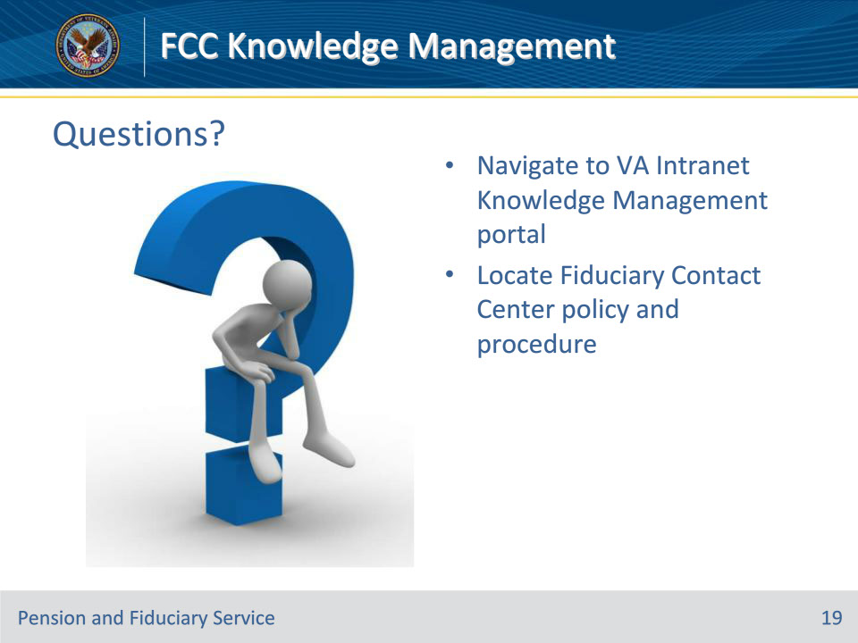

**Slide notes**

Instructor Notes:

(Recall) These are our learning objectives as stated from the beginning of the training:

• Navigate to VA Intranet Knowledge Management portal

• Locate Fiduciary Contact Center policy and procedure

Are there any additional questions?

Questions should be filtered through your QRT team. They will submit your questions to the Field Inquiry Tool (FIT) on your behalf.

**Slide 20 - TMS Survey/Assessment**

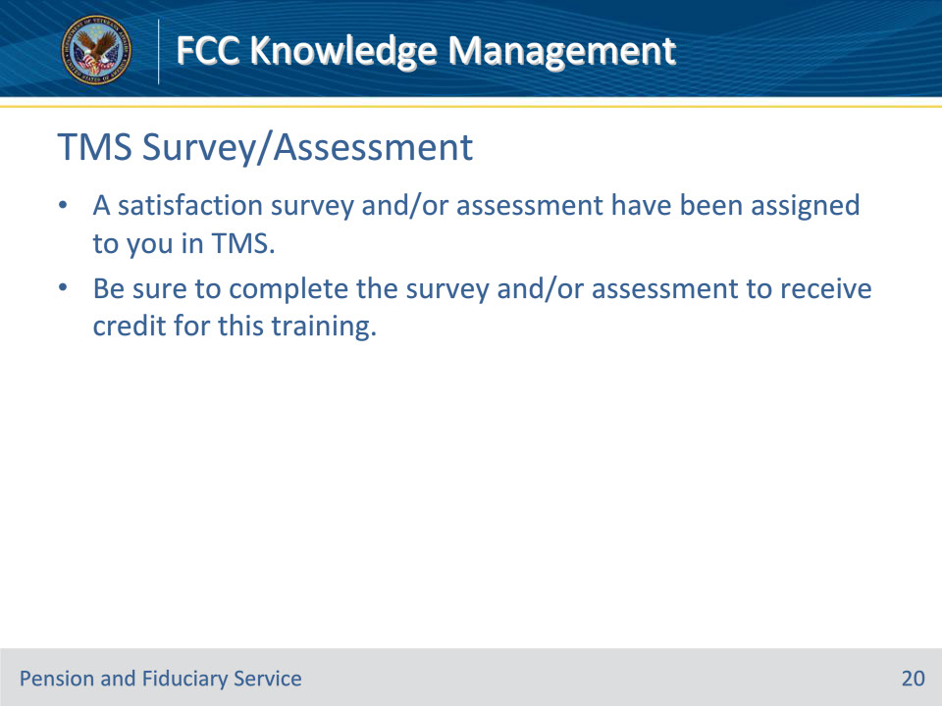

**Slide notes**

Instructor Notes

A satisfaction survey and/or assessment have been assigned to you in TMS.

Be sure to complete the survey and/or assessment to receive credit for this training.