**Slide 1 - Finalizing Field Examinations**

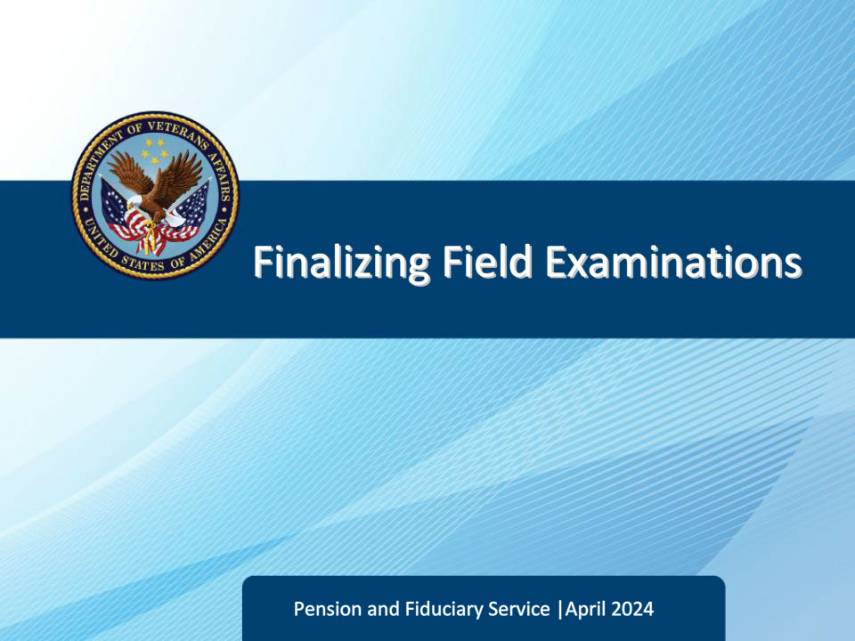

**Slide notes**

Course Description:

Welcome to Finalizing Field Examinations training. The course teaches the learner about the various processes involved in finalizing field examinations and promulgating related awards.

**Slide 2 - Objectives**

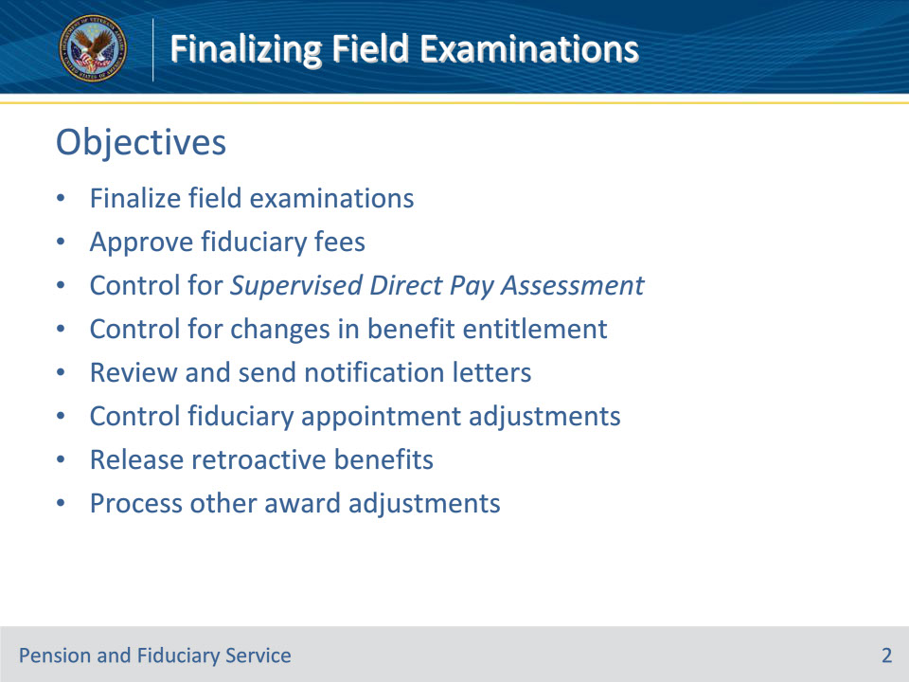

**Slide notes**

Instructor Notes:

At the end of this lesson, given the training and references, the learner will be able to do the following:

• Finalize field examinations

• Approve fiduciary fees

• Control for Supervised Direct Pay Assessment

• Control for changes in benefit entitlement

• Review and send notification letters

• Control fiduciary appointment adjustments

• Release retroactive benefits

• Process other award adjustments

**Slide 3 - References**

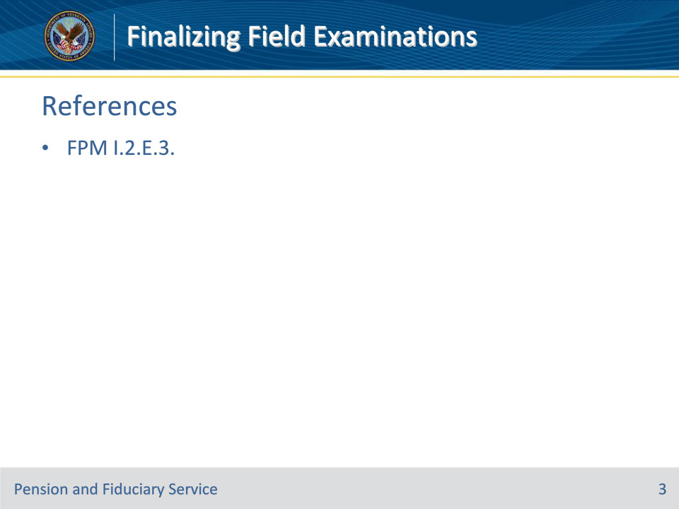

**Slide notes**

Instructor Notes:

These are the relevant references pertaining to this course:

• FPM I.2.E.3. Finalizing Field Examinations to Include Promulgation of Awards

**Slide 4 - Overview**

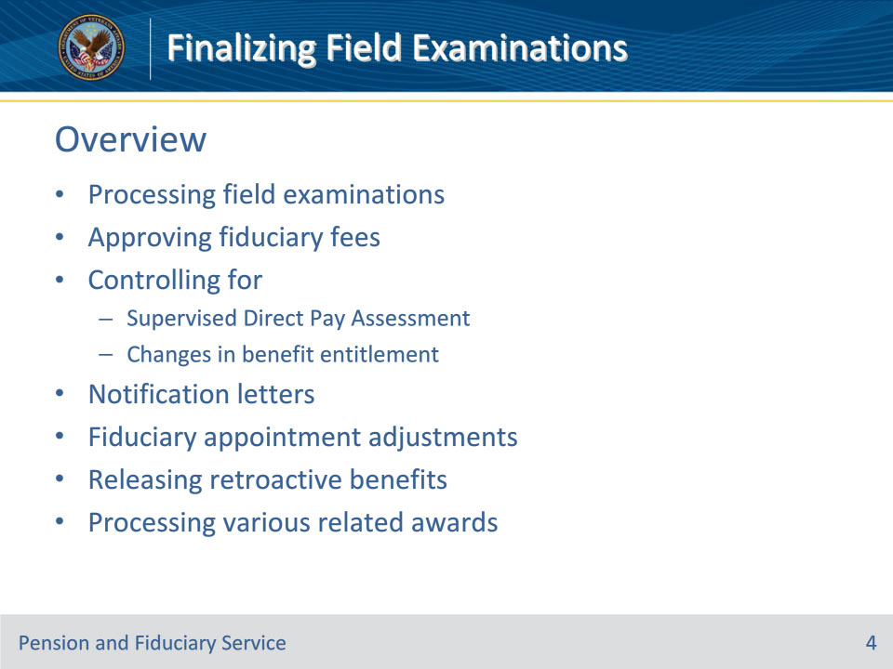

**Slide notes**

Policy Reference(s): FPM I.2.E.3. Introduction

Instructor Notes

This course contains information on finalizing field examinations, including:

• overview of processing Fiduciary Program field examinations

• approving the fiduciary fee

• controlling for

• Supervised Direct Pay Assessment, and

• changes in benefit entitlement

• reviewing and sending notification letters

• controlling fiduciary appointment adjustments

• releasing retroactive benefits, and

• processing

• a fiduciary adjustment related to a beneficiary’s restored ability to manage financial affairs

• retroactive benefits between $10,000 and $25,000

• reviews of retroactive benefits that exceed $25,000, and

• other award adjustments upon finalization of the field examination.

**Slide 5 - Processing Field Exams**

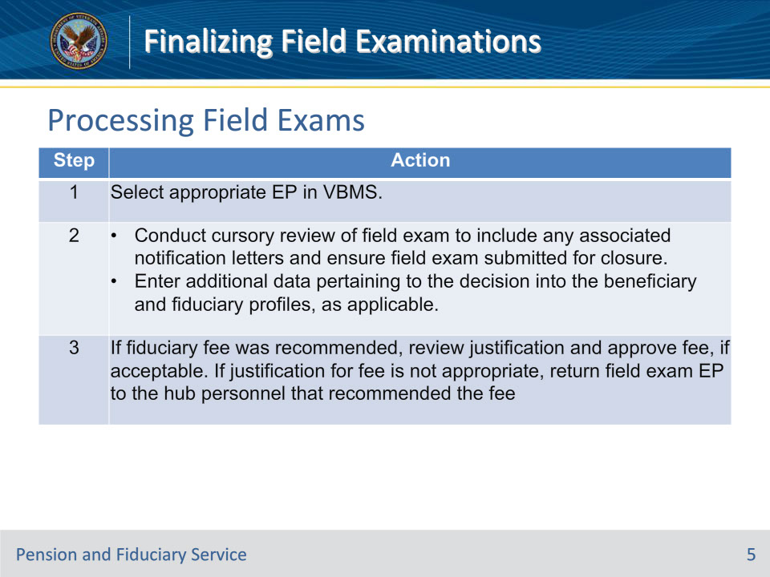

**Slide notes**

Policy Reference(s): FPM I.2.E.3.a.

Instructor Notes

Follow the steps in this table when processing field examinations.

**Slide 6 - Processing Field Exams**

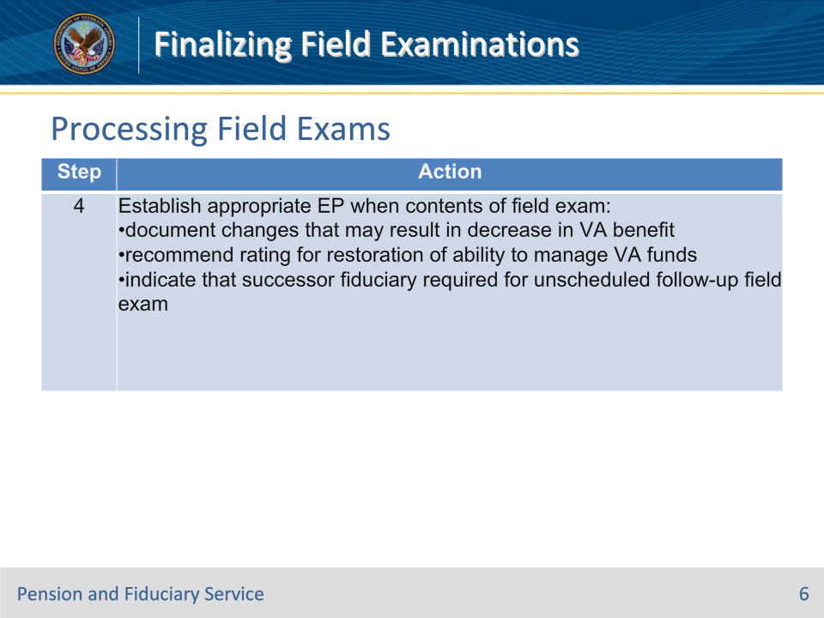

**Slide notes**

Policy Reference(s): FPM I.2.E.3.a.

Instructor Notes

Follow the steps in this table when processing field examinations.

**Slide 7 - Step 4 Notes**

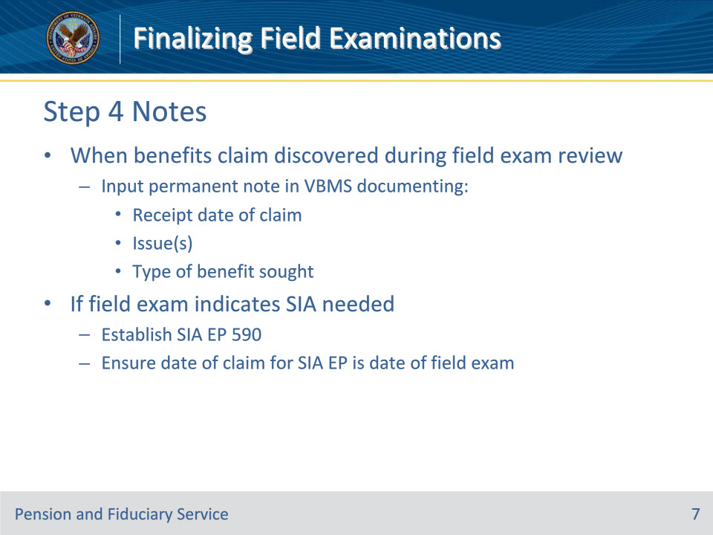

**Slide notes**

Policy Reference(s): FPM I.2.E.3.a.

Instructor Notes

Step 4 Notes:

• When a claim for benefits is discovered during the review of the field examination, hub personnel must input a permanent note in VBMS documenting the

• receipt date of the claim for benefits

• issue(s), and

• type of benefit sought.

• If the field examination indicates that an SIA is needed, hub personnel must

• establish the SIA EP 590, and

• ensure the date of claim for the SIA EP is the date of the field examination.

**Slide 8 - Processing Field Exams**

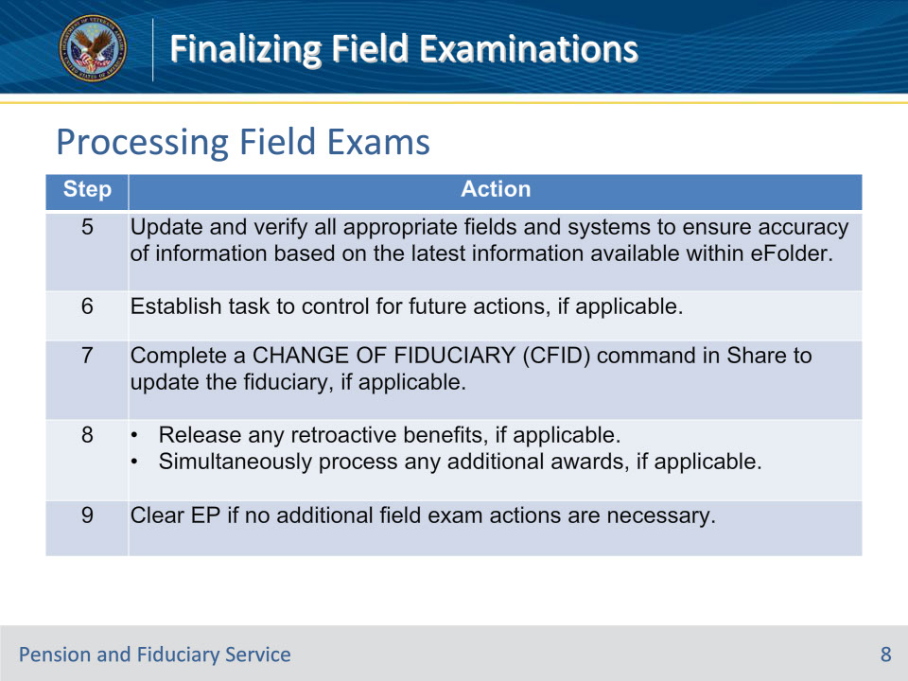

**Slide notes**

Policy Reference(s): FPM I.2.E.3.a.

Instructor Notes

Follow the steps in this table when processing field examinations.

**Slide 9 - Approving Fiduciary Fee**

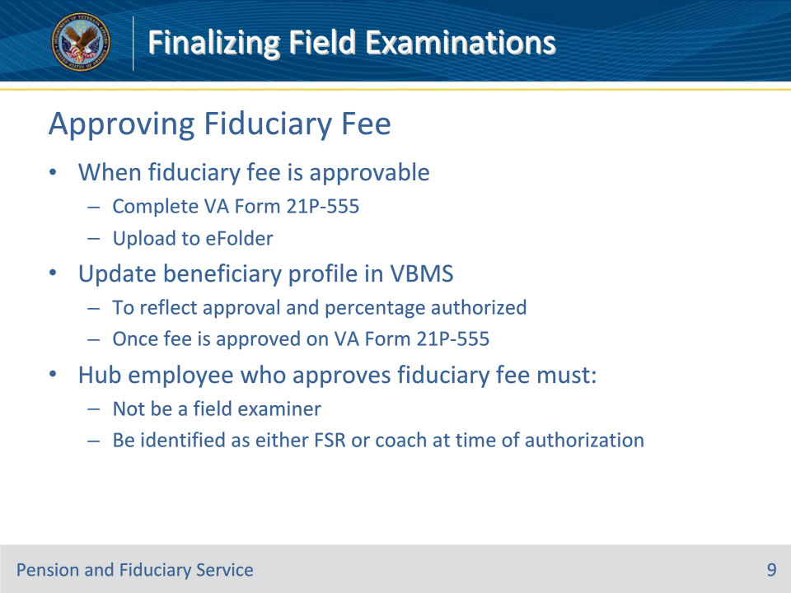

**Slide notes**

Policy Reference(s): FPM I.2.E.3.b.

Instructor Notes

When a fiduciary fee is approvable, appropriate hub personnel must complete a VA Form 21P-555 and upload it to the beneficiary’s eFolder.

Once the fee is approved on the VA Form 21P-555, the beneficiary profile in VBMS must be updated to reflect the approval and the percentage authorized.

Important:  The hub employee who approves a fiduciary fee must

• not be a field examiner (FE), and

• be identified as either a Fiduciary Service Representative (FSR) or a coach at the time of authorization.

**Slide 10 - SDP Assessment**

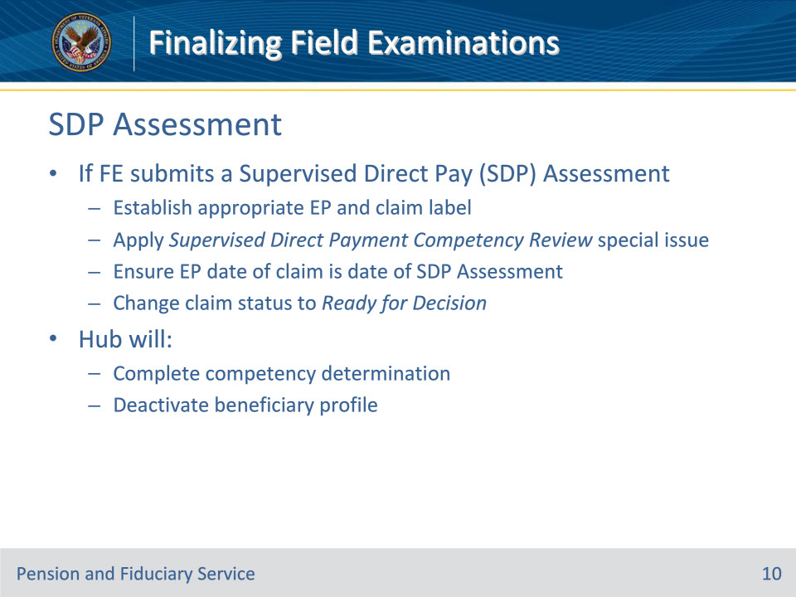

**Slide notes**

Policy Reference(s): FPM I.2.E.3.c.

Instructor Notes

If the FE submits a Supervised Direct Pay Assessment, the FSR or designee must:

• establish the appropriate EP and claim label for

• pension, use EP 120, claim label PMC-Incompetency Review – Pension

• Dependency and Indemnity Compensation (DIC), use EP 020, claim label PMC – Incompetency Review – DIC, or

• service-connected compensation, use EP 020, claim label Incompetency Review – S/C

• apply the Supervised Direct Payment Competency Review special issue indicator to the EP

• ensure the EP date of claim is the date of the Supervised Direct Pay Assessment, and

• change the claim status to Ready for Decision.

The hub will complete the competency determination (unless one of the exceptions in FPM, Part I, 1.A.2.b applies), and update the beneficiary profile to deactivate the beneficiary’s profile in accordance with FPM, Part II, 1.D.3.a.

**Slide 11 - Incompetency Review End Products**

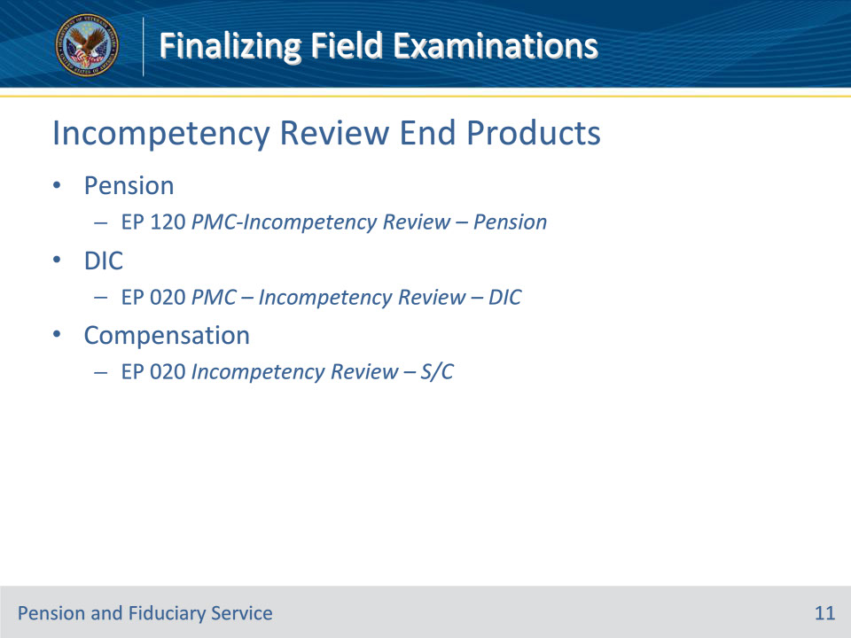

**Slide notes**

Policy Reference(s): FPM I.2.E.3.c.

Instructor Notes

If the FE submits a Supervised Direct Pay Assessment, the FSR or designee must:

• establish the appropriate EP and claim label for

• pension, use EP 120, claim label PMC-Incompetency Review – Pension

• Dependency and Indemnity Compensation (DIC), use EP 020, claim label PMC – Incompetency Review – DIC, or

• service-connected compensation, use EP 020, claim label Incompetency Review – S/C

**Slide 12 - Benefit Entitlement Changes**

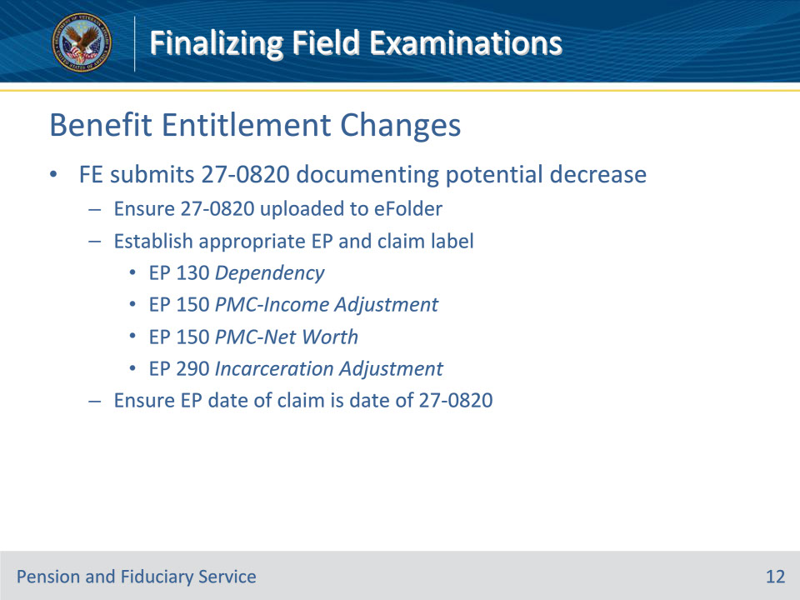

**Slide notes**

Policy Reference(s): FPM I.2.E.3.d.

Instructor NotesIf information associated with a potential decrease in benefit entitlement is obtained during a field examination, it must be provided to the regional office (RO) for review for any necessary award action.  This information must be documented by the FE on a VA Form 27-0820, Report of General Information, and must include all relevant details about the change that are necessary to take award action.

Examples:

• While documenting a beneficiary’s recurring income in accordance with FPM, Part I, 2.C.3.f, the FE discovers that the amount of the Veteran’s non-Federal retirement income identified during the field examination differs from the amount listed in the award information within the VA system.  The beneficiary is in receipt of pension benefits and the change in amount may affect entitlement.  The FE must document the amount identified during the field examination and the date the Veteran began receiving that amount, if known, within the VA Form 27-0820.

• The FE discovers during the field examination that the Veteran has recently been divorced.  A review of VA systems shows that the former spouse is listed on the Veteran’s award and the divorce may affect benefit entitlement.  The FE must document the date of the Veteran’s divorce on the VA Form 27-0820.

• While documenting the beneficiary’s expenses in accordance with FPM, Part I, 2.C.3.h, the FE discovers unreimbursed medical expenses that are no longer being paid by the beneficiary but are listed in the award information within the VA system as recurring medical expenses.  The beneficiary is in receipt of pension benefits and the change in unreimbursed medical expenses may affect entitlement.  The FE must document the following information when available:  the type of recurring medical expense that stopped (for example, caregiver fees, health insurance, etc.), and the date the unreimbursed medical expenses stopped being paid within the VA Form 27-0820.

When the FE submits a VA Form 27-0820, documenting a potential decrease in VA benefits, hubs have the responsibility of establishing claims in the appropriate system to ensure proper control.  The FSR or designee must

• ensure the VA Form 27-0820 is uploaded to the beneficiary’s VBMS eFolder

• establish the appropriate EP and claim label such as the following:

• EP 130, Dependency

• EP 150, PMC-Income Adjustment

• EP 150, PMC-Net Worth, or

• EP 290, Incarceration Adjustment, and

• ensure the EP date of claim is the date of the VA Form 27-0820.

**Slide 13 - Establishing End Products**

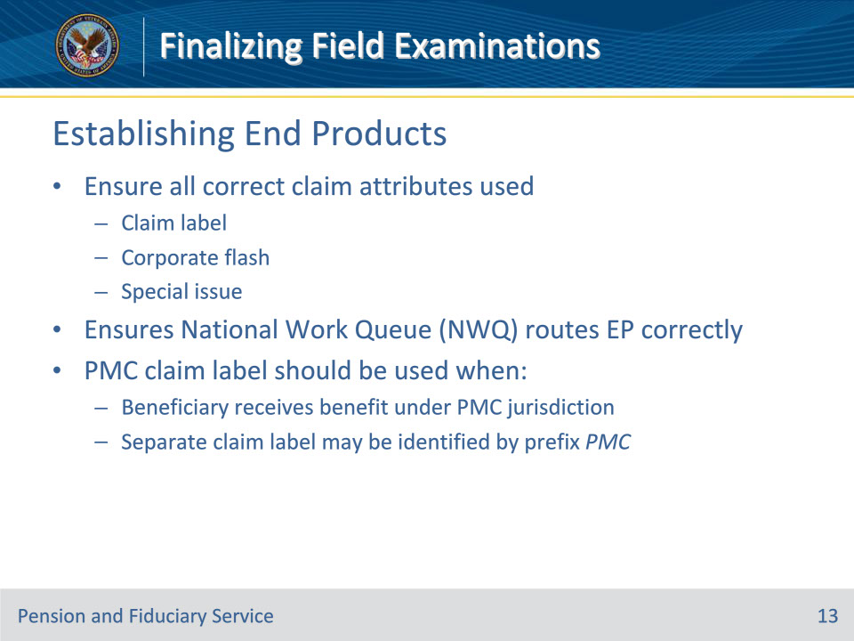

**Slide notes**

Policy Reference(s): FPM I.2.E.3.d.

Instructor Notes

When establishing EPs based on a change to benefit entitlement, hub personnel must ensure all correct claim attributes are used (e.g., claim label, corporate flash, or special issue) to ensure National Work Queue (NWQ) routes the EP to the correct Veterans Service Center or pension management center (PMC), as appropriate.  For many award adjustment EPs, such as those noted above, a separate claim label will be identified by the prefix “PMC” in the claim label name.  A PMC claim label should be used when the beneficiary receives a benefit under PMC jurisdiction.

**Slide 14 - Notification Letters**

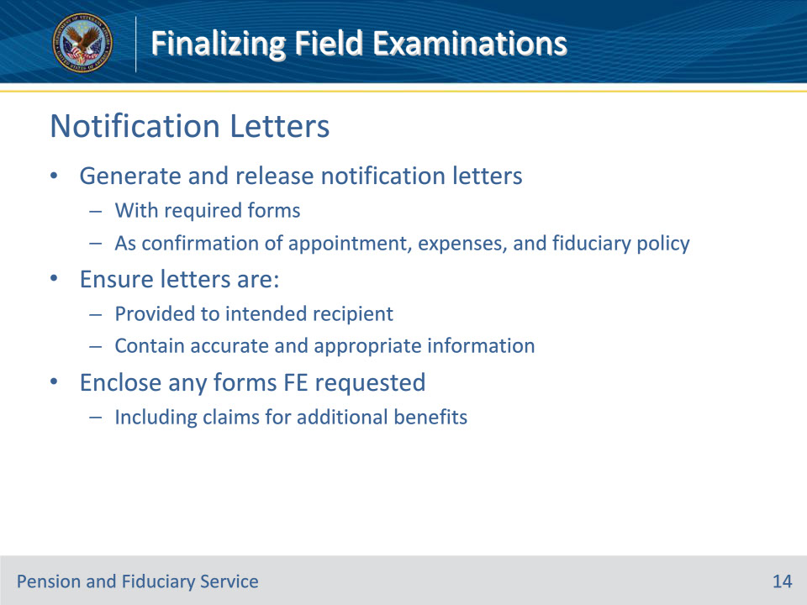

**Slide notes**

Policy Reference(s): FPM I.2.E.3.e.

Instructor Notes

Hub personnel finalizing the field examination will generate and release notification letters with the required forms as confirmation of appointment, expenses, and fiduciary policy.  Hub personnel are responsible for ensuring letters are provided to the intended recipient with accurate and appropriate information.

Enclose any forms the FE requested to include claims for additional benefits.

**Slide 15 - Fiduciary Appointment Adjustments**

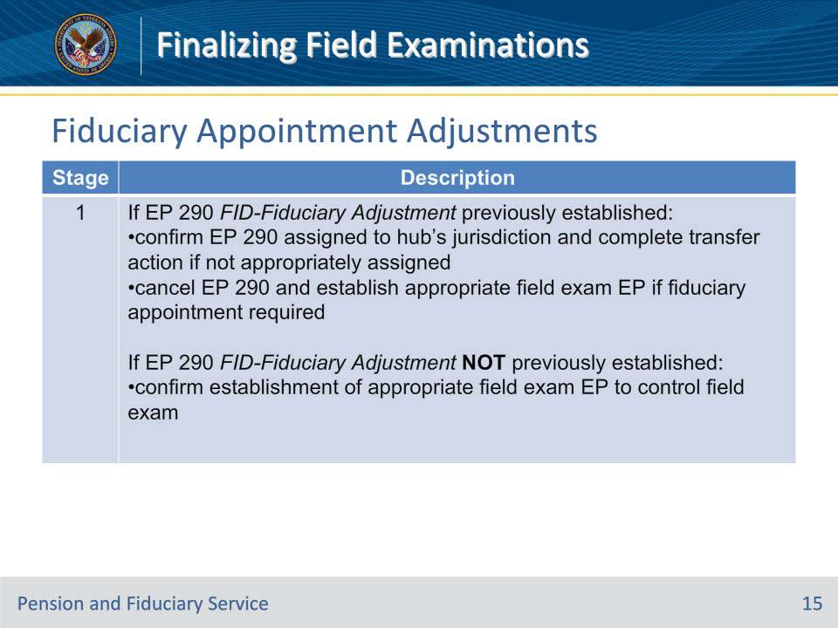

**Slide notes**

Policy Reference(s): FPM I.2.E.3.f.

Instructor Notes

This table describes the stages for controlling fiduciary adjustments upon a request for a fiduciary appointment.

Stage 1: Determine if an EP 290 with the FID-Fiduciary Adjustment claim label was previously established in Share/VBMS.  Use this table to determine the appropriate next action to take.

**Slide 16 - Stage 1 Notes**

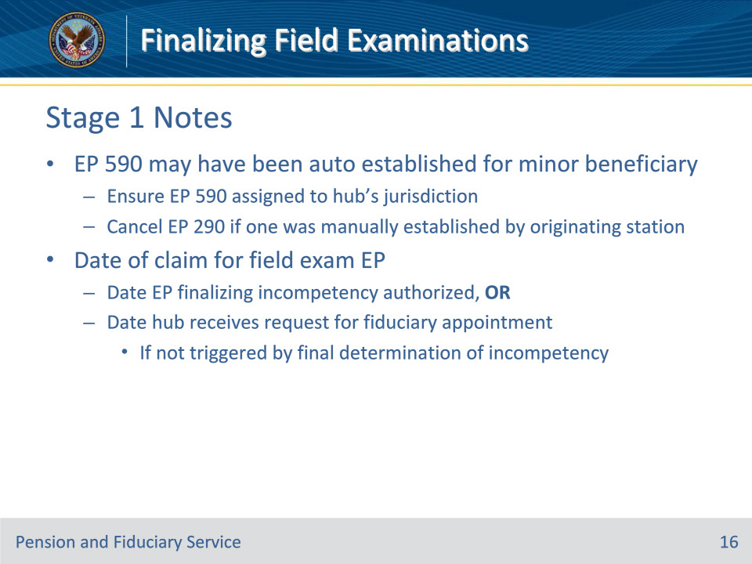

**Slide notes**

Policy Reference(s): FPM I.2.E.3.f.

Instructor Notes

Stage 1 Notes:

• In some instances, an EP 590 may have been established by the system for a minor beneficiary. In these cases

• ensure that the EP 590 is assigned to the hub’s jurisdiction, and

• cancel the EP 290, if one was manually established by the station of origination.

• The date of claim for the field examination EP is the date the EP finalizing incompetency is authorized; or, if not triggered by final determination of incompetency, the date the hub receives the request for fiduciary appointment.

**Slide 17 - Fiduciary Appointment Adjustments**

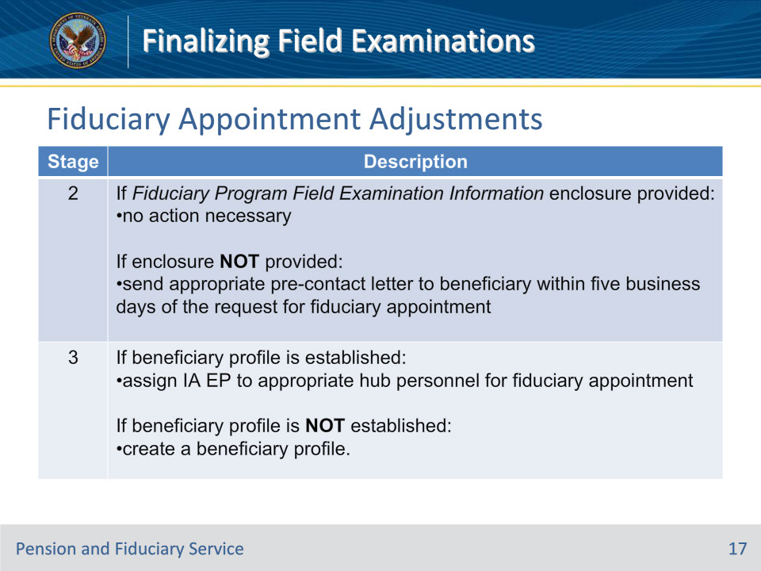

**Slide notes**

Policy Reference(s): FPM I.2.E.3.f.

Instructor Notes

This table describes the stages for controlling fiduciary adjustments upon a request for a fiduciary appointment.

Stage 2: Confirm that the beneficiary was provided the Fiduciary Program Field Examination Information enclosure.  Use this table to determine the appropriate next action to take.

Stage 3: Confirm that the beneficiary profile is established in the system.  Use this table to determine the appropriate next action to take.

**Slide 18 - Releasing Retroactive Benefits**

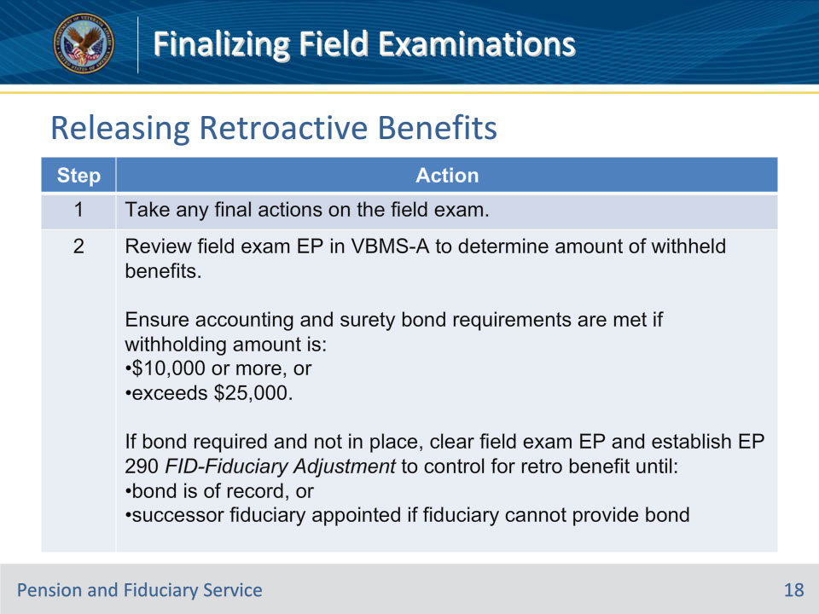

**Slide notes**

Policy Reference(s): FPM I.2.E.3.g.

Instructor Notes

Follow the steps in this table when processing fiduciary adjustments following certification of a fiduciary.

**Slide 19 - Step 2 Notes**

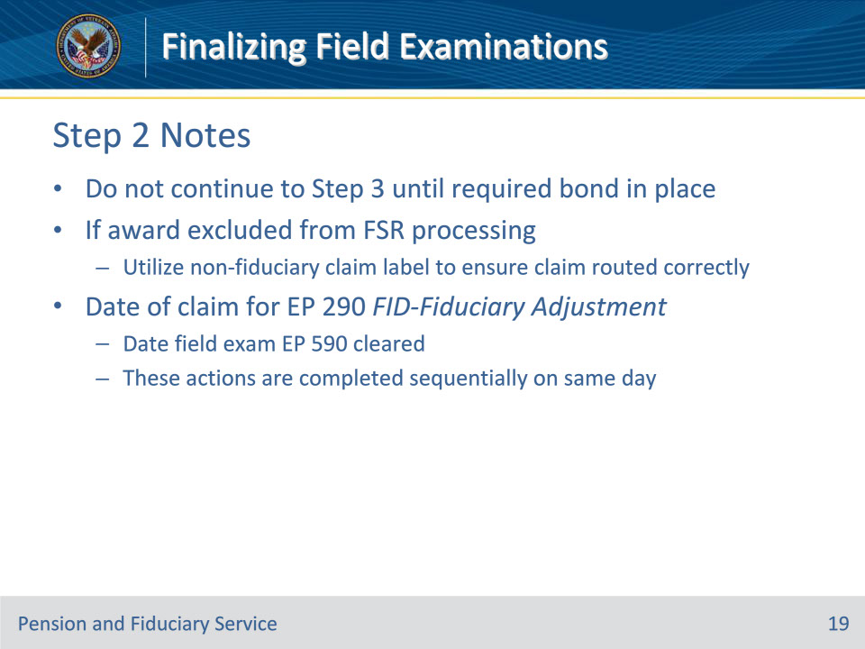

**Slide notes**

Policy Reference(s): FPM I.2.E.3.g.

Instructor Notes

Step 2 Notes:

• Do not continue to Step 3 until any required surety bond protection is in place.

• If the award is excluded from FSR processing, utilize a non-fiduciary program claim label to ensure the claim is routed to the appropriate station.

• The date of claim for the EP 290 with the FID-Fiduciary Adjustment claim label must be the date the field examination EP 590 is cleared, as these actions are completed sequentially on the same day.

**Slide 20 - Releasing Retroactive Benefits**

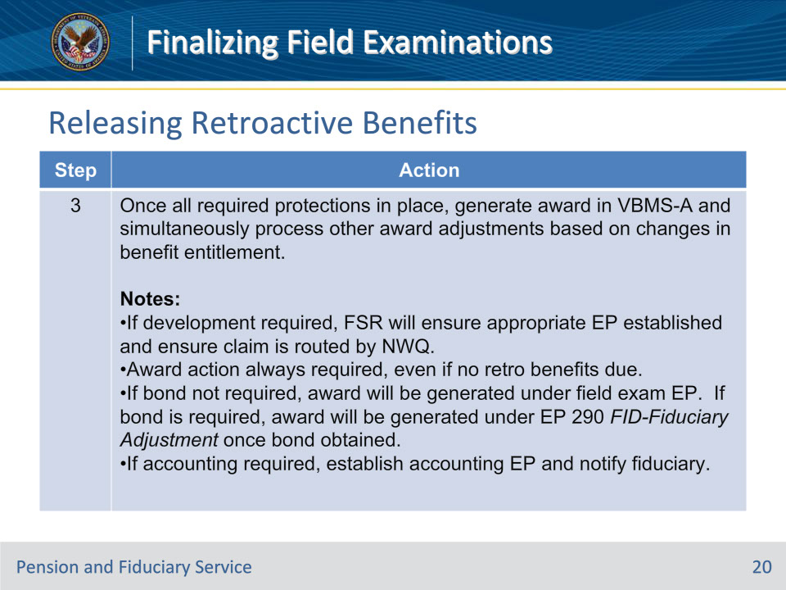

**Slide notes**

Policy Reference(s): FPM I.2.E.3.g.

Instructor Notes

Follow the steps in this table when processing fiduciary adjustments following certification of a fiduciary.

**Slide 21 - Releasing Retroactive Benefits**

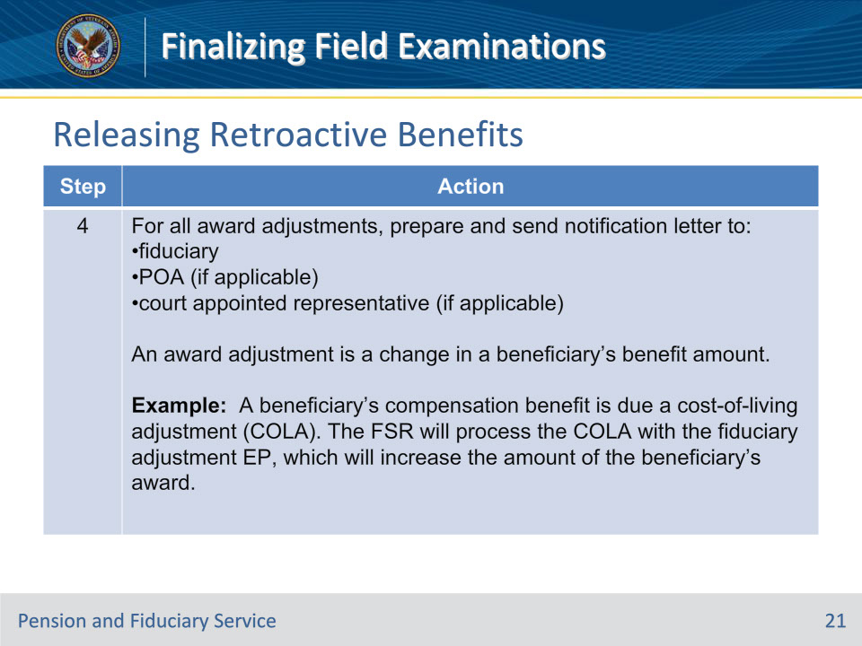

**Slide notes**

Policy Reference(s): FPM I.2.E.3.g.

Instructor Notes

Follow the steps in this table when processing fiduciary adjustments following certification of a fiduciary.

**Slide 22 - Releasing Retroactive Benefits**

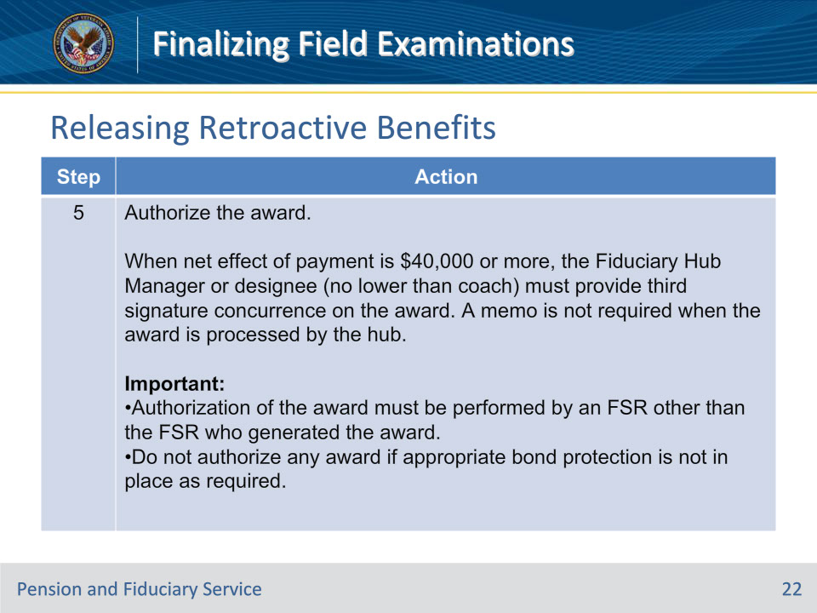

**Slide notes**

Policy Reference(s): FPM I.2.E.3.g.

Instructor Notes

Follow the steps in this table when processing fiduciary adjustments following certification of a fiduciary.

**Slide 23 - Releasing Retroactive Benefits**

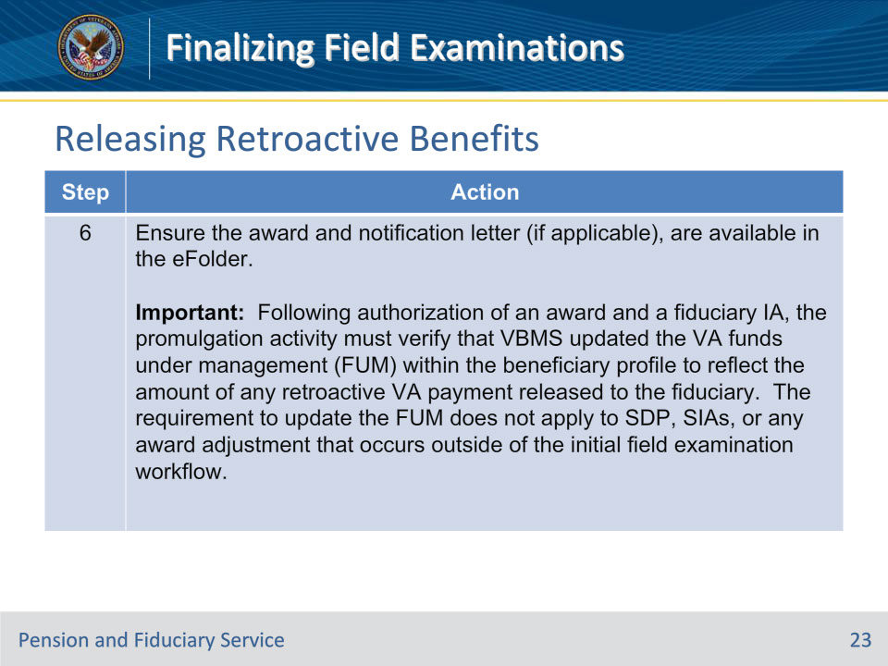

**Slide notes**

Policy Reference(s): FPM I.2.E.3.g.

Instructor Notes

Follow the steps in this table when processing fiduciary adjustments following certification of a fiduciary.

**Slide 24 - Competency Restoration**

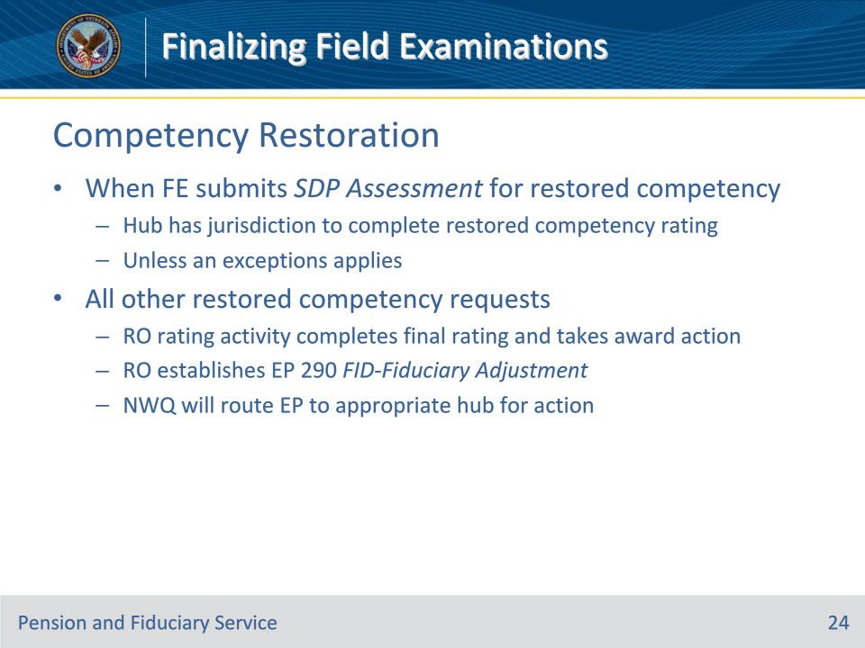

**Slide notes**

Policy Reference(s): FPM I.2.E.3.h.

Instructor NotesThe hub has jurisdiction to complete restored competency ratings when the FE submits a Supervised Direct Pay Assessment for restored competency unless one of the exceptions applies.

For all other restored competency requests, the RO rating activity completes a final rating determination restoring ability to manage financial affairs and takes award action.  The RO will establish an EP 290 with the FID-Fiduciary Adjustment claim label and the NWQ will route the EP to the appropriate hub for action.

**Slide 25 - Competency Restoration**

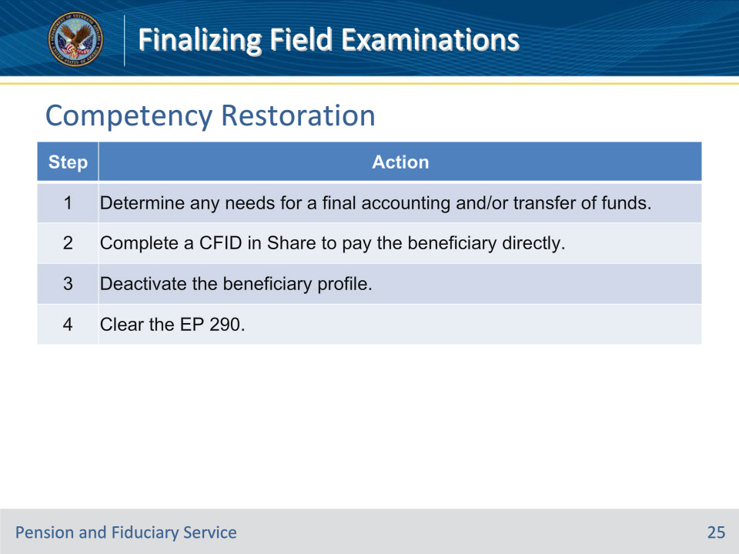

**Slide notes**

Policy Reference(s): FPM I.2.E.3.h.

Instructor NotesFollow the steps in this table upon review of the EP 290.

**Slide 26 - Competency Restoration**

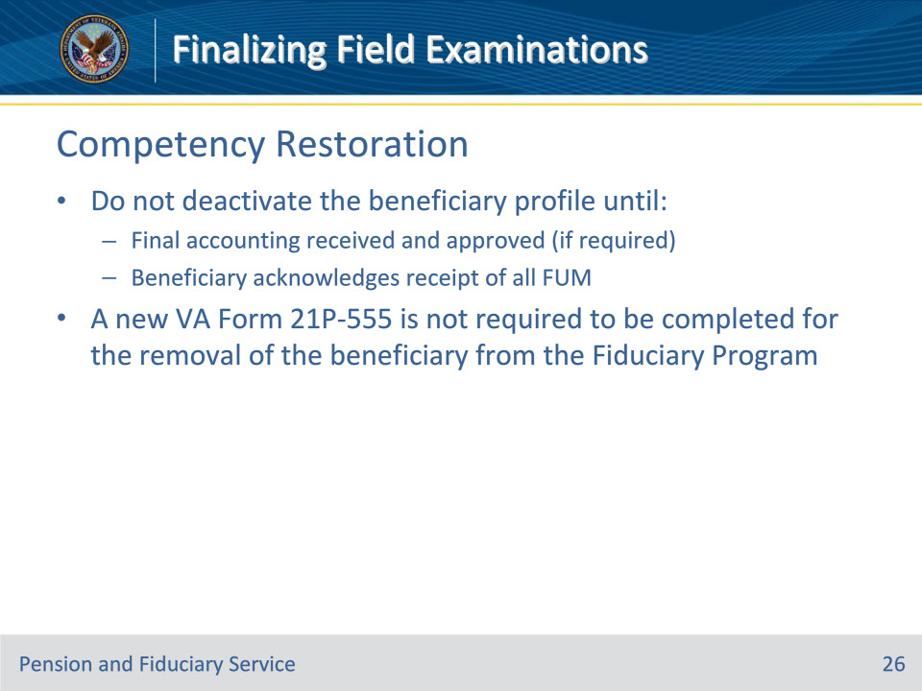

**Slide notes**

Policy Reference(s): FPM I.2.E.3.h.

Instructor NotesImportant:

• The hub must not deactivate the beneficiary profile until the

• final accounting is received and approved (if required), and

• beneficiary acknowledges receipt of all FUM.

• A new VA Form 21P-555 is not required to be completed for the removal of the beneficiary from the Fiduciary Program.

**Slide 27 - Accounting Requirement**

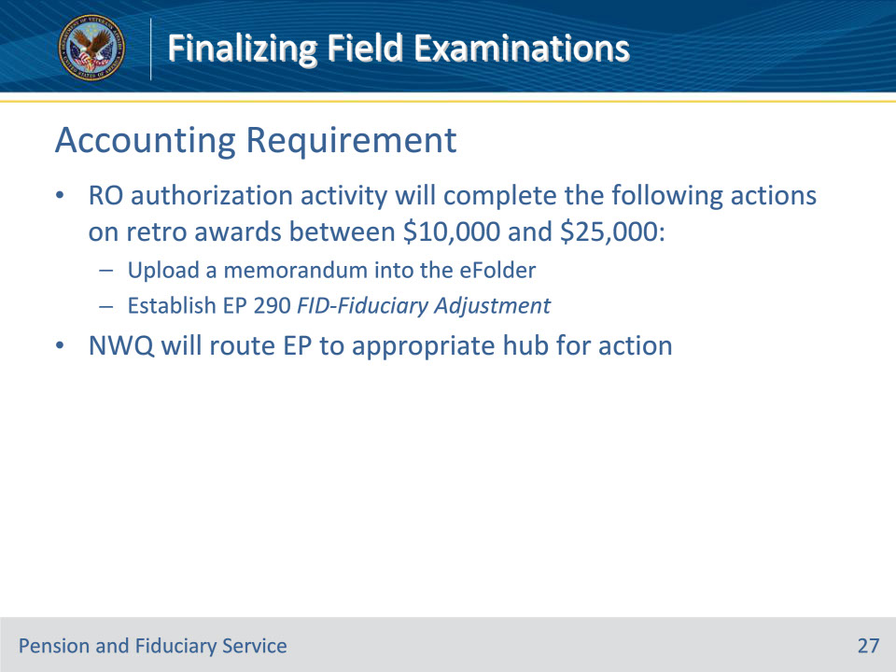

**Slide notes**

Policy Reference(s): FPM I.2.E.3.i.

Instructor NotesThe RO authorization activity will complete the following actions on retroactive awards that are between $10,000 and $25,000:

• upload a memorandum into the eFolder, and

• establish an EP 290 with the FID-Fiduciary Adjustment claim label.

Upon establishment of this claim label, NWQ will route the EP to the appropriate hub for action.

**Slide 28 - Accounting Requirement**

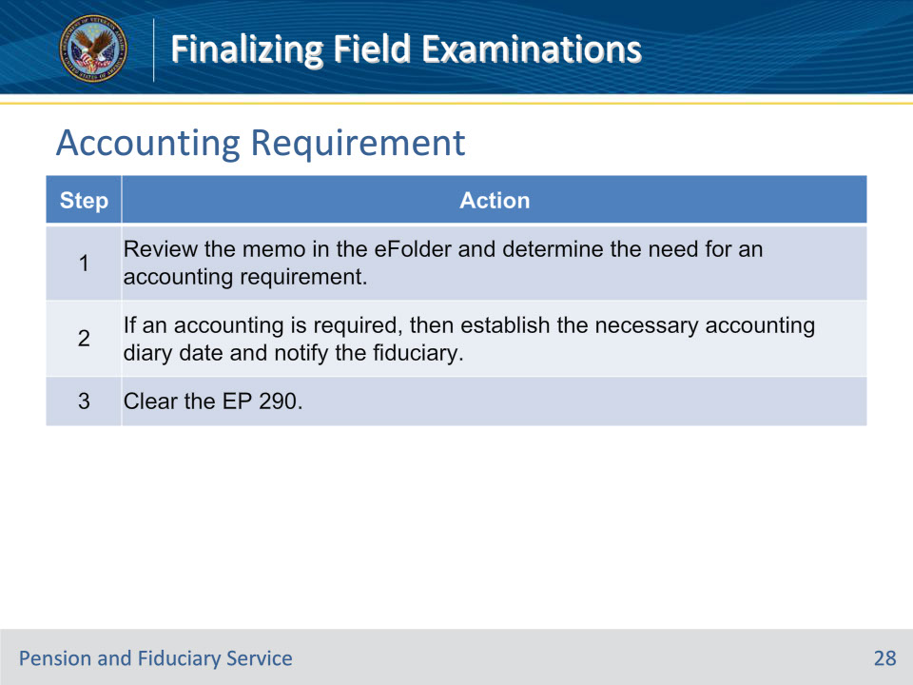

**Slide notes**

Policy Reference(s): FPM I.2.E.3.i.

Instructor NotesFollow the steps in this table upon review of the EP 290.

**Slide 29 - Bond Requirement**

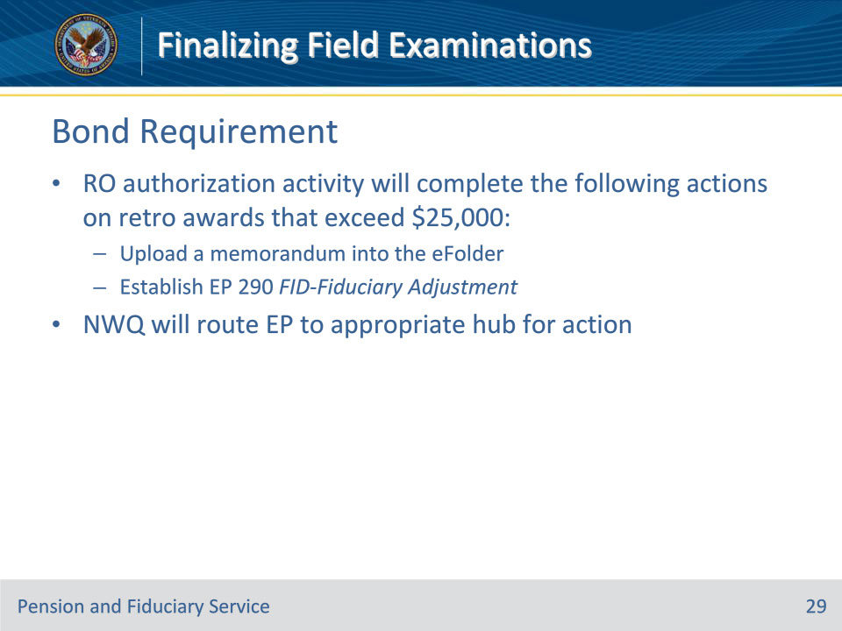

**Slide notes**

Policy Reference(s): FPM I.2.E.3.j.

Instructor NotesThe RO authorization activity will complete the following on retroactive awards that exceed $25,000:

• upload a memorandum into the eFolder, and

• establish an EP 290 with the FID-Fiduciary Adjustment claim label.

Upon establishment of this claim label, NWQ will route the EP to the appropriate hub for action.

**Slide 30 - Bond Requirement**

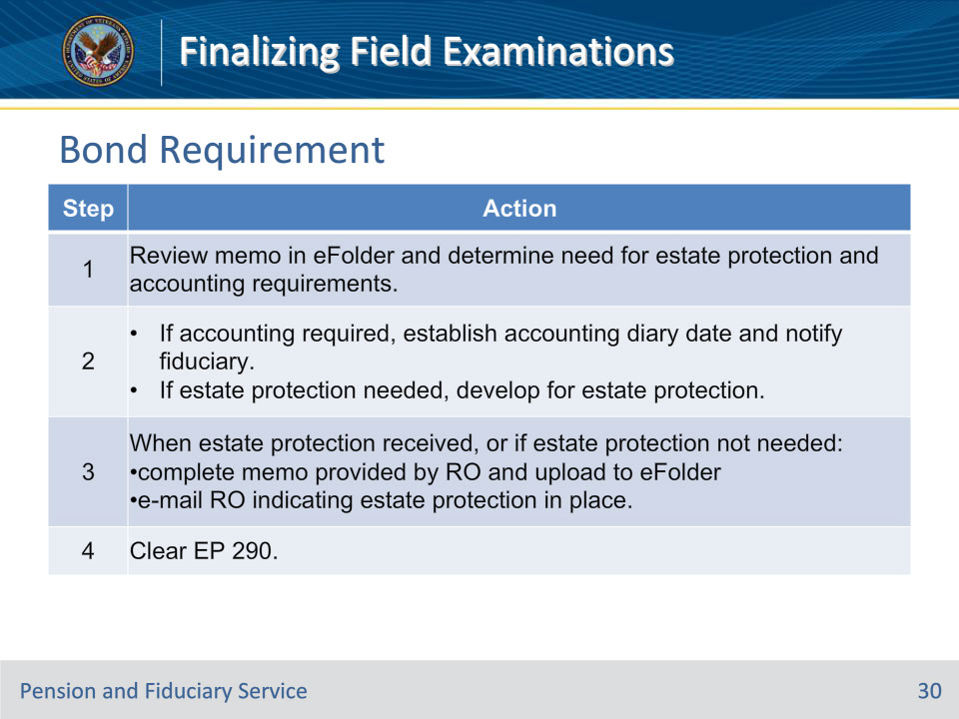

**Slide notes**

Policy Reference(s): FPM I.2.E.3.j.

Instructor NotesFollow the steps in this table upon review of the EP 290.

**Slide 31 - Other Award Adjustments**

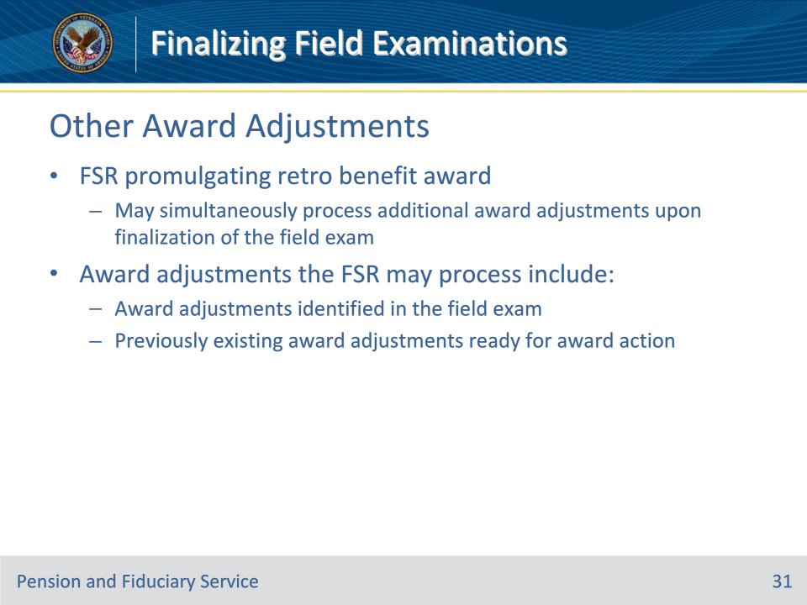

**Slide notes**

Policy Reference(s): FPM I.2.E.3.k.

Instructor NotesThe FSR promulgating the retroactive benefit award may simultaneously process any additional award adjustments that are ready for award action upon finalization of the field examination.  Award adjustments the FSR may process include

• the award adjustments that were identified in the field examination, and

• any previously existing award adjustments that are ready for award action.

**Slide 32 - Other Award Adjustments**

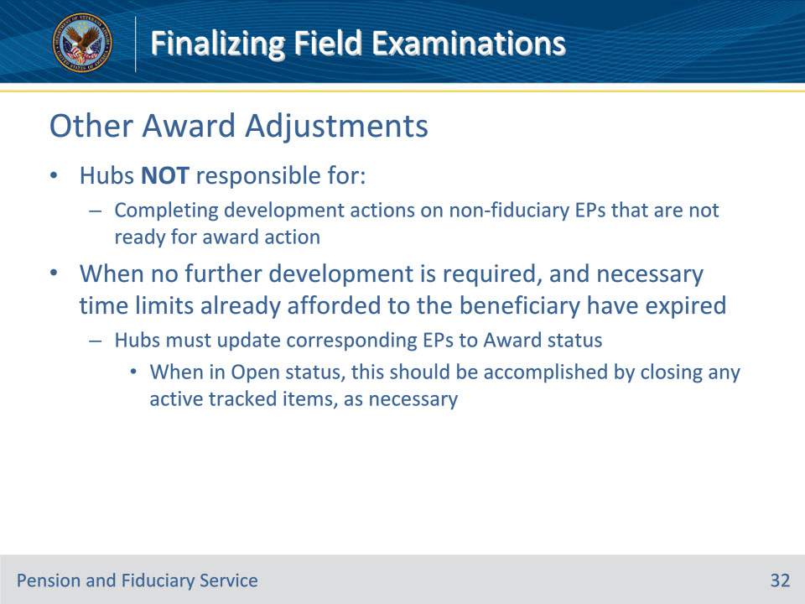

**Slide notes**

Policy Reference(s): FPM I.2.E.3.k.

Instructor NotesNote:  Hubs are not responsible for completing any development actions on non-fiduciary program EPs that are not ready for award action.  In such cases where no further development is required and necessary time limits already afforded to the beneficiary have expired, hubs must ensure the corresponding EP(s) are updated to an Award status.  When in an Open status, this should be accomplished by closing any active tracked items, as necessary.

**Slide 33 - Questions?**

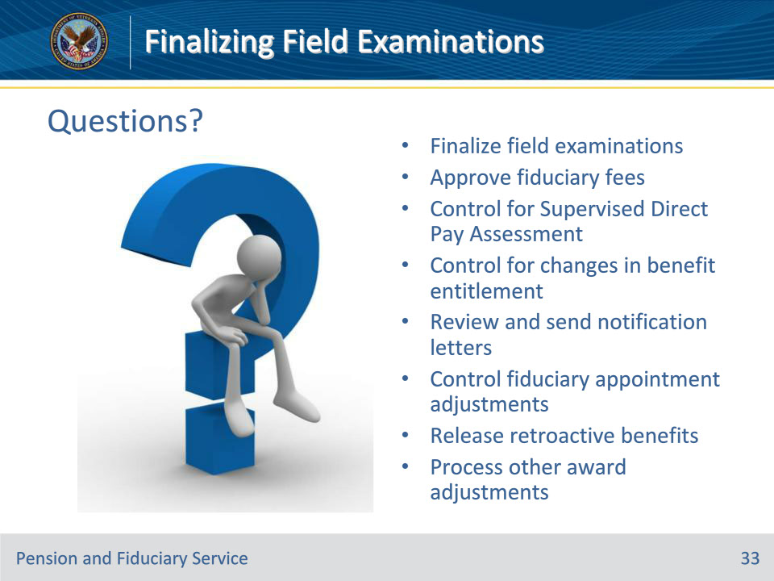

**Slide notes**

Instructor Notes:

(Recall) These are our learning objectives as stated from the beginning of the training:

• Finalize field examinations

• Approve fiduciary fees

• Control for Supervised Direct Pay Assessment

• Control for changes in benefit entitlement

• Review and send notification letters

• Control fiduciary appointment adjustments

• Release retroactive benefits

• Process other award adjustments

Are there any additional questions?

Questions should be filtered through your QRT team. They will submit your questions to the Field Inquiry Tool (FIT) on your behalf.

**Slide 34 - TMS Survey/Assessment**

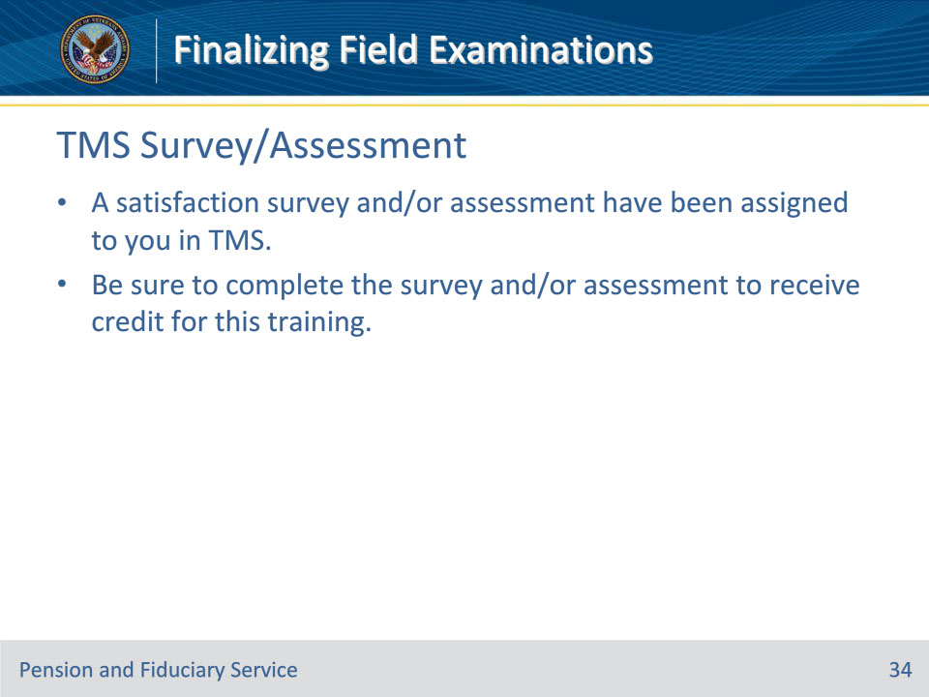

**Slide notes**

Instructor Notes

A satisfaction survey and/or assessment have been assigned to you in TMS.

Be sure to complete the survey and/or assessment to receive credit for this training.