**Slide 1 - FCC First Notice of Death**

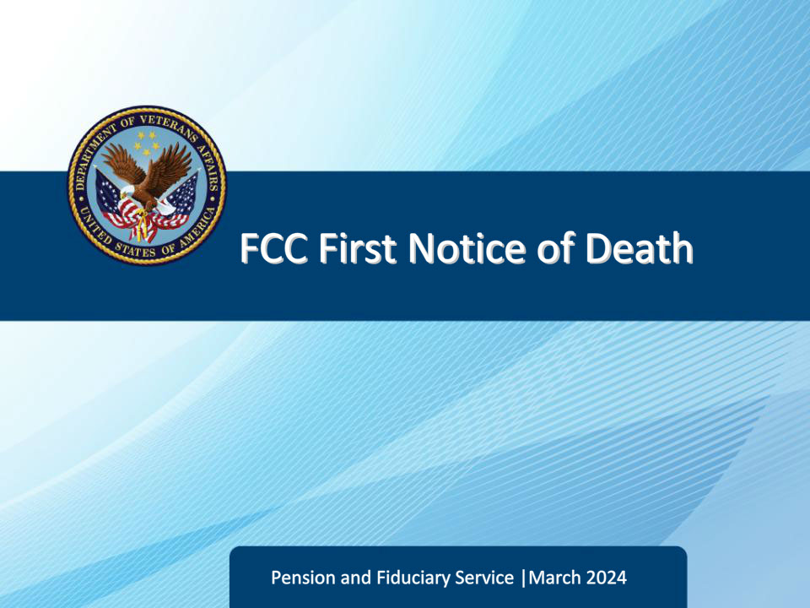

**Slide notes**

Course Description:

Welcome to the FCC First Notice of Death (FNOD) training. The course teaches the learner how to implement FCC FNOD procedures for Veteran and non-Veteran FNOD calls.

**Slide 2 - Objectives**

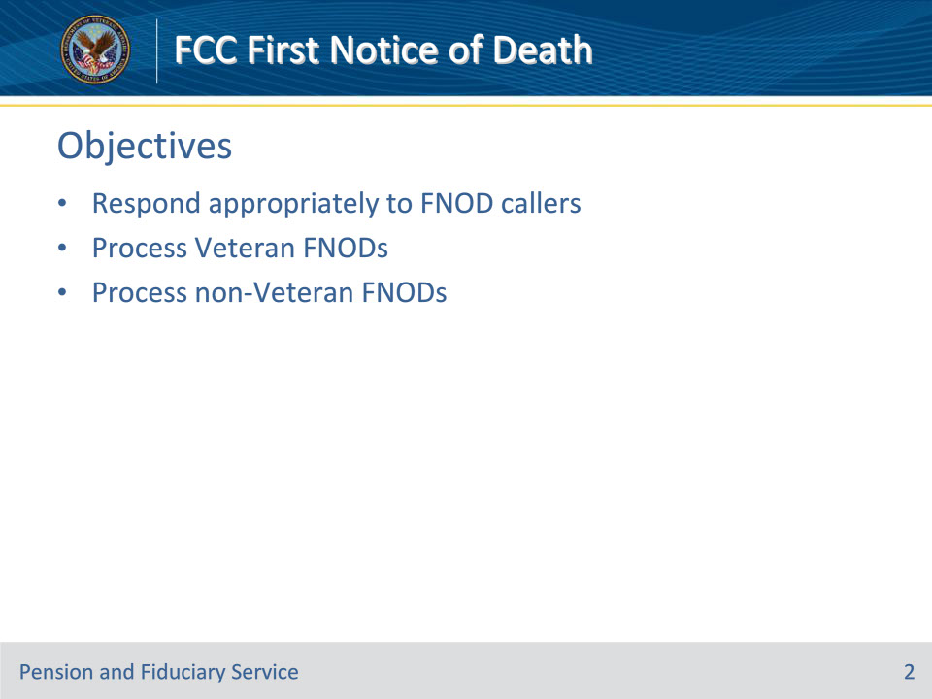

**Slide notes**

Instructor Notes:

At the end of this lesson, given the training and references, the learner will be able to do the following:

• Respond appropriately to FNOD callers

• Process Veteran FNODs

• Process non-Veteran FNODs

**Slide 3 - References**

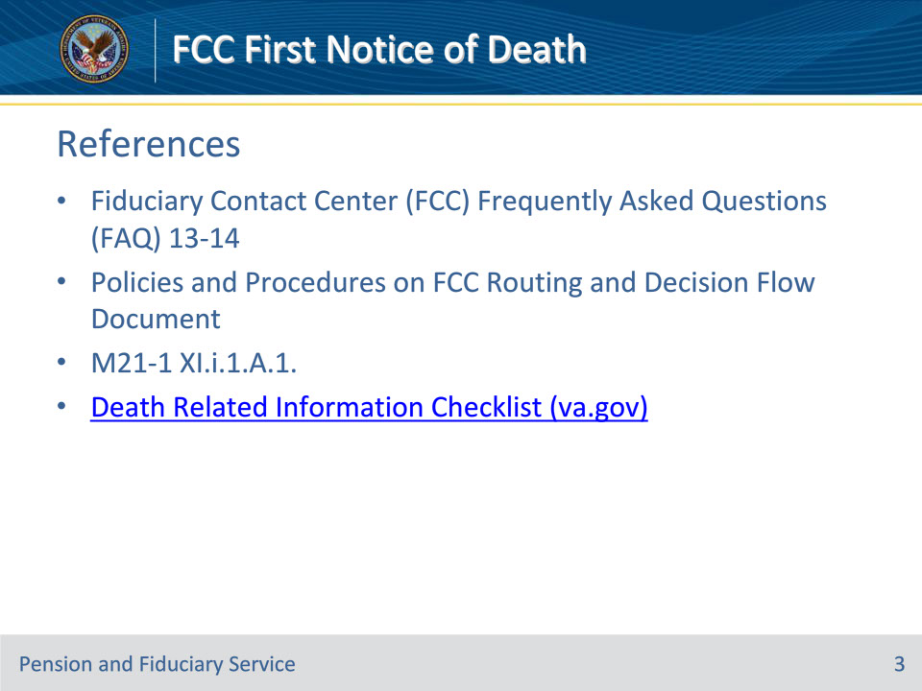

**Slide notes**

Instructor Notes:

These are the relevant references pertaining to this course:

• Fiduciary Contact Center (FCC) Frequently Asked Questions (FAQ) 13-14

• Policies and Procedures on FCC Routing and Decision Flow Document

• M21-1 XI.i.1.A.1. General Information About Veteran FNOD Processing

• Death Related Information Checklist (va.gov)

**Slide 4 - Suggested Responses**

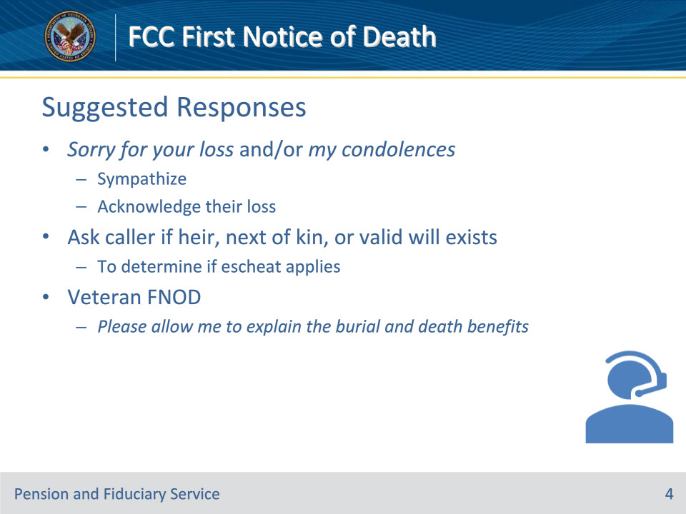

**Slide notes**

Policy Reference(s): Fiduciary Contact Center (FCC) Frequently Asked Questions (FAQ) 13-14; Policies and Procedures on FCC Routing and Decision Flow Document

Instructor NotesSuggested response:  Sorry for your loss/my condolences (state something similar to sympathize or acknowledge their loss).

FCC will ask caller if an heir, next of kin, or valid will exists to determine if escheat applies.

For Veteran FNODs: Please allow me to explain the burial and death benefits.

**Slide 5 - Fiduciary FNOD**

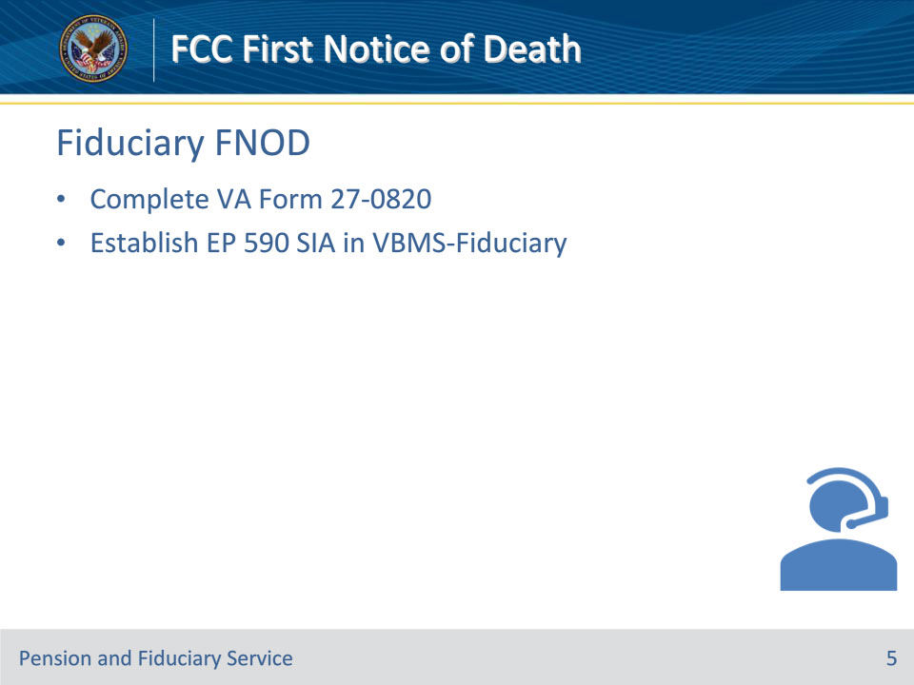

**Slide notes**

Policy Reference(s): Policies and Procedures on FCC Routing and Decision Flow Document

Instructor NotesFCC completes a VA Form 27-0820 and establishes EP 590 Successor Initial Appointment (SIA) in VBMS-Fid.

**Slide 6 - Non-Veteran FNOD**

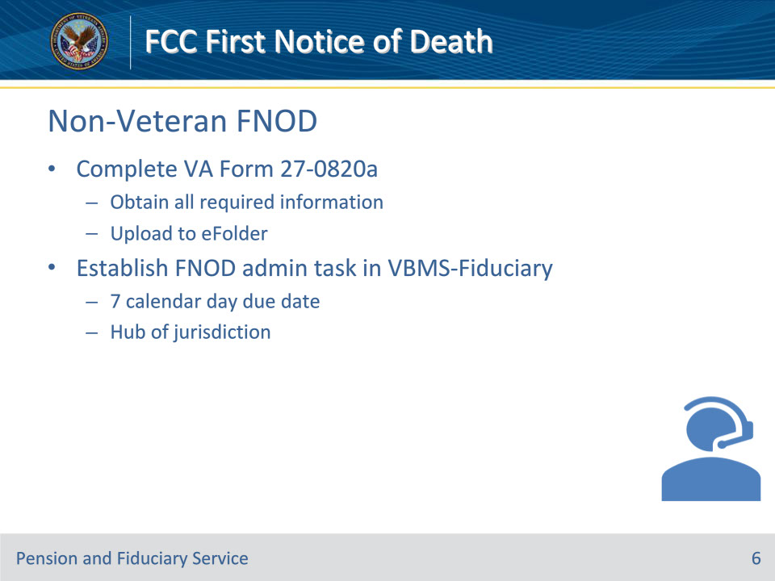

**Slide notes**

Policy Reference(s): Fiduciary Contact Center (FCC) Frequently Asked Questions (FAQ) 13; Policies and Procedures on FCC Routing and Decision Flow Document

Instructor NotesActions to take:

• Obtain all the information that is required to complete the VA Form 27-0820a and upload into the eFolder.

• Establish an FNOD administrative task.

• seven-calendar day due date for hub of jurisdiction.

**Slide 7 - Veteran FNOD**

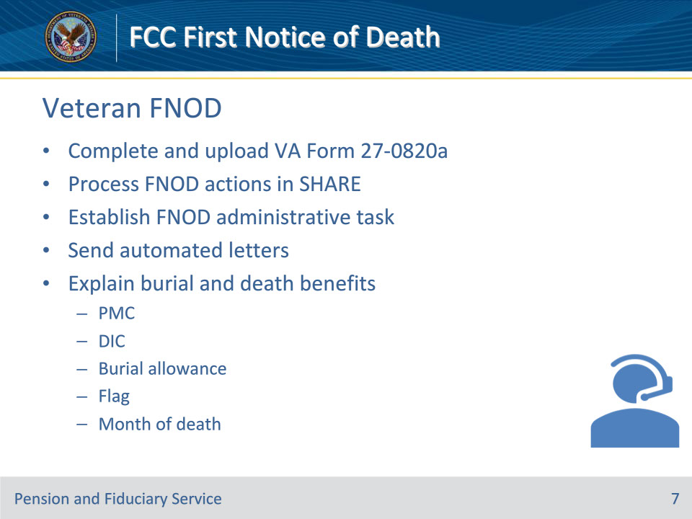

**Slide notes**

Policy Reference(s): Fiduciary Contact Center (FCC) Frequently Asked Questions (FAQ) 14; Policies and Procedures on FCC Routing and Decision Flow Document

Instructor NotesActions to take:

• Obtain all the information that is required to complete the VA Form 27-0820a and upload into the eFolder.

• Process First Notice of Death (FNOD) actions in SHARE.

• Establish an FNOD administrative task.

• with a due date of seven calendar days to hub of jurisdiction.

• Send automated letters.

• Explain burial and death benefits (PMC, DIC, burial allowance, flag, month of death).

**Slide 8 - Purpose**

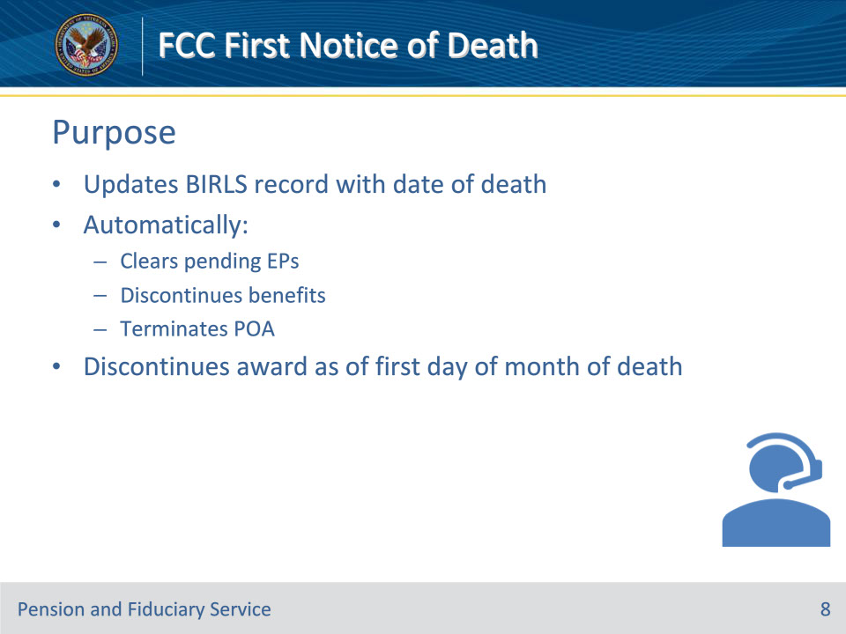

**Slide notes**

Policy Reference(s): M21-1 XI.i.1.A.1.a.

Instructor NotesFirst Notice of Death (FNOD) processing establishes or updates the Beneficiary Identification and Records Locator Subsystem record with the date of death.  It also automatically

• clears and takes end product (EP) credit on any pending issues for compensation and pension benefits that the Department of Veterans Affairs (VA) has not already authorized

• discontinues any benefits being paid, and

• terminates the power of attorney (POA) of record.

Note:  The FNOD process will discontinue an award as of the first day of the month of death (MOD).

**Slide 9 - Acceptable NODs**

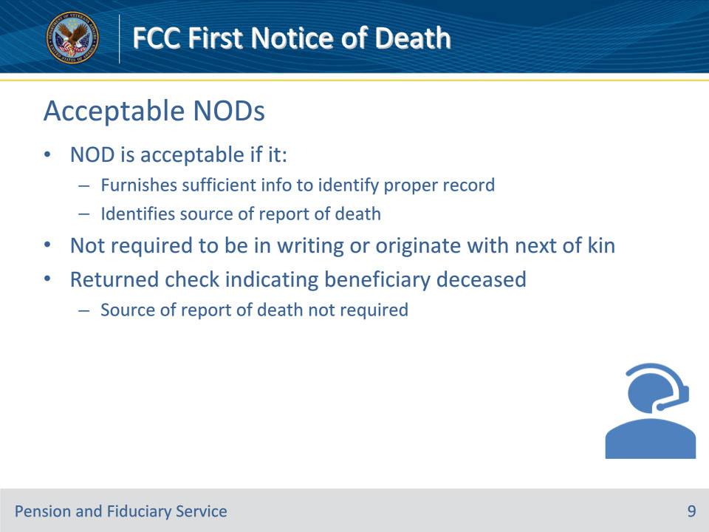

**Slide notes**

Policy Reference(s): M21-1 XI.i.1.A.1.b.

Instructor NotesA notice of death (NOD) is acceptable if it

• furnishes sufficient information about the beneficiary to allow a definite identification of the proper record, and

• identifies the source of the report of the death.

Exception:  If the NOD is a returned check indicating that the beneficiary is deceased, identification of the source of the report of death is not necessary.

There is no requirement that a NOD be in writing or originate with the next of kin.

**Slide 10 - Notice Requirements**

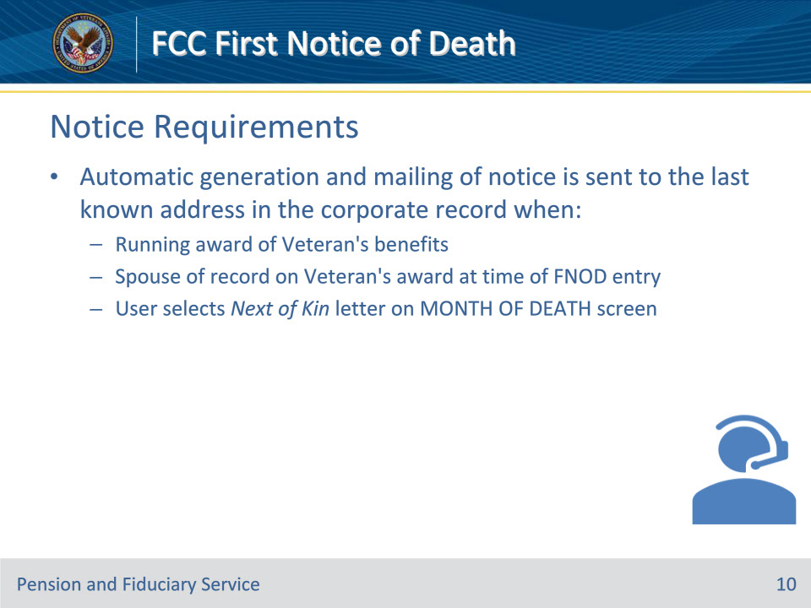

**Slide notes**

Policy Reference(s): M21-1 XI.i.1.A.1.d.

Instructor NotesContemporaneous notice of the action taken is required if the NOD was obtained by way of telephone or personal interview.

• An automatic generation and mailing of a contemporaneous notice is sent to the Veteran’s last known address (as it exists in the corporate record), when

• there was a running award of Veteran’s benefits

• a spouse is of record on the Veteran’s award at the time of the FNOD entry, and

• a user selects a Next of Kin letter on the MONTH OF DEATH screen.

**Slide 11 - Running Award**

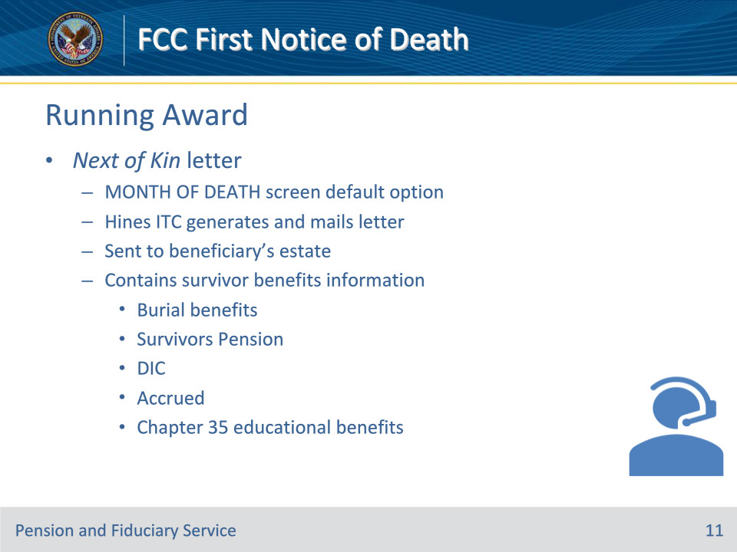

**Slide notes**

Policy Reference(s): M21-1 XI.i.1.A.1.e.

Instructor NotesWhen a VA employee processes the NOD and the Veteran has a running award, the employee is presented with the default option of sending a Next of Kin letter on the MONTH OF DEATH screen.  If the employee proceeds with this selection, the Hines Information Technology Center (ITC) generates and mails a letter to the Veteran’s estate containing information about survivor benefits to which the Veteran’s survivors and others may be entitled.  These benefits include

• burial benefits

• Survivors Pension

• Dependency and Indemnity Compensation (DIC)

• accrued, and

• educational benefits under 38 U.S.C. Chapter 35.

**Slide 12 - No Running Award**

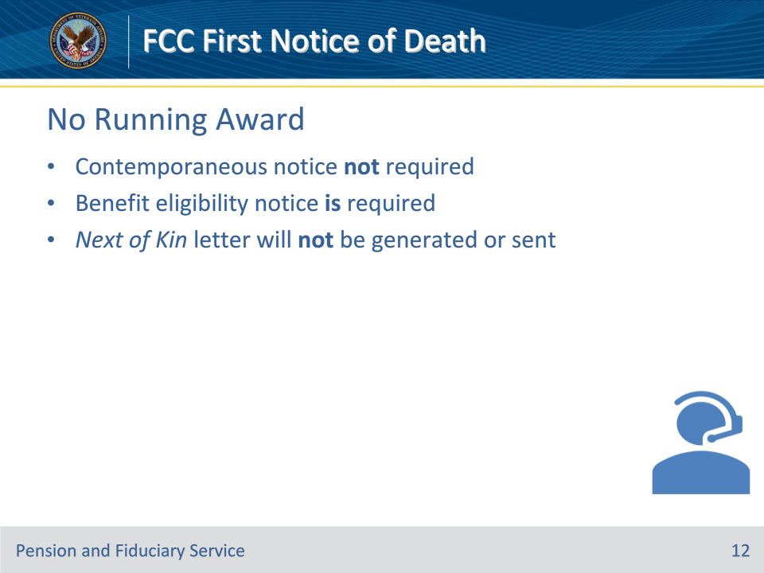

**Slide notes**

Policy Reference(s): M21-1 XI.i.1.A.1.f.

Instructor NotesWhen a VA employee processes a NOD and the Veteran has a suspended or terminated award or a pending claim where no award decision has been made, a contemporaneous notice is not required, per 38 CFR 3.103(b)(3)(iii).  However, VA is required to provide notice of benefit eligibility per 38 U.S.C. 6303.

Notes:

• When processing the NOD, the VA employee is presented with the option of sending a Next of Kin letter.  The Next of Kin letter will not be generated or sent if the letter option is selected but the Veteran did not have a running award.

**Slide 13 - Surviving Spouse Benefits**

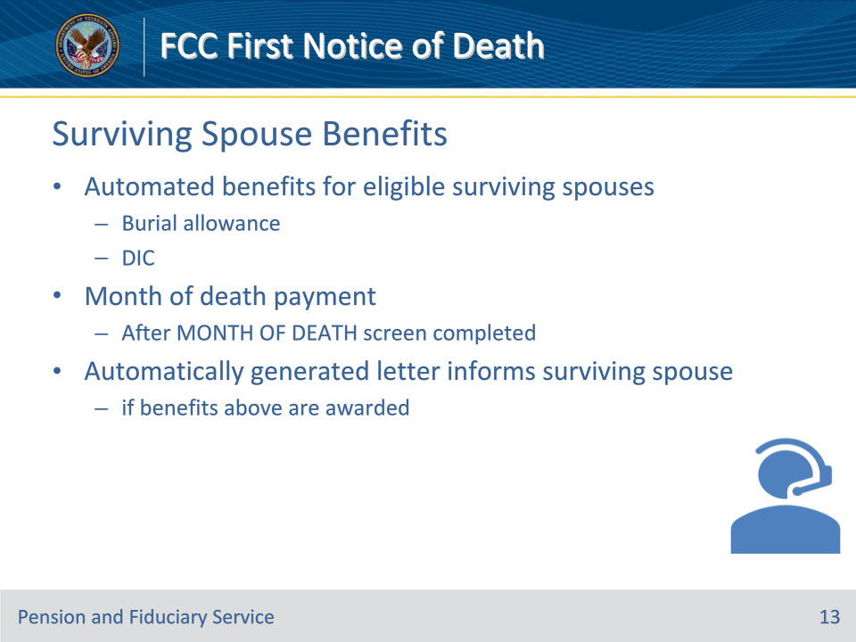

**Slide notes**

Policy Reference(s): M21-1 XI.i.1.A.1.h.

Instructor NotesAfter FNOD processing, the following automated benefits can be awarded to eligible surviving spouses based on information contained in the corporate record:

• burial allowance, and

• DIC.

The MOD payment is also awarded to eligible surviving spouses after a VA employee completes the MONTH OF DEATH screen that automatically appears after FNOD processing is completed.

Note:  An automatically generated letter informs the surviving spouse if the burial allowance, DIC, and/or MOD payment are awarded.

**Slide 14 - Month of Death Payment (MOD)**

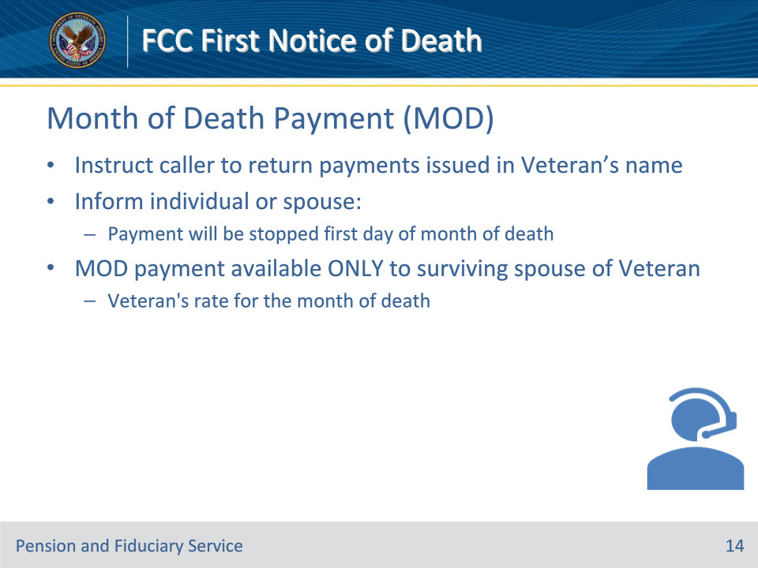

**Slide notes**

Policy Reference(s): Death Related Information Checklist

Instructor NotesFor all contacts, instruct clients to return any payments issued in the Veteran’s name.

When a notice of death is applicable for a Veteran, you will inform the individual or spouse that the Veteran’s disability payment will be stopped the first day of the month of death. The Veteran’s rate for the month of death, more commonly referred to as Month of Death or simply MOD, is an entitlement available ONLY to the surviving spouse of the Veteran.

**Slide 15 - Month of Death Payment (MOD)**

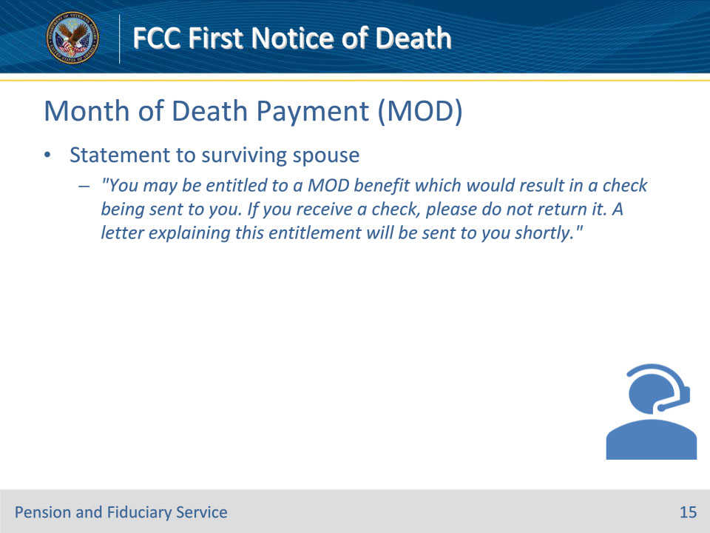

**Slide notes**

Policy Reference(s): Death Related Information Checklist

Instructor NotesStatement for the surviving spouse:

“You may be entitled to a MOD benefit which would result in a check being sent to you. If you receive a check, please do not return it. A letter explaining this entitlement will be sent to you shortly.”

**Slide 16 - Month of Death Payment (MOD)**

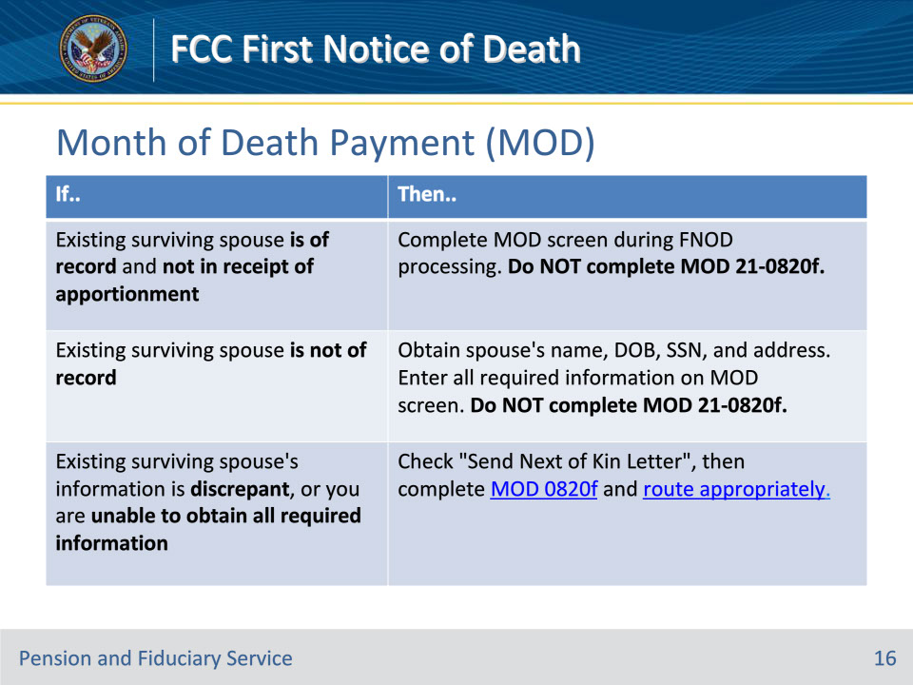

**Slide notes**

Policy Reference(s): Death Related Information Checklist

Instructor NotesThis table details the MOD process.

**Slide 17 - Month of Death Payment (MOD)**

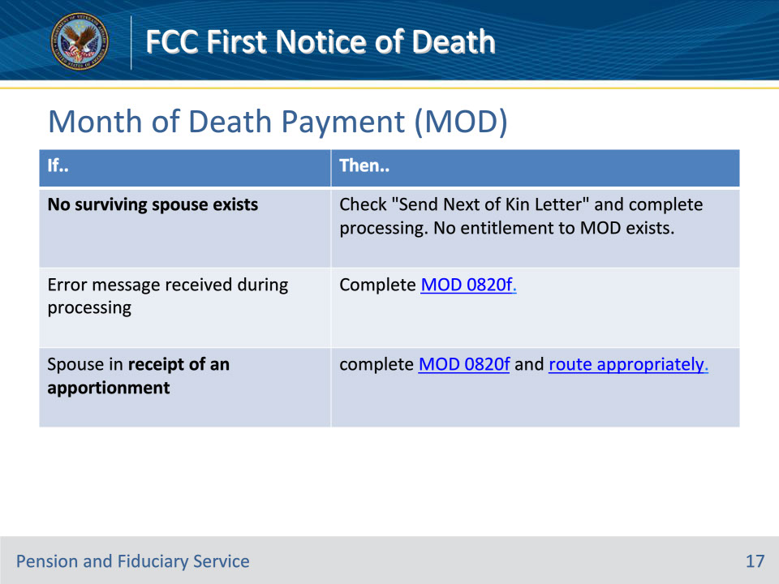

**Slide notes**

Policy Reference(s): Death Related Information Checklist

Instructor NotesThis table details the MOD process.

**Slide 18 - Presidential Memorial Certificate (PMC)**

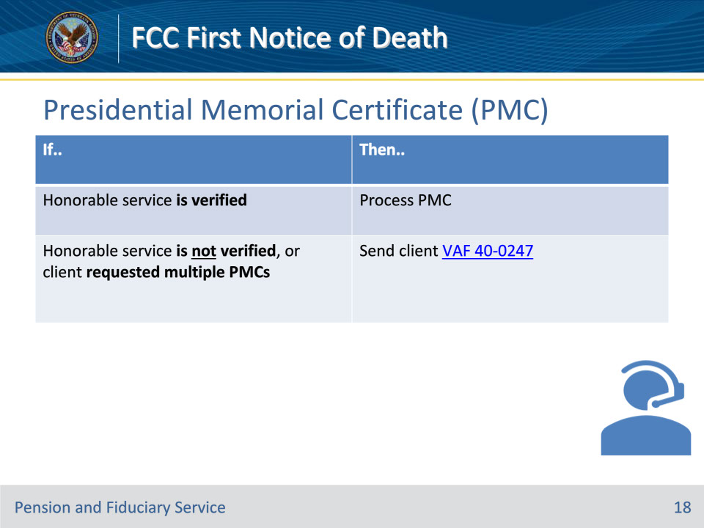

**Slide notes**

Policy Reference(s): Death Related Information Checklist

Instructor NotesThis table details the PMC process.

• National Cemetery Administration PMC Webpagehttps://www.cem.va.gov/facts/Presidential_Memorial_Certificates.asp

• PMC information on VA.govhttps://www.va.gov/burials-memorials/memorial-items/presidential-memorial-certificates/

**Slide 19 - Payment Status**

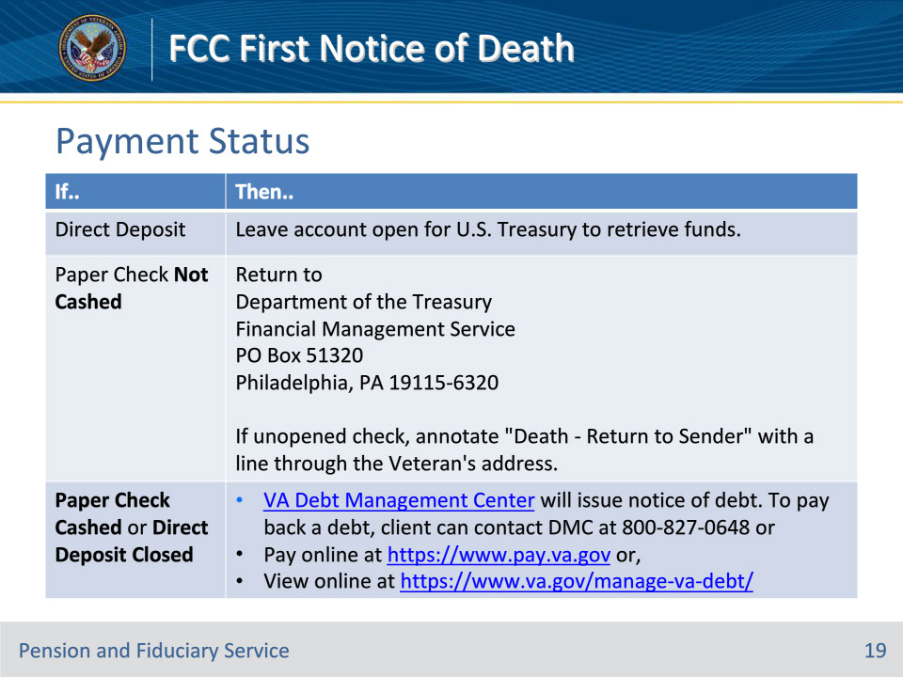

**Slide notes**

Policy Reference(s): Death Related Information Checklist

Instructor NotesAny payment issued after the Veteran’s death must be returned as dictated by the table on this slide.

**Slide 20 - Burial Information**

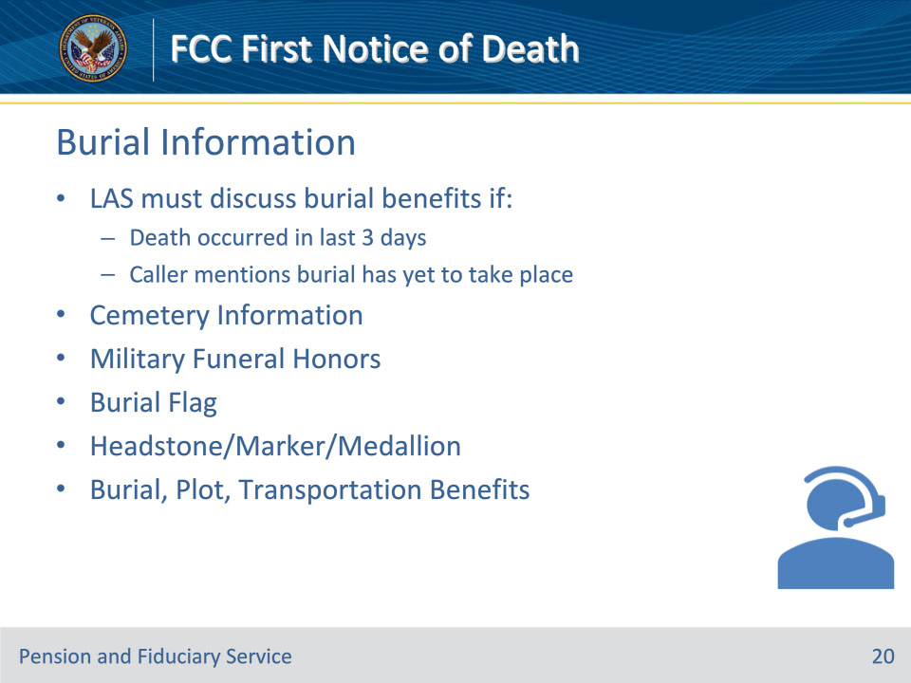

**Slide notes**

Policy Reference(s): Death Related Information Checklist

Instructor Notes

If the death occurred in the last 3 days or if the individual mentions the burial has yet to take place, LAS must discuss burial benefitsCemetery Information

• NCA Cemetery Informationhttps://www.cem.va.gov/cems/index.asp

• Burial in a Private Cemeteryhttps://www.cem.va.gov/burial_benefits/private_cemetery.asp

• State and Tribal Veterans Cemetery Listinghttps://www.cem.va.gov/cems/allstate.asp

Military Funeral Honors

• NCA Cemetery - Funeral Honors Informationhttps://www.cem.va.gov/military_funeral_honors.asp

• Military OneSource - Funeral Honorshttps://www.militaryonesource.mil/leaders-service-providers/casualty-assistance/military-funeral-honors/

• Military OneSource - What to expect during Military Funeral Honorshttps://www.militaryonesource.mil/military-life-cycle/veterans-military-funeral-honors/what-to-expect-during-military-funeral-honors/

Burial Flag

• Burial Flag information at VA.govhttps://www.va.gov/burials-memorials/memorial-items/burial-flags/

• NCA Burial Flag webpagehttps://www.cem.va.gov/burial_benefits/burial_flags.asp

• Burial Flag applicationhttps://vbaw.vba.va.gov/bl/20/cio/20s5/forms/VBA-27-2008-ARE.pdf

Headstone/Marker/Medallion

• Veterans headstones, markers, and medallions info at VA.govhttps://www.va.gov/burials-memorials/memorial-items/headstones-markers-medallions/

• NCA Headstones, Markers and Medallions webpagehttps://www.cem.va.gov/hmm/

• Claim for Standard Government Headstone or Marker applicationhttps://www.va.gov/vaforms/va/pdf/VA40-1330.pdf

Burial, Plot, and Transportation Benefits

• VA burial benefits and memorial items VA.govhttps://www.va.gov/burials-memorials/

• NCA Burial benefits webpagehttps://www.cem.va.gov/burial_benefits/index.asp

• Application for Burial Benefits (21P-530EZ)https://www.vba.va.gov/pubs/forms/VBA-21P-530EZ-ARE.pdf

• Send 21P-530EZ if apparent entitlement exists or when the client specifically asks

For possible entitlement to exist, the Veteran must have had “other than dishonorable” service and any of the following:

• was in receipt of pension or compensation at the time of death, or the death is determined service related

• was receiving military retired pay in lieu of compensation at the time of death

• had an original or reopened claim pending at the time of death and has been found entitled to compensation or pension from a date prior to the date of death

• died while hospitalized by VA

• died while receiving care under VA contract at a non-VA facility

• died while traveling, under proper authorization and at VA expense, to or from a specified place for the purpose of examination, treatment, or care, or

• died on or after October 9, 1996, while a patient at an approved State nursing home

**Slide 21 - VA Life Insurance**

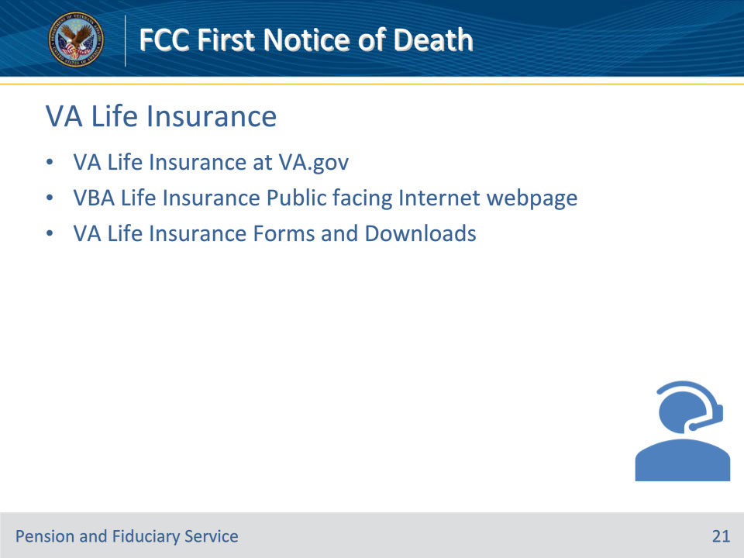

**Slide notes**

Policy Reference(s): Death Related Information Checklist

Instructor Notes

• VA Life Insurance at VA.govhttps://www.va.gov/life-insurance/

• VBA Life Insurance Public facing Internet webpagehttps://benefits.va.gov/insurance/index.asp

• VA Life Insurance Forms and Downloadshttps://www.benefits.va.gov/INSURANCE/resources-forms.asp

**Slide 22 - Survivors Benefits**

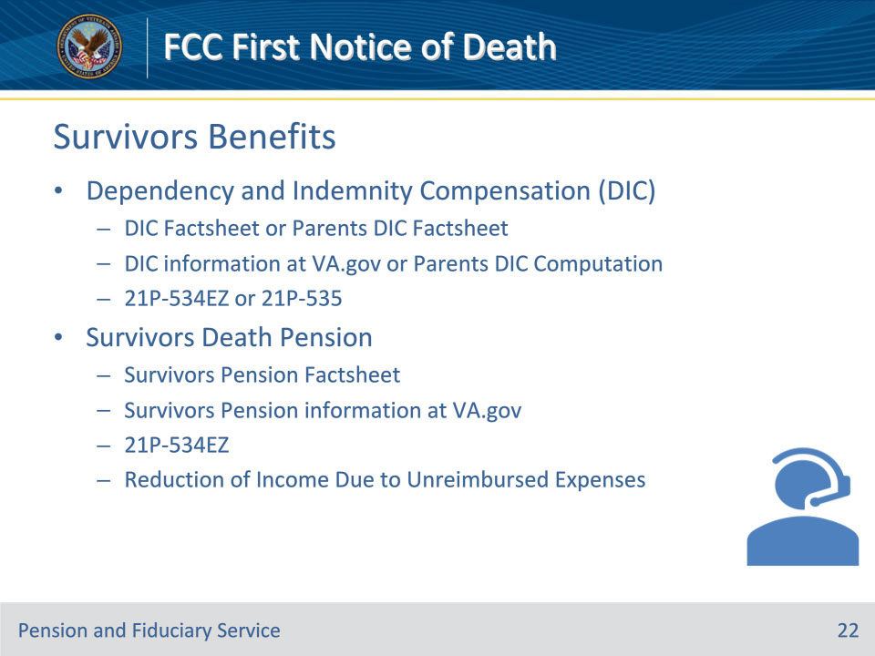

**Slide notes**

Policy Reference(s): Death Related Information Checklist

Instructor Notes

If Surviving Dependent(s), discuss each of the following:

Dependency and Indemnity Compensation (DIC)

• DIC Factsheethttps://www.benefits.va.gov/BENEFITS/factsheets/survivors/dic.pdf

• DIC information at va.govhttps://www.va.gov/disability/dependency-indemnity-compensation/

• Application for DIC, Survivors Pension, and/or Accrued Benefits (21P-534EZ)https://www.vba.va.gov/pubs/forms/VBA-21P-534EZ-ARE.pdf

• Parents DIC Factsheethttps://www.benefits.va.gov/BENEFITS/factsheets/survivors/parentsdic.pdf

• Parents DIC Application (21P-535)https://www.vba.va.gov/pubs/forms/VBA-21P-535-ARE.pdf

• Parents DIC Method of Payment Computationhttps://www.vba.va.gov/pubs/forms/VBA-21P-535-ARE.pdfhttps://www.ecfr.gov/current/title-38/chapter-I/part-3#3.25

Survivors Death Pension

• Survivors Pension Factsheethttps://www.benefits.va.gov/BENEFITS/factsheets/survivors/Survivorspension.pdf

• Survivors Pension information at va.govhttps://www.va.gov/pension/survivors-pension/

• Application for DIC, Survivors Pension, and/or Accrued Benefits (21P-534EZ)https://www.vba.va.gov/pubs/forms/VBA-21P-534EZ-ARE.pdf

• M21-1, Part IX, Subpart i, Chapter 3, Section D - Reduction of Income Due to Unreimbursed Expenseshttps://vaww.vrm.km.va.gov/system/templates/selfservice/va_kanew/help/agent/locale/en-US/portal/554400000001034/content/554400000178519/

**Slide 23 - Questions?**

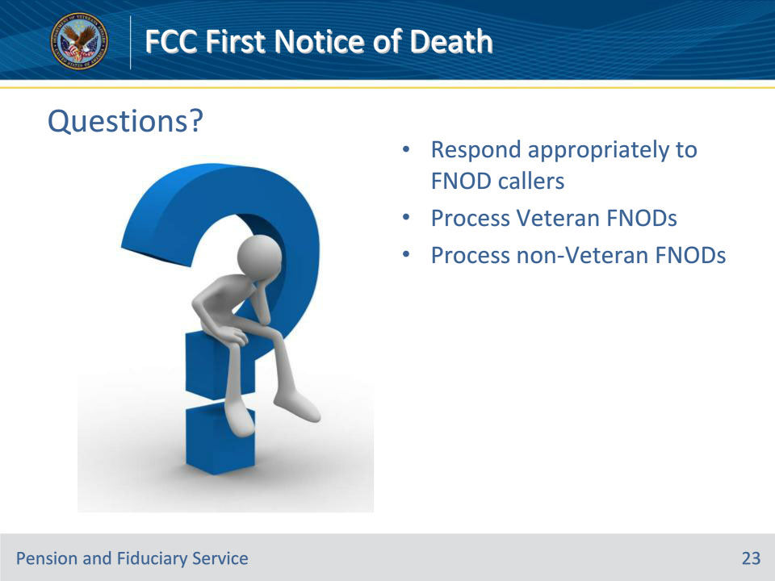

**Slide notes**

Instructor Notes:

(Recall) These are our learning objectives as stated from the beginning of the training:

• Respond appropriately to FNOD callers

• Process Veteran FNODs

• Process non-Veteran FNODs

Are there any additional questions?

Questions should be filtered through your QRT team. They will submit your questions to the Field Inquiry Tool (FIT) on your behalf.

**Slide 24 - TMS Survey/Assessment**

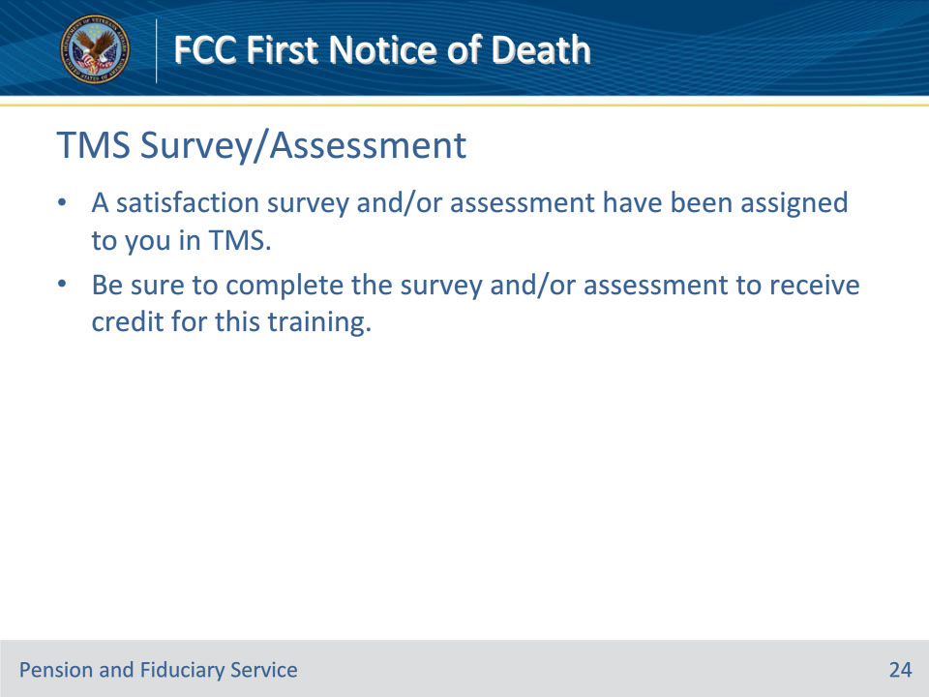

**Slide notes**

Instructor Notes

A satisfaction survey and/or assessment have been assigned to you in TMS.

Be sure to complete the survey and/or assessment to receive credit for this training.