**Slide 1 - FCC Routing & Referrals**

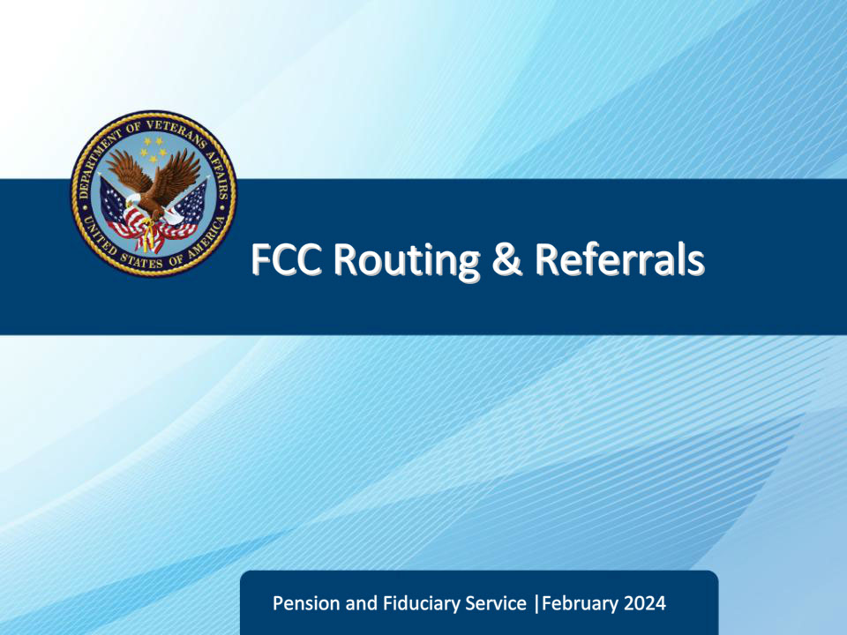

**Slide notes**

Course Description:

The purpose of this course is to teach LASs how to establish proper routing procedures to achieve one-call resolution.

**Slide 2 - Objectives**

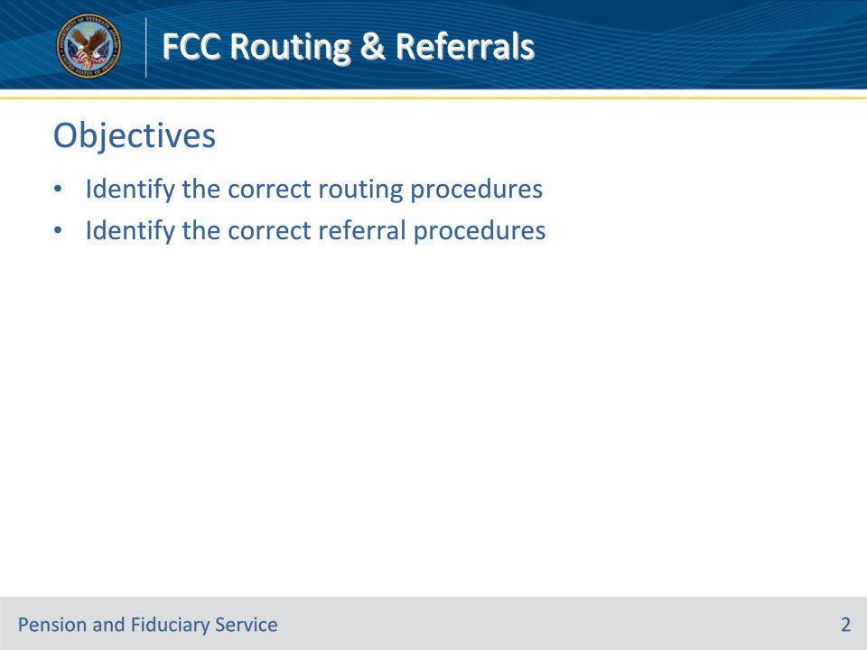

**Slide notes**

Instructor Notes:

At the end of this lesson, given the training and references, the learner will be able to do the following:

• Identify the correct routing procedures

• Identify the correct referral procedures

**Slide 3 - References**

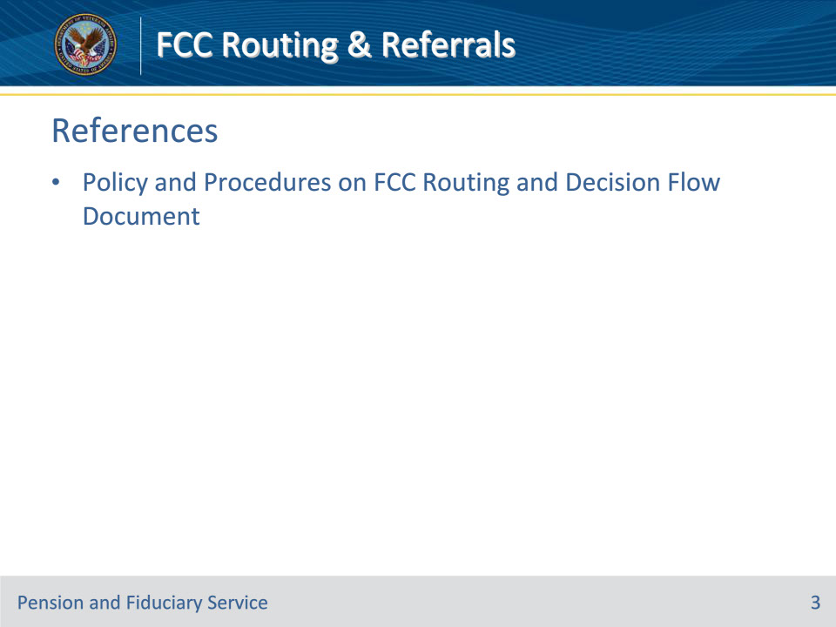

**Slide notes**

Instructor Notes:

These are the relevant references pertaining to this course:

• Policy and Procedures on FCC Routing and Decision Flow Document

**Slide 4 - Scenarios**

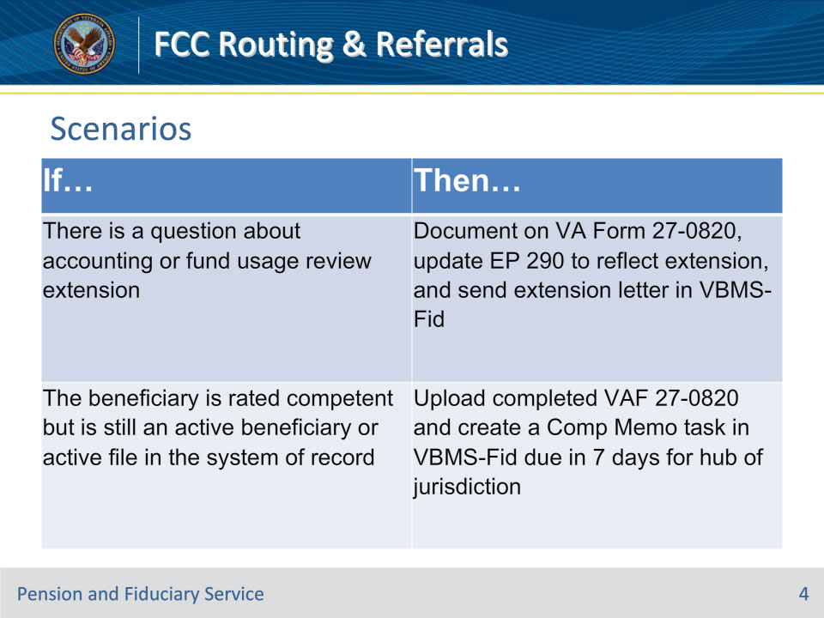

**Slide notes**

Policy Reference(s): Policy and Procedures on FCC Routing and Decision Flow Document

Instructor Notes

If there is a question about an accounting or fund usage review extension , then FCC documents on a VA Form 27-0820, Report of General Information, updates end product (EP) 290 to reflect extension, and sends extension letter in VBMS-Fid per Fiduciary Program Manual (FPM) Part I, 3.A.3.h-l, FPM, Part I, 1.B.3.w, FPM, Part I, 6.B.1.c, and if applicable, FPM, Part I, 3.A.1.k and FPM, Part I, 3.A.3.j-l.

If the beneficiary is rated competent but is still an active beneficiary or active file in system of record, then FCC uploads a completed VA Form 27-0820 and creates a Comp Memo task in VBMS-Fid due in seven days for hub of jurisdiction. See FPM, Part I, 2.E.3.h and FPM, Part I, 1.A.2.b.

(TASK =Title: Comp Memo; and FSR Action: Process full/Partial grant on Appeal).

**Slide 5 - Scenarios**

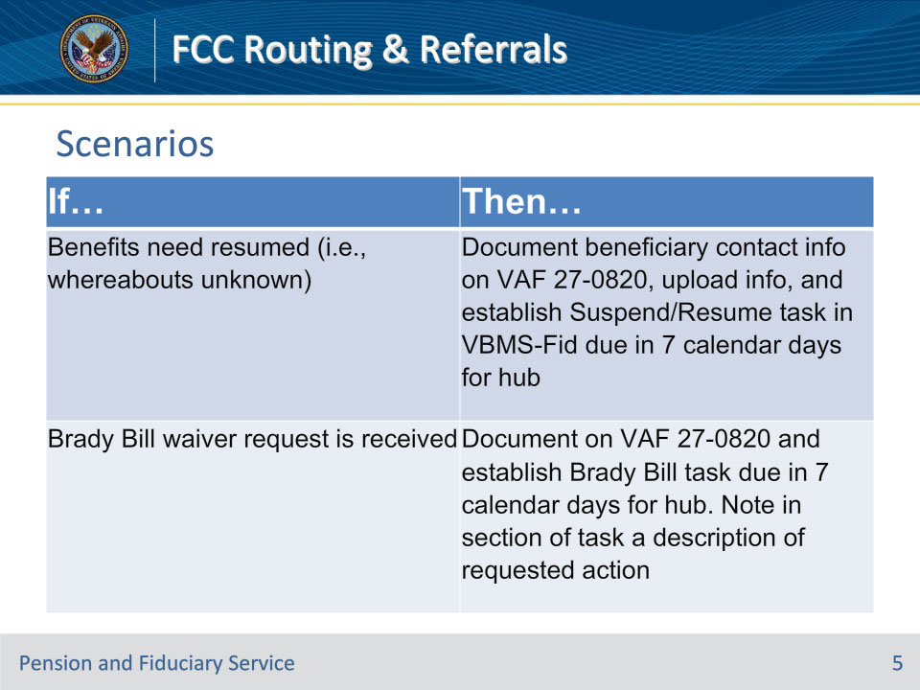

**Slide notes**

Policy Reference(s): Policy and Procedures on FCC Routing and Decision Flow Document

Instructor Notes

If benefits need to be resumed (i.e., whereabouts unknown), then FCC documents beneficiary’s contact information on VA Form 27-0820, uploads the information, and establishes a Suspend/Resume task in VBMS-Fid that is due in seven calendar days for hub of jurisdiction.

If a Brady Bill waiver request is received, then FCC documents on a VA Form 27-0820, uploads the information, and establishes a Brady Bill task in VBMS-Fid that is due in seven calendar days for hub of jurisdiction. FCC will note in section of the task a description of the requested action.

**Slide 6 - Scenarios**

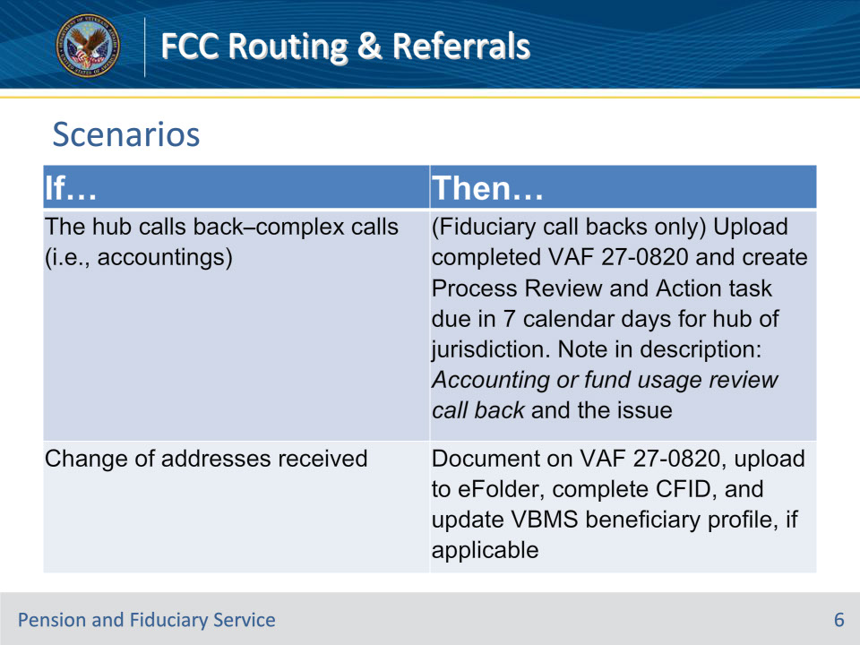

**Slide notes**

Policy Reference(s): Policy and Procedures on FCC Routing and Decision Flow Document

Instructor Notes

If the hub calls back–complex calls (i.e., accountings), then (Fiduciary call backs only) FCC uploads a completed VA Form 27-0820 and creates a Process Review and Action task in VBMS-Fid that is due in seven calendar days for hub of jurisdiction, noting in description: Accounting or fund usage review call back and the issue.

If a change of addresses is received, then FCC documents on VA Form 27-0820, uploads to the VBMS electronic claims folder (eFolder), completes a Change of Fiduciary, and updates the VBMS beneficiary profile, if applicable.

**Slide 7 - Knowledge Check #1**

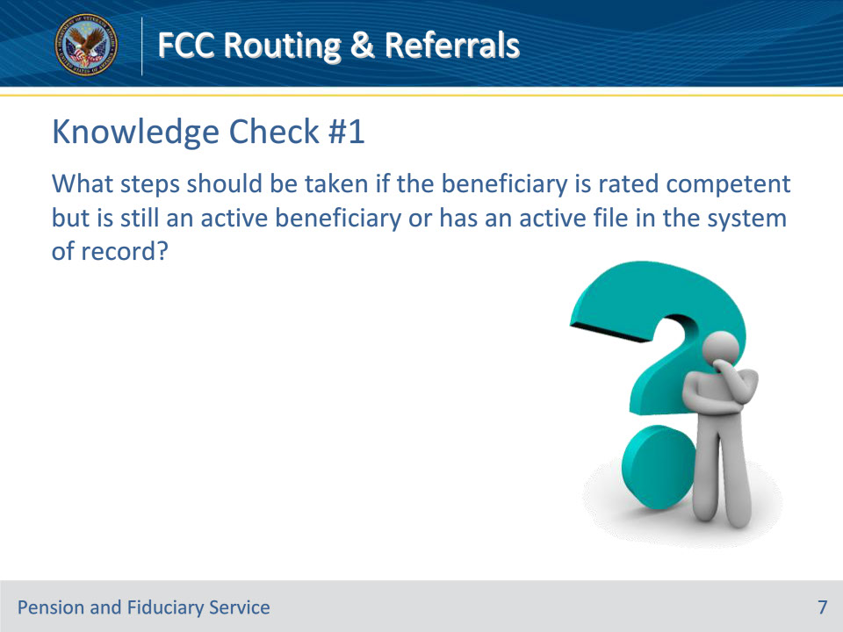

**Slide notes**

Policy Reference(s): Policy and Procedures on FCC Routing and Decision Flow Document

Instructor Notes

What steps should be taken if the Beneficiary is rated competent but is still an active Beneficiary or active file in system of record?

Answer: FCC uploads a completed VA Form 27-0820 and creates a Comp Memo task in VBMS-Fid due in seven days for hub of jurisdiction.

(TASK =Title: Comp Memo; and FSR Action: Process full/Partial grant on Appeal).

**Slide 8 - Scenarios**

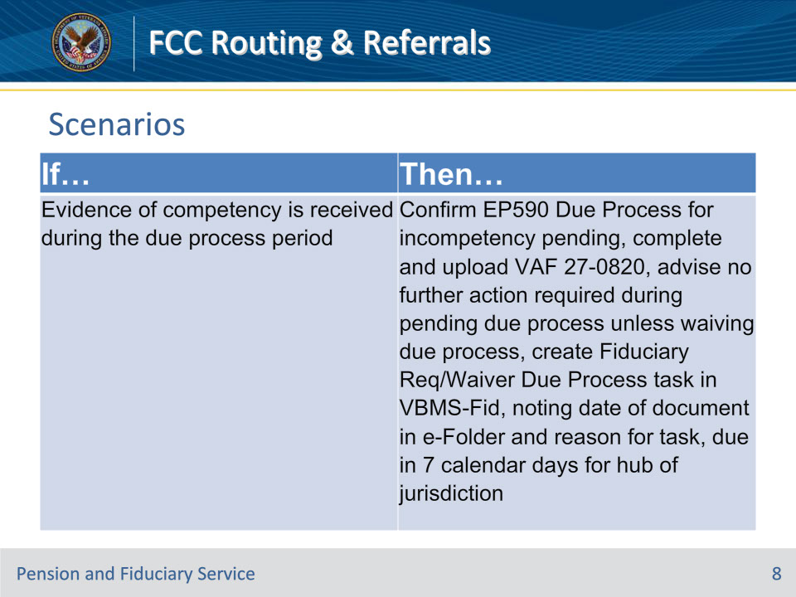

**Slide notes**

Policy Reference(s): Policy and Procedures on FCC Routing and Decision Flow Document

Instructor Notes

If evidence of competency is received during the due process period, then FCC will confirm there is an EP 590 Due Process for incompetency pending, completes and uploads the VA Form 27-0820, advise no further action is required during the pending due process while hub reviews incoming correspondences unless waiving of due process, create Fiduciary Req/Waiver Due Process task in VBMS-Fid noting date of document in eFolder and reason for task, due in seven calendar days for hub of jurisdiction.

**Slide 9 - Scenarios**

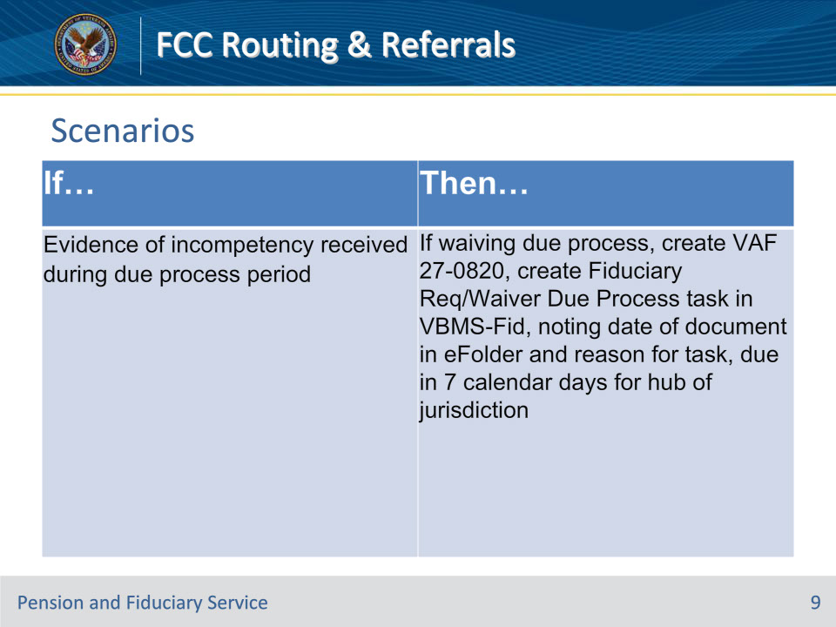

**Slide notes**

Policy Reference(s): Policy and Procedures on FCC Routing and Decision Flow Document

Instructor Notes

If evidence of incompetency is received during the due process period, then If waiving due process, FCC will create an VA Form 27-0820, create Fiduciary Req/Waiver Due Process task in VBMS-Fid noting date of document in eFolder and reason for task, due in seven calendar days for hub of jurisdiction. (See waiver of due process below in table). M21-1, Part X, Subpart ii, 6.D.3.i.

**Slide 10 - Scenarios**

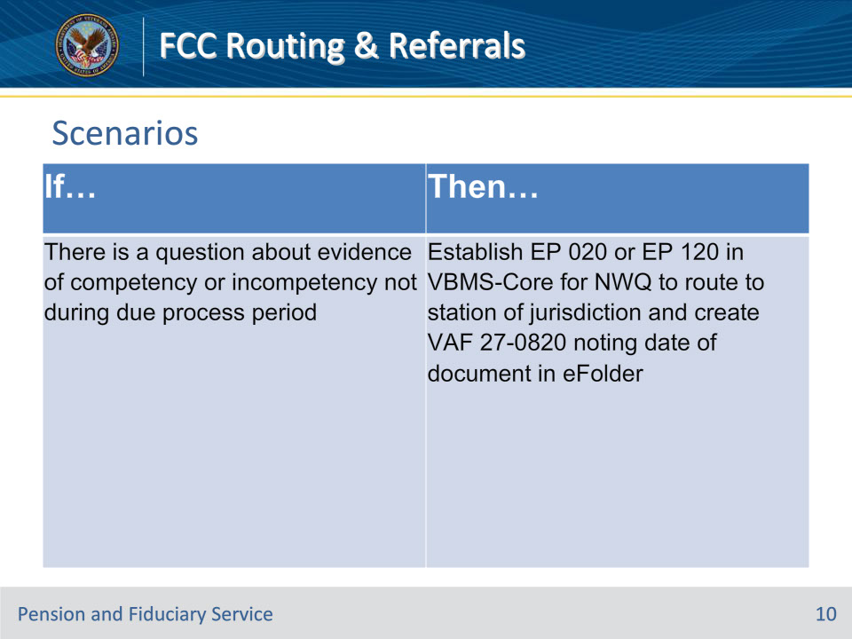

**Slide notes**

Policy Reference(s): Policy and Procedures on FCC Routing and Decision Flow Document

Instructor Notes

If there is a question about evidence of competency or incompetency not during due process period, then FCC establishes EP 020 or EP 120 in VBMS-Core for National Work Queue (NWQ) to route to station of jurisdiction and creates VA Form 27- 0820 noting date of document in eFolder. FPM, Part I, 5.A.3.a-c, M21-1, Part X, Subpart ii, 6.D.6.a.

**Slide 11 - Scenarios**

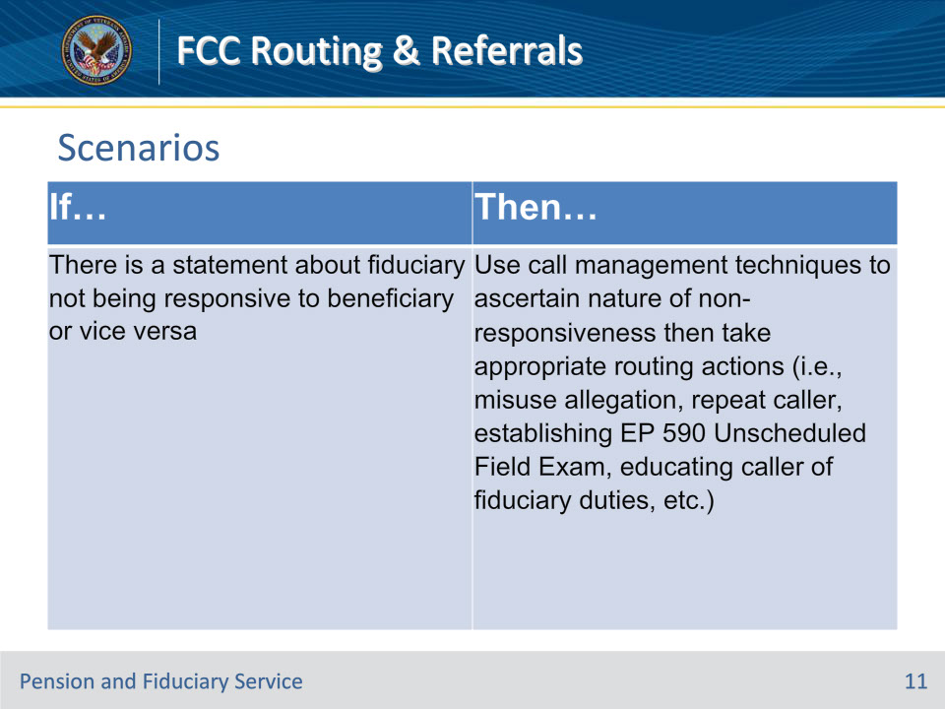

**Slide notes**

Policy Reference(s): Policy and Procedures on FCC Routing and Decision Flow Document

Instructor Notes

If there is a statement about fiduciary not being responsive to beneficiary or vice versa, then FCC uses call management techniques to ascertain the nature of the non-responsiveness then takes appropriate routing actions (i.e., misuse allegation, repeat caller, establishing EP 590 Unscheduled Field Exam in VBMS-Fid, educating the caller of fiduciary duties, etc.).

Note: If FCC calls fiduciary, Legal Administrative Specialist (LAS) must be cognizant to not circumvent the fiduciary appointment (i.e., order the release of VA funds to beneficiary, etc.).

**Slide 12 - Knowledge Check #2**

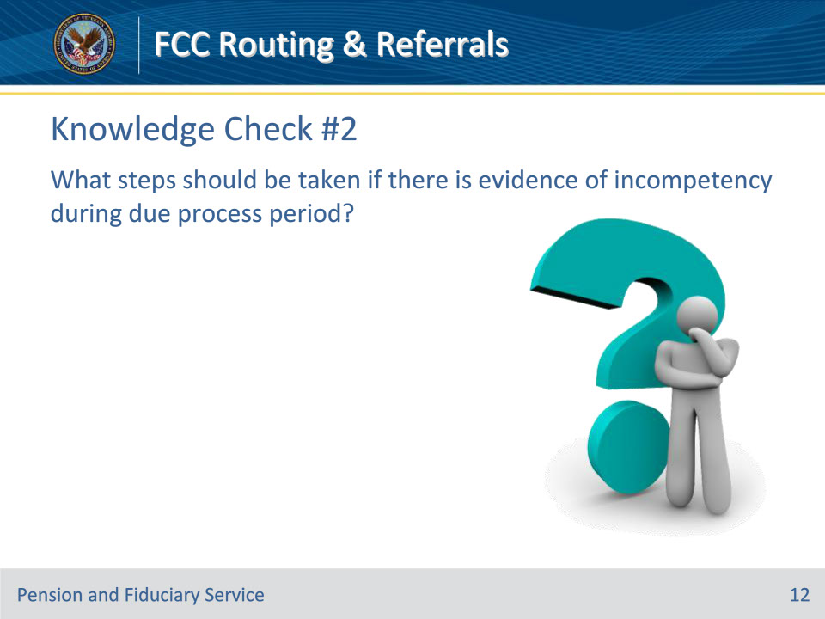

**Slide notes**

Policy Reference(s): Policy and Procedures on FCC Routing and Decision Flow Document

Instructor Notes

What steps should be taken if there is evidence of incompetency during Due Process period?

Answer: (Incompetency) If waiving due process, FCC will create an VA Form 27-0820, create Fiduciary Req/Waiver Due Process task in VBMS-Fid noting date of document in eFolder and reason for task, due in seven calendar days for hub of jurisdiction. (See waiver of due process below in table). M21-1, Part X, Subpart ii, 6.D.3.i.

**Slide 13 - Scenarios**

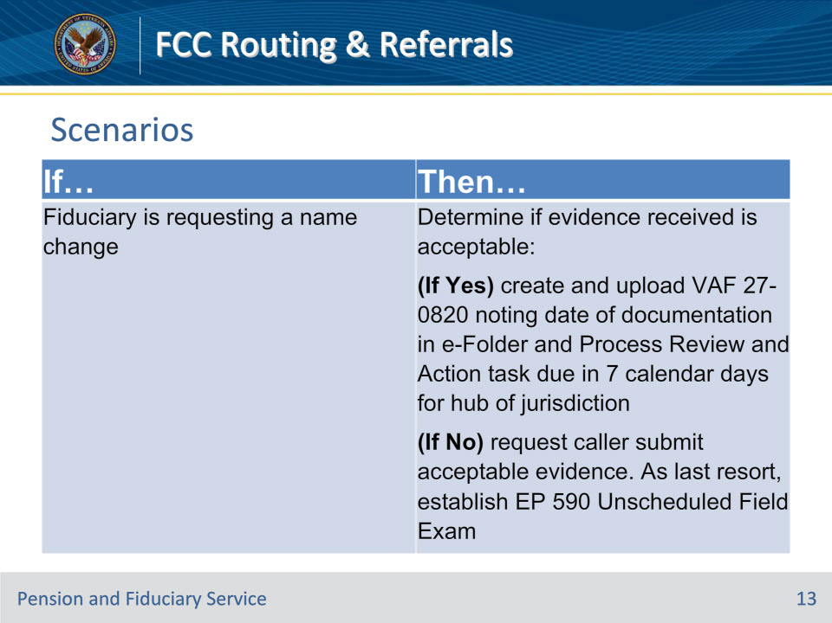

**Slide notes**

Policy Reference(s): Policy and Procedures on FCC Routing and Decision Flow Document

Instructor Notes

If fiduciary is requesting a name change, then FCC determines if evidence received is in line with FPM, Part II, 1.B.2.b, and M21-1 Part II, Subpart iii, 3.B.4.b for acceptable evidence:

(If Yes) If documents were received, FCC will create and upload a VA Form 27-0820 noting the date of documentation in eFolder and Process Review and Action task in VBMS-Fid, due in seven calendar days for hub of jurisdiction.

(If No) If documents were not received, request caller to submit acceptable evidence. As a last resort establish EP 590 Unscheduled Field Exam.

**Slide 14 - Scenarios**

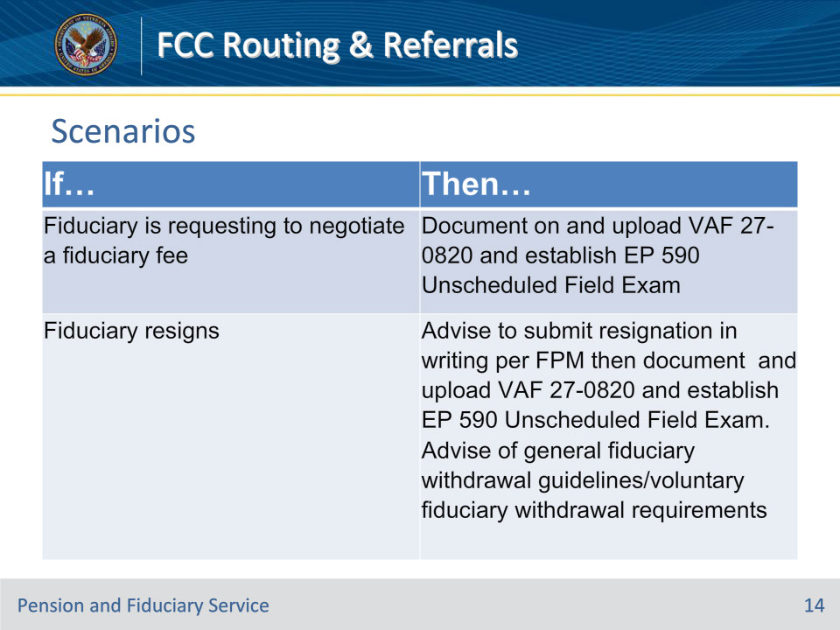

**Slide notes**

Policy Reference(s): Policy and Procedures on FCC Routing and Decision Flow Document

Instructor Notes

If fiduciary is requesting to negotiate a fiduciary fee, then FCC documents on and uploads a VA Form 27- 0820 and establishes EP 590 Unscheduled Field Exam in VBMS-Fid. See FPM, Part II, 1.C.4.

If fiduciary resigns, then FCC advises to submit resignation in writing per FPM then documents on and uploads a VA Form 27-0820 and establishes an EP 590 Unscheduled Field Exam in VBMS-Fid. Additionally, FCC will advise of FPM, Part II, 2.C.2.a, General Fiduciary Withdrawal Guidelines or FPM, Part II, 2.C.2.b, Voluntary Fiduciary Withdrawal Requirements. See FPM, Part I, 2.D.3.a.

**Slide 15 - Scenarios**

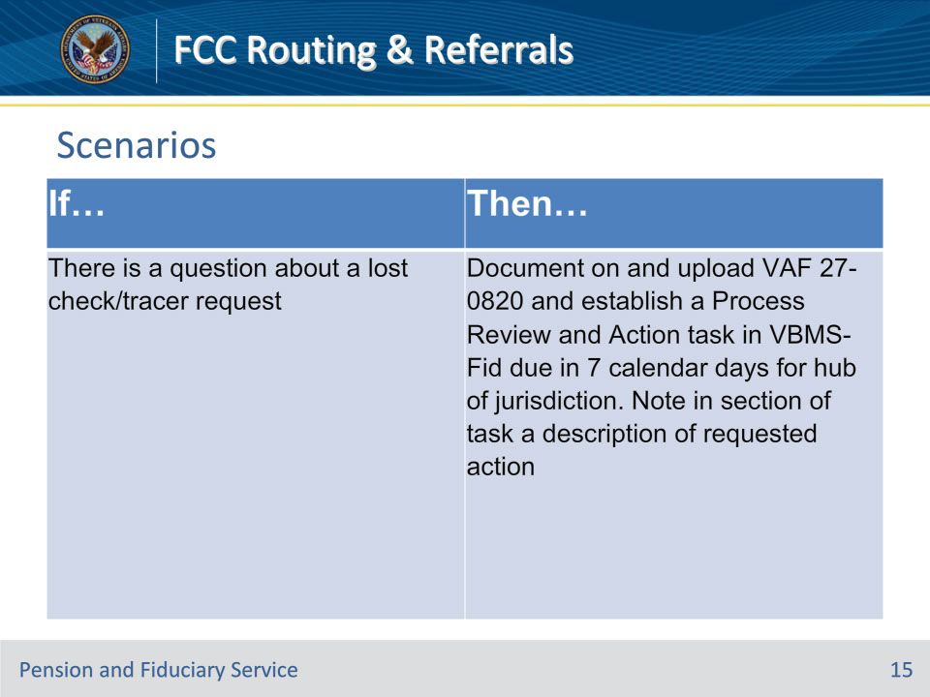

**Slide notes**

Policy Reference(s): Policy and Procedures on FCC Routing and Decision Flow Document

Instructor Notes

If there is a question about a lost check/tracer request, then FCC documents on and uploads a VA Form 27- 0820 and establishes a process review and action task in VBMS-Fid, due in seven calendar days for hub of jurisdiction. FCC will note in section of the task a description of the requested action.

**Slide 16 - Scenarios**

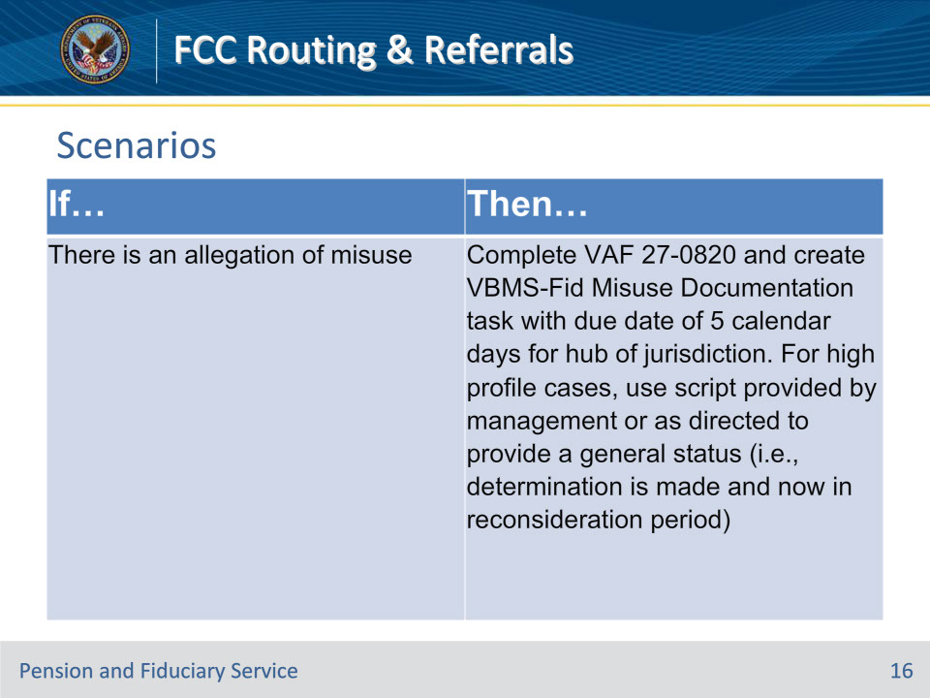

**Slide notes**

Policy Reference(s): Policy and Procedures on FCC Routing and Decision Flow Document

Instructor Notes

If there is an allegation of misuse, then FCC completes a VA Form 27-0820 and creates VBMS-Fid Misuse Documentation task with a due date of 5 calendar days for hub of jurisdiction.

For high profile cases, FCC will use a script provided by management or as directed to provide a general status (i.e., determination is made and now in reconsideration period).

**Slide 17 - Scenarios**

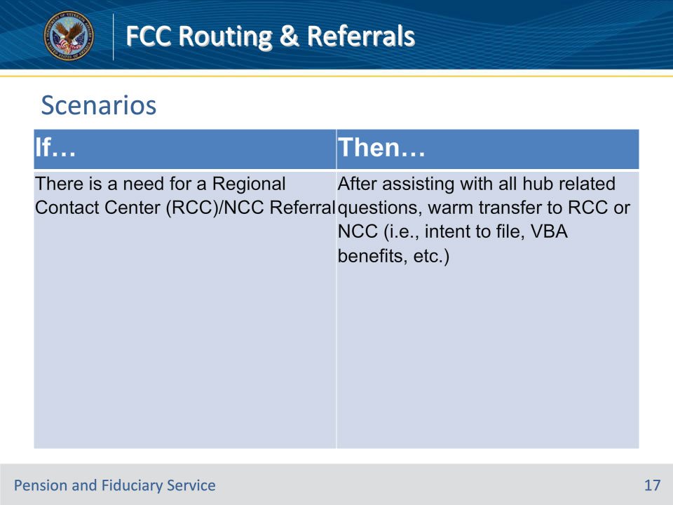

**Slide notes**

Policy Reference(s): Policy and Procedures on FCC Routing and Decision Flow Document

Instructor Notes

If there is a need for a Regional Contact Center (RCC)/NCC Referral, then after assisting with all hub related questions, warm transfer to RCC or NCC (i.e., intent to file, Veterans Benefits Administration (VBA) benefits, etc.).

**Slide 18 - Scenarios**

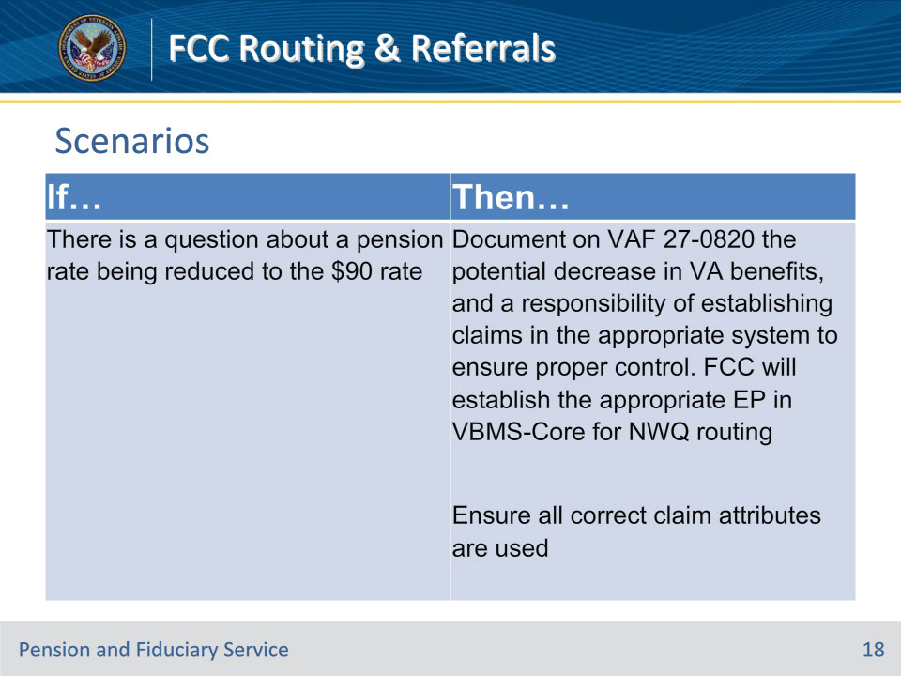

**Slide notes**

Policy Reference(s): Policy and Procedures on FCC Routing and Decision Flow Document

Instructor Notes

If there is a question about a pension rate being reduced to the $90 rate, then FCC documents on a VA Form 27-0820 the potential decrease in VA benefits, and a responsibility of establishing claims in the appropriate system to ensure proper control. FCC will establish the appropriate EP in VBMS-Core for NWQ routing in accordance with FPM, Part I, 2.E.3.d.

• EP 130, Dependency

• EP 150, PMC-Income Adjustment

• EP 150, PMC-Net Worth, or

• EP 290, Incarceration Adjustment, and

• ensure the EP date of claim is the date of the VA Form 27-0820.

Important: When establishing EPs based on a change to benefit entitlement, personnel must ensure all correct claim attributes are used (e.g., claim label, corporate flash, or special issue) to ensure NWQ routes the EP to the correct VSC or PMC, as appropriate.

**Slide 19 - Scenarios**

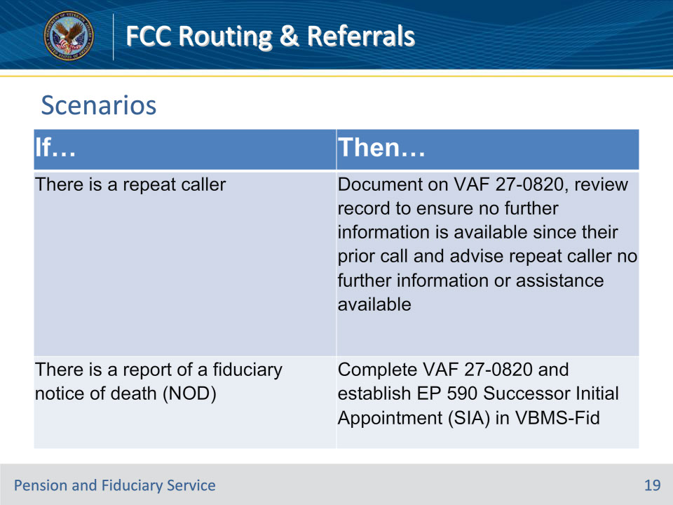

**Slide notes**

Policy Reference(s): Policy and Procedures on FCC Routing and Decision Flow Document

Instructor Notes

If there is a repeat caller, then FCC documents on a VA Form 27-0820, reviews record to ensure no further information is available since their prior call and advises repeat caller no further information or assistance is available.

If there is a report of a fiduciary notice of death (NOD), then FCC completes a VA Form 27-0820 and establishes EP 590 Successor Initial Appointment (SIA) in VBMS-Fid.

**Slide 20 - Scenarios**

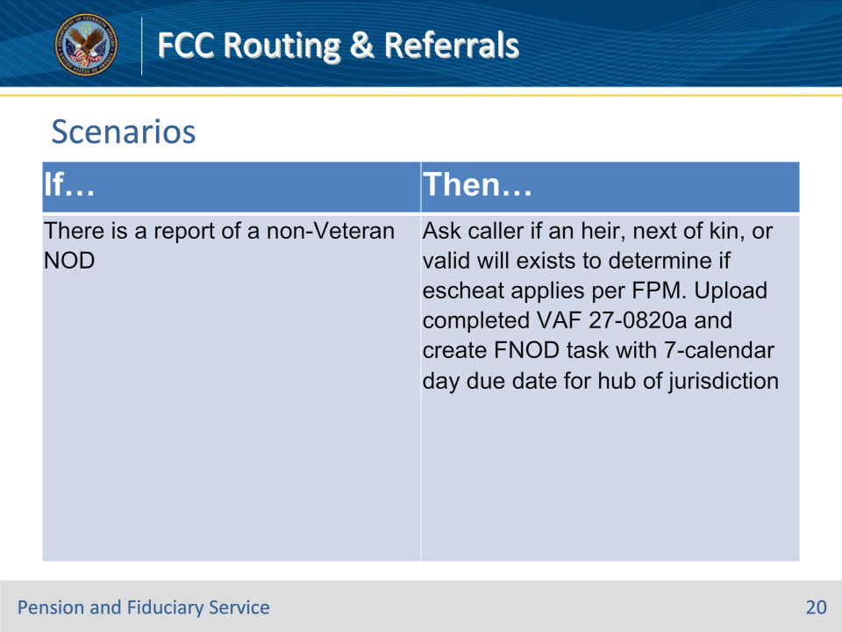

**Slide notes**

Policy Reference(s): Policy and Procedures on FCC Routing and Decision Flow Document

Instructor Notes

If there is a report of a non-Veteran NOD, then FCC will ask caller if an heir, next of kin, or valid will exists to determine if escheat applies per FPM Part II, 1.C.3.d. Upload completed a VA Form 27-0820a and creates FNOD task in VBMS-Fid with a seven-calendar due date for hub of jurisdiction.

**Slide 21 - Scenarios**

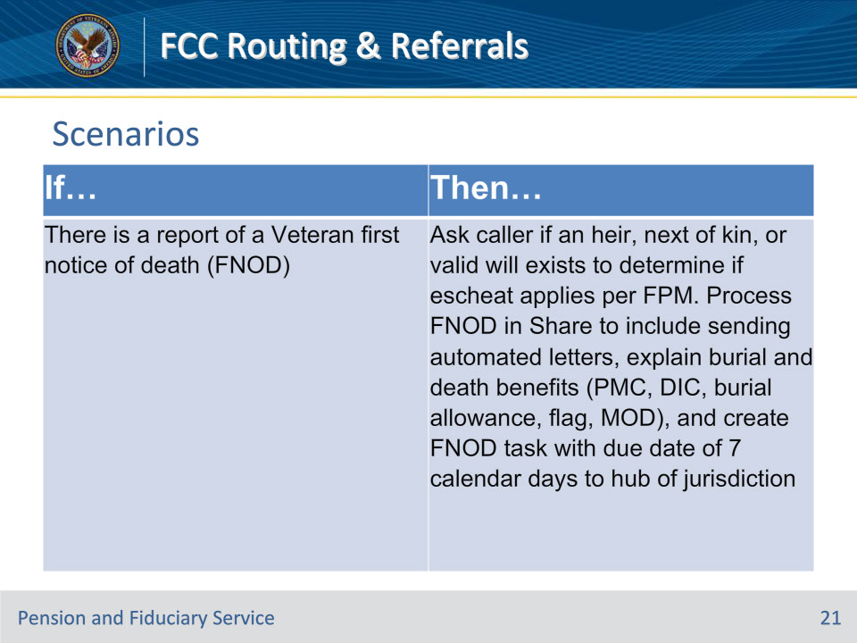

**Slide notes**

Policy Reference(s): Policy and Procedures on FCC Routing and Decision Flow Document

Instructor Notes

If there is a report of a Veteran first notice of death (FNOD), then FCC will ask caller if an heir, next of kin, or valid will exists to determine if escheat applies per FPM Part II, 1.C.3.d. FCC will process FNOD in Share actions to include sending automated letters, explain burial and death benefits (PMC, Dependency and Indemnity Compensation, burial allowance, flag, month of death), and create an FNOD task with a due date of seven calendar days to hub of jurisdiction.

**Slide 22 - Knowledge Check #3**

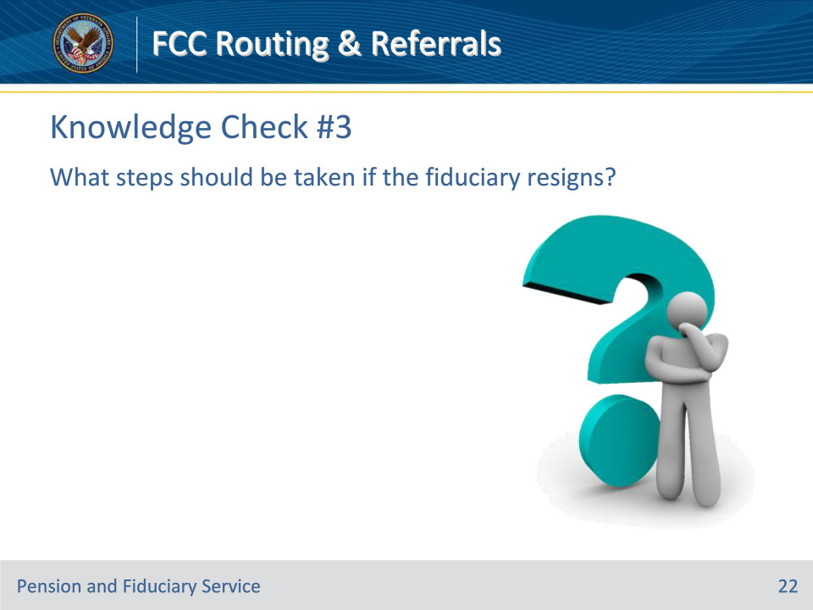

**Slide notes**

Policy Reference(s): Policy and Procedures on FCC Routing and Decision Flow Document

Instructor Notes

What steps should be taken if the Fiduciary resigns?

Answer: FCC advises to submit resignation in writing per FPM then documents on and uploads a VA Form 27-0820 and establishes an EP 590 Unscheduled Field Exam in VBMS-Fid.

**Slide 23 - Scenarios**

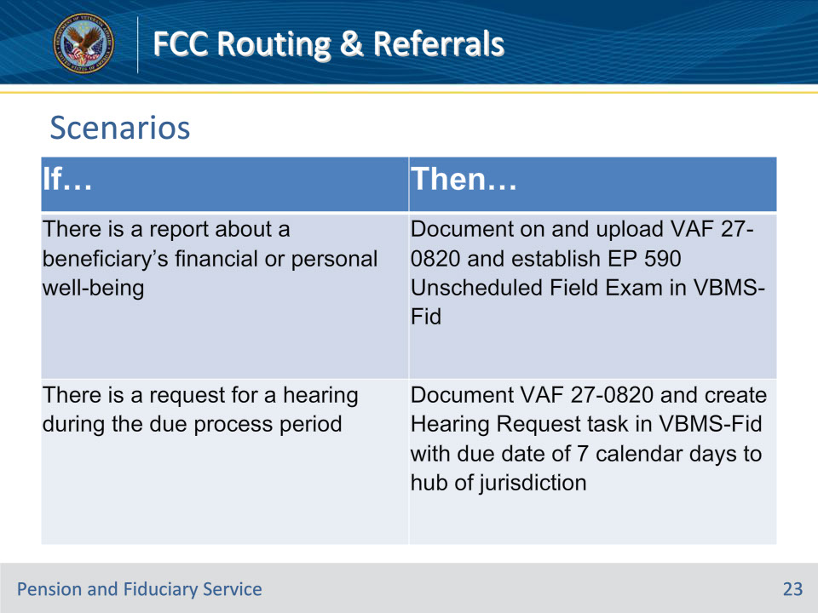

**Slide notes**

Policy Reference(s): Policy and Procedures on FCC Routing and Decision Flow Document

Instructor Notes

If there is a report about a beneficiary’s financial or personal well-being, then FCC documents on and uploads a VA Form 27- 0820 and establishes EP 590 Unscheduled Field Exam in VBMS-Fid.

If there is a request for a hearing during the due process period, then FCC documents a VA Form 27-0820 and creates Hearing Request task in VBMS-Fid with a due date of seven calendar days to hub of jurisdiction.

**Slide 24 - Scenarios**

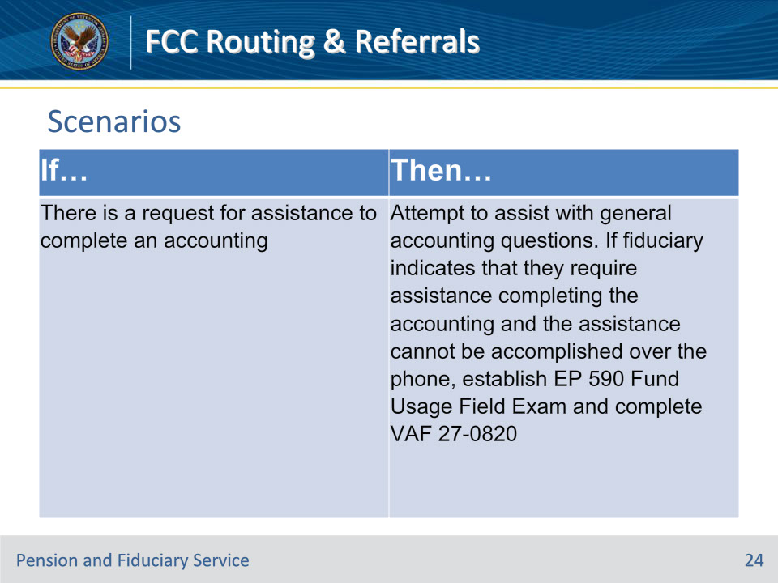

**Slide notes**

Policy Reference(s): Policy and Procedures on FCC Routing and Decision Flow Document

Instructor Notes

If there is a request for assistance to complete an accounting, then FCC attempts to assist with general accounting questions. If fiduciary indicates that they require assistance completing the accounting and the assistance cannot be accomplished over the phone, FCC will establish EP 590 Fund Usage Field Exam per FPM, Part I, 3.E.1.c and complete a VA Form 27-0820.

**Slide 25 - Scenarios**

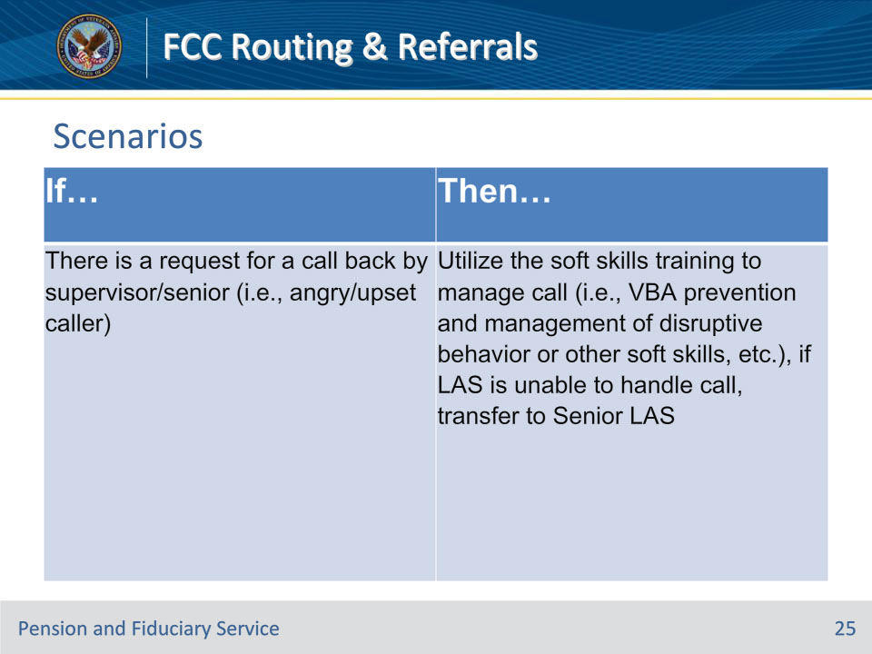

**Slide notes**

Policy Reference(s): Policy and Procedures on FCC Routing and Decision Flow Document

Instructor Notes

If there is a request for a call back by supervisor/senior (i.e., angry/upset caller), then FCC will utilize the soft skills training to manage call (i.e., VBA prevention and management of disruptive behavior or other soft skills, etc.), if LAS is unable to handle call, transfer to Senior LAS.

**Slide 26 - Scenarios**

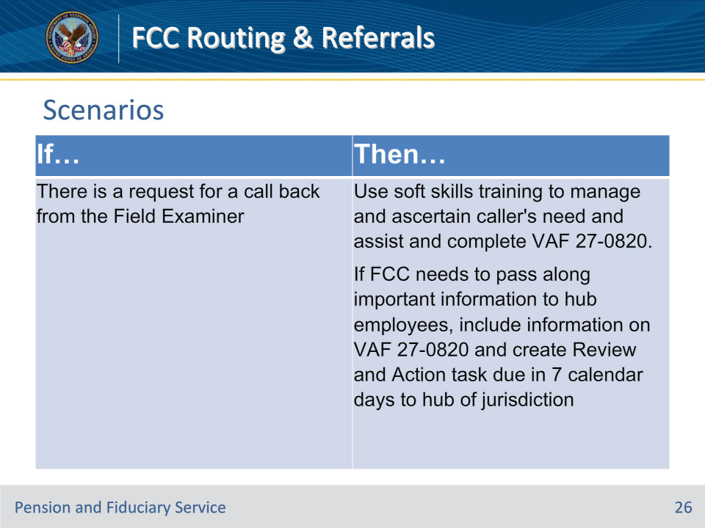

**Slide notes**

Policy Reference(s): Policy and Procedures on FCC Routing and Decision Flow Document

Instructor Notes

If there is a request for a call back from the Field Examiner, then FCC will use the soft skills training to manage and ascertain caller’s need and to assist (i.e., give status of field exam, information regarding benefits, misuse allegation intake etc.) and compete a VA Form 27-0820.

If FCC needs to pass along important information to hub employees, the FCC (LAS) will include the information on the VA Form 27-0820 and create a review and action task, due in seven calendar days to hub of jurisdiction.

**Slide 27 - Scenarios**

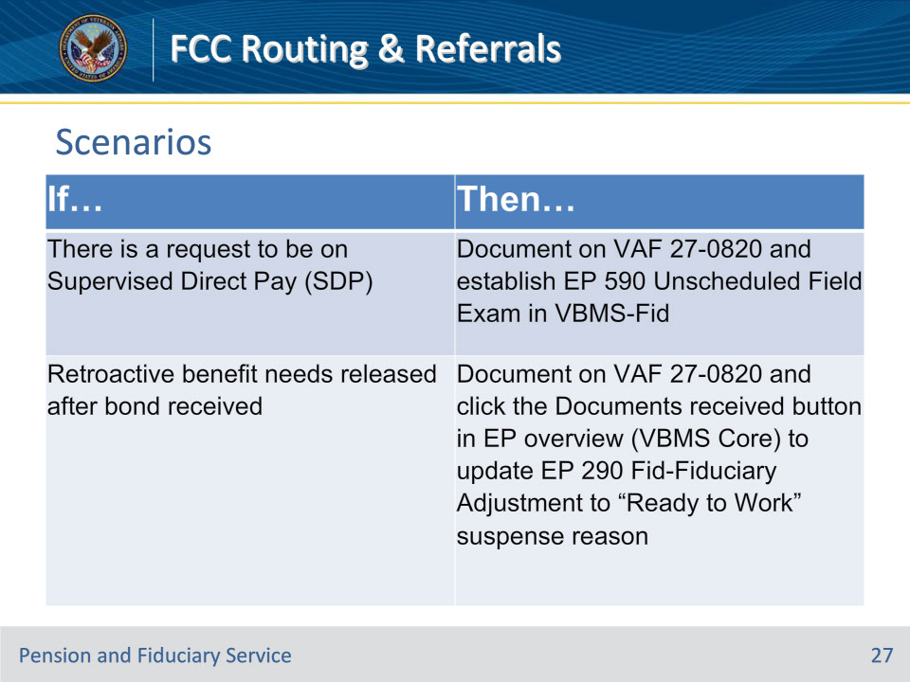

**Slide notes**

Policy Reference(s): Policy and Procedures on FCC Routing and Decision Flow Document

Instructor Notes

If there is a request to be on supervised direct pay (SDP), then FCC documents on a VA Form 27-0820 and establishes EP 590 Unscheduled Field Exam in VBMS-Fid.

If retroactive benefit needs released after bond received, then FCC documents on a VA Form 27-0820, and clicks the Documents received button in the EP overview (VBMS-Core) to update the EP 290 Fid- Fiduciary Adjustment to “Ready to Work” suspense reason.

**Slide 28 - Scenarios**

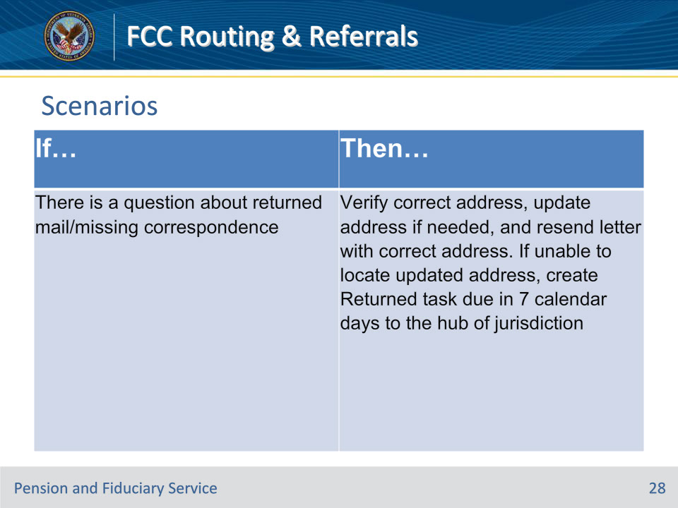

**Slide notes**

Policy Reference(s): Policy and Procedures on FCC Routing and Decision Flow Document

Instructor Notes

If there is a question about returned mail/missing correspondence, then FCC verifies correct address, updates address if needed, and resends letter with correct address. If unable to locate an updated address, create a Returned task, due in seven calendar days to hub of jurisdiction.

**Slide 29 - Knowledge Check #4**

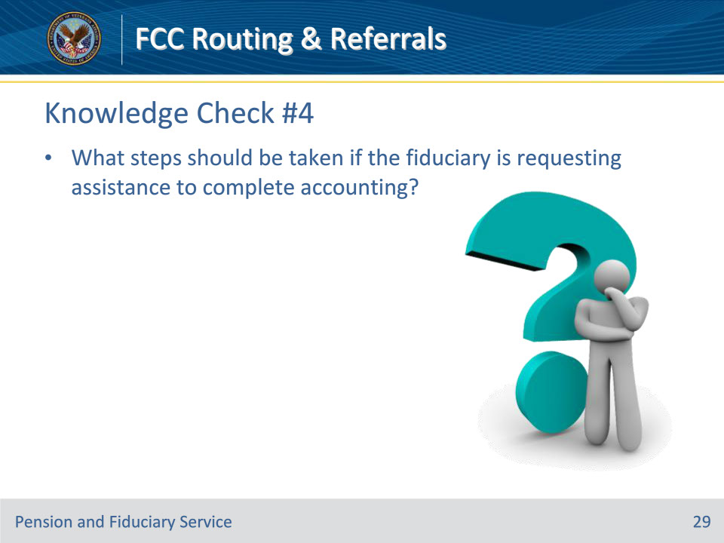

**Slide notes**

Policy Reference(s): Policy and Procedures on FCC Routing and Decision Flow Document

Instructor Notes

What steps should be taken if the Fiduciary is requesting assistance to complete accounting?

Answer: The FCC attempts to assist with general accounting questions. If fiduciary indicates that they require assistance completing the accounting and the assistance cannot be accomplished over the phone, FCC will establish EP 590 Fund Usage Field Exam per FPM, Part I, 3.E.1.c and complete a VA Form 27-0820.

**Slide 30 - Scenarios**

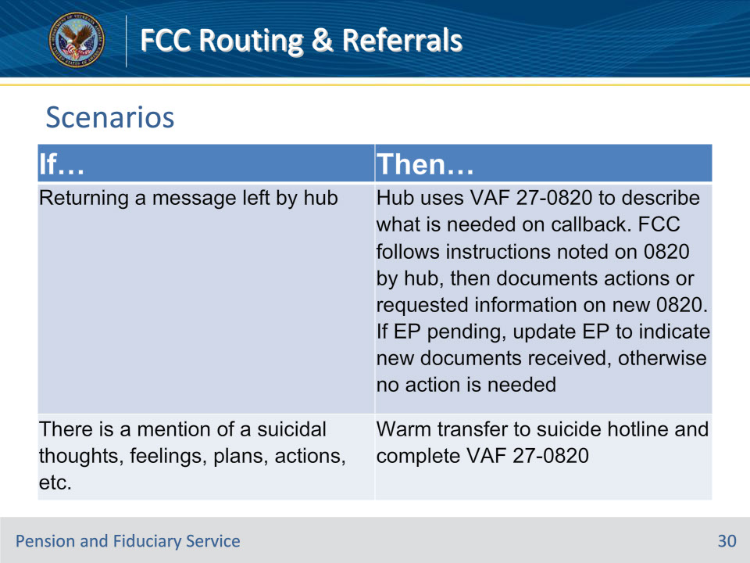

**Slide notes**

Policy Reference(s): Policy and Procedures on FCC Routing and Decision Flow Document

Instructor Notes

If returning a message left by hub, then Hub uses a VA Form 27-0820 to describe what is needed on callback. FCC follows instructions noted on the VA Form 27-0820 by the hub then documents actions or requested information on a new VA Form 27-0820. If an EP is pending, update EP to indicate new documents received, otherwise no action is needed.

If there is a mention of suicidal thoughts, feelings, plans, actions, etc., then Warm transfer to suicide hotline and complete a VA Form 27-0820.

**Slide 31 - Scenarios**

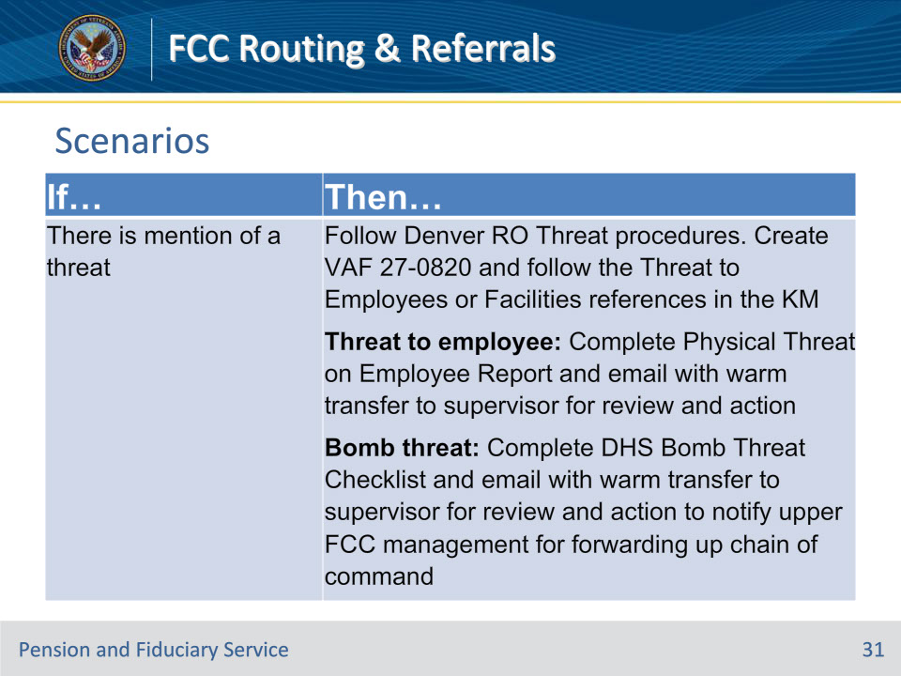

**Slide notes**

Policy Reference(s): Policy and Procedures on FCC Routing and Decision Flow Document

Instructor Notes

If there is a mention of a threat, then Follow Denver RO Threat procedures. In addition, FCC will create a VA Form 27-0820 and follow the Threat to Employees or Facilities references in the Knowledge Management Portal.

If the threat is to an employee, FCC will complete a Physical Threat on Employee Report (sharepoint.com) (Addendum B) and email it with a warm transfer to a supervisor for review and action.

If bomb threat, FCC will complete dhs-bomb-threat-checklist-2014-508.pdf (cisa.gov) (Addendum C) and email it with a warm transfer to a supervisor for review and action to notify upper FCC management for forwarding up chain of command.

**Slide 32 - Scenarios**

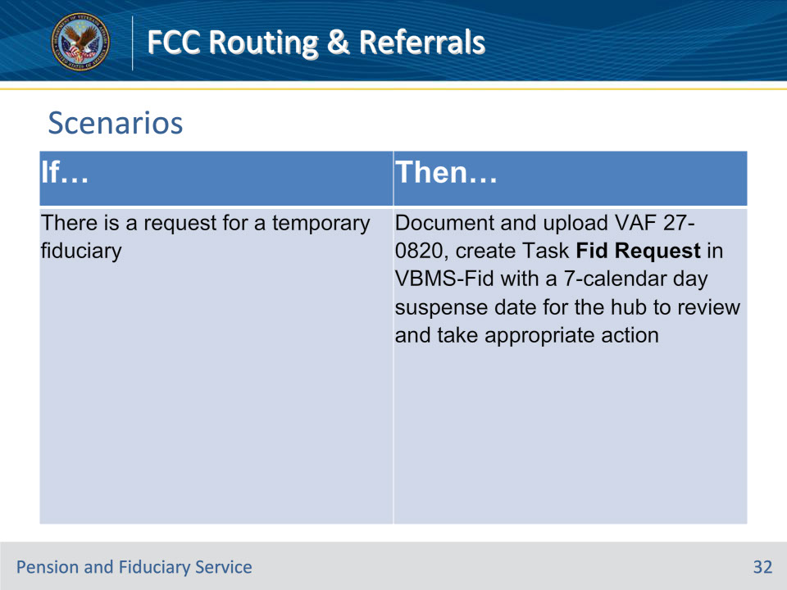

**Slide notes**

Policy Reference(s): Policy and Procedures on FCC Routing and Decision Flow Document

Instructor Notes

If there is a request for a temporary fiduciary, then FCC documents on and uploads a VA Form 27- 0820, creates Task Fid Request in VBMS-Fid with a seven-calendar day suspense date for hub to review and take appropriate action.

**Slide 33 - Scenarios**

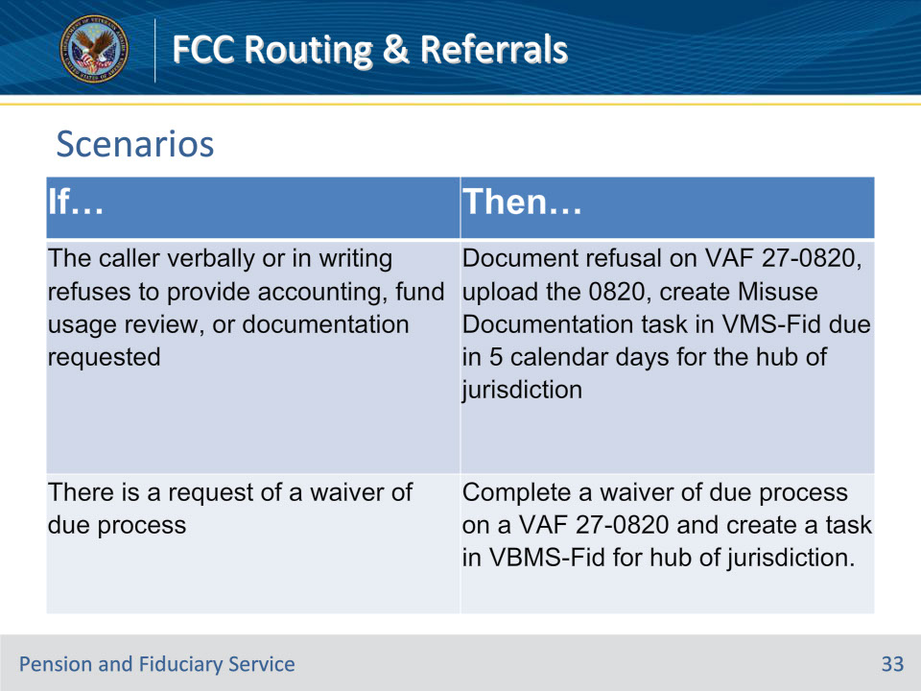

**Slide notes**

Policy Reference(s): Policy and Procedures on FCC Routing and Decision Flow Document

Instructor Notes

If the caller verbally or in writing refuses to provide accounting, fund usage review, or documentation requested, then FCC documents the refusal on a VA Form 27- 0820, uploads the VA Form 27-0820, creates Misuse Documentation task in VBMS-Fid due in five calendar days for the hub of jurisdiction. See FPM, Part I, 3.B.4.g and FPM, Part I, 3.E.1.a.

If there is a request of a waiver of due process, then FCC completes a waiver of due process on a VA Form 27-0820 following FPM, Part I, 1.B.1.g and creates a task in VBMS-Fid for hub of jurisdiction.

(TASK = Title: Fiduciary Req/Waiver Due Process; and FSR Action: Finalize Rating Decision).

**Slide 34 - Knowledge Check #5**

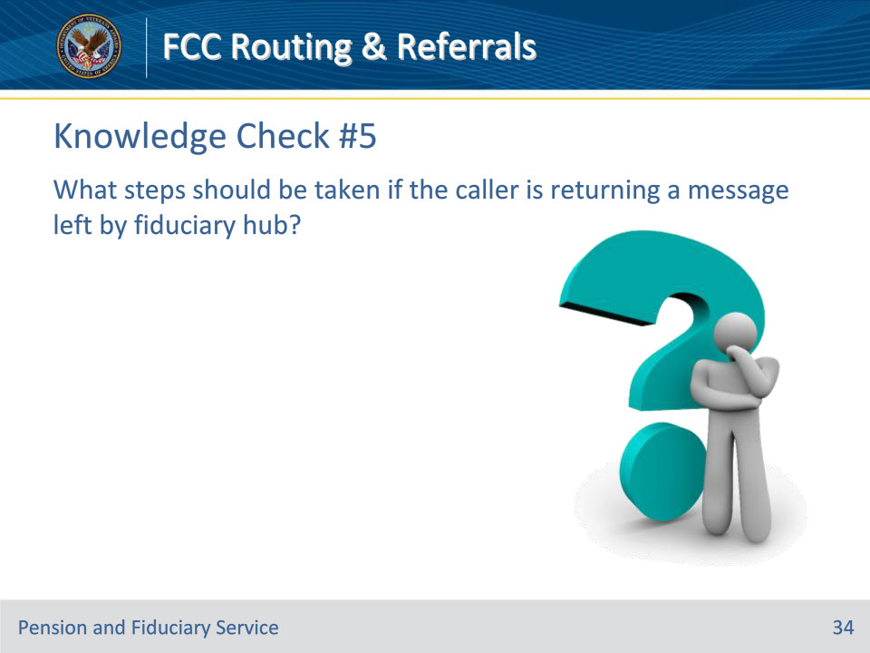

**Slide notes**

Policy Reference(s): Policy and Procedures on FCC Routing and Decision Flow Document

Instructor Notes

What steps should be taken if the caller is returning a message left by Fid Hub?

Answer: Fid Hub uses 0820 to describe what is needed on callback. FCC follows Fid Hub 0820 instructions then documents actions or requested information on a new 0820. If EP pending, updates EP to indicate new documents received, otherwise no action is needed.

**Slide 35 - Questions?**

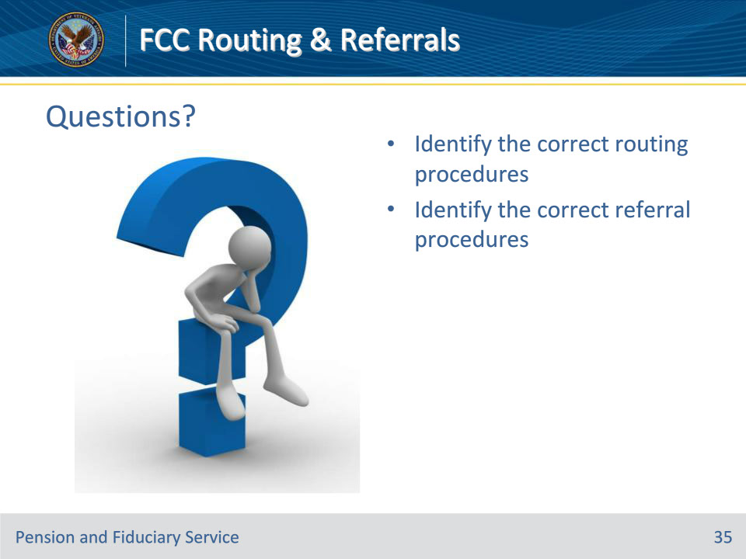

**Slide notes**

Instructor Notes:

(Recall) These are our learning objectives as stated from the beginning of the training:

• Identify the correct routing procedures

• Identify the correct referral procedures

Are there any additional questions?

Questions should be filtered through your QRT team. They will submit your questions to the Field Inquiry Tool (FIT) on your behalf.

**Slide 36 - TMS Survey/Assessment**

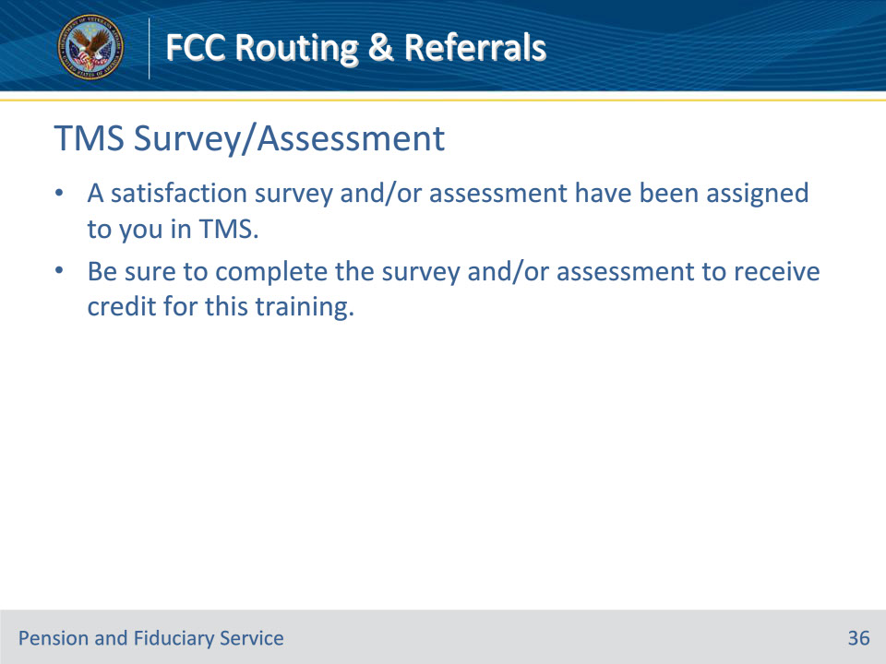

**Slide notes**

Instructor Notes

A satisfaction survey and/or assessment have been assigned to you in TMS.

Be sure to complete the survey and/or assessment to receive credit for this training.