**Pension and Fiduciary Service**



***FCC Routing and Referrals Job Aid***



February 2024

*This job aid will help the LAS identify the proper routing and referral techniques to achieve the goal of one-call resolution.*

|  |  |
| --- | --- |
| **If** ... | **Then** … |
| there is a question about an accounting or fund usage review extension | FCC documents on a *VA Form 27-0820, Report of General Information*, updates end product (EP) 290 to reflect extension, and sends extension letter in VBMS-Fid per Fiduciary Program Manual (FPM) **Part I, 3.A.3.h-l, FPM, Part I, 1.B.3.w,**  **FPM, Part I, 6.B.1.c, and if applicable, FPM, Part I, 3.A.1.k and FPM, Part I, 3.A.3.j-l.** |
| the beneficiary is rated competent but is still an active beneficiary or active file in system of record | FCC uploads a completed *VA Form 27-0820* and creates a Comp Memo task in VBMS-Fid due in seven days for hub of jurisdiction. **See FPM, Part I, 2.E.3.h and FPM, Part I, 1.A.2.b.**  **(TASK =Title:** *Comp Memo***;** and **FSR Action:**  Process full/Partial grant on Appeal**).** |
| benefits need to be resumed (i.e., whereabouts unknown) | FCC documents beneficiary's contact information on *VA Form 27-0820*, uploads the information, and establishes a Suspend/Resume task in VBMS-Fid that is due in seven calendar days for hub of jurisdiction. |
| a Brady Bill waiver request is received | FCC documents on a *VA Form 27-0820*, uploads the information, and establishes a Brady Bill task in VBMS-Fid that is due in seven calendar days for hub of jurisdiction. FCC will note in section of the task a description of the requested action. |
| the hub calls back–complex calls (i.e., accountings) | (**Fiduciary call backs only**) FCC uploads a completed *VA Form 27-0820* and creates a Process Review and Action task in VBMS-Fid that is due in seven calendar days for hub of  jurisdiction, noting in description: Accounting or fund usage review call back and the issue. |
| a change of addresses is received | FCC documents on *VA Form 27-0820*, uploads to the VBMS electronic claims folder (eFolder), completes a Change of Fiduciary, and updates the VBMS beneficiary profile, if applicable. |
| evidence of competency or incompetency is received during the due process period | (**Competency**) FCC will confirm there is an EP 590 Due Process for incompetency pending, completes and uploads the *VA Form 27-0820*, advise no further action is required during the pending due process while hub reviews incoming correspondences unless waiving of due process, create Fiduciary Req/Waiver Due Process task in VBMS-Fid noting date of document in eFolder and reason for task, due in seven calendar days for hub of jurisdiction. |

|  |  |
| --- | --- |
|  | (**Incompetency**) If waiving due process, FCC will create an *VA Form 27-0820*, create Fiduciary Req/Waiver Due Process task in VBMS-Fid noting date of document in eFolder and reason for task, due in seven calendar days for hub of jurisdiction. (See waiver of due process below in  table). **M21-1, Part X, Subpart ii, 6.D.3.i**. |
| there is a question about evidence of competency or incompetency not during due process period | FCC establishes EP 020 or EP 120 in VBMS- Core for National Work Queue (NWQ) to route to station of jurisdiction and creates *VA Form 27- 0820* noting date of document in eFolder. [**FPM,**](https://vaww.vrm.km.va.gov/system/templates/selfservice/va_kanew/help/agent/locale/en-US/portal/554400000001030/content/554400000223123/FPM-Part-I-Chapter-5-Section-A-Supervised-Direct-Pay-SDP?query=evidence%20of%20competency&3a)[**Part I, 5.A.3.a**](https://vaww.vrm.km.va.gov/system/templates/selfservice/va_kanew/help/agent/locale/en-US/portal/554400000001030/content/554400000223123/FPM-Part-I-Chapter-5-Section-A-Supervised-Direct-Pay-SDP?query=evidence%20of%20competency&3a)**-**[**c**](https://vaww.vrm.km.va.gov/system/templates/selfservice/va_kanew/help/agent/locale/en-US/portal/554400000001030/content/554400000223123/FPM-Part-I-Chapter-5-Section-A-Supervised-Direct-Pay-SDP?query=evidence%20of%20competency&3c)**,** [**M21-1, Part X, Subpart ii,**](https://vaww.vrm.km.va.gov/system/templates/selfservice/va_kanew/help/agent/locale/en-US/portal/554400000001030/content/554400000177977/M21-1-Part-X-Subpart-ii-Chapter-6-Section-D-Processing-Awards-to-Incompetent-Beneficiaries)[**6.D.6.a**](https://vaww.vrm.km.va.gov/system/templates/selfservice/va_kanew/help/agent/locale/en-US/portal/554400000001030/content/554400000177977/M21-1-Part-X-Subpart-ii-Chapter-6-Section-D-Processing-Awards-to-Incompetent-Beneficiaries)**.** |
| there is a statement about fiduciary not being responsive to beneficiary or vice versa | FCC uses call management techniques to ascertain the nature of the non-responsiveness then takes appropriate routing actions (i.e., misuse allegation, repeat caller, establishing EP 590 Unscheduled Field Exam in VBMS-Fid, educating the caller of fiduciary duties, etc.).  ***Note***: If FCC calls fiduciary, Legal Administrative Specialist (LAS) must be cognizant to ***not*** circumvent the fiduciary appointment (i.e., order the release of VA funds to beneficiary, etc.). |
| fiduciary is requesting a name change | FCC determines if evidence received is in line with **FPM, Part II, 1.B.2.b**, and **M21-1 Part II, Subpart iii, 3.B.4.b** for acceptable evidence:  (**If Yes)** If documents were received, FCC will create and upload a *VA Form 27-0820* noting the date of documentation in eFolder and Process Review and Action task in VBMS-Fid, due in seven calendar days for hub of jurisdiction.  (**If No**) If documents were not received, request caller to submit acceptable evidence. As a last resort establish EP 590 Unscheduled Field Exam. |
| fiduciary is requesting to negotiate a fiduciary fee | FCC documents on and uploads a *VA Form 27- 0820* and establishes EP 590 Unscheduled Field  Exam in VBMS-Fid. **See FPM, Part II, 1.C.4**. |
| fiduciary resigns | FCC advises to submit resignation in writing per FPM then documents on and uploads a *VA Form 27-0820* and establishes an EP 590 Unscheduled Field Exam in VBMS-Fid. Additionally, FCC will advise of **FPM, Part II, 2.C.2.a,** General Fiduciary Withdrawal Guidelines or **FPM, Part II, 2.C.2.b,** |

|  |  |
| --- | --- |
|  | Voluntary Fiduciary Withdrawal Requirements.  **See FPM, Part I, 2.D.3.a.** |
| there is a question about a lost check/tracer request | FCC documents on and uploads a *VA Form 27- 0820* and establishes a process review and action task in VBMS-Fid, due in seven calendar days for hub of jurisdiction. FCC will note in section of the task a description of the requested action. |
| there is an allegation of misuse | FCC completes a *VA Form 27-0820* and creates VBMS-Fid Misuse Documentation task with a **due date of 5 calendar days** for hub of jurisdiction.  For high profile cases, FCC will use a script provided by management or as directed to provide a general status (i.e., determination is  made and now in reconsideration period). |
| there is a need for a Regional Contact Center (RCC)/NCC Referral | After assisting with all hub related questions, warm transfer1 to RCC or NCC (i.e., intent to file, Veterans Benefits Administration (VBA) benefits, etc.). |
| there is a question about a pension rate being reduced to the  $90 | FCC documents on a *VA Form 27-0820* the potential decrease in VA benefits, and a responsibility of establishing claims in the appropriate system to ensure proper control. FCC will establish the appropriate EP in VBMS- Core for NWQ routing in accordance with **FPM, Part I, 2.E.3.d.**   * EP 130, *Dependency* * EP 150, *PMC-Income Adjustment* * EP 150, *PMC-Net Worth*, or * EP 290, *Incarceration Adjustment*, and * ensure the EP date of claim is the date of the ***VA Form 27-0820****.*   ***Important***: When establishing EPs based on a change to benefit entitlement, personnel must ensure all correct claim attributes are used (e.g., claim label, corporate flash, or special issue) to ensure NWQ routes the EP to the correct VSC or  PMC, as appropriate. |
| there is a repeat caller | FCC documents on a *VA Form 27-0820*, reviews record to ensure no further information is available since their prior call, and advises repeat caller no further information or assistance is available. |

1 Warm transfer is described in the FCC FAQs.

|  |  |
| --- | --- |
| there is a report of a fiduciary notice of death (NOD) | FCC completes a *VA Form 27-0820* and establishes EP 590 Successor Initial Appointment  (SIA) in VBMS-Fid. |
| there is a report of a non-Veteran NOD | FCC will ask caller if an heir, next of kin, or valid will exists to determine if escheat applies per **FPM Part II, 1.C.3.d.** Upload completed a *VA Form 27-0820a* and creates FNOD task in VBMS- Fid with a seven-calendar due date for hub of jurisdiction. |
| there is a report of a Veteran first notice of death (FNOD) | FCC will ask caller if an heir, next of kin, or valid will exists to determine if escheat applies per **FPM Part II, 1.C.3.d.** FCC will process FNOD in Share actions to include sending automated letters, explain burial and death benefits (PMC, Dependency and Indemnity Compensation, burial allowance, flag, month of death), and create an  FNOD task with a due date of seven calendar days to hub of jurisdiction. |
| there is a report about a beneficiary's financial or personal well-being | FCC documents on and uploads a *VA Form 27- 0820* and establishes EP 590 Unscheduled Field Exam in VBMS-Fid. |
| there is a request for a hearing during the due process period | FCC documents a *VA Form 27-0820* and creates Hearing Request task in VBMS-Fid with a due date of seven calendar days to hub of jurisdiction. |
| there is a request for assistance to complete an accounting | FCC attempts to assist with general accounting questions. If fiduciary indicates that they require assistance completing the accounting and the assistance cannot be accomplished over the phone, FCC will establish EP 590 Fund Usage Field Exam per **FPM, Part I, 3.E.1.c** and  complete a *VA Form 27-0820*. |
| there is a request for a call back by supervisor/senior (i.e., angry/upset caller) | FCC will utilize the soft skills training to manage call (i.e., VBA prevention and management of disruptive behavior or other soft skills, etc.), if LAS is unable to handle call, transfer to Senior LAS. |
| there is a requesting for a call back from the Field Examiner | FCC will use the soft skills training to manage and ascertain caller's need and to assist (i.e., give status of field exam, information regarding benefits, misuse allegation intake etc.) and compete a *VA Form 27-0820*.  If FCC needs to pass along important information to hub employees, the FCC (LAS) will include the information on the *VA Form 27-0820* and create a review and action task, due in seven calendar days to hub of jurisdiction. |

|  |  |
| --- | --- |
| there is a request to be on supervised direct pay (SDP) | FCC documents on a *VA Form 27-0820* and establishes EP 590 Unscheduled Field Exam in  VBMS-Fid. |
| retroactive benefit needs released after bond received | FCC documents on a *VA Form 27-0820*, and clicks the Documents received button in the EP overview (VBMS-Core) to update the EP 290 Fid- Fiduciary Adjustment to “Ready to Work” suspense reason. |
| there is a question about returned mail/missing correspondence | FCC verifies correct address, updates address if needed, and resends letter with correct address. If unable to locate an updated address, create a Returned task, due in seven calendar days to hub of jurisdiction. |
| returning a message left by hub | Hub uses a *VA Form 27-0820* to describe what is needed on callback. FCC follows instructions noted on the *VA Form 27-0820* by the hub then documents actions or requested information on a new *VA Form 27-0820*. If an EP is pending,  update EP to indicate new documents received, otherwise no action is needed. |
| there is a mention of suicidal thoughts, feelings, plans, actions, etc. | Warm transfer to suicide hotline and complete a  *VA Form 27-0820*. |
| there is a mention of a threat | Follow Denver RO Threat procedures. In addition, FCC will create a *VA Form 27-0820* and follow the Threat to Employees or Facilities references in the Knowledge Management Portal.  If the threat is to an employee, FCC will complete a [Physical Threat on Employee Report](https://dvagov.sharepoint.com/sites/VBABASqualitytraining/bastrain/siteassets/phythreat.aspx?isSPOFile=1) [(sharepoint.com)](https://dvagov.sharepoint.com/sites/VBABASqualitytraining/bastrain/siteassets/phythreat.aspx?isSPOFile=1) (Addendum B) and email it with a warm transfer to a supervisor for review and action.  If bomb threat, FCC will complete [dhs-bomb-](https://www.cisa.gov/sites/default/files/publications/dhs-bomb-threat-checklist-2014-508.pdf) [threat-checklist-2014-508.pdf (cisa.gov)](https://www.cisa.gov/sites/default/files/publications/dhs-bomb-threat-checklist-2014-508.pdf) (Addendum C) and email it with a warm transfer to a supervisor for review and action to notify upper FCC management for forwarding up chain  of command. |
| there is a request for a temporary fiduciary | FCC documents on and uploads a *VA Form 27- 0820*, creates Task **Fid Request** in VBMS-Fid with a seven-calendar day suspense date for hub to review and take appropriate action. |
| the caller verbally or in writing refuses to provide accounting, | FCC documents the refusal on a *VA Form 27- 0820*, uploads the *VA Form 27-0820*, creates Misuse Documentation task in VBMS-Fid due in |

|  |  |
| --- | --- |
| fund usage review, or documentation requested | five calendar days for the hub of jurisdiction. **See FPM, Part I, 3.B.4.g and FPM, Part I, 3.E.1.a.** |
| there is a request of a waiver of due process | FCC completes a waiver of due process on a *VA Form 27-0820* following **FPM, Part I, 1.B.1.g** and creates a task in VBMS-Fid for hub of jurisdiction.  **(TASK = Title:** *Fiduciary Req/Waiver Due Process*; and **FSR Action:** *Finalize Rating*  *Decision***).** |
| References | [Fiduciary Contact Center (FCC) Frequently Asked Questions (FAQ) (va.gov)](https://vaww.vrm.km.va.gov/system/templates/selfservice/va_kanew/help/agent/locale/en-US/portal/554400000001030/content/554400000250058/Fiduciary-Contact-Center-FCC-Frequently-Asked-Questions-FAQ)  [Fiduciary Contact Center (FCC) Phone Procedures (va.gov)](https://vaww.vrm.km.va.gov/system/templates/selfservice/va_kanew/help/agent/locale/en-US/portal/554400000001030/content/554400000255978/Fiduciary-Contact-Center-FCC-Phone-Procedures)  [Fiduciary Contact Center (FCC) Prompts (va.gov)](https://vaww.vrm.km.va.gov/system/templates/selfservice/va_kanew/help/agent/locale/en-US/portal/554400000001030/content/554400000247831/Fiduciary-Contact-Center-FCC-Prompts)  [Fiduciary Program Manual (va.gov)](https://vaww.vrm.km.va.gov/system/templates/selfservice/va_kanew/help/agent/locale/en-US/portal/554400000001030/topic/554400000002708/Fiduciary-Program-Manual)  [M21-1 Adjudication Procedures Manual (va.gov)](https://vaww.vrm.km.va.gov/system/templates/selfservice/va_kanew/help/agent/locale/en-US/portal/554400000001030/topic/554400000003061/M21-1-Adjudication-Procedures-Manual)  [Appendix B. End Product (EP) Codes (va.gov)](https://vaww.vrm.km.va.gov/system/templates/selfservice/va_kanew/help/agent/locale/en-US/portal/554400000001030/content/554400000011474/Appendix-B-End-Product-EP-Codes) |

**Addendum B**

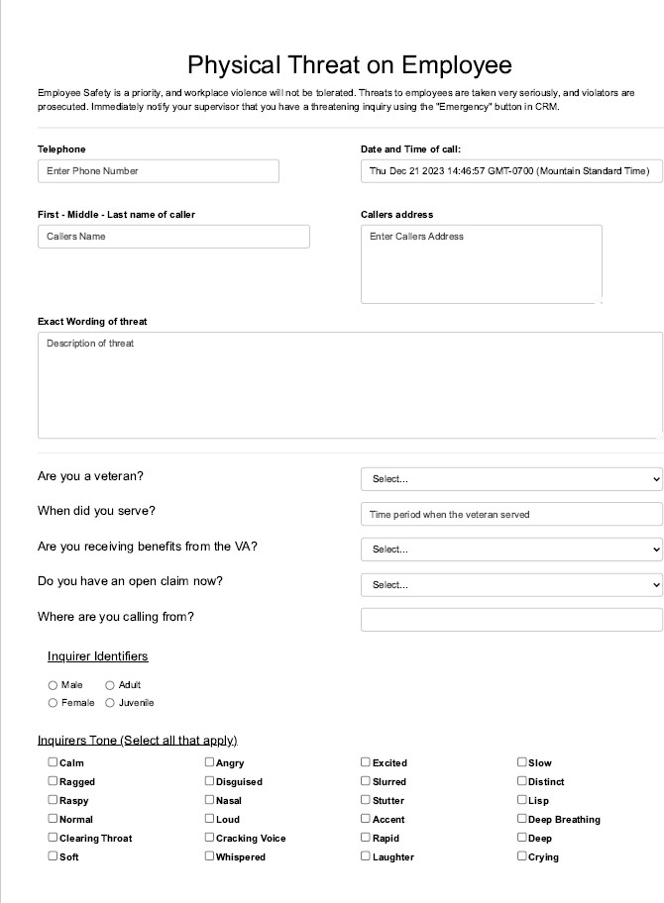

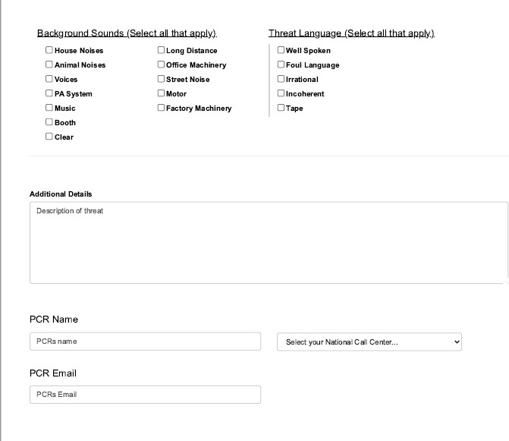

**Addendum C**

