**Slide 1 - FCC FAQs Scenarios Part 2**

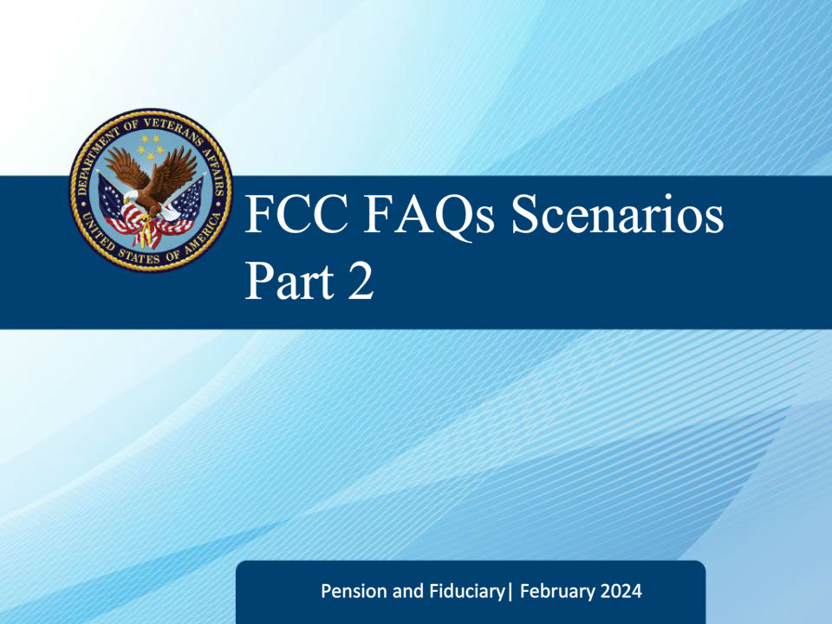

**Slide notes**

Welcome to the Fiduciary Contact Center Frequently Asked Questions Scenarios Part 2 training.

The purpose of this course is to help Legal Administration Specialists prepare for their duties by providing real-life examples of frequently asked questions and scenarios that may arise while fielding calls.

By going through these scenarios, you will learn how to handle different situations, communicate effectively with callers, and provide accurate and helpful information.

This training aims to equip you with the necessary skills to better serve the customers and fulfill your role as a Legal Administration Specialist.

**Slide 3 - FCC FAQs Scenarios Part 2**

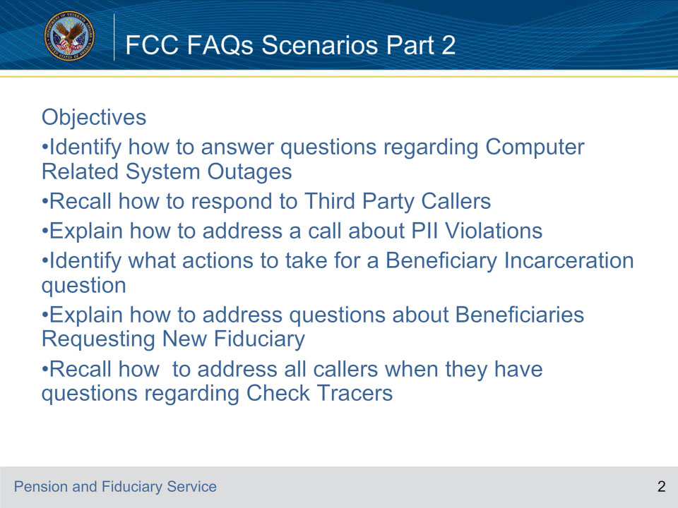

**Slide notes**

These are the objectives for this course:

Identify how to answer questions regarding Computer Related System Outages

Recall how to respond to Third Party Callers

Explain how to address a call about P.I.I Violations

Identify what actions to take for a Beneficiary Incarceration question

Explain how to address questions about Beneficiaries Requesting New Fiduciary

Recall how to address all callers when they have questions regarding Check Tracers

**Slide 4 - FCC FAQs Scenarios Part 2**

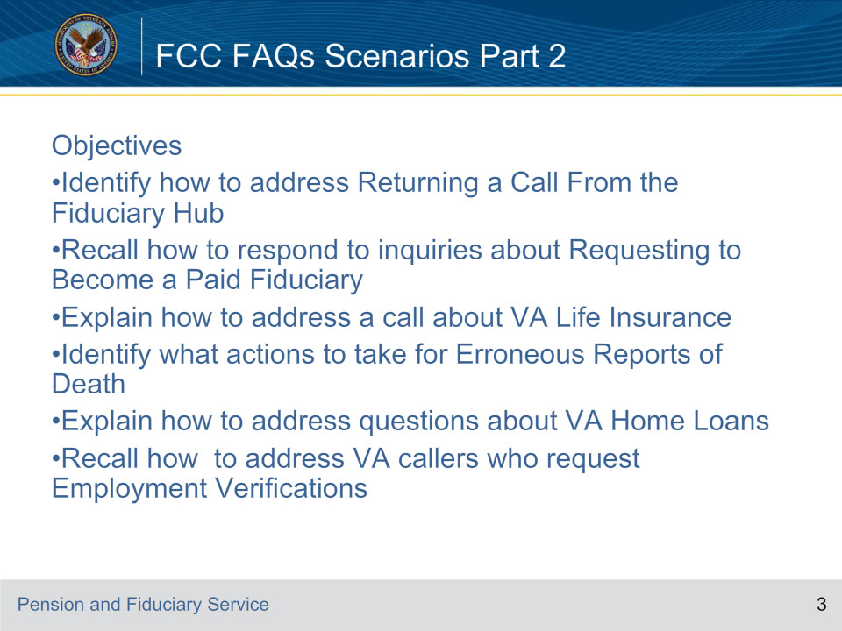

**Slide notes**

Objectives continued:

Identify how to address Returning a Call From the Fiduciary Hub

Recall how to respond to inquiries about Requesting to Become a Paid Fiduciary

Explain how to address a call about VA Life Insurance

Identify what actions to take for Erroneous Reports of Death

Explain how to address questions about VA Home Loans

Recall how to address VA callers who request Employment Verifications

**Slide 5 - Fiduciary Contact Center (FCC) Prompts**

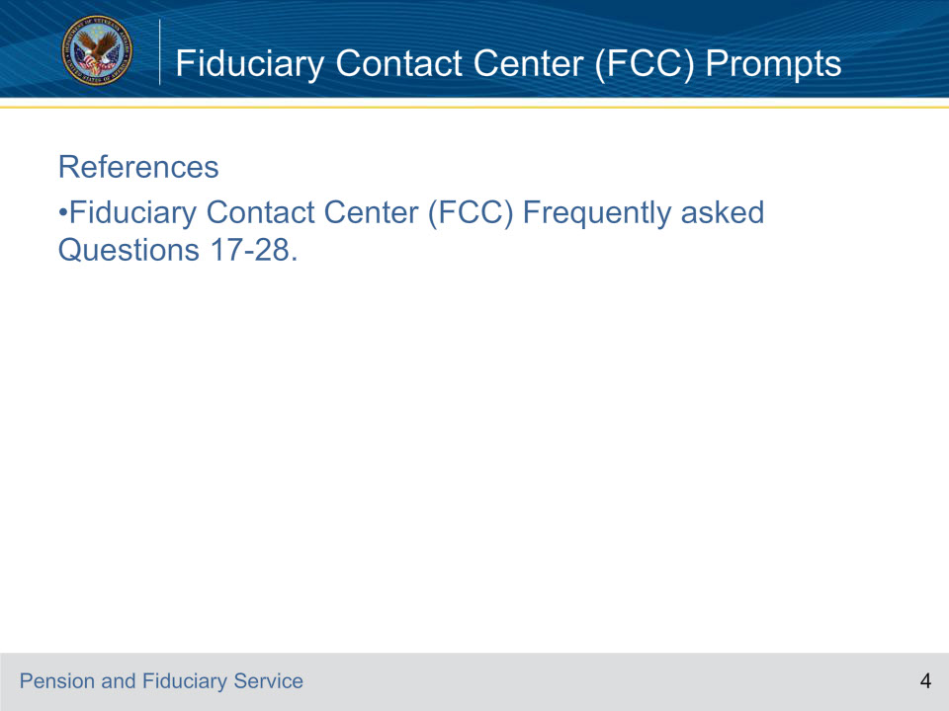

**Slide notes**

On this screen is the reference for this course.

**Slide 6 - Scenario**

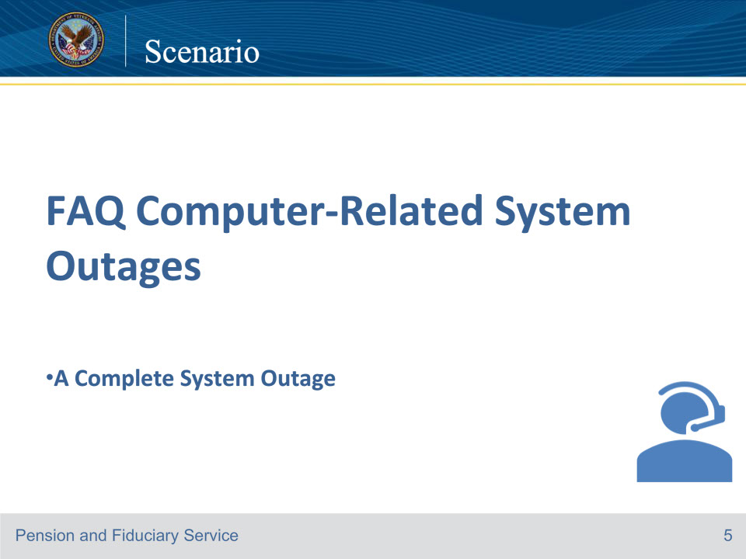

**Slide notes**

Good morning. Thank you for calling the Fiduciary Contact Center. My name is Jacob. May I start with your first and last name?

My name is Susie Williams.

Hi, Ms. Williams, I apologize for any inconvenience; unfortunately, our computer systems are currently unavailable. I can answer any general questions you may have.

I need to ask a claim question.

You may call back in two hours, the systems are scheduled to be online then. We will be happy to assist you.

Ok, I will try to call back then.

Again, I apologize for any inconvenience.

It is ok I will call back later.

Thank you have a great day.

Course of action: In this scenario, the ID protocol was incomplete, so only general information could be provided.

The VA Form 27-0820 Report of General Information is not required as no record was accessed.

References: FCC FAQs 17. a.

**Slide 7 - Scenario**

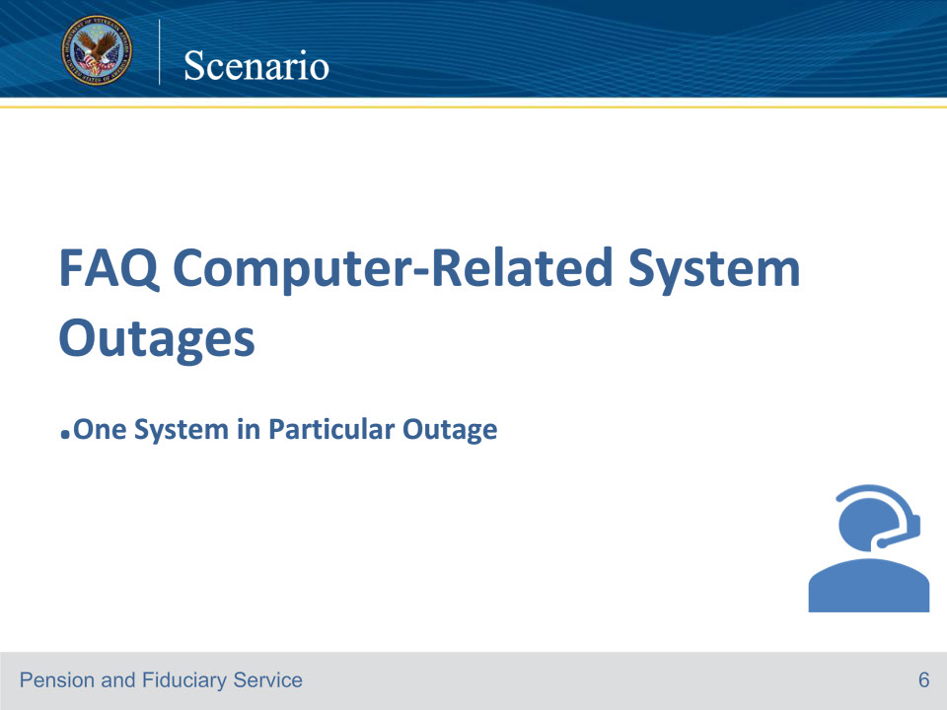

**Slide notes**

Good morning. Thank you for calling the Fiduciary Contact Center. My name is Jacob. May I start with your first and last name?

My name is John Coleman.

Hi, Mr. Coleman. How are you doing today?

I’m doing well. I can’t complain.

May I start with a file number?

Sure, it’s 555-55-555.

Can you provide the Veteran’s name, date of birth, and branch of service?

His name is Larry Coleman, his date of birth is January 30, 1958, and the branch of service is Navy.

Thanks for that information. How may I assist you?

I’m the fiduciary for my brother and I am requesting a budget letter.

Let me check. Can you give me a moment to review the Veteran’s e-folder?

Ok.

I apologize for any inconvenience; unfortunately, the system I need to access to best assist you is currently unavailable. You may call back in an hour, we will be happy to assist you.

Ok, I will call back then.

Again, I apologize for any inconvenience. Have a great day.

Course of action: In this scenario, you should document the Fiduciary’s request for the VA to send the Budget letter on a VA Form 27-0820 Report of General Information since this request is to a specific Veteran or beneficiary file.

References: FCC FAQs 17.b.

**Slide 8 - Scenario**

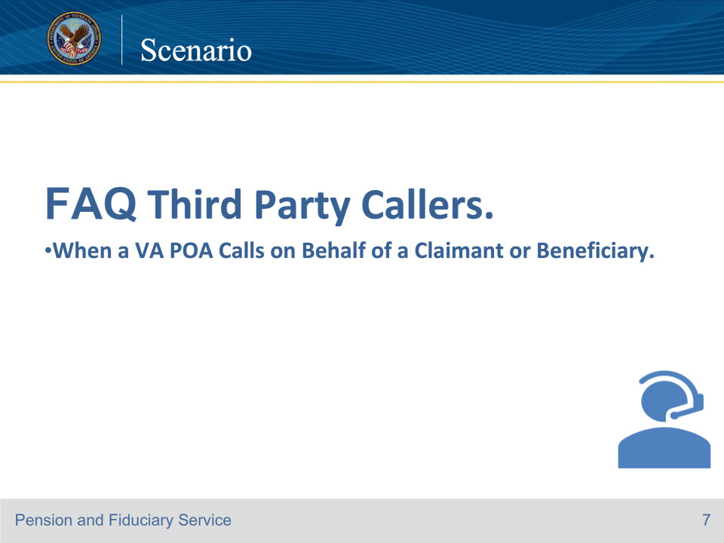

**Slide notes**

Good morning. Thank you for calling the Fiduciary Contact Center. My name is Katie. May I start with your first and last name?

My name is Jane Smith. I am the POA for Louis Andersen.

Hi, Ms. Smith. How are you doing today?

I’m doing well.

Please provide me with your organization so that I may verify the appointment of a POA.

I am with the American Legion.

Now that the POA accreditation has been verified, I must complete the ID protocol.

Ok.

May I have the file or social security number for verification purposes?

The file number is 555-55-5555.

Great, thank you. Can I have the Veteran’s name, date of birth and branch of service?

The veteran’s name is Louis Andersen, and his date of birth is June 27, 1954, and he was in the Marines.

Thank you for that information, how may I assist you today?

I just want to verify that the American Legion is the POA for Louis Andersen.

Yes. I can see the VA Form 21-22 and it shows the American legion as the POA. Is there anything else I can help you with?

No, thanks for your help.

You’re welcome. Have a great day.

Course of action: In this scenario, the LAS should complete a VA Form 27-0820, Report of General information documenting the phone call, and upload it to the proper e-Folder.

References: FCC FAQs 18.a.

For more information on evidence to restore competency, see M21-1, Part 10. Subpart 2.6.A.4.d

**Slide 9 - Scenario**

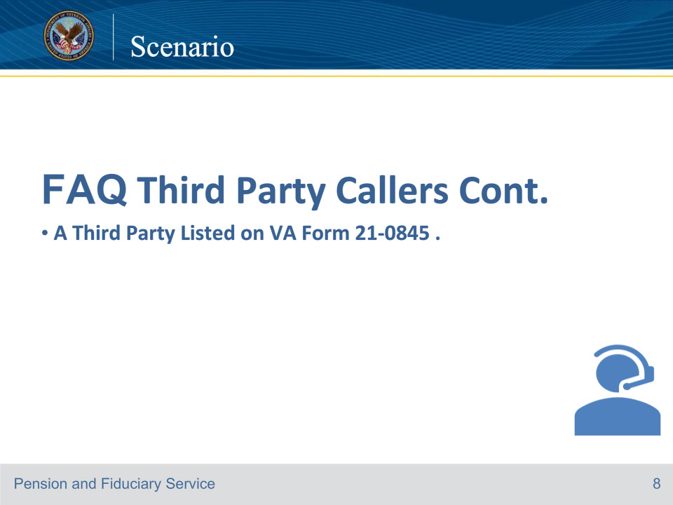

**Slide notes**

Good morning. Thank you for calling the Fiduciary Contact Center. My name is Katie. May I start with your first and last name?

My name is Jane Thomas.

Hi, Ms. Thomas. How are you doing today?

I’m doing well.

May I have the file or social security number for verification purposes?

The file number is 777-77-7777.

Great, thank you. Can I have the Veteran’s name, date of birth and branch of service?

The veteran’s name is Tony Cooper, and his date of birth is July 16, 1964, and he was in the Air Force.

Thank you for that information, how may I assist you today?

I had some questions about my brother’s VA file?

Unfortunately, I am unable to release any information at this time. I do not see a VA Form 21-0845 in the file. To release information, a valid VA Form 21-0845 is required to be submitted.

The form can be mailed to the intake center at Department of Veterans Affairs Fiduciary Intake PO Box 5211 Janesville, WI 53547-5211.

Ok, thanks for the information.

You’re welcome. Have a great day.

Course of action: In this scenario, the LAS should complete a VA Form 27-0820, Report of General information documenting the phone call, and upload it to the proper e-Folder.

References: FCC FAQs 18.b.

Important: A Veteran may only designate one person or one organization on the form.

Only one form may be valid at a time.

On the VA Form 21-0845, the information provided in Item 6, Name of Beneficiary or Claimant Who Is Not the Veteran, cannot be the same information provided in Item 10.

The VA Form 21-0845 signed by the fiduciary allows the LAS to provide information about the beneficiary, not the fiduciary.

If the LAS receives a call from a third party (i.e., a doctor’s office or court of jurisdiction for fiduciary activity) and

they have received a letter requesting evidence in support of the Veteran’s claim regarding fiduciary activity, the LAS can discuss only that letter with the third party.

References: For more information on the use of VA Form 21-0845, see M21-1, Part I, Subpart 1, 3.1.b, and

the required criteria for VA Form 21-0845, see M21-1, Part I, Subpart 1, 3.1.c.

**Slide 10 - Scenario**

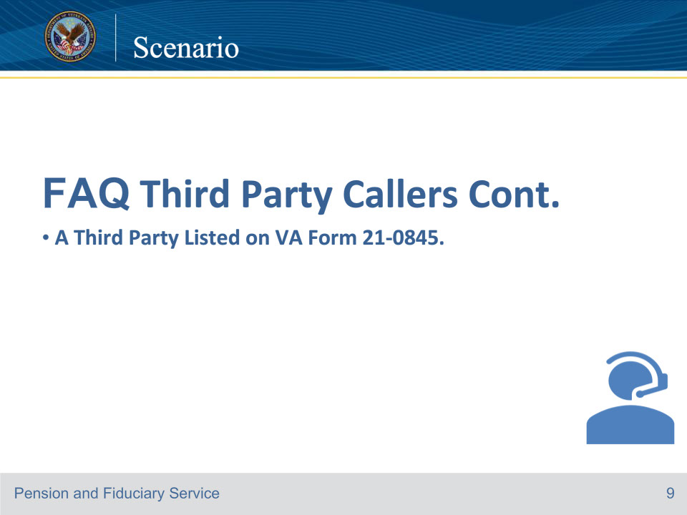

**Slide notes**

Good morning. Thank you for calling the Fiduciary Contact Center. My name is Katie. May I start with your first and last name?

My name is Jane Thomas. I submitted a form to get information about my brother’s file.

Hi, Ms. Thomas. How are you doing today?

I’m doing well.

Please allow me to complete the ID protocol and the security question listed on the valid VA Form 21-0845.

Ok.

May I have the file or social security number for verification purposes?

The file number is 777-77-7777.

Great, thank you. Can I have the Veteran’s name, date of birth and branch of service?

The veteran’s name is Tony Cooper, and his date of birth is July 16, 1964, and he was in the Air Force.

The security question is the city and state your mother was born in?

That would be Green Bay, Wisconsin.

Thank you for that information, how may I assist you today?

I would like to know what benefit my brother is getting and how much he receives.

100% Service-connected Compensation and the current rate is $3,737.85. Is there anything else I can help you with?

No, thanks for the information.

You’re welcome. Have a great day.

Course of action: In this scenario, the LAS should complete a VA Form 27-0820, Report of General information documenting the phone call, and upload it to the proper e-Folder.

References: FCC FAQs 18.b.

**Slide 11 - Scenario**

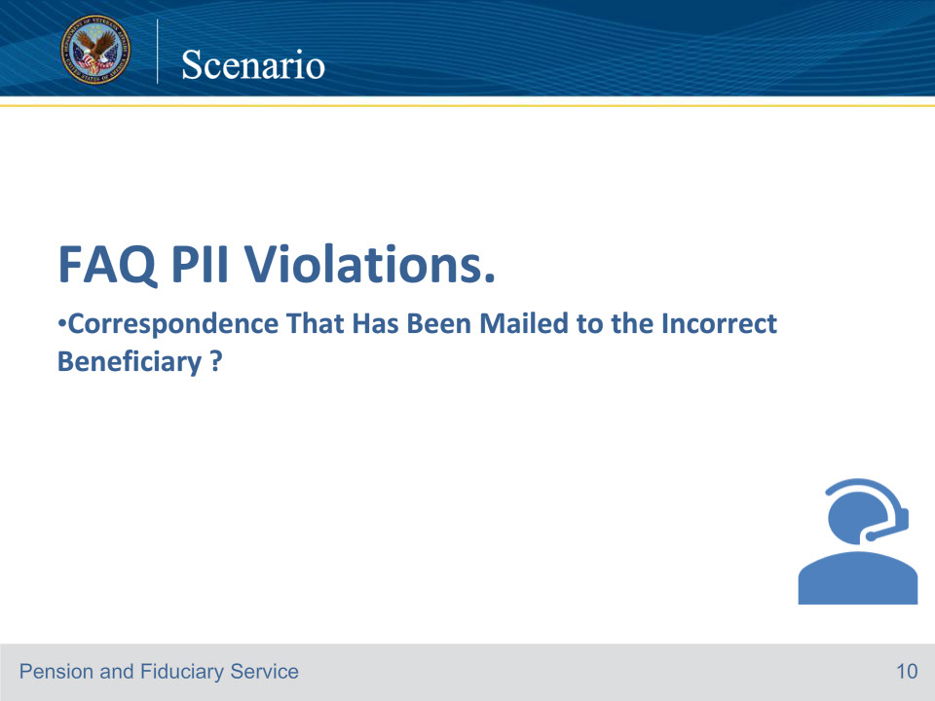

**Slide notes**

Good morning. Thank you for calling the Fiduciary Contact Center. My name is Katie. May I start with your first and last name?

My name is Frank Thomas.

Hi, Mr. Thomas. How are you doing today?

I’m ok, I would like to report that I received VA Fiduciary letter for Tony Thomas. It had my mailing address on it but it had his name and his Social Security 111-11-1111.

Thank you for reporting this information. Please return the letter to the VA, by mailing it to the intake center at Department of Veterans Affairs Fiduciary Intake PO Box 5211 Janesville, WI 53547-5211.

Oh ok I can mail it in.

May I have the file or social security number for verification purposes?

My Social Security number is 222-22-2222.

What is your branch of service?

Army.

Thank you for that information. I will take steps to correct this. Is there anything else I can help you with?

No, there isn’t.

Have a great day.

You too.

Course of action: In this scenario, there is no need for the LAS to complete a VA Form 27-0820 Report of General Information since the question was not related to a specific Veteran or beneficiary file.

Complete a VBMS Request for Document Deletion Form and all steps as outlined in M21-1, Part II, Subpart ii, 2.A.2.b.

Send a copy of the completed form to your supervisor.

References: FCC FAQs 19.a. For more information on document deletion, see M21-1, Part II, Subpart ii, 2.A.2.b.

**Slide 12 - Scenario**

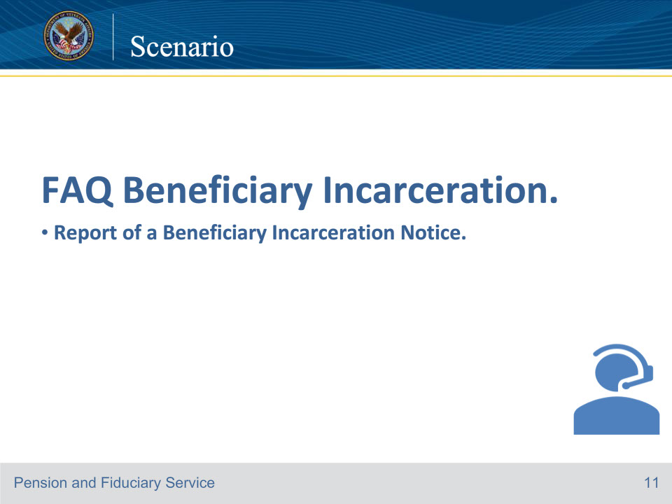

**Slide notes**

Good morning. Thank you for calling the Fiduciary Contact Center. My name is Jacob. May I start with your first and last name?

My name is Jane Sullivan.

Hi, Ms. Sullivan. How are you doing today?

I’m ok, I would like to report that my brother Patrick Sullivan is incarcerated.

To record this information, may I have the file or social security number for verification purposes?

The Social Security is 444-44-4444.

Can I have the Veteran’s date of birth and branch of service?

The Veteran’s date of birth is December 3, 1970 and the branch of service is Army.

Thank you for this information. Please answer some questions for me.

Ok!

What is the type of conviction?

It was a Felony Theft in the 1st degree.

What is the date (including month, day, and year) of the conviction?

December 19, 2023.

What is the date (including month, day, and year) of incarceration following the conviction?

December 26, 2023.

Will the incarceration last more than 60 days following the date of conviction?

Yes, he will be incarcerated for a few years.

I have recorded this information on the record. Is there anything else I can help you with?

No.

I hope you have a great day.

Thank you very much. Have a great day too!

Course of action: In this scenario, Complete VA Form 27-0820e. Establish an EP 290, using the claim label Bureau of Prisons Match or Social Security Prison Match (whichever applies).

References: FCC FAQs 20.a. For more information on how to handle beneficiary incarceration, see M21-1, Part VI, Subpart iii, 1.A.3.a and d.

**Slide 13 - Scenario**

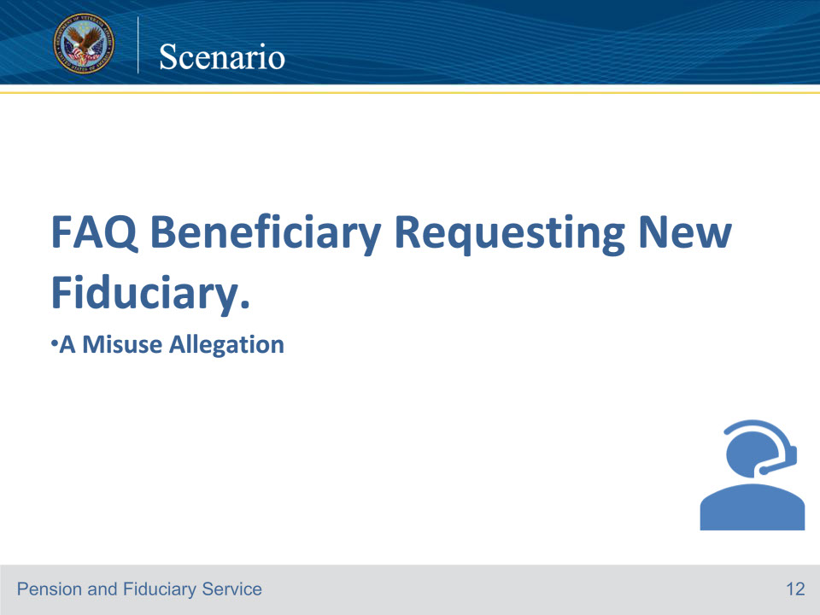

**Slide notes**

Good morning. Thank you for calling the Fiduciary Contact Center. My name is Jacob. May I start with your first and last name?

My name is Sam Alexander.

Hi, Mr. Alexander. How are you doing today?

Not so good. My brother, Michael Alexander has been stealing my younger brother’s VA money.

Thank you for reporting this, may I have the file or social security number for verification purposes?

Yes, my brother’s Social Security number is 777-77-7777.

Thank you. Can I have the Veteran’s name, date of birth and branch of service?

The Veteran’s name is Victor Alexander and his date of birth is June 1, 1986 and his branch of service is Army.

This seems to be Michael’s Social Security number, May I have the Veteran’s file number or social security number so that I can access the record?

His file number is 555-55-5555.

Great, Thank you for this information, I would like to ask some questions about this allegation.

Ok.

How did you discover this misuse?

I was reviewing bank statements with my brother Michael.

He is the fiduciary for Victor. I saw several cash withdrawals from the account and I asked Michael about them. He couldn’t explain what they were for.

Okay, do you know the date the misuse began?

Yes, I saw one cash withdrawal for $2,000 on December 15, 2023, and another for $3,000 on December 23, 2023.

Ok, may I have your full address and contact information?

Yes, 5000 Main Street, Brooksville, Florida 34601 and my phone number is 352-555-5555.

Thank you for that information, Is there anything else I can help you with?

No, not at this time.

Have a great day.

You too.

Course of Action: In this scenario, the LAS should complete a VA Form 27-0820, Report of General information documenting the phone call, misuse allegations and upload it to the proper e-Folder and the subject title should be misuse allegation.

Important: When receiving this request, do not immediately establish an SIA EP, as replacement of the fiduciary is only necessary when misuse

is found or when evidence discovered during the investigation indicates it would be in the beneficiary’s best interest to replace the fiduciary.

Notes: When uploading the VA Form 27-0820 to the beneficiary’s eFolder, the subject title is misuse allegation.

Add other important information to the VA Form 27-0820, such as if the caller refuses to identify themselves, and/or

fiduciary serves more than one beneficiary.

References: FCC FAQs 21.a. For more information on how to handle calls related to misuse, see FCC Prompt 6

documenting misuse allegations, see FPM, Part II, 3.A.2.d, and misuse allegations, see FPM, Part II, 3.A.3.c.

**Slide 14 - Scenario**

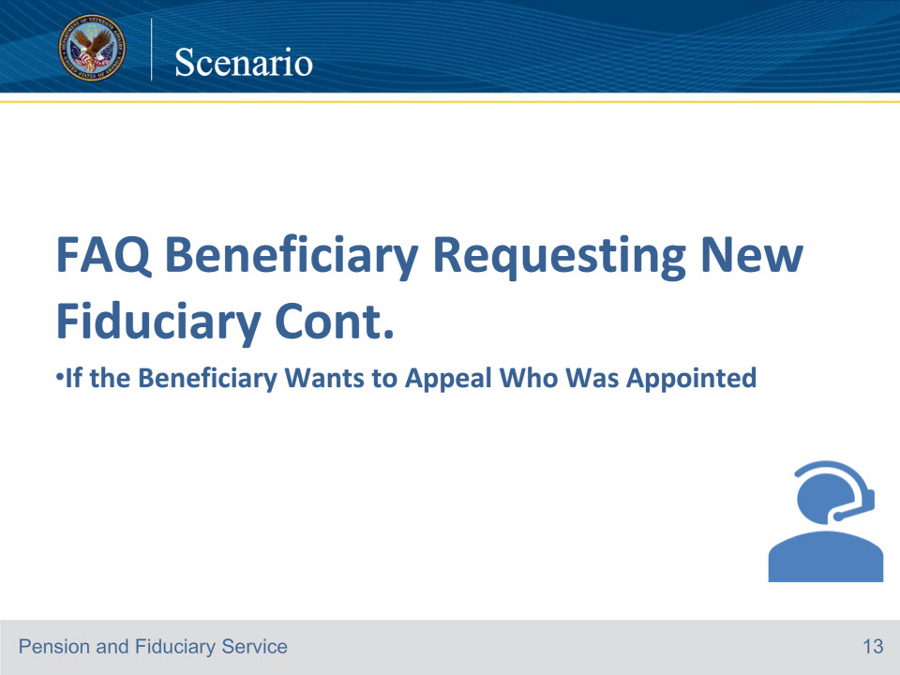

**Slide notes**

Good morning. Thank you for calling the Fiduciary Contact Center. My name is Jacob. May I start with your first and last name?

My name is Sam Jones.

Hi, Mr. Jones. How are you doing today?

Not so good. The VA appointed a fiduciary for me, and I want to appeal this decision. Is it true that I can appeal to the Board?

Yes, if you disagree with the VA on this matter, you may appeal to the Board by telling us you disagree with our decision and want the Board to review it or giving us new and relevant evidence, we do not already have that may lead us to change our decision.

Ok.

To begin your appeal, VA Form 10182 must be completed. The form must identify the specific fiduciary decision or decisions with which you, the beneficiary, disagree with. This process is called your notice of disagreement (NOD). Would you like me to send you a copy of this form?

No, I can download it.

Ok great. There are other appeal options would you like to hear them?

No, I want to go to the Board.

Ok, is there anything else I can help you with?

No, thanks for your help.

Have a great day.

You too.

Course of action: In this scenario, the ID protocol was not completed, so only general information could be provided. The VA Form 27-0820 Report of General Information is not required as no record was accessed.

It is important for the LAS to remember that a fiduciary who is not also serving in the role as the beneficiary’s accredited representative (POA), attorney, and/or claim agent cannot file an appeal of the appointment of fiduciary.

It is also important for the LAS to be aware of the two other appeal methods in case the caller inquire about them. This knowledge ensures that the caller is well-informed about their options.

References: FCC FAQs 21.b. For more information on how to handle issues

related to appeals, see FCC FAQ 5

new and relevant evidence, see FPM, Part III, 1.A.2.v

For more information on authority to appeal fiduciary decisions, see FPM, Part III, 1.A.1.a, and

fiduciary appealable decisions, see FPM, Part III, 1.A.3.a.

For more information on who may submit an NOD, see FPM, Part III, 1.C.6.b, and for NOD requirements, see FPM, Part III, 1.C.6.c.

**Slide 15 - Scenario**

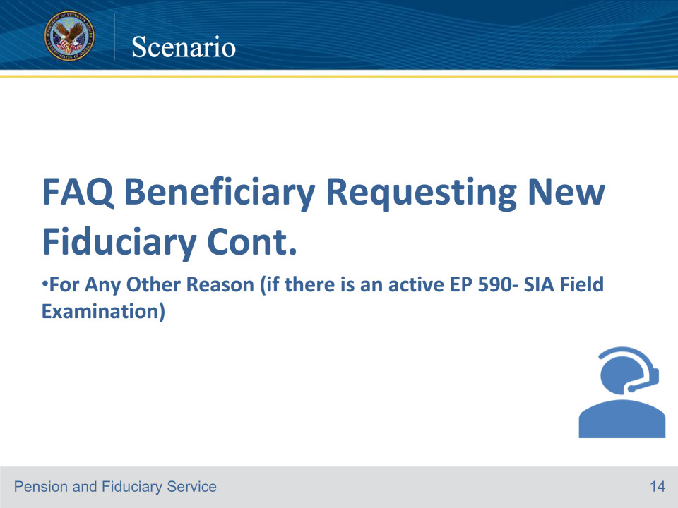

**Slide notes**

Good morning. Thank you for calling the Fiduciary Contact Center. My name is Jacob. May I start with your first and last name?

My name is Sam Jones.

Hi, Mr. Jones. How are you doing today?

Not so good. The VA appointed a fiduciary for me and I want another one.

May I have the file or social security number for verification purposes?

My Social Security number is 999-99-9999

Can I have your date of birth and branch of service?

My date of birth is April 10, 1989 and my branch of service is the Marines.

Thank you for your service, I have located your record.

Jacob: Thank you for this information, I have located your record.

You’re welcome.

I see that we are actively working on this request. A Field Examiner will contact you once the request is reviewed.

Is there anything else I can help you with?

No.

Have a great day.

You too.

Course of action: In this scenario, you should document the beneficiary’s request for a new fiduciary on a VA Form 27-0820 Report of General Information since this request is to a specific Veteran or beneficiary file.

References: FCC FAQs 21.c.

**Slide 16 - Scenario**

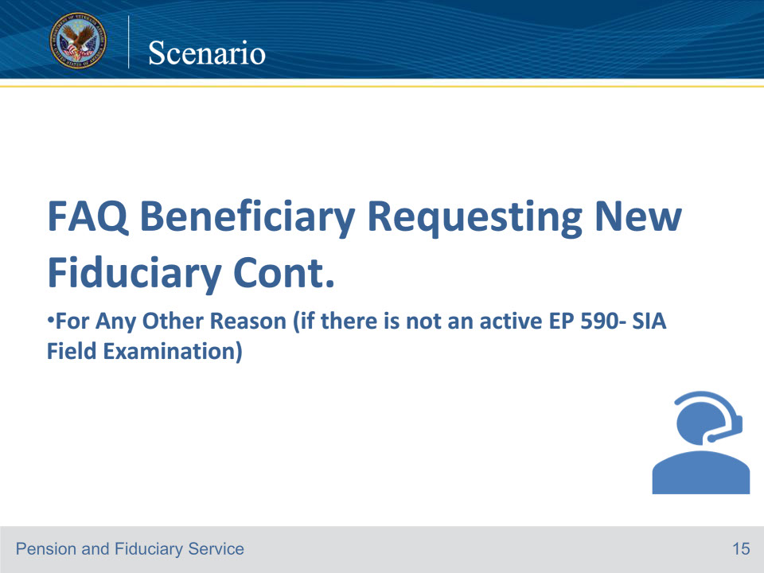

**Slide notes**

Good morning. Thank you for calling the Fiduciary Contact Center. My name is Jacob. May I start with your first and last name?

My name is Sam Jones.

Hi, Mr. Jones. How are you doing today?

Not so good. The VA appointed a fiduciary for me and I want my brother Fred Jones to be my fiduciary because he would do it for free.

May I have the file or social security number for verification purposes?

My Social Security number is 999-99-9999.

Can I have your date of birth and branch of service?

My date of birth is April 10, 1989 and my branch of service is the Marines.

Thank you for your service, and thank you for this information, I have located your record.

You’re welcome.

I will forward your request to the appropriate department for review. If the request is approved, then you’ll be notified that a field exam will need to be conducted.

If the request is not approved, the file will be notated with the reasoning as to why.

Do you know how long this will take?

A specific time frame for this process can’t be provided; however, you are more than welcome to contact us at any time for an update. Is there anything else I can help you with?

No.

Have a great day.

You too!

Course of action: In this scenario, you should document the beneficiary’s request for a new fiduciary on a VA Form 27-0820

Report of General Information since this request is to a specific Veteran or beneficiary file. Establish a Process Review and Action administrative task, that details the request for a new fiduciary.

Important: A fiduciary who is not also serving in the role as the beneficiary’s accredited representative (POA), attorney, and/or claim agent cannot file an appeal of the appointment of fiduciary.

References: FCC FAQs 21.c.

**Slide 17 - Scenario**

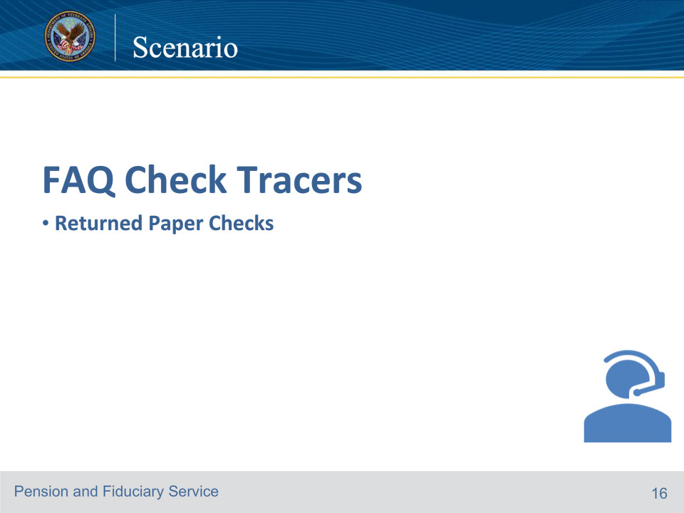

**Slide notes**

Good morning. Thank you for calling the Fiduciary Contact Center. My name is Lisa. May I start with your first and last name?

My name is Larry Butler, and I’m a Fiduciary.

Hi, Mr. Butler. How are you doing today?

I’m doing okay.

May I have the Veterans file number or social security number for verification purposes?

The file number is 555-55-5555.

Great, thank you. Can I have the Veteran’s name and date of birth as well?

Jane Moore, and their date of birth is June 27, 1955.

Do you know their branch of Service?

Yes, they were in the Navy.

Thank you for that information. How may I assist you today?

I would like to report I never got the retroactive payment for the Veteran.

It looks like the retroactive payment was returned due to a bad address. Can you please verify your address?

My address is 5000 Main Street Denver, Colorado 80211.

Please be advised it takes 10-14 calendar days for the VA to reissue payment.

Ok.

It is required to have a direct deposit account. This account is required to be a properly titled account. A properly titled account is titled in the beneficiary’s and fiduciary’s names and identifies the fiduciary relationship.

I just got appointed the fiduciary.

I will mail a copy of the SF 1199A. Please note the form must be returned within 30 days.

Thank you.

You’re welcome. Is there anything else I can help you with?

No.

Have a great day.

You too.

Course of action: Update the address information in SHARE (if applicable). Complete a VA Form 27-0820d.

Establish a Properly Titled Account administrative task to track receipt of the properly titled account. Send an SF 1199A.

References: FCC FAQs 22.a.

**Slide 18 - Scenario**

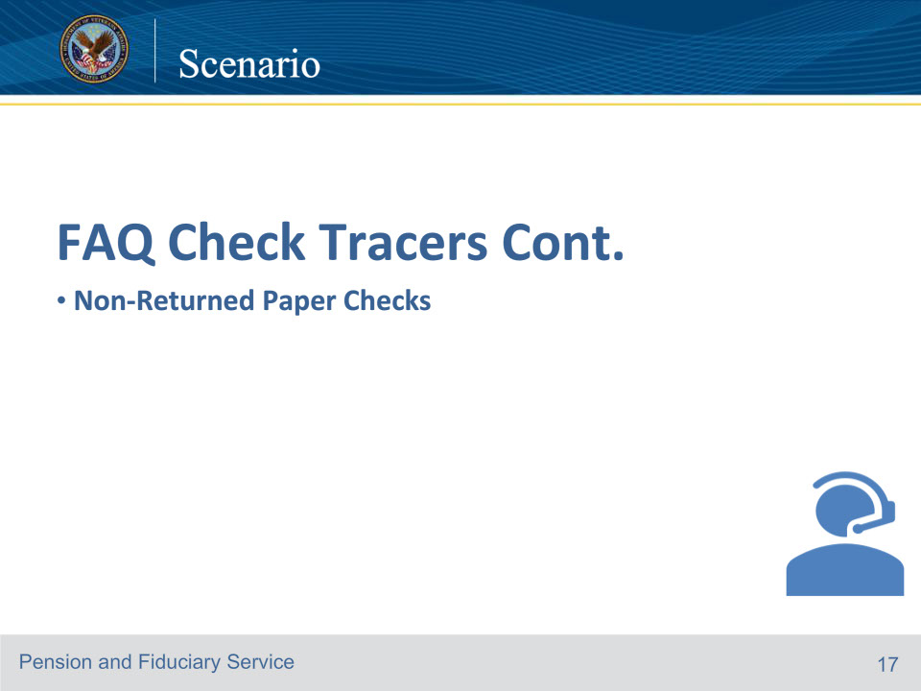

**Slide notes**

Good morning. Thank you for calling the Fiduciary Contact Center. My name is Lisa. May I start with your first and last name?

My name is Larry Butler, and I’m a Fiduciary.

Hi, Mr.Butler. How are you doing today?

I’m doing okay.

May I have the Veterans file number or social security number for verification purposes?

The file number is 555-55-5555.

Great, thank you. Can I have the Veteran’s name and date of birth as well?

Jane Veteran, and their date of birth is June 27,1955.

Do you know their branch of Service?

Yes, they were in the Navy.

Thank you for that information. How may I assist you today?

I would like to report I never got the retroactive payment for the veteran.

It looks like the paper check was mailed to your address. Can you please verify your address?

My address is 5000 Main Street Denver, Colorado 80211.

I will forward this information to the appropriate department to have the check traced. Please be advised the check tracer process takes two to six weeks to complete.

Ok.

It is required to have a direct deposit account. This account is required to be a properly titled account. A properly titled account is titled in the beneficiary’s and fiduciary’s names and identifies the fiduciary relationship.

I just got appointed the fiduciary.

I will mail a copy of the SF 1199A. Please note the form must be returned within 30 days.

Thank you.

You’re welcome. Is there anything else I can help you with?

No.

Have a great day.

You too.

Course of action: Update the address information in SHARE (if applicable). Complete a VA Form 27-0820d. Establish a Properly Titled Account administrative task to track receipt of the properly titled account. Send an SF 1199A.

Important: Prior to advising the caller a properly titled account is required, ensure they are not excluded from the properly titled account requirement.

If the check tracer is required.

establish an EP 400 with the claim label FID-CORRESPONDENCE, and

ensure the completed VA Form 27-0820d details five business days have passed, and the payment needs a check tracer completed.

If the EP 400 is established, the DOC, is required to match the date of the VA Form 27-0820d.

References: FCC FAQs 22.b. For more information on properly titled account see FPM, Part II, 1.B.2.a.

**Slide 19 - Scenario**

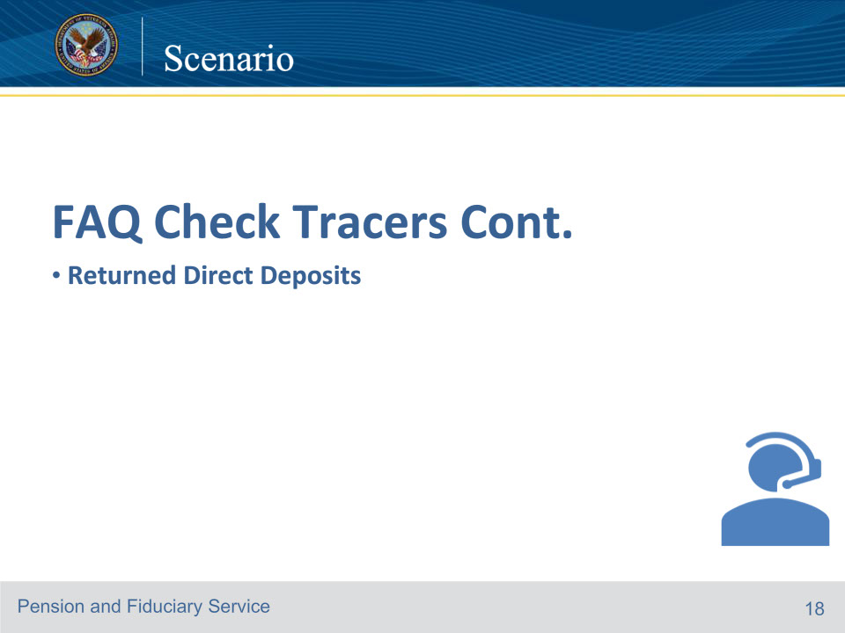

**Slide notes**

Good morning. Thank you for calling the Fiduciary Contact Center. My name is Lisa. May I start with your first and last name?

My name is Larry Butler, and I’m a Fiduciary.

Hi, Mr. Butler. How are you doing today?

I’m doing okay.

May I have the Veterans file number or social security number for verification purposes?

The file number is 555-55-5555.

Great, thank you. Can I have the Veteran’s name and date of birth as well?

Jane Veteran, and their date of birth is June 27, 1955

Do you know their branch of Service?

Yes, they were in the Navy.

Thank you for that information. How may I assist you today?

I would like to report I set up my direct deposit as the fiduciary and I didn’t get the VA payment on December 31, 2023

I need you to verify the account and routing number.

The routing number is 123456789 and the account number is 12345678910.

I will forward this information to the appropriate department. If it is found that payment was returned, it takes 10-14 calendar days for the payment to be reissued.

Ok, thank you.

You’re welcome. Is there anything else I can help you with?

No.

Have a great day.

You too.

Course of action: Complete a VA Form 27-0820d. Establish an EP 400 with the claim label FID-CORRESPONDENCE.

Important: The Date of claim for the EP 400 is required to match the date of the VA Form 27-0820d.

References: FCC FAQs 22.c.

**Slide 20 - Scenario**

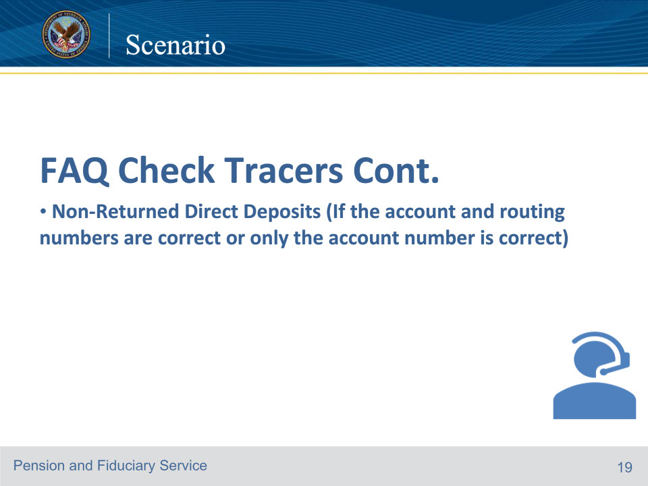

**Slide notes**

Good morning. Thank you for calling the Fiduciary Contact Center. My name is Lisa. May I start with your first and last name?

My name is Larry Butler, and I’m a Fiduciary.

Hi, Mr. Butler. How are you doing today?

I’m doing okay.

May I have the Veterans file number or social security number for verification purposes?

The file number is 555-55-5555.

Great, thank you. Can I have the Veteran’s name and date of birth as well?

Jane Veteran, and their date of birth is June 27,1955.

Do you know their branch of Service?

Yes, they were in the Navy.

Thank you for that information. How may I assist you today?

I would like to report I set up my direct deposit as the fiduciary and I didn’t get the VA payment on December 31, 2023.

It looks like the payment wasn’t returned. I need you to verify the account and routing number.

The routing number is 123456789 and the account number is 12345678910.

It looks like the routing number and account number are correct. Please contact the financial institution as they may be able to match the social security number to the VA payment.

Ok, thank you.

You’re welcome. Is there anything else I can help you with?

No.

Have a great day.

You too.

Course of action: In this scenario, the LAS should document the call on a VA Form 27-0820,  Report of General Information, and upload it to the proper e-Folder.

If caller advises they have verified with the bank that payment was not received, and 3 business days have passed

VA Form 27-0820d is required to be completed

establish an EP 400 with the claim label FID-CORRESPONDENCE, and

advise the caller a check tracer will need to be completed and the process takes two to six weeks.

References: FCC FAQs 22.c.

**Slide 21 - Scenario**

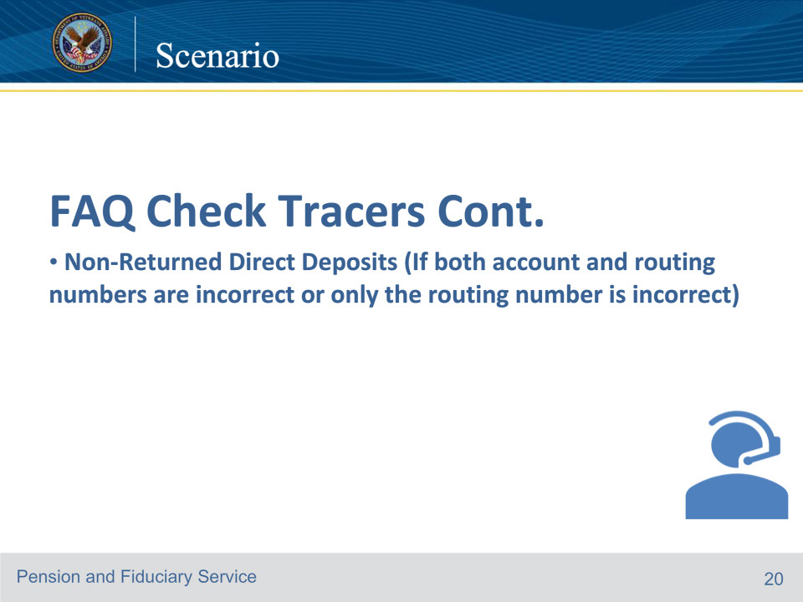

**Slide notes**

Good morning. Thank you for calling the Fiduciary Contact Center. My name is Lisa. May I start with your first and last name?

My name is Larry Butler, and I’m a Fiduciary.

Hi, Mr. Butler. How are you doing today?

I’m doing okay.

May I have the Veterans file number or social security number for verification purposes?

The file number is 555-55-5555.

Great, thank you. Can I have the Veteran’s name and date of birth as well?

Jane Veteran, and their date of birth is June 27,1955.

Do you know their branch of Service?

Yes, they were in the Navy.

Thank you for that information. How may I assist you today?

I would like to report I set up my direct deposit as the fiduciary and I didn’t get the VA payment on December 31, 2023

It looks like the payment wasn’t returned. I need you to verify the account and routing number.

The routing number is 1 2 3 4 5 6 7 8 9 and the account number is 1 2 3 4 5 6 7 8 9 1 0.

It looks like the routing number was incorrect. I apologize for this inconvenience. An updated SF 1199A is required to be completed and I will mail this.

I will forward the missing payment information to the appropriate department.

Ok, thank you, How long will this take to get the payment?

You’re welcome. It takes 10-14 calendar days for the payment to be reissued. Is there anything else I can help you with?

No.

Have a great day.

You too.

Course of action: Complete VA Form 27-0820d. Establish an EP 400 with the claim label FID-CORRESPONDENCE, to ensure the check tracer is routed to the appropriate department for review.

Establish a Properly Titled Account administrative task to track the receipt of the SF 1199A.

If caller advises they have verified with the bank that payment was not received, and 3 business days have passed:

VA Form 27-0820d is required to be completed

establish an EP 400 with the claim label FID-CORRESPONDENCE, and

advise the caller a check tracer will need to be completed and the process takes two to six weeks.

Review the previously submitted SF 1199A.

If the account and/or routing number is incorrect on the form, a new form must be completed.

The DOC for the EP 400, is required to match the date of the VA Form 27-0820d.

References: FCC FAQs 22.c.

**Slide 22 - Scenario**

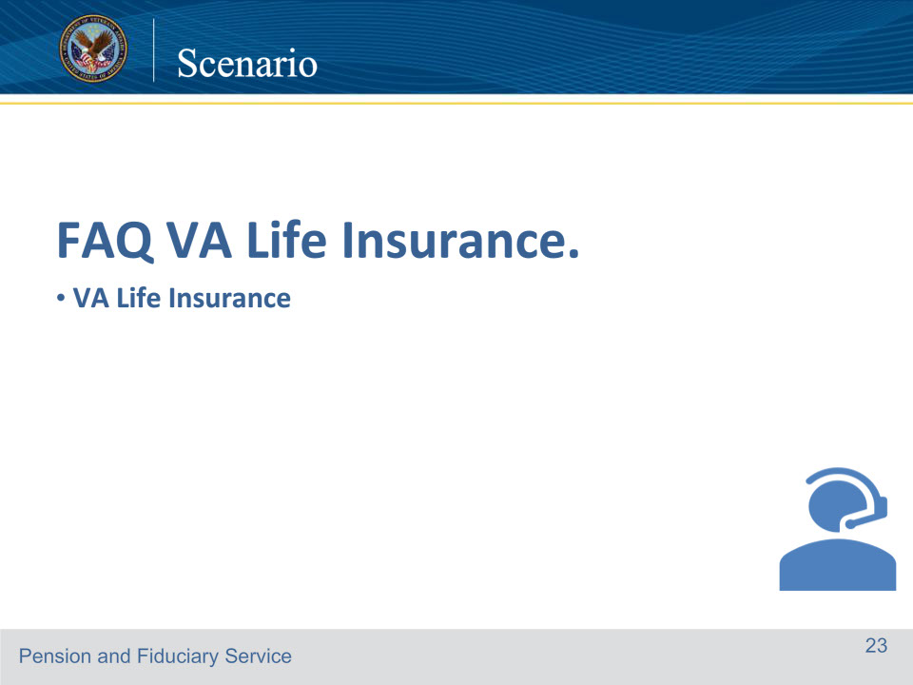

**Slide notes**

Good morning. Thank you for calling the Fiduciary Contact Center. My name is Lisa. May I start with your first and last name?

My name is Oliver Hayes, and I’m the Fiduciary for Jessica Hayes.

Hi, Mr. Hayes. How are you doing today?

I’m doing okay.

May I have the Veterans file number or social security number for verification purposes?

The file number is 555-55-5555.

Great, thank you. Can I have the Veteran’s name and date of birth as well?

Jessica Hayes and their date of birth is June 27, 1943

Do you know their branch of Service?

Yes, she was in the Air Force.

Thank you for that information. How may I assist you today?

My mother passed away and had VA life Insurance that she left to my two kids. They are under 18 so what will happen next?

I am sorry for your loss. The hub will appoint a fiduciary for a minor that is in receipt of a VA Life Insurance benefit. Once the fiduciary is appointed, the hub will notify

the Life Insurance Center to release the funds. Questions regarding this benefit and release of funds will need to be directed to the Insurance Center. Their phone number is 800-669-8477. Would you like to be transferred?

No, thank you for explaining the process.

You’re welcome. Is there anything else I can assist you with today?

No, have a great day.

Have a great day as well.

Lisa: Have a great day as well.

Course of action: In this scenario, the LAS should document the call on a VA Form 27-0820, Report of General Information, and upload it to the proper e-Folder.

Note: Release of insurance benefit funds will not be seen in the SHARE PAYMENT Screen.

Reference: For more information on VA life insurance, see the VA life insurance website. VA Life Insurance | Veterans Affairs

References: FCC FAQs 25.a.

**Slide 23 - Scenario**

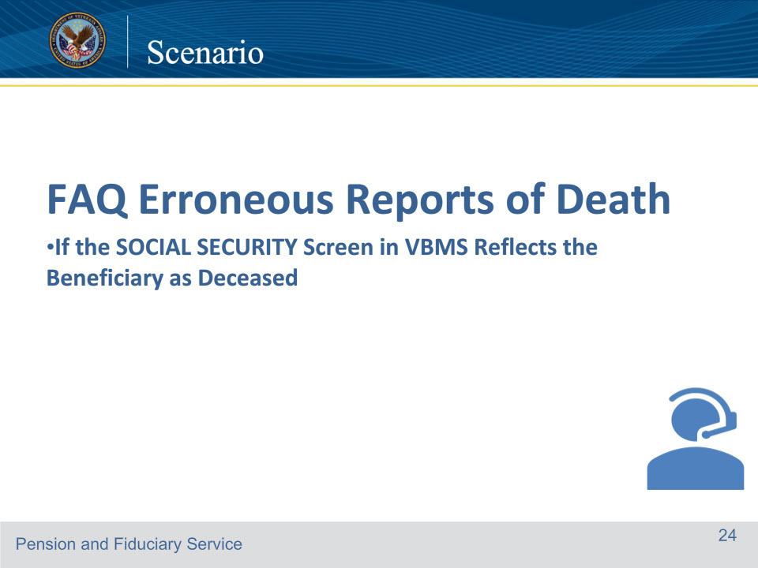

**Slide notes**

Good morning. Thank you for calling the Fiduciary Contact Center. My name is Jason. May I start with your first and last name?

My name is Tammy Hendrix.

Hi, Ms. Hendrix. How are you doing today?

I’m doing okay.

May I have the veteran’s file number or social security number for verification purposes?

I’m the Veteran; my file number is 555-55-5555.

Great, thank you. Can I have your date of birth?

July 6, 1968.

What’s your branch of Service?

Army.

Thank you for your service. How may I assist you today?

I have received notices from the VA that I passed away and they stopped my VA compensation.

Let me review the record, My apologies, being that the Social Security Administration also has a report of death, you will have to physically go to the SSA office to correct this issue.

Once you have documentation that supports the report of death is erroneous, you may send this information to the Department of Veterans Affairs Claims Intake Center, PO Box 5235, Janesville, WI 53547-5235.

Ok, I will go to the Social Security office and straighten this out.

Is there anything else I can assist you with today?

No, that’s all. Have a great day.

Have a great day as well.

Course of action: In this scenario, the LAS should document the call on a VA Form 27-0820, Report of General Information and upload it to the proper e-Folder.

The LAS should review the eFolder to determine if there is a report of death from the social Security Administration.

After locating the report, they should inform the Veteran that they must contact the Social Security Office to make corrections and then submit proof to the Claims Intake Center.

References: FCC FAQs 26.a.

**Slide 24 - Scenario**

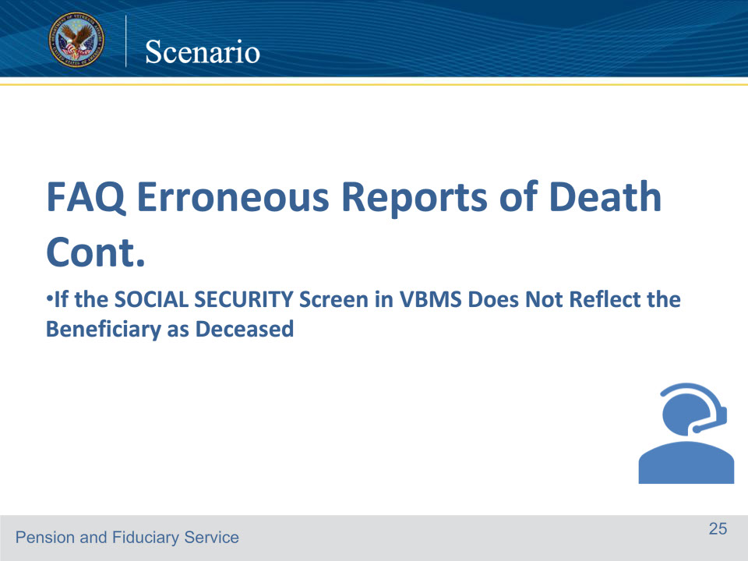

**Slide notes**

Good morning. Thank you for calling the Fiduciary Contact Center. My name is Jason. May I start with your first and last name?

My name is Tammy Hendrix.

Hi, Ms. Hendrix. How are you doing today?

I’m doing okay.

May I have the Veteran’s file number or social security number for verification purposes?

I’m the Veteran; my file number is 555-55-5555.

Great, thank you. Can I have your date of birth?

July 6, 1968.

What’s your branch of Service?

Army.

Thank you for your service. How may I assist you today?

I have received notices from the VA that I passed away and they stopped my VA compensation.

Let me review the record, Thank you for this information. I will forward this information to the appropriate department to get this information correctly updated.

Thank you.

Is there anything else I can assist you with today?

No, that’s all. Have a great day.

Have a great day as well.

Course of action: In this scenario, the LAS should document the call on a VA Form 27-0820, Report of General Information and upload to the proper e-Folder. Establish an EP 290 with the claim label FIDHUBADJ

Important: The date of claim for the EP 290, is required to match the date of the VA Form 27-0820.

Ensure the completed VA Form 27-0820 details,

the Veteran/Beneficiary was erroneously reported as deceased

the Veteran/Beneficiary is still alive

if the award is terminated or suspended

a request to resume the benefits, and

the date or dates of any missing payments.

References: FCC FAQs 26.b.

**Slide 25 - Scenario**

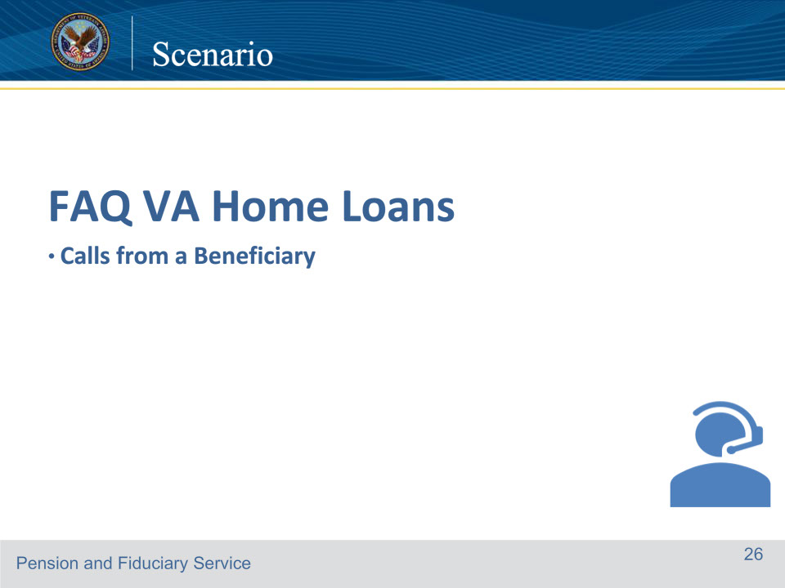

**Slide notes**

Good morning. Thank you for calling the Fiduciary Contact Center. My name is Robert. May I start with your first and last name?

My name is Shelia Thomas

Hi, Ms. Thomas. How are you doing today?

I’m doing well. I have a general question about VA home loans. I heard I must get approval from the fiduciary hub before applying for a VA Home Loan

My apologies, the Fiduciary Hub no longer concurs on VA Home Loans and does not conduct field exams for this reason. Please contact the VA Home Loan Center at 877-827-3702.

That’s good to know.

Is there anything else I can assist you with today?

No, you’ve answered all my questions. Thank you.

Have a great day.

You do the same.

Course of action: In this scenario, the ID protocol was incomplete, so only general information could be provided. The VA Form 27-0820 Report of General Information is not required as no record was accessed.

References: FCC FAQ 27.a. For more information on VA home loan approval requests, see FPM Part I, 4.B.3.a.

**Slide 26 - Scenario**

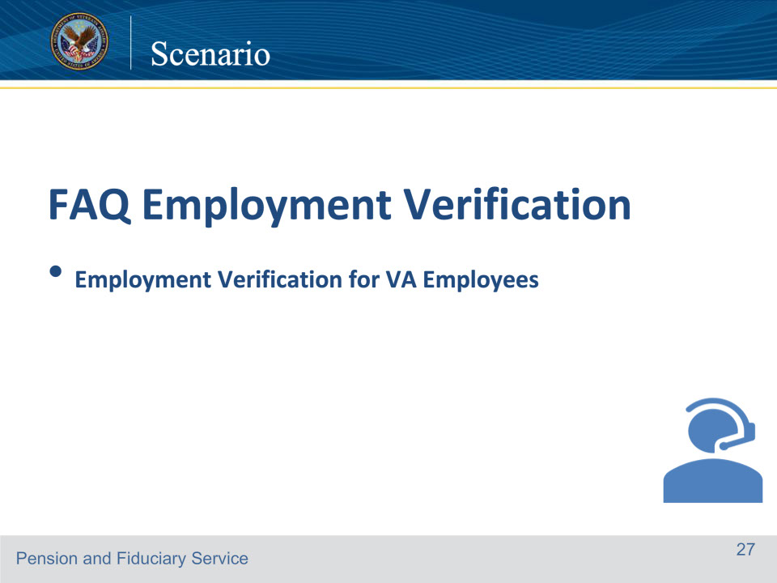

**Slide notes**

Good morning. Thank you for calling the Fiduciary Contact Center. My name is Robert. May I start with your first and last name?

My name is Maggie Ford.

Hi, Ms. Ford. How are you doing today?

I’m doing okay.

May I have the Veteran’s file number or social security number for verification purposes?

I work for the VA and I was wondering if you could provide employment verification to a bank for an auto loan

My apologies, the Fiduciary Contact Center is unable to provide employment verification. Please contact the employment verification line at 1-800-367-5690.

The Department of VA employer’s code is 10208.

OK, thank you that is helpful.

Is there anything else I can assist you with?

No, you’ve answered my question.

If there are no further questions, have a great day.

You too.

Course of action: In this scenario, the ID protocol was incomplete, so only general information could be provided. The VA Form 27-0820 Report of General Information is not required as no record was accessed.

References: FCC FAQs 28.a.

**Slide 27 - 31. Questions?**

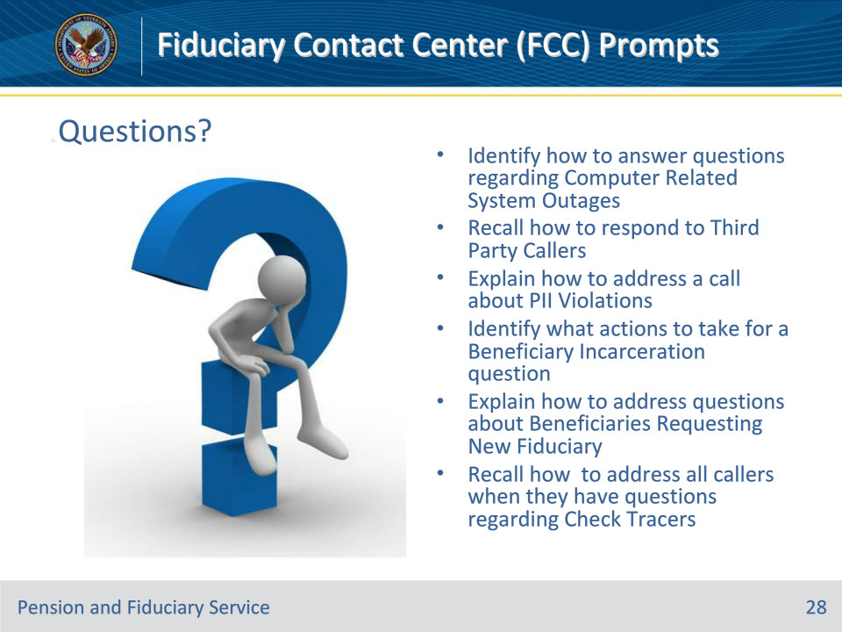

**Slide notes**

These are our learning objectives as stated from the beginning of the training:

Identify how to answer questions regarding Computer Related System Outages

Recall how to respond to Third Party Callers

Explain how to address a call about PII Violations

Identify what actions to take for a Beneficiary Incarceration question

Explain how to address questions about Beneficiaries Requesting New Fiduciary

Recall how to address all callers when they have questions regarding Check Tracers

**Slide 28 - 31. Questions?**

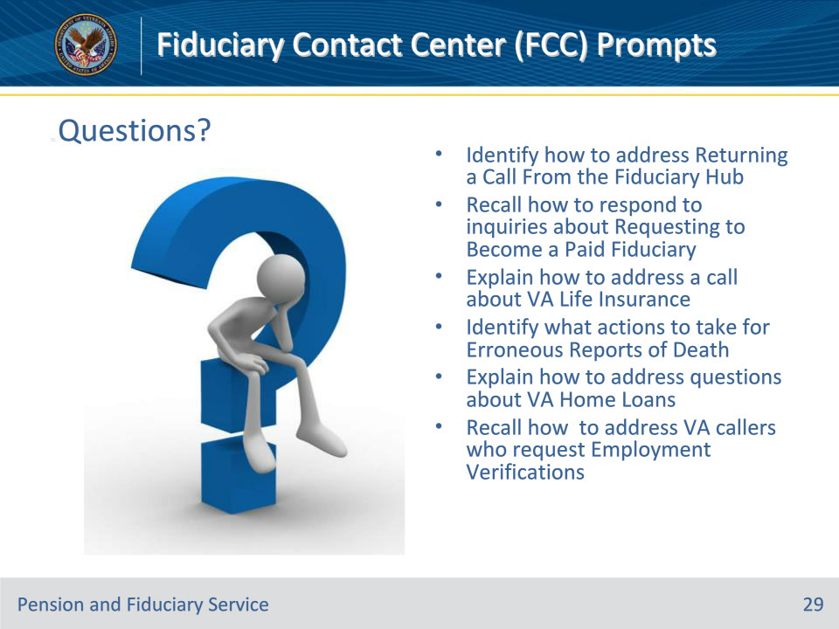

**Slide notes**

Learning objectives continued as stated from the beginning of the training:

Identify how to address Returning a Call From the Fiduciary Hub

Recall how to respond to inquiries about Requesting to Become a Paid Fiduciary

Explain how to address a call about VA Life Insurance

Identify what actions to take for Erroneous Reports of Death

Explain how to address questions about VA Home Loans

Recall how to address VA callers who request Employment Verifications

**Slide 29 - TMS Survey**

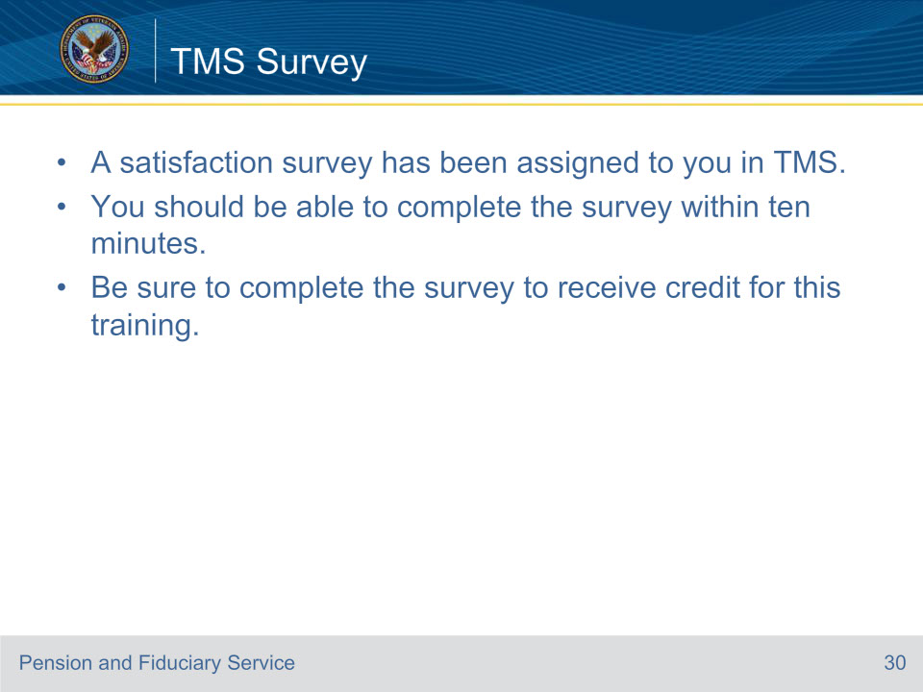

**Slide notes**

A satisfaction survey has been assigned to you in TMS. You should be able to complete it within ten minutes.

Completing it will allow you to receive credit for this training.