Slide 1 - FCC FAQs Scenarios Part 1
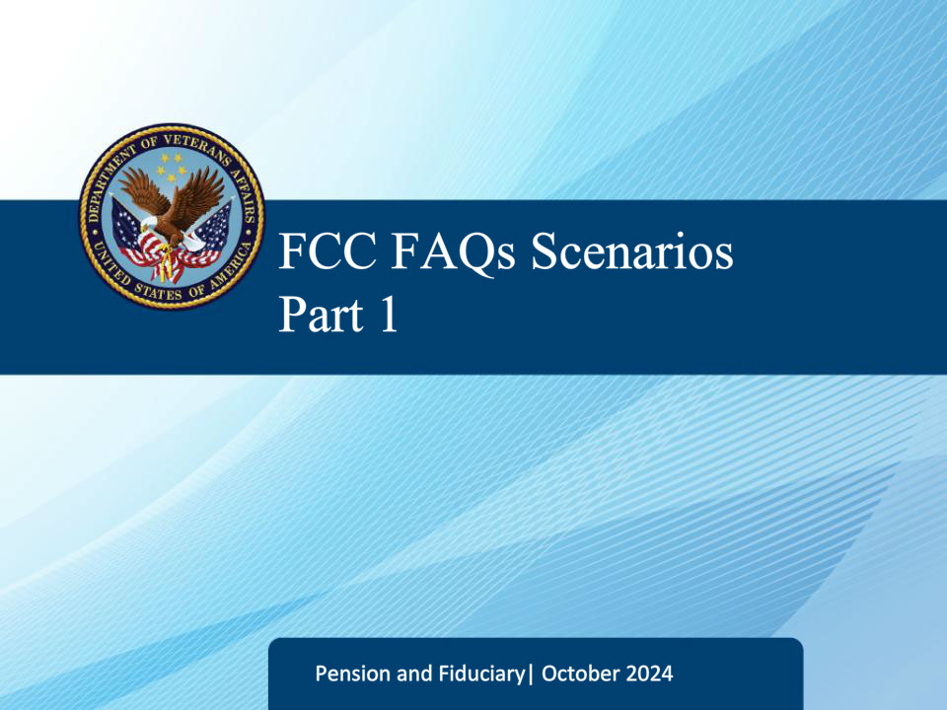
Slide notes

Welcome to the Fiduciary Contact Center Frequently Asked Questions Scenarios Part 1 training. The purpose of this course is to help Legal Administration Specialists prepare for their duties by providing real-life examples of frequently asked questions and scenarios that may arise while fielding calls. By going through these scenarios, you will learn how to handle different situations, communicate effectively with callers, and provide accurate and helpful information. This training aims to equip you with the necessary skills to better serve the customers and fulfill your role as a Legal Administration Specialist.

Slide 2 - FCC FAQs Scenarios
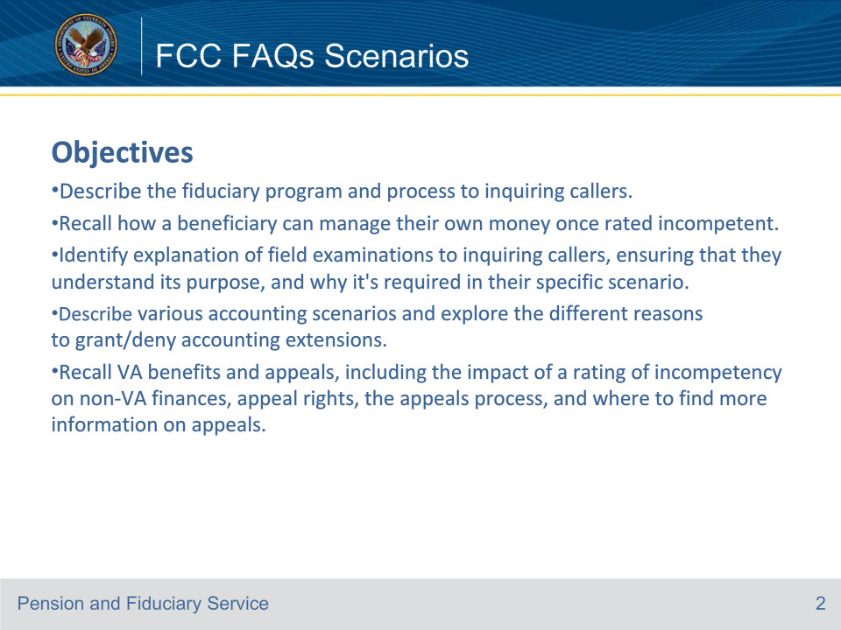
Slide notes

Describe the fiduciary program and process to inquiring callers.

Recall how a beneficiary can manage their own money once rated incompetent.

Identify explanation of field examinations to inquiring callers, ensuring that they understand its purpose, and why it’s required in their specific scenario.

Describe various accounting scenarios and explore the different reasons to grant/deny accounting extensions.

Recall VA benefits and appeals, including the impact of a rating of incompetency on non-VA finances, appeal rights, the appeals process, and where to find more information on appeals.

Slide 3 - FCC FAQs Scenarios
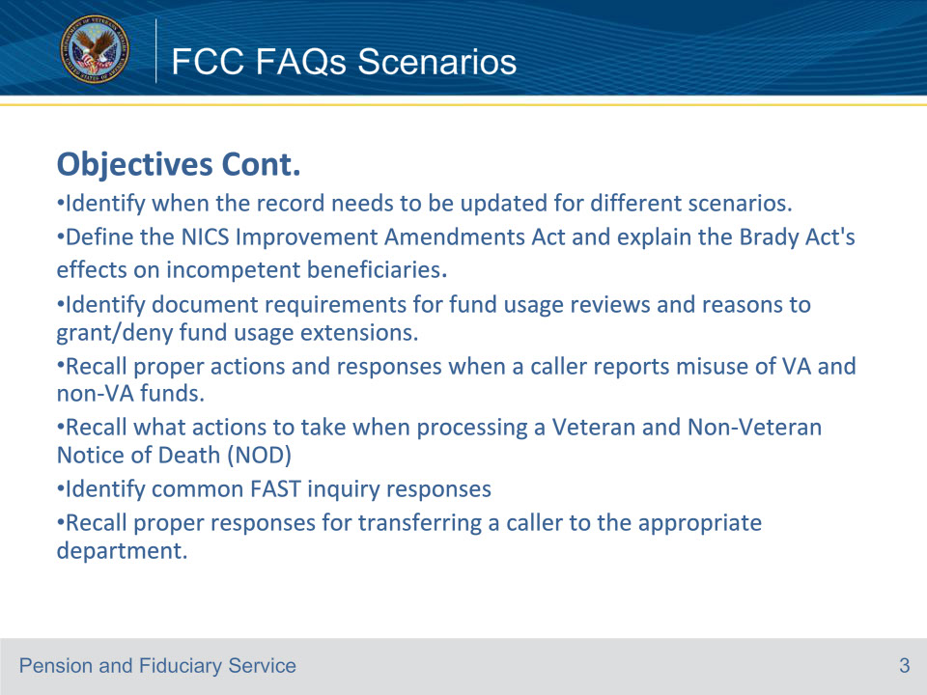
Slide notes

Objectives Cont.

Identify when the record needs to be updated for different scenarios.

Define the NICS Improvement Amendments Act and explain the Brady Act’s effects on incompetent beneficiaries.

Identify document requirements for fund usage reviews and reasons to grant/deny fund usage extensions.

Recall proper actions and responses when a caller reports misuse of VA and non-VA funds.

Recall what actions to take when processing a Veteran and Non-Veteran Notice of Death (NOD)

Identify common FAST inquiry responses

Recall proper responses for transferring a caller to the appropriate department.

Slide 4 - FCC FAQs Scenarios
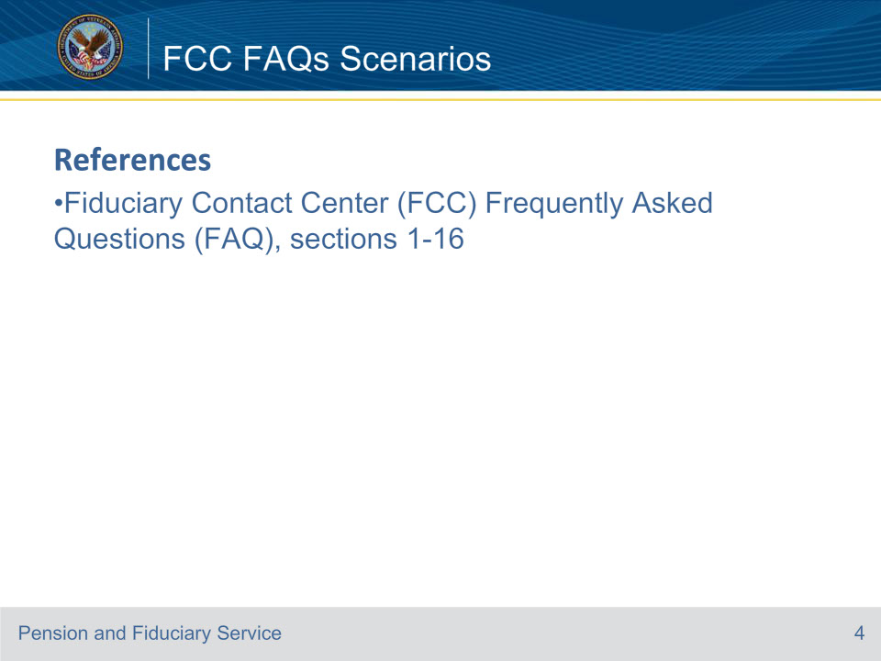
Slide notes

Instructor Notes:

Review references.

Slide 5 - FCC FAQs Scenarios
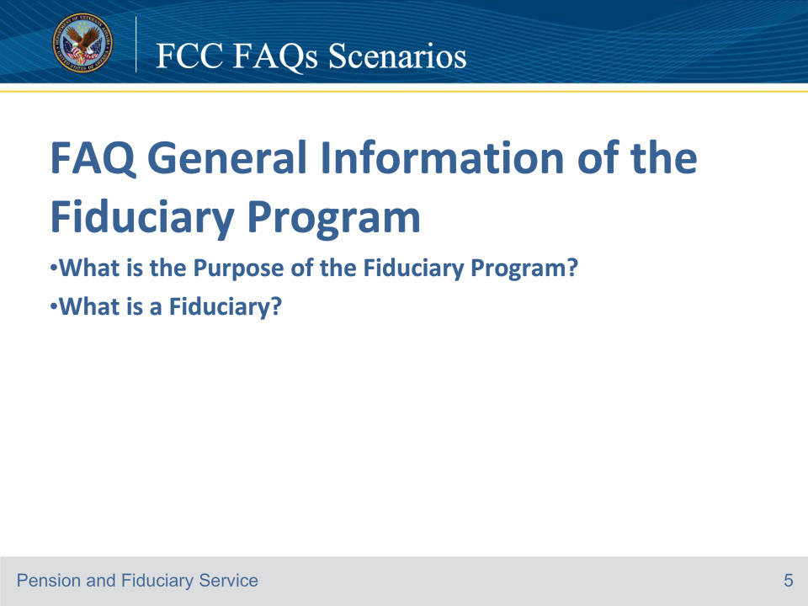
Slide notes

Jacob: Good morning. Department of Veterans Affairs. My name is Jacob. To better assist you may I have the Veteran’s file number or Social Security Number.

Susie: I don’t have a file number or Social Security number.

Jacob: Unfortunately, without that information, I cannot access the record and can only provide general information.

Susie: I want to know the purpose of the fiduciary program. I’m just concerned about my brother being in this program.

Jacob: The purpose of the program is to provide oversight to our most vulnerable beneficiaries who are unable to manage their VA benefit.

Susie: What’s a fiduciary?

Jacob: A fiduciary is a person or legal entity (such as a bank) charged with the duty of managing the estate of a beneficiary who is unable to manage their VA funds. Have I answered your questions?

Susie: Yes, you have. Thank you, Jacob.

Jacob: Is there anything else I can assist you with?

Susie: No, have a great day!

Course of action: In this scenario, the ID protocol was incomplete, so only general information could be provided. The VA Form 27-0820 Report of General Information is not required as no record was accessed.

References: FCC FAQs 1.a through b.

For more information on general fiduciary responsibilities, see FPM, Part I, 1.B.4.a.

Slide 6 - FCC FAQs Scenarios
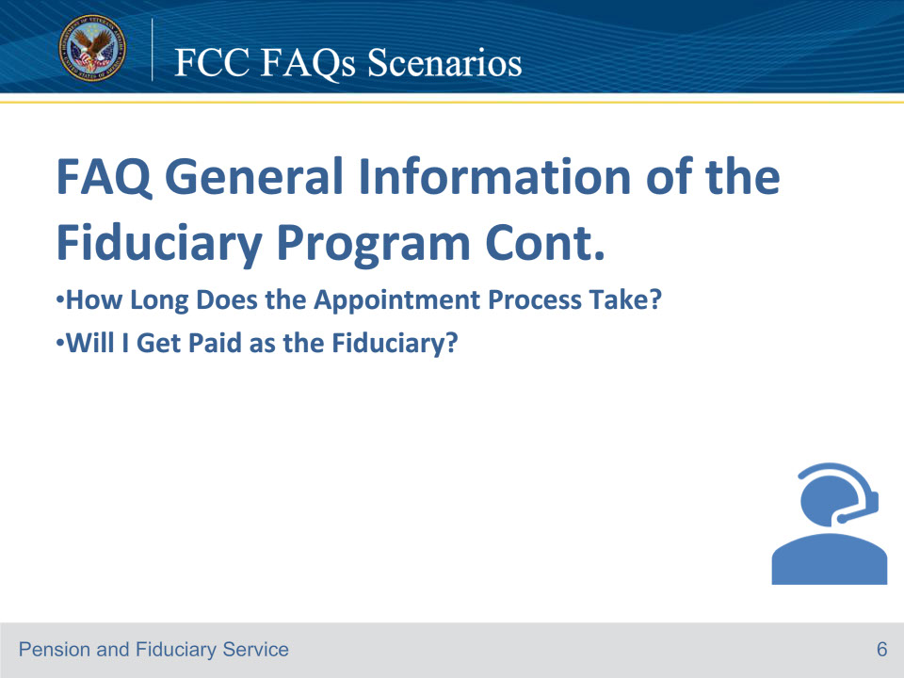
Slide notes

Jacob: Good morning. Department of Veterans Affairs. My name is Jacob. To better assist you may I have the Veteran’s file number or Social Security Number?

John: Sure, it’s 555-55-555.

Jacob: Can you verify the Veteran’s or Beneficiary’s Date of Birth?

John: The Veteran’s date of birth is January 30, 1958.

Jacob: Can you verify the branch of service?

John: The branch of service is the Navy.

Jacob: Thanks for that information. How may I help you?

John: I’m calling on behalf of my brother, Tom Coleman. I am Jacob Coleman.

Jacob: Have you submitted a VA Form 21-0845, which is a form that grants us authorization to disclose personal information to a third party?

John: No, I have not.

Jacob: At this time, I can only provide you with general information.

John: I don’t know if this is general, but how long would it take me to become my brother’s fiduciary? He received a letter in the mail saying one would be appointed.

Jacob: There isn’t an exact timeframe for the appointment process. Each appointment process is unique to each individual beneficiary. Once a fiduciary has been appointed, your brother will receive a written notification in the mail.

John: If I were to become the fiduciary, would I get paid?

Jacob: In this case, you are a family member; therefore, compensation will not be provided. Is there anything else I can help you with?

John: No, thanks!

Jacob: Have a great day!

Course of action: In this scenario, the caller could not provide a VA Form 21-0845, a document used to authorize the disclosure of personal information to a third party. As a result, only general information can be shared. To properly document the phone call, the LAS should complete VA Form 27-0820, Report of General Information, and upload it to the proper e-folder since the third party was able to successfully answer the ID protocol questions.

References: FCC FAQs 1.c through d

For more information on the purpose of the Fiduciary Program, see FPM, Part I, 1.B.3.a

For more information on general fiduciary responsibilities, see FPM, Part I, 1.B.4.a.

For more imitations on fees, see FPM, Part II, 1.C.4.b

For more information on selecting a qualified fiduciary, see FPM, Part I, 1.B.3.c.

Slide 7 - FCC FAQs Scenarios
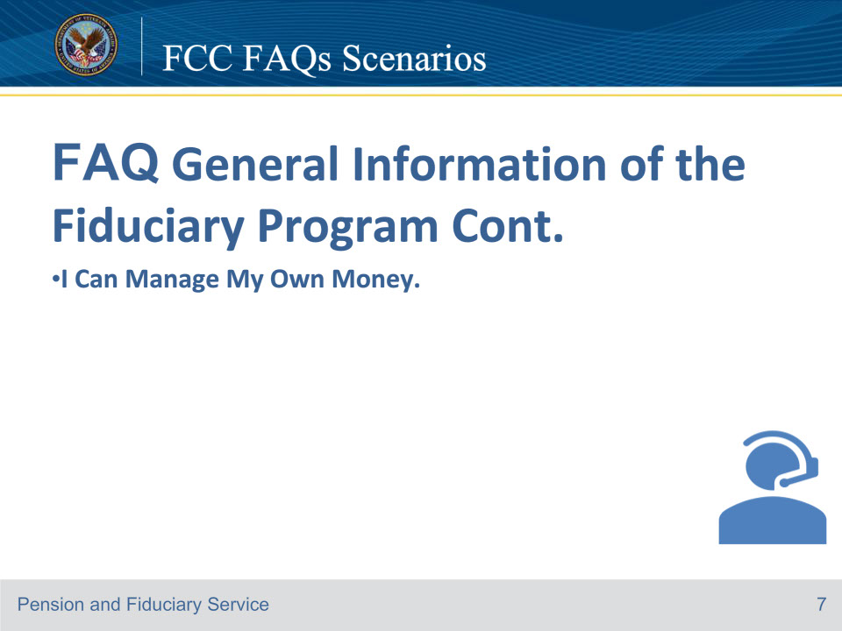
Slide notes

Katie: Good morning. Department of Veterans Affairs. My name is Katie. To better assist you may I have the Veteran’s file number or Social Security Number?

Jane: My file number is 555-55-5555.

Katie: Great, thank you. Can you verify your date of birth?

Jane: My date of birth is June 27, 1954.

Katie: Can you verify your branch of service?

Jane: My branch of service is the Marines.

Katie: What is your full name?

Jane: Jane Johnson

Katie: Thank you for your service. How may I help you?

Jane: A fiduciary was recently appointed for me, but I don’t need one. So how can I manage my own money?

Katie: Has any of your contact information changed?

Jane: No

Katie: The VA and/or State court has been provided evidence indicating that you may need some assistance managing your monthly VA benefit and expenses. If you demonstrate the ability to manage your funds, the decision can be revisited in the future. Is there anything else I can help you with?

Jane: No, thanks for your help.

Katie: You’re welcome. Have a great day.

Course of action: In this scenario, the LAS should complete a VA Form 27-0820, Report of General information documenting the phone call, and upload it to the proper e-Folder. If the Veteran has further questions on restoring their competency, refer to the manual reference identified in this scenario.

References: FCC FAQs 1.e

For more information on evidence to restore competency, see M21-1, Part X. Subpartii.6.A.4.d

Slide 8 - FCC FAQs Scenarios
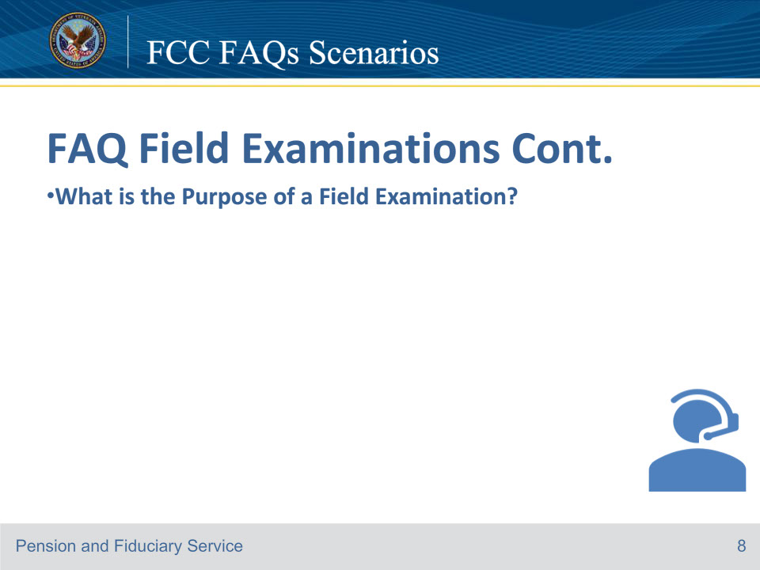
Slide notes

Katie: Department of Veterans Affairs. My name is Katie. To better assist you may I have the Veteran’s file number or Social Security Number?

Frank: I don’t have a file number. I’m a VA social worker, and I have a quick question.

Katie: What’s your question?

Frank: Why does a person need a field examination?

Katie: The VA will conduct field examinations for the purpose of performing oversight of beneficiaries in the Fiduciary Program and to provide supervision of fiduciaries appointed to manage their VA benefits.

Katie: Does that answer your question?

Frank: Yes, it does, thank you.

Katie: Is there anything else I can help you with?

Frank: No, there isn’t.

Katie: Have a great day.

Frank: You too.

Course of action: In this scenario, there is no need for the LAS to complete a VA Form 27-0820 Report of General Information since the question was not related to a specific Veteran or beneficiary file. The LAS should use general information when answering the question.

References: References: FCC FAQs 2.a

Slide 9 - FCC FAQs Scenarios
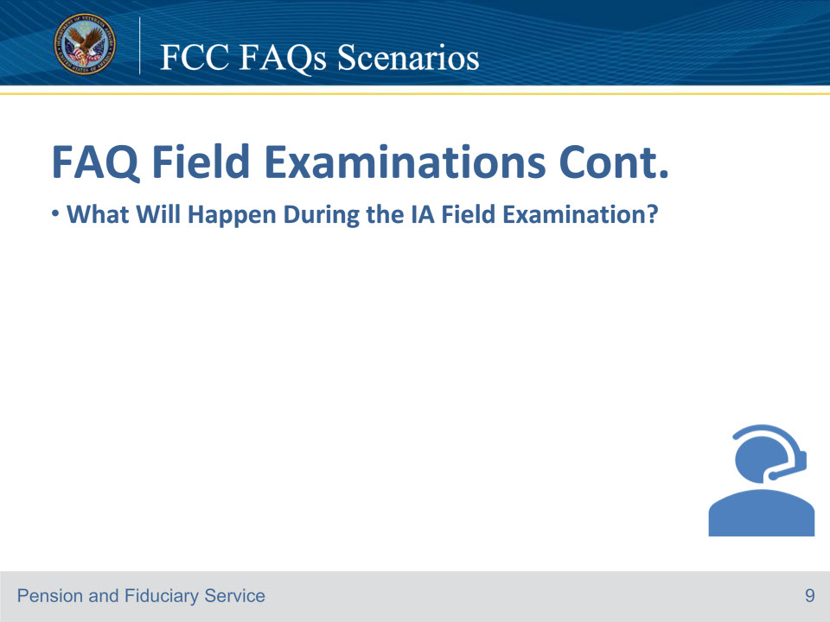
Slide notes

Jacob: Department of Veterans Affairs. My name is Jacob. To better assist you may I have the Veteran’s file number or Social Security Number?

Jane: I don’t have that information with me right now.

Jacob: Unfortunately, I’m unable to access the file without that information, but I can provide general information if that will help.

Jane: I received a voicemail from someone who says that they are VA Field Examiner and they would like to schedule an initial appointment field examination. I would like to know what will happen during the initial field examination.

Jacob: Initial Appointment field examinations are completed to assess the needs and well-being of the beneficiary and their dependents, evaluate the ability of an adult beneficiary to manage funds, identify a proposed fiduciary, and determine the suitability of the proposed fiduciary. The field Examiner will document income and expenditures for the beneficiary, ensure VA funds are properly protected, if required, and provide advice and assistance with benefits and needs. Have I answered all of your questions today?

Jane: Yes

Jacob: I hope you have a great day.

Jane: Thank you very much. Have a great day too!

Course of action: In this scenario, there is no need to complete VA Form 27-0820 Report of General Information, as the caller’s question was not related to a specific Veteran or beneficiary file. The LAS should use general information when answering the question and end the call without further action.

References: FCC FAQs 2.b

Slide 10 - FCC FAQs Scenarios
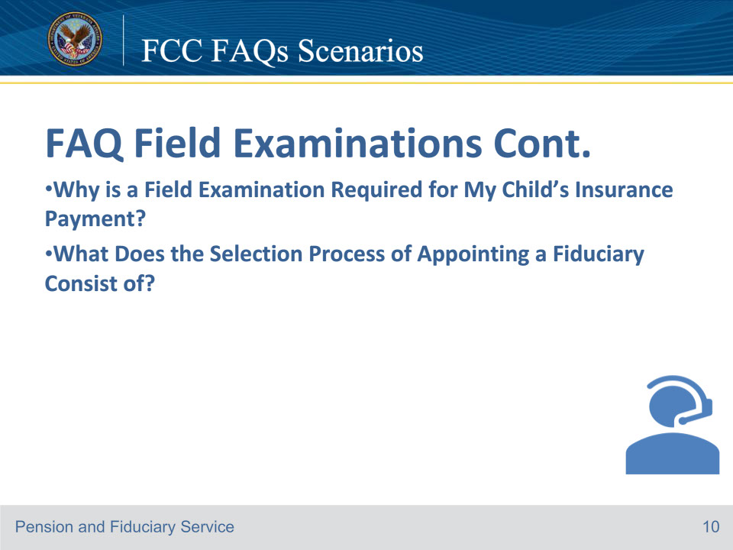
Slide notes

Jacob: Department of Veterans Affairs. My name is Jacob. To better assist you may I have the Veteran’s file number or Social Security Number?

Sam Alexander: My dad’s file number is 555-55-5555.

Jacob: Thank you. Can you verify the Veteran’s date of birth?

Sam: His date of birth is June 29, 1944.

Jacob: What was your father’s branch of service?

Sam: Marines.

Jacob: What is your father’s full name

Sam: Justin Alexander

Jacob: What is your full name

Sam: Sam Alexander

Sam Alexander: Thank you

Jacob: How may I assist you?

Sam Alexander: My father passed away and left a VA insurance policy for my son Jesse. Why is a field examination required for my child’s insurance payment? I don’t understand.

Jacob: I am sorry for your loss. Thank you for your father’s service.

Sam: Thank you.

Jacob: Okay, I have accessed the record and see a field examination pending. You wanted to know why a field examination is required; is that correct?

Sam: yes.

Jacob: Insurance payments are considered VA benefits, and a fiduciary is required whenever a beneficiary under the age of majority is in receipt of those benefits. Also, the VA insurance policy requires that these payments be supervised by the hub.

Sam: What does the selection process of appointing a fiduciary consist of?

Jacob: Fiduciary selection is based on an assessment of the qualifications of the proposed fiduciary, which include

the willingness to serve and fulfill the responsibilities of a fiduciary, an interview with the prospective fiduciary

credit report review, if applicable, and an inquiry into the criminal background. Does this answer your question?

Sam: Yes, thank you.

Jacob: Is there anything else I can help you with?

Sam: No, not at this time. Thank you.

Course of Action: In this scenario, the LAS should complete a VA Form 27-0820, Report of General information documenting the phone call, and upload it to the proper e-Folder. Confirm there is a field examination pending under EP 590 Expedited Initial Appointed or EP initial appointment in some circumstances.

References: FCC FAQs 2.c through d

• For more information on special considerations for a beneficiary under the age of majority, see FPM, Part I, 2.A.2.h.

• For more information on selecting a qualified fiduciary, see FPM, Part I, 1.B.3.c, and general policy on appointment and fiduciary types, see FPM, Part I, 2.C.4.a.

• For more information on types of initial appointments field examinations, see FPM, Part I, 2.A.2.b.

Slide 11 - FCC FAQs Scenarios
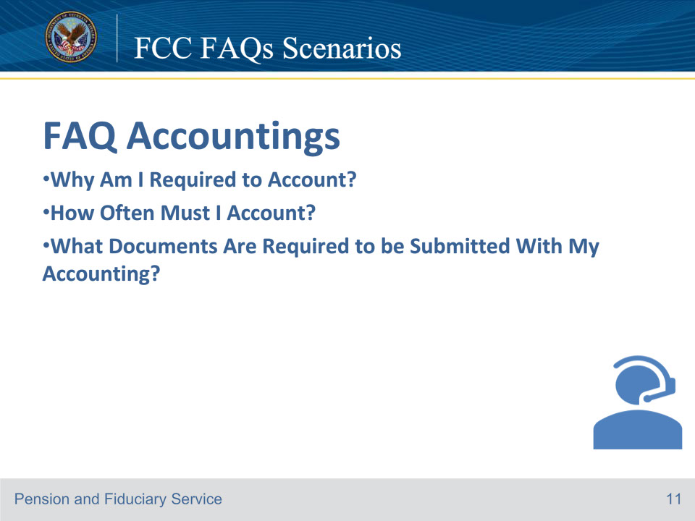
Slide notes

Lisa: Department of Veterans Affairs. My name is Lisa. To better assist you may I have the Veteran’s file number or Social Security Number?

Tom Smith: The Veteran’s file number is 555-55-5555.

Lisa: Can you verify the Veteran’s name and Date of Birth?

Tom Smith: Joe Veteran and their date of birth is March 15, 1954

Lisa: Can you verify their branch of Service?

Tom Smith: Yes, Joe was in the Army.

Lisa: What is your full name?

Tom Smith: Tom Smith I am the fiduciary for Joe Veteran.

Lisa: Thank you for that information. How may I assist you today?

Tom Smith: I want to know if I’m required to account?

Lisa: Let me check. Can you give me a moment to review the Veteran’s e-folder? Has any of your contact or payment information changed?

Tom Smith: No, it hasn’t. Sure, take your time.

Lisa: Okay, I’ve completed my review and see that you are required to account because you are deducting a VA-authorized fee. Does that answer your question?

Tom Smith: Yes, Lisa, thank you.

Lisa: Is there anything else I can assist you with?

Tom Smith: Yes, how often am I required to account?

Lisa: You must submit accountings on an annual basis.

Tom Smith: What documents are required to be submitted with my accounting

Lisa: The required documents for your accounting are financial statements detailing account transactions during the entire accounting period and the VA Form 21P-4706b, since you are a federal fiduciary, who is not an organization or entity. Is there anything else I can assist you with?

Tom Smith: No, thanks, Lisa. Have a great day.

Lisa: You too.

Course of action: Before providing an answer to the questions, the LAS should carefully review the e-Folder to check whether an accounting is required. If the LAS is uncertain, it is recommended to refer to all relevant manual references to determine the reasons and frequency of accountings. To determine which VA form is required, it is important to consider whether the fiduciary is an organization, entity, or court-appointed. Complete a VA Form 27-0820, Report of General information documenting the phone call, and upload it to the proper e-Folder.

Exception: If the accounting is submitted via FAST, the VA Form 21P-4706b or VA Form-21P-4706c isn’t required, as a form will be generated by the system. However, the FAST submission must contain

• the name of the beneficiary

• the VA file number associated with the beneficiary

• expenses, and

• income.

References: FCC FAQs 3.a through 3.c

For more information on VA-appointed fiduciaries, see FPM, Part I, 3.A.2.a.

For more information on accounting frequency, see FPM, Part I, 3.A.2.b.

For more information on elements of a complete accounting, see FPM, Part I, 3.A.3.a,

For more information on required financial institution statements, see FPM, Part I, 3.A.3.g.

Slide 12 - FCC FAQs Scenarios
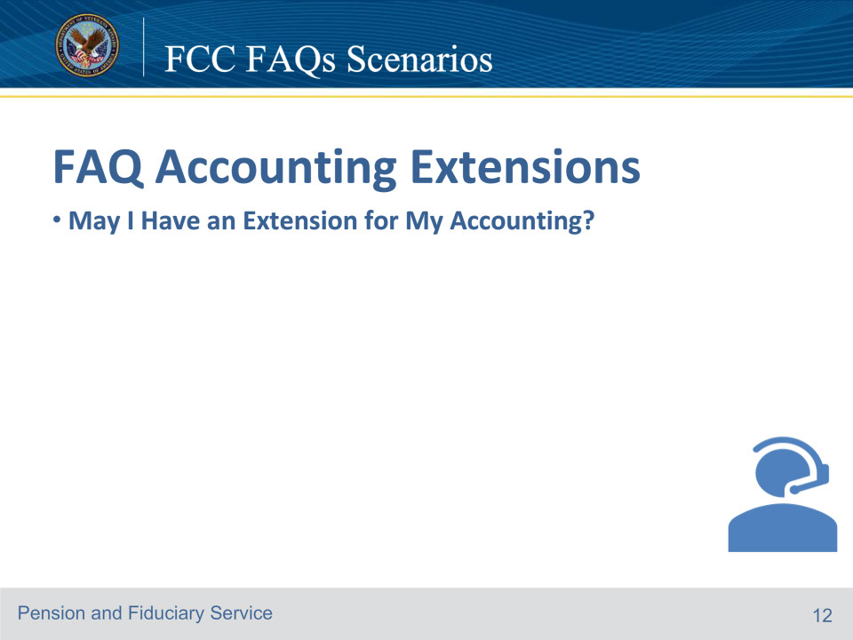
Slide notes

Lisa: Department of Veterans Affairs. My name is Lisa. To better assist you may I have the Veteran’s file number or Social Security Number?

Larry: The Veteran’s file number is 555-55-5555.

Lisa: Great, thank you. Can you verify the Veteran’s name and date of birth?

Larry: Jane Veteran, and their date of birth is June 27, 1955

Larry: Yes, they were in the Navy.

Lisa: What is your full name?

Larry: My name is Larry Butler, and I’m the Fiduciary.

Lisa: Thank you for that information. Has any of your contact information changed?

Larry: No, it has not changed.

Lisa: How may I assist you today?

Larry: I’d like to extend my accounting.

Lisa: Why do you wish to have an extension?

Larry: I was in the hospital for about two weeks.

Lisa: I’m sorry to hear that. Yes, an extension can be granted in this case. I will update the due date and add a note in the system to reflect the extension. Your new due date is 14 days from the date of the extension letter that I will be sending out.

Lisa: Do you understand this information?

Larry: Yes, I understand.

Lisa: I will document your file with the approval of the accounting extension and notify the appropriate department. Any questions?

Larry: No, thank you, Lisa.

Lisa: You’re welcome. Is there anything else I can help you with?

Larry: No

Lisa: Have a great day.

Larry: You too.

Course of action: In this scenario, the LAS should document the call on a VA Form 27-0820, Report of General Information and upload to the proper e-Folder. Since the fiduciary has shown good cause to grant the extension, the LAS should update the EP 290 by adding the development activity “Additional Information Request.” This action will notify the appropriate department. The LAS must verify that the suspense date has been updated to reflect 14 days, which should happen automatically. Additionally, the LAS should place a note in the note section of the EP that documents the extension approval. Then, create the accounting extension letter, upload it to the appropriate e-Folder, and mail it to the fiduciary.

References: FCC FAQs 4.a.

For more information on accounting extensions, see FPM, Part I, 3.A.3.h-m.

Slide 13 - FCC FAQs Scenarios
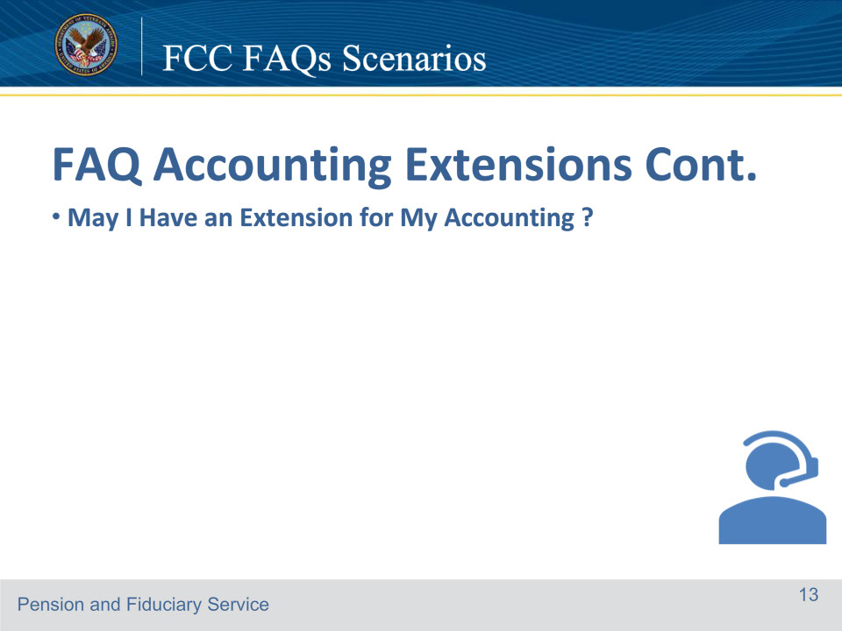
Slide notes

Lisa: Department of Veterans Affairs. My name is Lisa. To better assist you may I have the Veteran’s file number or Social Security Number?

Oliver: The Veteran’s file number is 555-55-5555.

Lisa: Great, thank you. Can I have the Veteran’s name and date of birth as well?

Oliver: Jessica Hayes and their date of birth is June 27, 1967

Lisa: Can you verify their branch of Service?

Oliver: Yes, they were in the Air Force.

Lisa: What is your full name?

Oliver: Oliver Twist I am the fiduciary for Jessica Hayes.

Lisa: Thank you for that information, Has any of your contact information changed?

Oliver: No it hasn’t changed

Lisa: How may I help you today?

Oliver: I’m calling to request an extension for my accounting.

Lisa: I see that an accounting extension was granted. You were notified about the extension on December 14. You have 14 days from that notification to submit the accounting.

Oliver: I forgot that I requested that extension.

Lisa: Unfortunately, since there is already an extension in place, we can not grant another one. The accounting is due on December 28th, and if it isn’t received by this date, it will be considered delinquent, and the process to obtain it will continue. After December 28, a delinquent accounting letter will be sent. I will update the record with the information I have provided to you. Do you understand that an extension can not be provided since you have already requested one?

Oliver: Yes, I understand I have until December 28th to send in the accounting.

Lisa: When do you expect to have the accounting submitted?

Oliver: Okay, thanks. I can have it submitted in about four days.

Lisa: Okay, so that’s December 29th. Does that sound correct?

Oliver: Yes.

Lisa: Okay, I have documented the date you plan to submit the accounting, but please note that this does not serve as approval for an accounting extension. Is there anything else I can assist you with today?

Oliver: No, have a great day.

Lisa: Have a great day as well.

Course of action: In this scenario, the LAS should document the call on a VA Form 27-0820, Report of General Information, and upload it to the proper e-Folder. Since the fiduciary has not shown good cause to grant the extension, no further action is required. The LAS should be sure to document the reason for the request, the date the accounting can be expected, and all other pertinent details of the call.

References: FCC FAQs 4.a.

For more information on accounting extensions, see FPM, Part I, 3.A.3.h-m.

Slide 14 - FCC FAQs Scenarios
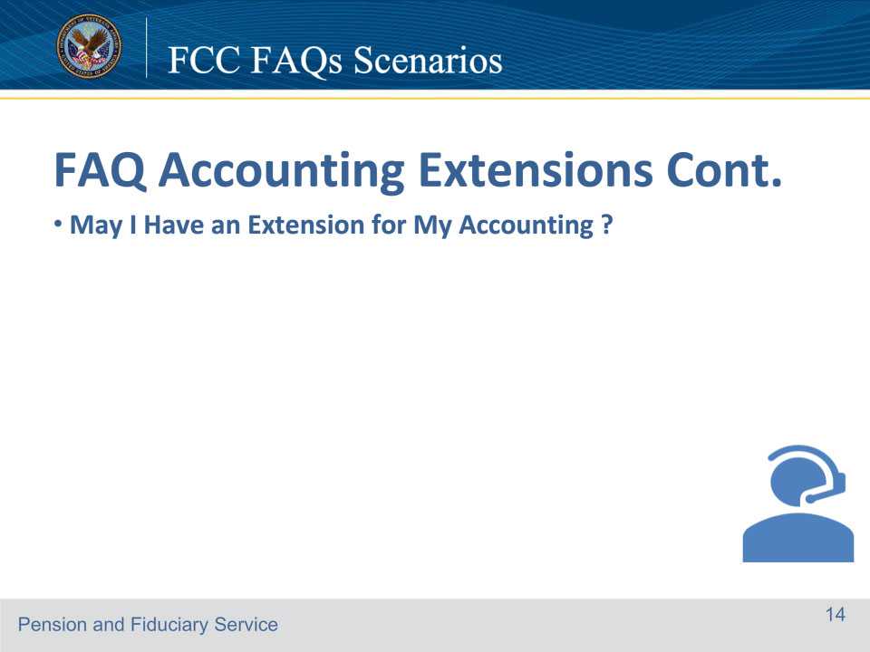
Slide notes

Lisa: Department of Veterans Affairs. My name is Lisa. To better assist you may I have the Veteran’s file number or Social Security Number?

Oliver: The Veteran’s file number is 555-55-5555.

Lisa: Thank you. Can I have the Veteran’s name and date of birth as well?

Oliver: Jessica Hayes and their date of birth is June 27, 1967

Lisa: Can you verify their branch of Service?

Oliver: Yes, they were in the Air Force.

Lisa: What is your full name?

Oliver: Oliver Twist. I am the fiduciary for Jessica Hayes.

Lisa: Thank you for that information. Has any of your contact information changed?

Oliver: No, it hasn’t changed

Lisa: How may I help you today?

Oliver: I’m calling to request an extension for my accounting.

Lisa: Why do you wish to have an extension?

Oliver: I had a lot of things going on, and it slipped my mind.

Lisa: Unfortunately, an accounting extension can’t be granted for that reason. The accounting was due on December 22nd, and it’s now considered delinquent and the process to obtain the accounting will continue. We understand that unforeseen circumstances can arise, an accounting delinquent letter will be sent to you soon. We request that you submit the accounting report as soon as possible to avoid further delays.

Oliver: So, there is nothing you can do?

Lisa: I will note the file you called for an extension. Do you understand that an accounting extension can not be granted at this time?

Oliver: Yes, I understand!

Lisa: When do you expect to have the accounting submitted?

Oliver: I can have it submitted in about 5 days.

Lisa: Okay, so that’s December 28th. Does that sound correct?

Oliver: Yes.

Lisa: Okay, I have documented the date you plan to submit the accounting, but please note that this does not serve as approval for an accounting extension. Is there anything else I can assist you with today?

Oliver: No, have a great day.

Lisa: Have a great day as well.

Course of action: In this scenario, the LAS should document the call on a VA Form 27-0820, Report of General Information, and upload it to the proper e-Folder. Since the fiduciary has not shown good cause to grant the extension, no further action is required. The LAS should be sure to document the reason for the request, the date the accounting can be expected, and all other pertinent details of the call.

References: FCC FAQs 4.a.

For more information on accounting extensions, see FPM, Part I, 3.A.3.h-m.

Slide 15 - FCC FAQs Scenarios
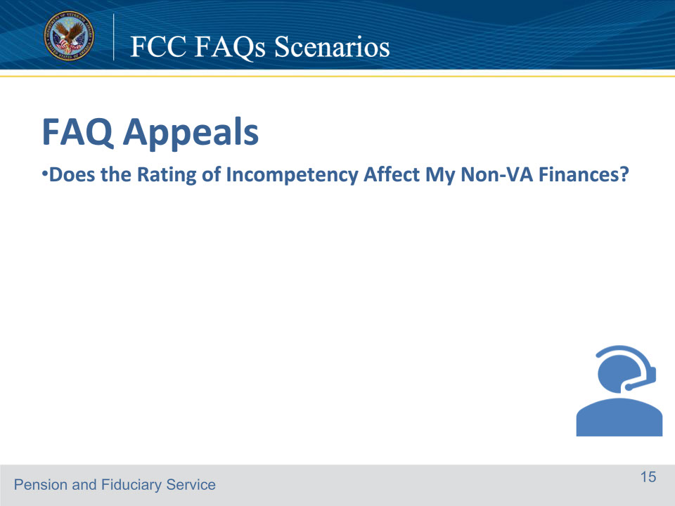
Slide notes

Jason: Department of Veterans Affairs. My name is Jason. To better assist you may I have the Veteran’s file number or Social Security Number?

Tammy: My file number is 222-22-2222.

Jason: What is your full name?

Tammy: Tammy Hendrix

Jason: Great, thank you. What is your date of birth?

Tammy: July 6, 1968

Jason: What is your branch of Service?

Tammy: Army

Jason: Thank you for that information and thank you for your service. Has any of your contact information changed?

Tammy: No

Jason: How may I assist you today?

Tammy: I have been rated incompetent by the VA will that affect my Social Security benefit?

Jason: No, the determination that you are unable to manage your VA benefits does not affect your non-VA finances, including your right to vote, and enter a contract. Is there anything else I can assist you with today?

Tammy: No, that’s all. Have a great day.

Jason: Have a great day as well.

Course of action: In this scenario, the LAS should document the call on a VA Form 27-0820, Report of General Information and upload to the proper e-Folder. Inform the Veteran that a rating of incompetency does not affect their non-VA finances.

References: FCC FAQs 5.a.

For more information on or more information on finalizing determinations, see FPM, Part I, 1.B.2.i

For more information on the purpose of the Fiduciary Program, see FPM, Part I, 1.B.3.a

For more information on the purpose of assessing the competence and personal well-being of beneficiaries, see FPM, Part I, 1.B.3.b.

Slide 16 - FCC FAQs Scenarios
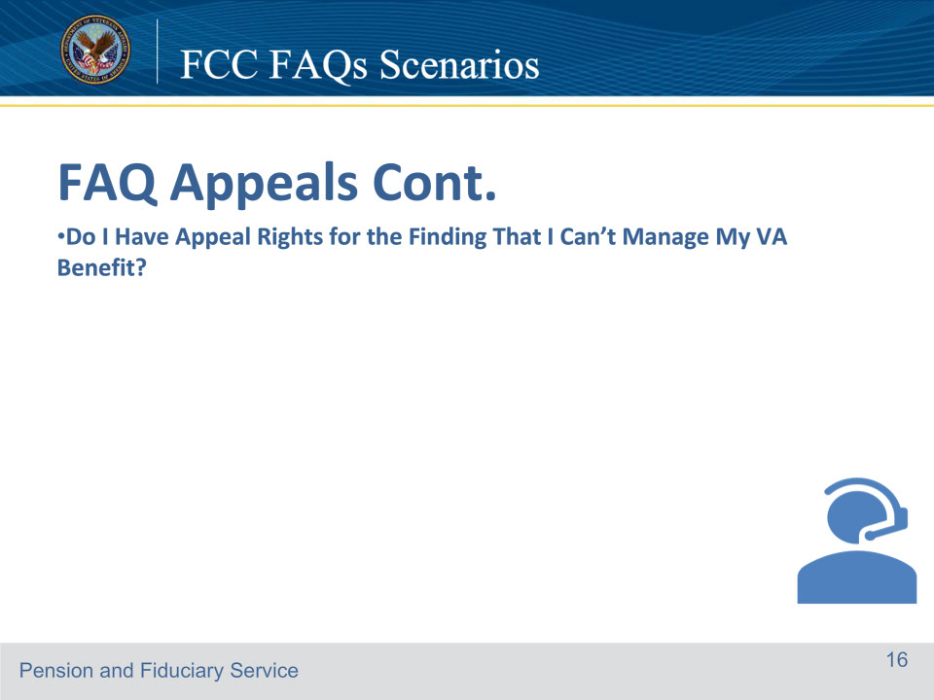
Slide notes

Robert: Department of Veterans Affairs. My name is Robert. To better assist you may I have the Veteran’s file number or Social Security Number?

Sheila: My file number is 111-11-1111.

Robert: Thank you, What is your full name and date of birth?

Sheila: My name is Sheila Polk, and my date of birth is January 16, 1955.

Robert: What branch of service were you in?

Sheila: Marines

Robert: Thank you for your service. Has any of your contact information changed?

Sheila: No

Robert: How may I assist you today?

Sheila: The VA has rated me incompetent, and I don’t agree. Do I have appeal rights?

Robert: Yes, you have the right to appeal VA’s finding that you are unable to manage your VA benefits. If you disagree with VA on this matter, you may appeal to the Board of Veterans’ Appeals by telling us you disagree with our decision and want the Board to review it or giving us any new and relevant evidence, we do not already have that may lead us to change our decision. You or your representative may file a request for a higher-level review (HLR). The request must be submitted on a VA Form 21-0996, and received within one year of the date the VA issuance of the notice of the decision. Do you understand what I have gone over?

Sheila: Yes

Robert: . Is there anything else I can assist you with today?

Sheila: No, you’ve answered all my questions. Thank you.

Robert: Have a great day.

Sheila: You do the same.

Course of action: In this scenario, the Legal Administrative Specialist should record the call on a VA Form 27-0820, Report of General Information, and upload it to the appropriate e-Folder. The beneficiary should be informed of their rights to appeal.

References: FCC FAQ 5.b.

For more information on additional evidence or hearing requests received during the due process period, see FPM, Part I, 1.B.1.h, and HLR request requirements, see FPM, Part III, 1.C.1.a

Slide 17 - FCC FAQs Scenarios
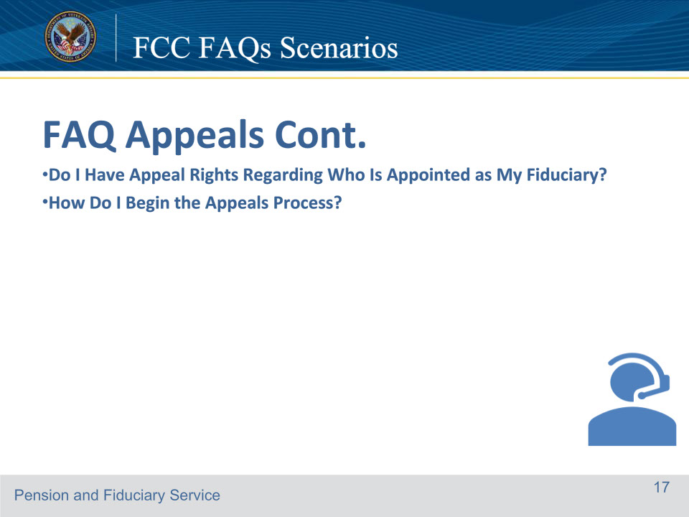
Slide notes

Robert: Department of Veterans Affairs. My name is Robert. To better assist you may I have the Veteran’s file number or Social Security Number?

Sheila: My file number is 111-11-1111.

Robert: Thank you, what is your full name and date of birth?

Sheila: My name is Sheila Polk, and my date of birth is January 16, 1955

Robert: What branch of service were you in?

Sheila: Marines

Robert: Thank you for your service. Has any of your contact information changed?

Sheila: No

Robert: How may I assist you today?

Sheila: Can I appeal who is appointed as my fiduciary,

Robert: Yes, you have the right to appeal VA’s decision on who has been appointed as your fiduciary. If you disagree with the VA on this matter, you may appeal to the Board by telling us you disagree with our decision and want the Board to review it, or giving new and relevant evidence we do not already have that may lead us to change our decision.

Sheila: How do I begin the appeals process?

Robert: If you disagree with the VA on this matter, there are three different review options. You may discuss the options with your representative to make the best decision for you.

•The first option is the higher-level review, in which the Decision Review Officer will review the decision. To request this, please complete and submit VA Form 20-0996, Information, and Instructions for Completing Decision Request: Higher-Level Review.

•The second review option is if you have new evidence, you may request supplemental review. To request this, please complete and submit VA Form 20-0995, Information, and Instructions for Completing Decision Request: Supplemental Claim.

•The third option is an appeal to the board. To request this, please submit VA Form 10182, Decision Review Request, Board Appeal, Notice of Disagreement. The form must identify the specific fiduciary decision(s) with which you disagree with. This process is called your notice of disagreement (NOD)

These forms can be accessed online by going to www.va.gov and selecting the Find a VA Form tab or we can mail you the forms.

Sheila: That’s ok, I know how to access the forms.

Robert: Is there anything else I can help you with?

Sheila: No, not at this time.

Robert: Have a great day

Sheila: You too

Course of action: In this scenario, the Legal Administrative Specialist should document the call on a VA Form 27-0820, Report of General Information, and upload it to the appropriate e-Folder. The beneficiary should be informed of their rights to appeal the fiduciary appointment. Additionally, the LAS should explain how to begin the appeals process to the beneficiary and send the applicable forms if requested.They should advise the beneficiary where to send the forms.

References: FCC FAQ 5.c-d

For more information on new and relevant evidence, see FPM, Part III, 1.A.2.v

For more information on new authority to appeal fiduciary decisions, see FPM, Part III, 1.A.1.a, and

For more information on appealable decisions, see FPM, Part III, 1.A.3.a.

For more information on appeals jurisdiction, see FPM, Part III, 1.A.1.b

For more information on who may submit an NOD, see FPM, Part III, 1.C.6.b, and for NOD requirements, see FPM, Part III, 1.C.6.c.

Slide 18 - FCC FAQs Scenarios
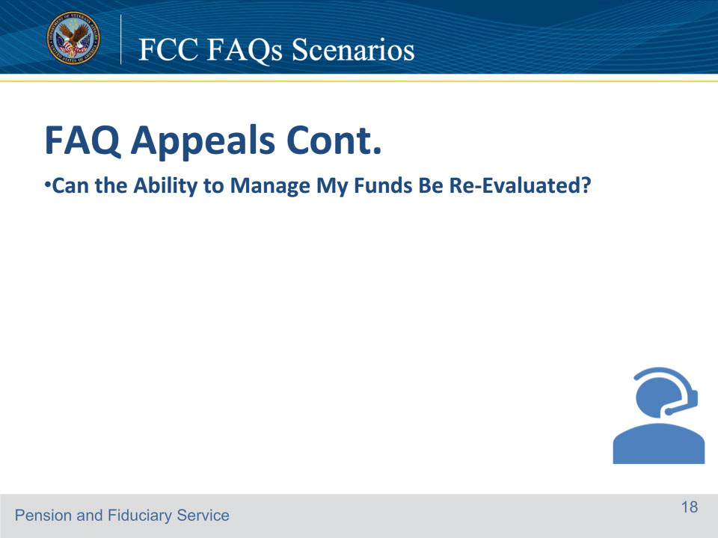
Slide notes

Robert: Department of Veterans Affairs. My name is Robert. To better assist you may I have the Veteran’s file number or Social Security Number?

Maggie: My file number is 555-55-5555.

Robert: Thank you, what is your full name and date of birth?

Maggie: My name is Maggie Polk and my date of birth is January 31, 1956.

Robert: What branch of service were you in?

Maggie: I was in the Navy.

Robert: Thank you for your service. Has any of your contact information changed?

Maggie: No it hasn’t.

Robert: How may I assist you today?

Maggie: I’m able to manage my own affairs. Can the ability to manage my funds be re-evaluated?

Robert: You may request that your ability to manage your VA benefits be re-evaluated. I see that you reside in Indianapolis. If you wish to have a re-evaluation, please submit your request in writing along with any new supporting medical evidence to the Indianapolis Regional Office. The address is Department of Veterans Affairs, Claims Intake Center, PO Box 4444, Janesville, WI 53547-4444. Is there anything else I can assist you with?

Maggie: No, you’ve answered all my questions.

Robert: If there are no further questions, have a great day.

Maggie: You too.

Course of action: In this scenario, the LAS should document the call on a VA Form 27-0820, Report of General Information, and upload it to the proper e-Folder. Inform the caller that their ability to manage their affairs can be evaluated and explain the process. The LAS should assist the caller with identifying the mailing address for the Regional Office.

References: FCC FAQs 5.e.

For more information on RO addresses, see the Regional Offices Websites

For more information on authority to restore competency, see FPM, Part I, 1.B.2.m

For more information on jurisdiction of evidence received after a final determination, see FPM, Part I, 1.A.2.e.

Slide 19 - FCC FAQs Scenarios
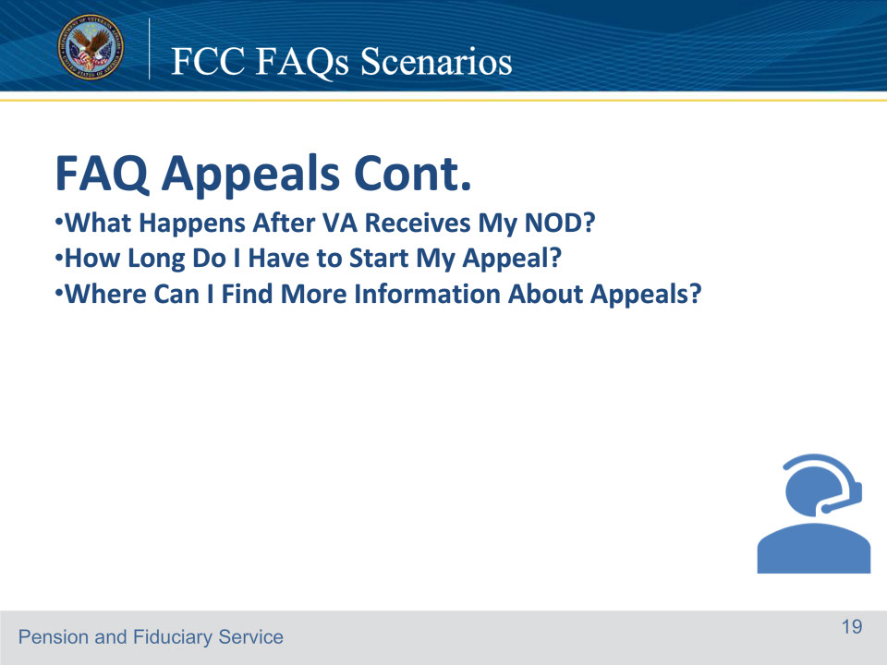
Slide notes

Jacob: Department of Veterans Affairs. My name is Jacob To better assist you, may I have the Veteran’s file number or Social Security Number?

William: My file number is 999-99-9999.

Jacob: Thank you. What is your full name and date of birth?

William: William Andersen and my date of birth is February 28, 1958.

Jacob: What’s your branch of Service?

William: Air Force

Jacob: Thank you for your service. Has any of your contact information changed?

William: No

Jacob: How may I assist you today?

William: I’m appealing the fiduciary decision. I submitted a Notice of Disagreement (NOD) but have not heard anything. What happens next?

Jacob: When did you send your Notice of Disagreement?

William: About two weeks ago.

Jacob: Let me review the file. I see your VA Form 10182 of record. Your case will be reviewed along with any new and relevant additional evidence you have provided. If the decision is changed, we will notify you in writing. If we make no change in our decision, we will send you a statement of the case (SOC). An SOC describes the facts, laws, regulations, and reasons we used to make our decision. If we send the SOC, we will also send you a VA Form 9 to complete and return it to us if you want to continue your appeal. Do you have any other questions that I can assist you with?

William: Yes. How long do I have to start my appeal and where can I find more information about Appeals?

Jacob: You have one year from the date of the notification letter regarding the selection of your fiduciary to submit a NOD via VA Form 10182. Your VA Form 10182 stating that you disagree with our decision and wish to appeal must be postmarked or received by us within one year from the date of this letter. You can For more information about appeals, you may visit the Board of Veterans’ Appeals website at https://www.bva.va.gov and review the VA pamphlet titled “How Do I Appeal?”

Course of action: In this scenario, the LAS must carefully review the e-Folder to ensure that the NOD has been received. The next step is to inform the caller what happens after the NOD has been submitted and communicate the time frame that the caller has to initiate the appeal process. The LAS should thoroughly document the call on a VA Form 27-0820, Report of General Information, and upload it to the appropriate e-Folder. Send the beneficiary a VA Form 9, if applicable.

References: FCC FAQs 5.f through h

For more information on the definition of a NOD, see FPM, Part III, 1.A.2.e, and SOC, see FPM, Part III, 1.A.2.i

For more information on new and relevant evidence, see FPM, Part III, 1.A.2.v

For more information on evidence received after notice of a decision, see FPM, Part III, 1.A.3.f.

For more information on the NOD time limits, see FPM, Part III, 1.B.1.a

Slide 20 - FCC FAQs Scenarios
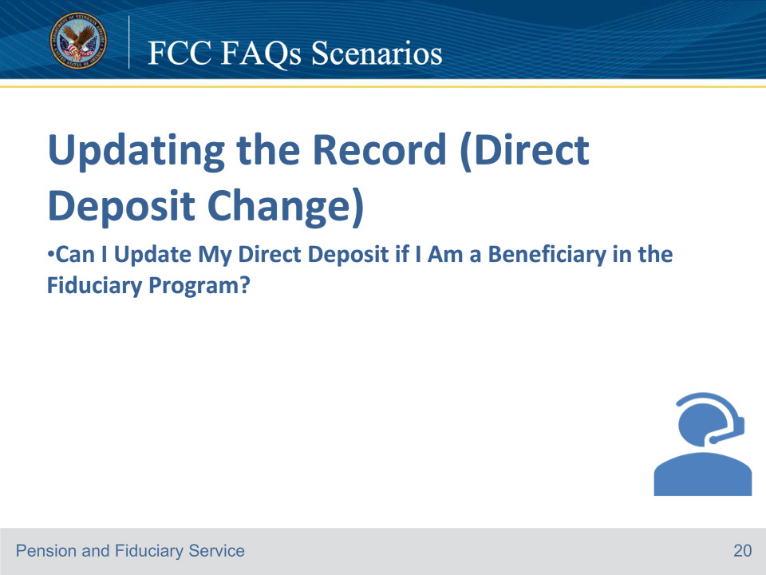
Slide notes

Raymond: Department of Veterans Affairs. My name is Raymond To better assist you, may I have the Veteran’s file number or Social Security Number?

Walter: My Social Security number is 111-11-1111.

Raymond: Thank you. What is your full name and date of birth?

Walter: Not doing well. My name is Walter Buchanan, and my date of birth is October 17, 1979.

Raymond: What branch of service were you in?

Walter: I was in the Army.

Raymond: Thank you for your service. I have located your record. Has any of your contact information changed?

Walter: Nothing has changed

Raymond: How may I help you?

Walter: Can I update my direct deposit if I am a beneficiary in the Fiduciary program?

Raymond: No, only your fiduciary may update the direct deposit information. Is there anything else I can help you with?

Walter: No, thank you.

Raymond: You’re welcome. Have a great day

Course of action: Complete a VA Form 27-0820, Report of General information documenting the phone call.

References: FCC FAQs 6.a.

For more information on the requirement for a properly titled account, see FPM, Part II, 1.B.2.a

handling a change of direct deposit account information, see FPM, Part II, 1.B.2.c, and

determining VA FUM, see FPM, Part I, 2.C.3.k.

Slide 21 - FCC FAQs Scenarios
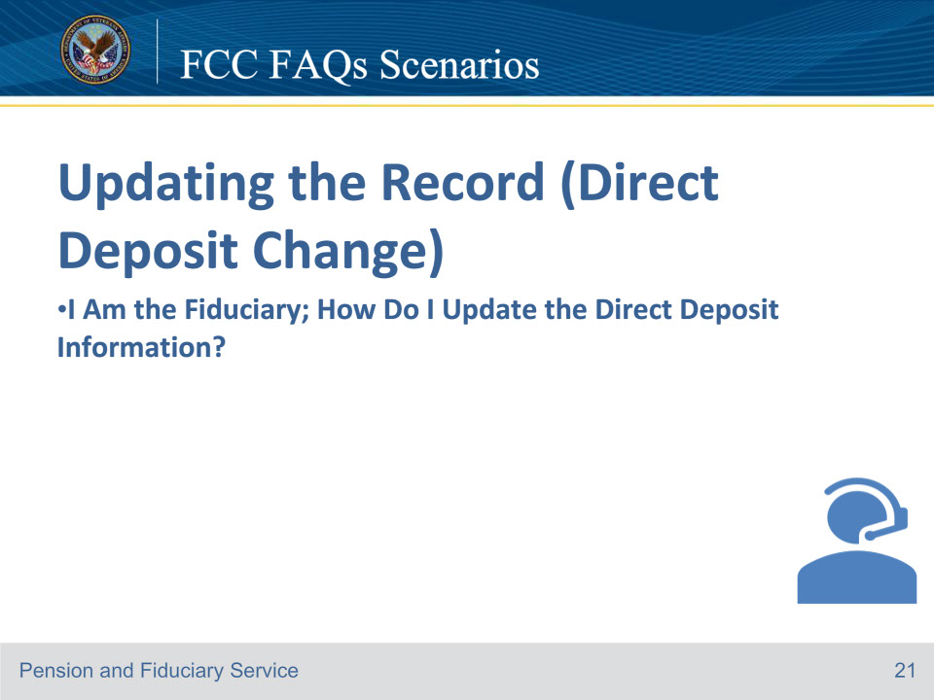
Slide notes

Hector: Department of Veterans Affairs. My name is Hector To better assist you, may I have the Veteran’s file number or Social Security Number?

Thomas: The Veteran’s Social Security number is 999-99-9999.

Hector: Thank you. Can you verify the Veteran’s date of birth?

Thomas: The Veteran’s date of birth is January 15, 1949.

Hector: Can you verify the Veteran’s branch of service?

Thomas: He was in the Air Force.

Hector: What is your full name?

Thomas: I’m Thomas Martin. I am the fiduciary for Sandra Butler. How can I update the direct deposit?

Hector: I’ve located the record. Have you submitted an SF 1199A?

Thomas: I’m not sure. I’ve submitted a lot of documents.

Hector: I’m not showing the form on file, so you must complete an SF 1199A. Be sure all 3 sections of the form is completed, and section 3 must be completed by the financial institution. You may also submit a voided check or deposit/ticket that is pre-printed and manufactured by either the institution or a company accepted by the institution to complete them. Lastly, you may submit a signed and notarized statement from a representative of the institution on letterhead outlining how the deposit account is titled. The document used to verify a properly titled account must clearly have all required elements. If any element is missing, an alternate allowable document containing all elements must be used. Once completed, the form should be mailed to Department of Veterans Affairs ((provide the correct mailing address for Janesville). Do you need me to mail you the form?

Thomas: No, I can find it online.

Hector: Has any of your contact information changed?

Thomas: No

Hector: Ok, Is there anything else I can assist you with?

Thomas: No, thanks for your help.

Hector: You’re welcome. Have a great day.

Thomas: You too.

Course of action: In this scenario, it is important for the LAS to recognize that this fiduciary does not meet the properly titled account exemptions. The LAS must carefully review the electronic folder and confirm that the SF 1199A is not of record. Advise the fiduciary to submit a complete SF 1199A form, making sure to emphasize the importance of having section 3 completed by a financial institution. Additionally, provide alternative options such as submitting a voided check or providing a notarized statement, in case filling out the SF 1199A form is not feasible. The LAS should thoroughly document the call on a VA Form 27-0820, Report of General Information, and upload it to the appropriate e-Folder.

Other actions to consider: It is important to note that if a fiduciary calls to inquire about their submitted SF 1199A, the LAS should conduct a thorough review to ascertain whether the verification documents are on record at the time of the call. If they are, the fiduciary should be notified that the documents have been received and the date for which they were received. The LAS should inform the fiduciary that the documents will be forwarded to the appropriate department for review, and they will be contacted if further information is needed. Additionally, the LAS should create an administrative task in VBMS called Process Review and Action, detailing the verification documents that need to be reviewed in the e-folder. If the document is not on record, the fiduciary should be mailed copy of the SF 1199A via mail.

References: FCC 6.b

• For more information on handling a change of direct deposit account information, see FPM, Part II, 1.B.2.c, and

• requirement for a properly titled account, see FPM, Part II, 1.B.2.a.

Slide 22 - FCC FAQs Scenarios
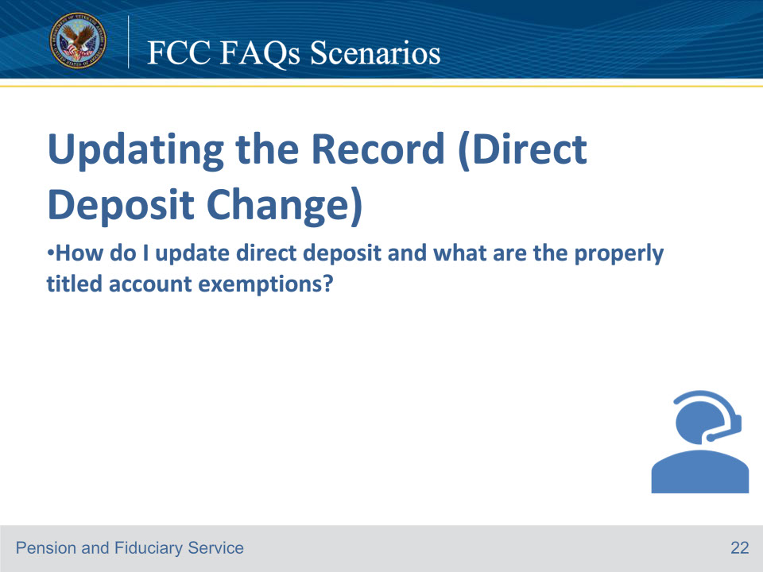
Slide notes

Hector: Department of Veterans Affairs. My name is Hector To better assist you may I have the Veteran’s file number or Social Security Number?

Thomas: The Veteran’s Social Security number is 999-99-9999.

Hector: Thank you. Can you verify the Veteran’s date of birth?

Thomas: The Veteran’s date of birth is January 15, 1943.

Hector: Can you verify the Veteran’s branch of service?

Thomas: He was in the Air Force.

Hector: What is your full name?

Thomas: I’m Thomas Martin. I am the Spouse fiduciary for Sandra Butler.

Hector: I’ve located the record. Thank you for your spouse’s service. Has any of your contact information changed?

Thomas: No, my contact has not changed.

Hector: How may I help you?

Thomas: I would like to update the direct deposit.

Hector: I can assist you with updating your direct deposit information. May I have the routing and checking account number?

Thomas: The routing number is 074000010 and the account number is 123456789.

Hector: Let me confirm, the routing number is 074000010 and the account number is 123456789.

Hector: Ok, Is there anything else I can assist you with?

Thomas: No, thanks for your help.

Hector: You’re welcome. Have a great day.

Thomas: You too.

Course of action: In this scenario, it is important for the LAS to recognize that The following fiduciaries are excluded from the properly titled account requirement:

beneficiary’s spouse, as defined in FPM, Part I, 2.C.4.a State and local government entities institutions, such as public or private medical care facilities, nursing homes, or other residential care facilities, when an annual accounting is not required, or a trust company or a bank with trust powers organized under the laws of the U.S. or a State. The LAS should thoroughly document the call on a VA Form 27-0820, Report of General Information, and upload it to the appropriate e-Folder.

Important: A pin is not necessary when any caller contacts the FCC for a direct deposit change.

References: FCC 6.c For more information on

• requirement for a properly titled account, see FPM, Part II, 1.B.2.a, and

• handling a change of direct deposit account information, see FPM, Part II, 1.B.2.c.

Slide 23 - FCC FAQs Scenarios
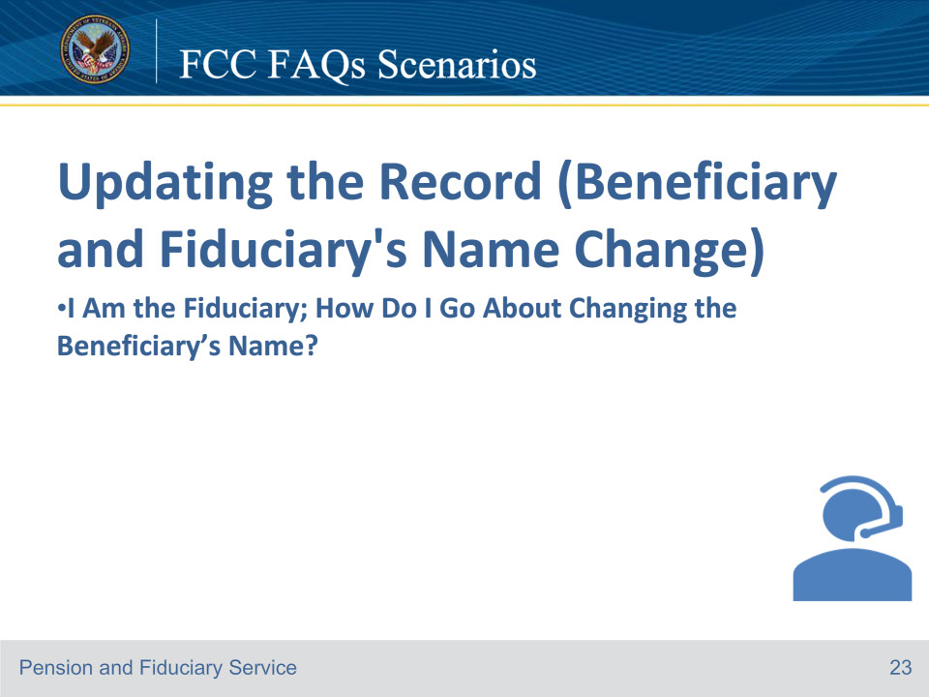
Slide notes

Reggie: Department of Veterans Affairs. My name is Reggie To better assist you may I have the Veteran’s file number or Social Security Number?

Sabrina: The Veteran’s Social Security number is 111-11-1111.

Reggie: Thank you, can you verify the Veteran’s date of birth?

Sabrina: The Veteran’s date of birth is July 5, 1930.

Reggie: Can you verify the Veteran’s branch of service?

Sabrina: He was in the Marines.

Reggie: What is your full name?

Sabrina: My name is Sabrina Thompson. I am the fiduciary for my dad Hunter Smith.

Reggie: I have located the record. Thank you for your father’s service. Has any of your contact information changed?

Sabrina: No

Reggie: How can I help you today?

Sabrina: The Veteran’s last name is spelled incorrectly. The VA has the spelling as S-M-Y-T-H-E. The correct spelling is S-M-I-T-H.

Reggie: Thank you for bringing this error to our attention. I wanted to confirm the correct spelling of the Veteran’s last is S-M-I-T-H. I will note the account and forward it to the appropriate department. Is there anything else I can help you with?

Sabrina: No, thank you.

Reggie: You’re welcome, have a great day.

Course of action: In this scenario, the LAS should complete a VA Form 27-0820, Report of General Information, to document the typographical error from the phone call. It is important to send an email to the correct hub’s Management Analyst office mailbox.

Reference: FCC FAQs 7.a.

For more information on handling a change of name or address, see FPM, Part II, 1.B.2.b.

Slide 24 - FCC FAQs Scenarios
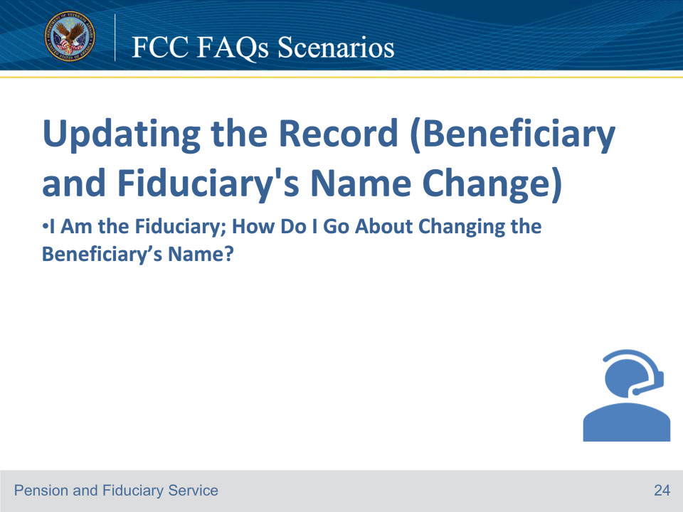
Slide notes

Reggie: Department of Veterans Affairs. My name is Reggie. To better assist you may I have the Veteran’s file number or Social Security Number?

Sabrina: The Veteran’s Social Security number is 111-11-1111.

Reggie: Thank you. Can you verify the Veteran’s date of birth?

Sabrina: The Veteran’s date of birth is July 5, 1930.

Reggie: Can you verify the Veteran’s branch of service?

Sabrina: He was in the Marines.

Reggie: What is your full name?

Sabrina: My name is Sabrina Thompson. I am the fiduciary for Hunter Smith.

Reggie: I have located the record. Has any of your contact information changed?

Sabrina: No

Reggie: How can I help you today?

Sabrina: I’m calling to inform you that the Veteran’s last name has been legally changed to Jones.

Reggie: Have you submitted any evidence to support the name change?

Sabrina: Yes, I submitted a copy of the updated social security card with their new name.

Reggie: To initiate the change, you must contact the National Call Center (NCC) at 800-827-1000. May I place you on a brief hold while I contact them to connect the call?

Sabrina: Yes, that is fine.

Reggie: Hello, my name is Reggie Henderson, and I am with the Fiduciary Contact Center. I have Sabrina Thompson on the line, and they need assistance updating the Veteran’s last name due to a legal name change. The required documents are in VBMS dated September 22, 2024.

National Call Center representative: Good afternoon, Reggie. I’ll assist them from here.

Reggie: Thank you. Sabrina, I’m leaving the call. You’ll be assisted from here.

Course of action: Complete a VA Form 27-0820, Report of General information documenting the legal name change from the phone call. Initiate warm transfer to the National Call Center to initiate the legal name change.

Reference: FCC FAQs 7.a.

For more information on handling a change of name or address, see FPM, Part II, 1.B.2.b, and SIAs, see FPM, Part I, 2.C.

Slide 25 - FCC FAQs Scenarios
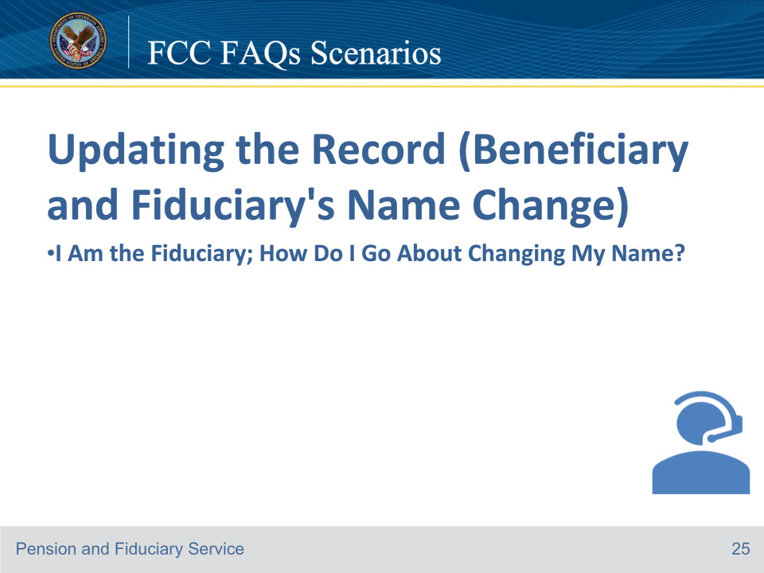
Slide notes

Patrick: Department of Veterans Affairs. My name is Patrick. To better assist you may I have the Veteran’s file number or Social Security Number?

Charles: The Veteran’s Social Security number is 222-22-2222.

Patrick: Thank you. Can you verify the Veteran’s date of birth?

Charles: The Veteran’s date of birth is August 13, 1990.

Patrick: Can you verify the Veteran’s branch of service?

Charles: She was in the Coast Guard.

Patrick: What is your full name?

Patrick: My name is Charles Griffin. I am the fiduciary for Maggie Robinson.

Charles: I have located the record. Has any of your contact information changed?

Sabrina: No

Patrick: How can I help you today?

Charles: The VA has my last name spelled incorrectly; the VA has the spelling as G-R-I-F-F-I-T-H. The correct spelling is G-R-I-F-F-I-N.

Patrick: Thank you for bringing this error to our attention. I wanted to confirm the correct spelling of your last name is G-R-I-F-F-I-N. I will note the account and forward it to the appropriate department. Is there anything else I can help you with?

Charles: No, thank you.

Patrick: You’re welcome. Have a great day.

Course of action: Complete a VA Form 27-0820, Report of General information documenting the typographical error from the phone call. Important: Send an email to the correct hub’s Management Analyst office mailbox.

Reference: FCC FAQs 7.b.

For more information one handling a change of name or address, see FPM, Part II, 1.B.2.b.

Slide 26 - FCC FAQs Scenarios
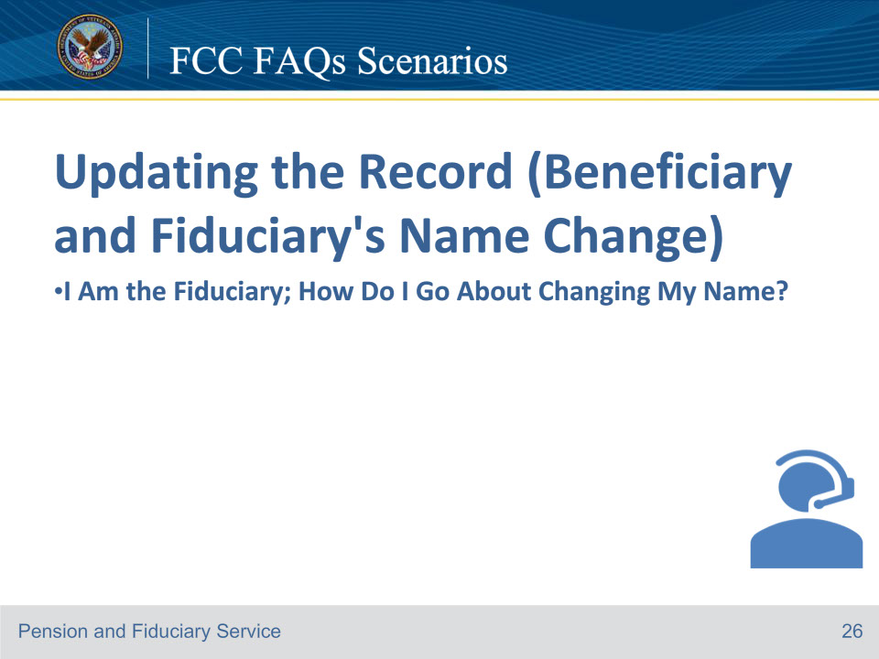
Slide notes

Patrick: Department of Veterans Affairs. My name is Patrick To better assist you may I have the Veteran’s file number or Social Security Number?

Charles: The Veteran’s Social Security number is 222-22-2222.

Patrick: Thank you, can you verify the Veteran’s date of birth?

Charles: The veteran’s date of birth is August 13, 1990.

Patrick: Can you verify the Veteran’s branch of service?

Charles: She was in the Coast Guard.

Patrick: What is your full name?

Patrick: My name is Charles Griffin. I am the fiduciary for my mother Maggie Robinson.

Charles: I have located the record. Thank you for your mother’s service. Has any of your contact information changed?

Sabrina: No

Patrick: How can I help you today?

Charles: I have legally changed my last name to Davidson.

Patrick: To change your name, you must submit sufficient evidence that supports a legal name change. These documents include a signed decree from a judge or court showing a legal name change has taken place or social security card that reflects your new name.

Charles: Yes, I sent that information to the VA a week ago.

Patrick: I found that information about your name change in our system. To initiate the change, you must contact the National Call Center at 800-827-1000. May I place you on a brief hold while I contact them to connect the call?

Charles: That will be fine.

Patrick: Hello, my name is Patrick Winfrey, and I am with the Fiduciary Contact Center. I have Charles Griffin on the line, and they need assistance with updating their last name to Davidson due to a legal name change. The required documents are in VBMS dated November 12, 2023.

National Call Center representative: Good afternoon, Patrick. I’ll assist them from here.

Course of action: Complete a VA Form 27-0820, Report of General information documenting the legal name change from the phone call. Initiate warm transfer to the National Call Center for the legal name change.

Important: If the name change will impose different requirements regarding the qualification and/or oversight of the fiduciary, establish an EP 590 - Successor Initial Appointment Field Examination. Example: A fiduciary was initially appointed as a VA-appointed fiduciary. The fiduciary and beneficiary are now married and the fiduciary type should be changed to spouse fiduciary.

Reference: FCC FAQs 7.b.

For more information on handling a change of name or address, see FPM, Part II, 1.B.2.b, and SIAs, see FPM, Part I, 2.C.

Slide 27 - FCC FAQs Scenarios
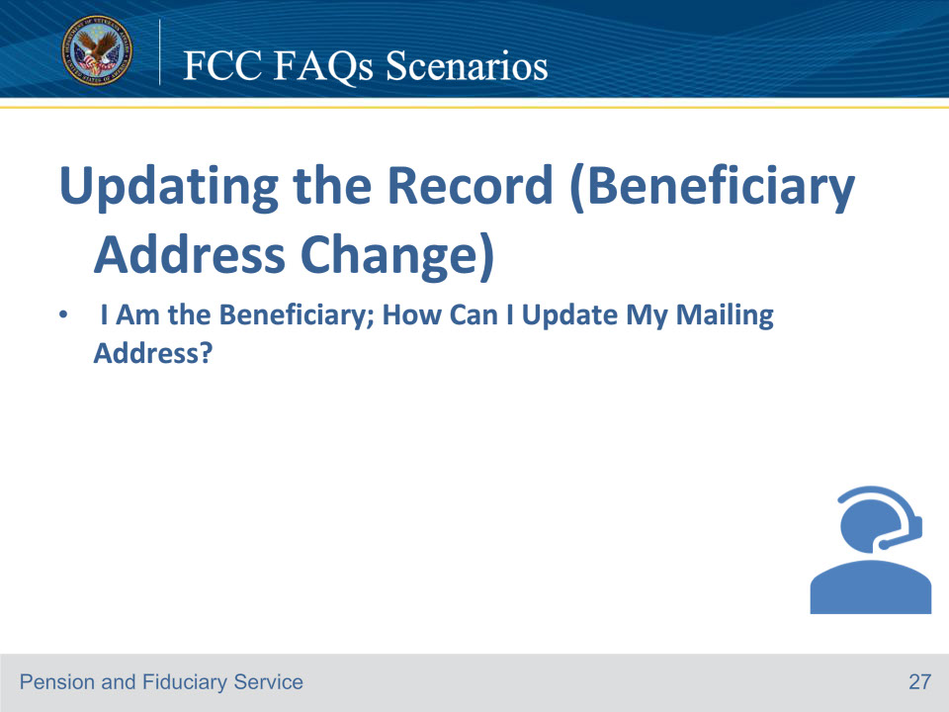
Slide notes

Tamara: Department of Veterans Affairs. My name is Tamara To better assist you may I have the Veteran’s file number or Social Security Number?

Erin: My Social Security is 444-44-4444.

Tamara: Thank you. What is your full name and date of birth?

Erin: My name is Erin Ewing, and my date of birth is 08/01/1976.

Tamara: What branch of service were you in?

Erin: I was in the Navy.

Tamara: Thanks for your service. I have accessed your record. Has any of your contact information changed?

Erin: Yes, I need to update my mailing address.

Tamara: The fiduciary is required to report your updated mailing address. I will update your address on file for beneficiary contact. Have you provided your fiduciary with your new mailing address?

Erin: No, I have not.

Tamara: It is important to inform your fiduciary whenever there is a change in your contact information. May I have your address?

Erin: Okay, I’ll contact them after this call. My address is 555 Midview Lane, Fort Wayne, Indiana, 12345

Tamara: Let me confirm that I have the correct address. It’s 555 Midview Lane, Fort Wayne, Indiana, 12345

Tamara: Yes, that’s correct.

Erin: Okay, I have that information updated. Is there anything else I can assist you with today?

Tamara: No, have a great day.

Erin: You too.

Course of action: In this scenario, the LAS should navigate to the beneficiary’s profile. Then, in the physical address section of the profile, ensure that the “same as mailing address” box is not checked before updating the beneficiary’s address. It is important to repeat the address back to the beneficiary to confirm accuracy. The LAS should be aware that the address should not be updated in any other system. Lastly, emphasize to the beneficiary the importance of notifying their fiduciary of any changes to their contact information.

References: FCC FAQs 8.a.

For more information on handling a change of name or address, see FPM, Part II, 1.B.2.b.

Slide 28 - FCC FAQs Scenarios
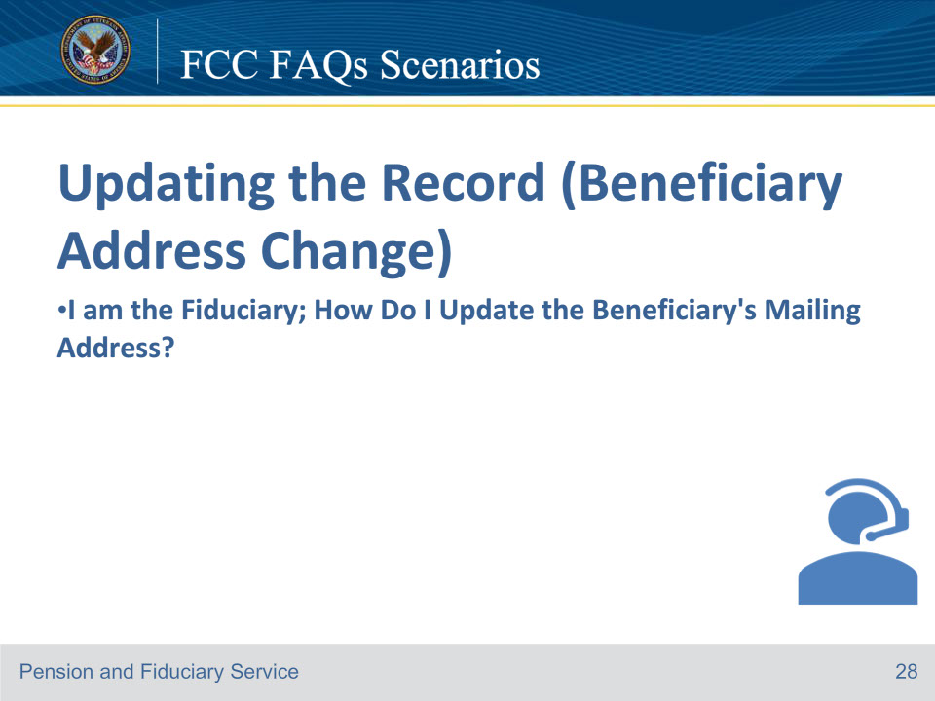
Slide notes

Reggie: Department of Veterans Affairs. My name is Reggie. To better assist you may I have the Veteran’s file number or Social Security Number?

Ryan: The Veteran’s file number is 111-11-111.

Reggie: Thank you, can you verify the Veteran’s date of birth?

Ryan: The Veteran’s date of birth is August 9, 1972.

Reggie: Can you verify the Veteran’s branch of service?

Ryan: He was in the Marines.

Reggie: What is your full name?

Ryan: My name is Ryan Ford I am the fiduciary for Tommy Hayes.

Reggie: I have located the record. Has any of your contact information changed?

Ryan: Yes, I would like to update the beneficiary’s mailing address.

Reggie: Please provide me with the updated address information.

Ryan: The address is 777 Hayes St. Mobile, Alabama, 12345

Reggie: Let me repeat the address. It’s 777 Hayes St. Mobile, Alabama, 12345

Ryan: That’s correct

Reggie: Give me one moment while I update this information.

Ryan: Ok

Reggie: I have that information updated. Is there anything else I can assist you with today?

Ryan: No, have a great day.

Reggie: You too.

• Course of action: In this scenario, the LAS should navigate to the beneficiary’s profile and establish and complete an address change administrative task that includes the old address and the new address. It is important to repeat the address back to the fiduciary to confirm accuracy.

Note: The address change administrative task should be established and completed at the time of creation.

Reference: FCC FAQs 8.b.

For more information on handling a change of name or address, see FPM, Part II, 1.B.2.b.

Slide 29 - FCC FAQs Scenarios
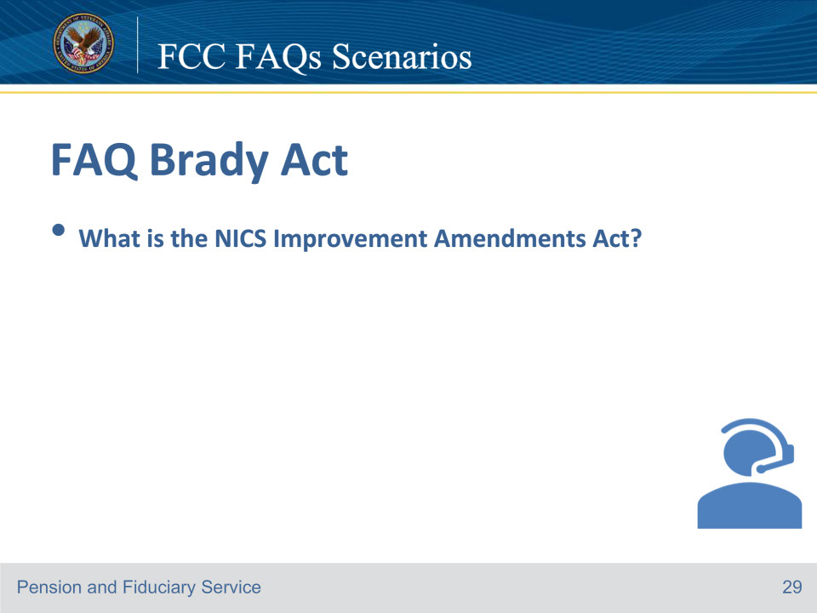
Slide notes

Tina: Department of Veterans Affairs. My name is Tina. To better assist you, may I have the Veteran’s file number or Social Security Number?

Paul: I don’t have that information with me right now.

Tina: Unfortunately, I’m unable to access the file without that information, but I can provide general information if that will help.

Paul: That’s fine. I just wanted to ask, What is the NICS Improvement Amendments Act?

Tina: The National Instant Criminal Background Check System (NICS) Improvement Amendments Act contains new provisions intended to improve the process of adding individuals to, and removing them from, a database called NICS. Gun sellers use the NICS database to check whether someone is allowed to buy firearms.

Paul: Thank you, that information was helpful.

Tina: Is there anything else I can help you with?

Paul: No, thank you for your time.

Tina: You’re welcome. I hope you have a great day.

Course of action: In this scenario, there is no need to complete a VA Form 27-0820 Report of General Information since the caller’s question was general and not related to a specific Veteran or beneficiary file. The LAS should explain the NICS Improvement Amendments Acts.

References: FCC FAQs 9.a

Slide 30 - FCC FAQs Scenarios
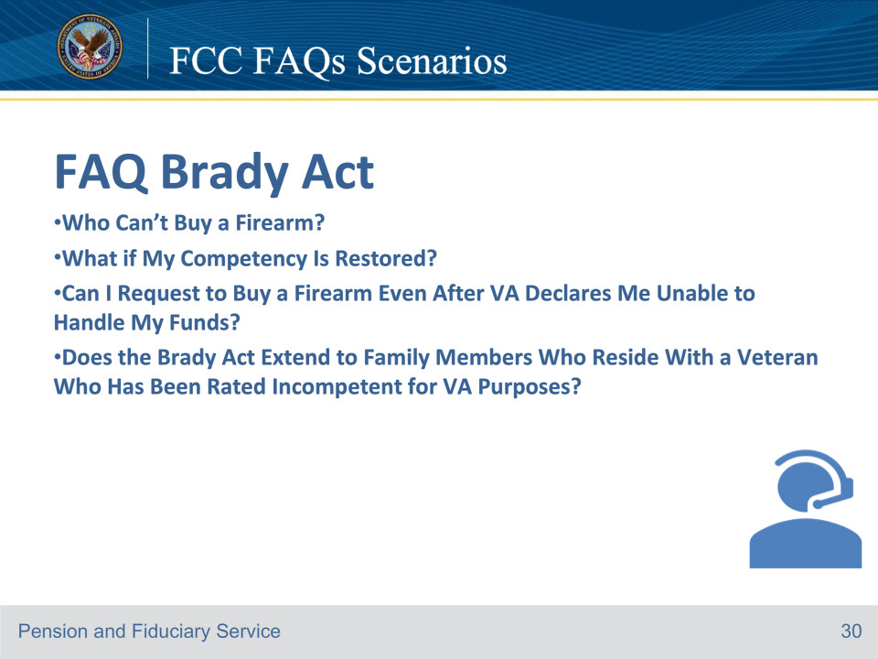
Slide notes

Tamara: Department of Veterans Affairs. My name is Tamara. To better assist you may I have the Veteran’s file number or Social Security Number?

Brian: My Social Security is 444-44-4444.

Tamara: Thank you, what is your full name and date of birth?

Brian: My name is Brian Washington and my date of birth is 01/01/1975.

Tamara: What branch of service were you in?

Brian: I was in the Army

Tamara: Thanks for your service. I have accessed your record. Has any of your contact information changed?

Brian: No, none of my information has changed.

Tamara: How may I help you?

Brian: Can I buy a firearm?

Tamara: Well no, since any person whom VA rated incompetent (that is, unable to handle their VA funds) is disqualified from possessing, shipping, transporting, or receiving firearms or ammunition and may be added to the NICS database. Your local law enforcement officer can tell you what other types of persons have firearm restrictions.

Brian: Well, then what happens if my competency is restored?

Tamara: If VA restores competency, we will report this change to NICS so your name can be removed from the database.

Brian: Ok, can I request to buy a firearm even though the VA rated me unable to handle my funds?

Tamara: The NICS Improvement Amendments Act allows a person who is prohibited from possessing, shipping, transporting, or receiving firearms or ammunition to apply for relief from firearms restrictions. You have to submit your written request for relief to the local Regional Office. Then, VA may grant such relief if it would not be contrary to the public interest and if the circumstances regarding your disability, your record, and reputation are such that you will not likely act in a manner dangerous to public safety.

Brian: I will have to do that tomorrow. Can I ask another question?

Tamara: Yes, of course

Brian: Does the Brady Act extend to my family members who reside with me?

Tamara: No, The VA’s authority under the Brady Act does not extend to a beneficiary’s family member’s right to purchase or possess a firearm. Also, VA does not have jurisdiction to make incompetency determinations for non-beneficiaries. VA does not have the authority to impact the rights of individuals who reside with a Veteran who has been rated incompetent for VA purposes.

Brian: That is good to know

Tamara: Is there anything else I can help you with?

Brian: No, thanks, you have answered all my questions.

Tamara: You’re welcome, I hope you have a great day.

Course of action: Complete a VA Form 27-0820, Report of General information documenting the phone call.

References: FCC FAQs 9.b through e.

For more information on the effect of the Brady Act on incompetent beneficiaries, see M21-1, Part X, Subpart ii, 6.D.4.a.

For more information on actions to take after making a decision on a request for relief, seeM21-1, Part X, Subpart ii, 6.D.4.k.

Slide 31 - FCC FAQs Scenarios
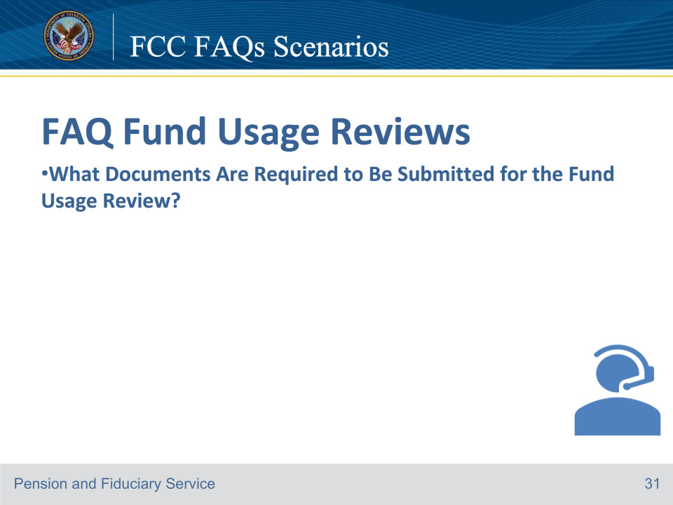
Slide notes

Hector: Department of Veterans Affairs. My name is Tamara. To better assist you may I have the Veteran’s file number or Social Security Number?

Matt: No, I just have a quick question

Hector: I’m unable to access the file without that information, but I can provide general information if that will help.

Matt: That’s fine. Can you tell me what documents are required to be submitted for the Fund Usage Review?

Hector: A fund usage report consists of three months of all financial statements containing VA funds. The fund usage report may also include any supporting documents, such as receipts, invoices, canceled checks, etc., that show irregular purchases. I can give you more detailed information if I have the file number.

Matt: No, that’s fine. That is all the information I need, thank you.

Hector: You’re welcome. I hope you have a great day.

Course of action: In this scenario, the caller’s inquiry was of a general nature and did not pertain to any particular Veteran or beneficiary file. Therefore, there is no need to fill out a VA Form 27-0820 Report of General Information. The LAS should inform the caller about the necessary documents required for submitting a fund usage review.

References: FCC FAQs 10.a.

Slide 32 - FCC FAQs Scenarios
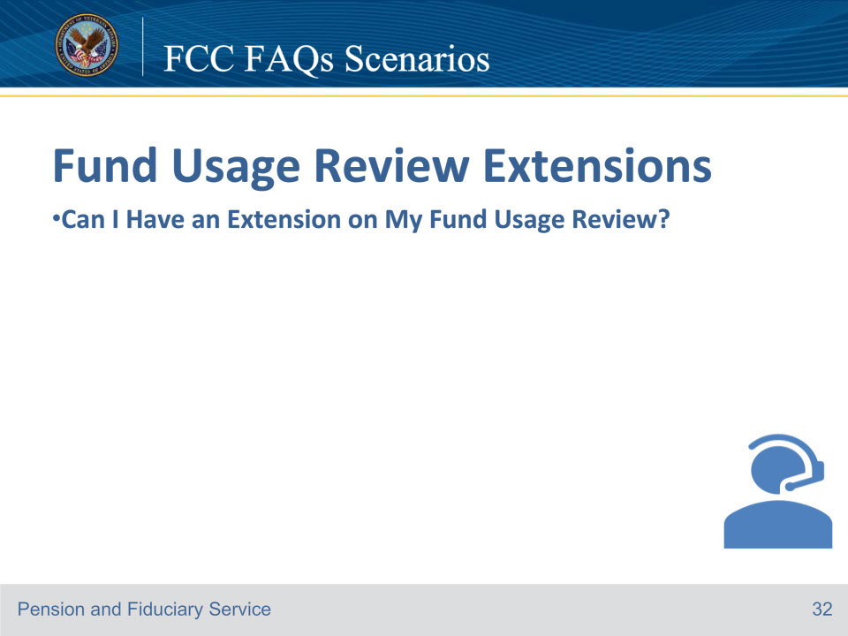
Slide notes

Tina: Department of Veterans Affairs. My name is Tina. To better assist you may I have the Veteran’s file number or Social Security Number?

Kathy: The file number is 12345678

Tina: Thank you, can you verify the Veteran’s date of birth?

Kathy: The Veteran’s date of birth is November 22, 1949

Tina: Can you verify the Veteran’s branch of service?

Kathy: He was in the Air Force.

Tina: What is your full name?

Kathy: My name is Kathy Johnson and I am the fiduciary for Rob Thompson.

Tina: Thank you for that information. I’ve accessed the record. Has any of your contact information changed?

Kathy: No

Tina: How may I assist you today?

Kathy: I’d like to request an extension on my fund usage review report.

Tina: Why do you wish to have an extension?

Kathy: My mother passed away, and I’m unable to submit the fund usage review by the deadline.

Tina: I’m sorry to hear that. My condolences to you and your family. I see that there is no existing fund usage extension, and you are requesting it prior to your fund usage review becoming past due. Yes, I can grant you an extension.

Kathy: Thank you so much.

Tina: You’re welcome. I will update the system with your new due date and document the extension approval. This will notify the appropriate department of the approval. I’ll be mailing you a Fund Usage Due Date Extension letter today. You’ll have 14 days from the date of the extension letter to submit your fund usage review. The fund usage review is required no later than this date. I know that was a lot of information at once, so do you have any questions on anything I just covered?

Kathy: No, I don’t have any other questions. You’ve been a big help. Thank you.

Tina: You’re welcome. I hope you have a good day.

Kathy: You too.

Course of action: In this scenario, the LAS should consider the following before deciding to extend the fund usage review:

• Why does the fiduciary wish to have an extension?

• Is the extension due to good cause (i.e., illness, hospitalization, death of immediate family member, non-receipt of VA’s request, or catastrophic event)? (If no, they don’t qualify).

• Is there evidence or any suspicion that the fiduciary is being evasive or misusing beneficiary funds? (If yes, they don’t qualify).

• Is there already an extension in place? (If yes, they don’t qualify).

• Is the request being made within 30 days of the fund usage review due date, or within 14 days of the VA’s request for additional information to approve the fund usage review or a complete fund usage review? (If no, they don’t qualify).

If they do qualify, use the following suggested responses:

• Yes, an extension can be granted in this case.

• Please note that I will update the due date and add a note in the system to reflect the extension.

• Your new due date is (advise of date 14 days from the date of letter). The fund usage review is required to be received no later than this date, and I will send a fund usage review extension letter that details this information.

• Do you understand this information? (Or something similar to confirm they understand the terms of the extension).

• I will document your file with the approval of the fund usage review extension and notify the appropriate department.

Course of action continued: Once the LAS determines that the fiduciary meets the qualifications for an extension, add the development activity “Additional Information Request” to the EP 290 - Fund Usage Review. The LAS must verify that the suspense date has been updated to reflect 14 days, which should happen automatically. Additionally, the LAS should place a note in the note section of the EP that documents the extension approval. These actions will serve as notification to the appropriate department. actions will Then, create the Fund Usage Due Date Extension letter, upload it to the appropriate e-Folder, and mail it to the fiduciary. The LAS should thoroughly document the call on a VA Form 27-0820, Report of General Information, and upload it to the appropriate e-Folder.

References: FCC 11.a

For more information on extensions, see

• FPM, Part I, 6.B.1.c, and

• 38 CFR 13.500(a)(2)(v).

Slide 33 - FCC FAQs Scenarios
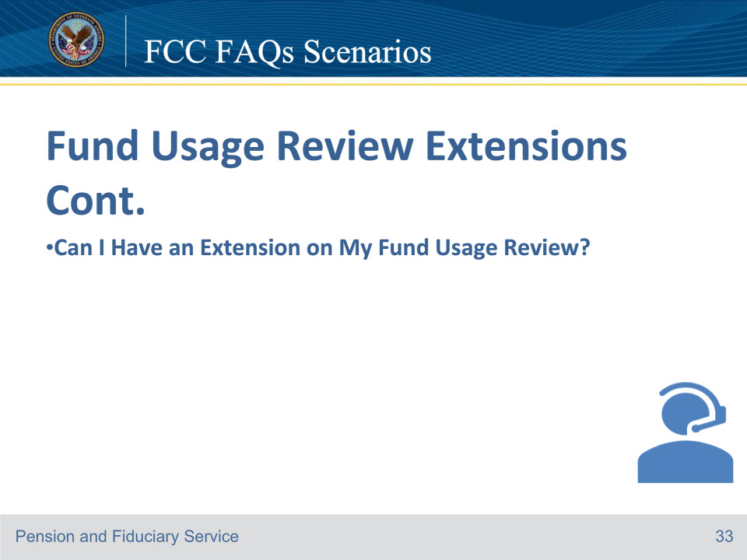
Slide notes

Tina: Department of Veterans Affairs. My name is Tina To better assist you may I have the Veteran’s file number or Social Security Number?

Kathy: The file number is 12345678

Tina: Thank you, can you verify the Veteran’s date of birth?

Kathy: The Veteran’s date of birth is November 22, 1949.

Tina: Can you verify the Veteran’s branch of service?

Kathy: He was in the Air Force.

Tina: What is your full name?

Kathy: My name is Kathy Johnson, and I am the fiduciary for Rob Thompson.

Tina: Thank you for that information. I’ve accessed the record. Has any of your contact information changed?

Kathy: No

Tina: How may I assist you today?

Kathy: I requested a fund usage review extension about two weeks ago because my mom passed away. I’m not able to get the fund usage review submitted by the deadline. I’d like to request another extension.

Tina: I’m sorry to hear about the passing of your mother. I see the extension was processed, and you were given an additional 14 days to submit your fund usage review, which is due by tomorrow. Unfortunately, a fund usage review extension can’t be granted because there’s already an extension in place. If the fund usage review isn’t received by this date, the fund usage review will be considered delinquent, and the process to obtain the fund usage review will continue. A delinquent fund usage review letter will be sent after the due date has passed.

Kathy: So, there’s nothing you can do?

Tina: I will note the record with what we discussed today. There will be a record of why your fund usage review is delinquent, but I cannot grant an extension. Please try to get the fund usage review in as soon as possible. Do you understand why this fund usage can not have an extension granted?

Kathy: Yes, I understand.

Tina: Is there anything else I can help you with?

Kathy: No, Thank you for your time. Have a great day.

Tina: You too.

Course of action: In this scenario, the LAS must first review the e-Folder to check if an extension has been granted for the fund usage review. Since the record reflects that an extension has already been granted, the fiduciary must be informed that no further extension can be given. The LAS should also inform the fiduciary that the discussion will be documented and emphasize that the fund usage review will be considered delinquent if not received by the due date. Additionally, the fiduciary should be encouraged to submit the fund usage review as soon as possible. The LAS should thoroughly document the call on a VA Form 27-0820, Report of General Information, and upload it to the appropriate e-Folder.

References: FCC 11.a

For more information on extensions, see

• FPM, Part I, 6.B.1.c, and

• 38 CFR 13.500(a)(2)(v).

Slide 34 - FCC FAQs Scenarios
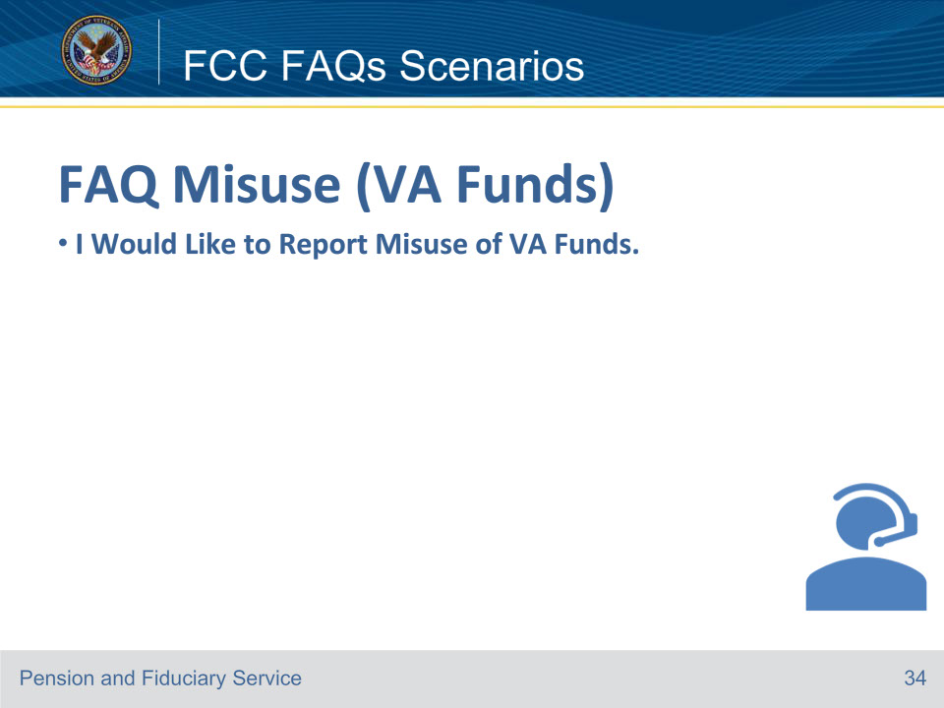
Slide notes

Luke: Department of Veterans Affairs. My name is Luke To better assist you may I have the Veteran’s file number or Social Security Number?

Jennifer: The File number is 11-111-111

Luke: Thank you, can you verify the Veteran’s date of birth?

Jennifer: His date of birth is September 1, 1948.

Luke: Can you verify the branch of service?

Jennifer: He was in the Army.

Luke: What is your full name?

Jennifer: My name is Jennifer Garnett and I am the daughter of George Van Buren who is receiving VA benefits.

Luke: Thank you for that information and thank you for your father’s service. Unfortunately, I’m unable to give you information about this file, but I can provide general information if that will help. Thank you for that information and thank you for your father’s service.

Jennifer: I would just like to report a misuse of VA funds, my brother has been stealing money from my dad who is a Veteran.

Luke: Thank you for reporting this information. The VA takes allegations of potential misuse, abuse, fraud, or misrepresentation seriously. I can help you with that. I will need to gather some additional information from you in order to properly document your concerns about your brother stealing money from a Veteran.

Luke: I have located the record. Can you tell me about the allegation of misuse?

Jennifer: My brother Tom Van Buren, who is my father’s VA fiduciary, has been taking cash out of my dad’s VA account to pay for his gambling habit.

Luke: Do you have any evidence you can provide?

Jennifer: Yes, I have copies of the bank statements showing the withdrawals and receipts from Parx Casino.

Luke: I see that the beneficiary and fiduciary both reside in Pennsylvania, so the Indianapolis Fiduciary Hub would have jurisdiction over this matter. Can you provide any details, such as the amounts and dates on which these cash withdrawals occurred?

Jennifer: Yes, I have the statements with me, there were two cash withdrawals of five thousand dollars on November 13, 2023, and one cash withdrawal of ten thousand dollars on November 15, 2023. I also have receipts from Parx casino showing bar tabs and gambling statements showing that my brother spent twenty thousand dollars at Parx on November 17, 2023.

Luke: Can I have your contact information, your name, address, and phone number?

Jennifer: Yes, Jennifer Garnett, 123 Anystreet Drive, Philadelphia, PA 19055. My phone number is 267-555-5555.

Luke: Please send your evidence Department of Veterans Affairs, Fiduciary Intake, PO Box 5211, Janesville, WI 53547-5211

Jennifer: OK, I will send in the information today. Thank you for your help.

Luke: You’re welcome. Is there anything else I can help you with?

Jennifer: No, Thank you.

Luke: You’re welcome, have a great day

Course of action: If an allegation is received verbally, the information must be documented on a VA Form 27-0820, Report of General Information, and uploaded to the beneficiary’s eFolder with the subject of the document listed as misuse allegation then Establish a Misuse Documentation administrative task in VBMS, that details a misuse allegation was received.

References: FCC FAQs 12.a.

For more information on documenting misuse, see FPM II.3.A.2.d.

For more information on Hub Jurisdictions and Contact Information, see FPM I.1.A.2.a

For more information on Shipping Mail to Scanning Vendors, see M21-1 II.i.1.A.2.c.

Slide 35 - FCC FAQs Scenarios
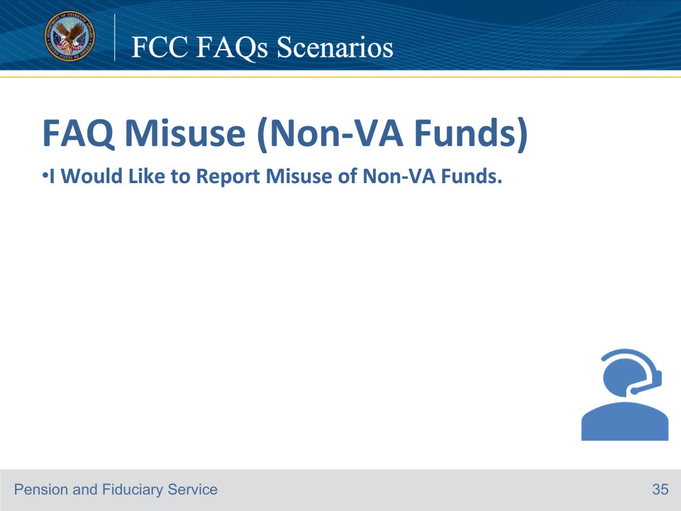
Slide notes

Diana: Department of Veterans Affairs. My name is Diana To better assist you may I have the Veteran’s file number or Social Security Number?

Sue: My name is Sue Parker and I would like to report that my sister has been stealing my brother’s work pension who is a Veteran.

Diana: May I Have the Veteran’s file number or Social Security number?

Sue: The Social Security number is 333-33-3333

Diana: Thank you, what is the veteran’s name and date of birth?

Sue: The veteran’s name is Harold Grant, and his date of birth is February 29, 1952.

Diana: Do you know the veteran’s branch of service?

Sue: He was in the Marines.

Diana: I have located the record. Thank you for your brother’s service.

Are you referring to a VA funds or a private work pension?

Sue: My sister has been paying her mortgage with my dad’s private work pension account.

Diana: We only investigate misuse if it involves misuse of VA funds. If you would like to report misuse of non-VA funds or abuse of a beneficiary, contact Adult Protective Services (APS) and/or your local law enforcement.

Sue: Ok, thank you

Diana: Is there anything else I can help you with?

Sue: No.

Diana: Have a great day.

Course of action: Send the completed VA Form 27-0820 to the team coach. The subject line should read Non-VA Funds Misuse Allegation.

Suggested Response (if there is not a VA file): Thank you for reporting this information; however, this information should be reported to APS or local law enforcement.

Reference: For more information on misuse allegations, see FPM, Part II, 3.A.2.

References: FCC FAQs 12.b.

Slide 36 - FCC FAQs Scenarios
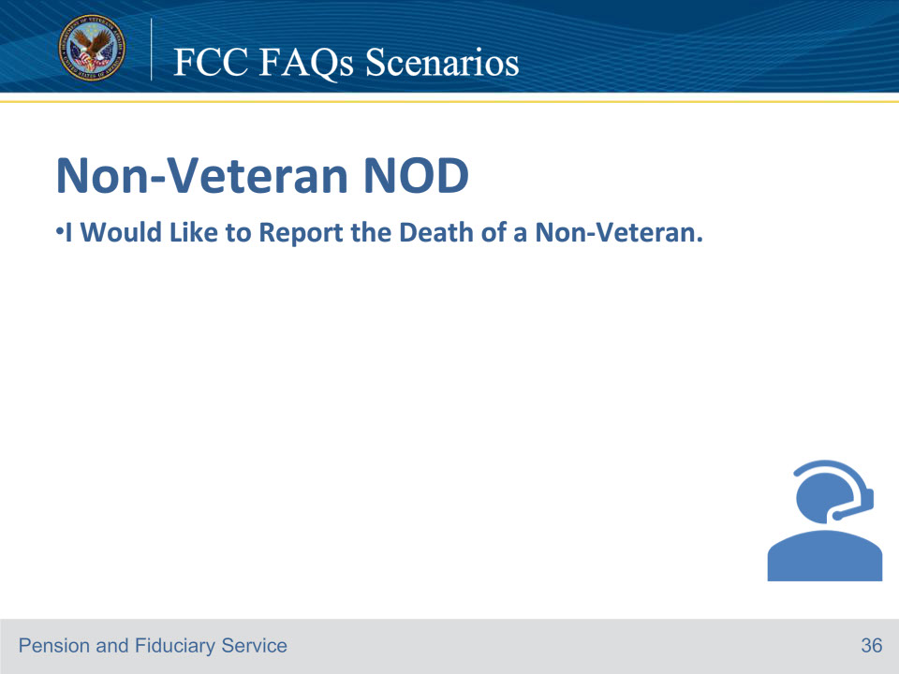
Slide notes

Jeremy: Department of Veterans Affairs. My name is Jeremy To better assist you may I have the Veteran’s file number or Social Security Number?

Patty: The Social Security number is 444-44-4444.

Jeremy: Thank you, what is the veteran’s name and date of birth?

Patty: The veteran’s name is Henry Harrison, and his date of birth is March 15, 1952.

Jeremy: Can you verify the Veteran’s branch of service?

Patty: He was in the Marines.

Tina: Thank you for that information. I’ve accessed the record. How may I help you?

Patty: My name is Patty Harrison

Jeremy: Hi, Ms. Harrison How are you doing today?

Patty: Not that well, I would like to report that my mother Harriet Harrison has passed away on November 19, 2023.

Jeremy: I am sorry for your loss, Let me ask some additional questions to complete this process. What is your address and telephone number?

Patty: My address is 1234 Memory Lane Sacramento, California 99999 and my phone number is 555-555-5555.

Jeremy: Can you verify the date of birth of Harriet Harrison and the state where the death occurred?

Patty: Yes, her date of birth was September 26, 1952, and the state was California.

Jeremy: The VA benefits will be stopped on the first day of the month of death, and that any payment issued following that date must be returned. There are options for the spouse to be buried in a national cemetery if the Veteran is buried there. I will route this report of death to the regional office of jurisdiction or PMC via approved method for stop payment processing.

Jeremy: Is there anything else I can help you with?

Patty: No, Thank you.

Jeremy: You’re welcome and sorry for your loss.

Course of action: Obtain all the information that is required to complete the VA Form 27-0820a and upload into the e-Folder.

Establish an FNOD administrative task.

References: FCC FAQs 13.a.

Slide 37 - FCC FAQs Scenarios
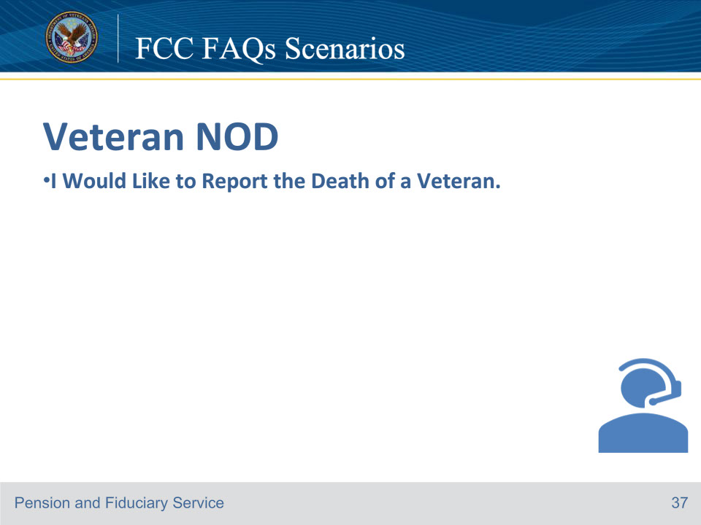
Slide notes

Tom: Department of Veterans Affairs. My name is Tom To better assist you may I have the Veteran’s file number or Social Security Number?

Kevin: My father’s Social Security number is 777-77-7777

Tom: Thank you, what is the veteran’s name and date of birth?

Kevin: My father’s name is George Adams and his date of birth is April 15, 1941.

Tom: Can you verify the branch of service?

Kevin: He was in the Army.

Tom: I have located the record. How may I help you?

Kevin: I would like to report that my father George Adams has passed away on November 21, 2023.

Tom: I am sorry for your loss, I have located the record. Let me ask some additional questions to complete this process.

Kevin Ok!

Tom: What is your address and telephone number?

Kevin: My address is 1234 Pine Lane, Philadelphia, PA 19000 and my phone number is 267-555-5555.

Tom: What was the state where the death occurred?

Kevin: He passed away in the state of Pennsylvania.

Tom: The VA benefits will be stopped on the first day of the month of death and any payment issued following that date must be returned. I looked up the Veteran’s record. I processed the Veterans first notice of death in our system of record. Do you have any questions concerning possible burial and death benefit entitlements? I processed the Veterans first notice of death in our system of record.

Kevin: No.

Tom: Is there anything else I can help you with?

Kevin: No, Thank you.

Tom: You’re welcome and sorry for your loss.

Course of action: Obtain all the information that is required to complete the VA Form 27-0820a and upload into the e-Folder.

Process First Notice of Death (FNOD) actions in SHARE.

Establish an FNOD administrative task.

Send automated letters. Explain burial and death benefits (PMC, DIC, burial allowance, flag, month of death).

References: FCC FAQs 14.a. For more information on

Veteran FNOD processing, see M21-1, Part XI, Subpart i, 1.A.1, and

proof of death, see M21-1, Part XI, Subpart iii, 1.A.4.f.

Slide 38 - FCC FAQ Scenarios
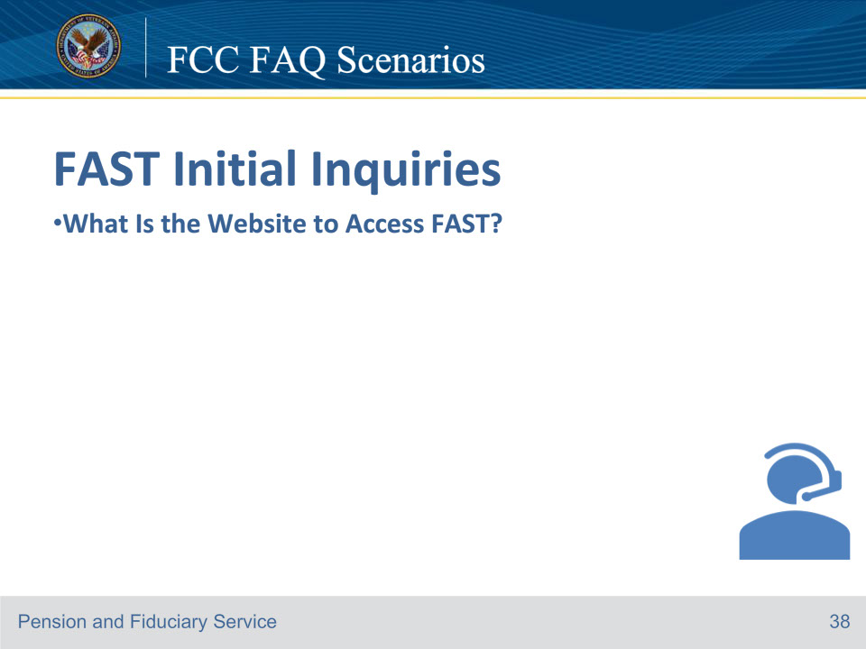
Slide notes

Hector: Department of Veterans Affairs. My name is Hector To better assist you may I have the Veteran’s file number or Social Security Number?

Jason: I don’t have either of those with me right now.

Hector: Without that information, I’m unable to access the record and can only provide general information

Jason: I would just like to know what the website is to Access FAST

Hector: The FAST website is eauth.va.gov/accessva/.

Hector: Is there anything else I can help you with?

Jason: No, Thank you.

Hector: You’re welcome, and have a nice day

Course of action: Since the caller’s question was general and not related to a specific Veteran or beneficiary file, there is no need to complete a VA Form 27-0820 Report of General Information.

The L A S can refer caller to the Log into FAST job aid located on the FAST website, Log_into_FAST_Job_Aid.pdf (va.gov)

References: FCC FAQs 15.a. For more information on FAST, see the FAST User Guide https://vbaw.vba.va.gov/pensionandfiduciary/pension/index.asp

Slide 39 - FCC FAQs Scenarios
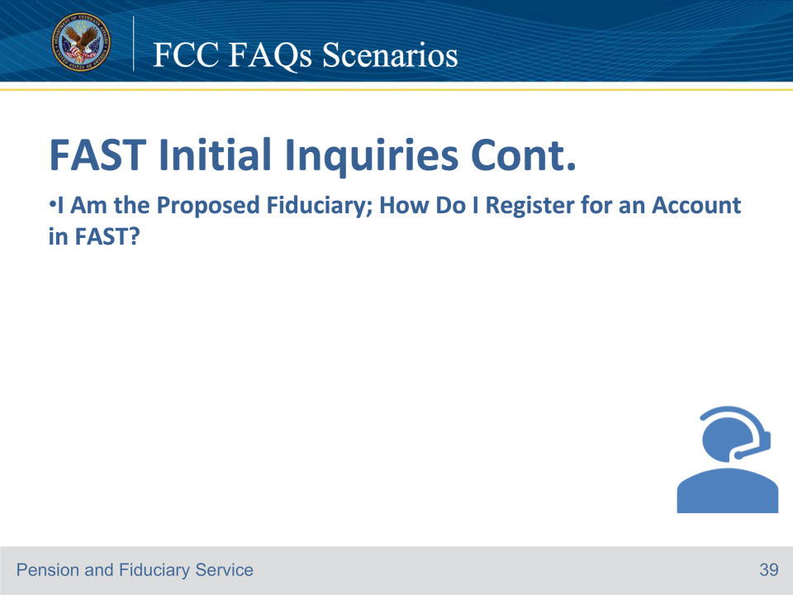
Slide notes

Jacob: Department of Veterans Affairs. My name is Jacob To better assist you may I have the Veteran’s file number or Social Security Number?

Susan: I don’t have either of those with me right now.

Jacob: Without that information, I’m unable to access the record and can only provide general information

Susan: I am the proposed fiduciary; how do I register for an account in FAST?

Jacob: No problem, I can help you with that. To self-register, enter the Access VA Website, which is https://eauth.va.gov/accessva/, and select one of the following three options: I am a Family Member, I am a VA Business Partner, or I am a VA Employee or Authorized Contractor. Then, you will click the FAST button, click on the ID.me button, and then click “Accept.”

Susan: Ok

Jacob: The system will then guide you through the identity verification and self-registration process.

Once you complete the first part of the process of self-registering, you will then be taken to the second part of the self-registration process, which will allow you to submit the application. Once you have successfully submitted the electronic VA Form 21P-4703, it will be vetted.

Susan: OK, I got it.

Jacob: Is there anything else I can help you with?

Susan: No, Thank you.

Jacob: You’re welcome, and have a nice day

Course of action: Since the caller’s question was general and not related to a specific Veteran or beneficiary file, there is no need to complete a VA Form 27-0820 Report of General Information.

The LAS Self_Registration_Job_Aid.pdf (va.gov)

References: FCC FAQs 15.b. Reference: For more information on FAST, see the FAST User Guide. https://vbaw.vba.va.gov/PENSIONANDFIDUCIARY/fiduciary/docs/FAST_User_Guide.pdf

Slide 40 - FCC FAQs Scenarios
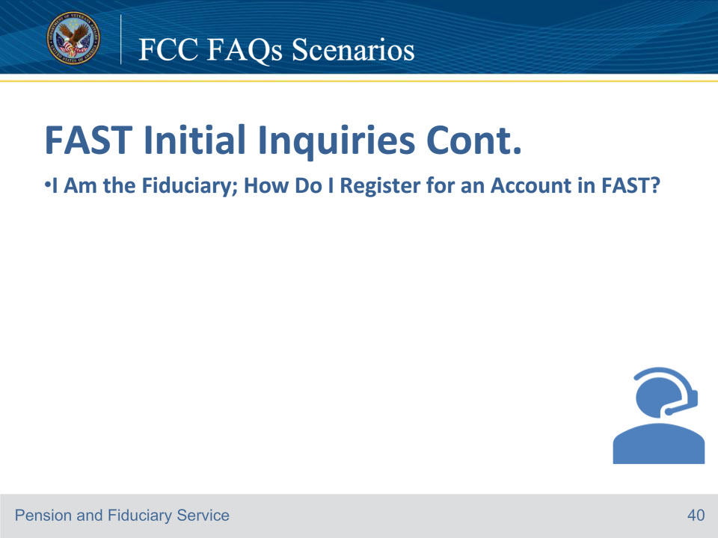
Slide notes

Katie: Department of Veterans Affairs. My name is Katie To better assist you may I have the Veteran’s file number or Social Security Number?

Jane: The Social Security number is 888-88-8888.

Katie: Thank you, Can you verify the Veteran’s date of birth?

Jane: The Veteran’s date of birth is December 12, 1972.

Katie: Can you verify the branch of service?

Jane: He was in the Coast Guard.

Katie: What is your full name?

Jane: I am Jane Martin and I am the fiduciary for Joe Jones.

Katie: Has any of your contact information changed?

Jane: No, my information has not changed, how do I register for an account in FAST?

Katie: I can help you with that. May I Have the Veteran’s file number or Social Security number?

Katie: I have located the record, To self-register, enter the Access VA Website which is https://eauth.va.gov/accessva/ and select one of the following three options: I am a Family Member, I am a VA Business Partner, or I am a VA Employee or Authorized Contractor. Then you will click the FAST button, click on the ID.me button, and then click “Accept.”

Jane: I understand

Katie: The system will then guide you through the identity verification and self registration process. If you are pre-approved, you will be granted immediate access upon completion of self-registration. If you are not pre-approved, the request for access will be reviewed and you will receive a confirmation email, once your request has been processed. After the self-registration access application has been reviewed and determined VA compliant, you will be able to log into the FAST system.

Jane: Ok I wrote that down.

Katie: Is there anything else I can help you with?

Jane: No, Thank you.

Katie: You’re welcome and have a great day.

Course of action: Obtain all the information that is required to complete the VA Form 27-0820 and upload into the e-Folder.

References: FCC FAQs 15.c.

Reference: For more information on FAST, see the FAST User Guide. https://vbaw.vba.va.gov/PENSIONANDFIDUCIARY/fiduciary/docs/FAST_User_Guide.pdf

Slide 41 - FCC FAQ Scenarios
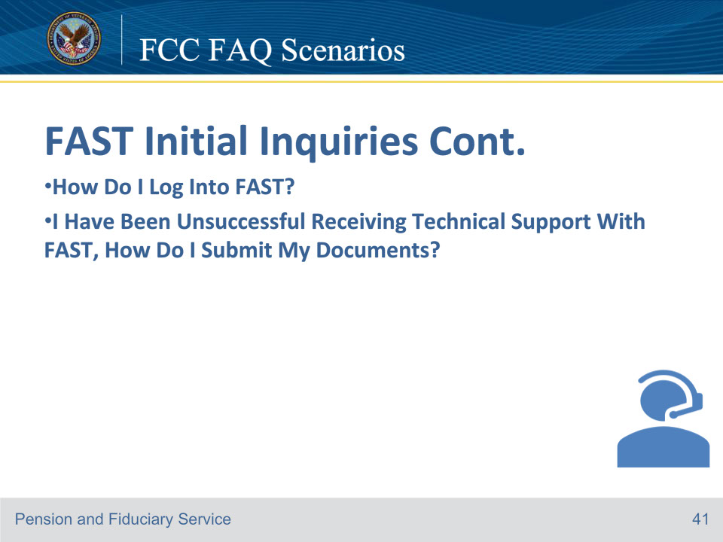
Slide notes

Hector: Department of Veterans Affairs. My name is Hector To better assist you may I have the Veteran’s file number or Social Security Number?

Brian: The Social Security number is 999-99-9999.

Hector: Thank you can you verify the veteran’s date of birth?

Brian: The veteran’s date of birth is January 15, 1943.

Hector: Can you know verify the veteran’s branch of service?

Brian: He was in the Air Force.

Hector: What is your full name?

Brian: I am a Brian Taylor the fiduciary for John Smith.

Hector: I’ve accessed the record. How may I help you?

Brian: How do I log into FAST?

Hector: Have you self registered in the FAST system?

Brian: Yes I have

Hector: You will enter the Access VA Website which is https://eauth.va.gov/accessva/ and select one of the following three options: I am a Family Member, I am a VA Business Partner, or I am a VA Employee or Authorized Contractor. Then you will click the FAST button, click on the ID.me button, and then click “Accept.”

Brian: Ok I understand

Hector: The system will You will enter your email and password then click “Sign in.” You will then follow the prompts to verify your identity. Once your identity is successfully verified, you will be logged into FAST.

Brian: I can’t log in and I have been unsuccessful receiving technical support with FAST, how do I submit my documents?

Hector: I am sorry for the inability to resolve technical issues with FAST, May I suggest you submit your documents via mail, I can provide you with the Janesville mailing address.

Brian: That would be great!

Hector: The mailing address is Department of Veterans Affairs, Fiduciary Intake, PO Box 5211, Janesville, WI 53547-5211.

Brian: Thank you. I will mail in the information tomorrow.

Hector: Is there anything else I can help you with?

Brian: No, Thank you.

Hector: You’re welcome and have a great day.

Course of action: Obtain all the information that is required to complete the VA Form 27-0820 and upload into the e-Folder.

References: FCC FAQs 15.d.,e.

• If they have fiduciary oversight questions, (accountings, bonds, fund usage reviews, etc.), provide guidance on the specific area in question.

• If the problems are FAST application system issues (error messages, inability to submit accountings, etc.), the LAS should submit a Digital Transformation Center (DTC) ticket via the DTC VA Helpdesk Form for the fiduciary.

• Identify that if they continue to have problems with electronic submission, they may be required to submit documents via mail (provide the Janesville mailing address) or via fax (provide the correct rightfax number).

Important: PII must not be uploaded as part of any DTC ticket.

Reference: For more information on FAST, see the FAST User Guide.

Reference: For more information on FAST, see the FAST User Guide. https://vbaw.vba.va.gov/PENSIONANDFIDUCIARY/fiduciary/docs/FAST_User_Guide.pdf

Slide 42 - FCC FAQs Scenarios
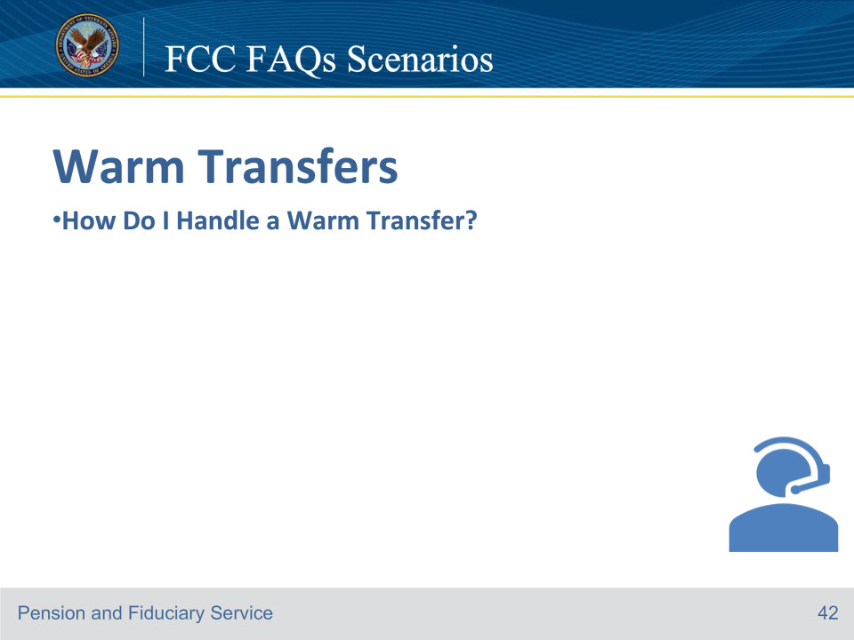
Slide notes

Jeremy: Department of Veterans Affairs. My name is Jeremy To better assist you may I have the Veteran’s file number or Social Security Number?

Jason: I just had a question on how to request a certificate of eligibility for a VA home loan?

Jeremy: Thank you for the information you have provided. I’m sorry I am unable to assist you in this matter, However, my colleague with VA Home loans will be able to assist you with this.

Jason: This is very frustrating.

Jeremy: I understand how frustrating it can be when you’ve reached the incorrect department, so I will ensure this doesn’t happen again, by connecting you to VA home loans.

Jason: Thank you.

Jeremy: You’re welcome, I can also provide you with the correct contact number, if you’d like (provide the correct telephone number 1-877-827-3702.

Jason: Ok, I wrote it down.

Jeremy: May I place you on a brief hold while I contact VA home department?

Jason: Yes!

Jeremy: Hello, my name is Jeremy Jones and I am with the Fiduciary Contact Center. I have Jason Taylor on the line, and they need assistance with how to request a certificate of eligibility for a VA home loan.

Julie: Thank you, I am available for the transfer.

Jeremy: Thank you for holding. I have Julie Ree on the line. I have advised them that you needed information on how to request a certificate of eligibility for a VA Home loan and they will assist you from here.

Jason: Thank you for your help

Jeremy: You’re welcome and have a great day.

Course of action: Since the caller’s question was general and not related to a specific Veteran or beneficiary file, there is no need to complete a VA Form 27-0820 Report of General Information.

Note: If caller is on the phone during the conversation with the other representative, tell the caller the following: Thank you for your patience and (state the representative’s name) will assist you from here.

References: FCC FAQs 16.a.

Slide 43 - FCC FAQs Scenarios
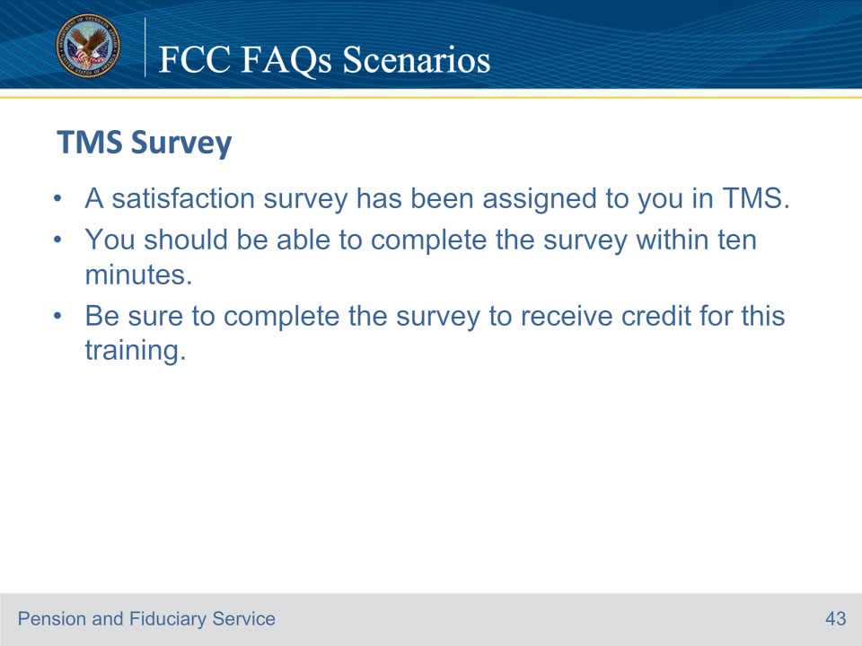
Slide notes

Instructor Notes:

A satisfaction survey has been assigned to you in TMS. You should be able to complete it within ten minutes.

Completing it will allow you to receive credit for this training.

Slide 44 - 31.Questions?
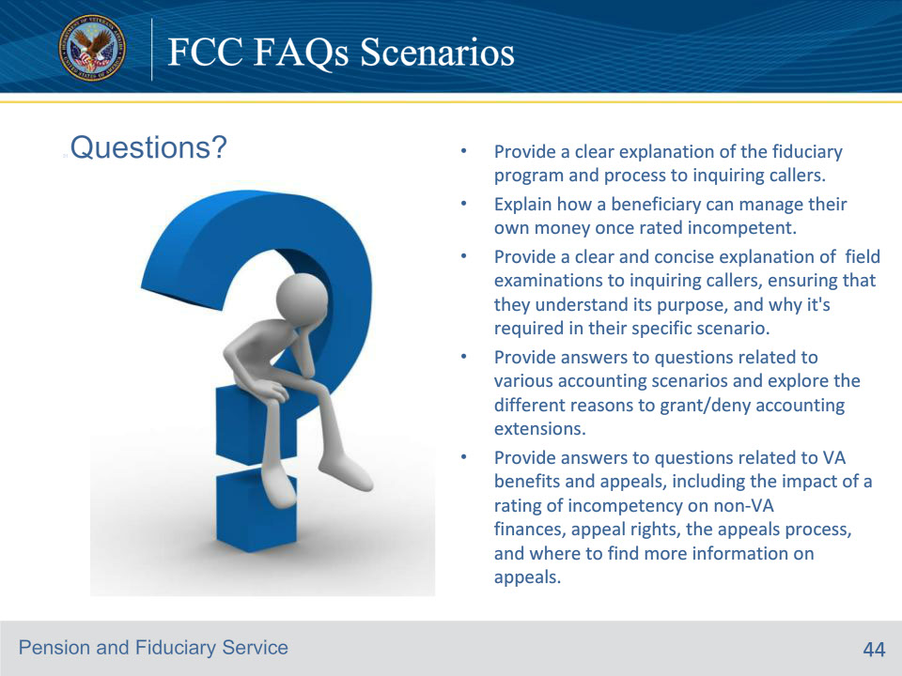
Slide notes

Provide a clear explanation of the fiduciary program and process to inquiring callers.

Explain how a beneficiary can manage their own money once rated incompetent.

Provide a clear and concise explanation of field examinations to inquiring callers, ensuring that they understand its purpose, and why it’s required in their specific scenario.

Provide answers to questions related to various accounting scenarios and explore the different reasons to grant/deny accounting extensions.

Provide answers to questions related to VA benefits and appeals, including the impact of a rating of incompetency on non-VA finances, appeal rights, the appeals process, and where to find more information on appeals.

Slide 45 - 31.Questions?
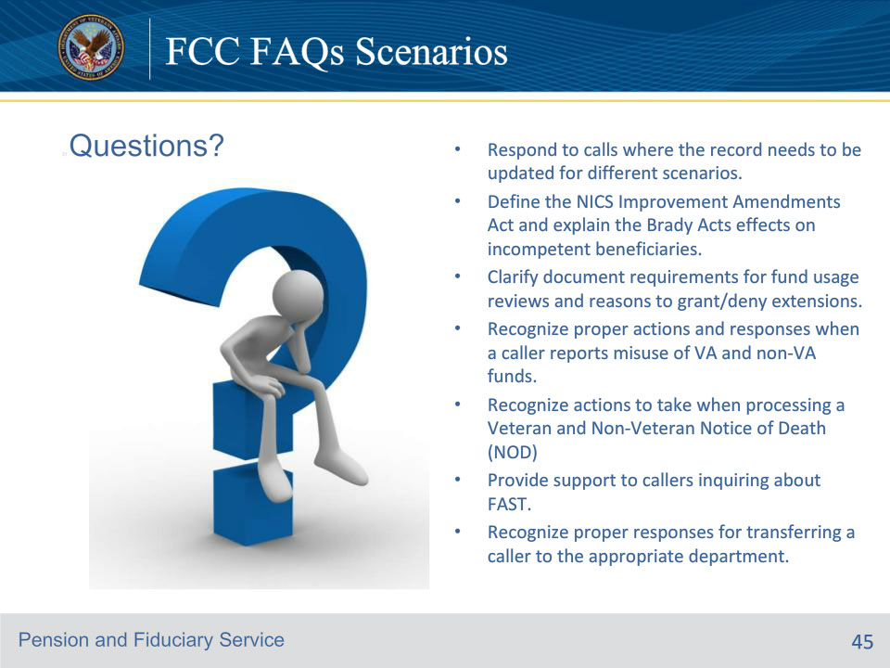
Slide notes

Respond to calls where the record needs to be updated for different scenarios.

Define the NICS Improvement Amendments Act and explain the Brady Acts effects on incompetent beneficiaries.

Clarify document requirements for fund usage reviews and reasons to grant/deny extensions.

Recognize proper actions and responses when a caller reports misuse of VA and non-VA funds.

Recognize actions to take when processing a Veteran and Non-Veteran Notice of Death (NOD)

Provide support to callers inquiring about FAST.

Recognize proper responses for transferring a caller to the appropriate department.

