**Slide 1 - Managing Sensitive Records, Call De-Escalation, and Abusive Calls**

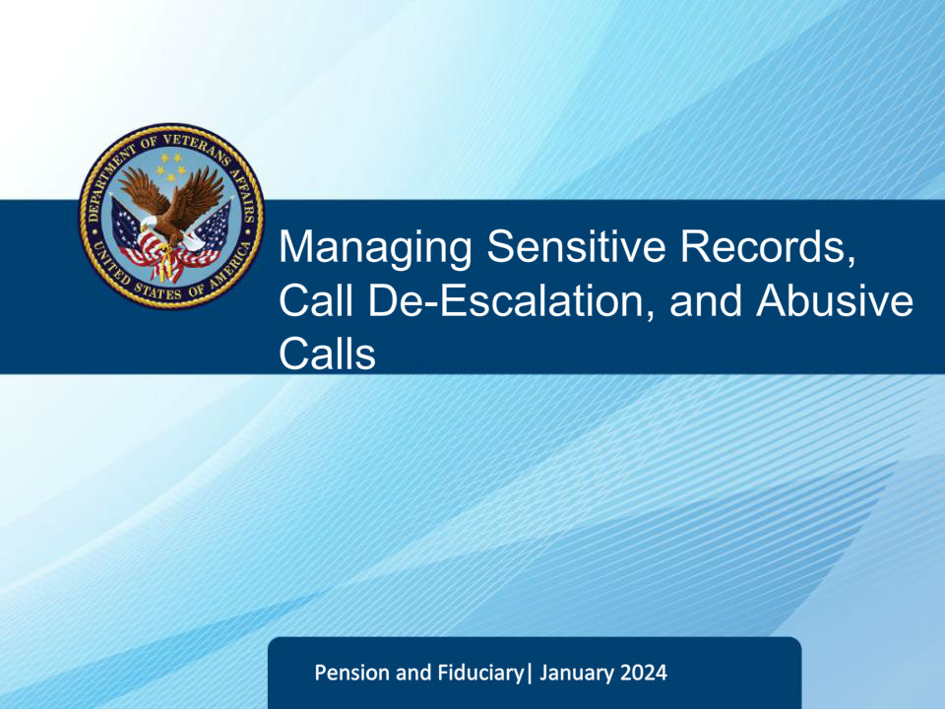

**Slide notes**

Welcome to the Fiduciary Contact Center Phone Procedures course. The purpose of this training is to help Legal Administration Specialists prepare for their duties by providing general guidelines for various interactions with callers. The course covers guidelines for Managing Sensitive Records, Call De-Escalation, and Abusive calls. This training will discuss how to deal with these situations when they arise as an LAS The training is aimed at equipping you with the necessary skills to better serve customers and fulfill your role as a Legal Administration Specialist.

**Slide 2 - Sensitive Records, Call De-Escalation, and Abusive Calls**

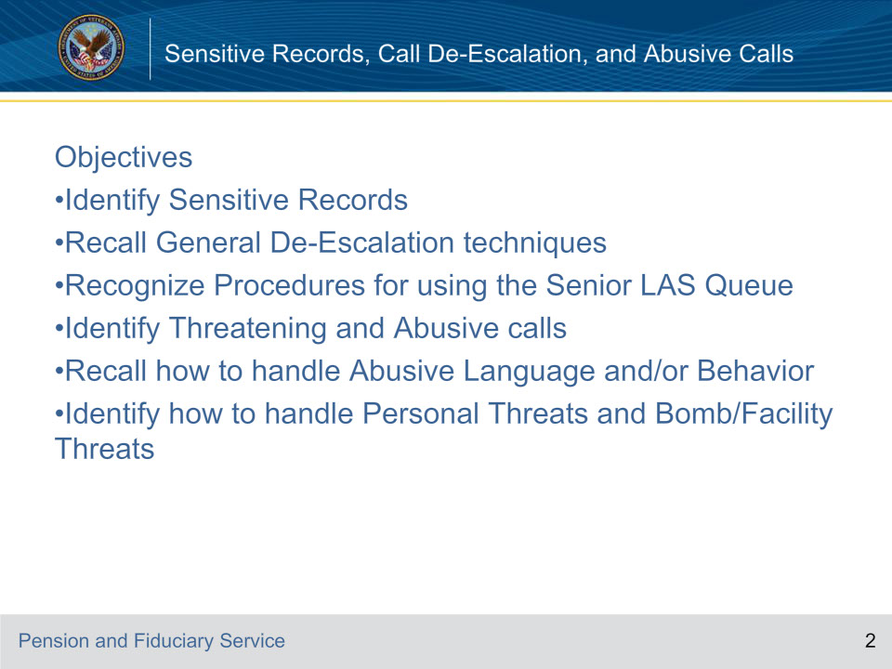

**Slide notes**

Instructor Notes:

Review the objectives of the lesson.

**Slide 3 - Sensitive Records, Call De-Escalation, and Abusive Calls**

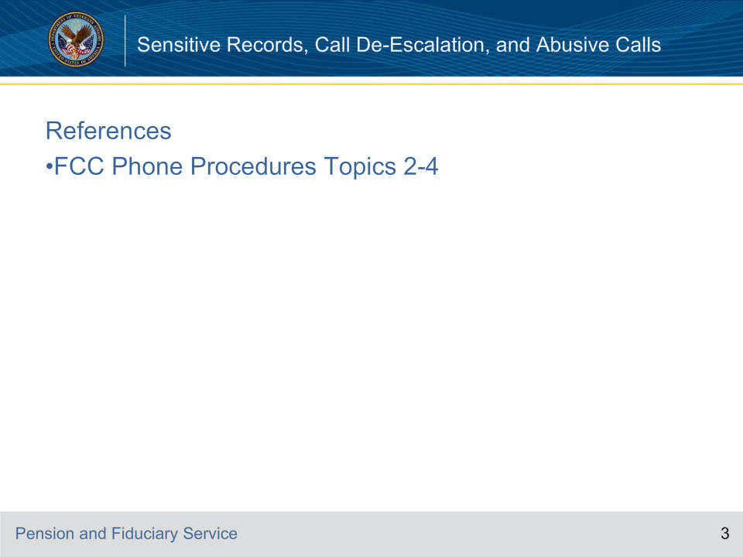

**Slide notes**

Instructor Notes:

Review the reference for this lesson.

**Slide 4 - Sensitive Records**

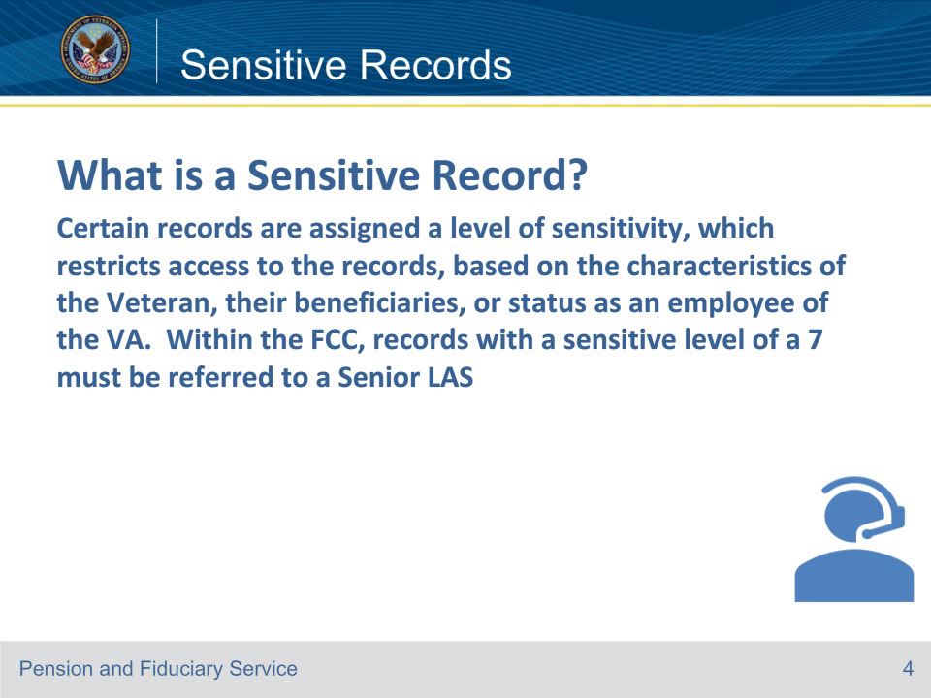

**Slide notes**

Instructor Notes

The LAS must not reference the sensitive level of the individual’s record unless directly asked by the individual.

Reference: Fiduciary Contact Center (FCC) Phone Procedures 2.a.

**Slide 5 - Sensitive Records**

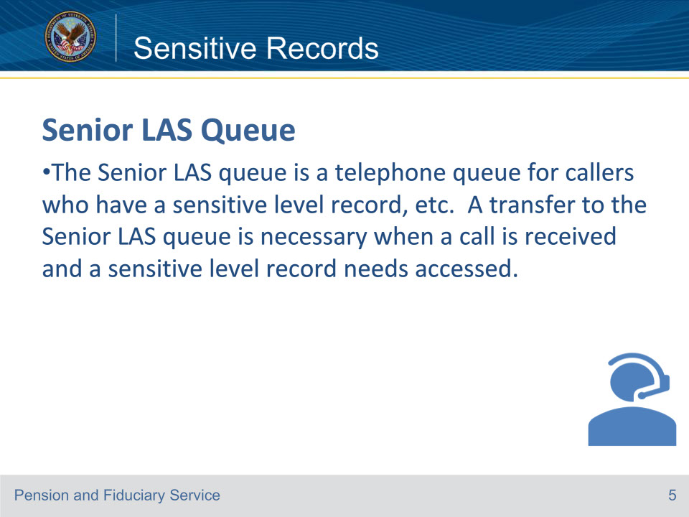

**Slide notes**

Instructor Notes

During the presentation, we will discuss the Senior LAS queue which is a telephone queue used for various reasons. One important reason to use this queue is when there is a sensitive level record. We will discuss other reasons for using this queue in more detail later in the presentation.

Reference: Fiduciary Contact Center (FCC) Phone Procedures 2.b.

**Slide 6 - Sensitive Records**

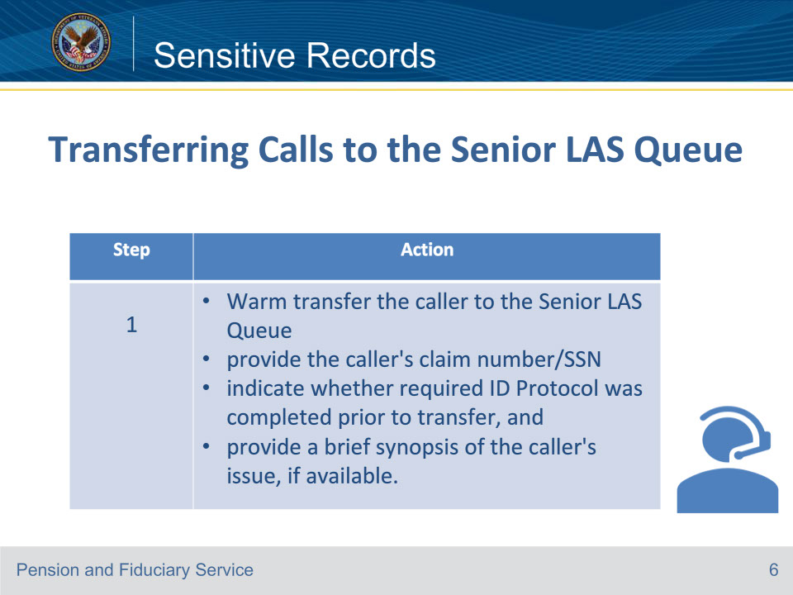

**Slide notes**

Instructor Notes

Follow the 1st step in the table below to transfer a call to the Senior LAS.

Reference: Fiduciary Contact Center (FCC) Phone Procedures 2.b.

**Slide 7 - Sensitive Records**

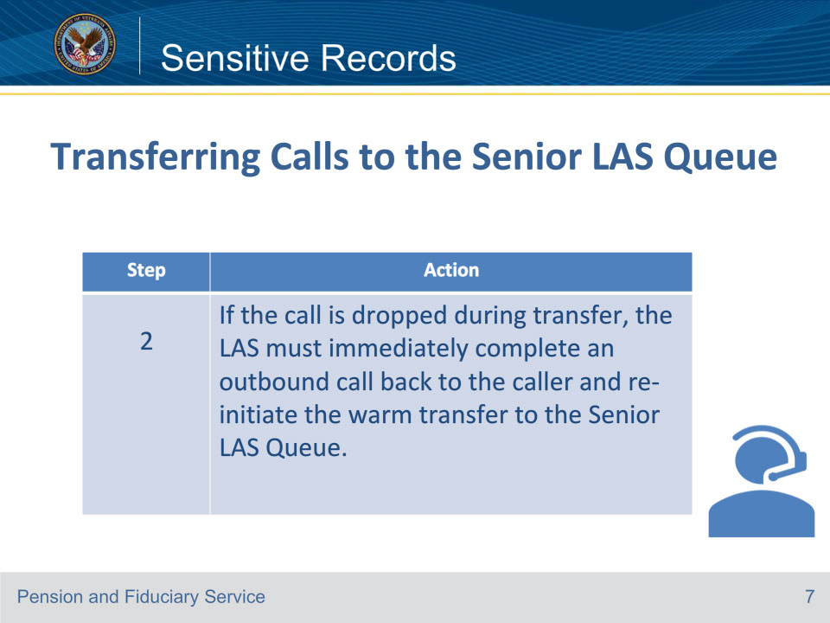

**Slide notes**

Instructor Notes

Follow the 2nd step in the table below to transfer a call to the Senior LAS.

Reference: Fiduciary Contact Center (FCC) Phone Procedures 2.b.

**Slide 8 - Call De-Escalation**

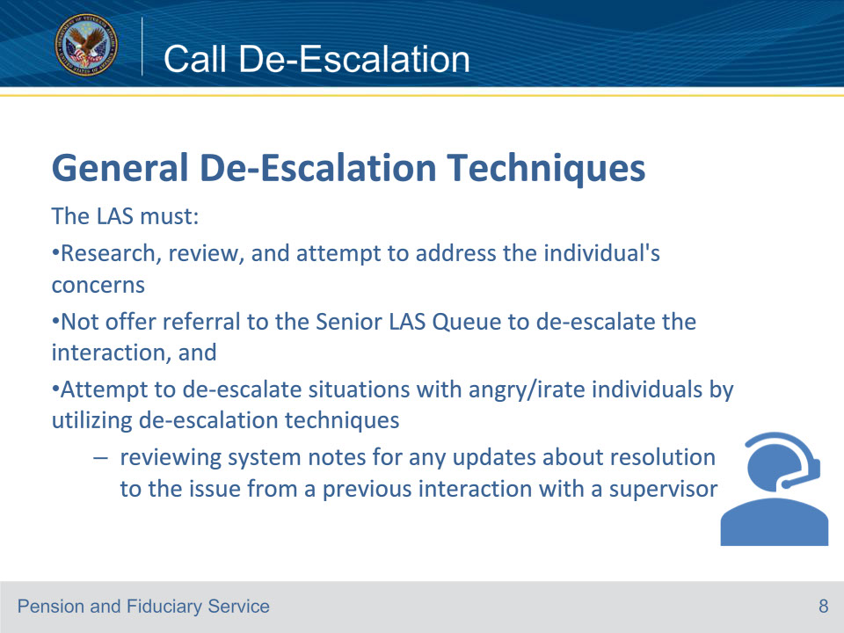

**Slide notes**

Instructor Notes

The LAS must not reference the sensitive level of the individual’s record unless directly asked by the individual.

Reference: Fiduciary Contact Center (FCC) Phone Procedures 3.a.

**Slide 9 - Call De-Escalation**

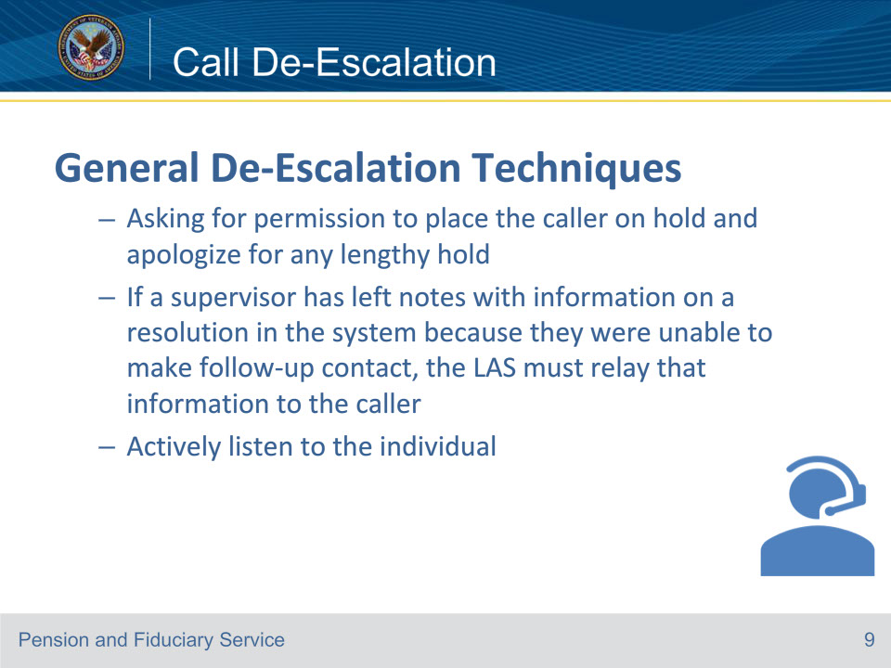

**Slide notes**

Instructor Notes

These are some of the de-escalating techniques.

Reference: Fiduciary Contact Center (FCC) Phone Procedures 3.a.

**Slide 10 - Call De-Escalation**

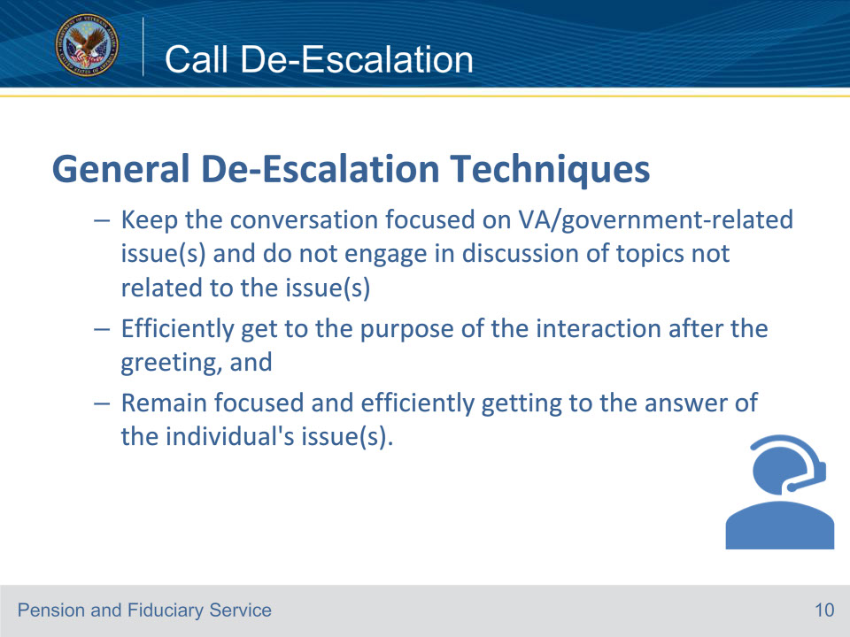

**Slide notes**

Instructor Notes

These are some more of the de-escalating techniques.

Reference: Fiduciary Contact Center (FCC) Phone Procedures 3.a.

**Slide 11 - Call De-Escalation**

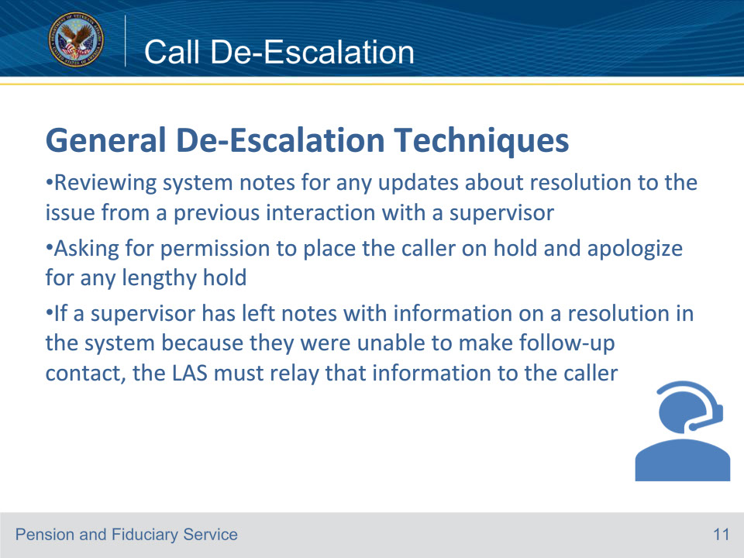

**Slide notes**

Instructor Notes

These are some of the de-escalating techniques.

Reference: Fiduciary Contact Center (FCC) Phone Procedures 3.a.

**Slide 12 - Call De-Escalation**

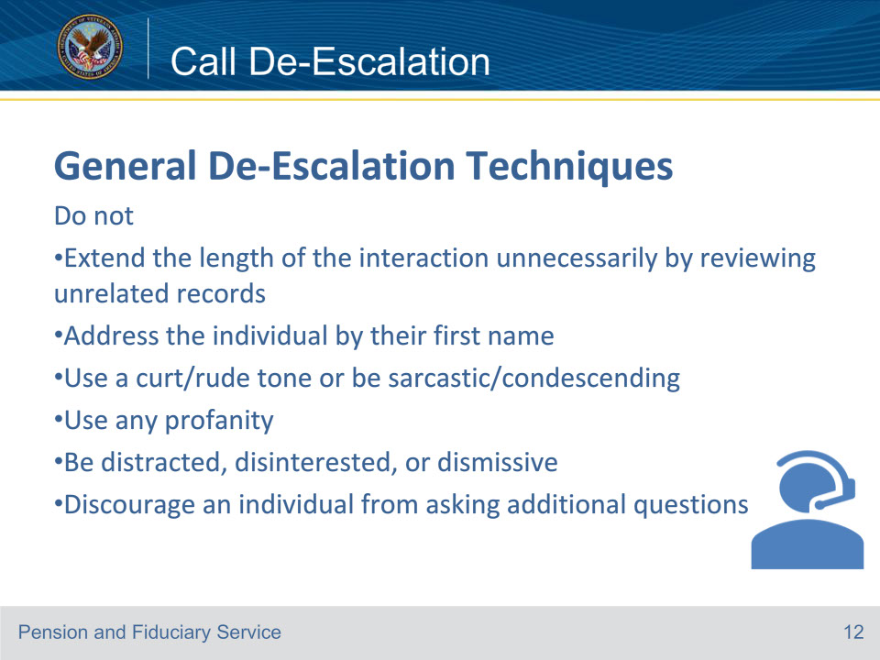

**Slide notes**

Instructor Notes

These are not recommended for De-Escalation techniques.

Reference: Fiduciary Contact Center (FCC) Phone Procedures 3.a.

**Slide 13 - Call De-Escalation**

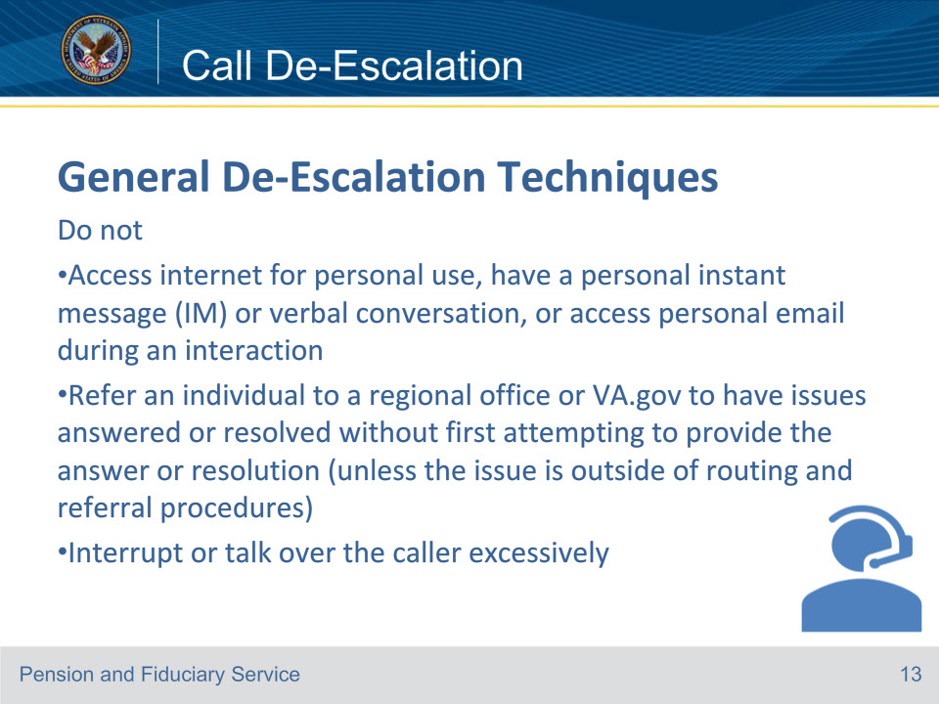

**Slide notes**

Instructor Notes

These are not recommended for De-Escalation techniques.

Reference: Fiduciary Contact Center (FCC) Phone Procedures 3.a.

**Slide 14 - Call De-Escalation**

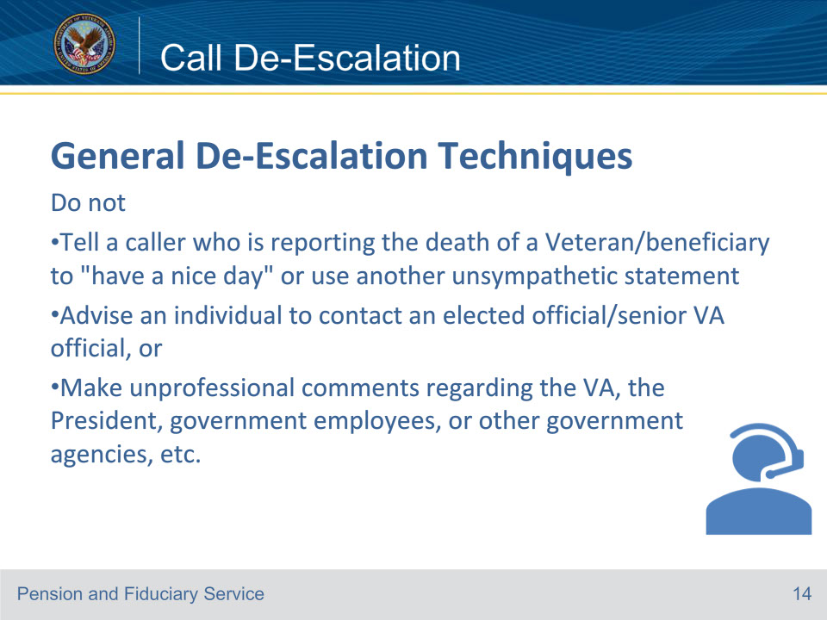

**Slide notes**

Instructor Notes

These are not recommended for De-Escalation techniques.

Reference: Fiduciary Contact Center (FCC) Phone Procedures 3.a.

**Slide 15 - Call De-Escalation**

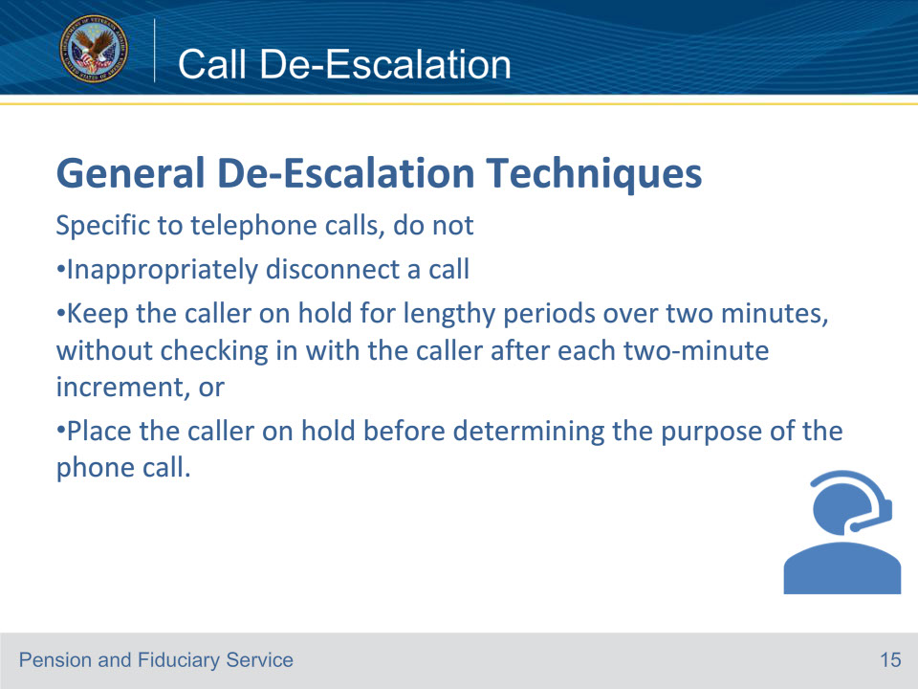

**Slide notes**

Instructor Notes

These are specific to telephone calls on how not to De-Escalate a call.

Note: If the caller identifies that the LAS utilized an incorrect gender or honorific, apologize, and ensure that the preferred gender/honorific is utilized for the rest of the call.

Reference: Fiduciary Contact Center (FCC) Phone Procedures 3.a.

**Slide 16 - Call De-Escalation**

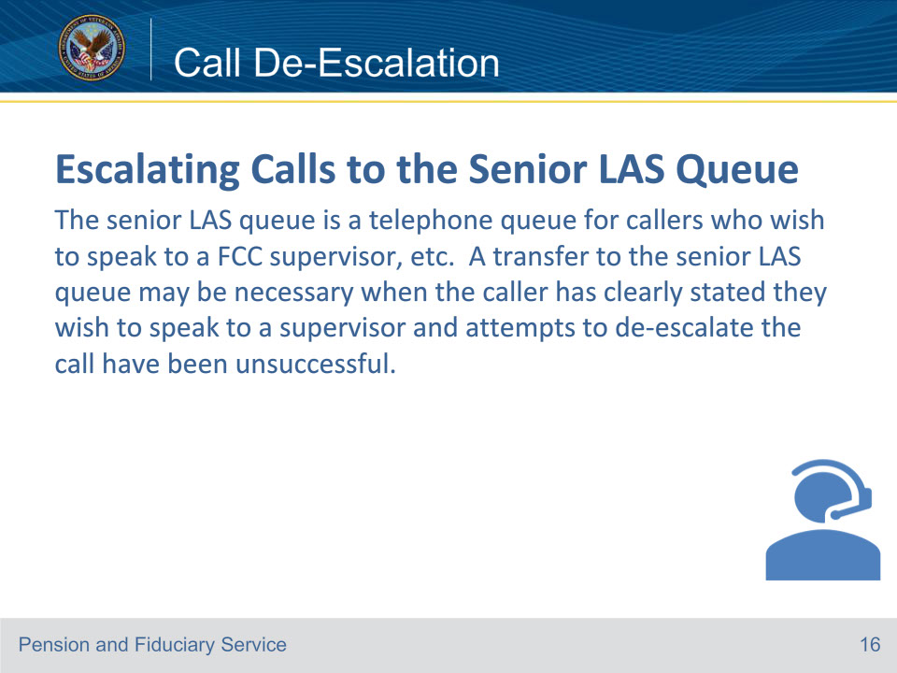

**Slide notes**

Instructor Notes

Prior to initiating a transfer, the LAS is expected to research, review, and attempt to answer the caller’s concerns.

Note: The LAS must not offer an unsolicited supervisor transfer.

Reference: Fiduciary Contact Center (FCC) Phone Procedures 3.b.

**Slide 17 - Call De-Escalation**

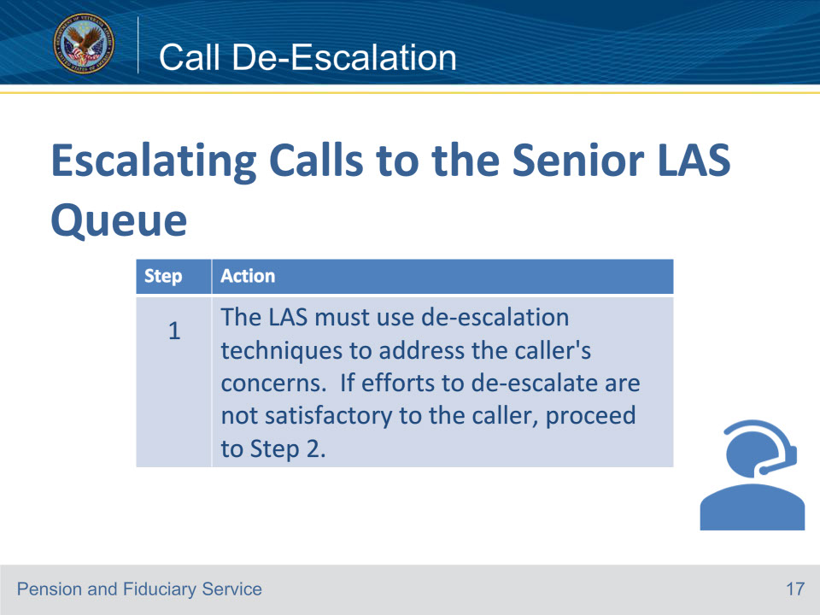

**Slide notes**

Instructor Notes

This is the first step to escalate a call to the Senior LAS Queue.

Reference: For more information on general de-escalation techniques, see FCC Phone Procedures, 3.a. Fiduciary Contact Center (FCC) Phone Procedures 3.b.

**Slide 18 - Call De-Escalation**

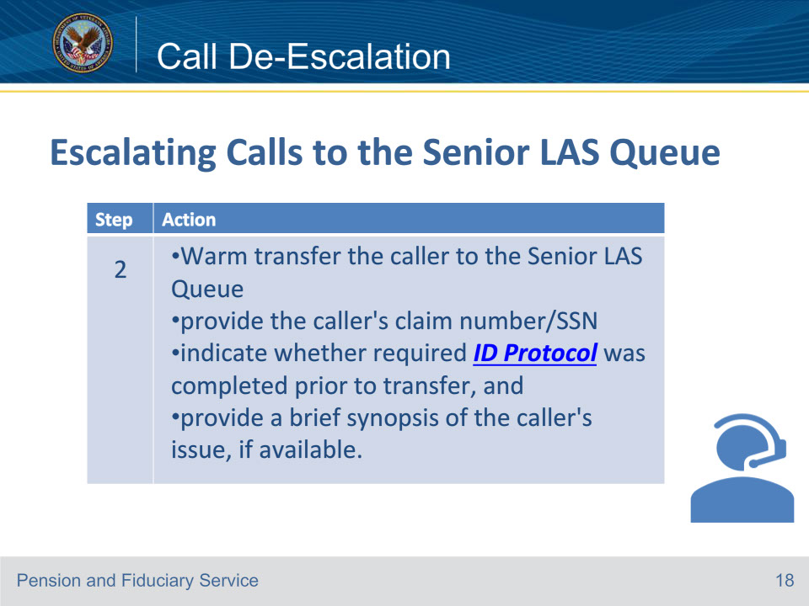

**Slide notes**

Instructor Notes

This is the second step to escalate a call to the Senior LAS Queue.

Reference: Fiduciary Contact Center (FCC) Phone Procedures 3.b.

**Slide 19 - Call De-Escalation**

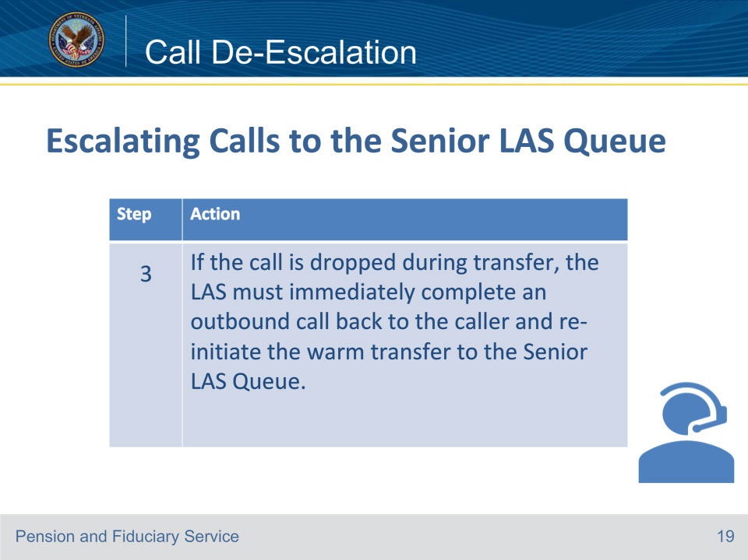

**Slide notes**

Instructor Notes

This is the third and last step to escalate a call to the Senior LAS Queue.

Reference: Fiduciary Contact Center (FCC) Phone Procedures 3.b.

**Slide 20 - Call De-Escalation**

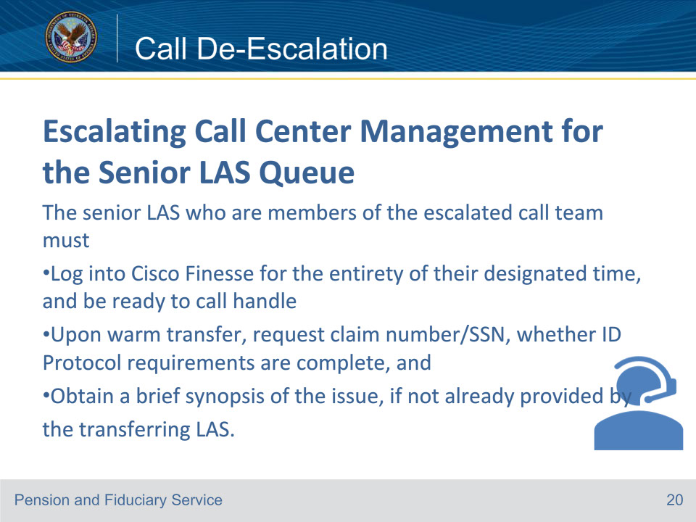

**Slide notes**

Instructor Notes

This slide reviews some of the responsibilities of the Senior LAS.

Reference: Fiduciary Contact Center (FCC) Phone Procedures 3.c.

**Slide 21 - Call De-Escalation**

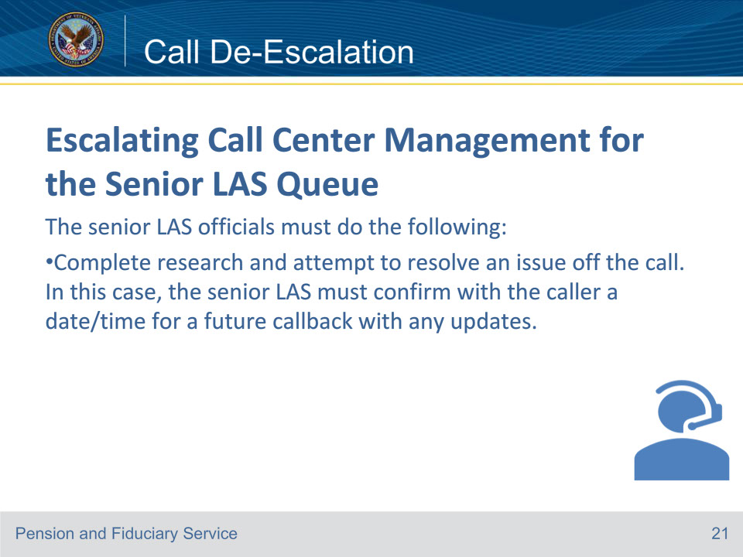

**Slide notes**

Instructor Notes

This slide reviews some the responsibilities of the Senior LAS when they are receiving a call in the Senior LAS Queue.

Reference: Fiduciary Contact Center (FCC) Phone Procedures 3.c.

**Slide 22 - Call De-Escalation**

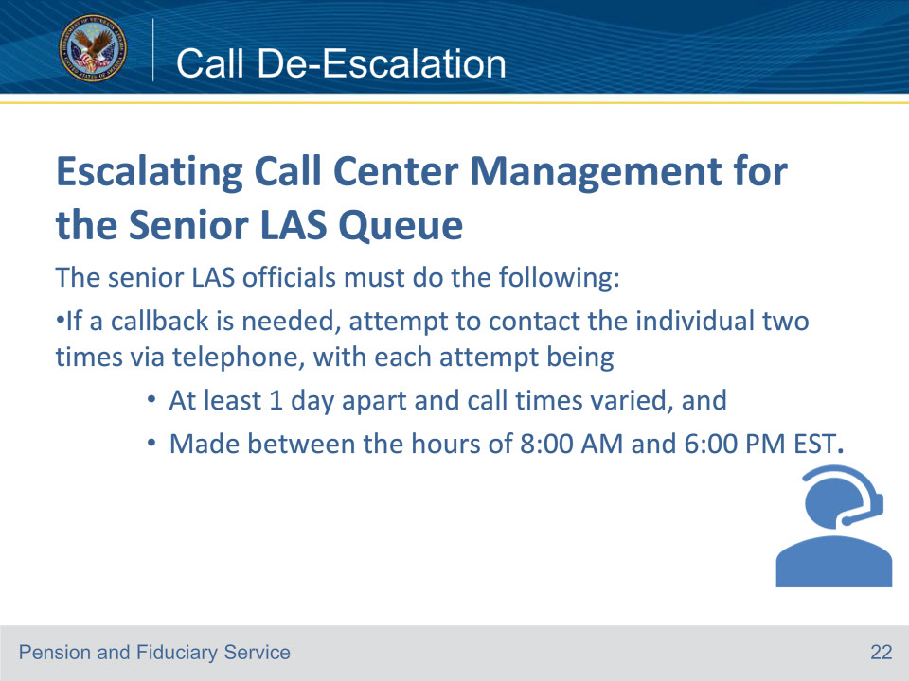

**Slide notes**

Instructor Notes

This slide reviews some the responsibilities of the Senior LAS when they are receiving a call in the Senior LAS Queue.

Reference: Fiduciary Contact Center (FCC) Phone Procedures 3.c.

**Slide 23 - Call De-Escalation**

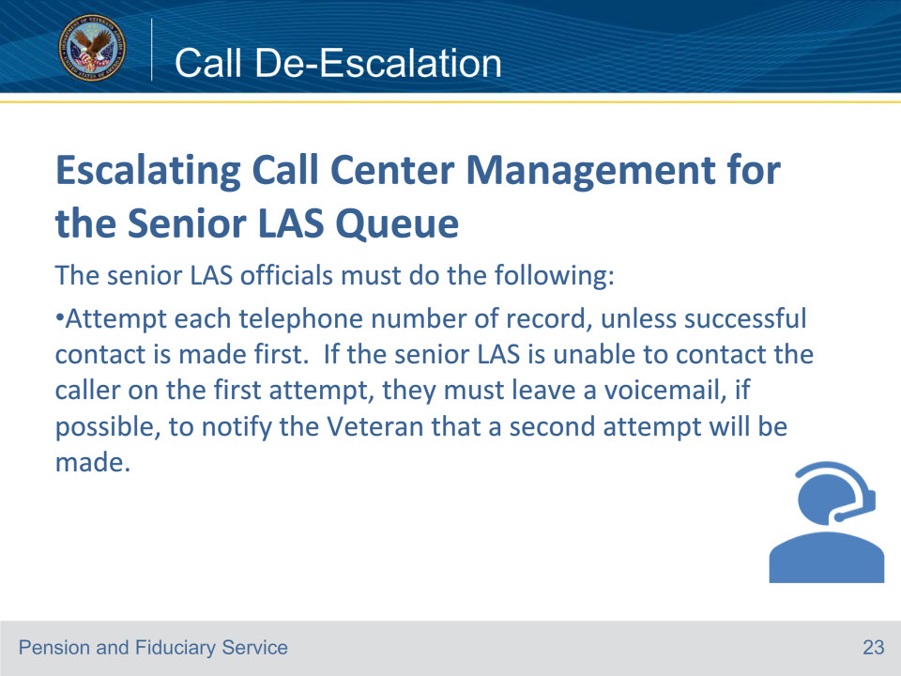

**Slide notes**

Instructor Notes

This slide reviews some the responsibilities of the Senior LAS when they are receiving a call in the Senior LAS Queue.

Note: Complete all required actions on a call, i.e., change of address, and VA Form 27-0820, etc. The senior LAS must not transfer calls back

to the LAS queue for action to be taken.

Reference: Fiduciary Contact Center (FCC) Phone Procedures 3.c.

**Slide 24 - Call De-Escalation**

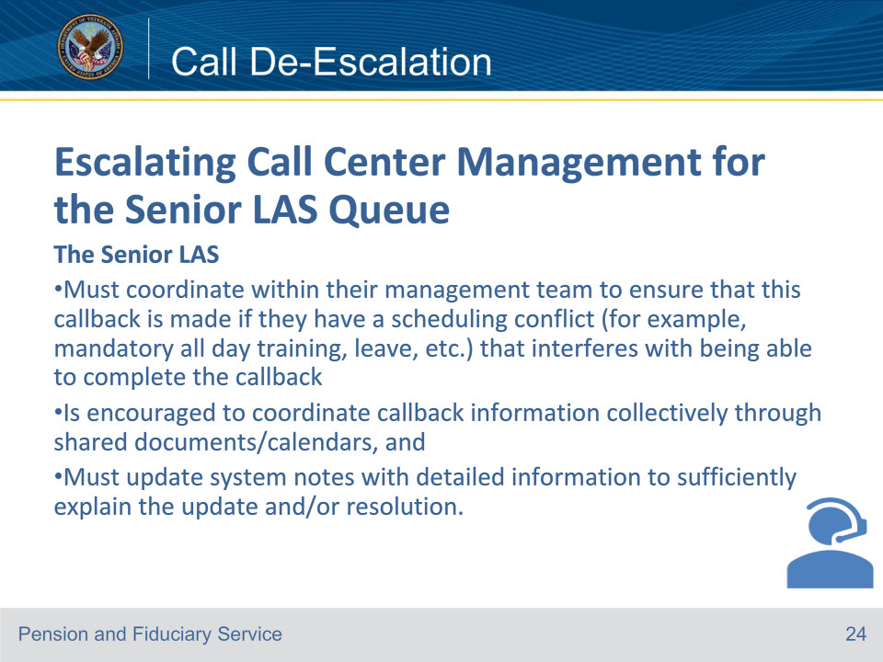

**Slide notes**

Instructor Notes

This slide reviews some the responsibilities of the Senior LAS when they are receiving a call in the Senior LAS Queue.

Notes: If basic ID Protocol was not completed

• asking the ID Protocol questions is required, or

• if the transferring LAS is not available to confirm completion of ID Protocol, the designated

management official must complete the necessary ID Protocol.

• If the LAS properly attempted to complete ID Protocol, but the caller failed the attempt, the senior LAS must not allow a subsequent attempt to pass ID Protocol requirements.

Reference: Fiduciary Contact Center (FCC) Phone Procedures 3.c.

**Slide 25 - Call De-Escalation**

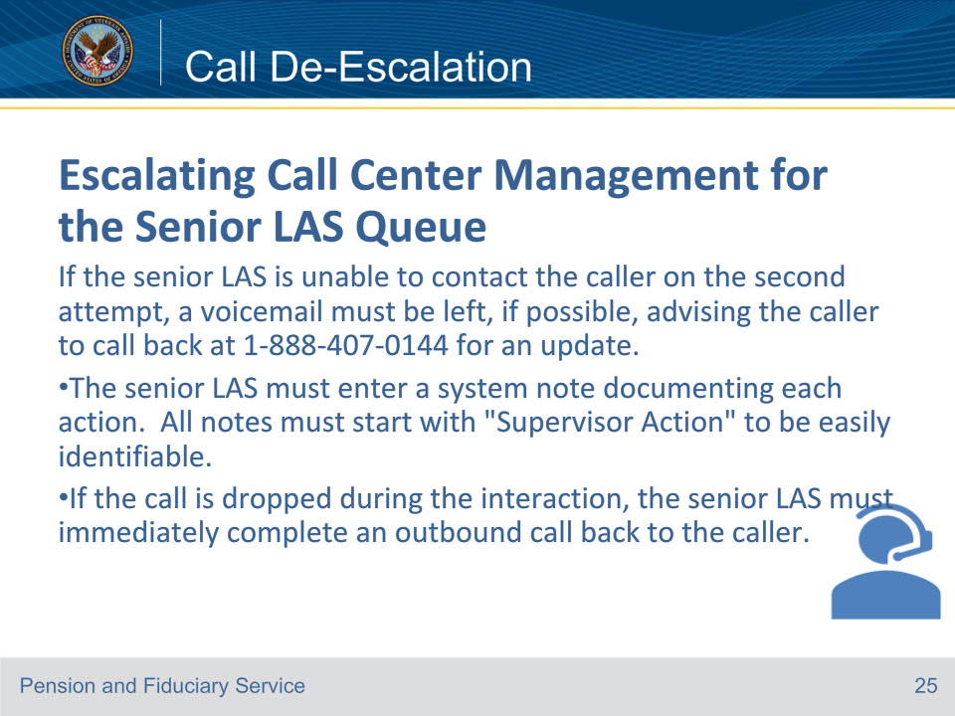

**Slide notes**

Instructor Notes

This slide reviews some the responsibilities of the Senior LAS when they are receiving a call in the Senior LAS Queue.

Note:

Important:

• If the caller is unsatisfied with the resolution provided by the senior LAS, it is required to escalate the caller to management or designee.

• The call escalation should be documented on the VA Form 27-0820.

Reference: Fiduciary Contact Center (FCC) Phone Procedures 3.c.

**Slide 26 - Abusive and Threatening Calls**

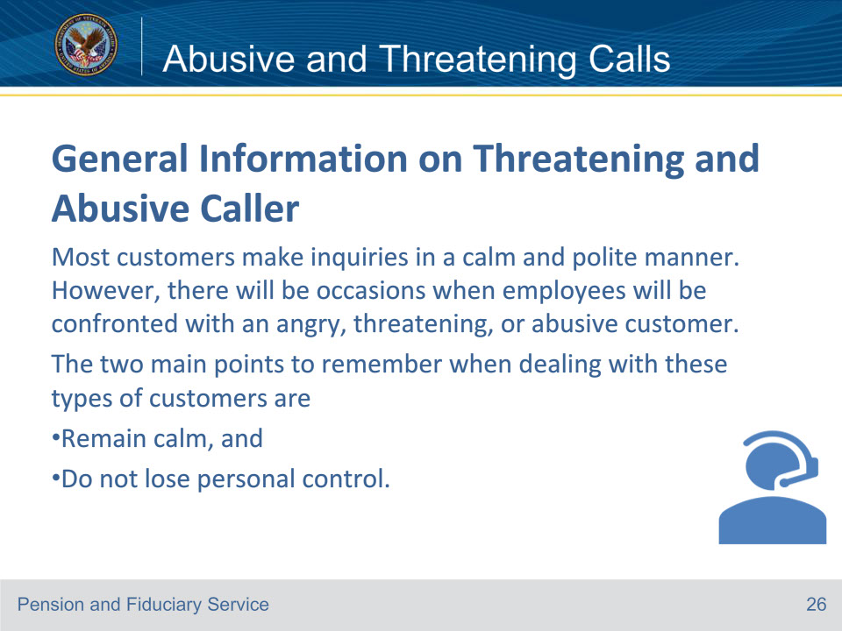

**Slide notes**

Instructor Notes

This slide contains information on the general information on Threatening and Abusive Callers.

Important: Use of abusive or foul language by Veterans Benefits Administration (VBA) personnel is never professional, appropriate, or allowed. Further, the use of such language by our employees is a conduct issue that will be addressed by management as appropriate.

Reference: Fiduciary Contact Center (FCC) Phone Procedures 4.a.

**Slide 27 - Abusive and Threatening Calls**

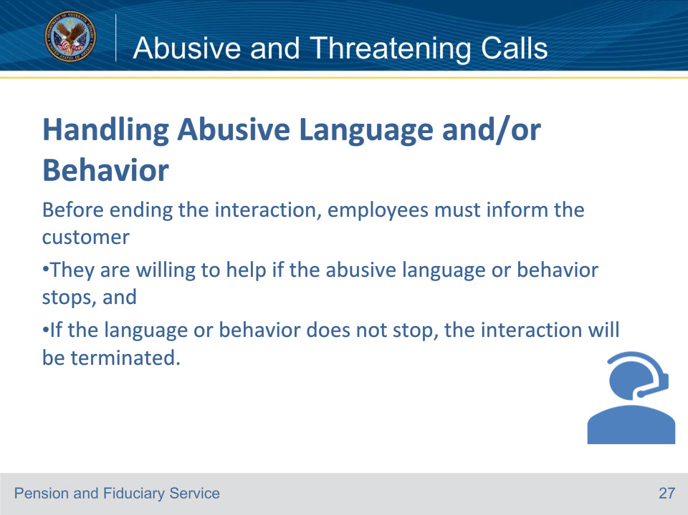

**Slide notes**

Instructor Notes

VBA does not expect its employees to tolerate or listen to abusive/derogatory language or behavior on the part of its customers.

There are times when the only prudent or appropriate course of action is to terminate the interaction by hanging up the phone.

Reference: Fiduciary Contact Center (FCC) Phone Procedures 4.b.

**Slide 28 - Abusive and Threatening Calls**

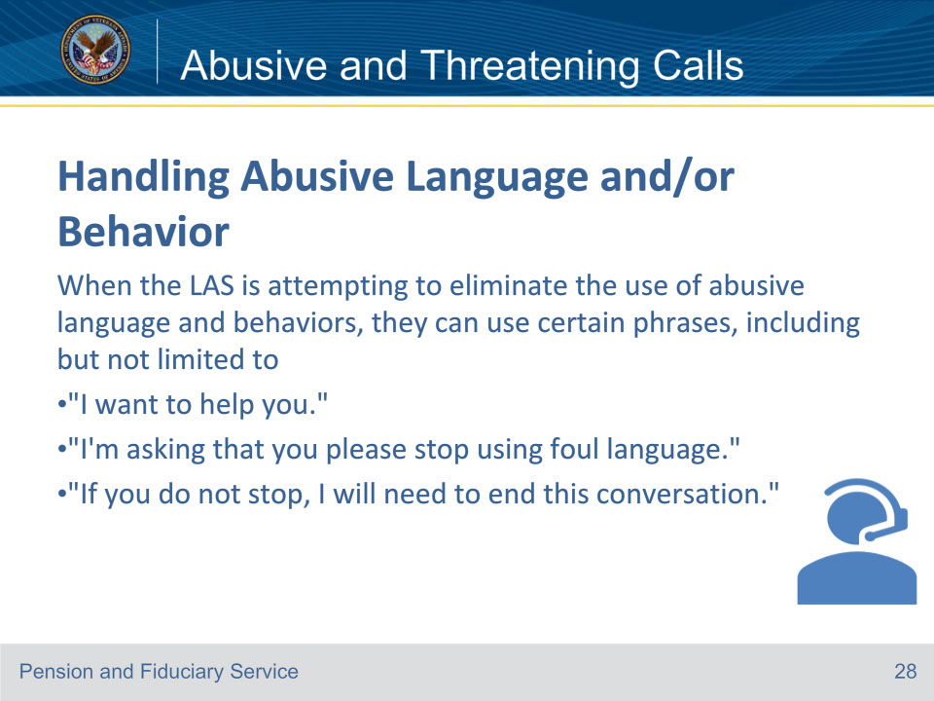

**Slide notes**

Instructor Notes

If they refuse to stop, and continue using abusive or foul language, the call may be disconnected in a professional tone, while using an appropriate tone.

Reference: Fiduciary Contact Center (FCC) Phone Procedures 4.b.

**Slide 29 - Abusive and Threatening Calls**

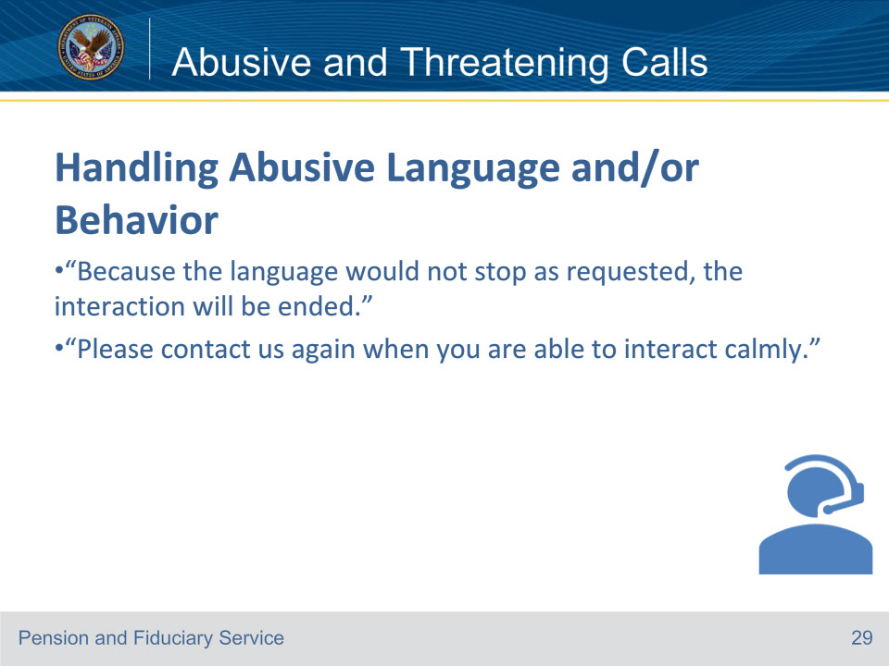

**Slide notes**

Instructor Notes

The call can be disconnected by utilizing non-combative phrases, including some of those shown on this slide.

Important: Immediately upon terminating the interaction, the LAS must submit the VA Form 27-0820

that they upload to the eFolder, via an encrypted email to their supervisor to briefly describe and outline the

situation, giving the customer’s name, if possible, and should enter a detailed note in VBMS-Fiduciary.

This will ensure an employee handling a subsequent interaction is informed of the prior interaction and can best support the customer.

Reference: Fiduciary Contact Center (FCC) Phone Procedures 4.b.

**Slide 30 - Abusive and Threatening Calls**

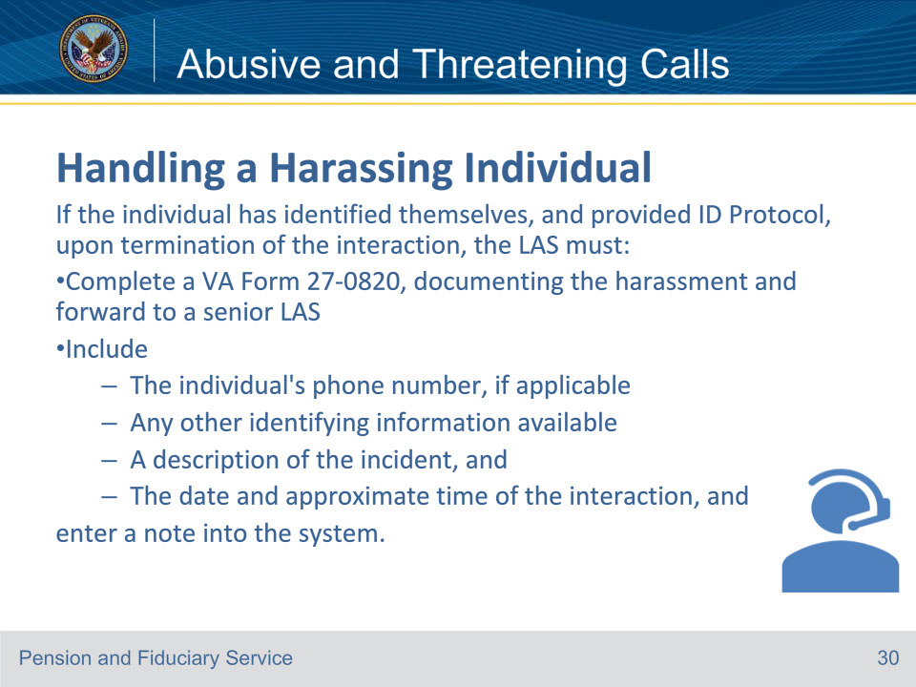

**Slide notes**

Instructor Notes

LAS’s are not required to continue with a customer interaction when harassing or intimidating language or actions occur.

For interactions where the LAS experiences harassment, the LAS is permitted to terminate the interaction immediately.

Reference: Fiduciary Contact Center (FCC) Phone Procedures 4.c.

**Slide 31 - Abusive and Threatening Calls**

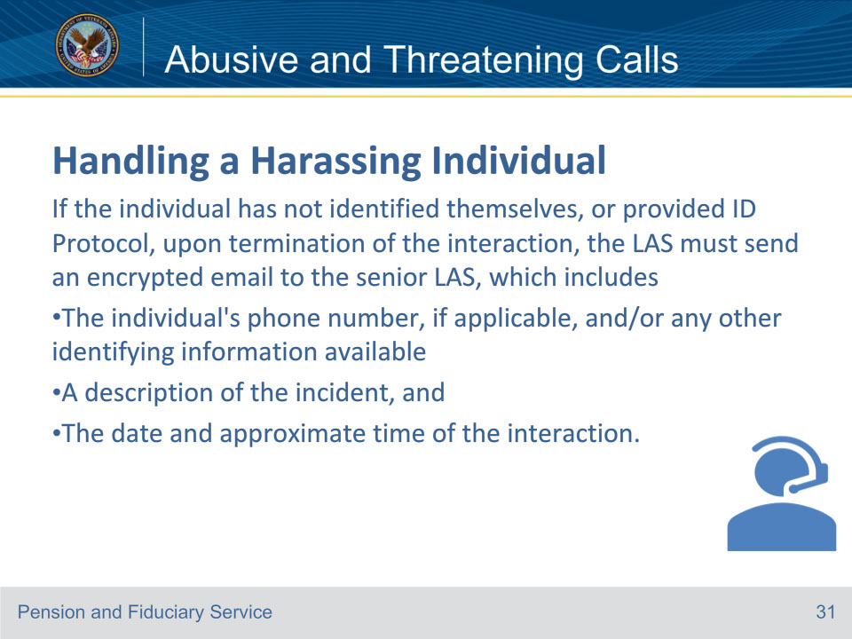

**Slide notes**

Instructor Notes

This slide details what actions to take for a harassing called who has not identified themselves.

Reference: Fiduciary Contact Center (FCC) Phone Procedures 4.c.

**Slide 32 - Abusive and Threatening Calls**

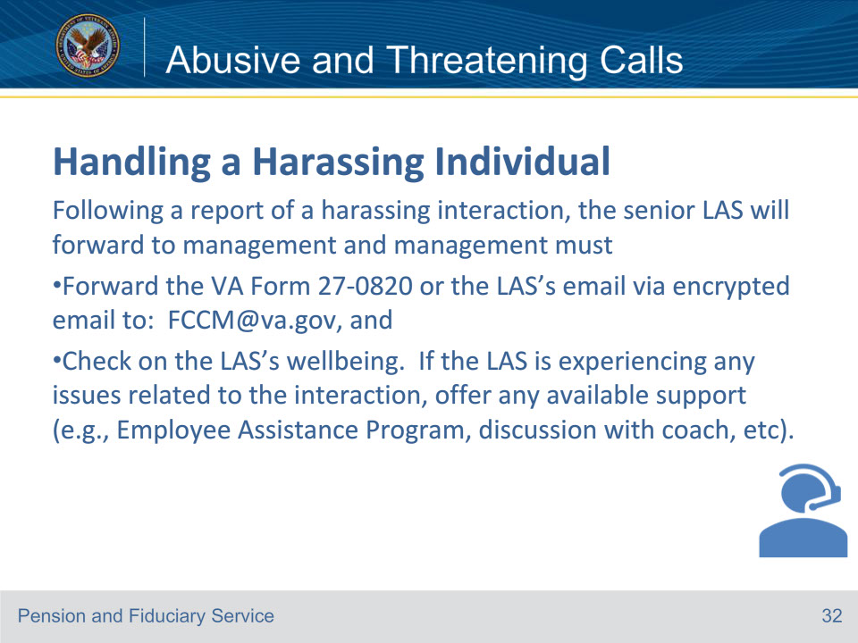

**Slide notes**

Instructor Notes

This slide details the actions the Senior LAS will take following a report of a harassing interaction.

Note: Senior LAS’s and/or coaches will notify the FCC Manager, who will then make the determination on whether to notify other Regional Contact Centers.

Reference: Fiduciary Contact Center (FCC) Phone Procedures 4.c.

**Slide 33 - Abusive and Threatening Calls**

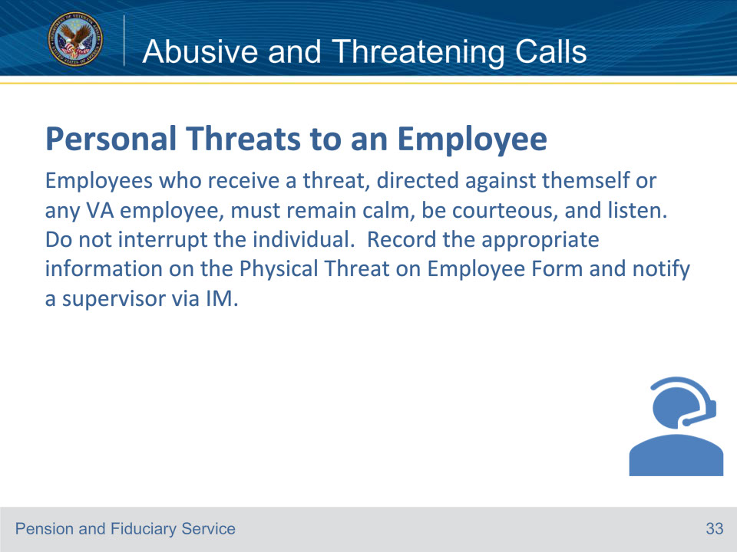

**Slide notes**

Instructor Notes

Employee safety is a priority and workplace violence will not be tolerated. VA takes threats to

employees very seriously and violators are prosecuted. Employees who receive a threat via chat, must immediately notify their supervisor via IM.

Reference: Fiduciary Contact Center (FCC) Phone Procedures 4.d.

**Slide 34 - Abusive and Threatening Calls**

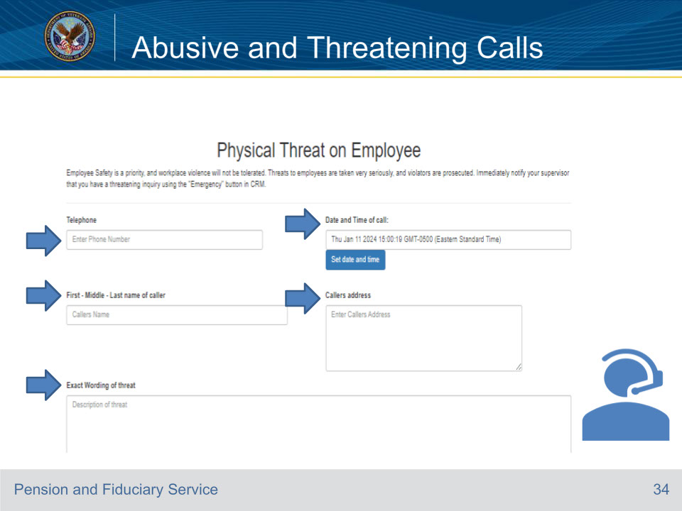

**Slide notes**

Instructor Notes:

This part of the Physical Threat on Employee Form includes the telephone number , Date and Time of the Call,

First- Middle- Last Name of Caller, Callers Address and the exact wording of the threat

Reference: Fiduciary Contact Center (FCC) Phone Procedures 4.d.

**Slide 35 - Abusive and Threatening Calls**

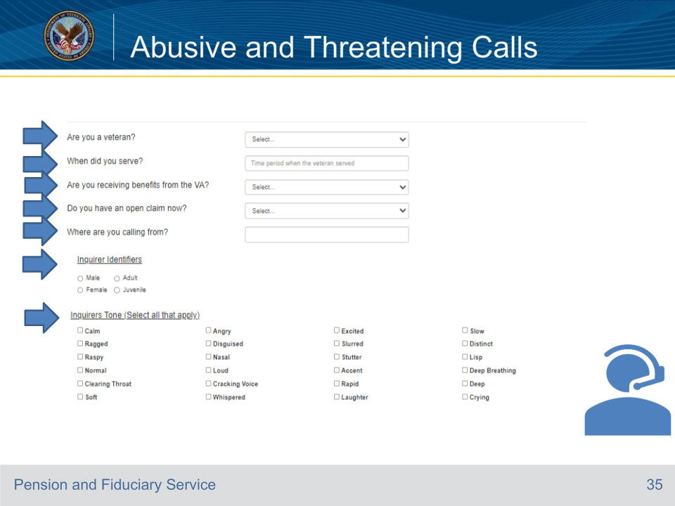

**Slide notes**

Instructor Notes:

This part of the Physical Threat on Employee Form includes:

• Are you a veteran? with yes or no as the choices

• When did you serve, which should be the time period the veteran served.

• First- Middle- Last Name of Caller, Callers Address and the exact wording of the threat

• Are you receiving benefits from the VA? with yes or no as the choices.

• Do you have an open claim? with yes or no as the choices.

• Where are you calling from?

• Inquirer Identifiers with choices as Male , Adult, Female, or Juvenile.

• Inquirers Tone (select all that apply Calm, Ragged, Raspy, Normal, Clearing Throat, Soft

• Angry, Disguised, Nasal, Loud, Cracking Voice, Whispered, Excited, Slurred, Stutter, Accent

• Rapid, Laughter, Slow, Distinct, Lisp, Deep Breathing, Deep, Crying

Physical Threat on Employee Report (sharepoint.com)

Reference: Fiduciary Contact Center (FCC) Phone Procedures 4.d.

**Slide 36 - Abusive and Threatening Calls**

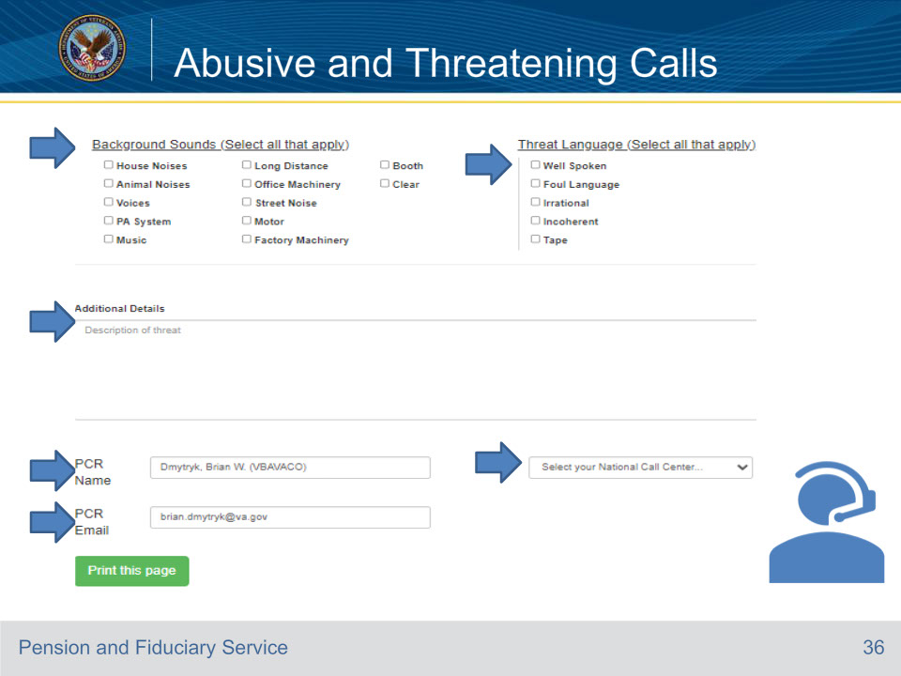

**Slide notes**

Instructor Notes:

This part of the Physical Threat on Employee Form includes

• Background Sounds (Select all that apply)

• House Noises, Animal Noises, Voices, PA System, Music, Long Distance, Office Machinery,Street Noise

• Motor, Factory Machinery, Booth, Clear

• Threat Language (Select all that apply)

• Well Spoken, Foul Language, Irrational, Incoherent, Tape

• Additional Details- Include the description of the threat.

• PCR Name- LAS Name in Fiduciary Contact Center

• Select your National Call Center dropdown include FCC

• PCR Email- LAS Email

• Physical Threat on Employee Report (sharepoint.com)

Reference: Fiduciary Contact Center (FCC) Phone Procedures 4.d.

**Slide 37 - Abusive and Threatening Calls**

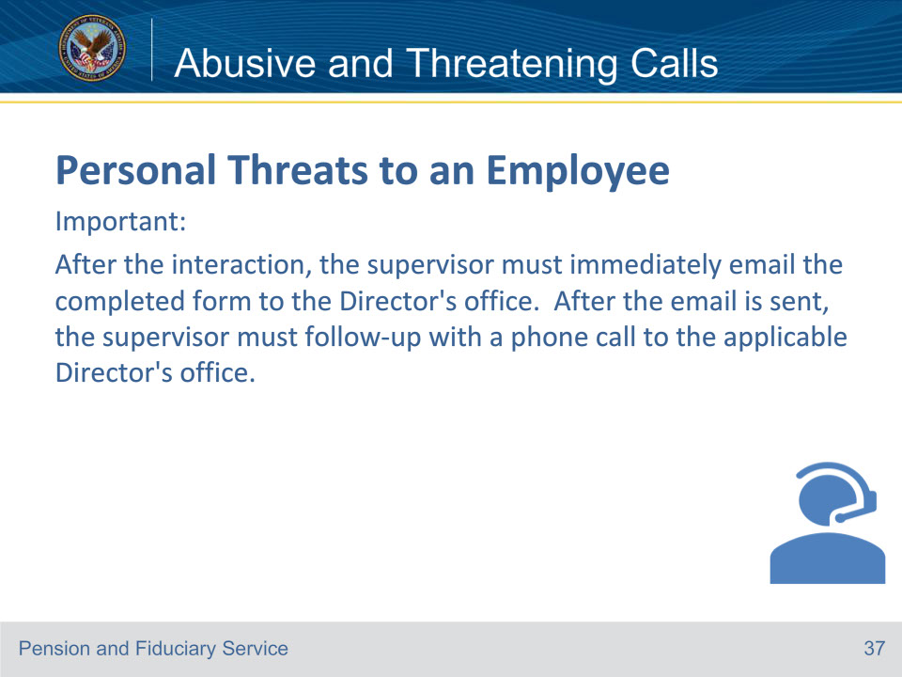

**Slide notes**

Instructor Notes

Review the slide to state the importance of the supervisor taking the action to email the completed Physical Threat on Employee Form to the Director’s office immediately.

Reference: Fiduciary Contact Center (FCC) Phone Procedures 4.d.

**Slide 38 - Abusive and Threatening Calls**

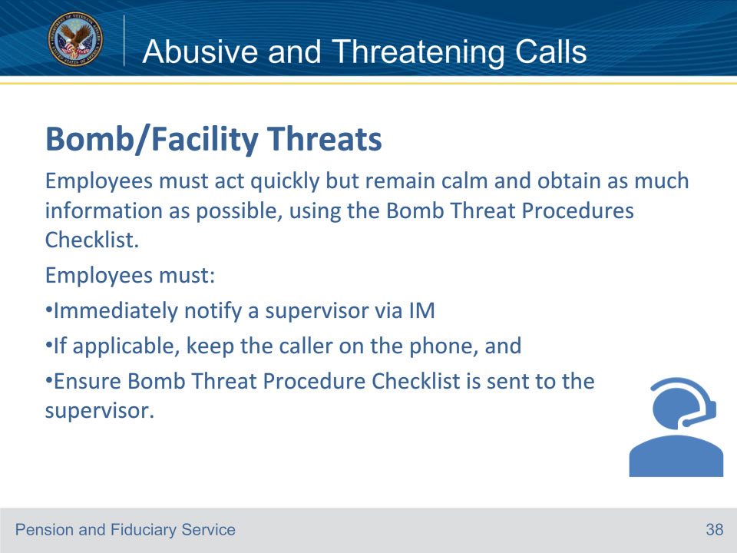

**Slide notes**

Instructor Notes

Most bomb/facility threats are received by telephone. Threats should always be considered serious until proven otherwise.

Reference: Fiduciary Contact Center (FCC) Phone Procedures 4.e.

**Slide 39 - Abusive and Threatening Calls**

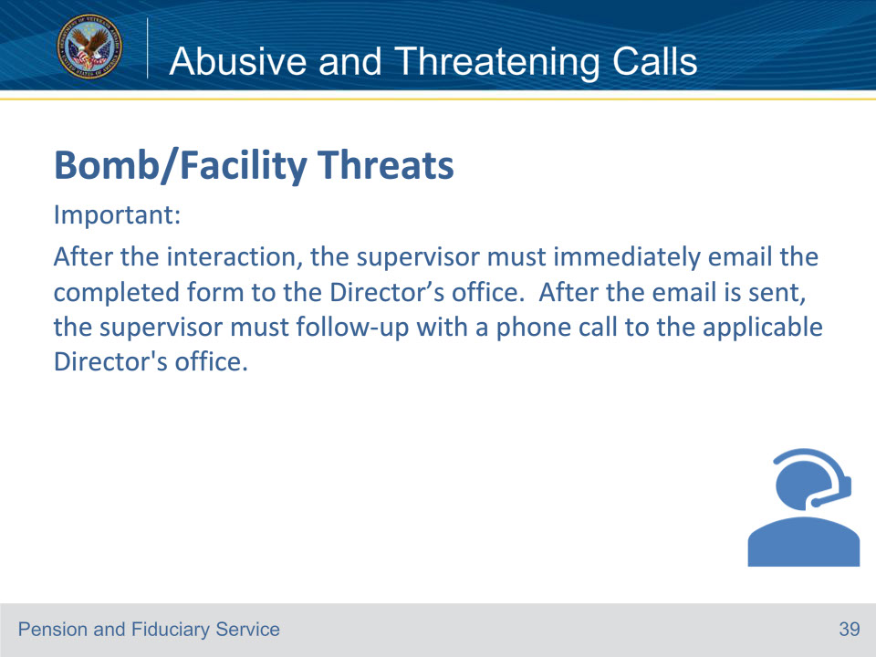

**Slide notes**

Instructor Notes

Bomb/facility threats received by any other method (i.e., email) should engage the station’s emergency notification procedures.

Reference: Fiduciary Contact Center (FCC) Phone Procedures 4.e.

**Slide 40 - Abusive and Threatening Calls**

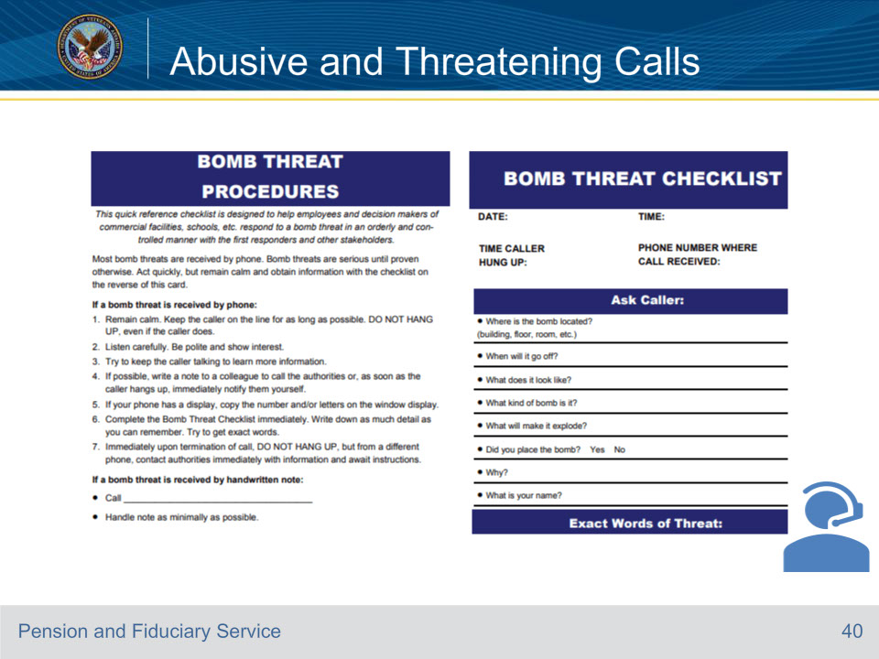

**Slide notes**

Instructor Notes

This is the first part of the Bomb Threat Procedures Checklist. “Review with students”

Reference: Fiduciary Contact Center (FCC) Phone Procedures 4.e.

**Slide 41 - Abusive and Threatening Calls**

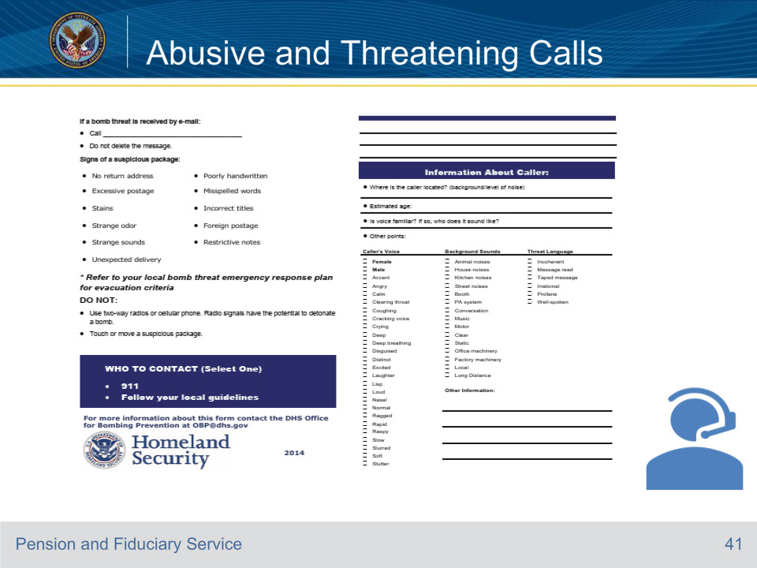

**Slide notes**

Instructor Notes

This is the bottom half of the of the Bomb Threat Procedures Checklist. “Review with students”

Reference: Fiduciary Contact Center (FCC) Phone Procedures 4.e.

**Slide 42 - 31. Questions?**

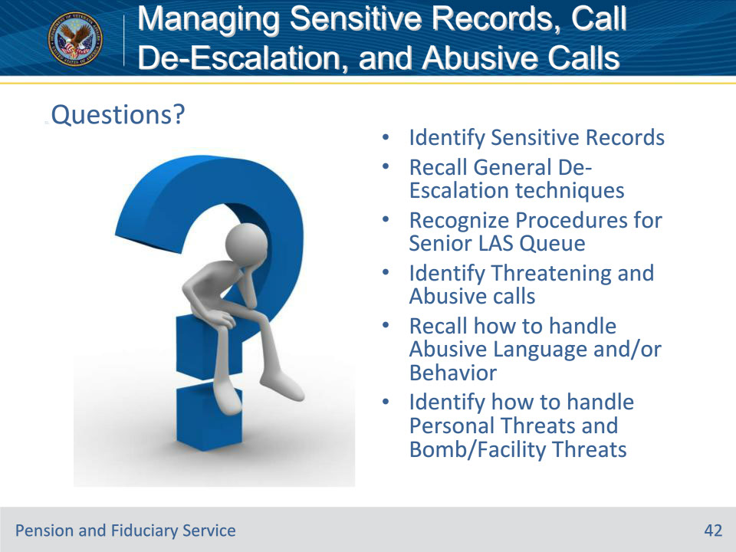

**Slide notes**

Instructor Notes:

(Recall) These are our learning objectives as stated from the beginning of the training:

• Identify Sensitive Records

• Recall General De-Escalation techniques

• Recognize Procedures for Senior LAS Queue

• Identify Threatening and Abusive calls

• Recall how to handle Abusive Language and/or Behavior

• Identify how to handle Personal Threats and Bomb/Facility Threats

Are there any additional questions?

**Slide 43 - TMS Survey**

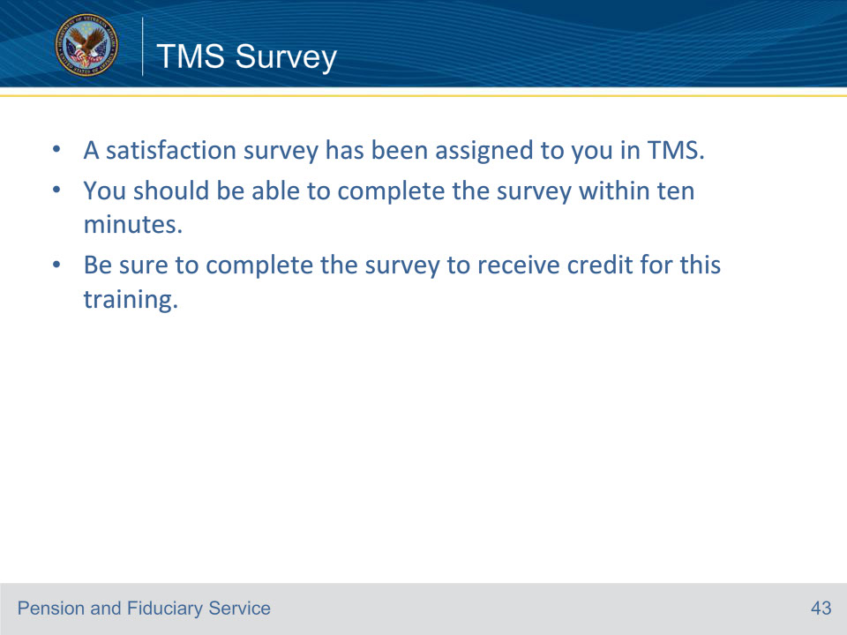

**Slide notes**

Instructor Notes:

A satisfaction survey has been assigned to you in TMS. You should be able to complete it within ten minutes.

Completing it will allow you to receive credit for this training.