Slide 1 - Fiduciary Contact Center (FCC) Crisis Interactions
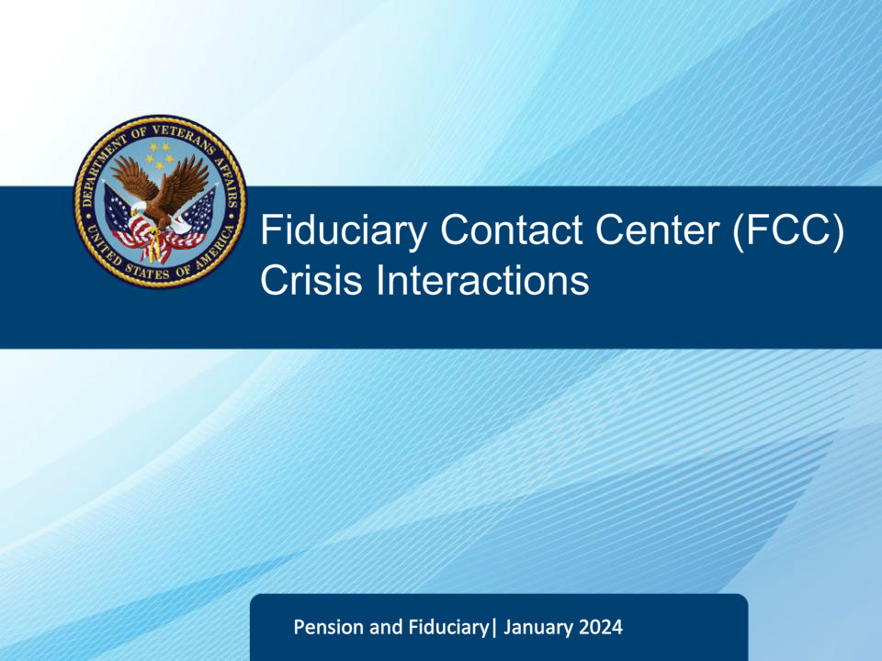
Slide notes

Welcome to the Fiduciary Contact Center Phone Procedures course. The purpose of this training is to help Legal Administration Specialists prepare for their duties by providing guidelines for various crisis interactions with callers. The course covers guidelines for Suicidal Individuals, Suicidal Crisis Healthcare, and Threats to Employees or VA Facilities. The training aims to equip you with the necessary skills to deal with crisis interactions as a Legal Administration Specialist.

Slide 2 - FCC Crisis Interactions
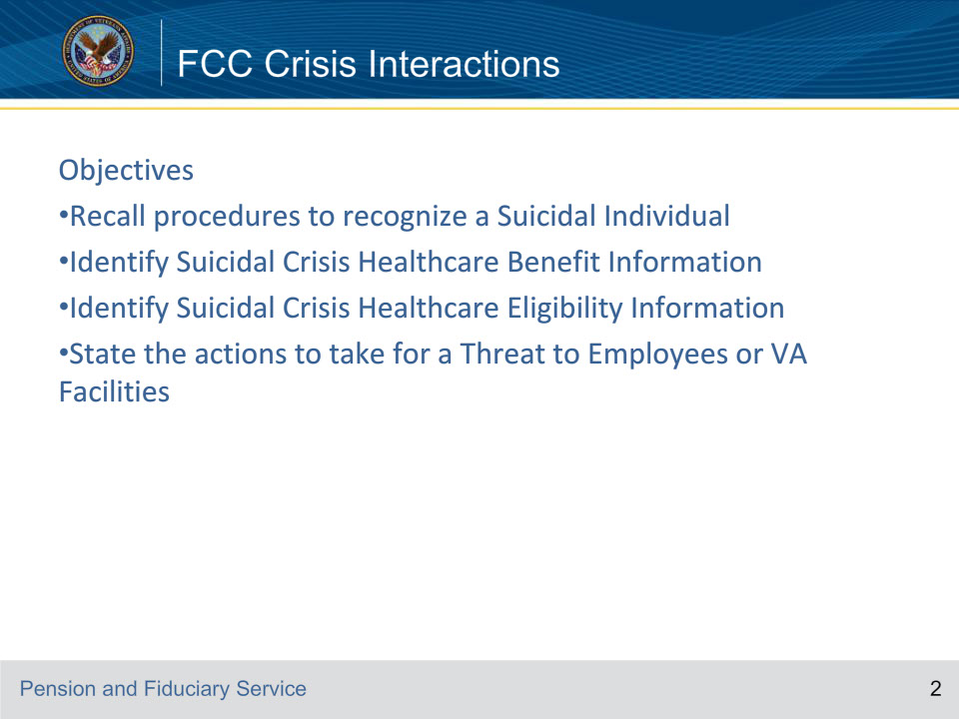
Slide notes

Instructor Notes:

Review the objectives of the lesson.

Slide 3 - FCC Crisis Interactions
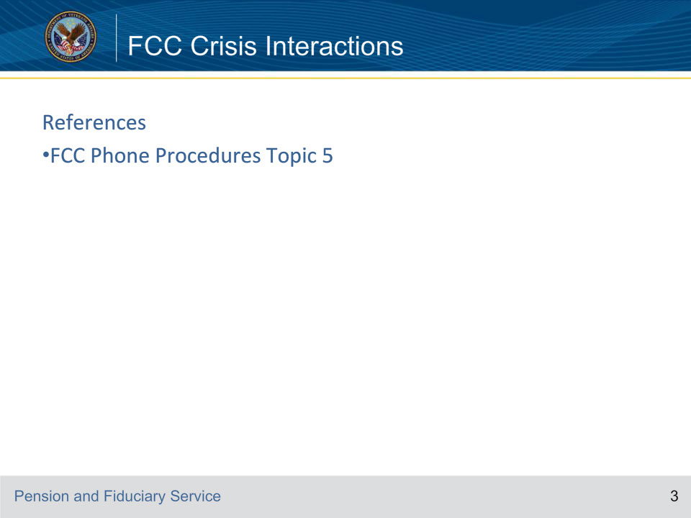
Slide notes

Instructor Notes:

Review the reference for this lesson.

Slide 4 - FCC Crisis Interactions
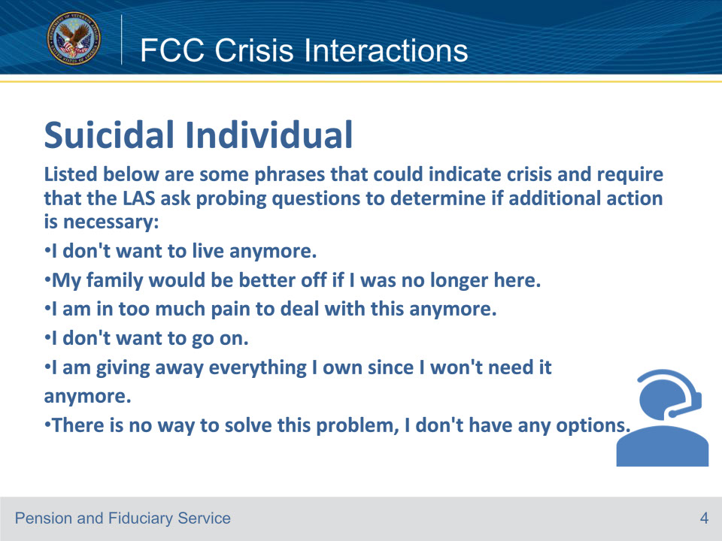
Slide notes

Instructor Notes

LAS must recognize the signs of a crisis. An individual may not specifically state they are going to commit suicide. The LAS must be able to analyze and pick up on clues that could indicate the individual is in danger of harming themself or others.

Reference: Fiduciary Contact Center (FCC) Phone Procedures 5.a.

Slide 5 - FCC Crisis Interactions
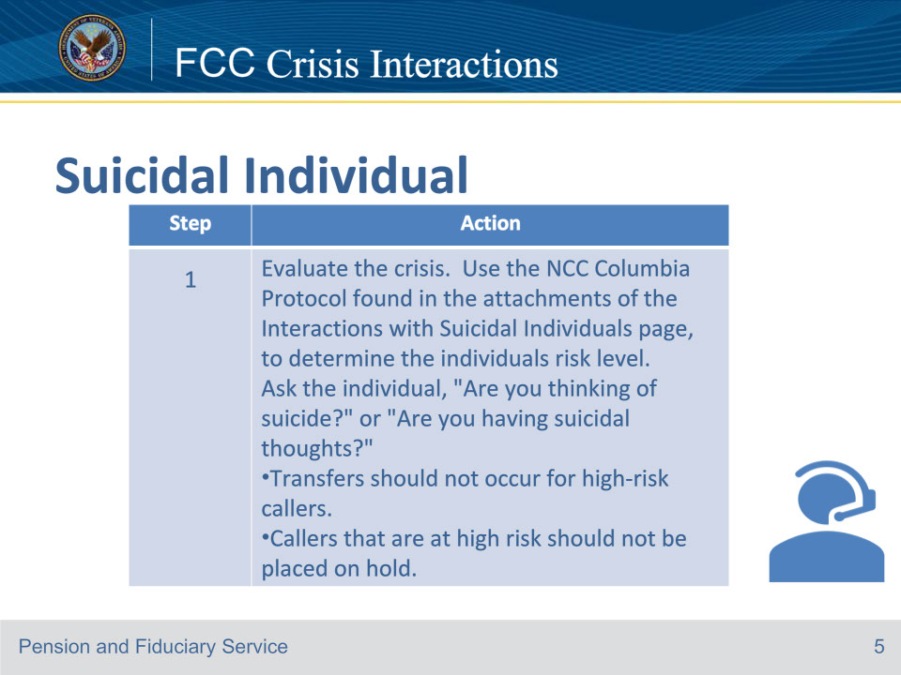
Slide notes

Instructor Notes

Follow the steps in this table, when conducting telephone or virtual interactions with individuals in crisis. This is step 1.

Reference: Fiduciary Contact Center (FCC) Phone Procedures 5.a.

Slide 6 - FCC Crisis Interactions
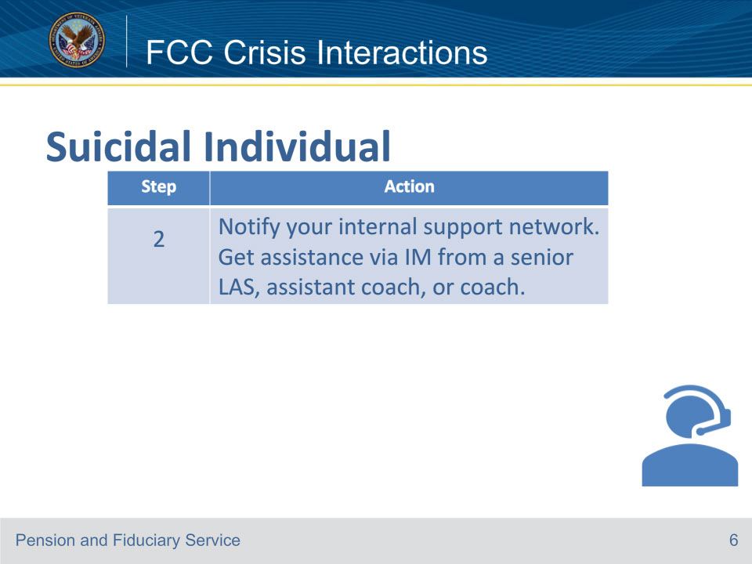
Slide notes

Instructor Notes

This is step 2, when conducting telephone or virtual interactions with individuals in crisis.

Reference: Fiduciary Contact Center (FCC) Phone Procedures 5.a.

Slide 7 - FCC Crisis Interactions
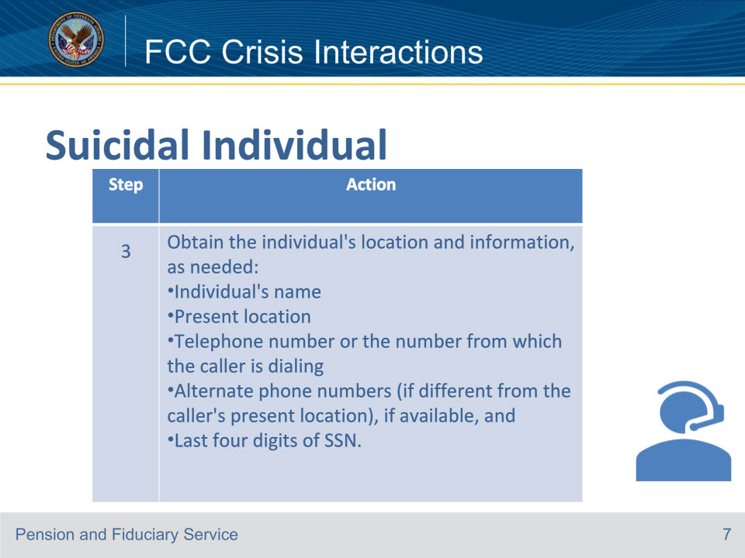
Slide notes

Instructor Notes

This is the third step when conducting telephone or virtual interactions with individuals in crisis.

Reference: Fiduciary Contact Center (FCC) Phone Procedures 5.a.

Slide 8 - FCC Crisis Interactions
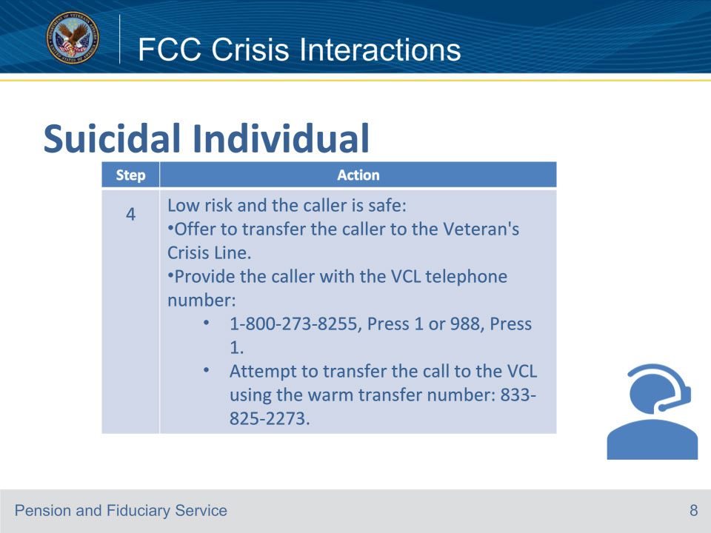
Slide notes

Instructor Notes

This is the fourth step when conducting telephone or virtual interactions with individuals in crisis. Offer crisis resources. For callers, determine if the caller is safe before attempting to transfer to the Veterans Crisis Line (VCL).

Reference: Fiduciary Contact Center (FCC) Phone Procedures 5.a.

Slide 9 - FCC Crisis Interactions
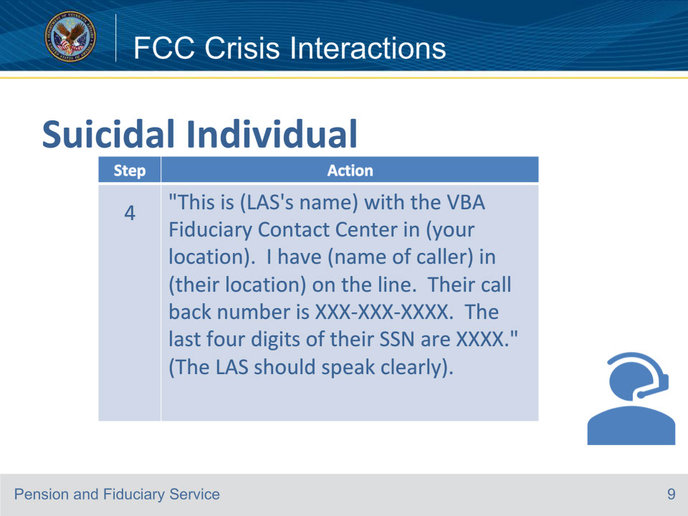
Slide notes

Instructor Notes

When transferring the call, use the following script on this slide.

Reference: Fiduciary Contact Center (FCC) Phone Procedures 5.a.

Slide 10 - FCC Crisis Interactions
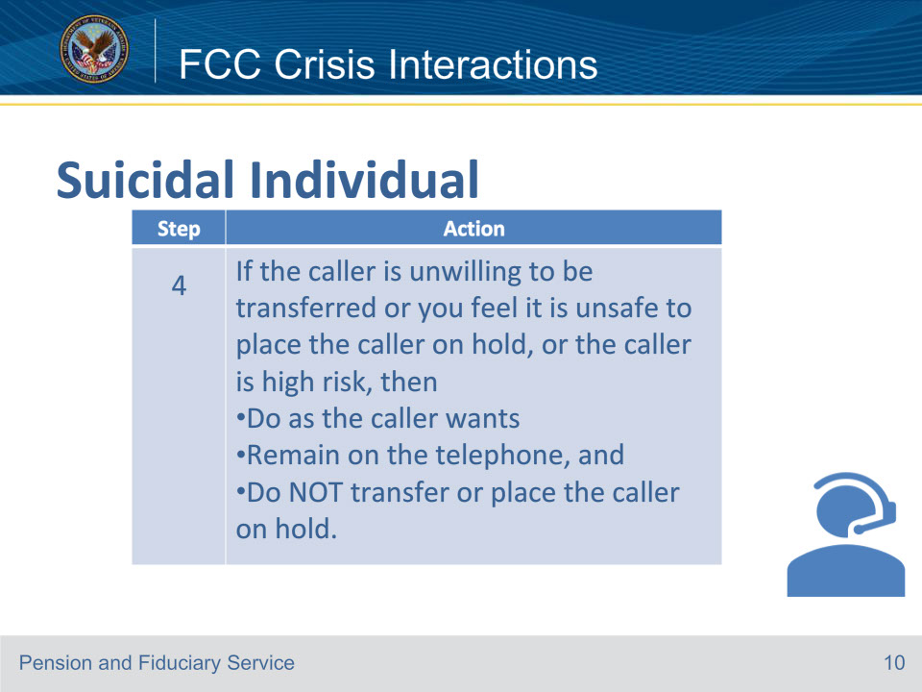
Slide notes

Instructor Notes

This slide is an example of when the caller is high risk or if the caller is unsafe: The supervisor should silently monitor the call and seek second-party assistance through local emergency services, if necessary.

Reference: Fiduciary Contact Center (FCC) Phone Procedures 5.a.

Slide 11 - FCC Crisis Interactions
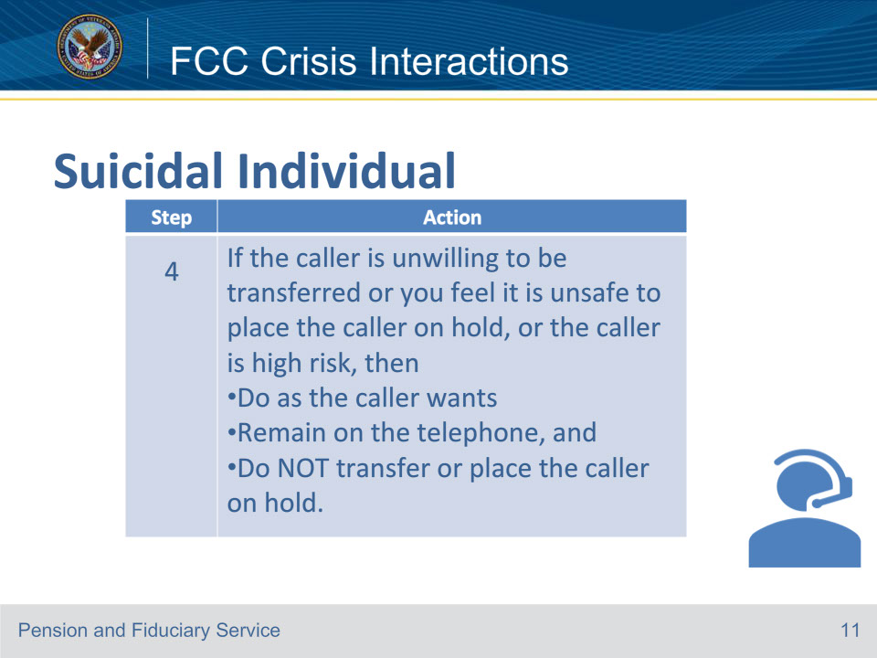
Slide notes

Instructor Notes

This slide is an example of when the caller is high risk or if the caller is unsafe: The supervisor should silently monitor the call and seek second-party assistance through local emergency services, if necessary.

Reference: Fiduciary Contact Center (FCC) Phone Procedures 5.a.

Slide 12 - FCC Crisis Interactions
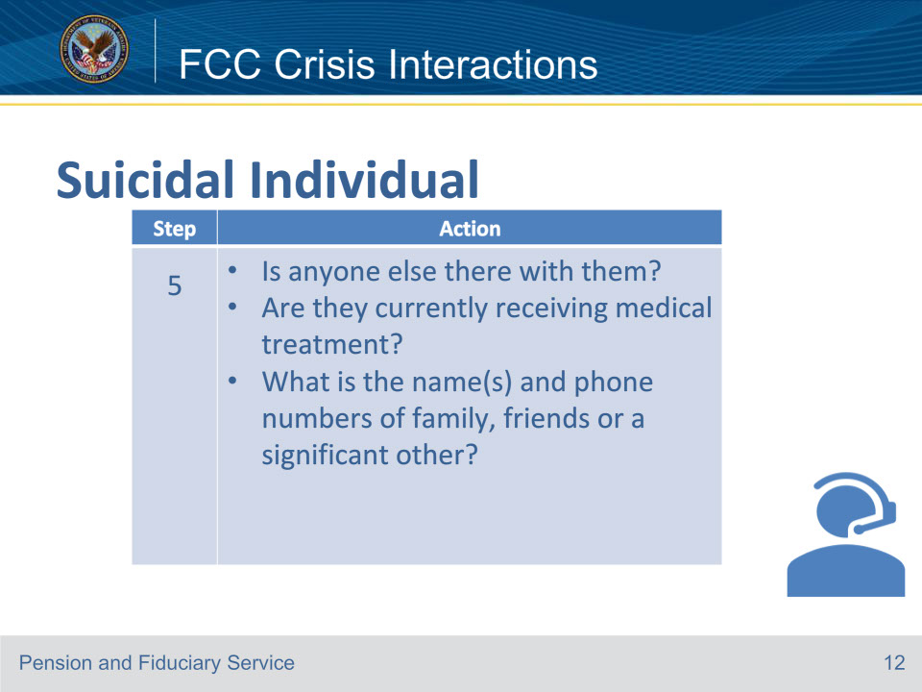
Slide notes

Instructor Notes

This is the fifth step when conducting telephone or virtual interactions with individuals in crisis is to verify the individual’s status.

Reference: Fiduciary Contact Center (FCC) Phone Procedures 5.a.

Slide 13 - FCC Crisis Interactions
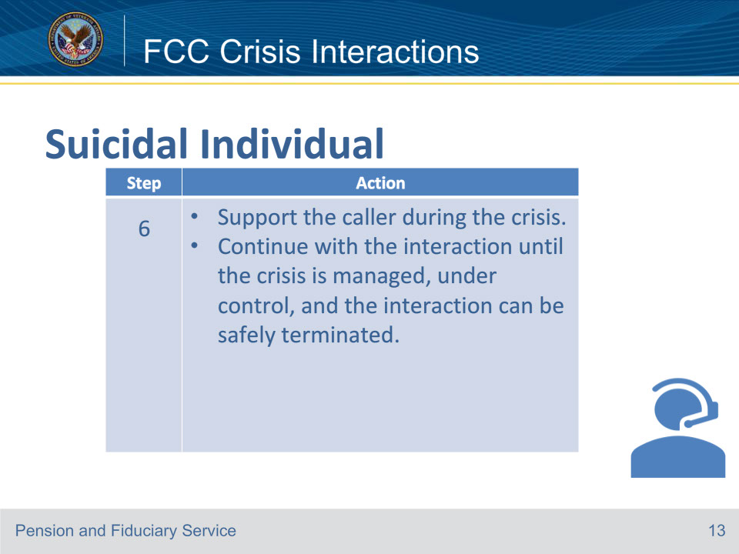
Slide notes

Instructor Notes

This is the sixth step when conducting telephone or virtual interactions with individuals in crisis.

Reference: Fiduciary Contact Center (FCC) Phone Procedures 5.a.

Slide 14 - FCC Crisis Interactions
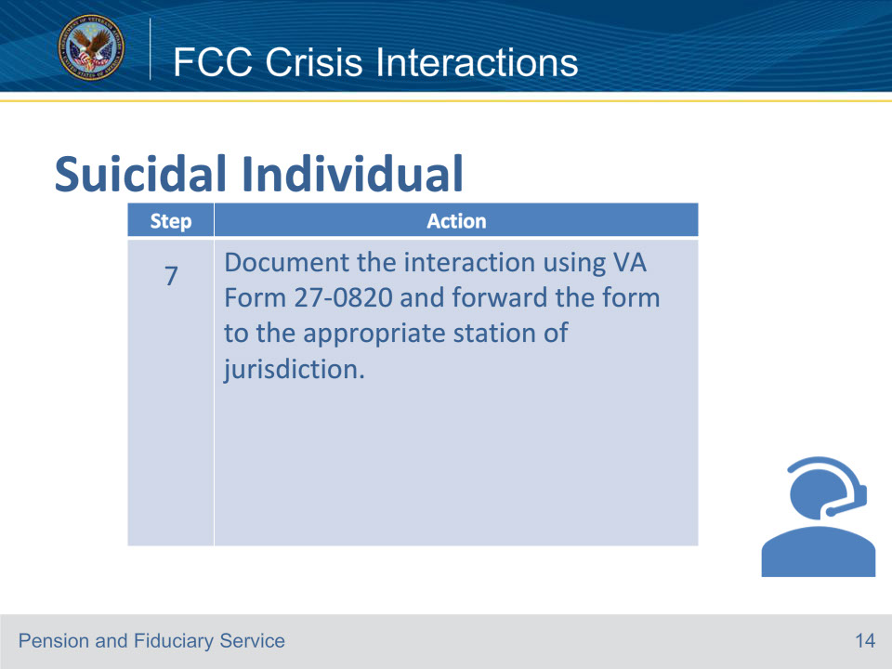
Slide notes

Instructor Notes

This is the last step when conducting telephone or virtual interactions with individuals in crisis.

Reference: For more information suicide prevention, see the Suicide Prevention Program Interactive PDF for VBA Staff found in the attachments of the

Interactions with Suicidal Individuals (va.gov) page. Fiduciary Contact Center (FCC) Phone Procedures 5.a.

Slide 15 - FCC Crisis Interactions
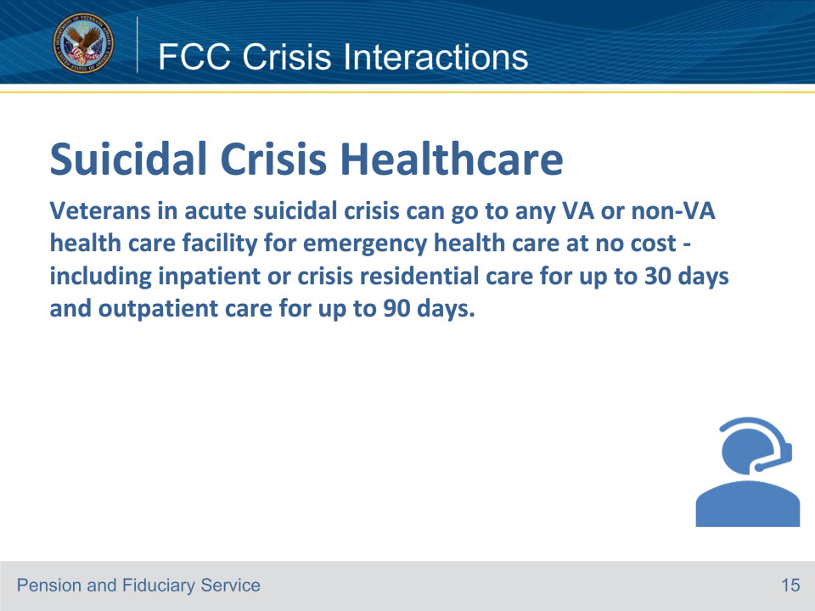
Slide notes

Instructor Notes

Veterans do not need to be enrolled in the VA system to use this benefit.

Reference: Fiduciary Contact Center (FCC) Phone Procedures 5.b.

Slide 16 - FCC Crisis Interactions
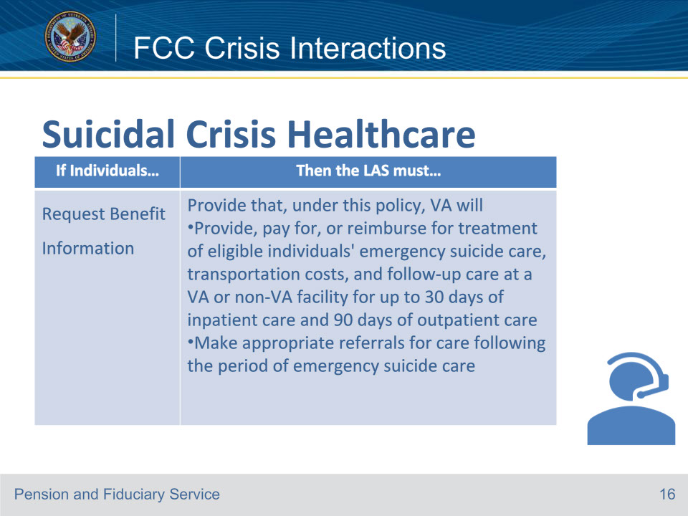
Slide notes

Instructor Notes

This slide goes over the required LAS actions for an individual in crisis when they request benefit information.

Reference: Fiduciary Contact Center (FCC) Phone Procedures 5.b.

Slide 17 - FCC Crisis Interactions
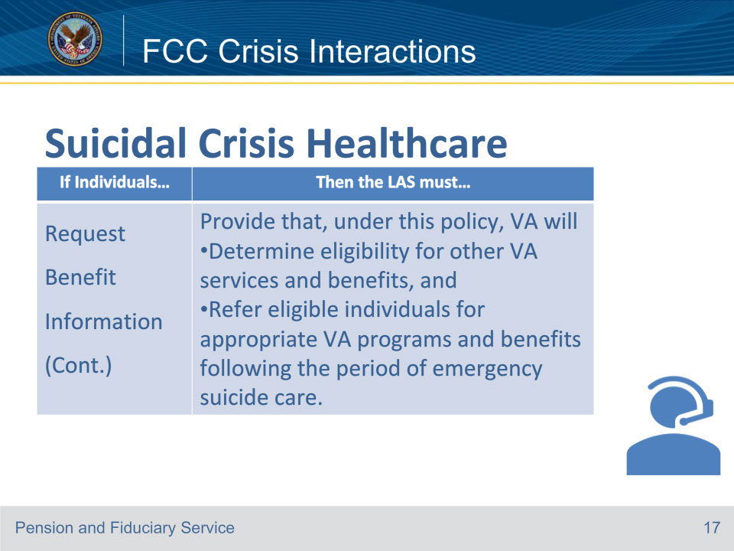
Slide notes

Instructor Notes

This slide goes over the other required LAS actions for an individual in crisis when they request benefits information

Reference: Fiduciary Contact Center (FCC) Phone Procedures 5.b.

Slide 18 - FCC Crisis Interactions
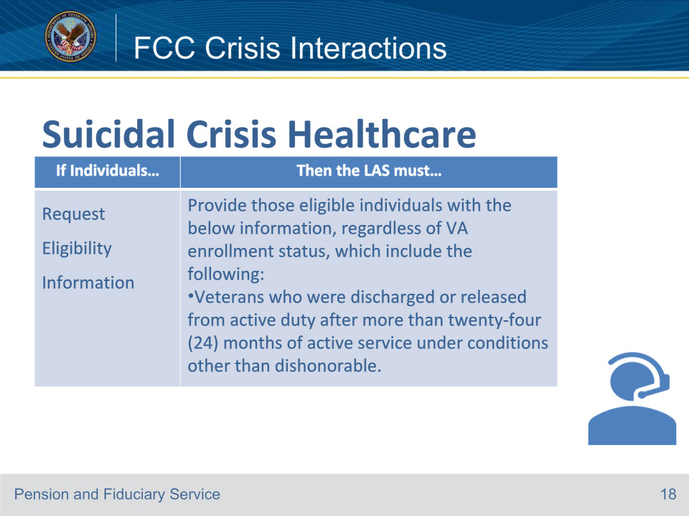
Slide notes

Instructor Notes

This slide goes over the required LAS actions for an individual in crisis when they request eligibility information regardless of VA enrollment status.

Reference: Fiduciary Contact Center (FCC) Phone Procedures 5.b.

Slide 19 - FCC Crisis Interactions
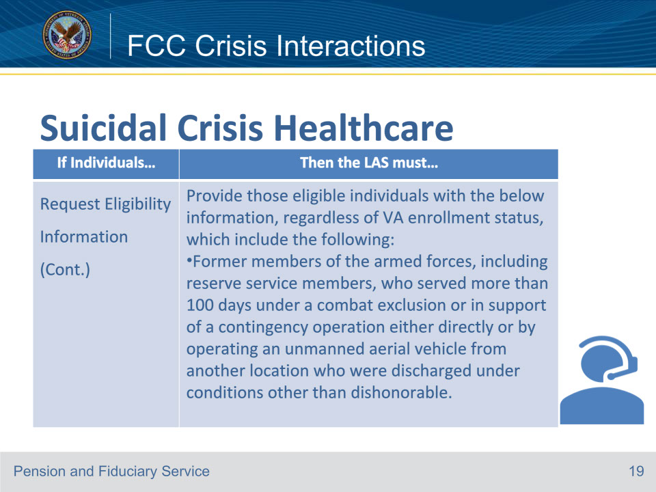
Slide notes

Instructor Notes

This slide goes over the additional required LAS action for an individual in crisis when they request eligibility information regardless of VA enrollment status.

Reference: Fiduciary Contact Center (FCC) Phone Procedures 5.b.

Slide 20 - FCC Crisis Interactions
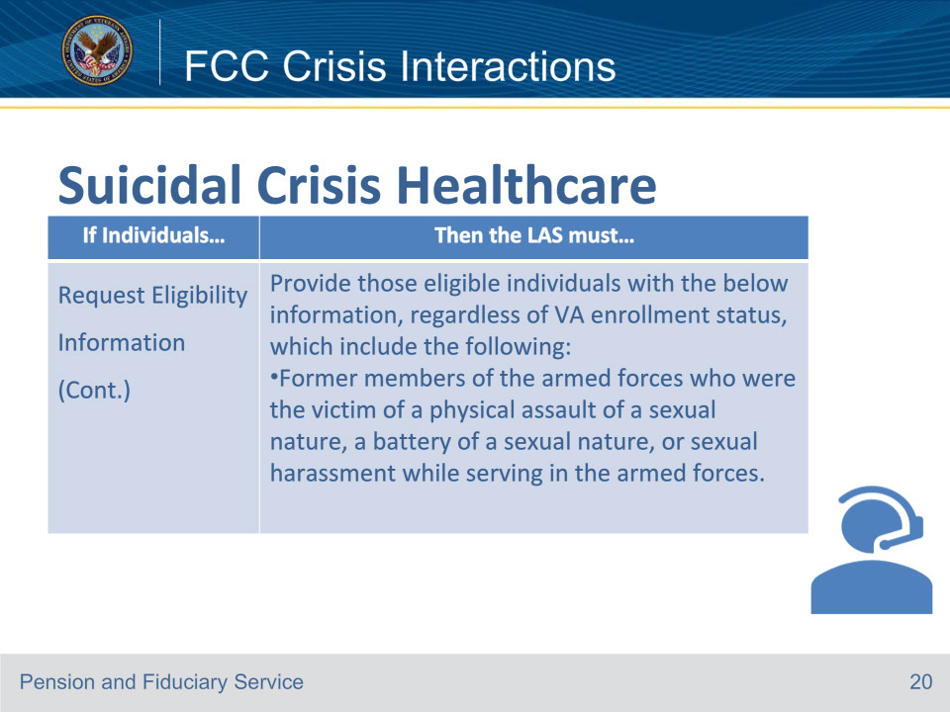
Slide notes

Instructor Notes

This slide goes over the additional required LAS action for an individual in crisis when they request eligibility information regardless of VA enrollment status.

Reference: Fiduciary Contact Center (FCC) Phone Procedures 5.b.

Slide 21 - FCC Crisis Interactions
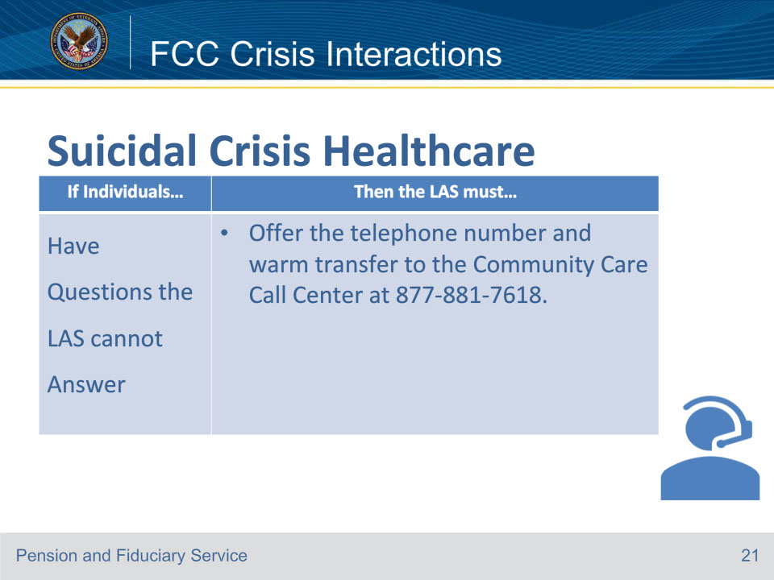
Slide notes

Instructor Notes

This slide goes over the additional required LAS action for an individual in crisis when the caller has questions that the LAS cannot answer.

Reference: Fiduciary Contact Center (FCC) Phone Procedures 5.b.

Slide 22 - FCC Crisis Interactions
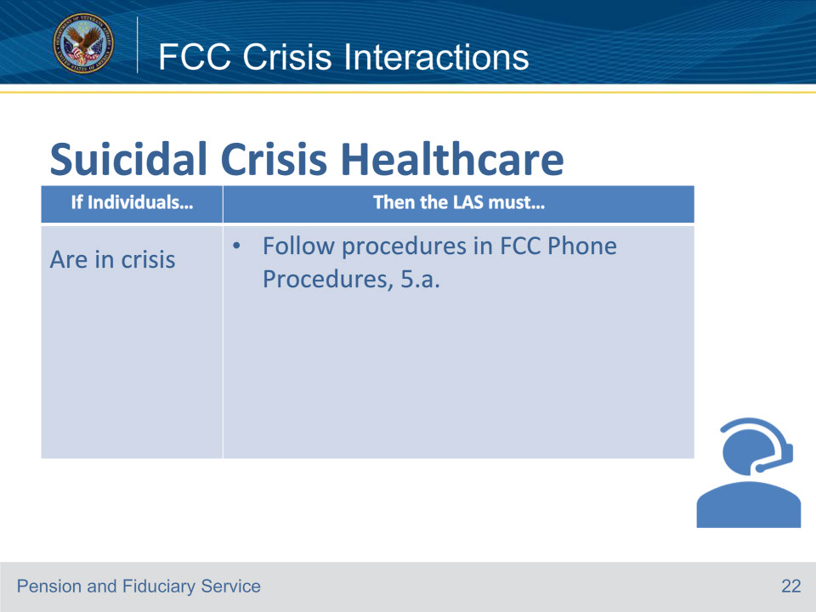
Slide notes

Instructor Notes

This slide goes over the additional required LAS action for an individual in crisis. The 7 steps that were covered earlier in this training should be followed.

Reference: Fiduciary Contact Center (FCC) Phone Procedures 5.b.

Slide 23 - FCC Crisis Interactions
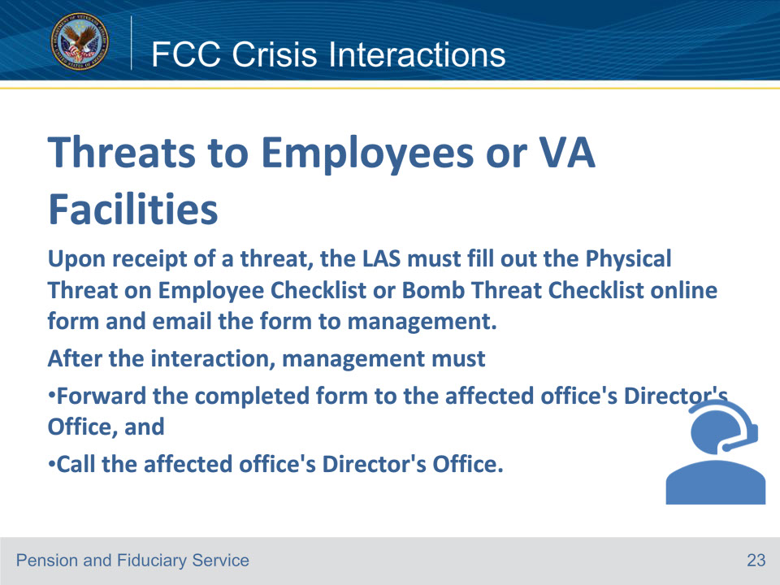
Slide notes

Instructor Notes

Employee safety is a priority, and workplace violence will not be tolerated. Threats to employees and VA facilities are taken very seriously.

Physical Threat on Employee Report (sharepoint.com)

dhs-bomb-threat-checklist-2014-508.pdf (cisa.gov)

Reference: Fiduciary Contact Center (FCC) Phone Procedures 5.c.

Slide 24 - FCC Crisis Interactions
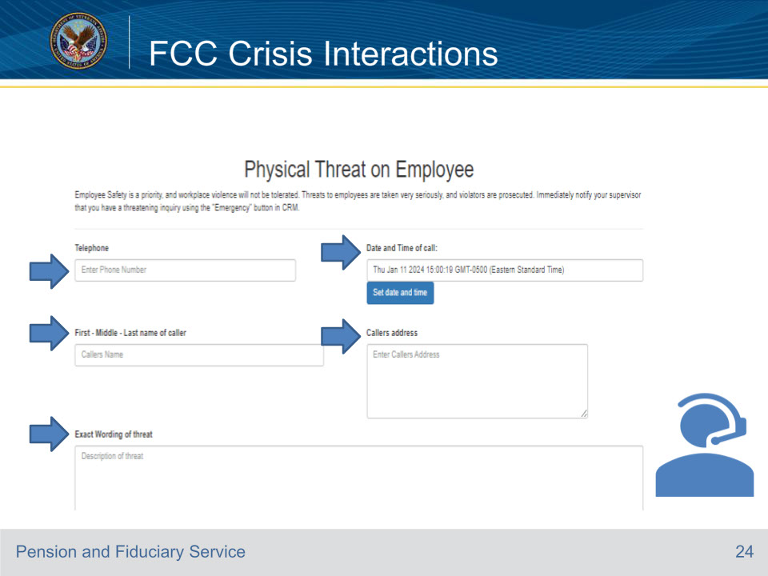
Slide notes

Instructor Notes:

This part of the Physical Threat on Employee Form includes the telephone number , Date and Time of the Call,

First- Middle- Last Name of Caller, Callers Address and the exact wording of the threat

Reference: Fiduciary Contact Center (FCC) Phone Procedures 5.c

Slide 25 - FCC Crisis Interactions
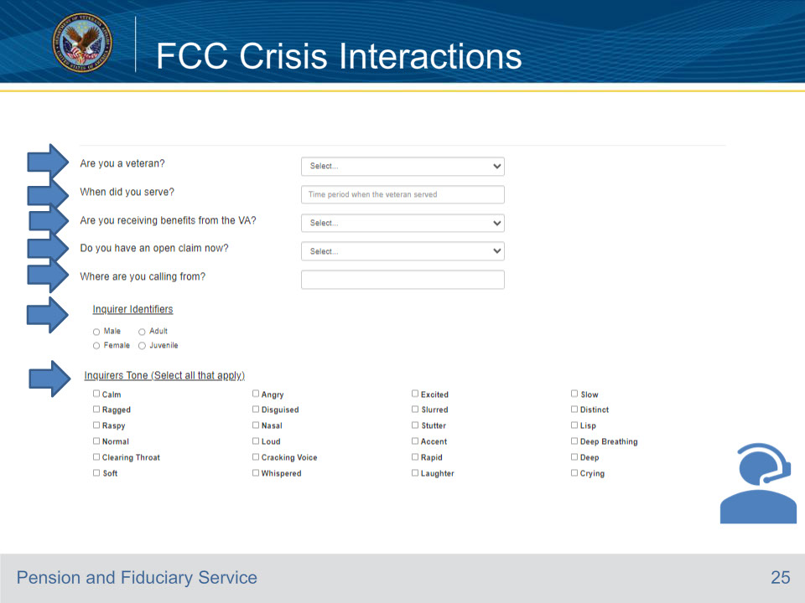
Slide notes

Instructor Notes:

This part of the Physical Threat on Employee Form includes:

• Are you a veteran? with yes or no as the choices

• When did you serve, which should be the time period the veteran served.

• First- Middle- Last Name of Caller, Callers Address and the exact wording of the threat

• Are you receiving benefits from the VA? with yes or no as the choices.

• Do you have an open claim? with yes or no as the choices.

• Where are you calling from?

• Inquirer Identifiers with choices as Male , Adult, Female, or Juvenile.

• Inquirers Tone (select all that apply Calm, Ragged, Raspy, Normal, Clearing Throat, Soft

• Angry, Disguised, Nasal, Loud, Cracking Voice, Whispered, Excited, Slurred, Stutter, Accent

• Rapid, Laughter, Slow, Distinct, Lisp, Deep Breathing, Deep, Crying

Physical Threat on Employee Report (sharepoint.com)

Reference: Fiduciary Contact Center (FCC) Phone Procedures 4.d.

Slide 26 - FCC Crisis Interactions
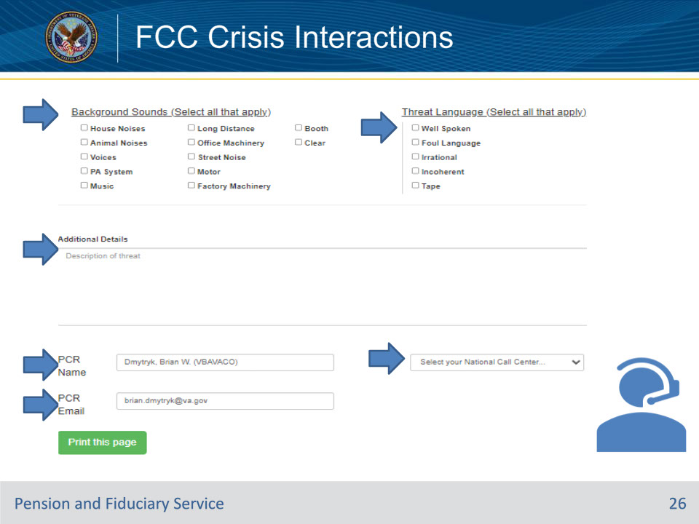
Slide notes

Instructor Notes:

This part of the Physical Threat on Employee Form includes

• Background Sounds (Select all that apply)

• House Noises, Animal Noises, Voices, PA System, Music, Long Distance, Office Machinery,Street Noise

• Motor, Factory Machinery, Booth, Clear

• Threat Language (Select all that apply)

• Well Spoken, Foul Language, Irrational, Incoherent, Tape

• Additional Details- Include the description of the threat.

• PCR Name- LAS Name in Fiduciary Contact Center

• Select your National Call Center dropdown include FCC

• PCR Email- LAS Email

• Physical Threat on Employee Report (sharepoint.com)

Reference: Fiduciary Contact Center (FCC) Phone Procedures 4.d.

Slide 27 - FCC Crisis Interactions
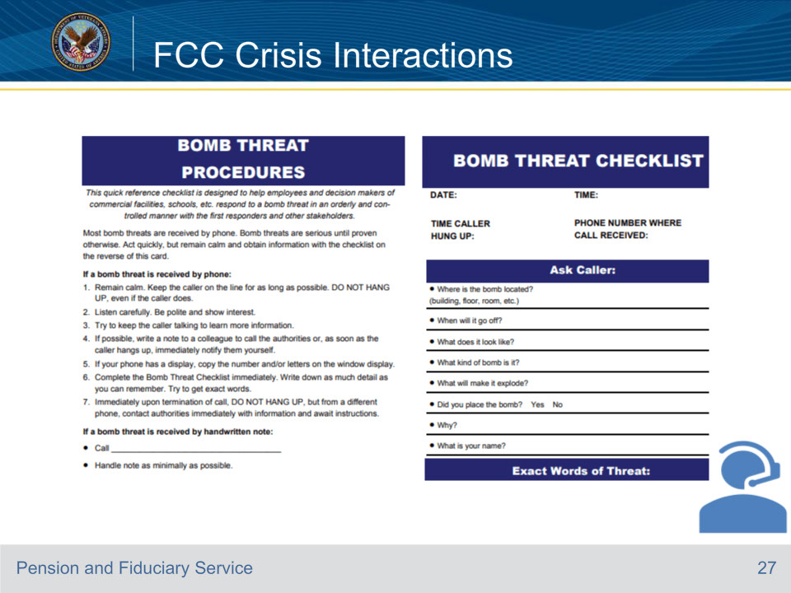
Slide notes

Instructor Notes

This is the first part of the Bomb Threat Procedures Checklist. “Review with students”

Reference: Fiduciary Contact Center (FCC) Phone Procedures 4.e.

Slide 28 - FCC Crisis Interactions
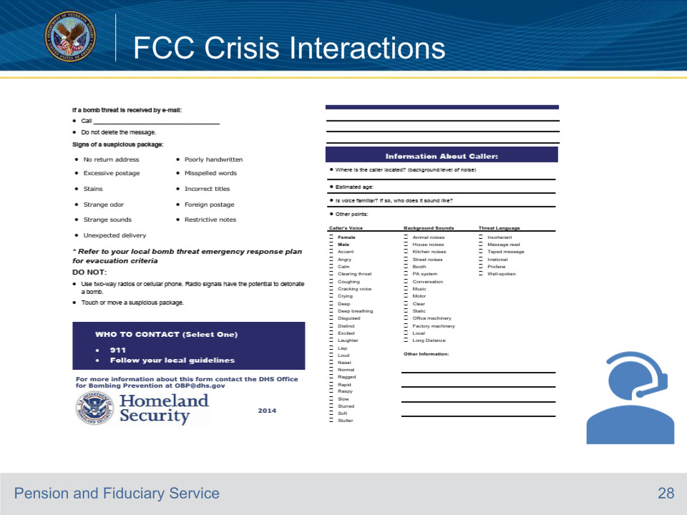
Slide notes

Instructor Notes

This is the bottom half of the of the Bomb Threat Procedures Checklist. “Review with students”

Reference: Fiduciary Contact Center (FCC) Phone Procedures 4.e.

Slide 29 - 31. Questions?
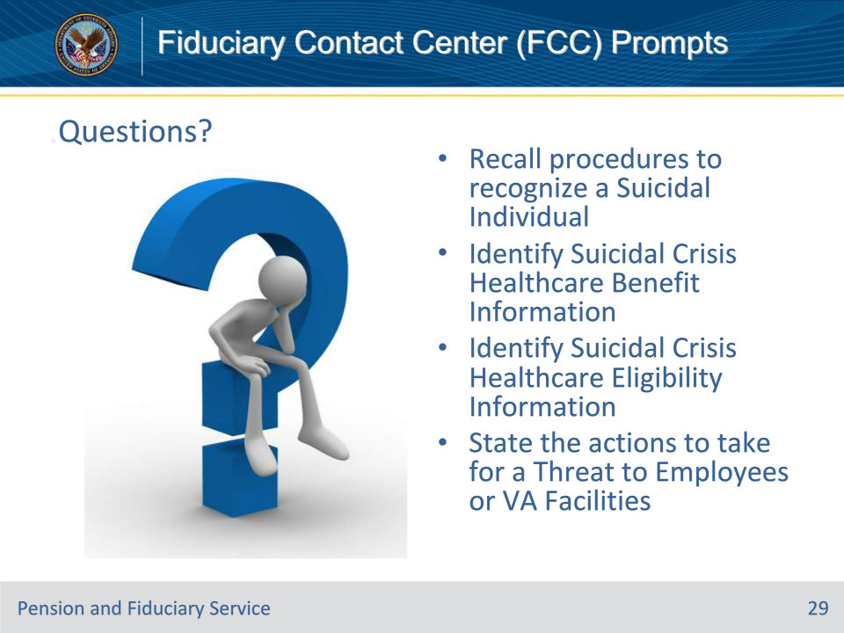
Slide notes

Instructor Notes:

(Recall) These are our learning objectives as stated from the beginning of the training:

• Recall procedures to recognize a Suicidal Individual

• Identify Suicidal Crisis Healthcare Benefit Information

• Identify Suicidal Crisis Healthcare Eligibility Information

• State the actions to take for a Threat to Employees or VA Facilities

Are there any additional questions?

Slide 30 - TMS Survey
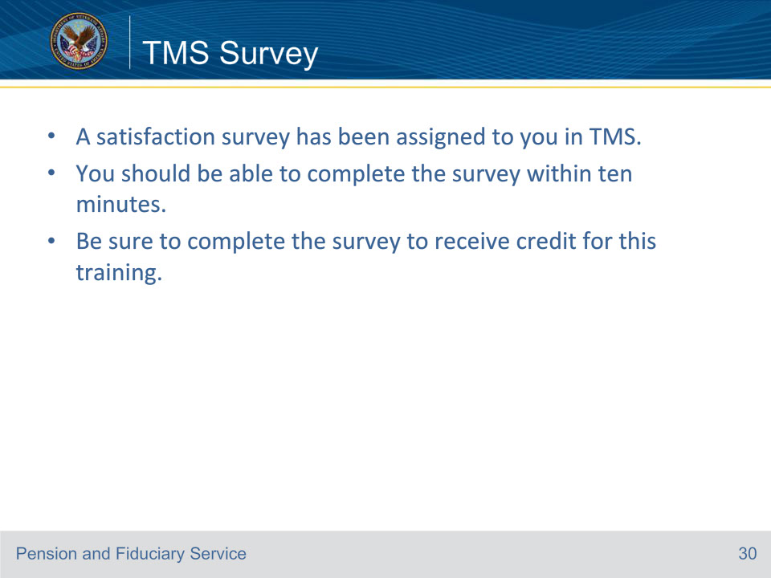
Slide notes

Instructor Notes:

A satisfaction survey has been assigned to you in TMS. You should be able to complete it within ten minutes.

Completing it will allow you to receive credit for this training.

