Slide 1 - Fiduciary Contact Center (FCC) General Guidelines for Interactions
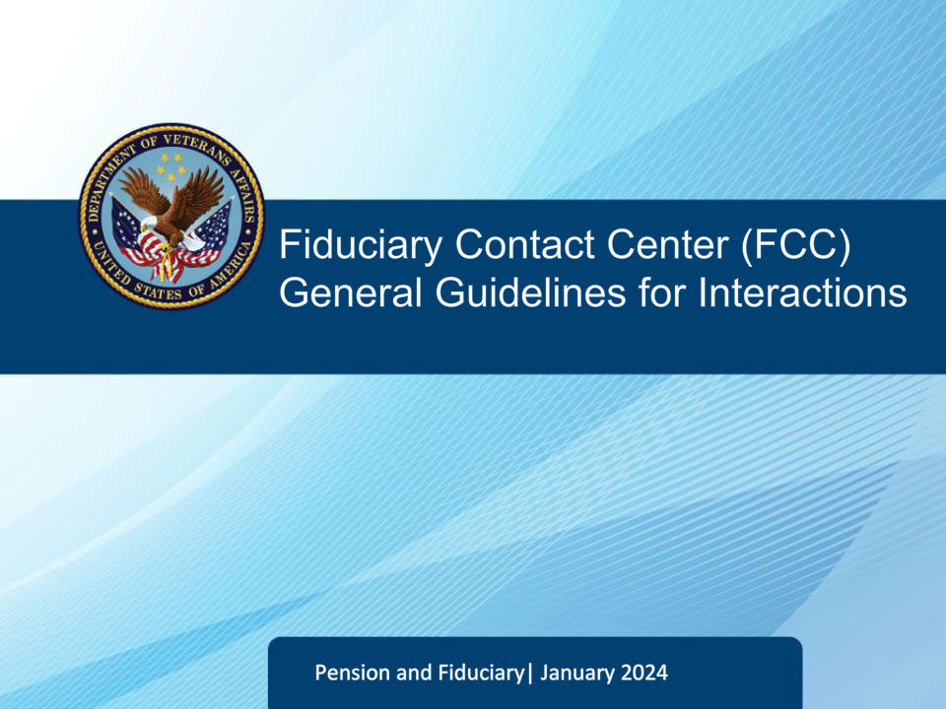
Slide notes

Welcome to the Fiduciary Contact Center Phone Procedures course. The purpose of this training is to help Legal Administration Specialists prepare for their duties by providing general guidelines for various interactions with callers. The course covers guidelines for interactions, identification protocol, opening and closing interactions, when to disconnect calls and controlling the flow of calls. The training is aimed at equipping you with the necessary skills to better serve customers and fulfill your role as a Legal Administration Specialist.

Slide 2 - FCC General Guidelines for Interactions
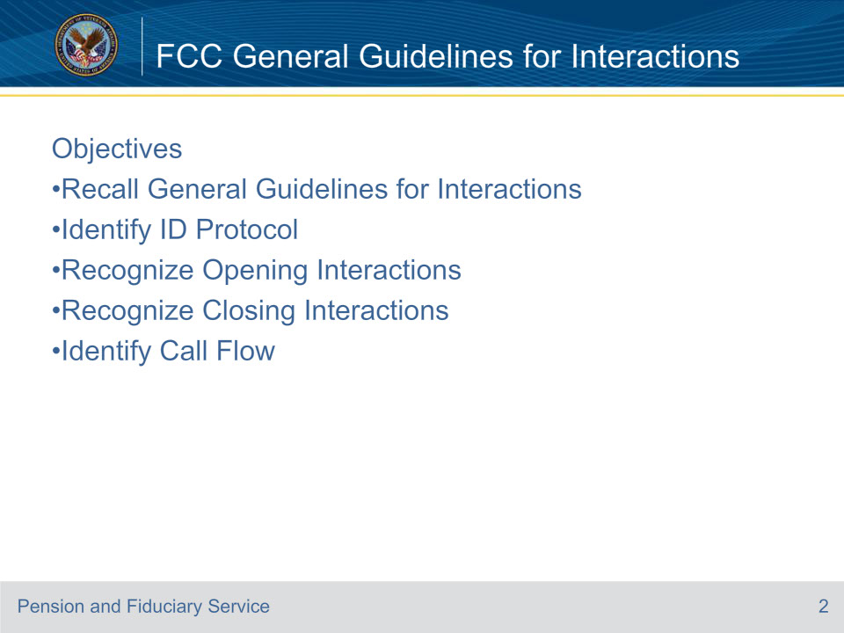
Slide notes

Instructor Notes:

Review the objectives of the lesson.

Slide 3 - FCC General Guidelines for Interactions
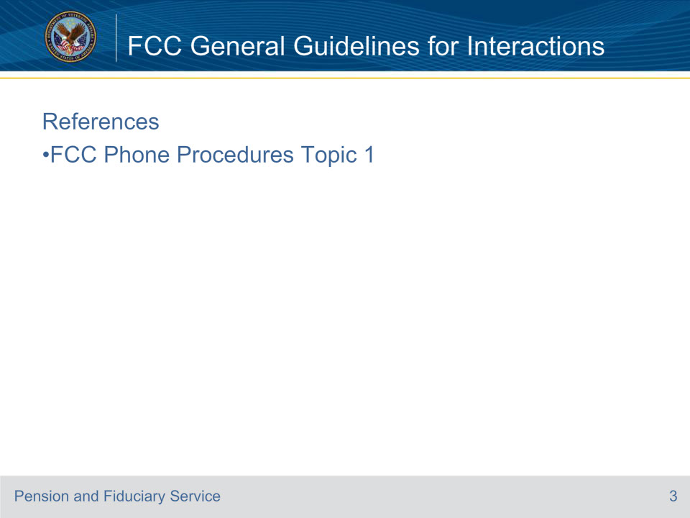
Slide notes

Instructor Notes:

Review the reference for this lesson.

Slide 4 - FCC General Guidelines for Interactions
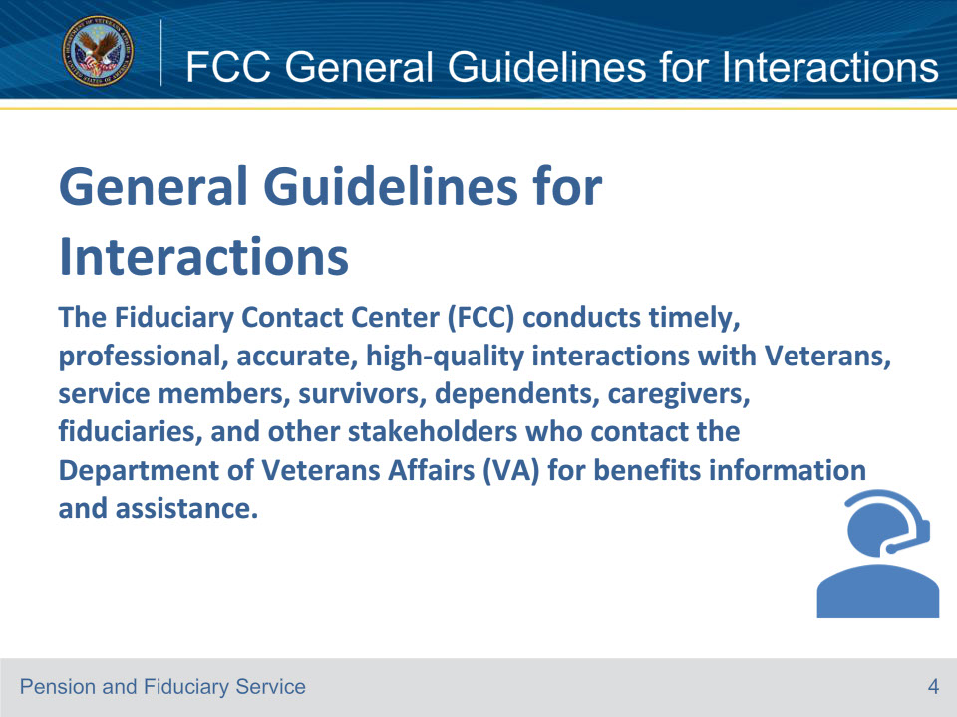
Slide notes

Instructor Notes

Interactions may be conducted via electronic channels (i.e., telephone and email).

Reference: Fiduciary Contact Center (FCC) Phone Procedures 1.a.

Slide 5 - FCC General Guidelines for Interactions
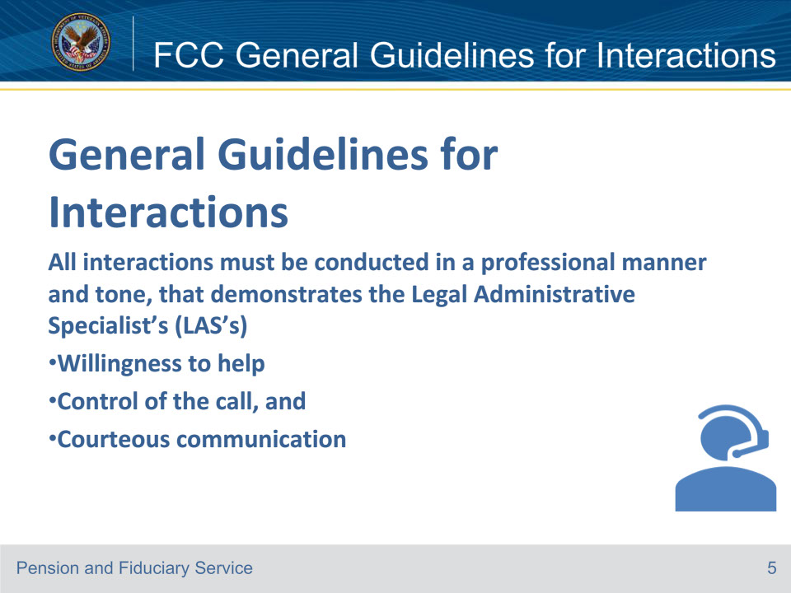
Slide notes

Instructor Notes

Document all calls on a VA Form 27-0820, Report of General Information, that details the name of the caller, the reason for the call, and the steps taken to resolve the call, and upload into the electronic claims folder (eFolder).

Note: When prompted, the Veterans Benefits Management System (VBMS)-Fiduciary is the appropriate system of record to input notes.

Reference: Fiduciary Contact Center (FCC) Phone Procedures 1.a.

Slide 6 - FCC General Guidelines for Interactions
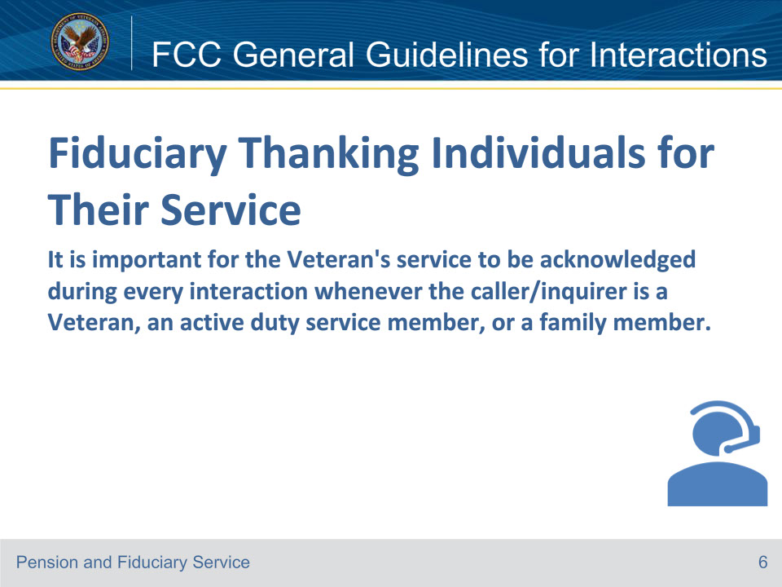
Slide notes

Instructor Notes

LASs must thank the Veteran or service member for their service (or the survivors/dependents/family members on behalf of the Veteran/service member) at any point during the interaction.

Reference: Fiduciary Contact Center (FCC) Phone Procedures 1.b.

Slide 7 - FCC General Guidelines for Interactions
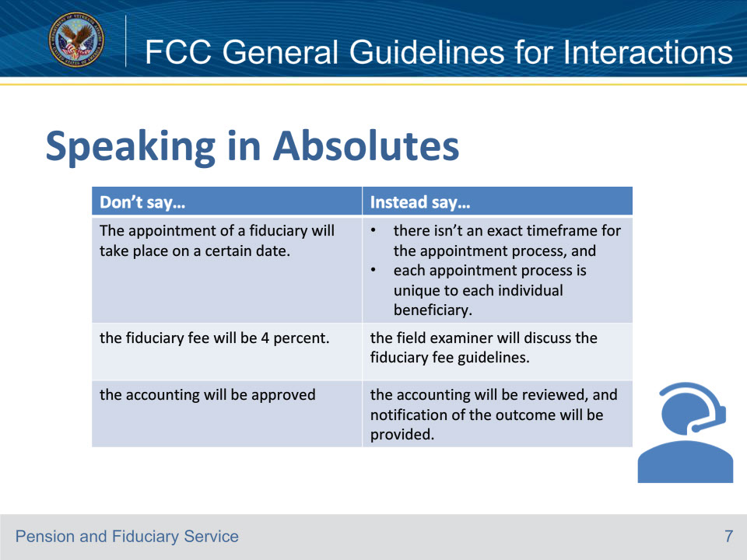
Slide notes

Instructor Notes

The LAS must refrain from speaking in absolute terms. This table provides examples of refraining from speaking in absolutes. The list is not all inclusive.

Reference: Fiduciary Contact Center (FCC) Phone Procedures 1.c.

Slide 8 - FCC General Guidelines for Interactions
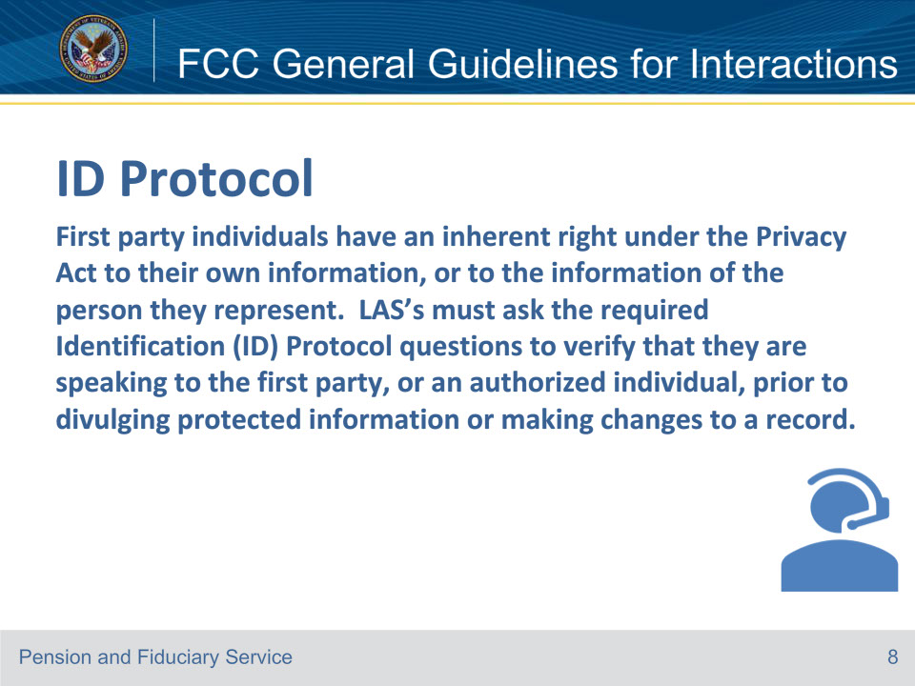
Slide notes

Instructor Notes

Protected information includes anything pulled from a living Veteran’s/beneficiary’s record except the current monthly benefit amount.

Notes:

• ID Protocol is not required for VA employees. VA Employees must provide a business need for the requested information and be verified in Outlook.

• ID Protocol is not required for third party development letter recipients. The. LAS may only discuss the letter received with the third party.

• The LAS must ask for enough information to be sure the correct Veteran’s record is accessed.

• Responses to ID Protocol requirements must be verified in the system of records.

Reference: Fiduciary Contact Center (FCC) Phone Procedures 1.d.

Slide 9 - FCC General Guidelines for Interactions
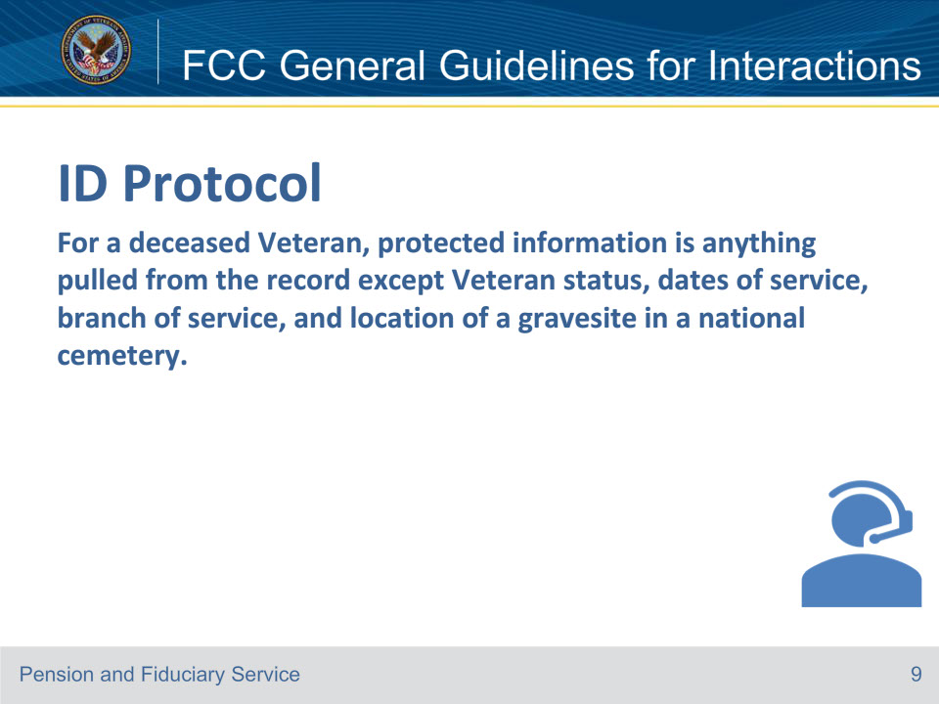
Slide notes

Instructor Notes

Records of deceased Veterans may be released to next of kin if disclosures will not be injurious to the physical or mental health of the person on whose behalf the information is sought or cause repugnance or resentment toward the decedent.

Notes:

• After asking required ID Protocol questions, the LAS may ask additional questions if they are not comfortable with the responses (see FCC Phone Procedures 1.e); however, the LAS may not substitute for any of the required questions if the inquirer is unable to provide the correct response.

• A note must be left in VBMS-Fiduciary indicating why additional questions were asked.

Reference: Fiduciary Contact Center (FCC) Phone Procedures 1.d.

Slide 10 - FCC General Guidelines for Interactions
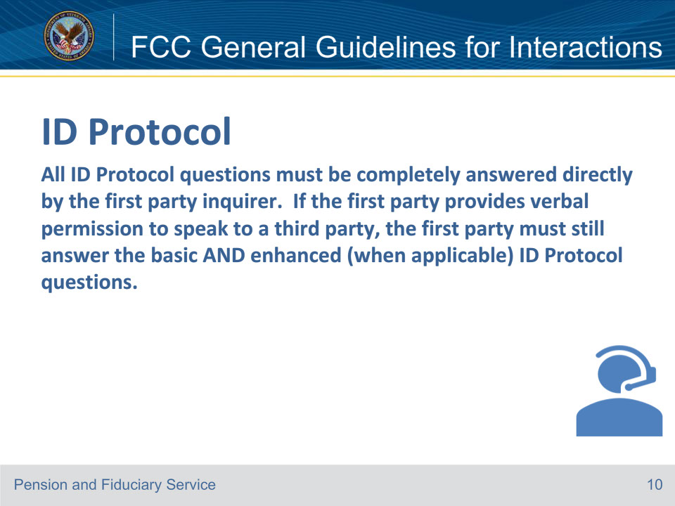
Slide notes

Instructor Notes

Notes:

• The ID Protocol used depends on the type of interaction and requested action.

• When verifying the VA file or claim number of record, if the number contains leading zeros (for example, 00012345), the inquirer does not need to verify the leading zeros.

• When reviewing for a VA Form 21-0845, Authorization to Disclose Personal Information to a Third Party, on record, the LAS may utilize a complete form that is viewable in the mail portal to complete ID Protocol.

Reference: Fiduciary Contact Center (FCC) Phone Procedures 1.d.

Slide 11 - FCC General Guidelines for Interactions
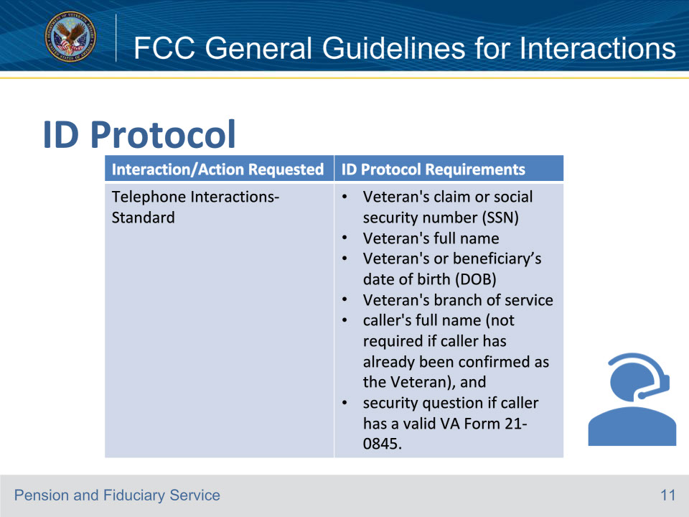
Slide notes

Instructor Notes

This table describes the proper ID Protocol for each interaction.

Note:

Cisco Finesse screens must be accessible on LAS’s monitors for quality review purposes.

Reference: Fiduciary Contact Center (FCC) Phone Procedures 1.d.

Slide 12 - FCC General Guidelines for Interactions
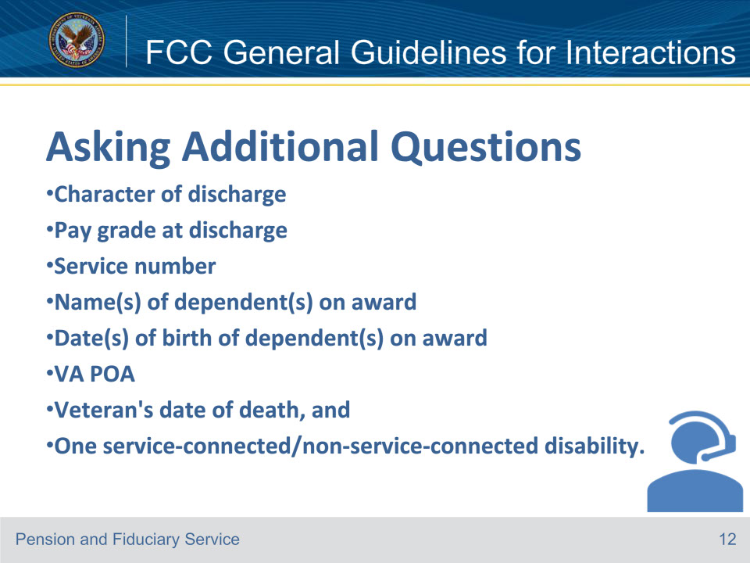
Slide notes

Instructor Notes

• These are some of the examples of additional questions that may be asked when the LAS is not comfortable with responses.

• The LAS may select additional data points from the record, if needed.

Reference: Fiduciary Contact Center (FCC) Phone Procedures 1.e.

Slide 13 - FCC General Guidelines for Interactions
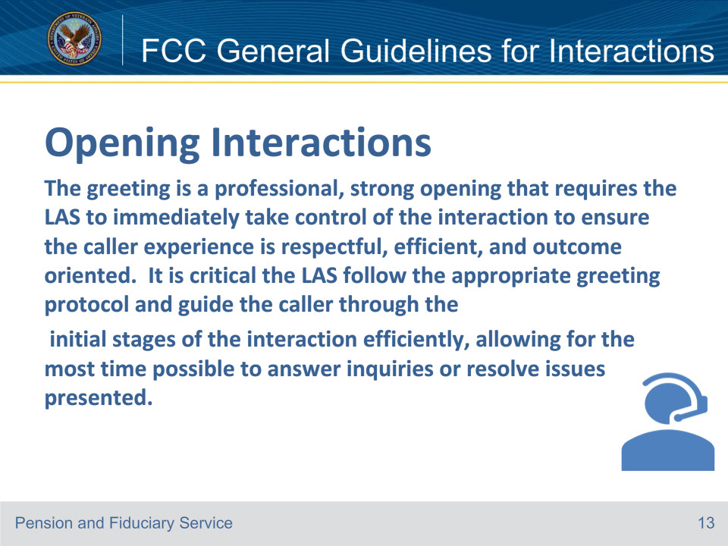
Slide notes

Instructor Notes

This slide details the importance of a good opening interaction.

Important: If the caller is the fiduciary and unable to identify the branch of service, the following alternate question may be asked:

“What is the most recent benefit amount?”

Notes:

• Cisco Finesse screens must be accessible on LAS’s monitors for quality review purposes.

• Be prepared to pull up the file number in all systems (VBMS CORE, VBMS-Fiduciary, and SHARE).

Reference: Fiduciary Contact Center (FCC) Phone Procedures 1.f.

Slide 14 - FCC General Guidelines for Interactions
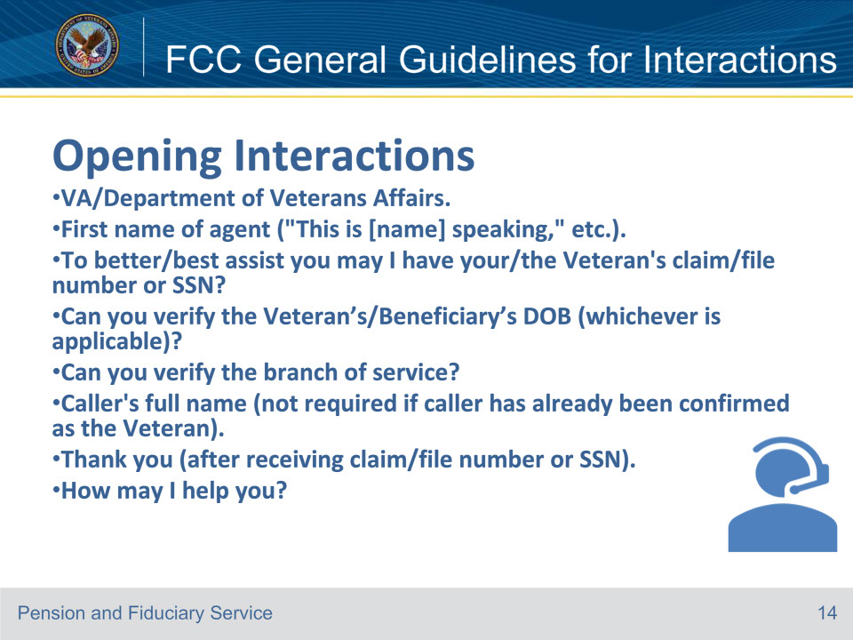
Slide notes

Instructor Notes

To enhance the customer service experience and to ensure the account information is reflected on the screen from the beginning of each phone call, FCC LAS’s are required to use the following greeting.

Important: If the caller is the fiduciary and unable to identify the branch of service, the following alternate question may be asked:

“What is the most recent benefit amount?”

Note: If the LAS greeting is interrupted, and/or the caller indicates the question is general in nature, the LAS is not required

to request the SSN/claim number and is not required to subsequently pull up all systems nor thank the caller for providing that information.

Reference: Fiduciary Contact Center (FCC) Phone Procedures 1.f.

Slide 15 - FCC General Guidelines for Interactions
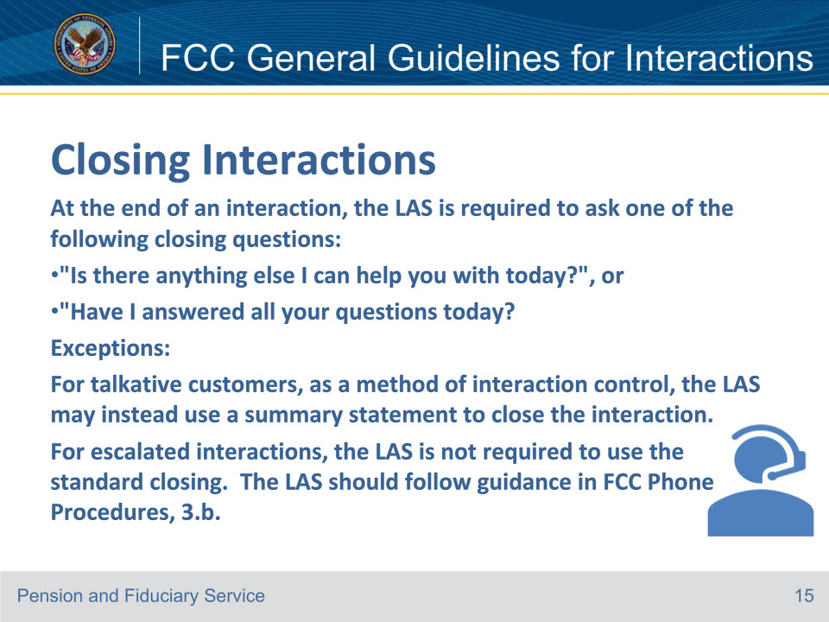
Slide notes

Instructor Notes

When closing the call, it is required to be closed in a confident manner that demonstrates continued respectful control of the call.

An approved closing is required on all calls to include transferred calls and calls where the Veteran/caller indicates

they have no further questions, or all their questions have been answered.

Note:

• The LAS is required to ask the question once per interaction, when applicable. The LAS is not required to repeat the closing question after any subsequent discussion.

• Make sure to properly end the call with an appropriate closing.

• “Have a nice/great day” or a similar sentiment must not be used during death-related interactions.

Reference: Fiduciary Contact Center (FCC) Phone Procedures 1.g.
Slide 16 - FCC General Guidelines for Interactions
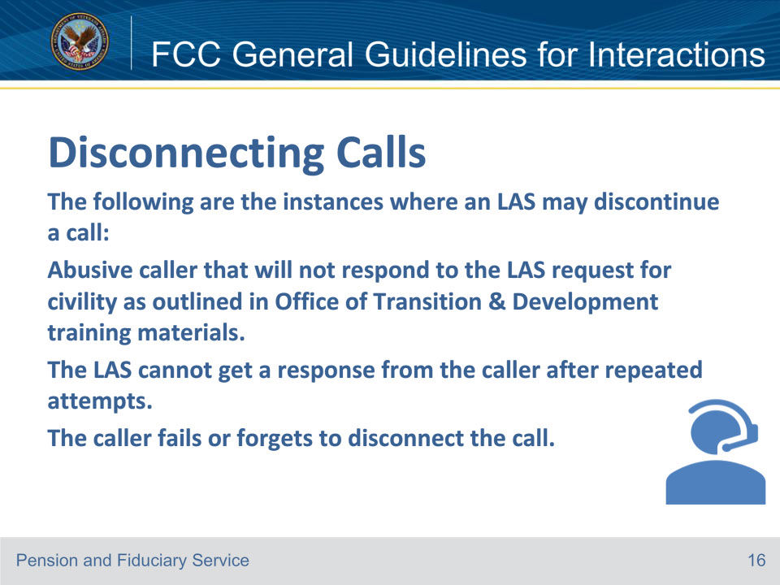
Slide notes

Instructor Notes

The LAS and Senior LAS must give callers the chance to hang up or disconnect the call first. When the LAS must disconnect the call

or complete a transfer, the hang-up button on the Jabber soft phone should be used to end the call

Reference: Fiduciary Contact Center (FCC) Phone Procedures 1.h.

Slide 17 - FCC General Guidelines for Interactions
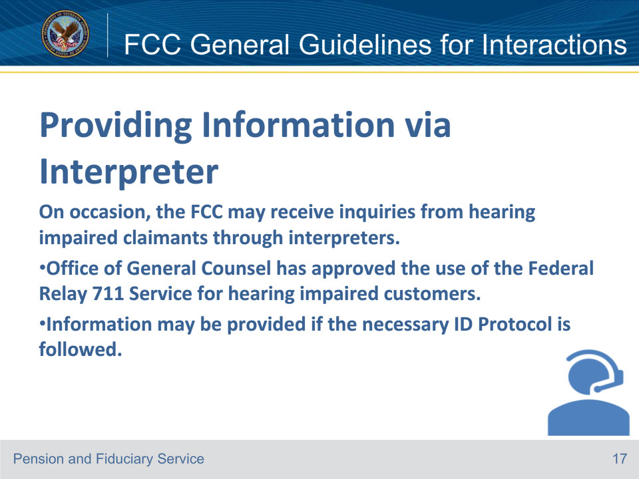
Slide notes

Instructor Notes

If the FCC LAS receives a call from a hearing-impaired caller or third-party interpreter not utilizing the Federal Relay 711 Service,

the LAS must provide the caller the 711 number for utilization when calling VA.

Reference: Fiduciary Contact Center (FCC) Phone Procedures 1.i.

Slide 18 - FCC General Guidelines for Interactions
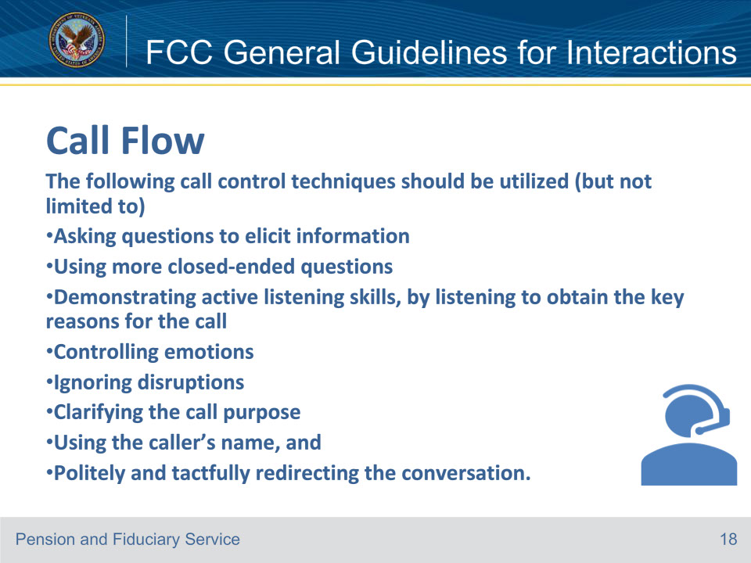
Slide notes

Instructor Notes

Controlling the flow of all calls by the LAS is required and is also an important component in high-quality customer service. Manage the conversation through questions

and statements to ensure the caller knows the objective is to resolve the reason for the call

Reference: Fiduciary Contact Center (FCC) Phone Procedures 1.j.

Slide 19 - 31. Questions?
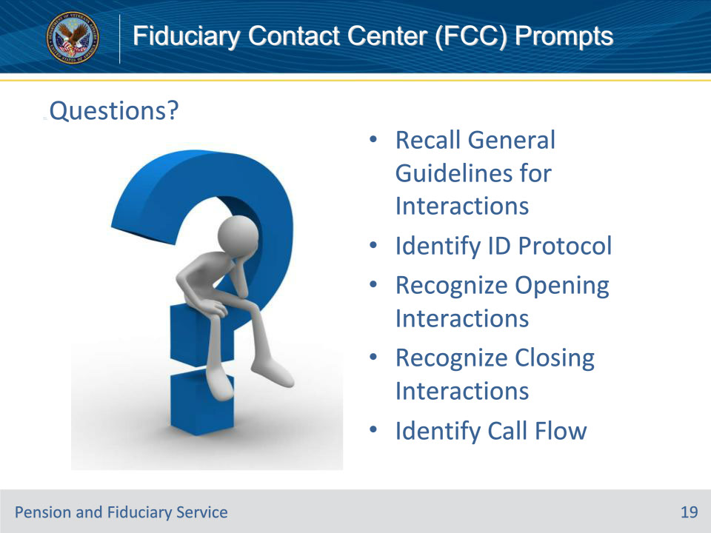
Slide notes

Instructor Notes:

(Recall) These are our learning objectives as stated from the beginning of the training:

• Recall General Guidelines for Interactions

• Identify ID Protocol

• Recognize Opening Interactions

• Recognize Closing Interactions

• Identify Call Flow

Are there any additional questions?

Slide 20 - TMS Survey
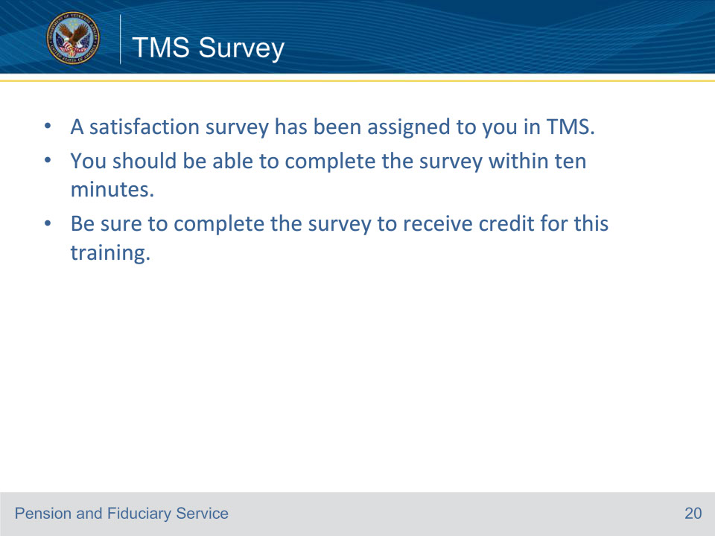
Slide notes

Instructor Notes:

A satisfaction survey has been assigned to you in TMS. You should be able to complete it within ten minutes.

Completing it will allow you to receive credit for this training.

