Slide 1 - FCC ID Protocol
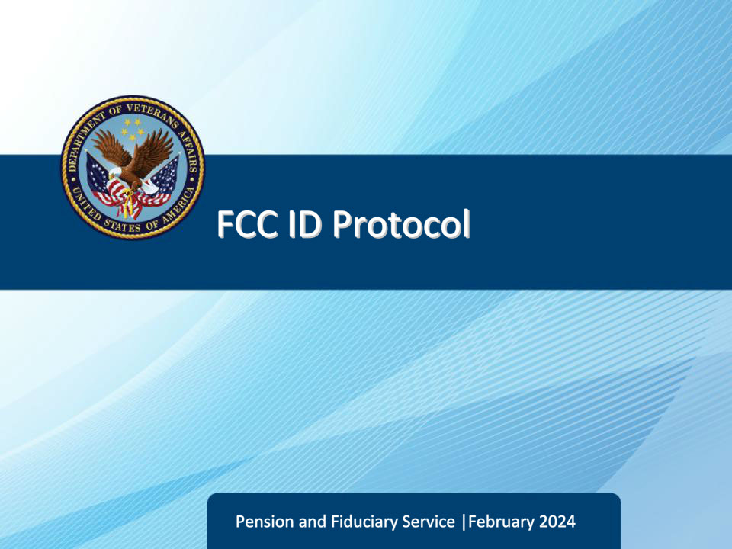
Slide notes

Course Description:

Welcome to the Fiduciary Contact Center ID Protocol training. The purpose of this course is to assist Legal Administrative Specialists (LAS) in preparing for their duties by conducting identification protocol. By completing this training, they will have a basic understanding of what is required to properly identify callers. The aim is to help safeguard information and ensure that Legal Administrative Specialists do not provide information to unauthorized callers. This training is designed to equip you with a clear understanding of what is required to complete proper identification protocol.

Slide 2 - Objectives
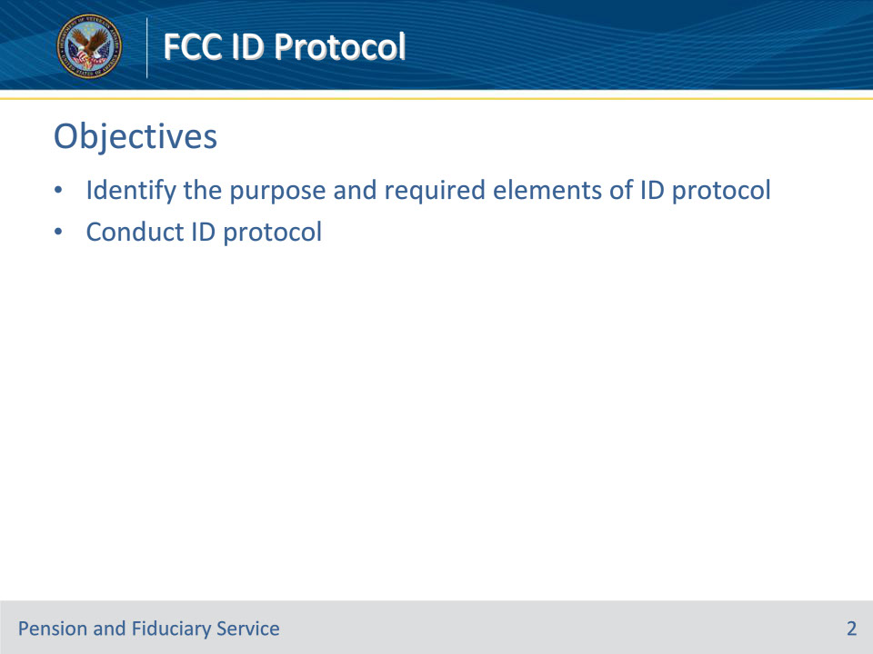
Slide notes

Instructor Notes:

At the end of this lesson, given the training and references, the learner will be able to do the following:

• Identify the purpose and required elements of ID protocol

• Conduct ID protocol

Slide 3 - References
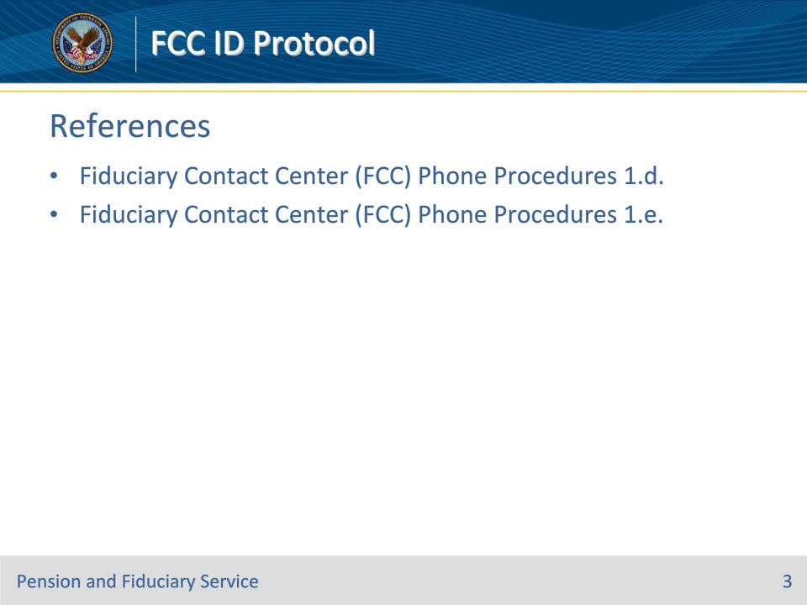
Slide notes

Instructor Notes:

These are the relevant references pertaining to this course:

• Fiduciary Contact Center (FCC) Phone Procedures 1.d.

• Fiduciary Contact Center (FCC) Phone Procedures 1.e.

Slide 4 - Purpose
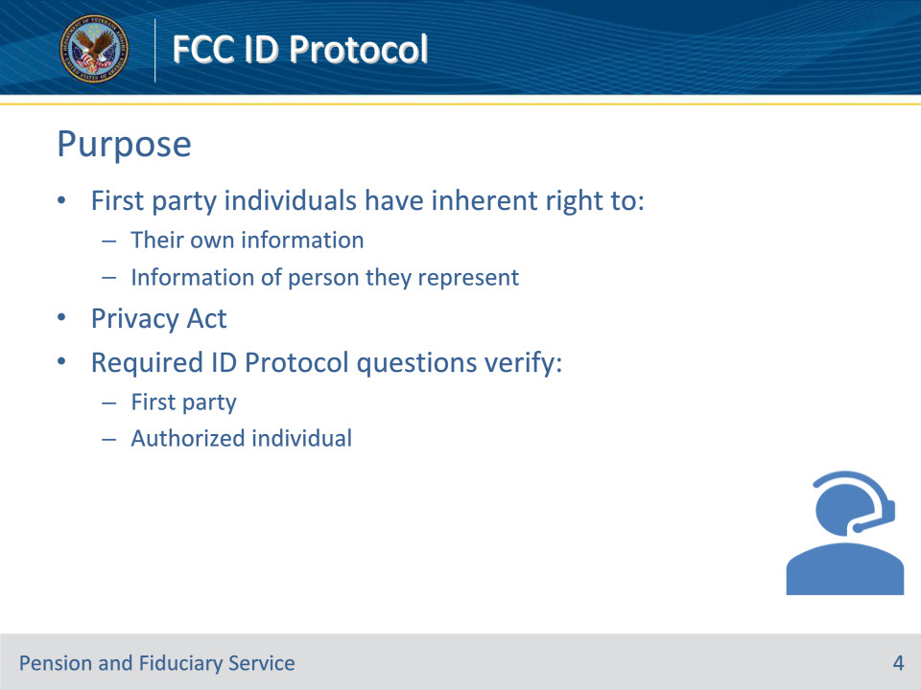
Slide notes

Policy Reference(s): Fiduciary Contact Center (FCC) Phone Procedures 1.d.

Instructor Notes

First party individuals have an inherent right under the Privacy Act to their own information, or to the information of the person they represent. LAS’s must ask the required Identification (ID) Protocol questions to verify that they are speaking to the first party, or an authorized individual, prior to divulging protected information or making changes to a record.

Slide 5 - Protected Information
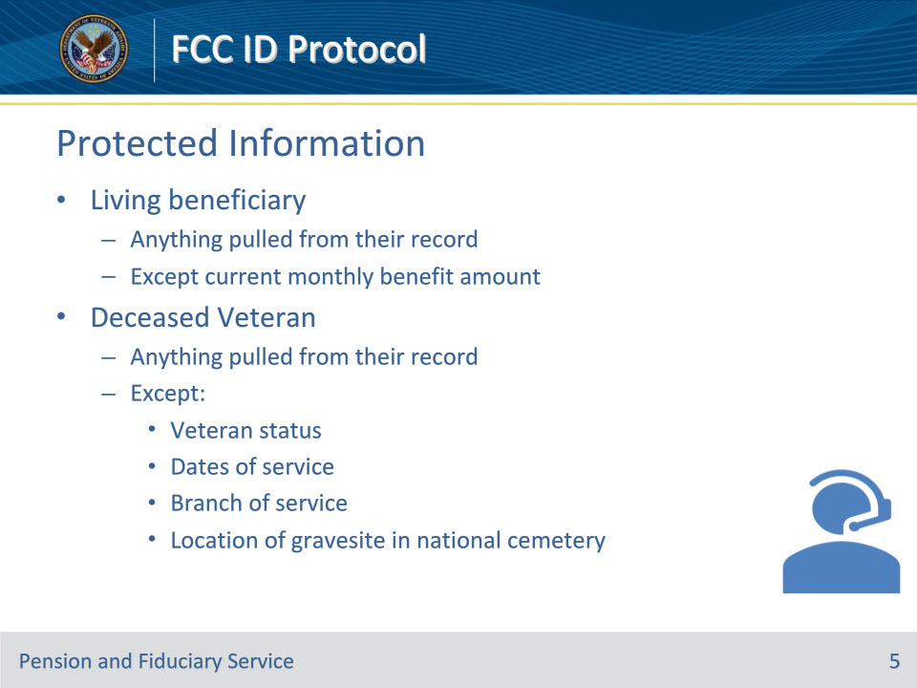
Slide notes

Policy Reference(s): Fiduciary Contact Center (FCC) Phone Procedures 1.d.

Instructor Notes

Protected information includes anything pulled from a living Veteran’s/beneficiary’s record except the current monthly benefit amount.

For a deceased Veteran, protected information is anything pulled from the record except Veteran status, dates of service, branch of service, and location of a gravesite in a national cemetery.

Slide 6 - Deceased Veteran Records
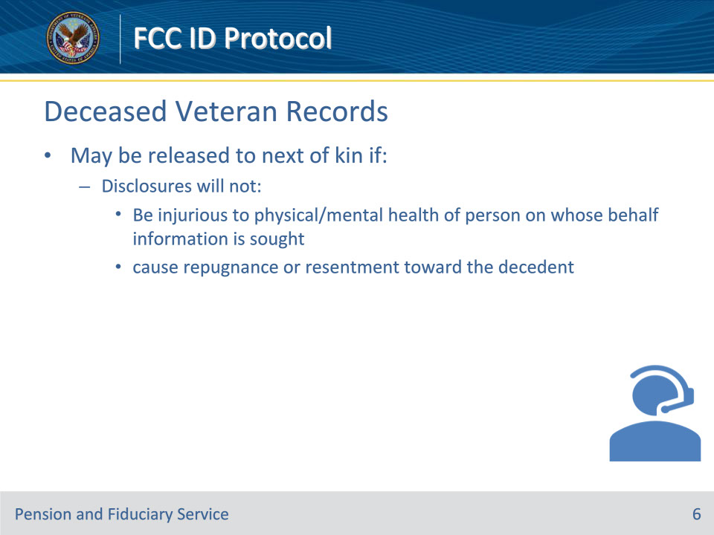
Slide notes

Policy Reference(s): Fiduciary Contact Center (FCC) Phone Procedures 1.d.

Instructor Notes

Records of deceased Veterans may be released to next of kin if disclosures will not be injurious to the physical or mental health of the person on whose behalf the information is sought or cause repugnance or resentment toward the decedent.

Slide 7 - 1st and 3rd Parties
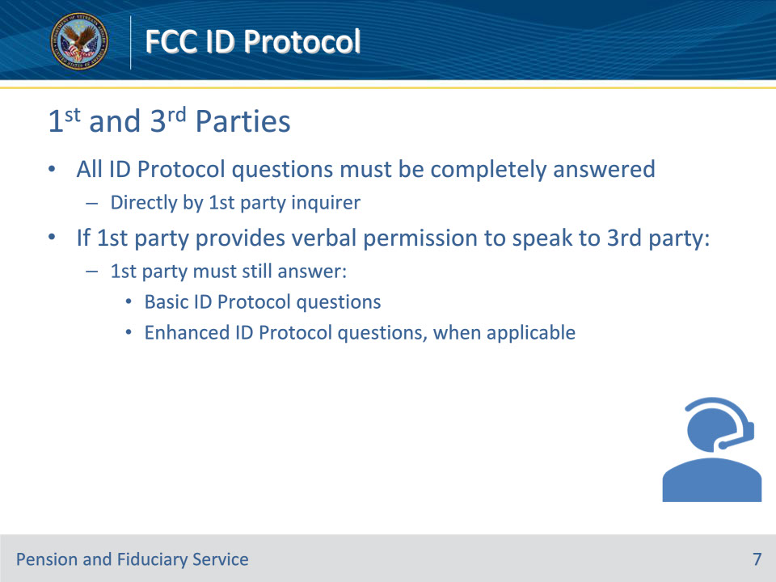
Slide notes

Policy Reference(s): Fiduciary Contact Center (FCC) Phone Procedures 1.d.

Instructor Notes

All ID Protocol questions must be completely answered directly by the first party inquirer. If the first party provides verbal permission to speak to a third party, the first party must still answer the basic AND enhanced (when applicable) ID Protocol questions.

Slide 8 - Representatives
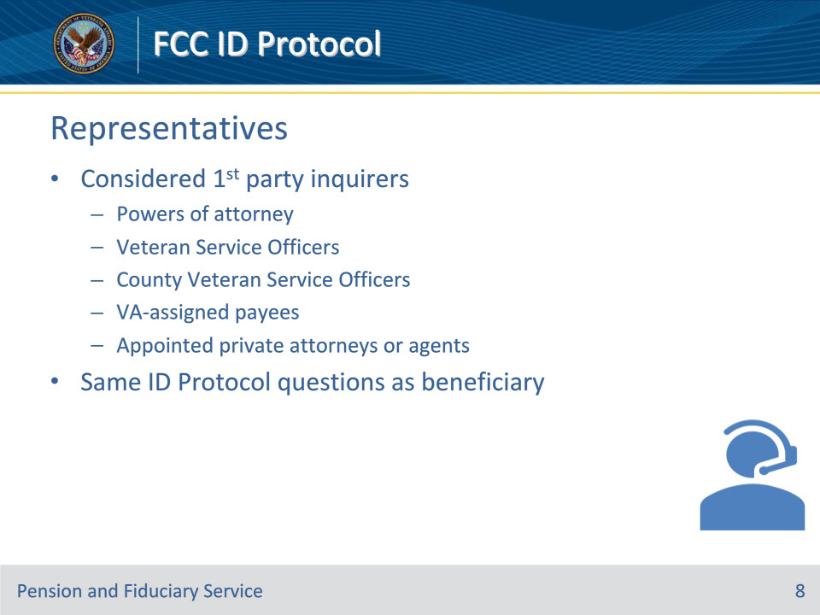
Slide notes

Policy Reference(s): Fiduciary Contact Center (FCC) Phone Procedures 1.d.

Instructor Notes

Powers of attorney (POAs), Veteran Service Officers, County Veteran Service Officers VA-assigned payees (fiduciary, guardian, custodian), and appointed private attorneys or agents are considered first-party inquirers and must be asked the same ID Protocol questions as if they were the Veteran or beneficiary.

Slide 9 - Other Callers
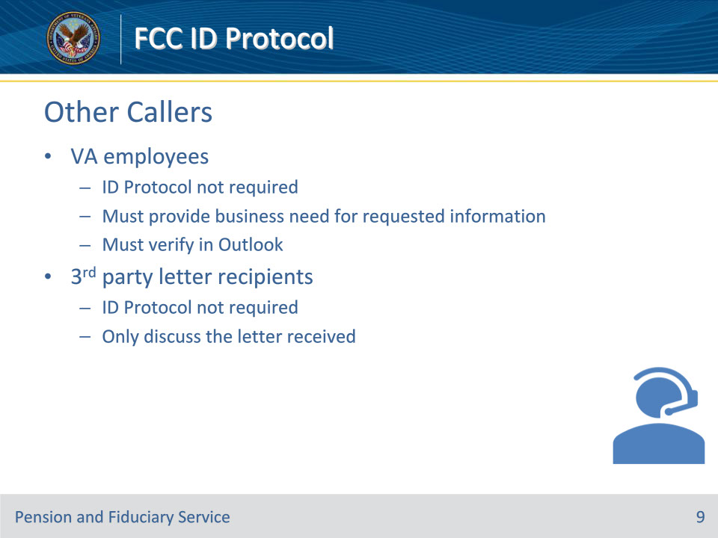
Slide notes

Policy Reference(s): Fiduciary Contact Center (FCC) Phone Procedures 1.d.

Instructor Notes

ID Protocol is not required for VA employees. VA Employees must provide a business need for the requested information and be verified in Outlook.

ID Protocol is not required for third party development letter recipients. The LAS may only discuss the letter received with the third party.

Slide 10 - Verification
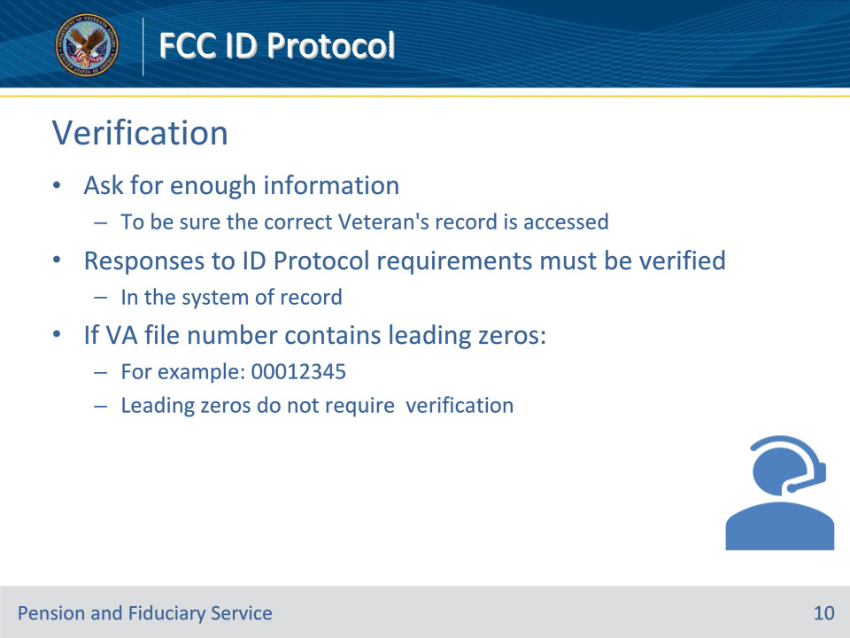
Slide notes

Policy Reference(s): Fiduciary Contact Center (FCC) Phone Procedures 1.d.

Instructor Notes

The LAS must ask for enough information to be sure the correct Veteran’s record is accessed.

Responses to ID Protocol requirements must be verified in the system of records.

When verifying the VA file or claim number of record, if the number contains leading zeros (for example, 00012345), the inquirer does not need to verify the leading zeros.

Slide 11 - VA Form 21-0845
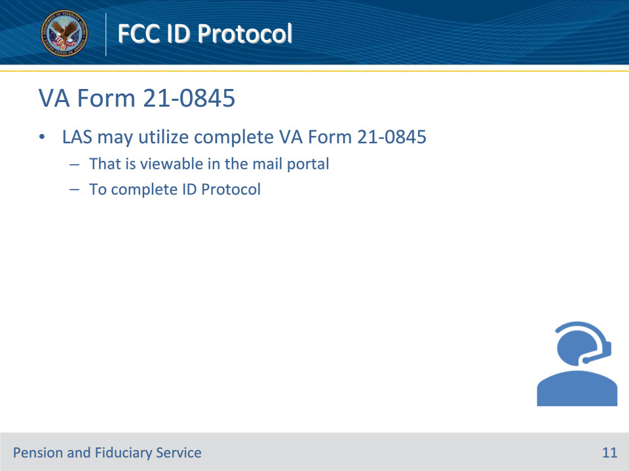
Slide notes

Policy Reference(s): Fiduciary Contact Center (FCC) Phone Procedures 1.d.

Instructor Notes

When reviewing for a VA Form 21-0845, Authorization to Disclose Personal Information to a Third Party, on record, the LAS may utilize a complete form that is viewable in the mail portal to complete ID Protocol.

Slide 12 - ID Protocol Requirements
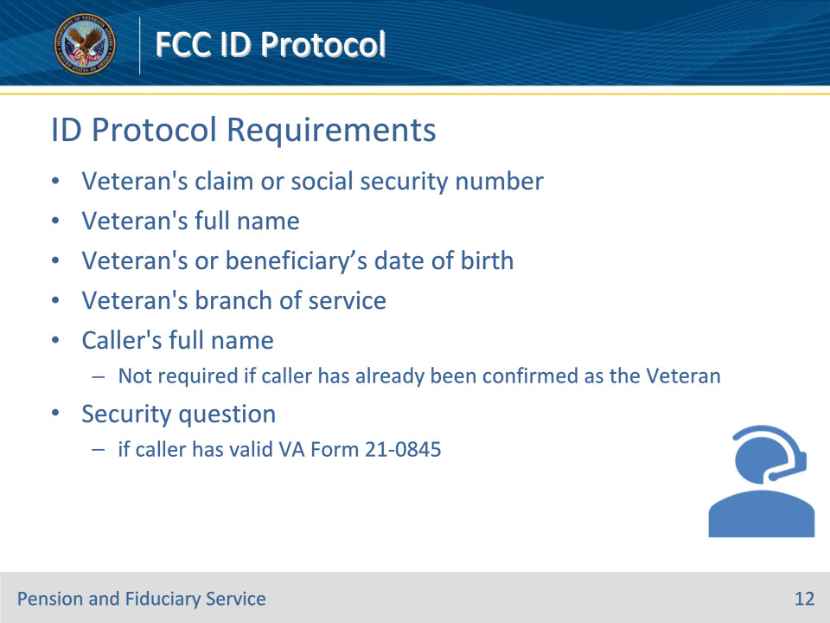
Slide notes

Policy Reference(s): Fiduciary Contact Center (FCC) Phone Procedures 1.d.

Instructor Notes

The ID Protocol Requirements for standard telephone interactions are listed on this slide:

• Veteran’s claim or social security number (SSN)

• Veteran’s full name

• Veteran’s or beneficiary’s date of birth (DOB)

• Veteran’s branch of service

• caller’s full name (not required if caller has already been confirmed as the Veteran), and

• security question if caller has a valid VA Form 21-0845.

Slide 13 - Additional Questions
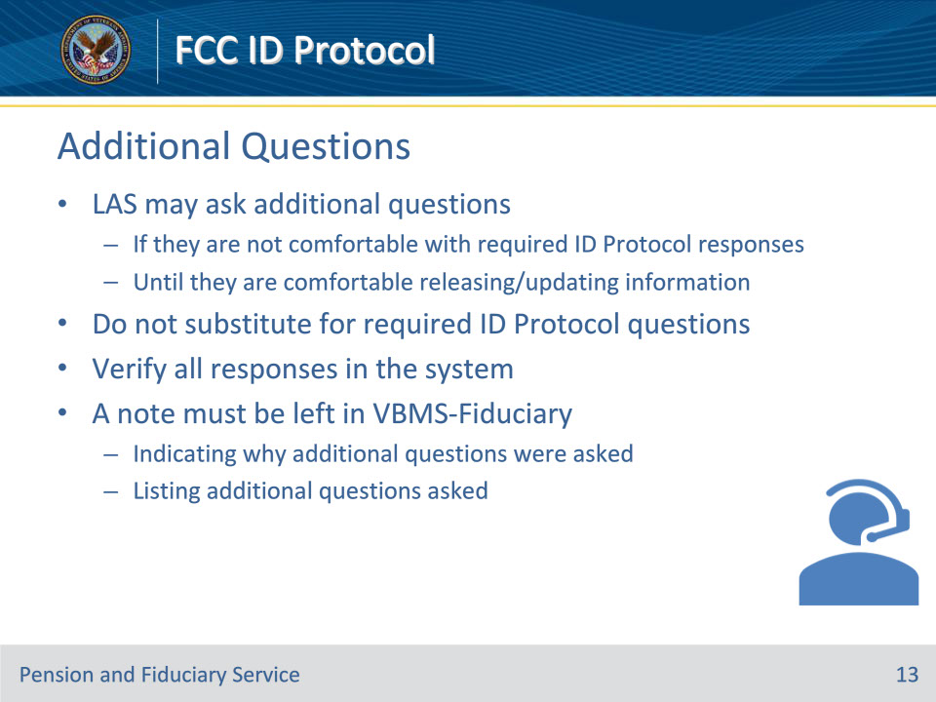
Slide notes

Policy Reference(s): Fiduciary Contact Center (FCC) Phone Procedures 1.d., e.

Instructor Notes

After asking required ID Protocol questions, the LAS may ask additional questions if they are not comfortable with the responses; however, the LAS may not substitute for any of the required questions if the inquirer is unable to provide the correct response.

A note must be left in VBMS-Fiduciary indicating why additional questions were asked.

All responses must be verified in the system. The LAS may ask additional questions until the LAS determines if they are comfortable releasing/updating information. The LAS must enter a note in the system listing the additional questions asked.

Slide 14 - Additional Questions
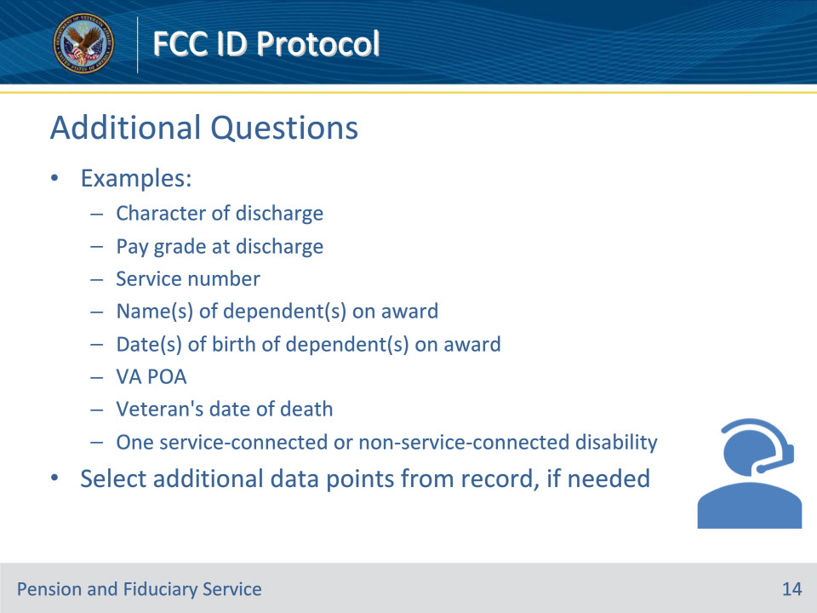
Slide notes

Policy Reference(s): Fiduciary Contact Center (FCC) Phone Procedures 1.e.

Instructor Notes

• Examples of additional questions that may be asked when the LAS is not comfortable with responses:

• character of discharge

• pay grade at discharge

• service number

• name(s) of dependent(s) on award

• date(s) of birth of dependent(s) on award

• VA POA

• Veteran’s date of death, and

• one service-connected or non-service-connected disability.

• The LAS may select additional data points from the record, if needed.

Slide 15 - Questions?
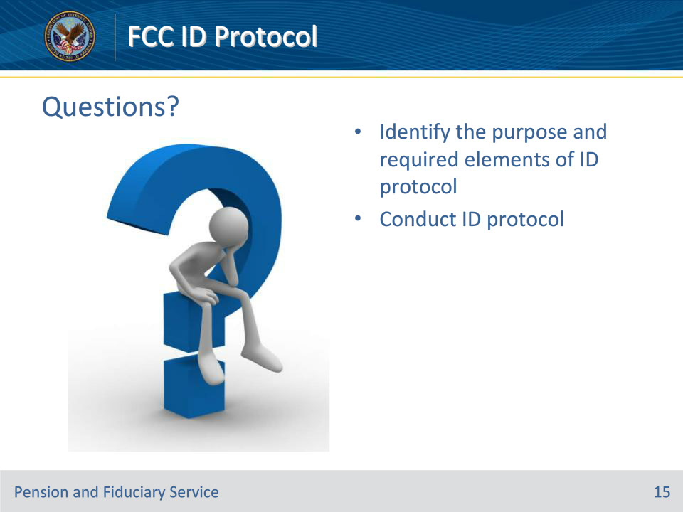
Slide notes

Instructor Notes:

(Recall) These are our learning objectives as stated from the beginning of the training:

• Identify the purpose and required elements of ID protocol

• Conduct ID protocol

Are there any additional questions?

Questions should be filtered through your QRT team. They will submit your questions to the Field Inquiry Tool (FIT) on your behalf.

Slide 16 - TMS Survey/Assessment
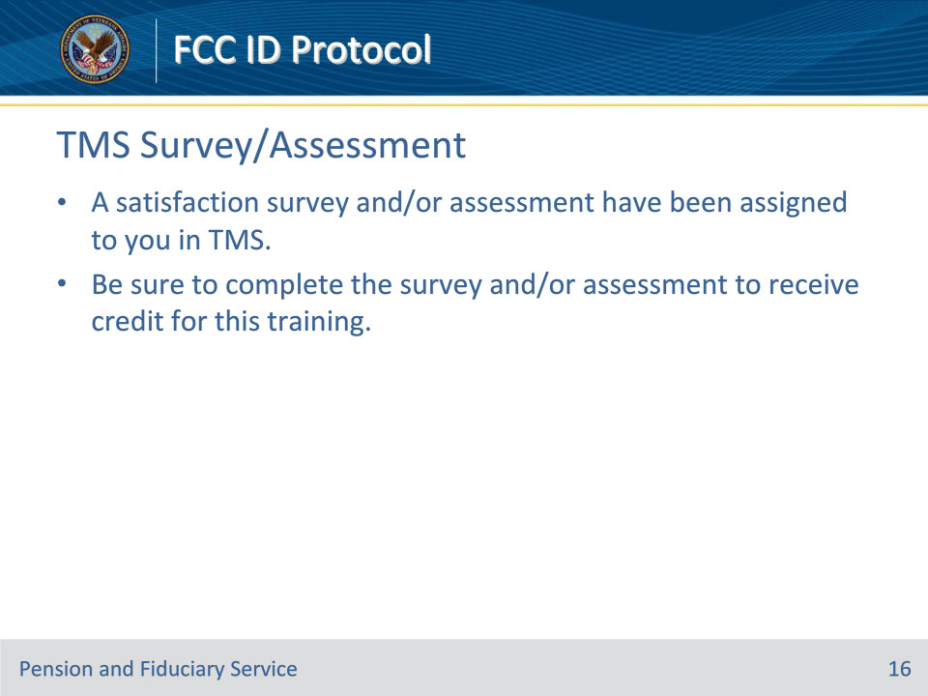
Slide notes

Instructor Notes

A satisfaction survey and/or assessment have been assigned to you in TMS.

Be sure to complete the survey and/or assessment to receive credit for this training.

