**Slide 1 - FCC Prompts**

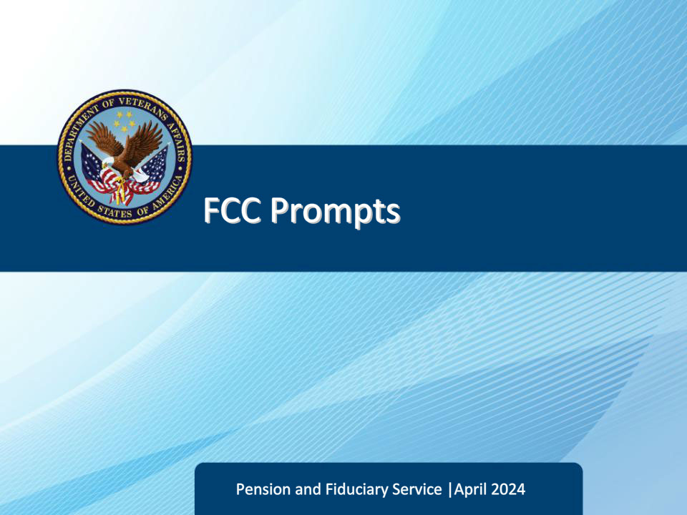

**Slide notes**

Course Description:

Welcome to the Fiduciary Contact Center Prompts training. The purpose of this course is to help Legal Administrative Specialists (LAS) prepare for their duties by providing real-life examples of frequently asked questions and scenarios that may arise while fielding calls. By going through these scenarios, you will learn how to handle different situations, communicate effectively with callers, and provide accurate and helpful information. This training aims to equip you with the necessary skills to better serve the customers and fulfill your role as a Legal Administrative Specialist.

**Slide 2 - Objectives**

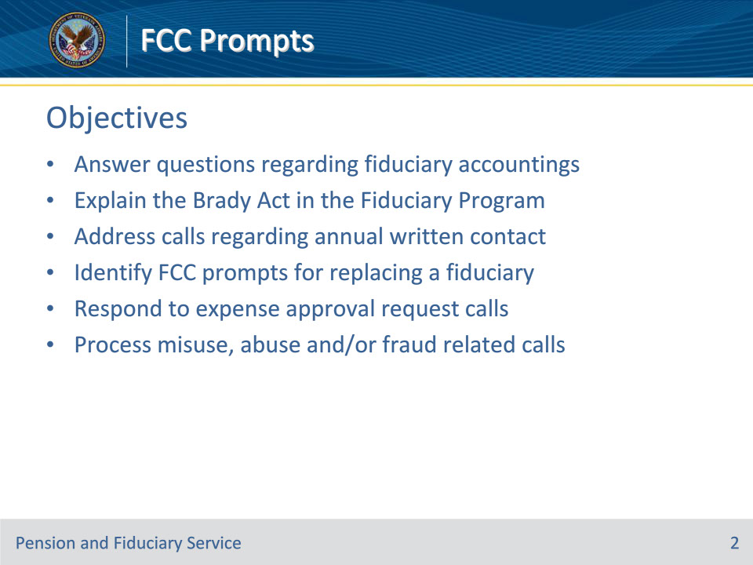

**Slide notes**

Instructor Notes:

At the end of this lesson, given the training and references, the learner will be able to do the following:

• Answer questions regarding fiduciary accountings

• Explain the Brady Act in the Fiduciary Program

• Address calls regarding annual written contact

• Identify FCC prompts for replacing a fiduciary

• Respond to expense approval request calls

• Process misuse, abuse and/or fraud related calls

**Slide 3 - References**

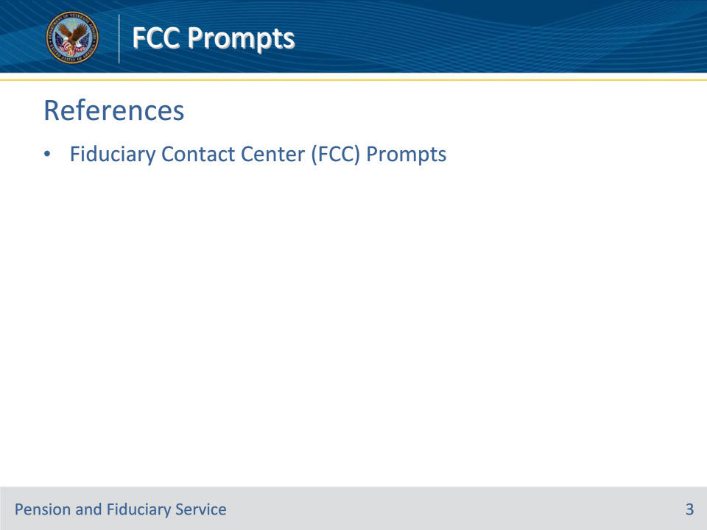

**Slide notes**

Instructor Notes:

These are the relevant references pertaining to this course:

• Fiduciary Contact Center (FCC) Prompts

**Slide 4 - Fiduciary Accounting Audit Status**

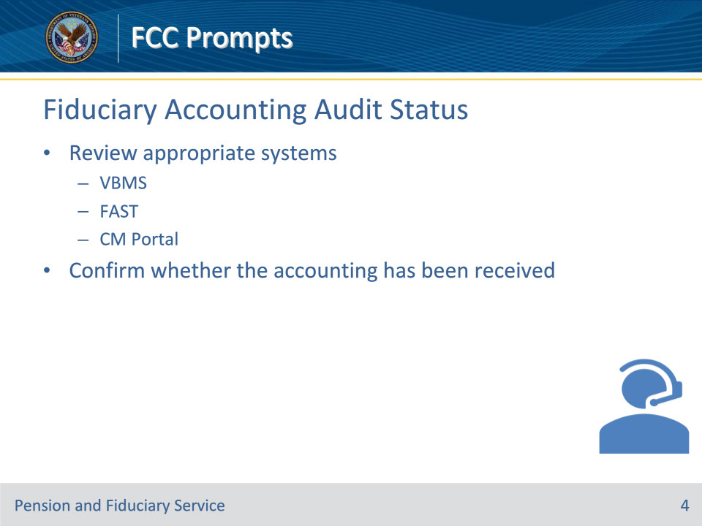

**Slide notes**

Policy Reference(s): Fiduciary Contact Center (FCC) Prompts 1.a.

Instructor Notes

VBA is required to provide proper oversight of the fiduciaries appointed to manage VA benefits. This oversight is typically conducted through accounting audits, in which bank expected expenses are compared to bank statements.  The LAS must review the appropriate systems, VBMS, FAST, and CM Portal to confirm whether the accounting has been received.

**Slide 5 - Fiduciary Accounting Audit Status**

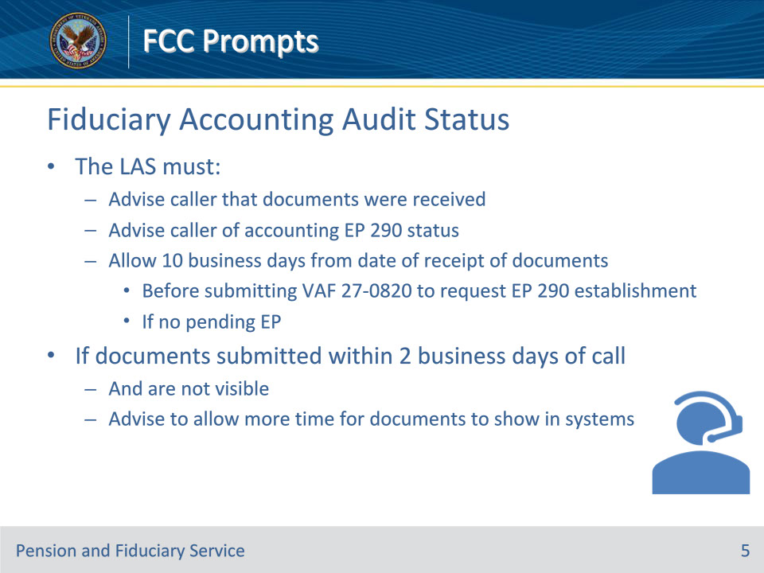

**Slide notes**

Policy Reference(s): Fiduciary Contact Center (FCC) Prompts 1.a.

Instructor Notes

The LAS must:

• advise the caller that the documents were received

• advise the caller of the status of the accounting EP 290, if one is pending, and

• if there is no pending EP, allow at least 10 business days from the date of receipt of documents before submitting VA Form 27-0820 to request an accounting EP 290 be established..

Note:  If the accounting documents were submitted within two business days of the call, and are not visible, advise the fiduciary to allow more time for the documents to show in our systems.

Reference: For more information on the accounting process, see FPM, Part I, 3.A and 38 CFR 13.200.

**Slide 6 - Fiduciary Accounting Extension**

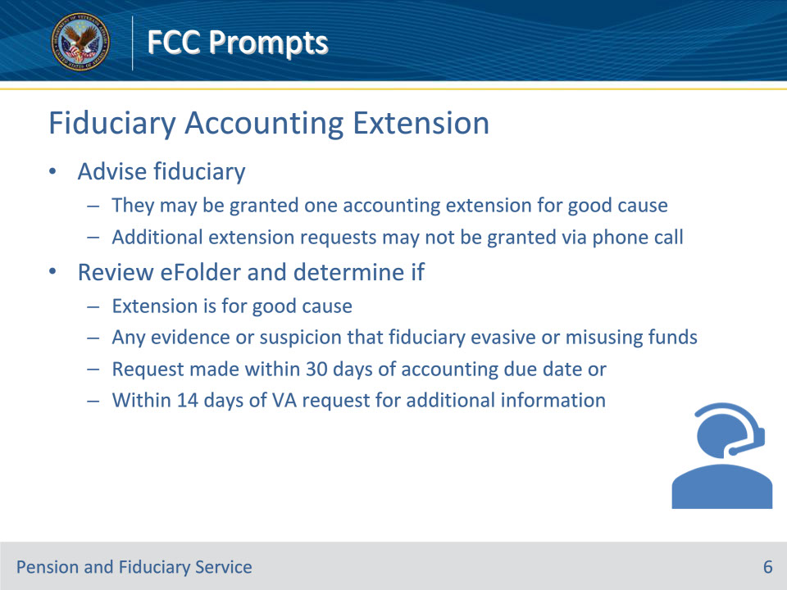

**Slide notes**

Policy Reference(s): Fiduciary Contact Center (FCC) Prompts 1.b.

Instructor Notes

The LAS must advise the fiduciary that they may be granted one accounting extension for good cause.  An additional request for an extension after one has already been granted may not be approved via phone call.  The LAS must review the eFolder and determine if

• the extension is for a good cause

• there is any evidence or any suspicion that the fiduciary is being evasive or misusing beneficiary funds, or

• the request is being made within 30 days of the accounting due date or within 14 days of VA’s request for additional information to approve or complete the accounting.

**Slide 7 - Fiduciary Accounting Extension**

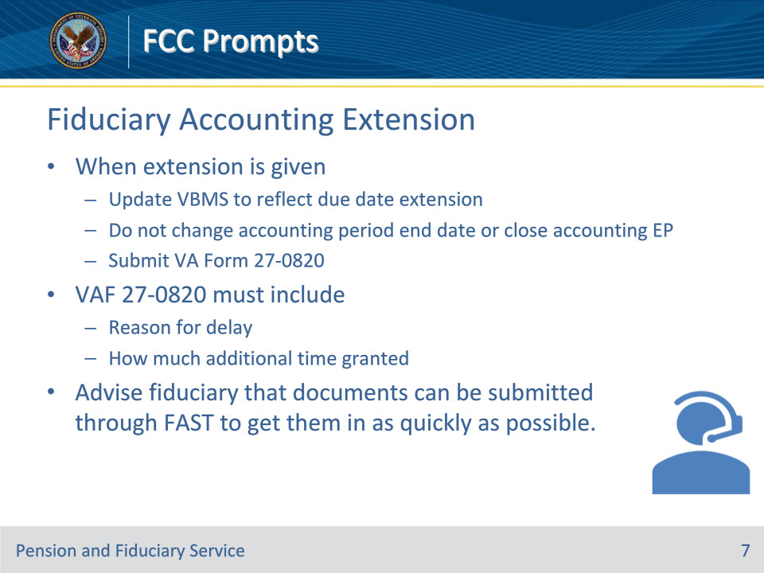

**Slide notes**

Policy Reference(s): Fiduciary Contact Center (FCC) Prompts 1.b.

Instructor Notes

When an extension of the accounting due date is given, update VBMS to reflect that the due date for accounting information has been extended. Do not change the accounting period end date or close the accounting EP.

If an LAS grants the fiduciary request for extension, they must submit VA Form 27-0820 in accordance with VA Form 27-0820 Routing Procedures.  The VA Form 27-0820 must include the reason for the delay and how much additional time the fiduciary has been given to submit documents.

Note:  The LAS must advise the fiduciary that documents can be submitted through FAST to get them in as quickly as possible.

Reference: For more information on accounting submissions, see

• FPM, Part I, 3.A.3.h-m, and

• 38 CFR 13.200.

**Slide 8 - Brady Act**

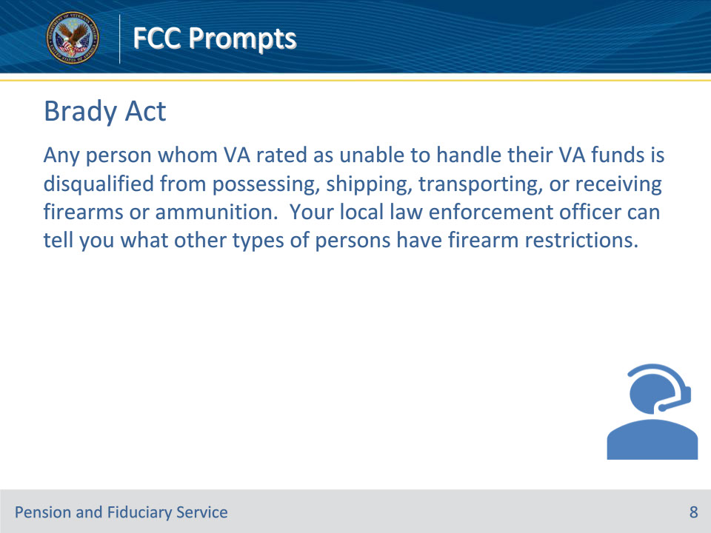

**Slide notes**

Policy Reference(s): Fiduciary Contact Center (FCC) Prompts 2.a.

Instructor Notes

The Brady Act of 1993 and the National Instant Criminal Background Check System (NICS) Improvement Amendments Act of 2007 (NIAA) contains provisions intended to improve the process of adding individuals to, and removing them from, a database called the NICS.

Any person whom VA rated as unable to handle their VA funds is disqualified from possessing, shipping, transporting, or receiving firearms or ammunition.  Your local law enforcement officer can tell you what other types of persons have firearm restrictions.

Reference:  For more information on Brady Act, see M21-1, Part X, Subpart ii, 6.D.4.b.

**Slide 9 - Consolidated Appropriations Act of 2024**

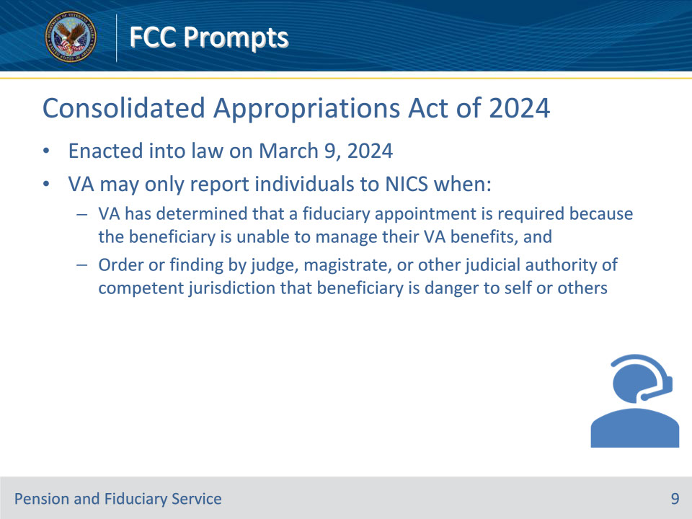

**Slide notes**

Policy Reference(s): Fiduciary Contact Center (FCC) Prompts 2.a.

Instructor Notes

Important:  In compliance with the Consolidated Appropriations Act of 2024, which was enacted into law on March 9, 2024, VA may only report individuals to NICS when

• VA has determined that a fiduciary appointment is required because the beneficiary is unable to manage their VA benefits, and

• there is an order or finding by a judge, magistrate, or other judicial authority of competent jurisdiction that the beneficiary is a danger to self or others.

**Slide 10 - Relief From Firearm Restrictions**

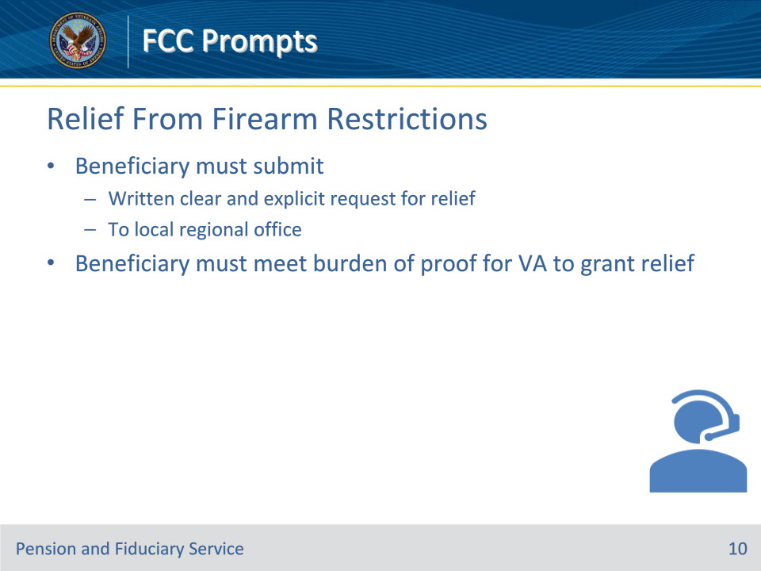

**Slide notes**

Policy Reference(s): Fiduciary Contact Center (FCC) Prompts 2.b.

Instructor Notes

The Brady Act allows a person who is prohibited from possessing, shipping, transporting, or receiving firearms or ammunition to apply for relief from firearms restrictions.  The beneficiary must submit their written clear and explicit request for relief to their local regional office.  The beneficiary must meet the burden of proof of these requests for VA to grant the request.

Reference:  For more information on relief from the Brady Act, see M21-1, Part X, Subpart ii, 6.D.4.c.

**Slide 11 - Brady Act Impacts**

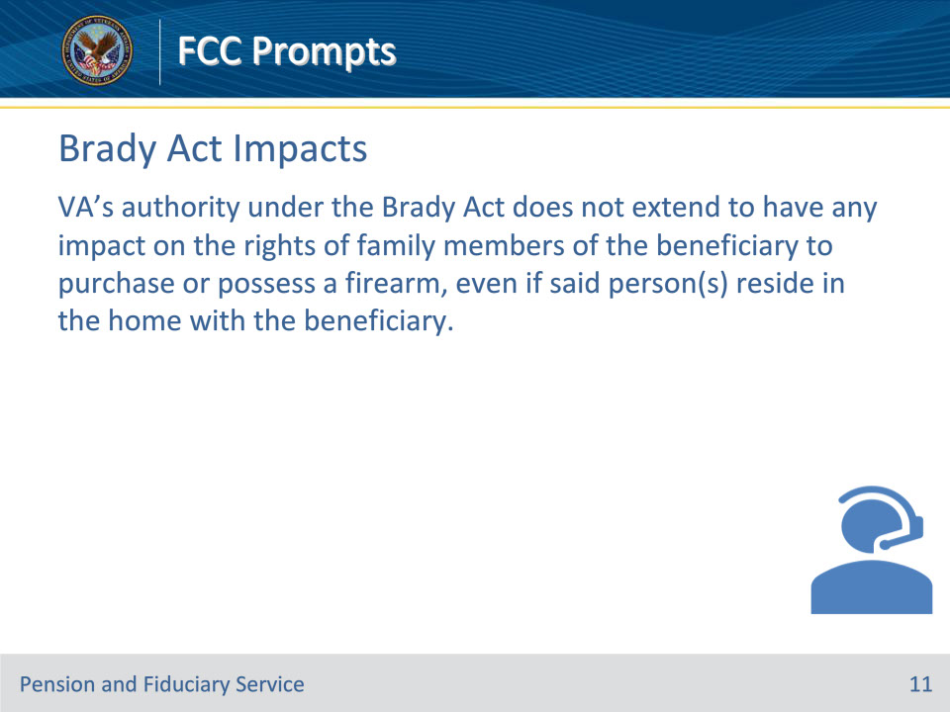

**Slide notes**

Policy Reference(s): Fiduciary Contact Center (FCC) Prompts 2.c.

Instructor Notes

VA’s authority under the Brady Act does not extend to have any impact on the rights of family members of the beneficiary to purchase or possess a firearm, even if said person(s) reside in the home with the beneficiary.

**Slide 12 - Fiduciary Brady Act**

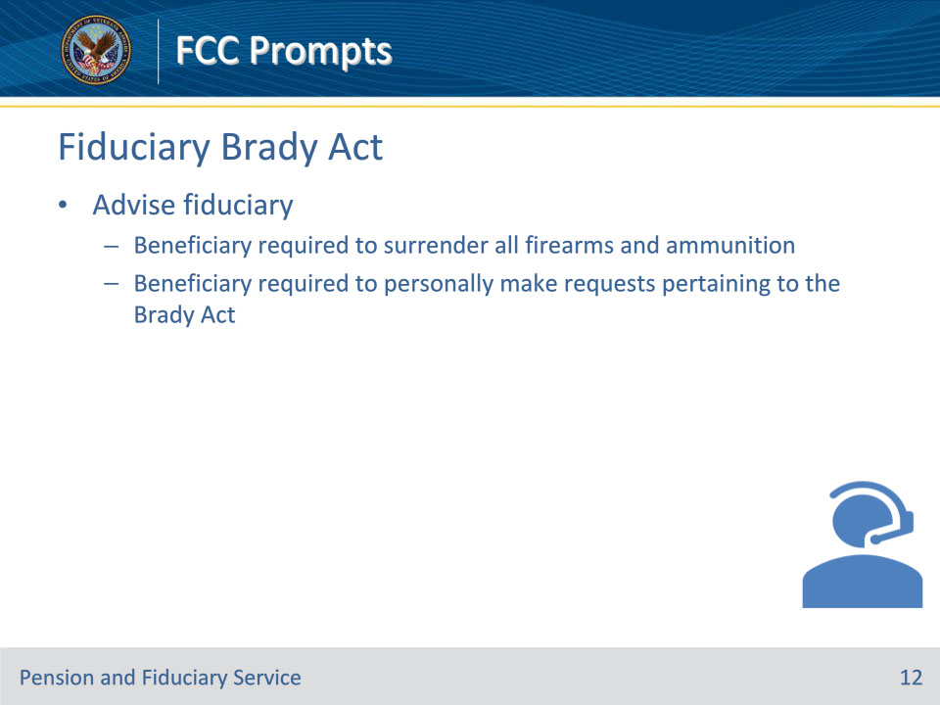

**Slide notes**

Policy Reference(s): Fiduciary Contact Center (FCC) Prompts 2.d.

Instructor Notes

When a fiduciary contacts the FCC regarding the application and effect of the Brady Act, the LAS must advise them that the beneficiary is required to surrender all their firearms and ammunition. The LAS should advise the fiduciary that VA will require the beneficiary to personally make requests pertaining to the Brady Act.

**Slide 13 - Competency Restoration**

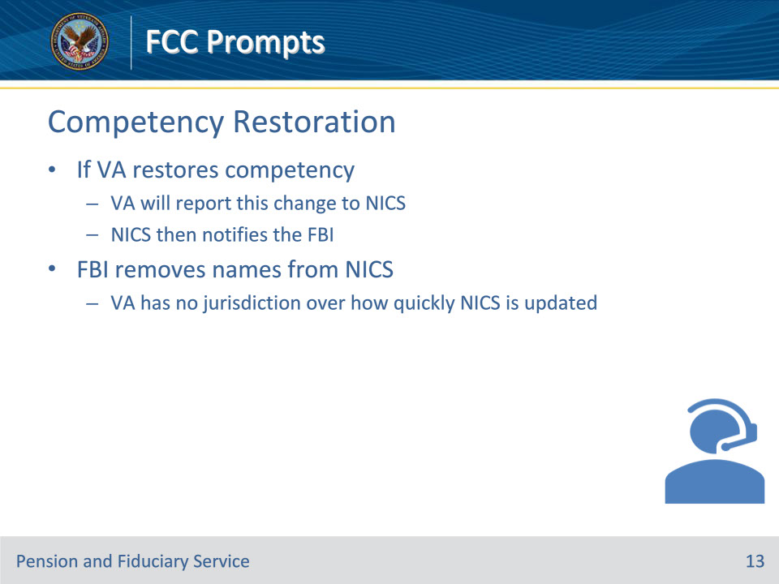

**Slide notes**

Policy Reference(s): Fiduciary Contact Center (FCC) Prompts 2.e.

Instructor Notes

If VA restores competency, VA will report this change to NICS. NICS then notifies the Federal Bureau of Investigation (FBI). The FBI removes names from NICS.

The VA has no jurisdiction over how quickly NICS is updated.

Reference:  For more information on the FBI removing names from NICS, see M21-1, Part X, Subpart ii, 6.D.4.k.

**Slide 14 - Annual Written Contact**

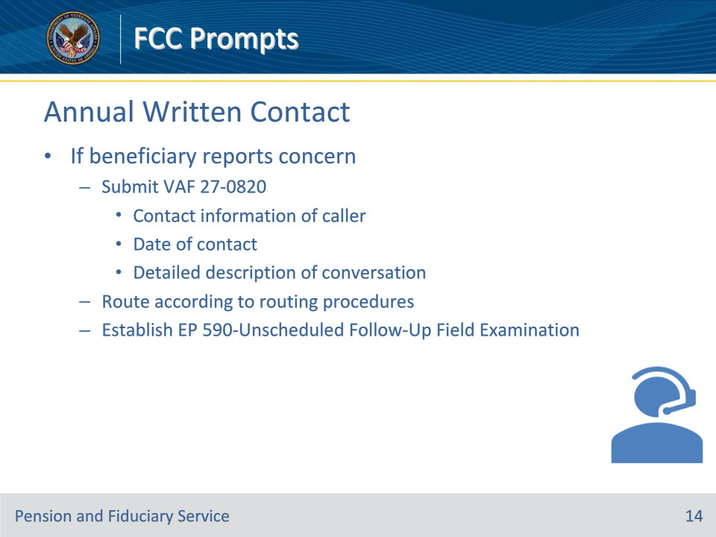

**Slide notes**

Policy Reference(s): Fiduciary Contact Center (FCC) Prompts 3.a.

Instructor Notes

Beneficiaries and fiduciaries may call the FCC when they have an issue or concern after receiving the annual written contact.  If a beneficiary reports a concern, the LAS must

• submit a VA Form 27-0820 documenting the following:

• name, address, and phone number of the person reporting the concern

• date of contact, and

• a detailed description of the conversation to include dates of concern, individuals involved, circumstances surrounding the issue/concern, and specifics regarding amounts or expense types (if any)

• route the VA Form 27-0820 according to VA Form 27-0820 Routing Procedures, and

• establish an EP590-Unscheduled Follow-Up Field Examination.

Reference:  For more information on annual written contact, see FPM, Part II, 2.D.

**Slide 15 - Fiduciary Contact**

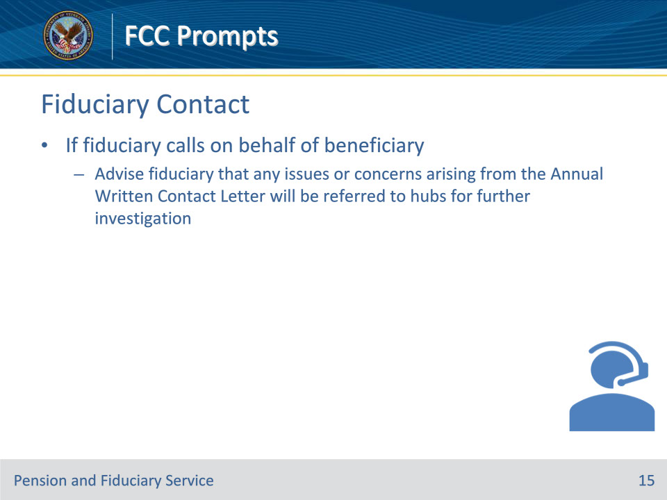

**Slide notes**

Policy Reference(s): Fiduciary Contact Center (FCC) Prompts 3.b.

Instructor Notes

If a fiduciary calls on behalf of the beneficiary, the LAS must advise the fiduciary that any issues or concerns arising from the Annual Written Contact Letter will be referred to hubs for further investigation.

Reference:  For more information on annual written contact, see FPM, Part II, 2.D.

**Slide 16 - New Fiduciary Request**

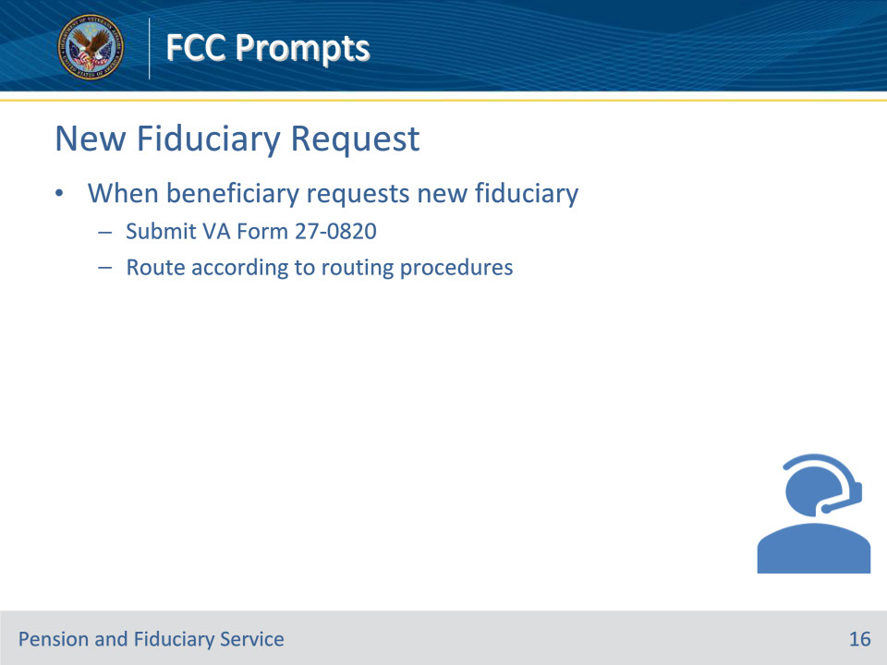

**Slide notes**

Policy Reference(s): Fiduciary Contact Center (FCC) Prompts 4.a.

Instructor Notes

The FCC may receive calls regarding the need to appoint a new fiduciary.  When a beneficiary contacts FCC to request a new fiduciary, the LAS must submit a VA Form 27-0820, and route according to VA Form 27-0820 Routing Procedures.

Reference:  For more information on removal of fiduciaries, see FPM, Part II, 2.C.1.a and 38 CFR 13.500.

**Slide 17 - Fiduciary Resignation**

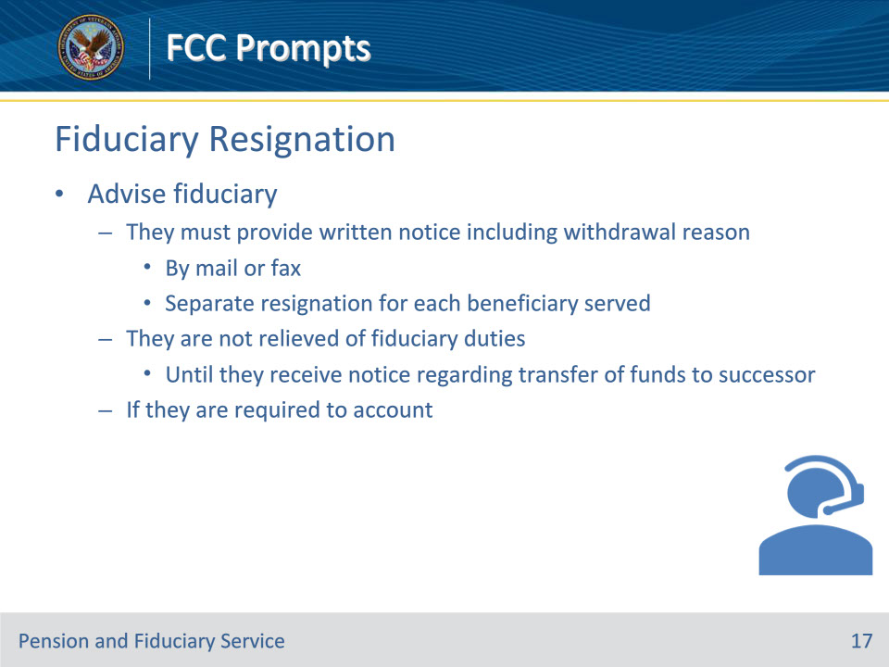

**Slide notes**

Policy Reference(s): Fiduciary Contact Center (FCC) Prompts 4.b.

Instructor Notes

The LAS must advise the fiduciary to submit a request in writing to the hub of jurisdiction by mail or fax.  If the fiduciary oversees more than one beneficiary, a separate resignation must be submitted for each case.

The LAS must advise the fiduciary of the following:

• they must provide notice in writing that includes the reason for withdrawal

• they are not relieved of their fiduciary duties and must continue to provide services until they receive notice regarding the transfer of funds to a successor, and

• if they are required to account, within the prescribed timeframe indicated on the notification that they receive which confirms that they have been replaced as the fiduciary.

References:  For more information on

• fiduciary withdrawals, see

• FPM, Part II, 2.C.2, and

• 38 CFR 13.510, and

• hub jurisdictions, see the Fiduciary Hub Jurisdiction and Contact Information website.

**Slide 18 - Report of Fiduciary Death**

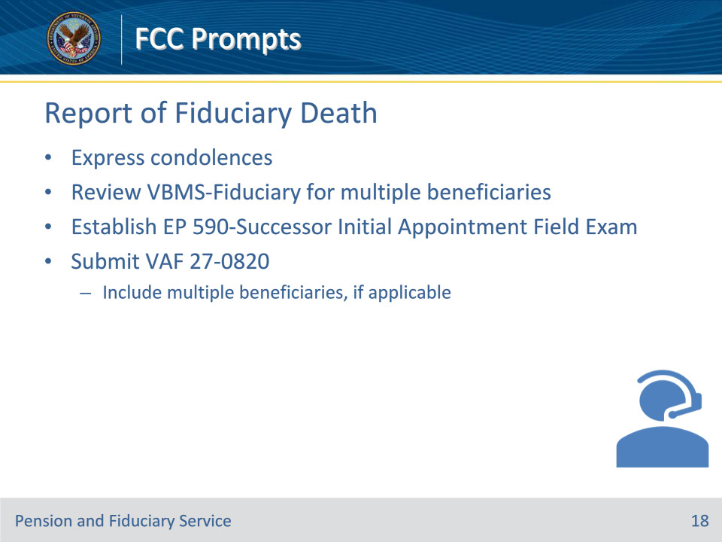

**Slide notes**

Policy Reference(s): Fiduciary Contact Center (FCC) Prompts 4.c.

Instructor Notes

The LAS must express condolences when notified of any death.

When the death is that of the fiduciary, the LAS must

• review the Active Beneficiaries within the fiduciary profile in VBMS-Fiduciary to determine if the fiduciary had multiple beneficiaries

• establish an EP 590-Successor Initial Appointment Field Examination, and

• submit VA Form 27-0820 according to VA Form 27-0820 Routing Procedures dedicated to FCC.

Important:  If there are multiple beneficiaries, the LAS must ensure this information is included on the VA Form 27-0820.

**Slide 19 - Fiduciary Expense Requests**

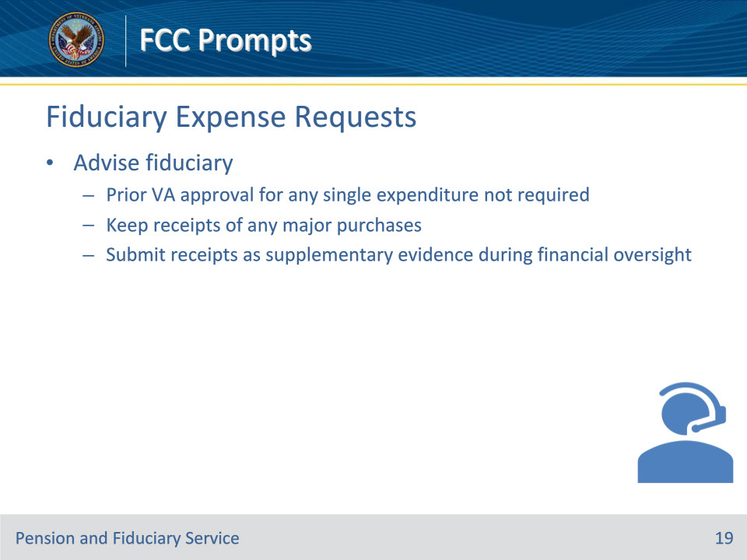

**Slide notes**

Policy Reference(s): Fiduciary Contact Center (FCC) Prompts 5.a.

Instructor Notes

Fiduciaries ensure VA benefits are spent for the care, support, education, health, welfare, desires and comfort of beneficiaries and their dependents.  When a fiduciary contacts the FCC for an expense approval, the LAS must advise the fiduciary

• they do not need to seek prior VA approval for any single expenditure made on behalf of a beneficiary, and

• to keep the receipt(s) of any major purchase(s) and submit those receipts as supplementary evidence to bank account statements provided during any financial oversight.

Note:  FCC LASs may refer the fiduciary to the VA Fiduciary Website to review the Fiduciary Basics (101) and the Acceptable Expenses videos.

**Slide 20 - Beneficiary Expense Requests**

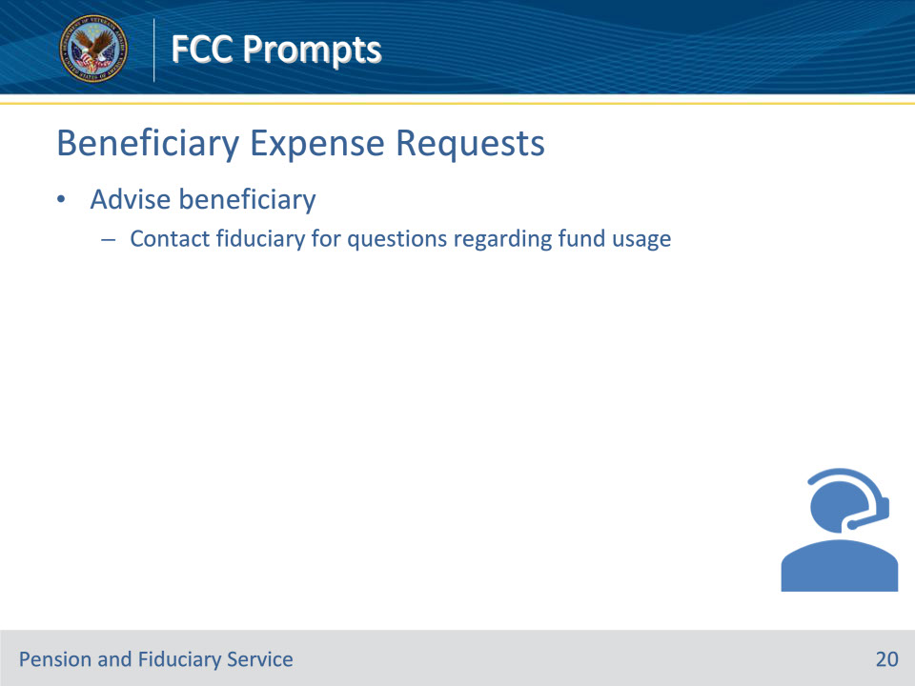

**Slide notes**

Policy Reference(s): Fiduciary Contact Center (FCC) Prompts 5.b.

Instructor Notes

The LAS must advise the beneficiary to contact their fiduciary for any question regarding their expenses and/or usage of their available funds.

**Slide 21 - Misuse Reports**

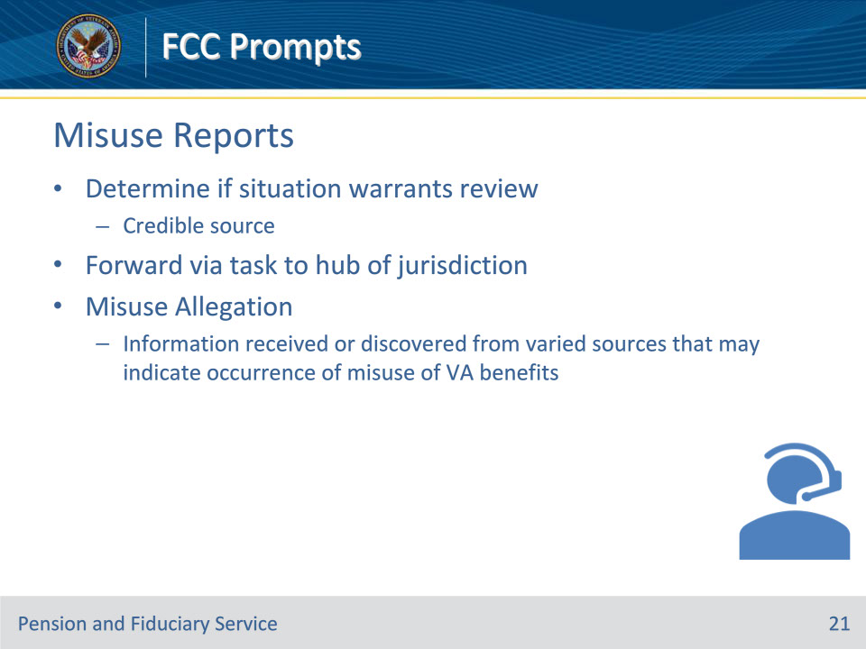

**Slide notes**

Policy Reference(s): Fiduciary Contact Center (FCC) Prompts 6.a.

Instructor Notes

LASs may receive reports of misuse, potential abuse, fraud, and/or misrepresentation from Veterans, beneficiaries, other stakeholders, and members of the public.  It is the role of the LAS role to determine if the situation warrants a review from a hub.  Typically, if allegations stem from a credible source (i.e., an agency or social services) the notification should be forwarded via task to the hub of jurisdiction.

A misuse allegation is any information received or discovered from varied sources that may indicate the occurrence of misuse of VA benefits.  Misuse cases may involve fraud, embezzlement, and other criminal conduct by fiduciaries appointed by VA.

**Slide 22 - Misuse Reports**

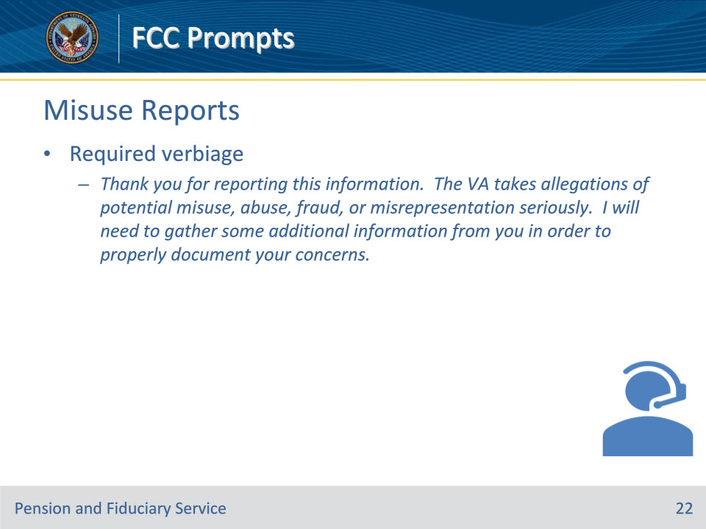

**Slide notes**

Policy Reference(s): Fiduciary Contact Center (FCC) Prompts 6.a.

Instructor Notes

Use the following verbiage when a call reporting misuse of VA funds is received:

Thank you for reporting this information.  The VA takes allegations of potential misuse, abuse, fraud, or misrepresentation seriously.  I will need to gather some additional information from you in order to properly document your concerns.

**Slide 23 - Misuse Reports**

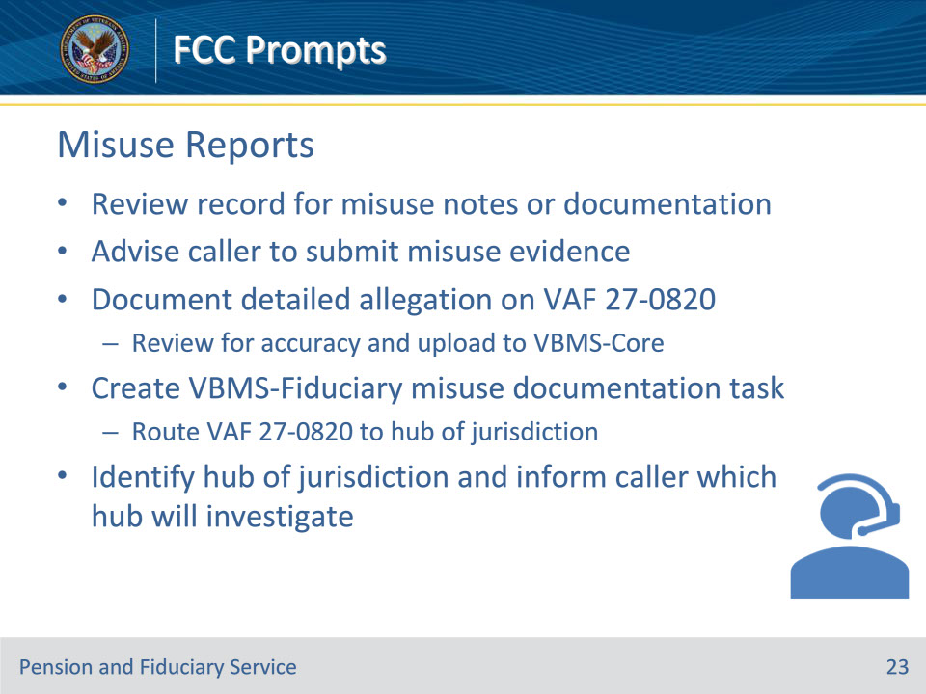

**Slide notes**

Policy Reference(s): Fiduciary Contact Center (FCC) Prompts 6.a.

Instructor Notes

If the caller is reporting misuse of VA funds, document the phone call on the VA Form 27-0820.  When receiving an allegation of misuse, the LAS must do the following:

• Review the record to determine if there are any notes or documentation concerning misuse.

• Advise the caller to submit any evidence of the misuse they may have.

• Document the allegation of misuse with specificity on the VA Form 27-0820.  Be sure to review the VA Form 27-0820 for accuracy and upload to VBMS-Core.

• Create a VBMS-Fiduciary misuse documentation task to route the VA Form 27-0820 to the hub of jurisdiction.

• Identify the hub of jurisdiction and inform the caller which hub will investigate the matter.

Reference:  For more information on the requirements of the VA Form 27-0820, see FPM, Part II, 3.A.2.d.

**Slide 24 - Non-VA Misuse Reports**

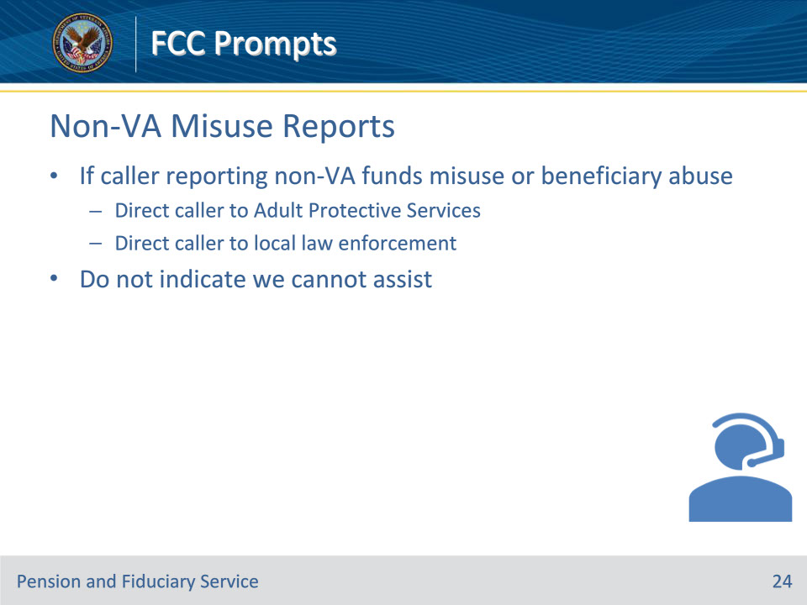

**Slide notes**

Policy Reference(s): Fiduciary Contact Center (FCC) Prompts 6.b.

Instructor Notes

We only investigate misuse if it involves misuse of VA funds.  If the caller is reporting misuse of non-VA funds or abuse of a beneficiary, they must be directed to call Adult Protective Services (APS) and/or local law enforcement.

Important:  If there is no VA file/record or they are reporting non-VA funds, do not indicate we cannot assist. Direct them to make a report to local law enforcement and APS.

**Slide 25 - Non-VA Misuse Reports**

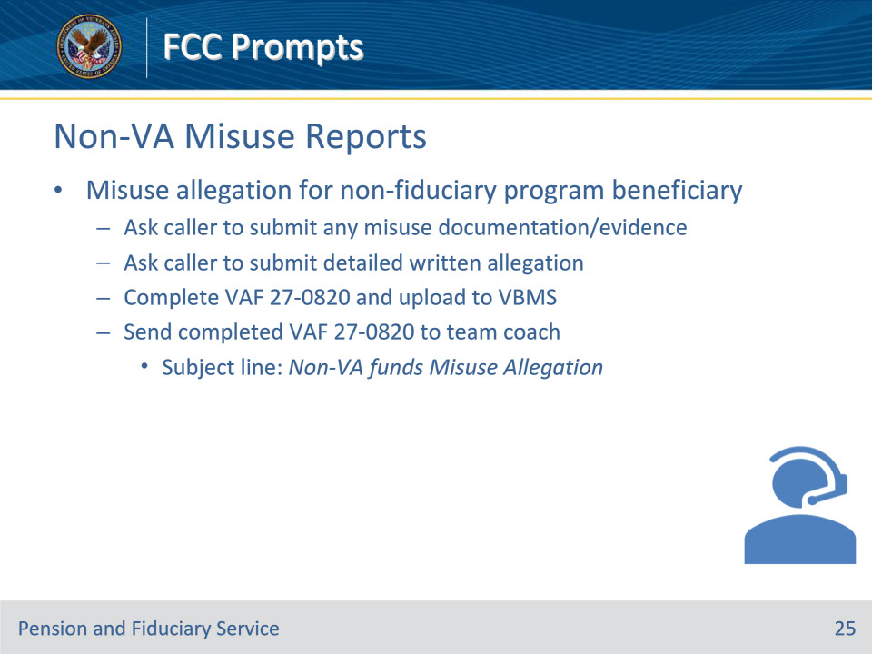

**Slide notes**

Policy Reference(s): Fiduciary Contact Center (FCC) Prompts 6.b.

Instructor Notes

If an allegation of misuse or fraud comes in for a non-fiduciary program Veteran or beneficiary

• ask the caller if they have any documentation of the misuse or fraud, and request that they submit said evidence

• ask them to submit the allegation in writing with as much detail as possible

• complete the VA Form 27-0820 and upload it to VBMS, and

• send the completed VA Form 27-0820 to the team coach; subject line should read Non-VA funds Misuse Allegation.

Notes:

• The LAS must not refer individuals to the OIG Hotline in lieu of taking the information, but if a caller asks for the information, they should disclose it.

• The LAS must follow Privacy Act/FOIA procedures for reportable incidents listed in that guidance.

References:  For more information on misuse, see FPM, Part II, 3.A.2 and 38 CFR 13.400.

**Slide 26 - Repeat Misuse Callers**

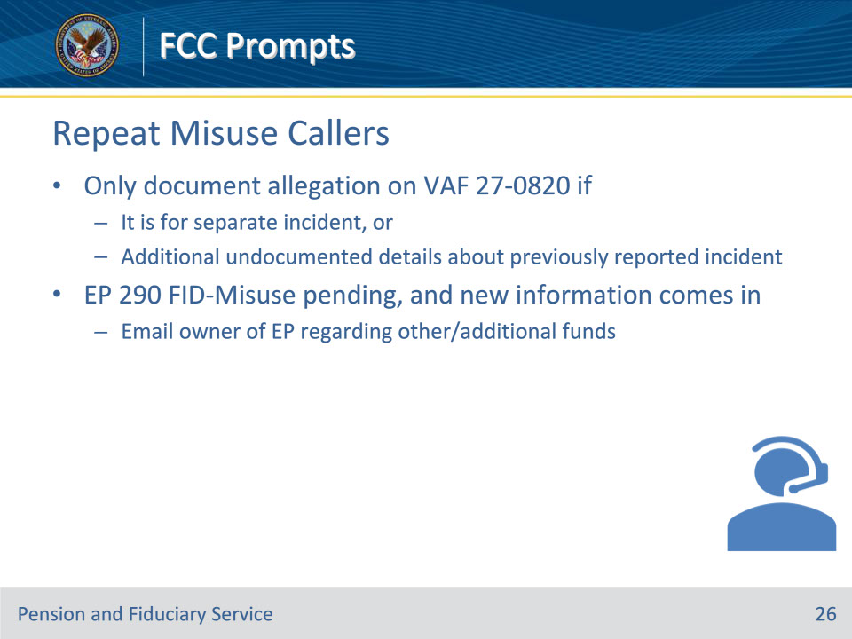

**Slide notes**

Policy Reference(s): Fiduciary Contact Center (FCC) Prompts 6.c.

Instructor Notes

For a repeat caller, only document the allegation on a VA Form 27-0820 if it is for a separate incident or if there are additional details about a previously reported incident that has not been documented.

If an EP 290 FID-Misuse is already pending and new information comes in, send an email to the owner of the EP regarding misuse allegation of other/additional funds.

Reference:  For more information on control of the misuse allegation, see FPM, Part II, 3.A.2.f.

**Slide 27 - Questions?**

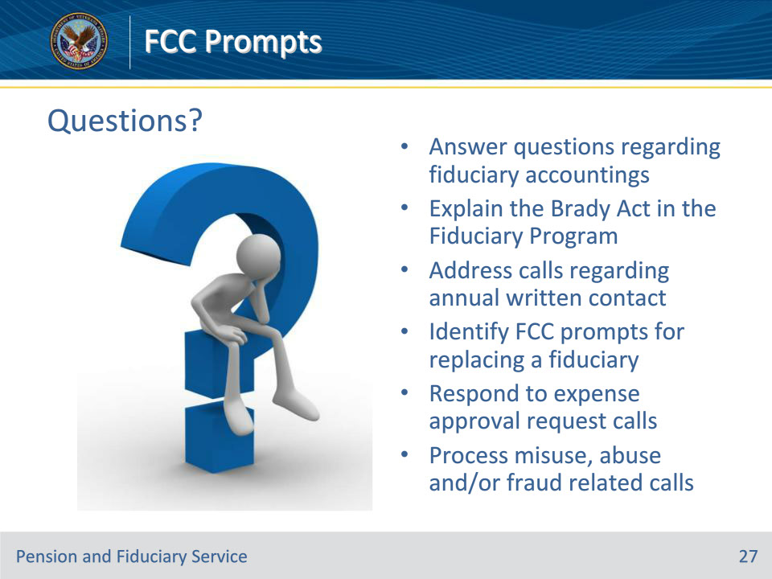

**Slide notes**

Instructor Notes:

(Recall) These are our learning objectives as stated from the beginning of the training:

• Answer questions regarding fiduciary accountings

• Explain the Brady Act in the Fiduciary Program

• Address calls regarding annual written contact

• Identify FCC prompts for replacing a fiduciary

• Respond to expense approval request calls

• Process misuse, abuse and/or fraud related calls

Are there any additional questions?

Questions should be filtered through your QRT team. They will submit your questions to the Field Inquiry Tool (FIT) on your behalf.

**Slide 28 - TMS Survey/Assessment**

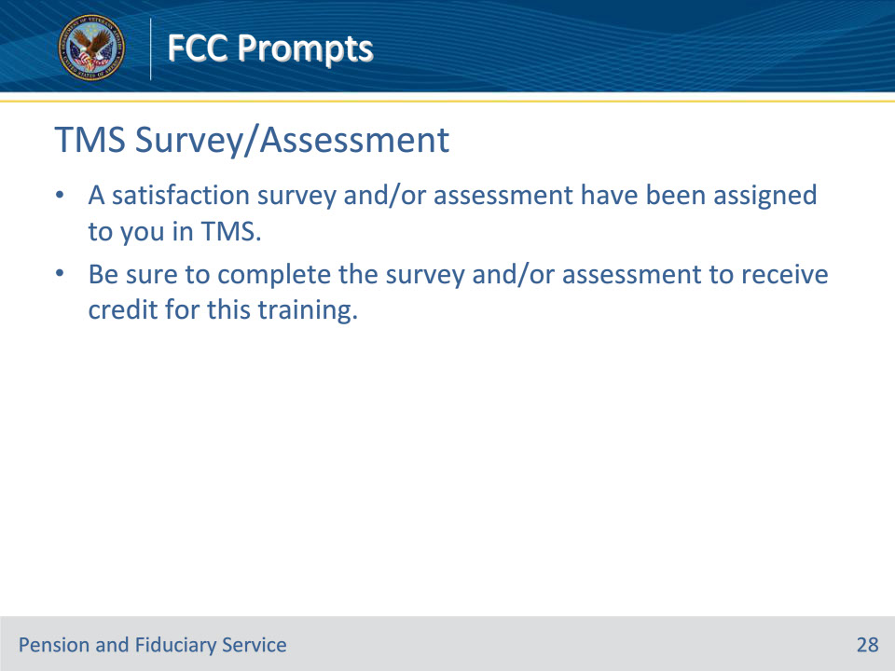

**Slide notes**

Instructor Notes

A satisfaction survey and/or assessment have been assigned to you in TMS.

Be sure to complete the survey and/or assessment to receive credit for this training.