**Slide 1 - Incarceration Adjustment Procedures**



**Slide notes**

Course Description:

The purpose of this lesson is to provide learners with procedures relating to incarceration adjustments.

**Slide 2 - Objectives**

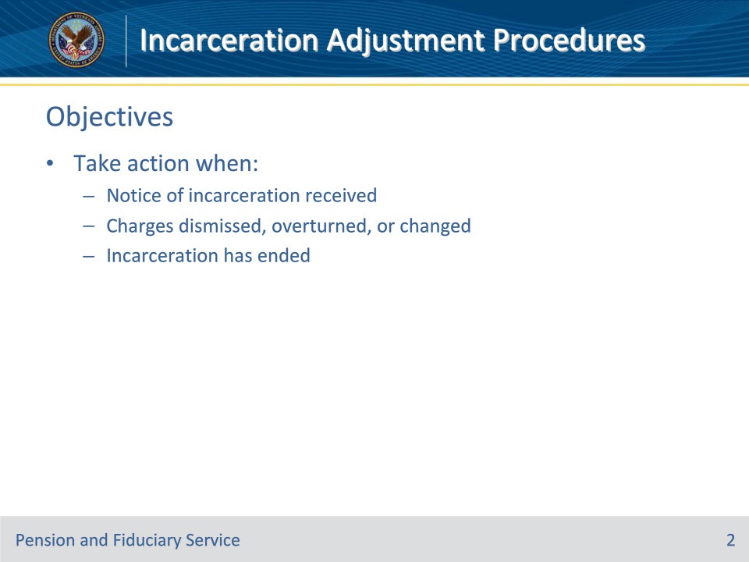

**Slide notes**

Instructor Notes:

At the end of this lesson, given the training and references, the learner will be able to do the following:

• Take action when:

• Notice of incarceration received

• Charges dismissed, overturned, or changed

• Incarceration has ended

**Slide 3 - References**

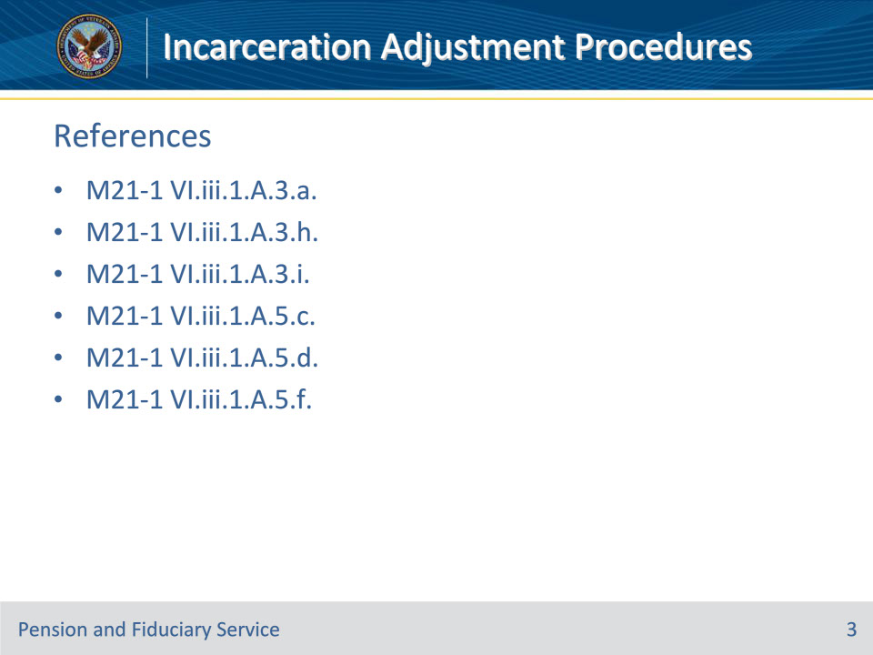

**Slide notes**

Instructor Notes:

This is the relevant reference to today’s training:

• M21-1 VI.iii.1.A.3.a.

• M21-1 VI.iii.1.A.3.h.

• M21-1 VI.iii.1.A.3.i.

• M21-1 VI.iii.1.A.5.c.

• M21-1 VI.iii.1.A.5.d.

• M21-1 VI.iii.1.A.5.f.

**Slide 4 - Notice of Incarceration**

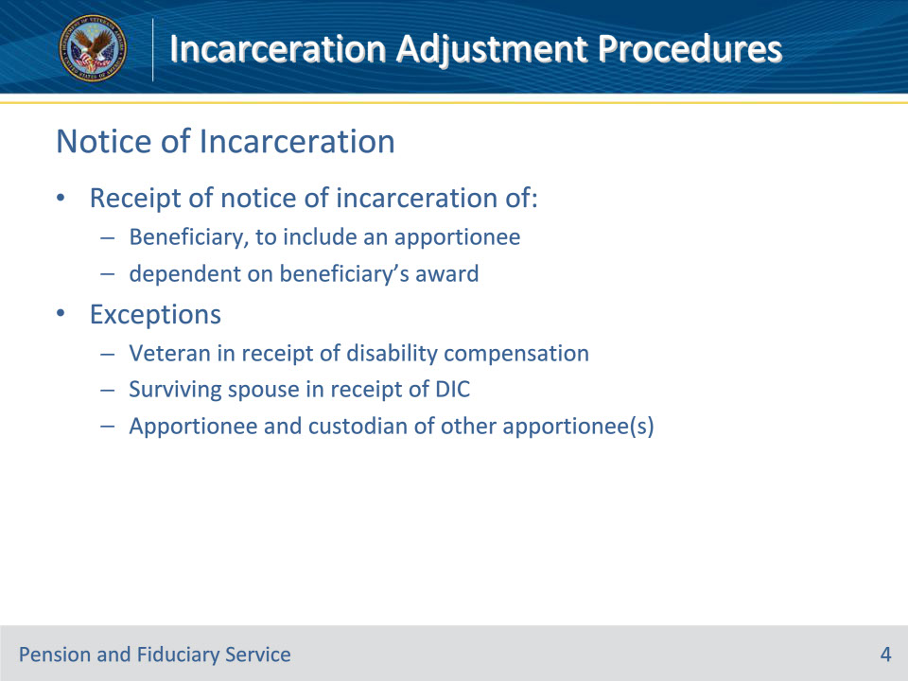

**Slide notes**

Policy Reference(s): M21-1 VI.iii.1.A.3.a.

Instructor Notes:

Follow the steps in this table upon receipt of notice of the incarceration of a

• beneficiary, to include an apportionee, or

• dependent on a beneficiary’s award.

Exceptions:

• As indicated in M21-1, Part VI, Subpart iii, 1.A.1.c, there is no requirement to remove an incarcerated dependent from the award of a

• Veteran in receipt of disability compensation, or

• surviving spouse in receipt of DIC.

• Instead of following the procedure described in the table below, follow the instructions in M21-1, Part VI, Subpart iii, 1.C.6, if the incarcerated individual is

• an apportionee, and

• the custodian of one or more other apportionees.

**Slide 5 - Notice of Incarceration**

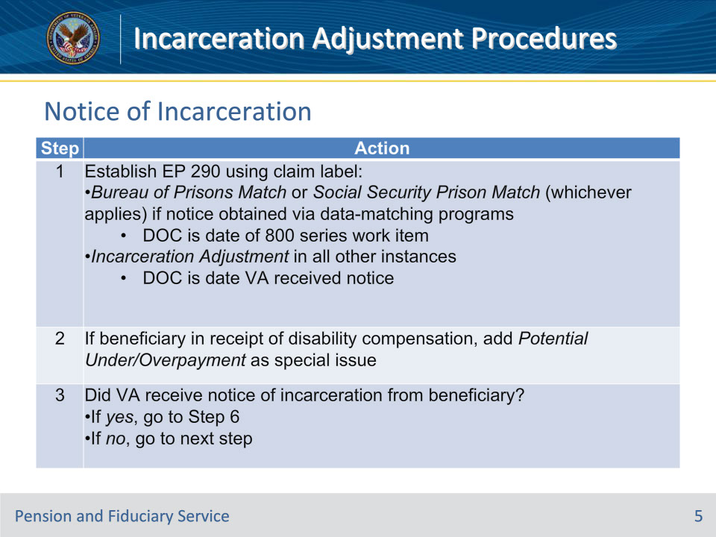

**Slide notes**

Policy Reference(s): M21-1 VI.iii.1.A.3.a.

Instructor Notes:

**Slide 6 - Notice of Incarceration**

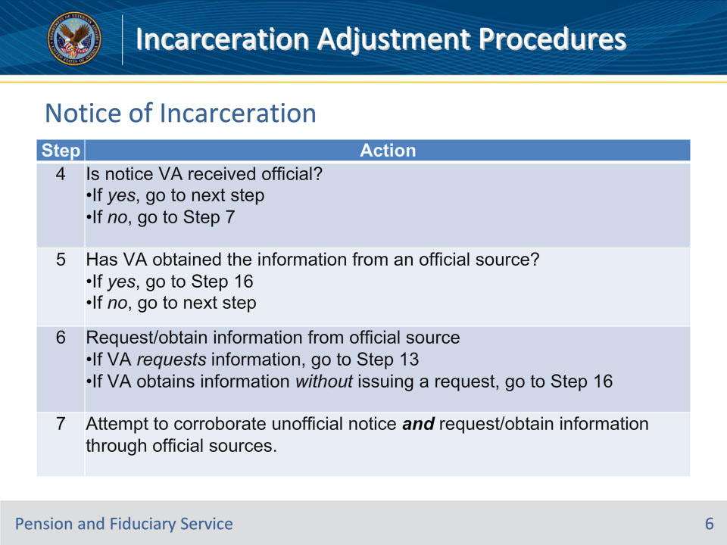

**Slide notes**

Policy Reference(s): M21-1 VI.iii.1.A.3.a.

Instructor Notes:Notes for Step 5:

• Although the worksheets referenced in M21-1, Part XIV, 7.1.b, constitute official notice of incarceration, they do not provide claims processors all the information referenced in M21-1, Part VI, Subpart iii, 1.A.3.d.

• A VA and Federal Bureau of Prisons Computer Match worksheet constitutes confirmation from an official source that the named prisoner was

• convicted of a felony or misdemeanor, and

• imprisoned in a Federal penal institution for more than 60 days.

• If Unknown appears in the Was Conviction for Felony field of a VA and Federal Bureau of Prisons Computer Match worksheet, confirmation of the type of conviction must be obtained from an official source, unless

• the inmate locator on the BOP website shows an actual or projected release date one year or more from the computation date, or

• the benefit that is subject to adjustment (discontinuation) is pension.

Note for Step 6:

Allow entities from which VA requests information concerning an individual’s incarceration 30 days to respond.

Note for Step 7:

Allow entities from which VA requests corroboration of and information concerning an individual’s incarceration 30 days to respond.

**Slide 7 - Notice of Incarceration**

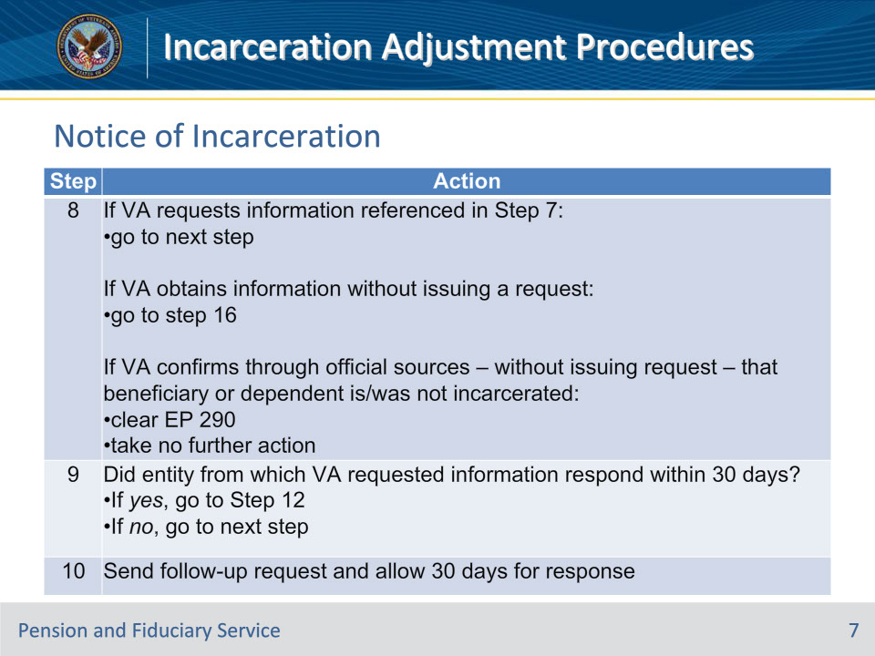

**Slide notes**

Policy Reference(s): M21-1 VI.iii.1.A.3.a.

Instructor Notes:

**Slide 8 - Notice of Incarceration**

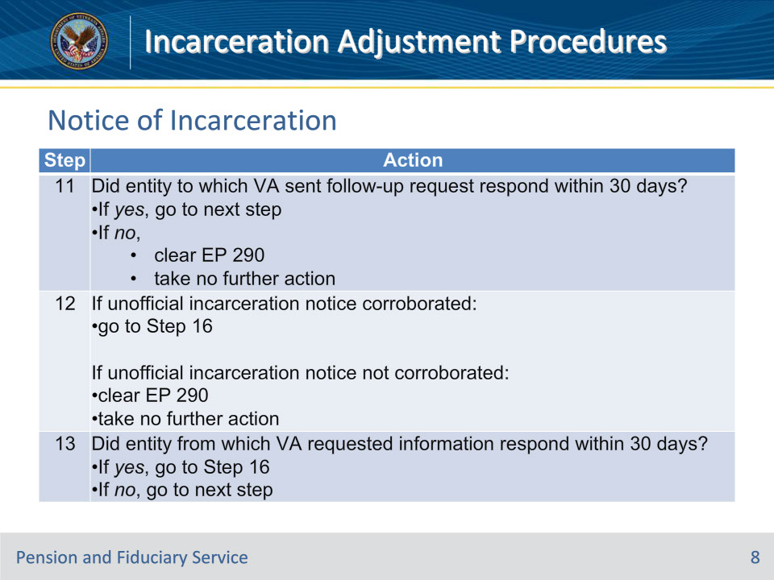

**Slide notes**

Policy Reference(s): M21-1 VI.iii.1.A.3.a.

Instructor Notes:

**Slide 9 - Notice of Incarceration**

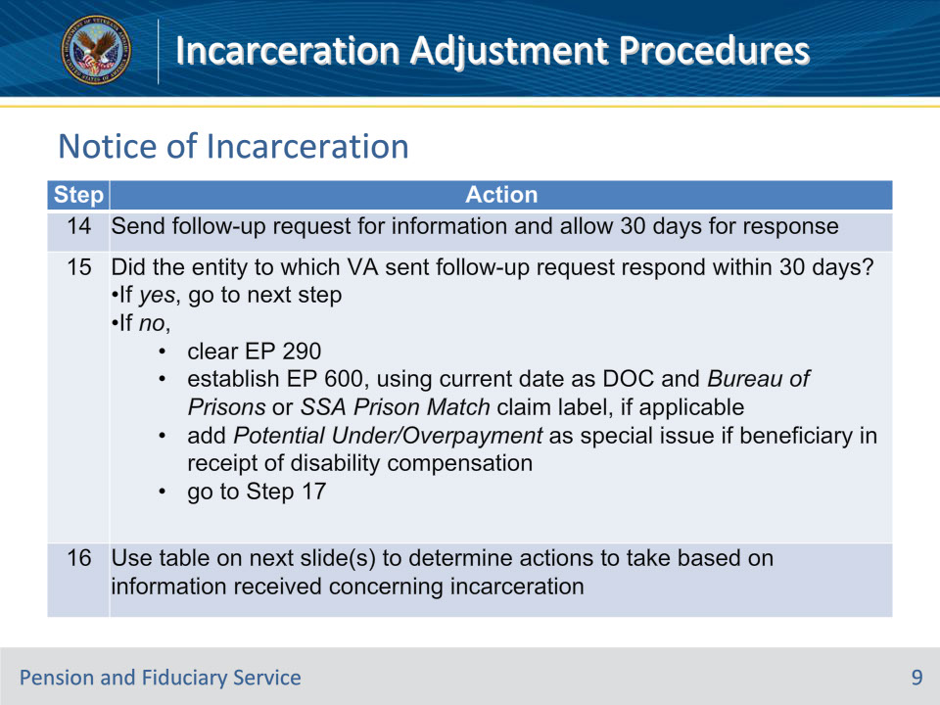

**Slide notes**

Policy Reference(s): M21-1 VI.iii.1.A.3.a.

Instructor Notes:

**Slide 10 - Notice of Incarceration (Step 16)**

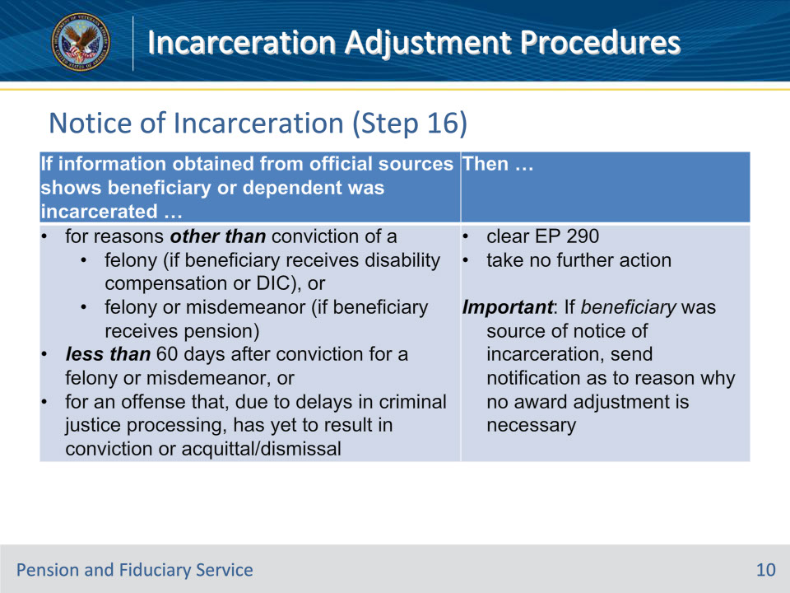

**Slide notes**

Policy Reference(s): M21-1 VI.iii.1.A.3.a.

Instructor Notes:

**Slide 11 - Notice of Incarceration (Step 16)**

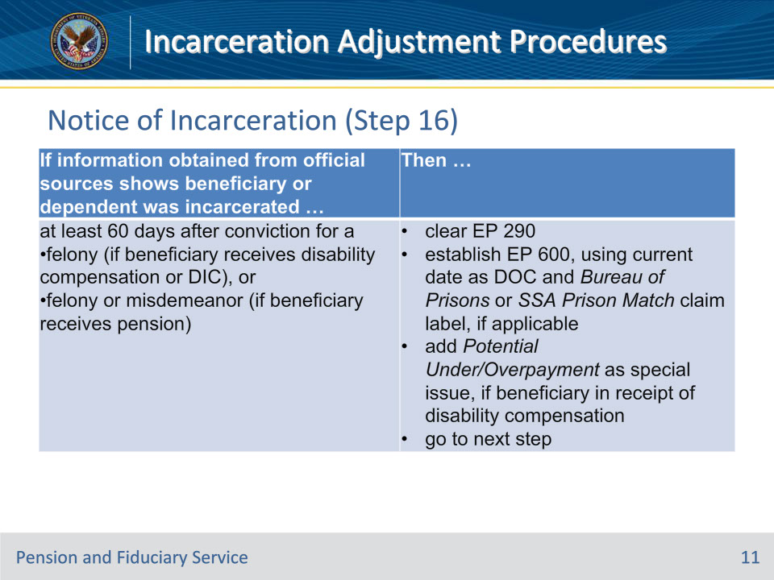

**Slide notes**

Policy Reference(s): M21-1 VI.iii.1.A.3.a.

Instructor Notes:

**Slide 12 - Notice of Incarceration**

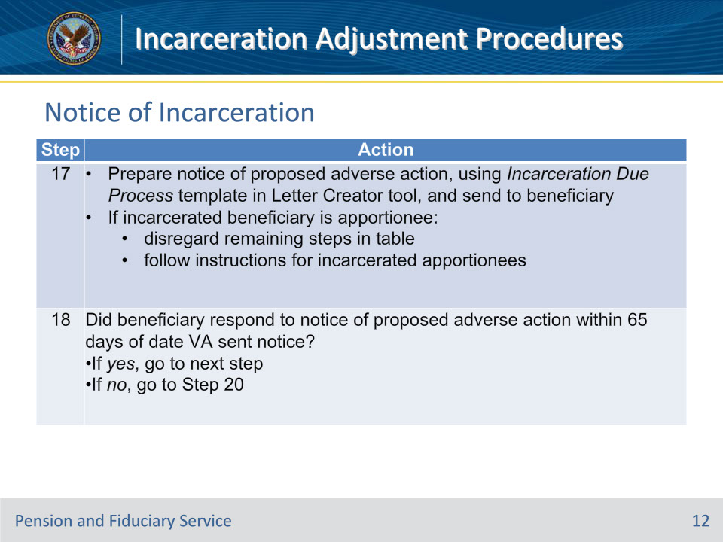

**Slide notes**

Policy Reference(s): M21-1 VI.iii.1.A.3.a.

Instructor Notes:

Important for Step 17:

• If the address of family members that are eligible for an apportionment or allotment of an incarcerated Veteran’s, surviving spouse’s, or surviving child’s (DIC only) benefits is known, send VA Form 21-0788, Information Regarding Apportionment of Beneficiary’s Award, to them at the same time the notice of proposed adverse action is sent to the beneficiary.

• A beneficiary is entitled to due process and the notice described in this cell each time incarceration (following conviction of a felony or misdemeanor, which ever applies) in excess of 60 days occurs.  This includes re-incarceration (after VA takes the actions described in M21-1, Part VI, Subpart iii, 1.A.5) because of

• a parole violation, or

• dismissal from a halfway house or work-release program.

• Send notice of proposed adverse action to a beneficiary at the current address of record, even if the incarcerated individual is a dependent (pension cases only).

• If the incarcerated beneficiary is an apportionee to whom VA is apportioning a Veteran’s disability compensation or a surviving spouse’s DIC, there is no need to send notice of proposed adverse action to the Veteran or surviving spouse.

• Do not send notice of proposed adverse action to the address of a prison unless that address happens to be a beneficiary’s current address of record.

• If the register or identification number a prison uses to identify an incarcerated beneficiary is known, include it after their name when sending correspondence to the beneficiary at the prison address.  (The worksheets referenced in M21-1, Part XIV, 7.1.b, provide these numbers.)

Note for Step 18:  Follow the instructions in M21-1, Part X, Subpart ii, 3.B, if a beneficiary requests a hearing in response to the notice of proposed adverse action.

**Slide 13 - Notice of Incarceration**

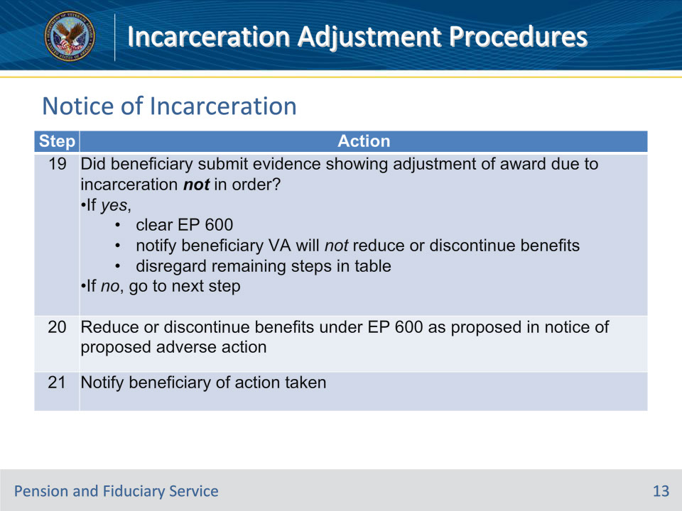

**Slide notes**

Policy Reference(s): M21-1 VI.iii.1.A.3.a.

Instructor Notes:

Note for Step 20:  To execute the reduction or discontinuance of benefits in the claims-processing system based on a beneficiary’s incarceration, follow the instructions in M21-1, Part VI, Subpart iii, 1.A.3.f.

**Slide 14 - Charges Changed**

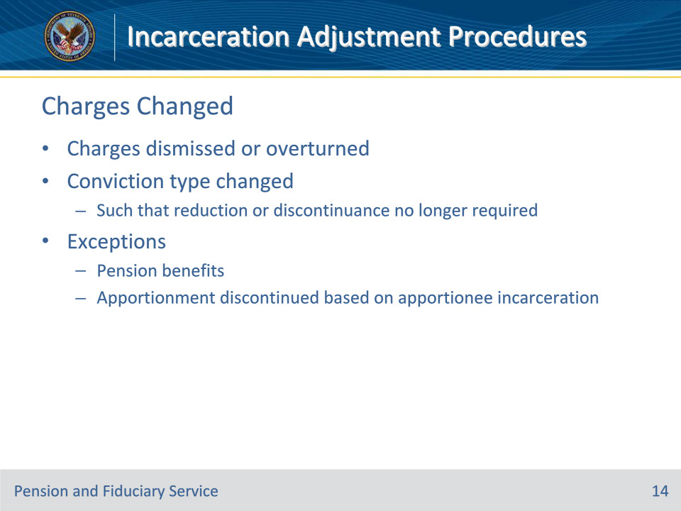

**Slide notes**

Policy Reference(s): M21-1 VI.iii.1.A.3.h.

Instructor Notes:

Follow the steps in this table after receiving notice of the

• charges that resulted in a beneficiary’s incarceration have been dismissed or were overturned, or

• type of conviction (felony) that resulted in incarceration has changed such that a reduction or discontinuance of benefits is no longer required under 38 CFR 3.665.

Exceptions:

• If the beneficiary is a former apportionee whose apportionment VA discontinued based on the former apportionee’s incarceration, follow the instructions in M21-1, Part VI, Subpart iii, 1.A.3.i, instead of the steps in the table below.

• There is no regulatory authority (such as that which exists in 38 CFR 3.665(m)) to take the actions described in this block if the benefit at issue is pension.

**Slide 15 - Charges Changed**

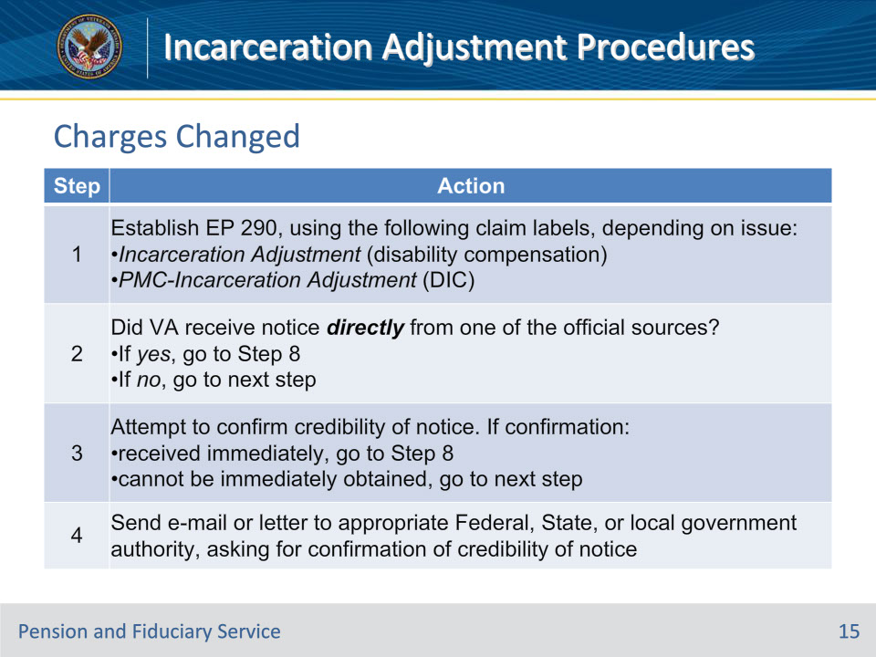

**Slide notes**

Policy Reference(s): M21-1 VI.iii.1.A.3.h.

Instructor Notes:

Important for step 2:  Go to the next step if the beneficiary submitted the notice, even if the notice was accompanied by what appears to be evidence from an official source.

**Slide 16 - Charges Changed**

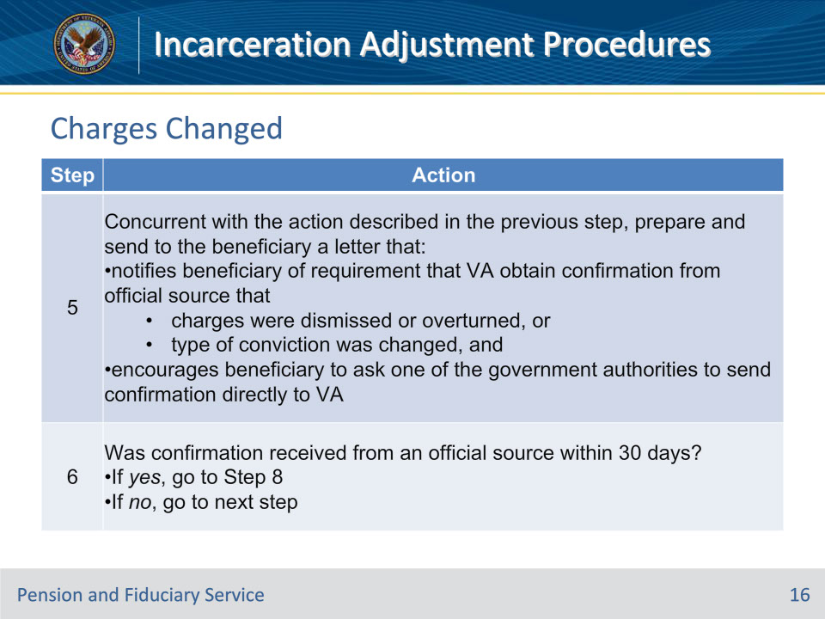

**Slide notes**

Policy Reference(s): M21-1 VI.iii.1.A.3.h.

Instructor Notes:

**Slide 17 - Charges Changed**

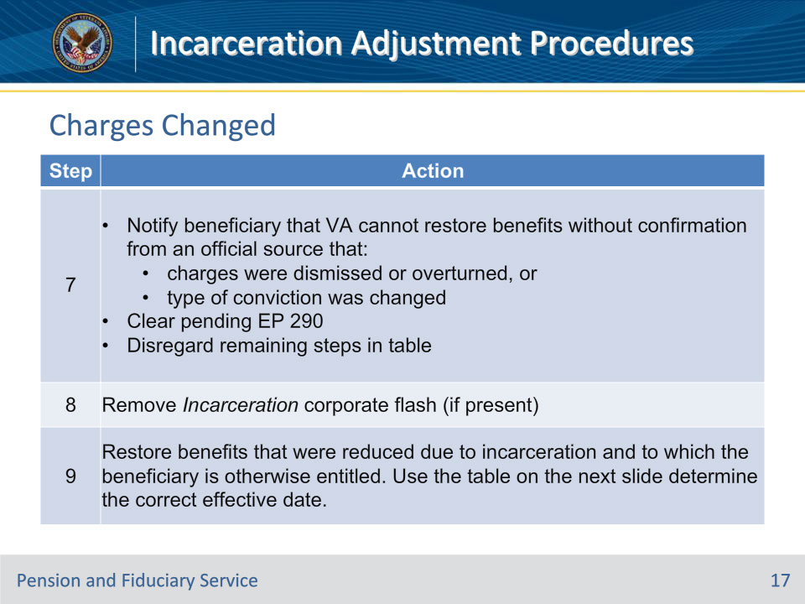

**Slide notes**

Policy Reference(s): M21-1 VI.iii.1.A.3.h.

Instructor Notes:Important for Step 9:

• Do not restore to a primary beneficiary benefits that VA apportioned to dependents as a result of the primary beneficiary’s incarceration.

• Apply the exclusion identified in 38 CFR 3.31(c)(3)(v) when determining the effective date of payment.

**Slide 18 - Charges Changed (Step 9)**

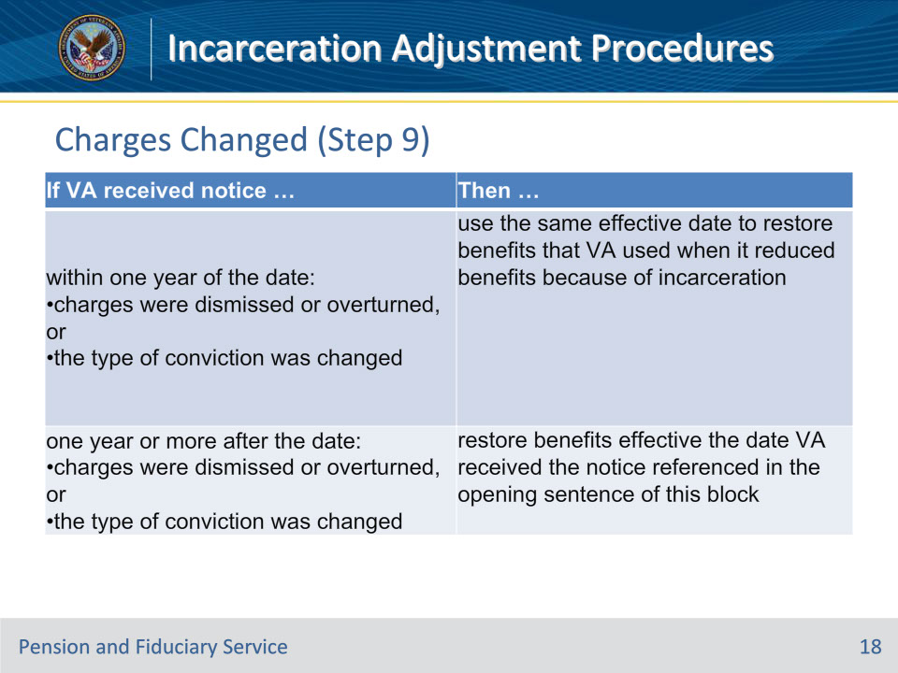

**Slide notes**

Policy Reference(s): M21-1 VI.iii.1.A.3.h.

Instructor Notes:

**Slide 19 - Apportionee**

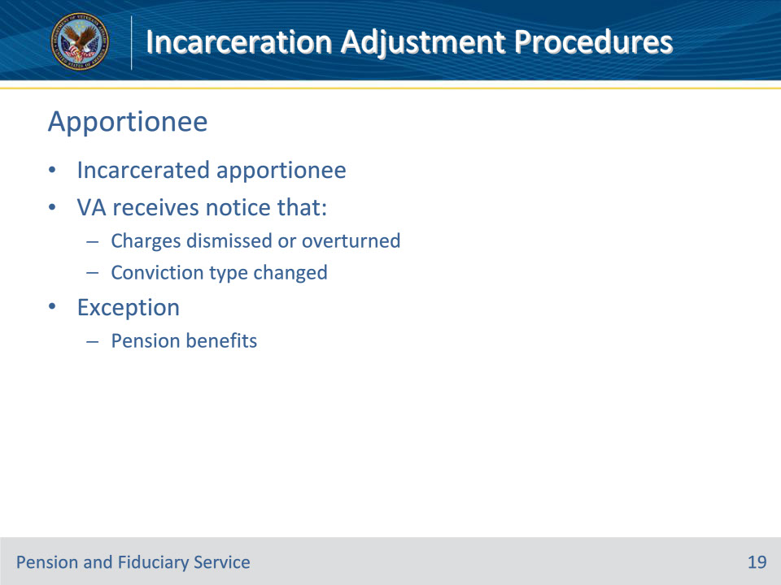

**Slide notes**

Policy Reference(s): M21-1 VI.iii.1.A.3.i.

Instructor Notes:After discontinuing an apportionment because the apportionee was incarcerated, follow the steps in this table if VA receives notice the

• charges that resulted in incarceration have been dismissed or were overturned, or

• type of conviction (felony) that resulted in incarceration has changed such that discontinuation of the apportionment may no longer be necessary under 38 CFR 3.665.

Exceptions:  There is no regulatory authority (such as that which exist in 38 CFR 3.665(m) to take the actions described in this block if the apportioned benefit is pension.

**Slide 20 - Apportionee**

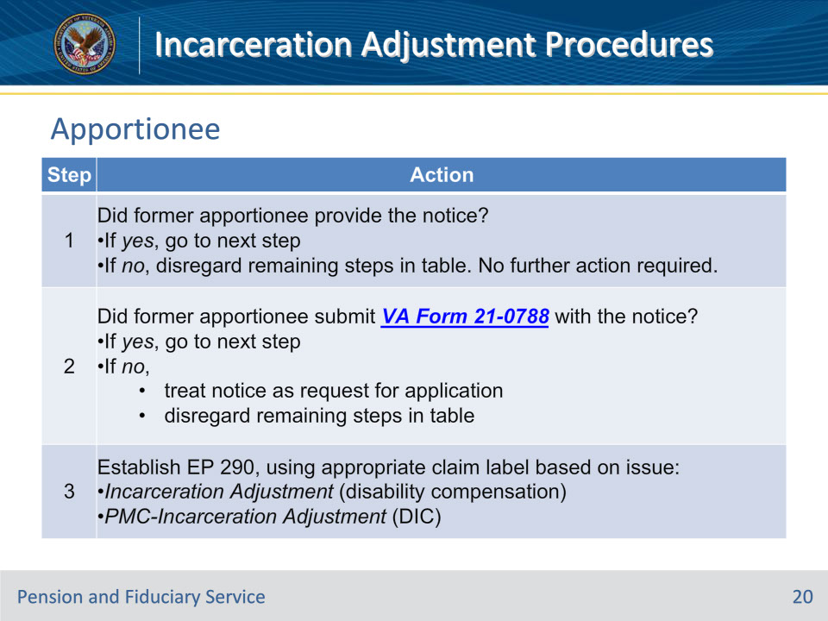

**Slide notes**

Policy Reference(s): M21-1 VI.iii.1.A.3.i.

Instructor Notes:

**Slide 21 - Apportionee**

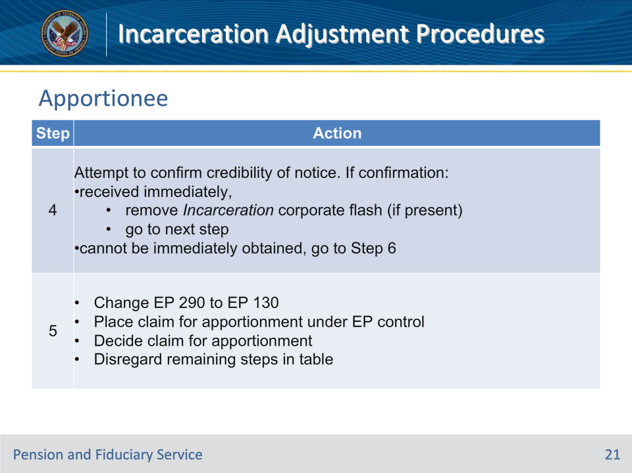

**Slide notes**

Policy Reference(s): M21-1 VI.iii.1.A.3.i.

Instructor Notes:

Important for Step 5:  If entitlement to an apportionment exists, the proper effective date is the date VA received the VA Form 21-0788 referenced in Step 2.  Apply the exclusion identified in 38 CFR 3.31(c)(3)(v) when determining the effective date of payment.

**Slide 22 - Apportionee**

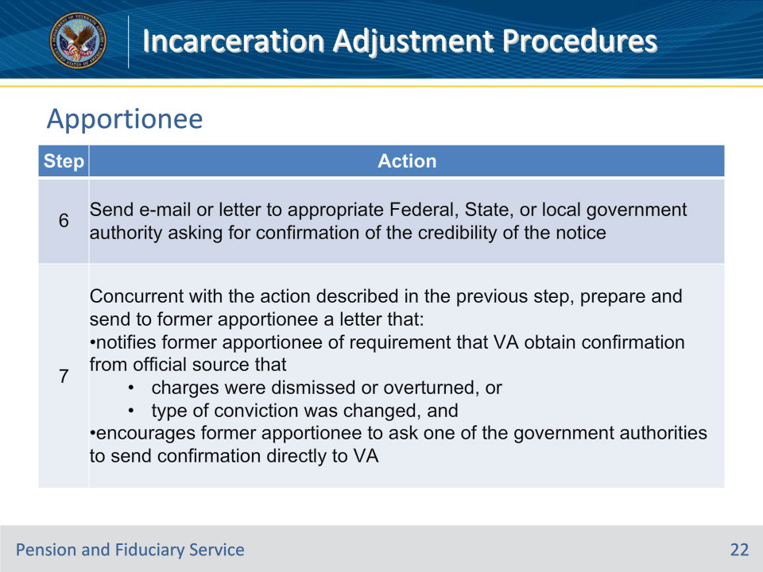

**Slide notes**

Policy Reference(s): M21-1 VI.iii.1.A.3.i.

Instructor Notes:

**Slide 23 - Apportionee**

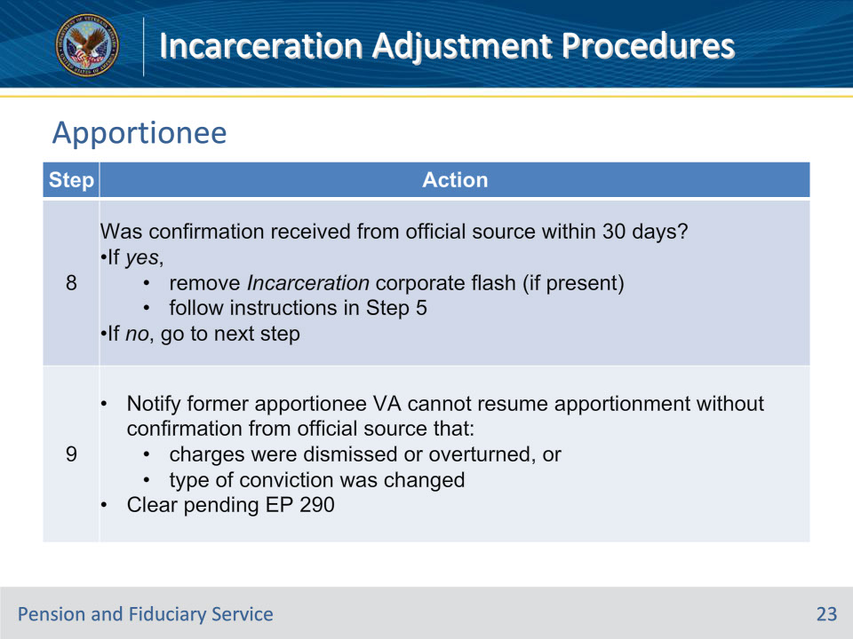

**Slide notes**

Policy Reference(s): M21-1 VI.iii.1.A.3.i.

Instructor Notes:

**Slide 24 - Incarceration End**

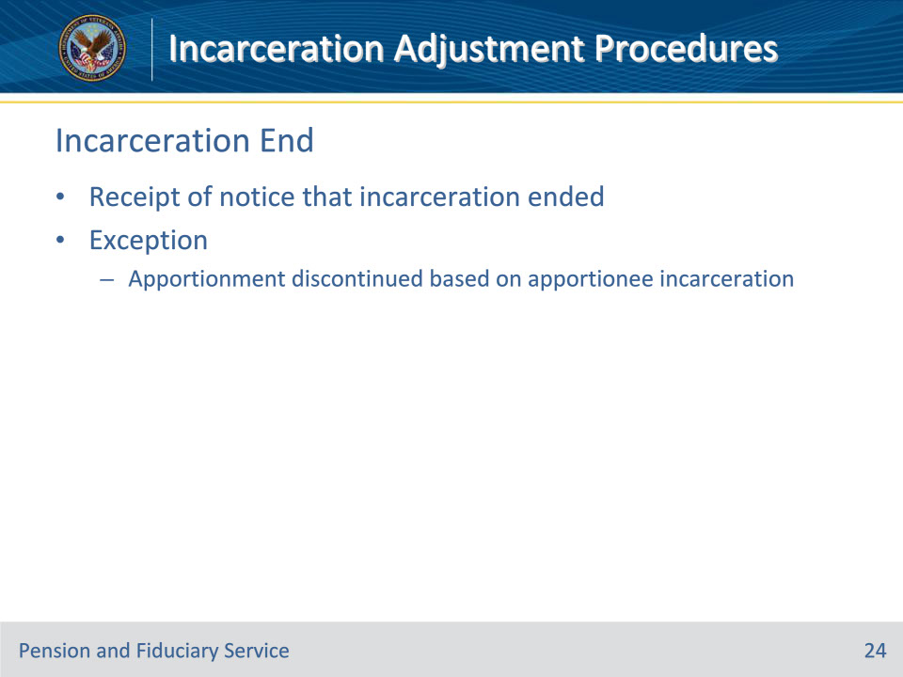

**Slide notes**

Policy Reference(s): M21-1 VI.iii.1.A.5.c.

Instructor Notes:Follow the steps in this table after receiving notice that incarceration has ended.

Exception:  If the beneficiary is a former apportionee whose apportionment VA discontinued based on the former apportionee’s incarceration, follow the instructions in M21-1, Part VI, Subpart iii, 1.A.5.f, instead of the steps in the table below.

**Slide 25 - Incarceration End**

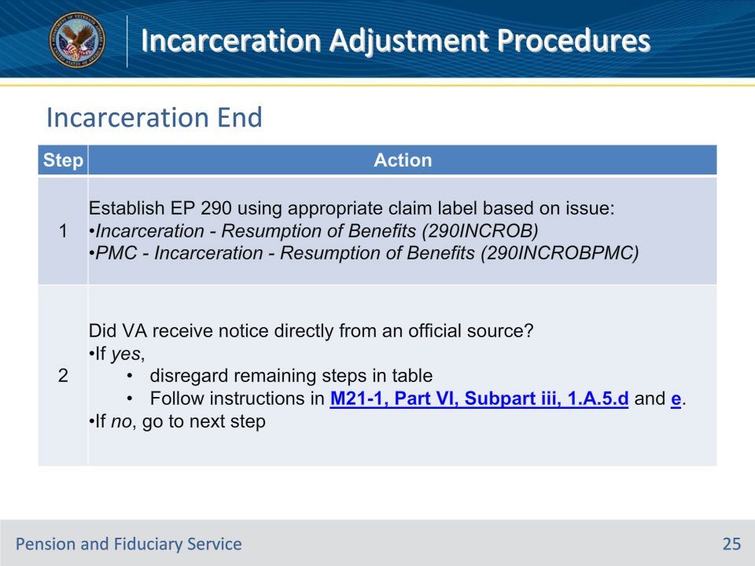

**Slide notes**

Policy Reference(s): M21-1 VI.iii.1.A.5.c.

Instructor Notes:

Important for Step 2:  Go to the next step if the beneficiary submitted the notice, even if the notice was accompanied by what appears to be evidence from an official source.

**Slide 26 - Incarceration End**

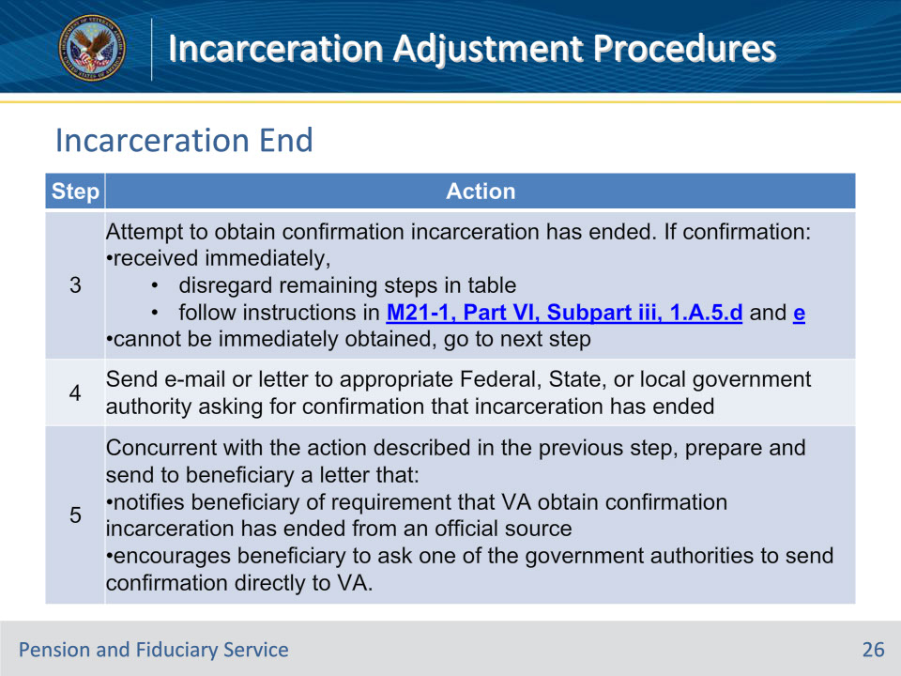

**Slide notes**

Policy Reference(s): M21-1 VI.iii.1.A.5.c.

Instructor Notes:

**Slide 27 - Incarceration End**

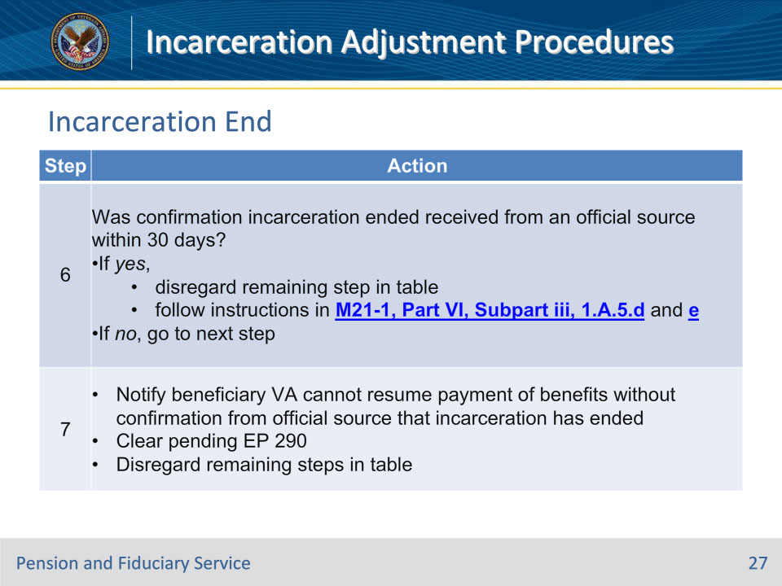

**Slide notes**

Policy Reference(s): M21-1 VI.iii.1.A.5.c.

Instructor Notes:

**Slide 28 - Apportionee Resumption**

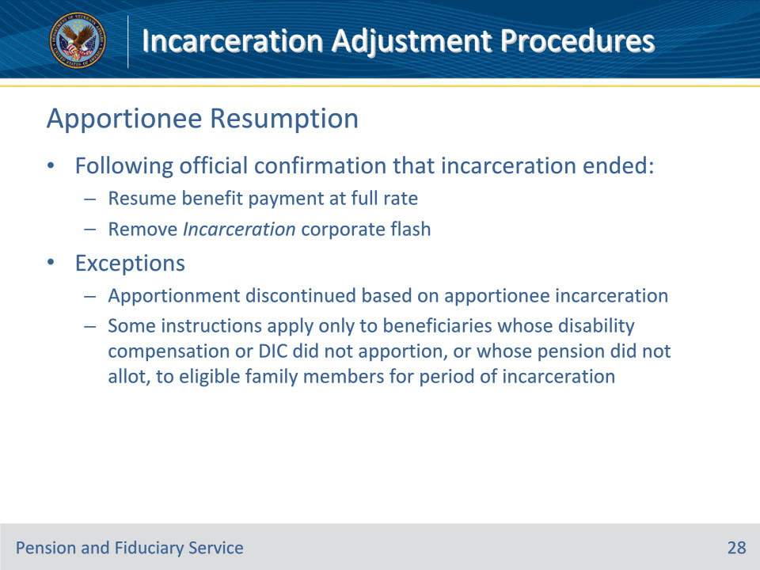

**Slide notes**

Policy Reference(s): M21-1 VI.iii.1.A.5.d.

Instructor Notes:

Following confirmation from an official source that incarceration has ended,

• resume the payment of benefits at the full rate to which the beneficiary is otherwise entitled, using the information in M21-1, Part VI, Subpart iii, 1.A.5.e, to determine the proper effective date, and

• remove the Incarceration corporate flash, if present.

Important:

• The instructions in this block do not apply to a former apportionee whose apportionment VA discontinued because the former apportionee was incarcerated.

• Some of the principles and instructions contained in this block apply only to beneficiaries whose disability compensation or DIC VA did not apportion, or whose pension VA did not allot, to eligible family members for the period of the beneficiary’s incarceration.  Before taking the actions described in this block, read the instructions in

• M21-1, Part VI, Subpart iii, 1.B.2.i-n if VA apportioned disability compensation to a Veteran’s dependent(s) for the period of incarceration, or

• M21-1, Part VI, Subpart iii, 1.B.1.j and k if VA allocated pension to a Veteran’s dependent(s) for the period of incarceration.

Use this table to determine the actions to take when other principles apply to the resumption or adjustment of a beneficiary’s award at the end of a period of incarceration.

**Slide 29 - Apportionee Resumption**

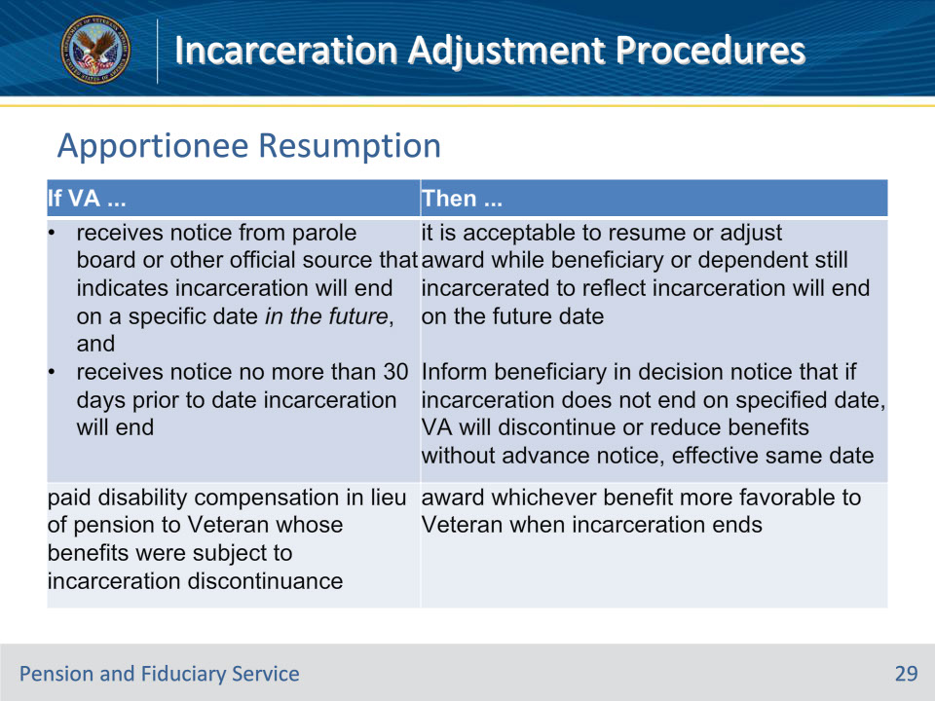

**Slide notes**

Policy Reference(s): M21-1 VI.iii.1.A.5.d.

Instructor Notes:

**Slide 30 - Apportionee Resumption**

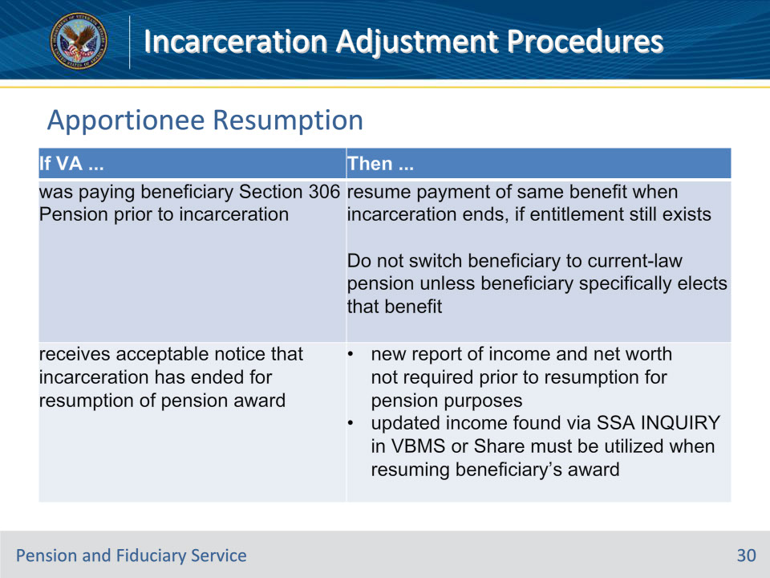

**Slide notes**

Policy Reference(s): M21-1 VI.iii.1.A.5.d.

Instructor Notes:

**Slide 31 - Apportionee Resumption**

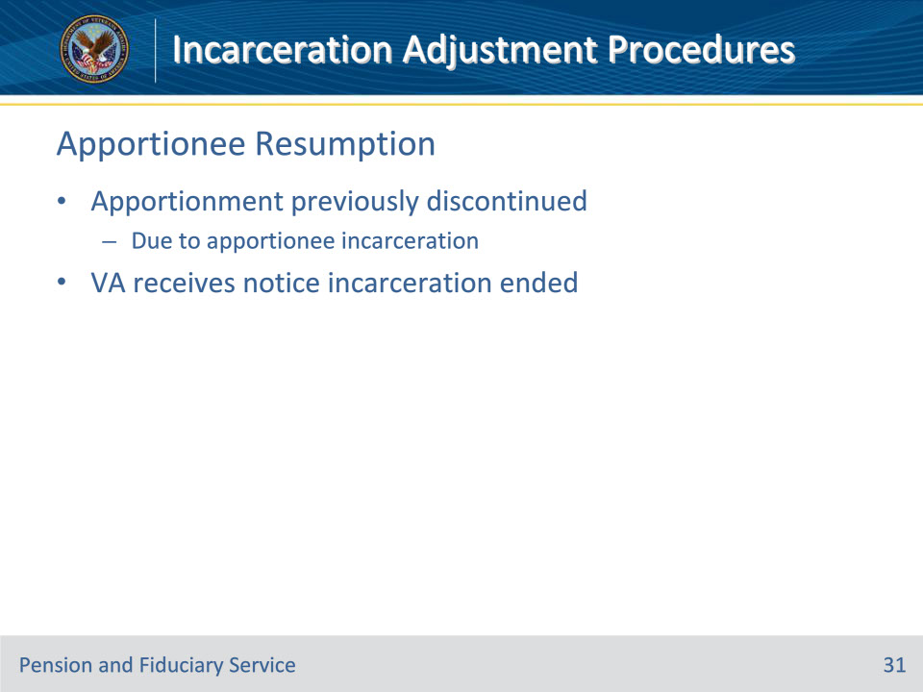

**Slide notes**

Policy Reference(s): M21-1 VI.iii.1.A.5.f.

Instructor Notes:After discontinuing an apportionment because the apportionee was incarcerated, follow the steps in this table when VA receives notice incarceration has ended.

**Slide 32 - Apportionee Resumption**

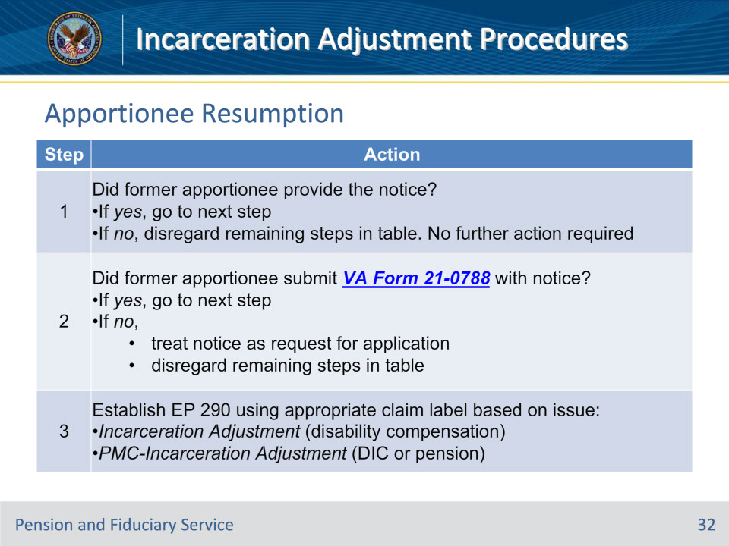

**Slide notes**

Policy Reference(s): M21-1 VI.iii.1.A.5.f.

Instructor Notes:

Note for Step 1:  If incarceration of the former apportionee required VA to remove them as a dependent from a Veteran’s or surviving spouse’s pension award, follow the instructions in M21-1, Part VI, Subpart iii, 1.A.5.a-e, to determine whether and from which effective date it is appropriate to add the former apportionee back onto the primary beneficiary’s award.

**Slide 33 - Apportionee Resumption**

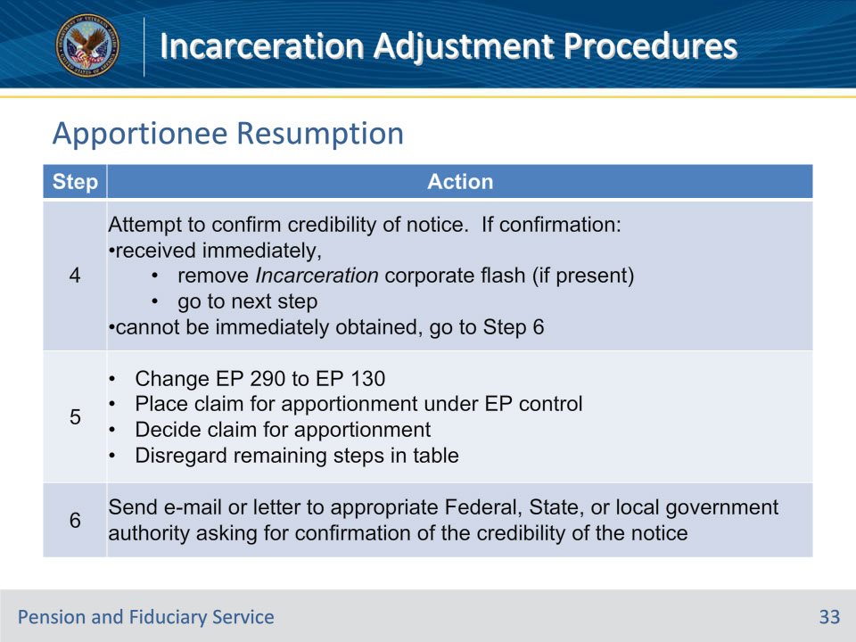

**Slide notes**

Policy Reference(s): M21-1 VI.iii.1.A.5.f.

Instructor Notes:Important for Step 5:  If entitlement to an apportionment exists, the proper effective date is the date VA received the VA Form 21-0788 referenced in Step 2.  Apply the exclusion identified in 38 CFR 3.31(c)(3)(v) when determining the effective date of payment.

**Slide 34 - Apportionee Resumption**

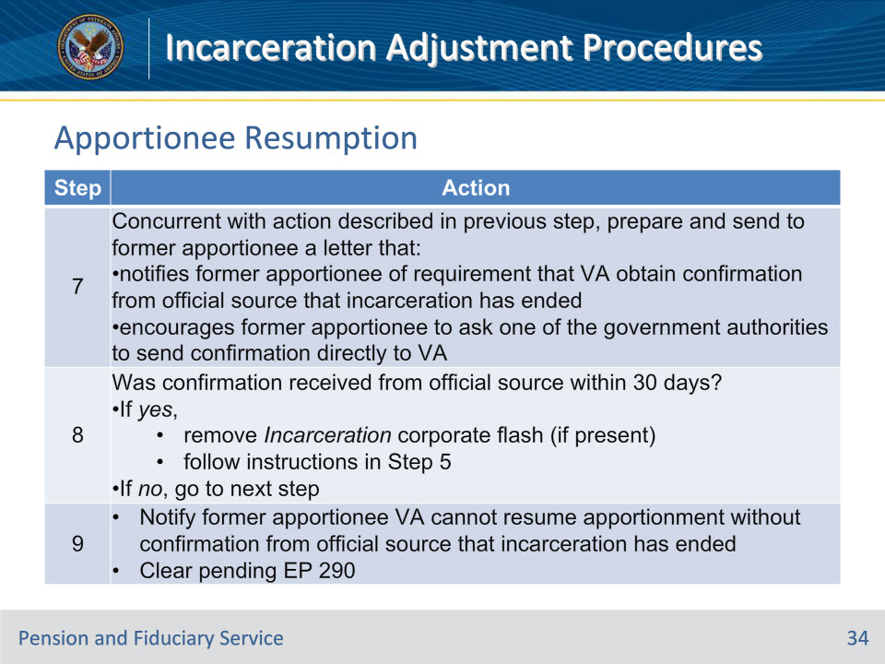

**Slide notes**

Policy Reference(s): M21-1 VI.iii.1.A.5.f.

Instructor Notes:

**Slide 35 - Questions?**

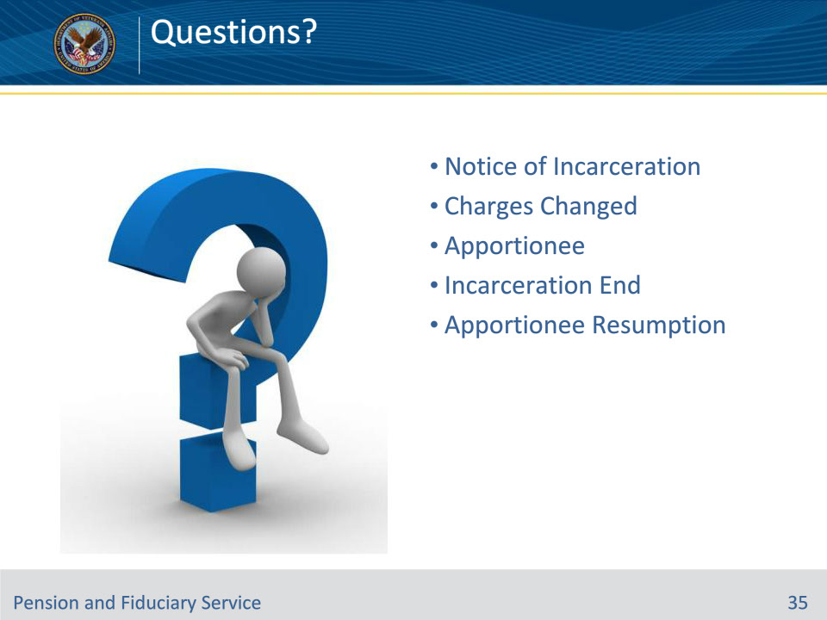

**Slide notes**

Instructor Notes:

(Recall) These are our learning objectives as stated from the beginning of the training:

• Take action when:

• Notice of incarceration received

• Charges dismissed, overturned, or changed

• Incarceration has ended

Are there any additional questions?

**Slide 36 - TMS Survey**

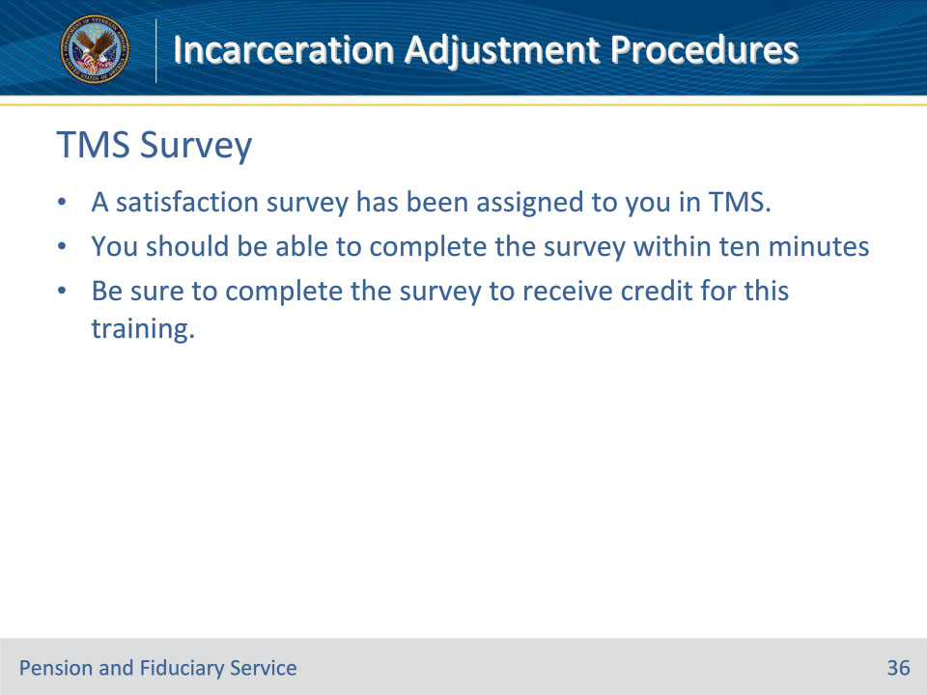

**Slide notes**

Instructor Notes:

A satisfaction survey has been assigned to you in TMS. You should be able to complete it within ten minutes.

Completing it will allow you to receive credit for this training.