Slide 1 - Deceased Beneficiary Funds
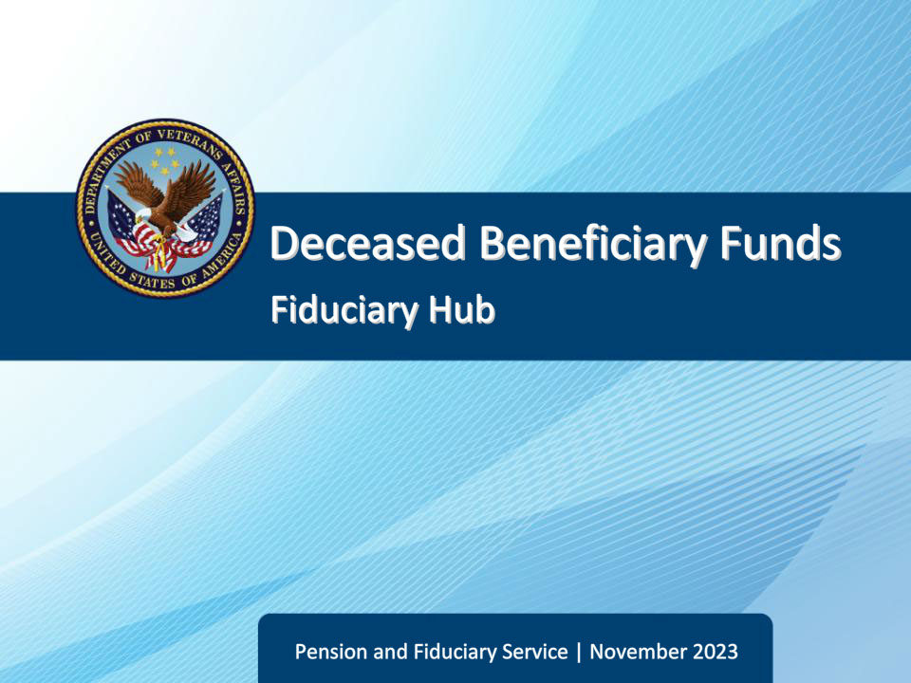
Slide notes

Course Description:

This course teaches learners information on the disposition of a deceased beneficiary’s funds.

Slide 2 - Objectives
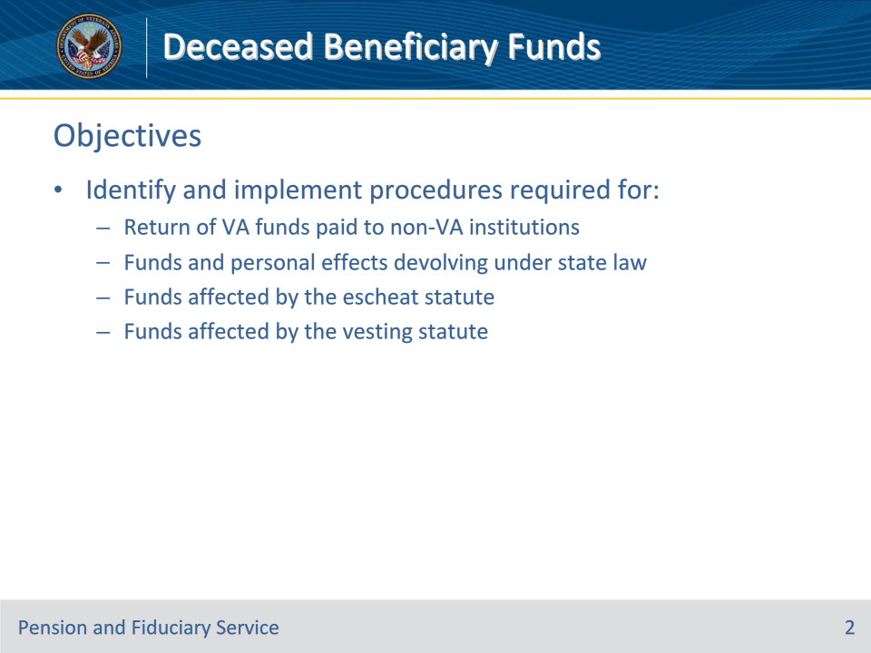
Slide notes

Instructor Notes:

At the end of this lesson, given the training and references, the learner will be able to do the following:

• Identify and implement procedures required for:

• Return of VA funds paid to non-VA institutions

• Funds and personal effects devolving under state law

• funds affected by the escheat statute

• funds affected by the vesting statute

Slide 3 - References
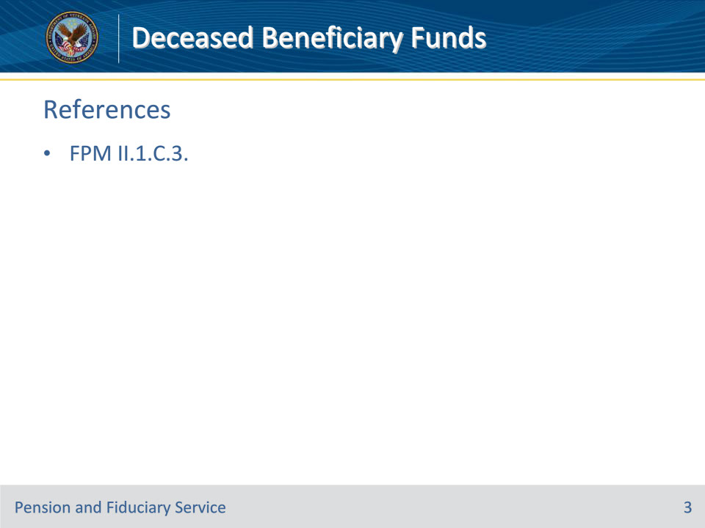
Slide notes

Instructor Notes:

These are the relevant references pertaining to this course:

• FPM II.1.C.3. Disposition of Deceased Beneficiaries’ Funds

Slide 4 - Non-VA Institutions
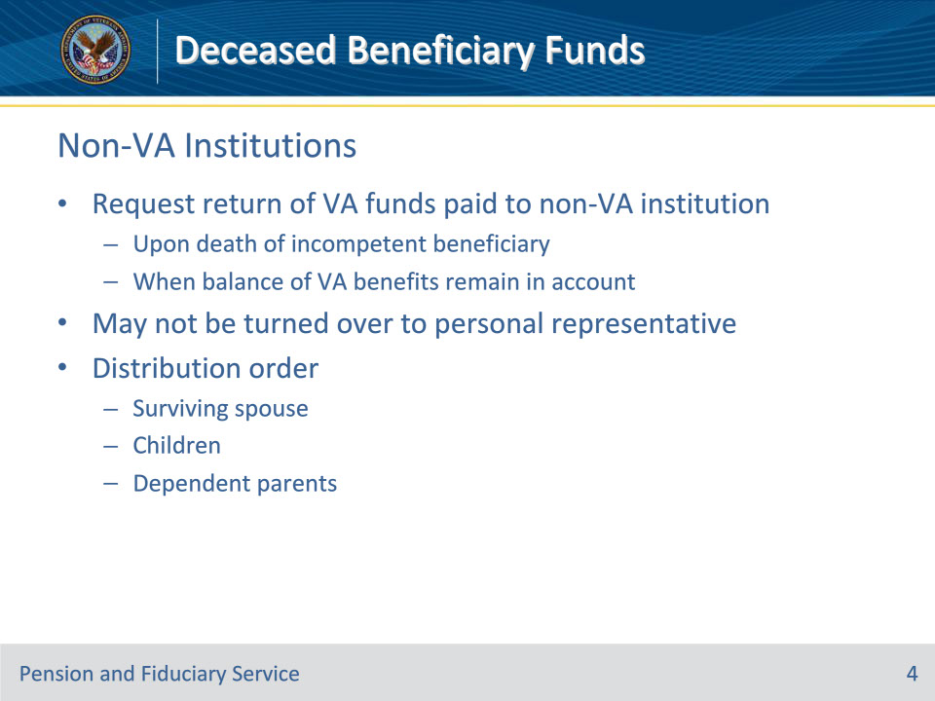
Slide notes

Policy Reference(s): FPM II.1.C.3.a.

Instructor Notes:

The hub must request the return of VA funds paid to a non-VA institution upon the death of an incompetent beneficiary when a balance of the gratuitous VA benefits remains in the beneficiary’s account at the institution per 38 U.S.C. 5502(d).

These funds may not be turned over to the personal representative of the deceased beneficiary, but are distributed by VA per 38 U.S.C. 5502(d) to the following individuals in the order listed:

• surviving spouse

• children, in equal parts, and

• dependent parents, in equal parts.

Slide 5 - Non-VA Institutions
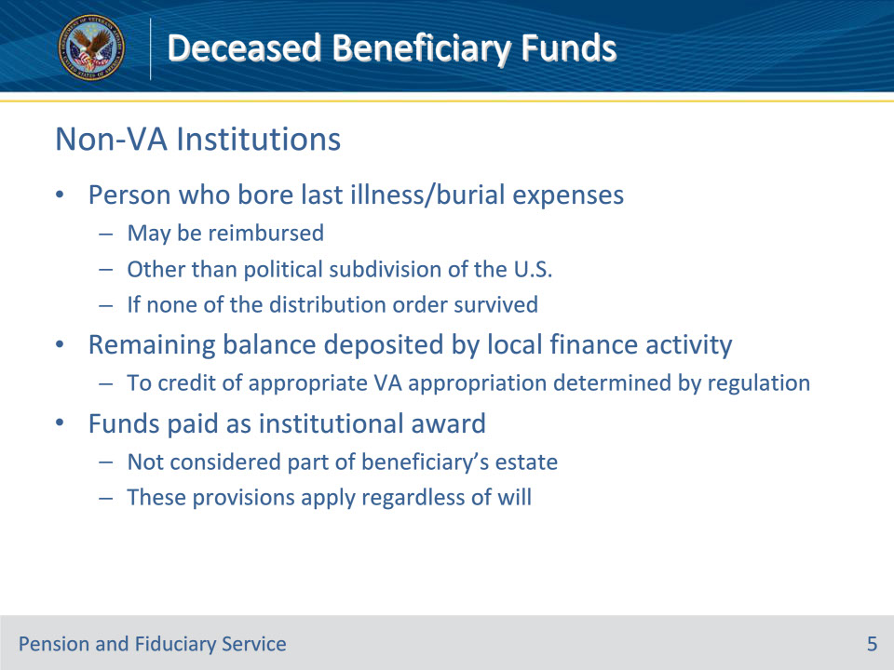
Slide notes

Policy Reference(s): FPM II.1.C.3.a.

Instructor Notes:

If none of the distribution order from the prior slide survive, the person, other than a political subdivision of the U.S., who bore the expenses of the beneficiary’s last illness and burial may be reimbursed. Any remaining balance is deposited by local finance activity to the credit of the appropriate VA appropriation. The appropriate VA appropriation will be determined by local finance per finance activity regulation.

Note: Funds paid as an institutional award are in a unique status. They are not considered to be part of a beneficiary’s estate, and therefore, these provisions apply whether or not there is a will.

Slide 6 - Devolving Under State Law
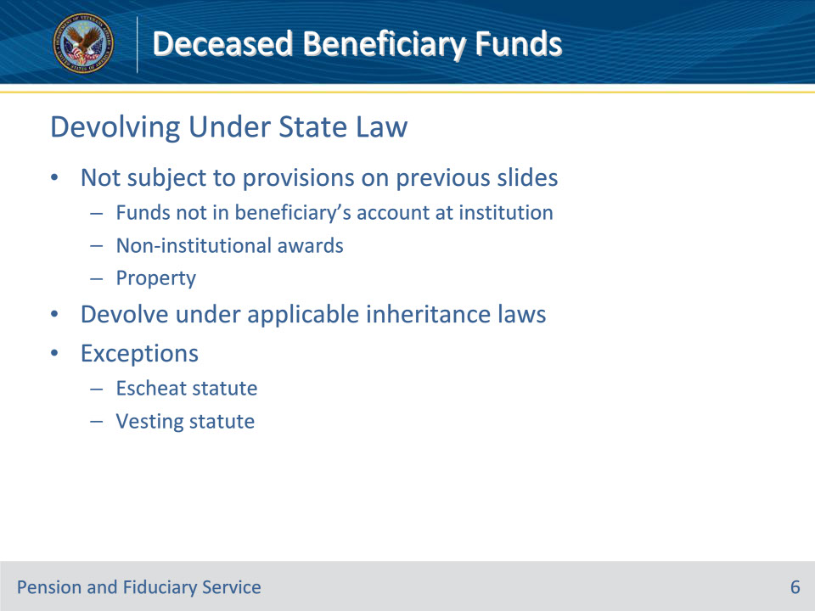
Slide notes

Policy Reference(s): FPM II.1.C.3.b.

Instructor Notes:

Funds and personal effects which are not subject to the provisions outlined in the previous slides include

• funds

• not in the beneficiary’s account at the institution, and

• which did not come to the institution by way of an institutional award, such as funds paid to a fiduciary and then deposited at the institution, and

• property such as bonds or personal effects of the beneficiary.

These funds devolve under the applicable inheritance laws unless they are affected by the provisions of the

• escheat statute, or

• vesting statute

Slide 7 - Escheat Statute
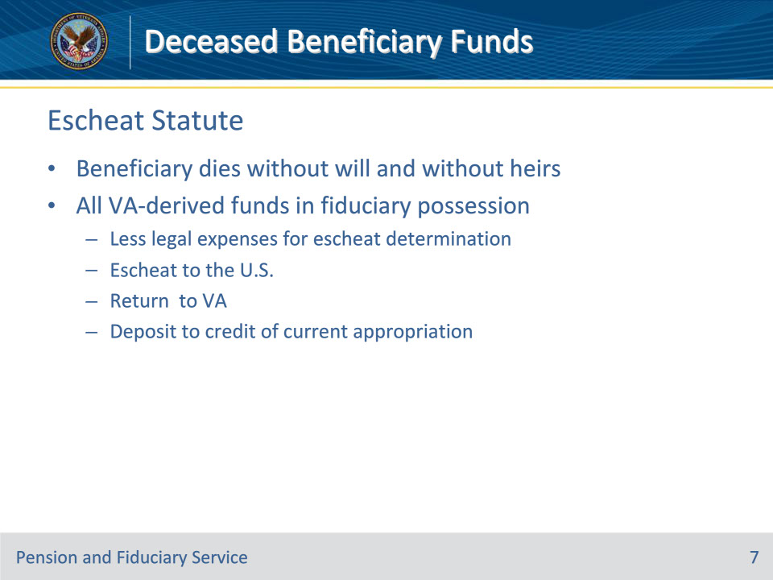
Slide notes

Policy Reference(s): FPM II.1.C.3.c.

Instructor Notes:

When a beneficiary dies without a will and without heirs, all funds derived from VA benefits in the hands of a fiduciary which would escheat to the State must escheat to the U.S. Such funds, less legal expenses of any administration necessary to determine that escheat is in order, must be

• returned to VA, and

• deposited to the credit of the current appropriation, per 38 U.S.C. 5502(e).

Slide 8 - Escheat Statute
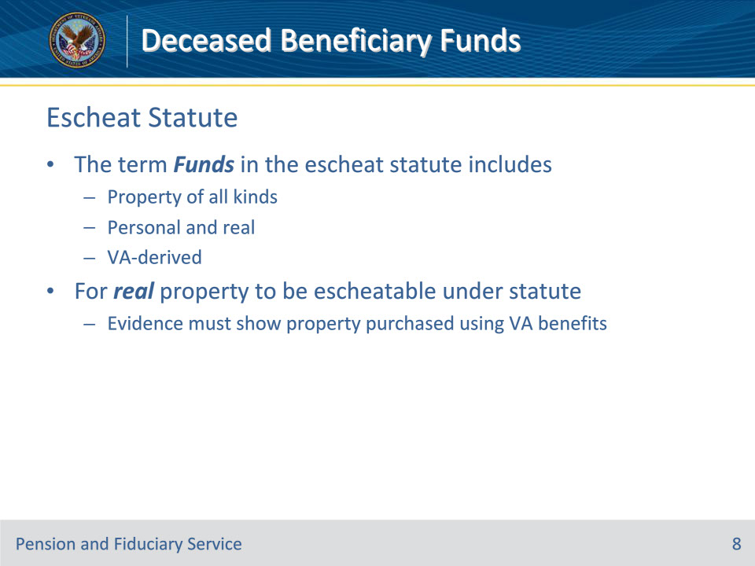
Slide notes

Policy Reference(s): FPM II.1.C.3.c.

Instructor Notes:

The term funds as used in the escheat statute, includes property of all kinds, both personal and real. However, such funds must have been derived from benefits payable under laws administered by VA, and to that extent the term has a restricted meaning.

For real property to be escheatable under the statute, the available evidence must clearly and convincingly show that the real property was purchased using VA benefits.

Slide 9 - Escheat Statute
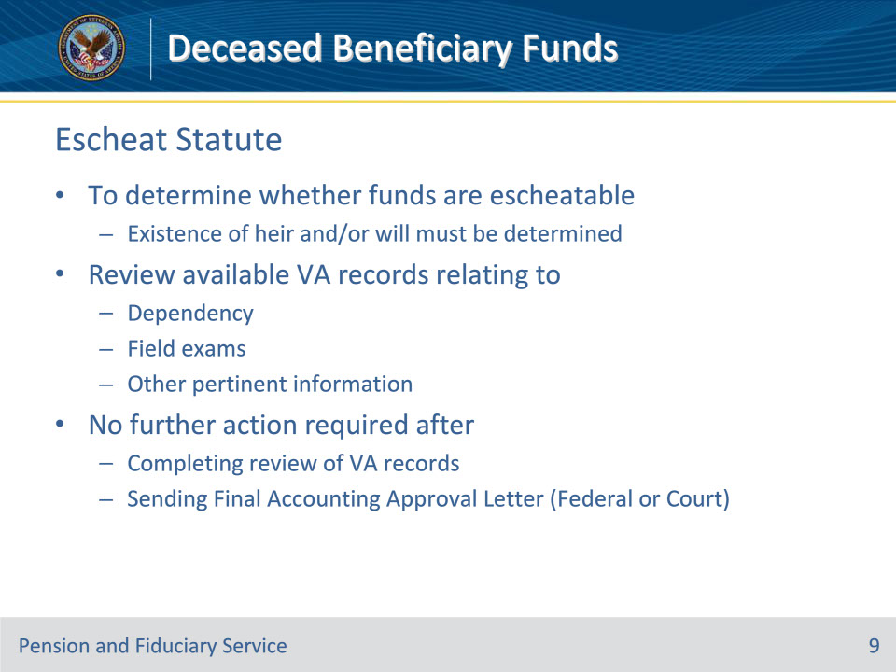
Slide notes

Policy Reference(s): FPM II.1.C.3.d.

Instructor Notes:

To determine whether funds are escheatable, a determination must be made as to the existence of an heir and/or a will. To do so, review available VA records relating to dependency, field exams, and other pertinent information to determine if VA has record of the existence of an heir and/or a will for the deceased beneficiary. No further action to identify the existence of an heir or will is required after completing the review of VA records and sending the Final Accounting Approval Letter (Federal or Court).

Slide 10 - Escheat Statute
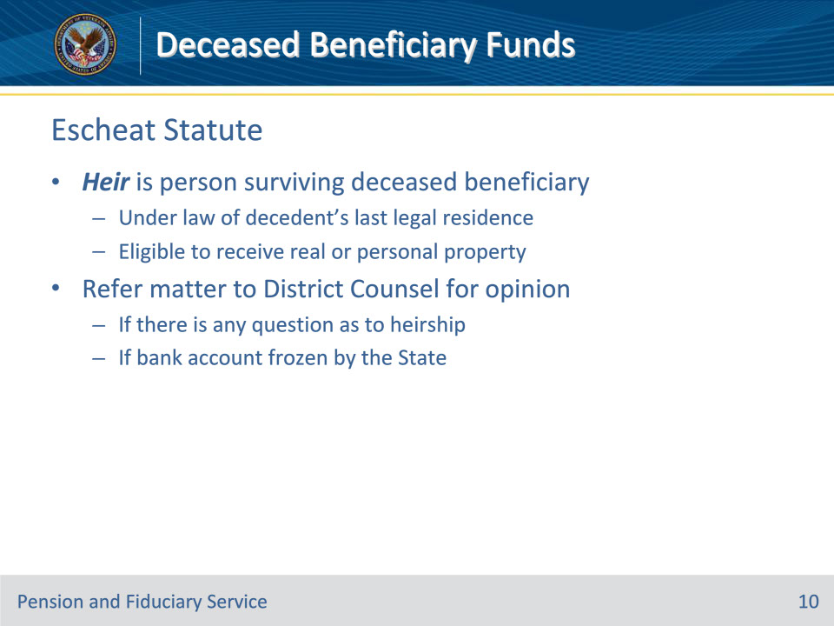
Slide notes

Policy Reference(s): FPM II.1.C.3.d.

Instructor Notes:

Notes:

• For this purpose, an heir is a person surviving the deceased beneficiary who, under the law of the decedent’s last legal residence, is eligible to receive real or personal property.

• If there is any question as to heirship, the matter must be referred to the District Counsel for an opinion.

• In the event a deceased beneficiary with no heirs and no will has their bank account frozen by the State, refer the case to District Counsel for an opinion.

Slide 11 - Escheat Statute
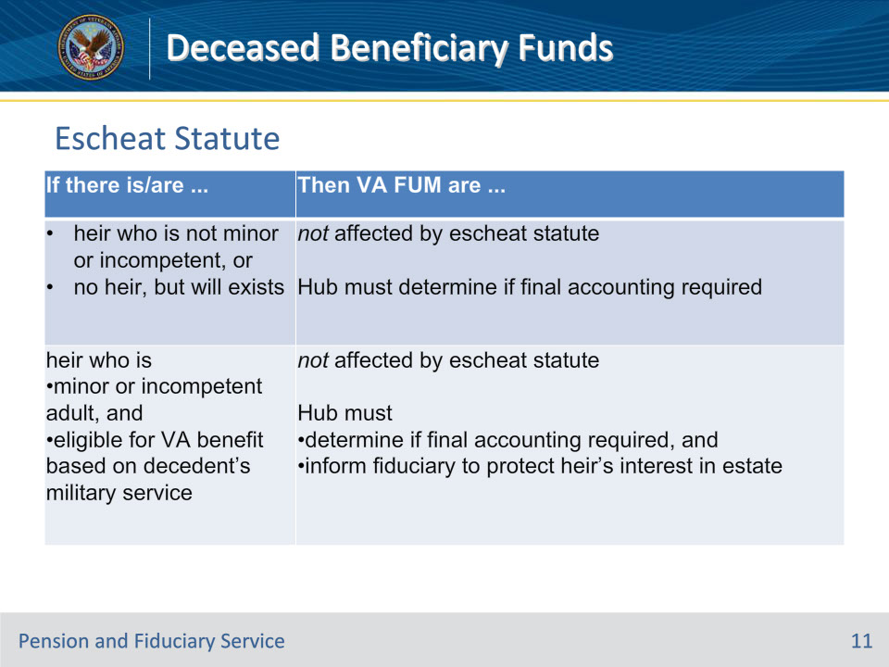
Slide notes

Policy Reference(s): FPM II.1.C.3.d.

Instructor Notes:

Use this table to determine the actions to take based upon the existence, or lack of, an heir and/or will.

Slide 12 - Escheat Statute
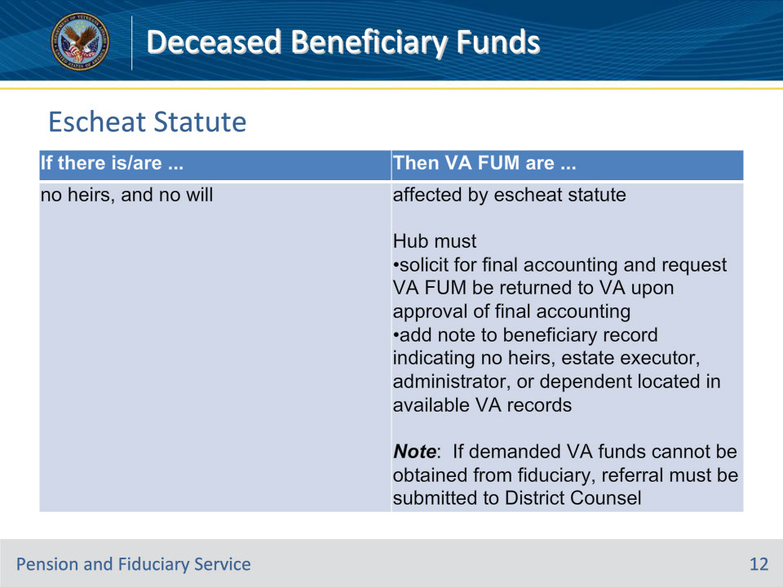
Slide notes

Policy Reference(s): FPM II.1.C.3.d.

Instructor Notes:

Use this table to determine the actions to take based upon the existence, or lack of, an heir and/or will.

Slide 13 - Escheat Statute
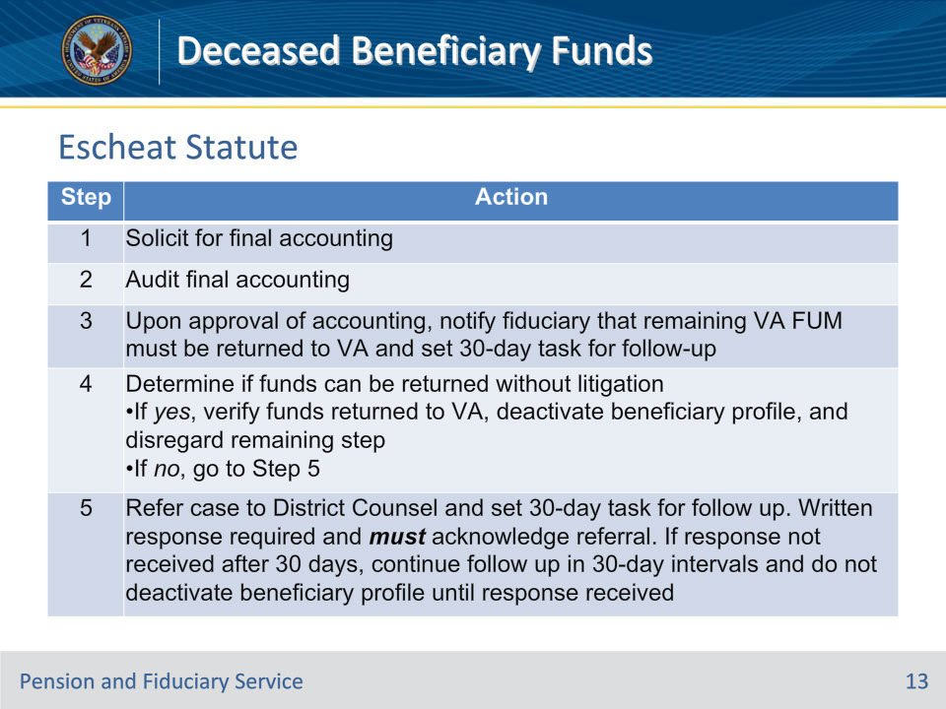
Slide notes

Policy Reference(s): FPM II.1.C.3.e.

Instructor Notes:

Follow the steps in this table when escheat is in order.

Note: Do not deactivate the beneficiary profile until all actions listed in the table below have been completed.

Important for Step 5: The response from District Counsel must be

• in the form of an email or letter, and

• uploaded to the electronic claims folder.

Slide 14 - Vesting Statute
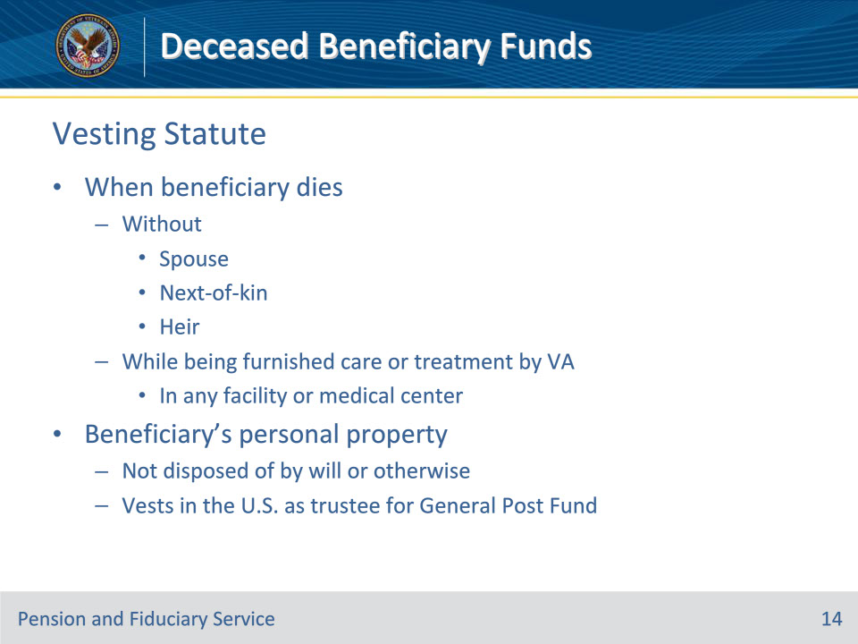
Slide notes

Policy Reference(s): FPM II.1.C.3.f.

Instructor Notes:

When a beneficiary dies without a spouse, next-of-kin, or heir while being furnished care or treatment by VA in any facility or medical center, the beneficiary’s personal property, not disposed of by will or otherwise, vests in the U.S. as trustee for the General Post Fund, per 38 U.S.C. 8520.

This application of the statute is a condition precedent to the care or treatment by VA. Acceptance of such care or treatment constitutes acceptance of the provisions of the statute and an assignment effective at death.

A beneficiary’s death, under these circumstances, creates a conclusive presumption of a valid contract for disposition of personal property per the statute.

Slide 15 - Vesting Statute
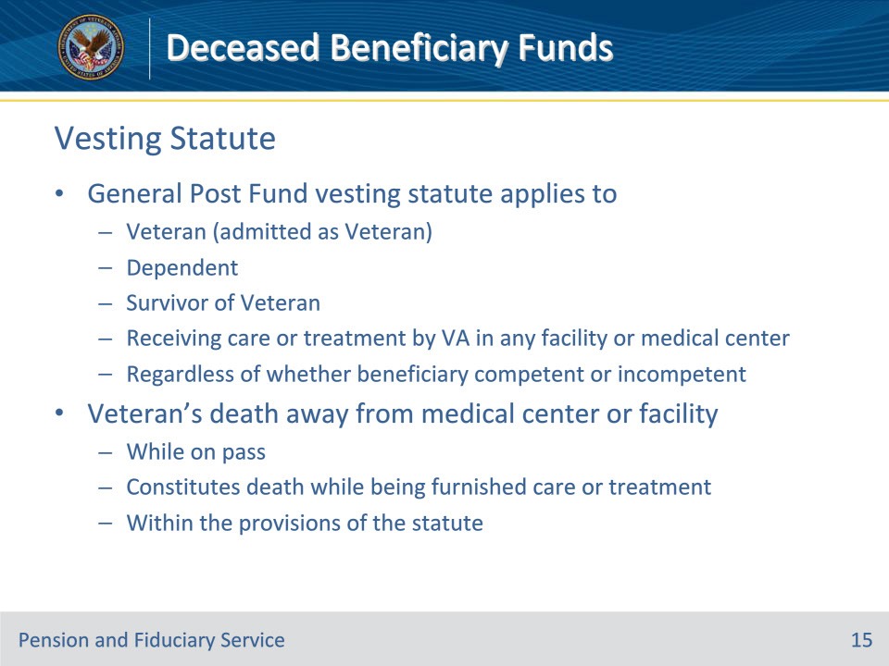
Slide notes

Policy Reference(s): FPM II.1.C.3.g.

Instructor Notes:

The General Post Fund vesting statute applies to a Veteran (admitted as a Veteran), or a dependent or survivor of a Veteran receiving care or treatment by VA in any facility or medical center activity regardless of whether the beneficiary is competent or incompetent, as competence is not a factor.

A Veteran’s death away from the medical center or facility while on pass constitutes death while being furnished care or treatment within the provisions of the statute.

Slide 16 - Vesting Statute
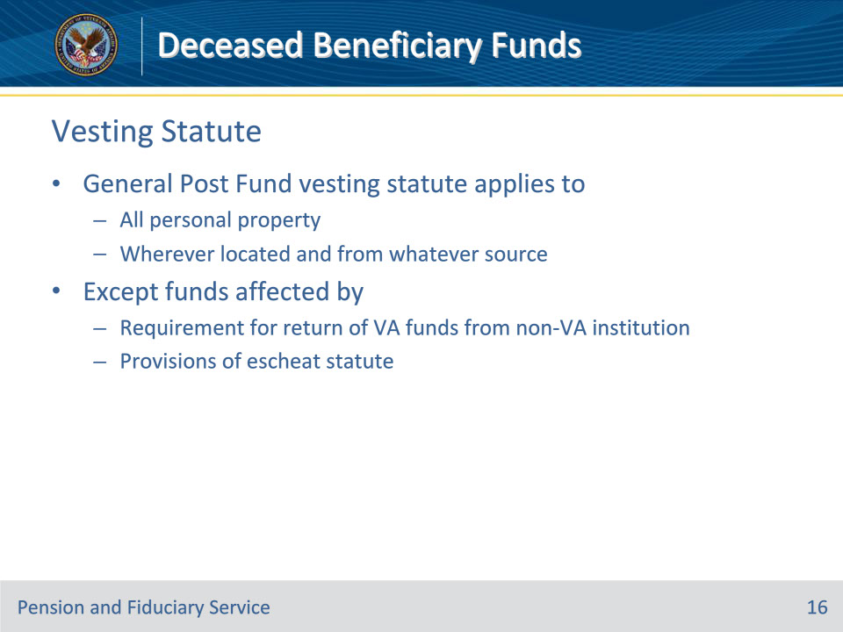
Slide notes

Policy Reference(s): FPM II.1.C.3.h.

Instructor Notes:

The General Post Fund vesting statute applies to all personal property, wherever located and from whatever source, except funds affected by the

• requirement for the return of VA funds paid by institutional award to a non-VA institution, and

• provisions of the escheat statute

Slide 17 - Vesting Statute
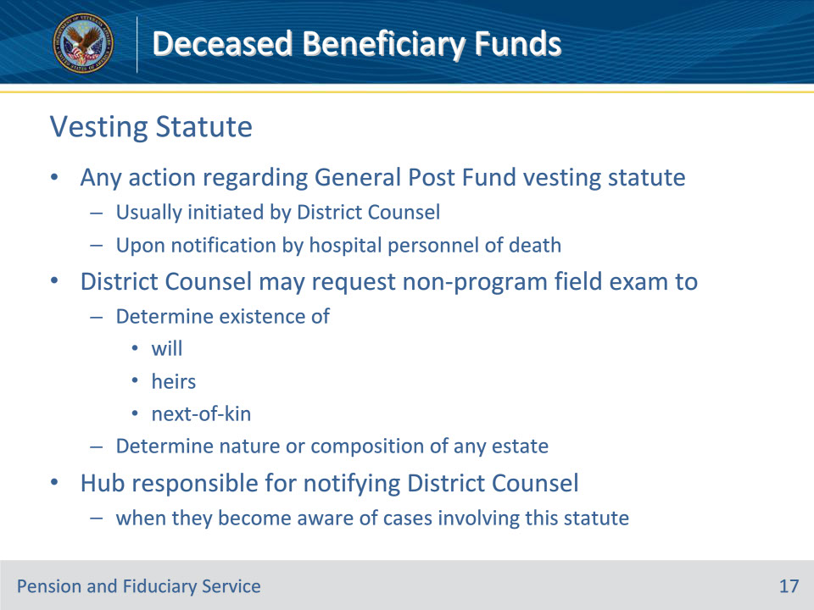
Slide notes

Policy Reference(s): FPM II.1.C.3.i.

Instructor Notes:

Any action regarding the General Post Fund vesting statute is usually initiated by the District Counsel upon notification by hospital personnel of the death of the beneficiary. The District Counsel may request a non-program field examination to investigate and gather information regarding the

• existence of

• a will

• heirs, or

• next-of-kin, and

• nature or composition of any estate.

Hub employees are also responsible for notifying the District Counsel when they become aware of cases involving the provisions of this statute.

Slide 18 - Questions?
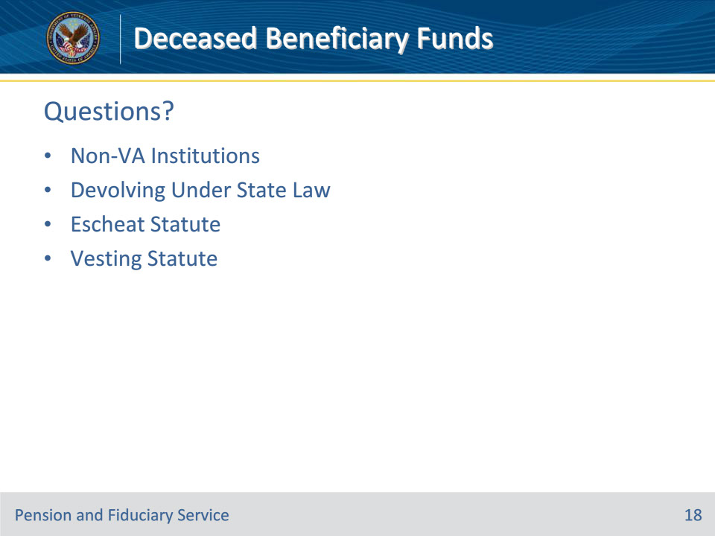
Slide notes

Instructor Notes:

(Recall) These are our learning objectives as stated from the beginning of the training:

• Identify and implement procedures required for:

• Return of VA funds paid to non-VA institutions

• Funds and personal effects devolving under state law

• funds affected by the escheat statute

• funds affected by the vesting statute

(Recap) We discussed each of these learning objectives through the following topics in each slide today:

• Non-VA Institutions

• Devolving Under State Law

• Escheat Statute

• Vesting Statute

Are there any additional questions?

Slide 19 - TMS Survey
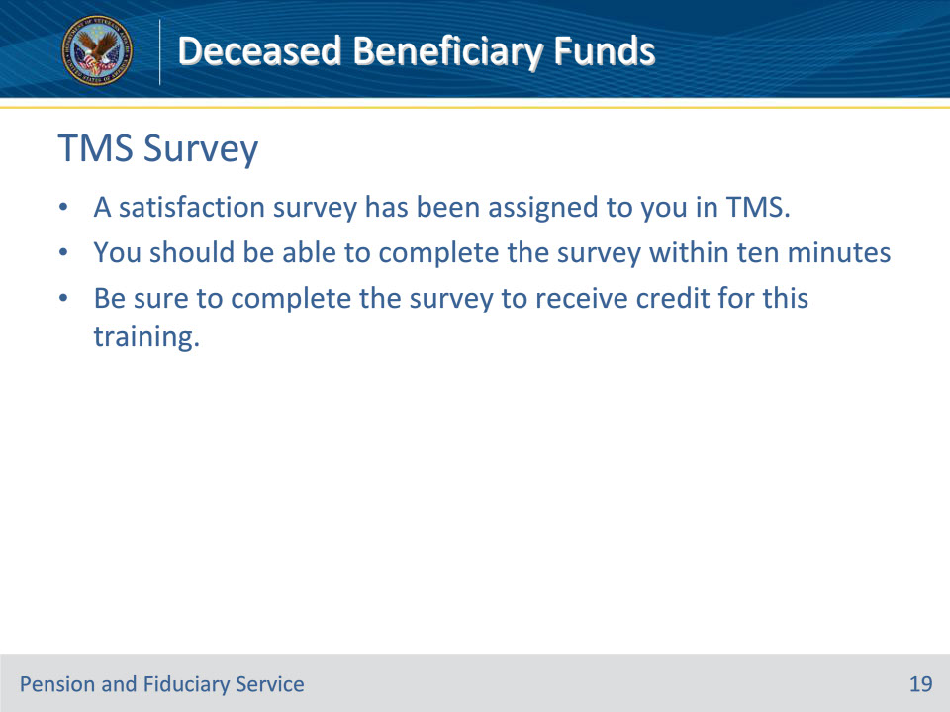
Slide notes

Instructor Notes:

A satisfaction survey has been assigned to you in TMS. You should be able to complete it within ten minutes.

Completing it will allow you to receive credit for this training.

