**Slide 1 - FCC Stress Management**

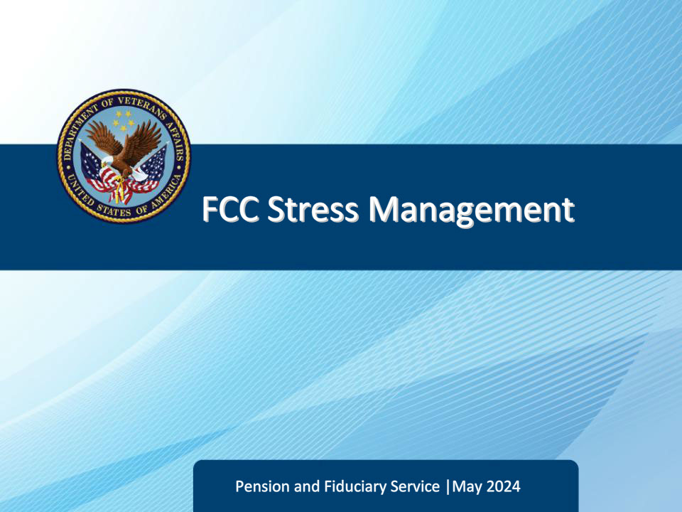

**Slide notes**

Course Description:

Welcome to the Fiduciary Contact Center (FCC) Stress Management training. This course teaches FCC Legal Administrative Specialists (LAS) ways to build resilience and manage stress. It includes understanding the types and impacts of stress, developing stress management skills, implementing relaxation strategies, bouncing back from adversity, building self-esteem, and making and maintaining connections.

**Slide 2 - Objectives**

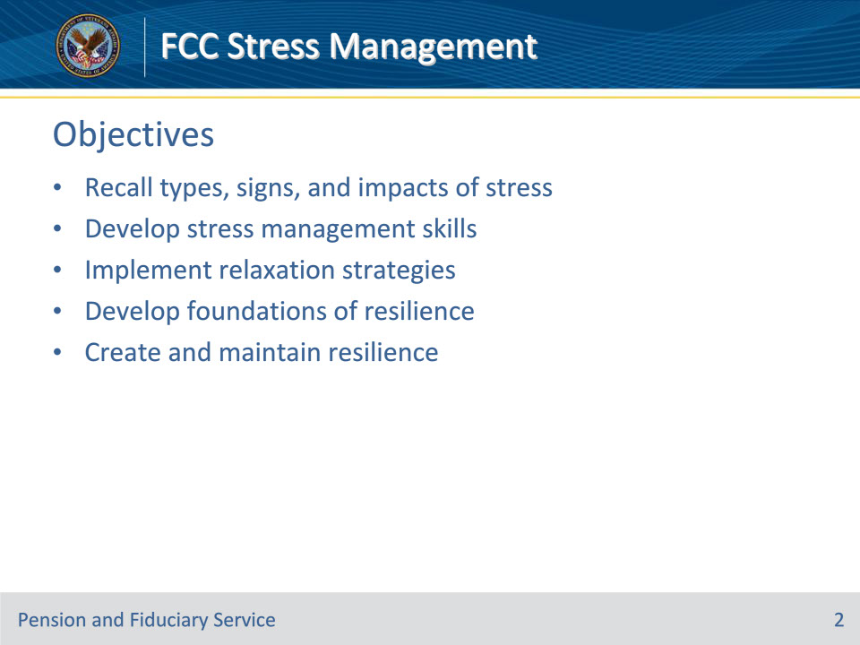

**Slide notes**

Instructor Notes:

At the end of this lesson, given the training and references, the learner will be able to do the following:

• Recall types, signs, and impacts of stress

• Develop stress management skills

• Implement relaxation strategies

• Develop foundations of resilience

• Create and maintain resilience

**Slide 3 - Types of Stress**

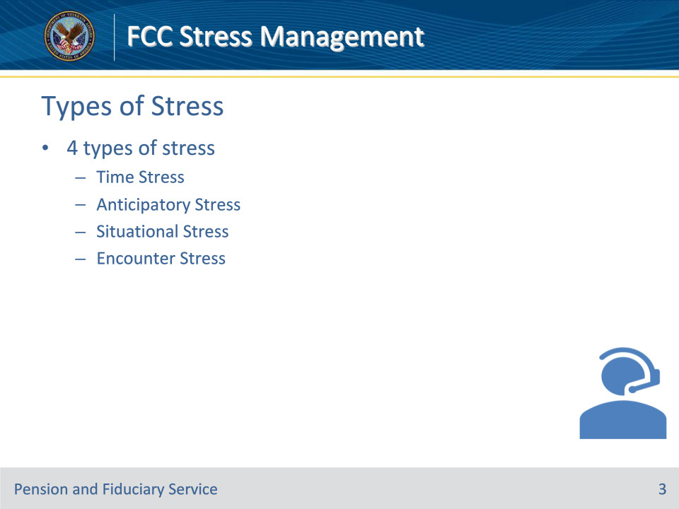

**Slide notes**

Instructor Notes

There have been numerous studies that have conclusively demonstrated that work-related stress negatively affects a growing number of individuals. Customer service representatives must juggle demands and complaints of varying degrees of complexity, all in a fast-paced, high-stakes environment. Due to these demands, customer representatives are susceptible to acute and chronic stress.

There are 4 types of stress

• Time Stress

• Anticipatory Stress

• Situational Stress

• Encounter Stress

**Slide 4 - Time Stress**

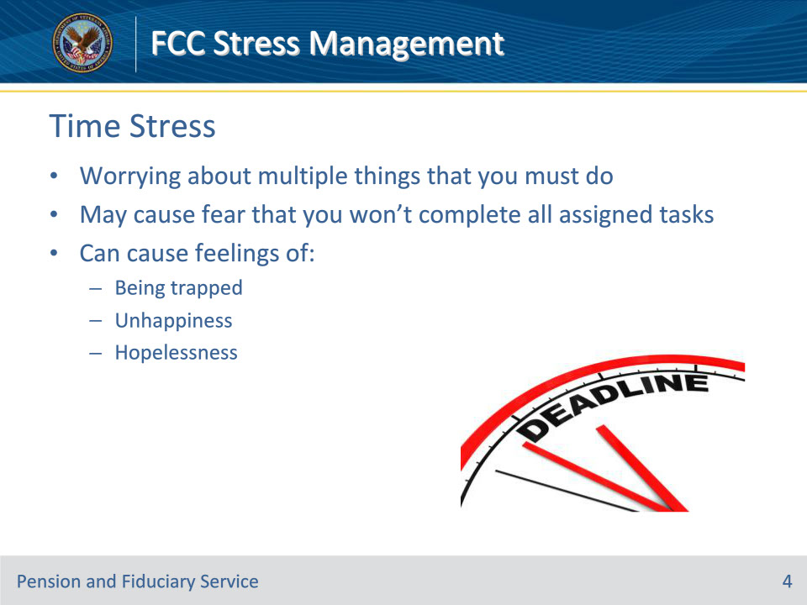

**Slide notes**

Instructor Notes

Time Stress

This is when you worry about multiple things that you must do; you may even fear that you won’t complete all assigned tasks. This type of stress can cause feelings of being trapped, unhappy, or even hopelessness.

**Slide 5 - Anticipatory Stress**

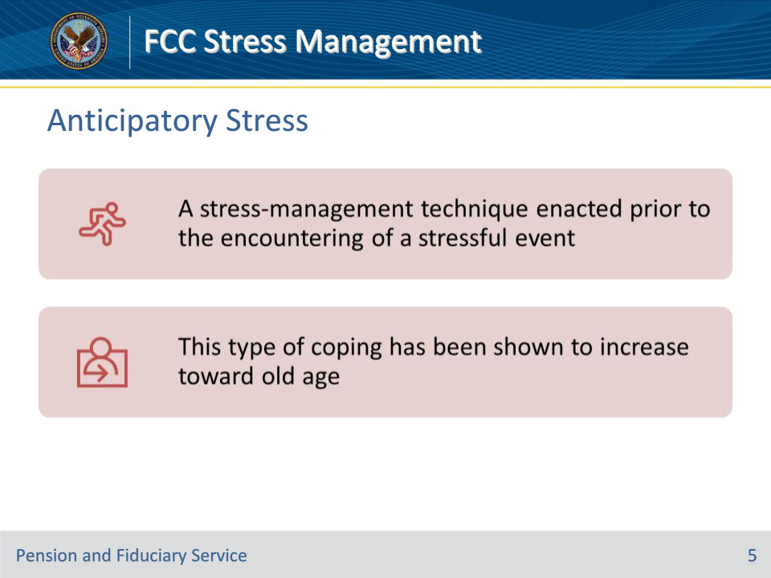

**Slide notes**

Instructor Notes

Anticipatory Stress

This is a stress-management technique used prior to encountering a stressful event. It may cause you to minimize the event/situation associated with stress. This type of coping has shown an increase toward old age.

**Slide 6 - Situational Stress**

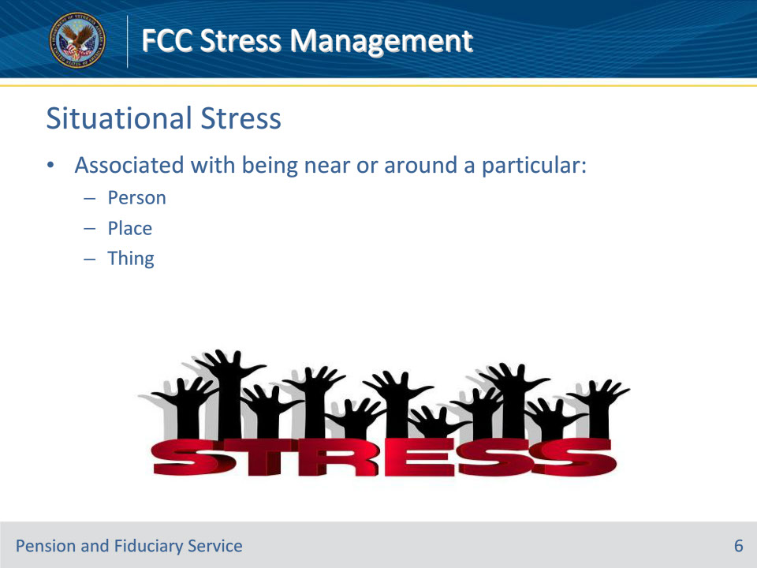

**Slide notes**

Instructor Notes

Situational Stress

Situation stress is stress that is associated with being near or around a particular person, place, or thing.

**Slide 7 - Encounter Stress**

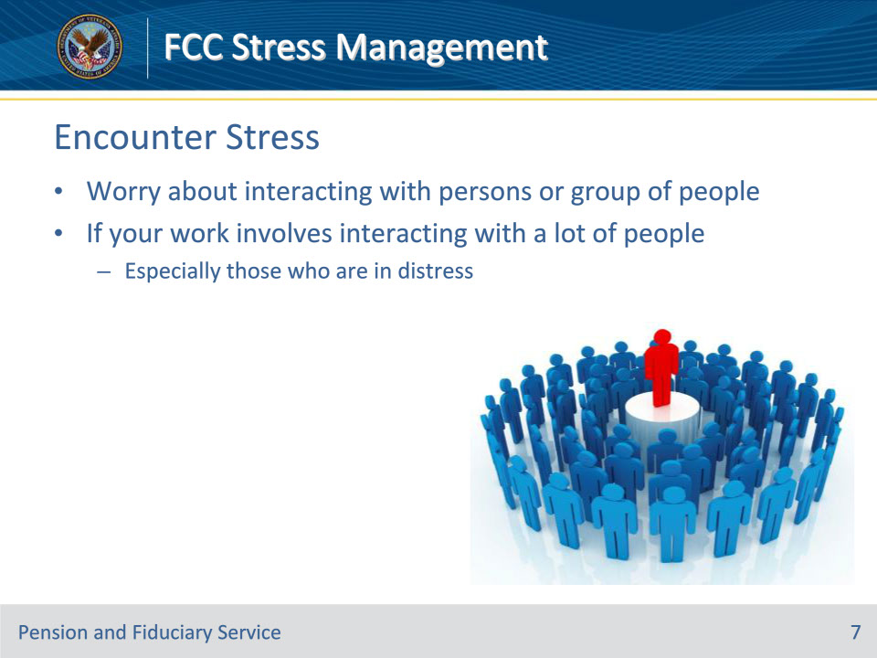

**Slide notes**

Instructor Notes

Encounter Stress

This occurs if you worry about interacting with some persons or a group of people. You may experience this stress if your work involves interacting with a lot of people, especially those who are in distress.

**Slide 8 - Signs of Stress**

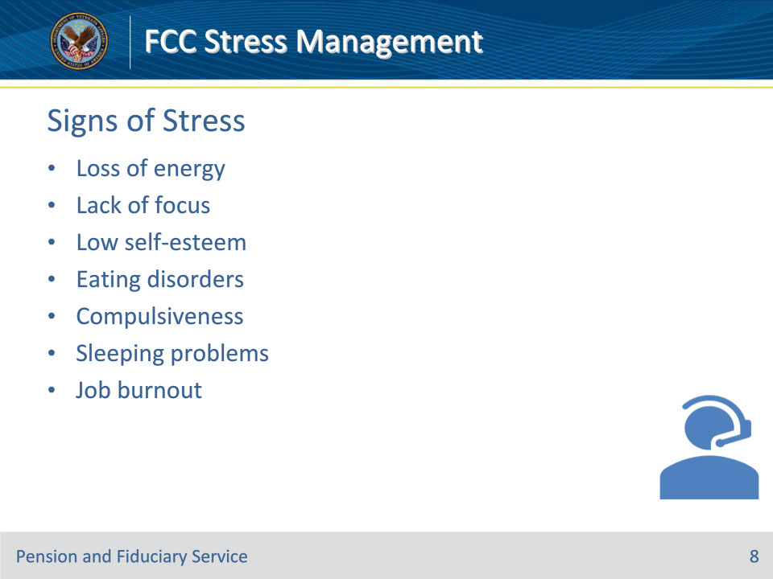

**Slide notes**

Instructor Notes

Signs of Stress

The following are some signs that could indicate you may be dealing with high levels of stress:

• Signs of Stress

• Loss of energy

• Lack of focus

• Low self-esteem

• Eating disorders

• Compulsiveness

• Sleeping problems

• Job burnout

**Slide 9 - Impacts of Stress**

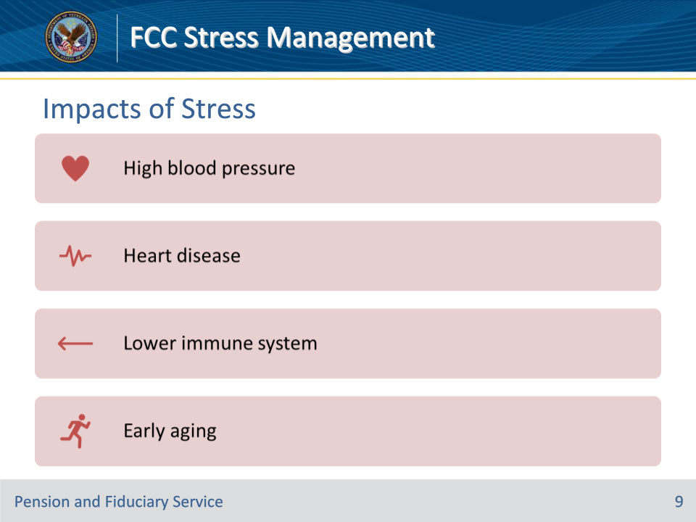

**Slide notes**

Instructor Notes

Impacts of Stress

Two of the most common health issues are high blood pressure and heart disease. Stress can dampen the immune system, which increases susceptibility to colds and other common infections.

**Slide 10 - Knowledge Check**

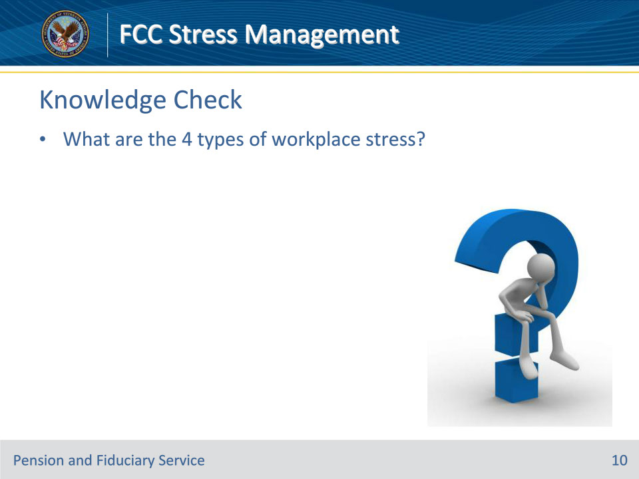

**Slide notes**

Instructor Notes

What are the 4 types of workplace stress?

(Answers on the next slide)

1. Time Stress

2. Situational Stress

3. Anticipatory Stress

4. Encounter Stress

**Slide 11 - Answers**

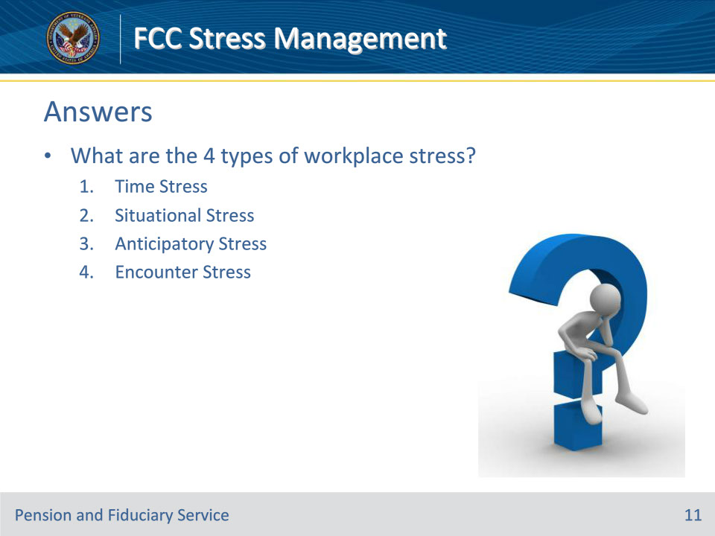

**Slide notes**

Instructor Notes

What are the 4 types of workplace stress?

Answers:

• Time Stress

• Situational Stress

• Anticipatory Stress

• Encounter Stress

**Slide 12 - Knowledge Check**

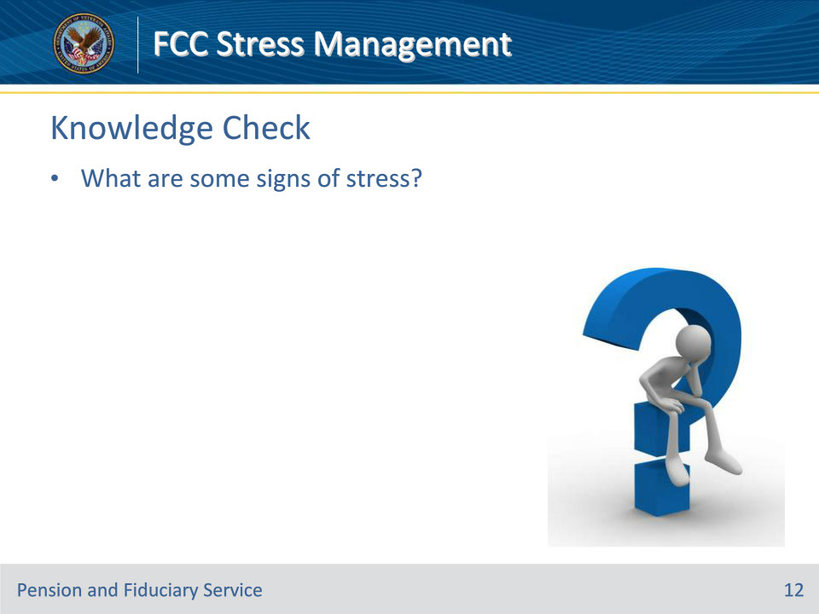

**Slide notes**

Instructor Notes

What are some signs of stress?

(Answers on the next slide)

• Loss of energy

• Lack of focus

• Low self-esteem

• Eating disorders

• Compulsiveness

• Sleeping problems

• Job burnout

**Slide 13 - Answers**

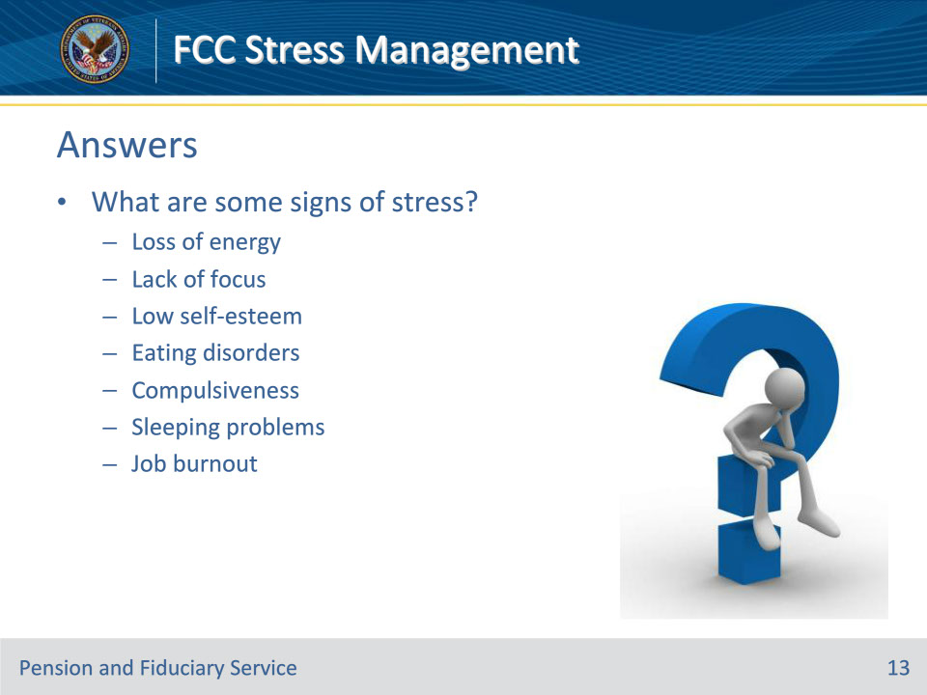

**Slide notes**

Instructor Notes

What are some signs of stress?

Answers:

• Loss of energy

• Lack of focus

• Low self-esteem

• Eating disorders

• Compulsiveness

• Sleeping problems

• Job burnout

**Slide 14 - Stress Management Skills**

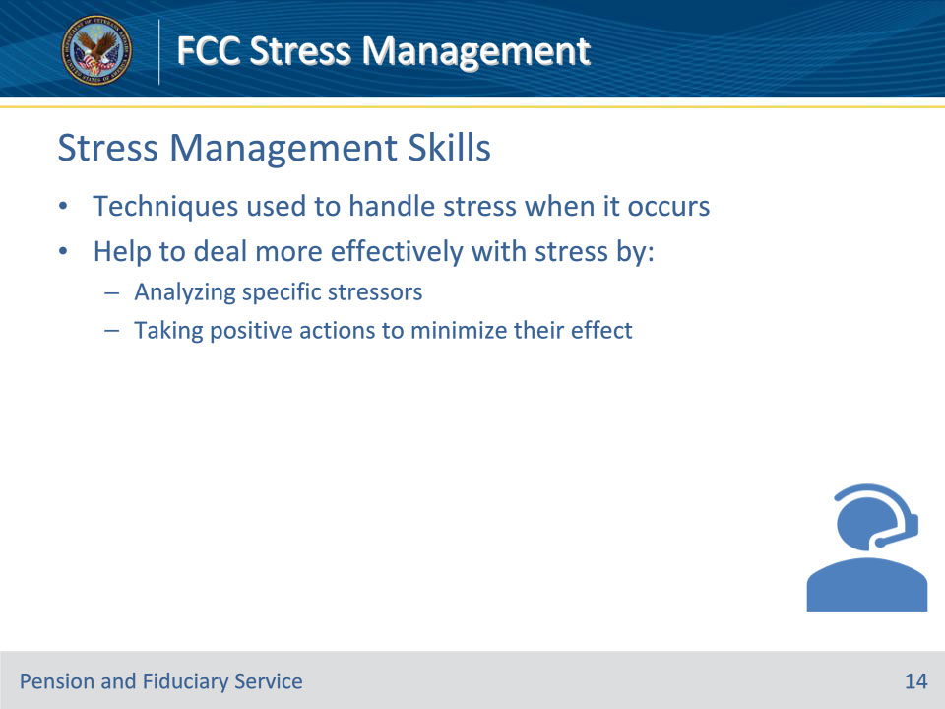

**Slide notes**

Instructor Notes

Stress management skills are techniques we use to handle stress when it occurs. These skills help us to deal more effectively with stress by analyzing specific stressors and taking positive actions to minimize their effect.

**Slide 15 - Stress Management Skills**

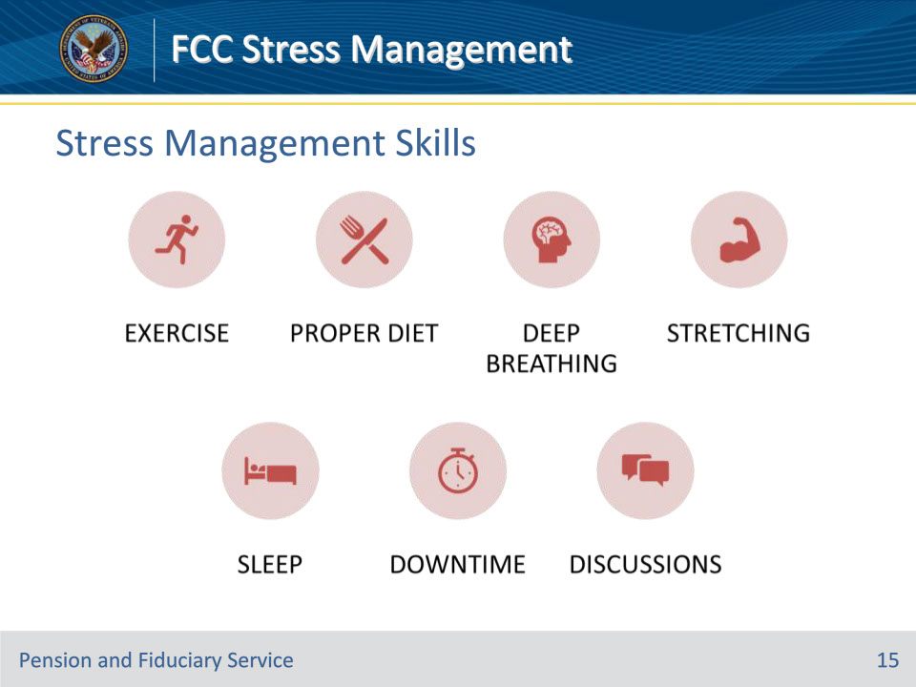

**Slide notes**

Instructor Notes

Managing Stress

Below are some techniques that could be used to assist in managing stress levels:

• Exercise

• Proper diet

• Deep breathing

• Stretching

• Sleep

• Downtime

• Discussions

**Slide 16 - Stress Management Skills**

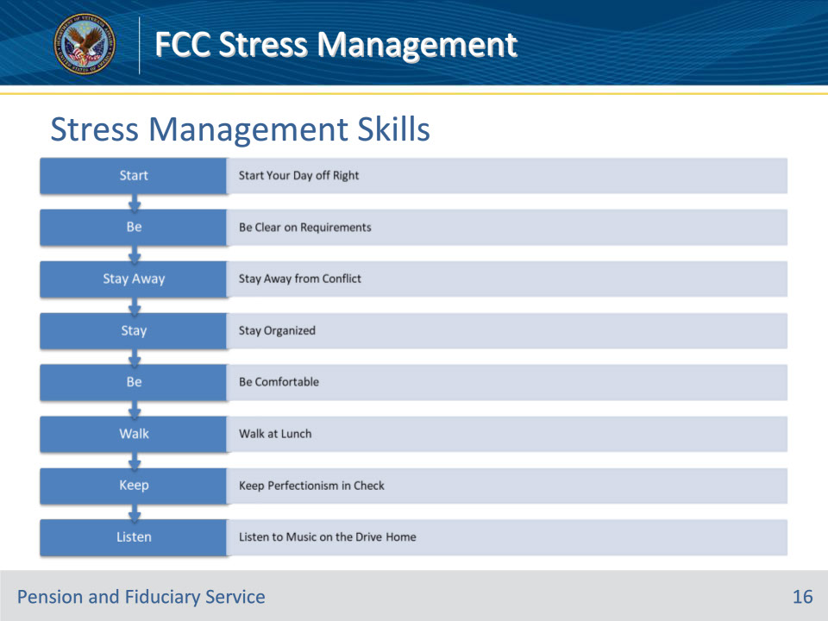

**Slide notes**

Instructor Notes

Simple Ways to Deal with Stress at Work

Below are some simple ways to deal with stress, which, when used, could assist in lowering your stress levels while at work.

• Start Your Day off Right

• Be Clear on Requirements

• Stay Away from Conflict

• Stay Organized

• Be Comfortable

• Walk at Lunch

• Keep Perfectionism in Check

• Listen to Music on the Drive Home

**Slide 17 - Knowledge Check**

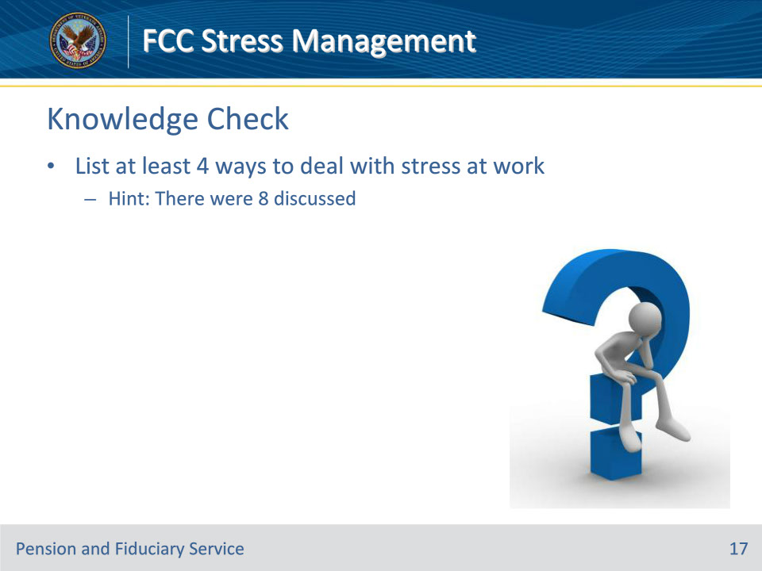

**Slide notes**

Instructor Notes

List at least 4 ways to deal with stress at work

Hint: There were 8 discussed

(Answers on the next slide)

• Start Your Day off Right

• Be Clear on Requirements

• Stay Away from Conflict

• Stay Organized

• Be Comfortable

• Walk at Lunch

• Keep Perfectionism in Check

• Listen to Music on the Drive Home

**Slide 18 - Answers**

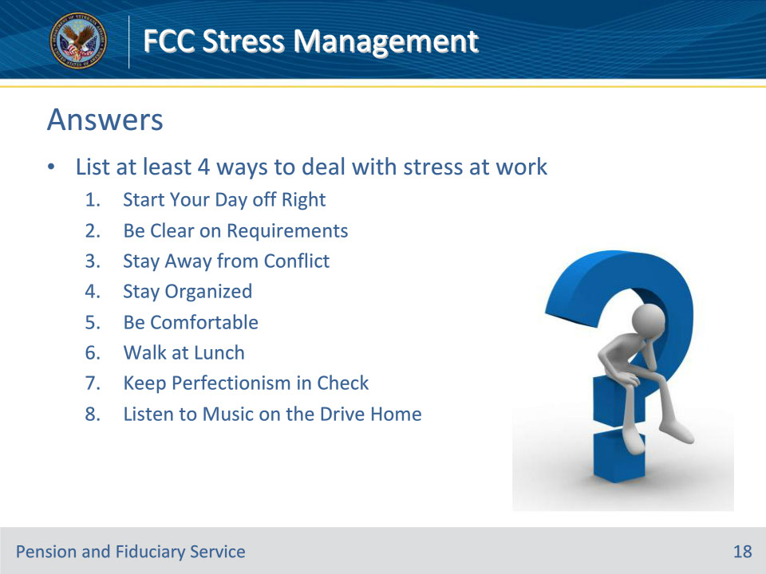

**Slide notes**

Instructor Notes

List at least 4 ways to deal with stress at work

Answers:

• Start Your Day off Right

• Be Clear on Requirements

• Stay Away from Conflict

• Stay Organized

• Be Comfortable

• Walk at Lunch

• Keep Perfectionism in Check

• Listen to Music on the Drive Home

**Slide 19 - Knowledge Check**

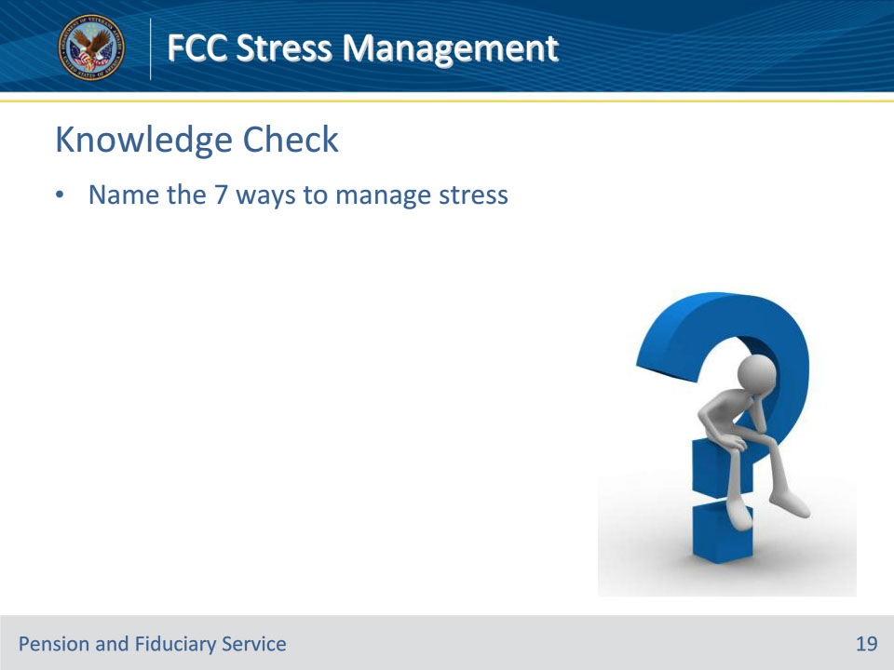

**Slide notes**

Instructor Notes

Name the 7 ways to manage stress.

(Answers on the next slide)

• Exercise

• Proper diet

• Deep breathing

• Stretching

• Sleep

• Downtime

• Discussions

**Slide 20 - Answers**

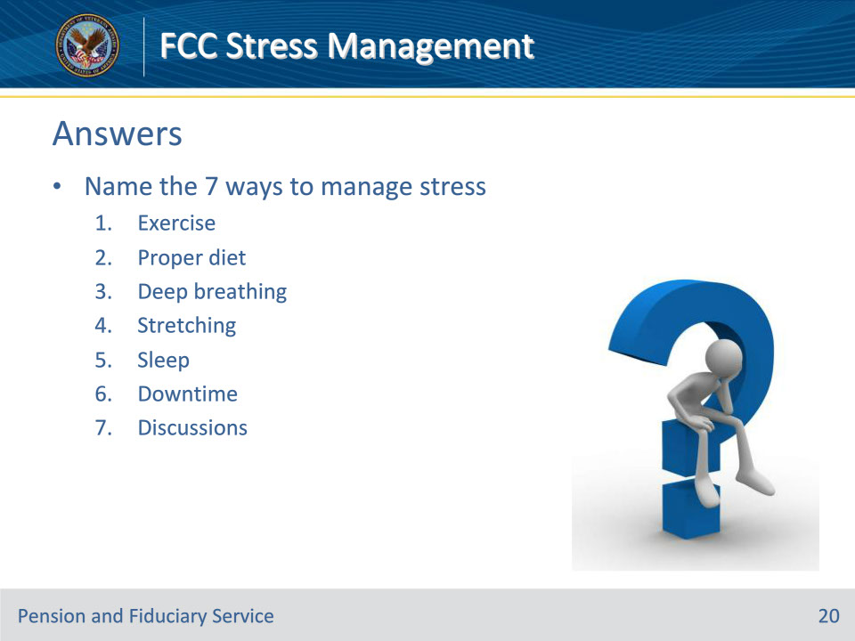

**Slide notes**

Instructor Notes

Name the 7 ways to manage stress.

Answers:

• Exercise

• Proper diet

• Deep breathing

• Stretching

• Sleep

• Downtime

• Discussions

**Slide 21 - Address Your Stress**

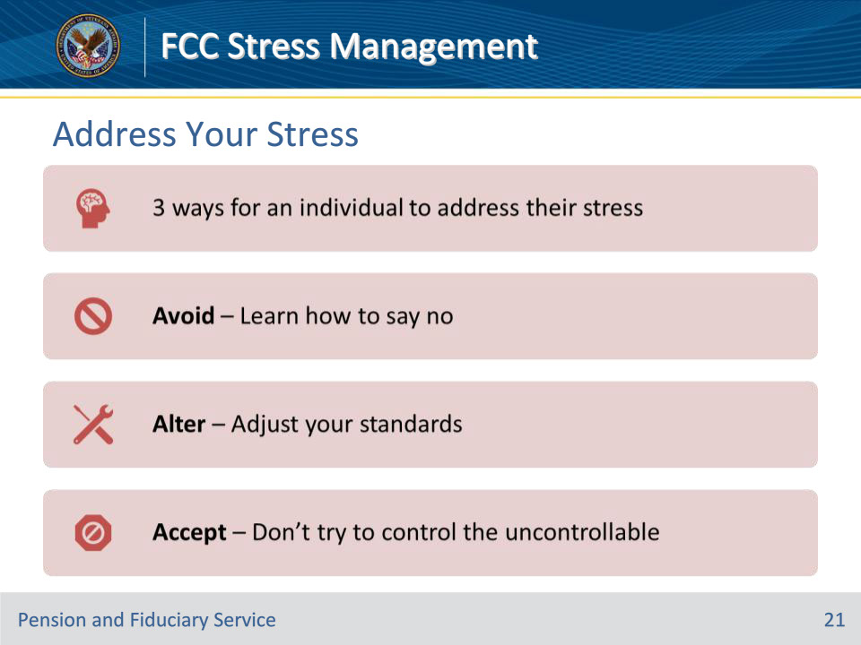

**Slide notes**

Instructor Notes

Address your Stress

There are three ways in which an individual can address their stress

• Avoid – Learn to say no.

• Alter – Adjust your standards.

• Accept – Don’t try to control the uncontrollable.

**Slide 22 - Engage Your Senses**

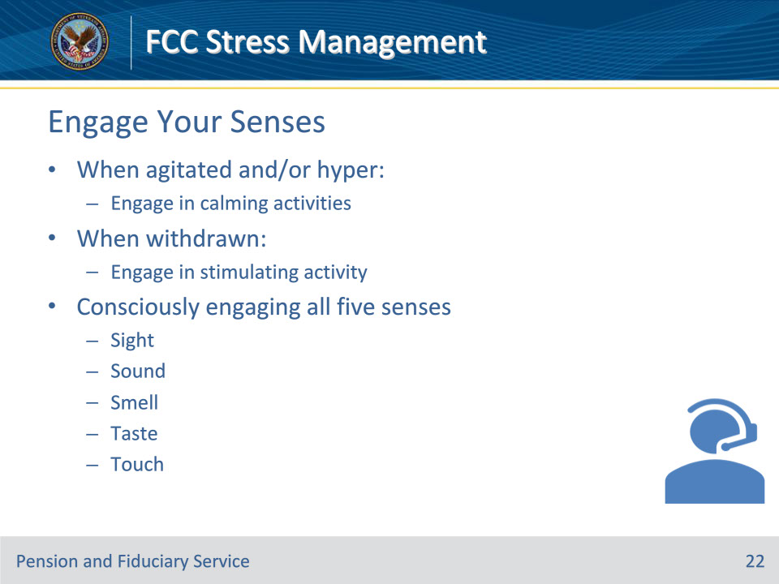

**Slide notes**

Instructor Notes

Engage your Senses

Engaging your senses can help in stressful situations. If you become agitated and hyper, engage in calming activities. If you become withdrawn, engage in stimulating activity. Consciously engaging all five senses is a sure-fire way to manage your stress.

• Sight

• Sound

• Smell

• Taste

• Touch

**Slide 23 - Symptoms of Burnout**

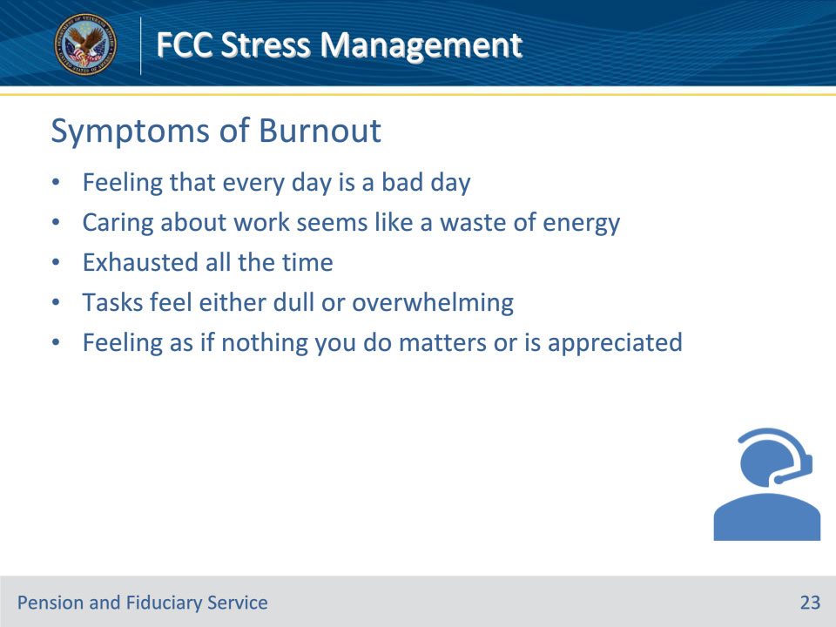

**Slide notes**

Instructor Notes

Burnout

You want to ensure you adopt healthy habits: get regular exercise, get plenty of rest, and eat well. Set boundaries: If you have trouble saying “no,” remind yourself that saying “no” allows you to say “yes” to things that really matter.

Symptoms of Burnout

• Every day is a bad day

• Caring about work seems like a total waste of energy

• You’re exhausted all the time

• Most of your day is spent on tasks that feel either dull or overwhelming

• You feel as if nothing you do makes a difference or is appreciated

**Slide 24 - Burnout Repair**

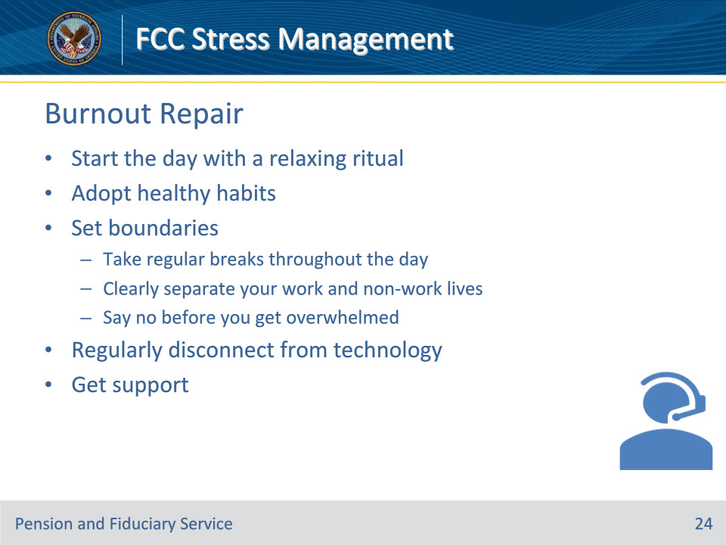

**Slide notes**

Instructor Notes

Burnout Repair

• Start the day with a relaxing ritual

• Adopt healthy habits

• Set boundaries

• Take regular breaks throughout the day

• Clearly separate your work and non-work lives

• Say no before you get overwhelmed

• Regularly disconnect from technology

• Get support

**Slide 25 - Rest & Relaxation**

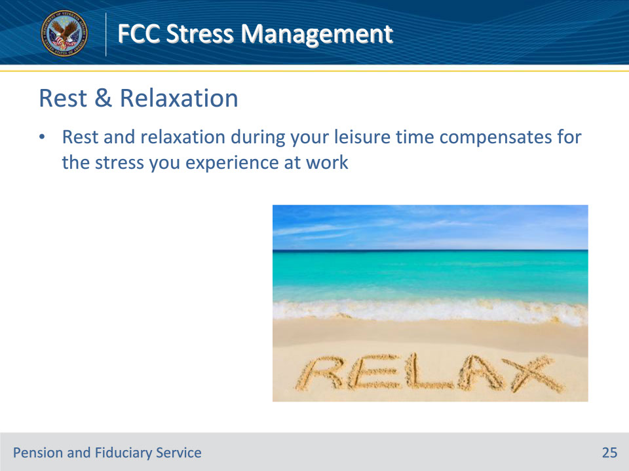

**Slide notes**

Instructor Notes

Rest and Relaxation

Rest and relaxation during your leisure time compensate for the stress you experience at work.

**Slide 26 - Get Enough Sleep**

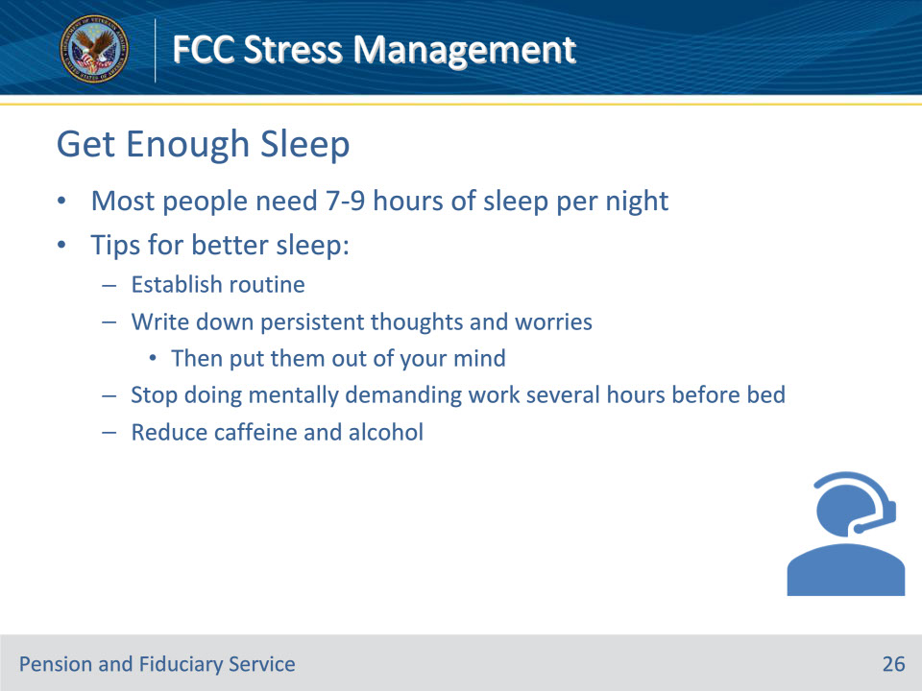

**Slide notes**

Instructor Notes

Get Enough Sleep

• Most people need 7-9 hours of sleep per night

• If you have trouble falling asleep, try these tips:

• Establish a routine

• Write down persistent thoughts and worries and then put them out of your mind

• Stop doing mentally demanding work several hours before bed

• Cut the caffeine and alcohol

**Slide 27 - Sports, Hobbies, & Activities**

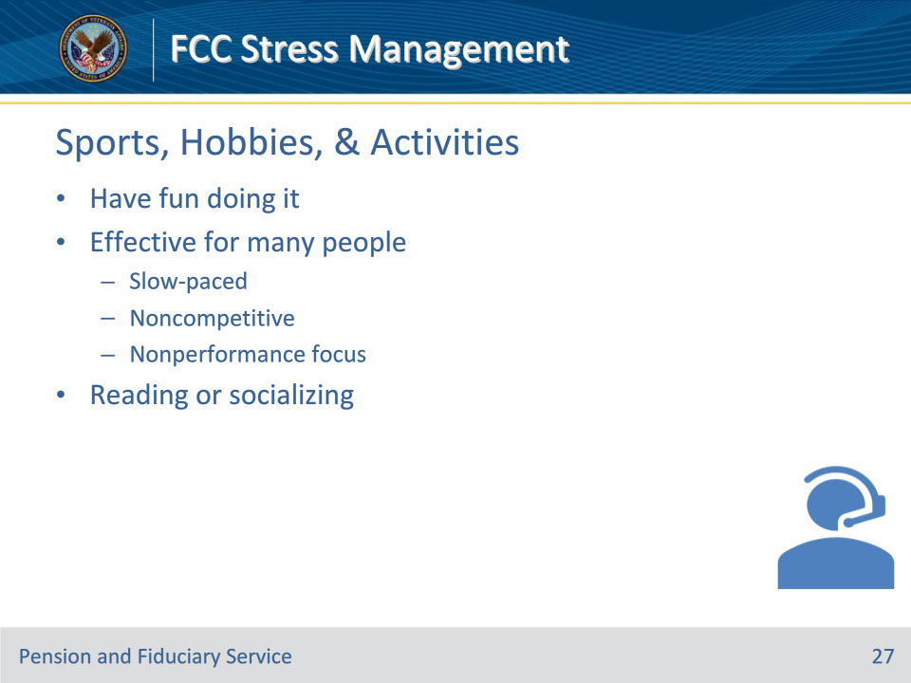

**Slide notes**

Instructor Notes

Engage in a Sport, Hobby, or Activity

• Have fun doing it

• Slow-paced, non-competitive, nonperformance focus works for many

• Reading or socializing can also be restful

**Slide 28 - Vacations**

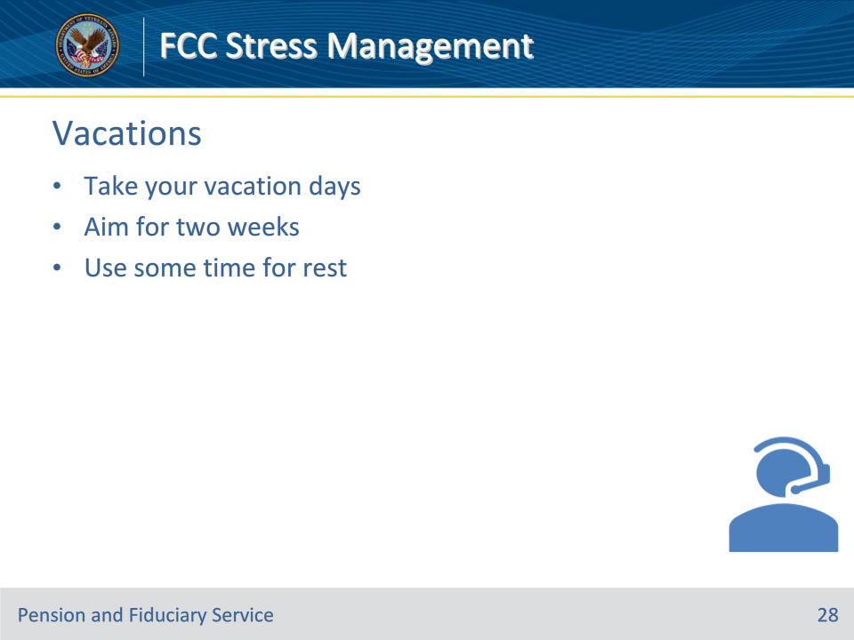

**Slide notes**

Instructor Notes

Take a Vacation

• Take your vacation days

• Aim for two weeks

• Use some time for rest

**Slide 29 - Knowledge Check**

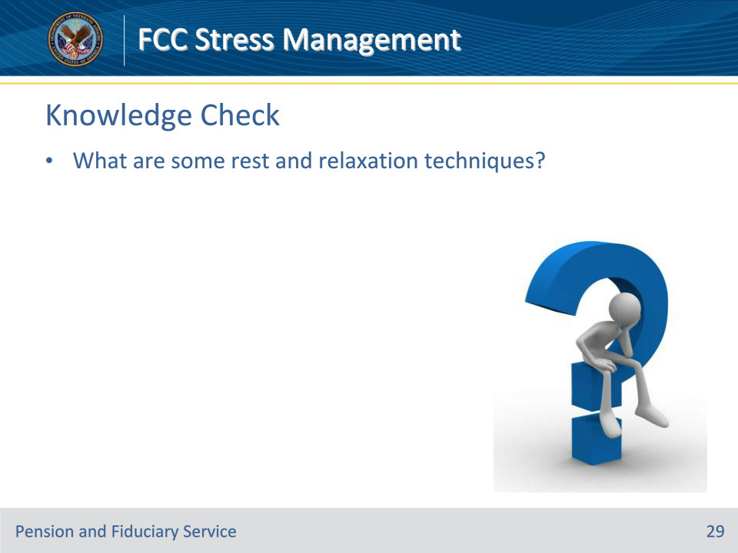

**Slide notes**

Instructor Notes

What are some rest and relaxation techniques?

(Answers on the next slide)

• Get enough sleep

• Engage in a sport, hobby, or activity

• Take a vacation

**Slide 30 - Answers**

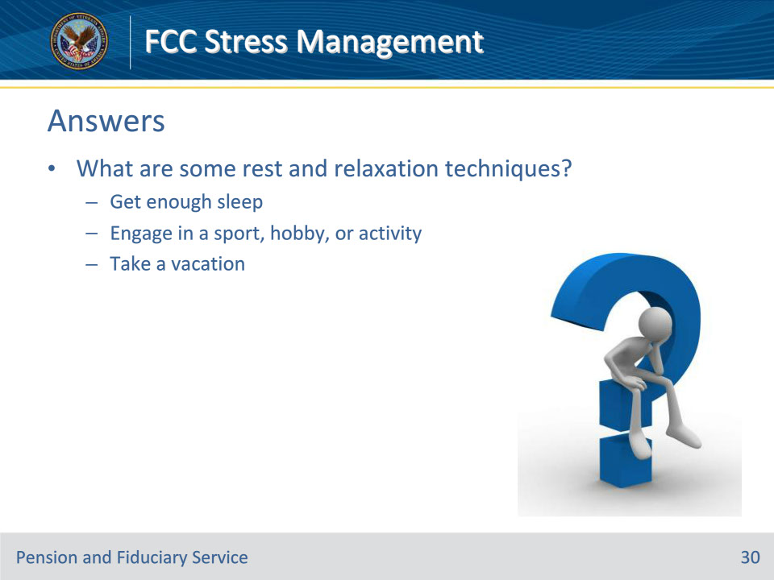

**Slide notes**

Instructor Notes

What are some rest and relaxation techniques?

Answers:

• Get enough sleep

• Engage in a sport, hobby, or activity

• Take a vacation

**Slide 31 - Resilience**

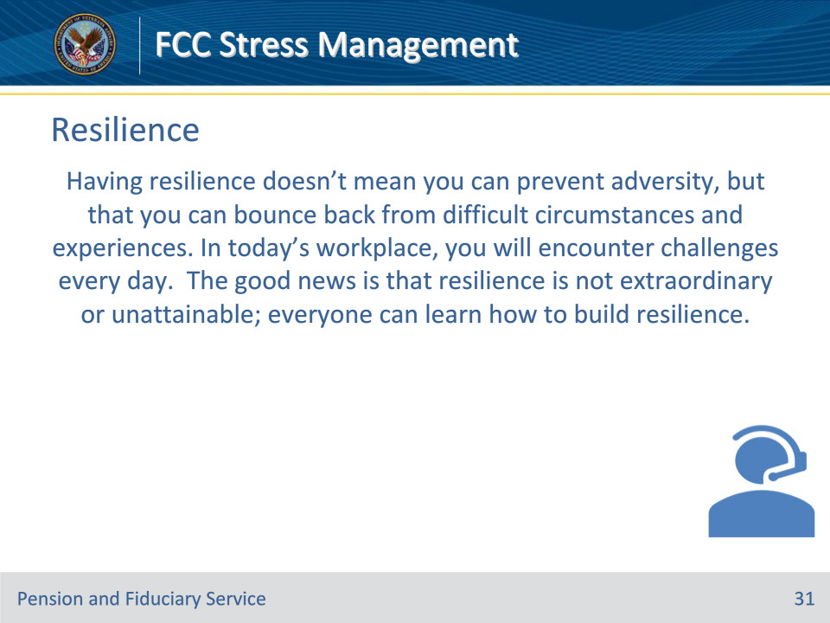

**Slide notes**

Instructor Notes

Having resilience doesn’t mean you can prevent adversity, but that you can bounce back from difficult circumstances and experiences. In today’s workplace, you will encounter challenges every day. The good news is that resilience is not extraordinary or unattainable; everyone can learn how to build resilience.

**Slide 32 - Self-Esteem**

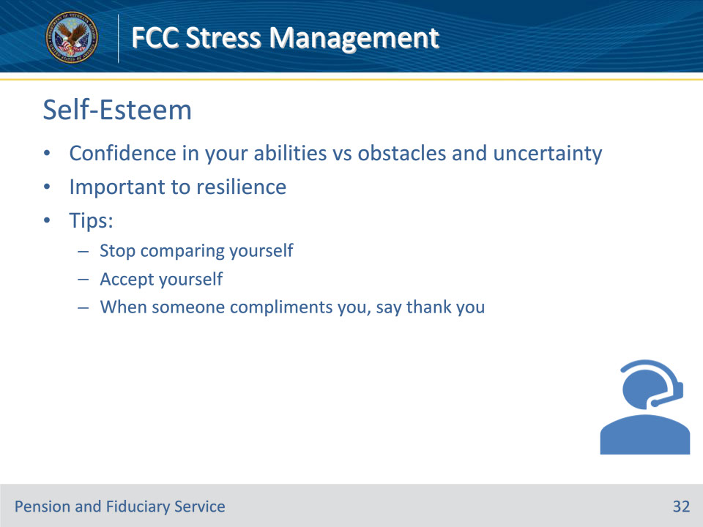

**Slide notes**

Instructor Notes

Strong Self-Esteem

Self-esteem is important to resilience because having resilience depends in part on having confidence in your own abilities in the face of obstacles and uncertainty.

Tips:

• Stop comparing yourself

• Accept yourself

• When someone compliments you, say thank you.

Accepting yourself doesn’t mean you don’t strive for self-improvement, but that you recognize your worth just as you are.

**Slide 33 - Negative Self Talk**

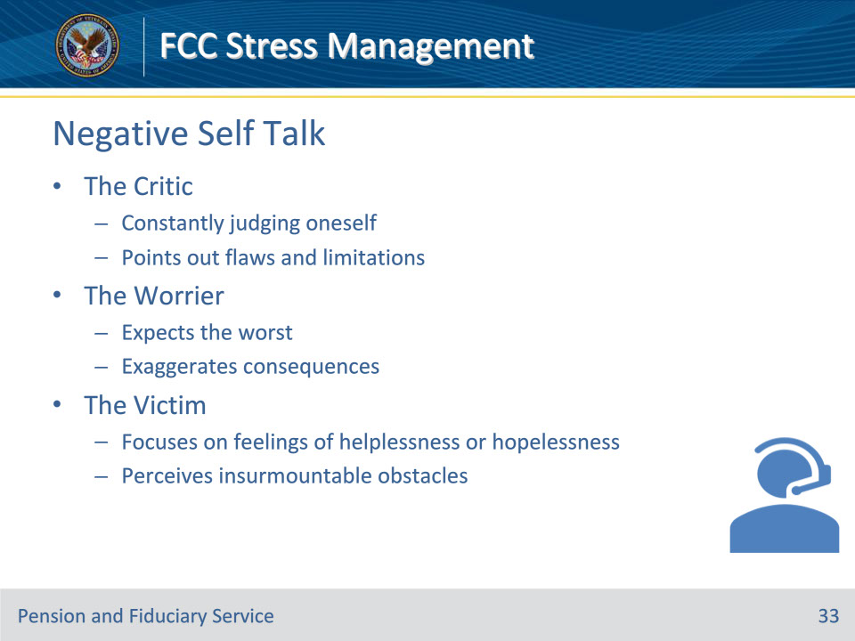

**Slide notes**

Instructor Notes

Recognize Negative Self Talk

If your thoughts are negative, it will be more difficult for you to build and maintain your self-confidence and self-esteem. Here are three of the most common negative self talk voices: the critic, the worrier, and the victim.

The Critic

• Constantly judging and evaluating oneself

• Points out flaws and limitations

• Typical self-talk: “I could have done better…”

The Worrier

• Expects the worst

• Exaggerates the consequences of “the worst” (potential negative event)

• Typical self-talk: “What if…?”

The Victim

• Focuses on feelings of helplessness or hopelessness

• Perceives insurmountable obstacles in accomplishing goals

• Typical self-talk: “I’ll never be able to…”

**Slide 34 - Monitor Self Talk**

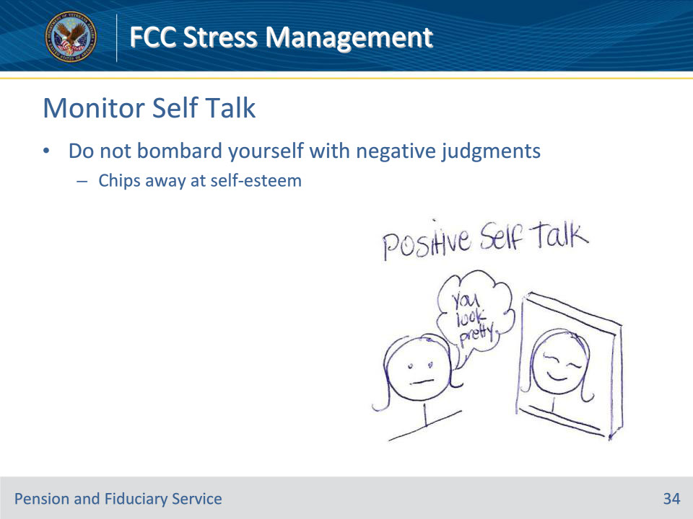

**Slide notes**

Instructor Notes

Monitor Your Self-Talk

You believe what you tell yourself. If you are constantly bombarding yourself with negative judgments, it will chip away at your self-esteem.

**Slide 35 - Support Network**

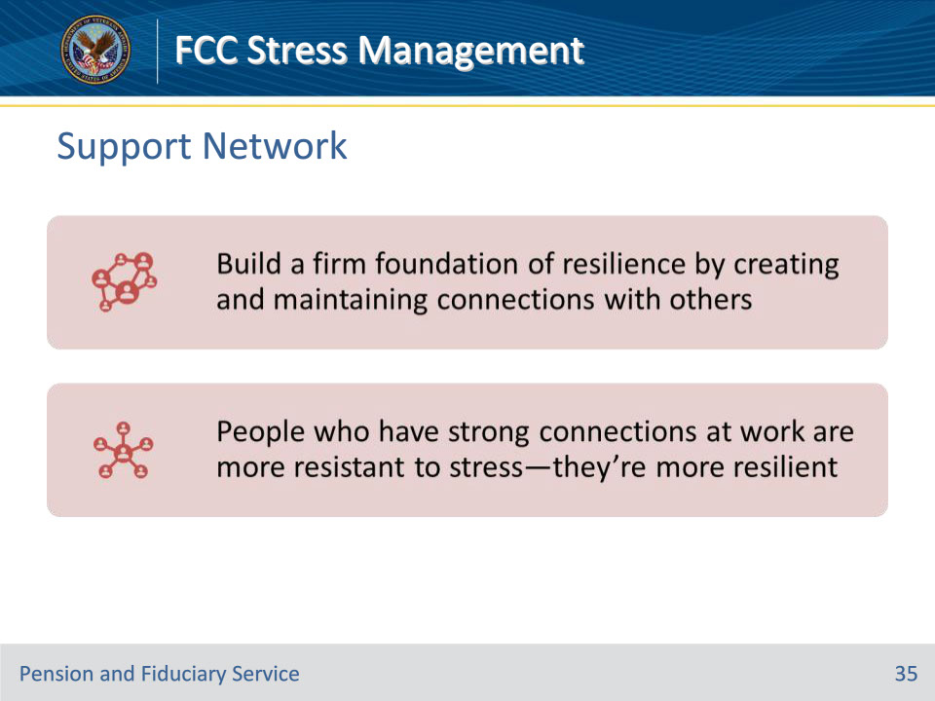

**Slide notes**

Instructor Notes

Identify Your Support Network

A second way to build a firm foundation of resilience is to make and maintain connections with others. The first aspect was strengthening your sense of self; this element is about strengthening your relationships with others.

People who have strong connections at work are more resistant to stress—they’re more resilient.

**Slide 36 - Building Support Networks**

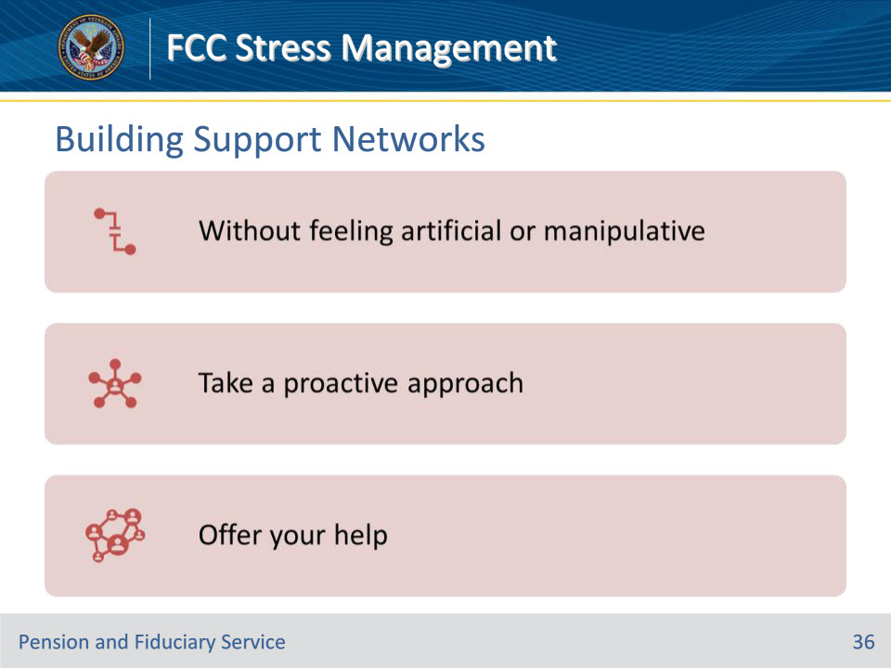

**Slide notes**

Instructor Notes

How to Build Your Support Network

If you need to build your support network, you may wonder how to do it without it feeling artificial or manipulative. It should never feel that way. You should be genuinely interested in each person as an individual, and not just for what he or she can do for you.

Take a proactive approach to building your support network. The more you reach out to others, the more likely you are to find genuine connections with others.

Offer your help. It feels good to help others, and it will strengthen your connection with that person.

**Slide 37 - Proactive Approach**

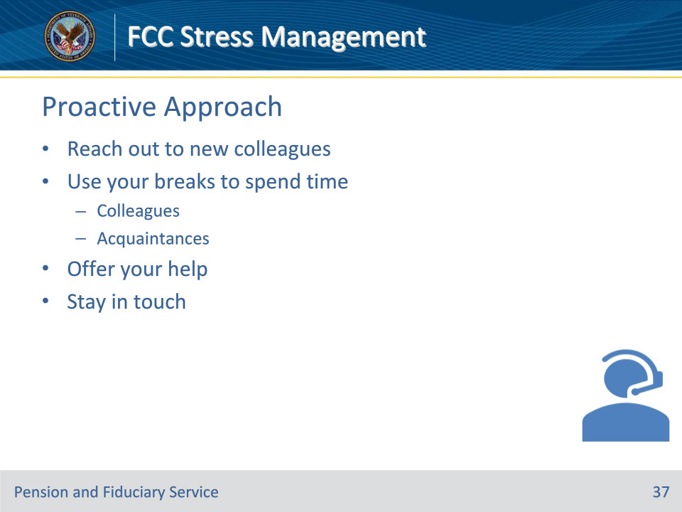

**Slide notes**

Instructor Notes

Take a Proactive Approach

Take a proactive approach to building your support network. The more you reach out to others, the more likely you are to find genuine connections with others.

• Reach out to new colleagues

• Use your breaks to spend time with a variety of colleagues and acquaintances

• Offer your help

• Stay in touch

**Slide 38 - Strengthen Connections**

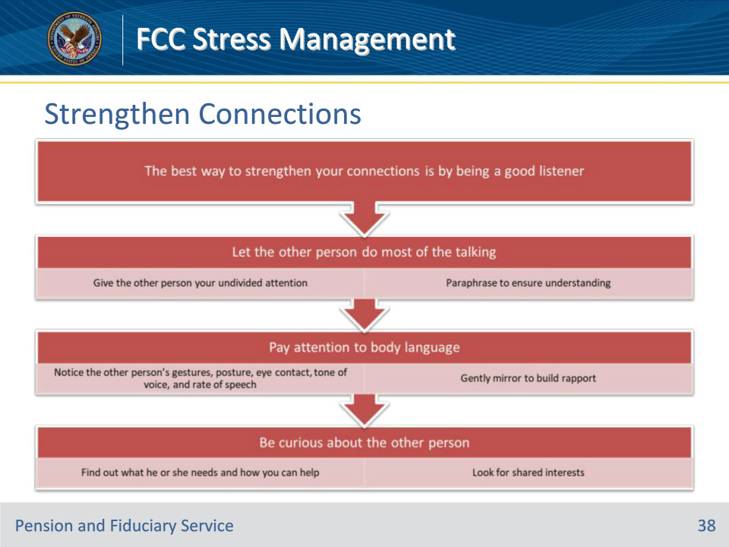

**Slide notes**

Instructor Notes

How to Strengthen Your Connection

The best way to strengthen your connections is by being a good listener.

• Let the other person do most of the talking

• Give the other person your undivided attention

• Paraphrase to ensure understanding

• Pay attention to body language

• Notice the other person’s gestures, posture, eye contact, tone of voice, and rate of speech

• Gently mirror to build rapport

• Be curious about the other person

• Find out what he or she needs and how you can help

• Look for shared interests

**Slide 39 - Work Through Conflict**

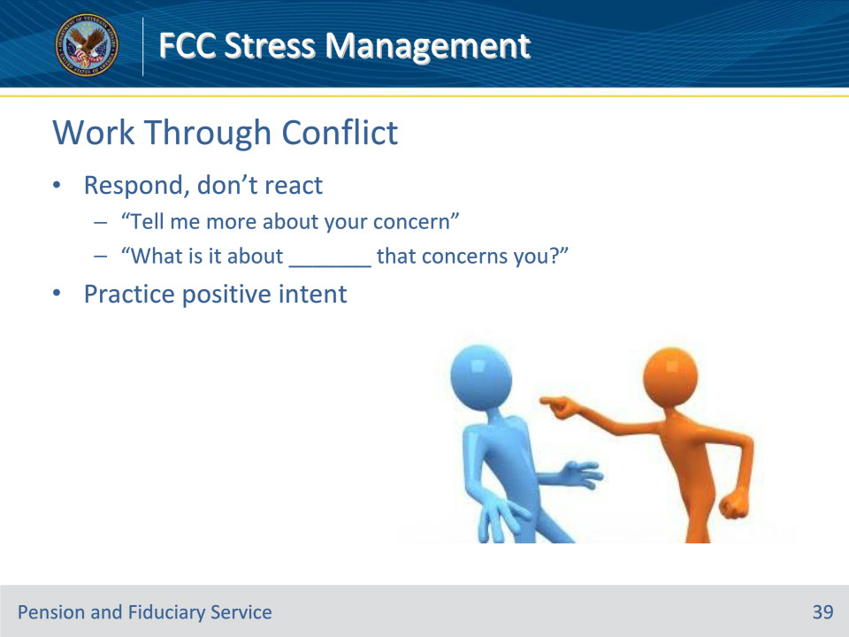

**Slide notes**

Instructor Notes

Work Through Conflict

• Respond, don’t react

• “Tell me more about your concern”

• “What is it about _______ that concerns you?”

• Practice positive intent

**Slide 40 - Goals**

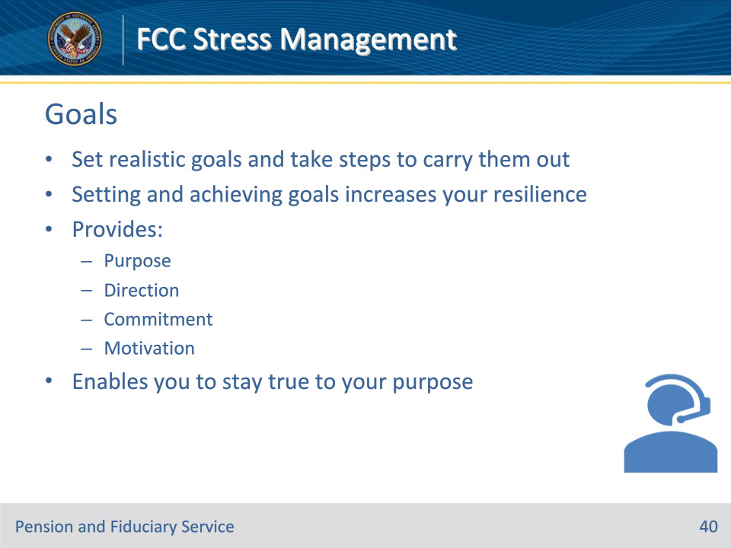

**Slide notes**

Instructor Notes

Set Goals and Achieve Them

• Building your foundation of resilience includes setting realistic goals and taking steps to carry them out.

• Setting and achieving goals increases your resilience because goals provide purpose, direction, commitment, and motivation.

• It enables you to stay true to your purpose no matter what is going on around you.

**Slide 41 - Setting Goals**

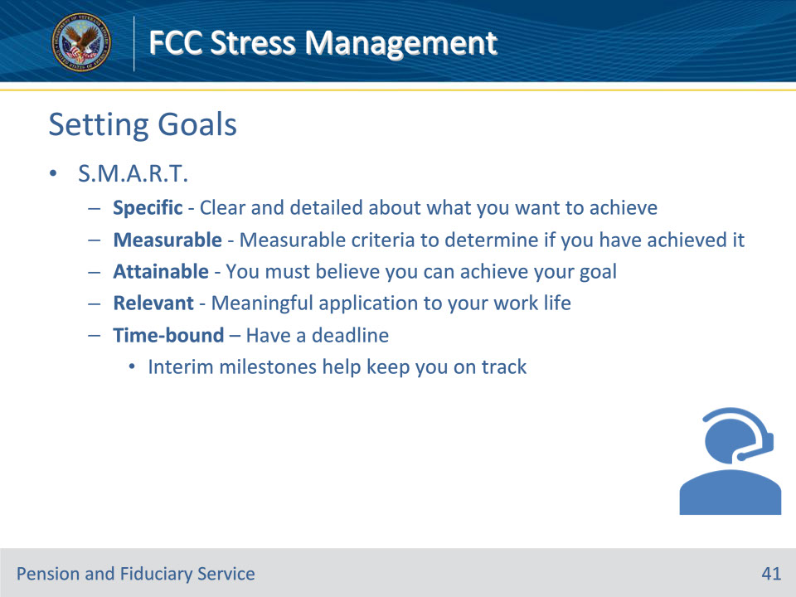

**Slide notes**

Instructor Notes

How to Set Goals

Think of the acronym S.M.A.R.T.

• Specific - Be clear and detailed about what you want to achieve.

• Measurable - Your goals must have criteria that can be measured to determine if you have achieved it.

• Attainable - You must believe you can achieve your goal (otherwise, it’s just a wish).

• Relevant- Your goal must have some meaningful application to your work life.

• Time-bound - Every goal must have a deadline. Interim milestone deadlines will help keep you on track.

**Slide 42 - Knowledge Check**

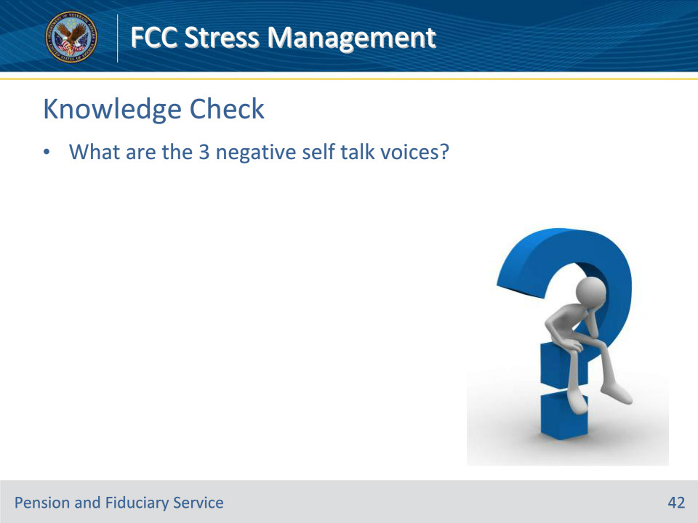

**Slide notes**

Instructor Notes

What are the 3 negative self talk voices?

(Answers on the next slide)

• The Critic

• The Worrier

• The Victim

**Slide 43 - Answers**

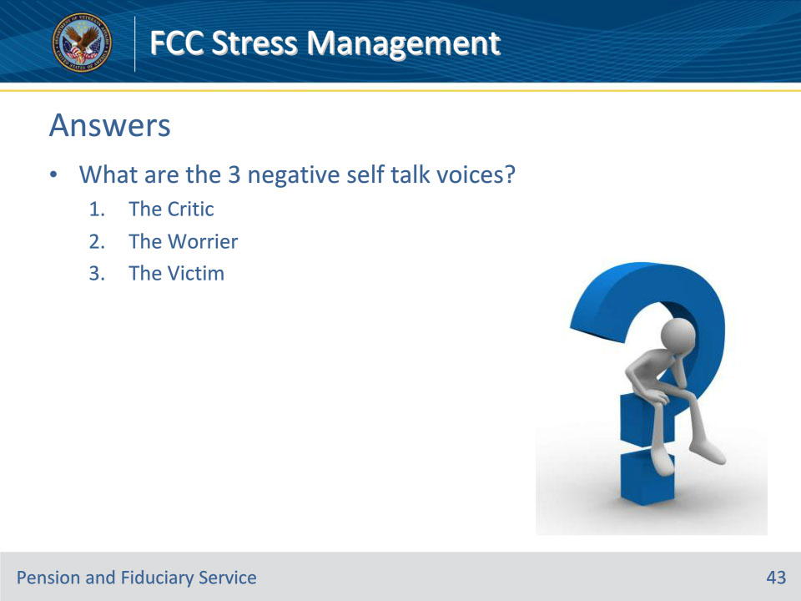

**Slide notes**

Instructor Notes

What are the 3 negative self talk voices?

Answers:

• The Critic

• The Worrier

• The Victim

**Slide 44 - Knowledge Check**

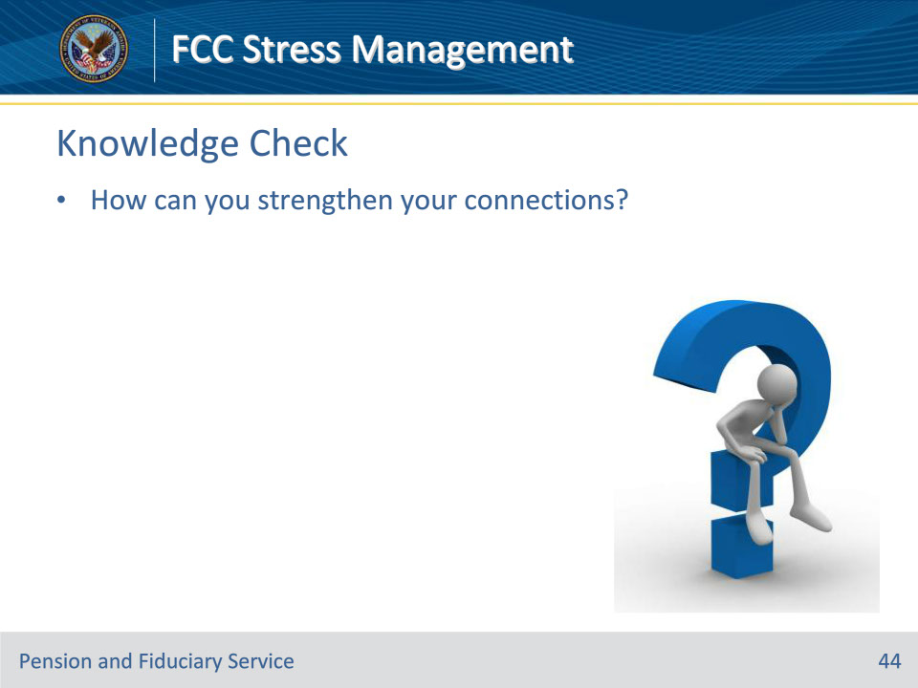

**Slide notes**

Instructor Notes

How can you strengthen your connections?

(Answers on the next slide)

• Connect through listening

• Work through conflict

**Slide 45 - Answers**

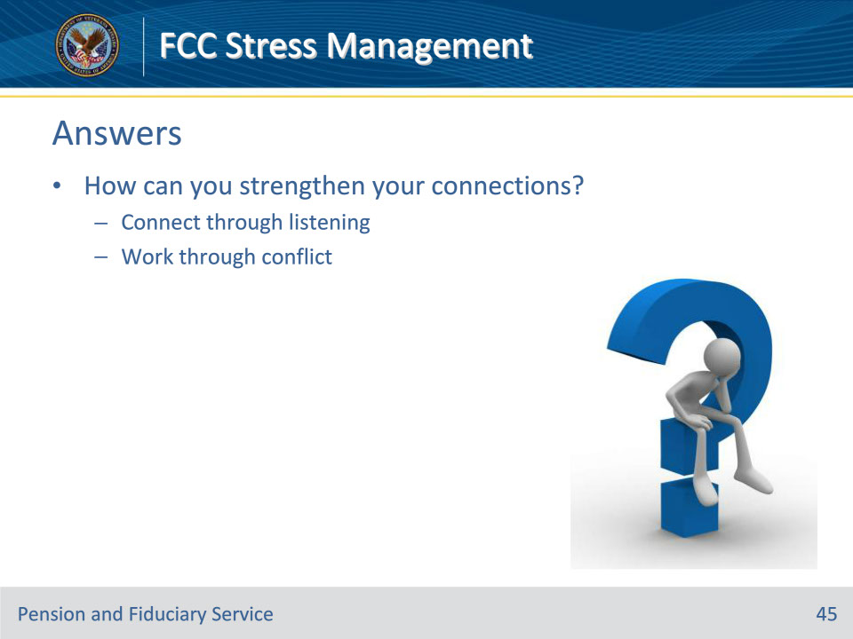

**Slide notes**

Instructor Notes

How can you strengthen your connections?

Answers:

• Connect through listening

• Work through conflict

**Slide 46 - Change**

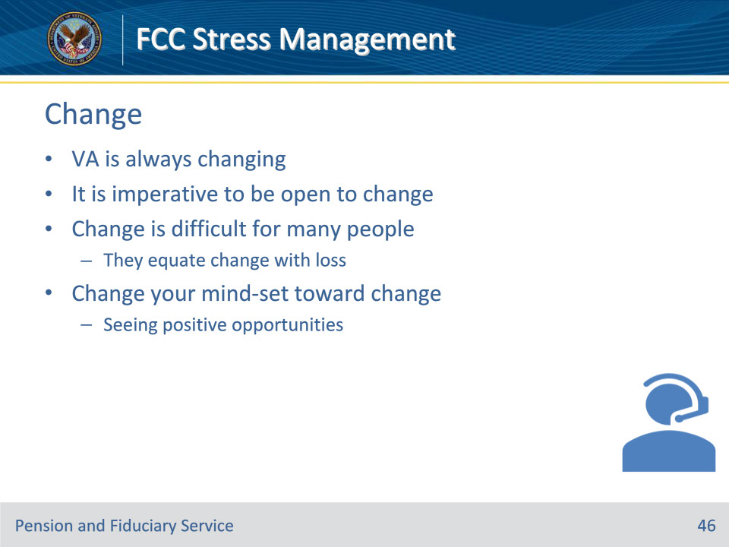

**Slide notes**

Instructor Notes

The VA is always changing. It is imperative to be open to change. In this position, change can happen daily. Change is difficult for many people because they equate change with loss.

Becoming more resilient means changing your mindset toward change and seeing the positive opportunities it holds.

**Slide 47 - Change Difficulties**

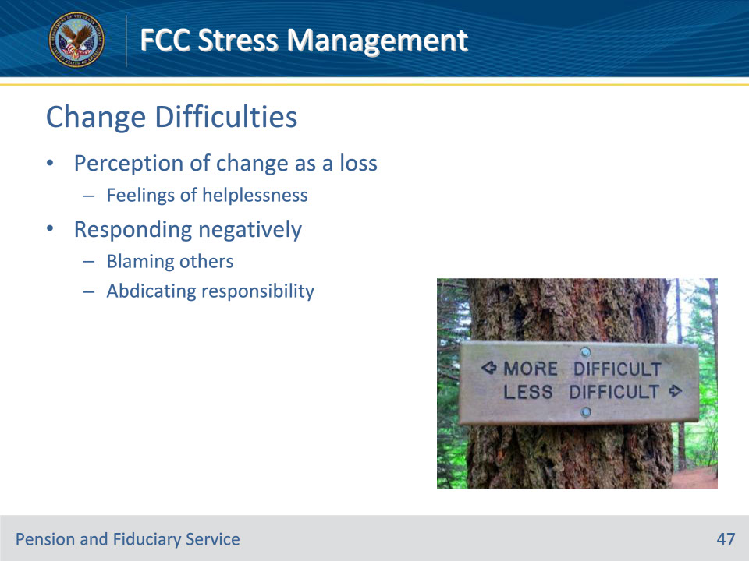

**Slide notes**

Instructor Notes

Why is Change Difficult

• Some people perceive change as a loss and feel helpless

• They may respond negatively, blaming others and abdicating responsibility.

**Slide 48 - 4 Stages of Change**

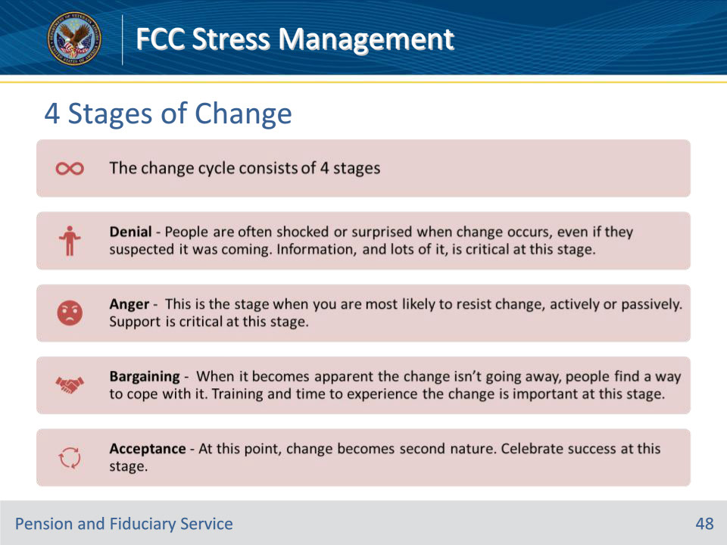

**Slide notes**

Instructor Notes

The Four Stages of Change

The change cycle consists of four stages, similar to the stages of grief:

• Denial – People are often shocked or surprised when change occurs, even if they suspected it was coming. Information, and lots of it, is critical at this stage.

• Anger – This is the stage when you are most likely to resist change, actively or passively. Support is critical at this stage.

• Bargaining – When it becomes apparent, the change isn’t going away, people find a way to cope with it. Training and time to experience the change are important at this stage.

• Acceptance – At this point, change becomes second nature. Celebrate success at this stage.

**Slide 49 - Responses to Change**

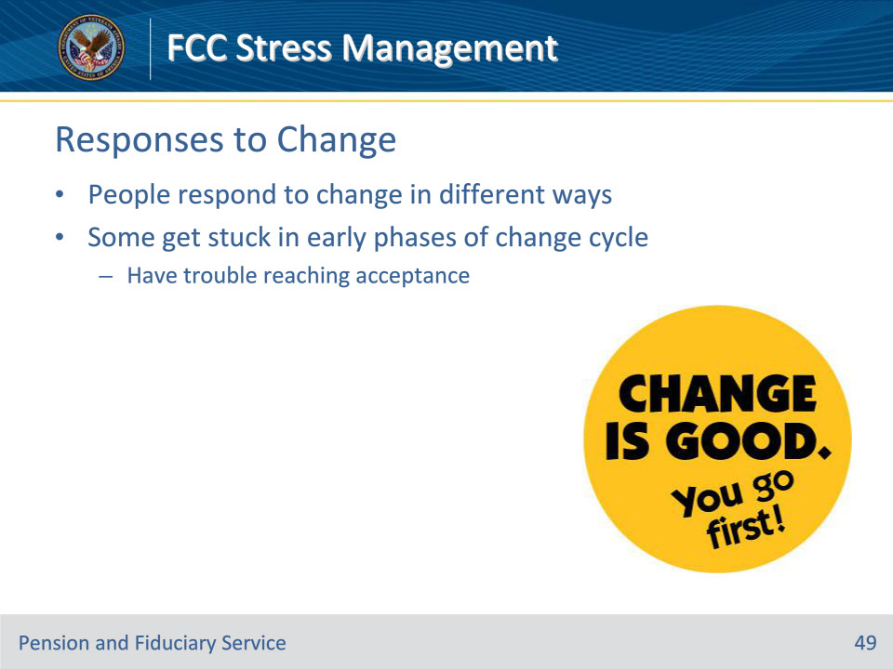

**Slide notes**

Instructor Notes

Personal Responses to Change

People respond to change in different ways. Some people get stuck in the early phases of the change cycle and have trouble reaching acceptance.

**Slide 50 - Resistance**

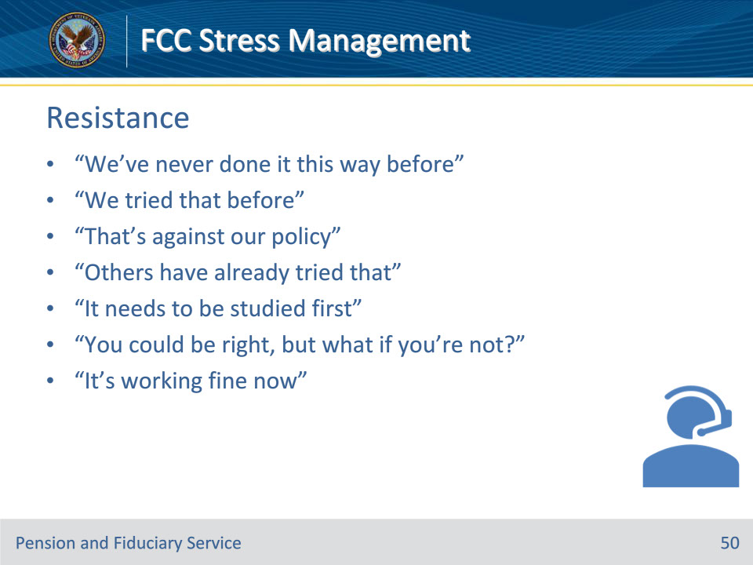

**Slide notes**

Instructor Notes

Recognizing and Overcoming Resistance

Obviously, resisting change is unproductive in terms of increasing your resilience. If you’re unsure whether you tend to resist, read the “recognizing resistance” statements. If you’ve ever said any of these things, you have probably gotten stuck in resistance.

Recognizing Resistance

• “We’ve never done it this way before.”

• “We tried that before.”

• “That’s against our policy.”

• “Others have already tried that.”

• “It needs to be studied first.”

• “You could be right, but what if you’re not?”

• “It’s working fine now.”

**Slide 51 - Overcoming Resistance**

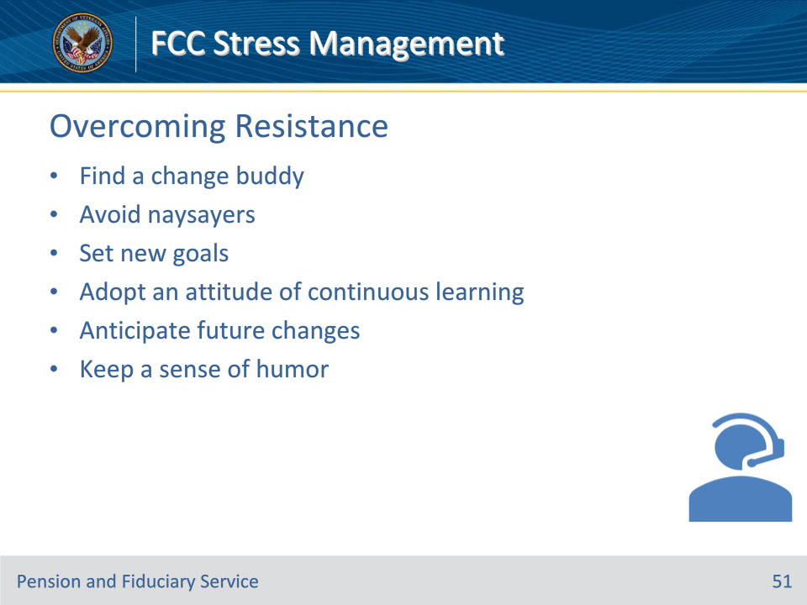

**Slide notes**

Instructor Notes

Overcoming Resistance

• Find a change buddy

• Avoid naysayers

• Set new goals

• Adopt an attitude of continuous learning

• Anticipate future changes

• Keep a sense of humor

**Slide 52 - Knowledge Check**

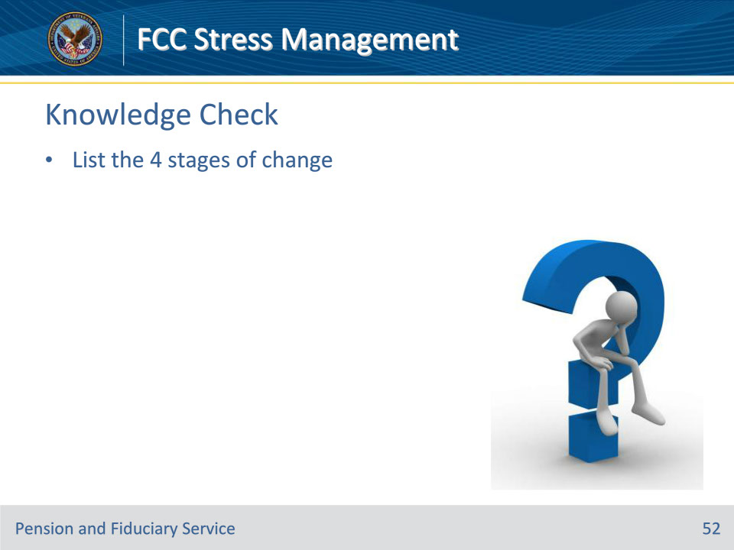

**Slide notes**

Instructor Notes

List the 4 stages of change

(Answers on the next slide)

• Denial

• Anger

• Bargaining

• Acceptance

**Slide 53 - Answers**

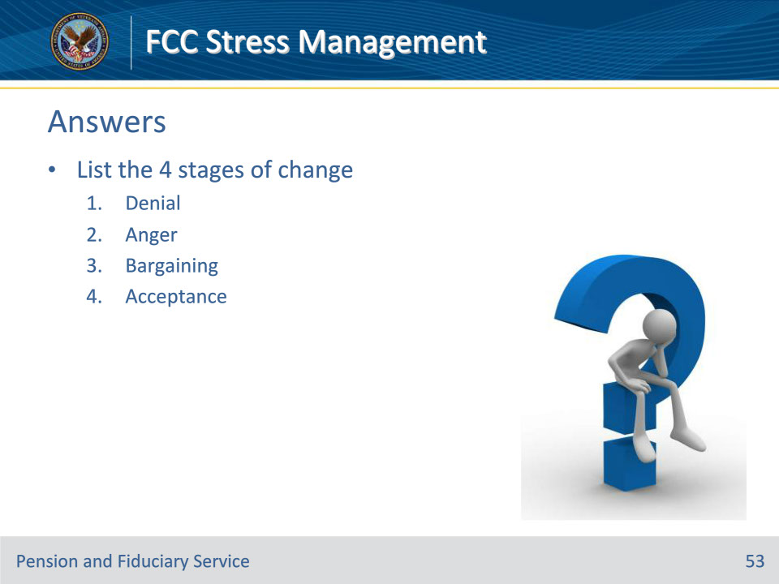

**Slide notes**

Instructor Notes

List the 4 stages of change

Answers:

• Denial

• Anger

• Bargaining

• Acceptance

**Slide 54 - Adapting to Change**

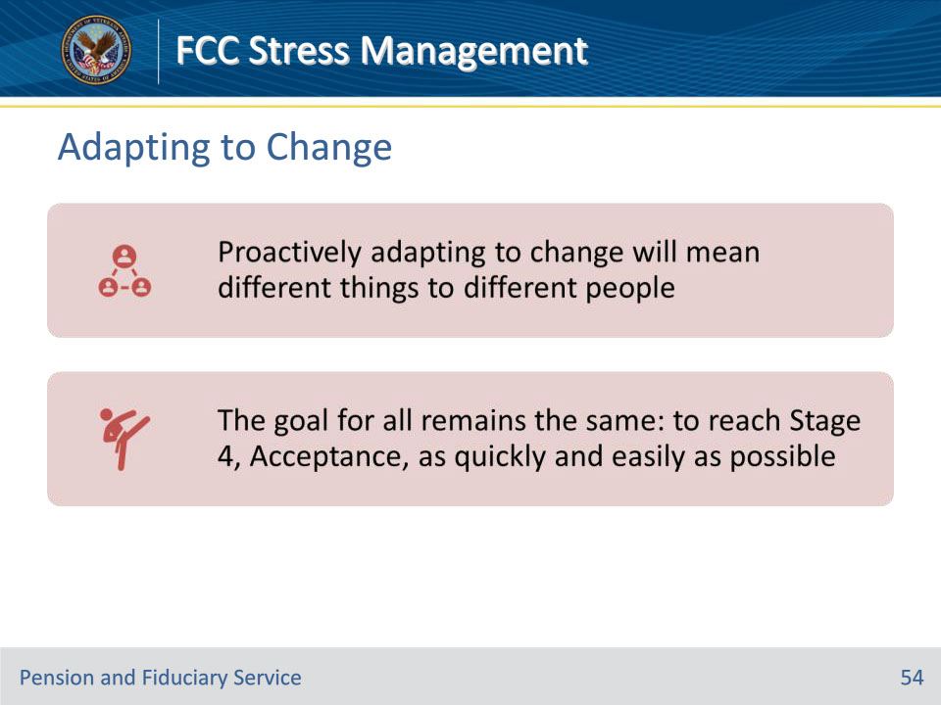

**Slide notes**

Instructor Notes

As we’ve seen, people have different responses to change. So proactively adapting to change will mean different things to different people.

The goal for all remains the same: to reach Stage 4, Acceptance, as quickly and easily as possible.

**Slide 55 - Approaches for Various Types**

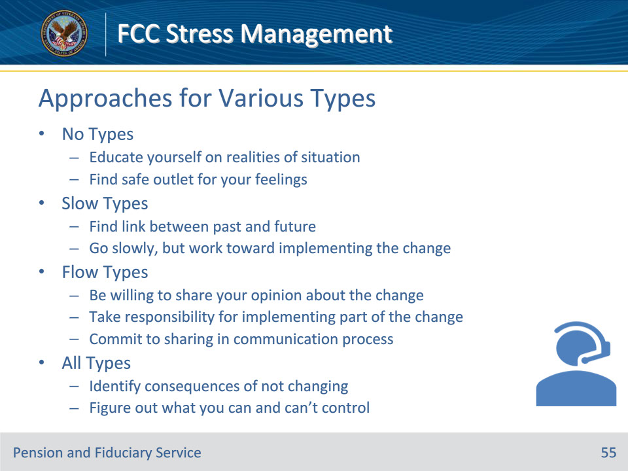

**Slide notes**

Instructor Notes

Best Approaches for Types

There are four best approach types:

• No Types

• Educate yourself on the realities of the situation

• Find a safe outlet for your feelings

• Slow Types

• Find a link between the past and the future

• Go slowly, but do something toward implementing the change

• Flow Types

• Be willing to share your opinion about the change

• Take responsibility for implementing part of the change: commit to sharing in the communication process

• All Types

• Identify the consequences of not changing

• Figure out what you can and can’t control

**Slide 56 - Flexible Thinking**

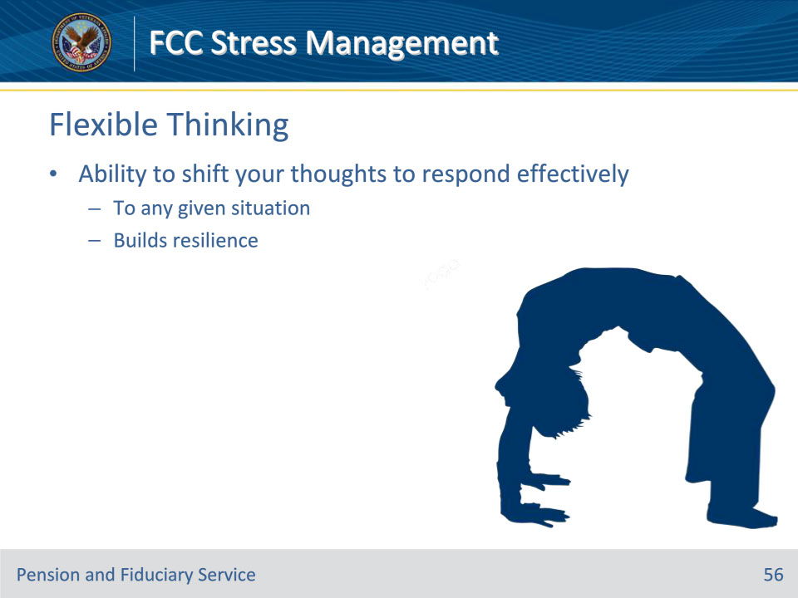

**Slide notes**

Instructor Notes

Flexible Thinking

Flexible thinking is about the ability to shift your thoughts in order to respond effectively to any given situation that “shakes” or “sways” you. That’s what builds resilience.

**Slide 57 - Mental Agility**

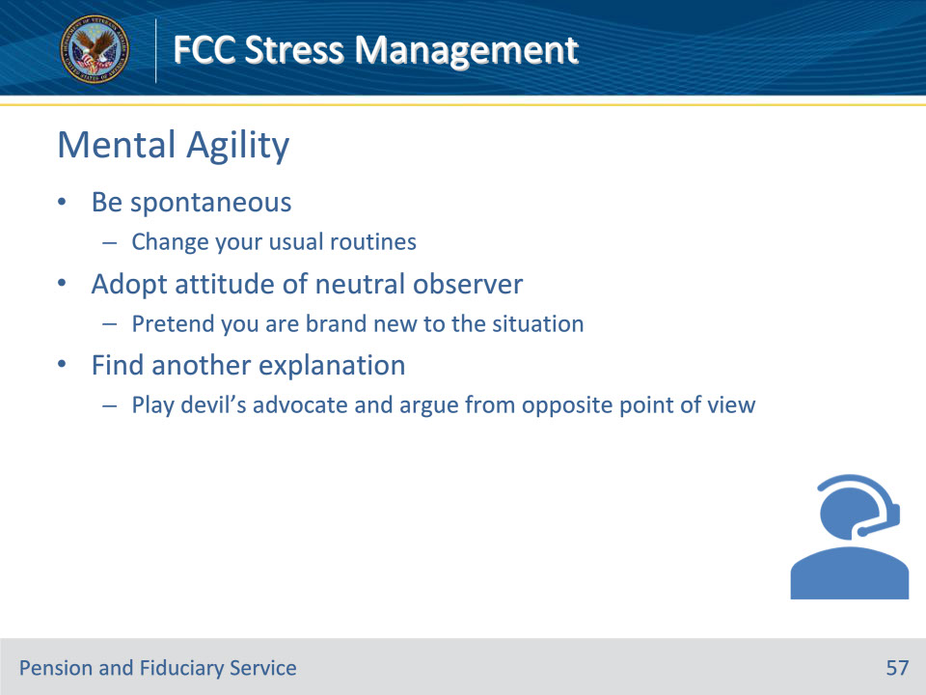

**Slide notes**

Instructor Notes

Mental Agility

• Be spontaneous - change your usual routines what you eat for lunch, your lunch companions, etc.

• Adopt the attitude of a neutral observer - pretend you are brand-new to the situation.

• Find another explanation - play devil’s advocate and argue from the opposite point of view.

**Slide 58 - Overcoming Obstacles**

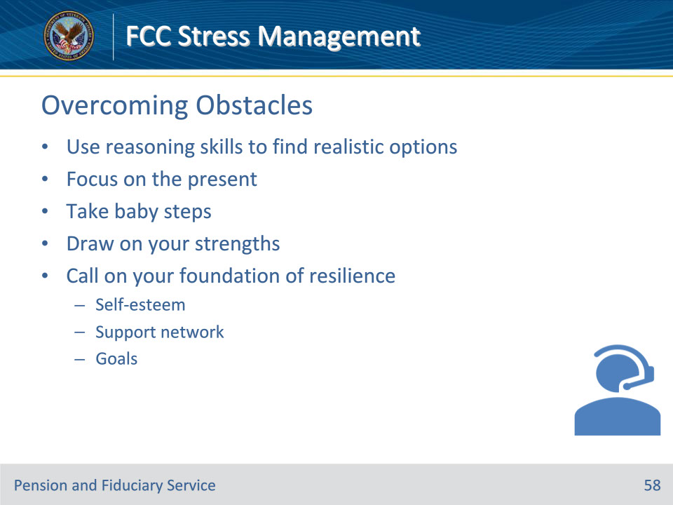

**Slide notes**

Instructor Notes

Overcoming Obstacles

Everything is going smoothly, but suddenly, you run into an obstacle. No need to panic; you have the tools to overcome difficulties.

• Use your reasoning skills to find realistic options

• Focus on the present

• Take baby steps

• Draw on your strengths

• Call on your foundation of resilience

• Self-esteem

• Support network

• Goals

**Slide 59 - Decisions Under Pressure**

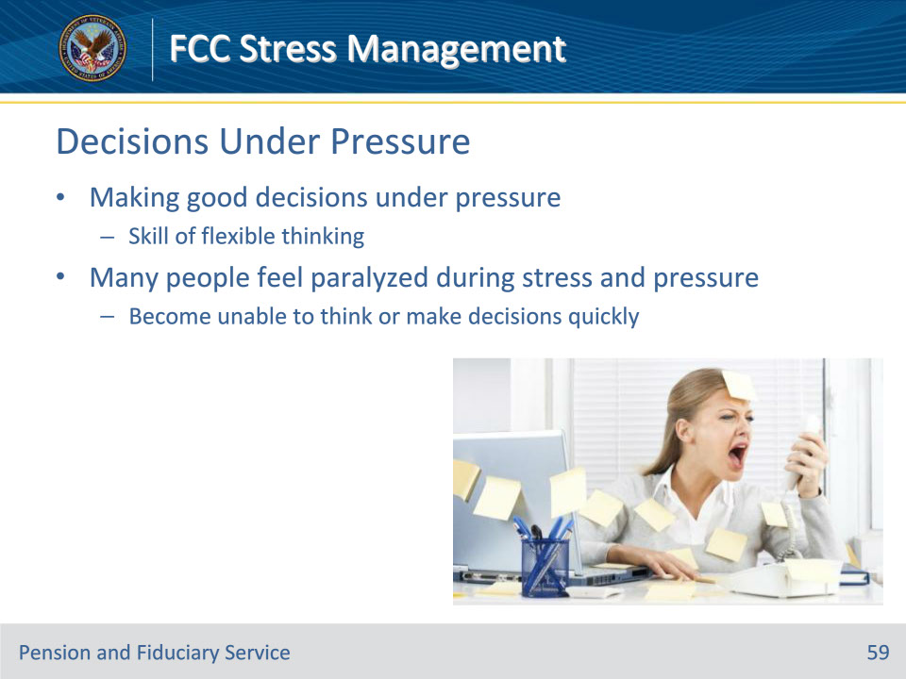

**Slide notes**

Instructor Notes

Making Decisions Under Pressure

Making good decisions under pressure is a skill of flexible thinking. Many people feel paralyzed in the face of stress and pressure and become unable to think or make decisions quickly.

**Slide 60 - Decisions Under Pressure**

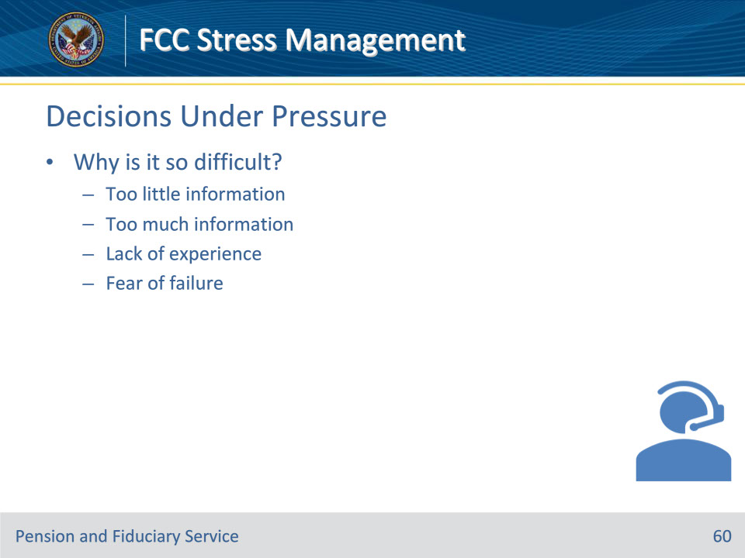

**Slide notes**

Instructor Notes

Why It’s So Difficult

• Too little information

• Too much information

• Lack of experience

• Fear of failure

**Slide 61 - Confidence**

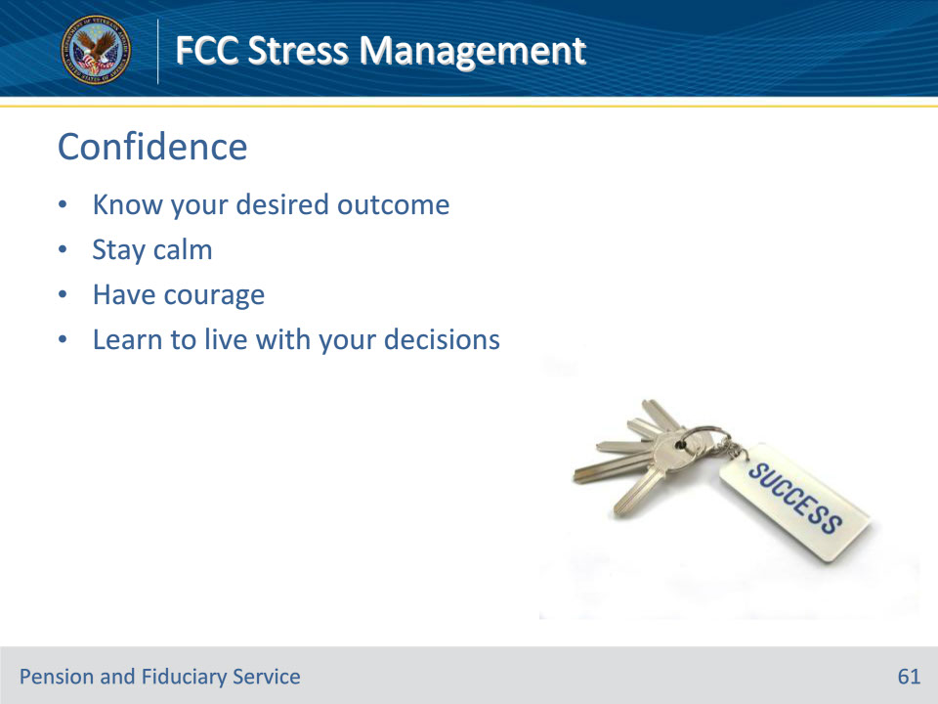

**Slide notes**

Instructor Notes

Keys to Building Your Confidence

• Know your desired outcome

• Stay calm

• Have courage

• Learn to live with your decisions

**Slide 62 - Coping Strategies**

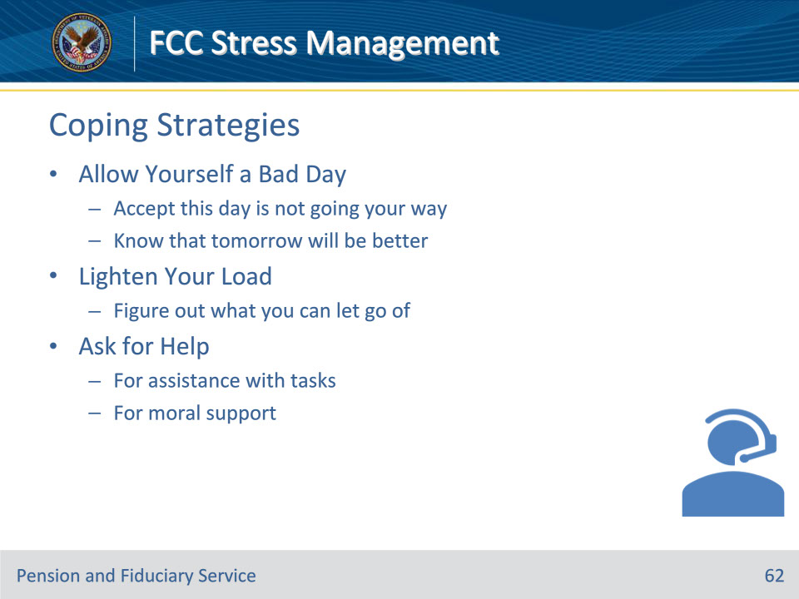

**Slide notes**

Instructor Notes

In-the-Moment Coping Strategies

In order to be resilient, you need some tools for dealing with being upset right when it is happening.

Allow Yourself a Bad Day

• Accept this day is not going your way. Know that tomorrow will be better.

Lighten Your Load

• Figure out what you can let go of

Ask for Help

• For assistance with tasks

• For moral support

**Slide 63 - Coping Strategies**

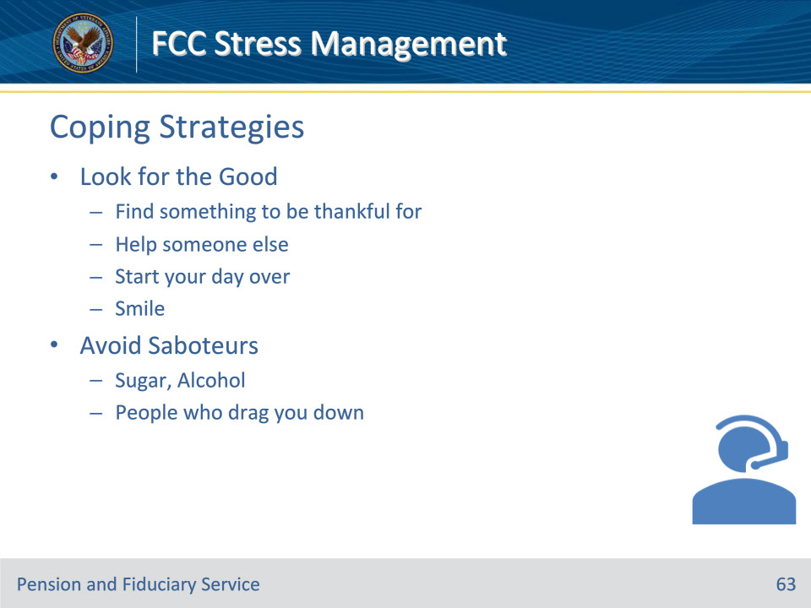

**Slide notes**

Instructor Notes

In-the-Moment Coping Strategies

In order to be resilient, you need some tools for dealing with being upset right when it is happening.

Look for the Good

• Find something to be thankful for

• Help someone else

• Start your day over

• Smile

Avoid Saboteurs

• Sugar, Alcohol

• People who drag you down

**Slide 64 - Questions?**

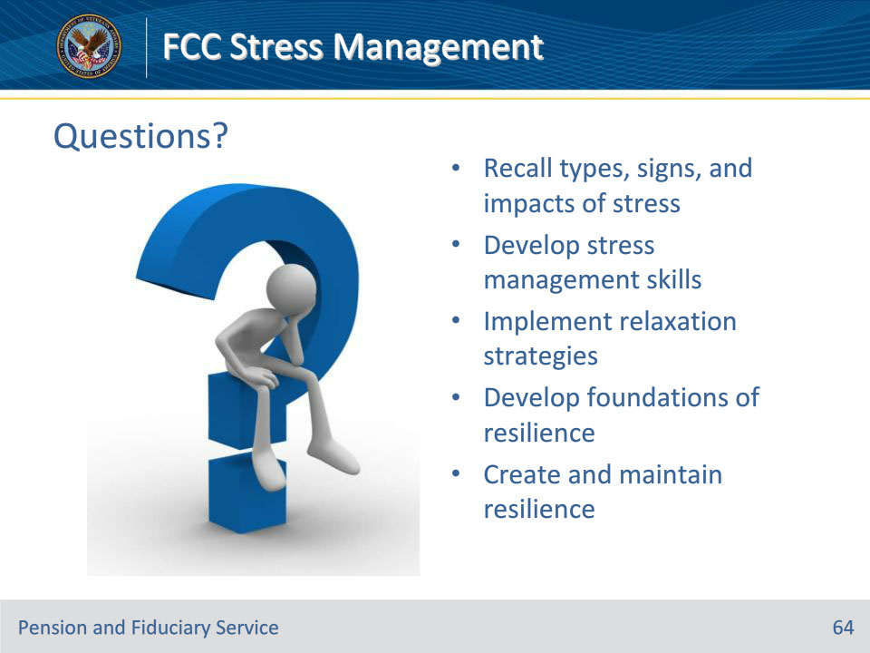

**Slide notes**

Instructor Notes:

(Recall) These are our learning objectives as stated from the beginning of the training:

• Recall types, signs, and impacts of stress

• Develop stress management skills

• Implement relaxation strategies

• Develop foundations of resilience

• Create and maintain resilience

Are there any additional questions?

Questions should be filtered through your QRT team. They will submit your questions to the Field Inquiry Tool (FIT) on your behalf.

**Slide 65 - TMS Survey/Assessment**

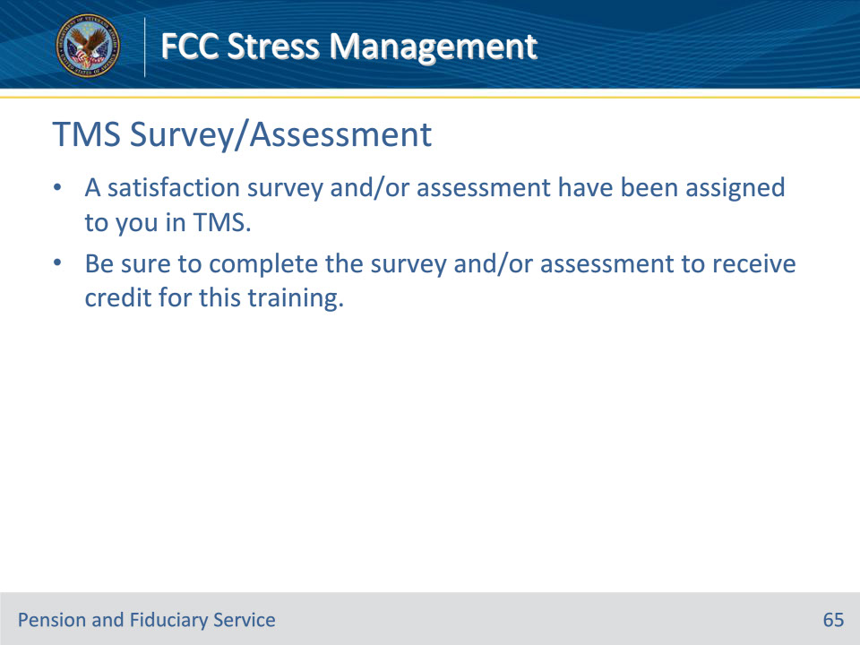

**Slide notes**

Instructor Notes

A satisfaction survey and/or assessment have been assigned to you in TMS.

Be sure to complete the survey and/or assessment to receive credit for this training.