**Slide 1 - FCC FOIA & Privacy Act**

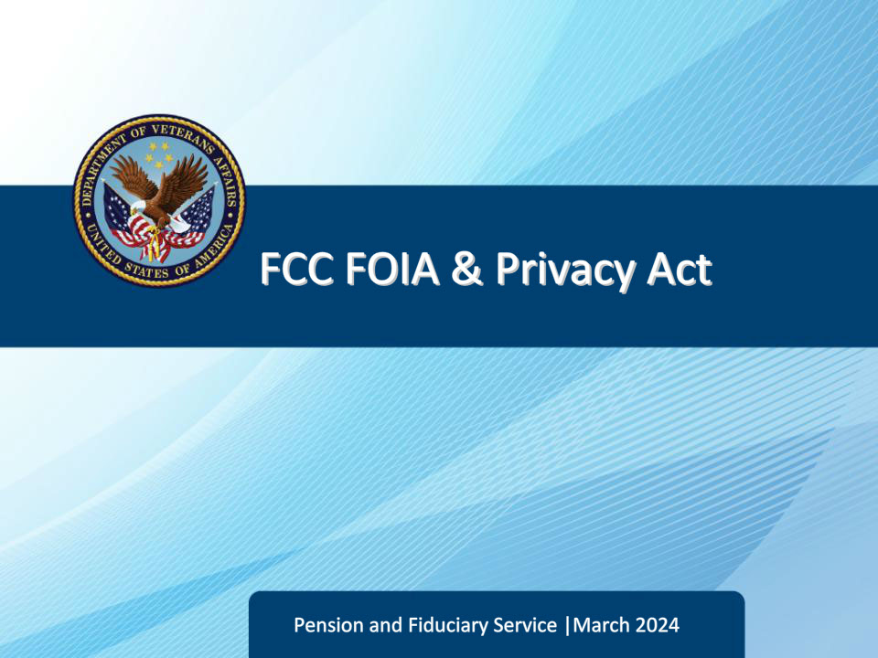

**Slide notes**

Course Description:

Welcome to the Fiduciary Contact Center Freedom of Information Act and Privacy Act training. In this course, Legal Administration Specialists will learn about the Freedom of Information Act (FOIA) and the Privacy Act (PA). The course covers the definition of FOIA and Privacy Act, the nine exemptions to FOIA, how to handle public and private information requests, the release of protected information, and the authorization of third parties.

**Slide 2 - Objectives**

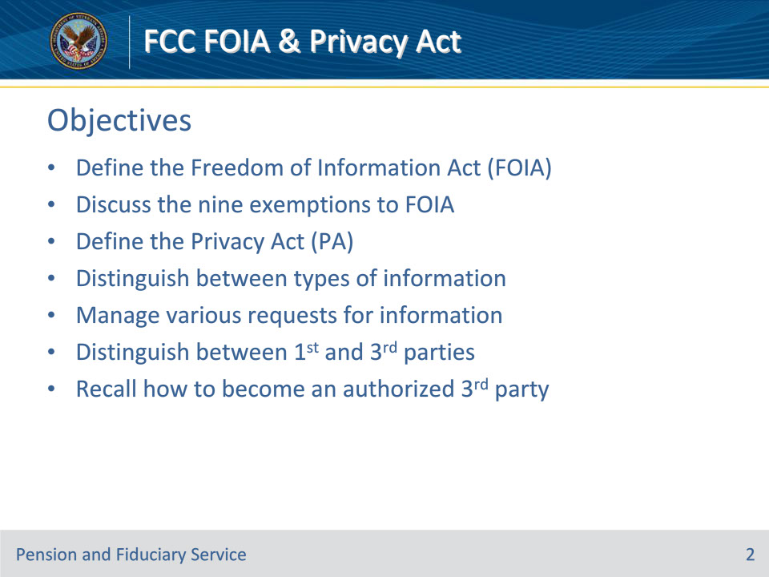

**Slide notes**

Instructor Notes:

At the end of this lesson, given the training and references, the learner will be able to do the following:

• Define the Freedom of Information Act (FOIA)

• Discuss the nine exemptions to FOIA

• Define the Privacy Act (PA)

• Distinguish between types of information

• Manage various requests for information

• Distinguish between 1st and 3rd parties

• Recall how to become an authorized 3rd party

**Slide 3 - References**

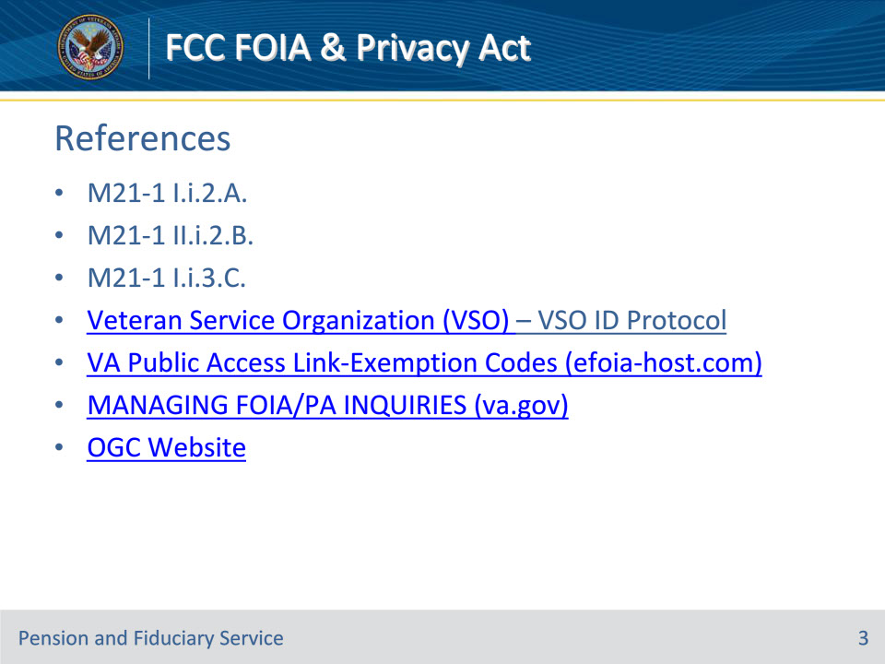

**Slide notes**

Instructor Notes:

These are the relevant references pertaining to this course:

• M21-1, Part I, Subpart i, Chapter 2, Section A - General Information on Power of Attorney (POA)

• M21-1, Part II, Subpart i, Chapter 2, Section B - Recording the Date of Receipt and Handling Signatures and Outdated Forms

• M21-1, Part I, Subpart i, Chapter 3, Section C, Other Information Disclosures

• Veteran Service Organization (VSO) – VSO ID Protocol

• VA Public Access Link-Exemption Codes (efoia-host.com)

• MANAGING FOIA/PA INQUIRIES (va.gov)

• OGC Website

**Slide 4 - Discussion**

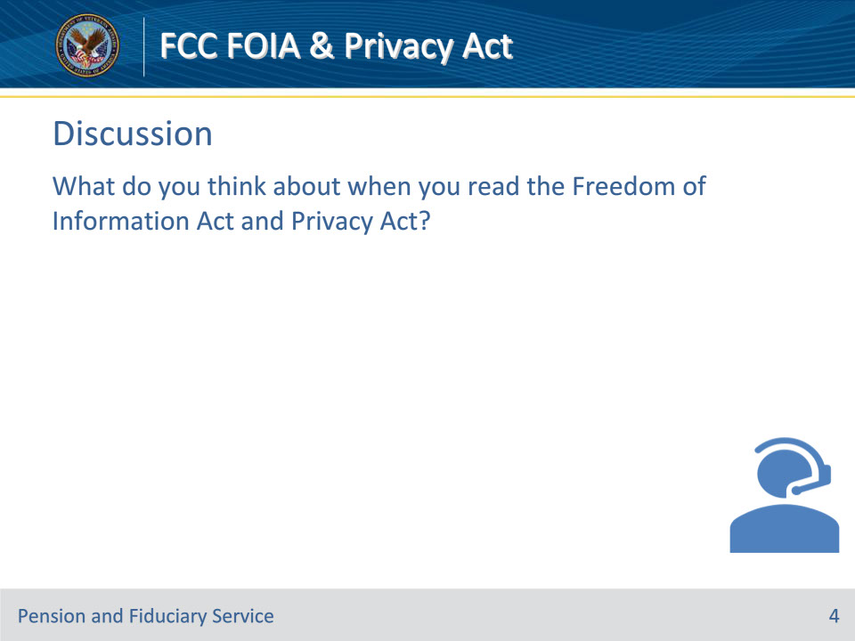

**Slide notes**

Policy Reference(s):

Instructor Notes

What do you think about when you read FOIA & Privacy Act?

Allow students to answer freely and express their ideas about FOIA & PA.

Each telephone interaction handled by the Fiduciary Call Center involves the Freedom of Information Act (FOIA) or the Privacy Act (PA).

This lesson is designed to give FCC LAS the understanding and tools needed to be able to make decisions related to FOIA and PA.

**Slide 5 - Slide 5**

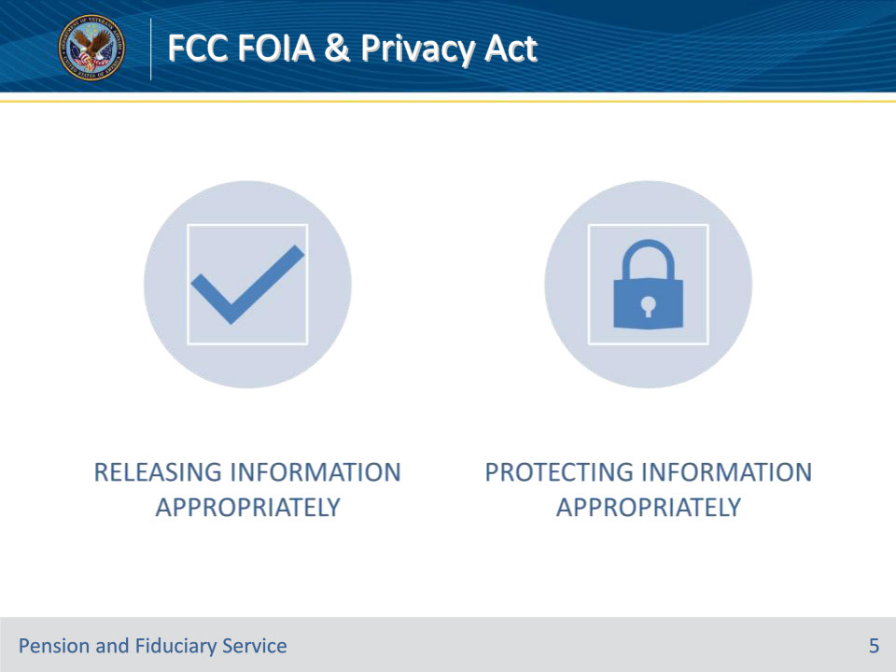

**Slide notes**

Policy Reference(s):

Instructor Notes

LASs are tasked with releasing and protecting information appropriately.

**Slide 6 - FOIA Definition**

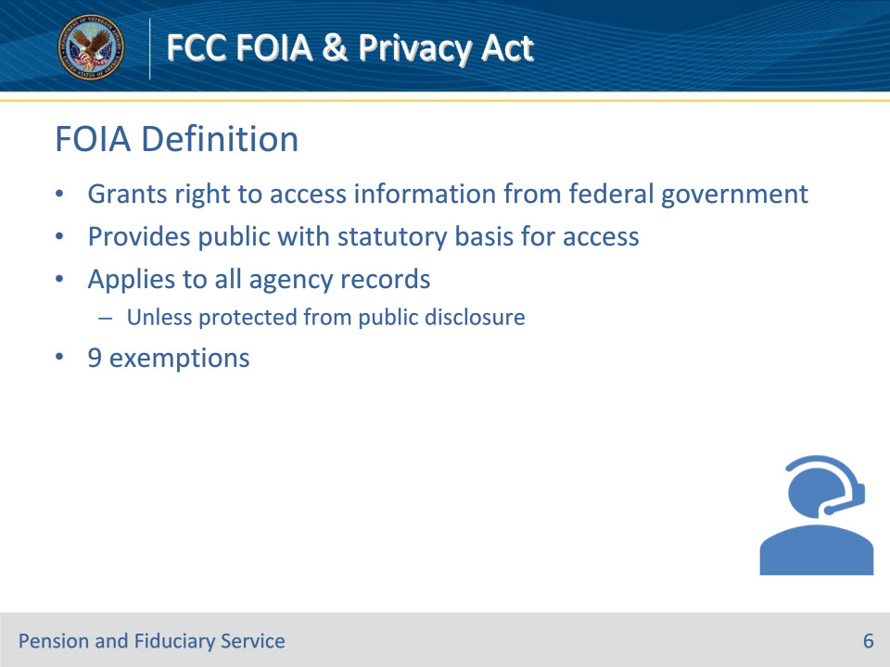

**Slide notes**

Policy Reference(s):

Instructor Notes

The Freedom of Information Act (FOIA) is a law that gives people the right to access information from the federal government. FOIA provides members of the public with a statutory basis for access to official agency information and applies to all agency records. Agency records are any items, collections, or groupings of information about an individual that is maintained by the Department.

Under the FOIA, agencies must disclose any information that is requested, unless that information is protected from public disclosure. There are nine (9) exemptions to FOIA that permit the withholding of information.

**Slide 7 - FOIA Exemptions**

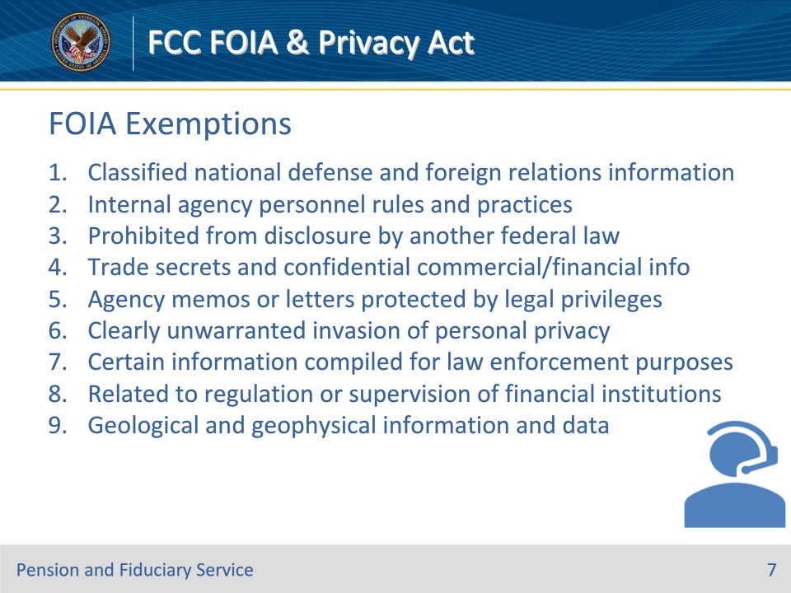

**Slide notes**

Policy Reference(s):

Instructor Notes

There are nine (9) exemptions to FOIA that permit the withholding of information.

1. Classified national defense and foreign relations information.

2. Internal agency personnel rules and practices.

3. Information that is prohibited from disclosure by another federal law.

4. Trade secrets and commercial or financial information obtained from a person that is privileged or confidential.

5. Inter-agency or intra-agency memoranda or letters that are protected by legal privileges.

6. Personnel, medical, financial, and similar files the disclosure of which would constitute a clearly unwarranted invasion of personal privacy.

7. Certain types of information compiled for law enforcement purposes.

8. Records that are contained in or related to examination, operating, or condition reports prepared by, on behalf of, or for the use of any agency responsible for the regulation or supervision of financial institutions.

9. Geological and geophysical information and data, including maps, concerning wells.

**Slide 8 - Personal Privacy Exemption**

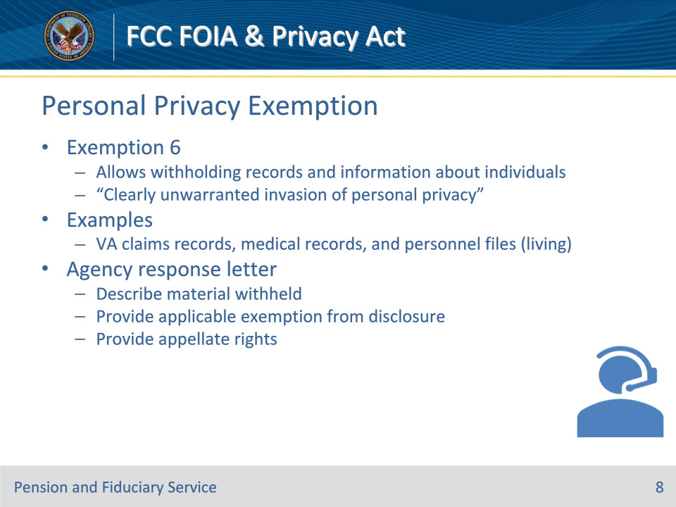

**Slide notes**

Policy Reference(s):

Instructor Notes

As LAS in the Fiduciary Contact Center (FCC), exemption 6 relates to your roles. The LAS will likely come across Exemption 6 more frequently than other exemptions. It allows withholding records and information about individuals as the disclosure would be a “clearly unwarranted invasion of personal privacy.”  ​

• EXAMPLES: VA claims records, medical records, and personnel files (pertaining to living individuals) ​

• When there is a FOIA request, the agency response letter must:​

• Describe the material withheld​

• Provide the applicable exemption from disclosure and ​

• Provide appellate rights.​

**Slide 9 - Privacy Act Definition**

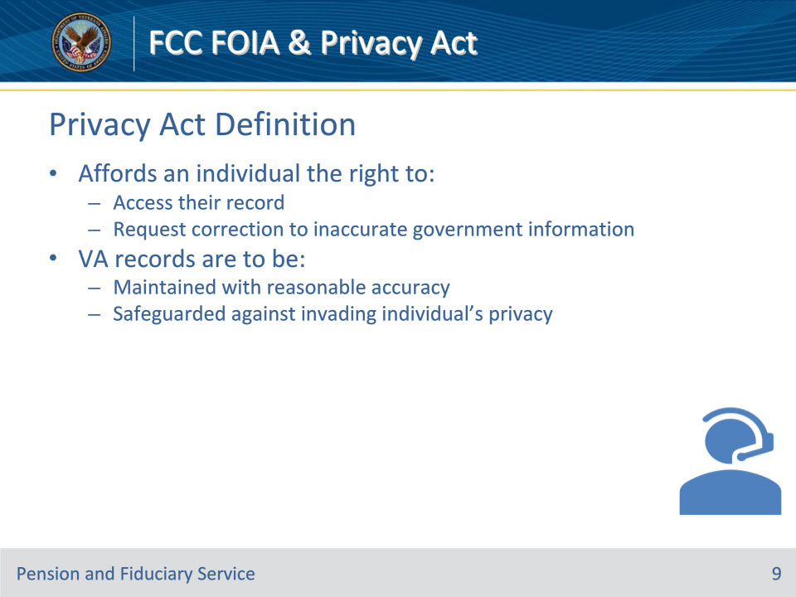

**Slide notes**

Policy Reference(s):

Instructor Notes

The Privacy Act establishes certain controls over what personal information is collected by the federal government and how that personal information is used. The PA compels the confidentiality of any VA record about an individual.

The PA affords an individual the right to:

• Access their record and

• Request correction to the information collected and used by the federal government that is not accurate.

• The PA compels the confidentiality of any VA record about an individual. VA records are to be maintained with reasonable accuracy and be safeguarded against the invasion of an individual’s privacy.

*An individual may request their information under the Privacy Act.

**Slide 10 - No Disclosures Without Consent Rule**

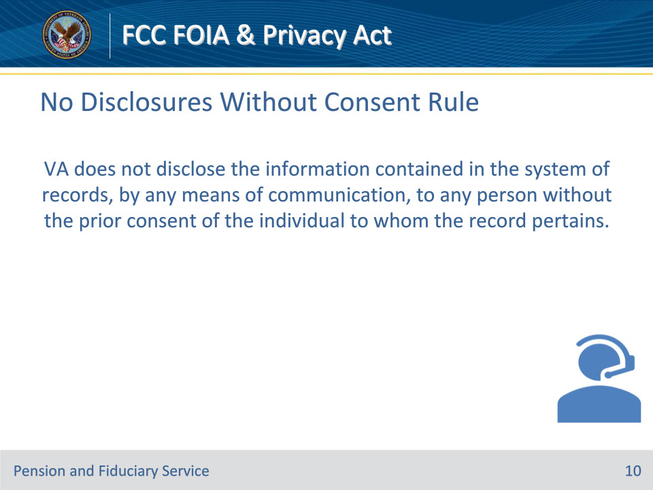

**Slide notes**

Policy Reference(s):

Instructor Notes

VA does not disclose the information contained in the system of records, by any means of communication, to any person without the prior consent of the individual to whom the record pertains.

**Slide 11 - 12 Exemptions**

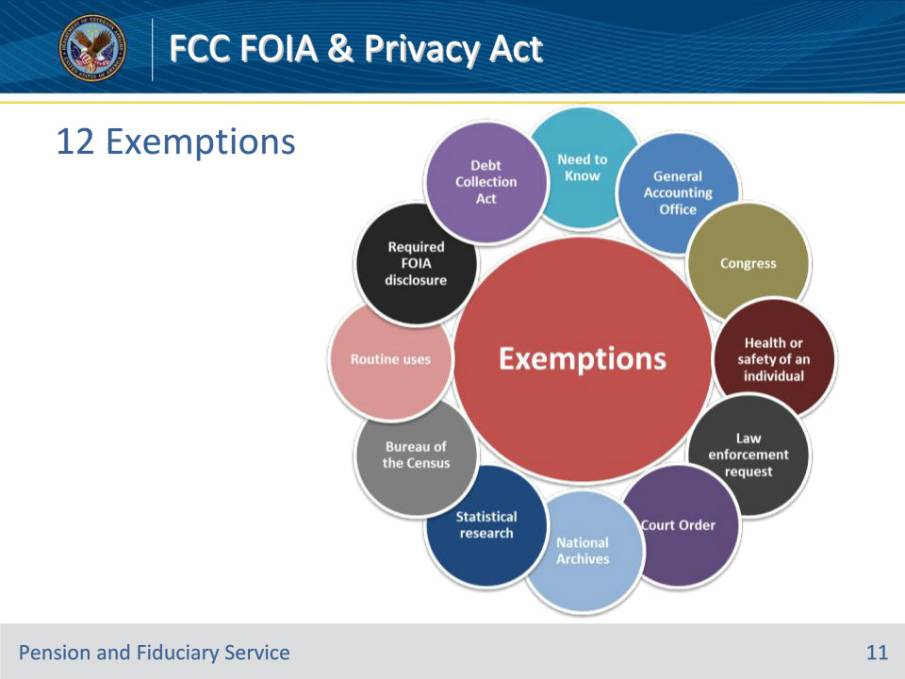

**Slide notes**

Policy Reference(s):

Instructor Notes

The No Disclosure Without Consent Rule has 12 exemptions which permit the release of information without the individual’s consent. Those exemptions are:

• Need to know within an agency

• Required FOIA disclosure

• Routine uses

• Bureau of the Census

• Statistical research

• National Archives

• Law enforcement request

• Health or safety of an individual

• Congress

• General Accounting Office

• Court Order

• Debt Collection Act

*Privacy Officers are responsible for fulfilling PA requests and managing the exemptions.

**Slide 12 - VA Employee Requests**

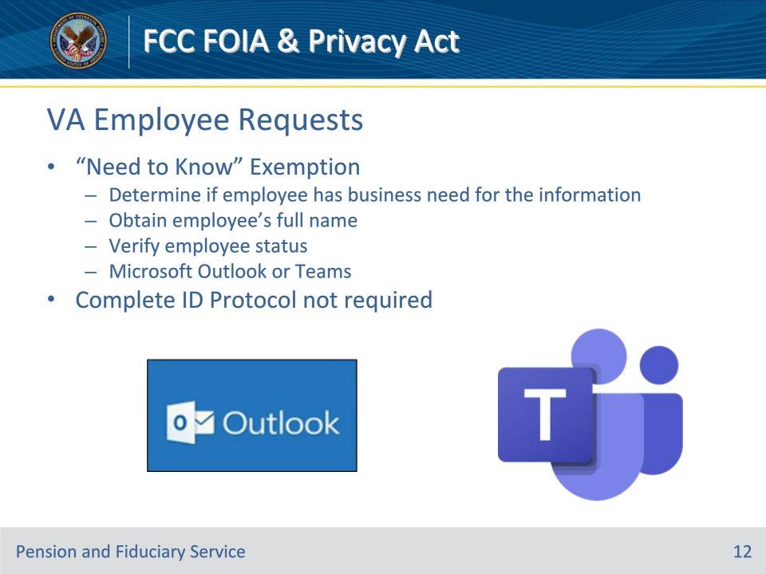

**Slide notes**

Policy Reference(s):

Instructor Notes

“Need to know” within the agency is the exception that FCC LAS will likely encounter. There must be a basis established that VA employees requesting information have a “need to know” to have access to the information.

• Complete ID Protocol NOT required

• Determine if employee has business need for the information

• Obtain employee’s full name

• Verify employee status

• Microsoft Outlook or Teams

Microsoft Outlook Global Address Book instructions:

• Access Microsoft Outlook

• Go to a new email

• Click “To”

• Search an employee’s name (last name, first name)

• Scroll over to see the employees’ title and location to verify they have a “need to know”

**Slide 13 - Knowledge Check**

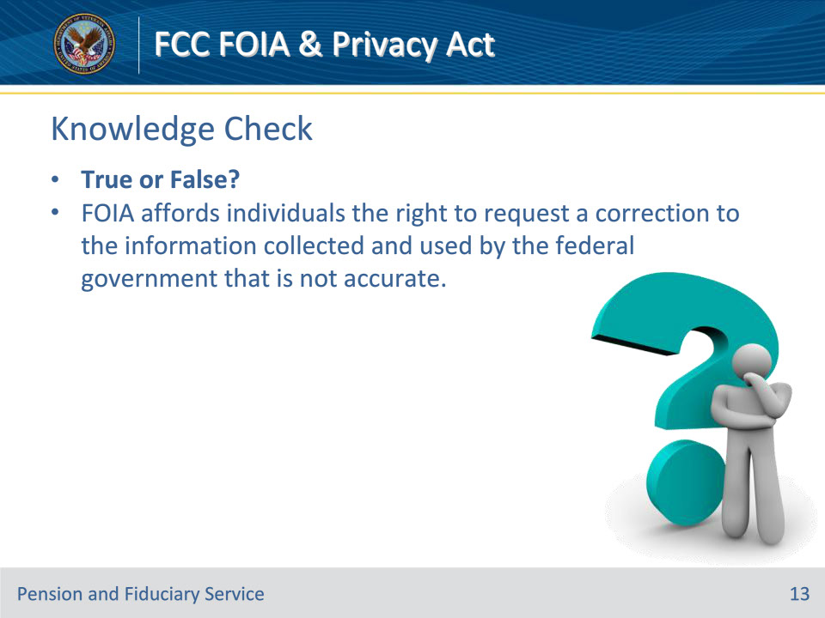

**Slide notes**

Policy Reference(s):

Instructor Notes

True or False?

FOIA affords individuals the right to request a correction to the information collected and used by the federal government that is not accurate.

Answer: False. Privacy Act.

**Slide 14 - Knowledge Check**

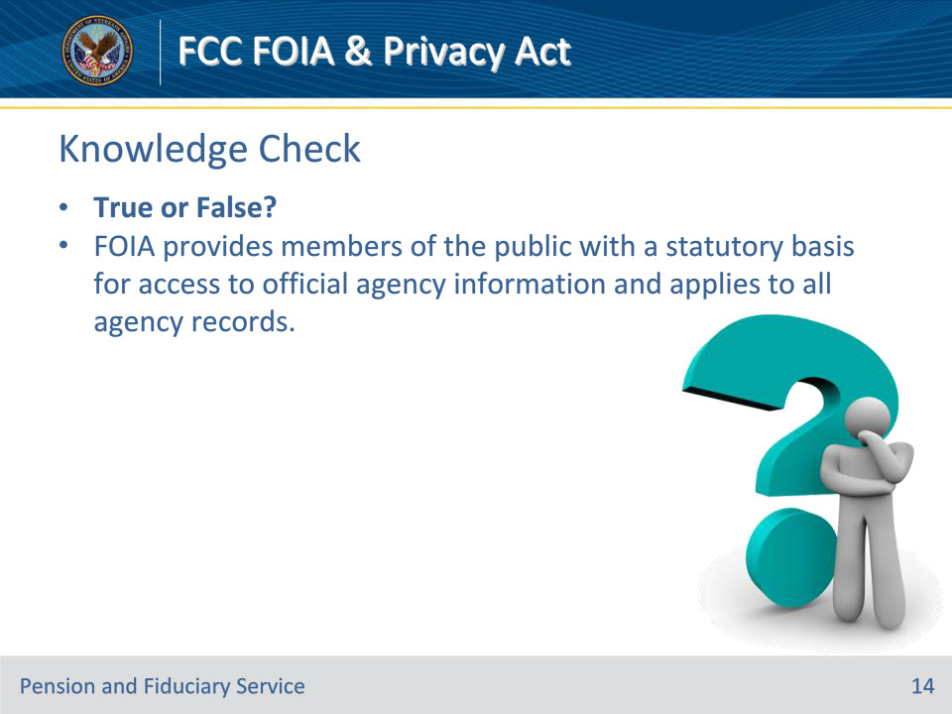

**Slide notes**

Policy Reference(s):

Instructor Notes

True or False?

FOIA provides members of the public with a statutory basis for access to official agency information and applies to all agency records.

Answer: True

**Slide 15 - General Information**

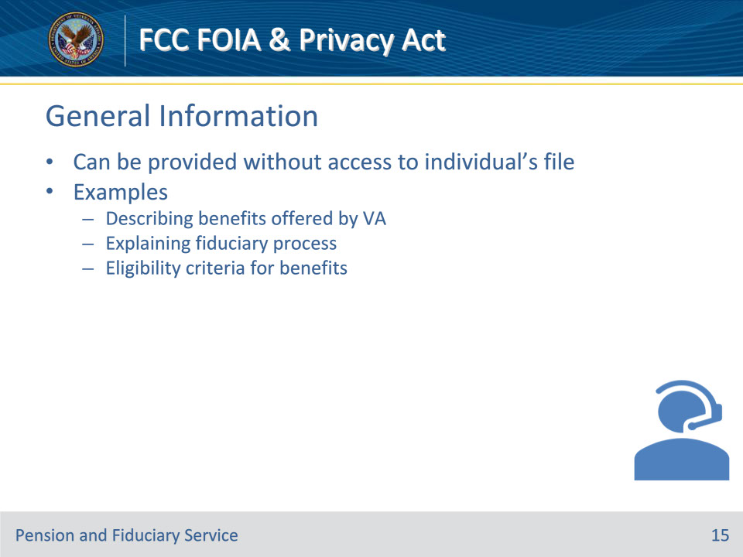

**Slide notes**

Policy Reference(s):

Instructor Notes

The Office of General Counsel and the Privacy Act/FOIA Office have approved certain information that can be released to anyone. VA refers to this information as public information. Public information may be released to anyone and without verifying Identification Protocol.

General information is information that can be provided without requiring access to an individual’s file. Some examples of general information include:

• Describing benefits offered by VA

• Explaining the fiduciary process

• Eligibility criteria for benefits

**Slide 16 - Protected Information**

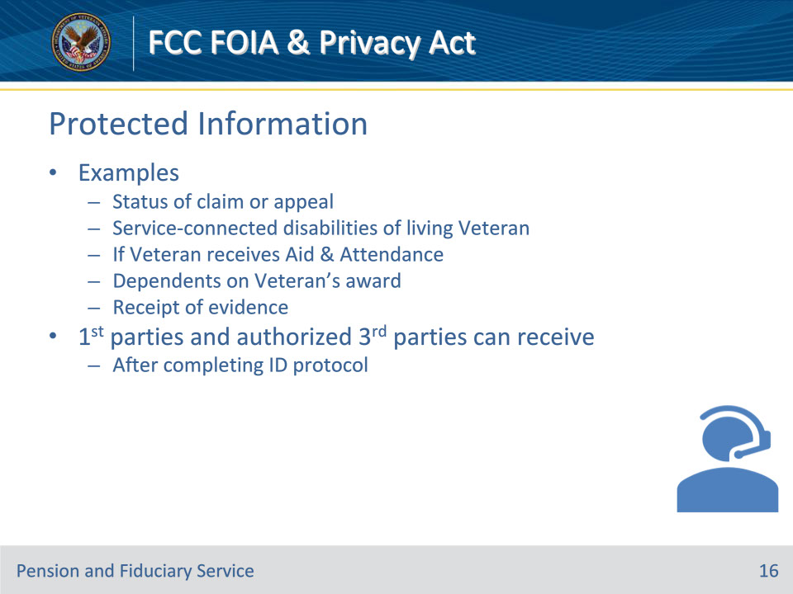

**Slide notes**

Policy Reference(s):

Instructor Notes

Some examples of protected information include:

• Status of Claim/Appeal

• Service-connected disabilities of a living Veteran

• If a Veteran receives Aid and Attendance

• Dependents on the Veteran’s award

• Receipt of evidence

First parties and authorized third parties who complete ID protocol can receive protected information.

**Slide 17 - First Party**

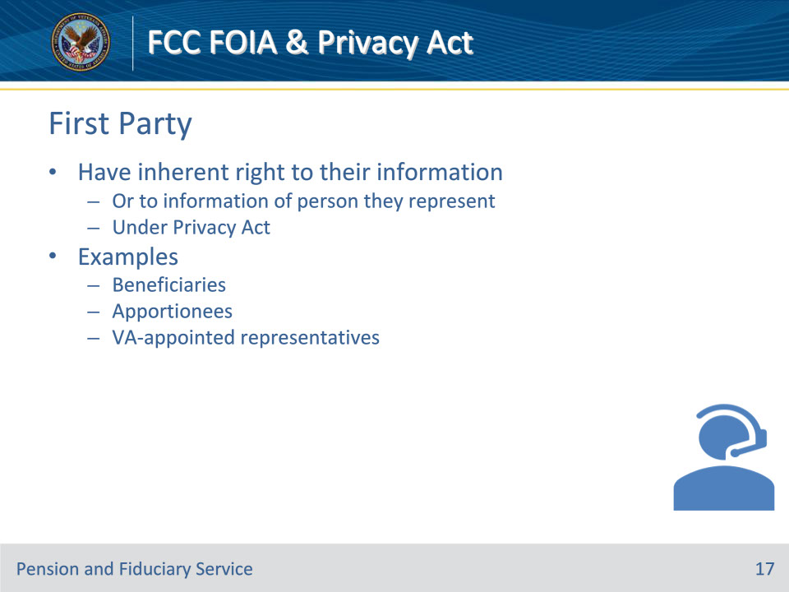

**Slide notes**

Policy Reference(s):

Instructor Notes

First-party individuals have an inherent right to their information (or to the information of the person they represent) under the Privacy Act.

Examples of first parties are beneficiaries, apportionees, and VA-appointed representatives.

**Slide 18 - Beneficiaries**

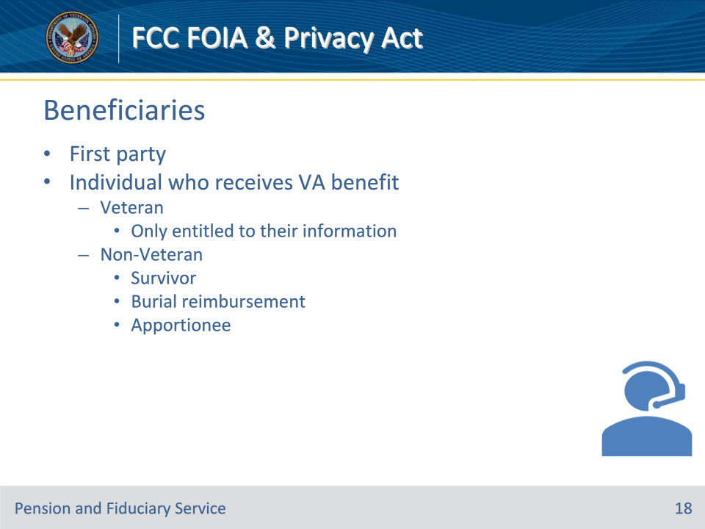

**Slide notes**

Policy Reference(s):

Instructor Notes

Beneficiaries are first parties. We use the term beneficiary when referring to an individual who receives a VA benefit. We will often refer to Veteran and non-Veteran applicants as beneficiaries as well. However, some Veterans are not receiving VA benefits, therefore, they are not a beneficiary but are still considered a first party because the information of record is their personal information.

* Releasing Information About Another Person to the Veteran

VA will not disclose, without the party’s permission, personal information concerning dependents (current or former spouses, children, or any other dependents) to the Veteran, even though the information may be within the Veteran’s claim folder or electronic record.

Non-Veteran beneficiaries are individuals other than Veterans who are applying for or in receipt of a VA benefit in their own right. Non-Veteran beneficiaries receive or are applying to receive benefits directly to themselves.

The following are some examples of non-Veteran beneficiaries:

• Survivors

• Burial reimbursement beneficiary

• Apportionees

**Slide 19 - Apportionees**

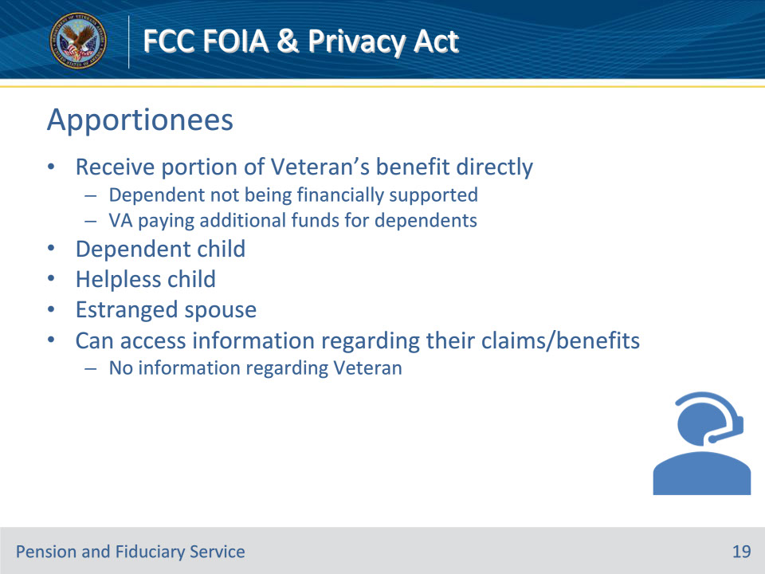

**Slide notes**

Policy Reference(s):

Instructor Notes

• Apportionment is a benefit where an individual receives a portion of a Veteran’s (or in some cases surviving beneficiary’s) benefit in cases where the dependent is not being financially supported and VA is paying additional funds for dependents.

• In apportionment cases, rather than the Veteran receiving additional dependency funds, apportionees receive a portion of the Veteran’s award directly. Payments are made to the apportioned dependent or their caretaker.

• Dependent children, including helpless children (medically incapable of self-support before age 18), and estranged spouses (separated, not divorced) may be apportioned benefits in some cases.

• Recipients of this benefit can access information regarding their own claims and benefits but are not to obtain information regarding the Veteran. Likewise, an apportionee’s personal information should be protected from the Veteran

**Slide 20 - Minors**

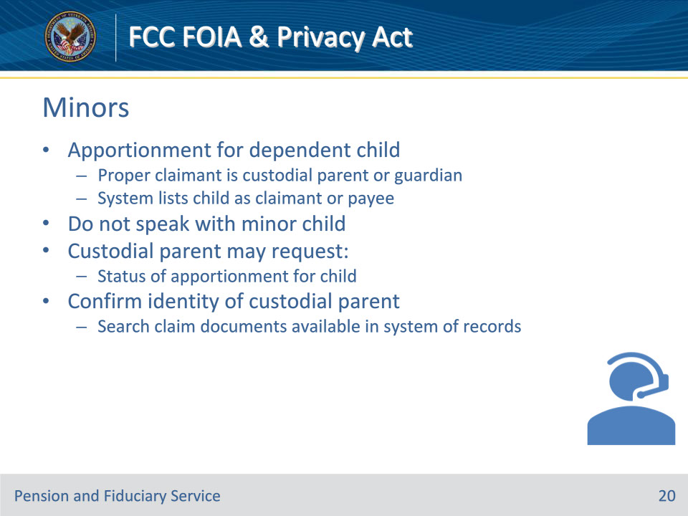

**Slide notes**

Policy Reference(s):

Instructor Notes

• In an apportionment, the proper claimant for a dependent child is the custodial parent or guardian, who should be afforded all information regarding the apportionment claim. The system requires these apportionments to list the child(ren)as the claimant or payee. We do not speak with a minor child.

• The custodial parent may request the status of apportionment for a child. The LAS must confirm the identity of this custodial parent by searching claim documents available in the system of records.

**Slide 21 - VA-Appointed Representatives**

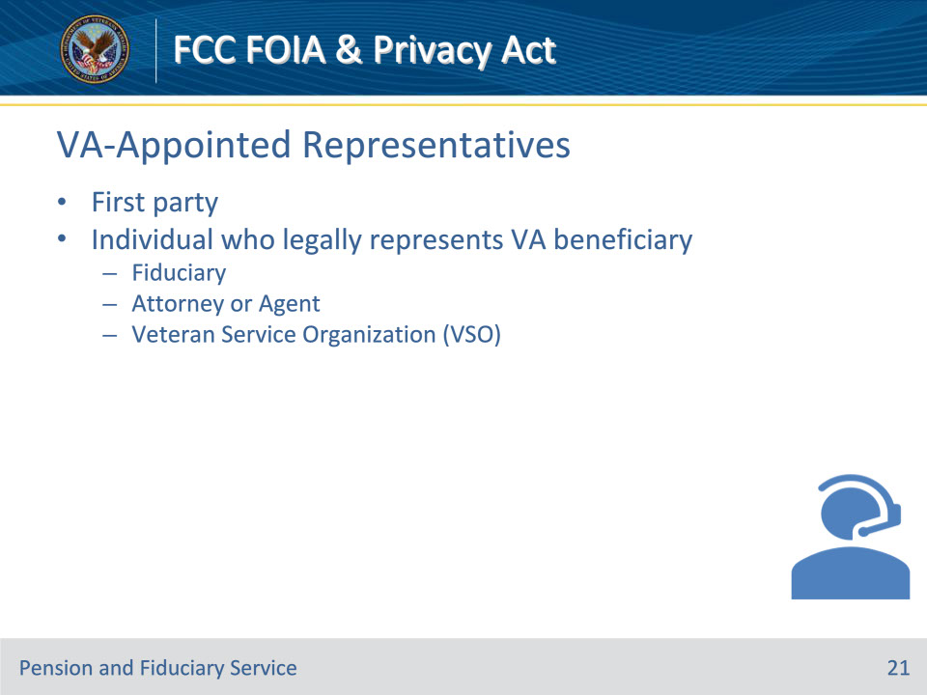

**Slide notes**

Policy Reference(s):

Instructor Notes

An individual who legally represents a VA beneficiary is also a first party. VA recognizes the following as first parties:

• Fiduciary

• Attorney or agent

• Veteran Service Organization (VSO) (we commonly refer to a VSO as a POA)

**Slide 22 - Knowledge Check**

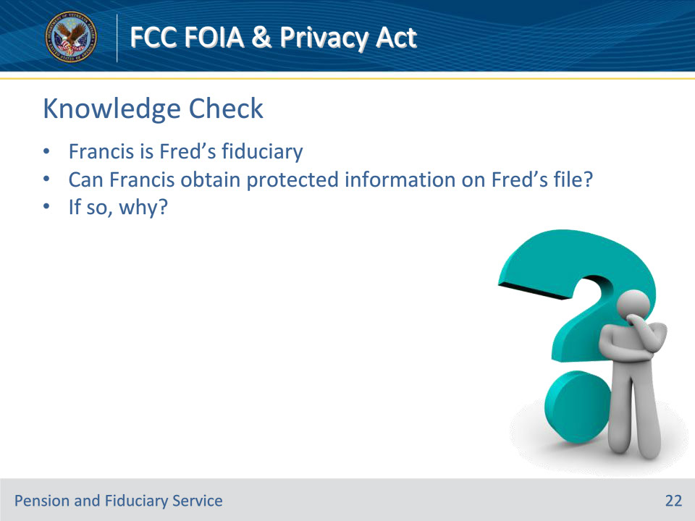

**Slide notes**

Policy Reference(s):

Instructor Notes

Francis is Fred’s fiduciary. Can Francis obtain protected information on Fred’s file? If so, why?

Answer: Once properly identified, Francis is considered a first party to Fred’s record and protected information may be released.

**Slide 23 - Third Party**

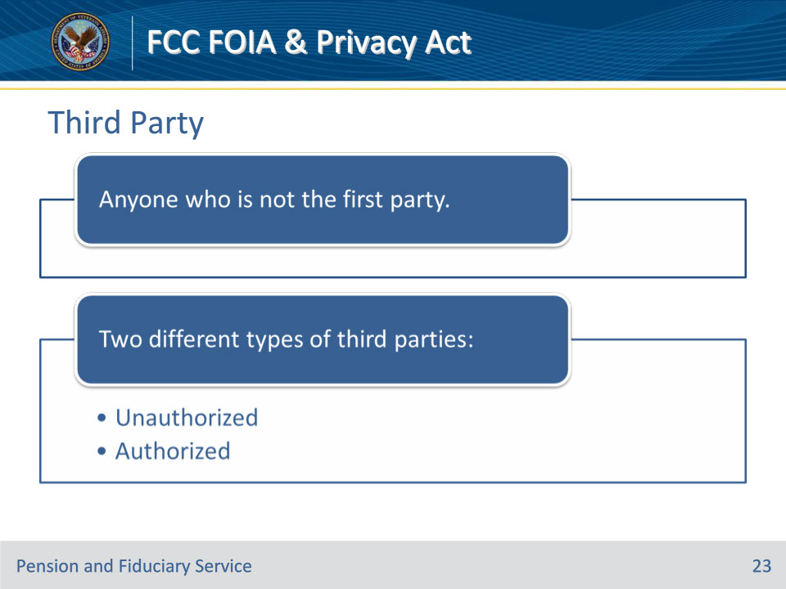

**Slide notes**

Policy Reference(s):

Instructor Notes

Third parties include anyone who is not the first party. There are two different types of third parties:

• Unauthorized

• Authorized

**Slide 24 - Unauthorized 3rd party**

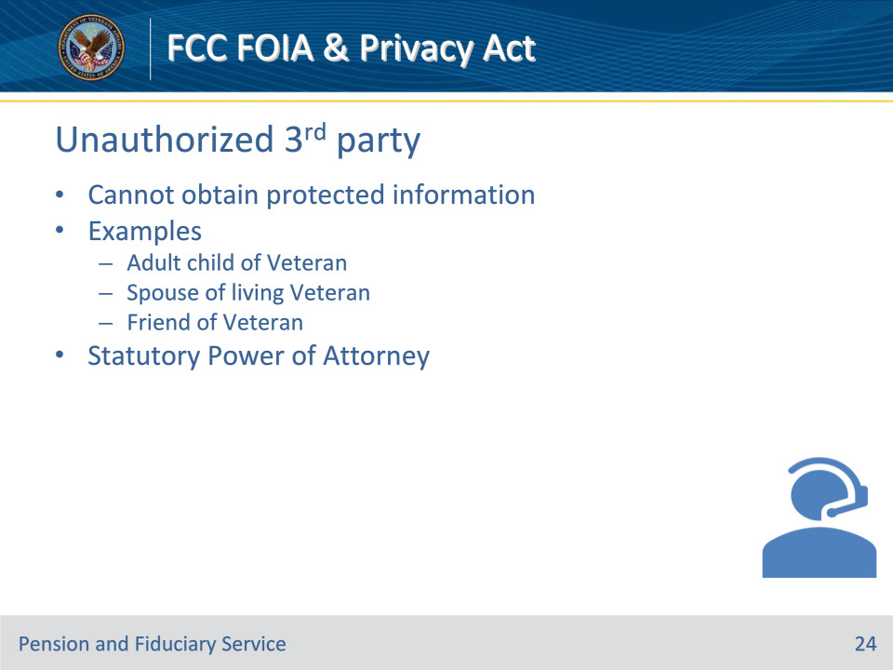

**Slide notes**

Policy Reference(s):

Instructor Notes

Unauthorized third parties have a legal right to the public information mentioned earlier in this lesson but cannot obtain any protected information.

Some examples of unauthorized 3rd parties include:

• An adult child of Veteran

• Spouse of living Veteran

• Friend of Veteran

LASs will receive requests from family members or others who are trying to assist Veterans or beneficiaries who are elderly, disabled, or overseas. Often, these individuals will explain they hold a power of attorney to handle the affairs of the beneficiary. There is no provision in the law for the VA to recognize the statutory power of attorney agreements. These individuals are considered unauthorized third parties without the Veteran’s consent to authorize VA to release information to them.

**Slide 25 - Unauthorized 3rd party**

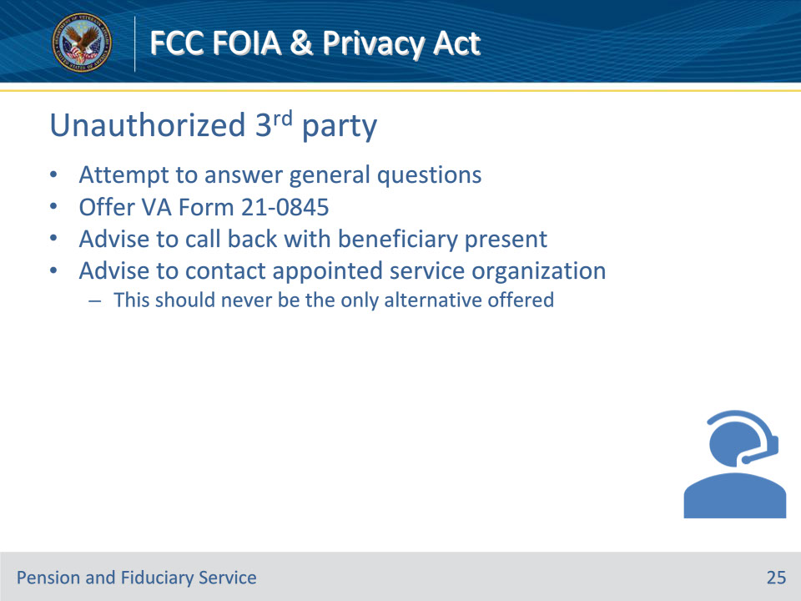

**Slide notes**

Policy Reference(s):

Instructor Notes

Unauthorized third parties will call to obtain information. LASs must ensure they properly identify all callers to determine if the person is a first party or third party. If the person calling is identified as a third party, the LAS must then decide if they are an authorized or unauthorized to receive information. If they are an unauthorized third party, and the Veteran/beneficiary is unavailable to give verbal permission, file-specific information cannot be released.

LASs must provide the caller alternative means to get the needed information:

• Try to answer any questions in general terms

• Offer VA Form 21-0845, Authorization to Disclose Personal Information to a Third Party, if it is evident that the Veteran/beneficiary needs assistance

• Advise calling back with the Veteran/beneficiary available

• Advise to contact the Veteran’s or beneficiary’s appointed service organization (this should never be the only alternative offered)

**Slide 26 - Authorized 3rd party**

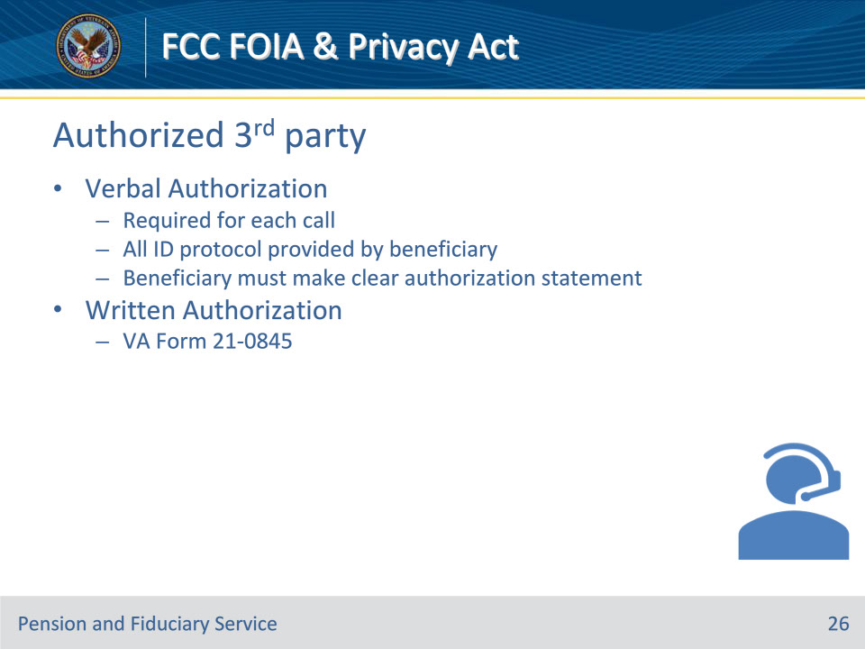

**Slide notes**

Policy Reference(s):

Instructor Notes

Authorized third parties have been permitted by the Veteran or beneficiary to speak on their behalf with the VA.

There are two ways a third party can be considered an authorized third party:

1. Verbal authorization or

2. Written authorization

Verbal Authorization

• Verbal authorization is required for each call. All ID protocol answers are to be provided by the Veteran or beneficiary. The LAS must have the Veteran or beneficiary make a clear statement that they are authorizing VA to release information from their record to the other individual on the call.

[Instructor Note: Give the class a sample call flow demonstrating how verbal authorization should be obtained.]

Written Authorization

• A third-party may be considered an authorized third-party with the beneficiary’s permission if a valid VA Form 21-0845, Authorization To Disclose Personal Information to a Third Party, is viewable in the Veteran’s record.

• Authorized third parties may call to obtain documents from the Veteran’s file. PCRs can resend copies of correspondence available in the eFolder to an authorized third-party requestor to an address other than the address of record, as long as all required ID Protocol requirements have been met.

**Slide 27 - Knowledge Check**

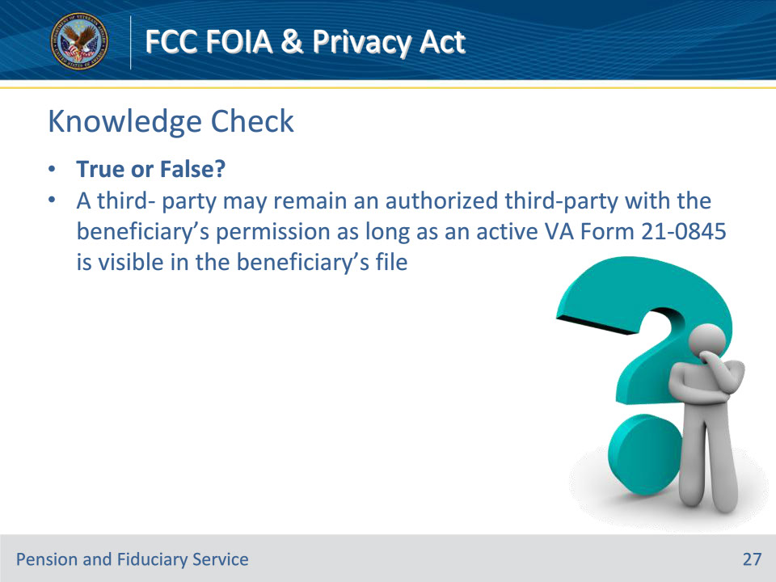

**Slide notes**

Policy Reference(s):

Instructor Notes

A third-party may remain an authorized third-party with the beneficiary’s permission as long as a valid VA Form 21-0845 is visible in the beneficiary’s file.

Answer: True.

**Slide 28 - ID Protocol**

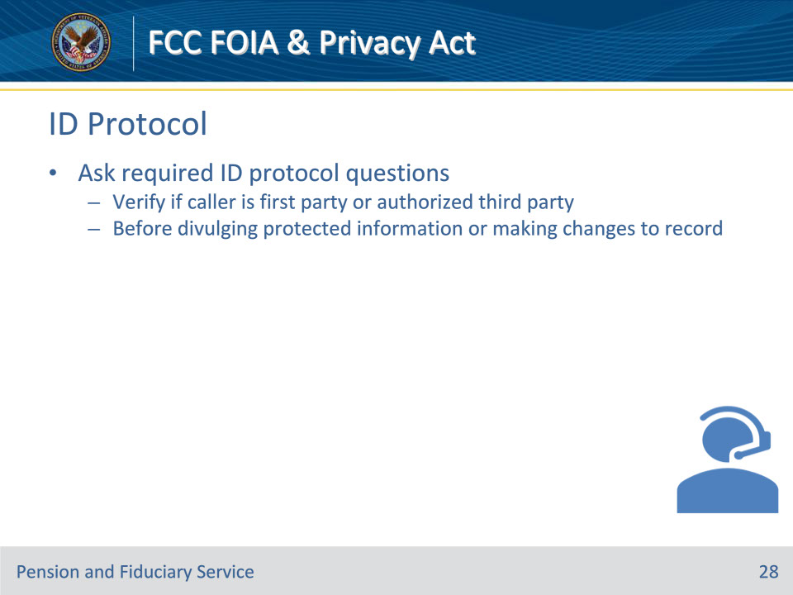

**Slide notes**

Policy Reference(s):

Instructor Notes

First-party individuals have an inherent right under the Privacy Act to their information (or to the information of the person they represent). LASs must ask required ID protocol questions to verify if they are speaking to the first party or an authorized individual before divulging protected information or making changes to a record.

Protected information may only be released to first parties or authorized third parties once properly identified. LASs must refer to KM article “Identification (ID) Protocol Requirements” for an expanded view of all requirements

[Instructor Note: Display and review KM article Identification (ID) Protocol Requirements thoroughly. Instructor should go through each section of the article and give an in-depth explanation of ID Protocol Requirements.]

**Slide 29 - Legal Representation**

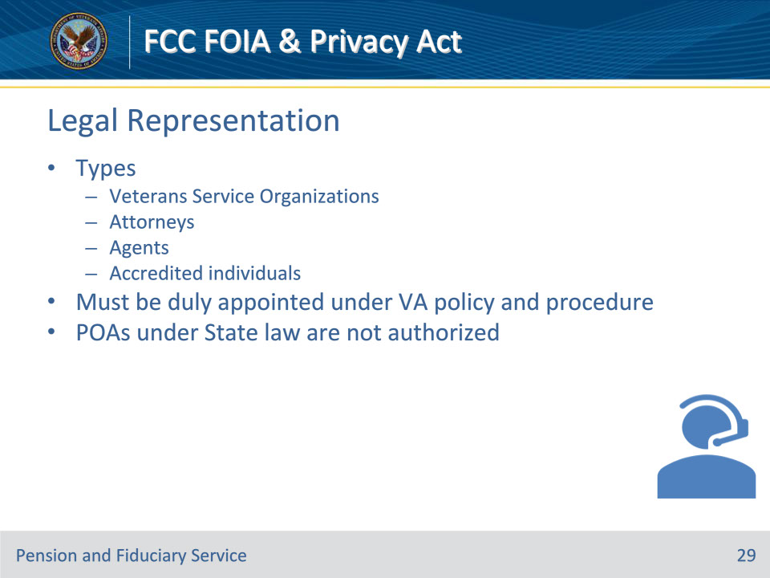

**Slide notes**

Policy Reference(s):

Instructor Notes

• Claimants before VA are provided representation by Veterans Service Organizations (VSOs), attorneys, agents, and other accredited individuals to ensure that such claimants have responsible, qualified representation to assist in the preparation, presentation, and prosecution of claims for benefits.

• Claimants may appoint a single representative for all claims, or they may choose to appoint a different representative on a limited basis for a particular claim.

• VA representation means broadly that an individual has completed legal formalities to authorize a VSO, attorney, agent, or individual to perform functions on his or her behalf in business before VA.

• The execution by a claimant of a POA under State law has no effect for the purposes of prosecuting a VA claim.  The individual with POA under State law is not authorized, based on the State appointment, to engage in VA representation.

• In order to be recognized by VA, a claimant’s representative must be duly appointed under VA policies and procedures. To be recognized by VA, a claimant’s representative must be appointed according to the procedures in M21-1, Part I, Subpart i, Chapter 2, Section A - General Information on Power of Attorney (POA)

**Slide 30 - Veteran Service Organizations**

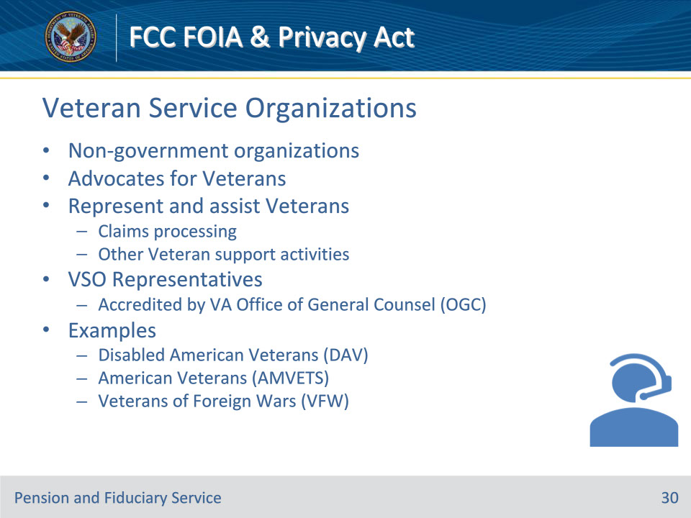

**Slide notes**

Policy Reference(s):

Instructor Notes

VSOs are non-government organizations that are the primary advocates for Veterans. They represent and assist Veterans with claim processing and other Veteran support activities with VA.

Representatives of VSOs must be accredited from the VA’s Office of General Counsel to represent claimants. These individuals are first parties and, once verified, may obtain the protected information of those they represent.

Some VSOs include:

• Disabled American Veterans (DAV)

• American Veterans (AMVETS)

• Veterans of Foreign Wars (VFW)

• Military Order of the Purple Heart (MOPH)

• American Legion (AL)

• Marine Corps League (MCL)

[Instructor Note: Display KM Desk reference and select a RO to view VSOs at that location.]

**Slide 31 - VA Form 21-22**

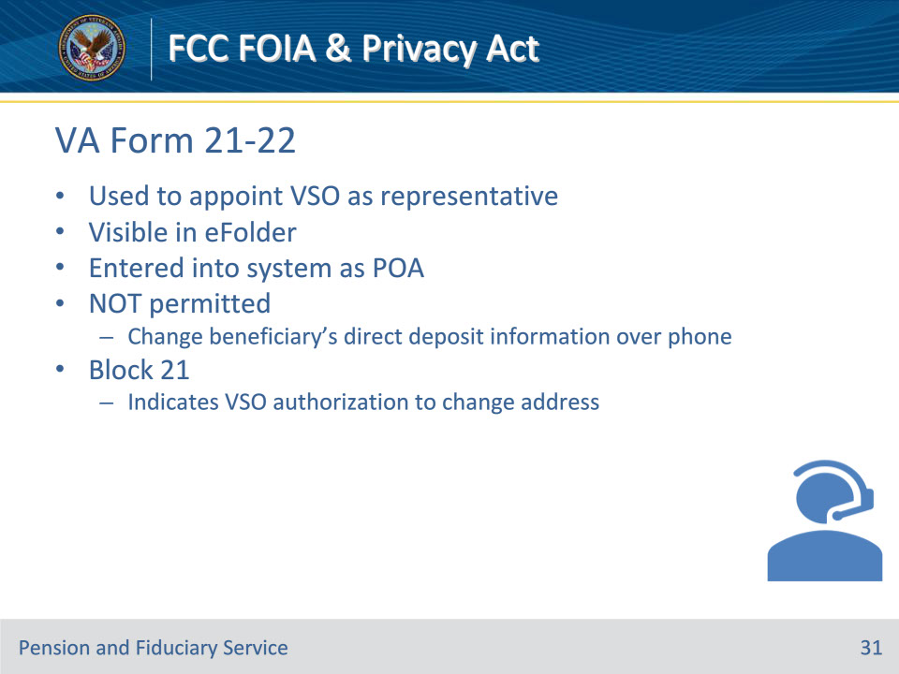

**Slide notes**

Policy Reference(s):

Instructor Notes

Veterans and beneficiaries appoint VSOs with VA Form 21-22 Appointment of Veterans Service Organization as Claimant’s Representative. This form is often located within Veterans Benefits Management System (VBMS); however, upon receipt, the organization is entered into the system as POA.

It is not VA’s policy to permit a VSO to change a claimant’s or beneficiary’s direct deposit information over the phone, and address changes are only permissible with the Veteran’s permission. Block 21 on VA Form 21-22 shows if the Veteran has given the VSO authorization to change their address.

[Instructor Note: Display and review VA Form 21-22. Refer to the disclosure limitations on the form.]

**Slide 32 - VSO Verification**

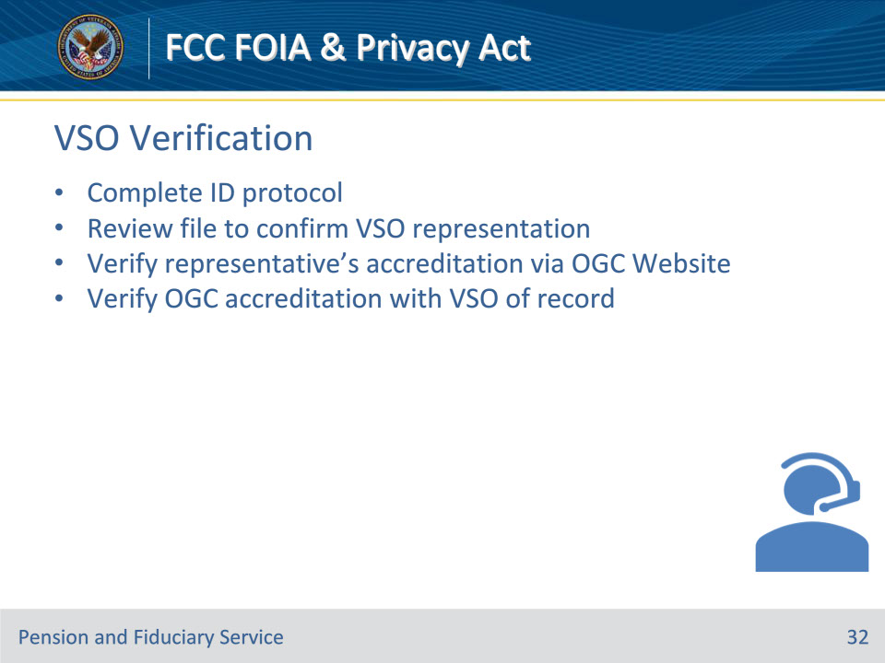

**Slide notes**

Policy Reference(s):

Instructor Notes

LASs must follow procedural guidance to verify a VSO:

1. Complete the ID protocols

2. Review the file to confirm the Veteran Service Organization represents the Veteran

3. View representative’s accreditation in OGC Website.

4. Confirm the OGC accredited representative is accredited with the VSO of record

LASs can refer to KM article Veteran Service Organization (VSO) – VSO ID Protocol for additional information.

Instructor Note: Display and review KM article Veteran Service Organization (VSO) Dedicated Helpdesk - VSO ID Protocol.

**Slide 33 - Agents & Attorneys**

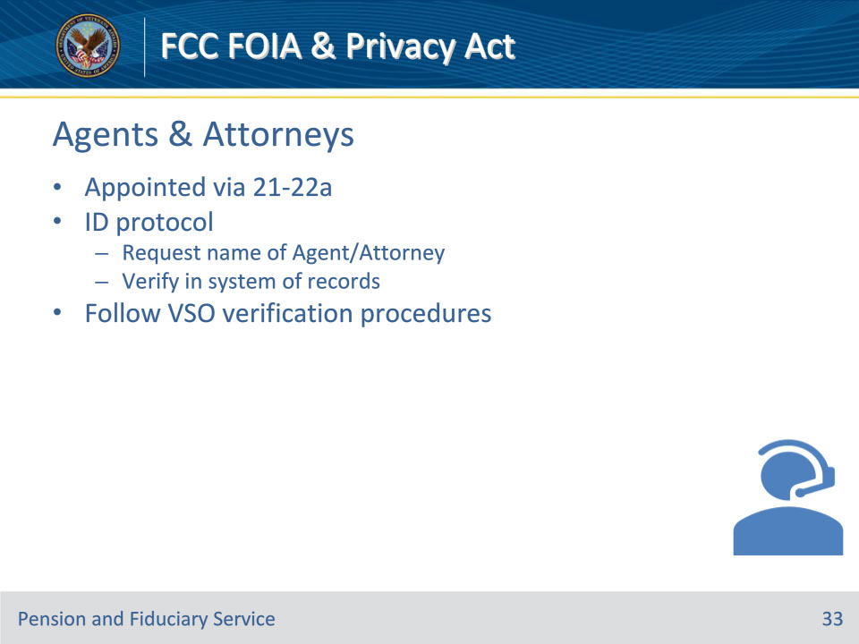

**Slide notes**

Policy Reference(s):

Instructor Notes

Accredited Agents and Attorneys are appointed via 21-22a Appointment of Individual as Claimant’s Representative. As a part of the ID protocol, the LAS must request the name of the Agent/Attorney and verify this information in the system of records. Aside from 21-22a, Attorney/Agent names may be found attached to letters.

Also, follow VSO verification procedures to verify accredited agents and attorneys.

[Instructor Note: Display and review VA Form 21-22a. Thoroughly review the form and specifically refer to the disclosure limitations on the form.]

**Slide 34 - Knowledge Check**

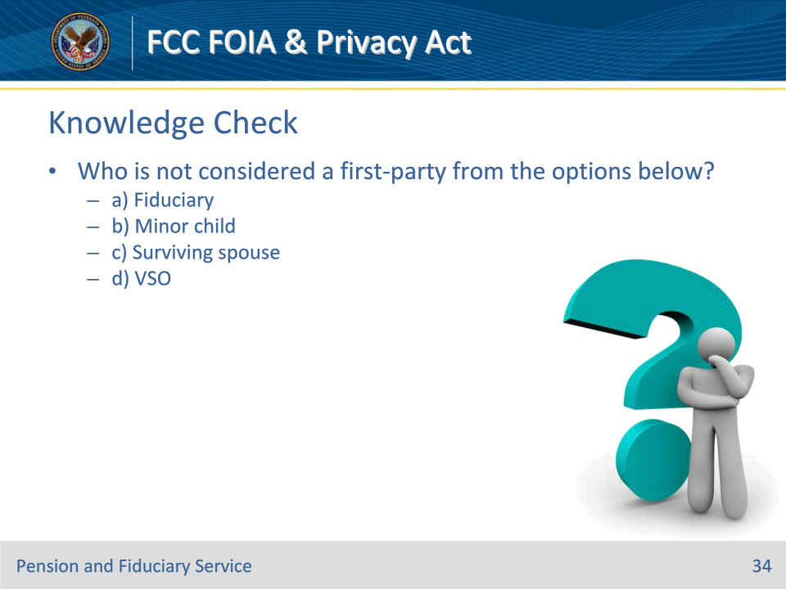

**Slide notes**

Policy Reference(s):

Instructor Notes

Who is not considered a first party from the options below?

a) Fiduciary

b) Minor Child

c) Surviving Spouse

d) VSO

Answer: b) Minor Child

**Slide 35 - Knowledge Check**

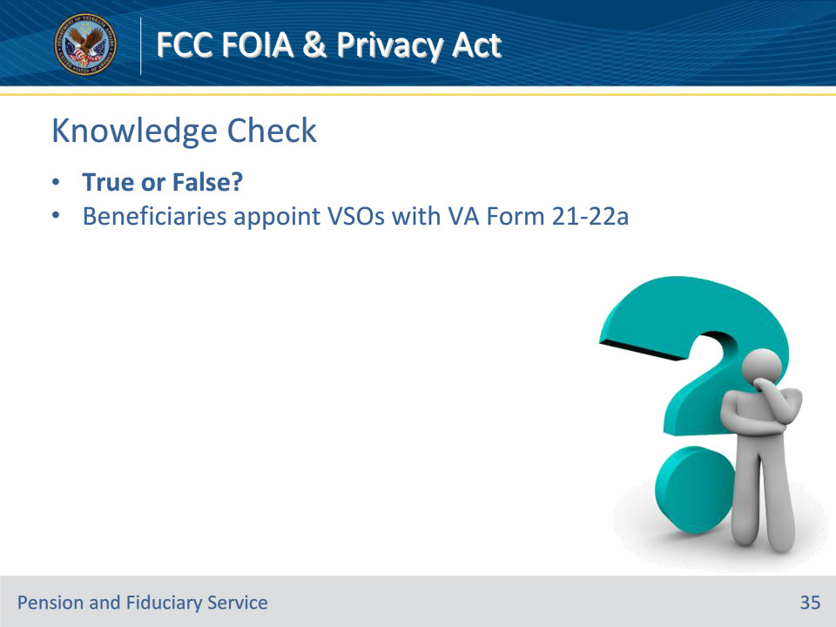

**Slide notes**

Policy Reference(s):

Instructor Notes

Veterans and beneficiaries appoint VSOs with VA Form 21-22a.

Answer: False. VA Form 21-22.

**Slide 36 - VA Form 21-0845**

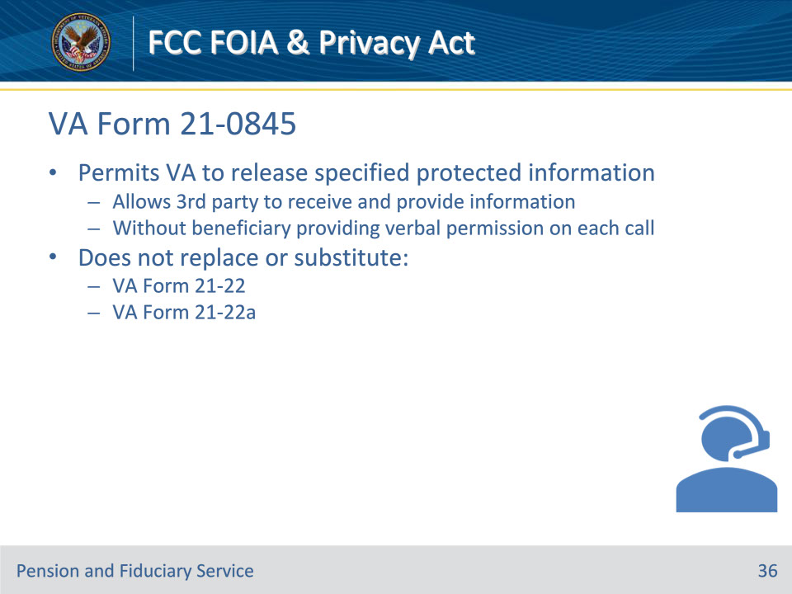

**Slide notes**

Policy Reference(s):

Instructor Notes

VA Form 21-0845 Authorization to Disclose Personal Information To a Third-Party permits VA to release specified information normally protected under the Privacy Act. This form was developed to allow a third party to receive and provide essential claim or benefit-related information without the Veteran or beneficiary having to give verbal permission on each call.

This form does not replace or substitute VA Forms 21-22 or 21-22a.

**Slide 37 - 21-0845 Verification**

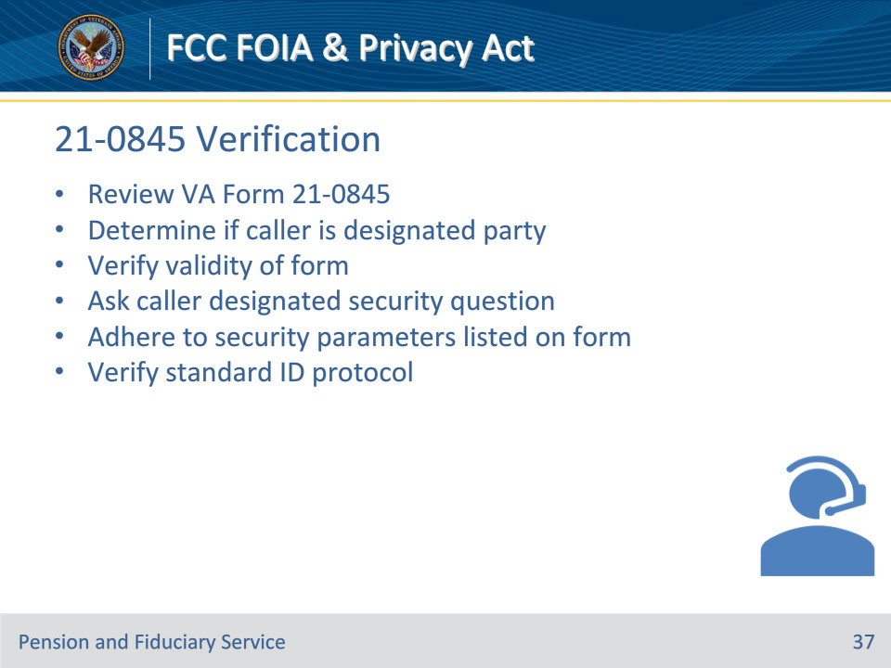

**Slide notes**

Policy Reference(s):

Instructor Notes

When 21-0845 is received by VA, the system of records is flashed. PCRs must:

• Review VA Form 21-0845

• Determine if the caller is the designated party

• Verify the form for validity

• Ask the caller the designated security question

• Ensure caller’s questions fall within other security parameters identified on the form

• Ask the caller to verify the standard ID protocol

**Slide 38 - 21-0845 Location**

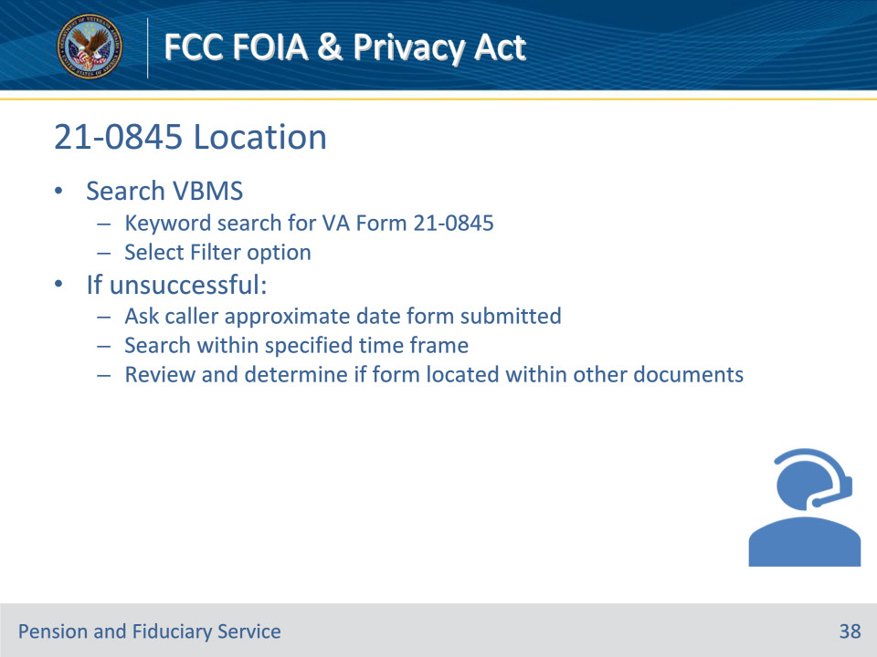

**Slide notes**

Policy Reference(s):

Instructor Notes

Once uploaded, VA form 21-0845 is available in VBMS.

Searching VBMS

1. Perform a “Keyword” search for VA Form 21-0845, Authorization to Disclose Personal Information to a Third Party and

2. Select the Filter option

If this search does not lead you to VA Form 21-0845 and the caller insists a VA Form 21-0845 was submitted to the VA, LASs should:

• Ask the caller the approximate date the form was submitted

• By searching within this time frame the PCR should be able to determine if the 0845 is located within multiple documents.

• If the form is not located, follow procedures outline in KM article Centralized Mail Processing Initiative - Background Information and FAQs.

[Instructor Note: Access VBMS and demonstrate performing a search VA Form 21-0845.]

**Slide 39 - 21-0845 Criteria**

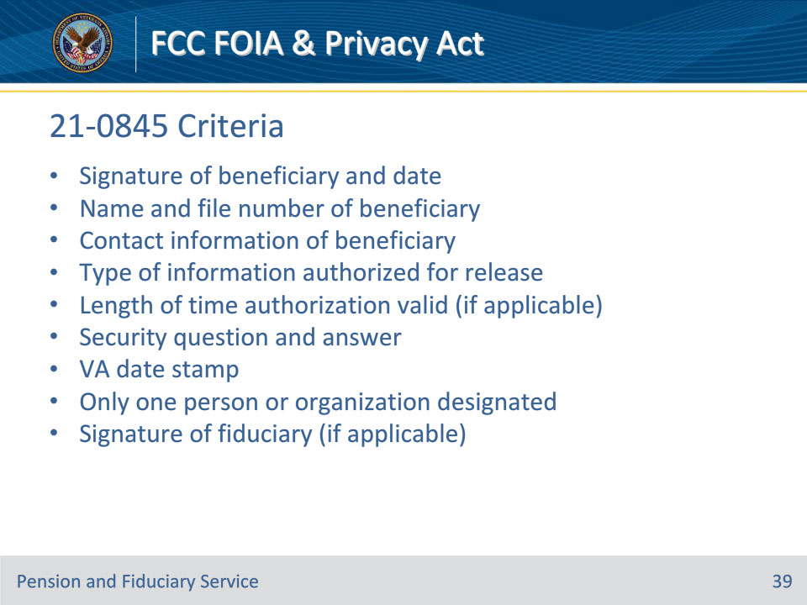

**Slide notes**

Policy Reference(s):

Instructor Notes

M21-1, Part I, Subpart i, Chapter 3, Section C, Other Information Disclosures details the required criteria for VA Form 21-0845 to be valid.

To be valid, VA Form 21-0845 must contain or meet the following criteria to be considered substantially complete:

• The signature of Veteran/claimant and date

• The name and claims folder number of the Veteran/claimant

• The contact information (address, daytime or cell phone number, or e-mail address) of the beneficiary

• The type of information authorized for release

• The length of time authorization is valid (if applicable):

• A security question and answer

• The form date stamped by the VA

• The form designates only one person or organization, and

• If the individual whose information is being released has a court-ordered or VA-appointed fiduciary, the signature of the fiduciary

[Instructor Note: Display and review VA Form 21-0845.]

**Slide 40 - 21-0845 Signature**

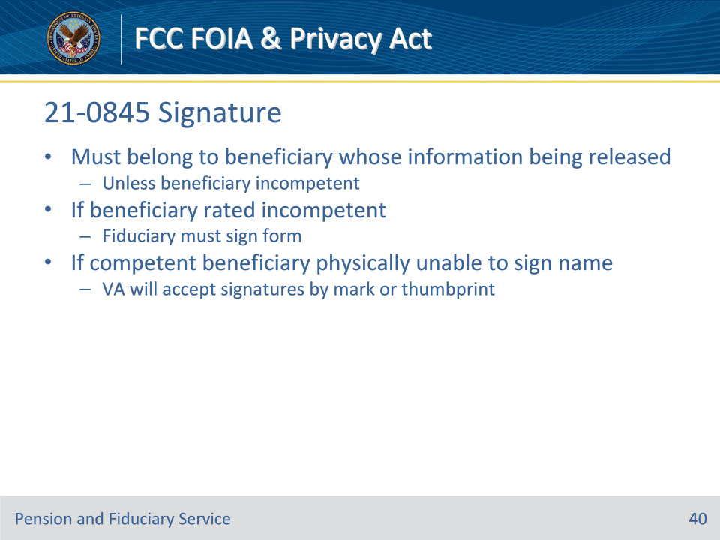

**Slide notes**

Policy Reference(s):

Instructor Notes

The signature cannot be someone other than the individual whose information is being released, except in cases where the individual is incompetent. For the signature of VA Form -21-0845:

• The signature must belong to the person who will be represented by the third-party (Veteran or beneficiary receiving or applying in their own right) unless that person is incompetent.

• If the Veteran/beneficiary is rated financially incompetent, their Fiduciary must sign the form.

If the represented individual is not rated incompetent and is physically unable to sign their name, VA will accept signatures by mark or thumbprint.

**Slide 41 - Questions?**

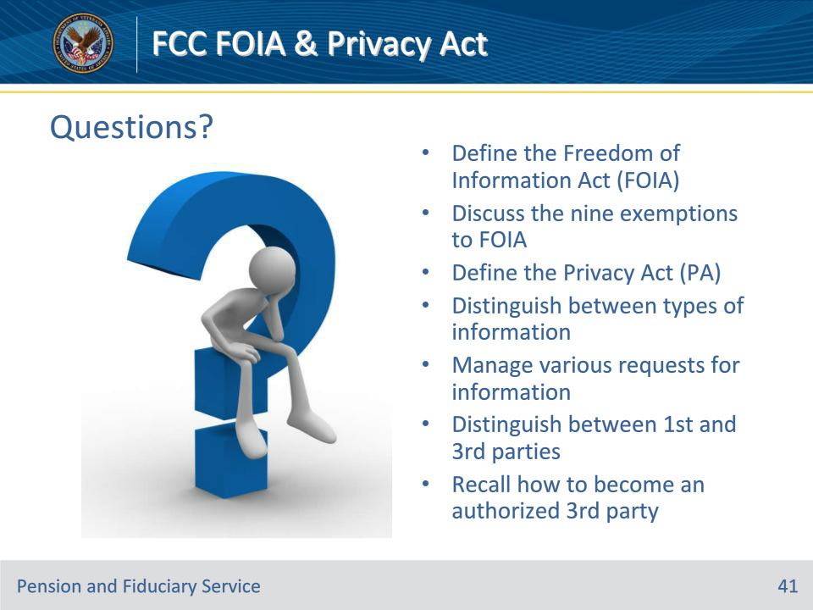

**Slide notes**

Instructor Notes:

(Recall) These are our learning objectives as stated from the beginning of the training:

• Define the Freedom of Information Act (FOIA)

• Discuss the nine exemptions to FOIA

• Define the Privacy Act (PA)

• Distinguish between types of information

• Manage various requests for information

• Distinguish between 1st and 3rd parties

• Recall how to become an authorized 3rd party

Are there any additional questions?

Questions should be filtered through your QRT team. They will submit your questions to the Field Inquiry Tool (FIT) on your behalf.

**Slide 42 - TMS Survey/Assessment**

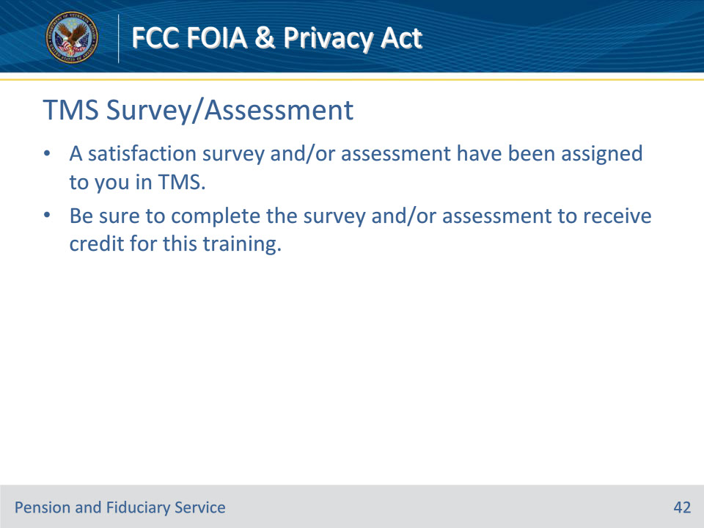

**Slide notes**

Instructor Notes

A satisfaction survey and/or assessment have been assigned to you in TMS.

Be sure to complete the survey and/or assessment to receive credit for this training.