Slide 1 - FCC Critical Thinking, Stress, & Time Management
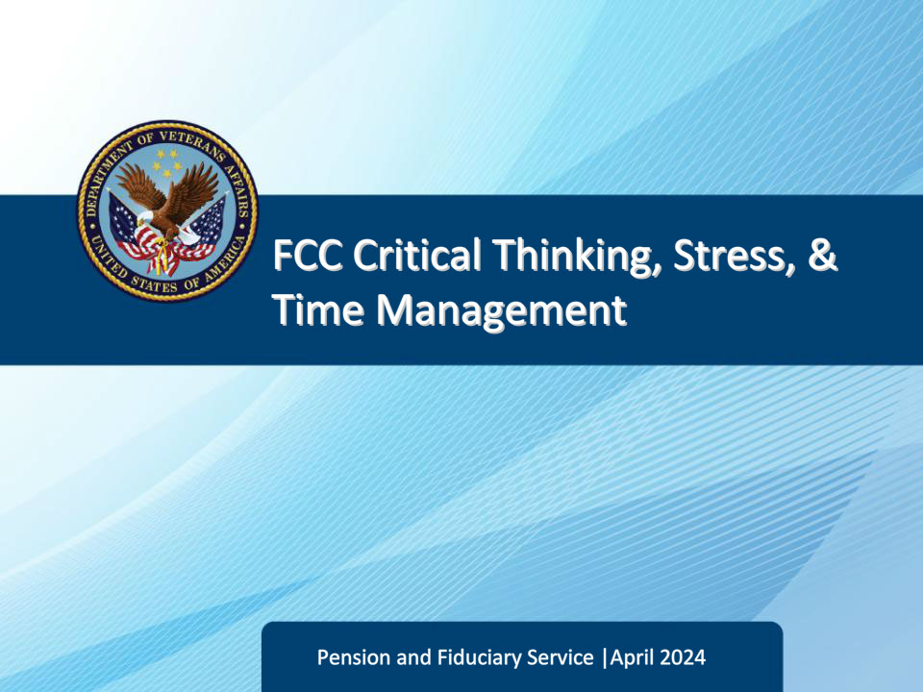
Slide notes

Course Description

This lesson teaches the FCC Legal Administrative Specialists various topics related to personal and professional development. It defines critical thinking and emotional intelligence and explains their importance. It also discusses stress management skills and 8 ways to deal with work-related stress. Additionally, it highlights the significance of personality and time management in achieving professional goals.

Slide 2 - Objectives
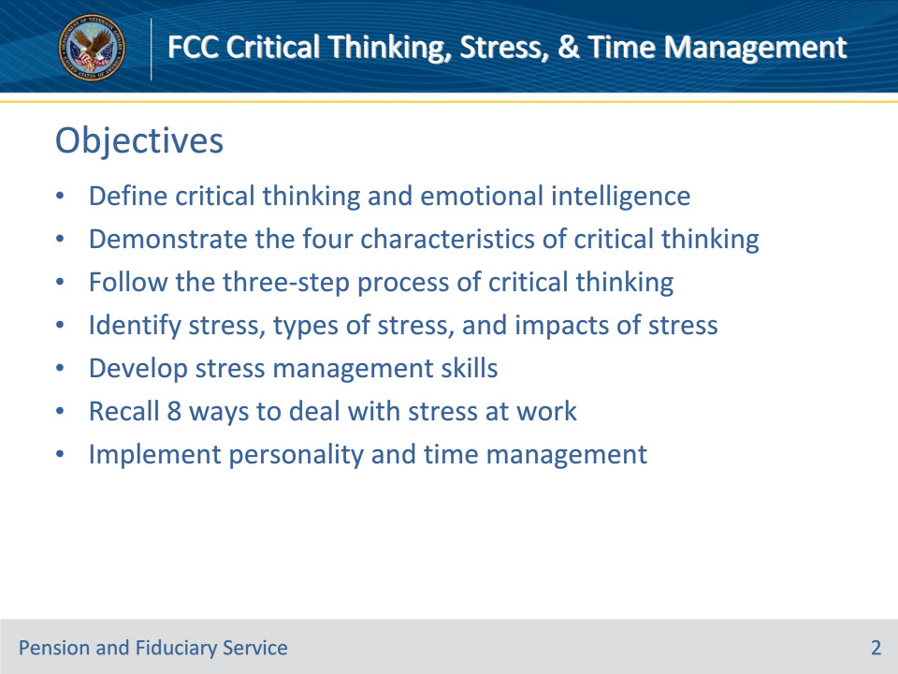
Slide notes

Instructor Notes

At the end of this lesson, given the training and references, the learner will be able to do the following:

• Define critical thinking and emotional intelligence

• Demonstrate the four characteristics of critical thinking

• Follow the three-step process of critical thinking

• Identify stress, types of stress, and impacts of stress

• Develop stress management skills

• Recall 8 ways to deal with stress at work

• Implement personality and time management

Slide 3 - Critical Thinking
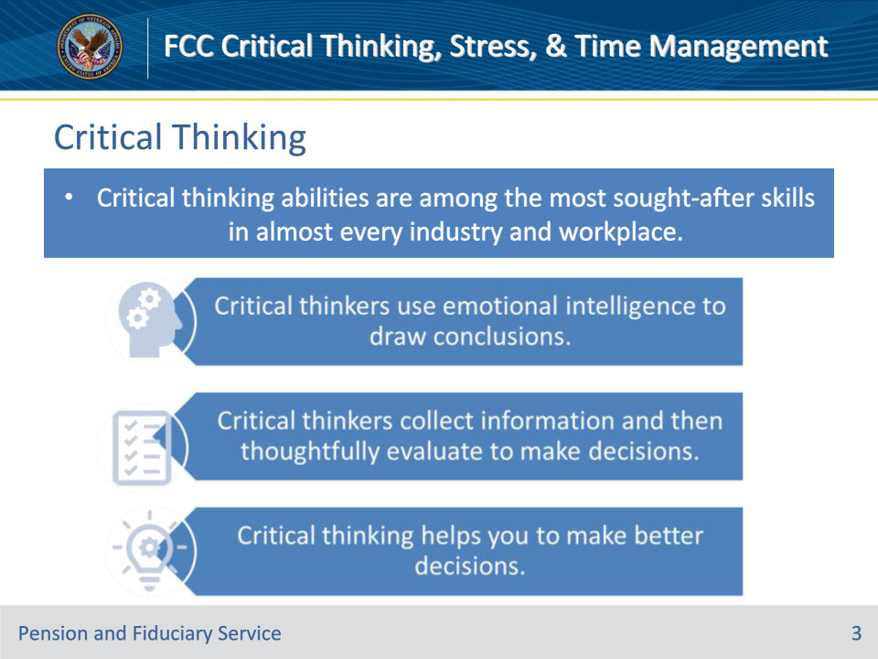
Slide notes

Policy Reference(s): N/A

Instructor Notes

Introduction to Critical Thinking

Critical thinking abilities are among the most sought-after skills in almost every industry and workplace. Often thinking is considered separate from emotions, but good critical thinkers use emotional intelligence to draw reasonable conclusions from a range of information sources determining what is useful and what isn’t. Critical thinking requires collecting information and then thoughtfully evaluating it in order to guide decision making. As a LAS, critical thinking helps you to make better decisions by engaging in logical reasoning, avoiding mistakes due to bias or inaccurate assumptions, and systematically working through options to identify the most relevant and reasonable solution.

• Critical thinkers use emotional intelligence to draw conclusions.

• Critical thinkers collect information and then thoughtfully evaluate to make decisions.

• Critical thinking helps you to make better decisions.

Slide 4 - Critical Thinking & Emotional Intelligence
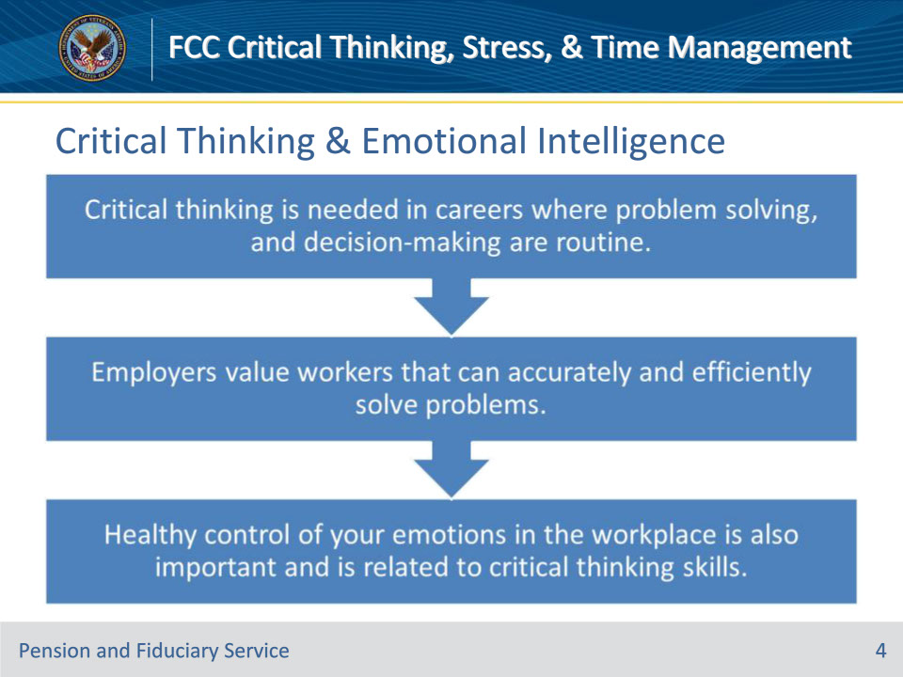
Slide notes

Policy Reference(s): N/A

Instructor Notes

Critical Thinking and Emotional Intelligence

Emotional Intelligence and critical thinking are regarded as important traits which may influence quality of work including decision-making and reasoning ability and adoption of evidence-based practice and practice-based knowledge.

Critical thinking is needed in careers where problem solving, and decision-making are routine.

Employers value workers that can accurately and efficiently solve problems.

Healthy control of your emotions in the workplace is also important and is related to critical thinking skills, since a calm head allows you to engage more effectively in critical thinking; both attributes can help you establish better relationships with co-workers, supervisors and customers.

Slide 5 - Critical Thinking & Emotional Intelligence
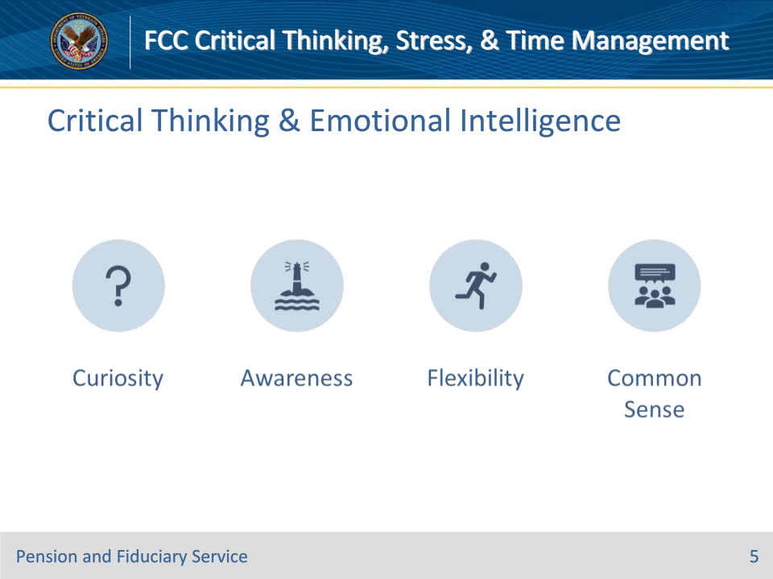
Slide notes

Policy Reference(s): N/A

Instructor Notes

Characteristics of Critical Thinking

The purpose of critical thinking is not to be right, but to gather and assess the right information. Consciously demonstrating these four characteristics will help you to improve your skills.

The four characteristics of critical thinking are:

• Curiosity

• Awareness

• Flexibility

• Common Sense

Slide 6 - Curiosity
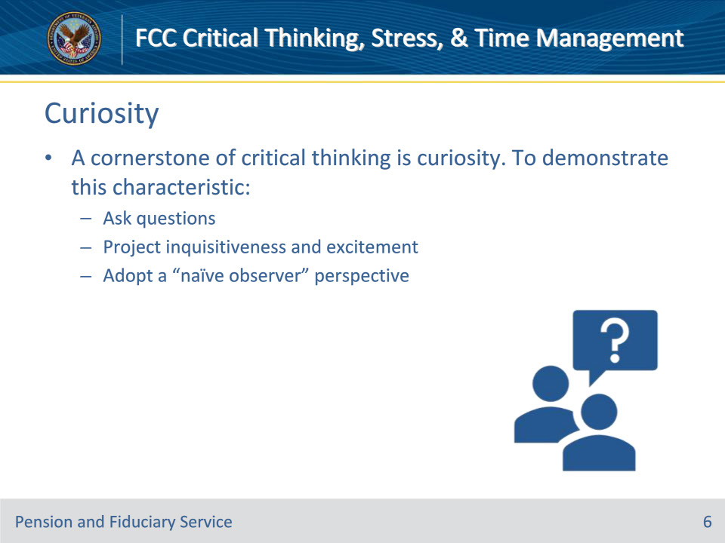
Slide notes

Policy Reference(s): N/A

Instructor Notes

Curiosity

A cornerstone of critical thinking is curiosity. To demonstrate this characteristic:

• Ask questions that reflect your willingness to grasp and accept new ideas and conclusions.

• Project inquisitiveness and excitement rather than skepticism or negativity.

• Adopt a “naïve observer” perspective when approaching an issue, instead of a “know-it-all” perspective, even if you’re an expert.

Slide 7 - Awareness
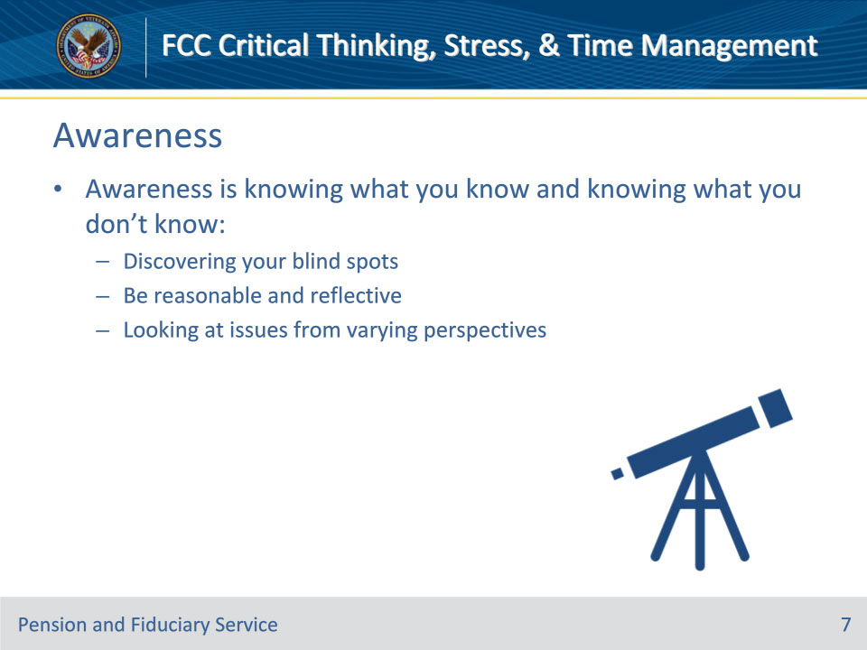
Slide notes

Policy Reference(s): N/A

Instructor Notes

Awareness

Awareness is knowing what you know and knowing what you don’t know. It is particularly critical when examining assumptions and biases.

Awareness means discovering your blind spots in order to make reasonable and reflective decisions by looking at an issue from a variety of perspectives. Self-reflection, education and open-mindedness are valuable tools for expanding awareness.

Slide 8 - Flexibility
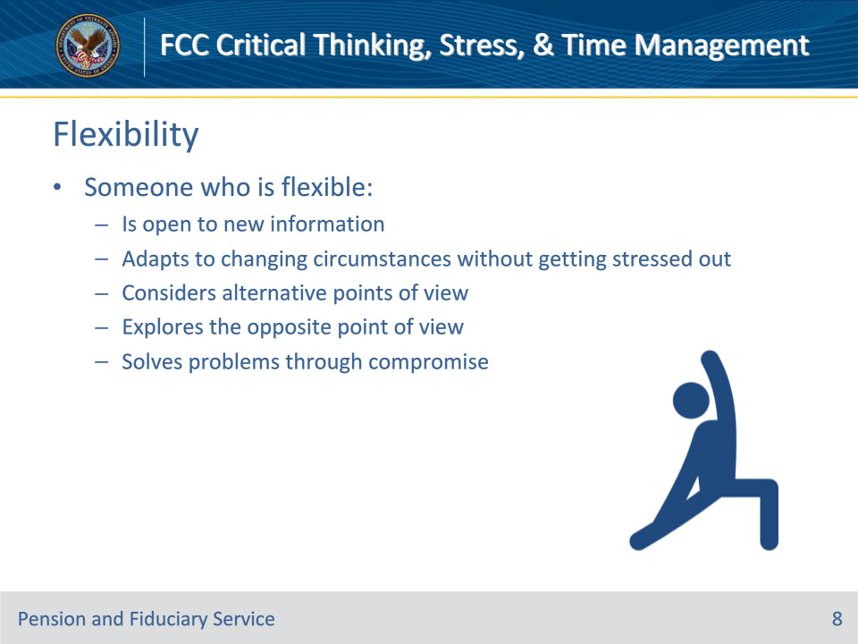
Slide notes

Policy Reference(s): N/A

Instructor Notes

Flexibility

Someone who is flexible:

• Is open to new information

• Adapts to changing circumstances and deals with ambiguity without getting stressed out

• Considers alternative points of view without being attached to any one perspective

• Plays devil’s advocate and explores the opposite point of view

• Solves problems through compromise and consensus and is willing to experiment with another person’s ideas

Slide 9 - Common Sense
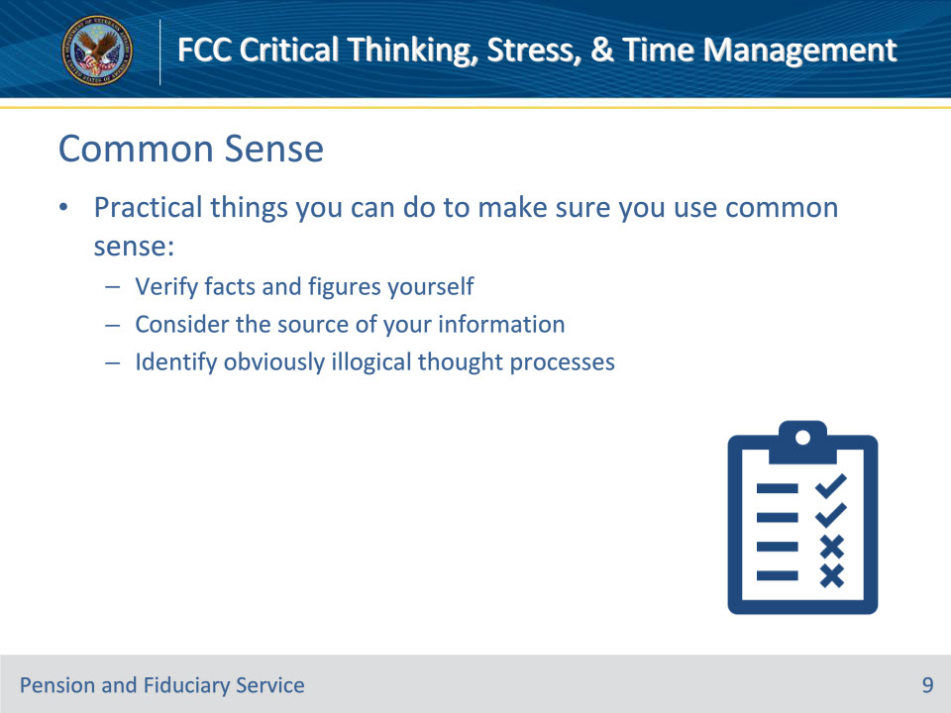
Slide notes

Policy Reference(s): N/A

Instructor Notes

Common Sense

Common sense means paying attention to the obvious. However, it’s not as easy or as common as it sounds. Some practical things you can do to make sure you use common sense are:

• Verifying facts and figures yourself. Check others’ work, as well as your own.

• Consider the source of your information. Can you find a second or independent source to confirm it?

• Identify obviously illogical thought processes. Does the information pass the “sniff test”? Think of outlandish urban legends, like stories of people who follow their GPS when it tells them to drive into a building.

Slide 10 - Interactive Activity
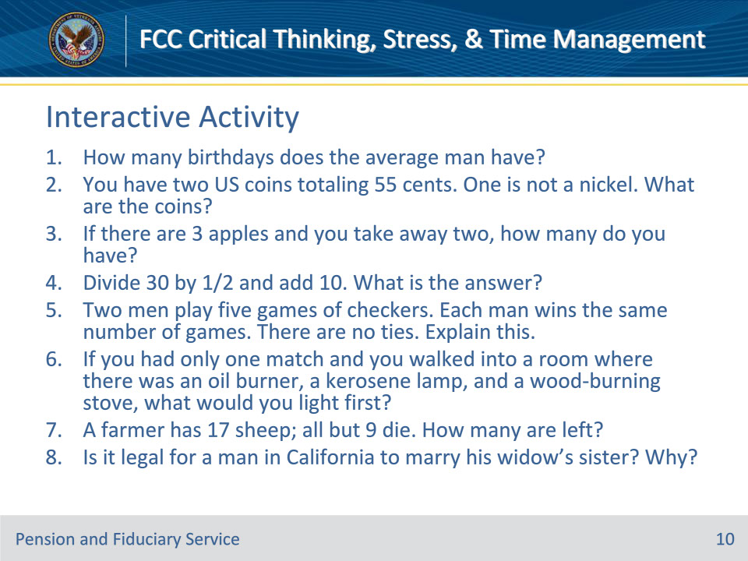
Slide notes

Policy Reference(s): N/A

Instructor Notes

Interactive Activity

The following is an interactive activity. Advise trainees that this activity is to test their common sense. Advise trainees they can put their answers in the participant guide. Provide trainees 10 minutes to complete the activity. Ask for volunteers to answer each question and discuss the correct answers with the trainees.

Answers are on the next slide:

1. One

2. A 50-cent piece and a nickel. Only one is not a nickel.

3. Two

4. 70

5. They were playing different people.

6. The match

7. Nine

8. No. He’s dead.

Slide 11 - Answers
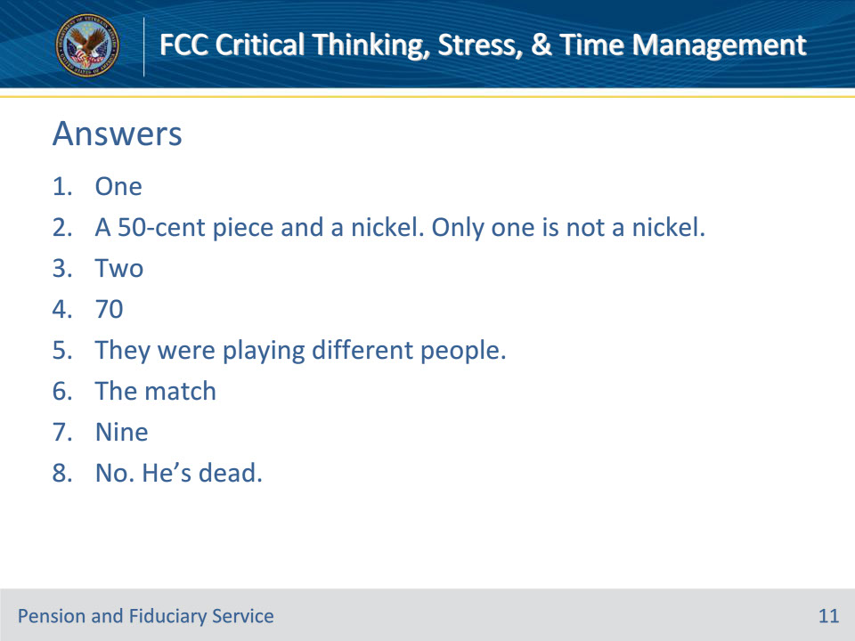
Slide notes

Policy Reference(s): N/A

Instructor Notes

Interactive Activity Answers

1. One

2. A 50-cent piece and a nickel. Only one is not a nickel.

3. Two

4. 70

5. They were playing different people.

6. The match

7. Nine

8. No. He’s dead.

Slide 12 - Critical Thinking Process
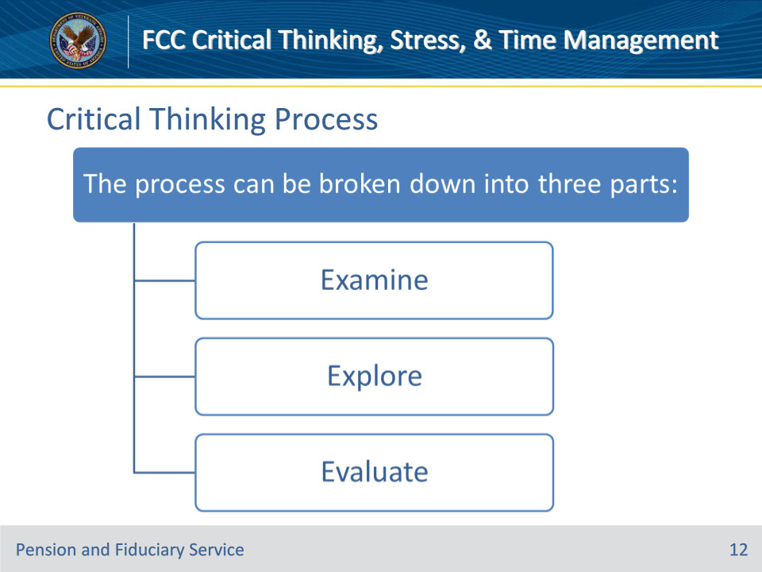
Slide notes

Policy Reference(s): N/A

Instructor Notes

Critical Thinking Process

Next, we will discuss critical thinking. Possessing the traits of critical thinkers is a great start, but one of the cornerstones of critical thinking is following a logical process. Adopting the three-step process establishes a consistent habit that you can rely on to guide your critical thinking. The critical thinking process can be divided into three parts: examine, explore, and evaluate.

Slide 13 - Examine
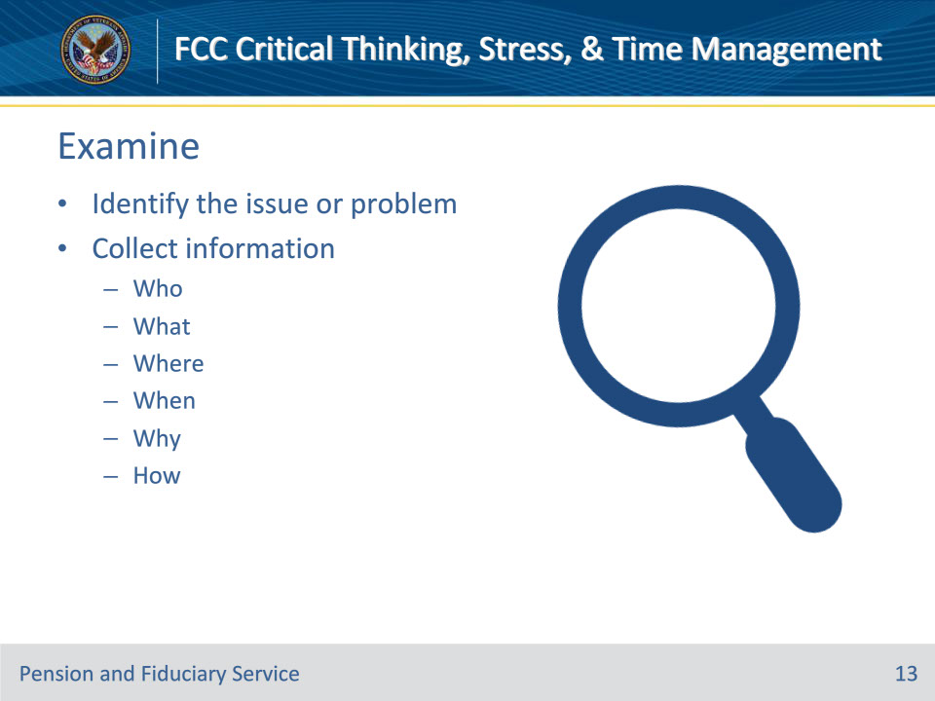
Slide notes

Policy Reference(s): N/A

Instructor Notes

Examine

Identify the issue or problem. What is the question or situation that requires an answer or conclusion? Make certain you identify the fundamental issue and not a conclusion or side issue.

Collect information. Cover the five W’s and H: Who, what, where, when, why, and how. Use direct observation/personal experience, intuition, examples, statistics, research, and expert testimony (know the depth and breadth of his/her expertise).

Slide 14 - Explore
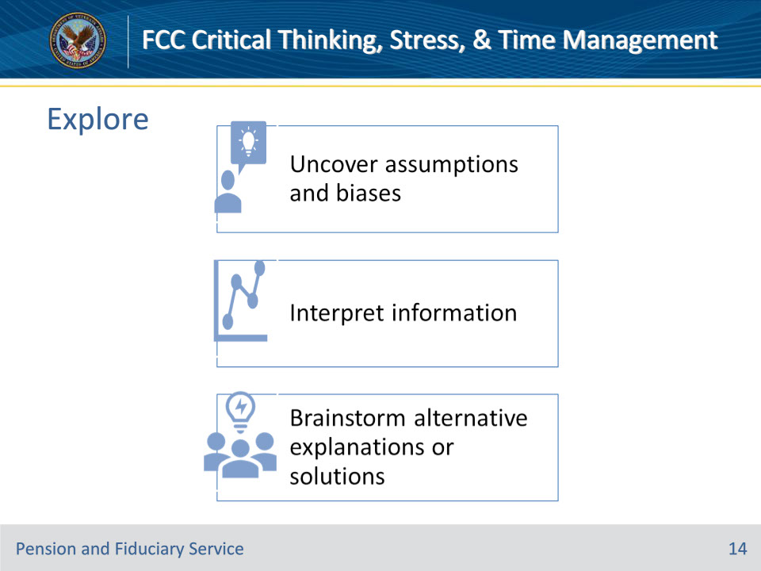
Slide notes

Policy Reference(s): N/A

Instructor Notes

Explore

When exploring you uncover assumptions and biases. Assumptions are unstated beliefs, usually related to values, priorities, and preferences. They are the filter through which we view the issue.

• When exploring you want to seek alternative viewpoints: Find out how other people view the same situation.

• You want to be aware of typical value conflicts: Such as, loyalty vs. honesty, competition vs. cooperation, security vs. excitement, self-control vs. spontaneity, individual rights vs. group/community interests.

• Be sure to recognize the assumptions being made: Ask “how do I/we know that?”

• Ensure you are considering the assumption’s relevance: Are you understanding the extent to which an assumption applies to the situation?

Interpreting information.

• When you interpret information, you have to separate fact from opinion. Look for concreate evidence.

• Clarify ambiguous words, phrases, examples or statistics. Example: “Profit-taking” = selling or cutting losses.

Do some brainstorming alternative explanations or solutions.

• What are all the explanations and options you can come up with?

• Dare to be different when you are exploring: Don’t’ be afraid to consider the most outlandish explanation and solutions.

Slide 15 - Evaluate
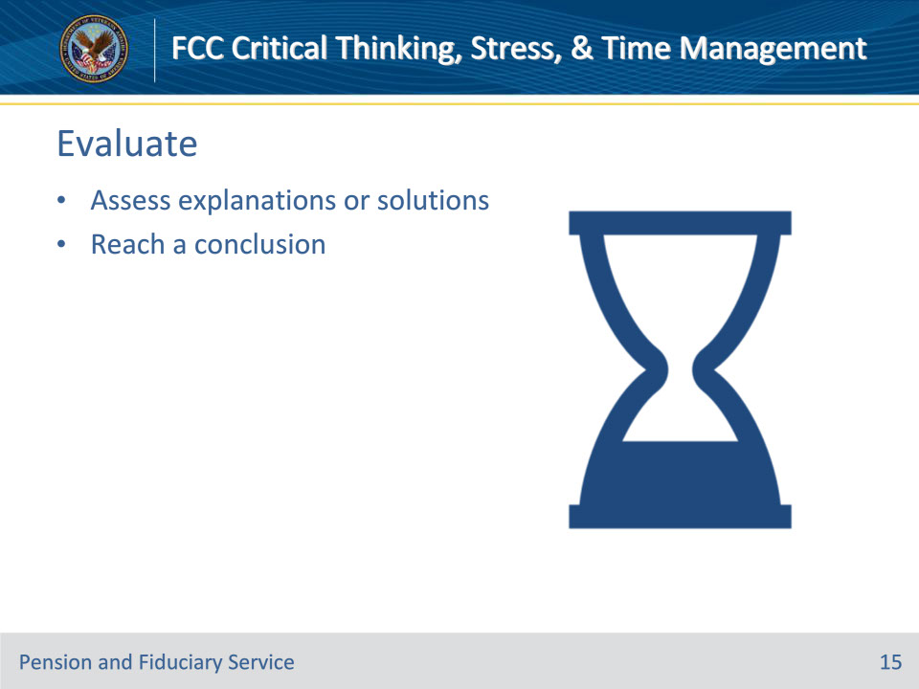
Slide notes

Policy Reference(s): N/A

Instructor Notes

Evaluate

When evaluating be sure to assess explanations or solutions. Ask the following questions:

• Are there erroneous assumptions?

• Are there fallacies in reasoning?

• How good is the information? What is the source? Can you test it?

• Is any information omitted?

• You want to beware of either/or choices. Multiple options are usually possible in a specific situation. Instead of asking “Should we do X or Y,” ask “What should we do about…?”

• How dependable are the statistics?

• Once you have reached a conclusion:

• You will want to eliminate options with incorrect assumptions, faulty reasoning, bad information, etc.

• Ensure you list the remaining choices on a value/effort grid. Look at each choice and determine the amount of effort it would take versus the amount of value it offers. Obviously, the most desirable choices are high value/low effort, while the least desirable are low value/high effort.

Slide 16 - Activity
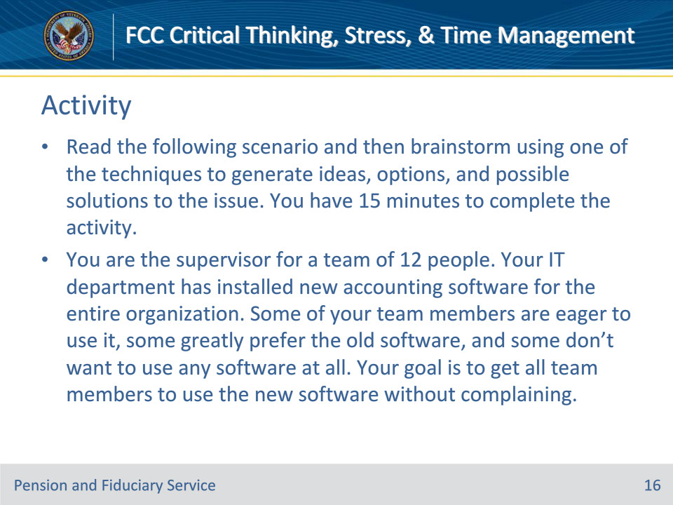
Slide notes

Policy Reference(s): N/A

Instructor Notes

Activity

Instructions: Have trainees read the following scenario and then use a brainstorming technique to generate ideas, options, and possible solutions to the issue. Provide trainees 15 minutes to complete the activity. Debrief by having a few share their ideas (try to get an example of each technique). Note: The actual ideas or solutions are not the point of the activity; the point is for participants to practice brainstorming techniques.

You are the supervisor for a team of 12 people. Your IT department has installed new accounting software for the entire organization. Some of your team members are eager to use it, some greatly prefer the old software, and some don’t want to use any software at all. Your goal is to get all team members to use the new software without complaining.

Slide 17 - Brainstorming Techniques
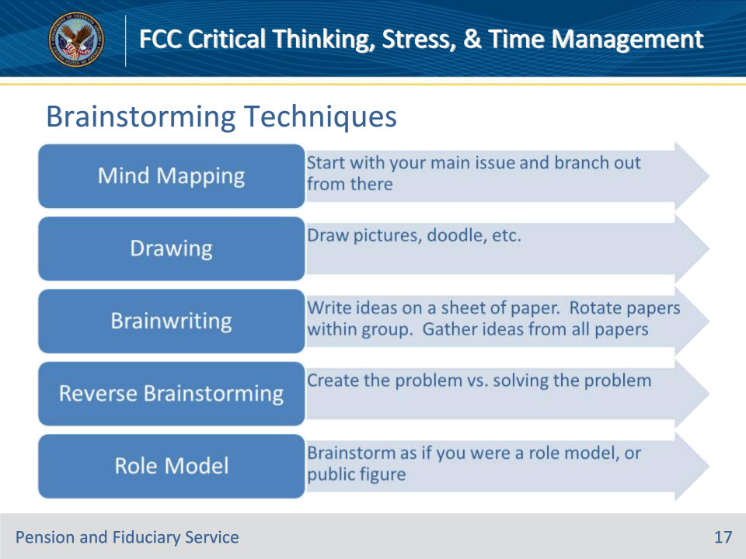
Slide notes

Policy Reference(s): N/A

Instructor Notes

Brainstorming Techniques

Mind Mapping

Is when you start with the issue or problem in the center of a flip chart or whiteboard. Create branches of sub-topics and branch out from those until you capture all of the ideas related to the issue.

Drawing

Is when you think of an issue or problem, consider major obstacles and draw pictures that come to your mind without trying to make them decipherable. Next, look at them to see what ideas or solutions arise from them.

Brainwriting

Is when you get a group of people together to have them write their ideas for how to solve a problem on their own sheet of paper. You would then rotate the sheets to different people and build off what the others write. Next you rotate as many times as you want, or until everyone has written on everyone else’s sheet. Once all sheets have been written on, you would begin to work on solving the problem as a group.

Reverse Brainstorming

Is exactly what it sounds like, the reverse of brainstorming. Instead of asking, “How can I solve this problem?” ask, “How can I create this problem?” From those ideas, see if you can work backward to solve your actual problem or issue.

Role Model

Is when you brainstorm ideas as if you were your role model or a public figure you admire.

Slide 18 - Common Mistakes
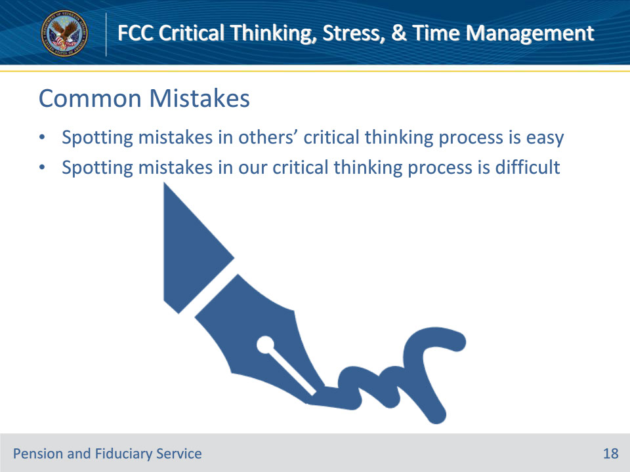
Slide notes

Policy Reference(s): N/A

Instructor Notes

Common Mistakes and How to Avoid Them

It’s usually easier to spot mistakes in other people’s critical thinking process than it is to notice our own. The common critical thinking mistakes are rationalization and emotional thinking. Let’s take a look at rationalization.

Slide 19 - Rationalization
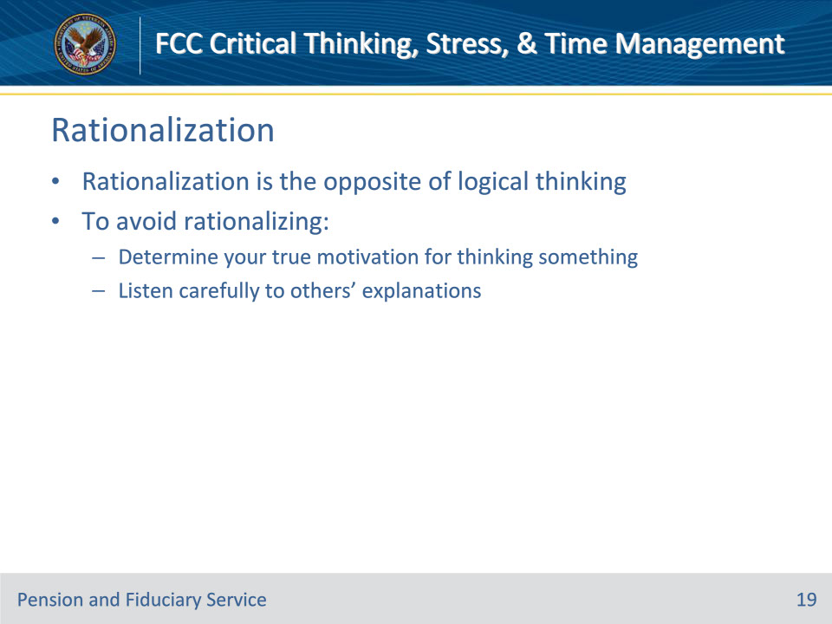
Slide notes

Policy Reference(s): N/A

Instructor Notes

Rationalization

Rationalization is the opposite of logical thinking. When thinking logically, you start with evidence and move to a conclusion based on the evidence. With rationalization, you begin with the conclusion you want and then gather evidence to support that conclusion. You can avoid rationalizing by:

• Determining your true motivation for thinking or believing a certain conclusion and

• Listen carefully to others’ explanations, . —both to uncover valid reasoning you haven’t thought about and to detect whether they are using invalid reasoning. Both of these will help you to uncover valid reasoning you haven’t thought about and to detect whether you are using valid reasoning or not.

Slide 20 - Emotional Thinking
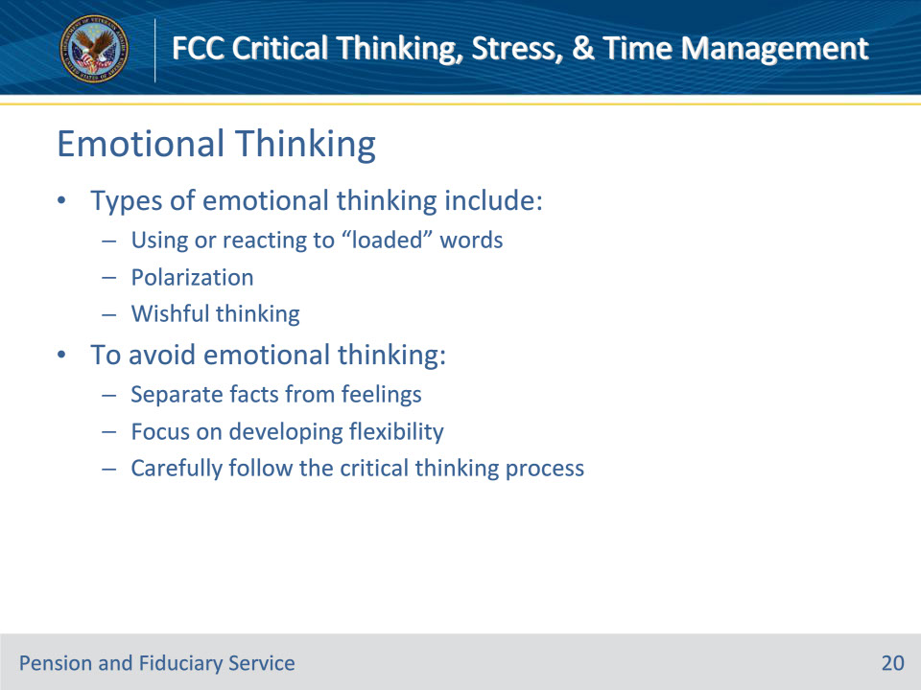
Slide notes

Policy Reference(s): N/A

Instructor Notes

Emotional Thinking

Now let’s take a look at emotional thinking. Emotional thinking reflects an absence of logic. Types of emotional thinking include:

• Using or reacting to “loaded” words. For example, calling someone a “bureaucrat” usually elicits a more negative reaction than “public employee.”

• Polarization means becoming emotionally attached to one side of an issue and judging beliefs without examining them.

• Wishful thinking means an unrealistic belief in something you want to be true.

To avoid emotional thinking, you should:

• Separate facts from feelings. In general, facts are more objective and useful for critical thinking than feelings.

• Focus on developing flexibility. This will help minimize any tendency you have to become attached to a solution too soon.

• Carefully follow the critical thinking process.

Slide 21 - Activity
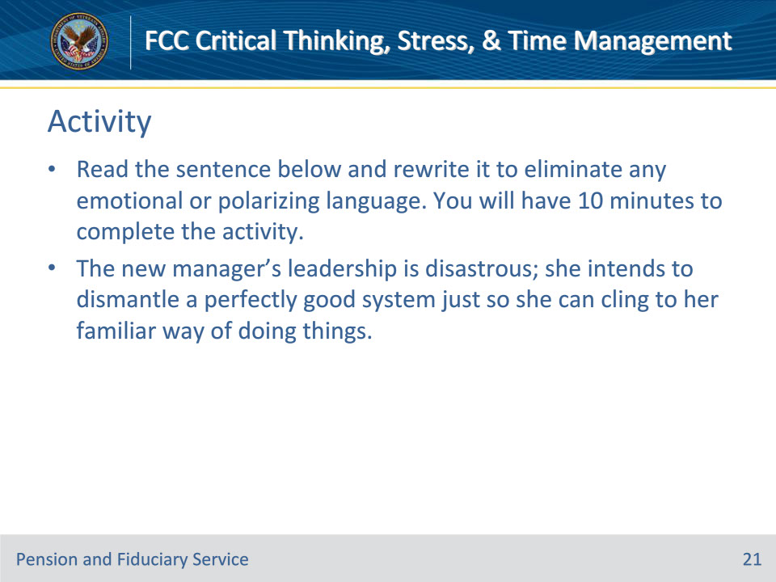
Slide notes

Policy Reference(s): N/A

Instructor Notes

Activity

Advise trainees to read the sentence below. The trainees should rewrite the sentence to eliminate any emotional or polarizing language. Provide trainees 10 minutes to complete the activity. Once the activity is complete, have trainees provide some of their answers to the group and discuss differences amongst the answers.

The new manager’s leadership is disastrous; she intends to dismantle a perfectly good system just so she can cling to her familiar way of doing things.

Answers should focus on replacing the following emotional words:

Disastrous, dismantle, good, and cling.

Here is one possible sentence rewrite:

The new manager’s leadership is uninspiring; she intends to rework a system to make it more familiar to her.

Slide 22 - Bias
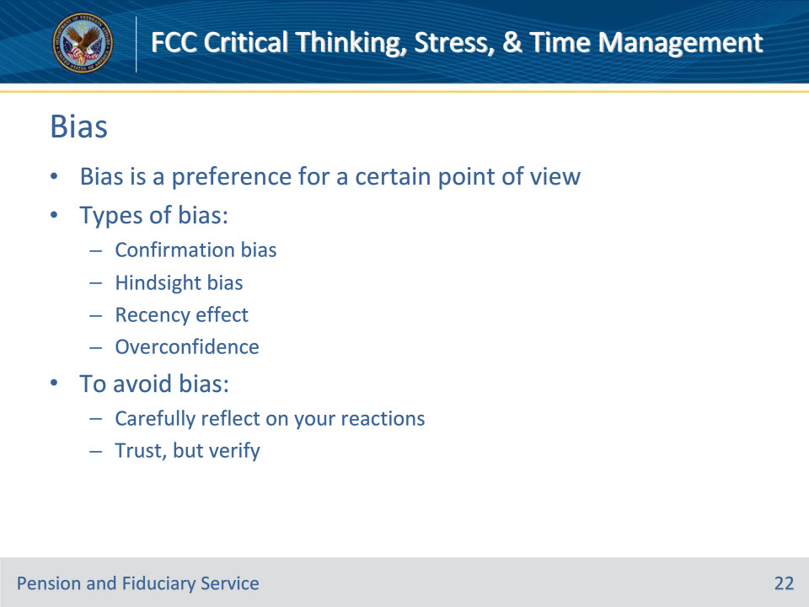
Slide notes

Policy Reference(s): N/A

Instructor Notes

Bias

Bias is a preference for a certain point of view. Types of bias include:

• Confirmation bias is the tendency to seek information that proves, rather than disproves, our beliefs.

• Hindsight bias is the tendency to see previous results as different or more probable than originally thought. An example is: “I knew we were going to lose.”

• Recency effect is the tendency to give more credence to the most recent data you receive. Have you ever noticed how you tend to remember information from the end of a list more readily than from the middle?

• Overconfidence is the tendency to overestimate your abilities. When people were asked to rank themselves against others, more than 80% of people placed themselves in the top 30% of the group!

To avoid bias you should:

• Carefully reflect on your reactions, looking for bias and ask others if they perceive you as biased.

• Trust, but verify. Don’t allow your relationship with a source to cause you to discount documented evidence that may contradict the source.

Slide 23 - Tunnel Vision
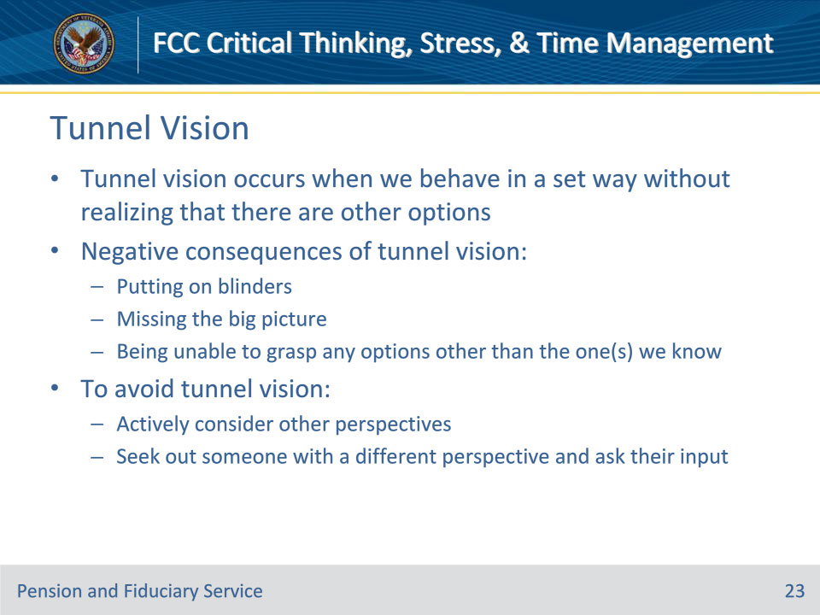
Slide notes

Policy Reference(s): N/A

Instructor Notes

Tunnel Vision

Tunnel vision occurs when we behave in a set way without realizing that there are other options. It is an ingrained way of thinking that is often the result of our upbringing or culture. The negative consequences of tunnel vision include:

• Putting on blinders.

• Missing the big picture.

• Being unable to grasp any options other than the one(s) we know.

To avoid tunnel vision, we should:

• Actively consider other perspectives.

• Seek out someone with a different perspective and ask for his or her input.

Slide 24 - Knowledge Check
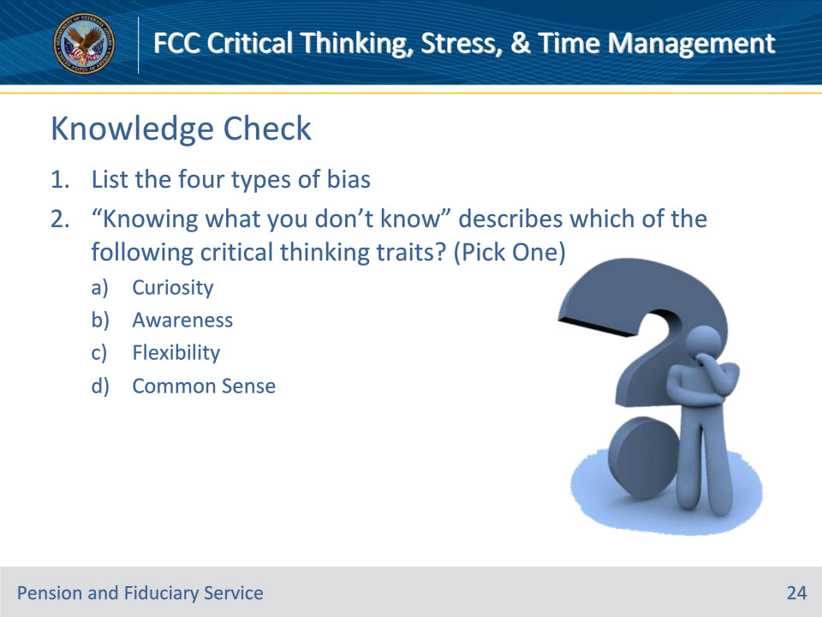
Slide notes

Policy Reference(s): N/A

Instructor Notes

Knowledge Check

1. List the four types of bias.

Answer on next slide…

Confirmation Bias

Hindsight Bias

Recency Effect

Overconfidence

“Knowing what you don’t know” describes which of the following critical thinking traits? (Pick One)

1. Curiosity

2. Awareness

3. Flexibility

4. Common Sense

Answer on next slide…

b. Awareness

Slide 25 - Answers
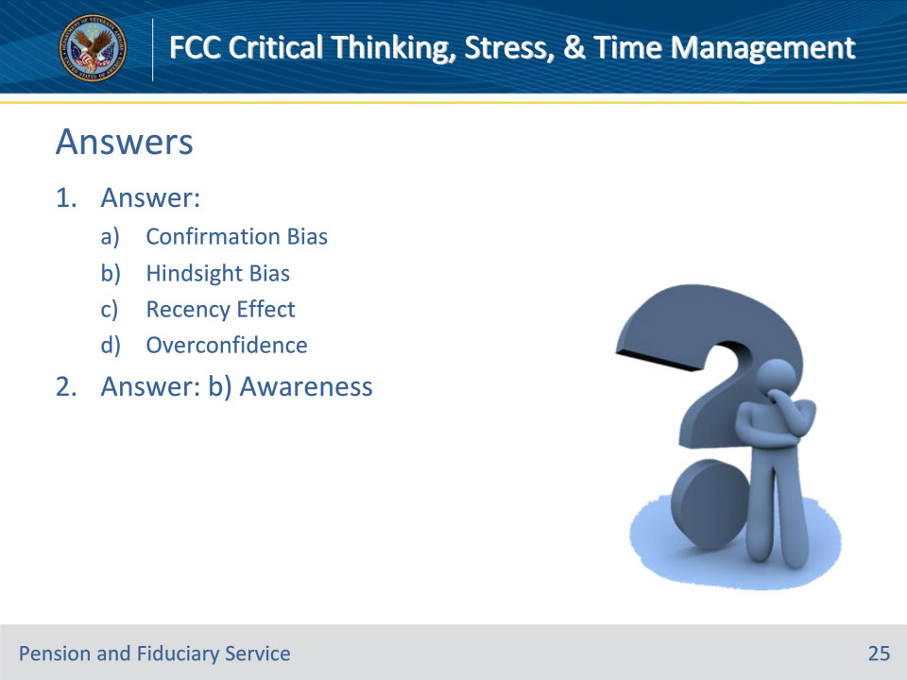
Slide notes

Policy Reference(s): N/A

Instructor Notes

Knowledge Check

1. List the four types of bias.

Answer:

Confirmation Bias

Hindsight Bias

Recency Effect

Overconfidence

2. “Knowing what you don’t know” describes which of the following critical thinking traits? (Pick One)

Answer: b. Awareness

Slide 26 - Knowledge Check
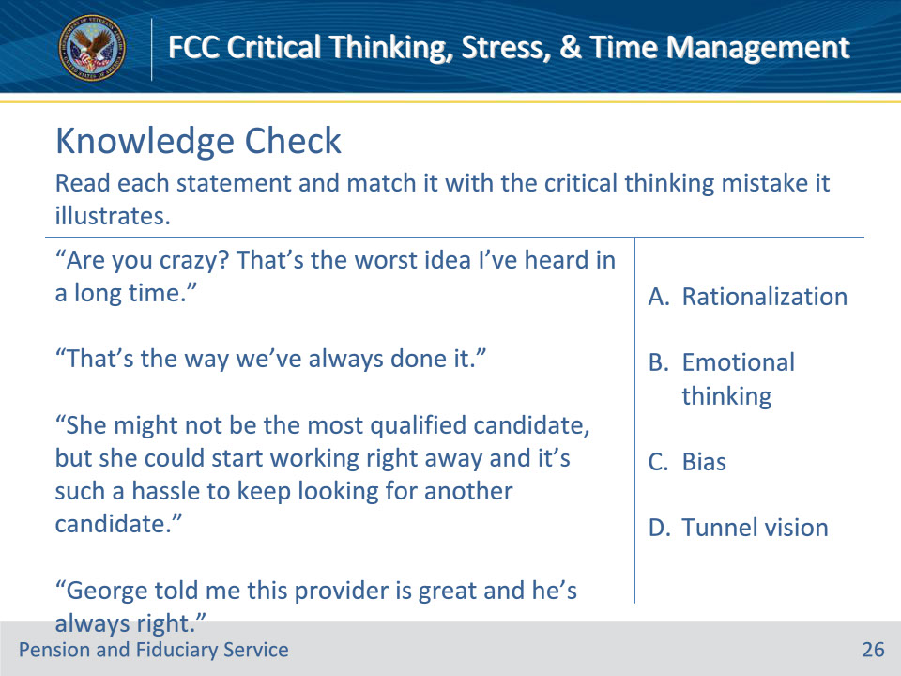
Slide notes

Policy Reference(s): N/A

Instructor Notes

Knowledge Check

Read each statement and match it with the critical thinking mistake it illustrates

1. “Are you crazy? That’s the worst idea I’ve heard in a long time.”

2. “That’s the way we’ve always done it.”

3. “She might not be the most qualified candidate, but she could start working right away and it’s such a hassle to keep looking for another candidate.”

4. “George told me this provider is great and he’s always right.”

Answer Choices:

1. Rationalization

2. Emotional thinking

3. Bias

4. Tunnel vision

Answers on next slide:

B., D., A., C.

Slide 27 - Answers
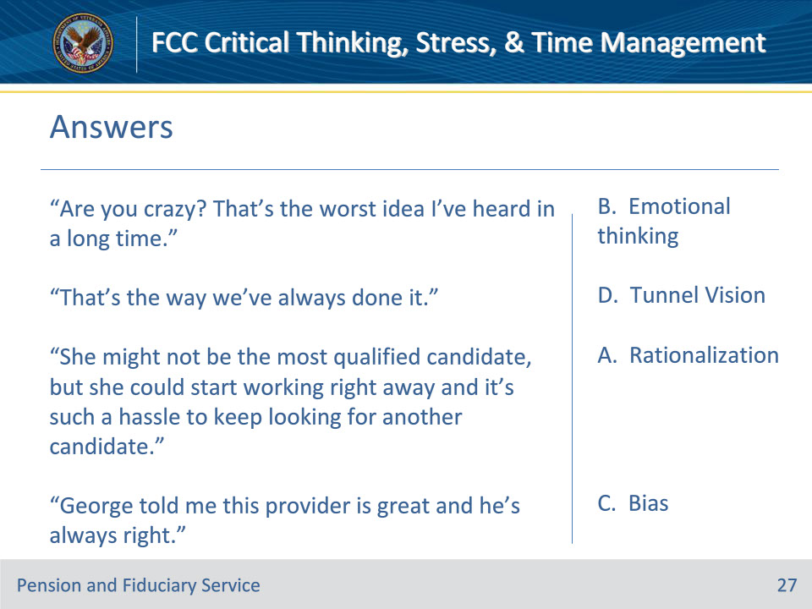
Slide notes

Policy Reference(s): N/A

Instructor Notes

Knowledge Check

Read each statement and match it with the critical thinking mistake it illustrates

Answers:

1. “Are you crazy? That’s the worst idea I’ve heard in a long time.” – B. Emotional thinking

2. “That’s the way we’ve always done it.” - D. Tunnel vision

3. “She might not be the most qualified candidate, but she could start working right away and it’s such a hassle to keep looking for another candidate.” - A. Rationalization

4. “George told me this provider is great and he’s always right.” - C. Bias

Slide 28 - Stress Management
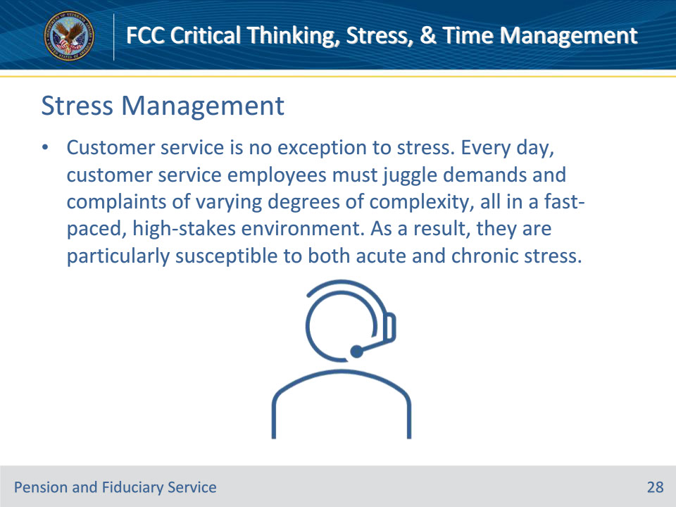
Slide notes

Policy Reference(s): N/A

Instructor Notes

Introduction to Stress Management

Over the past twenty years, an overwhelming amount of studies have conclusively demonstrated that work-related stress negatively affects a growing number of people. Customer service stress is no exception. Every day, customer service employees must juggle demands and complaints of varying degrees of complexity, all in a fast-paced, high-stakes environment. As a result, they are particularly susceptible to both acute and chronic stress. Workplace stress is a critically widespread problem. 80% of American workers reported feeling stressed on the job every day. This overwhelming prevalence means that stress as a phenomenon greatly affects employees and employers alike.

Slide 29 - Understanding Stress
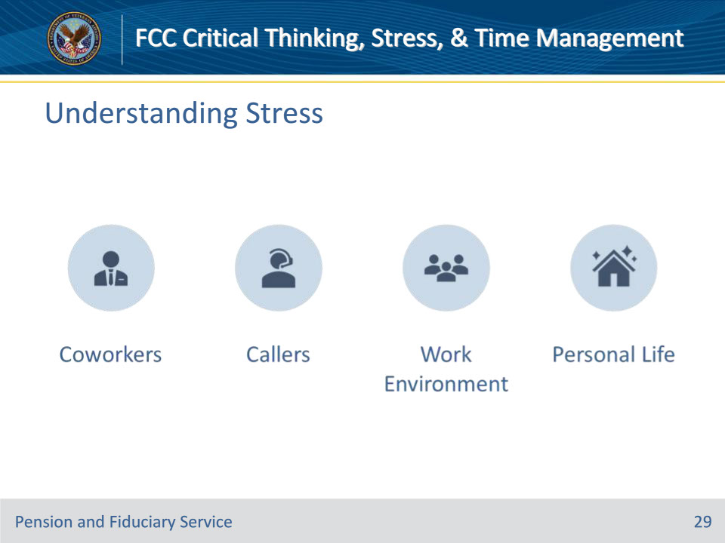
Slide notes

Policy Reference(s): N/A

Instructor Notes

Understanding Stress

In your role as a LAS, stress can result from multiple factors:

• Coworkers

• Callers

• Work environment

• Personal life

The Centers for Disease Control and Prevention (CDC) defines job stress as harmful physical and emotional responses that occur when the requirements of the job do not match the capabilities, resources, or needs of the worker. Job stress can lead to poor health and even injury.

Slide 30 - Types of Stress
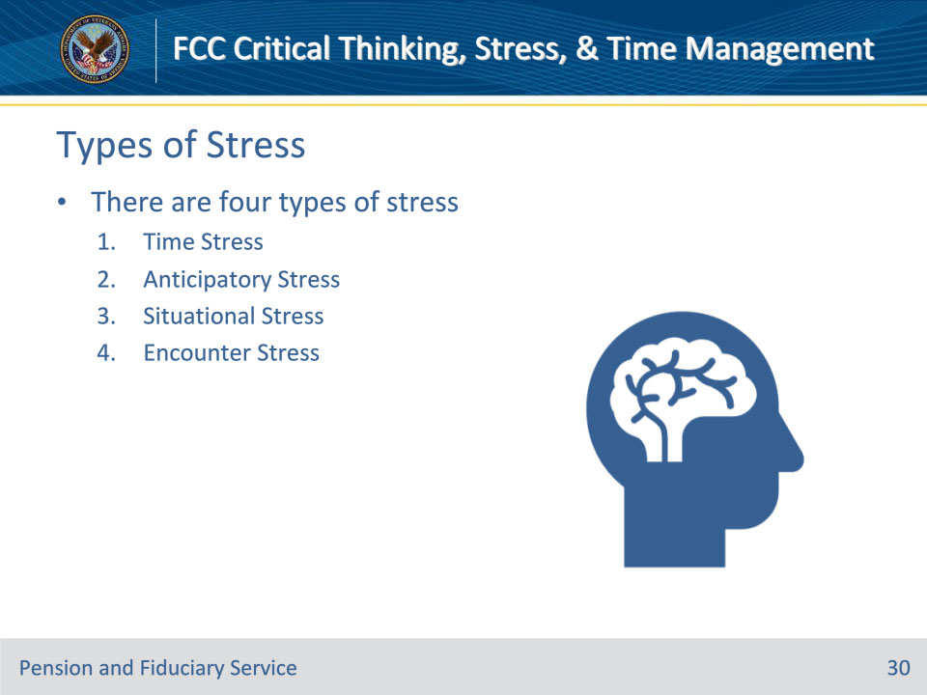
Slide notes

Policy Reference(s): N/A

Instructor Notes

Types of Stress

There are four types of “stress”

• Time Stress

• Anticipatory Stress

• Situational Stress

• Encounter Stress

Slide 31 - Time Stress
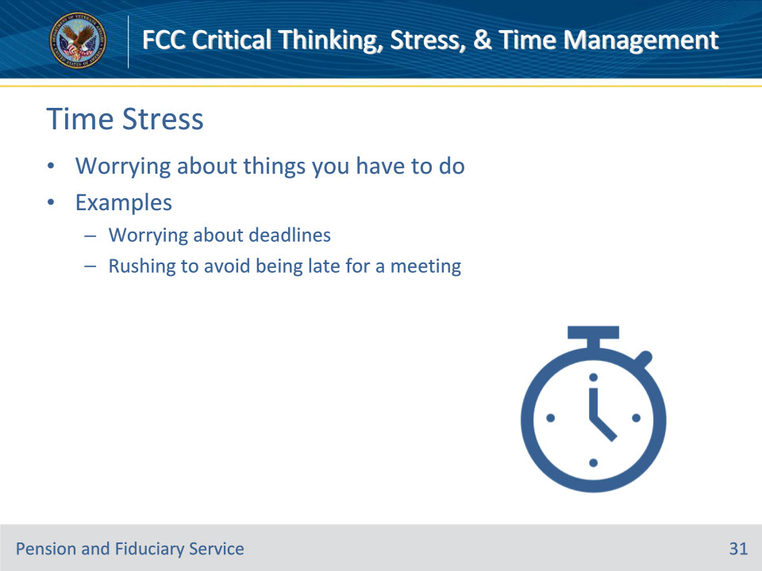
Slide notes

Policy Reference(s): N/A

Instructor Notes

Time Stress

Time stress is worrying about a number of things that you have to do, and you fear that you’ll fail to achieve something important. It often stems from worrying about the numerous tasks and responsibilities that need to be managed within a limited time frame. Time stress can lead to feeling overwhelmed, anxious and even hopeless.

Common examples of time stress include worrying about key deadlines, rushing to avoid being late for a meeting, or looking at a list of jobs that is unmanageable in the time you have to complete them.

Slide 32 - Anticipatory Stress
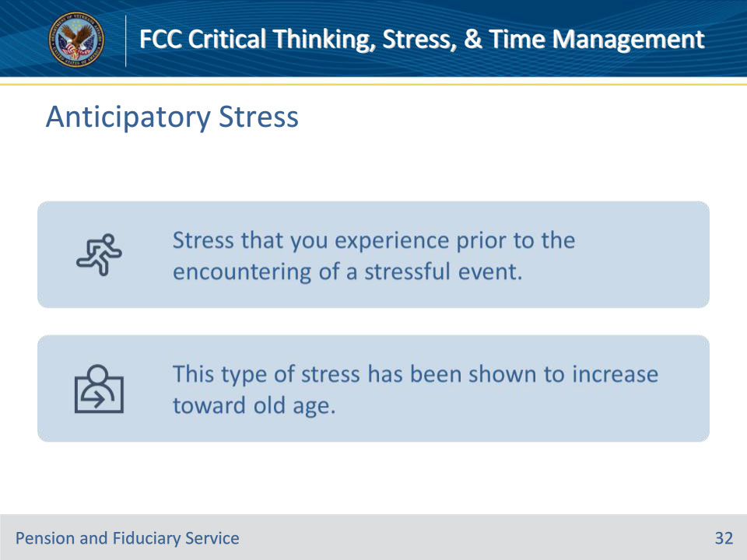
Slide notes

Policy Reference(s): N/A

Instructor Notes

Anticipatory Stress

Anticipatory stress is experienced prior to the encountering of a stressful event such as a presentation. However, anticipatory stress can also be vague and undefined, such as an overall sense of dread about the future, or a worry that “something will go wrong.“

This type of stress has been shown to increase toward old age.

Slide 33 - Situational Stress
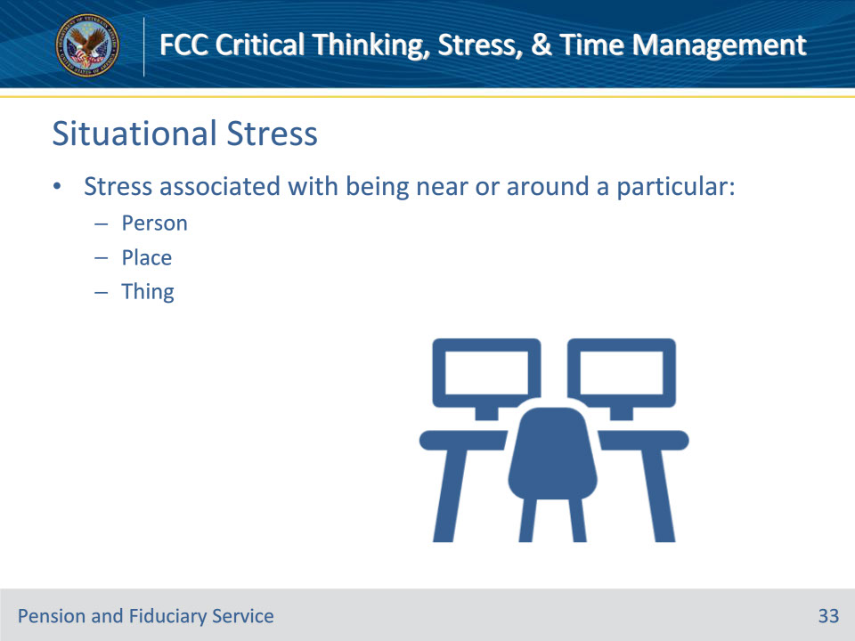
Slide notes

Policy Reference(s): N/A

Instructor Notes

Situational Stress

Situational stress is the stress associated with being near or around a particular person, place, or thing. It is typically temporary and related to particular circumstances.

Slide 34 - 7 Signs of Stress
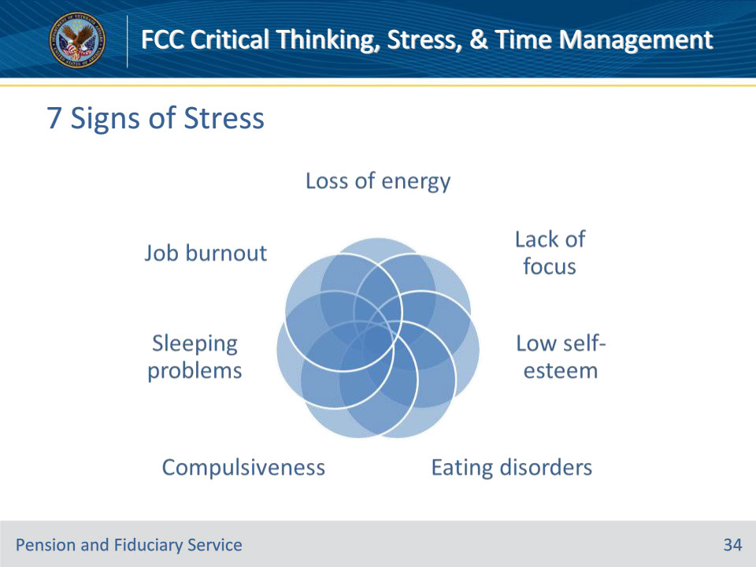
Slide notes

Policy Reference(s): N/A

Instructor Notes

7 Signs of Stress

• Loss of energy

• Lack of focus

• Low self-esteem

• Eating disorders

• Compulsiveness

• Sleeping problems

• Job burnout

Slide 35 - Impacts of Stress
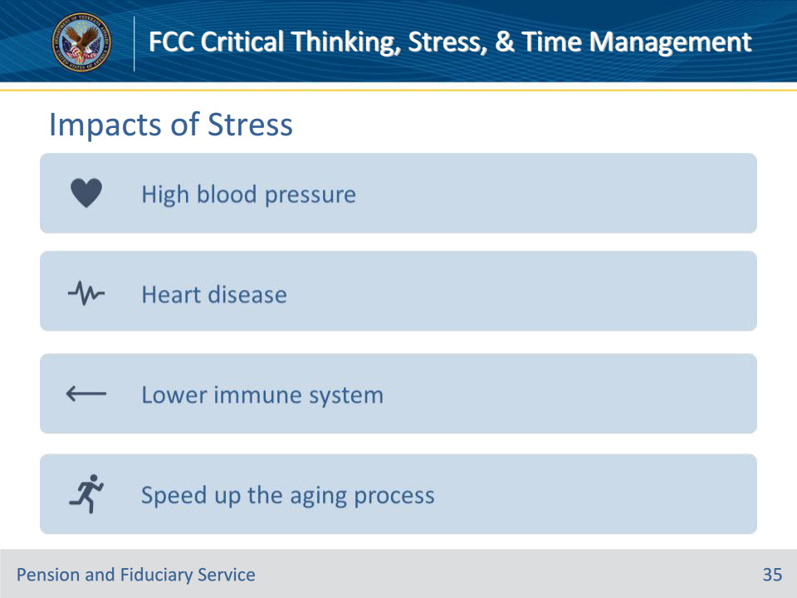
Slide notes

Policy Reference(s): N/A

Instructor Notes

Impacts of Stress

Chronic stress can lead to a number of health issues. Two of the most common health issues are high blood pressure and heart disease. Stress can dampen the immune system which increases susceptibility to colds and other common infections. New research suggests that high levels of stress somehow speed up the aging process.

Slide 36 - Stress Control Methods
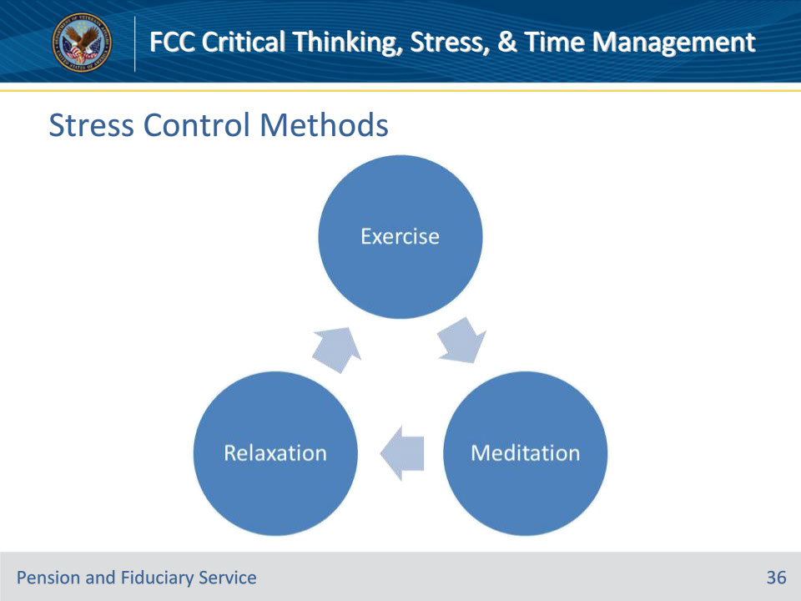
Slide notes

Policy Reference(s): N/A

Instructor Notes

Ways to Control Your Body’s Response to Stress

• Exercise reduces stress hormones and stimulates your endorphins, which are your brain’s feel-good neurotransmitters. It helps release negative emotions such as anger, fear or worry and improves your mood. Exercise also relaxes your muscles that have been tightened because of stress.

• Meditation can give you a sense of calm, peace and balance. It also helps refocus attention on something calming.

• Relaxation can help reduce stress by activating the body’s natural relaxation response. This state of deep rest puts the brakes on stress, slows your breathing and heart rate, lowers your blood pressure, and brings your body and mind back into balance.

Slide 37 - Knowledge Check
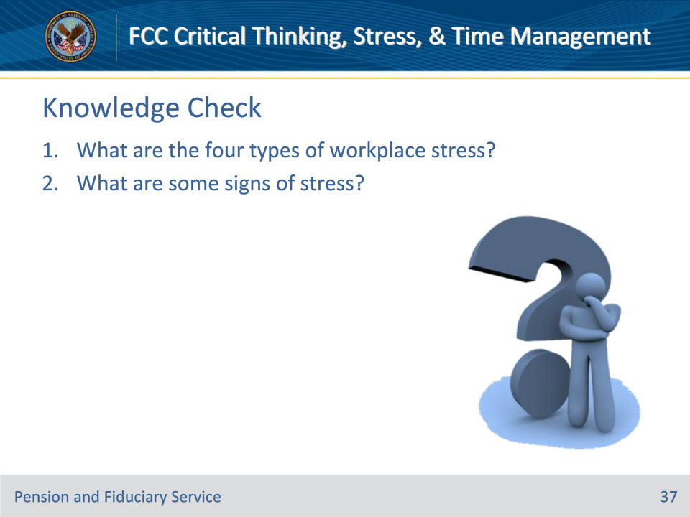
Slide notes

Policy Reference(s): N/A

Instructor Notes

Knowledge Check

What are the four types of workplace stress?

Answer on next slide:

• Time Stress

• Situational Stress

• Anticipatory Stress

• Encounter Stress

What are some signs of stress?

Answer on next slide:

• Loss of energy

• Lack of focus

• Low self-esteem

• Eating disorders

• Compulsiveness

• Sleeping problems

• Job burnout

Slide 38 - Answers
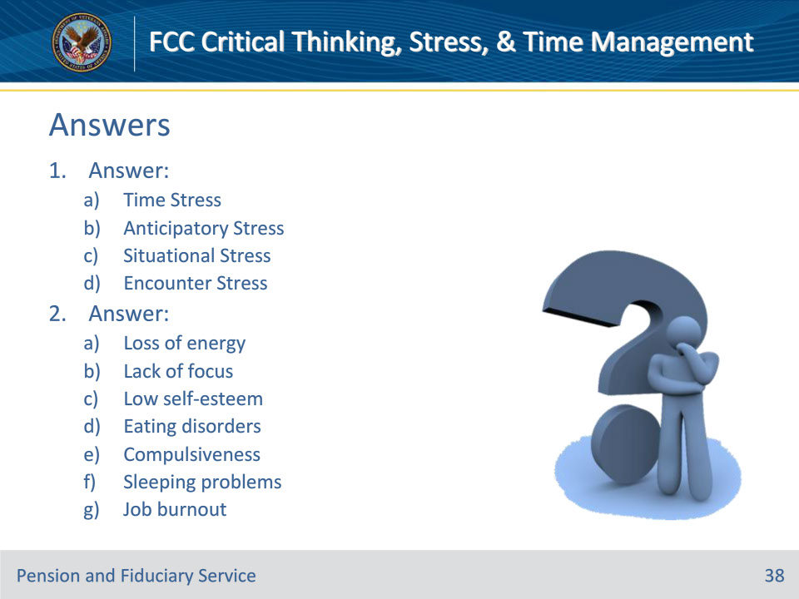
Slide notes

Policy Reference(s): N/A

Instructor Notes

Knowledge Check

What are the four types of workplace stress?

Answer:

Time Stress

Situational Stress

Anticipatory Stress

Encounter Stress

What are some signs of stress?

Answer:

Loss of energy

Lack of focus

Low self-esteem

Eating disorders

Compulsiveness

Sleeping problems

Job burnout

Slide 39 - Stress Management Skills
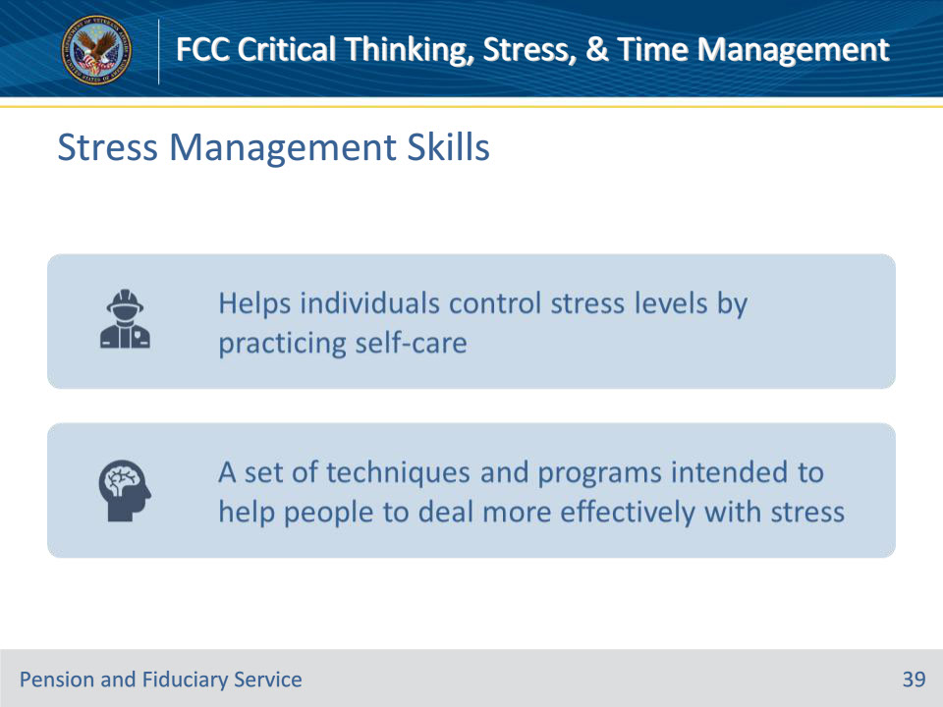
Slide notes

Policy Reference(s): N/A

Instructor Notes

Developing Stress Management Skills

Now let’s talk about some ways to manage stress. Stress management skills are techniques we use to handle stress when it occurs. These skills help us to deal more effectively with stress by analyzing specific stressors and taking positive actions to minimize their effect.

Slide 40 - Stress Management Skills
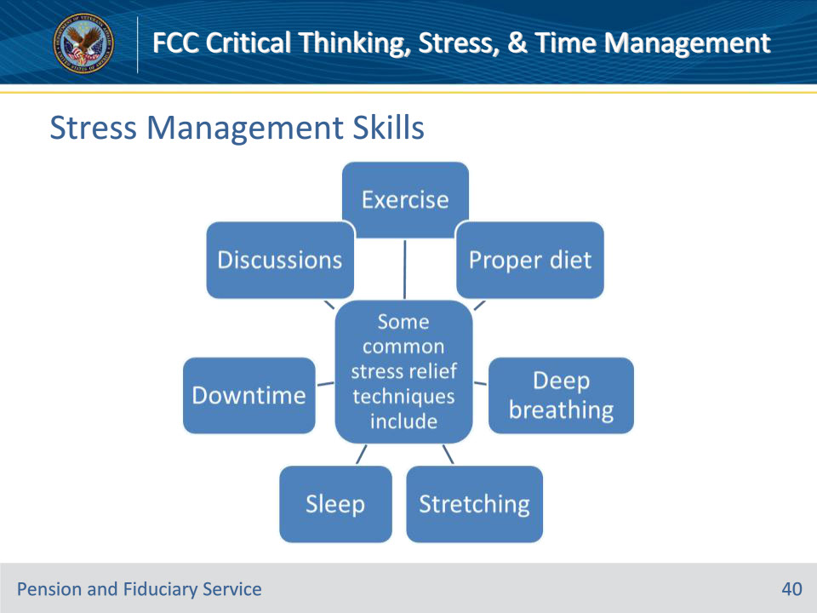
Slide notes

Policy Reference(s): N/A

Instructor Notes

Managing Stress

Some common stress relief techniques include:

• Exercise

• Proper diet

• Deep breathing

• Stretching

• Sleep

• Downtime

• Discussions

Slide 41 - Exercise & Proper Diet
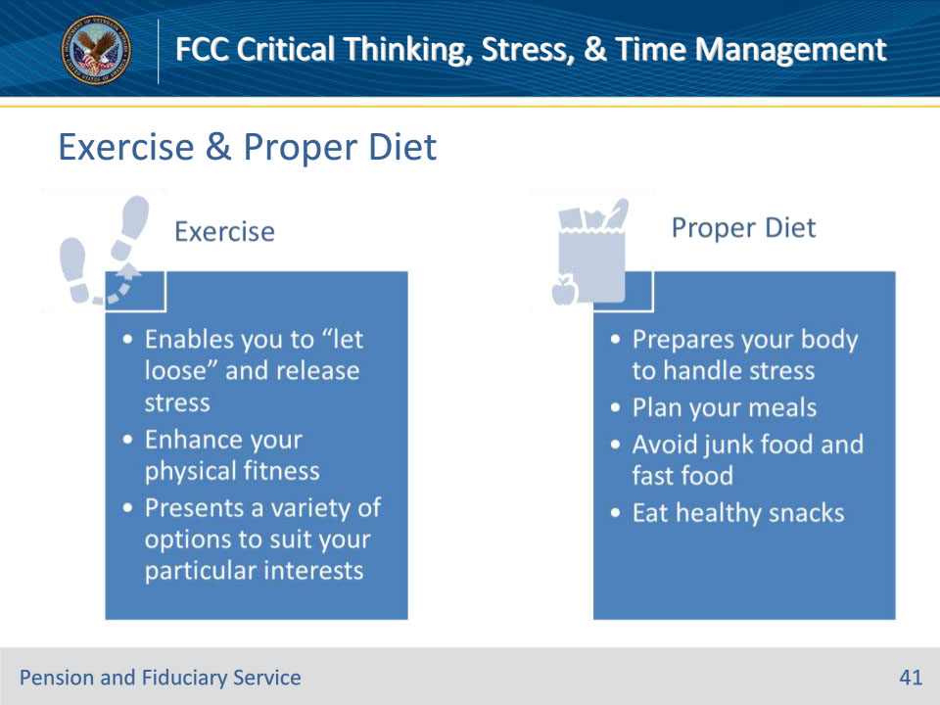
Slide notes

Policy Reference(s): N/A

Instructor Notes

Exercise and Proper Diet

Exercise

• Enables you to “let loose” and release stress

• Enhance your physical fitness

• Presents a variety of options to suit your particular interests

Proper Diet

• Prepares your body to handle stress

• Plan your meals

• Avoid junk food and fast food

• Eat healthy snacks

Slide 42 - Deep Breathing & Stretching
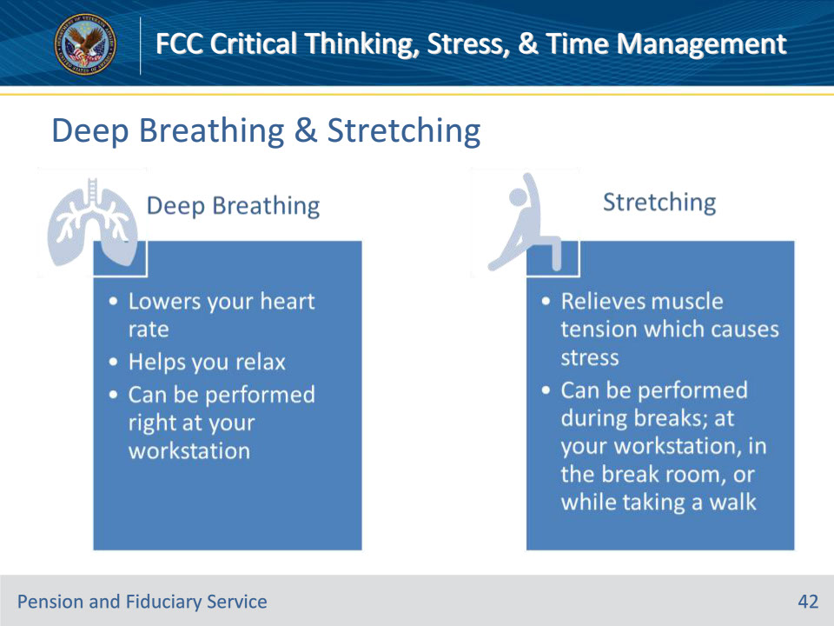
Slide notes

Policy Reference(s): N/A

Instructor Notes

Deep Breathing and Stretching

Deep Breathing

• Lowers your heart rate

• Helps you relax

• Can be performed right at your workstation

Stretching

• Occasional stretching throughout the day relieves muscle tension which causes stress

• This can be performed during breaks; at your workstation, in the break room, or while taking a walk

Slide 43 - Sleep & Downtime
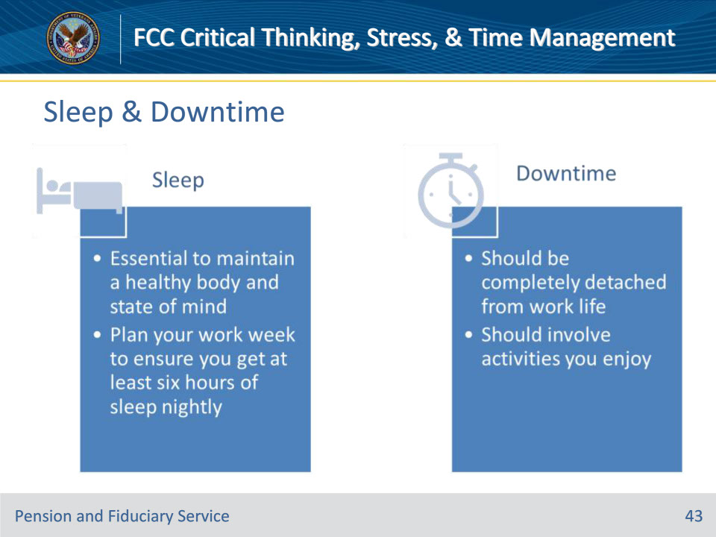
Slide notes

Policy Reference(s): N/A

Instructor Notes

Sleep and Downtime

Sleep

• Sleeping is essential to maintaining a healthy body and state of mind

• To keep your stress levels down, you should plan your work week to ensure you get at least six hours of sleep nightly

Downtime

• Should be completely detached from all elements of your work life

• Should involve activities you enjoy, such as listening to music, going to a movie, reading, or taking up a hobby.

Slide 44 - Discussions
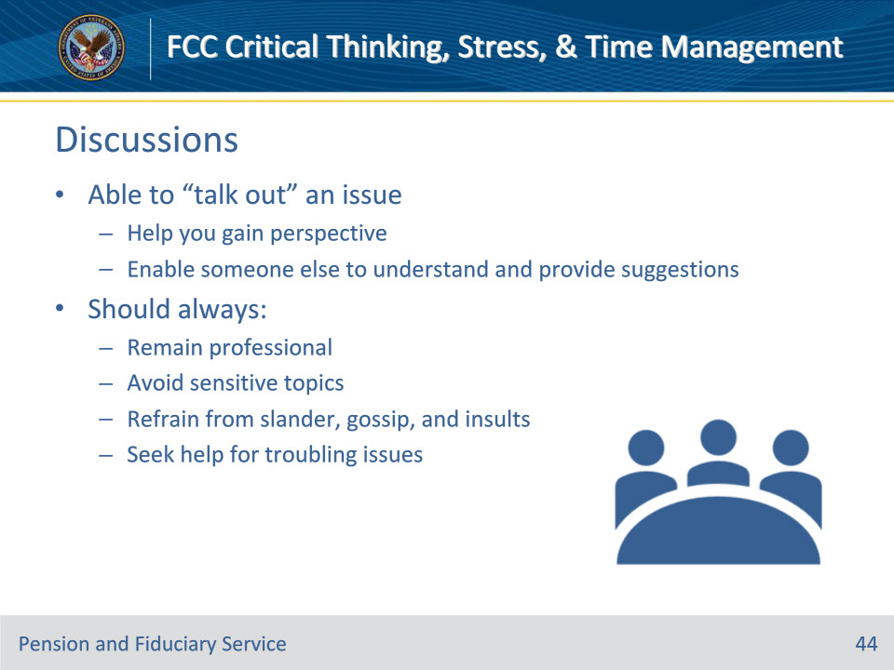
Slide notes

Policy Reference(s): N/A

Instructor Notes

Discussions

You want to ensure you are able to “talk out” an issue

• Doing this can help you gain a better perspective about a situation

• It will assist you in being able to assist someone else in understanding your situation and assist them in being able to provide helpful suggestions

When conducting discussions, regardless who they are with, customers, co-workers, supervisors, etc., you should always:

• Do you best to remain professional

• Be sure to avoid sensitive information except on a need-to-know basis

• Ensure you refrain from slander, gossip, and insults

• Look for guidance or seek help for troubling issues you are unable to handle yourself

Slide 45 - Knowledge Check
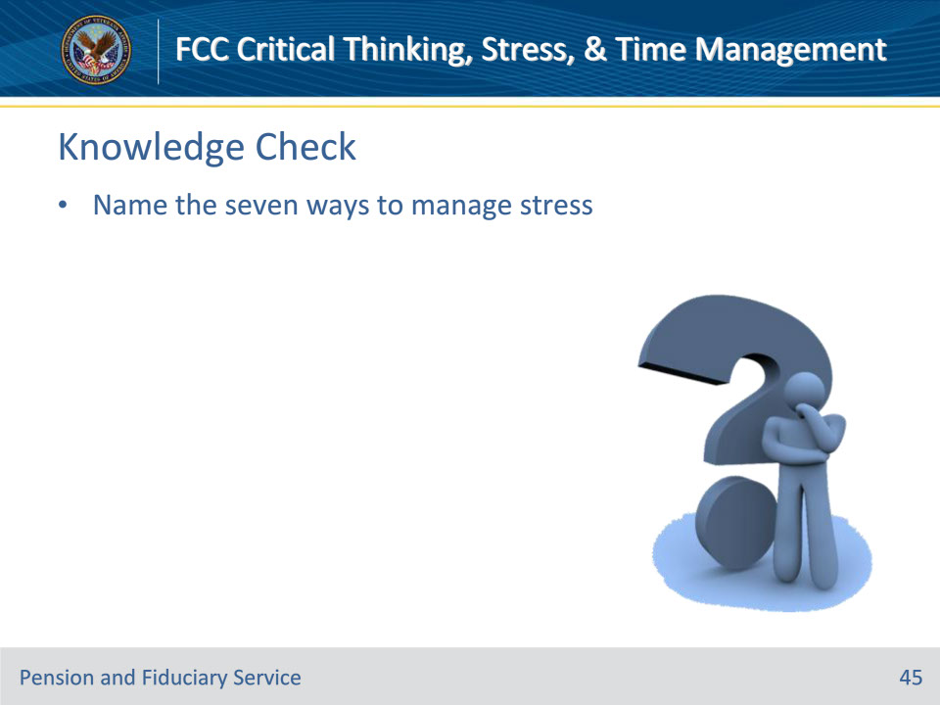
Slide notes

Policy Reference(s): N/A

Instructor Notes

Knowledge Check

Name the seven ways to manage stress.

Answer on next slide:

• Exercise

• Proper diet

• Deep breathing

• Stretching

• Sleep

• Downtime

• Discussions

Slide 46 - Answers
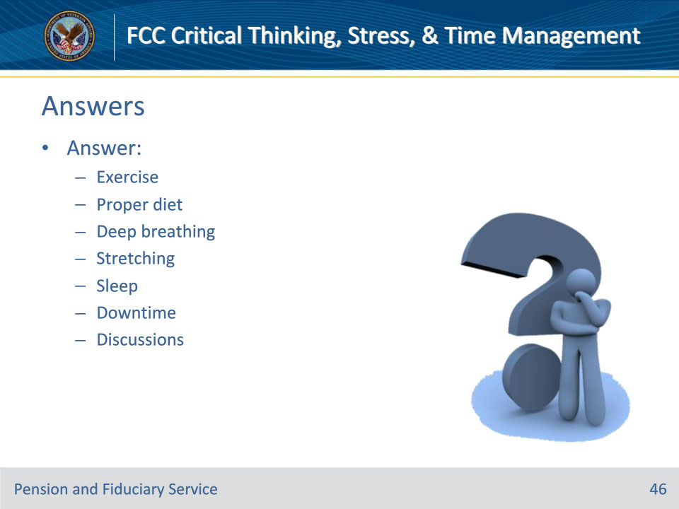
Slide notes

Policy Reference(s): N/A

Instructor Notes

Knowledge Check

Name the seven ways to manage stress.

Answer:

Exercise

Proper diet

Deep breathing

Stretching

Sleep

Downtime

Discussions

Slide 47 - Dealing with Stress
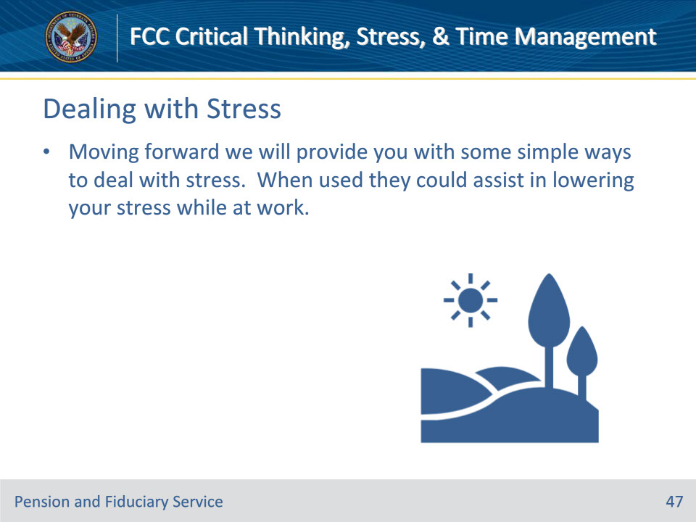
Slide notes

Policy Reference(s): N/A

Instructor Notes

Recommendations on Dealing with Stress at Work

We will provide you with some simple ways to deal with stress, which when used could assist in lowering your stress while at work.

Slide 48 - Techniques for Work
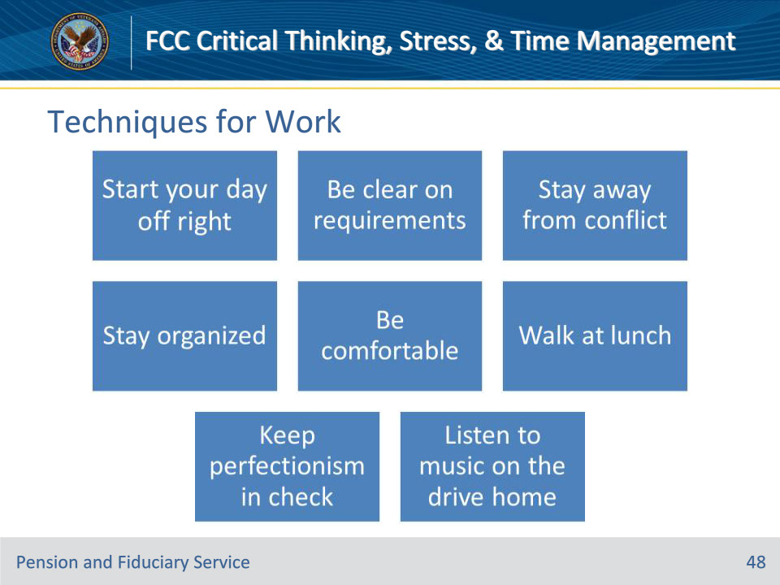
Slide notes

Policy Reference(s): N/A

Instructor Notes

8 Simple Ways to Deal with Stress at Work

• Start Your Day off Right

• Be Clear on Requirements

• Stay Away from Conflict

• Stay Organized

• Be Comfortable

• Walk at Lunch

• Keep Perfectionism in Check

• Listen to Music on the Drive Home

Slide 49 - Start Your Day Off Right
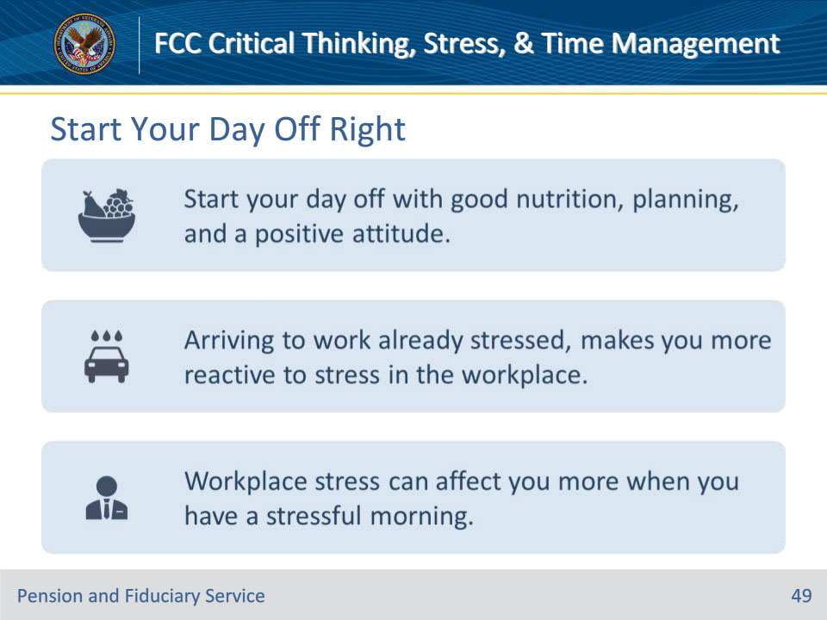
Slide notes

Policy Reference(s): N/A

Instructor Notes

Start your Day off Right

After scrambling to get the kids fed and off to school, dodging traffic and combating road rage, and gulping down coffee in lieu of a healthy breakfast, many people arrive to work already stressed. This makes them more reactive to stress in the workplace.

You might be surprised by how affected by workplace stress you are when you have a stressful morning. When you start off the day with planning, good nutrition, and a positive attitude, you might find that the stress of your job rolls off your back more easily.

Slide 50 - Be Clear on Requirements
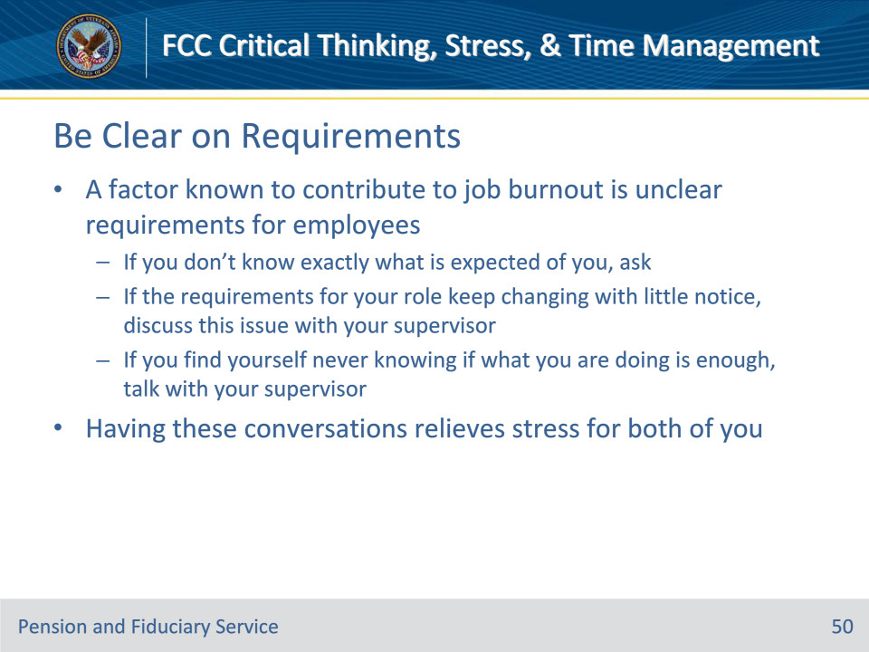
Slide notes

Policy Reference(s): N/A

Instructor Notes

Be Clear on Requirements

A factor known to contribute to job burnout is unclear requirements for employees. If you don’t know exactly what is expected of you, or if the requirements for your role keep changing with little notice, you might become extremely stressed.

If you find yourself never knowing if what you are doing is enough, it may help to have a talk with your supervisor. You can take the time to go over expectations and discuss strategies for meeting them. This can relieve stress for both of you!

Slide 51 - Stay Away from Conflict
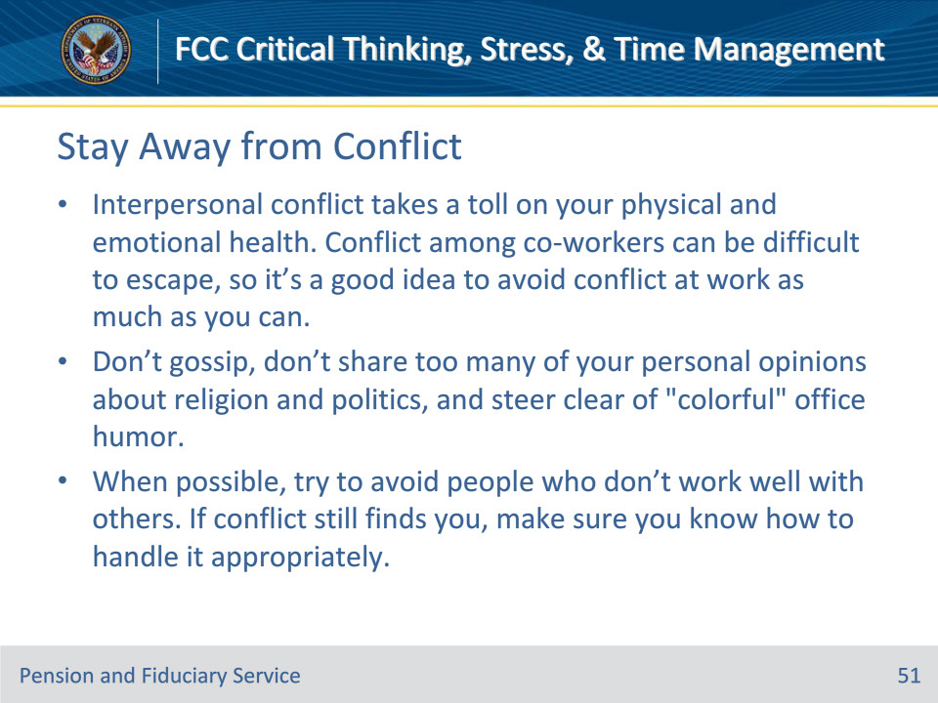
Slide notes

Policy Reference(s): N/A

Instructor Notes

Stay Away from Conflict

Interpersonal conflict takes a toll on your physical and emotional health. Conflict among co-workers can be difficult to escape, so it’s a good idea to avoid conflict at work as much as you can.

Don’t gossip, don’t share too many of your personal opinions about religion and politics, and steer clear of “colorful” office humor.

When possible, try to avoid people who don’t work well with others. If conflict finds you, anyway, make sure you know how to handle it appropriately.

Slide 52 - Stay Organized
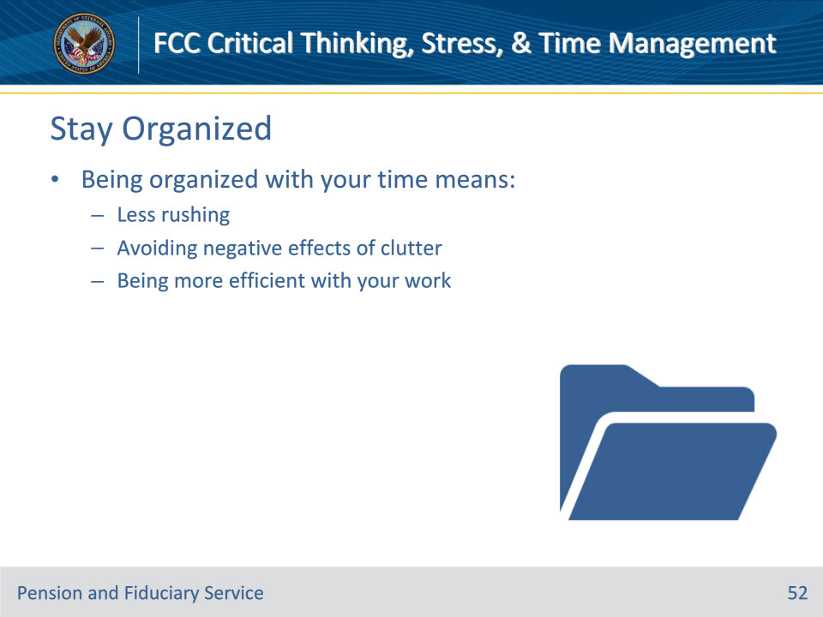
Slide notes

Policy Reference(s): N/A

Instructor Notes

Stay Away from Conflict

Interpersonal conflict takes a toll on your physical and emotional health. Conflict among co-workers can be difficult to escape, so it’s a good idea to avoid conflict at work as much as you can.

Don’t gossip, don’t share too many of your personal opinions about religion and politics, and steer clear of “colorful” office humor.

When possible, try to avoid people who don’t work well with others. If conflict finds you, anyway, make sure you know how to handle it appropriately.

Slide 53 - Be Comfortable
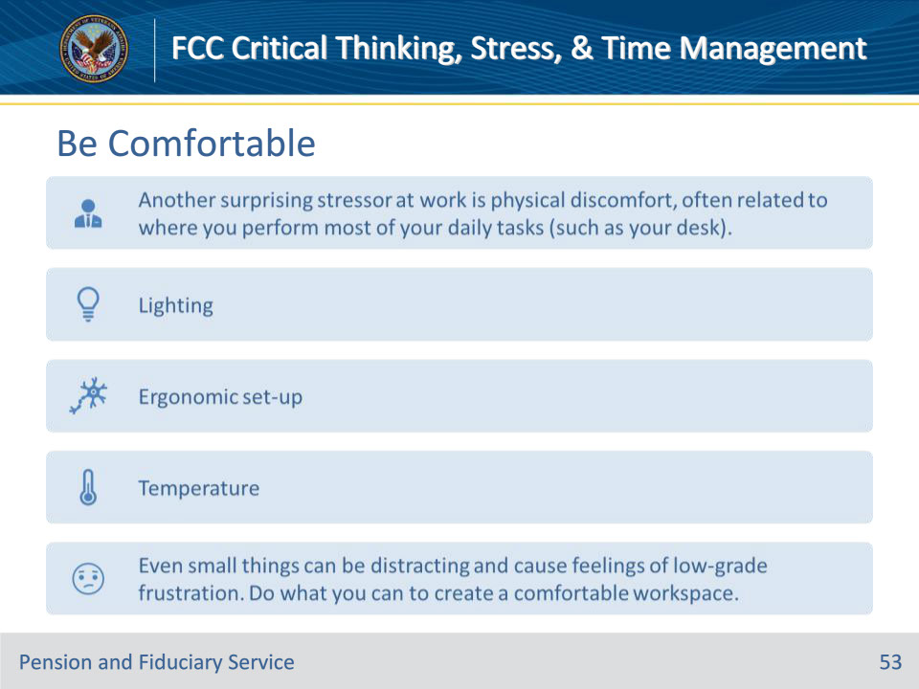
Slide notes

Policy Reference(s): N/A

Instructor Notes

Be Comfortable

Another surprising stressor at work is physical discomfort, often related to where you perform most of your daily tasks (such as your desk). You might not notice you’re stressed if you’re sitting in an uncomfortable chair for just a few minutes, but if you practically live in that chair when you’re at work, you might have a sore back and be more reactive to stress because of it.

Even small things like office noise can be distracting and cause feelings of low-grade frustration. Making your work environment more comfortable with appropriate lighting, an ergonomic set-up and adjusting the temperature can help reduce stress and fatigue during the day. Do what you can to create a quiet, comfortable, and soothing workspace.

Slide 54 - Walk at Lunch
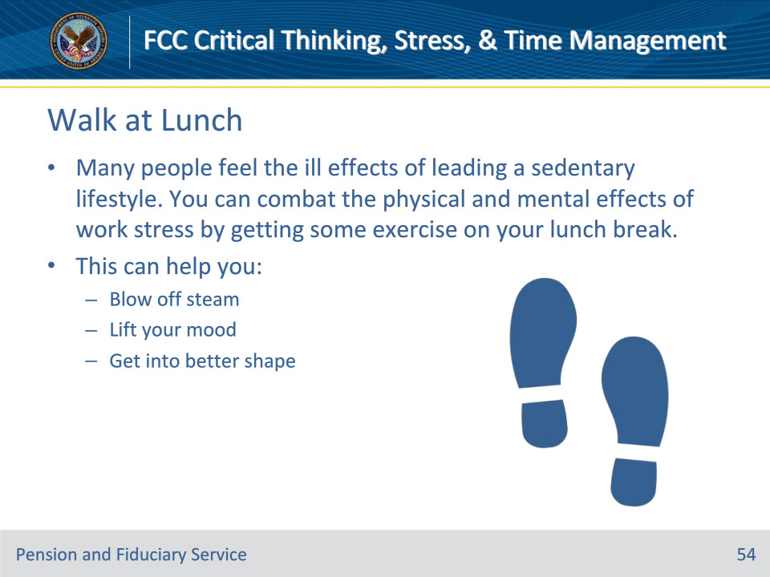
Slide notes

Policy Reference(s): N/A

Instructor Notes

Walk at Lunch

Many people feel the ill effects of leading a sedentary lifestyle. You can combat the physical and mental effects of work stress by getting some exercise on your lunch break. If your schedule allows for it, you might try taking short exercise breaks throughout the day. This can help you blow off steam, lift your mood, and get into better shape.

Slide 55 - Keep Perfectionism in Check
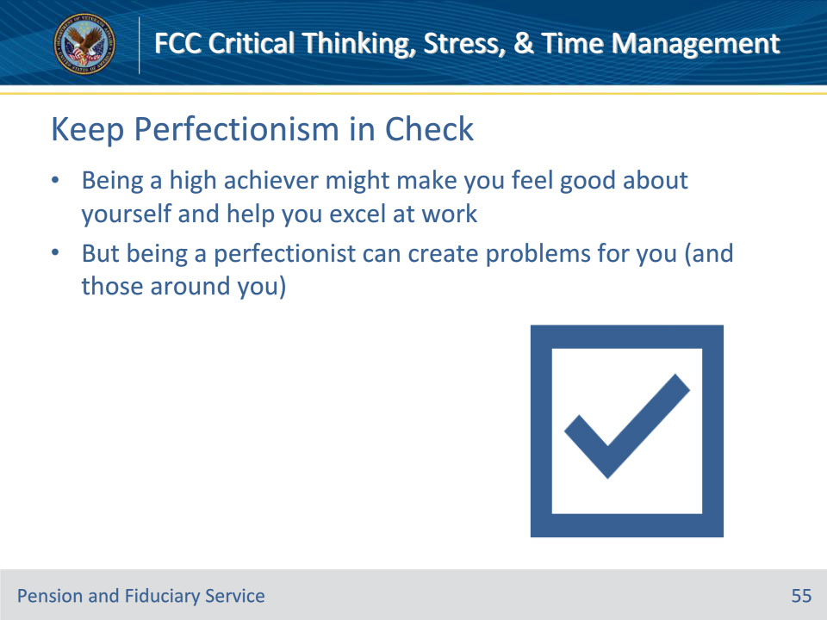
Slide notes

Policy Reference(s): N/A

Instructor Notes

Keep Perfectionism in Check

Being a high achiever might make you feel good about yourself and help you excel at work but being a perfectionist can create problems for you (and those around you).

You might not be able to do everything perfectly, every time—especially in a busy, fast-paced job. A good strategy to avoid the perfectionism trap is always striving to just do your best and making time to congratulate yourself on your efforts. You may find that your results are better, and you’ll be much less stressed at work.

Slide 56 - Listen to Music on the Drive Home
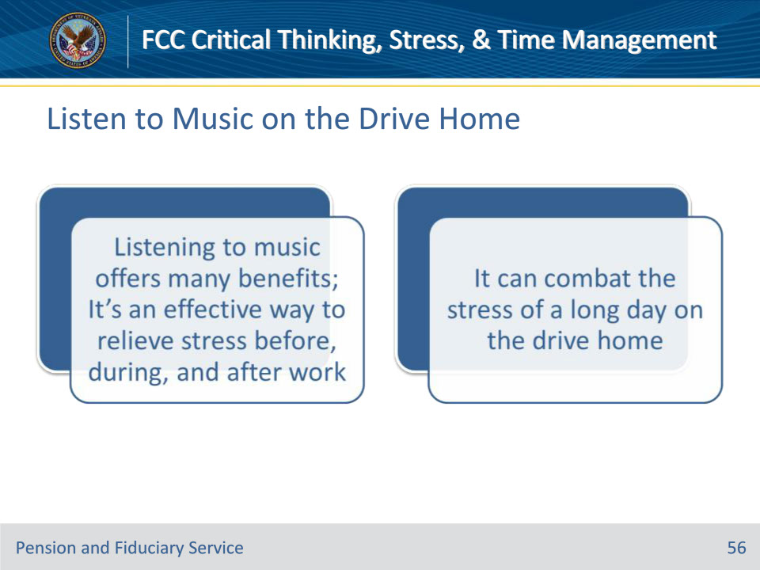
Slide notes

Policy Reference(s): N/A

Instructor Notes

Listen to Music on the Drive Home

Listening to music offers many benefits and can be an effective way to relieve stress before, during, and after work. Playing an uplifting song while you make breakfast can help you start the day off feeling better prepared to interact with the people in your life. Likewise, combating the stress of a long day with your favorite music on the drive home can help you wind down and feel less stressed when you get there. The key is finding music that makes you feel more calm, uplifted, or empowered. Experiment to see what works best for you in relieving stress.

Slide 57 - Emotional Intelligence
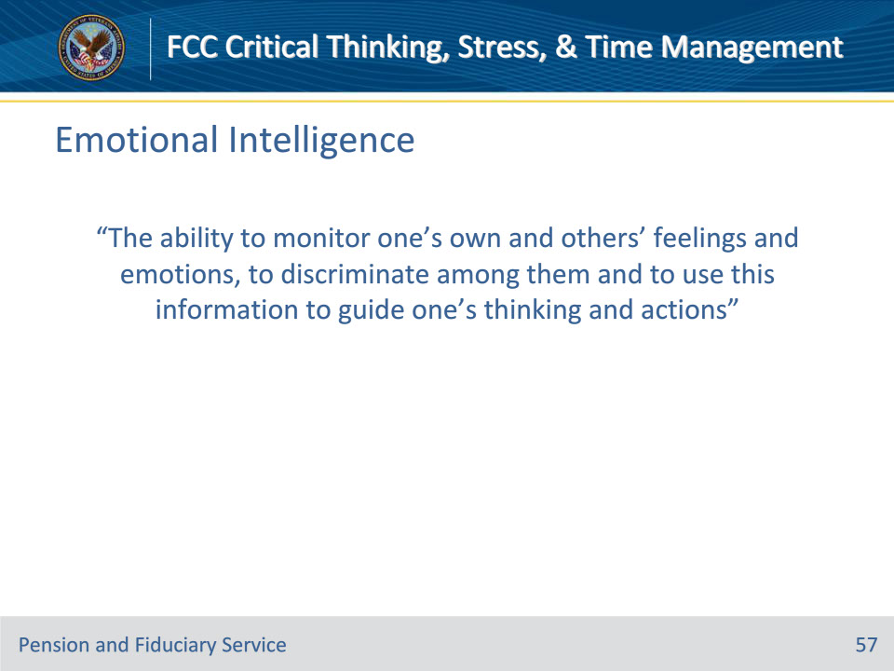
Slide notes

Policy Reference(s): N/A

Instructor Notes

What is Emotional Intelligence?

“The ability to monitor one’s own and others’ feelings and emotions, to discriminate among them and to use this information to guide one’s thinking and actions”

Slide 58 - Emotional Intelligence
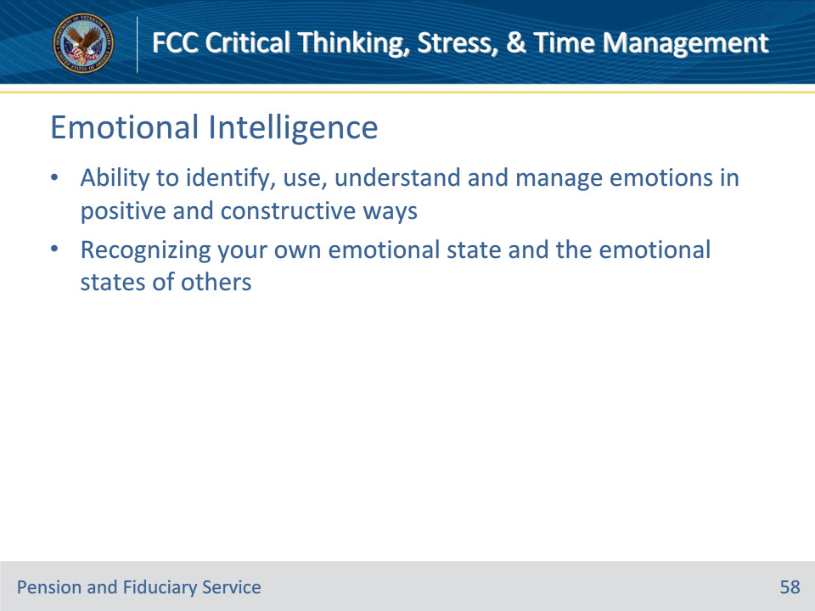
Slide notes

Policy Reference(s): N/A

Instructor Notes

Emotional Intelligence

• Ability to identify, use, understand and manage emotions in positive and constructive ways

• Recognizing your own emotional state and the emotional states of others

Slide 59 - Emotional Intelligence & Job Performance
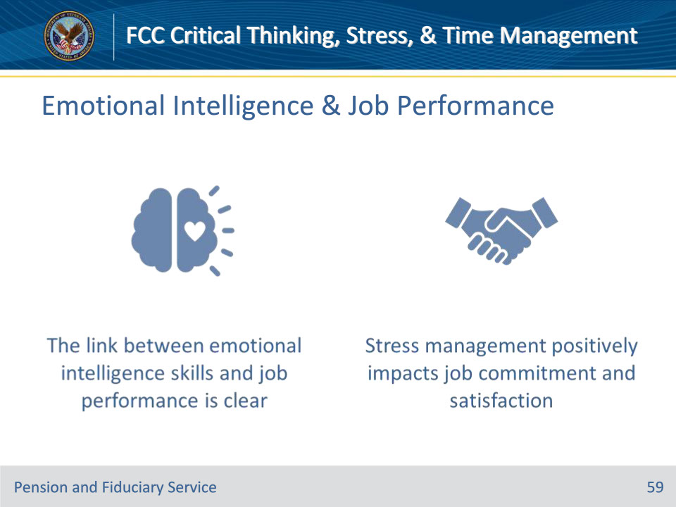
Slide notes

Policy Reference(s): N/A

Instructor Notes

How does Emotional Intelligence affect job performance?

If we think of emotional intelligence in terms of managing stress and building relationships, the link between emotional intelligence skills and job performance is undeniable. Stress management positively impacts job commitment and satisfaction.

Slide 60 - Emotional Intelligence & Job Performance
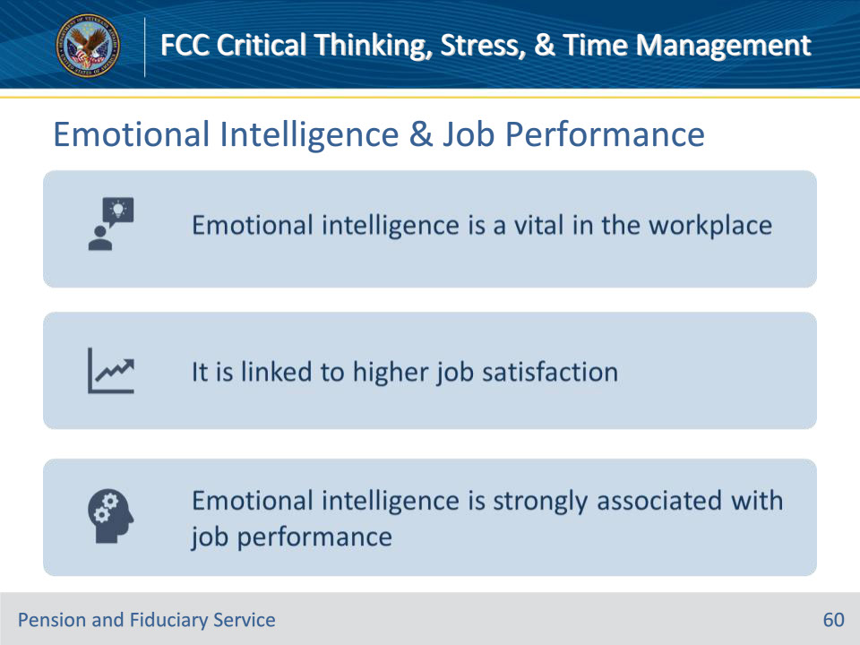
Slide notes

Policy Reference(s): N/A

Instructor Notes

Is Emotional Intelligence required in a workplace?

Emotional intelligence is a vital consideration in the workplace for many reasons, but there are two that really stick out. It is linked to higher job satisfaction for those with high emotional intelligence as well as employees who work with or are managed by those with high emotional intelligence. Emotional intelligence is strongly associated with job performance.

Slide 61 - Emotional Intelligence & Coping
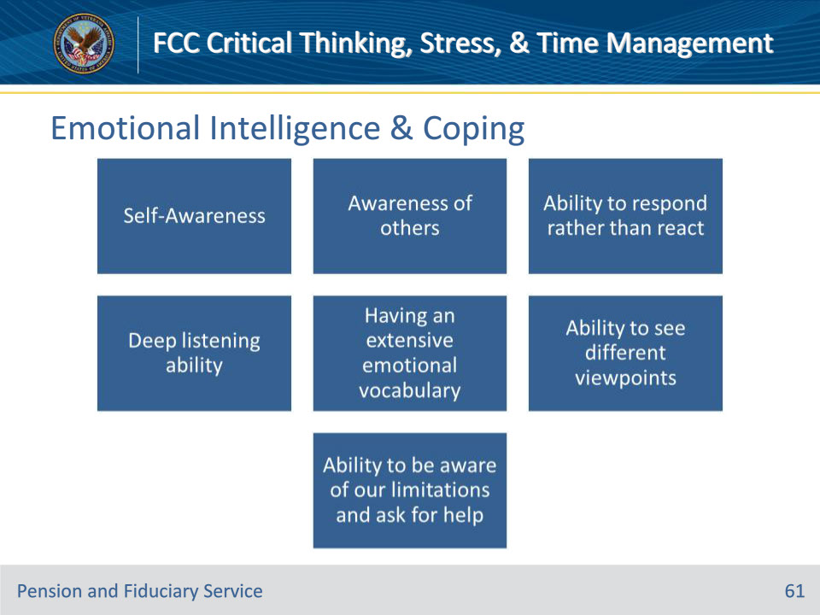
Slide notes

Policy Reference(s): N/A

Instructor Notes

7 Ways Emotional Intelligence can help you Cope

The 7 ways emotional intelligence can help you cope with stress are:

[You will need to discuss each of these items in detail and provide ways in which they can be applied during their interactions with customers.]

• Self-Awareness

• Awareness of others

• Ability to respond rather than react

• Deep listening ability

• Having an extensive emotional vocabulary

• Ability to see different viewpoints

• Ability to be aware of our limitations and ask for help

Slide 62 - Knowledge Check
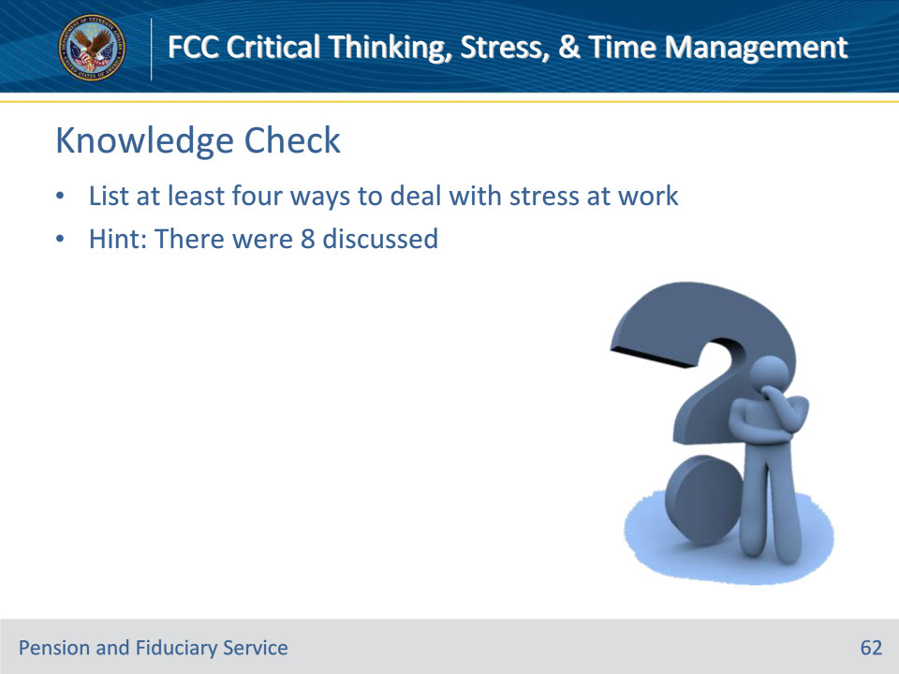
Slide notes

Policy Reference(s): N/A

Instructor Notes

Knowledge Check

Have trainees list at least four ways to deal with stress at work. Hint: There were eight discussed.

Answer on Next Slide:

• Start Your Day off Right

• Be Clear on Requirements

• Stay Away from Conflict

• Stay Organized

• Be Comfortable

• Walk at Lunch

• Keep Perfectionism in Check

• Listen to Music on the Drive Home

Slide 63 - Answers
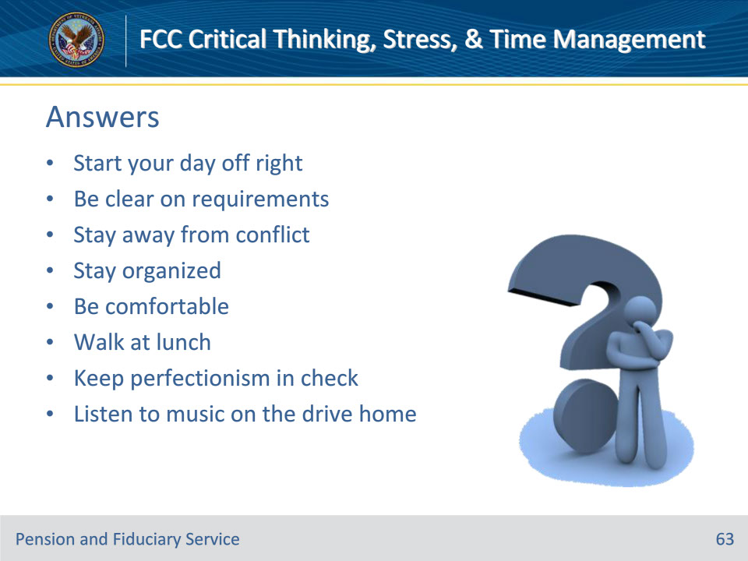
Slide notes

Policy Reference(s): N/A

Instructor Notes

Knowledge Check

Have trainees list at least four ways to deal with stress at work. Hint: There were eight discussed.

Answer:

• Start Your Day off Right

• Be Clear on Requirements

• Stay Away from Conflict

• Stay Organized

• Be Comfortable

• Walk at Lunch

• Keep Perfectionism in Check

• Listen to Music on the Drive Home

Slide 64 - Time Management
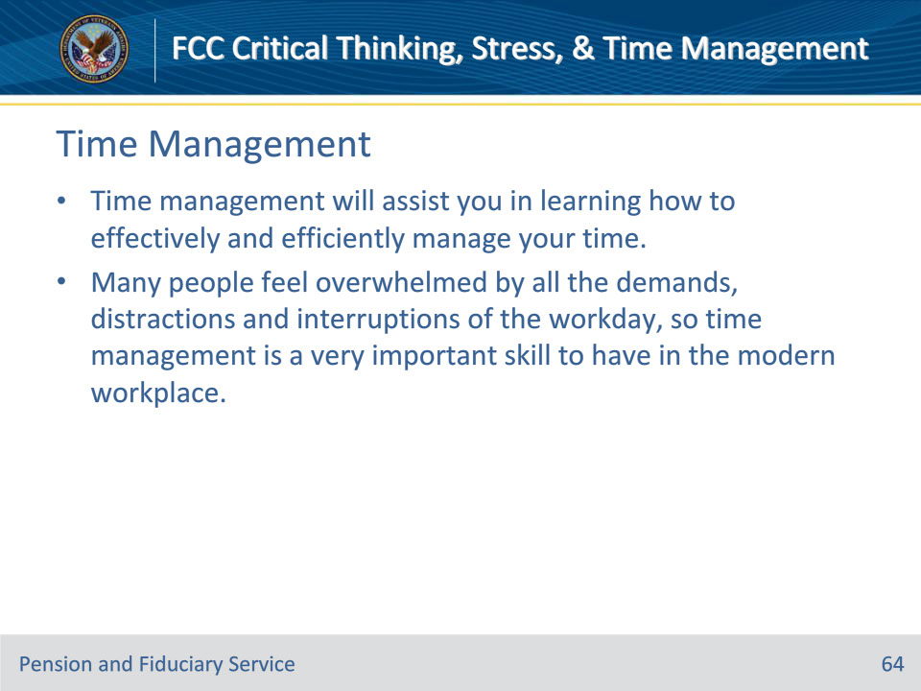
Slide notes

Policy Reference(s): N/A

Instructor Notes

Introduction to Time Management

Time management is the process of planning and exercising conscious control of time spent on specific activities, especially to increase effectiveness, efficiency, and productivity. Time management will assist you in learning how to effectively and efficiently manage your time. Many people feel overwhelmed by all the demands, distractions and interruptions of the working day, so time management is a very important skill to have in the modern workplace.

Slide 65 - Time Management
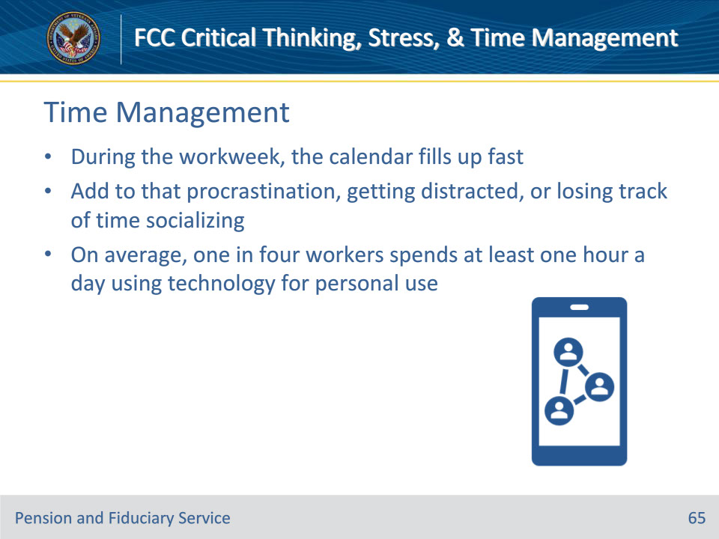
Slide notes

Policy Reference(s): N/A

Instructor Notes

Time Management

During the workweek, the calendar fills up fast. After reviewing emails for updated compliance, attending weekly trainings and meetings with your coach, your window of productivity can slowly disappear. Add to that a tendency to procrastinate, get distracted or lose track of time chit-chatting, and time management can become a real problem. On average, one in four workers spends at least one hour a day using technology for personal use. This usage causes a reduction in performance, ultimately leaving less time available to serve Veterans.

Slide 66 - Time Management
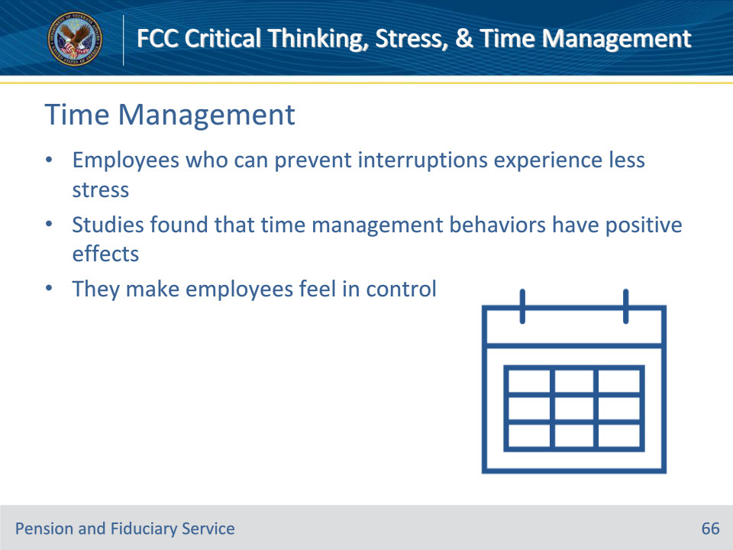
Slide notes

Policy Reference(s): N/A

Instructor Notes

Time Management

• Employees who can prevent interruptions experience less stress

• Studies found that time management behaviors have positive effects

• They make employees feel in control

Slide 67 - Personality & Time Management
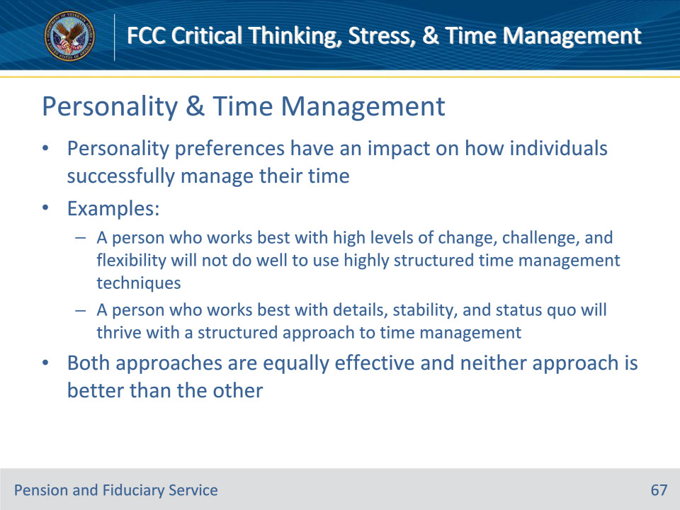
Slide notes

Policy Reference(s): N/A

Instructor Notes

Personality and Time Management Style

A simple glance at the desks of various workers reveals different organizational and time management practices that individuals have adapted to their personality. Personality preferences have an impact on how individuals successfully manage their time. For instance, a person who works best with high levels of change, challenge, and flexibility will not do well to use highly structured time management techniques. While a person who works best with details, stability, and status quo will thrive with a structured approach to time management. Both approaches are equally effective and neither approach is better than the other.

Slide 68 - Traditional Time Management
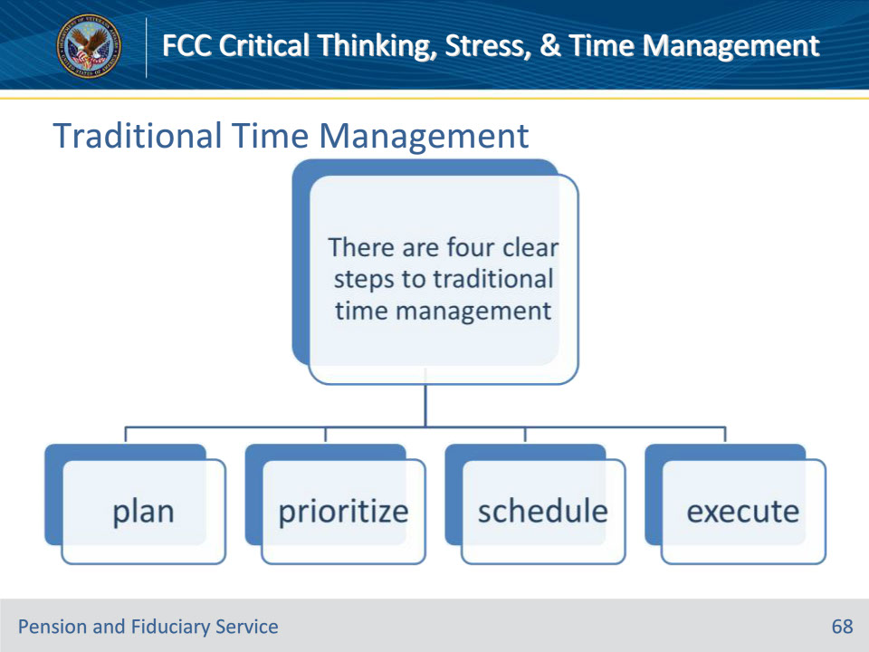
Slide notes

Policy Reference(s): N/A

Instructor Notes

Traditional Time Management

Traditional time management is a structured approach to planning the completion of multiple tasks or projects. The four steps to traditional time management are:

• planning

• prioritizing

• scheduling

• executing

This involves identifying the tasks to be completed, outlining the necessary sequence of tasks, prioritizing, developing a schedule for task completion, and carrying out the plan.

Slide 69 - Plan
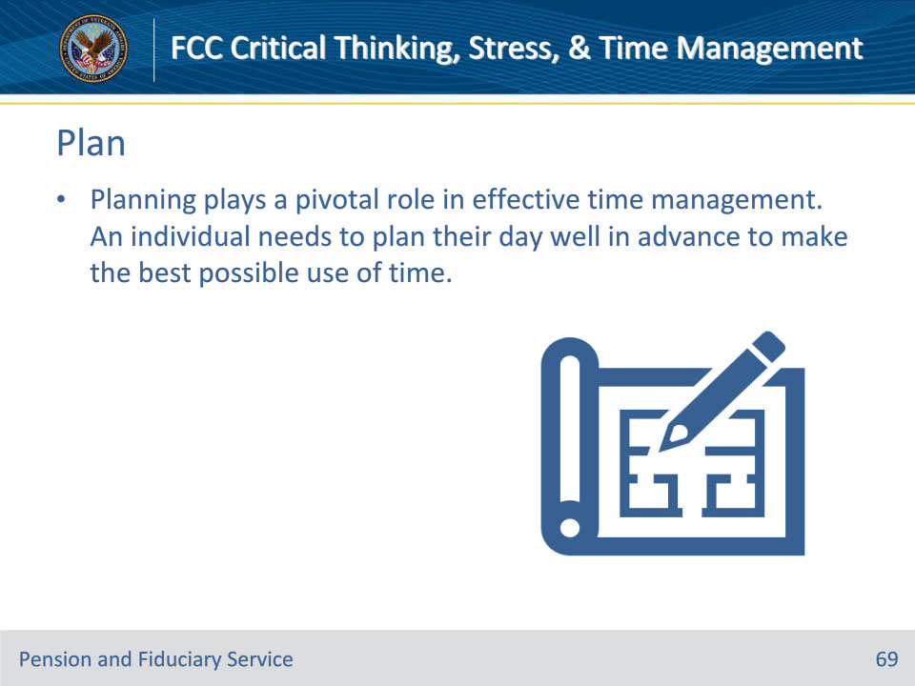
Slide notes

Policy Reference(s): N/A

Instructor Notes

Plan

Planning plays a pivotal role in effective time management. An individual needs to plan his/her day well in advance to make the best possible use of time.

Slide 70 - Prioritize
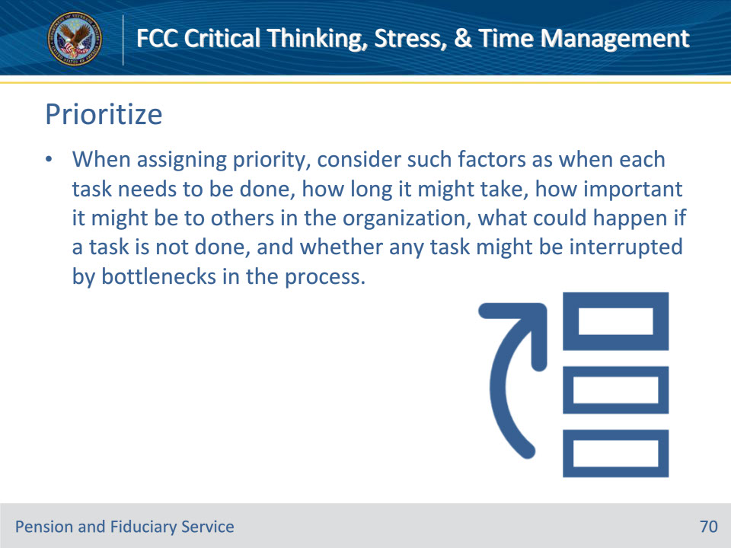
Slide notes

Policy Reference(s): N/A

Instructor Notes

Prioritize

It is important to prioritize so that you are able to complete the most important tasks in an order that makes sense. When assigning priority, consider such factors as when each task needs to be done, how long it might take, how important it might be to others in the organization, what could happen if a task is not done, and whether any task might be interrupted by bottlenecks in the process.

Slide 71 - Schedule
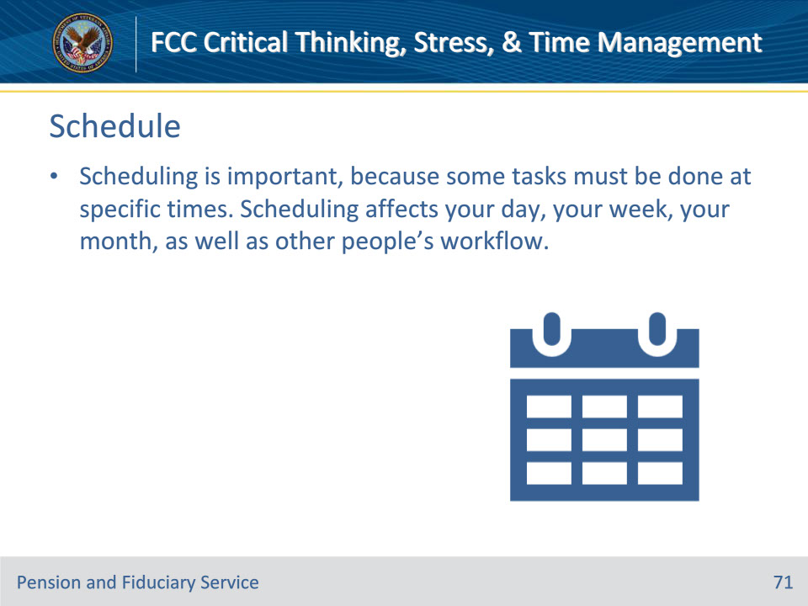
Slide notes

Policy Reference(s): N/A

Instructor Notes

Schedule

Scheduling is important, because some tasks have to be done at specific times. Scheduling affects your day, your week, your month, as well as other people’s workflow. Most have specific times of the day when they are more or less productive as a result of energy levels and demands of the day.

Slide 72 - Execute
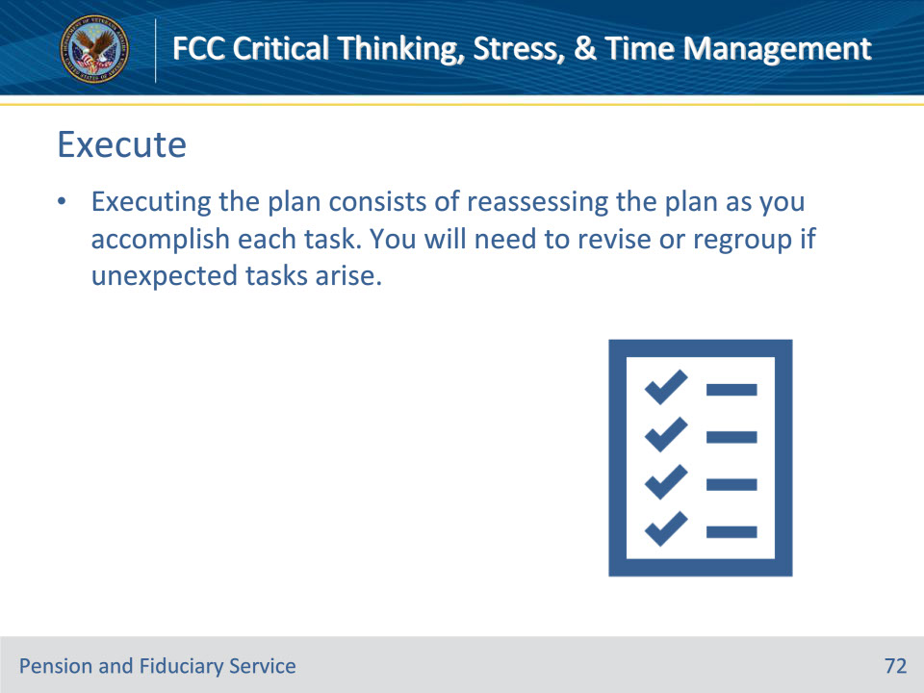
Slide notes

Policy Reference(s): N/A

Instructor Notes

Execute

Executing the plan consists of reassessing the plan as you accomplish each task. You will need to revise the plan if unexpected tasks arise. You may need to regroup if things are not going as planned.

Slide 73 - Knowledge Check
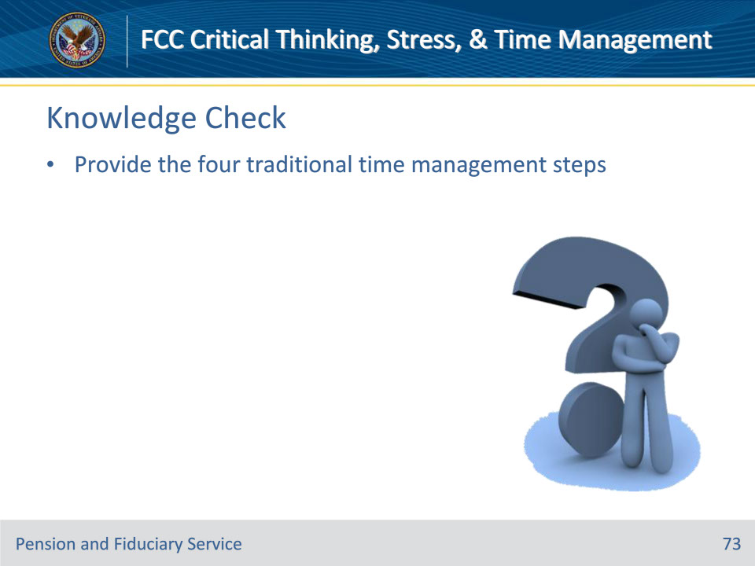
Slide notes

Policy Reference(s): N/A

Instructor Notes

Knowledge Check

Have trainees provide the four traditional time management steps.

Answer on next slide:

• plan

• prioritize

• schedule

• execute

Slide 74 - Answers
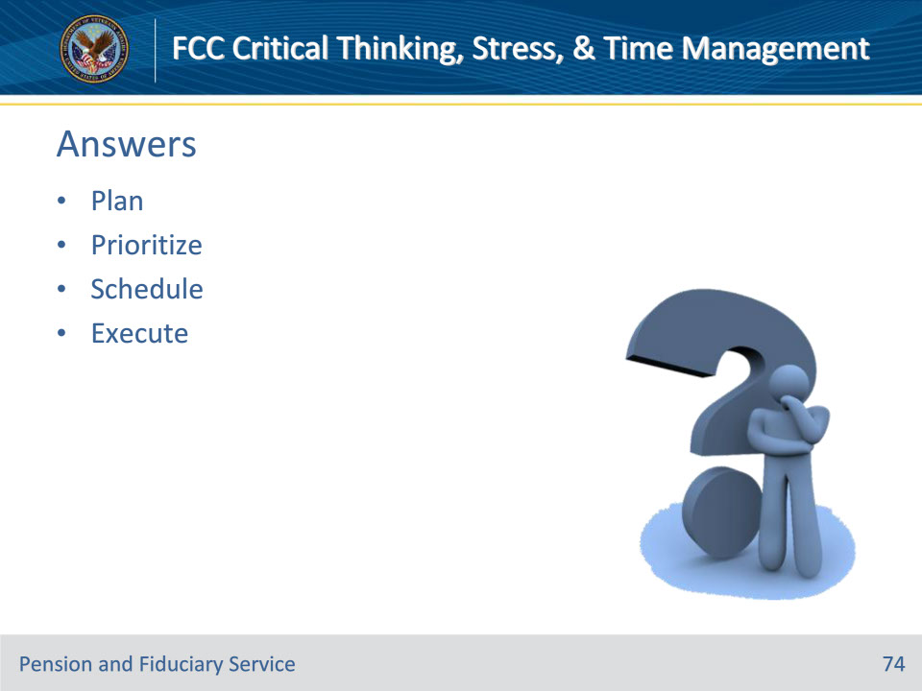
Slide notes

Policy Reference(s): N/A

Instructor Notes

Knowledge Check

Have trainees provide the four traditional time management steps.

Answer:

• plan

• prioritize

• schedule

• execute

Slide 75 - Questions?
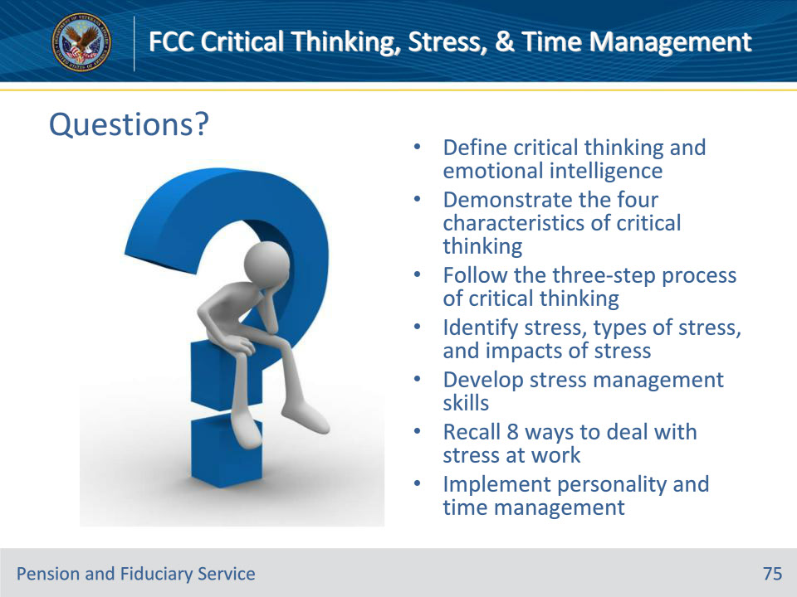
Slide notes

Instructor Notes

(Recall) These are our learning objectives as stated from the beginning of the training:

• Define critical thinking and emotional intelligence

• Demonstrate the four characteristics of critical thinking

• Follow the three-step process of critical thinking

• Identify stress, types of stress, and impacts of stress

• Develop stress management skills

• Recall 8 ways to deal with stress at work

• Implement personality and time management

Are there any additional questions?

Questions should be filtered through your QRT team. They will submit your questions to the Field Inquiry Tool (FIT) on your behalf.

Slide 76 - TMS Survey/Assessment
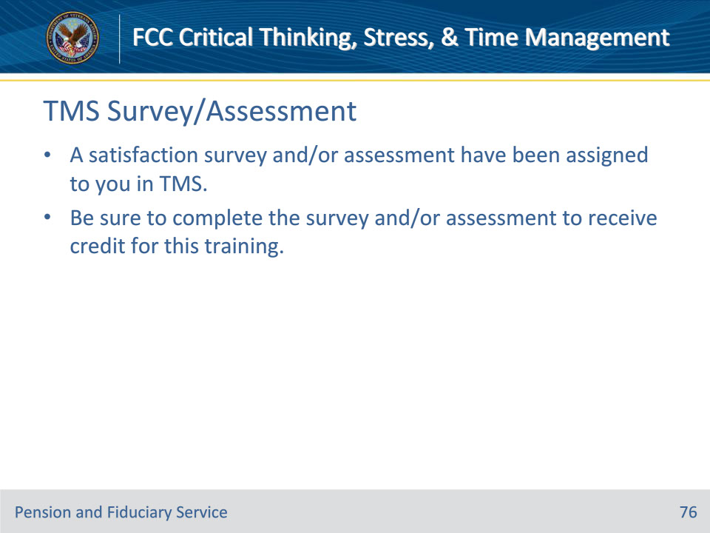
Slide notes

Instructor Notes

A satisfaction survey and/or assessment have been assigned to you in TMS.

Be sure to complete the survey and/or assessment to receive credit for this training.

