**Slide 1 - Introduction to VA Debts**

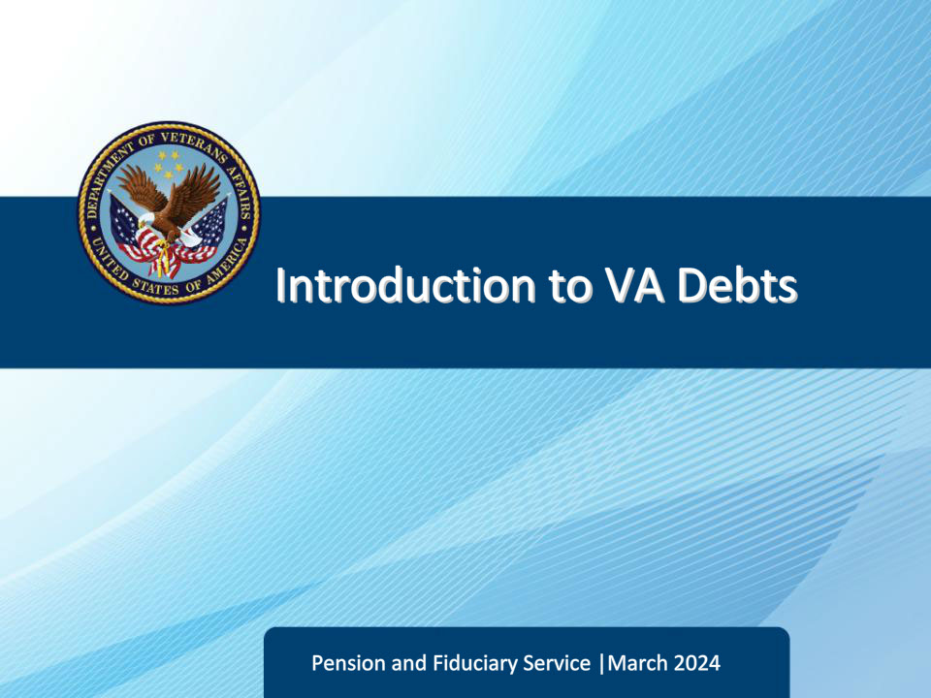

**Slide notes**

Course Description:

Welcome to Introduction to VA Debts training. This course teaches learners the various causes of VA debts, how VA debts are processed, and the role of the Debt Management Center (DMC).

**Slide 2 - Objectives**

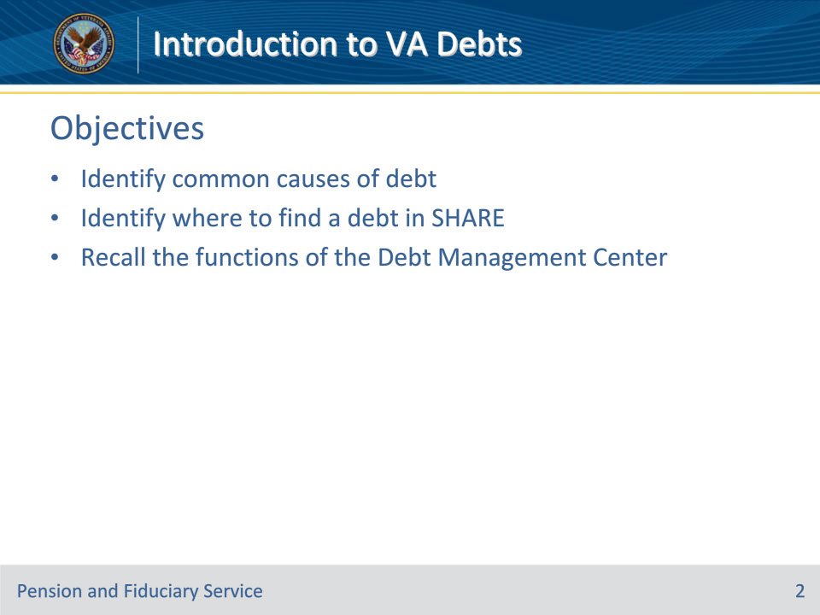

**Slide notes**

Instructor Notes:

At the end of this lesson, given the training and references, the learner will be able to do the following:

• Identify common causes of debt

• Identify where to find a debt in SHARE

• Recall the functions of the Debt Management Center (DMC)

**Slide 3 - References**

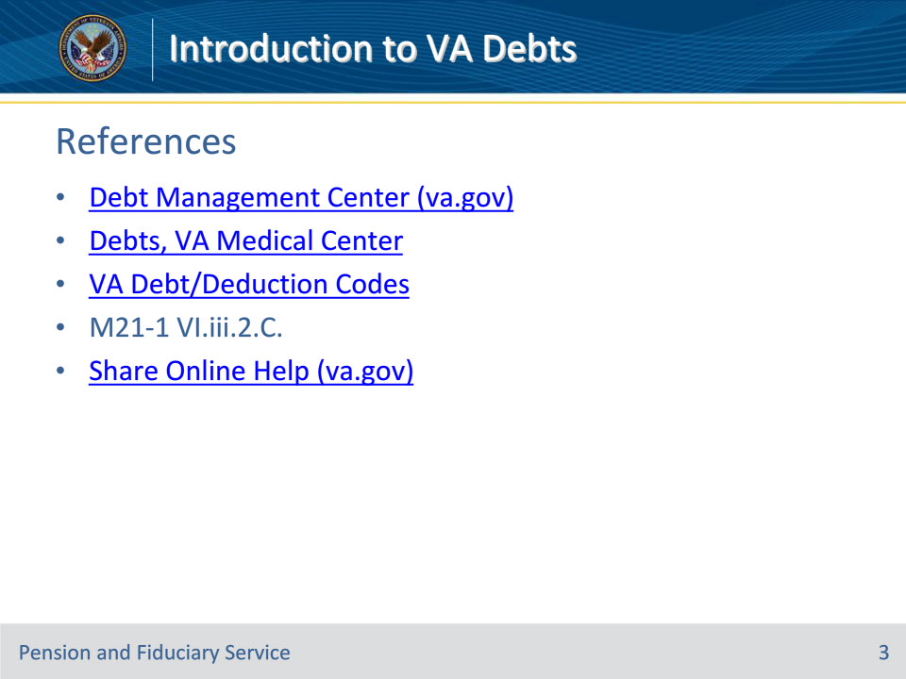

**Slide notes**

Instructor Notes:

These are the relevant references pertaining to this course:

• Debt Management Center (va.gov)

• Debts, VA Medical Center

• VA Debt/Deduction Codes

• M21-1 VI.iii.2.C.

• Share Online Help (va.gov)

**Slide 4 - What is a Debt?**

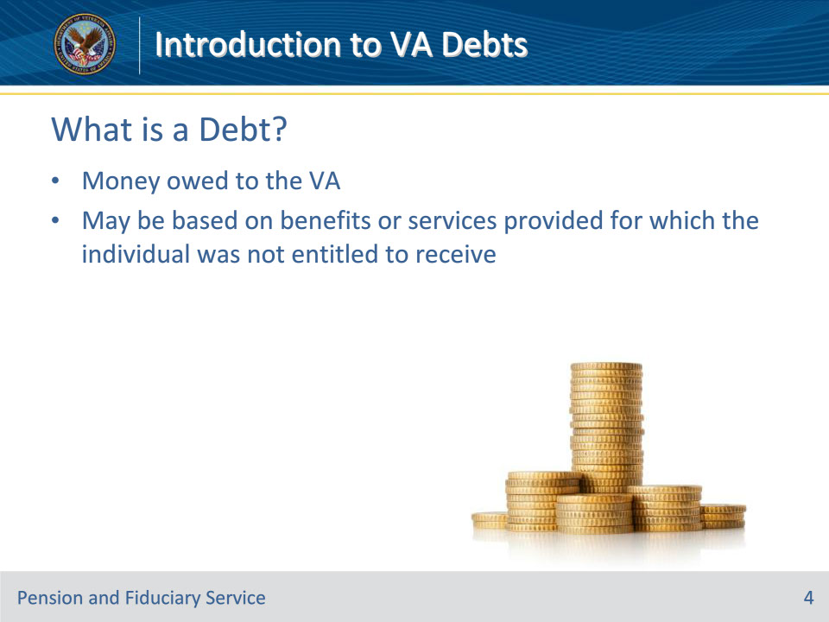

**Slide notes**

Instructor Notes

A debt is money owed to the VA. A debt may be based on benefits or services provided for which the individual was not entitled to receive.

**Slide 5 - Common Causes of Debts**

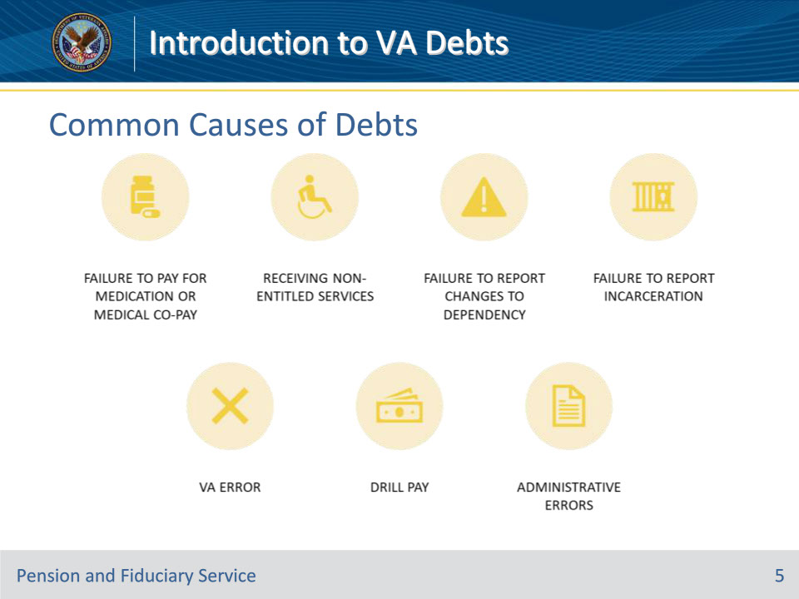

**Slide notes**

Instructor Notes

The common causes of VA debts are listed on this slide.

**Slide 6 - Medical Expenses**

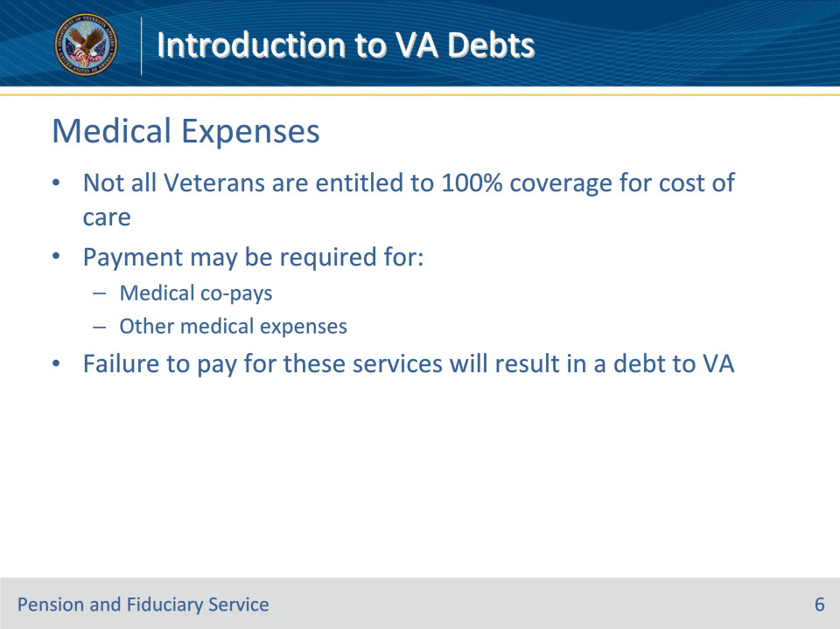

**Slide notes**

Instructor Notes

Not all Veterans are entitled to 100% coverage for cost of care.

Payment may be required for:

• Medical co-pays

• Other medical expenses

Failure to pay for these services will result in a debt to VA.

**Slide 7 - Non-Entitled Benefits**

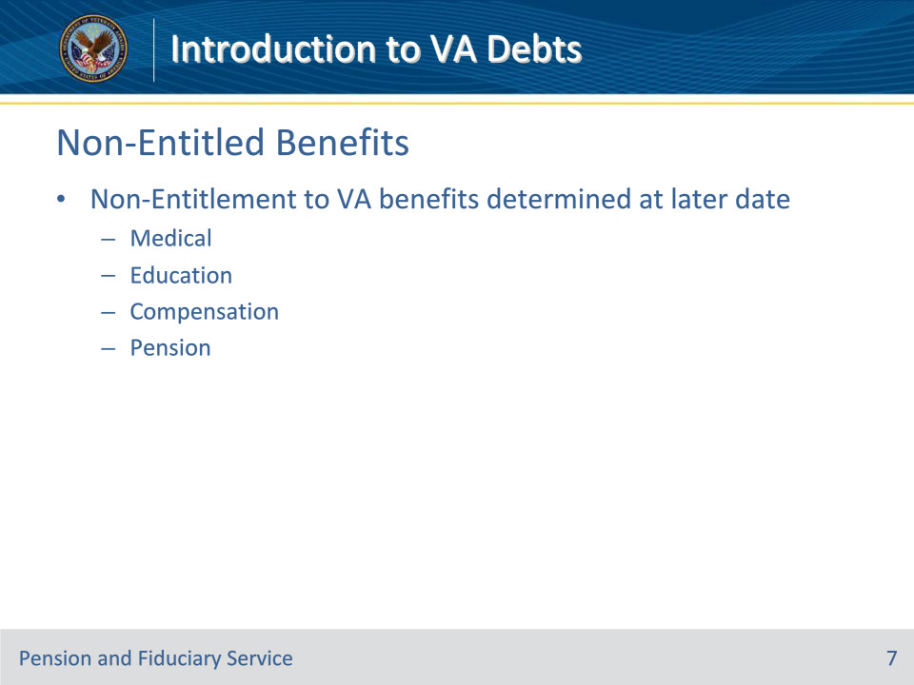

**Slide notes**

Instructor Notes

Beneficiaries may incur a debt to the VA for receiving benefits or services that they are later determined ineligible for.

Some examples of these types of benefits are:

• Medical

• Education

• Compensation

• Pension

**Slide 8 - Dependency Changes**

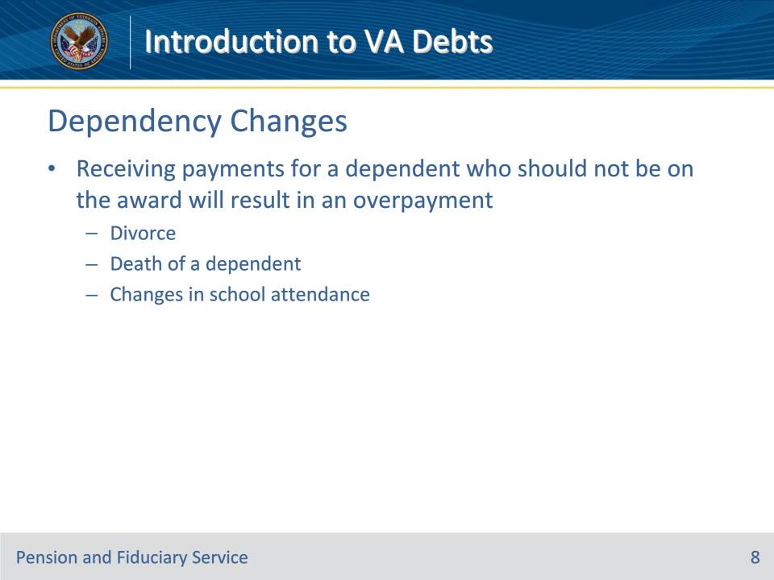

**Slide notes**

Instructor Notes

Receiving payments for a dependent who should not be on the award will result in an overpayment

• Divorce

• Death of a dependent

• Changes in school attendance

**Slide 9 - Incarceration**

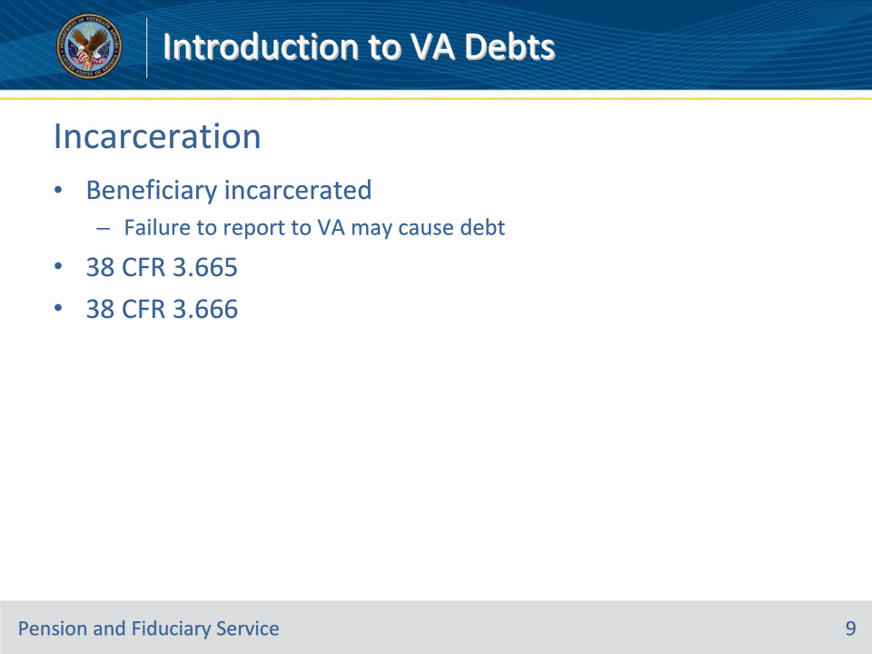

**Slide notes**

Instructor Notes

If a beneficiary is subject to a period of incarceration, but does not report this information to the VA, it may result in an overpayment.

38 CFR 3.665 requires reduction of beneficiary’s disability compensation or DIC when incarcerated more than 60 days following felony conviction.

38 CFR 3.666 requires discontinuance of beneficiary’s pension when incarcerated more than 60 days following felony or misdemeanor conviction.

**Slide 10 - VA & Administrative Errors**

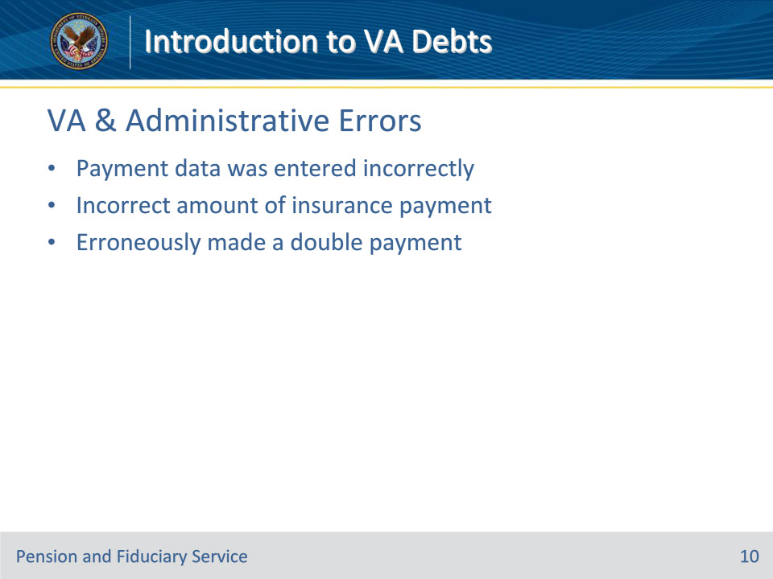

**Slide notes**

Instructor Notes

Another reason that a debt can be created is through VA & administrative errors.

Some examples:

• Payment data was entered incorrectly

• Incorrect amount of insurance payment

• Erroneously made a double payment

**Slide 11 - Drill Pay**

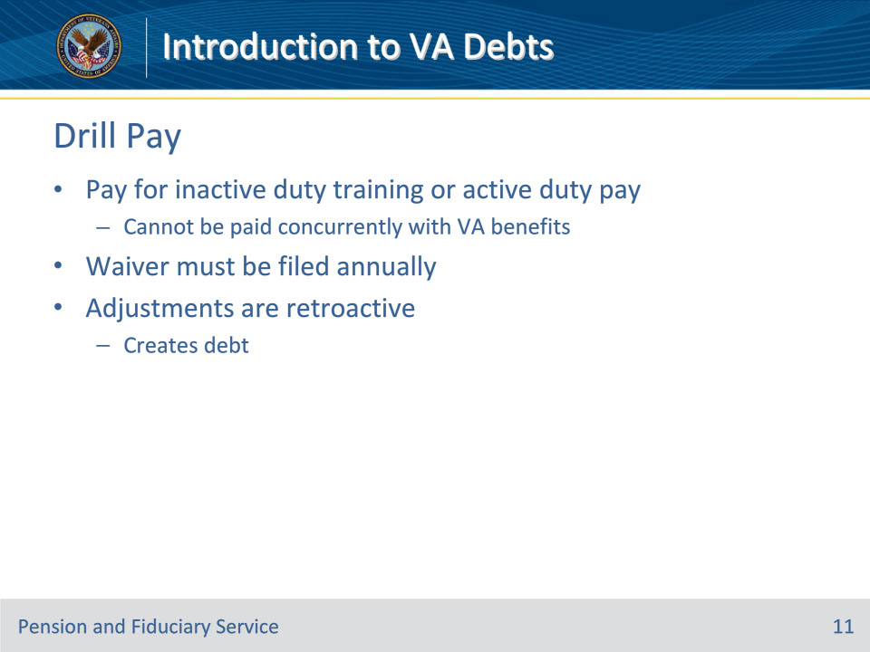

**Slide notes**

Instructor Notes

These are the reasons that a beneficiary may incur a debt to the VA for drill pay which cannot be paid concurrently with VA benefits:

• Failure to file annual waiver

• Adjustments are retroactive and create a debt

**Slide 12 - DMC Functions**

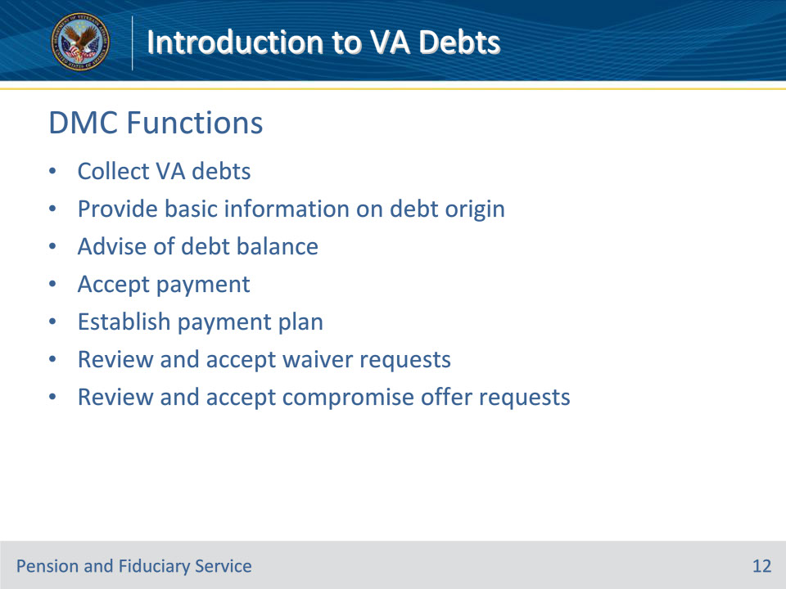

**Slide notes**

Instructor Notes

These are the functions of the Debt Management Center (DMC):

• Collect VA debts

• Provide basic information on which VA division established the debt

• Advise of the balance

• Accept a payment

• Make arrangements for repayment by setting up a payment plan

• Review and accept waiver requests

• Review and accept compromise offer requests

**Slide 13 - Debt Notification Process**

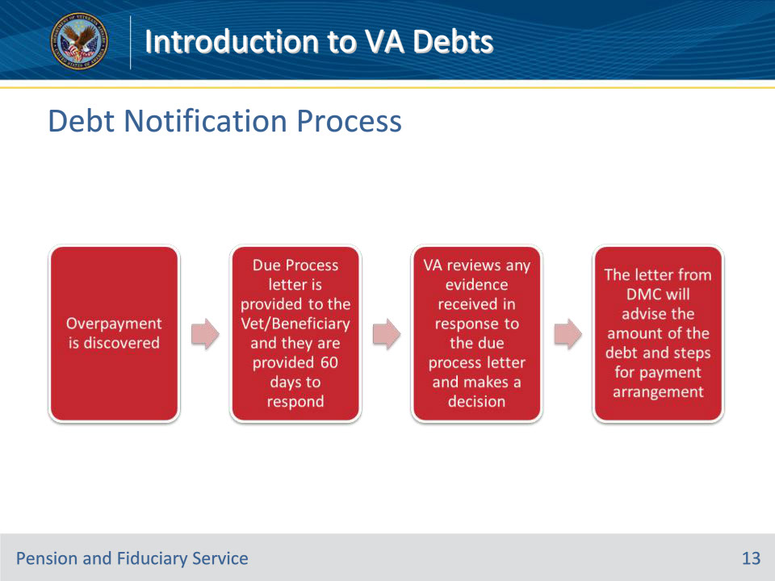

**Slide notes**

Instructor Notes

These are the steps of the debt notification process:

• Overpayment discovered

• Due Process Letter sent

• 60-day response time provided

• VA reviews evidence received (if applicable)

• VA completes decision

• DMC sends letter communicating debt information

**Slide 14 - DMC Notification**

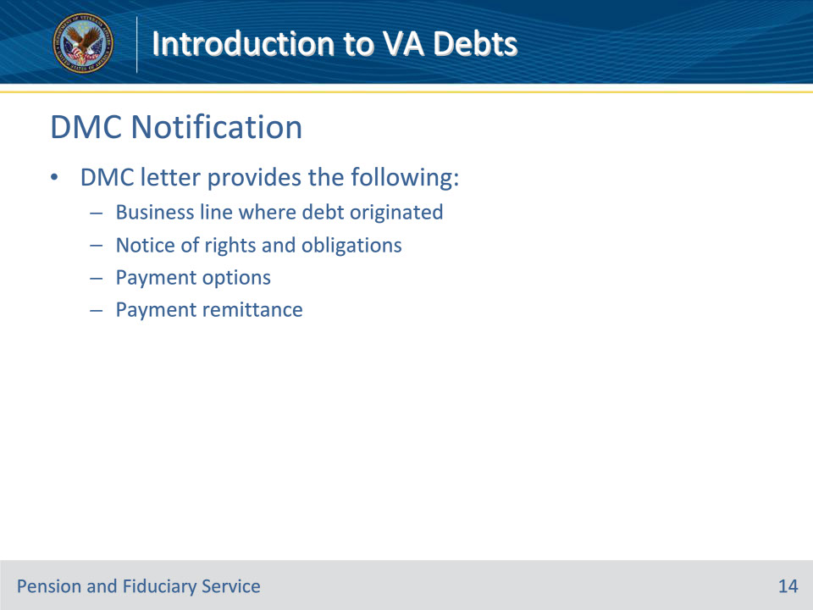

**Slide notes**

Instructor Notes

The Debt Management Center notification letter provides the following information:

• The business line where the debt originated

• Notice of rights and obligations

• Payment options

• Payment remittance

**Slide 15 - Share**

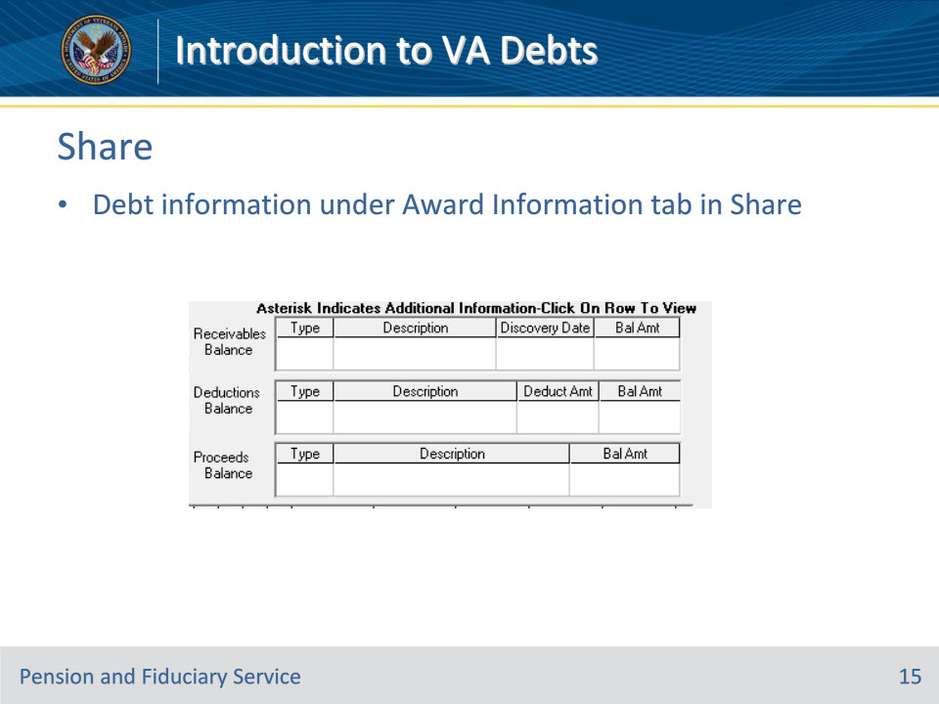

**Slide notes**

Instructor Notes

Debts will be listed in Share under the Award information tab.

**Slide 16 - Debt/Deduction Codes**

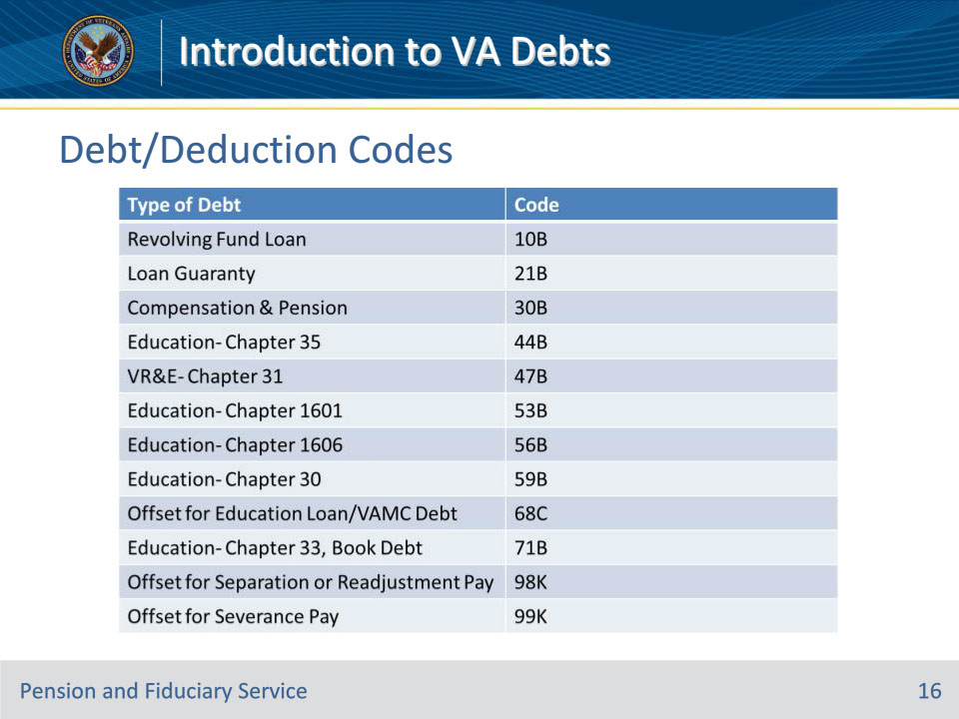

**Slide notes**

Instructor Notes

These are the debt deduction codes that will be in Share to identify the type of debt.

VA Debt/Deduction Codes

**Slide 17 - Debt Referral Contacts**

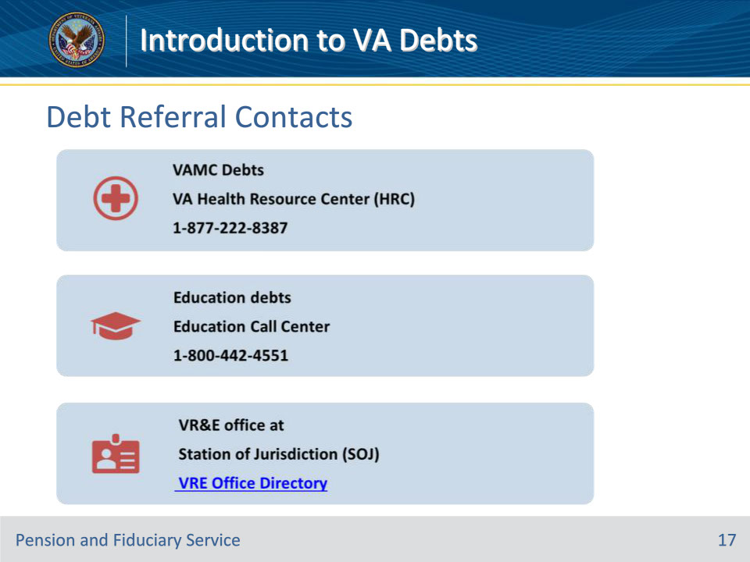

**Slide notes**

Instructor Notes

Contact information for various debt types:

VAMC Debts

VA Health Resource Center (HRC)

1-877-222-8387

Education debts

Education Call Center

1-800-442-4551

VR&E office at

Station of Jurisdiction (SOJ)

VRE Office Directory

**Slide 18 - Contacting DMC**

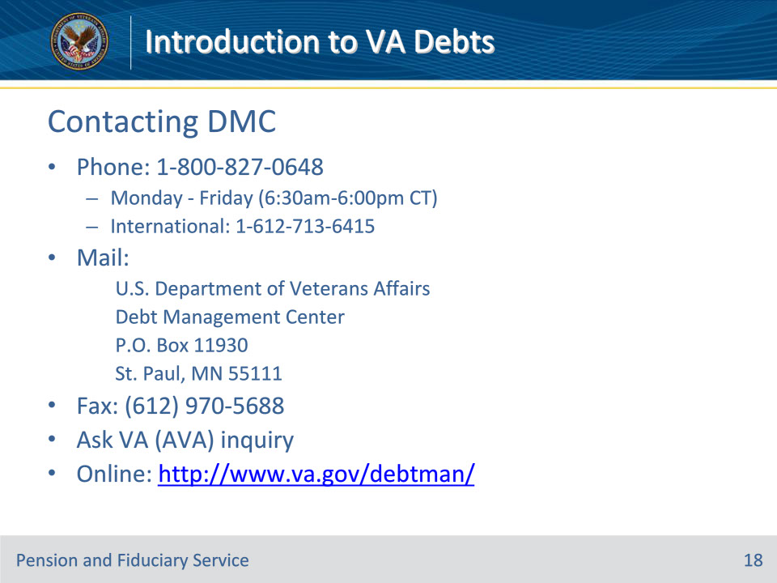

**Slide notes**

Instructor Notes

These are the options for contacting the Debt Management Center (DMC):

• Phone: 1-800-827-0648

• Monday - Friday (6:30am-6:00pm CT)

• International Number (1-612-713-6415)

• In writing:

U.S. Department of Veterans Affairs

Debt Management Center

P.O. Box 11930

St. Paul, MN 55111

• Fax (612) 970-5688

• Submit an inquiry through Ask VA (AVA)

• Online at the following website: http://www.va.gov/debtman/

**Slide 19 - Questions?**

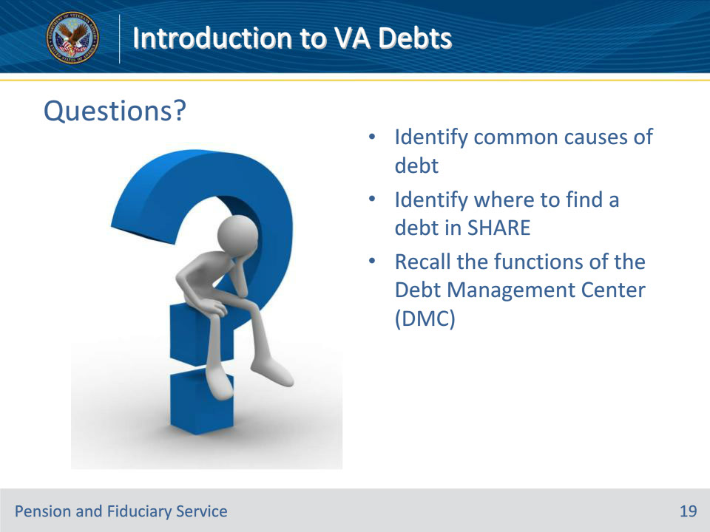

**Slide notes**

Instructor Notes:

(Recall) These are our learning objectives as stated from the beginning of the training:

• Identify common causes of debt

• Identify where to find a debt in SHARE

• Recall the functions of the Debt Management Center (DMC)

Are there any additional questions?

Questions should be filtered through your QRT team. They will submit your questions to the Field Inquiry Tool (FIT) on your behalf.

**Slide 20 - TMS Survey/Assessment**

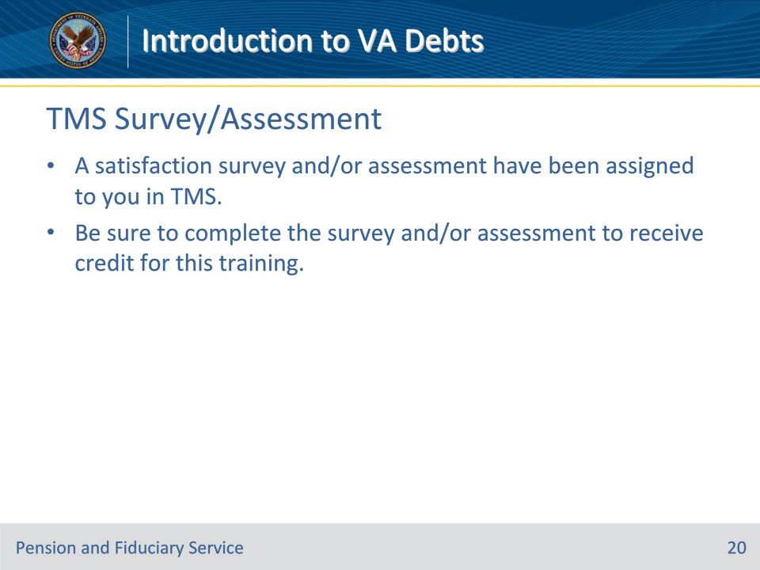

**Slide notes**

Instructor Notes

A satisfaction survey and/or assessment have been assigned to you in TMS.

Be sure to complete the survey and/or assessment to receive credit for this training.