**Slide 1 - FCC Challenging Interactions**

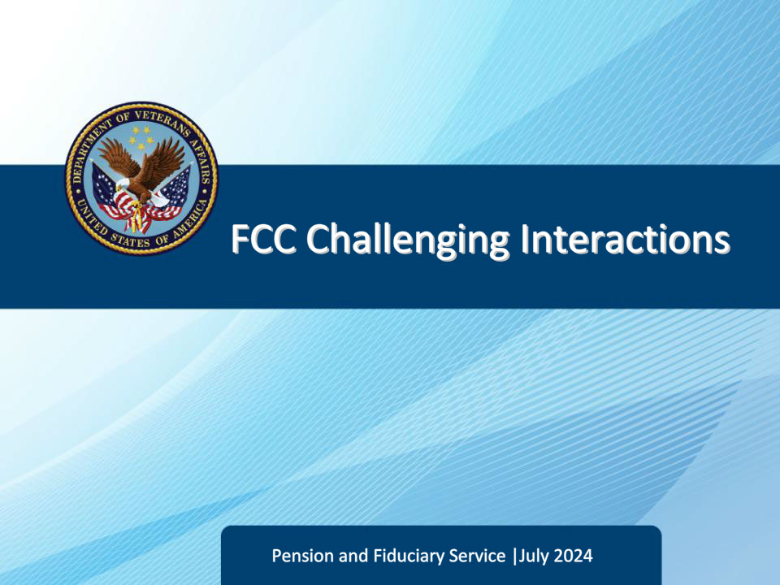

**Slide notes**

Course Description:

This course teaches Legal Administrative Specialists how to effectively communicate with different types of callers, from understanding and preparation to initiation and delivery.

**Slide 2 - Objectives**

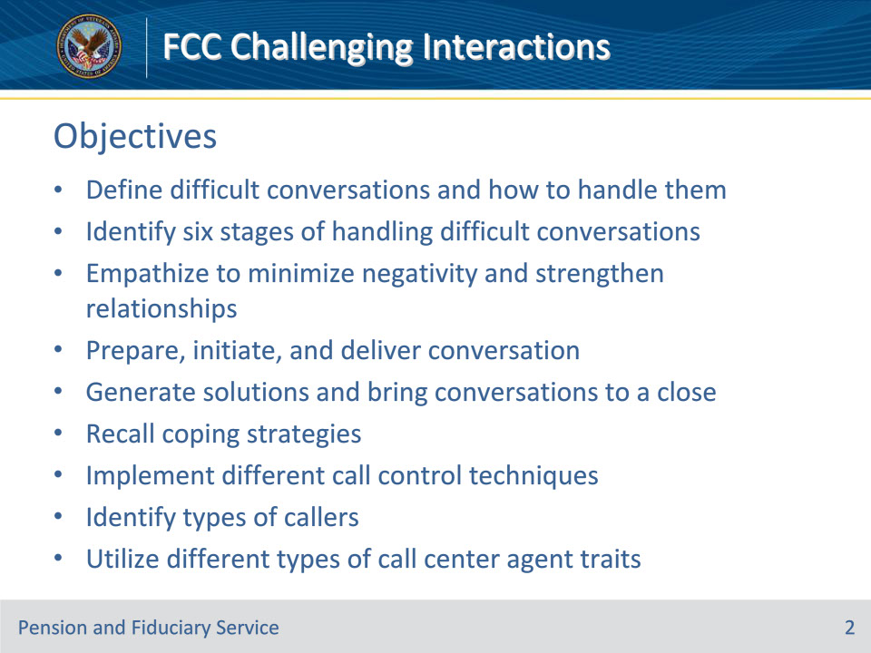

**Slide notes**

Instructor Notes:

At the end of this lesson, given the training and references, the learner will be able to do the following:

• Define difficult conversations and how to handle them

• Identify six stages of handling difficult conversations

• Empathize to minimize negativity and strengthen relationships

• Prepare, initiate, and deliver conversation

• Generate solutions and bring conversations to a close

• Recall coping strategies

• Implement different call control techniques

• Identify types of callers

• Utilize different types of call center agent traits

**Slide 3 - Difficult Conversations**

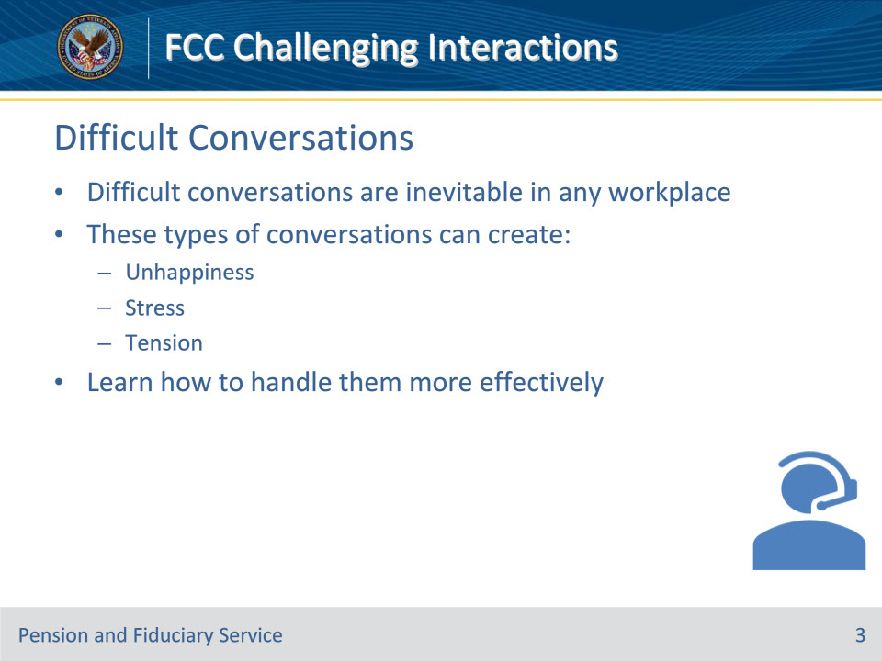

**Slide notes**

Instructor Notes

Difficult conversations are inevitable in any workplace. They can cause a lot of unhappiness, stress, and tension. There are ways to handle these conversations more effectively. By approaching the issue with the right mindset and strategies, you can create better outcomes for everyone involved. It’s important to remember that difficult conversations don’t have to be a source of conflict - they can also be an opportunity for growth and understanding. So don’t shy away from them - embrace them and learn how to handle them in a way that leaves both parties feeling satisfied.

**Slide 4 - Types of Difficult Conversations**

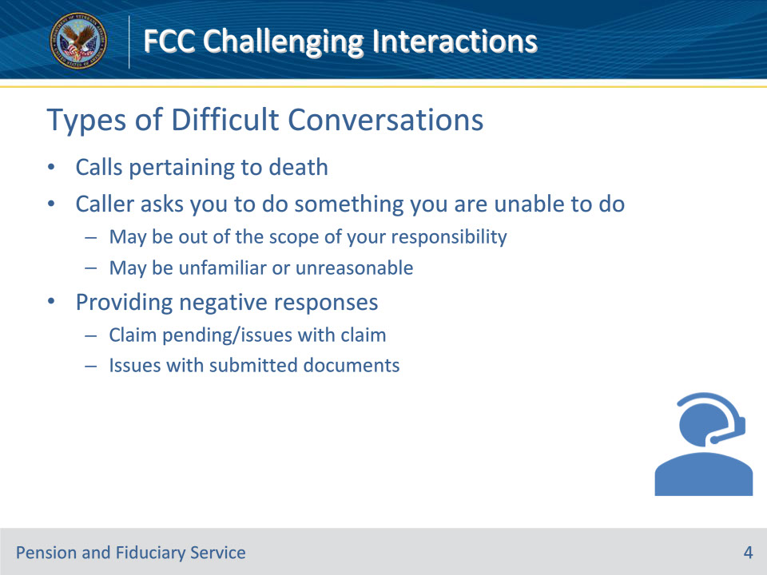

**Slide notes**

Instructor Notes

When dealing with calls pertaining to death and customers’ bereavement it’s important to make the callers feel at ease. The biggest part of dealing with customers in this position is to actively listen before addressing the issue.

Saying no can be difficult regardless if the request is unreasonable or simply not within the scope of your responsibilities., Here are six ways to address the situation while de-escalating potential problems.

1. Be positive and clear; refrain from overpromising and be candid about what you can and cannot do

2. Do not commit straight away. While you should assure your customer that you will try your best to help, all they will hear is that you are committing to fulfill their request, which will also create unrealistic expectations. Politely tell them that you will consider their request but cannot promise anything unless you have approval from the relevant authority.

3. Actively listen to your customers. It is important for them to feel heard - this can prevent the situation from escalating.

4. Propose alternate solutions. If there is anything you can offer let them know.

5. Try to resolve their issue. Before blurting out a denial of a customer request, win their trust. It does not matter whether you can offer them a solution or not, reassure them that you will try your best and follow the above steps to demonstrate that you’re on their side.

6. Follow-up on their request. Even when you have said “No” to a customer, you must follow up if you can find a way to resolve their situation. Doing so will make them feel valued and help you win their loyalty.

Providing negative responses can be difficult. Be honest, clear, and compassionate. Explain the situation in a way they can understand without being too harsh. Be ready to answer questions and offer alternatives. Approach the situation with empathy and professionalism, and keep communication open. This is an important part of doing business, so handle it carefully to maintain a positive relationship with clients.

**Slide 5 - Reasons for Difficult Conversations**

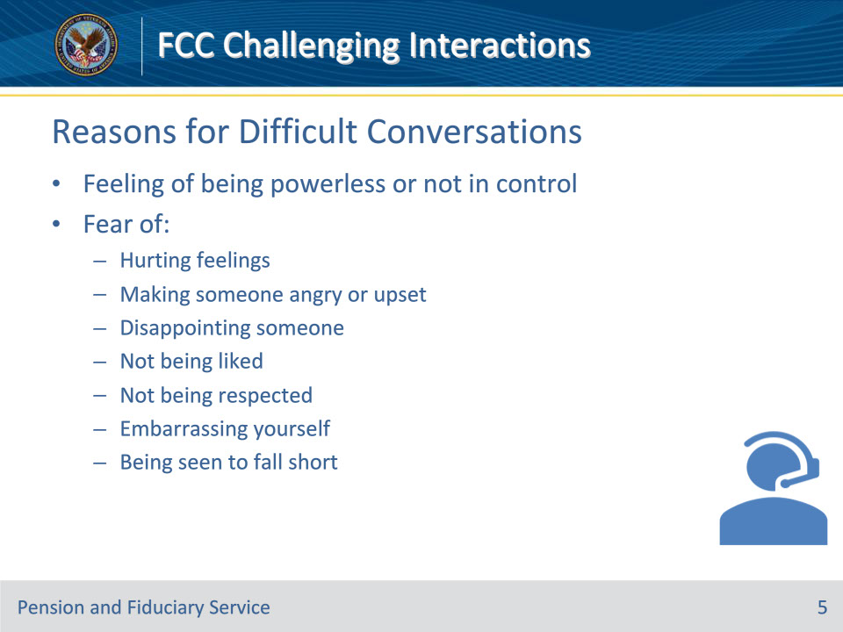

**Slide notes**

Instructor Notes

Interacting with customers can sometimes be challenging, as it may feel like you have no control over the situation. There is often the fear of inadvertently upsetting or angering someone, disappointing them, or not meeting their expectations. Additionally, there is the fear of embarrassing yourself or falling short in your responsibilities, which can be difficult to navigate. It’s important to remember that these feelings are normal and that with practice, you can become more confident in your interactions with customers.

**Slide 6 - Tips for Difficult Conversations**

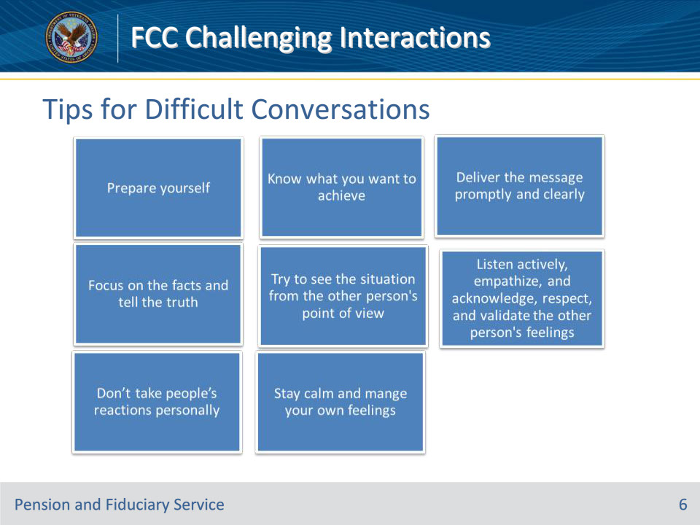

**Slide notes**

Instructor Notes

• Prepare yourself: Take a moment to clear your mind

• Know what you want to achieve: Consider your goals and how best to achieve them. Ask yourself, “What’s my purpose in this conversation?”

• Deliver the message promptly and clearly: Be clear on what ideas you are trying to express or the message you are trying to convey to the other person. Don’t beat around the bush – tell the person what they need to hear right away and be upfront with them.

• Focus on the facts and tell the truth: To Focus on the facts you must be knowledgeable about the topic. Sometimes, you won’t know the answers; pick out what you know. Do not make up an answer to satisfy the customer. If the answer to the question is within the scope of your duties research the topic and follow-up with the answer. This may require calling the customer back with the information.

• Try to see the situation from the other person’s point of view: Start by observing a difference in perspective — doing your best to describe that difference without judgment in either direction. State an interest in understanding the other person’s views and sharing your own.

• Listen actively, empathize, and acknowledge, respect, and validate the other person’s feelings: Seek first to understand. The intent is to immerse yourself fully in the other person and what they are experiencing. The key to listening and responding in a difficult conversation is to pay attention, focus on the speaker, show that you are interested and sincerely care, and keep an open mind.

• Don’t take people’s reactions personally: Sometimes hearing bad news is difficult. The reaction of the employee doesn’t reflect on the manager. Let them be upset if they need to be and give them a moment to collect themselves.

• Stay calm and manage your own feelings: Don’t bring unnecessary opinions into the conversation. Stay on topic and focus on the best outcome.

**Slide 7 - 6 Stages for Difficult Conversations**

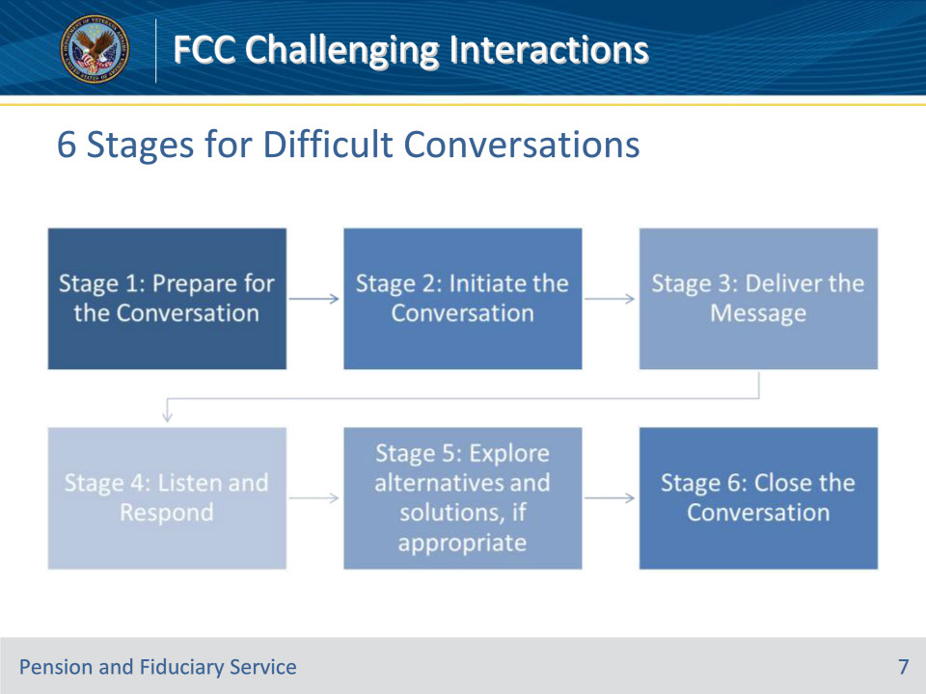

**Slide notes**

Instructor Notes

• Stage 1: Clear your mind; Focus on delivering excellent customer service to our Veterans and beneficiaries; Ignore distractions and unrelated concerns.

• Stage 2: Start warm, friendly, and professional. Greet the caller, build rapport/break the ice, and define the issue.

• Stage 3: Be clear and specific and focus on the facts; Be sincere, tell the truth, and provide accurate information; If you need more information about the situation, ask questions; Allow the other person the chance to ask questions; answer them honestly and briefly, and if you are not able to disclose the information, explain why; Give examples when possible.

• Stage 4: The key to listening and responding in a difficult conversation is to pay attention, focus on the speaker, show that you are interested and sincerely care, and keep an open mind

• Stage 5: Identify what’s important and non-negotiable to you. Have a collaborative attitude and seek a mutually satisfactory resolution. Work with the other person to generate possible alternatives and solutions

• Stage 6: Avoid letting the conversation drag out. Look for signs of a natural ending where the message has been delivered and received. Look for ways to end on a positive note

**Slide 8 - Preparing for Difficult Conversations**

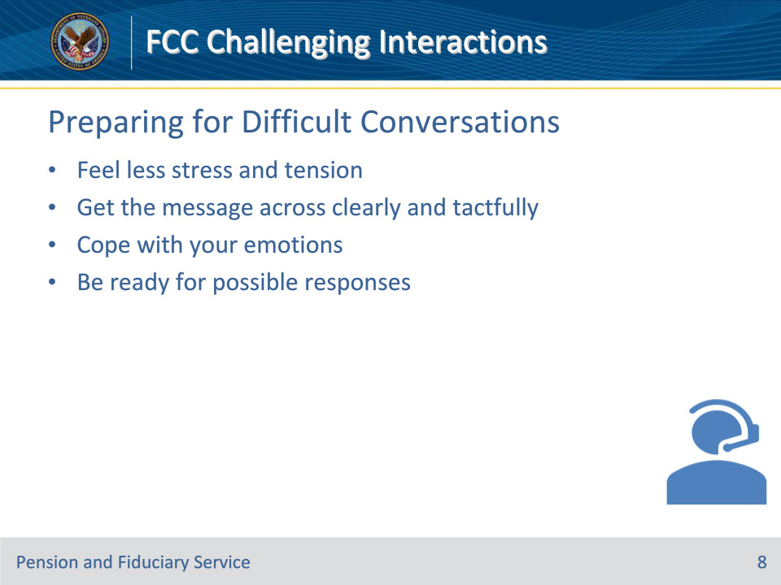

**Slide notes**

Instructor Notes

Handling difficult conversations and knowing how to navigate them takes time and practice but it doesn’t mean they have to be difficult to navigate. By working on your skills in this area through preparation you’ll be well-prepared to get through these conversations with ease. Ultimately you will;

• Feel less stress and tension

• Get the message across clearly and tactfully

• Cope with your emotions

• Be ready for possible responses

**Slide 9 - Preparation Questions**

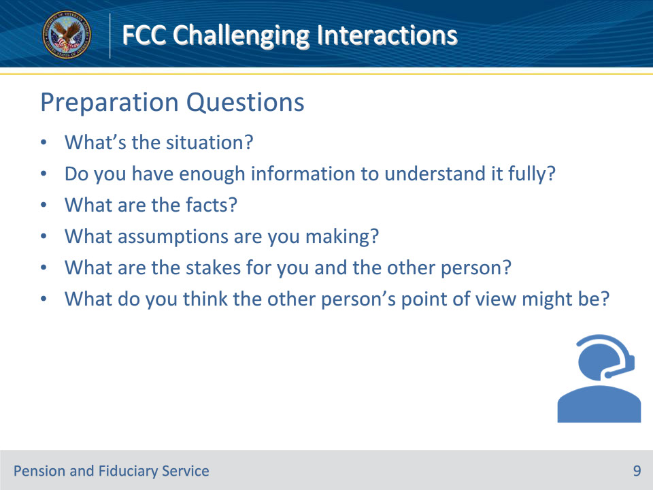

**Slide notes**

Instructor Notes

A difficult conversation usually means one or both parties experience strong emotions, like anger, fear or frustration. Difficult conversations may involve conflict or differences of opinion.  The following list of questions can help you reflect before you begin a difficult conversation. They can help you think about your own mindset, your intended outcome and potential consequences from the conversation.

• What’s the situation? Do you have enough information to understand it fully?

• What are the facts? What assumptions are you making?

• What are the stakes for you and the other person?

• What do you think the other person’s point of view might be?

**Slide 10 - Knowledge Check**

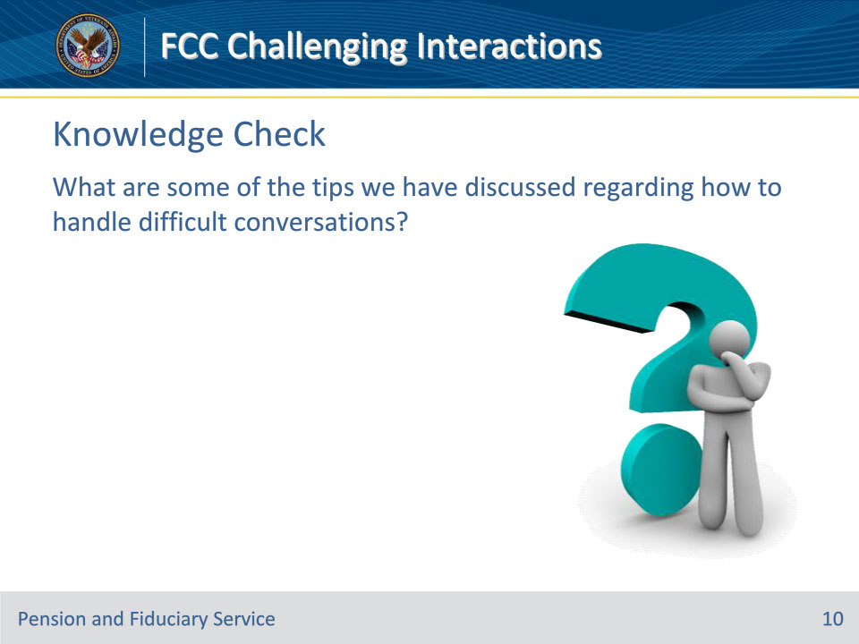

**Slide notes**

Instructor Notes

What are some of the tips we have discussed regarding how to handle difficult conversations?

Answers on next slide:

1. Prepare yourself.

2. Make sure you know what you want to achieve.

3. Deliver the message promptly and clearly.

4. Focus on the facts and tell the truth.

5. Ask questions and try to see the situation from the other person’s point of view.

6. Listen actively, empathize, and acknowledge, respect, and validate the other person’s feelings

7. Don’t take people’s reactions personally.

8. Stay calm and manage your own feelings.

**Slide 11 - Answers**

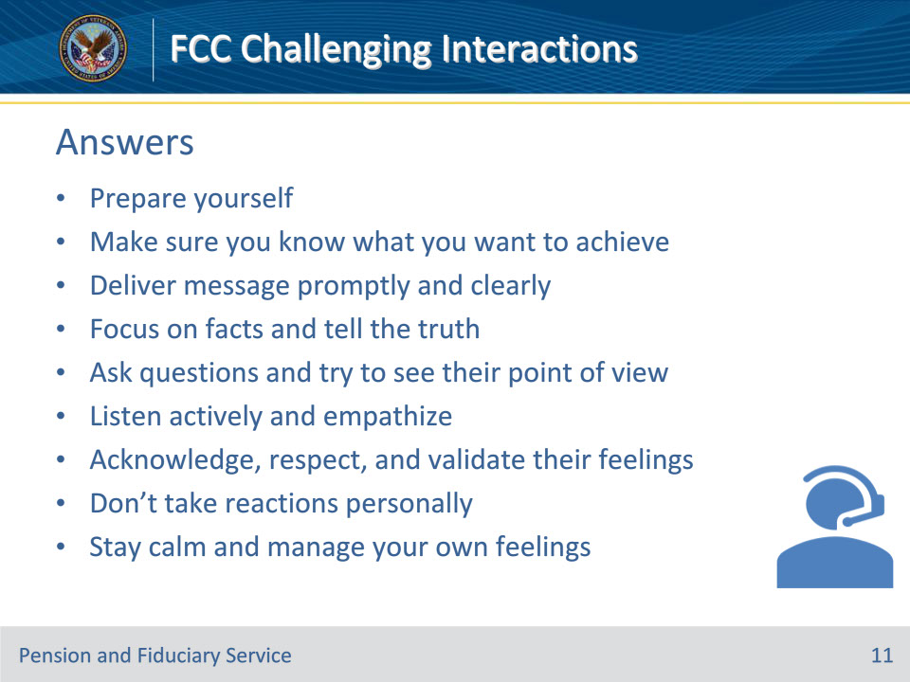

**Slide notes**

Instructor Notes

Answers:

1. Prepare yourself.

2. Make sure you know what you want to achieve.

3. Deliver the message promptly and clearly.

4. Focus on the facts and tell the truth.

5. Ask questions and try to see the situation from the other person’s point of view.

6. Listen actively, empathize, and acknowledge, respect, and validate the other person’s feelings

7. Don’t take people’s reactions personally.

8. Stay calm and manage your own feelings.

**Slide 12 - Group Activity**

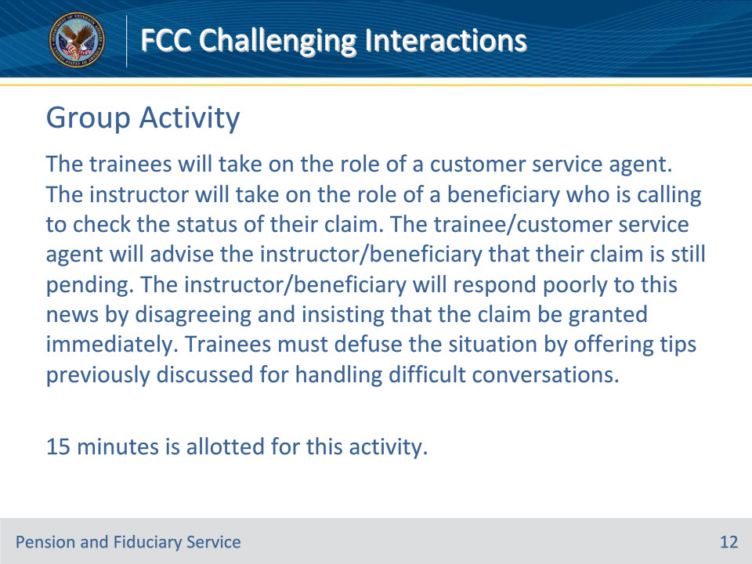

**Slide notes**

Instructor Notes

After the group activity is read, the instructor and trainees will role-play. The instructor will ask for one volunteer from the group. The instructor will pretend to be a beneficiary who is calling to check the status of their claim. The trainee must advise the instructor that their claim is still pending. The instructor is to respond poorly to the news (note: remain respectful during role-play). The instructor will ask the volunteer to provide one tip or strategy for handling difficult conversations. Next, the instructor will ask for assistance from the audience to defuse the situation by placing some tips in the chat or unmuting their mics.

Note: The goal of this exercise is for the trainees to identify the tips and strategies that were previously discussed rather than to implement and act them out. Their responses do not have to be identical to the ones previously discussed, but they should capture the ideas of the following:

• Prepare yourself

• Know what you want to achieve

• Deliver the message promptly and clearly

• Focus on the facts and tell the truth

• Try to see the situation from the other person’s point of view

• Listen actively, empathize, and acknowledge, respect, and validate the other person’s feelings

• Don’t take people’s reactions personally

• Stay calm and manage your own feelings

**Slide 13 - Introduction to Empathy**

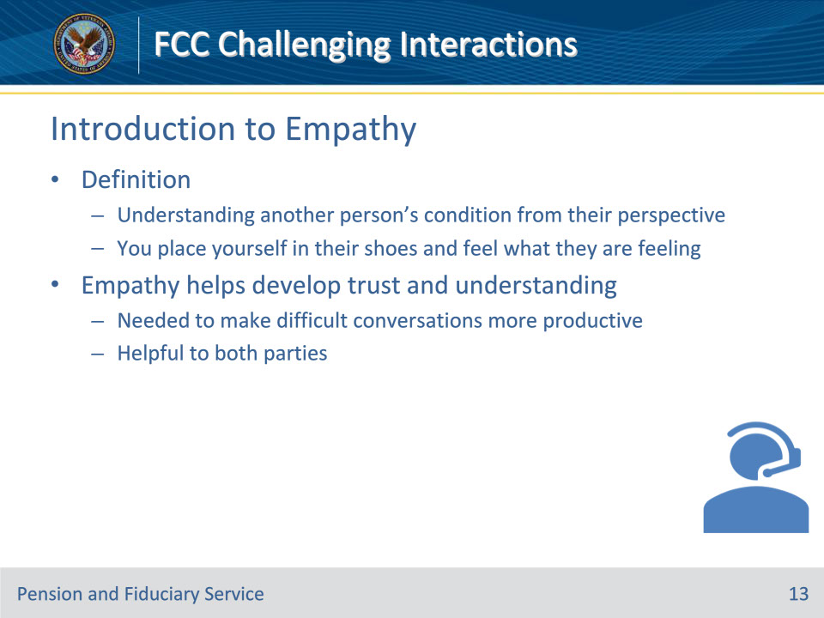

**Slide notes**

Instructor Notes

• Empathy is “the experience of understanding another person’s condition from their perspective. You place yourself in their shoes and feel what they are feeling.” Empathy helps develop the trust and understanding needed to make difficult conversations more productive and helpful to both parties.

• It’s important to understand where others are coming from in order to build trust and have productive conversations. Empathy is the ability to put yourself in another person’s shoes and truly feel what they’re feeling. This allows you to see their perspective and gain a deeper understanding of their condition. By practicing empathy, you can create a safe space for difficult conversations and come to a resolution that benefits everyone involved.

• An exceptional Legal Administration Specialist has to reflect genuine interest and empathy when dealing with customers. You are the face of the company and hence need to radiate warmth, genuine interest, concern and understanding of customers and their issues.

**Slide 14 - 5 Advantages of Empathy**

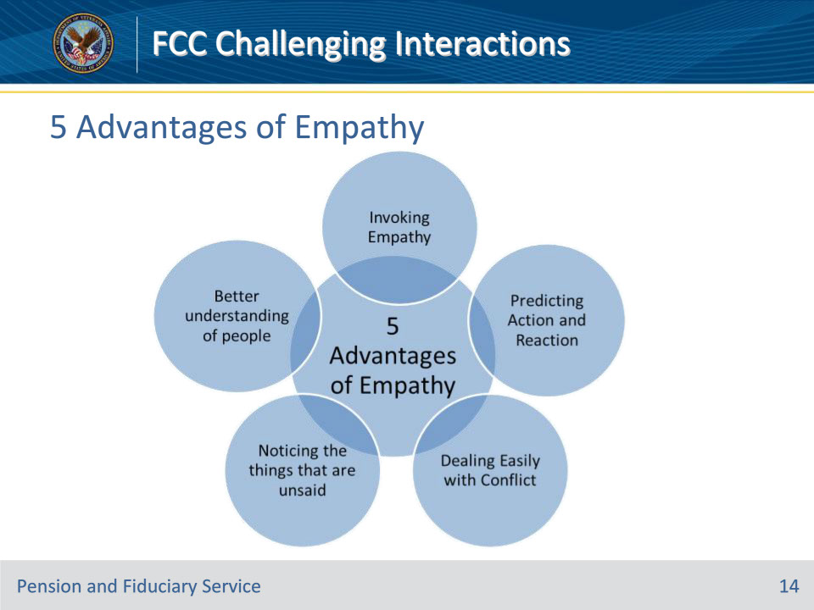

**Slide notes**

Instructor Notes

There are many benefits to expressing empathy apart from moving the bottom line which is “making customers happy”.  Here are five advantages of empathy:

1. A Better Understanding of People: Customer Service is all about people. If you understand the people better, you can support better. Practicing empathy every day will help you do that.

2. Noticing Things that are Unsaid: Callers should not have to spell out their needs and feelings. Based on their situation, voice, and tone, you should be able to pick up on what motivated them to call.

3. Dealing Easily with Conflict: When you understand what is unsaid, you can address it and make callers feel heard – which is the first step towards resolving conflict.

4. Invoking Empathy: There are a lot of hard conversations in customer service. Lack of empathy will make the caller mistrust your intentions but when you are able to understand their motivation and point of view, it gets much easier to gain their trust.

5. Predicting Action and Reaction: You will be able to predict a caller’s follow up question and proactively answer them. You will be able to predict what they will feel when you provide your answer.

**Slide 15 - Maintaining Empathy**

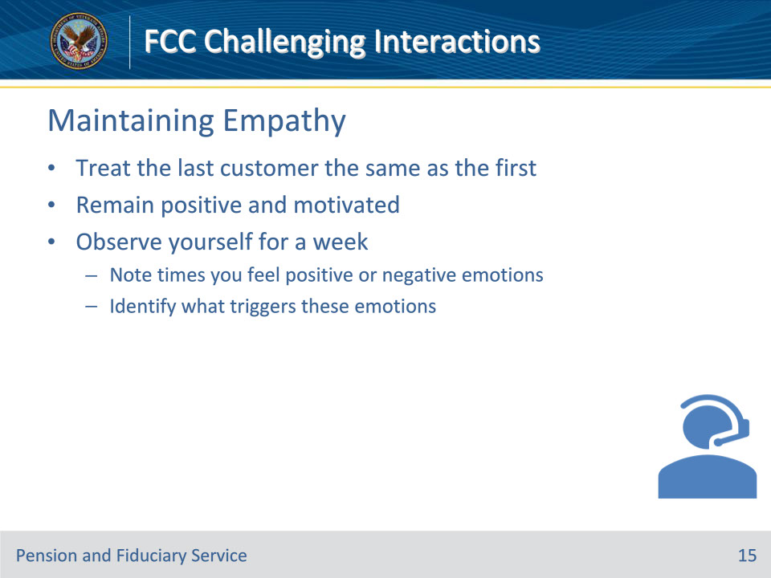

**Slide notes**

Instructor Notes

• Being empathetic to the first customer of the day is easy. But to treat the last customer in the same way you treated the first customer, you need to remain positive and motivated. To do this, you’ll need to challenge yourself. Empathy exists on a spectrum, and in most cases, it isn’t entirely absent — it’s just diminished. Because empathy is an ability, most people can develop it. Having low empathy doesn’t mean you’ll feel this way forever.

1. Observe yourself for a week noting time you feel a positive or negative emotion.

2. Identify what triggers the emotion

• Working on recognizing your own emotions may help you connect with other people.

**Slide 16 - Maintaining Empathy**

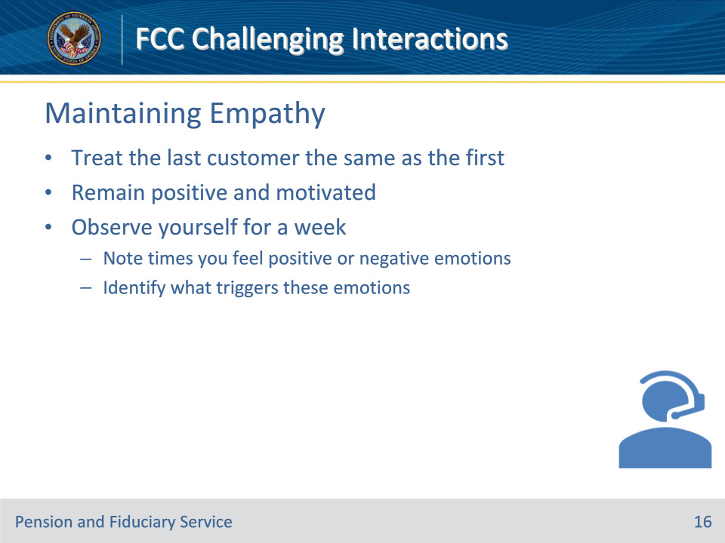

**Slide notes**

Instructor Notes

• Being empathetic to the first customer of the day is easy. But to treat the last customer in the same way you treated the first customer, you need to remain positive and motivated. To do this, you’ll need to challenge yourself. Empathy exists on a spectrum, and in most cases, it isn’t entirely absent — it’s just diminished. Because empathy is an ability, most people can develop it. Having low empathy doesn’t mean you’ll feel this way forever.

1. Observe yourself for a week noting time you feel a positive or negative emotion.

2. Identify what triggers the emotion

• Working on recognizing your own emotions may help you connect with other people.

**Slide 17 - Lack of Empathy**

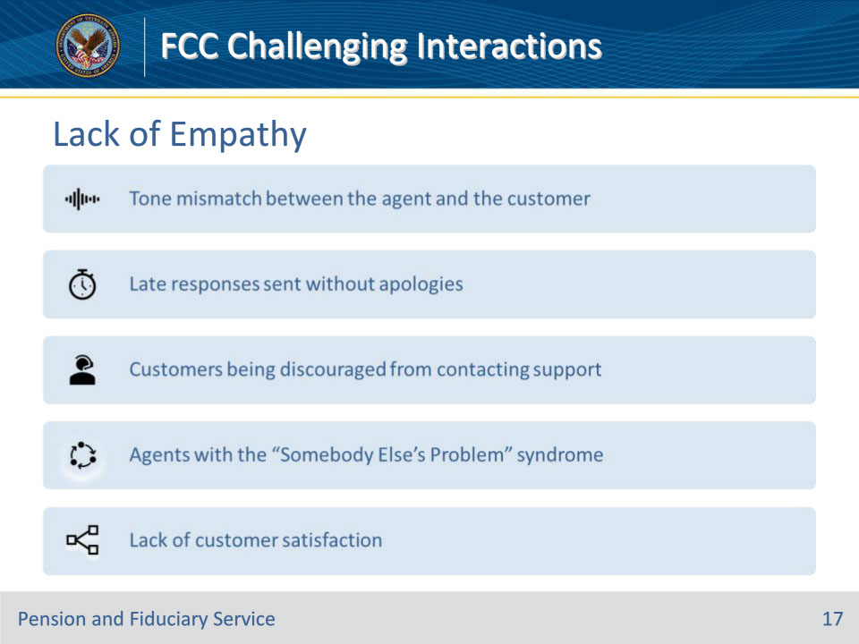

**Slide notes**

Instructor Notes

As a consumer, you might have noticed that some customer service interactions make you feel happy even when you don’t end up getting what you wanted. Chances are, you were lucky enough to talk to a particularly empathetic customer service team or rep. Here in this slide we’ll talk about classic signs of lack of empathy within an organization.

• Tone mismatch between the agent and the customer- One of them is too formal and the other too informal.

• Late responses without an apology-Customer service agents not taking accountability for lapse in service.

• Customers being discouraged from contacting support, through words and behavior- This typically occur from a previous unhappy experience with your organization or another organization.

• Agents with the Somebody Else’s Problem syndrome-That is, issues getting deflected to other departments without any explanations or follow-ups.

• Lack of customer satisfaction-There is no bigger sign of lack of empathy than the customer being unhappy even after getting what they want.

**Slide 18 - Understanding Customers**

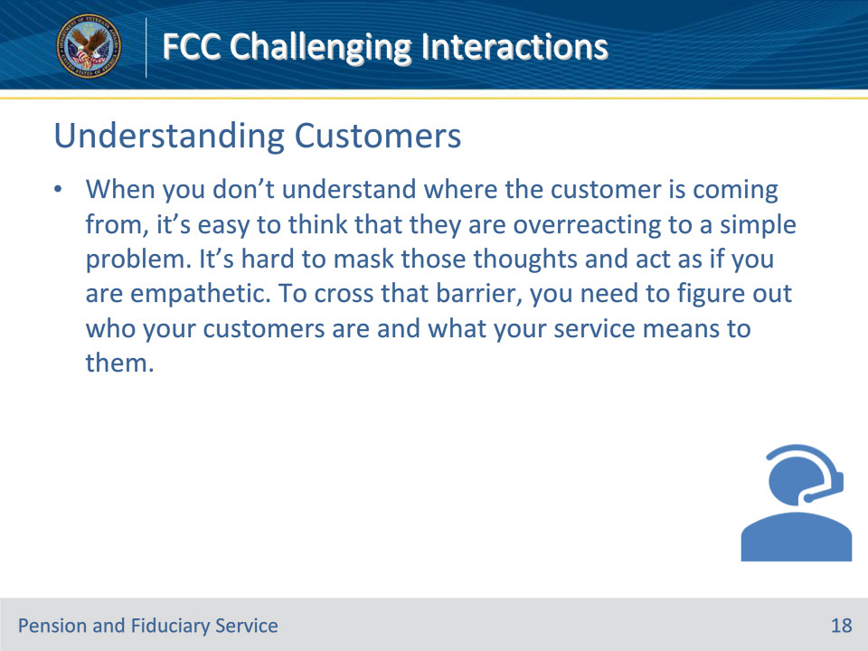

**Slide notes**

Instructor Notes

• When you don’t understand where the customer is coming from, it’s easy to think that they are overreacting to a simple problem. It’s hard to mask those thoughts and act as if you are empathetic. To cross that barrier, you need to figure out who your customers are and what your service means to them.

• But it’s important to remember that everyone has their own unique perspective and experiences that inform their reactions. By taking the time to really get to know your customers and what your service means to them, you can better understand their needs and concerns, and provide more empathetic and effective support. At the end of the day, it’s all about building trust and a strong relationship with your customers.

**Slide 19 - Quality Customer Service**

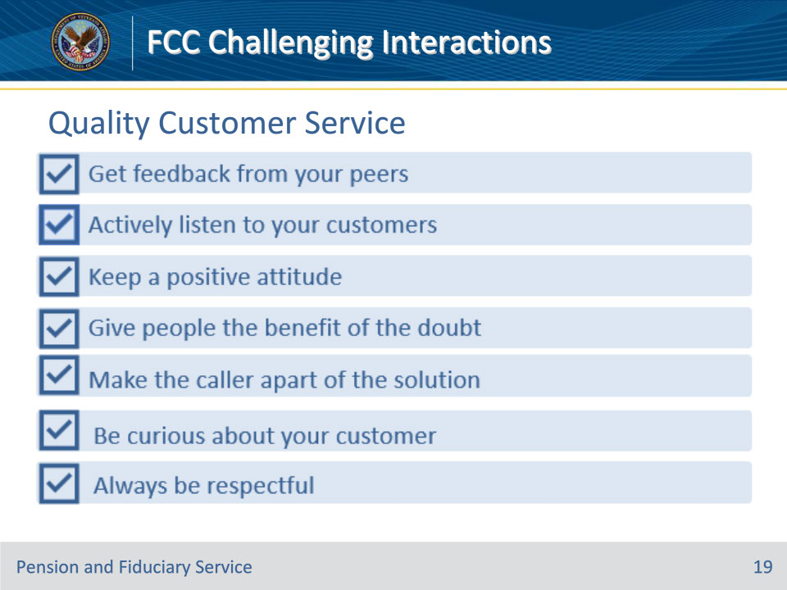

**Slide notes**

Instructor Notes

• Get feedback from your peers: You can ask a peer who gets along well with customers for their opinion on the way you talk with customers. The important thing to remember here is to receive the feedback with an open mind.

• Actively listen to tour customers: Let your customers talk and actively listen to what they are saying. Do not jump to conclusions. Do not offer a solution before they can finish telling you about the problem.

• Keep a positive attitude: Focus on something positive that “anchors” your attitude where it needs to be to deliver outstanding service. You can surround yourself with things like pictures of family or friends, motivational or funny quote posters. Remember always have you always have the power of seeing any problem as an opportunity to creatively find a solution or draw a useful lesson from the situation.

• Give people the benefit of the doubt: Remember it’s not personal. Maybe they are having a bad day or they have a personal problem. Always work under the assumption that this interaction is going to make their day better.

• Make the caller a part of the solution: There will be times you think the customer is being unreasonable. In such cases, ask them what they think the right solution is. This will give them a chance to put themselves in your shoes instead of being against you.

• Be curious about your customer: When it comes to your clients, being curious is the best way to get to know them and understand their needs. It also shows them that you’re interested in them as more than just a client

• Always be respectful: Always greet the customer with their name. It’s easy to forget manners when the conversation is taking a bad turn. Even as you are standing up for yourself, remember to not put them down.

**Slide 20 - Quality Customer Service**

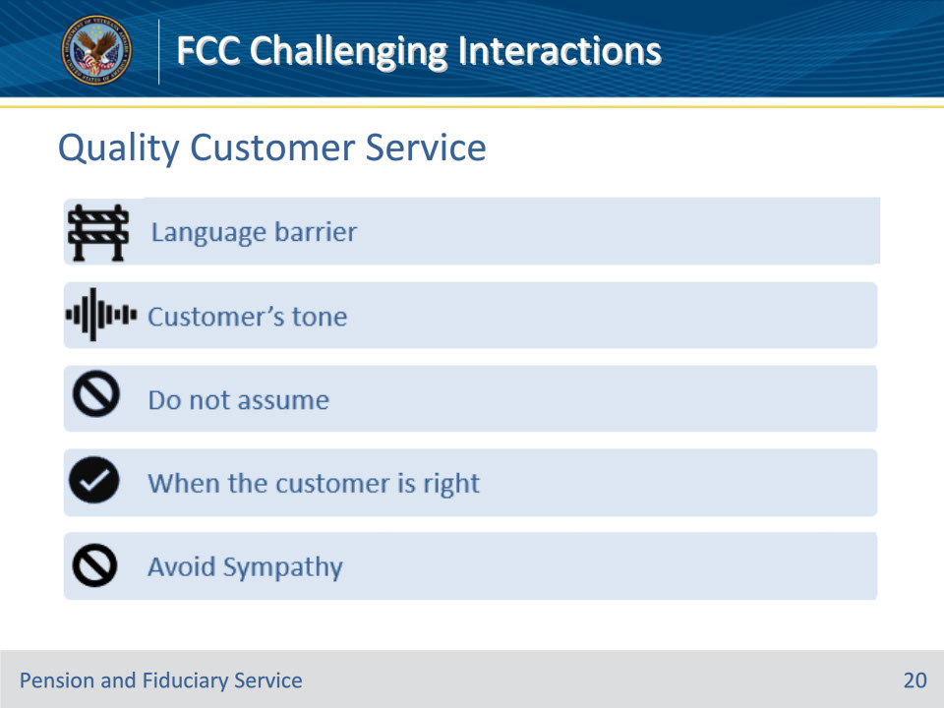

**Slide notes**

Instructor Notes

• How to respond to language barriers: When talking to someone who comes from a different culture or country, things can be lost in translation. Be careful in these situations and try to make yourself as clear as possible, while remaining respectful.

• How to respond to a customer’s tone: Always respond to the customer’s tone. You don’t have to give up your own or the VA’s (organization) personality in the process. Just have a formal-informal scale that you are comfortable with and pick a tone that’s between that scale.

• Avoid assumptions: Do not assume that callers would not know the simplest solution. If you assume, not only will the resolution be delayed, the caller will also feel like they are being rushed.

• How to respond when the customer is right: Don’t be afraid to take their side. Customers will respect you and your company for it. They will understand that you truly value THEIR’ opinions

• Avoid sympathy: The most important thing to remember when you are expressing empathy is to avoid sympathy. Empathy allows you to be professional and caring at the same time. It also allows you to avoid becoming emotionally involved.

1. (Sympathy) “Wow. I can’t believe that we made this kind of mistake. This should never happen. I’m so sorry that you have to deal with this. I promise we’ll get it fixed right away.”

2. (Empathy) “Thank you for bringing this issue to our attention. I understand how frustrating this kind of thing can be. Please let me do what I can to find out what went wrong and determine the next steps toward a resolution.”

**Slide 21 - Knowledge Check**

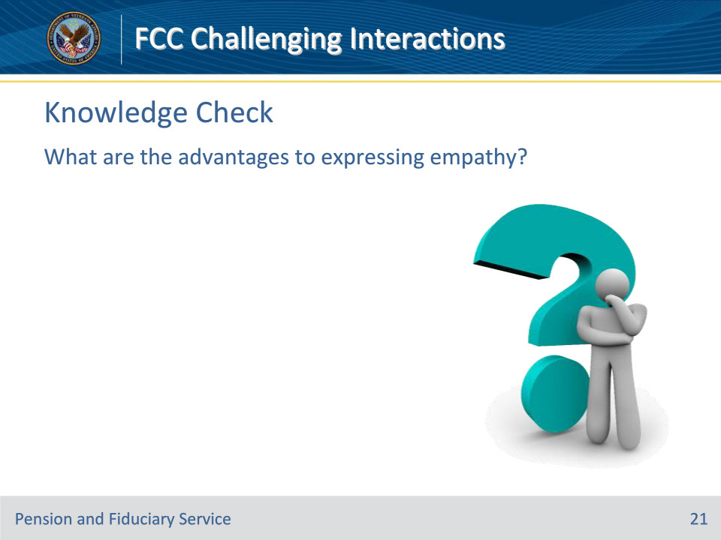

**Slide notes**

Instructor Notes

What are the advantages to expressing empathy?

Answers on next slide:

1. A Better Understanding of People

2. Noticing Things that are Unsaid

3. Dealing Easily with Conflict

4. Invoking Empathy

5. Predicting Action and Reaction

**Slide 22 - Answers**

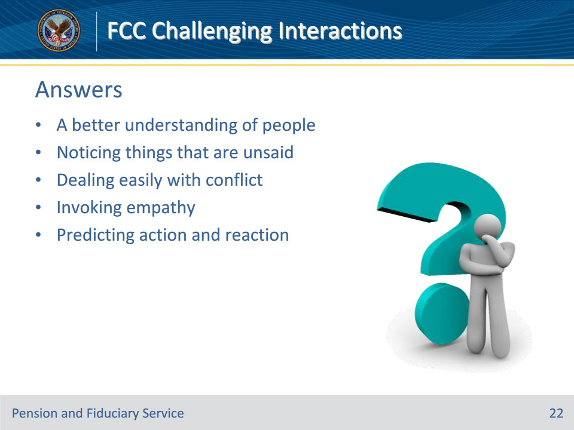

**Slide notes**

Instructor Notes

Answers:

1. A Better Understanding of People

2. Noticing Things that are Unsaid

3. Dealing Easily with Conflict

4. Invoking Empathy

5. Predicting Action and Reaction

**Slide 23 - Knowledge Check**

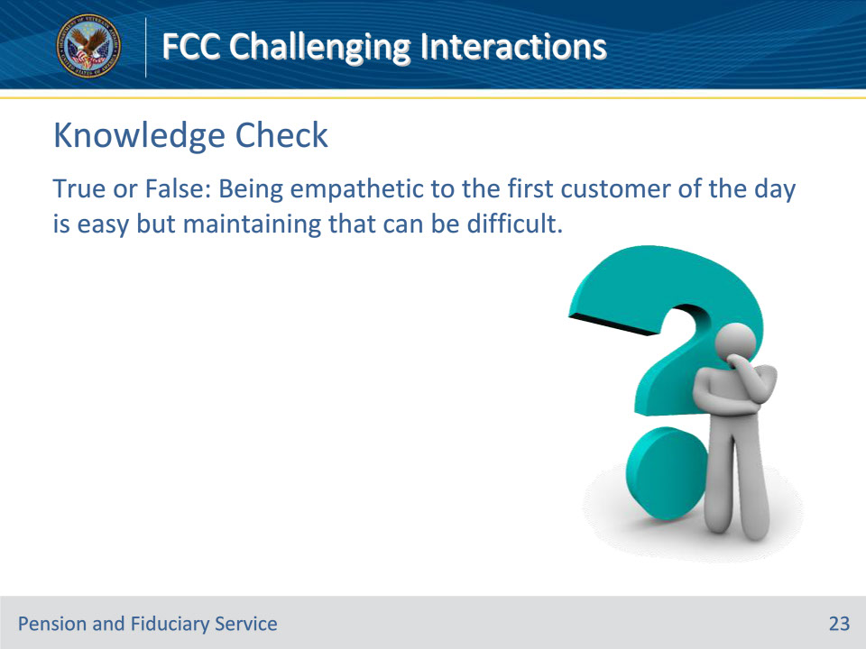

**Slide notes**

Instructor Notes

True or False: Being empathetic to the first customer of the day is easy but maintaining that can be difficult.

Answer on next slide:

TRUE: Being empathetic to the first customer of the day is easy. But you need to remain positive and motivated to treat the last customer like the first customer.

**Slide 24 - Answer**

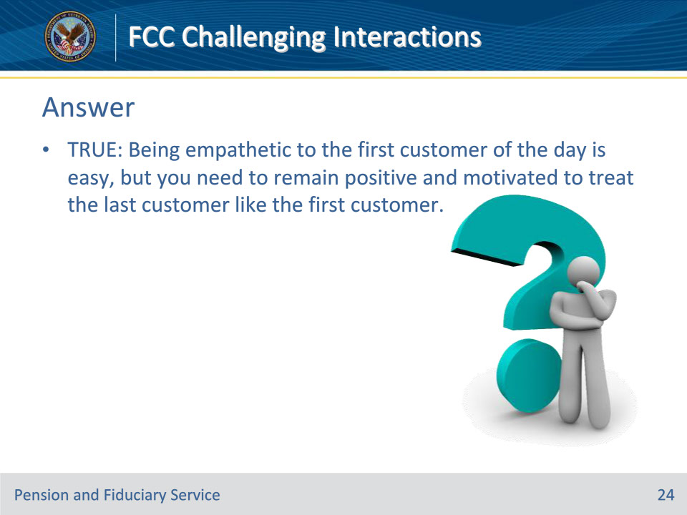

**Slide notes**

Instructor Notes

Answer:

TRUE: Being empathetic to the first customer of the day is easy. But you need to remain positive and motivated to treat the last customer like the first customer.

**Slide 25 - Capturing the Message**

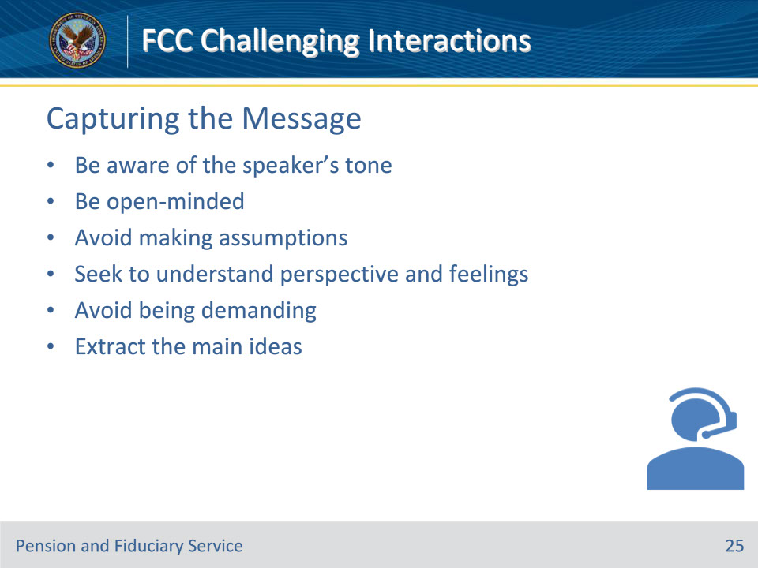

**Slide notes**

Instructor Notes

• Be aware of the speaker’s tone, we can understand their message better and respond appropriately. Remember that tone can be misunderstood, so it’s always a good idea to ask questions to make sure we understand their intended message.

• Be open-minded—respect the speaker’s feelings and point of view, even if you think they may be wrong. Don’t assume only your beliefs are valid, as this can cause misunderstandings and hurt feelings. By listening with an open mind, you might even learn something new or gain a different perspective. So, be respectful and stay open-minded when disagreeing with someone.

• Avoid making assumptions about what the speaker thinks, wants, or feels. To avoid misunderstandings and offense, it’s important to actively listen, clarify with questions, and practice empathy when communicating. Avoid assuming what the speaker thinks, wants, or feels. This leads to a more productive and respectful conversation.

• Seek to understand the person’s perspective on and feelings about the situation. Empathy is key in difficult situations. Try to understand the other person’s perspective to build trust and respect in your relationship. This leads to better problem-solving and decision-making.

• Avoid being demanding. When taking a message from a caller avoid being pushy. Ask open-ended questions, listen attentively, and be patient, respectful, and empathetic. This helps establish a connection and makes the caller feel at ease sharing their concerns.

• Extract the main ideas. It’s important to listen closely to callers and take note of their needs and concerns. Asking for clarification and repeating back what you’ve heard can help ensure effective communication and prompt resolution of any issues. The goal is to provide great customer service and leave the caller feeling heard and satisfied.

**Slide 26 - Help the Speaker**

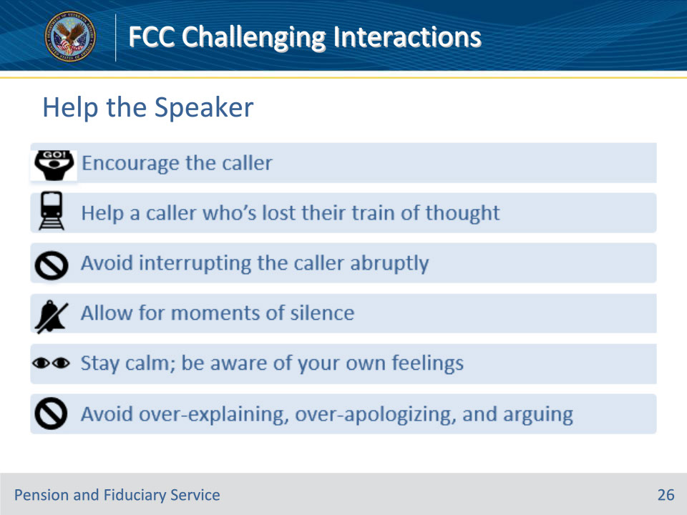

**Slide notes**

Instructor Notes

• Encourage the caller: Give the caller confirmation by saying things like “yes, I see”.

• Help a caller who’s lost their train of thought: “You were just saying…” or “I think you also wanted to say something about…”

• Avoid interrupting the caller: Try to refrain from cutting the customer off abruptly. However, also avoid letting the conversation drag out: Look for signs of a natural ending where the message has been delivered and received

• Allow for moments of silence: Remember that it can be difficult for someone to get their message across.

• Stay calm; be aware of your own feelings: if you feel angry or upset, take a deep breath to relax and get your emotions under control.

• Avoid over-explaining, over-apologizing, and arguing: In an effort to be polite and avoid seeming rude, some people can fall into a tendency to apologize profusely or overexplain the reason why they’re setting a limit.  You should convey your message clearly, apologize if necessary, and limit going back and forth with the caller.

**Slide 27 - Managing Calls**

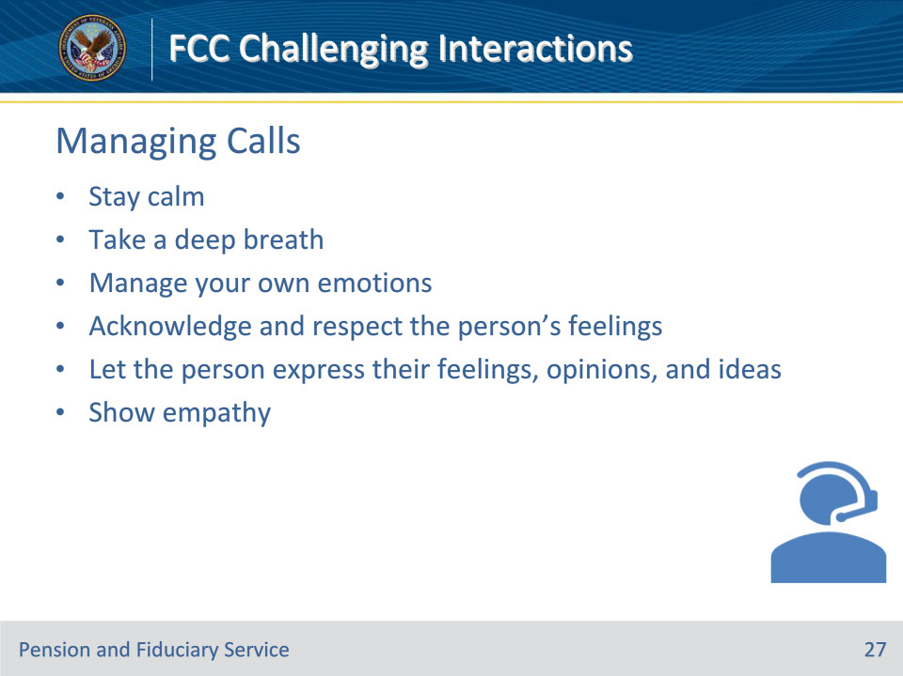

**Slide notes**

Instructor Notes

• When you feel your emotions rising, take a moment to breathe deeply and calm yourself. Breathing can help you lower your heart rate, blood pressure, and stress levels. It can also help you clear your mind and focus on the situation at hand.

• Practicing acknowledgment does not mean you have to agree with the other person; however, validating the customer’s feelings will reduce any anger or defensiveness that might be bubbling up

• Let the customer vent but don’t tolerate abusive behavior.

• One of the best ways to diffuse a tense situation is to show empathy and validation to the customer.

**Slide 28 - Specific Strategies**

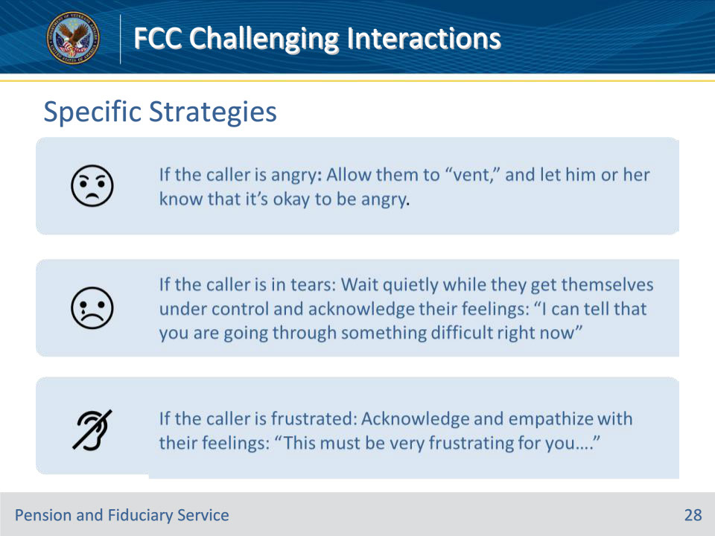

**Slide notes**

Instructor Notes

• If the person is angry: Allowing the caller to vent helps them express their feelings and then calm down. Once they’ve calmed down, you can ask some basic questions to get at the underlying cause of the customer’s frustration. The goal is to redirect the conversation back to critical issues and provide constructive solutions to their problems.

• If the person is in tears: Wait quietly while they get themselves under control and acknowledge their feelings: “I can tell that you are going through something difficult right now.” The two most important things you can do is be supportive and be an active listener.

• If the person is frustrated: Acknowledging the caller’s feelings is a good way to avoid escalating the conflict. Use supportive statements to acknowledge your understanding and empathy: “Oh, I see;” “That sounds like it upset you.”

**Slide 29 - Specific Strategies**

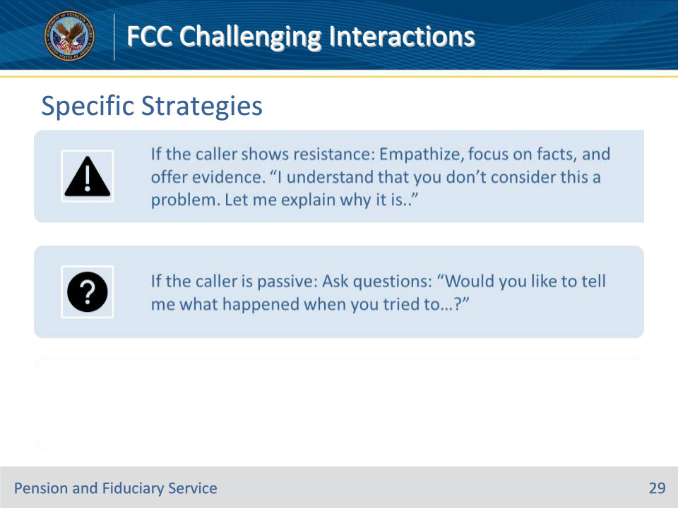

**Slide notes**

Instructor Notes

• If the caller shows resistance: The first step to overcoming customer resistance is to identify the root cause of their objections or concerns. Empathize, focus on facts, and offer evidence. “I understand that you don’t consider this a problem. Let me explain why it is”

• If the person is passive: Ask questions because they typically avoid expressing their opinions and needs; they don’t disclose all information and often give vague replies. Depending on the situation you can ask probing questions like “Would you like to tell me what happened when you tried to…?”

**Slide 30 - Closing Conversations**

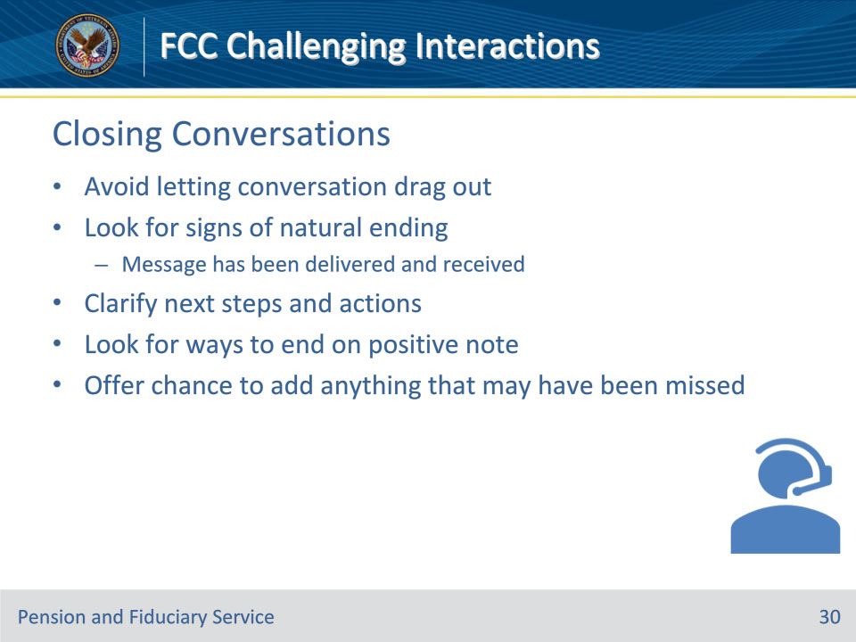

**Slide notes**

Instructor Notes

• Avoid letting the conversation drag out: Look for signs of a natural ending where the message has been delivered and received. This helps ensure that the conversation stays on track and doesn’t become too drawn out or repetitive. Additionally, it allows both parties to move on to other tasks or conversations without feeling like they’re being held hostage by the current discussion. By recognizing these signs and ending the conversation in a timely manner, you can help facilitate more productive and efficient communication.

• Clarify the next steps and actions that each of you can agree to take. You can do this by reviewing the main points of your discussion and summarizing any agreements or decisions that were made. It may also be useful to outline any follow-up tasks or deadlines that need to be met. By establishing a clear plan, you can ensure that everyone is on the same page and that you can move forward with confidence. Thank you for your time and attention.

• Look for ways to end on a positive note: This can help leave the caller feeling satisfied and happy with the interaction, even if their issue wasn’t fully resolved. Some ways to end on a positive note could be to thank the caller for their time and, to wish them a great day, or to assure them that their issue will be taken care of as soon as possible. Remember to always remain friendly and helpful throughout the call, and to make the caller feel heard and valued.

• Offer the person the chance to add anything that may have been missed: It is important to offer the person the chance to add anything that may have been missed during a call because it shows that you care about their concerns and want to make sure that they are satisfied with the service they received. It also gives them the opportunity to fully express their thoughts and feelings, which can help you provide better assistance and improve your company’s overall customer service experience. By offering this chance, you are demonstrating that you value their feedback and are committed to resolving any issues they may have.

**Slide 31 - Knowledge Check**

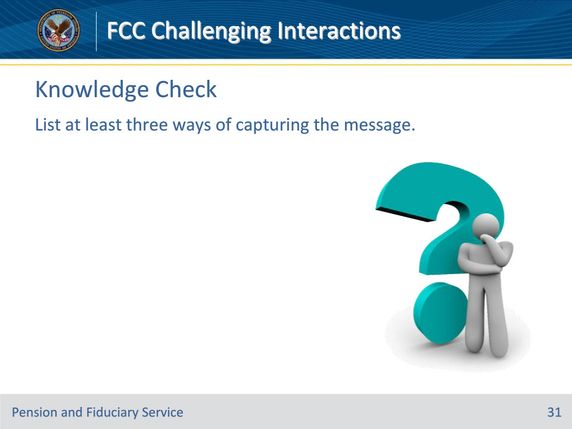

**Slide notes**

Instructor Notes

List at least three ways of capturing the message.

Answers on next slide:

• Be aware of the speaker’s tone.

• Be open-minded—respect the speaker’s feelings and point of view, even if you think they may be wrong.

• Avoid making assumptions about what the speaker thinks, wants, or feels.

• Seek to understand the person’s perspective on and feelings about the situation.

• Avoid telling the person what you think they should do—you want to help them come to their own conclusions.

• Extract the main ideas.

**Slide 32 - Answers**

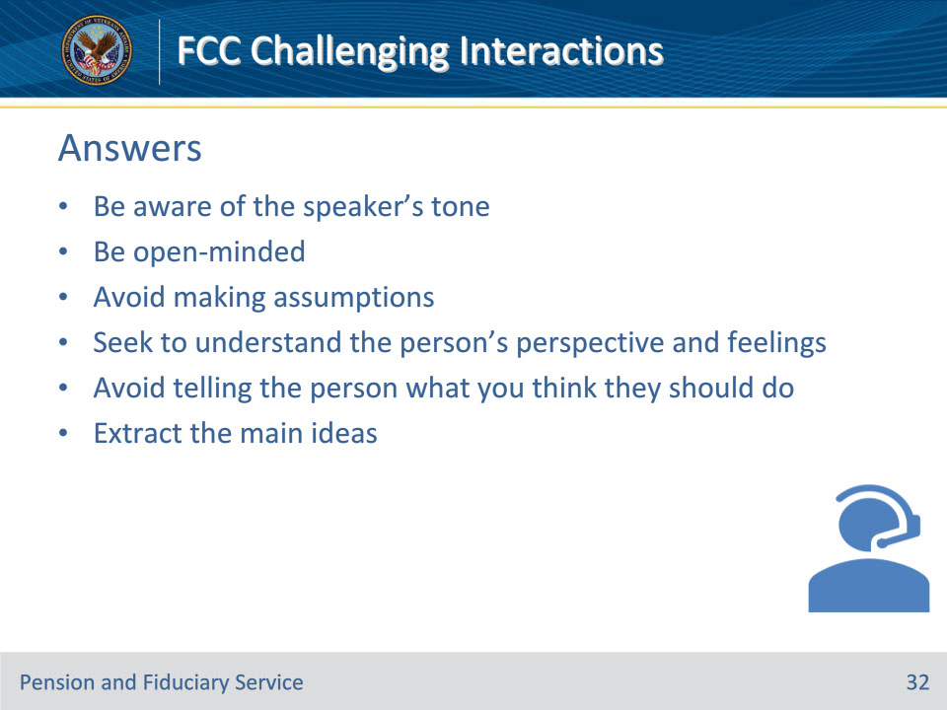

**Slide notes**

Instructor Notes

Answers:

• Be aware of the speaker’s tone.

• Be open-minded—respect the speaker’s feelings and point of view, even if you think they may be wrong.

• Avoid making assumptions about what the speaker thinks, wants, or feels.

• Seek to understand the person’s perspective on and feelings about the situation.

• Avoid telling the person what you think they should do—you want to help them come to their own conclusions.

• Extract the main ideas.

**Slide 33 - Call Control**

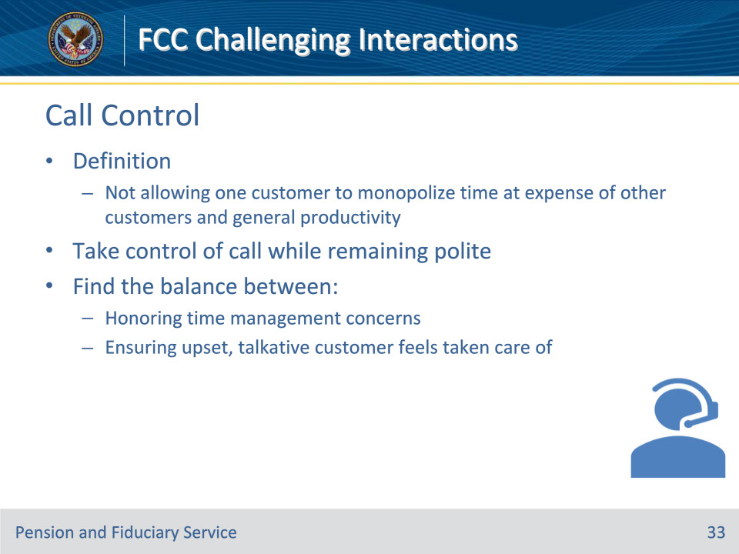

**Slide notes**

Instructor Notes

While it’s important to be sensitive to the needs of the customer, it’s equally important not to allow one customer to monopolize your time at the expense of other customers and general productivity. Taking control of a customer service call while remaining polite is one of the trickier skills a good customer service representative should have in their arsenal. It requires finding the right balance between honoring time management concerns and making sure an upset, overly talkative customer feels taken care of.

**Slide 34 - Solution Oriented**

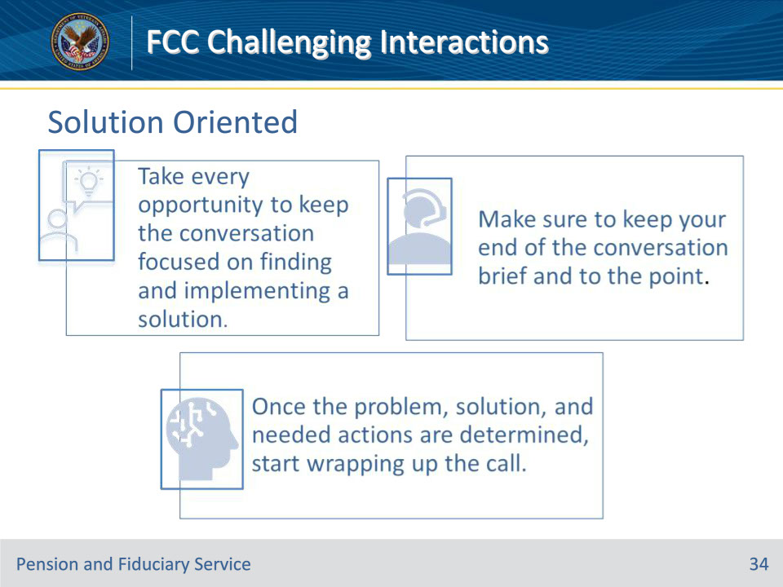

**Slide notes**

Instructor Notes

• Take every opportunity to keep the conversation focused on finding and implementing a solution. Whether it’s a customer inquiry or a complaint, the goal is to resolve the issue as quickly and efficiently as possible. By keeping the conversation focused on finding a solution, you can avoid getting sidetracked by irrelevant details or emotions. This not only helps to resolve the issue faster, but it also helps to build trust and confidence with the customer.

• Make sure to keep your end of the conversation brief and to the point.

• Once the problem, solution, and needed actions are determined, start wrapping up the call.

**Slide 35 - Persistent Callers**

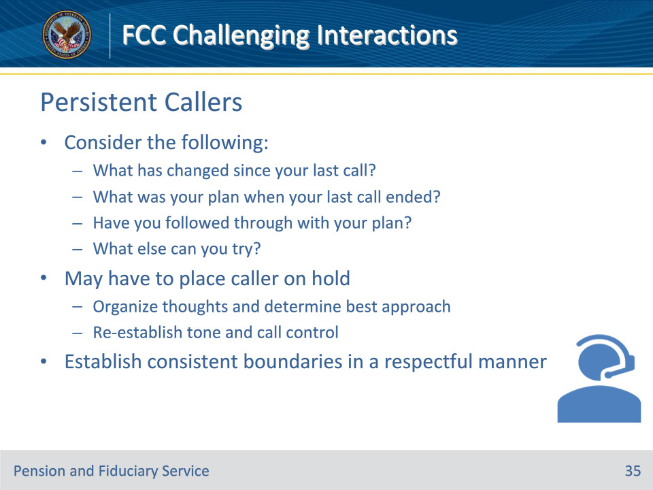

**Slide notes**

Instructor Notes

Overly persistent callers

May have to place the caller on hold. This provides a few moments to organize thoughts and figure out the best way to approach wrapping up the call effectively. It also provides a second opportunity to re-establish the tone of the call and assert greater control over the situation. Challenge yourself to create a thoughtful approach to handling these calls, while maintaining boundaries, consistency, and setting limitations. Establish firm and consistent boundaries in a respectful manner. Consider the following when dealing with persistent callers:

• What has changed since your last call?

• What was your plan when your last call ended? Have you tried…?

• Have you followed through with your plan?

• What else can you try?

Time is valuable

As a customer service representative, it’s useful to approach most situations with an accommodating demeanor, but it’s just as important to have the capability to shift into a more take control attitude from time to time, steer the conversation in the right direction, and take control of the conversation to resolve issues efficiently

**Slide 36 - Call Control Tips**

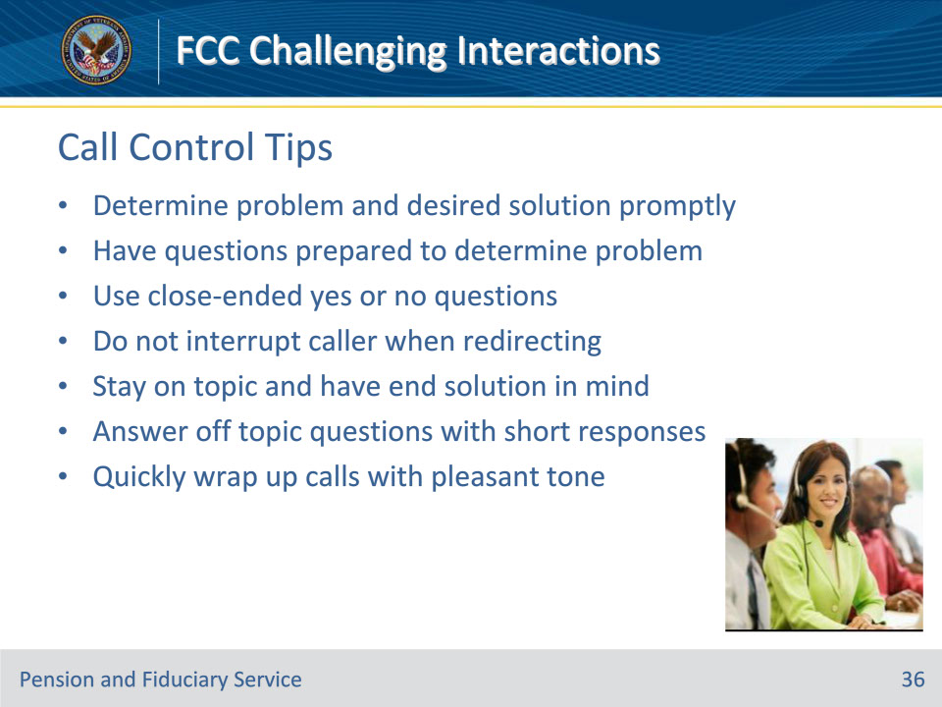

**Slide notes**

Instructor Notes

• Make sure the customer’s problem and desired solution are stated as early in the call as possible.

• Have specific questions prepared for customers who have issues explaining the problem.

• Use close-ended questions — questions that can be answered with a “yes” or “no”.

• Always wait for a pause in the conversation in order to redirect the conversation, don’t interrupt the caller.

• Be sure to stay on topic and have the end solution in mind. This will set the tone for the entire phone call.

• Remember to be friendly but not a friend. Answer questions that are off topic with short responses.

• Quickly wrap up calls in a pleasant tone.

**Slide 37 - Identifying Caller Types**

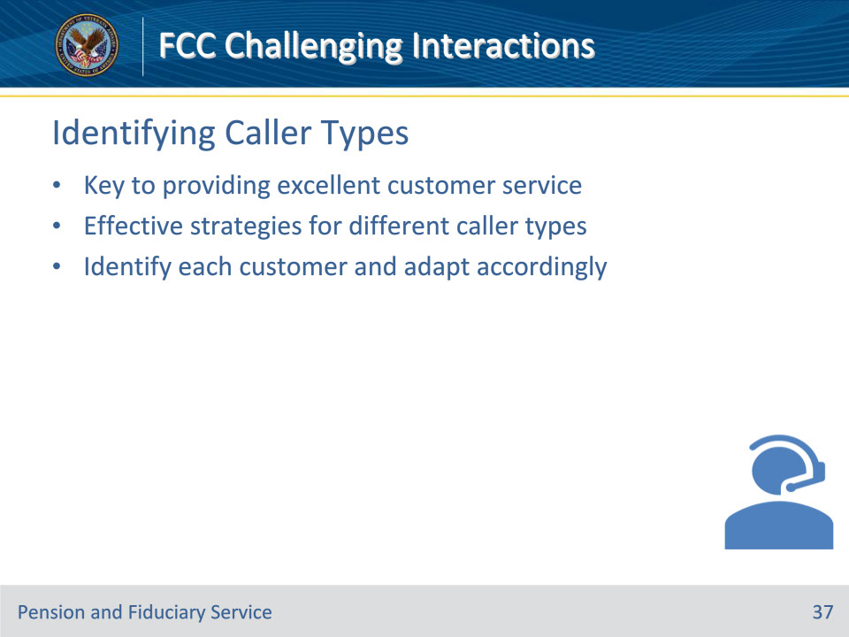

**Slide notes**

Instructor Notes

• Knowing the types of callers to expect and how to deal with each one as an individual is the key to providing excellent customer service. Be intuitive and adapt an effective strategy in handling different types of customers.

• Typically, a customer service agent handle customers eight hours a day for five days a week. This task can be exhausting, especially because every interaction you handle comes with unique challenges. Call center agents must therefore know how to identify each customer and adapt accordingly to ensure a smooth interaction.

**Slide 38 - Caller Types**

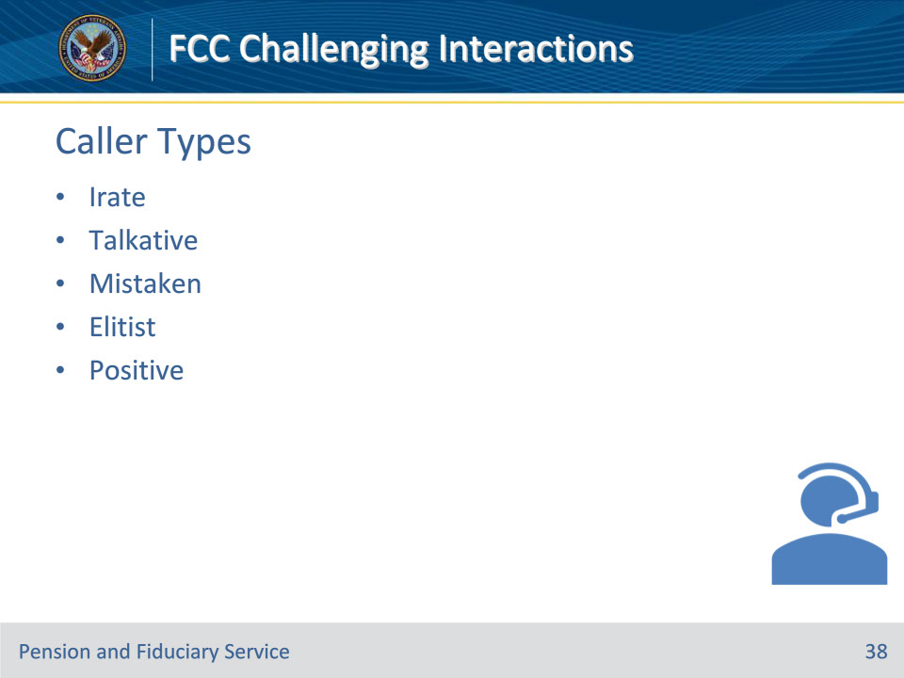

**Slide notes**

Instructor Notes

Here are the five different types of customers you might encounter.

• The irate caller

• The talkative caller

• The mistaken caller

• The elitist caller

• The positive caller

**Slide 39 - Irate Caller**

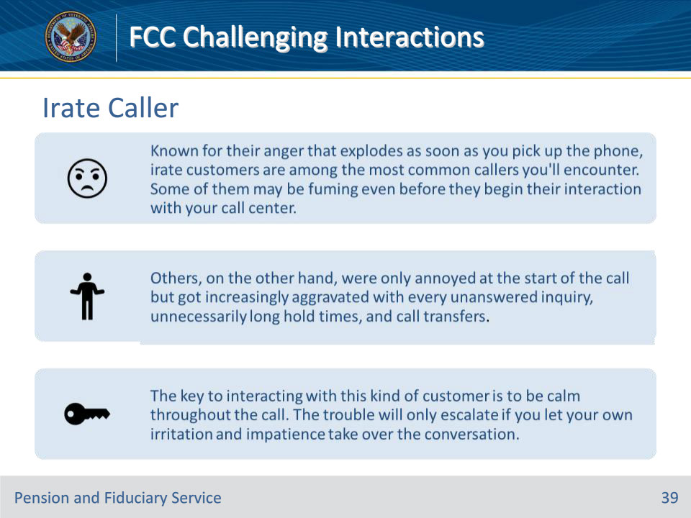

**Slide notes**

Instructor Notes

The irate caller

• Known for their anger that explodes as soon as you pick up the phone, irate customers are among the most common callers you’ll encounter.

• Some of them may be fuming even before they begin their interaction with your call center. Others, on the other hand, were only annoyed at the start of the call but got increasingly aggravated with every unanswered inquiry, unnecessarily long hold times, and call transfers.

• The key to interacting with this kind of customer is to be calm throughout the call. The trouble will only escalate if you let your own irritation and impatience take over the conversation. Instead, assure the customer you know how to solve the problem, and then provide a solution as soon as you can.

**Slide 40 - Talkative Caller**

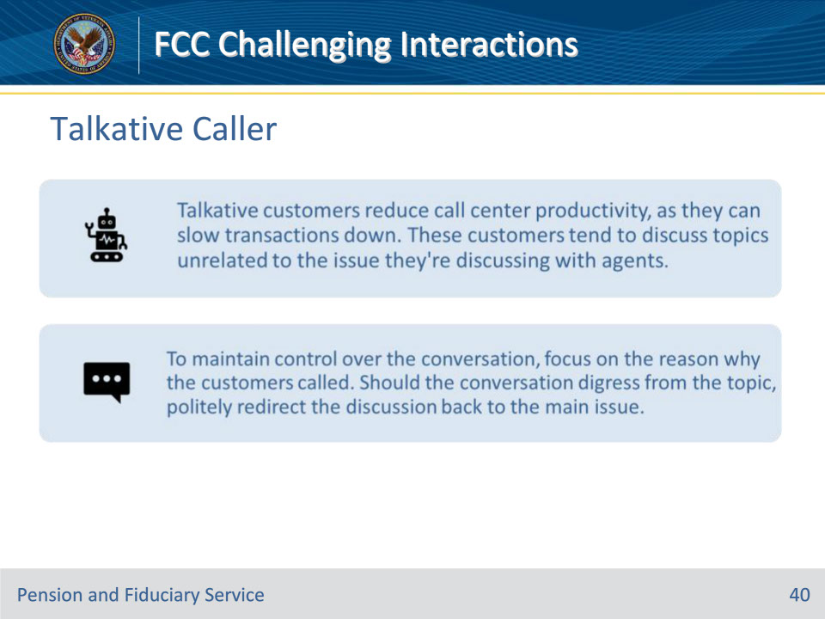

**Slide notes**

Instructor Notes

The Talkative Customer

• Talkative customers reduce call center productivity, as they can slow transactions down.

• These customers tend to discuss topics unrelated to the issue they’re discussing with agents. Because conversations with them take too long, you may have to put other queued customers on hold. This means you’ll be losing the opportunity to help other customers.

• To maintain control over the conversation, focus on the reason why the customers called. Should the conversation digress from the topic, politely redirect the discussion back to the main issue.

**Slide 41 - Mistaken Caller**

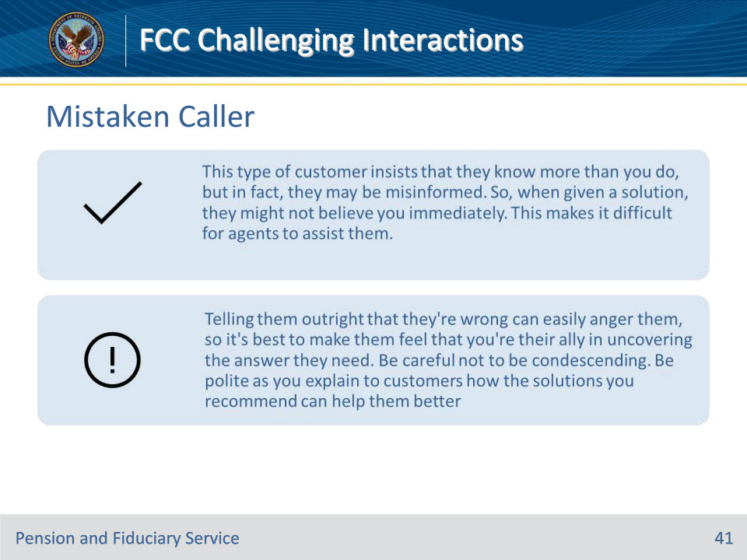

**Slide notes**

Instructor Notes

The Mistaken Caller

• This type of customer insists that they know more than you do, but in fact, they may be misinformed. So when given a solution, they might not believe you immediately.

• This makes it difficult for agents to assist them.

• Telling them outright that they’re wrong can easily anger them, so it’s best to make them feel that you’re their ally in uncovering the answer they need. Be careful not to be condescending.

• Be polite as you explain to customers how the solutions you recommend can help them better.

**Slide 42 - Elitist Caller**

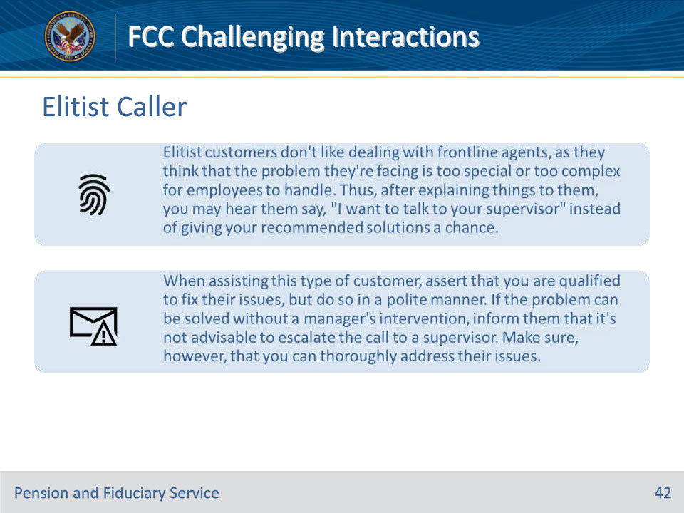

**Slide notes**

Instructor Notes

The Elitist Caller

• Elitist customers don’t like dealing with frontline agents, as they think that the problem they’re facing is too special or too complex for employees to handle. Thus, after explaining things to them, you may hear them say, “I want to talk to your supervisor” instead of giving your recommended solutions a chance.

• When handling this type of customer, assert that you are qualified to fix their issues, but do so in a polite manner. If the problem can be solved without a manager’s intervention, inform them that it’s not advisable to escalate the call to a supervisor. Make sure, however, that you can thoroughly address their issues.

**Slide 43 - Positive Caller**

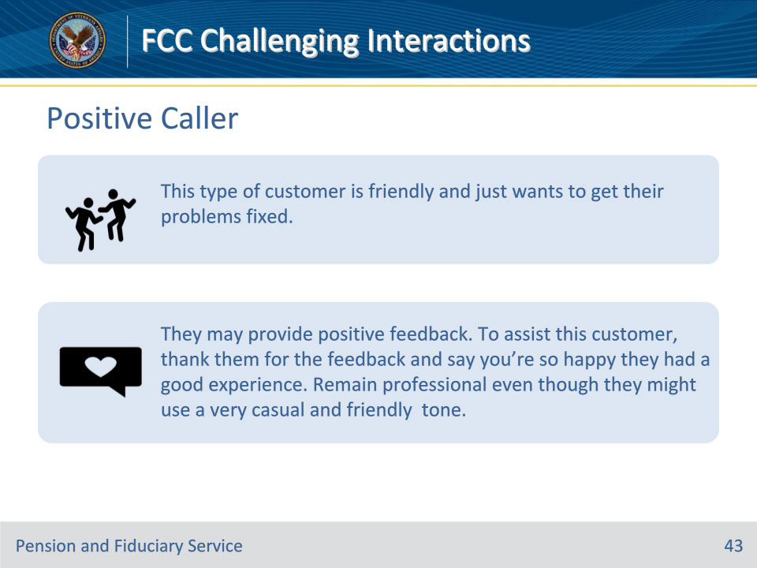

**Slide notes**

Instructor Notes

The Positive Caller

• This type of customer is friendly and just wants to get their problems fixed.

• Unlike the negative customer, the positive customer enters the conversation with a cheery disposition.

• They may provide positive feedback. To assist this customer, thank them for the feedback and say you’re so happy they had a good experience. Remain professional even though they might use a very casual and friendly tone.

**Slide 44 - Knowledge Check**

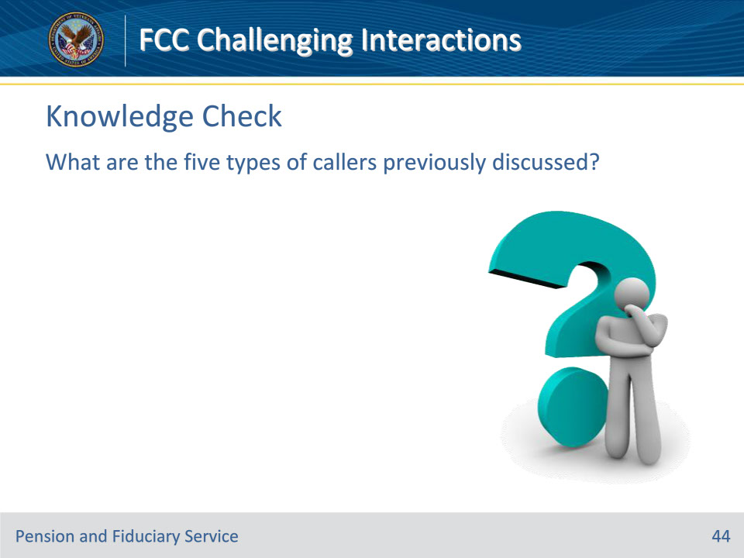

**Slide notes**

Instructor Notes

What are the five types of callers previously discussed?

Answers on next slide:

• The irate caller

• The talkative caller

• The mistaken caller

• The elitist caller

• The positive caller

**Slide 45 - Answers**

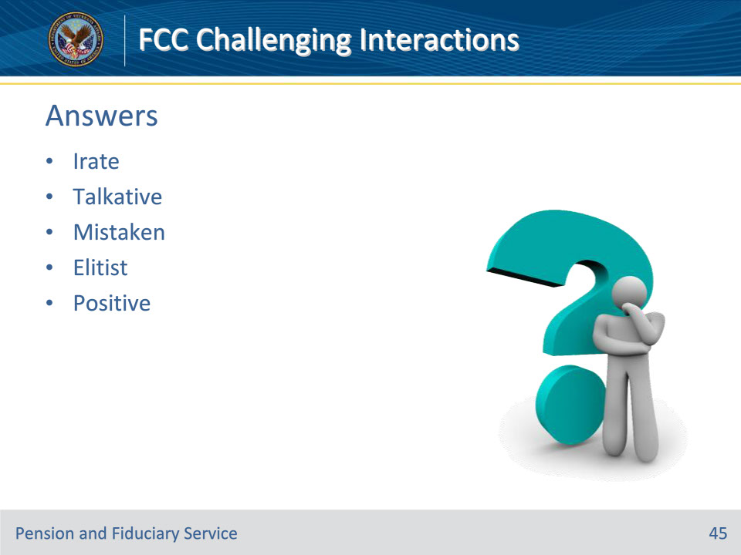

**Slide notes**

Instructor Notes

Answers:

• The irate caller

• The talkative caller

• The mistaken caller

• The elitist caller

• The positive caller

**Slide 46 - Grieving Callers**

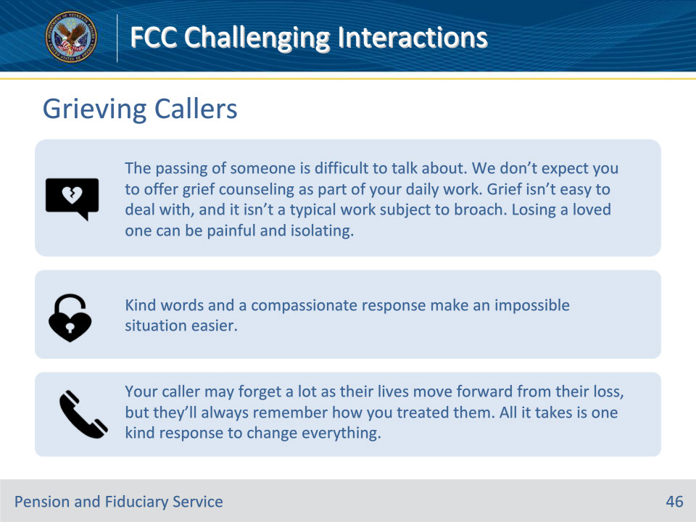

**Slide notes**

Instructor Notes

Grieving Callers

• The passing of someone is difficult to talk about. We don’t expect you to offer grief counseling as part of your daily work. Grief isn’t easy to deal with, and it isn’t a typical work subject to broach. Losing a loved one can be painful and isolating.

• Kind words and a compassionate response make an impossible situation easier. If you want to say something to a client or a customer, make sure that you avoid stating these common phrases:

1. “Your loved one died doing what they love.” Saying this belittles the feelings of the individual grieving. This statement projects the thought of making their grief logical rather than emotional.

2. “I know how you feel.” Never pretend to know how the other person feels. Everyone grieves differently. If you’ve lost a loved one. Take note that every relationship is unique. Every grieving person, therefore, is unique. Although you may not have gone through the same tough circumstances that your customer is facing, you may still empathize with them. Do your best to place yourself in the shoes of your customer.

• Your caller may forget a lot as their lives move forward from their loss, but they’ll always remember how you treated them. All it takes is one kind response to change everything. Remember to be kind and supportive towards the caller who is going through a loss.

**Slide 47 - Grieving Caller Tips**

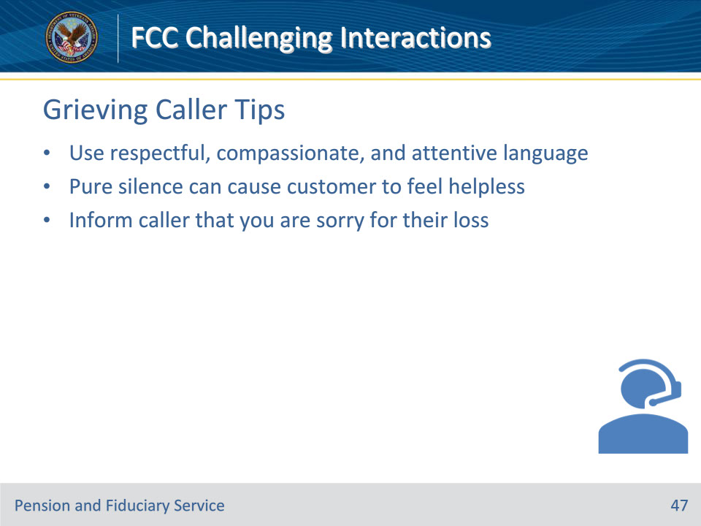

**Slide notes**

Instructor Notes

When speaking with someone who has experienced a loss, it is essential to use respectful, compassionate, and attentive language to show that you understand and empathize with their situation. It can be difficult for the customer to express their emotions, and pure silence on the agent’s part may cause them to feel even more helpless. Therefore, agents are encouraged to respond to the caller with a compassionate message, letting them know that they are sorry for their loss. This simple action can go a long way in providing comfort and support during a difficult time.

**Slide 48 - Call Center Agent Traits**

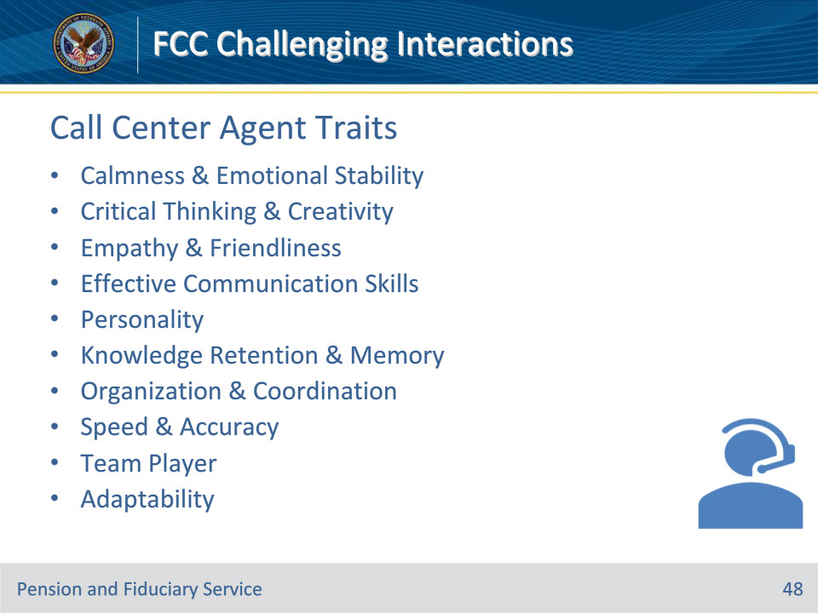

**Slide notes**

Instructor Notes

These traits are essential to the success of any call center operation, and we will be exploring each one in detail to gain a better understanding of their importance.

1. Stay Calm Under Pressure/Emotional Stability

2. Critical Thinking/Creativity

3. Empathy & Friendliness

4. Effective Communication Skills

5. Personality: Attitude/Customer Service/Positivity/Patience

6. Knowledge Retention/Memory

7. Organization/Coordination

8. Speed and Accuracy

9. Team Player

10. Adaptability: Able to see the Picture

**Slide 49 - Calmness & Emotional Stability**

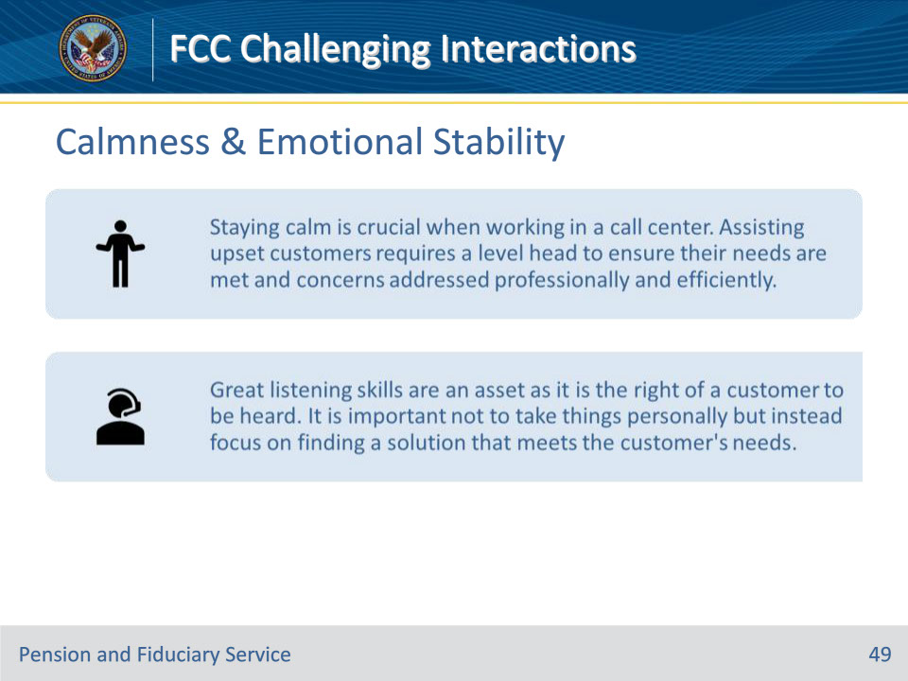

**Slide notes**

Instructor Notes

Calmness & Emotional Stability

• An agent should be able to stay calm under the different pressures they may experience. Staying calm is crucial when working in a call center. Assisting upset customers requires a level head to ensure their needs are met and concerns addressed professionally and efficiently. A calm demeanor builds trust and ensures a positive experience.

• Great listening skills are an asset as it is the right of a customer to be heard. It is important to remain professional during conversations with customers, even when there are difficult situations or complaints. By actively listening and engaging with customers, you can help resolve issues more effectively and build a positive relationship with the customer. It is important not to take things personally but instead focus on finding a solution that meets the customer’s needs. This approach can help to build trust and loyalty with customers over time.

**Slide 50 - Critical Thinking & Creativity**

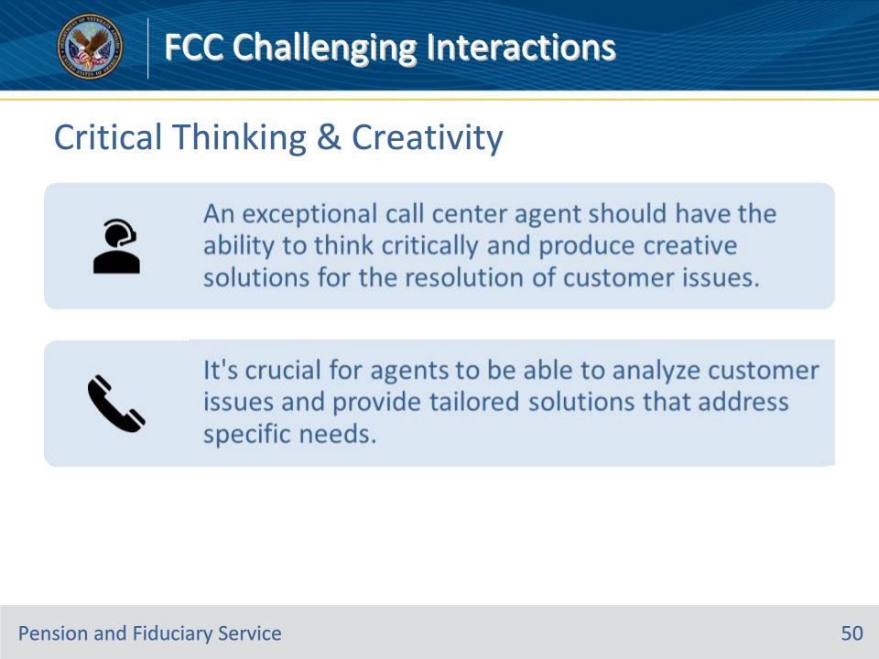

**Slide notes**

Instructor Notes

Critical Thinking & Creativity

• An exceptional call center agent should have the ability to think critically and produce creative solutions for the resolution of customer issues. This requires not only a deep understanding of the services offered, in this case by VA, but also a willingness to listen actively and empathize with the customer’s needs. By taking the time to truly understand the customer’s concerns, an agent can often identify unique solutions that may not be immediately apparent. Additionally, an exceptional agent should be able to communicate clearly and effectively, both verbally and in writing, to ensure that the customer feels heard and their issues are being addressed. Overall, the ability to think creatively and approach each customer interaction as a unique opportunity to provide exceptional service is a hallmark of a truly exceptional call center agent.

• Hence, the second successful call center agent trait is the ability to examine situations and produce solutions that best fit. It’s crucial for agents to be able to think on their feet, analyze customer issues, and provide tailored solutions that address specific needs. Effective call center agents should be able to identify the underlying problem, ask the right questions, and provide clear and concise answers that satisfy customers. By doing so, they can build trust and establish a positive relationship with customers.

**Slide 51 - Empathy & Friendliness**

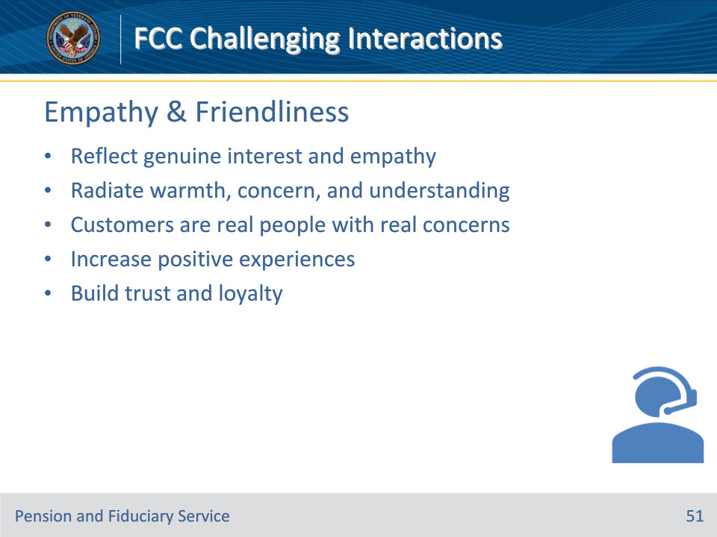

**Slide notes**

Instructor Notes

Empathy & Friendliness

An exceptional customer service agent must reflect genuine interest and empathy when dealing with customers. Customer service agents are the face of the company and hence need to radiate warmth, concern, and understanding of customers and their issues. As a customer service agent, it’s important to always keep in mind that your customers are real people with real concerns. When customers feel like you truly care about their problems and are willing to help in any way possible, they are more likely to have a positive experience. By doing so, you can build trust and loyalty.

**Slide 52 - Personality**

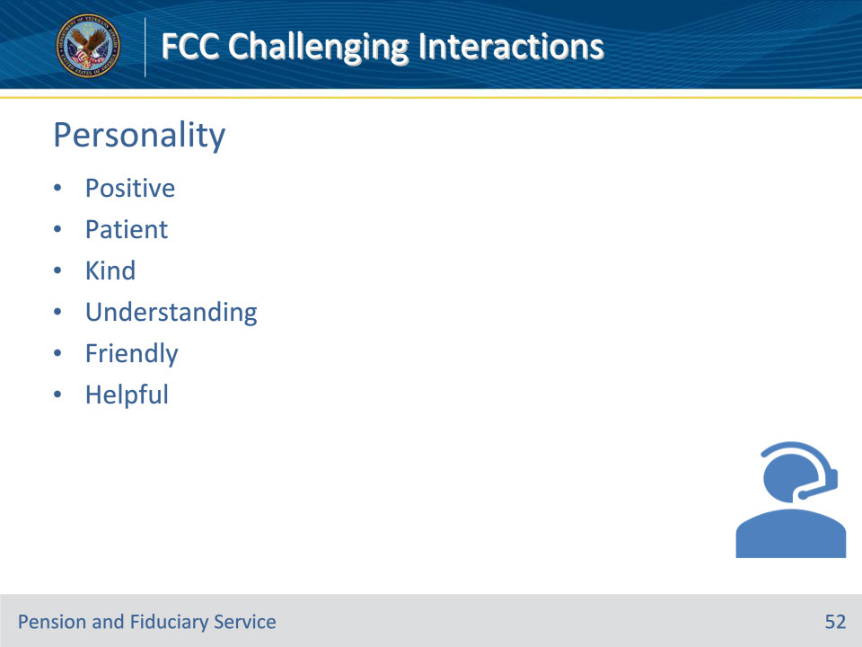

**Slide notes**

Instructor Notes

Personality

A positive attitude helps reassure customers and keep them motivated; a patient attitude helps prevent the escalation of customer hostility and frustration when issues are taking too long to be resolved. Remember to always approach customer interactions with kindness and understanding and strive to provide the best possible service. Having a positive attitude and being patient in customer service can make a huge difference in how customers perceive the organization. When you approach customers with a friendly and helpful demeanor, it can help to diffuse any tension or frustration they may be feeling. Additionally, being patient and taking the time to really understand their concerns can help to build trust and credibility with the customer, in short, a positive attitude and patience can help to provide better service, build stronger relationships with our customers.

**Slide 53 - Knowledge Retention & Memory**

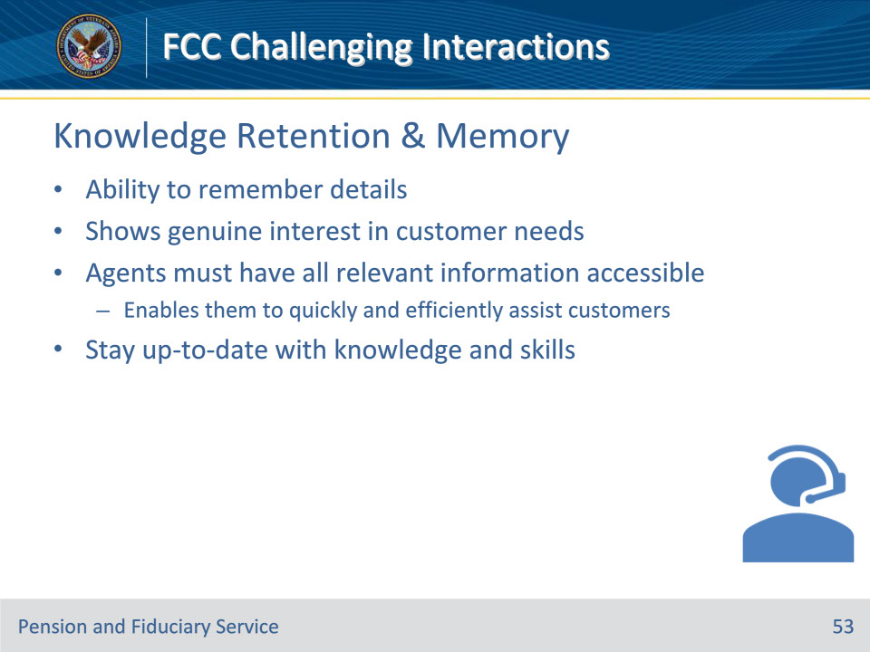

**Slide notes**

Instructor Notes

Knowledge Retention & Memory

• In customer service, having the ability to remember details is crucial. It shows that you are genuinely invested in the customer’s needs and are willing to go above and beyond to ensure their satisfaction. Taking note of details can make all the difference in creating a positive experience for the customer. So, always strive to remember the little things and show your customers that they are valued and appreciated.

• Being a call center agent can be challenging due to the high volume of customers that must be assisted daily. It requires excellent communication and customer service skills to ensure that each interaction is productive and satisfactory for both parties. The agent must also be able to multitask and prioritize tasks to meet the needs of all customers efficiently. Despite the challenges, a call center agent can find fulfillment in assisting and resolving customer issues, improving their day-to-day experiences.

• To provide accurate and effective help, customer support representatives need to have all the relevant information, their practices, services and products, troubleshooting answers, and other information at their fingertips. This will enable them to quickly and efficiently assist customers with their queries and concerns, ensuring a positive customer experience. Ensure you are always up-to-date and equipped with the knowledge and skills necessary to provide top-notch customer service.

**Slide 54 - Organization & Coordination**

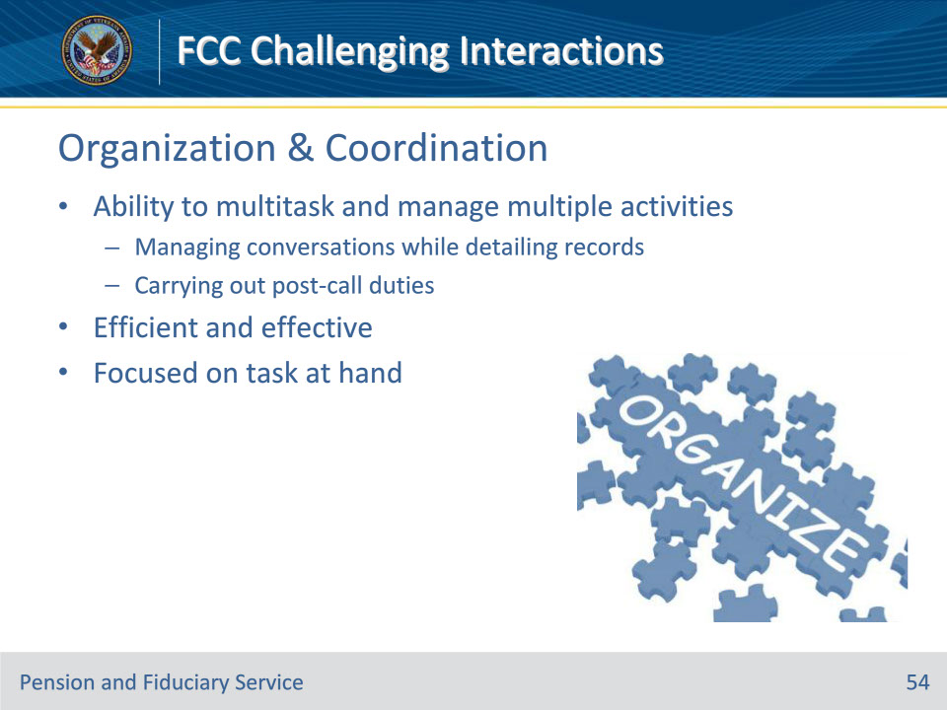

**Slide notes**

Instructor Notes

Organization & Coordination

• An effective call center agent must be organized. This includes the ability to multitask and to manage multiple activities like managing conversations while detailing records and carrying out post-call duties. It’s important to stay on top of everything to ensure that nothing falls through the cracks. Being able to juggle multiple tasks at once is a valuable skill that can make all the difference in providing excellent customer service. It’s all about being efficient and effective and staying focused on the task at hand.

**Slide 55 - Speed & Accuracy**

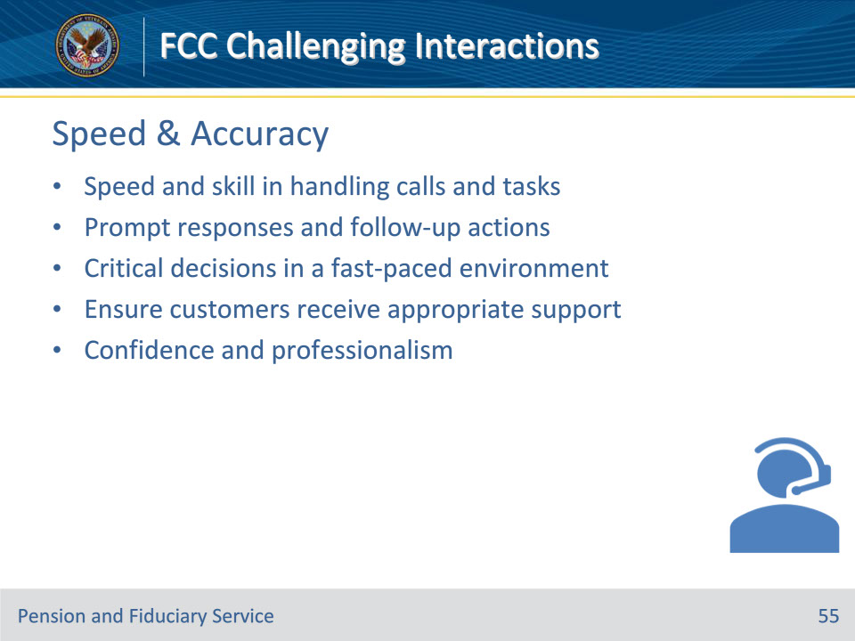

**Slide notes**

Instructor Notes

Speed & Accuracy

• A successful contact center agent must demonstrate speed and skill in handling calls and other tasks. They should be able to provide prompt responses and follow-up actions to ensure that customers are satisfied with the service they receive. Additionally, a great contact center agent should have the ability to make critical decisions in a fast-paced environment. They must know when to escalate an issue to ensure customers receive appropriate support. Overall, a quality contact center agent is someone who can handle any situation with confidence and professionalism.

**Slide 56 - Team Player**

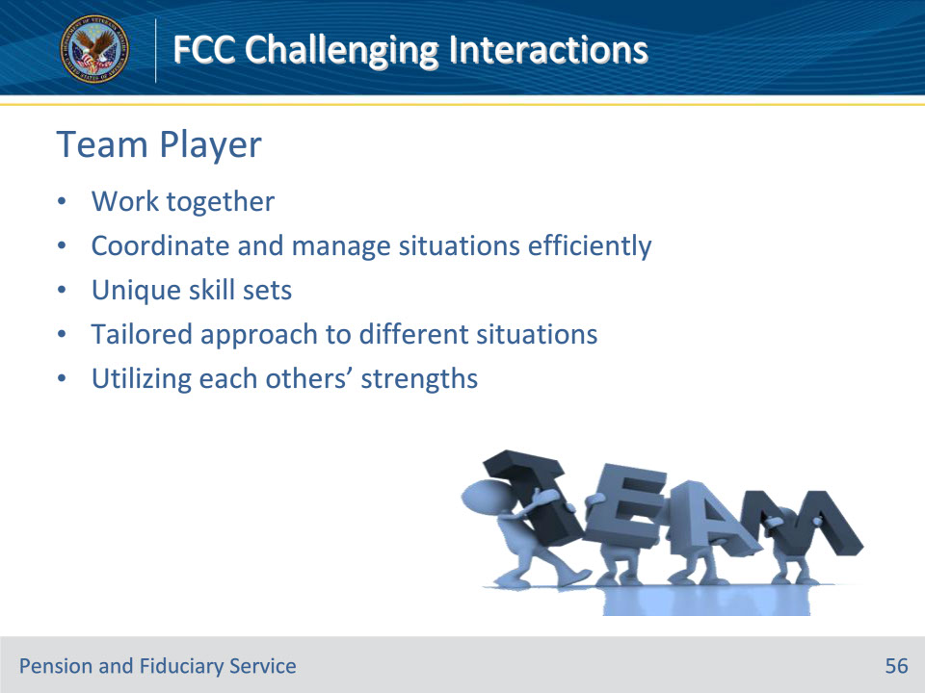

**Slide notes**

Instructor Notes

Team Player

• A team player attitude is critical to ensure smooth coordination of management of customer issues. Different members with different skill sets are best suited to certain situations. It’s important to have a team player attitude when dealing with customer issues. This ensures that everyone is working together to coordinate and manage the situation in the most efficient way possible. Each team member brings unique skill sets to the table, allowing for a more tailored approach to different situations. By working as a team and utilizing each other’s strengths, customer issues can be resolved quickly and effectively.

**Slide 57 - Image & Reputation**

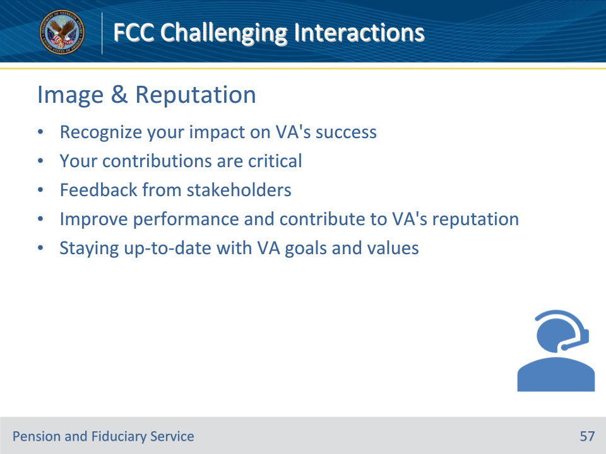

**Slide notes**

Instructor Notes

Image & Reputation

• As a contact center agent, you should always strive to understand how your role fits into the VA’s image and reputation. Recognizing your impact on the VA’s success will drive you to do your best and provide exceptional customer service. Every employee must see how their contributions are critical to the VA’s success. One way to understand your role’s impact is to receive feedback from stakeholders. This feedback can help you improve your performance and contribute to the VA’s reputation. Additionally, staying up-to-date with the VA’s goals and values can also help you align your actions with the VA’s image. Remember, your role is essential to the success of the VA, and by providing excellent customer service, you contribute to a positive reputation.

**Slide 58 - Questions?**

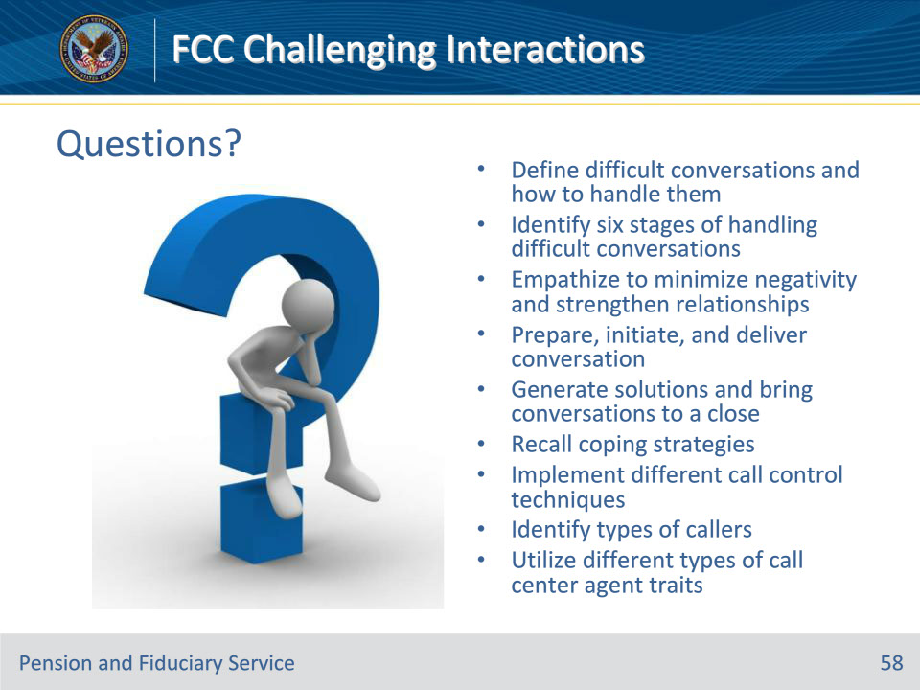

**Slide notes**

Instructor Notes:

(Recall) These are our learning objectives as stated from the beginning of the training:

• Define difficult conversations and how to handle them

• Identify six stages of handling difficult conversations

• Empathize to minimize negativity and strengthen relationships

• Prepare, initiate, and deliver conversation

• Generate solutions and bring conversations to a close

• Recall coping strategies

• Implement different call control techniques

• Identify types of callers

• Utilize different types of call center agent traits

Are there any additional questions?

Questions should be filtered through your QRT team. They will submit your questions to the Field Inquiry Tool (FIT) on your behalf.

**Slide 59 - TMS Survey/Assessment**

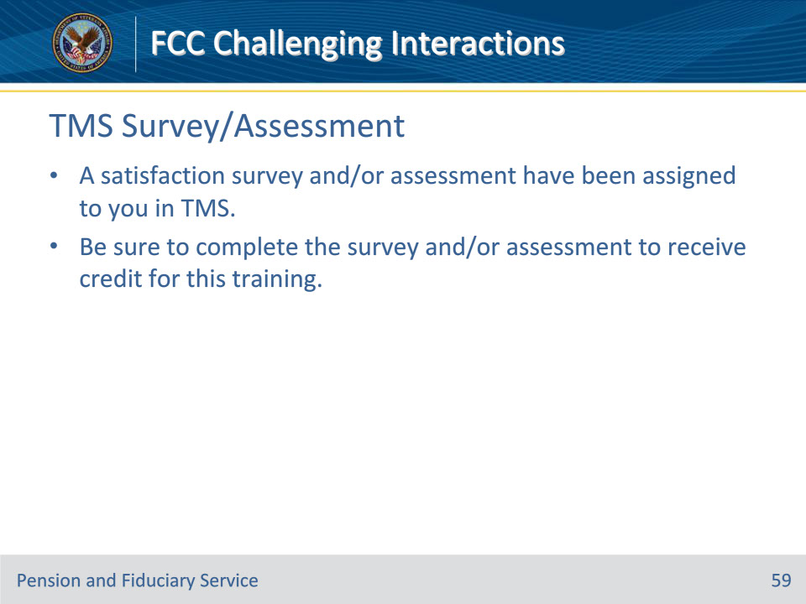

**Slide notes**

Instructor Notes

A satisfaction survey and/or assessment have been assigned to you in TMS.

Be sure to complete the survey and/or assessment to receive credit for this training.