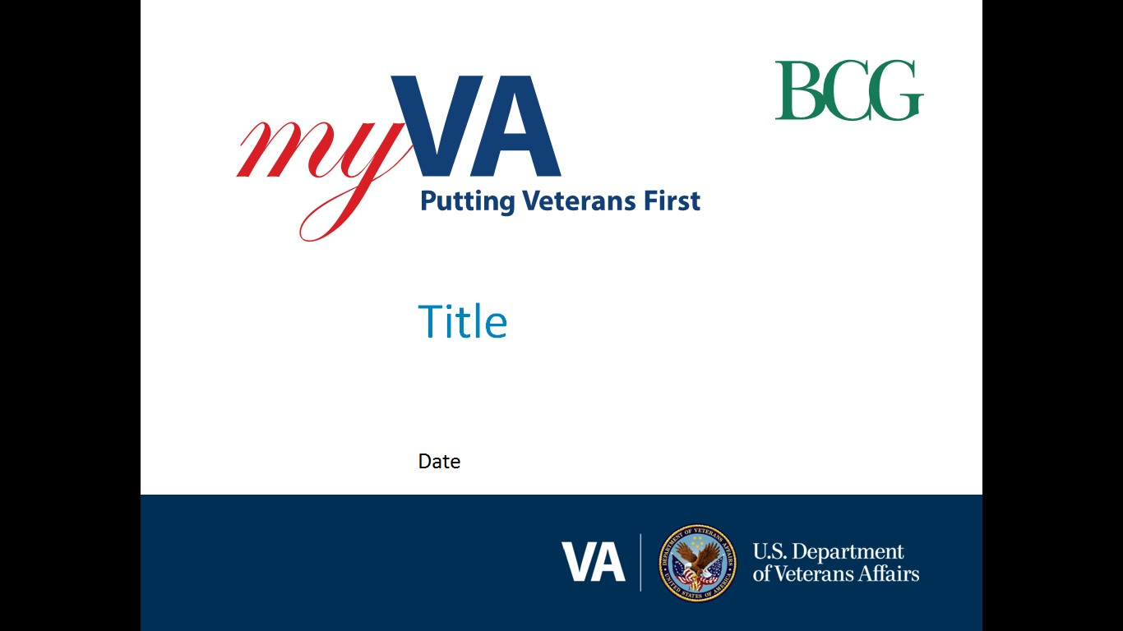

**Pension and Fiduciary (P&F) Service**

|  |  |
| --- | --- |
| Fiduciary Quality Call | June 22, 2023TMS: # VA 4645451 |

|  |  |
| --- | --- |
| AGENDA TOPICS ITEM 1: FIDUCIARY STAR QUARTERLY ANALYSIS  ITEM 2: QMS REMINDERS  ITEM 3: SFR FINDINGS  ITEM 4: ACCESSING TRAINING REQUIREMENTS IN THE M21-3  ITEM 5: INTERACTIVE DISCUSSION  QUESTIONS AND ANSWERS (Q&A)  CLOSING, QUESTIONS, NEXT QUALITY CALL |  |

# AGENDA ITEMS

|  |  |  |  |
| --- | --- | --- | --- |
| Agenda item: | FIDUCIARY STAR QUARTERLY ANALYSIS | Presenter: | ALVIN HILL, ANALYST |

#### Target Audience:

#### 

#### Quality Review Team (QRT) Program Specialists and Coaches/Assistant Coaches

#### Discussion:

There was a slight decrease from 95.14 percent to 94.58 percent in national fiduciary accuracy but it remains at the Outstanding level.

|  |  |  |
| --- | --- | --- |
|  | **April 2023**  **Rolling Accuracy** | **May 2023**  **Rolling Accuracy** |
| National Fiduciary Accuracy | 95.14% | 94.58% |

**Field Examination**

Field examination accuracy continues to demonstrate proficiency with completing field examinations. The field examination errors cited during the review period are as follows:

|  |  |  |
| --- | --- | --- |
| **Error Title** | **Error Description** | **Instances** |
| NFFEQR9b (Critical) | The dependents needs were not addressed in the field examination. | 1 |
| NFFEQR17c | The Hub did not establish all appropriate diary dates. | 1 |
| NFFEQR17d | The Hub did not establish proper future oversight. | 1 |
| NFFEQR17e | All documentation was not complete and uploaded to the eFolder. | 2 |

**Accounting**

The most common critical errors cited during the review period resulted from excessive and/or unauthorized fees not reimbursed to the beneficiary prior to accounting approval, missing accounting forms and financial statements, and the accounting being approved with outstanding corrections due by the fiduciary. The following chart outlines the number of instances for each accounting error:

|  |  |  |
| --- | --- | --- |
| **Error Title** | **Error Description** | **Instances** |
| NFAQR2b (Critical) | All known financial accounts and funds under management were not verified. | 1 |
| NFAQR3c | The Hub did not notify all the next of kin (NOK) with the fiduciary’s contact information. | 1 |
| NFAQR3d | The Hub did not remove the requirement to provide the beneficiary a copy of the accounting approval notification letter. | 1 |
| NFAQR4b | The accounting starting balance is not correct. | 2 |
| NFAQR4c | Unusual or inappropriate expenses were not appropriately clarified and or documented in the notes section in the accounting audit tool. | 5 |
| NFAQR8a (Critical) | The excessive and/or unauthorized fees were not reimbursed to the beneficiary’s funds under management prior to accounting approval. | 2 |
| NFAQR9a (Critical) | The fiduciary did not meet all appropriate financial account requirements. | 1 |
| NFAQR11b (Critical) | The Bond section in the Accounting Audit Tool was not completed to indicate verification of a new or an existing surety bond. | 1 |
| NFAQR13a (Critical) | The accounting was approved without receipt of a complete VA Form 21P-4706b, 21P-4706c and/or financial statements for the entire accounting period. | 3 |
| NFAQR13b (Critical) | A credit report has not been obtained and reviewed, if applicable. | 1 |
| NFAQR13d (Critical) | The financial accounts are not properly titled. | 1 |
| NFAQR13e (Critical) | The accounting was approved with outstanding corrections due by the fiduciary. | 2 |
| NFAQR14b | A detailed explanation of any resolved discrepancies was not noted in the NOTES section of the Accounting Audit Tool prior to approval. | 3 |
| NFAQR20c (Critical) | The Hub did not make telephone contact with the fiduciary when the FUR was past due. | 1 |
| NFAQR21c (Critical) | The Hub did not follow the guidance to request additional or corrected FUR information. | 1 |
| NFAQR22a | Required tasks were not established and/or updated. | 6 |
| NFAQR22b | Required documents were not upload to the VBMS eFolder. | 4 |
| NFAQR22c | The beneficiary and/or fiduciary profile was not properly updated. | 6 |
| NFAQR22d | The accounting/fund usage review diary dates were not properly updated in and/or removed from the beneficiary profile. | 9 |
| NFAQR22e | The notification letter was not sent and/or did not include all notification letter requirements. | 5 |
| NFAQR22g | The Accounting Audit Tool was not updated to reflect the accounting approval. | 1 |

**Note:** Prior analysis indicated that low accounting quality was found in both Fund Usage Review (FUR) and Accounting reviews. However, FUR quality has shown significant improvements this review period.

| References/Contacts |  |  |
| --- | --- | --- |
| FPM [I.2. Field Examinations](https://vaww.vrm.km.va.gov/system/templates/selfservice/va_kanew/help/agent/locale/en-US/portal/554400000001030/topic/554400000018933/Chapter-2-Field-Examinations)  FPM [I.3. Accounting](https://vaww.vrm.km.va.gov/system/templates/selfservice/va_kanew/help/agent/locale/en-US/portal/554400000001030/topic/554400000018934/Chapter-3-Accounting)  FPM [I.6. Fund Usage Oversight](https://vaww.vrm.km.va.gov/system/templates/selfservice/va_kanew/help/agent/locale/en-US/portal/554400000001030/topic/554400000023676/Chapter-6-Fund-Usage-Oversight)  Quality Management System |  |  |

|  |  |  |  |
| --- | --- | --- | --- |
| Agenda item: | QMS REMINDERS | Presenter: | ALVIN HILL, ANALYST |

#### Target Audience:

#### Quality Review Team (QRT) Program Specialists and Coaches/Assistant Coaches

#### Discussion:

**Reminder #1**: The Quality Management System (QMS) team has received several inquiries regarding instances in which fiduciary coaches are unable to pull quality reviews. To ensure coaches have the ability to pull/conduct quality reviews, specific fields in the QMS contact record must be populated correctly. The [Quality Management System (QMS) QRT Supervisor Guide](https://va.my.salesforce.com/sfc/p/t00000004X38/a/t00000025VTx/COBAo1gIIYgV.2zuATPnf0OIVzUbq7kCT42VMgHs39g) provides information for Contact Record Updates starting on page 12.

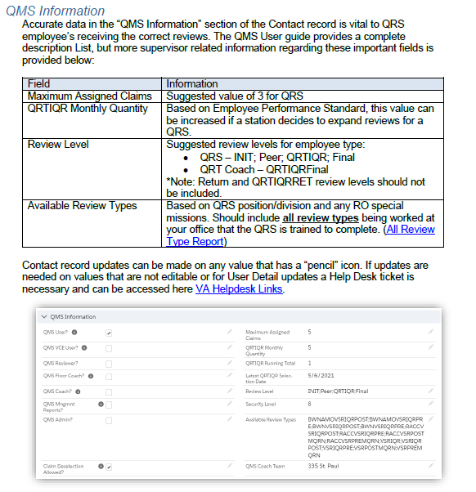

**Reminder #2**: QMS incorrectly identifying all criminal background transactions as “Criminal Background Check Mitigation Evidence.”

Each claim-based transaction correlates to an action that has been taken in VBA systems and all claim-based transactions are the result of one specific completed action. However, Performance Analysis and Integrity (PA&I) has found that “Criminal Background Investigation” and “Criminal Background Check Mitigation Evidence” are collapsed into a single transaction that appears in QMS as “Criminal Background Check Mitigation Evidence.” P&F Service realizes this creates confusion in the quality review process and is actively working with PA&I to separate the two transactions in QMS. Until the transactions are separated, the “Criminal Background Check Mitigation Evidence” transaction should not be deselected and the VBMS eFolder should be reviewed to determine what type of criminal background transaction should be reviewed. Once the two transactions are separated, QMS will identify the appropriate name of the completed criminal background transaction.

**Reminder #3**: Trainee transactions were incorrectly included in the Individual Quality Reviews (IQR) monthly sample.

P&F Service discovered that trainee actions were incorrectly included in the QMS review samples pulled each month for IQRs. This was corrected and trainee reviews are no longer included with the monthly IQR sample effective June 1, 2023.

| References/Contacts |  |  |
| --- | --- | --- |
| [Quality Management System (QMS) QRT Supervisor Guide](https://va.my.salesforce.com/sfc/p/t00000004X38/a/t00000025VTx/COBAo1gIIYgV.2zuATPnf0OIVzUbq7kCT42VMgHs39g) |  |  |

|  |  |  |  |
| --- | --- | --- | --- |
| Agenda item: | SFR FINDINGS | Presenter: | GLENDA RUSSELL, ANALYST &  SANDY LUNDQUIST, ANALYST |

#### Target Audience:

#### Quality Review Team (QRT) Program Specialists and Coaches/Assistant Coaches

#### Discussion:

Hub Individual Quality Review (IQR) Deselections

P&F Service completed a Special Focused Reviews (SFR) of hub IQR deselections. No deficiencies were found with the reviewed deselection decisions. However, the field was not compliant with noting the reason for the deselection, as required by QMS User Guide.

The largest categories for deselections were Transactions Not Reviewed (63%) and Employee In Training (30%). Since a number of training deselected cases had errors, which did not affect the accuracy findings of this SFR, it may be indicative of an issue with the hub trainee review process or the mentor training process. Please review your trainee work review processes to ensure it is properly reviewed before release.

P&F Service will also provide a comprehensive list of transactions that are excluded from IQRs.

Loan Guaranty (LGY) Fiduciary Notifications

P&F Service also completed an SFR of LGY fiduciary notifications.

When hubs receive notification that a beneficiary in the fiduciary program defaults on a home loan or becomes delinquent over several months, hubs must immediately establish a Fund Usage Follow Up Field Examination EP. The field examination must assess and document current VA FUM, use of VA funds to determine if misuse allegation is warranted, fiduciary relationship with the beneficiary, and reason for the past due VA backed mortgage. Per FPM I.2.D.4.l., the hub must provide a copy of the field examination report electronically to the RLC following completion.

From August 2022 to January 2023, a total of 56 cases were found where LGY informed the hub of a VA backed loan being in default. The following table provides a summary of findings:

|  |  |  |  |  |  |
| --- | --- | --- | --- | --- | --- |
| Number Reviewed | Number of Completed Exams | Number Correct | Number with Missing Elements | Number of Missing Reports to RLC | Number with No Actions Taken |
| 56 | 46 | 5 | 30 | 33 | 10 |

In addition, P&F Service reviewed the case file to ensure all pertinent information was reflected in the Fund Usage Field Examination Report, with the following summary of findings:

|  |  |  |  |  |
| --- | --- | --- | --- | --- |
| Number Reviewed | Number of Cases with No Errors | Number of Cases with No VA FUM Documented | Number of Cases with No Bene/Fid Relationship Documented | Number of Cases where Reason for Delinquency is not Documented |
| 46 | 16 | 29 | 8 | 7 |

The SFR found that hubs only had a compliance/accuracy rate of 10.8 percent. Due to the low compliance and accuracy rate, a follow-up SFR will be completed next year on this subject.

| References/Contacts |  |  |
| --- | --- | --- |
| [FPM, I.2.D.4.j. – Evaluating the Management of VA Funds When the VA Home Loan is in Default or Extended Delinquency](https://vaww.vrm.km.va.gov/system/templates/selfservice/va_kanew/help/agent/locale/en-US/portal/554400000001030/content/554400000153952/FPM-Part-I-Chapter-2-Section-D-Follow-Up-Field-Examinations#4j)  [FPM, I.2.D.4.l, - Notification of Field Examination Completion](https://vaww.vrm.km.va.gov/system/templates/selfservice/va_kanew/help/agent/locale/en-US/portal/554400000001030/content/554400000153952/FPM-Part-I-Chapter-2-Section-D-Follow-Up-Field-Examinations#4l)  Quality Management System User GuideM21-4, 8.12 - IQRs |  |  |

|  |  |  |  |
| --- | --- | --- | --- |
| Agenda item: | ACCESSING TRAINING REQUIREMENTS IN THE M21-3 | Presenter: | HECTOR MATTOS, TRAINING ANALYST |

#### Target Audience:

#### Quality Review Team (QRT) Program Specialists and Coaches/Assistant Coaches

#### Discussion:

In collaboration with Human Capital Services, P&F Service updated and deployed TMS Curriculum IDs utilized to assign FOCUS/Centralized Training for newly hired fiduciary hub employees. These updates facilitate the maintenance of centralized curricula, expedite updates to the curricula, and provide notification to the field soon after any curricula updates. In addition, these updates allow Training Managers to directly assign courses to new employees within a centralized curriculum managed by TMS. In turn, P&F Service will be able to reduce the amount of manual change requests, monitor compliance, and verify that required training is being provided per M21-3 requirements.

The Curriculum IDs and items contained in them are listed in the Learning Catalog within the [**VBA Learning Catalog Homepage > Useful Links > Fiduciary Service FY23 Mandated Courses Released.**](https://view.officeapps.live.com/op/view.aspx?src=https%3A%2F%2Fvba-media1.vbatraining.org%2FVBA_Learning_Catalog%2FFiduciary%2FFiduciary_FY23_NTC.xlsx&wdOrigin=BROWSELINK)

* Required TMS items listed within the centralized curricula are updated in the VBA Learning Catalog workbook each Friday (excluding holidays).
* Relevant updates to the M21-3 linking the Centralized Training workbook displayed in the Learning Catalog were published June 9, 2023.

|  |  |  |  |
| --- | --- | --- | --- |
| Agenda item: | INTERACTIVE DISCUSSION | Presenter: | NICOLE WEATHERALL, ANALYST |

#### Target Audience:

#### Quality Review Team (QRT) Program Specialists and Coaches/Assistant Coaches

#### Discussion:

Best practices for reviewing accounting EPs were discussed. This includes federal accountings and fund usage reviews. FPM 1.3.C.4.c mandates that a fiduciary fee cannot exceed 4 percent. A best practice is to notify the fiduciary, upon appointment, that they are not allowed more than 4 percent. The next best practice is when reviewing bank statements and the fiduciary sends additional statements to note in the notification letter that the additional statements were received and reviewed.

| References/Contacts |  |  |
| --- | --- | --- |
| * FPM, Part I, Chapter 3 Section A-E |  |  |

***Q&A***

**Original Question 1**: Is the LIE required to request the fiduciary to obtain documentation from the Social Security Administration about social security fees or can the accounting be approved/disapproved without such documentation?

**Original P&F Service Response**: Generally, the LIE is not required to request documentation from the fiduciary about social security fees before an accounting can be approved or disapproved. Fees for services in connection with SSA funds is, in and of itself, not a questionable expense as outlined in FPM, Part I, 3.C.3.e. Documentation to support the authorization of this fee is not necessary unless there is reason to question the expense, such as when the expense is not consistently recurring or there are discrepancies in the information provided.

Validating expenses is done through use of financial institution documents as outlined in FPM, Part I, 3.C.3.h. If questionable, the LIE must contact the fiduciary, financial institutions, family members, and/or the beneficiary for additional information or obtain additional evidence to justify the expense per FPM, Part I, 3.C.3.f. This may or may not result in requesting documentation about the fees from SSA through the fiduciary, depending on the situation. It is important to note that fees in connection with services as a representative for SSA funds is not a valid expense of VA benefit funds. If a VA appointed fiduciary is also managing SSA funds for the same beneficiary but the SSA funds are being deducted exclusively from the VA benefit funds, the expense is to be denied without the need for any clarification or documentation.

**Updated P&F Service Response:** It was not P&F Service’s intent to stipulate that VA and Social Security Administration (SSA) funds must be maintained in separate accounts in order for the fiduciary to deduct an SSA fee. VA will not prescribe which income source(s) must be used to pay the beneficiary’s expenses. However, all income handled by a beneficiary’s fiduciary is expected to be used for the care and maintenance of the beneficiary and any dependents, in accordance with [FPM, Part II, 2.A.1.c](https://vaww.vrm.km.va.gov/system/templates/selfservice/va_kanew/help/agent/locale/en-US/portal/554400000001030/content/554400000153968/FPM-Part-II-Chapter-2-Section-A-Accounts-and-Investments).

When reviewing financial documentation, the fiduciary hub (hub) must determine whether expenses deducted from the beneficiary account(s) are appropriate in accordance with [FPM, Part I, 3.C.3](https://vaww.vrm.km.va.gov/system/templates/selfservice/va_kanew/help/agent/locale/en-US/portal/554400000001030/content/554400000153957/FPM-Part-I-Chapter-3-Section-C-Audits), to include a review of any deducted fees. If it is clear that a VA-appointed fiduciary is deducting the SSA fee exclusively from the VA benefit funds (i.e., the fiduciary maintains separate accounts for each benefit), the hub employee must review the SSA account to ensure that a duplicate or additional fee is not being deducted from that account. The same review should be applied for a VA fee being exclusively deducted from an SSA rep payee account, etc. If there is any question as to whether the fees are appropriate, the hub must follow the guidance in [FPM, Part I, 3.C.3.f](https://vaww.vrm.km.va.gov/system/templates/selfservice/va_kanew/help/agent/locale/en-US/portal/554400000001030/content/554400000153957/FPM-Part-I-Chapter-3-Section-C-Audits#3f).

With regard to the authorization of a VA fiduciary fee, per [38 U.S.C. 5502(a)(2)](https://www.law.cornell.edu/uscode/text/38/5502), a commission may not be authorized for a fiduciary who receives any other form of remuneration or payment in connection with rendering fiduciary services for benefits under Title 38. Because SSA benefits are not benefits received under Title 38, the hub may authorize a VA fiduciary fee when appropriate, even when the fiduciary is receiving a fee for managing SSA benefits.

P&F Service is currently reviewing the FPM to determine how the procedures for fee review and authorization can be improved. If a manual change is implemented, the field will be notified via the Compensation Service Calendar email blast. To subscribe to this email blast, visit the [Calendar Subscriptions](http://vbacoweb03.dva.va.gov/bl/21/Calendar/cal_Subscribe.asp) website.

# Post-Call Follow Up

**Quality Call Recording and Bulletins:**

A recording and bulletin for the June 2023 Fiduciary Quality Call, will be available once finalized.

**TMS Course:**

Available content from the Quality Call (bulletin, recording, etc.) will be available in TMS. The TMS # for the June 2023 Pension and Fiduciary Quality Call is VA 4645451 (Pension and Fiduciary Service Quality Call – Fiduciary June 2023).

#### P&F Quality Mailbox:

We will solicit for agenda topic(s) for each future Quality Call. If you have a specific topic suggestion, please feel free to email it to the Pension and Fiduciary (P&F) Quality mailbox at [PFTNGQUALOVRST.VBACO@va.gov](mailto:PFTNGQUALOVRST.VBACO@va.gov)

#### For specific policy and procedures related topics, please send inquiries through the [P&F Service Field Inquiry Tool (FIT](https://gcc02.safelinks.protection.outlook.com/?url=https%3A%2F%2Fapps.gov.powerapps.us%2Fplay%2Fe%2Fdefault-e95f1b23-abaf-45ee-821d-b7ab251ab3bf%2Fa%2F0a333bae-1e5d-446f-b2d1-c25be963c99d%3FtenantId%3De95f1b23-abaf-45ee-821d-b7ab251ab3bf%26source%3Dportal&data=05%7C01%7C%7C7e57527ccb104c4cf7e908daee8a90c7%7Ce95f1b23abaf45ee821db7ab251ab3bf%7C0%7C0%7C638084576146818115%7CUnknown%7CTWFpbGZsb3d8eyJWIjoiMC4wLjAwMDAiLCJQIjoiV2luMzIiLCJBTiI6Ik1haWwiLCJXVCI6Mn0%3D%7C3000%7C%7C%7C&sdata=QmlXA%2BnoE6ops2TJVkdEaKfE2nNzs23U4R2EoE%2BHLHI%3D&reserved=0)).

#### The next Quality Call is tentatively scheduled for August 2023.