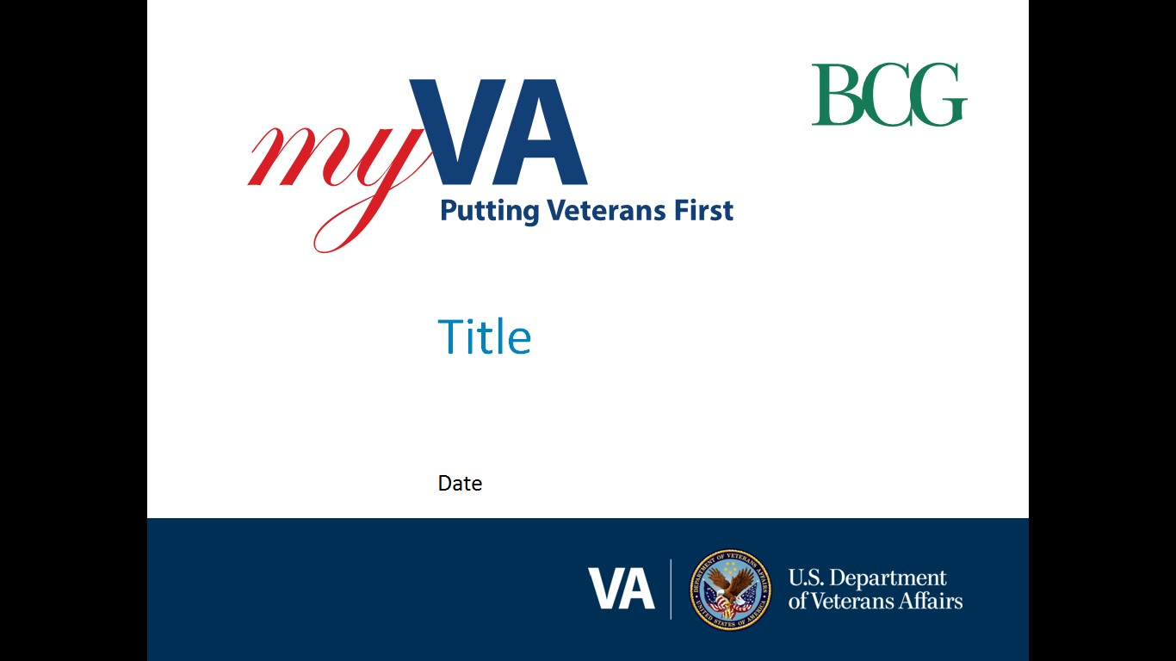

**Pension and Fiduciary (P&F) Service**

|  |  |
| --- | --- |
| Fiduciary Quality Call | Date: April 27, 2023TMS: # VA 4643266 |

|  |  |
| --- | --- |
| AGENDA TOPICS ITEM 1: FIDUCIARY QUALITY ERROR TREND ANALYSIS  ITEM 2: FIDUCIARY QUALITY ERROR TREND – CASE STUDY  ITEM 3: INTERACTIVE DISCUSSION ON PROMULGATION  CLOSING, QUESTIONS, NEXT QUALITY CALL |  |

# AGENDA ITEMS

|  |  |  |  |
| --- | --- | --- | --- |
| Agenda item: | Fiduciary Quality Error Trend Analysis | Presenter: | Alvin Hill, Analyst |

#### Target Audience:

#### Quality Review Team (QRT) Program Specialists and Coaches/Assistant Coaches

#### Discussion: The quality errors identified amongst the fiduciary hubs were discussed by the analyst.

The February 2023 and March 2023 STAR reviews resulted in 56 errors. Overall, there were 13 critical errors found in 12 unique cases that impact individual hub and overall national quality. The remaining 43 errors are non-critical and do not impact national quality. Although the non-critical errors do not impact quality, the errors do provide relevant insight into quality error trends of fiduciary actions.

**Field Examinations**

There was a total of nine field examination errors cited on eight unique cases with one critical error impacting national fiduciary quality. Overall, field examination accuracy continues to demonstrate national fiduciary hub proficiency with completing field examinations.

**Accounting/Fund Usage Review**

There were nine critical accounting error types found during the review period with three of the nine being equally cited as the most often errors, NFAQR13a, NFAQR13b and NFAQR21c.

The most common critical errors cited during the review period, resulted from missing accounting forms, financial statements, credit reports and the hub not requesting additional or corrected fund usage review information.

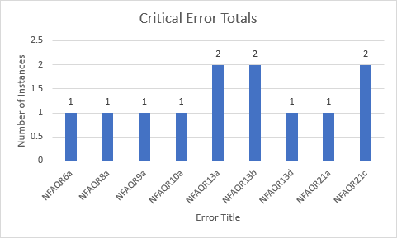

# The most common non-critical error cited during the review period, NFAQR22b, was found in eight case reviews. This error is the result of not uploading required documentation to the VBMS eFolder.

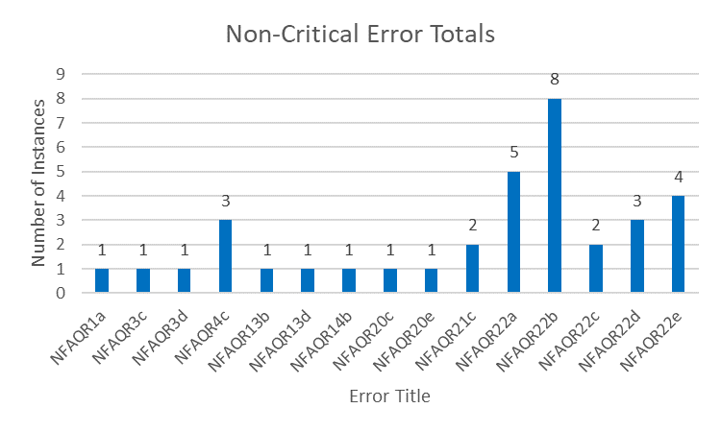

| References/Contacts |  |  |
| --- | --- | --- |
| * FPM Part 1 Chapter 3 |  | |
| * FPM Part 1 Chapter 6 |  | |

|  |  |  |  |
| --- | --- | --- | --- |
| Agenda item: | Fiduciary Quality Error Trend – Case Study | Presenter: | Nicole Weatherall, Analyst |

#### Target Audience:

#### Quality Review Team (QRT) Program Specialists and Coaches/Assistant Coaches

#### Below is the case study presented on the call along with the Fiduciary Hub questions and P&F Service responses provided during the call.

**Fund Usage Review (FUR) CASE STUDY**

**Accounting Checklist 21c – Critical error**

**Error Description:** The Hub did not follow the guidance to request additional or corrected FUR information.

**Error Narrative:** The fund usage due letter was dated 07/25/2022 and the fiduciary submitted bank statements from 03/11/2022-06/12/2022. Per FPM 1.6.B.2.b, (formerly FPM II.1.C.4.p) the dates do not need to be the period exactly preceding the date of that letter if they cover a consecutive three-month period that ends no earlier than one month prior to the date of the Fund Usage Due Letter. The hub must request the fiduciary submit the bank statements through at least 06/25/2022.

**Timeline of Events**

* 07/25/2022 – FUR Due Letter (Incorrect due date of 07/20/2022 listed; instead, 08/24/2022 should have been used)
* 08/31/2022 – FUR Past Due Call
* 09/01/2022 – FUR Past Due Letter (Cascading error, due to incorrect initial due date of 07/20/2022 used Additionally, the hub incorrectly requested financial statements for the three-month period prior to 07/20/2022 when it should have been 07/25/2022)
* 09/06/2022 – Financial statements received for 03/11/2022-06/12/2022
* 09/22/2022 – FUR Complete Letter
* 11/01/2022 – FUR Additional Evidence Letter (after STAR error notification)
* 11/23/2022 – Financial statements received for 06/13/2022-10/10/2022) after STAR error notification)

| References/Contacts |
| --- |
| * FPM Part 1. Chapter 6 |

**Question 1:** There is not a good reference in the manual concerning the dates covered for the letter, whether it should cover the dates on the bank statements or the required period. Will the manual be updated to reflect this anytime soon?

**P&F Service Response:** Whether it is in the manual or not, we want to give the correct information to the fiduciary. If they reviewed six months’ worth of statements, then they need to record those six months on the letters to the fiduciary showing that this is the information received and reviewed. Always include what you received and reviewed.

**P&P Response**: At minimum, the *Fund Usage Review Complete* Letter must notify the fiduciary that the fiduciary hub (hub) has accepted and completed the review of their management of VA benefit funds for the prescribed fund usage review period shown on the *Fund Usage Due Letter*.

As a best practice, the hub should notify the fiduciary of the full date range(s) of all documents that the fiduciary submitted in response to the most recent *Fund Usage Due Letter*, which includes the date range of the documents submitted outside of the fund usage review period.  Notifying the fiduciary of the full date range(s) of fund usage review documents supports effective communication between VA and the fiduciary.

**Question 2:** If we receive the bank statements outside of the window that we are reviewing, we are not doing a full review but just reviewing them for red flag indicators, is that correct?

**P&F Service Response:** That is correct. FPM 1.6.B.2.a states, “when a fiduciary submits more information than required for the fund usage review period, the hub must review the financial documents for red flag indicators of misuse.” Per the manual, that is all we are reviewing them for. If you have bank statements outside of the time period requested, you are only looking for Misuse Red Flag indicators.

**Question 3:** If we have the bank statements and then receive additional statements that fall within that window of time and there is a $900.00 check on the statement, but we did not get a copy of the check, would we need to have the copy of the $900.00 check before we can close the review successfully?

**P&F Service Response:** If you are reviewing a transaction that falls within the time period you need to get that check before the accounting or, FUR can be approved.

**Question 4:** If you have the bank statements and receive additional months that have transactions listed that on them, we are responsible for gathering the additional information for the additional months before we can complete the review?

**P&F Service Response:** All transactions and bank statements reviewed need to be included in the completion letter. The case review was based on an error cited on a fund usage review where the hub did not receive financial statements for the period up through at least one month prior to the date of the Fund Usage Due Letter dated July 25, 2022. Financial statements received were through June 12, 2022. Per FPM 1.6.B.2.b, financial documents must be received showing transactions at least through June 25, 2022, not just the month of June. FPM 1.6.B.2.b provides an example that clearly indicates the day of the month is just as important as the month itself.

Example: If the Fund Usage Due Letter is dated November 1, 2020, the earliest three-month financial statement transaction period allowable is July 1, 2020, to October 1, 2020. The statement transaction dates may be any consecutive three-month period between July 1, 2020, and December 1, 2020. The due date for submitting these financial statements is December 1, 2020.

|  |  |  |  |
| --- | --- | --- | --- |
| Agenda item: | Interactive Discussion on Promulgation | Presenter: | Glenda Russell, Analyst |

#### Target Audience:

#### Quality Review Team (QRT) Program Specialists and Coaches/Assistant Coaches

#### Discussion:

P&F Service engaged in a discussion with the field regarding their reflections and views on the promulgation reviews seen in their hubs and where oversight can benefit best with these cases.

| References/Contacts |  |  |
| --- | --- | --- |
| * I.1.B.7.a. General FSR Responsibilities | |  |
| * I.1.B.7.b. Competency Determinations | |  |
| * I.1.B.7.c. Fiduciary Appointment Responsibilities | |  |
| * I.1.B.7.d. Award Action Responsibilities | |  |
|  | |  |

# Q&A

**Question 1**: Is the LIE required to request the fiduciary to obtain documentation from the Social Security Administration about social security fees or can the accounting be approved/disapproved without such documentation?

**P&F Service Response**: Generally, the LIE is not required to request documentation from the fiduciary about social security fees before an accounting can be approved or disapproved. Fees for services in connection with SSA funds is, in and of itself, not a questionable expense as outlined in FPM, Part I, 3.C.3.e. Documentation to support the authorization of this fee is not necessary unless there is reason to question the expense, such as when the expense is not consistently recurring or there are discrepancies in the information provided.

Validating expenses is done through use of financial institution documents as outlined in FPM, Part I, 3.C.3.h. If questionable, the LIE must contact the fiduciary, financial institutions, family members, and/or the beneficiary for additional information or obtain additional evidence to justify the expense per FPM, Part I, 3.C.3.f. This may or may not result in requesting documentation about the fees from SSA through the fiduciary, depending on the situation. It is important to note that fees in connection with services as a representative for SSA funds is not a valid expense of VA benefit funds. If a VA appointed fiduciary is also managing SSA funds for the same beneficiary but the SSA funds are being deducted exclusively from the VA benefit funds, the expense is to be denied without the need for any clarification or documentation.

**Question 2**: Is it P&F Service’s intent that a green CBI result is sufficiently documented by responding Yes to the “Criminal background check completed?” and by not checking any of the “Identify bars to service” in the Credit and Criminal Background Inquiry section of the VBMS Field Examination Report.

**P&F Service Response**: [FPM, Part I, 2.C.5.k](https://vaww.vrm.km.va.gov/system/templates/selfservice/va_kanew/help/agent/locale/en-US/portal/554400000001030/content/554400000153950/FPM-Part-I-Chapter-2-Section-C-Initial-Appointments-IAs-and-Successor-IAs-SIAs) provides that if the CLEAR calculated risk result is green, the proposed fiduciary is considered a low risk, and the FE must document the green result in the field examination. Therefore, simply indicating that the CBI was completed does not meet the requirements of [FPM, Part I, 2.C.5.k](https://vaww.vrm.km.va.gov/system/templates/selfservice/va_kanew/help/agent/locale/en-US/portal/554400000001030/content/554400000153950/FPM-Part-I-Chapter-2-Section-C-Initial-Appointments-IAs-and-Successor-IAs-SIAs). Fiduciary hubs may utilize the COMMENTS AND OBSERVATION SECTION to document the CLEAR calculated risk result within the field examination report.

# Closing Comments

#### P&F Quality Mailbox:

We will solicit for agenda topic(s) for each future Quality Call. If you have a specific topic suggestion, please feel free to email it to the Pension and Fiduciary (P&F) Quality mailbox at [PFTNGQUALOVRST.VBACO@va.gov](mailto:PFTNGQUALOVRST.VBACO@va.gov)

#### For specific policy and procedures related topics, please send inquiries through the [P&F Service Field Inquiry Tool (FIT](https://gcc02.safelinks.protection.outlook.com/?url=https%3A%2F%2Fapps.gov.powerapps.us%2Fplay%2Fe%2Fdefault-e95f1b23-abaf-45ee-821d-b7ab251ab3bf%2Fa%2F0a333bae-1e5d-446f-b2d1-c25be963c99d%3FtenantId%3De95f1b23-abaf-45ee-821d-b7ab251ab3bf%26source%3Dportal&data=05%7C01%7C%7C7e57527ccb104c4cf7e908daee8a90c7%7Ce95f1b23abaf45ee821db7ab251ab3bf%7C0%7C0%7C638084576146818115%7CUnknown%7CTWFpbGZsb3d8eyJWIjoiMC4wLjAwMDAiLCJQIjoiV2luMzIiLCJBTiI6Ik1haWwiLCJXVCI6Mn0%3D%7C3000%7C%7C%7C&sdata=QmlXA%2BnoE6ops2TJVkdEaKfE2nNzs23U4R2EoE%2BHLHI%3D&reserved=0)).

#### Quality Call Bulletins

Quality Call Bulletins can be found within TMS along with call recordings. Once the monthly bulletin is finalized, information will be sent to the Fiduciary Hubs which will include the

TMS #4643266.

#### The next Quality Call is tentatively scheduled for June 2023.

# Post-Call Follow Up

**Quality Call Recording:**

A recording of the April 2023 Fiduciary Quality Call can be found [here](https://dvagov.sharepoint.com/:v:/r/sites/VBA21PFSService/new/TMS%20Training%20Video%20Document%20Library/P_F%20Service%20Fiduciary%20Quality%20Call%20April%202023.mp4?csf=1&web=1&e=4kewQc) (open in Chrome):

**TMS Course:**

Available content from the Quality Call (bulletin, recording, etc.) will be available in TMS. The TMS # for the April 2023 Pension and Fiduciary Quality Call is VA 4643266 (Pension and Fiduciary Service Quality Call – Fiduciary April 2023).

