Slide 1 - Field Examination Report
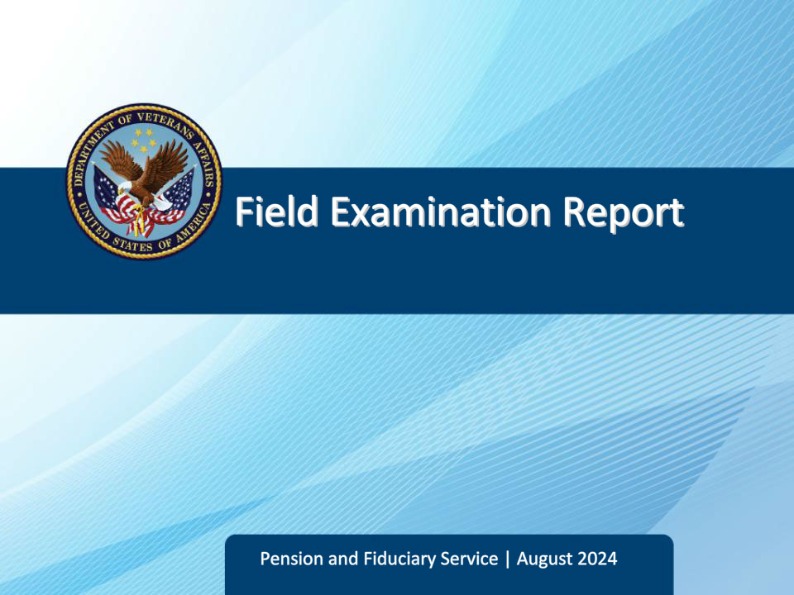
Slide notes

Course Description:

The purpose of this lesson is to provide students with an overview of the field examination report and information housed in the VBMS-Fiduciary Field Examination Report.

Slide 2 - Objectives
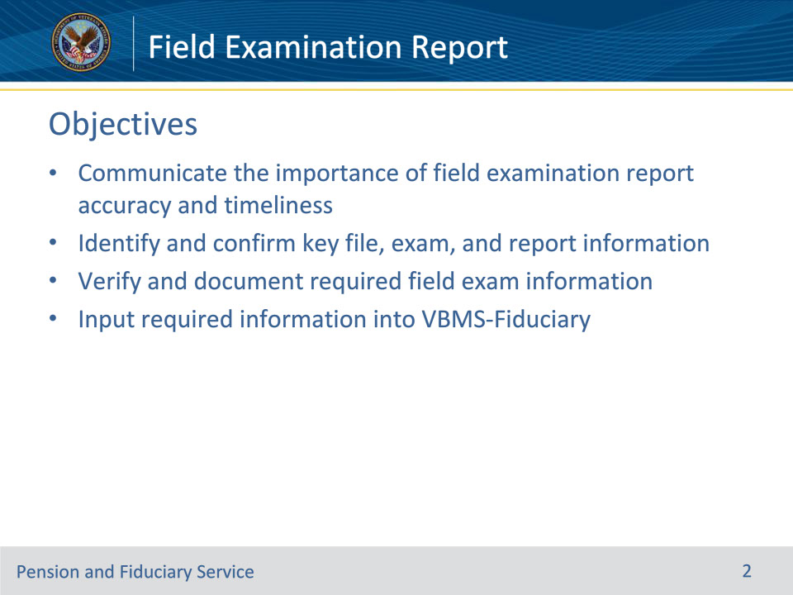
Slide notes

By the end of this lesson, the student will be able to do the following:

• Communicate the importance of field examination report accuracy and timeliness

• Identify and confirm key file, exam, and report information

• Verify and document required field exam information

• Input required information into VBMS-Fiduciary

Slide 3 - References
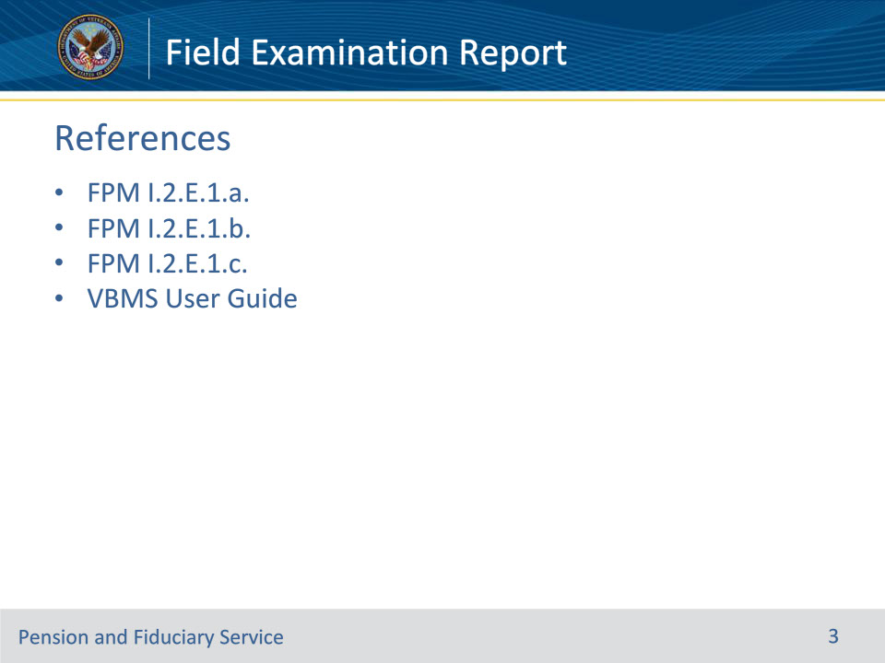
Slide notes

These are the relevant references for this training:

• FPM I.2.E.1.a. Documenting a Field Examination

• FPM I.2.E.1.b. Expressing Personal Opinions

• FPM I.2.E.1.c. When to Prepare Field Examination Documentation

• VBMS User Guide

Slide 4 - Documentation
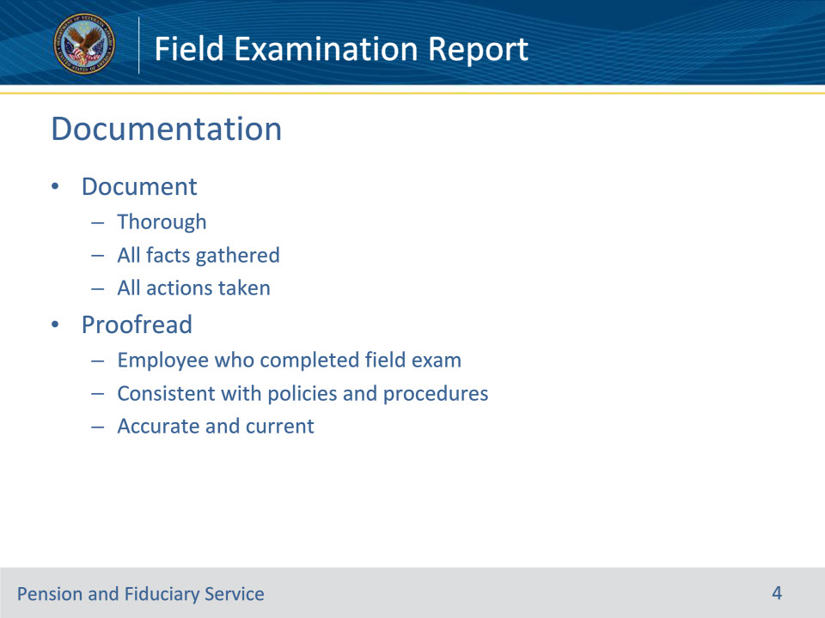
Slide notes

Policy Reference(s): FPM I.2.E.1.a.

Instructor Notes:

The field examination must thoroughly document all facts gathered and actions taken during the field examination process.

The fiduciary hub employee who completed the field examination is responsible for proofreading the report, ensuring the report is consistent with policies and procedures, and the information is both accurate and current.

Slide 5 - Documentation
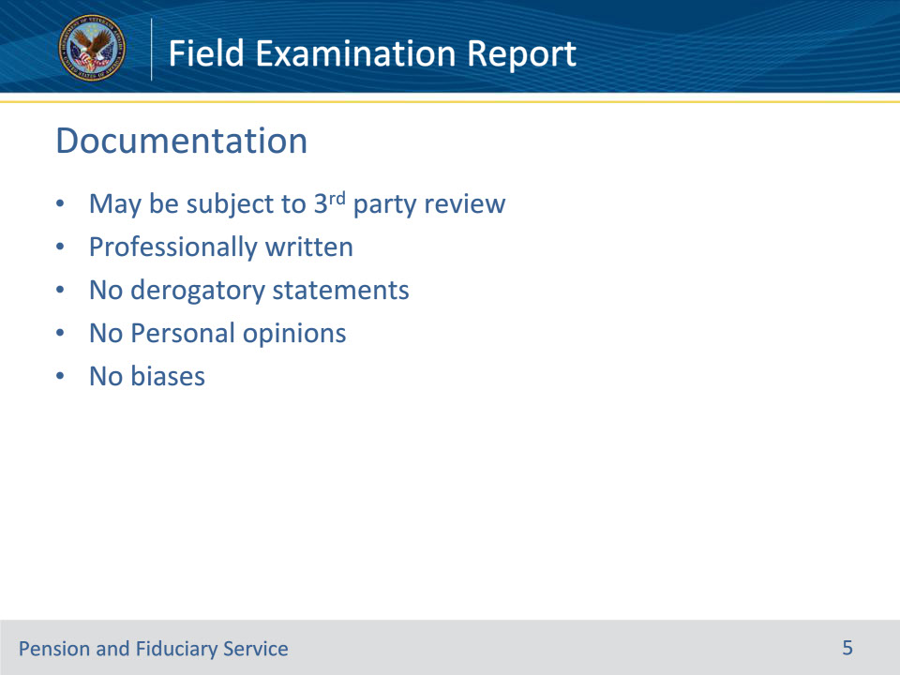
Slide notes

Policy Reference(s): FPM I.2.E.1.b.

Instructor Notes:

Field examinations may be subject to third party review. Field examinations must be professionally written and must not contain derogatory statements reflecting the hub employee’s personal opinions and/or biases.

Slide 6 - Documentation
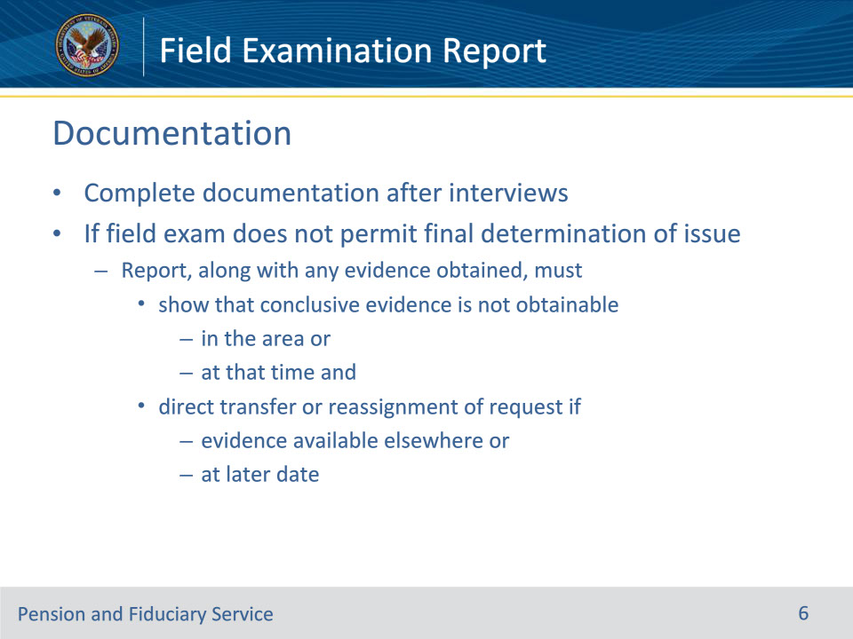
Slide notes

Policy Reference(s): FPM I.2.E.1.c.

Instructor Notes:

Field examination documentation is completed after interviews are conducted.

If the field examination does not permit a final determination of an issue, the report, along with any evidence obtained, must

• show that conclusive evidence is not obtainable in the area, or at that time, and

• direct the transfer or reassignment of the request, if the evidence is available elsewhere, or at a later date.

Slide 7 - VBMS-Fiduciary
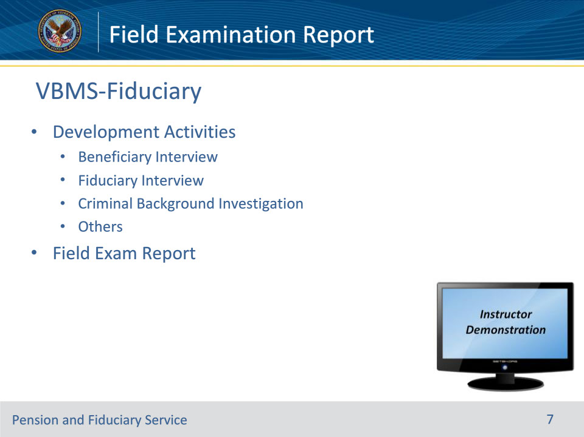
Slide notes

Policy Reference(s): VBMS User Guide

Instructor Notes:

Actions taken during the course of the field examination process can be documented in VBMS-Fid as Development Activities.

When updating the Development Activity, this updates the suspense reason. (Done for tracking purposes to know field exam status.)

Once you mark the interview(s) complete, you can create a field exam report and begin typing.

Once the appropriate Development Activities are Completed, press the “Add Field Exam Report Activity” button.

Select the Field Exam Report Activity Type.

Instructor Actions:

Open VBMS, share your screen and demo adding development activities and creating a field exam report

Slide 8 - Exam Information
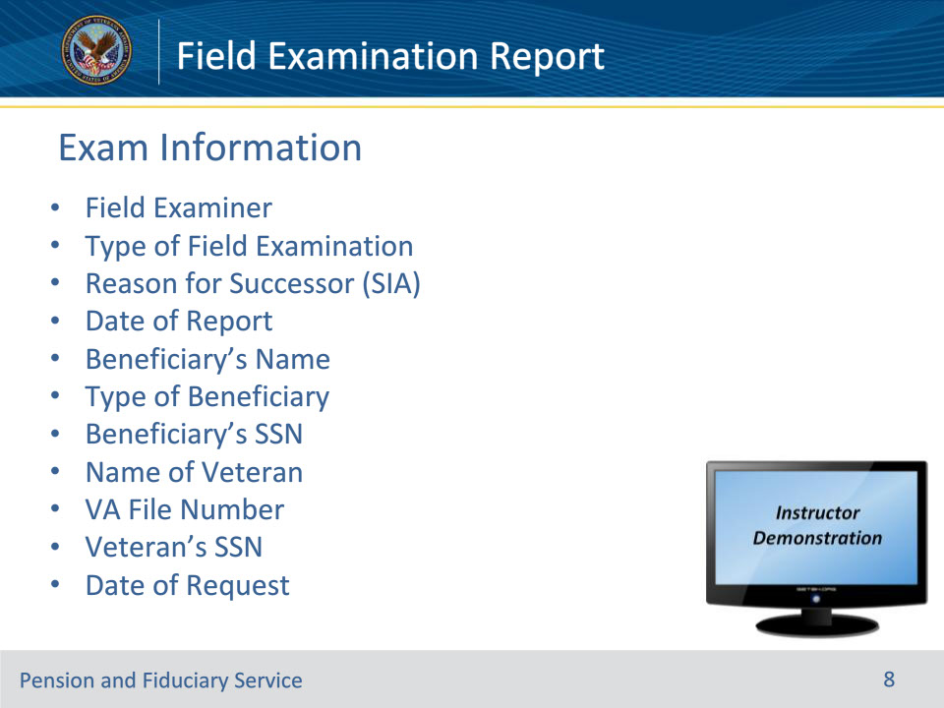
Slide notes

Policy Reference(s): VBMS User Guide

Instructor Notes:

Most information should pre-populate from Corporate record and should be self-explanatory. However, the FE should verify all information is correct.

• Field Examiner name

• Type of exam

• Reason for Successor (SIA)—If doing a SIA, from the drop-down menu, select the most accurate reason for the SIA. If Other is chosen, a free-text box will appear for further clarification.

• Successor—Misuse

• Successor—Relationship

• Successor—Fid Resignation

• Successor—SDP

• Other

• Date of Report—This block will fill in with the current date when the “Complete Report” button is pressed.

• Beneficiary’s name

• Type of beneficiary—From the drop-down menu, select the most accurate description of the beneficiary’s relationship to the Veteran.

• Veteran

• Minor

• Spouse

• Dependent Parent

• Helpless Adult

• Insurance

• Beneficiary’s SSN

• Name of Veteran

• VA File Number

• Veteran’s SSN

• Date of Request

Instructor Actions: Open VBMS-Fid, share your screen and demo the information just discussed.

Slide 9 - Beneficiary Information
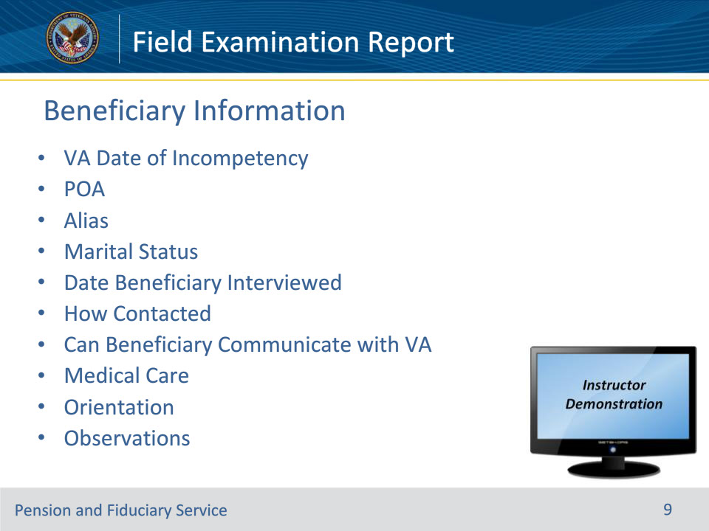
Slide notes

Policy Reference(s): VBMS User Guide

Instructor Notes:

• VA Date of Incompetency—Make sure this matches the Rating Decision code sheet.

• POA—Make sure this matches the 21-22 or 21-22a on record

• Alias—If the beneficiary is also/previously known under a different name, fill in that name here.

• Marital status—From the drop-down menu, select the beneficiary’s current marital status.

• Single

• Married

• Divorced

• Widow(er)

• Separated

• Date Beneficiary interviewed

• How contacted

• In person, Physical Address

• In Person, Other Location

• Telephone (with no visuals)

• Not Seen

• Letter

• Virtual Conference

• Can the beneficiary communicate with VA verbally and/or in writing?

• This is a “yes or no” drop down menu.

• The beneficiary receives medical care from—Select the box(es) corresponding to the organization that pays for the beneficiary’s medical care

• Orientation—Check the box(es) showing which sphere(s) the beneficiary is oriented to

• Person

• Place

• Events

• Time

• None

• Observations during Interview—Free text box for the FE to place additional information.

Instructor Actions: Open VBMS-Fid, share your screen and demo the information just discussed.

Slide 10 - Fiduciary Information (IA)
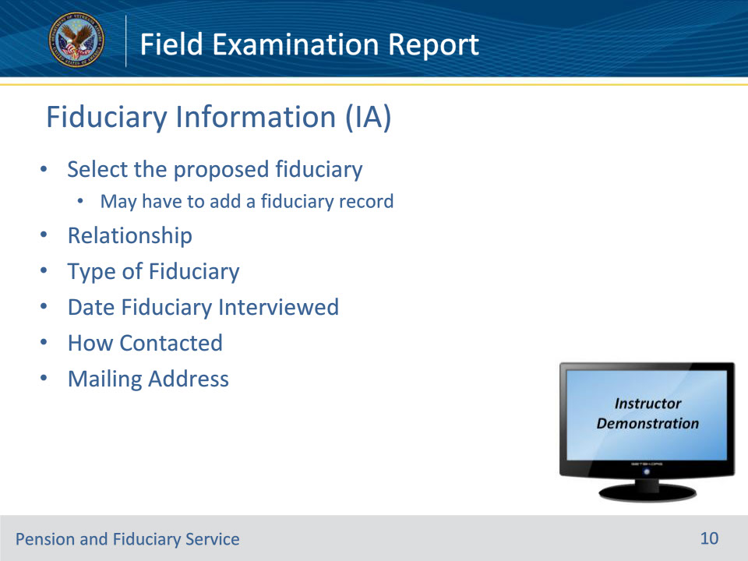
Slide notes

Policy Reference(s): VBMS User Guide

Instructor Notes:

• For an IA, this “Fiduciary Information” tab appears. For a SIA, a Previous Fiduciary Information and a Successor Fiduciary Information tab appears.

• Fiduciary Name—Choose the name of the Fiduciary using the magnifying glass

• Relationship—From the drop-down menu, select the most appropriate option.

• Spouse

• Family Member

• Parent

• Non-Family Member

• Friend

• Caregiver

• Other Third Party

• Trustee

• Guardian

• Facility

• Bonded Officer of an Indian Reservation

• Individual Appointed By A Court

• Temporary

• Type of fiduciary—Select the VA Appointment Type from the drop-down menu

• VA-appointed fiduciary

• Spouse fiduciary

• Supervised Direct Pay

• Temporary

• Date Fiduciary Interviewed

• How contacted

• In person, Physical Address

• In Person, Other Location

• Telephone

• Not Seen

• Letter

• Virtual Conference

• Mailing Address for the proposed fiduciary.

Instructor Actions: Open VBMS, share your screen and demo the information just discussed.

Slide 11 - Previous Fiduciary Information (SIA)
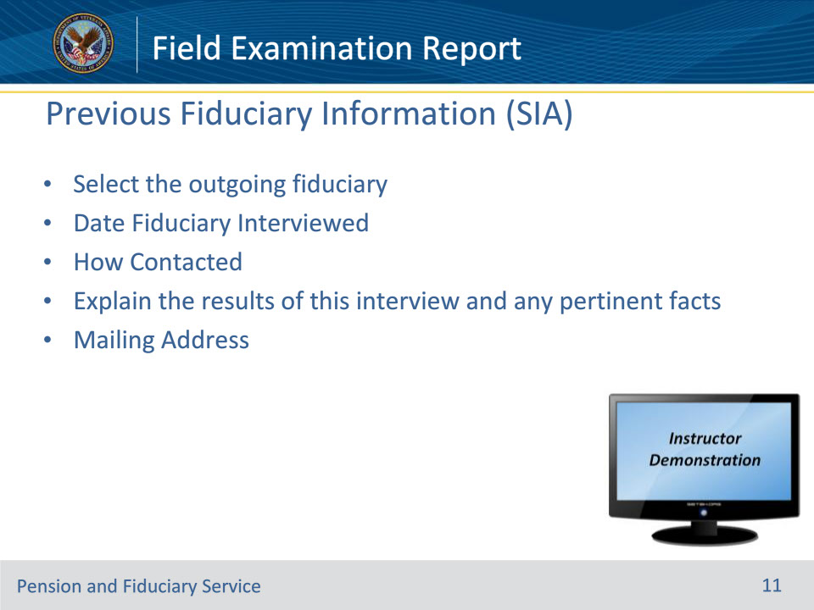
Slide notes

Policy Reference(s): VBMS User Guide

Instructor Notes:

• For a SIA, a Previous Fiduciary Information and a Successor Fiduciary Information tab appears. The Previous Fiduciary Information tab is for the outgoing fiduciary and the Successor Fiduciary Information tab is for the incoming fiduciary.

• Fiduciary Name—Choose the name of the Fiduciary using the magnifying glass

• Date Fiduciary Interviewed

• How contacted:

• In person, Physical Address

• In Person, Other Location

• Telephone

• Not Seen

• Letter

• Virtual Conference

• Explain the results of this interview and any pertinent facts. This is a free-text box for the FE to provide any relevant information.

• Mailing Address for the previous fiduciary.

Instructor Actions: Open VBMS, share your screen and demo the information just discussed.

Slide 12 - Successor Fiduciary Information (SIA)
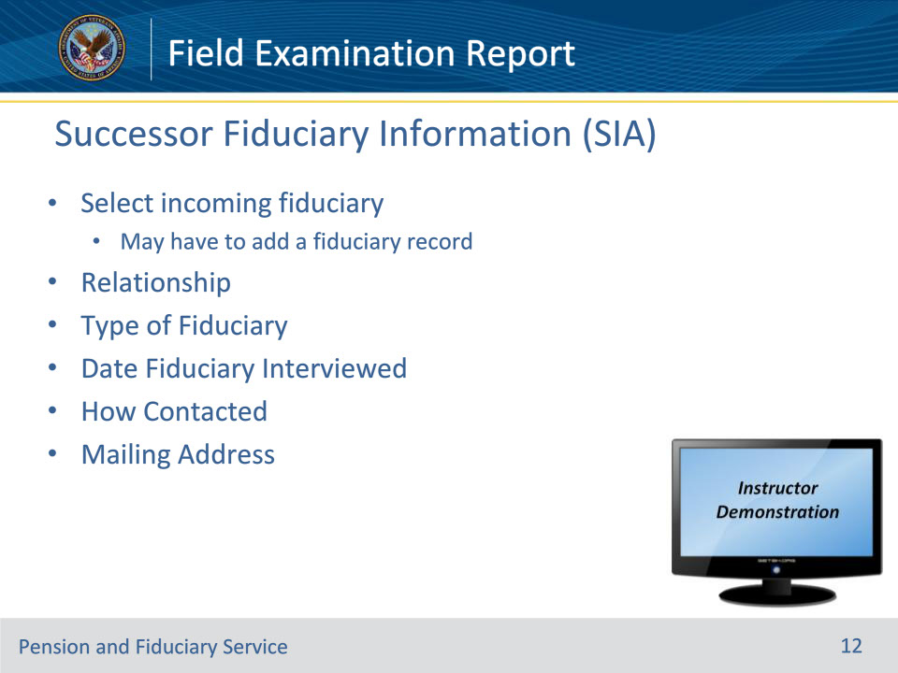
Slide notes

Policy Reference(s): VBMS User Guide

Instructor Notes:

• The Successor Fiduciary Information tab is for the incoming fiduciary.

• Fiduciary Name—Choose the name of the Fiduciary using the magnifying glass

• Relationship—From the drop-down menu, select the most appropriate option.

• Spouse

• Family Member

• Parent

• Non-Family Member

• Friend

• Caregiver

• Other Third Party

• Trustee

• Guardian

• Facility

• Bonded Officer of an Indian Reservation

• Individual Appointed By A Court

• Temporary

• Type of fiduciary—Select the VA Appointment Type from the drop-down menu

• VA-appointed fiduciary

• Spouse fiduciary

• Supervised Direct Pay

• Temporary

• Date Fiduciary Interviewed

• How contacted

• In person, Physical Address

• In Person, Other Location

• Telephone

• Not Seen

• Letter

• Virtual Conference

• Mailing Address

Instructor Actions: Open VBMS, share your screen and demo the information just discussed.

Slide 13 - Dependents
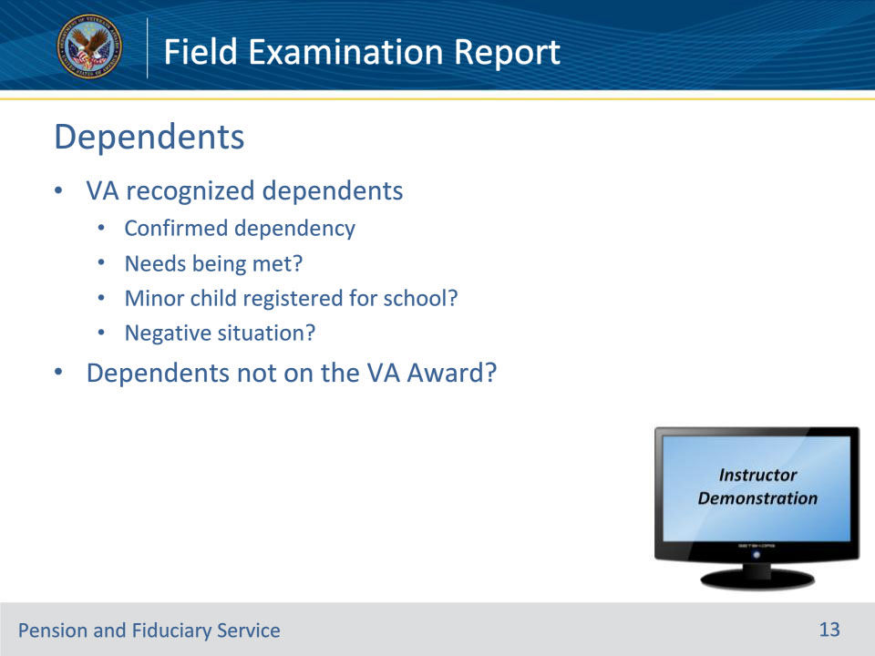
Slide notes

Policy Reference(s): VBMS User Guide

Instructor Notes:

Dependents currently on the VA award should automatically appear here already.

• Confirmed Dependency—Check the box to confirm the person listed is still a dependent of the beneficiary.

• Are their needs being met, such as sufficient clothing, food, medical care and housing?

• This is a “yes or no” drop down menu.

• Minor child registered for school (if beneficiary is a child)?

• This is a “yes or no” drop down menu.

• If any negative situations exist, please explain.

• This is a free-text box.

• Are there dependents not on the award?

• NOTE: The question is a “reverse” question—”Are there dependents not on the award?” FE must choose from drop-down menu.

• No—No additional questions.

• Yes—Several additional fields open up for the FE to complete:

• Name—Free text box for the name of the dependent

• Relationship (to the VA beneficiary)—Drop down menu

• Are the dependents’ needs being met (food, clothing, medical, housing, etc.)?—Drop down menu

• If no, FE must use free text box to explain the negative situation.

• Press “Add Dependent” to open another set of boxes to add another dependent not yet on the VA Award

NOTE: This section does NOT automatically CEST a dependency EP in VBMS. FE will still need to determine appropriate follow up action(s), if any, to add the dependent to the VA Award.

Instructor Actions: Open VBMS, share your screen and demo the information just discussed.

Slide 14 - Other Interviews/Contacts
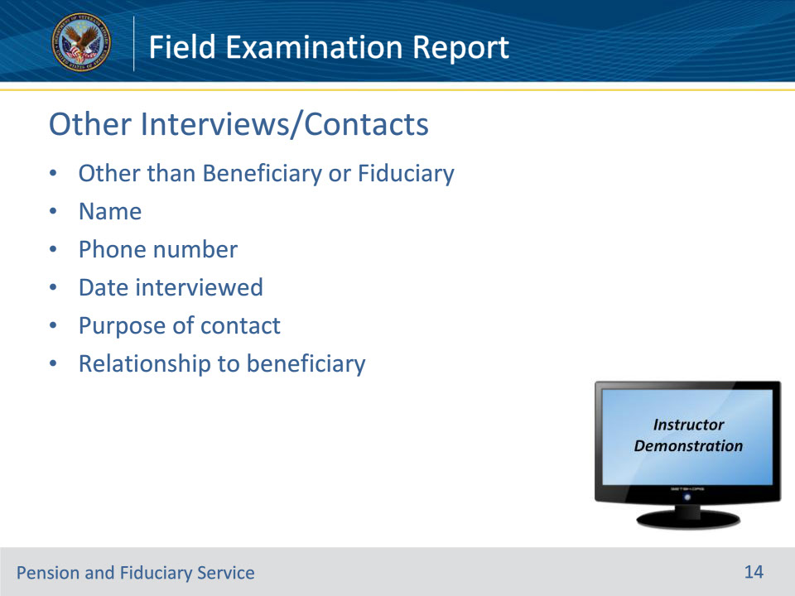
Slide notes

Policy Reference(s): VBMS User Guide

Instructor Notes:

If anyone other than the beneficiary or fiduciary, then input the interview information here.

• Name of person interviewed

• Phone number—telephone number of person interviewed

• Date interviewed—Date the interview took place

• Purpose of contact—drop down menu

• Confirmed beneficiary’s well-being and/or needs

• Confirmed beneficiary’s capacity to manage funds

• Confirmed beneficiary’s contact info

• Confirmed misuse allegations or evidence

• Other reason—will have to fill out a free text box to explain why the person was contacted.

• Relationship to beneficiary—Fill in the contact’s relation to the beneficiary. This could be family member, friend, co-worker, etc.

Instructor Actions: Open VBMS, share your screen and demo the information just discussed.

Slide 15 - Capacity to Manage Funds
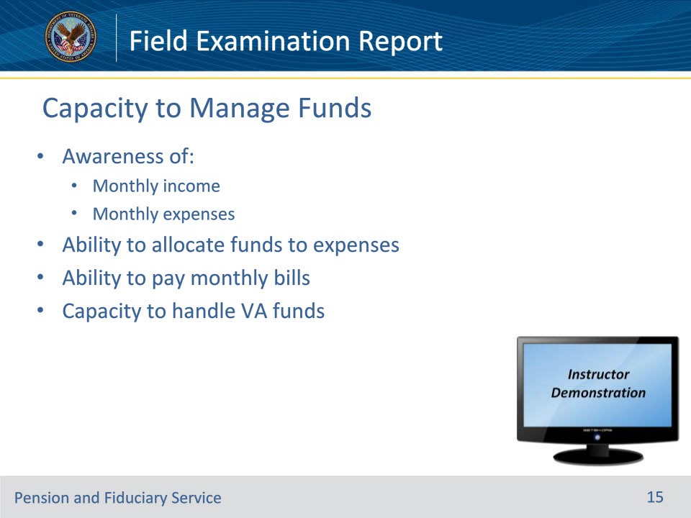
Slide notes

Policy Reference(s): VBMS User Guide

Instructor Notes:

• These are drop down “yes-no” questions to the beneficiary’s awareness of the financial situation:

• Aware of monthly income

• Aware of monthly expenses

• Ability to allocate funds to expenses

• Ability to pay monthly bills

• Capacity to handle VA funds—Drop down menu of either:

• Beneficiary has no capacity to manage funds, or;

• Beneficiary has full capacity to manage funds.

Instructor Actions: Open VBMS, share your screen and demo the information just discussed.

Slide 16 - Environmental and Social Conditions
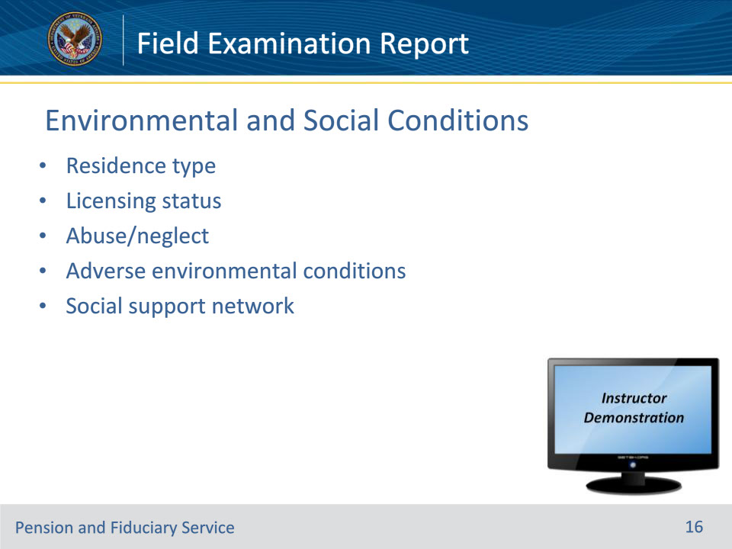
Slide notes

Policy Reference(s): VBMS User Guide

Instructor Notes:

• Residence type—Select the type of residence where the beneficiary resides.

• Drop down menu with many options.

• Common choices will be Assisted Independent Living, Assisted Living Facility, Nursing Home, and Single-Family Home.

• Options:

• Adult Foster Care

• Apartment

• Assisted Independent Living

• Assisted Living Facility

• Automobile

• Institution

• Jail

• Motel

• Multi-family home

• Nursing home

• RCF (Residential Care Facility)

• Room and Board

• Shelter

• Single Family Home

• State Hospital

• State Veterans Home

• Tent

• Trailer

• VA Contracted Nursing Home

• VA Domiciliary

• VAMC

• Other

• Licensing status—Drop down menu showing the license status of the facility—

• Licensed (valid and unexpired license);

• Licensed, awaiting state review (transitional status of waiting on State to renew license during regular review);

• Unlicensed, license not issued by State; (could be VAMC, VA Domiciliary, state hospital, jail) or,

• Unlicensed, did not qualify for State license (facility did not qualify or license has been revoked.)

• Is there suspected physical or mental Abuse/neglect in the residence?

• Drop down menu of yes or no.

• Are there adverse environmental living conditions?

• Drop down menu of yes or no.

• If Yes is selected, then To whom was the abuse/neglect referred question appears.

• Does the beneficiary have a social support network?

• This is a drop down yes or no.

• If Yes is selected, then To whom was the abuse/neglect referred question appears.

• This question is important for helping determine the follow-up type of exam, if any.

Instructor Actions: Open VBMS, share your screen and demo the information just discussed.

Slide 17 - Income
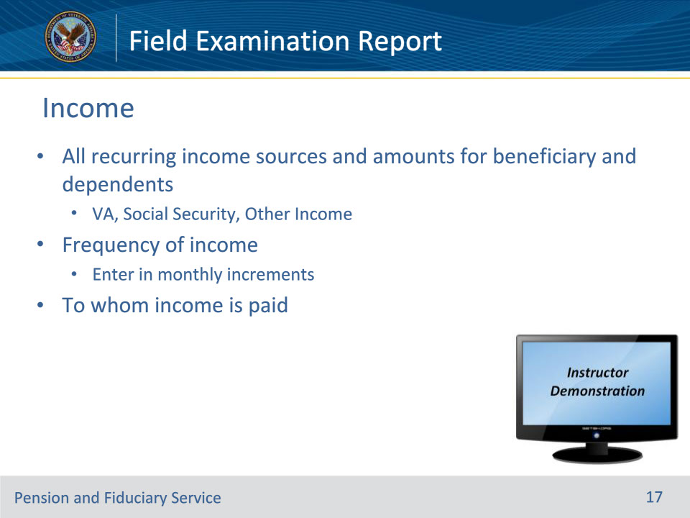
Slide notes

Policy Reference(s): VBMS User Guide

Instructor Notes:

• List all sources of recurring income for the beneficiary and dependents. The user will have to enter the name of the source of income under Beneficiary’s Income block.

• FE should enter the amount the beneficiary is paid in the Amount block.

• NOTE: Amounts should be calculated in monthly amounts.

• If there is a dependent and the dependent is receiving income, the FE should put the dependent’s name in the name block and the amount the dependent is receiving. As with the beneficiary, the amount should be entered as a monthly amount.

Instructor Actions: Open VBMS, share your screen and demo the information just discussed.

Slide 18 - Expenses
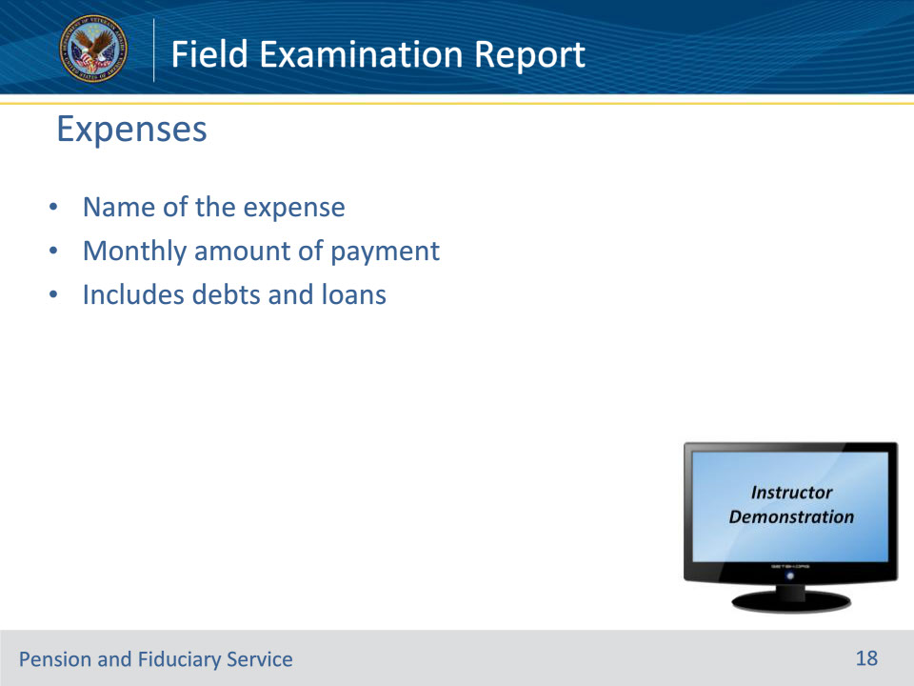
Slide notes

Policy Reference(s): VBMS User Guide

Instructor Notes:

• FE must fill in the free-text box with the name of the expense.

• FE must fill in the corresponding monthly amount of the expense in the Monthly Amount column.

• After the 10th expense entry, if the FE needs to enter more expenses, press the Add Expense button and additional row will be provided.

Instructor Actions: Open VBMS, share your screen and demo the information just discussed.

Slide 19 - Assets
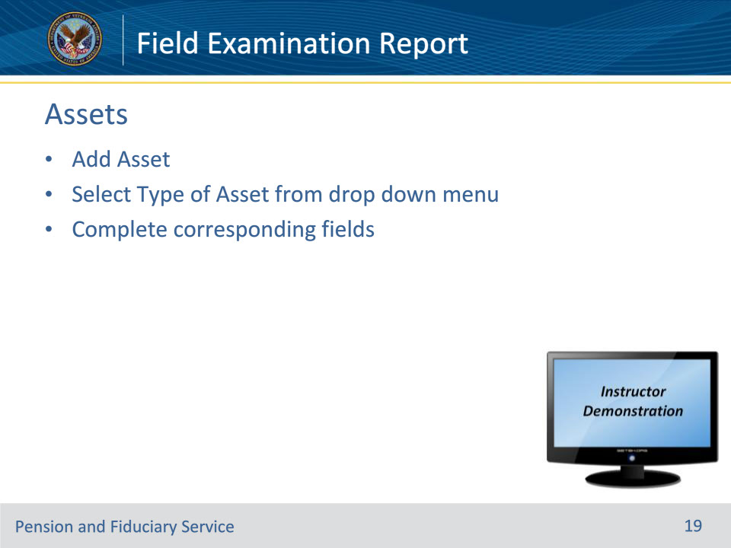
Slide notes

Policy Reference(s): VBMS User Guide

Instructor Notes:

• Adding any Asset to the Field Exam Report begins with selecting the Add Asset button and then selecting the type of Asset from the drop-down menu that the FE wishes to add. Drop-down menu options include:

• Checking

• Savings

• CD

• IRA

• Money Market

• Mutual Funds

• Personal Funds of the Patient (PFOP)

• Resident Trust Account (RTA)

• Vehicle

• Non-VA Life Insurance

• Pre-Need Burial

• Real Estate

• Relevant boxes appear based on the type of asset selected.

Instructor Actions: Open VBMS, share your screen and demo the information just discussed.

Slide 20 - Liquid Assets
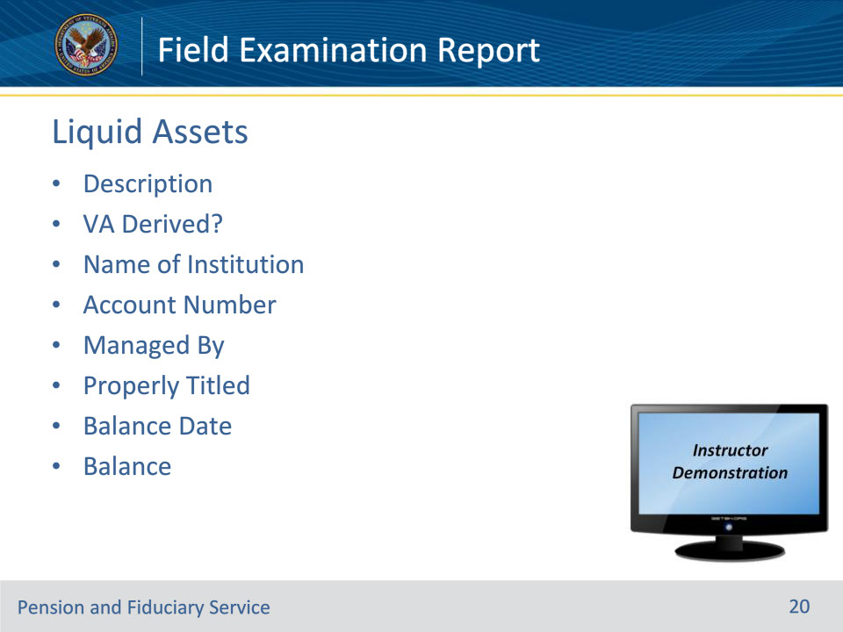
Slide notes

Policy Reference(s): VBMS User Guide

Instructor Notes:

The FE must review and document in the Field Examination Report all the beneficiary’s liquid assets on each IA and SIA field examination. A liquid asset is an item that may easily be converted into cash.

• Liquid Assets: Checking Account, Savings Account, CD, IRA, Money Market, Mutual Funds, Personal Funds of the Patient (PFOP), and Resident Trust Account (RTA) all have the same data fields available.

• Select the Asset Type from the drop-down menu:

• Checking/Savings account

• CD – A Certificate of Deposit

• IRA

• Money Market

• Mutual Funds

• Personal Funds of the Patient (PFOP) – These are personal accounts normally held or managed by the VAMC during long-term inpatient stays.

• Residential Accounts (RTA) – This is for any account held by an ALF, Nursing Home, or facility that is used to hold and dispense the beneficiary’s funds.

• For non-VA Life Insurance policy--If a beneficiary has a non-VA life insurance policy that has a cash value, document the policy using the liquid asset requirements.

• VA derived--FE must use the pull-down menu to state whether the funds are VA-derived, partially VA-derived, or not VA-derived.

• Fully derived - This is when all funds in the account are from the VA. No other sources fund this account.

• Partially derived – This is when there are funds that are partly from the VA and partly from another source.

• For example: The beneficiary receives $3,000 a month from the VA each month and $2,000 a month from the SS. VA funds and SSA funds are going into the same account each month and VA and SSA funds are split for the expenses. The account would be partially derived of VA and partially derived of SSA.

• Is Not derived - This is when no VA funds are deposited into the account. The account must be made solely of funds from non-VA sources.

• In the “Name of Institution” block, fill in the name of the financial institution holding the account.

• In the “Account Number” block, fill in the account number.

• Use the pull-down to indicate who has control over the asset. Choices are:

• Current Fiduciary – Asset is controlled by the current fiduciary or proposed fiduciary.

• Beneficiary – Asset is controlled by the beneficiary.

• Other Party – Asset is under the control of a third party.

• Previous Fiduciary – Asset is under the control of the outgoing or previous fiduciary (used most often during EP590SIAFE – Successor Initial Appointment Field Exam).

• Unknown – FE is unable to ascertain who controls the asset.

• Use pull-down to select whether the asset is properly titled (for VA Fid Hub purposes) or not.

• Balance Date—The calendar date matching the Balance Amount.

• Balance Amount—The value of the liquid asset.

Instructor Actions: Open VBMS, share your screen and demo the information just discussed.

Slide 21 - Non-Liquid Assets
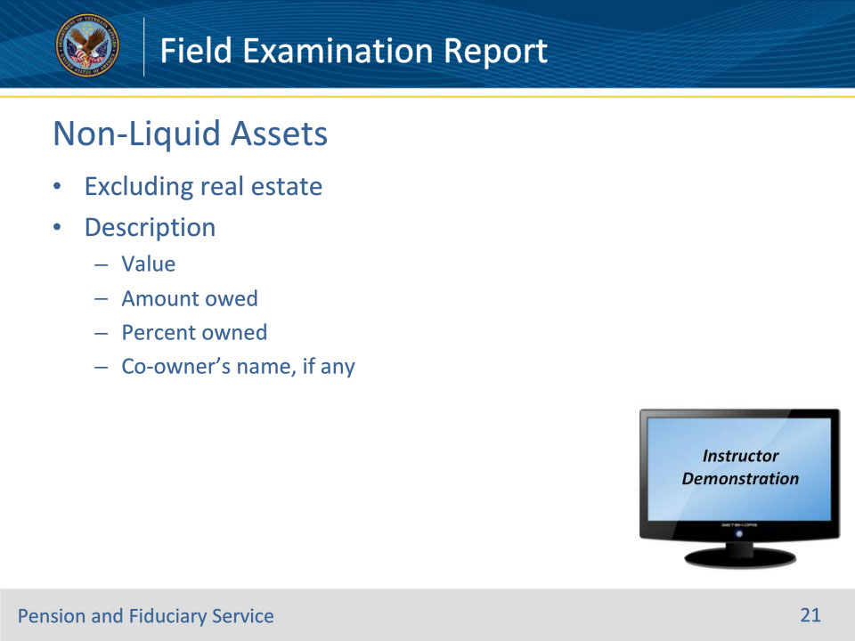
Slide notes

Policy Reference(s): VBMS User Guide

Instructor Notes:

• A non-liquid asset is an item or possession not easily converted into cash and generally requires the buyer to change the asset into cash.

Non-Liquid Assets (excluding Real Estate): Vehicle, Non-VA Life Insurance (with no cash value), and Pre-Need Burial all have the same data fields available.

• Select the non-liquid Asset type from the drop-down menu:

• Vehicle – These are vehicles (cars, trucks, etc.) owned by the beneficiary.

• Non-VA Life Insurance – Documents any non-VA life insurance policy that has no cash value.

• Pre-Need Burial—Documents a burial policy purchased for the beneficiary.

• For any items that don’t have an existing field, the FE should put the information in the Comments and Observations section.

• Use the free text “Description” box to document required items. There are no individual boxes (like for liquid assets) for the information; only a free text box.

• Asset Description

• Asset value—it is a good idea to include a brief statement noting how the value was determined, so future valuations may use the same source, for consistency purposes.

• Amount owed

• Percent owned

• Co-owner’s name, if any

Instructor Actions: Open VBMS, share your screen and demo the information just discussed.

Slide 22 - Real Estate
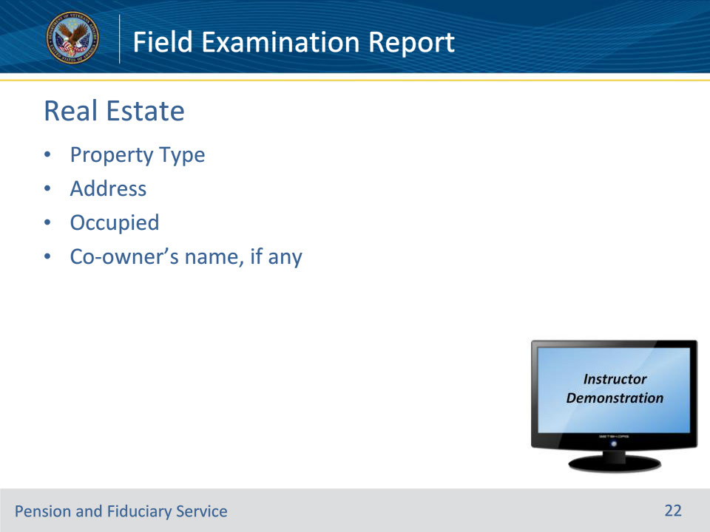
Slide notes

Policy Reference(s): VBMS User Guide

Instructor Notes:

• Real Estate: Personal property (residences, undeveloped land, and manufactured homes) owned by the beneficiary.

• Select Real Estate from the Asset Type drop-down menu.

• Select the most appropriate description of the property from the Property Type drop-down menu:

• Primary Residence – Select this choice when the beneficiary resides in the real estate you are listing in this section.

• Investment – Select this choice if the beneficiary owns the real estate but does not reside in it.

• Dependent’s Residence – Select this if the dependent resides at the location and the beneficiary does not.

• Land Asset – Select this choice when the real estate is an undeveloped piece of land.

• Other – Select this option if you have an asset that does not fit in another category. You can input the real estate type in the Description block.

• Property address

• If the property is occupied

• List co-owner’s name, if any

Instructor Actions: Open VBMS, share your screen and demo the information just discussed.

Slide 23 - Fiduciary Fee
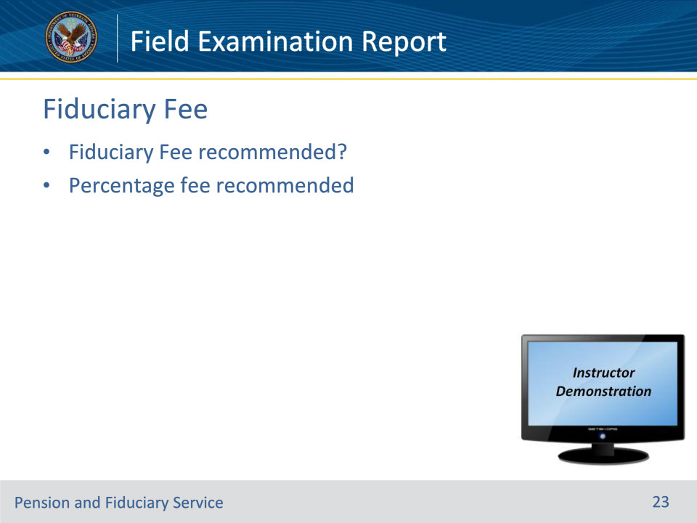
Slide notes

Policy Reference(s): VBMS User Guide

Instructor Notes:

• Fiduciary fee recommended? Drop down yes or no menu. The FE must document whether a fiduciary fee is recommended or not.

• If yes is chosen, a new menu of “percentage fee recommended” shows up with a drop-down menu of 0, 1, 2, 3 or 4.

Instructor Actions: Open VBMS, share your screen and demo the information just discussed.

Slide 24 - Preferred Fiduciary Information
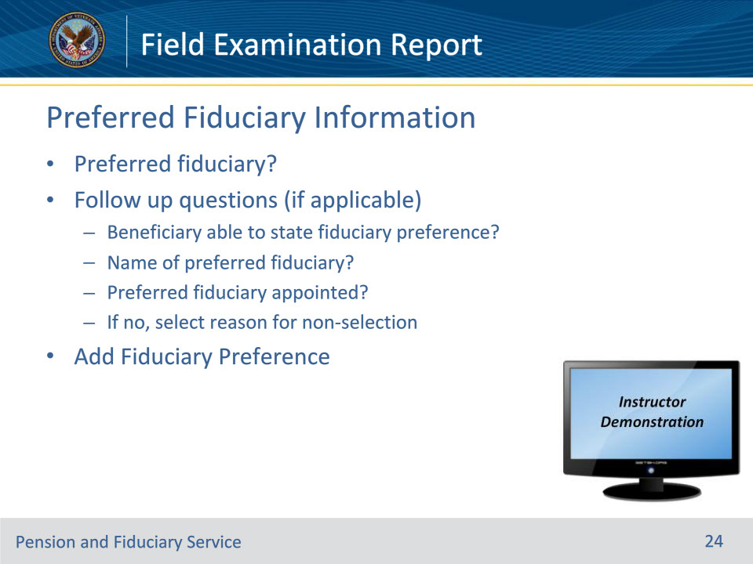
Slide notes

Policy Reference(s): VBMS User Guide

Instructor Notes:

Fiduciary Preference—Has the beneficiary expressed (could be in writing or during the exam) a preferred fiduciary? Drop down menu for yes or no. Based on this answer, VBMS-Fid shows different follow up questions…

No Fiduciary Preference → No follow-up questions.

Yes Fiduciary Preference → Does beneficiary have capacity to state their fiduciary preference?

• If Yes, then FE must list the name of preferred fiduciary and whether the person was appointed. If the FE did not appoint the person, then FE must checkmark one of several pre-programmed reasons the preferred fiduciary was not appointed.

• If No, then FE must state “Reason why fid preference not indicated” from several pre-programmed options in a drop-down menu.

There is an “Add Fiduciary Preference” button for the FE to use if the beneficiary gives more than one preferred fiduciary.

Instructor Actions: Open VBMS, share your screen and demo the information just discussed.

Slide 25 - Comments and Observations
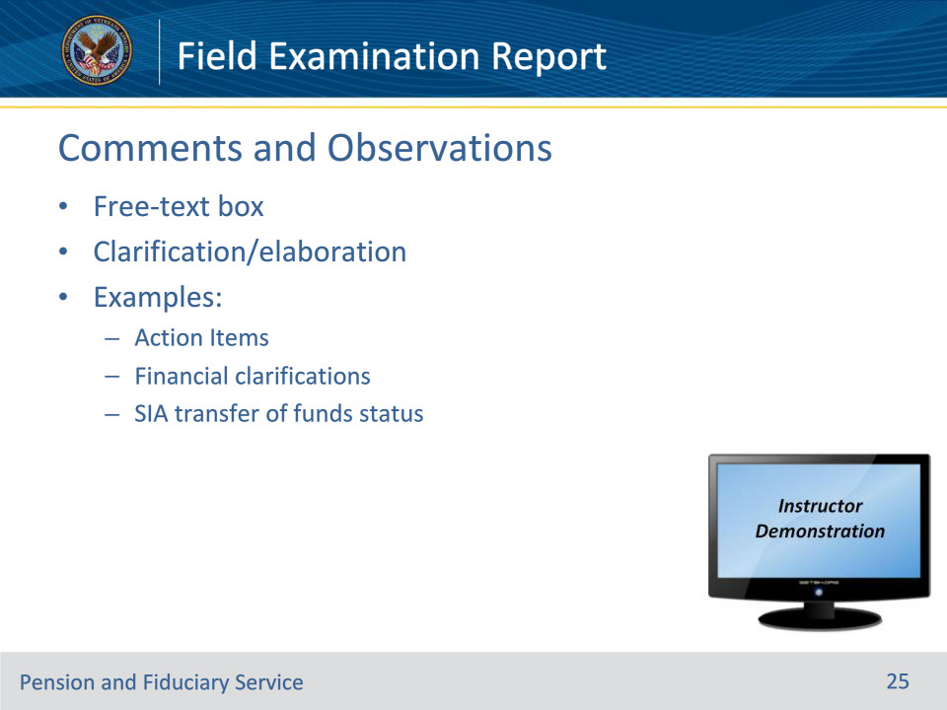
Slide notes

Policy Reference(s): VBMS User Guide

Instructor Notes:

• The Comments and Observation block on the Field Exam report is for the FE to put any information that did not fit in a box or section elsewhere in the report or provide additional explanation.

• Some possible examples may be:

• Action items for the FSR to be aware of

• Clarifications regarding a unique situation with the beneficiary’s finances

• On a SIA, FE documenting the status of the funds transfer from the previous fiduciary to the incoming fiduciary

Instructor Actions: Open VBMS, share your screen and demo the information just discussed.

Slide 26 - Finalizing the Field Exam Report
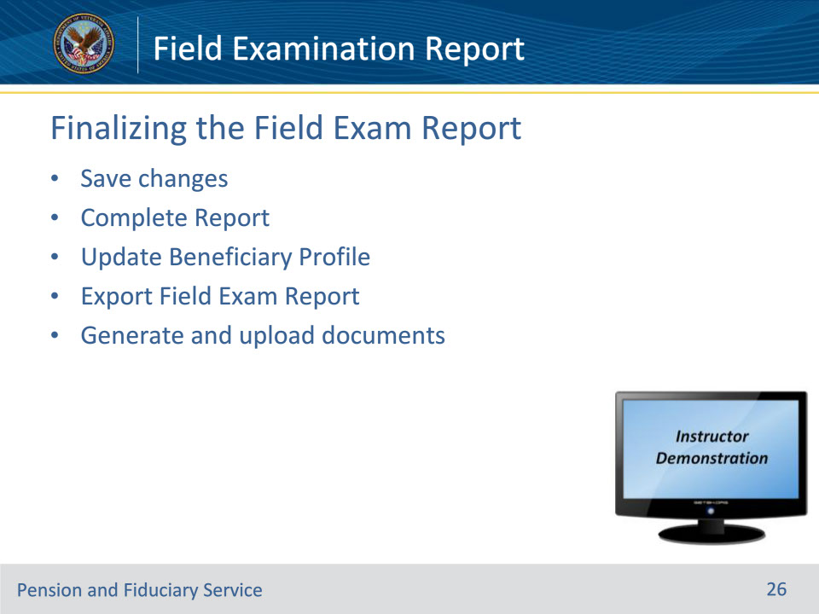
Slide notes

Policy Reference(s): VBMS User Guide

Instructor Notes:

Some steps to finalize the field exam report and the EP590:

• Save changes—Press the “Save Changes” button

• Complete report—Press the “Complete Report” button. Pressing this button should open the “Update Beneficiary” box.

• Update Beneficiary—Use the shortcut “Update Beneficiary” block to easily update block in the Beneficiary Profile screen.

• Export—Press the “Export” button to generate a copy of the report.

• Generate and upload required documents to the eFolder

Instructor Actions: Open VBMS, share your screen and demo the information just discussed.

Slide 27 - Questions?
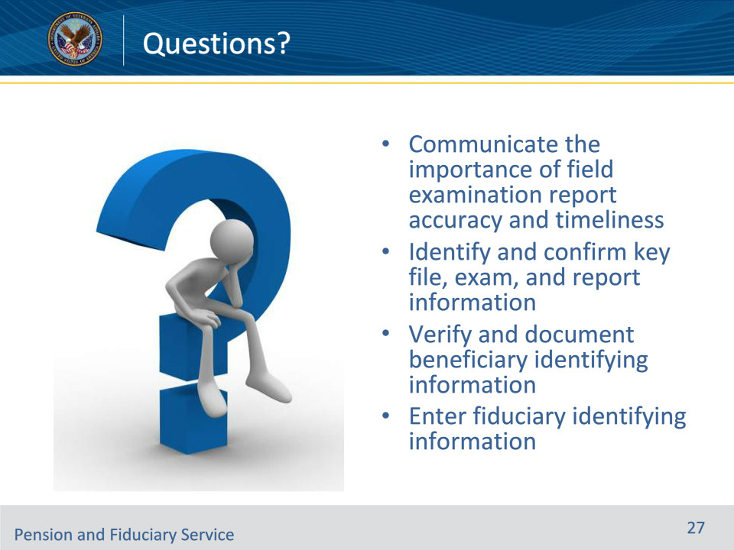
Slide notes

(Recall) These are our learning objectives as stated from the beginning of the training:

• Communicate the importance of field examination report accuracy and timeliness

• Identify and confirm key file, exam, and report information

• Verify and document beneficiary identifying information

• Enter fiduciary identifying information

(Recap) We discussed each of these learning objectives through the following topics in each slide today:

• Documentation

• VBMS-Fiduciary

• Exam Information

• Beneficiary Information

• Fiduciary Information (IA)

• Previous Fiduciary Information (SIA)

• Successor Fiduciary Information (SIA)

• Dependents

• Other Interviews/Contacts

• Capacity to Manage Funds

• Environmental and Social Conditions

• Income

• Expenses

• Assets

• Liquid Assets

• Non-Liquid Assets

• Real Estate

• Fiduciary Fee

• Preferred Fiduciary Information

• Comments and Observations

• Finalizing the Field Exam Report

Are there any additional questions?

Questions should be filtered through your QRT team. They will submit your questions to the Field Inquiry Tool (FIT) on your behalf.

Slide 28 - TMS Survey/Assessment
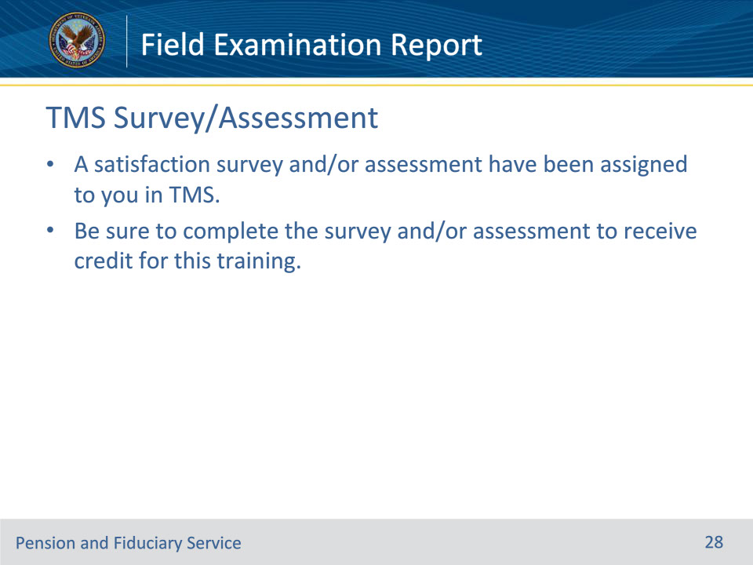
Slide notes

Instructor Notes

A satisfaction survey and/or assessment have been assigned to you in TMS.

Be sure to complete the survey and/or assessment to receive credit for this training.

