Slide 1 - Field Examination Requests
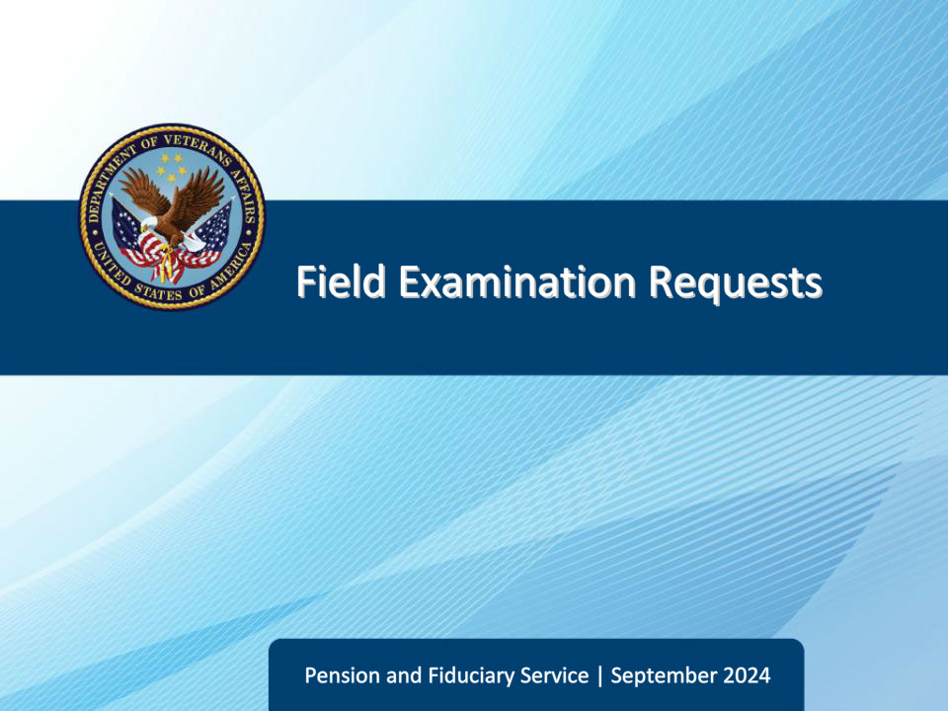
Slide notes

Course Description:

The purpose of this lesson is to provide learners information regarding field examination requests, including origination of requests, content requirements, review of requests, transmittal, and oversight.

Slide 2 - Objectives
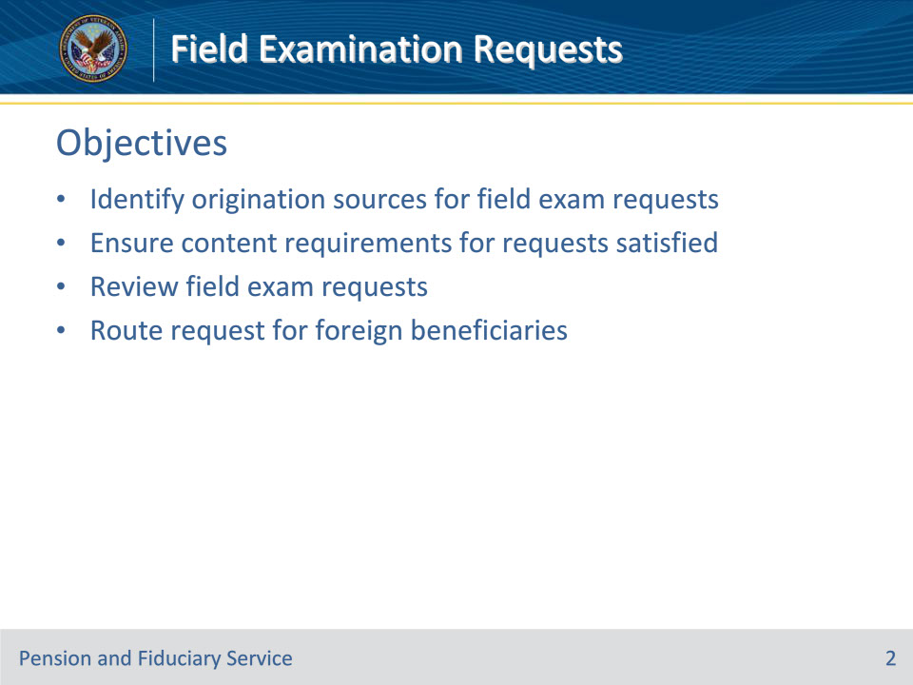
Slide notes

Instructor Notes:

At the end of this lesson, given the training and references, the learner will be able to do the following:

• Identify origination sources for field exam requests

• Ensure content requirements for requests satisfied

• Review field exam requests

• Route request for foreign beneficiaries

Slide 3 - Reference
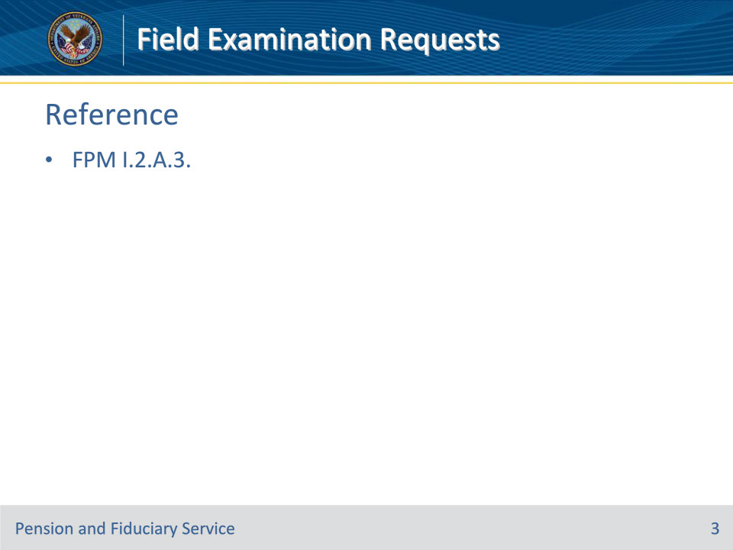
Slide notes

Instructor Notes:

These are the relevant references pertaining to this course:

• FPM I.2.A.3. Field Examination Requests

Slide 4 - Origination
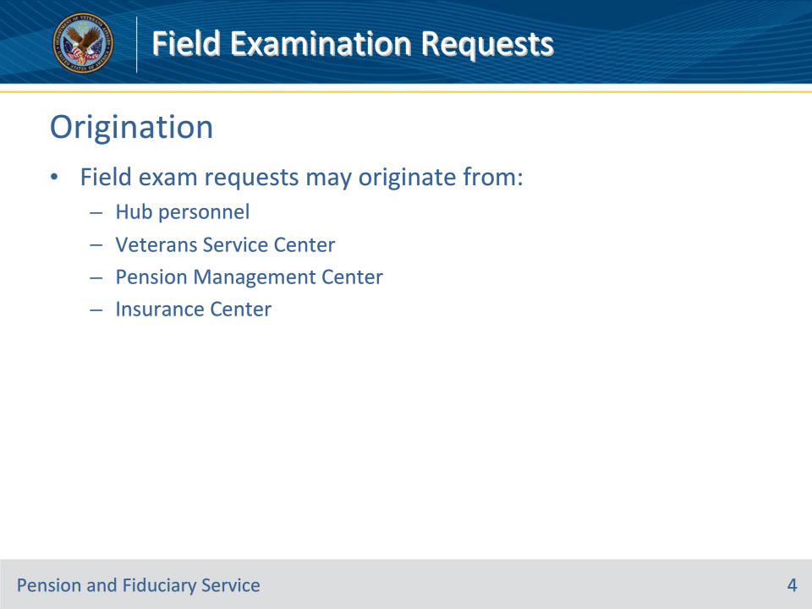
Slide notes

Policy Reference(s): FPM I.2.A.3.a.

Instructor Notes:Field examination requests may originate from hub personnel or from other sources such as the Veterans Service Center, pension management center, or Insurance Center.

Slide 5 - Content Requirements
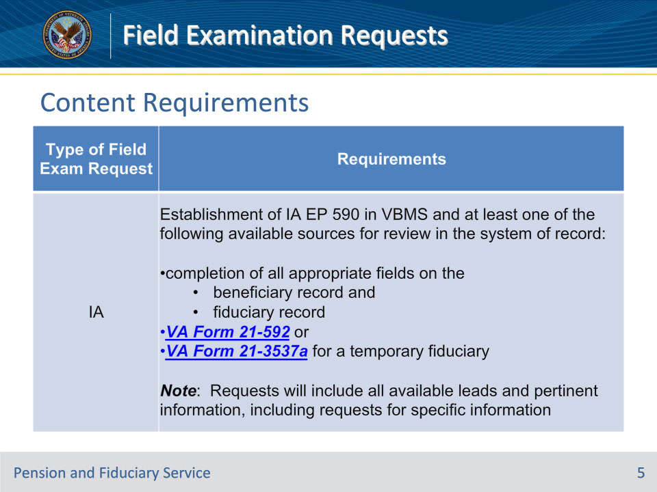
Slide notes

Policy Reference(s): FPM I.2.A.3.b.

Instructor Notes:This table describes the content requirements for various types of field examination requests prior to the field examination interview.

Slide 6 - Content Requirements
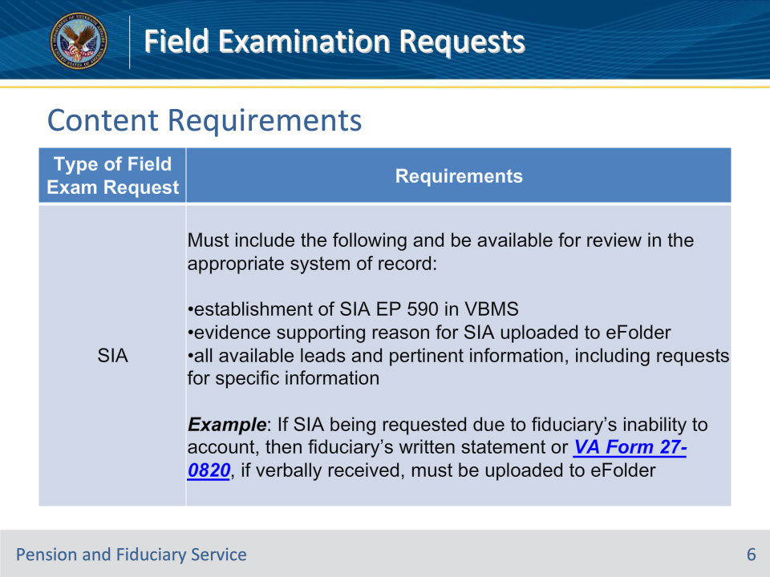
Slide notes

Policy Reference(s): FPM I.2.A.3.b.

Instructor Notes:This table describes the content requirements for various types of field examination requests prior to the field examination interview.

Slide 7 - Content Requirements
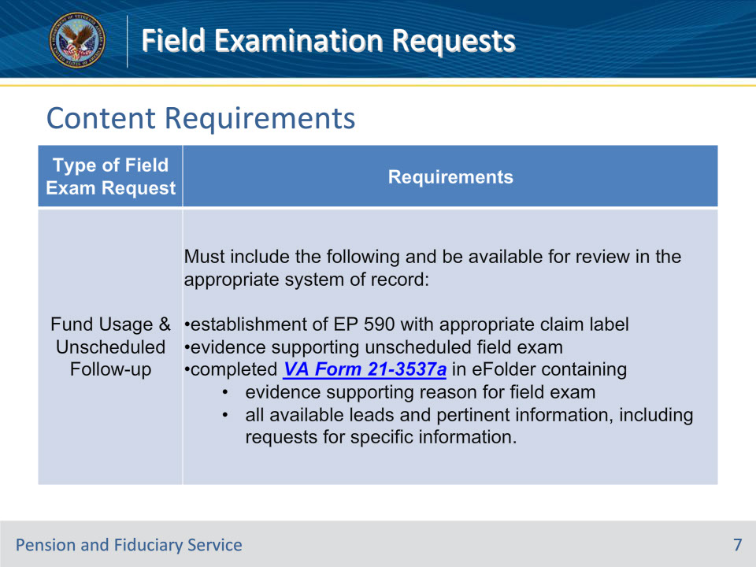
Slide notes

Policy Reference(s): FPM I.2.A.3.b.

Instructor Notes:This table describes the content requirements for various types of field examination requests prior to the field examination interview.

Slide 8 - Content Requirements
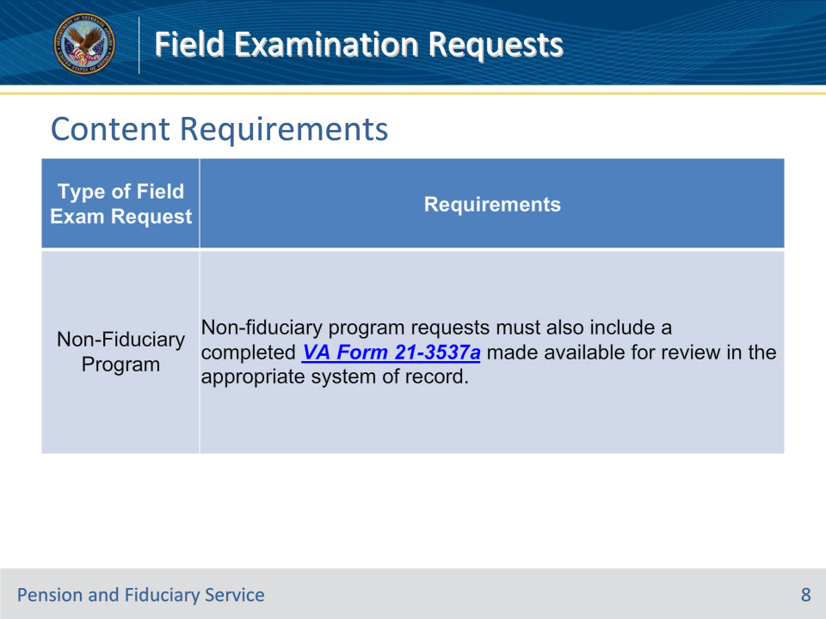
Slide notes

Policy Reference(s): FPM I.2.A.3.b.

Instructor Notes:This table describes the content requirements for various types of field examination requests prior to the field examination interview.

Slide 9 - Review of Requests
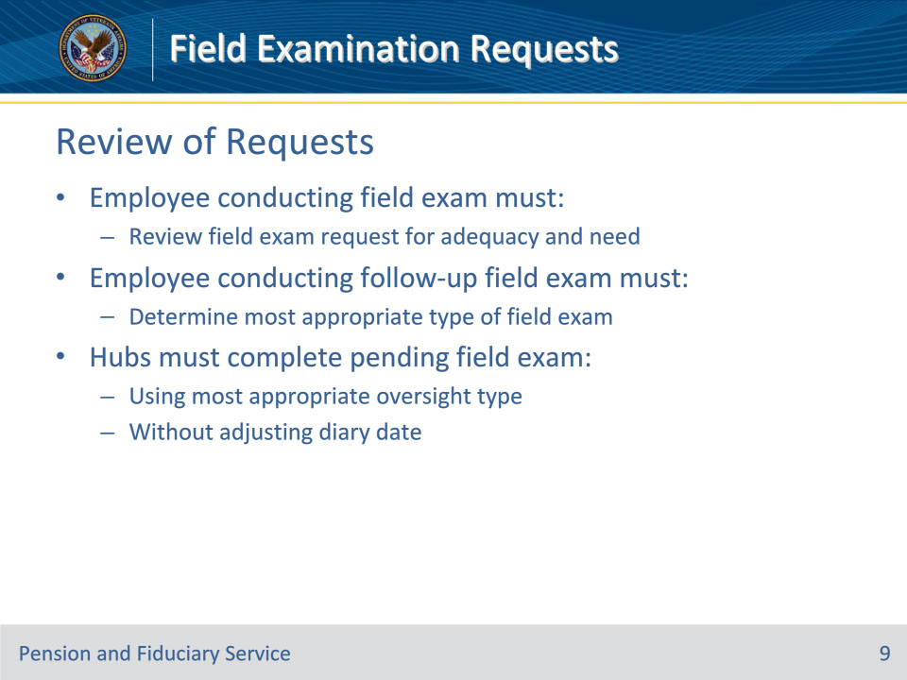
Slide notes

Policy Reference(s): FPM I.2.A.3.c.

Instructor Notes:The hub employee conducting the field examination must review the field examination request for adequacy and need. Additionally, the hub employee conducting a follow-up field examination must determine the most appropriate type of field examination based on the beneficiary’s situation on the date of review.

Hubs must complete the pending field examination using the most appropriate oversight type without adjusting the diary date.

Slide 10 - Review of Requests
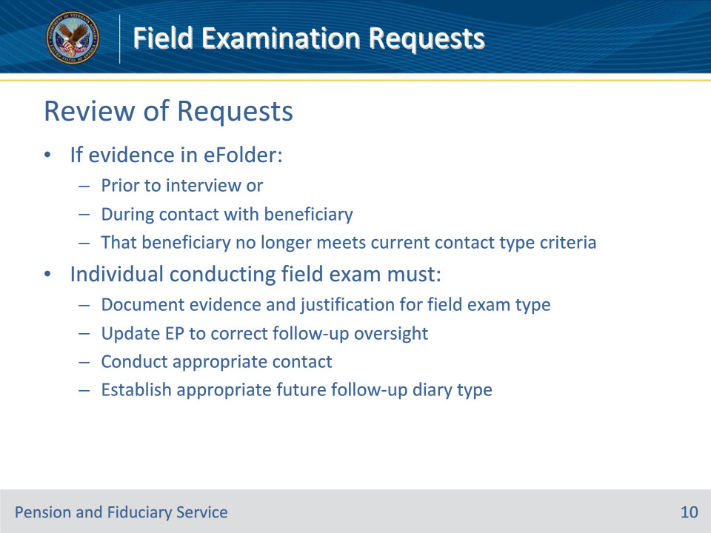
Slide notes

Policy Reference(s): FPM I.2.A.3.c.

Instructor Notes:

If the hub employee conducting the field examination determines that there is evidence in the eFolder prior to the interview or during contact with the beneficiary that the beneficiary no longer meets the criteria for the current beneficiary follow-up contact type, the individual conducting the field examination must

• document the

• evidence, and

• specific justification for the follow-up field examination, to include that the oversight of the beneficiary requires a different follow-up field examination type because the beneficiary no longer meets the criteria

• update the EP to reflect the follow-up oversight that is consistent with the beneficiary’s situation

• conduct the appropriate contact, and

• establish the appropriate future follow-up diary type based on the beneficiary’s current situation.

Slide 11 - Non-Program Requests
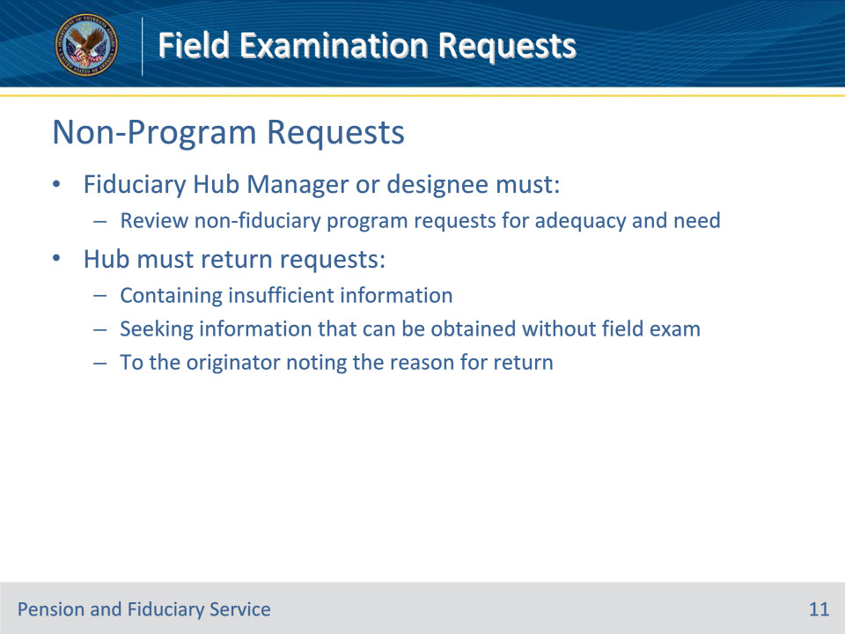
Slide notes

Policy Reference(s): FPM I.2.A.3.d.

Instructor Notes:The Fiduciary Hub Manager (FHM) or designee must review non-fiduciary program requests for adequacy and need. The hub must return requests containing insufficient information or seeking information that can be obtained without a field examination to the originator noting the reason for return.

Slide 12 - Foreign Countries
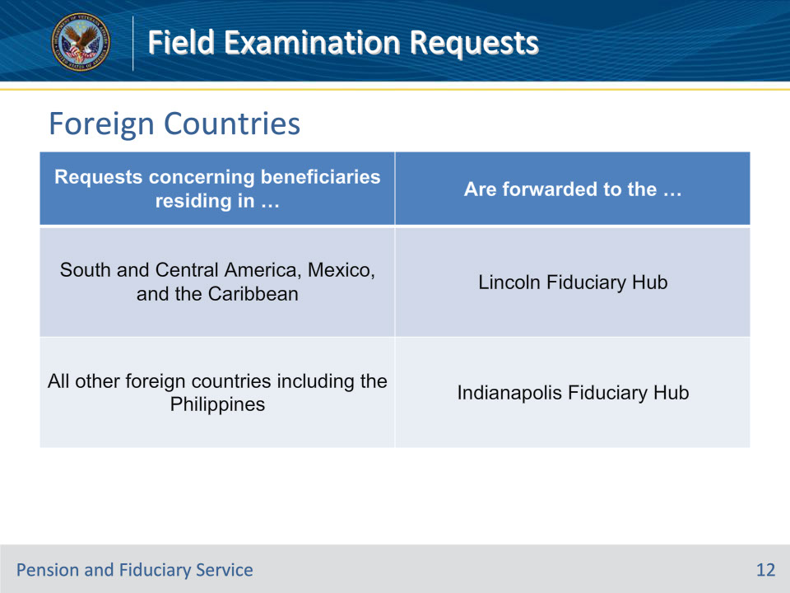
Slide notes

Policy Reference(s): FPM I.2.A.3.e.

Instructor Notes:Requests for IA field examinations for beneficiaries in foreign countries are under the jurisdiction of hubs based upon the beneficiary’s location.

This table describes the process for forwarding IA requests for beneficiaries living in foreign countries.

The hub will transmit requests for IA field examinations for beneficiaries in foreign countries to the appropriate foreign service post.

Slide 13 - Foreign Countries
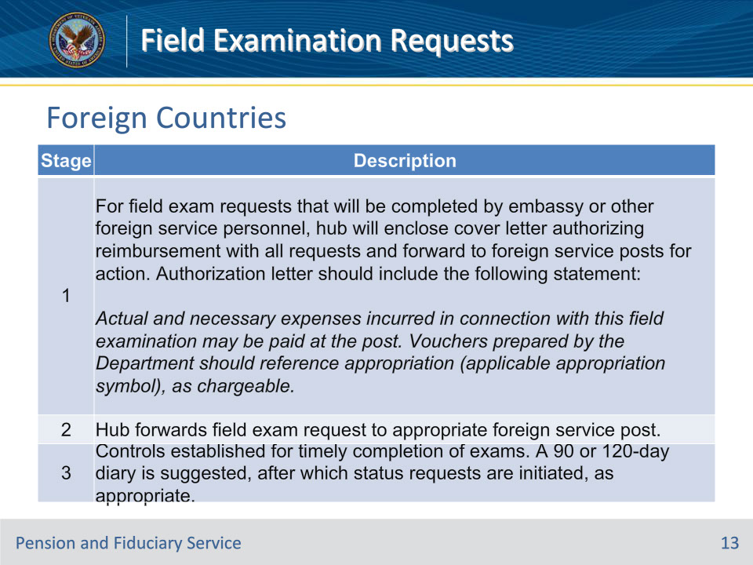
Slide notes

Policy Reference(s): FPM I.2.A.3.f.

Instructor Notes:

This table describes the Lincoln and Indianapolis Fiduciary Hubs’ process for transmitting foreign field examination requests.

Slide 14 - Foreign Countries
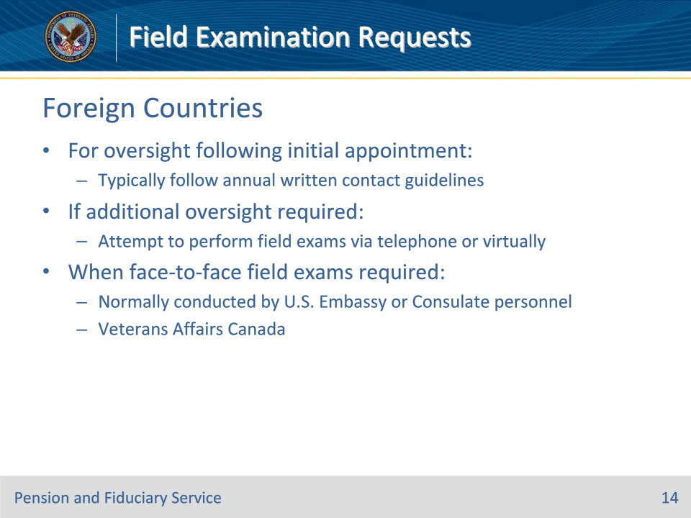
Slide notes

Policy Reference(s): FPM I.2.A.3.g.

Instructor Notes:Foreign beneficiaries will be afforded the least restrictive method of oversight. For oversight following the IA, hubs will typically follow the annual written contact guidelines.

If additional oversight is required for a foreign beneficiary, hubs must first attempt to perform the required field examinations via telephone or virtual methods. When face-to-face field examinations are required in foreign countries, they are normally conducted by U.S. Embassy or Consulate personnel. In Canada, field examinations are conducted by personnel of Veterans Affairs Canada.

Slide 15 - Questions?
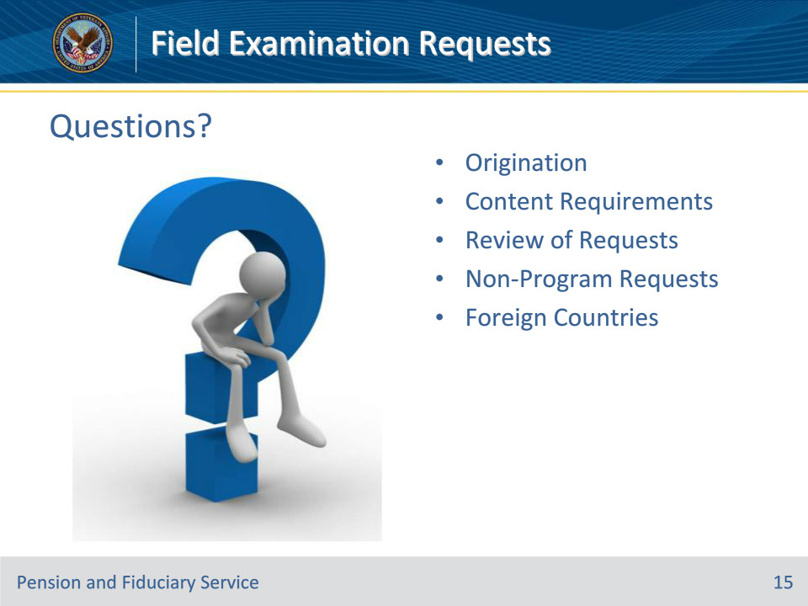
Slide notes

Instructor Notes:

(Recall) These are our learning objectives as stated from the beginning of the training:

• Identify origination sources for field exam requests

• Ensure content requirements for requests satisfied

• Review field exam requests

• Route request for foreign beneficiaries

(Recap) We discussed each of these learning objectives through the following topics in each slide today:

• Origination

• Content Requirements

• Review of Requests

• Non-Program Requests

• Foreign Countries

Are there any additional questions?

Questions should be filtered through your QRT team. They will submit your questions to the Field Inquiry Tool (FIT) on your behalf.

Slide 16 - TMS Survey/Assessment
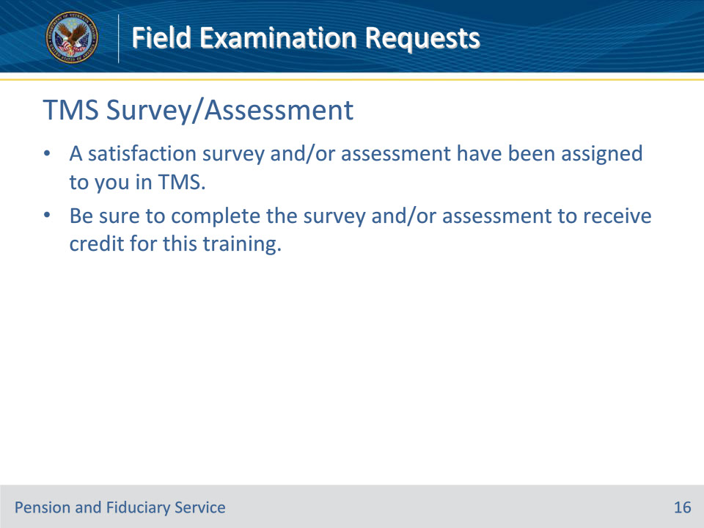
Slide notes

Instructor Notes:

A satisfaction survey and/or assessment have been assigned to you in TMS.

Be sure to complete the survey and/or assessment to receive credit for this training.

