Slide 1 - Field Examination Notifications
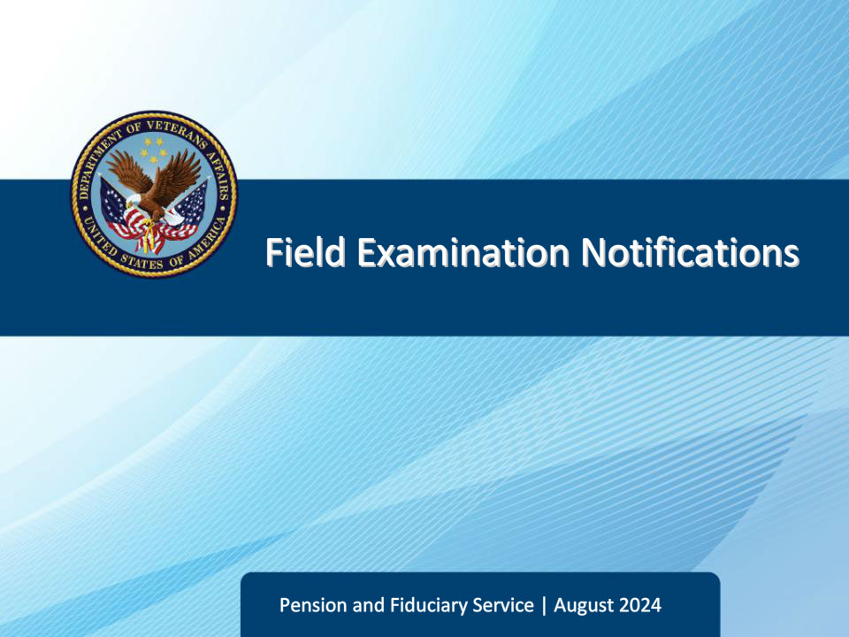
Slide notes

Course Description:

The purpose of this lesson is to provide learners information on notification requirements upon completion of a field examination.

Slide 2 - Objectives
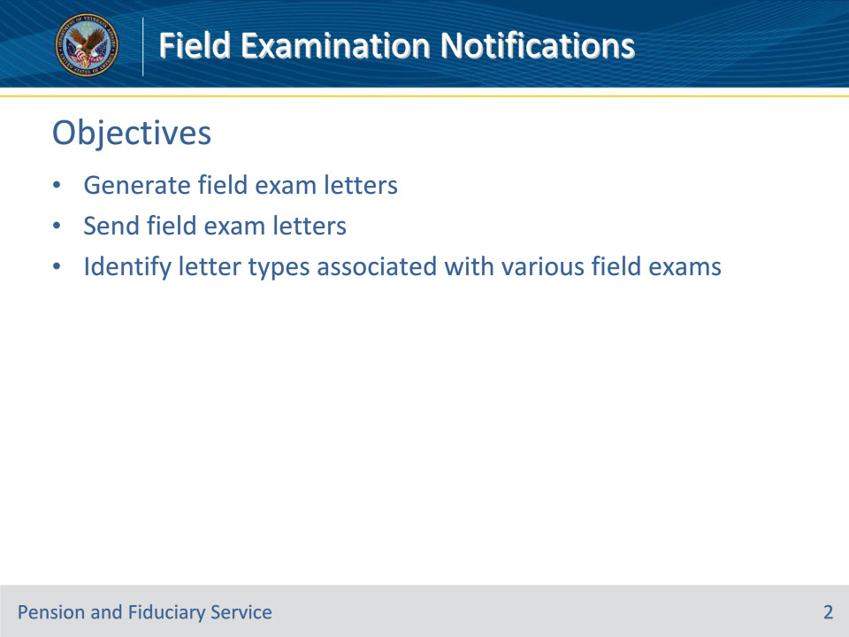
Slide notes

Instructor Notes:

At the end of this lesson, given the training and references, the learner will be able to do the following:

• Generate field exam letters

• Send field exam letters

• Identify letter types associated with various field exams

Slide 3 - References
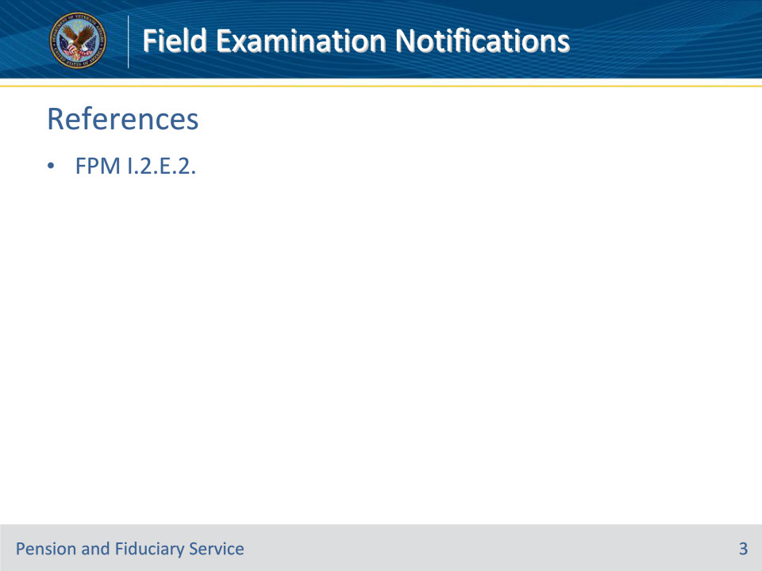
Slide notes

Instructor Notes:

These are the relevant references pertaining to this course:

• FPM I.2.E.2. Field Examination Notifications

Slide 4 - Generating Letters
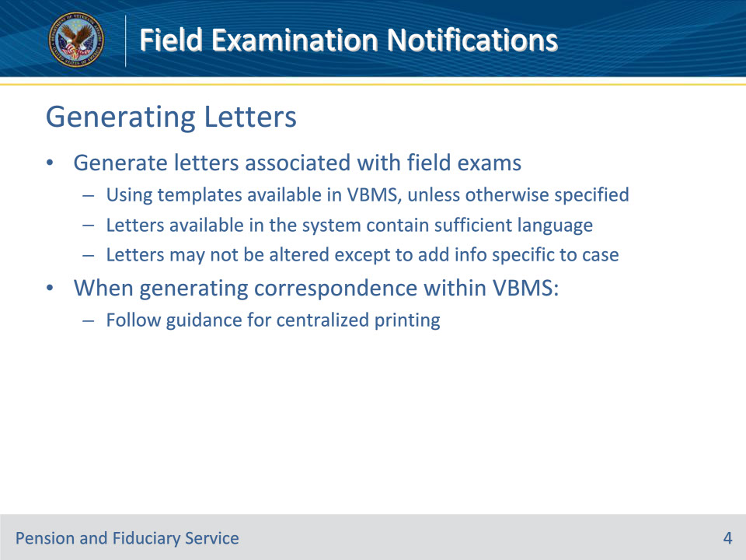
Slide notes

Policy Reference(s): FPM I.2.E.2.a.

Instructor Notes:Hubs must generate letters associated with field examinations using the templates available in VBMS, unless otherwise specified. The letters available in the system contain sufficient language to fulfill notification requirements. Letters may not be altered except to add information specific to the case.

When generating correspondence within VBMS the hub must follow the guidance for centralized printing.

Slide 5 - Generating Letters
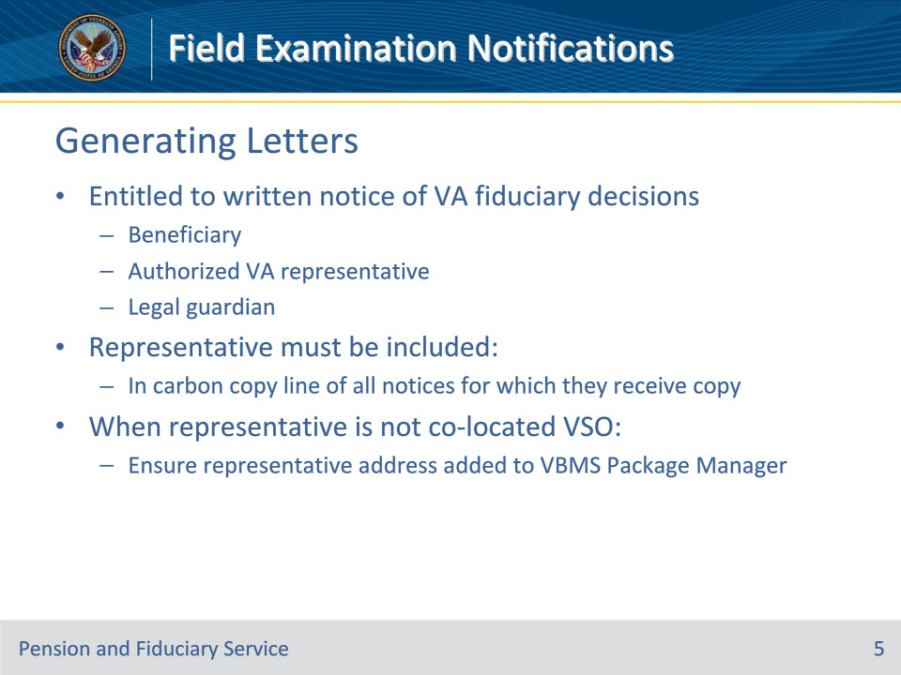
Slide notes

Policy Reference(s): FPM I.2.E.2.a.

Instructor Notes:

The beneficiary, their authorized VA representative, and their legal guardian are entitled to written notice of any VA decisions related to fiduciary matters that are appealable under 38 CFR 13.600 and are also within the scope of representation. The representative must be included in the carbon copy line of all notices for which they will receive a copy. When the representative is not a co-located Veterans service organization, the hub employee must ensure that the representative’s address is added to the VBMS Package Manager.

Slide 6 - Sending Letters
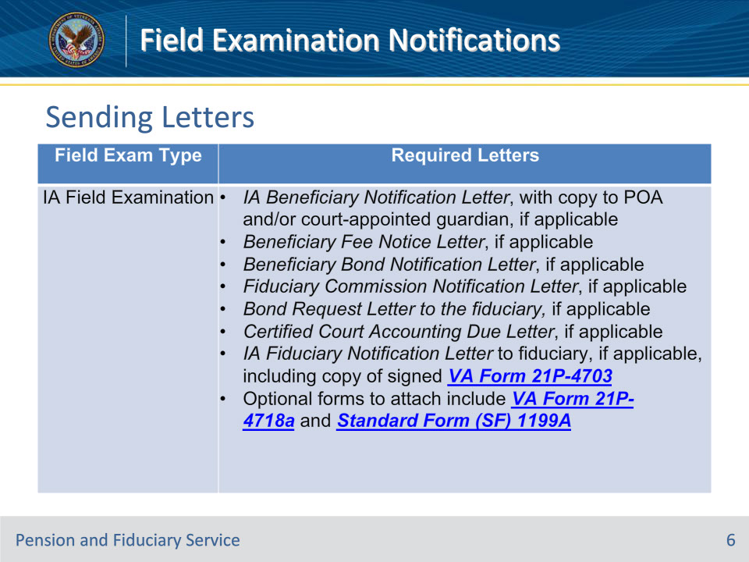
Slide notes

Policy Reference(s): FPM I.2.E.2.b.

Instructor Notes:This table lists the required notification letters for each specified field examination type.

Slide 7 - Sending Letters
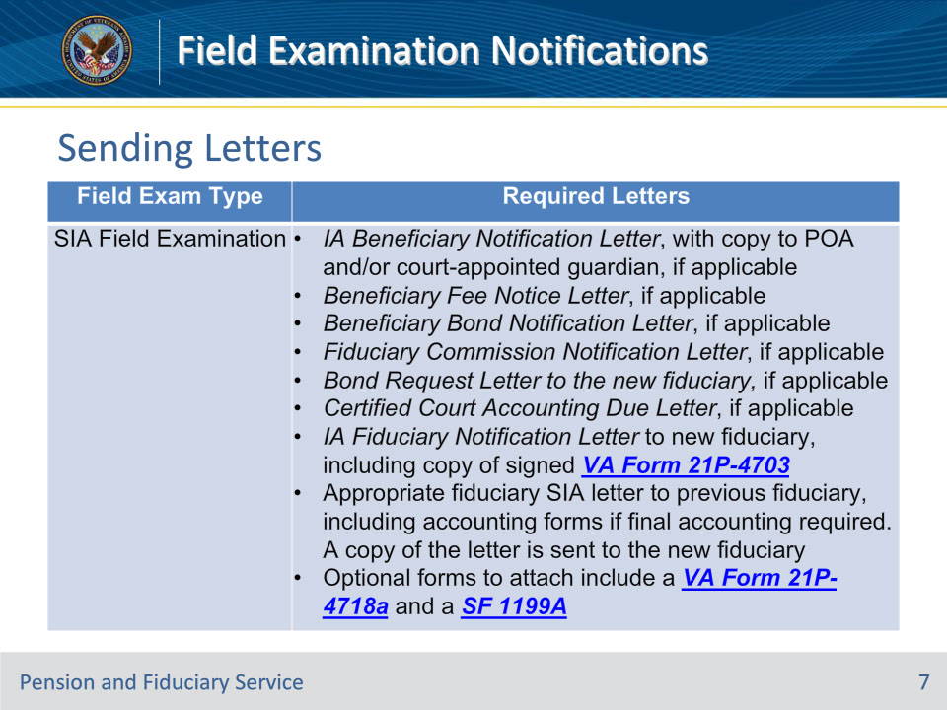
Slide notes

Policy Reference(s): FPM I.2.E.2.b.

Instructor Notes:This table lists the required notification letters for each specified field examination type.

Slide 8 - Sending Letters
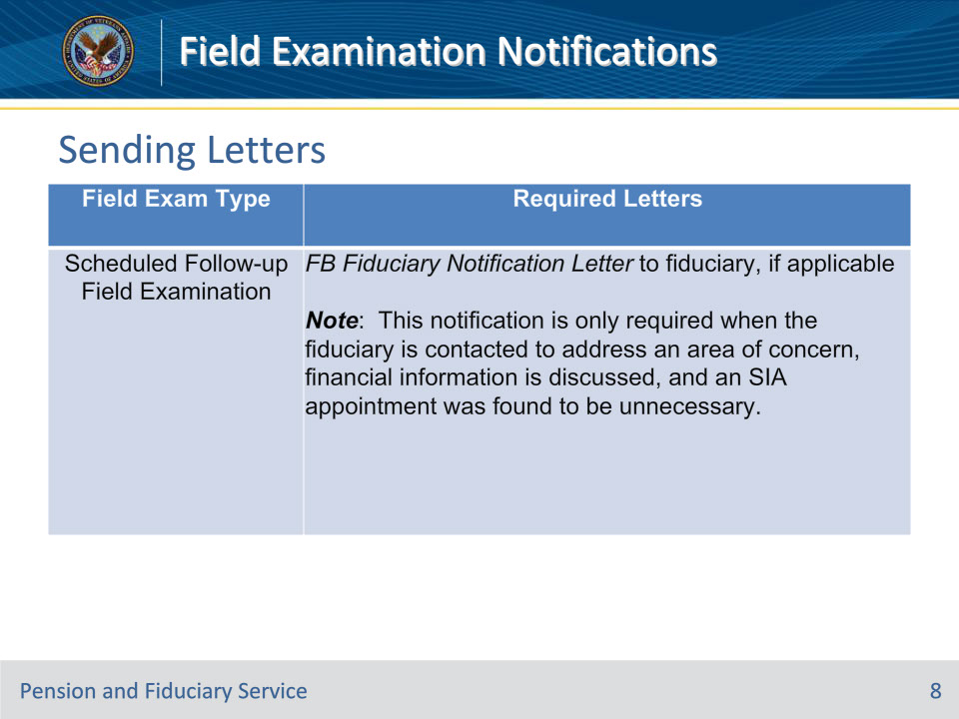
Slide notes

Policy Reference(s): FPM I.2.E.2.b.

Instructor Notes:This table lists the required notification letters for each specified field examination type.

Slide 9 - Notice of Fiduciary Appointment
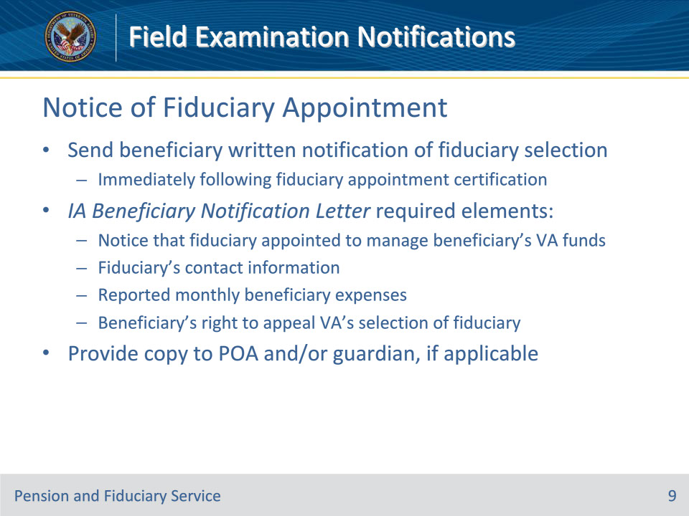
Slide notes

Policy Reference(s): FPM I.2.E.2.c.

Instructor Notes:The hub must send the beneficiary written notification of the selection of a fiduciary to manage the beneficiary’s VA benefits immediately following the completion of the fiduciary appointment certification.

The IA Beneficiary Notification Letter must contain the following required elements:

• notice that a fiduciary was appointed to manage the beneficiary’s VA funds

• fiduciary’s contact information including the fiduciary’s name, telephone number, mailing address, and e-mail address

• the reported monthly beneficiary expenses, and

• beneficiary’s right to appeal VA’s selection of a fiduciary.

A copy of the letter must be provided to the POA and/or court-appointed guardian, if applicable.

Slide 10 - Notice of Fiduciary Appointment
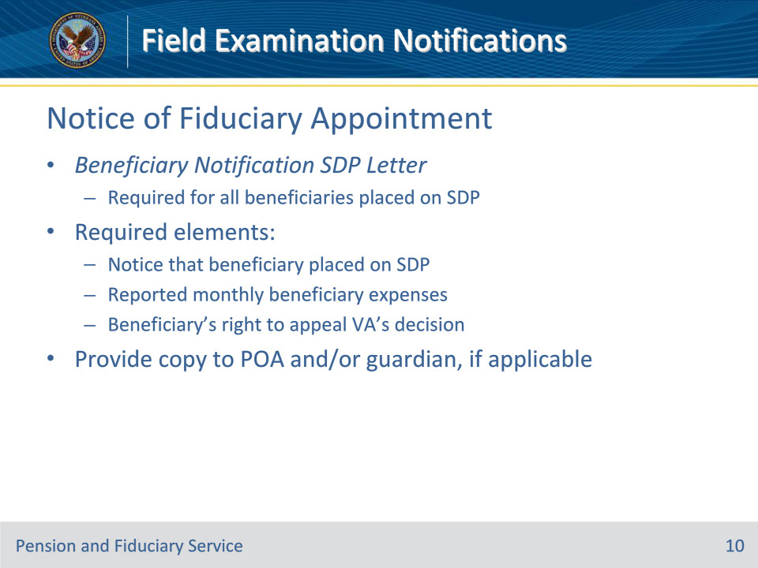
Slide notes

Policy Reference(s): FPM I.2.E.2.c.

Instructor Notes:

The Beneficiary Notification SDP Letter is required for all beneficiaries who are rated as unable to manage VA funds and have been placed on SDP. The letter must contain the following required elements:

• notice that the beneficiary has been placed on SDP

• the reported monthly beneficiary expenses, and

• beneficiary’s right to appeal VA’s decision.

A copy of the letter must be provided to the POA and/or court-appointed guardian, if applicable.

Slide 11 - Notice of Fiduciary Fee
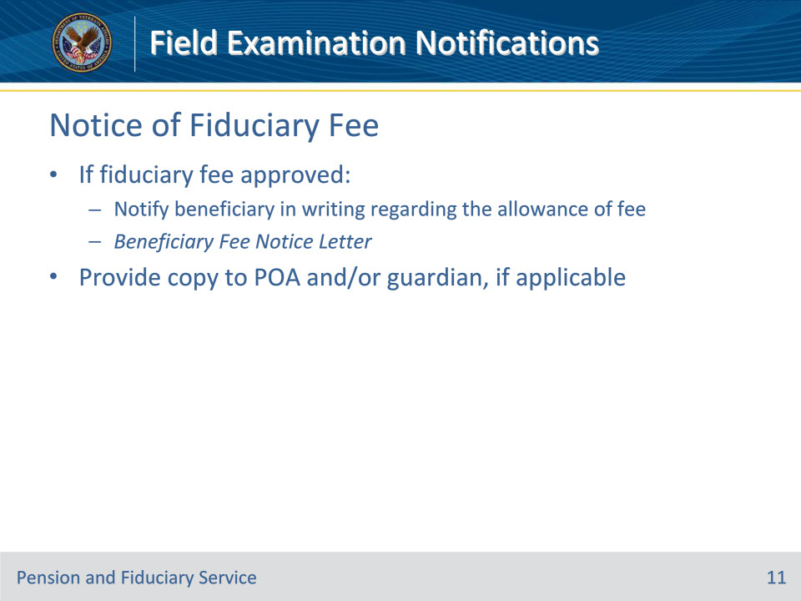
Slide notes

Policy Reference(s): FPM I.2.E.2.d.

Instructor Notes:If a fiduciary fee was approved, the hub must notify the beneficiary in writing regarding the allowance of the fee payable from the beneficiary’s funds. This letter is referred to as the Beneficiary Fee Notice Letter.

A copy of the Beneficiary Fee Notice Letter must be provided to the POA and/or court-appointed guardian, if applicable.

Slide 12 - Notice of Bond Expense
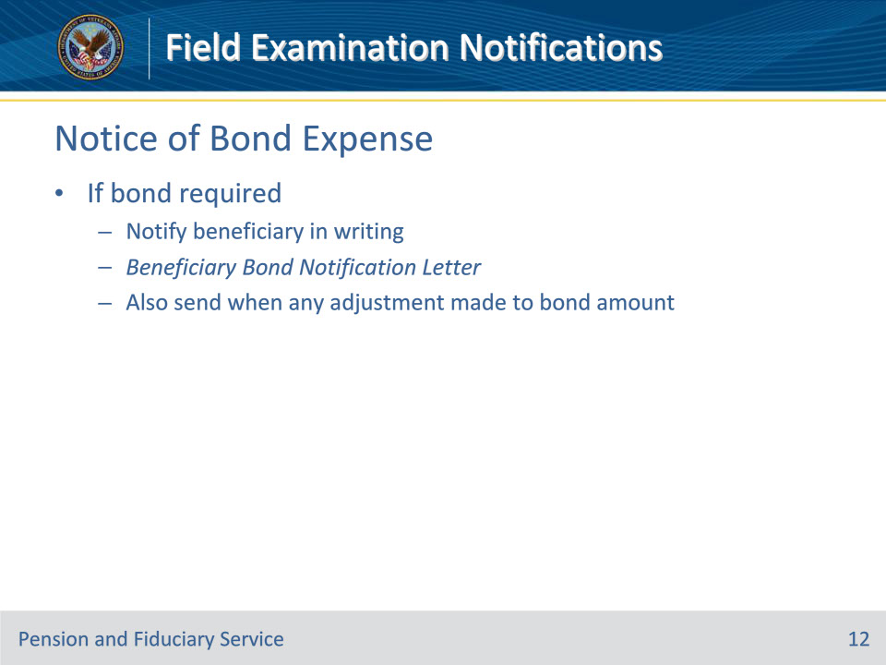
Slide notes

Policy Reference(s): FPM I.2.E.2.e.

Instructor Notes:If a bond is required, the hub must notify the beneficiary in writing regarding the bond furnished at the beneficiary’s expense. This letter is referred to as the Beneficiary Bond Notification Letter. This letter must be sent when any adjustment is made to the surety bond amount.

Slide 13 - Notice to Fiduciary
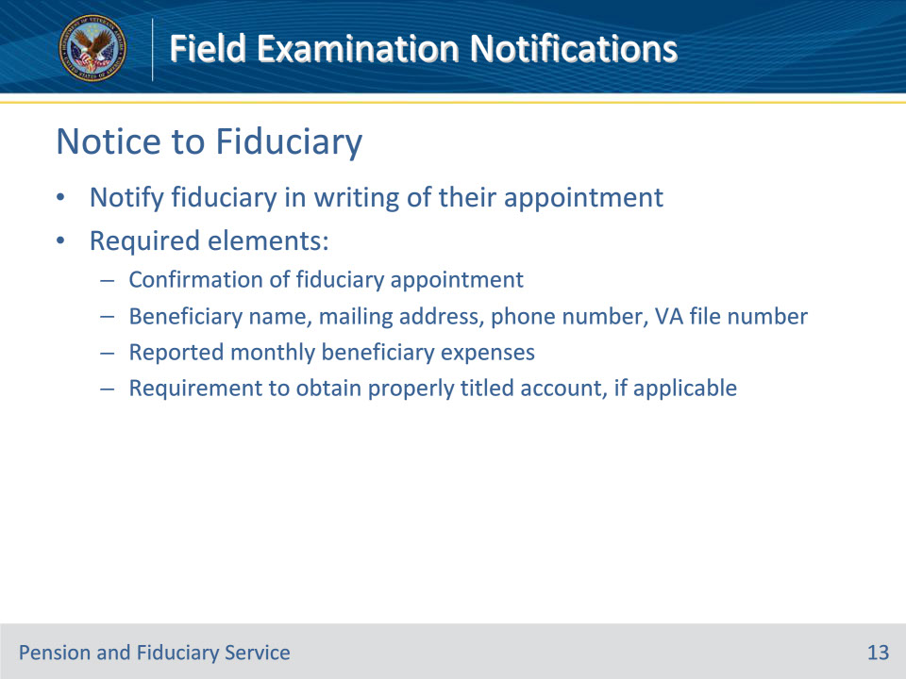
Slide notes

Policy Reference(s): FPM I.2.E.2.f.

Instructor Notes:The hub must notify the fiduciary in writing of their appointment as a fiduciary.

The initial or follow-up appointment notification letter must contain the following elements:

• confirmation of the fiduciary appointment

• beneficiary name, mailing address, phone number, and VA file number

• the reported monthly beneficiary expenses, and

• the requirement to obtain a properly titled account, if applicable

Slide 14 - Notice to Fiduciary
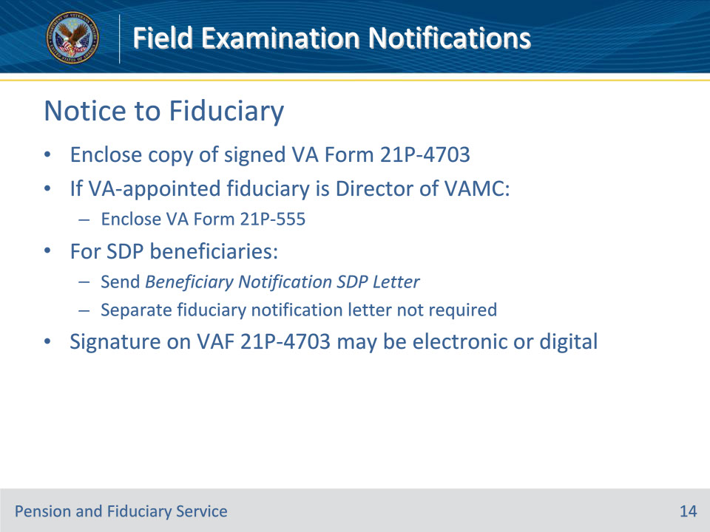
Slide notes

Policy Reference(s): FPM I.2.E.2.f.

Instructor Notes:

Enclose a copy of the signed VA Form 21P-4703.

If the VA-appointed fiduciary is the Director of a VA Medical Center, enclose a VA Form 21P-555.

For beneficiaries approved for SDP, send the Beneficiary Notification SDP Letter for SDP. A separate fiduciary notification letter is not required.

The signature on the VA Form 21P-4703 may be an electronic or digital signature if it meets the requirements specified in M21-1, Part II, Subpart i, 2.B.2.g.

Slide 15 - Notice to Former Fiduciary
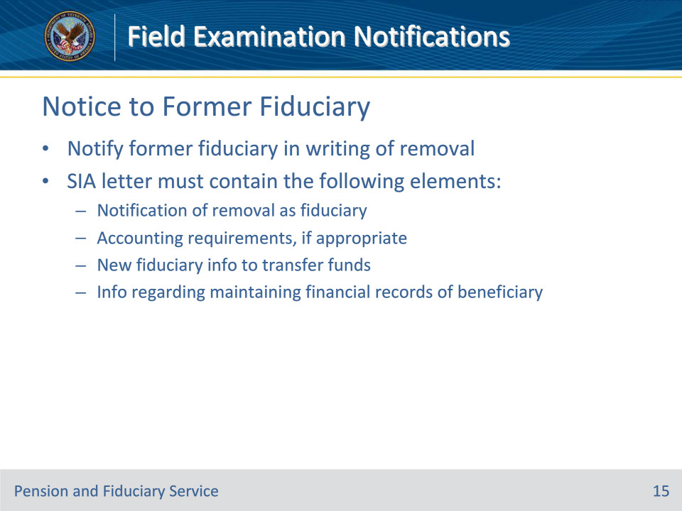
Slide notes

Policy Reference(s): FPM I.2.E.2.g.

Instructor Notes:The hub must notify the former fiduciary being released from fiduciary service in writing of their removal as fiduciary.

The SIA letter must contain the following elements:

• notification of removal as fiduciary

• accounting requirements, if appropriate

• new fiduciary information to transfer funds, and

• information regarding maintaining financial records of the beneficiary.

Slide 16 - Court Accounting Notice
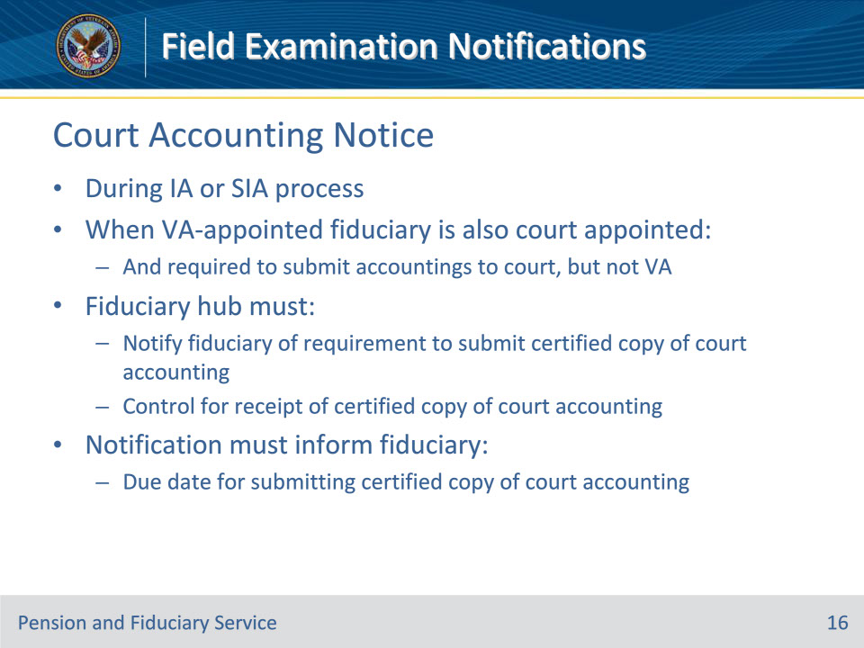
Slide notes

Policy Reference(s): FPM I.2.E.2.h.

Instructor Notes:During the IA or SIA process, when a VA-appointed fiduciary who is also court appointed is required to submit accountings to the court, but not to VA, the hub must

• notify the fiduciary of the requirement to submit a certified copy of the court accounting, and

• control for receipt of the certified copy of the court accounting.

The notification must inform the fiduciary of the due date for submitting the certified copy of the court accounting.

Slide 17 - Questions?
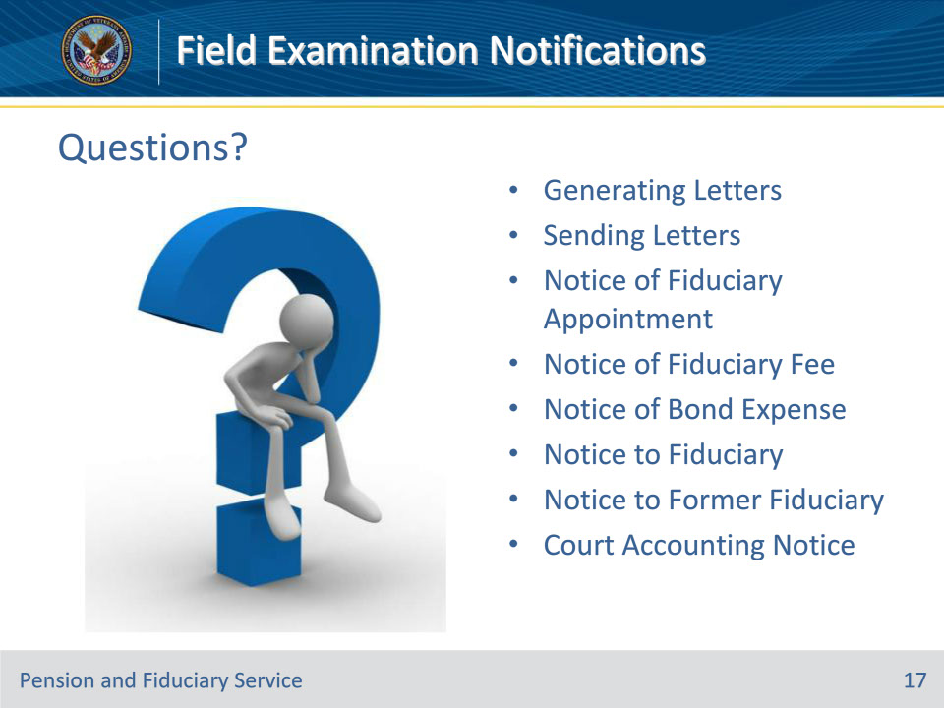
Slide notes

Instructor Notes:

(Recall) These are our learning objectives as stated from the beginning of the training:

• Generate field exam letters

• Send field exam letters

• Identify letter types associated with various field exams

(Recap) We discussed each of these learning objectives through the following topics in each slide today:

• Generating Letters

• Sending Letters

• Notice of Fiduciary Appointment

• Notice of Fiduciary Fee

• Notice of Bond Expense

• Notice to Fiduciary

• Notice to Former Fiduciary

• Court Accounting Notice

Are there any additional questions?

Questions should be filtered through your QRT team. They will submit your questions to the Field Inquiry Tool (FIT) on your behalf.

Slide 18 - TMS Survey/Assessment
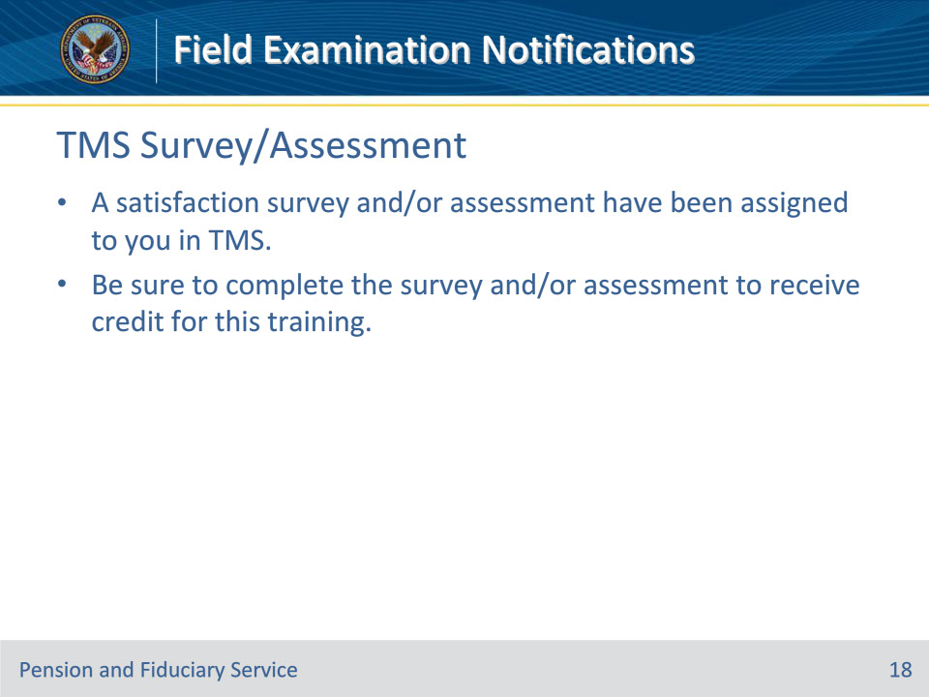
Slide notes

Instructor Notes

A satisfaction survey and/or assessment have been assigned to you in TMS.

Be sure to complete the survey and/or assessment to receive credit for this training.

